UNITED STATES
SECURITIES AND EXCHANGE COMMISSION
Washington, DC 20549

FORM 8-K

CURRENT REPORT

PURSUANT TO SECTION 13 OR 15(d) OF THE
SECURITIES EXCHANGE ACT OF 1934

Date of Report (Date of earliest event reported): August 11, 2026
Aquestive Therapeutics, Inc.
(Exact name of Registrant as specified in its charter)
Delaware |  |  | 001-38599 |  |  | 82-3827296
(State or other jurisdiction of incorporation) |  |  | (Commission File Number) |  |  | (I.R.S. Employer Identification No.)

30 Technology Drive
Warren, NJ 07059
(908) 941-1900
(Address, Including Zip Code, and Telephone Number, Including Area Code, of Registrant’s Principal Executive Offices)

Not Applicable
(Former name or former address, if changed since last report)

________________________________________________________________________________________________________________________
Check the appropriate box below if the Form 8-K filing is intended to simultaneously satisfy the filing obligation of the registrant under any of the following provisions:
☐ |  |  | Written communications pursuant to Rule 425 under the Securities Act (17 CFR 230.425)
☐ |  |  | Soliciting material pursuant to Rule 14a-12 under the Exchange Act (17 CFR 240.14a-12)
☐ |  |  | Pre-commencement communications pursuant to Rule 14d-2(b) under the Exchange Act (17 CFR 240.14d-2(b))
☐ |  |  | Pre-commencement communications pursuant to Rule 13e-4(c) under the Exchange Act (17 CFR 240.13e-4(c))

Securities registered pursuant to Section 12(b) of the Act:

Title of each class |  |  | Trading Symbol(s) |  |  | Name of each exchange on which  registered
Common Stock, par value $0.001 per share |  |  | AQST |  |  | Nasdaq Global Market

Indicate by check mark whether the registrant is an emerging growth company as defined in Rule 405 of the Securities Act of 1933 (§230.405 of this chapter) or Rule 12b-2 of the Securities Exchange Act of 1934 (§240.12b-2 of this chapter).
Emerging growth company |  |  | ☐
If an emerging growth company, indicate by check mark if the registrant has elected not to use the extended transition period for complying with any new or revised financial accounting standards provided pursuant to Section 13(a) of the Exchange Act. ☐

Item 2.02 |  |  | Results of Operations and Financial Condition.
On August 11, 2026, Aquestive Therapeutics, Inc. (the “Company”) issued a press release announcing its reported financial results for the second quarter ended June 30, 2026 and provided an update on recent developments in its business. A copy of the Company’s press release and the attached financial schedules are attached as Exhibit 99.1 to this Current Report On Form 8-K and incorporated in this Item 2.02 by reference.
The information in this Item 2.02 (including Exhibit 99.1) shall not be deemed to be “filed” for purposes of, or otherwise subject to the liabilities of Section 18 of the Exchange Act,nor shall it be deemed to be incorporated by reference in any filing under the Securities Act of 1933, as amended (the “Securities Act”), or the Exchange Act, except as shall be expressly set forth by specific reference in any such filing.
Item 7.01 |  |  | Regulation FD Disclosure.
The Company is furnishing this Current Report on Form 8-K in connection with the disclosure of information, in the form of a investor presentation, to be given at meetings with institutional investors, analysts and others. This information may be amended or updated at any time and from time to time through another Current Report on Form 8-K, a later Company filing or other means. A copy of the Company’s investor presentation is attached hereto as Exhibit 99.2 to this Current Report on Form 8-K and incorporated into this Item 7.01 by reference. The investor presentation is available on the Events and Presentations page in the Investors section of the Company’s website located at www.aquestive.com, although the Company reserves the right to discontinue that availability at any time.
The information in this Item 7.01 (including Exhibit 99.2) shall not be deemed to be “filed” for purposes of, or otherwise subject to the liabilities of Section 18 of the Exchange Act, nor shall it be deemed to be incorporated by reference in any filing under the Securities Act or the Exchange Act, except as shall be expressly set forth by specific reference in any such filing.

Item 9.01 |  |  | Financial Statements and Exhibits.

(d) Exhibits.

Exhibit Number |  |  |  |  |  | Description
99.1 |  |  |  |  |  | Press Release, dated August 11, 2026, announcing the Company’s reported financial results for the second quarter ended June 30, 2026 and providing an update on recent developments in its business.
99.2 |  |  |  |  |  | Aquestive Therapeutics, Inc. Q2 Earnings Supplemental Materials dated August 11, 2026.
104 |  |  |  |  |  | Cover Page Interaction Data File (embedded within the Inline XBRL document)

SIGNATURE

Pursuant to the requirements of the Securities Exchange Act of 1934, as amended, the Registrant has duly caused this report to be signed on its behalf by the undersigned hereunto duly authorized.

Dated: August 11, 2026 |  |  | Aquestive Therapeutics, Inc.
 |  |  | By: |  |  | /s/ A. Ernest Toth, Jr
 |  |  |  |  |  | Name: A. Ernest Toth, Jr.
 |  |  |  |  |  | Title: Chief Financial Officer

Exhibit 99.1



Aquestive Therapeutics Reports Second Quarter 2026 Financial Results
and Provides Business Update

•Successfully completed human factors validation study and pharmacokinetic study for Anaphylm™ (dibutepinephrine) sublingual film
•Remains on track to resubmit Anaphylm NDA to the FDA in Q3 2026
•Continues pre-launch medical affairs activities and payer engagement
•On track to begin ex-U.S. filings of Anaphylm in Q4 2026
•Company to host investor call on August 12, 2026, at 8:00 a.m. ET

Warren, N.J., August 11, 2026 – Aquestive Therapeutics, Inc. (NASDAQ: AQST) ("Aquestive" or the "Company"), a pharmaceutical company advancing medicines to bring meaningful improvement to patients' lives through innovative science and delivery technologies, today announced financial results for the second quarter ended June 30, 2026, and provided a strategic business update.

“The epinephrine rescue market continues to grow and remains available for conversion from older medical device technology including autoinjectors,” said Daniel Barber, President and Chief Executive Officer of Aquestive Therapeutics. “As we bring Anaphylm to market, if approved by the FDA, we believe we can be instrumental in driving conversion in the allergist office and, ultimately, the broader market. As we prepare to resubmit our application to the FDA in the coming weeks, our full attention will be to prepare for a focused, allergist-first launch of Anaphylm as quickly as possible, if approved by the FDA. In the meantime, our medical affairs team continues to interact with the allergy community on a daily basis.”

“We also continue to expand our understanding of our AdrenaVerse epinephrine prodrug platform and the opportunity it presents,” continued Daniel Barber. “Controlling the absorption and release of epinephrine allows us to target a variety of indications, especially in dermatological indications such as atopic dermatitis. The well-documented ability of epinephrine to lower histamine release through stabilizing mast cells while also downregulating key inflammatory components of atopic dermatitis creates the potential for a compelling product profile. Although AQST-108 is still in early-stage development, we are encouraged by the emerging data and plan on continuing to advance the program as we look towards 2027.”

Anaphylm™ (dibutepinephrine) sublingual film
Anaphylm is an oral epinephrine product candidate being developed for the treatment of type I allergic reactions, including anaphylaxis. The Company believes Anaphylm has the potential to be the first and only non-invasive, orally delivered epinephrine product for the treatment of type I allergic reactions, including anaphylaxis, if approved by the U.S. Food and Drug Administration (FDA).

In the second quarter of 2026, Aquestive completed the human factors validation study and the pharmacokinetic (PK) study required to address the deficiencies identified in the Complete Response Letter (CRL) issued by the FDA dated January 30, 2026. The human factors validation study evaluated a revised packaging design, incorporating modifications to the pouch opening, instructions for use, pouch and carton labeling. The study results showed significant improvement across each deficiency identified

in the CRL. Based on preliminary data, the PK study met its primary endpoints. No administration errors were observed in the self-administration arm of the PK study. In addition, there were no serious adverse events and no events that led to study drug discontinuation. The Company reaffirms its guidance to resubmit the Anaphylm New Drug Application (NDA) in the third quarter of 2026. As previously disclosed, the CRL did not identify any chemistry, manufacturing, or controls (CMC) deficiencies, and clinical results supporting comparability to autoinjectors were not questioned by the FDA. The Company will request an expedited review upon resubmission, though no shortened or expedited review timeline can be guaranteed.

Aquestive continues to advance its global regulatory strategy for Anaphylm. The Company remains on track to submit regulatory applications in Canada by the end of 2026 and in the European Union in the first quarter of 2027. The Company expects its existing clinical data to support regulatory submissions in additional markets in 2027, including the United Kingdom.

Aquestive continues to advance commercial readiness in anticipation of a potential Anaphylm launch. The Company's Medical Affairs team is driving healthcare professional awareness, and the Company recently strengthened its Scientific Advisory Board to further support scientific exchange and education. Aquestive also maintains active partnerships with leading allergy-focused patient advocacy organizations. In parallel, the commercial team continues to refine launch execution and market access strategies. These efforts are supported by the Company's experienced commercial team and its established infrastructure, enabling Aquestive to execute a focused and disciplined launch strategy, if Anaphylm is approved by the FDA.

AQST-108 (epinephrine) topical gel
AQST-108 is a topical epinephrine prodrug gel product candidate being evaluated for various potential dermatologic indications. The Company completed the AQST-108 Phase 1 study in androgenic alopecia with no safety concerns observed, supporting continued development. The program is expanding into additional dermatologic inflammatory indications, including atopic dermatitis. This disciplined, data-driven approach is consistent with the Company’s strategy of maximizing the value of the AdrenaVerse™ platform while maintaining focus on the Anaphylm NDA resubmission.

Atopic dermatitis affects approximately 7%–10% of U.S. adults and 10%–20% of children, making it one of the most common chronic inflammatory skin diseases in the U.S.

AQST-108 is believed to have potential immunomodulatory effects, including downregulation of certain chemoattractants and inflammatory mediators, while stabilizing mast cells. Based on this mechanism, Aquestive believes AQST-108’s potential may extend beyond atopic dermatitis and alopecia areata to additional dermatologic inflammatory and immunologic indications.

Aquestive’s AdrenaVerse™ platform comprises approximately 20 epinephrine prodrugs designed to enable control of absorption and conversion rates of epinephrine across a range of dosage forms and delivery sites. The Company continues to analyze the AdrenaVerse platform’s long-term potential to address multiple indications.

Commercial Collaborations and Other
Aquestive continues to manufacture products for the licensing and supply collaborations that it has established. The Company manufactured approximately 48 million doses in the second quarter 2026, compared to approximately 37 million doses in the second quarter 2025. The Company continues to

manufacture Indivior’s Suboxone® Sublingual Film product and the Company's other global collaborations, including Sympazan® (clobazam) oral film product for Cosette Pharmaceuticals, Inc. in the U.S., Ondif® (ondansetron) oral film product for Hypera Pharma in Brazil and Emylif® (riluzole) oral film product by Zambon S.p.A. in Europe. Aquestive’s manufacturing business remains steady.

On April 8, 2026, Cosette Pharmaceuticals, Inc. ("Cosette"), a United States-based, branded specialty pharmaceutical company, acquired the rights to Sympazan for the treatment of seizures associated with Lennox-Gastaut Syndrome in patients two years of age and older, from Assertio Holdings, Inc. ("Assertio"), including Assertio's rights under the Company's License Agreement for Sympazan with Otter Pharmaceuticals, LLC, a subsidiary of Assertio (the "Assertio License Agreement"). Cosette will continue to purchase Sympazan® (clobazam) Oral Film Product and pay royalties and milestones to Aquestive under the Assertio License Agreement.
Sales of royalty-based products, inclusive of Sympazan, contributed to the Company's revenue in the second quarter of 2026.
The Company, being a U.S. based manufacturer with intellectual property domiciled in the U.S., confirms that its supply chain currently remains largely unaffected by both implemented and proposed government tariffs, providing continued reliability and stability in production and global distribution for the near term.

Libervant® (diazepam) buccal film is currently tentatively approved in the United States for epilepsy patients ages 12 years and older and is expected to become eligible for full approval following the expiration in January 2027 of the orphan drug exclusivity protecting another company's FDA-approved product. Aquestive believes expanding patient access to non-invasive seizure rescue therapies is vital and remains committed to putting Libervant in the hands of epilepsy patients as soon as permitted by FDA approval and applicable regulatory requirements.

Second Quarter 2026 Financials
Total revenues increased to $13.8 million in the second quarter 2026 from $10.0 million in the second quarter 2025. The 38% increase was primarily driven by increases in manufacture and supply revenue and increases in license and royalty revenue.
Manufacture and supply revenue increased to $11.9 million in the second quarter 2026 from $9.6 million in the second quarter 2025, primarily due to increases in Suboxone revenues, partially offset by lower Ondif revenues.
License and royalty revenue increased to $1.3 million in the second quarter 2026 from $0.8 million in the second quarter 2025, primarily due to royalty revenue from Zevra.
Research and development expenses decreased to $4.0 million in the second quarter 2026 from $4.1 million in the second quarter 2025. The decrease in research and development expenses was primarily due to lower development and manufacturing costs associated with the Anaphylm program, partially offset by increases in preclinical costs.
Selling, general and administrative expenses increased to $14.1 million in the second quarter 2026 from $12.7 million in the second quarter of 2025. The increase primarily represents higher legal fees of approximately $2.1 million, higher severance costs of approximately $1.4 million which includes acceleration of share-based compensation, higher personnel costs of approximately $0.9 million, and higher share-based compensation expenses of approximately $0.3 million as well as other expenses, partially offset by lower commercial spending of approximately $2.6 million, lower regulatory and licensing fees of approximately $1.0 million related to the regulatory fee for Libervant, and lower regulatory expenses related to Anaphylm of approximately $0.2 million.

In the second quarter 2026, the Company recognized a one-time loss on extinguishment of debt of $11.7 million, which represents the difference between the carrying value of the 13.5% Notes as of May 12, 2026 and the total payoff amount of the 13.5% Notes.
Aquestive’s net loss for the second quarter 2026 was $22.9 million, or $0.18 for both basic and diluted loss per share, compared to the net loss in the second quarter 2025 of $13.5 million, or $0.14 for both basic and diluted loss per share. Excluding the impact of the one-time recognition of the loss on extinguishment on the Company's 13.5% Notes, the net loss in the second quarter 2026 was $11.2 million. The increase in net loss was primarily driven by the loss on extinguishment of debt, decreases in interest income and other income, net and increases in selling, general, and administrative expenses, partially offset by increases in revenues, and decreases in manufacture and supply expenses and research and development expenses.
Non-GAAP adjusted EBITDA loss was $5.2 million in the second quarter 2026, compared to non-GAAP adjusted EBITDA loss of $9.3 million in the second quarter 2025.

Cash and cash equivalents were $98.5 million as of June 30, 2026.

2026 Outlook
Aquestive's full-year 2026 financial guidance remains unchanged.

The Company expects:
 |  |  |  | Guidance
Total revenue (in millions) |  |  |  | $46 to $50
Non-GAAP adjusted EBITDA loss (in millions) |  |  |  | $35 to $30

Tomorrow’s Conference Call and Webcast Reminder
The Company will host a conference call at 8:00 a.m. ET on Wednesday, August 12, 2026.

In order to participate, please register in advance here to obtain a local or toll-free phone number and your personal PIN.

A live webcast of the call will be available on Aquestive’s website at: Second Quarter 2026 Earnings Call.

About Anaphylm™
Anaphylm™ (dibutepinephrine) sublingual film is a polymer matrix-based epinephrine prodrug product. Anaphylm is similar in size to a postage stamp, weighs less than an ounce, and begins to dissolve on contact. No water or swallowing is required for administration. The primary packaging for Anaphylm is thinner and smaller than an average credit card, can be carried in a pocket, and is designed to withstand weather excursions such as exposure to rain and/or sunlight. The Anaphylm trade name for AQST-109 has been conditionally approved by the FDA. Final approval of the Anaphylm proprietary name is conditioned on FDA approval of the product candidate.

About AQST-108
AQST-108 (epinephrine) topical gel is a topically delivered adrenergic agonist prodrug product candidate. Aquestive completed a first-in-human study for AQST-108 without any serious or topical adverse events observed. AQST-108 is based on Aquestive’s AdrenaVerse™ platform which contains a library of over twenty epinephrine prodrugs intended to control absorption and conversion rates across a variety of possible dosage forms and delivery sites.
About Libervant®
Libervant® (diazepam) buccal film is a buccally, or inside of the cheek, administered film formulation of diazepam, a benzodiazepine intended for the acute treatment of intermittent, stereotypic episodes of frequent seizure activity (i.e., seizure clusters, acute repetitive seizures) that are distinct from a patient’s usual seizure pattern in patients with epilepsy. Aquestive developed Libervant as an alternative to the device-based products currently available for patients with refractory epilepsy, including a rectal gel and nasal spray products. The FDA approval for U.S. market access received in April 2024 for Libervant was for these epilepsy patients between two and five years of age. However, the FDA converted this approval to a "tentative approval" due to a subsequent court ruling finding that the FDA did not have authority to approve Libervant for U.S. market access for patients aged between two and five years due to the existing orphan drug market exclusivity granted by the FDA to an intranasal spray of another company. The FDA granted tentative approval in August 2022 for Libervant for treatment of these epilepsy patients twelve years of age and older. We filed for FDA approval for use of Libervant for these epilepsy patients aged between 6 and 11 years in Q2 2026. U.S. market access for Libervant for epilepsy patients twelve years of age and older is currently subject to the expiration of the existing orphan drug market exclusivity of the previously FDA approved drug scheduled to occur in January 2027.

Important Safety Information
Do not give Libervant to your child between the ages of two and five if your child is allergic to diazepam or any of the ingredients in Libervant or has an eye problem called acute narrow angle glaucoma.

What is the most important information I should know about Libervant?

•Libervant is a benzodiazepine medicine. Taking benzodiazepines with opioid medicines, alcohol, or other central nervous system (CNS) depressants (including street drugs) can cause severe drowsiness, breathing problems (respiratory depression), coma, and death. Get emergency help right away if any of the following happens:
◦shallow or slowed breathing,
◦breathing stops (which may lead to the heart stopping),
◦excessive sleepiness (sedation).

Do not allow your child to drive a motor vehicle, operate heavy machinery, or ride a bicycle until you know how taking Libervant with opioids affects your child.
•Risk of abuse, misuse, and addiction. Libervant is used in children 2 to 5 years of age. The unapproved use of Libervant has a risk for abuse, misuse, and addiction, which can lead to overdose and serious side effects including coma and death.
•Serious side effects including coma and death have happened in people who have abused or misused benzodiazepines, including diazepam (the active ingredient in Libervant). These serious side effects may also include delirium, paranoia, suicidal thoughts or actions, seizures, and difficulty breathing. Call your child’s healthcare provider or go to the nearest hospital emergency room right away if you get any of these serious side effects.

◦Your child can develop an addiction even if your child takes Libervant as prescribed by your child’s healthcare provider.
◦Give Libervant exactly as your child’s healthcare provider prescribed.
◦Do not share Libervant with other people.
◦Keep Libervant in a safe place and away from children.
•Physical dependence and withdrawal reactions. Libervant is intended for use if needed in order to treat higher than usual seizure activity. Benzodiazepines, including Libervant, can cause physical dependence and withdrawal reactions, especially if used daily. Libervant is not intended for daily use.
◦Do not suddenly stop giving Libervant to your child without talking to your child’s healthcare provider. Stopping Libervant suddenly can cause serious and life-threatening side effects, including, unusual movements, responses, or expressions, seizures that will not stop (status epilepticus), sudden and severe mental or nervous system changes, depression, seeing or hearing things that others do not see or hear, homicidal thoughts, an extreme increase in activity or talking, losing touch with reality, and suicidal thoughts or actions. Call your child’s healthcare provider or go to the nearest hospital emergency room right away if your child gets any of these symptoms.
◦Some people who suddenly stop benzodiazepines have symptoms that can last for several weeks to more than 12 months including, anxiety, trouble remembering, learning, or concentrating, depression, problems sleeping, feeling like insects are crawling under your skin, weakness, shaking, muscle twitching, burning, or prickling feeling in your hands, arms, legs or feet, and ringing in your ears.
◦Physical dependence is not the same as drug addiction. Your child’s healthcare provider can tell you more about the differences between physical dependence and drug addiction.
•Do not give your child more Libervant than prescribed or give Libervant more often than prescribed.

Libervant can make your child sleepy or dizzy and can slow your child’s thinking and motor skills.

•Do not allow your child to drive a motor vehicle, operate machinery, or ride a bicycle until you know how Libervant affects your child.
•Do not give other drugs that may make your child sleepy or dizzy while taking Libervant without first talking to your child’s healthcare provider. When taken with drugs that cause sleepiness or dizziness, Libervant may make your child’s sleepiness or dizziness much worse.

Like other antiepileptic medicines, Libervant may cause suicidal thoughts or actions in a small number of people, about 1 in 500.

•Call a healthcare provider right away if your child has any of these symptoms, especially if they are new, worse, or worry you:
◦thoughts about suicide or dying
◦new or worse depression
◦feeling agitated or restless
◦trouble sleeping (insomnia)
◦acting aggressive, being angry or violent
◦other unusual changes in behavior or mood
◦attempts to commit suicide
◦new or worse anxiety or irritability

◦an extreme increase in activity and talking (mania)
◦new or worse panic attacks
◦acting on dangerous impulses
•Pay attention to any changes, especially sudden changes in mood, behaviors, thoughts, or feelings.
•Keep all follow-up visits with your child’s healthcare provider as scheduled.
•Call your child’s healthcare provider between visits as needed, especially if you are worried about symptoms. Suicidal thoughts or actions can be caused by things other than medicines. If your child has suicidal thoughts or actions, your child’s healthcare provider may check for other causes.

What are the possible side effects of Libervant?
•The most common side effects of Libervant are sleepiness and headache.
•These are not all the possible side effects of Libervant.
•Call your doctor for medical advice about side effects. You may report side effects to FDA at 1-800-FDA-1088.

For more information about Libervant, talk to your doctor, and see Product Information: Medication Guide and Instructions For Use.

About Aquestive Therapeutics, Inc.
Aquestive is a pharmaceutical company advancing medicines to bring meaningful improvement to patients' lives through innovative science and delivery technologies. The worldwide leader in delivering trusted, quality medications on oral film, Aquestive operates as both a developer of its own proprietary products and a Contract Development and Manufacturing Organization (CDMO) for licensees, with its headquarters in New Jersey and U.S.-based manufacturing facilities in Indiana. The Company is the exclusive manufacturer of four commercialized products marketed by its licensees across six continents using proprietary, best-in-class technologies like PharmFilm®. Aquestive's AdrenaVerse™ platform contains a library of more than 20 epinephrine prodrugs enabling the pursuit of various potential allergy and dermatological indications. The Company is advancing Anaphylm™ (dibutepinephrine) sublingual film for the treatment of severe allergic reactions, including anaphylaxis, and AQST-108 (epinephrine) topical gel for various potential dermatological conditions. For more information, visit Aquestive.com and follow us on LinkedIn.

Non-GAAP Financial Information
This press release and our webcast earnings call regarding our quarterly financial results contains financial measures that do not comply with U.S. generally accepted accounting principles (GAAP), such as non-GAAP adjusted EBITDA loss, non-GAAP adjusted EBITDA (loss) income excluding adjusted R&D expenses, non-GAAP adjusted costs and expenses and other adjusted expense measures, because such measures exclude, as applicable, share-based compensation expense, loss on extinguishment of debt, interest expense, interest expense related to the sale of future revenue, interest income, depreciation, amortization, and income taxes.
Specifically, the Company adjusts net loss for certain non-cash expenses, including share-based compensation expenses; loss on extinguishment of debt; depreciation and amortization; and interest expense related to the sale of future revenue, interest income and other income, net and income taxes, with a result of adjusted EBITDA loss. Similarly, manufacture and supply expense, R&D expense, and selling, general and administrative expense were adjusted for certain non-cash expenses of share-based compensation expense and depreciation and amortization. Adjusted EBITDA loss and these non-GAAP expense categories are used as a supplement to the corresponding GAAP measures to provide additional insight regarding the Company’s ongoing operating performance.
These measures supplement the Company’s financial results prepared in accordance with GAAP. Aquestive management uses these measures to analyze its financial results, and its future manufacture and supply expenses, gross margins, R&D expense and selling, general and administrative expense and to help make managerial decisions. In management’s opinion, these non-GAAP measures provide added transparency into the operating performance of Aquestive and added insight into the effectiveness of our operating strategies and actions. The Company may provide one or more revenue measures adjusted for certain discrete items, such as fees collected on certain licensed products, in order to provide investors added insight into our revenue stream and breakdown, along with providing our GAAP revenue. Such measures are intended to supplement, not act as substitutes for, comparable GAAP measures and should not be read as a measure of liquidity for Aquestive. Adjusted EBITDA loss and the other non-GAAP measures are also likely calculated in a way that is not comparable to similarly titled measures reported by other companies.
Non-GAAP Outlook
In providing the outlook for non-GAAP adjusted EBITDA and non-GAAP gross margin, we exclude certain items which are otherwise included in determining the comparable GAAP financial measures. In order to inform our outlook measures of non-GAAP adjusted EBITDA and non-GAAP gross margin, a description of the adjustments which have been applicable in determining non-GAAP Adjusted EBITDA and non-GAAP gross margin for these periods are reflected in the tables below. In providing outlook for non-GAAP gross margin, the Company adjusts for non-cash share-based compensation expense and depreciation and amortization. The Company is providing such outlook only on a non-GAAP basis because the Company is unable to predict with reasonable certainty the totality or ultimate outcome or occurrence of these adjustments for the forward-looking period such as share-based compensation expense, income tax, amortization, and certain other adjusted items, which can be dependent on future events that may not be reliably predicted. Based on past reported results, where one or more of these items have been applicable, such excluded items could be material, individually or in the aggregate, to reported results.

Forward-Looking Statement
Certain statements in this press release include “forward-looking statements” within the meaning of the Private Securities Litigation Reform Act of 1995. Words such as “believe,” “anticipate,” “plan,” “expect,” “estimate,” “intend,” “may,” “will,” or the negative of those terms, and similar expressions, are intended to identify forward-looking statements. These forward-looking statements include, but are not limited to, statements regarding the advancement and related timing of our product candidate Anaphylm™ (dibutepinephrine) sublingual film through clinical development and approval by the FDA, including our ability to address the concerns raised by the FDA in the CRL dated January 30, 2026 and the Type A meeting with the FDA, and the timing of our resubmission and FDA review of the NDA; the advancement and related timing of potential international regulatory filings and marketing authorizations for Anaphylm outside of the U.S.; that Anaphylm will be the first and only non-invasive, orally delivered epinephrine product, if Anaphylm is approved by the FDA; the commercial launch strategy if Anaphylm is approved by the FDA; the advancement, growth and related timing of our AdrenaVerse™ pipeline epinephrine prodrugs, including AQST-108 (epinephrine) topical gel, through clinical development and the FDA regulatory approval process, including with respect to the design and timing of clinical studies, including those necessary to support the indications of alopecia areata, atopic dermatitis and potential other treatment indications for AQST-108; market access for Libervant® (diazepam) buccal film for epilepsy patients experiencing acute repetitive seizures (ARS) upon expiration of orphan drug market exclusivity of an approved FDA product of another company; the future commercial opportunity of Anaphylm, Libervant and AQST-108 should these product candidates be approved by the FDA; the potential benefits our product candidates could bring to patients, including with respect to Anaphylm, Libervant and AQST-108, if these product candidates are approved by the FDA, and acceptance by patients, prescribers and payors of our product candidates as an alternative to existing standards of care for the targeted medical indication of these product candidates; that our supply chain is largely unaffected by implemented and proposed government tariffs and will be reliable and stable in production and global distribution for the near term; our cash requirements, cash funding and cash burn; short-term and longer term liquidity, including access to additional funds if Anaphylm is approved by the FDA, and the ability to fund our business operations and key objectives in 2026 and beyond, including the launch of Anaphylm, if approved by the FDA; our growth and future financial and operating results and financial position, including with respect to our 2026 financial outlook; and business strategies, market opportunities, and other statements that are not historical facts. Such forward-looking statements also include statements regarding anticipated timelines, milestones, and guidance relating to regulatory submissions, clinical studies, regulatory interactions, and potential approvals, which are inherently uncertain and subject to change based on regulatory feedback, protocol alignment, data sufficiency, and other factors outside the Company’s control.
These forward-looking statements are based on our current expectations and beliefs and are subject to a number of risks and uncertainties that could cause actual results to differ materially from those described in the forward-looking statements. Such risks and uncertainties include, but are not limited to, risks associated with our development work, including any delays or changes to the timing, cost and success of our product development activities and clinical trials and plans for Anaphylm and AQST-108; risk of delays in advancement of the regulatory approval process through the FDA of our product candidates Anaphylm, Libervant and AQST-108, or failure to receive FDA approval at all of any or all of these product candidates; risk of the Company’s ability to generate sufficient clinical and other human factor data, including with respect to our submission of pharmacokinetic and pharmacodynamic (PK/PD) comparability data for FDA approval of Anaphylm; risks associated with our ability to address the FDA’s comments on and identified deficiencies in our NDA, including the concerns raised by the FDA in the CRL and Type A meeting for Anaphylm, and whether the FDA may request further information from us (including additional clinical studies), disagree with our protocols, study designs, and findings or otherwise undertake a lengthy review of the resubmission of our NDA; challenges regarding the following

commercial launch of Anaphylm, if approved by the FDA; risk of delays in advancement of the regulatory approval process of our product candidates, including Anaphylm and Libervant, outside of the U.S., or failure to receive approval at all of any or all of these product candidates by such foreign regulatory authorities; including risks that regulatory authorities outside the United States may require different, additional, or more extensive clinical, non-clinical, human factors, pharmacokinetic, or manufacturing data than anticipated, or may not accept data generated for U.S. regulatory purposes; risk of FDA inspections of manufacturing and clinical study sites for any of our product candidates, including Anaphylm, Libervant and AQST-108; risk of government shutdowns or actions to reduce government workforces on the ability of the FDA to act on a timely basis or at all on the approval of our product candidates, including Anaphylm, Libervant and AQST-108; risks associated with the success of any competing products, including generics; risks and uncertainties inherent in commercializing a new product (including technology risks, financial risks, market risks and implementation risks and regulatory limitations); risk of development of a sales and marketing capability for commercialization of our product candidates, including Anaphylm, Libervant and AQST-108, if these product candidates are approved by the FDA; risks associated with the potential impact on the value of the Company of the sale or outlicensing of our product candidates, including Anaphylm, Libervant and AQST-108; risk of sufficient capital and cash resources, including sufficient access to available debt and equity financing, including under our debt and ATM facilities, and revenues from operations, to satisfy all of our short-term and longer-term liquidity and cash requirements to support our business operations, key initiatives and growth strategy, and other cash needs, at the times and in the amounts needed, and to fund future clinical development and commercial activities for our product candidates, including Anaphylm, Libervant and AQST-108, should these product candidates be approved by the FDA , including risks that assumptions underlying projected cash runway, liquidity, and capital sufficiency may prove incorrect due to changes in operating plans, regulatory requirements, timing or scope of clinical activities, market conditions, or the availability, timing, and terms of financing; risk of the impact of our obligations under the Company's Purchase Agreement and the Royalty Rights Agreement with third parties, each of which agreements requires the Company to make payments to each counterparty thereof, respectively, of a portion of our revenues, on our ability to contribute to the funding of our operations; risk that our manufacturing capabilities will be sufficient to support demand of our product candidates in the U.S. and abroad, including Anaphylm and Libervant, if such product candidates should be approved by the FDA and other regulatory authorities, and our licensed products in the U.S. and abroad; risk of eroding market share for Suboxone® as a sunsetting product, which accounts for a substantial part of our current operating revenue; risk of default of our debt instruments; risks related to the outsourcing of certain sales, marketing and other operational and staff functions to third parties; risk of the rate and degree of market acceptance in the U.S. and abroad of our product candidates, including Anaphylm, Libervant, and AQST-108 should these product candidates be approved by the FDA and other regulatory authorities, and for our licensed products in the U.S. and abroad; risk associated with the size and growth of our product markets and expected related revenues and sales; risk associated with our compliance with all FDA and other governmental and customer requirements for our manufacturing facilities; risks associated with intellectual property rights and infringement claims relating to our products; risk that our patent applications for our product candidates, including for Anaphylm, will not be timely issued, or issued at all, by the U.S. Patent and Trademark Office or, if issued, will be sufficient to provide long-term commercial success of these product candidates; risk of unexpected patent developments; risk of legislation and regulatory actions and changes in laws or regulations affecting our business, including relating to our products and product candidates and product pricing, reimbursement or access therefor; risk of loss of significant customers; risks related to claims and legal proceedings against us including patent infringement, securities, business torts, investigative, product safety or efficacy and antitrust litigation matters; risk of product recalls and withdrawals; risks related to any disruptions in our information technology networks and systems, including the impact of cybersecurity attacks; risk of increased cybersecurity attacks and data accessibility disruptions, including due to remote working arrangements; risk of adverse developments affecting the

financial services industry; risks related to inflation and changing interest rates; risks related to the impact of pandemic diseases on our business; risks and uncertainties related to general economic, political (including the Ukraine, Israel and Iran wars and other acts of war and terrorism), business, industry, regulatory, financial and market conditions and other unusual items; risks related to uncertainty about presidential administration initiatives and their impact on our business, including imposition of government tariffs and other trade restrictions; and other uncertainties affecting the Company including those described in the "Risk Factors" section and in other sections included in the Company’s Annual Report on Form 10-K, Quarterly Reports on Form 10-Q, and Current Reports on Form 8-K filed with the U.S. Securities and Exchange Commission. Given those uncertainties, you should not place undue reliance on these forward-looking statements, which speak only as of the date made. All subsequent forward-looking statements attributable to the Company or any person acting on its behalf are expressly qualified in their entirety by this cautionary statement. The Company assumes no obligation to update forward-looking statements or outlook or guidance after the date of this press release whether as a result of new information, future events or otherwise, except as may be required by applicable law.
Libervant®, PharmFilm®, Sympazan® and the Aquestive logo are registered trademarks of Aquestive Therapeutics, Inc. All other registered trademarks referenced herein are the property of their respective owners.

Investor inquiries:
Astr Partners
Brian Korb
brian.korb@astrpartners.com

AQUESTIVE THERAPEUTICS, INC.
Condensed Balance Sheets
(In thousands, except share and per share amounts)
(Unaudited)

 |  |  | June 30,  2026 |  |  |  |  |  | December 31,  2025
Assets
Current assets:
Cash and cash equivalents |  |  | $ | 98,490 |  |  |  |  | $ | 121,169
Trade and other receivables, net |  |  | 9,326 |  |  |  |  |  | 17,763
Inventories |  |  | 7,366 |  |  |  |  |  | 6,169
Prepaid expenses and other current assets |  |  | 3,312 |  |  |  |  |  | 4,168
Total current assets |  |  | 118,494 |  |  |  |  |  | 149,269
Property and equipment, net |  |  | 3,960 |  |  |  |  |  | 3,893
Right-of-use assets, net |  |  | 7,949 |  |  |  |  |  | 4,621
Other non-current assets |  |  | 1,701 |  |  |  |  |  | 2,642
Total assets |  |  | $ | 132,104 |  |  |  |  | $ | 160,425
Liabilities and stockholders’ deficit
Current liabilities:
Accounts payable |  |  | $ | 8,965 |  |  |  |  | $ | 29,862
Accrued expenses |  |  | 4,518 |  |  |  |  |  | 5,029
Lease liabilities, current |  |  | 820 |  |  |  |  |  | 631
Deferred revenue, current |  |  | 1,092 |  |  |  |  |  | 1,092
Liability related to the sale of future revenue, current |  |  | 1,000 |  |  |  |  |  | 1,000
Royalty obligations, current |  |  | 51 |  |  |  |  |  | —
Debt, current |  |  | 32 |  |  |  |  |  | 9,994
Total current liabilities |  |  | 16,478 |  |  |  |  |  | 47,608
Debt, long-term, net |  |  | 50,654 |  |  |  |  |  | 27,519
Royalty obligations, net |  |  | 27,835 |  |  |  |  |  | 25,941
Liability related to the sale of future revenue, net |  |  | 61,168 |  |  |  |  |  | 62,023
Lease liabilities |  |  | 7,525 |  |  |  |  |  | 4,337
Deferred revenue, net of current portion |  |  | 18,845 |  |  |  |  |  | 19,390
Other non-current liabilities |  |  | 6,185 |  |  |  |  |  | 7,269
Total liabilities |  |  | 188,690 |  |  |  |  |  | 194,087
Contingencies
Stockholders’ deficit:
Common stock, $0.001 par value. Authorized 250,000,000 shares; 125,511,648 and 122,044,299 shares issued and outstanding at June 30, 2026 and December 31, 2025, respectively |  |  | 126 |  |  |  |  |  | 122
Additional paid-in capital |  |  | 421,207 |  |  |  |  |  | 413,214
Accumulated deficit |  |  | (477,919) |  |  |  |  |  | (446,998)
Total stockholders’ deficit |  |  | (56,586) |  |  |  |  |  | (33,662)
Total liabilities and stockholders’ deficit |  |  | $ | 132,104 |  |  |  |  | $ | 160,425

AQUESTIVE THERAPEUTICS, INC.
Condensed Statements of Operations and Comprehensive Loss
(In thousands, except share and per share data amounts)
(Unaudited)

 |  |  | Three Months Ended June 30, |  |  |  |  |  |  |  |  |  |  |  | Six Months Ended  June 30,
 |  |  | 2026 |  |  |  |  |  | 2025 |  |  |  |  |  | 2026 |  |  |  |  |  | 2025
Revenues |  |  | $ | 13,819 |  |  |  |  | $ | 10,003 |  |  |  |  | $ | 28,265 |  |  |  |  | $ | 18,723
Costs and expenses:
Manufacture and supply |  |  | 4,017 |  |  |  |  |  | 4,561 |  |  |  |  |  | 7,486 |  |  |  |  |  | 8,213
Research and development |  |  | 3,962 |  |  |  |  |  | 4,105 |  |  |  |  |  | 8,166 |  |  |  |  |  | 9,466
Selling, general and administrative |  |  | 14,063 |  |  |  |  |  | 12,705 |  |  |  |  |  | 25,040 |  |  |  |  |  | 31,777
Total costs and expenses |  |  | 22,042 |  |  |  |  |  | 21,371 |  |  |  |  |  | 40,692 |  |  |  |  |  | 49,456
Loss from operations |  |  | (8,223) |  |  |  |  |  | (11,368) |  |  |  |  |  | (12,427) |  |  |  |  |  | (30,733)
Other income/(expenses):
Loss on extinguishment of debt |  |  | (11,683) |  |  |  |  |  | — |  |  |  |  |  | (11,683) |  |  |  |  |  | —
Interest expense |  |  | (2,807) |  |  |  |  |  | (2,781) |  |  |  |  |  | (5,710) |  |  |  |  |  | (5,563)
Interest expense related to royalty obligations |  |  | (972) |  |  |  |  |  | (1,434) |  |  |  |  |  | (1,945) |  |  |  |  |  | (2,871)
Interest expense related to the sale of future revenue |  |  | (61) |  |  |  |  |  | (61) |  |  |  |  |  | (121) |  |  |  |  |  | (120)
Interest income and other income, net |  |  | 882 |  |  |  |  |  | 2,096 |  |  |  |  |  | 965 |  |  |  |  |  | 2,809
Net loss before income taxes |  |  | (22,864) |  |  |  |  |  | (13,548) |  |  |  |  |  | (30,921) |  |  |  |  |  | (36,478)
Net loss |  |  | $ | (22,864) |  |  |  |  | $ | (13,548) |  |  |  |  | $ | (30,921) |  |  |  |  | $ | (36,478)
Comprehensive loss |  |  | $ | (22,864) |  |  |  |  | $ | (13,548) |  |  |  |  | $ | (30,921) |  |  |  |  | $ | (36,478)
Loss per share attributable to common stockholders:
Basic and diluted (in dollars per share) |  |  | $ | (0.18) |  |  |  |  | $ | (0.14) |  |  |  |  | $ | (0.25) |  |  |  |  | $ | (0.37)
Weighted average common shares outstanding:
Basic and diluted (in shares) |  |  | 124,994,165 |  |  |  |  |  | 99,326,701 |  |  |  |  |  | 123,808,666 |  |  |  |  |  | 97,422,458

AQUESTIVE THERAPEUTICS, INC.
Reconciliation of Non-GAAP Adjustments - Net Loss to Non-GAAP Adjusted EBITDA
(In Thousands)
(Unaudited)

 |  |  | Three Months Ended June 30, |  |  |  |  |  |  |  |  |  |  |  | Six Months Ended  June 30,
 |  |  | 2026 |  |  |  |  |  | 2025 |  |  |  |  |  | 2026 |  |  |  |  |  | 2025
GAAP net loss |  |  | $ | (22,864) |  |  |  |  | $ | (13,548) |  |  |  |  | $ | (30,921) |  |  |  |  | $ | (36,478)
Share-based compensation expense |  |  | 2,895 |  |  |  |  |  | 1,884 |  |  |  |  |  | 5,213 |  |  |  |  |  | 3,471
Interest expense |  |  | 2,807 |  |  |  |  |  | 2,781 |  |  |  |  |  | 5,710 |  |  |  |  |  | 5,563
Interest expense related to royalty obligations |  |  | 972 |  |  |  |  |  | 1,434 |  |  |  |  |  | 1,945 |  |  |  |  |  | 2,871
Interest expense related to the sale of future revenue |  |  | 61 |  |  |  |  |  | 61 |  |  |  |  |  | 121 |  |  |  |  |  | 120
Interest income and other income, net |  |  | (882) |  |  |  |  |  | (2,096) |  |  |  |  |  | (965) |  |  |  |  |  | (2,809)
Loss on extinguishment of debt |  |  | 11,683 |  |  |  |  |  | — |  |  |  |  |  | 11,683 |  |  |  |  |  | —
Depreciation and Amortization |  |  | 136 |  |  |  |  |  | 140 |  |  |  |  |  | 249 |  |  |  |  |  | 279
Total non-GAAP adjustments |  |  | $ | 17,672 |  |  |  |  | $ | 4,204 |  |  |  |  | $ | 23,956 |  |  |  |  | $ | 9,495
Non-GAAP adjusted EBITDA |  |  | $ | (5,192) |  |  |  |  | $ | (9,344) |  |  |  |  | $ | (6,965) |  |  |  |  | $ | (26,983)
Excluding Non-GAAP adjusted R&D expenses |  |  | (3,635) |  |  |  |  |  | (3,681) |  |  |  |  |  | (7,589) |  |  |  |  |  | (8,697)
Non-GAAP adjusted EBITDA excluding Non-GAAP adjusted R&D expenses |  |  | $ | (1,557) |  |  |  |  | $ | (5,663) |  |  |  |  | $ | 624 |  |  |  |  | $ | (18,286)

AQUESTIVE THERAPEUTICS, INC.
Reconciliation of Non-GAAP Adjustments - GAAP Expenses to Non-GAAP Adjusted Expenses
(In Thousands, except percentages)
(Unaudited)

 |  |  | Three Months Ended  June 30, |  |  |  |  |  |  |  |  |  |  |  | Six Months Ended  June 30,
 |  |  | 2026 |  |  |  |  |  | 2025 |  |  |  |  |  | 2026 |  |  |  |  |  | 2025
Total costs and expenses |  |  | $ | 22,042 |  |  |  |  | $ | 21,371 |  |  |  |  | $ | 40,692 |  |  |  |  | $ | 49,456
Non-GAAP adjustments:
Share-based compensation expense |  |  | (2,895) |  |  |  |  |  | (1,884) |  |  |  |  |  | (5,213) |  |  |  |  |  | (3,471)
Depreciation and amortization |  |  | (136) |  |  |  |  |  | (140) |  |  |  |  |  | (249) |  |  |  |  |  | (279)
Non-GAAP adjusted costs and expenses |  |  | $ | 19,011 |  |  |  |  | $ | 19,347 |  |  |  |  | $ | 35,230 |  |  |  |  | $ | 45,706
Manufacture and Supply Expenses |  |  | $ | 4,017 |  |  |  |  | $ | 4,561 |  |  |  |  | $ | 7,486 |  |  |  |  | $ | 8,213
Gross Margin on total revenue |  |  | 71 |  | % |  |  |  | 54 |  | % |  |  |  | 74 |  | % |  |  |  | 56 |  | %
Non-GAAP adjustments:
Share-based compensation expense |  |  | (66) |  |  |  |  |  | (128) |  |  |  |  |  | (135) |  |  |  |  |  | (228)
Depreciation and amortization |  |  | (109) |  |  |  |  |  | (112) |  |  |  |  |  | (195) |  |  |  |  |  | (227)
Non-GAAP adjusted manufacture and supply expenses |  |  | $ | 3,842 |  |  |  |  | $ | 4,321 |  |  |  |  | $ | 7,156 |  |  |  |  | $ | 7,758
Non-GAAP Gross Margin on total revenue |  |  | 72 |  | % |  |  |  | 57 |  | % |  |  |  | 75 |  | % |  |  |  | 59 |  | %
Research and Development Expenses |  |  | $ | 3,962 |  |  |  |  | $ | 4,105 |  |  |  |  | $ | 8,166 |  |  |  |  | $ | 9,466
Non-GAAP adjustments:
Share-based compensation expense |  |  | (313) |  |  |  |  |  | (408) |  |  |  |  |  | (549) |  |  |  |  |  | (738)
Depreciation and amortization |  |  | (14) |  |  |  |  |  | (16) |  |  |  |  |  | (28) |  |  |  |  |  | (31)
Non-GAAP adjusted research and development expenses |  |  | $ | 3,635 |  |  |  |  | $ | 3,681 |  |  |  |  | $ | 7,589 |  |  |  |  | $ | 8,697
Selling, General and Administrative Expenses |  |  | $ | 14,063 |  |  |  |  | $ | 12,705 |  |  |  |  | $ | 25,040 |  |  |  |  | $ | 31,777
Non-GAAP adjustments:
Share-based compensation expense |  |  | (2,516) |  |  |  |  |  | (1,348) |  |  |  |  |  | (4,529) |  |  |  |  |  | (2,505)
Depreciation and amortization |  |  | (13) |  |  |  |  |  | (12) |  |  |  |  |  | (26) |  |  |  |  |  | (21)
Non-GAAP adjusted selling, general and administrative expenses |  |  | $ | 11,534 |  |  |  |  | $ | 11,345 |  |  |  |  | $ | 20,485 |  |  |  |  | $ | 29,251
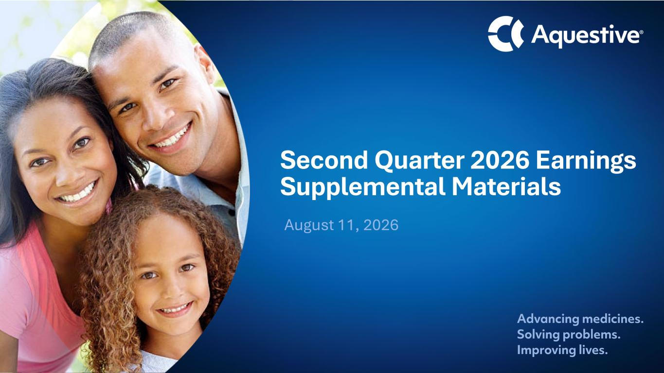

Advancing medicines. Solving problems. Improving lives. September 2024 Second Quarter 2026 Earnings Supplemental Materials August 11, 2026

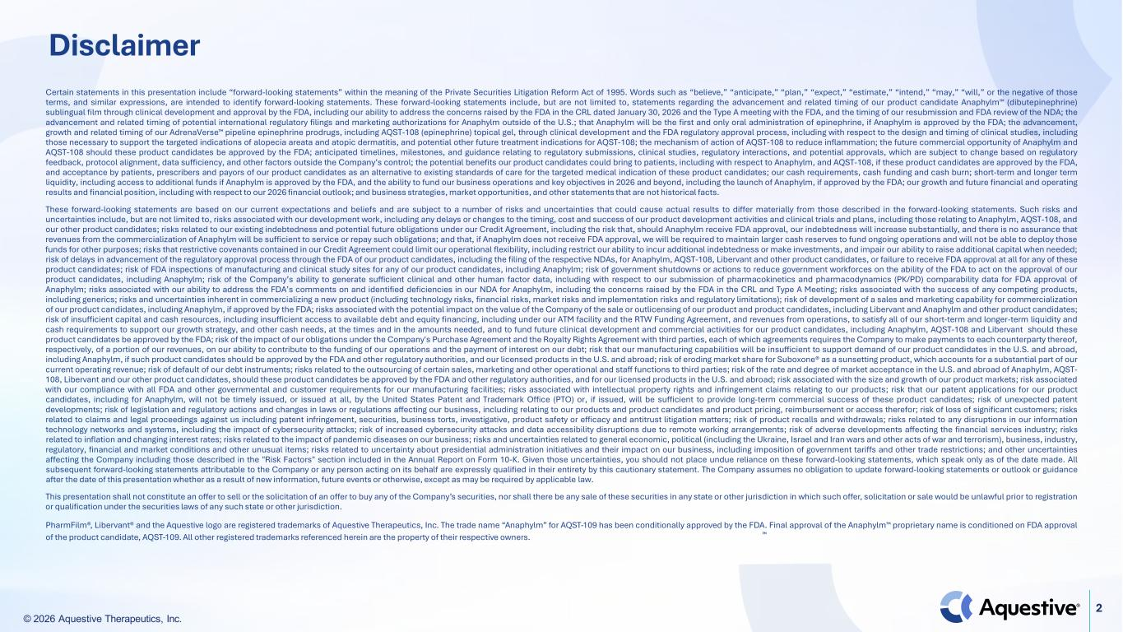
© 2026 Aquestive Therapeutics, Inc. 2 Disclaimer Certain statements in this presentation include “forward-looking statements” within the meaning of the Private Securities Litigation Reform Act of 1995. Words such as “believe,” “anticipate,” “plan,” “expect,” “estimate,” “intend,” “may,” “will,” or the negative of those terms, and similar expressions, are intended to identify forward-looking statements. These forward-looking statements include, but are not limited to, statements regarding the advancement and related timing of our product candidate Anaphylm (dibutepinephrine) sublingual film through clinical development and approval by the FDA, including our ability to address the concerns raised by the FDA in the CRL dated January 30, 2026 and the Type A meeting with the FDA, and the timing of our resubmission and FDA review of the NDA; the advancement and related timing of potential international regulatory filings and marketing authorizations for Anaphylm outside of the U.S.; that Anaphylm will be the first and only oral administration of epinephrine, if Anaphylm is approved by the FDA; the advancement, growth and related timing of our AdrenaVerse pipeline epinephrine prodrugs, including AQST-108 (epinephrine) topical gel, through clinical development and the FDA regulatory approval process, including with respect to the design and timing of clinical studies, including those necessary to support the targeted indications of alopecia areata and atopic dermatitis, and potential other future treatment indications for AQST-108; the mechanism of action of AQST-108 to reduce inflammation; the future commercial opportunity of Anaphylm and AQST-108 should these product candidates be approved by the FDA; anticipated timelines, milestones, and guidance relating to regulatory submissions, clinical studies, regulatory interactions, and potential approvals, which are subject to change based on regulatory feedback, protocol alignment, data sufficiency, and other factors outside the Company’s control; the potential benefits our product candidates could bring to patients, including with respect to Anaphylm, and AQST-108, if these product candidates are approved by the FDA, and acceptance by patients, prescribers and payors of our product candidates as an alternative to existing standards of care for the targeted medical indication of these product candidates; our cash requirements, cash funding and cash burn; short-term and longer term liquidity, including access to additional funds if Anaphylm is approved by the FDA, and the ability to fund our business operations and key objectives in 2026 and beyond, including the launch of Anaphylm, if approved by the FDA; our growth and future financial and operating results and financial position, including with respect to our 2026 financial outlook; and business strategies, market opportunities, and other statements that are not historical facts. These forward-looking statements are based on our current expectations and beliefs and are subject to a number of risks and uncertainties that could cause actual results to differ materially from those described in the forward-looking statements. Such risks and uncertainties include, but are not limited to, risks associated with our development work, including any delays or changes to the timing, cost and success of our product development activities and clinical trials and plans, including those relating to Anaphylm, AQST-108, and our other product candidates; risks related to our existing indebtedness and potential future obligations under our Credit Agreement, including the risk that, should Anaphylm receive FDA approval, our indebtedness will increase substantially, and there is no assurance that revenues from the commercialization of Anaphylm will be sufficient to service or repay such obligations; and that, if Anaphylm does not receive FDA approval, we will be required to maintain larger cash reserves to fund ongoing operations and will not be able to deploy those funds for other purposes; risks that restrictive covenants contained in our Credit Agreement could limit our operational flexibility, including restrict our ability to incur additional indebtedness or make investments, and impair our ability to raise additional capital when needed; risk of delays in advancement of the regulatory approval process through the FDA of our product candidates, including the filing of the respective NDAs, for Anaphylm, AQST-108, Libervant and other product candidates, or failure to receive FDA approval at all for any of these product candidates; risk of FDA inspections of manufacturing and clinical study sites for any of our product candidates, including Anaphylm; risk of government shutdowns or actions to reduce government workforces on the ability of the FDA to act on the approval of our product candidates, including Anaphylm; risk of the Company’s ability to generate sufficient clinical and other human factor data, including with respect to our submission of pharmacokinetics and pharmacodynamics (PK/PD) comparability data for FDA approval of Anaphylm; risks associated with our ability to address the FDA’s comments on and identified deficiencies in our NDA for Anaphylm, including the concerns raised by the FDA in the CRL and Type A Meeting; risks associated with the success of any competing products, including generics; risks and uncertainties inherent in commercializing a new product (including technology risks, financial risks, market risks and implementation risks and regulatory limitations); risk of development of a sales and marketing capability for commercialization of our product candidates, including Anaphylm, if approved by the FDA; risks associated with the potential impact on the value of the Company of the sale or outlicensing of our product and product candidates, including Libervant and Anaphylm and other product candidates; risk of insufficient capital and cash resources, including insufficient access to available debt and equity financing, including under our ATM facility and the RTW Funding Agreement, and revenues from operations, to satisfy all of our short-term and longer-term liquidity and cash requirements to support our growth strategy, and other cash needs, at the times and in the amounts needed, and to fund future clinical development and commercial activities for our product candidates, including Anaphylm, AQST-108 and Libervant should these product candidates be approved by the FDA; risk of the impact of our obligations under the Company's Purchase Agreement and the Royalty Rights Agreement with third parties, each of which agreements requires the Company to make payments to each counterparty thereof, respectively, of a portion of our revenues, on our ability to contribute to the funding of our operations and the payment of interest on our debt; risk that our manufacturing capabilities will be insufficient to support demand of our product candidates in the U.S. and abroad, including Anaphylm, if such product candidates should be approved by the FDA and other regulatory authorities, and our licensed products in the U.S. and abroad; risk of eroding market share for Suboxone® as a sunsetting product, which accounts for a substantial part of our current operating revenue; risk of default of our debt instruments; risks related to the outsourcing of certain sales, marketing and other operational and staff functions to third parties; risk of the rate and degree of market acceptance in the U.S. and abroad of Anaphylm, AQST- 108, Libervant and our other product candidates, should these product candidates be approved by the FDA and other regulatory authorities, and for our licensed products in the U.S. and abroad; risk associated with the size and growth of our product markets; risk associated with our compliance with all FDA and other governmental and customer requirements for our manufacturing facilities; risks associated with intellectual property rights and infringement claims relating to our products; risk that our patent applications for our product candidates, including for Anaphylm, will not be timely issued, or issued at all, by the United States Patent and Trademark Office (PTO) or, if issued, will be sufficient to provide long-term commercial success of these product candidates; risk of unexpected patent developments; risk of legislation and regulatory actions and changes in laws or regulations affecting our business, including relating to our products and product candidates and product pricing, reimbursement or access therefor; risk of loss of significant customers; risks related to claims and legal proceedings against us including patent infringement, securities, business torts, investigative, product safety or efficacy and antitrust litigation matters; risk of product recalls and withdrawals; risks related to any disruptions in our information technology networks and systems, including the impact of cybersecurity attacks; risk of increased cybersecurity attacks and data accessibility disruptions due to remote working arrangements; risk of adverse developments affecting the financial services industry; risks related to inflation and changing interest rates; risks related to the impact of pandemic diseases on our business; risks and uncertainties related to general economic, political (including the Ukraine, Israel and Iran wars and other acts of war and terrorism), business, industry, regulatory, financial and market conditions and other unusual items; risks related to uncertainty about presidential administration initiatives and their impact on our business, including imposition of government tariffs and other trade restrictions; and other uncertainties affecting the Company including those described in the "Risk Factors" section included in the Annual Report on Form 10-K. Given those uncertainties, you should not place undue reliance on these forward-looking statements, which speak only as of the date made. All subsequent forward-looking statements attributable to the Company or any person acting on its behalf are expressly qualified in their entirety by this cautionary statement. The Company assumes no obligation to update forward-looking statements or outlook or guidance after the date of this presentation whether as a result of new information, future events or otherwise, except as may be required by applicable law. This presentation shall not constitute an offer to sell or the solicitation of an offer to buy any of the Company’s securities, nor shall there be any sale of these securities in any state or other jurisdiction in which such offer, solicitation or sale would be unlawful prior to registration or qualification under the securities laws of any such state or other jurisdiction. PharmFilm®, Libervant® and the Aquestive logo are registered trademarks of Aquestive Therapeutics, Inc. The trade name “Anaphylm” for AQST-109 has been conditionally approved by the FDA. Final approval of the Anaphylm proprietary name is conditioned on FDA approval of the product candidate, AQST-109. All other registered trademarks referenced herein are the property of their respective owners.

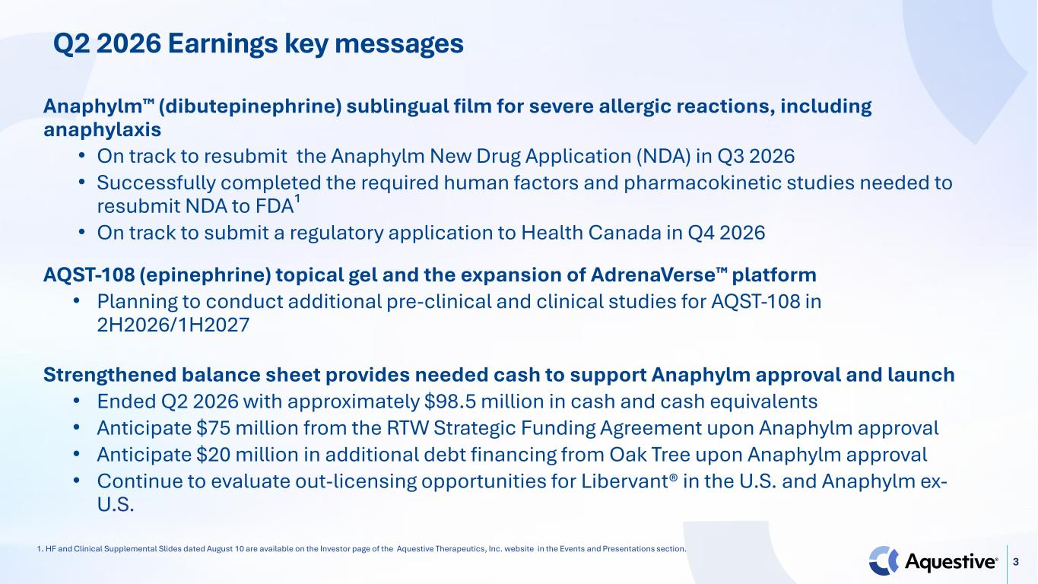
3 Q2 2026 Earnings key messages Anaphylm (dibutepinephrine) sublingual film for severe allergic reactions, including anaphylaxis • On track to resubmit the Anaphylm New Drug Application (NDA) in Q3 2026 • Successfully completed the required human factors and pharmacokinetic studies needed to resubmit NDA to FDA¹ • On track to submit a regulatory application to Health Canada in Q4 2026 AQST-108 (epinephrine) topical gel and the expansion of AdrenaVerse platform • Planning to conduct additional pre-clinical and clinical studies for AQST-108 in 2H2026/1H2027 Strengthened balance sheet provides needed cash to support Anaphylm approval and launch • Ended Q2 2026 with approximately $98.5 million in cash and cash equivalents • Anticipate $75 million from the RTW Strategic Funding Agreement upon Anaphylm approval • Anticipate $20 million in additional debt financing from Oak Tree upon Anaphylm approval • Continue to evaluate out-licensing opportunities for Libervant® in the U.S. and Anaphylm ex- U.S. 1. HF and Clinical Supplemental Slides dated August 10 are available on the Investor page of the Aquestive Therapeutics, Inc. website in the Events and Presentations section.

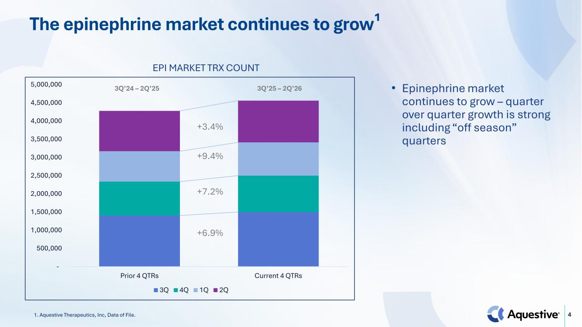
4 The epinephrine market continues to grow¹ 1. Aquestive Therapeutics, Inc, Data of File. - 500,000 1,000,000 1,500,000 2,000,000 2,500,000 3,000,000 3,500,000 4,000,000 4,500,000 5,000,000 Prior 4 QTRs Current 4 QTRs 3Q 4Q 1Q 2Q +3.4% EPI MARKET TRX COUNT +6.9% +7.2% +9.4% • Epinephrine market continues to grow – quarter over quarter growth is strong including “off season” quarters 3Q’24 – 2Q’25 3Q’25 – 2Q’26

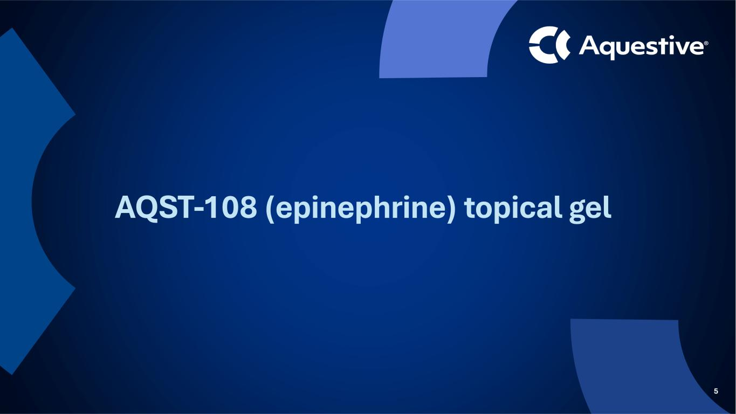
5 AQST-108 (epinephrine) topical gel

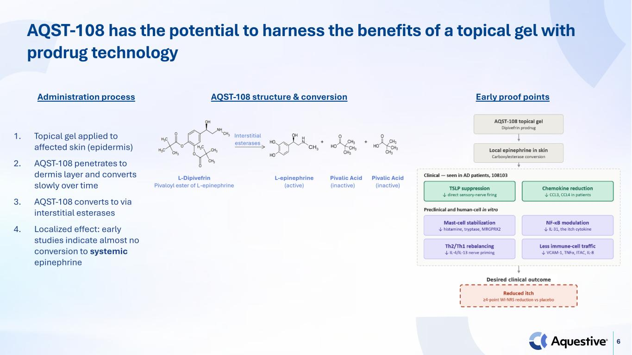
6 AQST-108 has the potential to harness the benefits of a topical gel with prodrug technology 1. Topical gel applied to affected skin (epidermis) 2. AQST-108 penetrates to dermis layer and converts slowly over time 3. AQST-108 converts to via interstitial esterases 4. Localized effect: early studies indicate almost no conversion to systemic epinephrine AQST-108 structure & conversionAdministration process Early proof points

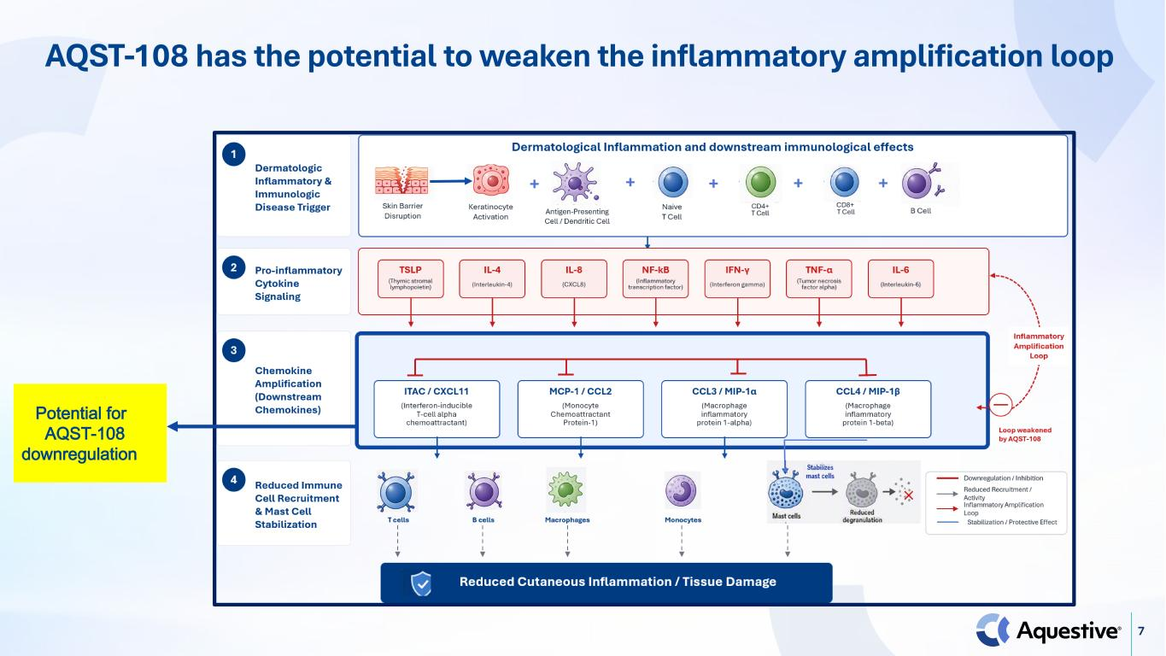
7 AQST-108 has the potential to weaken the inflammatory amplification loop Potential for AQST-108 downregulation

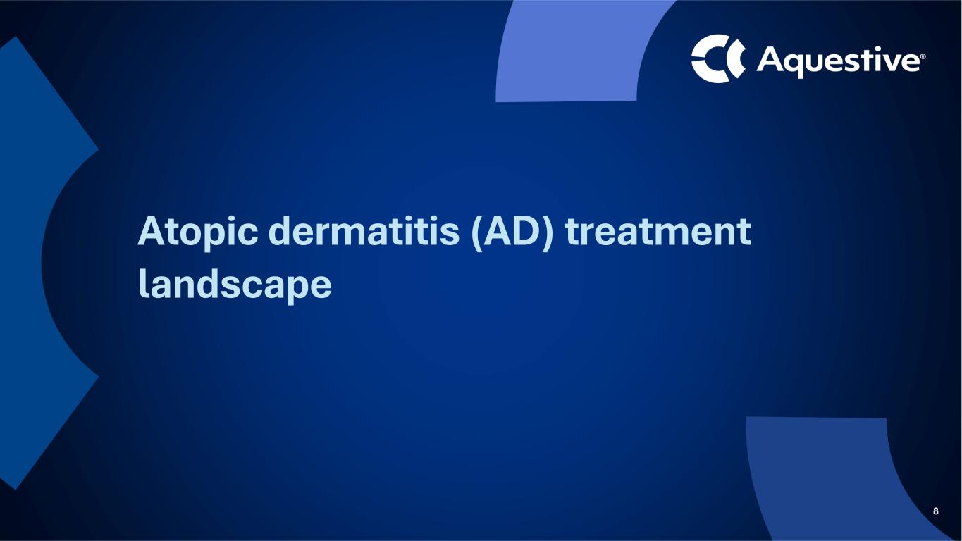
8 Atopic dermatitis (AD) treatment landscape

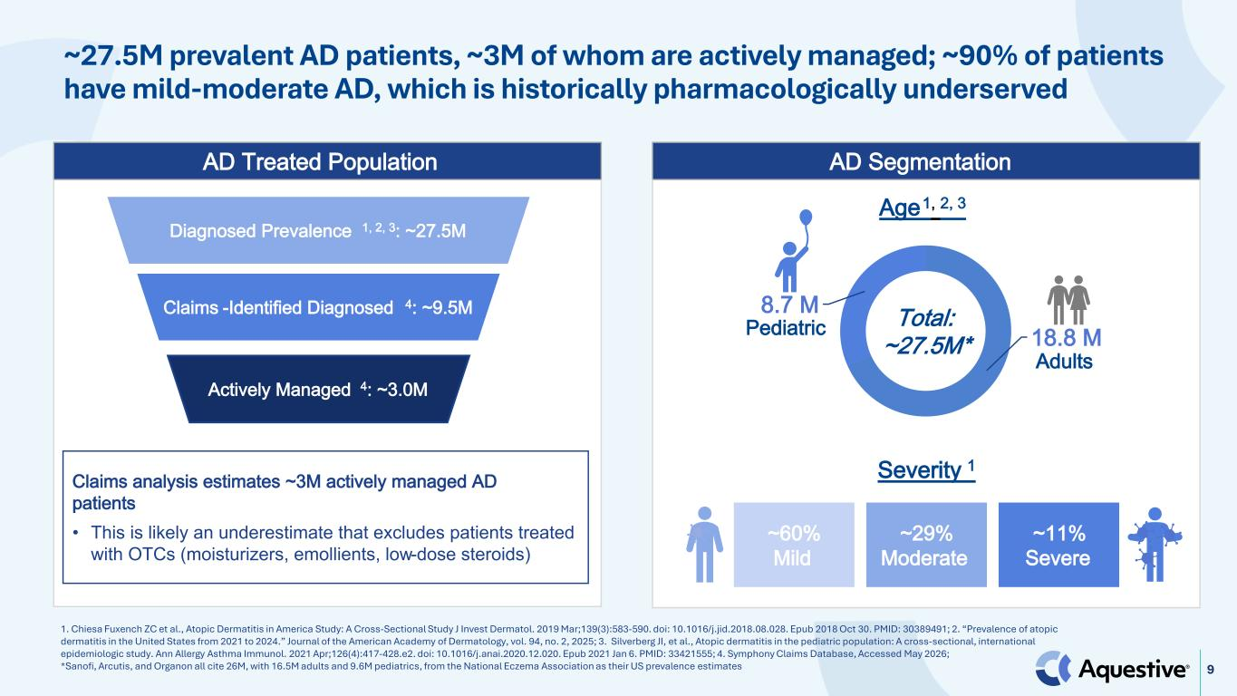
9 ~27.5M prevalent AD patients, ~3M of whom are actively managed; ~90% of patients have mild-moderate AD, which is historically pharmacologically underserved 1. Chiesa Fuxench ZC et al., Atopic Dermatitis in America Study: A Cross-Sectional Study J Invest Dermatol. 2019 Mar;139(3):583-590. doi: 10.1016/j.jid.2018.08.028. Epub 2018 Oct 30. PMID: 30389491; 2. “Prevalence of atopic dermatitis in the United States from 2021 to 2024.” Journal of the American Academy of Dermatology, vol. 94, no. 2, 2025; 3. Silverberg JI, et al., Atopic dermatitis in the pediatric population: A cross-sectional, international epidemiologic study. Ann Allergy Asthma Immunol. 2021 Apr;126(4):417-428.e2. doi: 10.1016/j.anai.2020.12.020. Epub 2021 Jan 6. PMID: 33421555; 4. Symphony Claims Database, Accessed May 2026; *Sanofi, Arcutis, and Organon all cite 26M, with 16.5M adults and 9.6M pediatrics, from the National Eczema Association as their US prevalence estimates AD Treated Population AD Segmentation 18.8 M 8.7 M Total: ~27.5M* ~60% Mild ~29% Moderate ~11% Severe Age1, 2, 3 Severity 1 Diagnosed Prevalence 1, 2, 3: ~27.5M Claims -Identified Diagnosed 4: ~9.5M Actively Managed 4: ~3.0M Claims analysis estimates ~3M actively managed AD patients • This is likely an underestimate that excludes patients treated with OTCs (moisturizers, emollients, low-dose steroids) Pediatric Adults

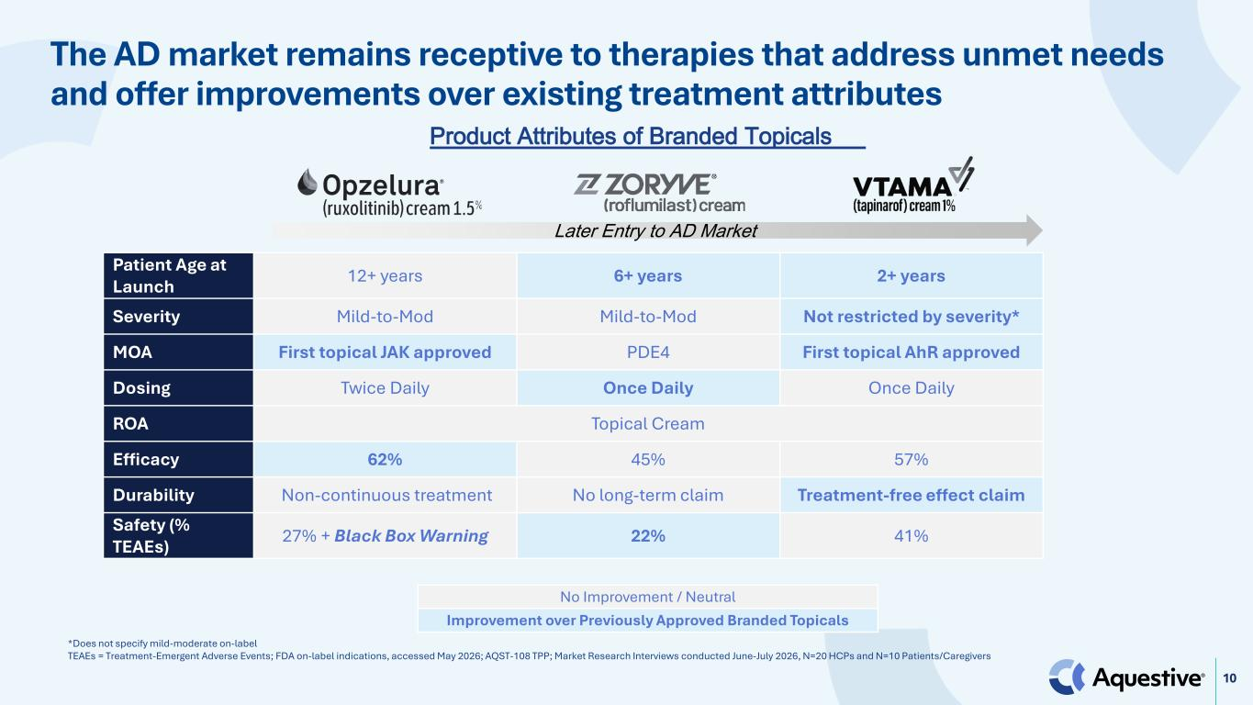
10 The AD market remains receptive to therapies that address unmet needs and offer improvements over existing treatment attributes *Does not specify mild-moderate on-label TEAEs = Treatment-Emergent Adverse Events; FDA on-label indications, accessed May 2026; AQST-108 TPP; Market Research Interviews conducted June-July 2026, N=20 HCPs and N=10 Patients/Caregivers Patient Age at Launch 12+ years 6+ years 2+ years Severity Mild-to-Mod Mild-to-Mod Not restricted by severity* MOA First topical JAK approved PDE4 First topical AhR approved Dosing Twice Daily Once Daily Once Daily ROA Topical Cream Efficacy 62% 45% 57% Durability Non-continuous treatment No long-term claim Treatment-free effect claim Safety (% TEAEs) 27% + Black Box Warning 22% 41% Later Entry to AD Market Product Attributes of Branded Topicals No Improvement / Neutral Improvement over Previously Approved Branded Topicals

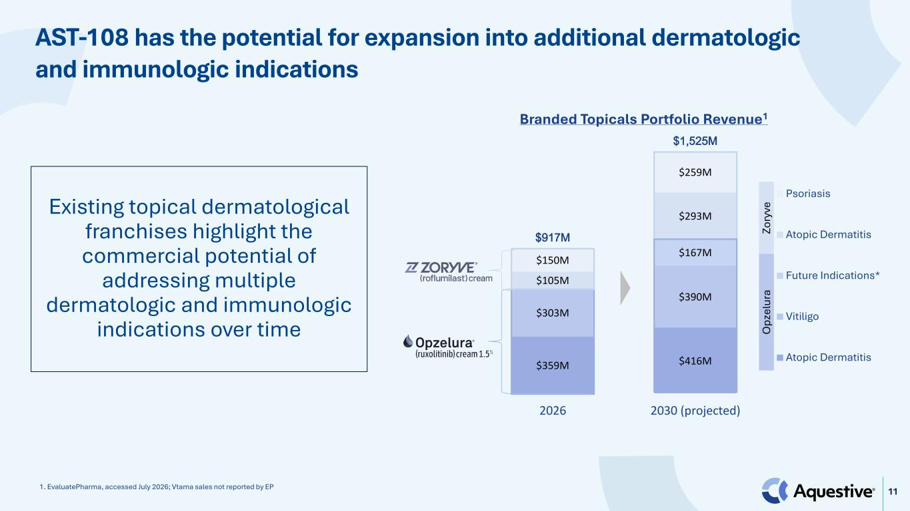
11 Existing topical dermatological franchises highlight the commercial potential of addressing multiple dermatologic and immunologic indications over time 1. EvaluatePharma, accessed July 2026; Vtama sales not reported by EP $359M $416M $303M $390M $167M $105M $293M $150M $259M $917M $1,525M 2026 2030 (projected) Psoriasis Atopic Dermatitis Future Indications* Vitiligo Atopic Dermatitis O pz el ur a Zo ry ve Branded Topicals Portfolio Revenue1 AST-108 has the potential for expansion into additional dermatologic and immunologic indications


12 Upcoming Milestones & Second Quarter 2026 Results

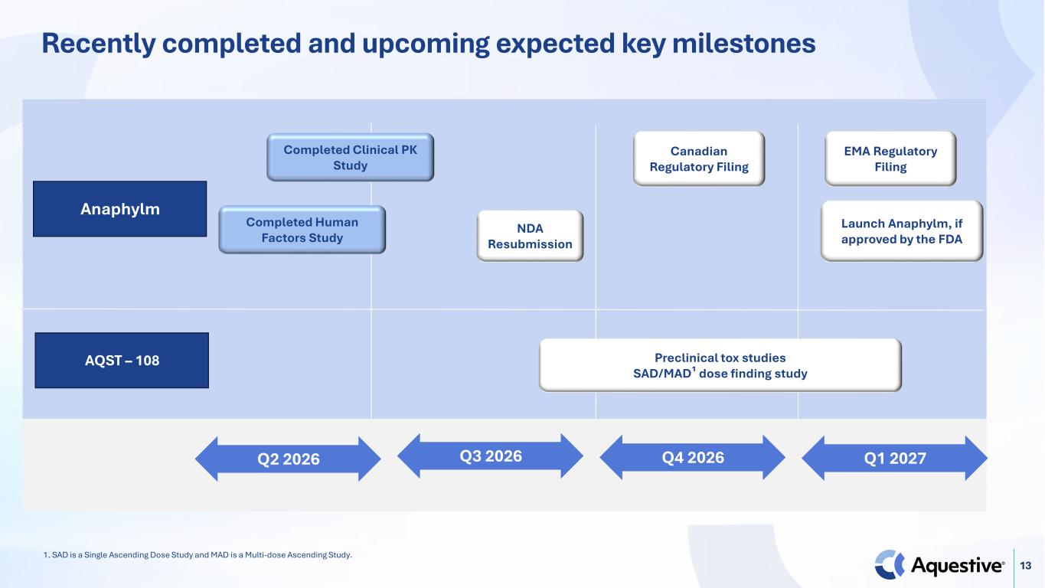
13 Recently completed and upcoming expected key milestones AQST – 108 Q1 2027Q2 2026 Q3 2026 Q4 2026 Anaphylm Canadian Regulatory Filing NDA Resubmission Preclinical tox studies SAD/MAD¹ dose finding study Completed Clinical PK Study Completed Human Factors Study Launch Anaphylm, if approved by the FDA EMA Regulatory Filing 1. SAD is a Single Ascending Dose Study and MAD is a Multi-dose Ascending Study.

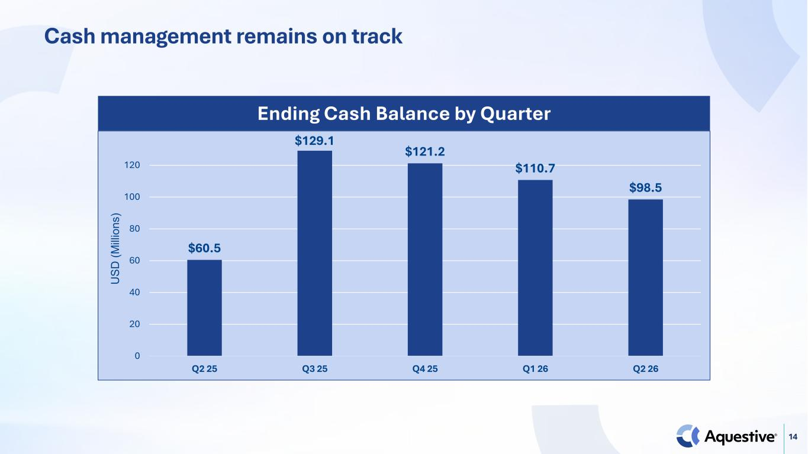
14 Cash management remains on track $60.5 $129.1 $121.2 $110.7 $98.5 0 20 40 60 80 100 120 Q2 25 Q3 25 Q4 25 Q1 26 Q2 26 U SD (M illi on s) Ending Cash Balance by Quarter

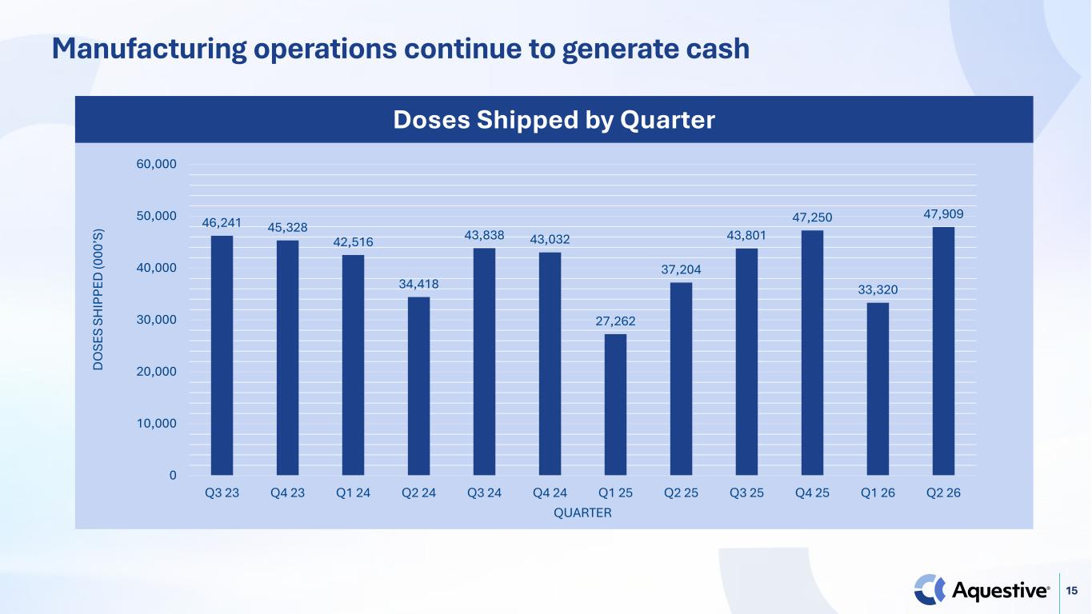
15 46,241 45,328 42,516 34,418 43,838 43,032 27,262 37,204 43,801 47,250 33,320 47,909 0 10,000 20,000 30,000 40,000 50,000 60,000 Q3 23 Q4 23 Q1 24 Q2 24 Q3 24 Q4 24 Q1 25 Q2 25 Q3 25 Q4 25 Q1 26 Q2 26 D O SE S SH IP PE D (0 00 ’S ) QUARTER Doses Shipped by Quarter Manufacturing operations continue to generate cash

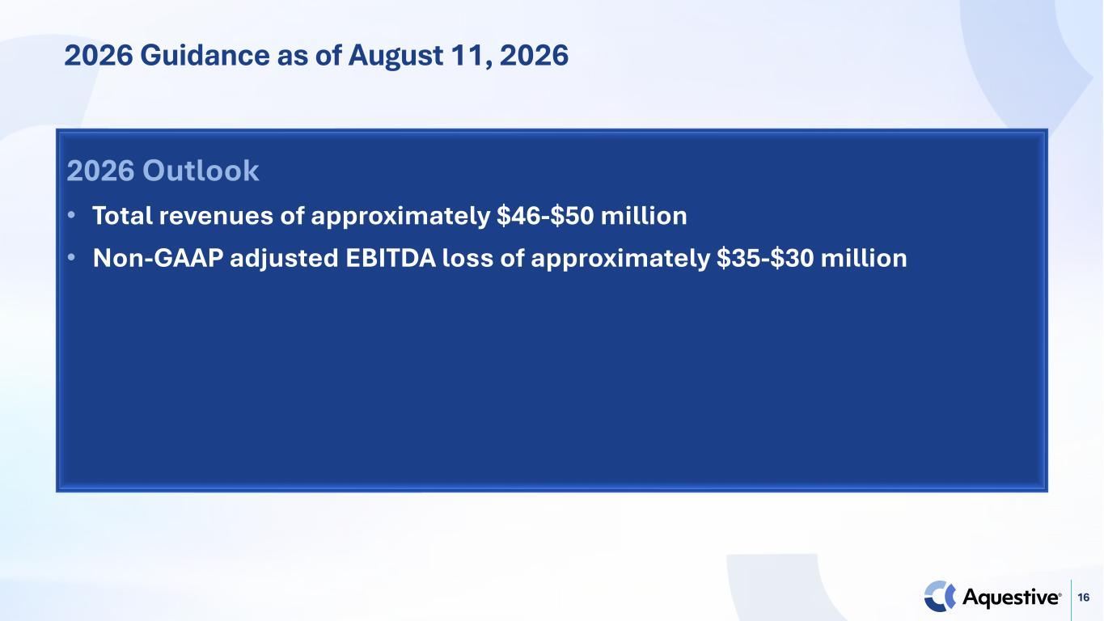
16 2026 Guidance as of August 11, 2026 2026 Outlook • Total revenues of approximately $46-$50 million • Non-GAAP adjusted EBITDA loss of approximately $35-$30 million


17 Thank You

