UNITED STATES
SECURITIES AND EXCHANGE COMMISSION
Washington, D.C. 20549

FORM 10-K

(Mark One)

☒ |  |  | ANNUAL REPORT PURSUANT TO SECTION 13 OR 15(d) OF THE SECURITIES EXCHANGE ACT OF 1934

For the fiscal year ended December 31, 2022

OR

☐ |  |  | TRANSITION REPORT PURSUANT TO SECTION 13 OR 15(d) OF THE SECURITIES EXCHANGE ACT OF 1934

For the transition period from _____ to _____

Commission File Number: 001-38599

Aquestive Therapeutics, Inc.
(Exact Name of Registrant as Specified in its Charter)

Delaware |  |  |  |  |  | 82-3827296
(State or Other Jurisdiction of Incorporation or Organization) |  |  |  |  |  | (I.R.S. Employer Identification Number)
30 Technology Drive, Warren, NJ |  |  |  |  |  | 07059
(Address of Principal Executive Offices) |  |  |  |  |  | (Zip Code)

(908) 941-1900
(Registrant’s Telephone Number, Including Area Code)

Securities registered pursuant to Section 12(b) of the Act:
Title of each class |  |  |  |  |  | Trading Symbol(s) |  |  |  |  |  | Name of each exchange on which registered
Common Stock, par value $0.001 per share |  |  |  |  |  | AQST |  |  |  |  |  | NASDAQ Global Market

Securities registered pursuant to Section 12(g) of the Act: None

Indicate by check mark if the registrant is a well-known seasoned issuer, as defined in Rule 405 of the Securities Act. £ Yes S No

Indicate by check mark if the registrant is not required to file reports pursuant to Section 13 or Section 15(d) of the Act. £ Yes S No

Indicate by check mark whether the registrant: (1) has filed all reports required to be filed by Section 13 or 15(d) of the Securities Exchange Act of 1934 during the preceding 12 months (or for such shorter period that the registrant was required to file such reports), and (2) has been subject to such filing requirements for the past 90 days. S Yes £ No

Indicate by check mark whether the registrant has submitted electronically every Interactive Data File required to be submitted pursuant to Rule 405 of Regulation S-T (section 232.405 of this chapter) during the preceding 12 months (or for such shorter period that the registrant was required to submit such files). S Yes £ No

Indicate by check mark whether the registrant is a large accelerated filer, an accelerated filer, a non-accelerated filer, a smaller reporting company or an emerging growth company. See the definitions of “large accelerated filer,” “accelerated filer”, “smaller reporting company” and “emerging growth company” in Rule 12b-2 of the Securities Exchange Act of 1934.

Large accelerated filer ☐ |  |  | Accelerated filer ☐
Non-accelerated filer ☒ |  |  | Smaller reporting company ☒
 |  |  | Emerging growth company ☒

If an emerging growth company, indicate by check mark if the registrant has elected not to use the extended transition period for complying with any new or revised financial accounting standards provided to Section 7(a)(2)(B) of the Securities Act. ☐

Indicate by check mark whether the registrant is a shell company (as defined in Rule 12b-2 of the Exchange Act). ☐ Yes S No

Indicate by check mark whether the registrant has filed a report on and attestation to its management's assessment of the effectiveness of its internal control over financial reporting under Section 404(b) of Sarbanes-Oxley Act (15 U.S.C. 7263(b)) by the registered public accounting firm that prepared or issued its audit report. ☐

If securities are registered pursuant to Section 12(b) of the Act, indicate by check mark whether the financial statements of the registrant included in the filing reflect the correction of an error to previously issued financial statements. ☐

Indicate by check mark whether any of those error corrections are restatements that required a recovery analysis of incentive-based compensation received by any of the registrant's executive officers during the relevant recovery period pursuant to Section 240.10D-1(b). ☐

As of June 30, 2022, the last day of the registrant’s most recently completed second fiscal quarter, the aggregate market value of the common stock held by non-affiliates of the registrant was approximately $27.6 million based on the closing price of the registrant’s common stock on such date.

The number of outstanding shares of the registrant’s par value $0.001 common stock as of the close of business on March 1, 2023 was 55,870,556.

The registrant intends to file a definitive proxy statement pursuant to Regulation 14A in connection with its 2023 Annual Meeting of Shareholders within 120 days of the end of its fiscal year ended December 31, 2022. Portions of such definitive proxy statement are incorporated by reference into Part III of this Annual Report on Form 10-K.

Table of Contents

 |  |  |  |  |  | Page No.
PART I |  |  |  |  |  | 4
Item 1. |  |  | Business |  |  | 5
Item 1A. |  |  | Risk Factors |  |  | 22
Item 1B. |  |  | Unresolved Staff Comments |  |  | 57
Item 2. |  |  | Properties |  |  | 57
Item 3. |  |  | Legal Proceedings |  |  | 57
Item 4. |  |  | Mine Safety Disclosures |  |  | 57
PART II |  |  |  |  |  | 57
Item 5. |  |  | Market for Registrant’s Common Equity, Related Stockholder Matters and Issuer Purchases of Equity Securities |  |  | 57
Item 6. |  |  | Reserved |  |  | 57
Item 7. |  |  | Management’s Discussion and Analysis of Financial Condition and Results of Operations |  |  | 58
Item 7A. |  |  | Quantitative and Qualitative Disclosures about Market Risk |  |  | 68
Item 8. |  |  | Financial Statements and Supplementary Data |  |  | 68
Item 9. |  |  | Changes in and Disagreements with Accountants on Accounting and Financial Disclosure |  |  | 68
Item 9A. |  |  | Controls and Procedures |  |  | 68
Item 9B. |  |  | Other Information |  |  | 68
Item 9C. |  |  | Disclosure Regarding Foreign Jurisdictions That Prevent Inspections |  |  | 68
PART III |  |  |  |  |  | 70
Item 10. |  |  | Directors, Executive Officers and Corporate Governance |  |  | 70
Item 11. |  |  | Executive Compensation |  |  | 70
Item 12. |  |  | Security Ownership of Certain Beneficial Owners and Management and Related Stockholder Matters |  |  | 70
Item 13. |  |  | Certain Relationships and Related Transactions, and Director Independence |  |  | 70
Item 14. |  |  | Principal Accounting Fees and Services |  |  | 70
PART IV |  |  |  |  |  | 71
Item 15. |  |  | Exhibits, Financial Statement Schedules |  |  | 71

Table of Contents
PART I

Forward-Looking Statements

This Annual Report on Form 10-K and certain other communications made by us include forward-looking statements within the meaning of the Private Securities Litigation Reform Act of 1995. Words such as “believe,” “anticipate,” “plan,” “expect,” “estimate,” “intend,” “may,” “will,” or the negative of those terms, and similar expressions, are intended to identify forward-looking statements.

These forward-looking statements include, but are not limited to, statements regarding the advancement and related timing of our product candidates AQST-109 and AQST-108 through the regulatory and development pipeline; the focus on continuing to manufacture Suboxone®, Exservan®, Sympazan® and other licensed products; the ability to overcome the seven year orphan drug exclusivity granted by the United States Food and Drug Administration (FDA) for the approved nasal spray product of a competitor in the U.S. in order for Libervant™ to be granted U.S. market access; the potential benefits our products and product candidates could bring to patients; the 2023 financial outlook; and business strategies, market opportunities, and other statements that are not historical facts. These forward-looking statements are also subject to the uncertain impact of the COVID-19 global pandemic on our business including with respect to our clinical trials including site initiation, patient enrollment and timing and adequacy of clinical trials; on regulatory submissions and regulatory reviews and approvals of our product candidates; pharmaceutical ingredients and other raw materials supply chain, manufacture and distribution; sale of and demand for our products; our liquidity and availability of capital resources, customer demand for our products and services; customers' ability to pay for goods and services; and ongoing availability of an appropriate labor force and skilled professionals. Given these uncertainties, we are unable to provide assurance that operations can be maintained as planned prior to the COVID-19 pandemic.

These forward-looking statements include, but are not limited to, statements about our growth and future financial and operating results and financial position, regulatory approvals and pathways, clinical trial timing and plans, the achievement of clinical and commercial milestones, product orders and fulfillment, short-term and longer term liquidity and cash requirements, cash funding and cash burn, business strategies, market opportunities, financing, and other statements that are not historical facts.

These forward-looking statements are based on our current expectations and beliefs and are subject to a number of risks and uncertainties that could cause actual results to differ materially from those described in the forward-looking statements. Such risks and uncertainties include, but are not limited to, risks associated with our development work, including any delays or changes to the timing, cost and success of our product development activities and clinical trials and plans, including those relating to AQST-109; risk of delays in regulatory advancement through the FDA of AQST-109 and our other drug candidates or failure to receive approval at all; the risk that we may not overcome the seven year orphan drug exclusivity granted by the FDA for the approved nasal spray product of a competitor in the U.S. in order for Libervant to be granted U.S. market access; risk in obtaining market access from the FDA for our other product candidates; risk inherent in commercializing a new product (including technology risks, financial risks, market risks and implementation risks and regulatory limitations); the risk of the failure to obtain U.S. market access for Libervant to restrict our ability to access additional funding under the Company's 12.5% Notes prior to March 31, 2023; risks and uncertainties concerning the revenue stream from the monetization of our royalty rights for the product KYNMOBI®, as well as the achievement of royalty targets worldwide or in any jurisdiction and certain other commercial targets required for contingent payments under the KYNMOBI monetization transaction; risk of development of a sales and marketing capability for future commercialization of our product candidates; risk of sufficient capital and cash resources, including access to available debt and equity financing, including under the Company's ATM facility and the Lincoln Park Purchase Agreement, and revenues from operations, to satisfy all of our short-term and longer-term cash requirements and other cash needs, at the times and in the amounts needed, including near-term debt amortization schedules; risk of failure to satisfy all financial and other debt covenants and of any default; short-term and long-term liquidity and cash requirements, cash funding and cash burn; risk related to government claims against Indivior Inc. ("Indivior") for which we license, manufacture and sell Suboxone® and which accounts for the substantial part of our current operating revenues; risks related to the outsourcing of certain sales, marketing and other operational and staff functions to third parties; risk of the rate and degree of market acceptance of our product and product candidates; the success of any competing products including generics, risk of the size and growth of our product markets; risk of compliance with all FDA and other governmental and customer requirements for our manufacturing facilities; risks associated with intellectual property rights and infringement claims relating to our products; risk of unexpected patent developments; risk of legislation and regulatory actions and changes in laws or regulations affecting our business including relating to our products and products candidates and product pricing, reimbursement or access therefor; risk of loss of significant customers; risks related to claims and legal proceedings including patent infringement, securities, business torts, investigative, product safety or efficacy and antitrust litigation matters; risk of product recalls and withdrawals; adverse developments affecting the financial services industry; risks related to inflation and rising interest rates; uncertainties related to general economic, political, business, industry, regulatory and market conditions and other unusual items; and other uncertainties affecting us including those described in the "Risk Factors" section and in other sections included in this Annual Report on Form 10-K, in our Quarterly Reports on Form 10-Q, and in our Current Reports on Form 8-K filed with the Securities and Exchange Commission (SEC). Given these uncertainties, you should not place undue reliance on these forward-looking statements, which speak only as the date made. All subsequent forward-looking statements attributable to us or any person acting on our behalf are expressly qualified in their entirety by this cautionary statement. We assume no obligation to update forward-looking statements, or outlook or guidance after the date of this Annual Report on Form 10-K, whether as a result of new information, future events or otherwise, except as may be required by applicable law. Readers should not rely on the forward-looking statements included in this Annual Report on Form 10-K as representing our views as of any date after the date of the filing of this Annual Report on Form 10-K.

These forward-looking statements involve known and unknown risks, uncertainties and other factors that may cause our actual results, levels of activity, performance or achievements to differ materially from those expressed or implied by these statements. These factors include the matters discussed and referenced in Part I-Item 1A. Risk Factors of this Form 10-K.

Unless the context requires otherwise, references in this Annual Report on Form 10-K to "Aquestive," the "Company," "we," "us," and "our" refer to Aquestive Therapeutics, Inc. and its subsidiary.

4

Item 1. Business Overview

Aquestive Therapeutics, Inc. ("we", "Aquestive", the "Company") is a pharmaceutical company advancing medicines to solve patients' problems with current standards of care and provide transformative products to improve their lives. We are developing pharmaceutical products that deliver complex molecules through alternative administrations to invasive and inconvenient standard of care therapies. Aquestive has five licensed commercialized products which are marketed by our licensees in the U.S. and around the world. We are the exclusive manufacturer of these licensed products. Aquestive also collaborates with pharmaceutical companies to bring new molecules to market using proprietary, best-in-class technologies, like PharmFilm®, and has proven drug development and commercialization capabilities. Aquestive is advancing a product pipeline for the treatment of severe allergic reactions, including anaphylaxis. The Company has also developed a product pipeline focused on treating diseases of the central nervous system, or CNS. Our production facilities are located in Portage, Indiana, and our corporate headquarters and primary research laboratory facilities are based in Warren, New Jersey.

We manufacture licensed products at our facilities and anticipate that our current manufacturing capacity is sufficient for commercial quantities of our products and product candidates currently in development. Our facilities have been inspected by the Food and Drug Administration (FDA), Australian Government Department of Health's Therapeutics Goods Administration (TGA), and Drug Enforcement Agency (DEA), and are subject to inspection by all applicable health agencies, including the Brazilian Health Regulatory Agency (ANVISA) and European Medicines Agency (EMA). Not all collaborative or licensed products of the Company that may be commercially launched in the future will necessarily be manufactured by us, such as the case with KYNMOBI®.

PharmFilm® – Our Oral Film Technology

We are presently the worldwide leader in oral film drug delivery and manufacturing, having historically supplied the substantial majority of the world’s oral films for prescription pharmaceutical use, and we have the capability to produce more than one billion commercial doses a year. We developed our PharmFilm® technology to provide meaningful clinical and therapeutic advantages over other existing dosage forms and, in turn, to improve the lives of patients and caregivers. PharmFilm is protected by our patent portfolio, which currently includes at least 204 issued patents worldwide, of which at least 40 are U.S. patents, and more than 120 pending patent applications worldwide. Several of the patents in this intellectual property portfolio are utilized in each of our proprietary pipeline products. We are continuing to develop additional intellectual property and know-how related to the applications and engineering of PharmFilm alone or in combination with other technologies to create product capabilities that have compelling value propositions.

PharmFilm is comprised of proprietary polymer compositions that serve as film formers to hold active pharmaceutical ingredients, or APIs, and excipients in place. Proprietary and patent-protected compositions, formulations and manufacturing techniques and technology are employed to ensure that the API is distributed uniformly throughout the film and that target absorption levels are achieved. Our proprietary technology and manufacturing processes enable PharmFilm to be engineered to fit a variety of target product profiles in order to best address unmet patient needs present within specific disease states. PharmFilm, which is similar in thickness and size to a postage stamp, can be administered via buccal, sublingual or lingual oral delivery.

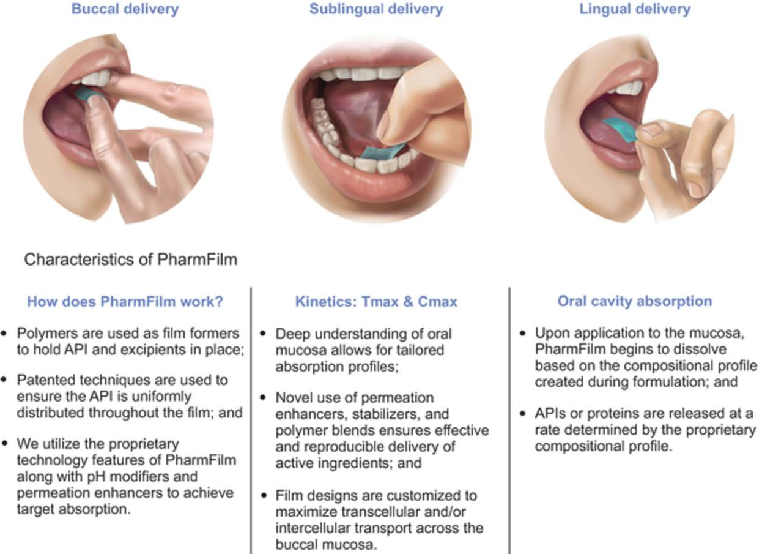

5

We believe the innovative nature of our drug delivery platform has the potential to offer a number of meaningful advantages to patients, caregivers and physicians compared to current standard of care therapies, including:

•preferred alternative to more invasive drug administration methods such as injection, rectal or nasal applications;

•faster, or at least equivalent, onset of action;

•ease of administration and availability (no device required, no gel to transport);

•direct absorption into the bloodstream reducing or avoiding “first pass” effects in the liver;

•reduced gastrointestinal, or GI, side effects;

•positive dosing outcomes, especially for patients with physical (e.g., dysphagia) or psychological barriers to other methods of drug administration;

•stable, durable, portable and quick dissolving (with or without water);

•customizable delivery routes for tailored pharmacokinetic, or PK, profiles (buccal, sublingual or lingual); and

•customizable taste profiles.

Our Product Portfolio and Pipeline

The following table outlines our proprietary growth drivers and licensed products.
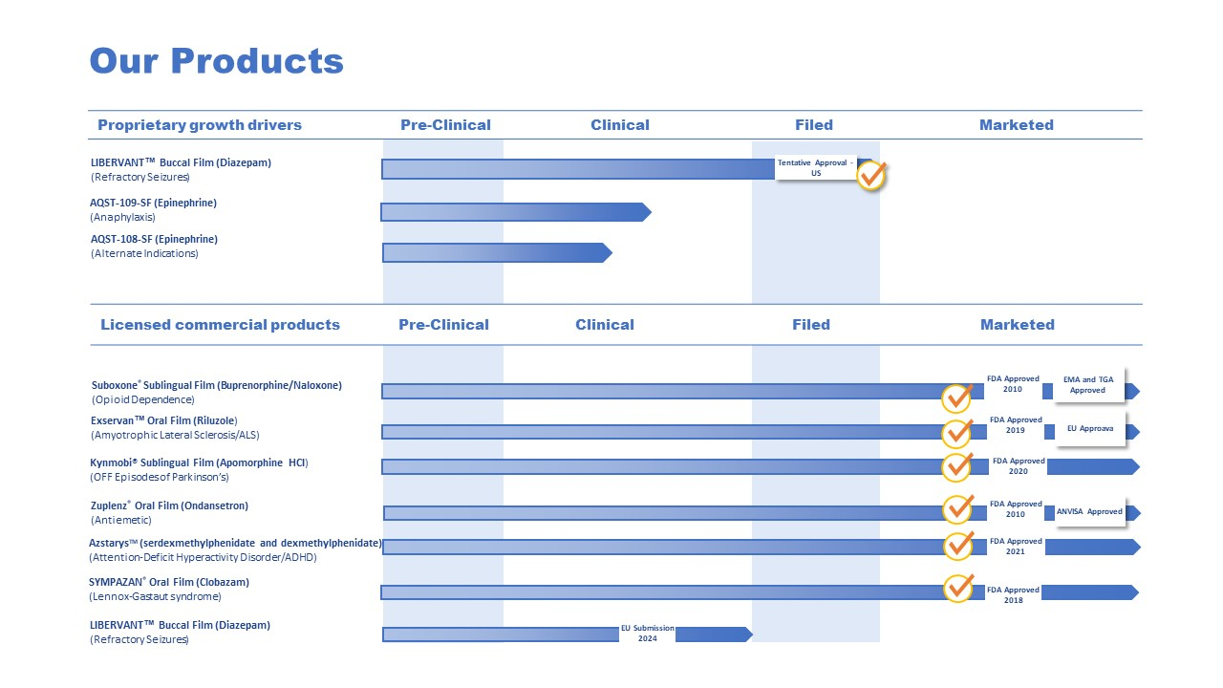

Sympazan®, Zuplenz®, PharmFilm® and the Aquestive logo are registered trademarks of Aquestive Therapeutics, Inc. All other registered trademarks referenced herein are the property of their respective owners.

Proprietary Growth Drivers

Complex Molecule Portfolio

Our PharmFilm® technology allows us to develop medicines that offer non-invasive delivery, customized suitability for patients with dysphagia, or trouble swallowing, can be administered without water and ensures consistent therapeutic dosing. We believe that these characteristics will permit us to achieve the desired patient outcomes, while potentially reducing the total cost of patient care.

6

We have developed a proprietary pipeline of complex molecule-based product candidates as alternatives to invasively administered standard of care therapeutics addressing large market opportunities. The active programs in our complex molecule pipeline portfolio are:

•AQST-109-SF (or sublingual film)– the first and only orally delivered epinephrine product candidate that has shown clinical results comparable to autoinjectors (such as EpiPen® and Auvi-Q®) for the emergency treatment of allergic reactions, including anaphylaxis. Epinephrine is the standard of care in the treatment of anaphylaxis and is currently administered via intramuscular injection (IM) including auto-injectors, such as EpiPen® and Auvi-Q®, which require patients or caregivers to inject epinephrine into their thighs during an emergency allergic reaction. As a result of this route of administration, many patients and their caregivers are reluctant to use currently available products. However, AQST-109 would, if approved by the FDA, allow a patient to simply place a dissolvable strip, approximately the size and weight of a postage stamp, under the tongue, providing an appropriate medication where it is needed, when it is needed and in a form preferred by patients.

We completed a first-in-human Phase 1 clinical trial for AQST-109 in Canada. This Phase 1 randomized, single-ascending dose study was performed in order to assess the safety, tolerability, and pharmacologic profile of AQST-109. On February 25, 2022, we reported positive topline data from Part 1 of our crossover study of AQST-109, EPIPHAST, a randomized, open-label, three-part adaptive design, crossover study in healthy adult subjects comparing the pharmacokinetics (PK) and pharmacodynamics (PD) of epinephrine delivered via AQST-109 oral film compared to epinephrine IM. The EPIPHAST study was also conducted in Canada. In Part 1 of the EPIPHAST study, multiple oral film formulations and dosage strengths of AQST-109 were evaluated. The lead formulation of AQST-109 has shown clinically meaningful blood concentrations when delivered in two different physical configurations, with a median time to maximum concentration (Tmax) of 13.5 minutes and 22.5 minutes, respectively. Part 1 also showed arithmetic mean maximum concentrations (Cmax) of 771 pg/mL and 580 pg/mL for the two configurations, or geometric mean Cmax values of 258pg/mL and 268pg/mL for the two configurations, respectively. These geometric mean Cmax and median Tmax values are consistent with those previously reported for approved injectable epinephrine devices such as EpiPen. Under the EPIPHAST study, the healthy volunteers were also exposed to a 0.5mg IM of epinephrine, allowing for a comparison with the PK, safety, and tolerability of the higher end of the approved dosage range of epinephrine, consistent with guidance received from the FDA in a written response to our Investigational New Drug Application (IND) for AQST-109. The findings show that these two configurations of the selected AQST-109 formulation can deliver clinically meaningful blood concentrations of epinephrine sooner than that observed with the higher dose of epinephrine IM injection, and in line with existing epinephrine autoinjectors. In addition, dosing with AQST-109 resulted in changes in blood pressure and heart rate that were comparable to epinephrine auto-injectors. The EPIPHAST trial indicated that treatment was well tolerated, with no serious adverse events, significant medical events, or treatment-related severe adverse events reported. On February 24, 2022, the FDA cleared our IND, allowing for clinical investigation of AQST-109 in the U.S. The FDA confirmed that the 505(b)(2) approval pathway is acceptable for the development of AQST-109. The FDA granted Fast Track designation in March 2022 to AQST-109 for the emergency treatment of allergic reactions, including anaphylaxis.

In April 2022, we reported positive topline results from Part 2 of the EPIPHAST study for AQST-109. Part 2 is a randomized, crossover design comparing AQST-109 12mg to epinephrine IM 0.3mg. Utilizing a replicate crossover design, Part 2 confirmed in a larger population of 24 healthy subjects the key PK and PD measures observed in Part 1 of the EPIPHAST study and the first-in-human PK study. The median Tmax was observed to be 15 minutes for AQST-109, compared to 50 minutes for the epinephrine IM 0.3mg.

In July 2022, we reported positive topline results from the final two arms of Part 3 of the EPIPHAST study for AQST-109. The purpose of Part 3 was to continue to study the administration of the film under a variety of conditions to further characterize its PK, PD and safety. The final two arms were designed to assess the impact of (1) administering the film sublingually two minutes after consuming a peanut butter sandwich and (2) swallowing the film whole immediately with water. Part 3 study results demonstrated consistent Tmax of 12 minutes with sublingual administration of AQST-109 epinephrine oral film, after consuming a peanut butter sandwich. Part 3 study also showed positive results with an unexpectedly high level of gastrointestinal absorption after swallowing AQST-109 whole immediately with water that was distinct from the sublingually absorbed profile.

In September 2022, we reported positive topline results from the EPIPHAST II trial for AQST-109. The EPIPHAST II trial was designed to compare single doses of AQST-109 to EpiPen 0.3mg and epinephrine IM 0.3mg, as well as repeat doses of AQST-109 to repeat doses of epinephrine IM 0.3mg. Results from the single dose administration showed AQST-109 achieved a significantly faster Tmax (12 minutes), compared to both EpiPen (22.5 minutes) and epinephrine IM 0.3mg (45 minutes). AQST-109 repeat dosing provided significantly higher drug plasma concentrations, with a Tmax of 8 minutes after administration, and extensive absorption was observed. The mean Cmax of AQST-109 was 465 pg/mL after one dose and 2,958 pg/mL after two doses. In comparison, the epinephrine IM 0.3mg Cmax was 489 pg/mL after one dose and 911 pg/mL after two doses. The single dose of EpiPen resulted in a Cmax of 869 pg/mL. Changes in systolic blood pressure and heart rate were similar after a single dose of AQST-109 when compared to a single dose of EpiPen. This data, along with the data from the completed EPIPHAST study, was the basis for our second End-of-Phase 2 (EoP2) meeting with the FDA. We received a positive written feedback from the FDA after our initial EoP2 meeting request to discuss Chemistry, Manufacturing, and Controls (CMC) for AQST-109, which we believe indicates that our approach to characterizing attributes of AQST-109 appears reasonable in the context of a potential future filing.

In late December 2022, we received the final minutes from the EoP2 meeting with the FDA which provided clarity as to the FDA’s expectations regarding key program areas. We are conducting an additional PK study to aide in the selection of the comparator products to be used in the upcoming pivotal trial in the second half of 2023. We anticipate conducting the pivotal PK study in the third quarter of 2023, and continue to plan for a potential launch in 2025, if approved by the FDA.

•AQST-108-SF – AQST-108 is composed of the prodrug dipivefrin which is enzymatically cleaved into epinephrine after administration. Dipivefrin is currently available outside of the U.S. for ophthalmic indications. A sublingual film formulation

7

delivering systemic epinephrine has been development by Aquestive for the treatment of conditions other than anaphylaxis. Based on topline results of a recent second Phase 1 PK trial in 28 healthy adult volunteers conducted by Aquestive, AQST-108 was generally well-tolerated, with systemic adverse events observed that are consistent with the known adverse events profile for epinephrine. Additional indications and delivery methods are currently being explored preclinically. Upon completion of the preclinical work, we will request a pre-IND meeting for AQST-108 with the FDA and plan to disclose the indication and path forward for development, once we have received feedback from the FDA.

Proprietary CNS Product Candidate

We believe the application of PharmFilm is particularly valuable and relevant to patients suffering from certain CNS disorders to meet patients' unmet medical needs and to solve patients' therapeutic problems. We believe there remains significant opportunity to develop additional products in the CNS market. Additionally, our know-how and proprietary position have broad application beyond CNS, and we plan to explore the applications of PharmFilm in other disease areas. Our most advanced asset within our proprietary CNS portfolio, focused in epilepsy, is as follows:

•Libervant™ – a buccally, or inside of the cheek, administered soluble film formulation of diazepam is our most advanced proprietary investigational product candidate. Aquestive developed Libervant as an alternative to device-dependent rescue therapies currently available to patients with refractory epilepsy, which are a rectal gel and nasal sprays. In August 2022, the FDA granted tentative approval for Libervant for the acute treatment of intermittent, stereotypic episodes of frequent seizure activity (i.e., seizure clusters, acute repetitive seizures) that are distinct from a patient’s usual seizure pattern in patients with epilepsy 12 years of age and older. The FDA has concluded that Libervant has met all required quality, safety, and efficacy standards for approval. Due to an existing FDA regulatory grant of orphan drug market exclusivity for Valtoco®, a diazepam nasal spray product sold by another company, Libervant is not yet eligible for marketing in the United States. As a result of the FDA determination, the FDA cannot give final approval for Libervant until the expiration or inapplicability of the orphan drug market exclusivity, including, for example, by a reversal of the FDA’s decision and determination that Libervant is “clinically superior” to Valtoco. We are actively engaging the FDA regarding its determination. We provided the FDA with additional clinical data in September 2022 and were informed that the FDA was reviewing this data. Furthermore, in October 2022, we provided the FDA with a draft protocol for a head-to-head comparative PK study of Libervant versus the competing product. We continue to believe that, particularly in the case of our submitted studies on the effect of food on the absorption of diazepam formulations, Libervant has the distinct advantage of being able to be readily administered when needed without regard to food, providing an important benefit to patients. However, overcoming the orphan drug marketing exclusivity is difficult to establish, with limited precedent, and there can be no assurance that the FDA will agree with our position seeking to overcome such market exclusivity and approve Libervant for U.S. market access earlier than January 2027, the schedule date for expiration of orphan drug market exclusivity, if this effort is not successful. Further, there can be no assurance that a competitor will not obtain other FDA market exclusivity that blocks U.S. market access for Libervant. More details on this product approval are described in the “Competition” section of this Item I. Business of this Form 10-K.

In September 2022, we announced the grant of an exclusive license to Atnahs Pharma UK Limited ("Pharmanovia") for Pharmanovia to develop and commercialize Libervant for the treatment of prolonged or acute, convulsive seizures in all ages in certain countries of the European Union, the United Kingdom, Switzerland, Norway and the Middle East and North Africa (the "Territory") during the term of the Pharmanovia licensee. Pharmanovia will lead the regulatory and commercialization activities for Libervant in the Territory and the Company will serve as the exclusive sole manufacturer and supplier of Libervant in the Territory.

Licensed Commercial Products and Product Candidates

Our portfolio also includes products and product candidates that we have licensed, or will seek to license, or for which we have licensed our intellectual property for commercialization. In the years ended December 31, 2022 and 2021, our licensed product portfolio generated $40.0 million and $42.3 million in revenue to Aquestive, respectively. Those products include:

•Suboxone® – a sublingual film formulation of buprenorphine and naloxone, respectively an opioid agonist and antagonist, that is marketed in the United States and internationally for the treatment of opioid dependence. Suboxone was launched by our licensee, Indivior Inc., or Indivior, in 2010. Suboxone is the most prescribed branded product in its category and was the first sublingual film product for the treatment of opioid dependence. We are the sole and exclusive supplier and manufacturer of Suboxone and have produced over 2.5 billion doses of Suboxone since its launch in 2010. As of December 31, 2022, Suboxone retains approximately 34% film market share as generic film-based products have penetrated this market. We have filed patent infringement lawsuits against certain companies relating to generic film-based products for buprenorphine-naloxone. More details regarding these lawsuits are described in Part II Item 8. Financial Statements and Supplementary Data, Note 20, Contingencies.

•Exservan® – an oral film formulation of riluzole, has been developed by the Company for the treatment of amyotrophic lateral sclerosis (ALS). We believe that Exservan can bring meaningful assistance to patients who are diagnosed with ALS and face difficulties swallowing traditional forms of medication. Exservan was approved by the FDA on November 22, 2019. During the fourth quarter of 2019, we announced the grant of a license to Zambon S.p.A. ("Zambon") for the development and commercialization of Exservan in the European Union (EU) for the treatment of ALS. Zambon is a multinational pharmaceutical company with a focus on the CNS therapeutic area. Under the terms of the license agreement with Zambon, an upfront payment was

8

paid to Aquestive for the development and commercialization rights of Exservan in the EU, and Aquestive will be paid development and sales milestone payments and low double-digit royalties on net sales of the product in the EU. Zambon is responsible for the regulatory approval and marketing of Exservan in the countries where Zambon seeks to market the product, and Aquestive will be responsible for the development and manufacture of the product. During the fourth quarter of 2022, Aquestive received a $0.5 million milestone payment upon in connection with the receipt of regulatory approval for Exservan pursuant to the terms of the license agreement with Zambon.

In January 2021, we announced that the Company granted an exclusive license to Mitsubishi Tanabe Pharma Holdings America, Inc. ("MTHA") for the commercialization in the United States of Exservan. MTHA is a multinational pharmaceutical company with a focus on patients with ALS. The product was launched by MTHA in June 2021. Under the terms of the MTHA license agreement, Aquestive is the exclusive manufacturer and supplier of Exservan for MTHA in the United States. Exservan may potentially fulfill a critical need for ALS patients, given it can be administered safely and easily, twice daily, without water.

In March 2022, we announced the grant of an exclusive license to Haisco Pharmaceutical Group Co., Ltd. ("Haisco") for Haisco to develop and commercialize Exservan for the treatment of ALS in China. Haisco is a China-based public pharmaceutical company. Haisco will lead the regulatory and commercialization activities for Exservan in China. Aquestive will serve as the exclusive sole manufacturer and supplier for Exservan in China. Under the the terms of license agreement with Haisco, as amended, Aquestive received a $7.0 million upfront cash payment, and will receive regulatory milestone payments, double-digit royalties on net sales of Exservan in China, and earn manufacturing revenue upon the sale of Exservan in China.

•KYNMOBI® – a sublingual film formulation of apomorphine, which is a dopamine agonist, was developed to treat episodic off-periods in Parkinson’s disease. We licensed our intellectual property to Cynapsus Therapeutics, Inc., a company that was acquired by Sunovion Pharmaceuticals Inc., or Sunovion, for the commercialization of KYNMOBI under an Agreement dated April 1, 2016, as amended (the "Sunovion License Agreement"). KYNMOBI was approved by the FDA on May 21, 2020 and commercially launched by Sunovion in September 2020. On November 3, 2020, we entered into a Purchase and Sale Agreement (the "Monetization Agreement") with MAM Pangolin Royalty, LLC, an affiliate of Marathon Asset Management ("Marathon"). Under the terms of the Monetization Agreement, we sold all of our contractual rights to receive royalties and milestone payments due under the Sunovion License Agreement related to Sunovion's apomorphine product, KYNMOBI.

•Zuplenz® – an oral soluble film formulation of ondansetron, a 5-HT antagonist, was developed for the treatment of nausea and vomiting associated with chemotherapy and post-operative recovery. Ondansetron is available as branded and generic products as intravenous injections, intramuscular injections, orally dissolving tablets, oral solution tablets, and film. We licensed commercial rights for Zuplenz to Hypera in Brazil (which Hypera markets as Ondif). Hypera received approval to market Zuplenz in Brazil from the Brazilian regulatory authority (ANVISA) on February 21, 2022. We licensed commercial rights for Zuplenz to Fortovia Therapeutics Inc. (previously Midatech Pharma PLC, "Fortovia") in the United States, Canada, and China. Fortovia launched Zuplenz in the United States in 2015. We had been the sole and exclusive manufacturer of Zuplenz for Fortovia. On August 31, 2020 Fortovia filed a Chapter 11 bankruptcy proceeding in the Bankruptcy Court for the Eastern District of North Carolina. On January 29, 2021, the Bankruptcy Court approved an agreement pursuant to which the license and supply agreement between Aquestive and Fortovia was terminated, and all rights to commercialize Zuplenz returned to us, effective January 30, 2021.

•AzstarysTM – an FDA-approved, once-daily product for the treatment of attention deficit hyperactivity disorder (ADHD) in patients age six years or older. AZSTARYS consists of serdexmethylphenidate, a prodrug of d-methylphenidate (d-MPH), co-formulated with immediate release d-MPH. In March 2012, the Company entered into an agreement with Zevra Therapeutics, Inc. (formerly KemPharm, Inc.) (“Zevra”), to terminate a Collaboration and License Agreement entered into by the Company and Zevra in April 2011. Under this termination arrangement, the Company has the right to participate in any and all value that Zevra may derive from the commercialization or any other monetization of KP-415 and KP-484 compounds or their derivatives. Among these monetization transactions are those related to any business combinations involving Zevra and collaborations, royalty arrangements, or other transactions from which Zevra may realize value from these compounds, including the product Azstarys. On March 2, 2021, Zevra announced FDA approval of Azstarys for the treatment of ADHD. For the year ended December 31, 2021, the Company received payment of $2.0 million under this arrangement, which was included in License and royalty revenues.

9

•Libervant™ - a buccal film formulation of diazepam tentatively approved by the FDA for the acute treatment of intermittent, stereotypic episodes of frequent seizure activity (i.e., seizure clusters, acute repetitive seizures) that are distinct from a patient’s usual seizure pattern in patients with epilepsy 12 years of age and older. The Company entered into a License and Supply Agreement with Atnahs Pharma UK Limited, a company registered in England and Wales ("Pharmanovia"), effective as of September 26, 2022 (the "Pharmanovia Agreement"), pursuant to which the Company granted Pharmanovia an exclusive license to certain of the Company's intellectual property to develop and commercialize Libervant for the treatment of prolonged or acute, convulsive seizures in all ages in certain countries of the European Union, the United Kingdom, Switzerland, Norway and the Middle East and North Africa (the "Territory") during the term of the Pharmanovia Agreement. Under the Pharmanovia Agreement, Pharmanovia will lead the regulatory and commercialization activities for Libervant in the Territory and the Company will serve as the exclusive sole manufacturer and supplier of Libervant in the Territory.

•Sympazan® – an oral soluble film formulation of clobazam used for the treatment of seizures associated with a rare, intractable form of epilepsy known as Lennox-Gastaut syndrome, or LGS, in patients aged two years of age or older, was approved by the FDA on November 1, 2018. We commercially launched Sympazan in December 2018. On October 26, 2022, the Company entered into a License Agreement with Otter Pharmaceuticals, LLC, a subsidiary of Assertio Holdings, Inc. (“Assertio”), a specialty pharmaceutical company offering differentiated products to patients, pursuant to which the Company granted an exclusive, worldwide license of its intellectual property for Sympazan to Assertio during the term of that agreement. The Company is the exclusive sole manufacturer and supplier of Sympazan for Assertio.

Market Overview

Anaphylaxis

Anaphylaxis is a severe systemic allergic reaction that can be triggered by certain foods, medications, insect stings and latex, among other allergens. Signs and symptoms of anaphylaxis typically occur within seconds or minutes of exposure and may include low blood pressure, skin rash or itching, constriction of the airway and difficulty breathing and nausea and vomiting. If not treated immediately, anaphylaxis can lead to death due to airway restriction or cardiac arrest. Anaphylaxis is a potentially life-threatening systemic allergic reaction, with an estimated incidence of 50 to 112 episodes per 100,000 people per year. An international study found that hospital admissions for anaphylaxis has increased over a 15-year study period. The most common causes of reactions that can include anaphylaxis are medications, foods (such as peanuts), and venom from insect stings. Because anaphylaxis can progress quickly, the ability to administer a reliable and accurate dose of epinephrine as quickly as possible following a reaction is critical for patient recovery and survival.

Treatment of anaphylaxis typically consists of an intramuscular injection of epinephrine administered at the earliest opportunity, followed by additional intramuscular or intravenous injections as needed. A generic form of epinephrine auto-injector (brand form EpiPen®) is the leading self-administered form of epinephrine. People with known allergies and who are at risk for anaphylaxis are advised to carry two epinephrine auto-injectors with them at all times and self-administer at the first signs of an anaphylactic reaction. Auto-injectors can be inconvenient to transport and many patients and caregivers dislike injections as a delivery method. Proper dosing and the ability to effectively administer epinephrine in a timely, reliable manner is critical for patients experiencing anaphylaxis. However, we believe that the inability to administer complex molecules via oral administration has limited the development of treatments that have the potential to provide significant patient benefit. We designed AQST-109, a “first of its kind” oral sublingual film formulation delivering systemic epinephrine, as a rescue medicine for the treatment of anaphylaxis, using Aquestive’s proprietary PharmFilm® technologies, to improve patient compliance and lower the total cost of care. We believe there is a significant market opportunity for a non-injectable, easier to administer product with a fast onset of action. A product with this profile could enable patients to conveniently and rapidly self-administer a reliable and accurate dose of epinephrine during an anaphylactic reaction, which we believe will improve patient compliance. Subject to our achieving regulatory approval of this product candidate, which we cannot assure, we believe AQST-109 has the potential to reduce the treatment burden currently associated with intramuscular injections and may lower costs to the healthcare system associated with anaphylaxis, due to inaccurate or untimely dosing.

Epilepsy

Epilepsy is a chronic CNS disorder characterized by recurrent seizure activity. There are 3.4 million people in the United States suffering from epilepsy. According to Symphony Health data, antiepileptic medications generated billions of dollars of sales in the United States in 2022. The direct (medical) and indirect (lost wages and productivity) annual costs associated with epileptic patients in the United States are significant.

Epilepsy treatment regimens typically consist of chronic and acute management therapies. Chronic medicines are used on a daily basis to suppress seizure activity. Approximately 1.1 million of those suffering from epilepsy will continue to suffer with breakthrough seizures and may require an acute (rescue) management strategy. Patients are routinely prescribed antiepileptic drugs, or AEDs, as “maintenance” therapy to control chronic seizure activity. Most AEDs specifically target neuronal excitation or neuronal inhibitory pathways. Patients are routinely prescribed benzodiazepines as “rescue” therapy for the management of acute seizure emergencies.

Rescue therapies are administered as needed in the event of an acute seizure to rapidly terminate seizure activity. One of the most effective benzodiazepines currently available for the treatment of acute seizures is diazepam. Diazepam has historically been marketed as a product administered rectally and more recently, a nasal spray product was introduced to the market. Rectal administration of this drug

10

presents a particular challenge for patients. We developed our product candidate Libervant as an alternative to the device-dependent rescue therapies currently available to patients with refractory epilepsy. See “Our Product Portfolio and Pipeline” above and “Competition” below in this Item 1. Business of this Form 10-K for additional information concerning the Libervant FDA approval process and market access issues.

There are multiple epileptic syndromes including LGS, which is a rare, intractable form of epilepsy. Patients with LGS are often drug resistant, predisposing them to recurrent seizures, and are typically prescribed a combination of antiepileptic medications, which often includes clobazam. Clobazam (branded name Onfi) is available in both a tablet and suspension formulation. Generic versions of the clobazam tablet and suspension formulation are available to patients, as well. Sympazan was developed as an alternative to these other routes of administration of clobazam.

Manufacturing and Product Supply

We operate two manufacturing and primary packaging facilities located in Portage, Indiana, where we currently manufacture our licensed products, Suboxone, Exservan, Ondif and Sympazan, on an exclusive basis. These facilities are expected to have a combined capacity to accommodate the production of our proprietary product pipeline candidates and licensed products, without any current need for additional infrastructure. In 2022, we completed work to expand our manufacturing capabilities to include serialization and secondary packaging. This expansion allows us to support our existing and possible future business collaborations more broadly. With the GMP facilities in Indiana, we will continue to explore possible additional manufacturing capabilities in 2023. We will also continue to consider our anticipated facilities and infrastructure needs as our product development grows. We have produced over 1.0 billion doses in the last five years. As a company, our research and development laboratories are registered with the DEA for Schedule II-V drugs.

We are subject to various regulatory requirements, such as the regulations of the FDA, the DEA, the EU and other foreign health authorities such as the TGA. We are required to register our facilities and adhere to current Good Manufacturing Practices (cGMP) standards. These standards require manufacturers to follow elaborate design, testing, control, documentation and other quality assurance procedures throughout the entire manufacturing process. Our facilities have undergone inspections by the FDA, DEA, TGA, and several quality assurance inspections by pharmaceutical companies for cGMP compliance. In each case, the facilities have passed inspection and are subject to periodic re-inspection. Failure to comply with these and other statutory and regulatory requirements subjects a manufacturer to possible legal or regulatory action, including warning letters, the seizure or recall of products, injunctions, consent decrees placing significant restrictions on or suspending manufacturing operations and civil and criminal penalties. Adverse events with the product or product complaints must be reported and could result in the imposition of market restrictions through labeling changes or in product removal. Product approvals may be withdrawn if compliance with regulatory requirements is not maintained or if problems concerning safety or efficacy of the product occur following approval.

We purchase our raw materials, including active pharmaceutical ingredients, from qualified, approved vendors both domestically and internationally. While we typically source raw materials from the lowest cost provider whenever possible, we continue to pursue a multi-supplier strategy for critical raw materials, where available or appropriate. Our product packaging foil is supplied by a single manufacturer. Such manufacturer utilizes multiple manufacturing facilities for production of our packaging foil. We may enter into more formal supply agreements in the future as production volumes increase and are more predictive.

Subject to the supervision of our internal clinical development staff, we use third-party contract research organizations, or CROs, to administer and conduct many aspects of our planned clinical trials including monitoring and managing data, and we will rely upon such CROs, as well as medical institutions, clinical investigators and consultants, to conduct our trials in accordance with our clinical protocols. We intend for such CROs to play a significant role in the subsequent collection and analysis of data from such trials.

Competition

We compete with pharmaceutical and biotechnology companies that develop and commercialize therapeutics for the treatment of a broad range of disease areas and indications. Additionally, we compete with companies that utilize advanced drug administration platforms, such as oral, injectable, intranasal, transdermal patch and pulmonary delivery, to create improved therapeutics over current standards of care. This industry is highly competitive and new products and technologies evolve and come to market at a rapid pace. The companies operating in this market include multinational organizations, established biotechnology companies, single product pharmaceutical and biotechnology companies, specialty pharmaceutical companies, and generic drug companies. Many of the larger, established organizations currently have commercialization capabilities in-house, and may have partnership or license agreements in place with smaller companies for commercialization rights. These companies may develop new drugs to treat the indications that we target or seek to have existing drugs approved for the treatment of the indications that we target.

We will compete with commercialized products in all markets for which we have approval and are seeking approval.

The biotechnology and pharmaceutical industries are characterized by rapid evolution and advancements of technologies, intense competition and strong defense of intellectual property. Any products and product candidates that we successfully develop and commercialize will compete with existing therapies and new therapies that may become available in the future. Key product features that would affect our ability to effectively compete with other therapeutics include the efficacy, safety and convenience of our products and the ease of use and effectiveness of any companion diagnostics. The level of generic competition and the availability of reimbursement from government and other third-party payors will also significantly affect the pricing and competitiveness of our products.

11

On January 10, 2020, a competitor of Aquestive obtained FDA approval of its diazepam nasal spray drug candidate, Valtoco, and was granted orphan-drug-exclusivity for this drug commencing as of January 10, 2020. A company that obtains FDA approval for a designated orphan drug receives orphan market exclusivity for that drug for the designated indication for a period of seven years from the grant date in the United States. This orphan drug exclusivity approval prevents a subsequent product seeking FDA approval from being marketed in the United States during the exclusivity period for the same active moiety for the same orphan drug indication except in the case where the drug candidate sponsor is able to demonstrate, and the FDA concludes, that the later drug is “clinically superior” to the approved products (e.g., safer, more effective, or providing a major contribution to patient care) within the meaning of FDA regulations and guidance. In assessing whether a drug candidate sponsor has demonstrated that its drug candidate provides a “major contribution to patient care” over and above the currently approved drugs, which is evaluated by the FDA on a case by case basis, there is no single objective standard and the FDA may, in appropriate circumstances, consider such factors as convenience of treatment location, duration of treatment, patient comfort, reduced treatment burden, advances in ease and comfort of drug administration, longer periods between doses, and potential for self-administration.

In August 2022, the FDA granted tentative approval for Libervant for the acute treatment of intermittent, stereotypic episodes of frequent seizure activity (i.e., seizure clusters, acute repetitive seizures) that are distinct from a patient’s usual seizure pattern in patients with epilepsy 12 years of age and older. The FDA concluded that Libervant has met all required quality, safety, and efficacy standards for approval. Due to an existing FDA regulatory grant of orphan drug market exclusivity for our competitor's diazepam nasal spray product discussed above, Libervant is not yet eligible for marketing in the United States. As a result of the FDA determination, the FDA cannot give final approval for Libervant until the expiration or inapplicability of the orphan drug market exclusivity. We are actively engaging the FDA regarding its determination. We provided the FDA with additional clinical data in September 2022 and were informed that the FDA was reviewing this data. Furthermore, in October 2022, we provided the FDA with a draft protocol for a head-to-head comparative PK study of Libervant versus the competing product. We continue to believe that, particularly in the case of our submitted studies on the effect of food on the absorption of diazepam formulations, Libervant has the distinct advantage of being able to be readily administered when needed without regard to food, providing an important benefit to patients. However, overcoming the orphan drug marketing exclusivity is difficult to establish, with limited precedent, and there can be no assurance that the FDA will agree with our position seeking to overcome such market exclusivity and approve Libervant for U.S. market access. Further, there can be no assurance that a competitor will not obtain other FDA market exclusivity that blocks U.S. market access for Libervant.

Material Agreements

More details regarding material agreements are described in Part IV Notes to Consolidated Financial Statements, Note 6, Material Agreements.

Intellectual Property

We currently seek, and intend to continue seeking, patent protection whenever commercially reasonable for any patentable aspects of our product candidates and related technology or any new products or product candidates we acquire in the future. Where our intellectual property is not protected by patents, we may seek to protect it through other means, including maintenance of trade secrets and careful protection of our proprietary information.

In addition, we intend to seek orphan drug exclusivity in jurisdictions in which it is available. A prerequisite to orphan drug exclusivity in the United States and in the EU is orphan drug designation. An orphan drug designation may be granted where a drug is developed specifically to treat a rare or uncommon medical condition. If a product which has an orphan drug designation subsequently receives the first regulatory approval for the indication for which it has such designation, the product is entitled to orphan drug exclusivity, meaning that the applicable regulatory authority may not approve any other applications to market the same drug for the same indication, except in certain very limited circumstances, for a period of 7 years in the United States and 10 years in the EU. Orphan drug exclusivity does not prevent competitors from developing or marketing different drugs for the indication protected by exclusivity, or the same drug for a different indication.

Patents

Our patent portfolio currently comprises at least 232 issued patents worldwide, of which at least 43 are U.S. patents, and more than 120 pending patent applications worldwide. These issued patents and pending patent applications provide both process of making and composition of matter protection for our PharmFilm® technology and products and product candidates, including Suboxone and our PharmFilm® formulations of tadalafil, diazepam, clobazam, riluzole, and epinephrine. These patents and, if issued as patents, pending patent applications will likely expire between 2023 and 2042. The pending patent applications filed in 2017 will provide composition of matter and process of making protection for our PharmFilm® dosage formulations of diazepam and epinephrine and, if issued as patents, will likely expire by 2042. The projected expiration dates exclude any patent term adjustment or patent term extension.

12

PharmFilm® – Our Oral Film Technology

Our PharmFilm® technology is covered by at least 12 patent families. These patent families provide process, composition of matter protection for our PharmFilm® technology, and comprise at least 49 issued patents worldwide, of which at least 12 are U.S. patents, and related pending patent applications worldwide. The patents and pending patent applications, if issued as patents, will likely expire between 2023 and 2042, excluding any patent term adjustment or patent term extension.

The PharmFilm® technology patents and/or patent applications also generically and specifically protect the technology utilized in the products and product candidates in our CNS programs, our complex molecule programs, as well as our licensee programs. For example, encompassed within our platform technology patents and/or patent applications is specific coverage directed to PharmFilm dosage formulations of CNS molecules such as diazepam. Also encompassed within our platform technology is coverage for our complex molecule program which includes molecules such as epinephrine. Our platform technology patents and/or patent applications further cover the products Suboxone and Zuplenz, as well as our formulations of the molecules apomorphine and tadalafil, which are part of our licensed programs. The expiration dates for patents covering these products and product candidates, and for pending applications if issued as patents, extend from 2023 to 2042, excluding any patent term adjustment or patent term extension.

We note that several of our issued patents are or have been involved in administrative proceedings, such as reexamination and inter partes review at the U.S. Patent and Trademark Office, or USPTO, and opposition at the European Patent Organization, or EPO.

Certain of our patents and patent applications, if granted, will be published in the FDA’s Approved Drug Products with Therapeutic Equivalence Evaluations, commonly known as the Orange Book. Drugs listed in the Orange Book can, in turn, be cited by potential generic competitors in support of approval of an abbreviated new drug application, or ANDA, or a 505(b)(2) NDA. If any of these potential generic competitors claim that their product will not infringe our listed patents, or that such patents are invalid, then they must send notice to us once the ANDA or 505(b)(2) NDA has been accepted for filing by the FDA. We may then initiate a patent infringement lawsuit in response to the notice of the Paragraph IV certification, which would automatically prevent the FDA from approving the ANDA or 505(b)(2) NDA until the earlier of 30 months, expiration of the patent, settlement of the lawsuit, or a decision in the infringement case that is favorable to the ANDA or 505(b)(2) NDA applicant.

The rest of our patent portfolio largely relates to patents and applications owned by us and directed to our product development portfolio and other product candidates and related compositions and/or manufacturing processes.

Trade Secrets and Other Proprietary Information

We seek to protect our proprietary information, including our trade secrets and proprietary know-how, by requiring our colleagues, consultants and other advisors to execute confidentiality agreements upon the commencement of their employment or engagement. These agreements generally provide that all confidential information developed or made known during the relationship with us be kept confidential and not be disclosed to third parties except in specific circumstances, nor used outside the scope of their employment. In the case of our colleagues, the agreements also typically provide that all inventions resulting from work performed for us, utilizing our property or relating to our business and conceived or completed during employment shall be our exclusive property to the extent permitted by law. Where appropriate, agreements we obtain with our consultants also typically contain similar assignment of invention provisions. Further, we generally require confidentiality agreements from third parties that receive our confidential information. There can be no assurance, however, that these agreements will provide meaningful protection or adequate remedies for our trade secrets in the event of unauthorized use or disclosure of such information.

Trademarks

We also rely on trademarks to develop and maintain our competitive position. Our trademarks or registered trademarks are filed in the United States and other select geographical areas.

Regulatory

FDA Approval Process

In the United States, pharmaceutical products are subject to extensive regulation by the FDA. The Federal Food, Drug, and Cosmetic Act, or FDCA and other federal and state statutes and regulations, govern, among other things, the research, development, testing, manufacture, storage, recordkeeping, approval, labeling, promotion and marketing, distribution, post-approval monitoring and reporting, sampling, and import and export of pharmaceutical products. Failure to comply with applicable FDA or other requirements may subject a company to a variety of administrative or judicial sanctions, such as FDA refusal to approve pending applications, clinical holds, warning or untitled letters, product recalls, product seizures, total or partial suspension of production or distribution, withdrawal of product from the market, injunctions, fines, civil penalties and criminal prosecution.

FDA approval is required before any new drug or dosage form, including a new use of a previously approved drug, can be marketed in the United States. The process required by the FDA before a new drug may be marketed in the United States generally involves:

13

•completion of preclinical laboratory and animal testing and formulation studies in compliance with the FDA’s current good laboratory practice, or GLP, regulations;

•submission to the FDA of an Investigational New Drug, or IND, application for human clinical testing which must become effective before human clinical trials may begin in the United States;

•approval by an independent institutional review board, or IRB, at each clinical trial site before each trial may be initiated;

•performance of adequate and well-controlled human clinical trials in accordance with current good clinical practices, or GCP, to establish the safety and efficacy of the proposed drug product for each intended use;

•submission to the FDA of a New Drug Application, or NDA;

•satisfactory completion of an FDA pre-approval inspection of the facility or facilities at which the product is manufactured to assess compliance with the FDA’s current good manufacturing, or cGMP, regulations to assure that the facilities, methods and controls are adequate to preserve the drug’s identity, strength, quality and purity;

•satisfactory completion of a potential review by an FDA advisory committee, if applicable; and

•FDA review and approval of the NDA.

The preclinical and clinical testing and approval process takes many years and the actual time required to obtain approval, if any, may vary substantially based upon the type, complexity and novelty of the product or disease.

Preclinical tests include laboratory evaluation of product chemistry, formulation and toxicity, as well as animal studies to assess the characteristics and potential safety and efficacy of the product. The conduct of the preclinical tests must comply with federal regulations and requirements, including current Good Laboratory Practices (GLPs). The results of preclinical testing are submitted to the FDA as part of an IND application along with other information, including information about product chemistry, manufacturing and controls and a proposed clinical trial protocol. Long-term preclinical tests, such as animal tests of reproductive toxicity and carcinogenicity, may continue after the IND application is submitted.

The IND application automatically becomes effective 30 days after receipt by the FDA, unless the FDA, within the 30-day time period, raises concerns or questions relating to one or more proposed clinical trials and places the clinical trial on a clinical hold, including concerns that human research subjects will be exposed to unreasonable health risks. In such a case, the IND sponsor and the FDA must resolve any outstanding concerns before the clinical trial can begin. A separate submission to an existing IND application must also be made for each successive clinical trial conducted during product development. Further, an independent institutional review board, or IRB, covering each site proposing to conduct the clinical trial must review and approve the plan for any clinical trial and informed consent information for subjects before the trial commences at that site and it must monitor the study until completed. The FDA, the IRB, or the sponsor may suspend a clinical trial at any time on various grounds, including a finding that the subjects or patients are being exposed to an unacceptable health risk or for failure to comply with the IRB’s requirements, or may impose other conditions. Clinical trials involve the administration of the investigational new drug to healthy volunteers or patients under the supervision of a qualified investigator in accordance with GCP requirements, which includes the requirement that all research subjects provide their informed consent in writing for their participation in any clinical trial. Sponsors of clinical trials generally must register and report, at the NIH-maintained website ClinicalTrials.gov, key parameters of certain clinical trials. For purposes of an NDA submission and approval, human clinical trials are typically conducted in the following sequential phases, which may overlap or be combined:

Phase 1 |  |  | In Phase 1, through the initial introduction of the drug into healthy human subjects or patients, the drug is tested to assess metabolism, pharmacokinetics, pharmacological actions, side effects associated with increasing doses, and, if possible, early evidence on effectiveness.
Phase 2 |  |  | Phase 2 usually involves trials in a limited patient population to determine the effectiveness of the drug for a particular indication, dosage tolerance and optimum dosage, and to identify common adverse effects and safety risks.
Phase 3 |  |  | Phase 3 trials are undertaken to obtain the additional information about clinical efficacy and safety in a larger number of patients, typically at geographically dispersed clinical trial sites, to permit the FDA to evaluate the overall benefit-risk relationship of the drug and to provide adequate information for the labeling of the drug. In most cases, the FDA requires two adequate and well controlled Phase 3 clinical trials to demonstrate the efficacy of the drug. A single Phase 3 trial with other confirmatory evidence may be sufficient in rare instances where the study is a large multicenter trial demonstrating internal consistency and a statistically persuasive finding of a clinically meaningful effect on mortality, irreversible morbidity or prevention of a disease with a potentially serious outcome and confirmation of the result in a second trial would be practically or ethically impossible.

14

After completion of the required clinical testing, an NDA is prepared and submitted to the FDA. FDA approval of the NDA is required before marketing of the product may begin in the United States. The NDA must include the results of all preclinical, clinical and other testing and a compilation of data relating to the product’s pharmacology, chemistry, manufacture and controls. Under federal law, the submission of most NDAs is subject to a substantial application user fee, and applicant under an approved NDA is also subject to an annual program fee for each prescription drug product, which beginning in Fiscal Year 2018 replaced the product and establishment fees.

The FDA has 60 days from its receipt of an NDA to determine whether the application will be accepted for filing based on the agency’s threshold determination that it is sufficiently complete to permit substantive review. The FDA may request additional information rather than accept an NDA for filing. In this event, the NDA must be resubmitted with the additional information and is subject to payment of additional user fees. The resubmitted application is also subject to review before the FDA accepts it for filing. Once the submission is accepted for filing, the FDA begins an in-depth substantive review. Under the Prescription Drug User Fee Act, or PDUFA, the FDA has agreed to certain performance goals in the review of NDAs through a two-tiered classification system, Standard Review and Priority Review. Priority Review designation is given to drugs that offer major advances in treatment or provide a treatment where no adequate therapy exists. The FDA endeavors to review applications subject to Standard Review within ten to twelve months, whereas the FDA’s goal is to review Priority Review applications within six to eight months.

Before approving an NDA, the FDA will typically inspect one or more clinical sites to assure compliance with GCP requirements. The FDA will not approve the product unless it determines that the manufacturing process and facilities are in compliance with cGMP requirements and are adequate to assure consistent production of the product within required specifications and the NDA contains data that provide substantial evidence that the drug is safe and effective in the indication studied.

After the FDA evaluates the NDA and the manufacturing facilities and possibly conducts a sponsor inspection, it issues either an approval letter or a complete response letter. A complete response letter generally outlines the deficiencies in the NDA and may require substantial additional testing, or information, in order for the FDA to reconsider the application. Even with submission of this additional information, the FDA may ultimately decide that an application does not satisfy the regulatory criteria for approval. If, or when, the deficiencies have been addressed to the FDA’s satisfaction in a resubmission of the NDA, the FDA will issue an approval letter. The review by the FDA is two months for a Class I resubmission and six months for a Class 2 resubmission. An approval letter authorizes commercial marketing of the drug with specific prescribing information for specific indications.

As a condition of NDA approval, the FDA may require a REMS, or Risk Evaluation and Mitigation Strategy, to help ensure that the benefits of the drug outweigh the potential risks. If the FDA determines a REMS is necessary during review of the application, the drug sponsor must agree to the REMS plan at the time of approval. A REMS may be required to include various elements, such as a medication guide or patient package insert, a communication plan to educate healthcare providers of the drug’s risks, limitations on who may prescribe or dispense the drug, or other elements to assure safe use, such as special training or certification for prescribing or dispensing, dispensing only under certain circumstances, special monitoring and the use of patient registries. In addition, the REMS must include a timetable to periodically assess whether the REMS plan is effective. The requirement for a REMS can materially affect the potential market and profitability of a drug.

Moreover, product approval may require substantial post-approval testing and surveillance to monitor the drug’s safety or efficacy, and the FDA has the authority to prevent or limit further marketing of a product based on the results of these post-marketing programs. Once granted, product approvals may be withdrawn if compliance with regulatory standards is not maintained or problems are identified following initial marketing. Drugs may be marketed only for the approved indications and in accordance with the provisions of the approved label, and, even if the FDA approves a product, it may limit the approved indications for use for the product or impose other conditions, including labeling or distribution restrictions or other risk-management mechanisms.

Further changes to some of the conditions established in an approved application, including changes in indications, labeling, or manufacturing processes or facilities, require submission and FDA approval of a new NDA or NDA supplement before the change can be implemented, which may require us to develop additional data or conduct additional preclinical studies and clinical trials. An NDA supplement for a new indication typically requires clinical data similar to that in the original application, and the FDA uses similar procedures in reviewing NDA supplements as it does in reviewing NDAs.

Post-Approval Requirements

Ongoing adverse event reporting and submission of periodic reports are required following FDA approval of an NDA. The FDA also may require post-marketing testing, known as Phase 4 testing, REMS, and surveillance to monitor the effects of an approved product, or the FDA may place conditions on an approval that could restrict the distribution or use of the product. In addition, quality control, drug manufacture, packaging, and labeling procedures must continue to conform to cGMPs and NDA specifications after approval. Drug manufacturers and certain of their subcontractors are required to register their establishments with FDA and obtain licenses from certain state agencies. Registration with the FDA subjects entities to periodic unannounced inspections by FDA, during which the agency inspects manufacturing facilities to assess compliance with cGMPs or other applicable laws, such as adverse event recordkeeping and reporting. Accordingly, manufacturers must continue to expend time, money, and training and compliance efforts in the areas of production and quality control to maintain compliance with cGMPs or other applicable laws, such as adverse event recordkeeping and reporting requirements. Regulatory authorities may require remediation, withdraw product approvals or request product recalls if a company fails to comply with regulatory standards, if it encounters problems following initial marketing, or if previously unrecognized problems or new concerns are subsequently discovered. In addition, other regulatory action, including, among other things, warning letters, the seizure of products,

15

injunctions, consent decrees placing significant restrictions on or suspending manufacturing operations, civil penalties, and criminal prosecution may be pursued.

In addition, any distribution of prescription drug products must comply with the U.S. Prescription Drug Marketing Act, or PDMA, a part of the FDCA. In addition, Title II of the Federal Drug Quality and Security Act of 2013, known as the Drug Supply Chain Security Act or the DSCSA, has imposed new “track and trace” requirements on the distribution of prescription drug products by manufacturers, distributors, and other entities in the drug supply chain. These requirements are being phased in over a ten-year period. The DSCSA ultimately will require product identifiers (i.e., serialization) on prescription drug products in order to establish an electronic interoperable prescription product system to identify and trace certain prescription drugs distributed in the United States. The DSCSA replaced the prior drug “pedigree” requirements under the PDMA and preempts existing state drug pedigree laws and regulations. The DSCSA also establishes new requirements for the licensing of wholesale distributors and third-party logistic providers. These licensing requirements preempt states from imposing licensing requirements that are inconsistent with, less stringent than, directly related to, or otherwise encompassed by standards established by the FDA pursuant to the DSCSA. Until the FDA promulgates regulations to address the DSCSA’s new national licensing standard, current state licensing requirements typically remain in effect.

The Hatch-Waxman Amendments

ANDA Approval Process

The Hatch-Waxman Amendments established abbreviated FDA approval procedures for drugs that are shown to be equivalent to drugs previously approved by the FDA through its NDA process. Approval to market and distribute these drugs is obtained by submitting an ANDA to the FDA. An ANDA is a comprehensive submission that contains, among other things, data and information pertaining to the active pharmaceutical ingredient, drug product formulation, specifications and stability of the generic drug, as well as analytical methods, manufacturing process validation data and quality control procedures. Premarket applications for generic drugs are termed abbreviated because they generally do not include preclinical and clinical data to demonstrate safety and effectiveness. Instead, a generic applicant must demonstrate that its product is bioequivalent to the innovator drug. In certain situations, an applicant may obtain ANDA approval of a generic product with a strength or dosage form that differs from a referenced innovator drug pursuant to the filing and approval of an ANDA Suitability Petition. The FDA will approve the generic product as suitable for an ANDA application if it finds that the generic product does not raise new questions of safety and effectiveness as compared to the innovator product. A product is not eligible for ANDA approval if the FDA determines that it is not equivalent to the referenced innovator drug, if it is intended for a different use, or if it is not subject to an approved Suitability Petition. However, such a product might be approved under an NDA, with supportive data from clinical trials.

505(b)(2) NDAs

As an alternative path to FDA approval for modifications to formulations or uses of products previously approved by the FDA, an applicant may submit an NDA under Section 505(b)(2) of the FDCA. Section 505(b)(2) was enacted as part of the Hatch-Waxman Amendments and permits the filing of an NDA where at least some of the information required for approval comes from studies not conducted by, or for, the applicant. If the 505(b)(2) applicant can establish that reliance on FDA’s previous findings of safety and effectiveness is scientifically appropriate, it may eliminate the need to conduct certain preclinical or clinical studies of the new product. The FDA may also require companies to perform additional studies or measurements, including clinical trials, to support the change from the approved branded reference drug. The FDA may then approve the new product candidate for all, or some, of the label indications for which the branded reference drug has been approved, as well as for any new indication sought by the 505(b)(2) applicant.

Orange Book Listing

In seeking approval for a drug through an NDA, including a 505(b)(2) NDA, applicants are required to list with the FDA certain patents with claims that cover the applicant’s product. Upon approval of an NDA, each of the patents listed in the application for the drug is then published in the Orange Book. Any applicant who files an ANDA seeking approval of a generic equivalent version of a drug listed in the Orange Book or a 505(b)(2) NDA referencing a drug listed in the Orange Book must certify to the FDA that (i) no patent information on the drug product that is the subject of the application has been submitted to the FDA; (ii) such patent has expired; (iii) the date on which such patent expires; or (iv) such patent is invalid or will not be infringed upon by the manufacture, use or sale of the drug product for which the application is submitted. This last certification is known as a paragraph IV certification. A notice of the paragraph IV certification must be provided to each owner of the patent that is the subject of the certification and to the holder of the approved NDA to which the ANDA or 505(b)(2) application refers. The applicant may also elect to submit a “section viii” statement certifying that its proposed label does not contain (or carves out) any language regarding the patented method-of-use rather than certify to a listed method-of-use patent.

If the reference drug NDA holder and patent owners assert a patent challenge directed to one of the Orange Book listed patents within 45 days of the receipt of the paragraph IV certification notice, the FDA is prohibited from approving the application until the earlier of 30 months from the receipt of the paragraph IV certification, expiration of the patent, settlement of the lawsuit or a decision in the infringement case that is favorable to the applicant. The ANDA or 505(b)(2) application also will not be approved until any applicable non-patent exclusivity listed in the Orange Book for the branded reference drug has expired as described in further detail below.

16

Non-Patent Exclusivity

In addition to patent exclusivity, the holder of the NDA for the listed drug may be entitled to a period of non-patent related exclusivity, during which the FDA cannot review, or in some cases, approve an ANDA or 505(b)(2) application that relies on the listed drug. For example, a company may obtain five years of non-patent exclusivity upon NDA approval of a new chemical entity, or NCE, which is a drug that contains an active moiety that has not been approved by the FDA in any other NDA. An “active moiety” is defined as the molecule or ion responsible for the drug substance’s physiological or pharmacologic action. During the five-year exclusivity period, the FDA cannot accept for filing any ANDA seeking approval of a generic version of that drug or any 505(b)(2) NDA for the same active moiety and that relies on the FDA’s findings regarding that drug, except that FDA may accept an application for filing after four years if the follow-on applicant makes a paragraph IV certification.

A drug, including one approved under Section 505(b)(2), may obtain a three-year period of exclusivity for a particular condition of approval, or change to a marketed product, such as a new formulation of a previously approved product, if one or more new clinical studies (other than bioavailability or bioequivalence studies) was essential to the approval of the application and was conducted/sponsored by the applicant. Should this occur, the FDA would be precluded from approving any ANDA or 505(b)(2) application for the protected modification until after that three-year exclusivity period has run. However, unlike NCE exclusivity, the FDA can accept an application and begin the review process during the exclusivity period.

Orphan Drug Designation and Exclusivity

The Orphan Drug Act provides incentives for the development of products intended to treat rare diseases or conditions. Under the Orphan Drug Act, the FDA may grant orphan designation to a drug or biological product intended to treat a rare disease or condition, which is generally a disease or condition that affects fewer than 200,000 individuals in the United States, or more than 200,000 individuals in the United States and for which there is no reasonable expectation that the cost of developing and making a drug or biological product available in the United States for this type of disease or condition will be recovered from sales of the product. If a sponsor demonstrates that a drug is intended to treat rare diseases or conditions, the FDA will grant orphan designation for that product for the orphan disease indication. Orphan designation must be requested before submitting an NDA. After the FDA grants orphan product designation, the identity of the therapeutic agent and its potential orphan use are disclosed publicly by the FDA. Orphan drug designation, however, does not convey any advantage in, or shorten the duration of, the regulatory review and approval process.

Orphan drug designation provides manufacturers with research grants, tax credits and eligibility for orphan drug exclusivity. If a product that has orphan drug designation subsequently receives the first FDA approval of the active moiety for that disease or condition for which it has such designation, the product is entitled to orphan drug exclusivity, which for seven years prohibits the FDA from approving another product with the same active ingredient for the same indication, except in limited circumstances. If a drug designated as an orphan product receives marketing approval for an indication broader than the orphan indication for which it received the designation, it will not be entitled to orphan drug exclusivity. Orphan exclusivity will not bar approval of another product under certain circumstances, including if a subsequent product with the same active ingredient for the same indication is shown to be clinically superior to the approved product on the basis of greater efficacy or safety, or providing a major contribution to patient care, or if the company with orphan drug exclusivity is not able to meet market demand. Further, the FDA may approve more than one product for the same orphan indication or disease as long as the products contain different active ingredients. Moreover, competitors may receive approval of different products for the indication for which the orphan product has exclusivity or obtain approval for the same product but for a different indication for which the orphan product has exclusivity. As a result, even if one of our product candidates receives orphan exclusivity, we may still be subject to competition. Orphan exclusivity also could block the approval of one of our products for seven years if a competitor obtains approval of the same drug or if our product candidate is determined to be contained within the competitor’s product for the same indication or disease.

Anti-Kickback and False Claims Laws and Other Regulatory Matters

In the United States, we are subject to complex laws and regulations pertaining to healthcare “fraud and abuse,” including, but not limited to, the Federal Anti-Kickback Statute, the Federal False Claims Act, and other state and federal laws and regulations. The Federal Anti-Kickback Statute makes it illegal for any person, including a prescription drug manufacturer (or a party acting on its behalf) to knowingly and willfully solicit, receive, offer, or pay any remuneration that is intended to induce the referral of business, including the purchase, order, or prescription of a particular drug, for which payment may be made under a federal healthcare program, such as Medicare or Medicaid. Violations of this law are punishable by up to five years in prison, criminal fines, administrative civil money penalties, and exclusion from participation in federal healthcare programs. In addition, many states have adopted laws similar to the Federal Anti-Kickback Statute. Some of these state prohibitions apply to the referral of patients for healthcare services reimbursed by any insurer, not just federal healthcare programs such as Medicare and Medicaid.

The Federal False Claims Act prohibits anyone from knowingly presenting, or causing to be presented, for payment to federal programs (including Medicare and Medicaid) claims for items or services, including drugs, that are false or fraudulent, claims for items or services not provided as claimed, or claims for medically unnecessary items or services. Although we would not submit claims directly to payors, manufacturers can be held liable under these laws if they are deemed to “cause” the submission of false or fraudulent claims by, for example, providing inaccurate billing or coding information to customers or promoting a product off-label. In addition, our activities relating to the reporting of wholesaler or estimated retail prices for our products, the reporting of prices used to calculate Medicaid rebate information and other information affecting federal, state and third-party reimbursement for our products, and the sale and marketing of our products, are subject to scrutiny under this law. For example, pharmaceutical companies have been found liable under the Federal False Claims Act in

17

connection with their off-label promotion of drugs. Penalties for a False Claims Act violation include three times the actual damages sustained by the government, plus mandatory civil penalties of between $10,000 and $25,000 for each separate false claim, the potential for exclusion from participation in federal healthcare programs, and, although the Federal False Claims Act is a civil statute, conduct that results in a False Claims Act violation may also implicate various federal criminal statutes. In addition, private individuals can bring actions under the Federal False Claims Act and certain states have enacted laws modeled after the Federal False Claims Act.

In addition to the privacy and security requirements of the Health Insurance Portability and Accountability Act of 1996, as amended by the Health Information Technology for Economic and Clinical Health Act (which we refer to collectively as HIPAA), HIPAA also expanded and created several additional federal crimes, including healthcare fraud and false statements relating to healthcare matters. The healthcare fraud statute prohibits, among other things, knowingly and willfully executing a scheme to defraud any healthcare benefit program, including private third-party payors. The false statements statute prohibits knowingly and willfully falsifying, concealing or covering up a material fact or making any materially false, fictitious or fraudulent statement or representation, or making or using any false writing or document knowing the same to contain any materially false, fictitious or fraudulent statement or entry in connection with the delivery of or payment for healthcare benefits, items or services.

There are also an increasing number of state laws with requirements for manufacturers and/or marketers of pharmaceutical products. Some states require the reporting of expenses relating to the marketing and promotion of drug products and the reporting of gifts and payments to individual healthcare practitioners in these states. Other states prohibit various marketing-related activities, such as the provision of certain kinds of gifts or meals. Still other states require the reporting of certain pricing information, including information pertaining to and justification of price increases, or prohibit prescription drug price gouging. In addition, states such as California, Connecticut, Nevada, Massachusetts and the District of Columbia require pharmaceutical companies to implement compliance programs and/or marketing codes. Many of these laws contain ambiguities as to what is required to comply with the laws. In addition, as discussed below, a similar federal requirement requires manufacturers to track and report to the federal government certain payments made to physicians, physician assistants, nurse practitioners, clinical nurse specialists, certified nurse anesthetists, certified nurse-midwives and teaching hospitals made in the previous calendar year. In addition, given the lack of clarity with respect to these laws and their implementation, our reporting actions could be subject to the penalty provisions of the pertinent state, and soon federal, authorities.

The Physician Payments Sunshine Act, implemented as the Open Payments Program, and its implementing regulations, requires certain manufacturers of drugs, devices, biologics and medical supplies that are reimbursable under Medicare, Medicaid, or the Children’s Health Insurance Program to report annually to CMS information related to certain payments made in the previous calendar year and other transfers of value to physicians, physician assistants, nurse practitioners, clinical nurse specialists, certified nurse anesthetists, certified nurse-midwives and teaching hospitals, as well as ownership and investment interests held by physicians and their immediate family members.

In addition, HIPAA, and its implementing regulations impose certain obligations on entities subject to the law, such as health plans and most healthcare providers, and their business associates who provide certain services involving the use or disclosure of HIPAA protected health information on their behalf, with respect to the privacy and security of such protected health information. Further, most states have enacted laws governing the privacy and security of health information in certain circumstances, many of which differ from each other in significant ways and may not have the same effect, thus complicating compliance efforts in certain circumstances, such as specific disease states.

Compliance with such laws and regulations requires substantial resources. While we no longer engage in the commercial sale of any proprietary drug products, because of the breadth of these various fraud and abuse laws, it is possible that some of our business activities in the past could be subject to challenge under one or more of such laws. Such a challenge could have material adverse effects on our business, financial condition and results of operations. In the event governmental authorities conclude that our business practices did not comply with current or future statutes, regulations or case law involving applicable fraud and abuse or other healthcare laws and regulations, they may impose sanctions under these laws, which are potentially significant and may include civil monetary penalties, damages, exclusion of an entity or individual from participation in government health care programs, criminal fines and individual imprisonment, additional reporting requirements if we become subject to a corporate integrity agreement or other settlement to resolve allegations of violations of these laws, as well as the potential curtailment or restructuring of our operations. Further, we may be subject to contractual damages and reputational harm as result of such non-compliance. Even if we are not determined to have violated these laws, government investigations into these issues typically require the expenditure of significant resources and generate negative publicity.

International Regulation

In addition to regulations in the United States, we are and will be subject to a variety of foreign regulations regarding development, approval, commercial sales and distribution of our products. Whether or not we obtain FDA approval for a product, we must obtain the necessary approvals by the comparable regulatory authorities of foreign countries before we can commence clinical trials or marketing of the product in those countries. The approval process varies from country to country and can involve additional product testing and additional review periods, and the time may be longer or shorter than that required to obtain FDA approval. The requirements governing, among other things, the conduct of clinical trials, product licensing, pricing and reimbursement vary greatly from country to country. Regulatory approval in one country does not ensure regulatory approval in another, but a failure or delay in obtaining regulatory approval in one country may negatively impact the regulatory process in others. If we fail to comply with applicable foreign regulatory requirements, we may be subject to fines, suspension or withdrawal of regulatory approvals, product recalls, seizure of products, operating restrictions and criminal prosecution. In the European Union, or EU, we may seek marketing authorization under either the centralized authorization procedure or national authorization procedures.

18

Centralized procedure. The European Medicines Agency, or EMA, implemented the centralized procedure for the approval of human medicines to facilitate marketing authorizations that are valid throughout the EU. This procedure results in a single marketing authorization issued by the European Commission following a favorable opinion by the EMA that is valid across the European Union, as well as Iceland, Liechtenstein and Norway. The centralized procedure is compulsory for human medicines that are: derived from biotechnology processes, such as genetic engineering, contain a new active substance indicated for the treatment of certain diseases, such as HIV/AIDS, cancer, diabetes, neurodegenerative disorders or autoimmune diseases and other immune dysfunctions, and officially designated orphan medicines. For medicines that do not fall within these categories, an applicant has the option of submitting an application for a centralized marketing authorization to the EMA, as long as the medicine concerned is a significant therapeutic, scientific or technical innovation, or if its authorization would be in the interest of public health.

National authorization procedures. There are also two other possible routes to authorize medicinal products in several European Union countries, which are available for investigational medicinal products that fall outside the scope of the centralized procedure: the decentralized procedure and the mutual recognition procedure. Under the decentralized procedure, an applicant may apply for simultaneous authorization in more than one EU country for medicinal products that have not yet been authorized in any EU country and that do not fall within the mandatory scope of the centralized procedure. Under the mutual recognition procedure, a medicine is first authorized in one EU Member State, in accordance with the national procedures of that country. Following a national authorization, the applicant may seek further marketing authorizations from other EU countries under a procedure whereby the countries concerned agree to recognize the validity of the original, national marketing authorization.

In the EU, medicinal products designated as orphan products benefit from financial incentives such as reductions in marketing authorization application fees or fee waivers and 10 years of market exclusivity following medicinal product approval. For a medicinal product to qualify as orphan: (i) it must be intended for the treatment, prevention or diagnosis of a disease that is life-threatening or chronically debilitating; (ii) the prevalence of the condition in the EU must not be more than five in 10,000 or it must be unlikely that marketing of the medicine would generate sufficient returns to justify the investment needed for its development; and (iii) no satisfactory method of diagnosis, prevention or treatment of the condition concerned can be authorized, or, if such a method exists, the medicine must be of significant benefit to those affected by the condition.

United States Healthcare Reform

Among policy makers and payors in the United States and elsewhere, there is significant interest in promoting changes in healthcare systems with the stated goals of containing healthcare costs, improving quality and/or expanding access. In the United States, the Patient Protection and Affordable Care Act, as amended by the Health Care and Education Reconciliation Act of 2010, or, collectively, the PPACA, substantially changed the way healthcare is financed by both governmental and private insurers and significantly impacted the pharmaceutical industry. Changes that may affect our business include those governing enrollment in federal healthcare programs, reimbursement changes, benefits for patients within a coverage gap in the Medicare Part D prescription drug program, or commonly known as the donut hole in which manufacturers must agree to offer 50% (increased to 70% pursuant to the Bipartisan Budget Act of 2018, effective as of 2019) point-of-sale discounts off negotiated prices of applicable brand drugs to eligible beneficiaries during their coverage gap period, rules regarding prescription drug benefits under the health insurance exchanges, changes to the Medicaid Drug Rebate program, expansion of the Public Health Service’s 340B drug pricing discount program, or 340B program, fraud and abuse, and enforcement. These changes impacted existing government healthcare programs and are resulting in the development of new programs, including Medicare payment for performance initiatives and improvements to the physician quality reporting system and feedback program.

Some states have elected not to expand their Medicaid programs to individuals with an income of up to 133% of the federal poverty level, as is permitted under the PPACA. For each state that does not choose to expand its Medicaid program, there may be fewer insured patients overall, which could impact our sales of products for which we receive regulatory approval, business and financial condition. Where new patients receive insurance coverage under any of the new Medicaid options made available through the PPACA, the possibility exists that manufacturers may be required to pay Medicaid rebates on drugs used under these circumstances, a decision that could impact manufacturer revenues.

Since its enactment, there have been numerous judicial, administrative, executive, and legislative challenges to certain aspects of the PPACA, and we expect there will be additional challenges and amendments to the PPACA in the future. Various portions of the PPACA are currently undergoing legal and constitutional challenges in the United States Supreme Court, previous administrations issued various Executive Orders which eliminated cost-sharing subsidies and various provisions that would impose a fiscal burden on states or a cost, fee, tax, penalty or regulatory burden on individuals, healthcare providers, health insurers, or manufacturers of pharmaceuticals or medical devices; and Congress has introduced several pieces of legislation aimed at significantly revising or repealing the PPACA. It is unclear whether the PPACA will be overturned, repealed, replaced, or further amended.

There has been heightened governmental scrutiny in the United States of pharmaceutical pricing practices in light of the rising cost of prescription drugs and biologics. Such scrutiny has resulted in several recent Congressional inquiries and proposed and enacted federal and state legislation designed to, among other things, bring more transparency to product pricing, review the relationship between pricing and manufacturer patient programs, and reform government program reimbursement methodologies for products. On July 24, 2020, four Executive Orders were signed and enacted directing the Secretary of HHS to: (1) eliminate protection under an Anti-Kickback Statute safe harbor for certain retrospective price reductions provided by drug manufacturers to sponsors of Medicare Part D plans or pharmacy benefit managers that are not applied at the point-of-sale, which may be delayed until 2032 by the recent Consolidated Appropriations Act ; (2) allow the importation of certain drugs from other countries through individual waivers, permit the re-importation of insulin products, and prioritize

19

finalization of FDA’s December 2019 proposed rule to permit the importation of drugs from Canada; (3) ensure that payment by the Medicare program for certain Medicare Part B drugs is not higher than the payment by other comparable countries (depending on whether pharmaceutical manufacturers agree to other measures); and (4) allow certain low-income individuals receiving insulin and epinephrine purchased by a Federally Qualified Health Center, or FQHC, as part of the 340B drug program to purchase those drugs at the discounted price paid by the FQHC. On October 1, 2020, the FDA issued its final rule allowing importation of certain prescription drugs from Canada. On September 13, 2020, President Trump signed an Executive Order directing HHS to implement a rulemaking plan to test a payment model, pursuant to which Medicare would pay, for certain high-cost prescription drugs and biological products covered by Medicare Part B, no more than the most-favored-nation price (i.e., the lowest price) after adjustments, for a pharmaceutical product that the drug manufacturer sells in a member country of the Organization for Economic Cooperation and Development that has a comparable per-capita gross domestic product. While some proposed measures will require authorization through additional legislation to become effective, Congress has indicated that they will continue to pursue new legislative and/or administrative measures to control drug costs, including price or patient reimbursement constraints, discounts, restrictions on certain access and marketing cost disclosure and transparency measures, and, in some cases, designed to encourage importation from other countries and bulk purchasing.

Most recently, the Inflation Reduction Act of 2022, or IRA, included a number of significant drug pricing reforms, which include the establishment of a drug price negotiation program within the U.S. Department of Health and Human Services, or HHS (beginning in 2026) that requires manufacturers to charge a negotiated “maximum fair price” for certain selected drugs or pay an excise tax for noncompliance, the establishment of rebate payment requirements on manufacturers under Medicare Parts B and D to penalize price increases that outpace inflation (first due in 2023), and a redesign of the Part D benefit, as part of which manufacturers are required to provide discounts on Part D drugs (beginning in 2025).

It is difficult at this time to predict whether additional executive or legislative initiatives may be proposed related to drug pricing. At the state level, legislatures are increasingly passing legislation and implementing regulations designed to control pharmaceutical and biological product pricing, including price or patient reimbursement constraints, discounts, restrictions on certain product access and marketing cost disclosure and transparency measures and, in some cases, designed to encourage importation from other countries and bulk purchasing. We expect that healthcare reform measures that may be adopted in the future could have a material adverse effect on our industry generally and on our ability to maintain or increase sales of products for which we receive regulatory approval or to successfully commercialize our product candidates, if approved.

Coverage and Reimbursement

The commercial success of our products and product candidates, if and when approved, is partially dependent on the availability of coverage and adequate reimbursement from public (i.e., federal and state government) and private (i.e., commercial) payors. These third-party payors may deny coverage or reimbursement for a product or therapy, either in whole or in part, if they determine that the product or therapy was not medically appropriate or necessary. Also, third-party payors will continue to control costs by limiting coverage through the use of formularies and other cost-containment mechanisms, and the amount of reimbursement for particular procedures or drug treatments.

As discussed above, the cost of pharmaceuticals continues to generate substantial governmental and third-party payor interest. We expect that the pharmaceutical industry will experience pricing pressures, given the trend toward managed healthcare, the increasing influence of managed care organizations, and additional regulatory and legislative proposals. Our results of operations and business could be adversely affected by current and future third-party payor policies, as well as healthcare legislative reforms.

Additionally, discounted pricing or rebates on purchases of pharmaceutical products must be offered under various federal and state healthcare programs, including: the Centers for Medicare & Medicaid Services’ Medicaid Drug Rebate Program, Medicare Part B Program and Medicare Part D Coverage Gap Discount Programs, the U.S. Department of Veterans Affairs’ Federal Supply Schedule Program, and the Health Resources and Services Administration’s 340B Drug Pricing Program. Specific prices must be reported to government agencies under healthcare programs, such as the Medicaid Drug Rebate Program. The calculations necessary to determine the prices reported are complex and the failure to report prices accurately may expose us to penalties.

Some third-party payors may have cost-containment measures to be adopted or implemented in the future, including any changes to any Medicare reimbursement program, these requirements or any announcement or adoption of such proposals could have a material adverse effect on our ability to obtain adequate prices for our product candidates and to operate profitably.

In international markets, reimbursement and healthcare payment systems vary significantly by country, and many countries have instituted price ceilings on specific products and therapies. There can be no assurance that our products and product candidates will be considered medically reasonable and necessary for a specific indication, that our products and product candidates will be considered cost-effective by third-party payors, that an adequate level of reimbursement will be available, or that the third-party payors’ reimbursement policies will not adversely affect our ability to sell our products and product candidates, if approved, profitably.

Additional information regarding these programs is discussed under the heading “If we are unable to achieve and maintain adequate levels of coverage and reimbursement for our products or product candidates, if approved, their commercial success may be severely hindered” in the “Risk Factors” section of this Annual Report on Form 10-K.

20

Other Regulation

We are also subject to various laws and regulations regarding laboratory practices, the experimental use of animals, and the use and disposal of hazardous or potentially hazardous substances in connection with our research. While we believe we are in compliance with applicable environmental and other regulations, in each of these areas, as above, the FDA and other government agencies have broad regulatory and enforcement powers, including, among other things, the ability to levy fines and civil penalties, suspend or delay issuance of approvals, seize or recall products, and withdraw approvals, any one or more of which could have a material adverse effect on us.

Human Capital

As of December 31, 2022, we employed approximately 130 colleagues. All of our colleagues were employed in the U.S. Of these colleagues, 16 are directly involved in research and development, 81 are involved in manufacturing operations, and 33 are involved in business development and general and administrative activities. Our colleagues are not represented by a labor union.

Culture and Colleagues Engagement

We believe that our colleagues are an essential element of our strategy and critical to our continued success. Our corporate values – safety, compliance, collaboration, integrity and high performance are built on the foundation that the colleagues we hire, the steps we use to engage them and the way we treat one another promote the creativity, innovation and productivity that spurs the Company’s success.

Supporting that philosophy, our management team is responsible for ensuring that our policies and procedures reflect and reinforce the Company’s desired corporate culture including policies and procedures related to risk management, ethics and compliance.

We engage advisors to ensure that we design, plan and execute competitive compensation strategies and benefit programs to help us attract and retain a diverse workforce with the appropriate skills and talent that drive the organization's success. We also engage our colleagues in important dialogue regarding organizational performance, and reward our colleagues accordingly to create a successful and attractive workplace. We are committed to creating a culture of inclusion in which all colleagues have the opportunity to be heard, make an impact and thrive.

Colleagues’ Health, Wellness and Safety

The well-being of our colleagues is a top priority, and we are committed to creating a safe and healthy workplace. We provide ongoing training in support of that commitment.

We remain proactive in ensuring the safety of our colleagues, their families, our patients and our products as we continue to monitor the COVID-19 landscape both in the United States and globally. We were able to overcome many of the challenges presented by the worldwide COVID-19 pandemic by engaging colleagues early and often through organizational messaging aimed at reinforcing our commitment to safety. We continue to engage and educate our colleagues to prevent the spread of COVID-19 to minimize any impact to our business. We follow the CDC guidelines and provide testing to and quarantining of colleagues, when necessary.

Environmental Safety

We have few environmental risks but are committed to be part of the global solution. We run environmentally responsible laboratory waste collection, recycling and disposal programs. We educate and encourage our colleagues to be environmentally responsible. As of December 31, 2022, we were in compliance with government and environmental regulations.

Available Information

We file with or submit to the SEC our annual, quarterly, periodic and current reports, proxy statements and other information meeting the informational requirements of the Securities Exchange Act of 1934, as amended (the "Exchange Act"). We make available, free of charge, on our website our proxy statement, annual report on Form 10-K, quarterly reports on Form 10-Q, current reports on Form 8-K and amendments to those reports and other publicly filed information available as soon as reasonable practicable after we electronically file such material with, or furnish it to the SEC. Our Internet address where these documents and other information can be found is https//aquestive.com. Information contained on our website is not incorporated by reference into this Annual Report, and you should not consider that information to be part of this Annual Report. Our annual, quarterly, periodic and current reports, proxy statements and other public filings are also available free of charge on the EDGAR Database on the SEC's Internet website at www.sec.gov.

21

Item 1A. Risk Factors

Investing in our common stock involves significant risk and investors should carefully consider the risks described below, together with all other information included or referenced in this Annual Report on Form 10-K. There are numerous and varied risks, known and unknown, that may prevent us from achieving our goals. The risks described below are not the only ones we will face. In addition to the other information in this Annual Report on Form 10-K, any of the factors set forth below could significantly and negatively affect our business, financial condition, results of operations or prospects and the trading price of our stock. This section contains forward-looking statements. You should refer to the explanation of the qualifications and limitations on forward-looking statements at the beginning of this Annual Report on Form 10-K. The dollar amounts presented in this section are depicted in thousands.

Summary of Risk Factors

Material risks that may affect our business, operating results and financial condition include, but are not necessarily limited to, those relating to:

•we may need to raise substantial funds in the future to fund our operations. These funds may not be available on acceptable terms or at all and our ability to fund the execution of our business objectives cannot be assured. A failure to obtain this necessary capital when needed could force us to delay, limit, scale back or cease some or all operations.

•we have incurred significant operating losses since inception and cannot assure you that we will ever achieve or sustain profitability;

•we may fail to obtain regulatory approvals to market our products in the United States or in other countries;

•the failure to overcome a present stay on Libervant entering the U.S. market due to a competitor's orphan drug market exclusivity status;

•the development of pharmaceutical products involves a lengthy and expensive process, with an uncertain outcome. We may incur additional costs or experience delays in completing, or ultimately be unable to complete, the development and commercialization of any product;

•if our competitors are better able to develop products for the diagnosis and treatment of diseases of the central nervous system and the treatment for anaphylaxis that are safer, more effective, less costly, easier to use or otherwise more attractive than our PharmFilm technology, our business will be adversely impacted;

•even if our product candidates are approved for commercial sale, if we are unable to develop a sales and marketing infrastructure, we may not be successful in commercializing our products in the United States;

•our ability to commercialize our product candidates will depend in part on the extent to which reimbursement will be available from government and health administration authorities, private health maintenance organizations and health insurers, and other healthcare payors;

•any delays or changes to the timing, cost and success of clinical trials for AQST- 109 and our other product candidates;

•failure to generate sufficient data in our PK and PD comparability submission for FDA approval of AQST-109;

•we have entered into, and may enter into collaborations, licensing arrangements, joint ventures, strategic alliances or partnerships with third-parties that may not result in the development of commercially viable products or the generation of significant future revenues;

•we are and will be dependent on third-party contract research organizations to conduct all of our clinical trials. If these third parties do not successfully carry out their contractual duties or regulatory obligations or meet expected deadlines, if the third parties need to be replaced or if the quality or accuracy of the data they obtain is compromised due to the failure to adhere to our clinical protocols or regulatory requirements or for other reasons, our preclinical development activities or clinical trials may be extended, delayed, suspended or terminated and we may not be able to obtain regulatory approval for any of our product candidates;

•our future success depends on our ability to retain key executives and to attract, retain and motivate qualified personnel;

•our ability to protect our intellectual property and proprietary technology is uncertain;

•we may be subject to damages resulting from claims that we, or our colleagues, have wrongfully used or disclosed alleged trade secrets of our competitors or are in breach of non-competition or non-solicitation agreements with our competitors;

•our products and operations are subject to extensive governmental regulation, and failure to comply with applicable requirements could cause our business to suffer;

•if we issue more shares of our Common Stock to raise capital, our current stockholders will incur substantial dilution;

•we may be subject to damages resulting from litigation matters currently pending against the Company;

22

•our business and operations may be adversely affected by the COVID-19 pandemic; and

•adverse developments affecting the financial services industry which could adversely affect our current and projected business operations and our financial condition and results of operations.

Risks Related to Our Financial Condition and Need for Additional Capital

We have incurred significant losses since our inception and anticipate that we will continue to incur significant losses for the foreseeable future and may never achieve or maintain profitability.

Some of our product candidates will require substantial additional development time and resources before we are able to receive regulatory approvals, implement commercialization infrastructure and strategies, or license product out to begin generating revenue from product sales or royalty streams. Our current product candidates are still in their early stages and we may not generate substantial revenue from sales or royalties of our product candidates in the near term, if ever.

We have devoted most of our financial resources to product development. To date, we have financed our operations primarily through the sale of equity and debt securities, proceeds from our debt facilities, and from revenues from certain product licenses and collaborations. The extent of future net losses will depend, in part, on the rate of future expenditures and our ability to generate revenue.

The development, regulatory approval process, and commercialization of drug candidates involve significant risk and significant uncertainty, including matters over which we have no control. Because of the numerous risks and uncertainties associated with pharmaceutical product development, we are unable to fully predict the timing or amount of our expenses. We expect to incur substantial expenses going forward, which we expect will increase as we expand our development activities and product portfolio. Some of the expenses we expect to incur going forward include:

•conducting clinical trials of our product candidates;

•seeking regulatory approval for any of our product candidates that successfully complete clinical development;

•maintaining, expanding and protecting our intellectual property portfolio;

•acquiring or in-licensing new technologies or development-stage or approved products;

•adding clinical, scientific, operational, financial, and management information systems personnel, including personnel to support our product development and to support our operations as a public company; and

•experiencing incremental costs due to delays or encountering any issues with any of the above, including, but not limited to, failed or not fully successful trials, complex results, safety issues or other regulatory challenges.

We expect to continue to incur net losses for at least the next few years as we pursue the development efforts of our product candidates. Our net losses may fluctuate significantly from period to period, depending on regulatory approval developments concerning our product candidates, the timing of our planned clinical trials and expenditures on our other research and development. We expect our expenses will continue to be substantial in 2023 and future periods as we continue to:

•continue to clinically develop AQST-109 and provide supporting data needed for market approval from the FDA;

•continue to seek licensing and other transactions of our product candidates; and

•continue to engage with the FDA to overcome the present stay on Libervant entering the U.S. market due to a competitor's orphan drug market exclusivity status.

We expect to continue to manage the timing and level of expenses in light of the declining Suboxone revenues, while focusing on the development and commercialization of AQST-109.

Until we become profitable, if ever, we expect to need to raise significant additional capital in the future through equity or debt issuances, or both, to continue to manage our expenses to extend our capital runway, in order to further the development, and regulatory approval of our products and product candidates, and to conduct our business. We have no committed sources of additional capital, and there can be no assurance that such needed capital or debt financing will be available on favorable terms, or at all. We may seek to obtain additional capital in the future through the issuance of our Common Stock, through other public or private equity or debt financings, through potential non-dilutive capital raising events that may result from royalty streams that may be realizable from our licensed products or licensed intellectual property, through collaborations or licensing arrangements with other companies, and through the sale of assets, including product, product candidates, plants or other tangible assets, or by other means, if available. We may not be able to raise additional capital or other funding on terms acceptable to us, or at all, and any failure to raise capital as and when needed could compromise our ability to execute on our business plan and cause us to delay or curtail our operations until such funding is received. To the extent that we raise additional funds by issuance of equity securities, our stockholders would experience dilution, and debt financings, if available (and subject to all of the existing restrictions and conditions under the Company's debt instruments) may involve increased restrictive covenants and increased fixed payments or may otherwise further constrain our financial flexibility.

23

To the extent that we raise additional funds through collaborative or licensing arrangements, it may be necessary to relinquish some rights to our intellectual property or grant licenses on terms that are not favorable to us. In addition, payments made by potential collaborators or licensees generally will depend upon our achievement of negotiated development and regulatory milestones. Failure to achieve these milestones may harm our future capital position.

We will need substantial additional capital to fund our operations, which may not be available on acceptable terms, if at all.

The Company’s cash requirements for 2023 and beyond include expenses related to continuing development and clinical evaluation of our products, manufacture and supply costs, costs of regulatory filings, patent prosecution expenses and litigation expenses, as well as costs to comply with the requirements of being a public company operating in a highly regulated industry. As of December 31, 2022, we had $27.3 million of cash and cash equivalents.

On November 3, 2020, we entered into a Purchase and Sale Agreement (the "Monetization Agreement") with MAM Pangolin Royalty, LLC, an affiliate of Marathon Asset Management ("Marathon"). Under the terms of the Monetization Agreement, we sold all of our contractual rights to receive royalties and milestone payments due under the Sunovion License Agreement related to Sunovion's apomorphine film product, KYNMOBI®, for the treatment of off episodes in Parkinson’s disease patients, which received approval from the FDA on May 21, 2020. We have received an aggregate amount of $50.0 million through December 31, 2022 under the Monetization Agreement.

Under the Monetization Agreement, additional contingent payments of up to $75.0 million may be due to us upon the achievement of worldwide royalty and other commercial targets within a specified timeframe, which could result in total potential proceeds of $125.0 million. Based on the current forecast by Sunovion of estimated KYNMOBI sales as of December 31, 2022, we may not receive any of the additional contingent payments under the Monetization agreement.

With the upfront proceeds of the Marathon monetization, we repaid $22.5 million of the Company's Senior Secured Notes due 2025 (the "12.5% Notes"), and issued $4.0 million of new 12.5% Notes in lieu of paying a prepayment premium due to the holders of the 12.5% Notes (the "Holders") under the Indenture dated July 15, 2019, among Aquestive Therapeutics, Inc., as Issuer, any Guarantor that becomes party thereto and U.S. Bank National Association, as Trustee and Collateral Agent (the "Indenture") on the early repayment of the 12.5% Notes. As a result, we reduced the aggregate principal balance of the 12.5% Notes outstanding to $51.5 million, and such aggregate principal amount remains outstanding as of December 31, 2022. In addition, as of the closing of the Marathon monetization transaction, we issued to the holders of the 12.5% Notes warrants to purchase 143,000 shares of our Common Stock.

On October 7, 2021, we entered into the Fourth Supplemental Indenture in connection with the 12.5% Notes. Pursuant to the Fourth Supplemental Indenture, the amortization schedule for the 12.5% Notes has been amended to provide for the date of the first amortization payment to be extended to March 30, 2023. The Fourth Supplemental Indenture did not change the maturity date of June 30, 2025 or the interest payment obligation due under the Notes.

On May 13, 2022, pursuant to the Fifth Supplemental Indenture, the Holders agreed to further extend from June 30, 2022 to March 31, 2023 our ability to access, at our option, an additional $30.0 million of 12.5% Notes re-openers under the Indenture. The Fifth Supplemental Indenture also provided that the Company's access to re-openers is subject to the full approval of Libervant by the FDA for sale in the United States, which full approval includes U.S. market access for Libervant. In addition, the Fifth Supplemental Indenture provided that the holders of 12.5% Notes have the right, but not the obligation, to purchase the re-openers. If and to the extent that we access these re-openers, we will grant the Holders warrants to purchase up to 714,000 shares of Common Stock, with the strike price calculated based on the 30-day volume weighted average closing price of our Common Stock at the warrant grant date.

In 2019, we established an “at-the-market” (ATM) facility, under which, from time to time, we may offer and sell shares of our Common Stock. In April 2022, we entered into a Purchase Agreement with Lincoln Park, under which, from time to time, we may cause Lincoln Park to purchase shares of our Common Stock.

We may not be able to raise additional capital or secure other funding on terms acceptable to us, or at all, and any failure to raise additional capital or other funding as and when needed for our cash requirements, including payments on our 12.5% Notes, would have a negative impact on our business, financial condition and prospects and on our ability to execute and achieve our business plan. We expect to be subject to the issuer "baby shelf" rules of the SEC upon filing this Annual Report on Form 10-K, which will limit our ability to access all available amounts under our ATM and the Lincoln Park Purchase Agreement and limit our ability to otherwise fully utilize our shelf registration statement for capital raising. See "Liquidity and Capital Resources".

If adequate funds are not available for our liquidity needs and cash requirements, as and when needed, from the sources referred to above or otherwise, or at all, we would be required to engage in expense management activities such as reducing staff, delaying, significantly scaling back, or even discontinuing some or all of our current or planned research and development programs and clinical and other product development activities, or reducing our planned commercialization efforts and otherwise significantly reducing our other spending and adjusting our operating plan, and we would need to seek to take other steps intended to improve our liquidity. We also may be required to evaluate additional licensing opportunities, if any become available, of our proprietary product and product candidate programs that we currently plan to self-commercialize or explore other potential liquidity opportunities or other alternatives or options or strategic alternatives, including asset sales, although we cannot assure that any of these actions would be available or available on reasonable terms. If we do not have sufficient funds to continue operations, we could be required to seek bankruptcy protection or other alternatives that would likely result in our stockholders losing most, if not all, of their investment in the Company.

We may sell additional equity, incur debt or raise funds through licensing arrangements to fund our operations, which may result in dilution to our stockholders, impose restrictions on our business or require us to relinquish proprietary rights.

24

Aquestive has experienced a history of net losses and our accumulated deficits totaled $311.2 million as of December 31, 2022. The net losses and accumulated deficits were partially offset by gross margins from sales of commercialized licensed and proprietary products, license fees, milestone and royalty payments from commercial licensees and co-development parties.

On November 20, 2020, the Company began utilizing the Company's ATM facility. For the year ended December 31, 2022, the Company sold 2,860,538 shares which provided net proceeds of approximately $3.9 million, after deducting commissions and other transaction costs of $0.3 million. This ATM facility has approximately $33.4 million available at December 31, 2022.

For the year ended December 31, 2021, the Company sold 6,550,486 shares which provided net proceeds of approximately $29.8 million after deducting commissions and other transaction costs of $1.3 million.

Until such time, if ever, that we can generate sufficient revenue to fully fund our operations, we would need to seek additional capital and cash resources through public or private equity or debt financings, third-party funding, marketing and distribution arrangements, as well as other collaborations, strategic alliances and licensing arrangements, or any combination of these approaches. To the extent that we raise additional capital through the sale of equity or convertible debt securities, the stockholders' existing ownership interest will be diluted, and the terms may include liquidation or other preferences that adversely affect the rights of existing stockholders. Debt financings may be coupled with an equity component, such as warrants to purchase shares of our common stock, which could also result in dilution of existing stockholders’ ownership. The incurrence of additional indebtedness would result in increased fixed payment obligations and could also result in certain increased restrictive covenants (most, if not all, of which currently exist under our existing debt facilities), such as limitations on our ability to incur additional debt, limitations on our ability to acquire or license intellectual property rights or sell assets, and other operating restrictions that could adversely impact our ability to conduct our business and continue to result in liens being placed on all of our assets and intellectual property. If we were to default on such indebtedness, we could lose all such assets and intellectual property and our ability to operate our business.

If we raise additional funds through collaborations, or strategic alliance, marketing, distribution or licensing arrangements with third parties, we may need to relinquish valuable rights to our technologies, product candidates or future revenue streams or grant licenses on terms that are not favorable to us.

Even if we can generate revenues from our operations in the future, our revenues and operating income is likely to fluctuate significantly from year-to-year or quarter-to-quarter and create volatility in our stock price.

Even if we are able to generate future revenues, our results of operations would likely continue to vary significantly from year-to-year and quarter-to-quarter. Variations may result from, among other factors:

•the timing of FDA or any other regulatory approval, delay in any FDA or other regulatory approvals, or failure to obtain any such FDA or other regulatory approvals;

•competitor’s product candidates obtaining FDA or other regulatory approval, which may include orphan drug market exclusivity for seven years in the U.S., before our product has received any such regulatory approval and/or orphan drug exclusivity, or obtaining other FDA marketing exclusivity that blocks U.S. market access for our product candidates;

•the timing of process validation for particular product candidates;

•the timing of addressing any additional data required to obtain FDA approval of AQST-109 and delays as a result thereof;

•changes in the timing of and the amount we spend to research, develop, acquire, license or promote new product candidates;

•the timing, amount we spend on, and outcome of our research, development, preclinical studies and clinical trial programs;

•serious or unexpected health or safety concerns related to our products or product candidates;

•the introduction of new branded and generic products by others that render our product candidates obsolete, subject to greater competition or noncompetitive;

•our ability to maintain selling prices and gross margins on our products;

•changes in coverage and reimbursement policies of health plans and other health insurers, including changes to Medicare, Medicaid
and similar government healthcare programs;

•our ability to comply with complex governmental regulations applicable to many aspects of our business;

•increases in the cost of raw materials used to manufacture our products and product candidates;

•manufacturing and supply interruptions, including product rejections or recalls due to failure to comply with manufacturing specifications or current Good Manufacturing Practices;

25

•timing of revenue recognition related to our collaboration agreements;

•our ability and the significant cost to protect our intellectual property and avoid infringing the intellectual property of others and any adverse developments in any related legal proceeding or in other legal proceedings of any nature; and

•the outcome and cost of existing or possible future litigation with third parties.

Our level of indebtedness and significant debt service obligations could constrain our ability to invest in our business and make it more difficult for us to fund our operations.

We have substantial debt and substantial debt service obligations. At December 31, 2022, we had an aggregate principal amount of $51.5 million of outstanding indebtedness, represented by the 12.5% Notes. In the future, we may need to raise additional funds.

Because of our indebtedness:

•we may have difficulty satisfying our obligations with respect to our existing indebtedness including the repayment of such indebtedness;

•we may have difficulty obtaining financing in the future (and we have substantial restrictions on incurring any additional indebtedness under our current debt instruments) for working capital, capital expenditures, acquisitions or other purposes;

•we will need to use a substantial portion of our available cash flow to pay interest and principal on our debt, which will reduce the amount of money available to finance our operations and other business activities;

•we may be more vulnerable to general economic downturns and adverse industry conditions;

•if cash flow from revenues from licensed product or collaborative arrangements are insufficient to satisfy our obligations with respect to our existing indebtedness, we may be forced to seek to sell assets (subject to obtaining consent under the Indenture) or seek additional capital, which we may not be able to accomplish on favorable terms, if at all;

•we could be limited in our flexibility in planning for, or reacting to, changes in our business and in our industry in general;

•we could be placed at a competitive disadvantage compared to our competitors that have less debt, less debt restriction or less restrictive debt covenants;

•our failure to comply with the financial and other restrictive covenants in our debt instruments which, among other things, limits our ability to incur additional debt and sell or dispose of assets, could result in an event of default that, if not cured or waived, would have a material adverse effect on our business or prospects; and

•our tangible and intangible assets, including our intellectual property, are subject to first priority liens and may be used to satisfy our outstanding debt.

We intend to satisfy our current and future debt service obligations with our existing cash and cash equivalents and potential access to other funding. However, we may not have sufficient funds, and may be unable to arrange for additional financing, to pay the amounts due under the Indenture and 12.5% Notes or any other debt instruments we may enter into. Failure to make required debt service payments or comply with other covenants under our existing debt facilities or such other debt instruments would result in an event of default and acceleration of amounts due, which would have a material adverse effect on our business, financial condition and results of operations.

We are dependent upon the commercial success of our licensed products and other licensing activities to generate revenue for the near future.

Although we are in the process of testing and developing proprietary product candidates and may seek to acquire rights in other approved drugs, we anticipate that our ability to generate revenue and to become profitable in the near future will depend upon the continued commercial success of Sympazan, Suboxone, Exservan, Azstarys, and KYNMOBI in the U.S., the continued commercial success of Ondif® in Brazil, and our ability to commercialize our product candidate Libervant subject to FDA approval for U.S. market access, including our ability to overcome the current orphan drug market exclusivity of another approved drug, which is difficult to establish and with limited precedent. There can be no assurance that the FDA will agree with our position seeking to overcome such market exclusivity and approve Libervant for U.S. market access. Further, there is no assurance that we will become commercially successful to the extent necessary to become profitable. If our current products are not commercially successful, our ability to generate manufacturing and sale margins and licensing or royalty revenues will be impaired. Without those revenues, our ability to continue planned development initiatives and commercialization efforts would be limited. Due to our dependence on the commercial success of our products, delays or setbacks in the commercial success of any of these products would likely materially adversely affect our business, prospects, results and operations and financial consideration.

26

A substantial portion of our revenues is derived from a single customer and license and any loss or material reduction in revenues from such significant customer would adversely affect our business.

Historically, a substantial portion of our revenues in each quarter and year has been derived from a single customer and this trend is expected to continue while we continue to develop, seek regulatory approval of and seek to commercialize our proprietary products and product candidates. If revenues from such key customer were to decline significantly, it would materially adversely affect our business, financial condition and results of operations. Indivior accounted for approximately 76% and 73% of our revenues for 2022 and 2021, respectively, and we believe in the future will continue to account for a substantial part of our revenues.

Further, the Indivior License Agreement under which we manufacture and supply Suboxone to Indivior on an exclusive basis, may be terminated should certain causes or events occur. For example, either party to the Indivior License Agreement may terminate the relationship in connection with a material breach by the other party of its contractual obligations. Indivior may also terminate the Indivior License Agreement if the FDA or other applicable regulatory authority declares our manufacturing site to no longer be suitable for the manufacture of Suboxone or Suboxone is no longer suitable to be manufactured due to health or safety reasons. In addition, the Indivior Licensing Agreement currently has a one-year term, subject to automatic one-year renewals unless either party provides the other party with twelve months’ prior notice of non-renewal. As a result, there can be no assurance that either party will not terminate the Indivior License Agreement either due to any future breach of obligation, other termination cause or event, or notice of non-renewal. Any such termination would have a material adverse impact on our business, results of operations, capital position and prospects.

Although Suboxone has continued to retain meaningful market share, we expect erosion of this sunsetting branded product over time, which will further affect our total revenues and our results from operations.

Indivior is a party to a number of lawsuits alleging Indivior engaged in deceptive and misleading marketing and distribution practices in its distribution and sale of Suboxone and seeking a monetary relief. We cannot assess whether this settlement and disposition will have a material adverse financial impact on our business, prospects, liquidity, financial condition and operating results.

We have been involved in antitrust litigation in connection with the launch of Suboxone and any adverse decisions in such litigation could impair our ability to raise addition capital and significantly harm our business.

We were named as a defendant in antitrust litigation brought against us and Indivior. The litigation involves allegations that we have engaged in conduct intended to interfere with the introduction of generic drug products that would compete with Suboxone in the marketplace. On October 19, 2022, the court in that lawsuit entered an order dismissing all claims against the Company in the lawsuit. The order dismissing all claims against the Company could be appealed by the plaintiffs in the case. The Company is not able to determine or predict whether the plaintiffs will appeal the order or the ultimate outcome of this proceeding or provide a reasonable estimate or range of estimates of the possible outcome or loss, if any, in this matter. For more information, please see Part II Item 8. Financial Statements and Supplementary Data, Note 20, Contingencies.

KYNMOBI® is commercialized by Sunovion Pharmaceuticals, Inc., therefore, it is unlikely we will receive additional contingent payments pursuant to the Monetization Agreement in the amount or at the time we have planned, or at all, and any failure to receive such payments would have a material adverse impact on our financial position and capital needs.

On November 3, 2020, we entered into a Purchase and Sale Agreement (the "Monetization Agreement") with MAM Pangolin Royalty, LLC, an affiliate of Marathon Asset Management ("Marathon"). Under the terms of the Monetization Agreement, we sold all of our contractual rights to receive royalties and milestone payments due under the Sunovion License Agreement related to Sunovion's apomorphine film product, KYNMOBI, for the treatment of off episodes in Parkinson’s disease patients, which received approval from the FDA on May 21, 2020. We have received an aggregate amount of $50.0 million through December 31, 2022 under the Monetization Agreement.

Under the Monetization Agreement, additional aggregate contingent payments of up to $75.0 million may be due to us upon the achievement of worldwide royalty and other commercial targets within a specified timeframe, which could result in total potential proceeds of $125.0 million. Based on the current forecast by Sunovion of estimated KYNMOBI sales as of December 31, 2022, the Company likely may not receive any of the additional contingent payments under the Monetization agreement.

With the upfront proceeds received under the Monetization Agreement, we repaid $22.5 million of the 12.5% Notes, and issued $4.0 million of new 12.5% Notes in lieu of paying a prepayment premium due to the Holders under the Indenture on the early repayment of the 12.5% Notes, reducing the aggregate principal balance of 12.5% Notes outstanding to $51.5 million as of December 31, 2022.

Risks Related to Development and Commercialization of Our Products and Product Candidates

Our business was significantly adversely affected by the determination by FDA that Libervant is approvable, but not approved for U.S. market access.

On September 25, 2020, we received a Complete Response Letter (CRL) from the FDA for Libervant. The FDA issues a CRL to indicate that the review cycle for an application is complete but the application cannot be approved in its current form. In the CRL, the FDA cited that, in a study submitted by the Company with the NDA, certain weight groups showed a lower drug exposure level than desired. In a Type A meeting with the FDA in November 2021, the FDA confirmed that these issues may be addressed by utilizing modeling and simulations for an updated dosing regimen. The Company resubmitted a revised weight-based dosing regimen with modeling and simulations in December 2020. In February 2021, the FDA provided feedback on the December 2020 submission which provided clarity regarding the information that the FDA expected to see in our

27

population pharmacokinetic (PK) model and safety data as it relates specifically to the patient population included in the studies. In June 2021, we resubmitted our New Drug Application ("NDA") to the FDA. In July 2021, the FDA accepted our resubmission filing of the NDA and assigned a PDUFA target goal date of December 23, 2021. In addition to responding to a number of information requests, the FDA concluded an audit of our post marketing adverse event reporting capabilities, requested and received additional information about the patent coverage for the product, approved for use the trade name for Libervant, and made recommendations for changes in language related to our packaging. Concurrently, we spoke with the FDA Office of Orphan Products Development and provided additional information supplementing our original correspondence to the group. On December 20, 2021, we received notification from the FDA that it was not ready to act by the PDUFA target goal date of December 23, 2021 for the Company’s NDA for Libervant Buccal Film, and was unable to provide an estimate of the timing of an expected action.

On February 15, 2022, the FDA notified us that it was continuing to consider whether the orphan-drug exclusivity granted for another approved product affects the approvability of Libervant and could not provide a specific update regarding timeliness or an anticipated action date for approval of Libervant. On August 30, 2022, the FDA provided an approvable letter for Libervant that stated that Libervant was not cleared for U.S. market access until the orphan drug market exclusivity for Valtoco, a competing product, ends in January 2027.

A company that obtains FDA approval for a designated orphan drug receives market exclusivity for that drug for the designated indication for a period of seven years from the grant date in the United States. This orphan drug exclusivity approval may prevent a subsequent product seeking FDA approval from being marketed in the United States during the exclusivity period for the same active moiety for the same orphan drug indication except in the case where the drug candidate sponsor is able to demonstrate, and the FDA concludes, that the later drug is “clinically superior” to the approved products (e.g., safer, more effective, or providing a major contribution to patient care) within the meaning of FDA regulations and guidance. In assessing whether a drug candidate sponsor has demonstrated that its drug candidate provides a “major contribution to patient care” over and above the currently approved drugs, which is evaluated by the FDA on a case by case basis, there is no one objective standard and the FDA has determined that Libervant is not "clinically superior" to Valtoco. There is no assurance that the FDA will determine that Libervant is "clinically superior" to Valtoco prior to January 2027, and therefore we would not earn any revenues, if any, until then in the United States.

We cannot be certain that we will be able to successfully develop our product candidates or obtain regulatory approval for our product candidates.

Prior to receiving approval to commercialize any of our drug products, we must demonstrate with substantial evidence from well-controlled clinical trials, and to the satisfaction of the FDA and/or other regulatory authorities in the U.S. and other countries, that our particular product candidates are both safe and effective. For each drug product, we must demonstrate its efficacy and monitor its safety throughout the process. If development within these parameters is unsuccessful, our business could be harmed, and our stock price could be adversely affected.

We currently have product candidates in preclinical and clinical development. Our business depends primarily on the successful clinical development, regulatory approval and commercialization of our product candidates. Before our product candidates can be marketed, the FDA and other comparable foreign regulatory agencies must approve our applicable NDA or comparable regulatory submissions. Clinical testing is expensive, difficult to design and implement, can take many years to complete and is very uncertain as to outcome. A failure of one or more clinical trials can occur at any stage of testing. Further, positive results from earlier stage clinical trials may not be predictive of later clinical trials or other regulatory developments. In addition, many companies in the pharmaceutical and biotechnology industries have suffered significant setbacks in later stage clinical trials after achieving positive results in early stage development, and we cannot be certain that we will not face similar setbacks. Also, preclinical and clinical data are often susceptible to varying interpretations and analyses, and many companies that believed their product candidates performed satisfactorily in preclinical studies and clinical trials nonetheless failed to obtain FDA approval. Even after successful completion of clinical testing, there is a risk that the FDA may request further information from us, disagree with our findings or otherwise undertake a lengthy review of our submission. We also face hurdles and setbacks by reason of competitors’ drug candidates obtaining FDA or other regulatory approvals, including orphan drug market exclusivity, prior to our obtaining FDA or other regulatory approval of our similar drug candidate. Even if the FDA approves our NDA, we may be unable to successfully commercialize our products and product candidates.

In some instances, there can be significant variability in safety or efficacy results between different clinical trials of the same product candidate due to the numerous factors, including changes in clinical trial procedures set forth in protocols, differences in the size and type of the patient populations, adherence to the dosing regimen, and other clinical trial protocols, and the rate of dropout among clinical participants. If we fail to produce positive results in our planned preclinical studies or clinical trials of any of our product candidates, the development timeline and regulatory approval and commercialization prospects for our product candidates and, correspondingly, our business and financial prospects, would be materially adversely affected.

It is also possible that the FDA will not approve an application that we may submit, or our product candidates may not obtain appropriate regulatory approvals necessary for us to commence clinical trials for our product candidates. Any delay or failure in obtaining required approvals could have a material adverse effect on our business. This process from development to commercialization can take many years and will likely require the expenditure of substantial resources beyond the proceeds we currently have on hand, without any guarantee or assurance that we will be successful with regulatory approval, or commercial success, of such product candidate.

Even if we obtain approval from the FDA and comparable foreign regulatory authorities for our current and future product candidates, any approval might contain significant limitations related to use restrictions for specified age groups, warnings, precautions or contraindications, or may be subject to burdensome post-approval study or risk management requirements. If we are unable to obtain regulatory approval, or any approval contains significant limitations, we may not be able to obtain sufficient funding or generate sufficient revenue to continue the development of that product candidate or any other product candidate that we may in-license, develop or acquire in the future.

28

If we do not obtain market exclusivity for our certain of our products, including orphan drug exclusivity, our business may be harmed.

We have sought orphan drug market exclusivity for our drug candidate Libervant and may in the future seek market exclusivity for other product candidates, including orphan drug market exclusivity. Regulatory authorities in some jurisdictions, including the United States, may designate drugs for relatively small patient populations as orphan drugs. Under the Orphan Drug Act, the FDA may designate a product as an orphan drug if it is a drug intended to treat a rare disease or condition, which is generally defined as a patient population of fewer than 200,000 individuals in the United States.

Generally, if a product with an orphan drug designation subsequently receives the first marketing approval for the indication for which it has such designation, the product is entitled to a period of market exclusivity, which precludes the FDA from approving another marketing application for the same drug for the same disease for seven years. Orphan drug exclusivity may be lost if the FDA determines that the request for designation was materially defective or if the manufacturer is unable to assure sufficient quantity of the drug to meet the needs of patients with the rare disease or condition. Orphan drug designation must be requested before submitting an application for marketing approval.

A company that first obtains FDA approval for a designated orphan drug for the designated rare disease or condition receives orphan drug market exclusivity for that drug for the designated disease for a period of seven years in the United States. This orphan drug exclusivity prevents the FDA from approving another application to market a drug containing the same active moiety for the same orphan indication, except in very limited circumstances, including when the FDA concludes that the later drug is safer, more effective or makes a major contribution to patient care within the meaning of FDA regulations and guidance. In addition, a designated orphan drug may not receive orphan drug exclusivity if it is approved for a use that is broader than the indication for which it received orphan designation.

Even if we receive orphan drug designation for one or more of our drug candidates, we may not be the first to obtain marketing approval for the orphan-designated indication due to the uncertainties associated with developing product candidates. If any of these other pharmaceutical companies obtains approval of an NDA before we are able to receive approval for one or more of our drug candidates with the same active moiety for the same indication, we would be barred from marketing that product in the United States during the seven-year orphan drug exclusivity period, unless we could demonstrate that such drug candidate is clinically superior to the approved products or satisfies one of the other limited exceptions to such orphan drug exclusivity.

Further, even if we obtain orphan drug exclusivity for a product, that exclusivity may not effectively protect the product from competition because different drugs with different active moieties can be approved for the same condition or a drug with the same active moiety can be approved for a different indication. Orphan drug designation neither shortens the development time or regulatory review time of a drug nor gives the drug any advantage in the regulatory review or approval process. In addition, even if we intend to seek orphan drug designation for any of our product candidates or indications, we may never receive such designations or obtain orphan drug exclusivity.

Also, overcoming the orphan drug exclusivity is difficult to establish, with limited precedent, and there can be no assurance that the FDA will agree with our position seeking to overcome such market exclusivity and approve Libervant for U.S. market access with orphan drug exclusivity. If we fail to receive such exclusive rights, our ability to prevent competitors from manufacturing, marketing and selling competing products will be materially impaired, and our results of operations and financial condition may be significantly adversely affected.

Clinical trials may be delayed, suspended or terminated for many reasons, which will increase our expenses and delay the time it takes to develop our product candidates.

We may experience delays in our ongoing or future preclinical trials, and we do not know whether future preclinical studies or clinical trials will begin on time, need to be redesigned, enroll an adequate number of patients on time or be completed on schedule. The commencement and completion of clinical trials for our clinical product candidates may be delayed suspended or terminated as a result of many factors, including:

•the FDA disagreeing as to the design, protocol or implementation of our clinical studies;

•the delay or refusal of regulators or institutional review boards, or IRBs, to authorize us to commence a clinical trial at a prospective trial site;

•changes in regulatory requirements, policies and guidelines;

•delays or failure to reach an agreement on acceptable terms with prospective clinical research organizations, or CROs, and clinical trial sites;

•the inability to enroll or delays in enrolling a sufficient number of patients in trials, particularly in orphan indications, to observe statistically significant treatment effects in the trial;

•having clinical sites deviate from the trial protocol;

•negative or inconclusive results from ongoing preclinical studies or clinical trials, which may require us to conduct additional preclinical studies or clinical trials or to abandon projects that we had expected to be promising;

29

•reports from preclinical testing of other similar therapies that raise safety or efficacy concerns;

•regulators or IRBs requiring that we or our investigators suspend or terminate clinical research for various reasons, including noncompliance with regulatory requirements or safety concerns, among others;

•lower than anticipated retention rates of patients and volunteers in clinical trials;

•our CROs or clinical trial sites failing to comply with regulatory requirements or meet their contractual obligations to us in a timely manner, or at all, deviating from the protocol or dropping out of a trial;

•delays in establishing the appropriate dosage levels; and

•exceeding budgeted costs due to difficulty in accurately predicting costs associated with clinical trials.

If we experience delays in the commencement or completion of any clinical trial of our product candidates, or if any clinical trials suspended or terminated, our costs may substantially increase and the commercial prospects of our product candidates may be harmed and our ability to generate revenue from sales of any product candidate will be delayed or not realized at all. Significant preclinical study or clinical trial delays also could shorten the period during which we have exclusive rights to commercialize a product candidate or allow our competitors to bring products to market before we do and impair our ability to successfully commercialize a product candidate.

We have directly marketed just a single product, Sympazan. With this limited experience, we may lack the necessary expertise, personnel and resources to successfully commercialize our other product candidates that must first receive regulatory approval, either on our own or together with collaborators.

We rely on our third-party licensees to commercialize our multiple licensed products and to date have only marketed, through our own efforts and with the services of third-party outsourcing vendors, including contract sales personnel, our first self-developed product, Sympazan, launched in December 2018. With the license of Sympazan to Assertio in October, 2022, we scaled back many of our commercial operations, including elimination of our sales and marketing force. Given our limited history of direct experience in commercializing product candidates, and current limited commercial operations, we have no long-term experience upon which to measure our ability or success in commercializing future product candidates, if approved, or our ability to make predictions about financial results or prospects of any future launches of product candidates, if approved.

Our ongoing commercial strategy for our product candidates involves the development of a commercial infrastructure that spans multiple jurisdictions and is dependent upon our ability to build an infrastructure that is capable of implementing our commercial product launch strategy. The establishment and development of our commercial infrastructure will be expensive and time consuming, and we may not be able to develop our commercial infrastructure successfully or in a timely manner, or at all. Doing so will require a high degree of coordination and compliance with laws and regulations in numerous territories, including in the United States, each state, and other countries in which we do business, including restrictions on advertising practices, enforcement of intellectual property rights, restrictions on pricing or discounts, transparency laws and regulations, and unexpected changes in regulatory requirements and tariffs. If we are unable to effectively coordinate such activities or comply with such laws and regulations, our ability to commercialize our product candidates in the United States and other jurisdictions in which they are or may be available will be materially adversely affected.

We also intend to enter into strategic licenses with third parties to commercialize our product candidates outside of the United States. We may have difficulty establishing relationships with third parties on terms that are acceptable to us, or in all of the regions where we wish to commercialize our products, or at all. If we are unable to build our own distribution and marketing capabilities or to find suitable licensees for the commercialization of our products and product candidates, if approved, we may have difficulties generating revenue from them and our business, results of operations, financial condition and prospects and the trading price of our stock may be materially adversely affected.

Our success depends upon attaining significant market acceptance of our licensed products and product candidates, if approved, among patients, physicians, pharmacists and the medical community.

It is possible that we may not complete development of our product candidates or obtain regulatory approval for those product candidates. Even if we do complete development and obtain regulatory approval for our product candidates, our product candidates may not gain market acceptance among patients, physicians, nurses, pharmacists, the medical community or third-party payors, which is critical to commercial success. Market acceptance of our products and any product candidate for which we receive approval depends on a number of factors, including:

•the timing of market introduction of the product candidate as well as competitive products;

•the clinical indications for which the product candidate is approved;

•the potential and perceived advantages of such product candidate over alternative treatments;

•favorable pricing and the availability of coverage and adequate reimbursement by third-party payors and government authorities;

30

•relative convenience and ease of administration;

•any negative publicity related to our or our competitors’ products that include the same active ingredient;

•the prevalence and severity of adverse side effects, including limitations or warnings contained in a product’s FDA-approved labeling; and

•the effectiveness of sales and marketing efforts.

Even if a potential product displays a favorable efficacy and safety profile in clinical trials, market acceptance of the product will not be known until a period of time after it is launched. If our products or product candidates, if approved, fail to achieve an adequate level of acceptance by patients, physicians, nurses, pharmacists, the medical community or third-party payors, we will be unable to generate significant revenues, and we may not become or remain profitable.

In addition, the potential market opportunities for our product candidates are difficult to estimate. Our estimates of the potential market opportunities are predicated on several key assumptions such as industry knowledge and publications, third-party research reports or analyses and other analytical information. While we believe that our internal assumptions are reasonable, these assumptions may be inaccurate. If any of the assumptions proves to be inaccurate, then the actual market for our product candidates could be smaller than our estimates of the potential market opportunity. If the actual market for our product candidates is smaller than we expect, or if the products fail to achieve an adequate level of acceptance by physicians, health care payors and patients, our revenue from product sales may be limited and we may be unable to achieve or maintain profitability.

Further, we may not be able to hire or contract for a sales force that is sufficient in size or has adequate expertise in the medical markets that we intend to target for our product candidates in the future. Any failure or delay in the development of our sales, marketing and distribution capabilities would adversely impact the commercialization of our product candidates, if approved.

Regulatory approval for any approved product is limited by the FDA to those specific indications and conditions for which clinical safety and efficacy have been demonstrated, and any allegations of our failure to comply with such approved indications could limit our sales efforts and have a material adverse effect on our business.

The FDA strictly regulates marketing, labeling, advertising and promotion of prescription drugs. These regulations include standards and restrictions for direct-to-consumer advertising, industry-sponsored scientific and educational activities, promotional activities involving the internet and off-label promotion. Any regulatory approval that the FDA grants is limited to those specific diseases and indications for which a product is deemed to be safe and effective by the FDA. In addition to the FDA approval required for new formulations, any new indication for an approved product also requires FDA approval. If we are not able to obtain FDA approval for any desired future indications for our products and product candidates, our ability to effectively market and sell our products may be reduced and our business may be materially adversely affected.

While physicians in the U.S. may choose and are generally permitted to prescribe drugs for uses that are not described in the product’s labeling and for uses that differ from those tested in clinical trials and approved by the regulatory authorities, our ability to promote our products is narrowly limited to those indications that are specifically approved by the FDA. These “off-label” uses are common across medical specialties and may constitute an appropriate treatment for some patients in varied circumstances. Regulatory authorities in the U.S. generally do not regulate the behavior of physicians in their choice of treatments. Regulatory authorities do, however, restrict communications by pharmaceutical companies on the subject of off-label use. Promotional activities that fail to comply with the FDA’s regulations or guidelines may be subject to warnings from, or enforcement action by, these authorities and may cause the FDA to issue warning letters or untitled letters, bring an enforcement actions, suspend or withdraw an approved product from the market, require a recall or institute fines, or could result in disgorgement of money, operating restrictions, injunctions or criminal prosecution, any of which could materially harm our reputation and our business significantly.

We could incur substantial costs and disruption to our business and delays in the launch of our product candidates if our competitors and/or collaborators bring legal actions against us, which could harm our business and operating results.

We cannot predict whether our competitors or potential competitors, some of whom we collaborate with, may bring legal action against us based on our research, development and commercialization activities, as well as any product candidates or products resulting from these activities, claiming, among other things, infringement of their intellectual property rights, breach of contract, false or disparaging statements about another company’s products or product candidates, or other legal theories. To date we have been subject to a number of claims of this nature. In defending such lawsuits, whether or not they are with or without merit or are ultimately determined in our favor, we would continue to face costly litigation and diversion of technical and management personnel. These lawsuits could hinder our ability to enter the market early with our product candidates and thereby hinder our ability to influence usage patterns when fewer, if any, of our potential competitors have entered the market, which could adversely impact our potential revenue from such product candidates. Some of our competitors have substantially greater resources than we do and could be able to sustain the cost of litigation to a greater extent and for longer periods of time than we can. Furthermore, an adverse outcome of a dispute may require us: to pay damages, potentially including treble damages and attorneys’ fees, if we are found to have willfully infringed a party’s patent or other intellectual property rights; to cease making, licensing or using products that are alleged to incorporate or make use of the intellectual property of others; to expend additional development resources to reformulate our products or prevent us from marketing a product; and to enter into potentially unfavorable royalty or license agreements in order to obtain the rights to use necessary technologies.

Guidelines and recommendations published by government agencies can reduce the use of our products or product candidates.

31

Government agencies promulgate regulations and guidelines applicable to certain drug classes which may include our products and product candidates. Regulations and guidelines of government agencies may relate to such matters as usage, dosage, route of administration and use of concomitant therapies. Regulations or guidelines suggesting the reduced use of certain drug classes which may include our products and product candidates or the use of competitive or alternative products as the standard of care to be followed by patients and healthcare providers could result in decreased use of our products or product candidates or negatively impact our ability to gain market acceptance and market share. For example, Suboxone, which treats opioid addiction, has as one of its active ingredients an opioid, buprenorphine. Revisions to regulations or guidelines suggesting the reduced use of opioid drugs such as buprenorphine could result in decreased use of Suboxone.

We face significant competition from other pharmaceutical companies, and our operating results will suffer if we fail to compete effectively.

The pharmaceutical industry is intensely competitive and subject to rapid and significant technological change. We expect to have competitors both in the United States and internationally, including major multinational pharmaceutical companies, biotechnology companies and universities and other research institutions. Many of our competitors have substantially greater financial, technical and other resources, such as larger research and development staff and experienced marketing and manufacturing organizations. Mergers and acquisitions in the biotechnology and pharmaceutical industries may result in even more resources being concentrated in our competitors. As a result, these companies may obtain regulatory approval more rapidly than we are able and may be more effective in selling and marketing their products. Smaller or early-stage companies may also prove to be significant competitors, particularly through collaborative arrangements with large, established companies. Competition may increase further as a result of advances in the commercial applicability of technologies and greater availability of capital for investment in these companies. Our competitors may succeed in developing, acquiring or licensing on an exclusive basis drug products or drug administration technologies that are more effective than our products or product candidates. In addition, our competitors may file citizen petitions with the FDA in an attempt to persuade the FDA that our product candidates, or the clinical studies that support their approval, contain deficiencies. Such actions by our competitors could delay or even prevent the FDA from approving any NDA that we submit under Section 505(b)(2) or other filing pathways.

We believe that our ability to successfully compete will depend on, among other things:

•the efficacy and safety of our products and product candidates;

•the time it takes for our product candidates to complete preclinical and clinical development and receive marketing approval;

•our ability to maintain a good relationship with regulatory authorities;

•our ability to commercialize and market any of our product candidates after receiving regulatory approval;

•the price of our products relative to pricing of branded or generic competitors;

•whether coverage and adequate levels of reimbursement are available under private and governmental health insurance plans,
including Medicare and Medicaid;

•our ability to protect intellectual property rights related to our products and product candidates;

•our ability to manufacture on a cost-effective basis for our products and product candidates that receive regulatory approval; and

•acceptance by physicians and other healthcare providers of any of our products and product candidates that receive regulatory approval.

If our competitors' market products that are more effective, safer or less expensive than our product candidates, or that reach the market sooner than our product candidates, our products may enter the market too late in the cycle and may not achieve commercial success. In addition, the biopharmaceutical industry is characterized by rapid technological change. Because we have limited research and development capabilities, it may be difficult for us to stay abreast of the rapid changes in each technology. If we fail to stay at the forefront of technological change, we may be unable to compete effectively. Technological advances or products developed by our competitors may render our technologies or product candidates obsolete, less competitive or not economical.

If we are unable to achieve and maintain coverage and adequate reimbursement from third-party payors for our licensed products or product candidates, if approved, their commercial success may be severely hindered.

Successful commercialization of our licensed products and product candidates, if approved, will depend in part on the extent to which coverage and adequate reimbursement are available from third-party payors, including governmental healthcare programs such as Medicare and Medicaid, commercial health insurers and managed care organizations, and how quickly such coverage and reimbursement can be obtained, if obtained at all. Third-party payors determine which medications they will cover and establish reimbursement levels. Reimbursement decisions by third-party payors depend upon a number of factors, including, among other things, each third-party payor’s determination that use of a product is:

•a covered benefit under its health plan;

32

•appropriate and medically necessary for the specific condition or disease;

•cost effective; and

•neither experimental nor investigational.

Obtaining coverage and reimbursement approval from third-party payors may be a time consuming and costly process that could require us to provide supporting scientific, clinical and cost-effectiveness data, including results from expensive pharmacoeconomic studies, beyond the data required to obtain marketing approval, to each third-party payor. There is no guarantee that we will be able to provide data sufficient to gain acceptance with respect to coverage and reimbursement.

Cost containment is a primary concern of the U.S. healthcare industry and elsewhere as well as for governmental authorities. Third-party payors are increasingly attempting to contain healthcare costs by limiting both coverage and the level of reimbursement for medical products and services. Third-party payors may deny reimbursement for covered products if they determine that a medical product was not used in accordance with third-party payor coverage policies, such as required procedures for cost-effective diagnosis methods and other conditions that must be met before the third-party payor will provide coverage for use of a product. For example, insurers may establish a “step-edit” system that requires a patient to first use a lower price alternative product prior to becoming eligible for reimbursement of a higher price product. Third-party payors also may refuse to reimburse for drugs, procedures and devices deemed to be experimental, or that are prescribed for an unapproved indication. It is also possible that a third-party payor may consider our products or product candidates as substitutable by less expensive therapies and only offer to reimburse patients for the less expensive product. Even if we show improved efficacy or improved convenience of administration with our products or product candidates, pricing of existing drugs may limit the amount that can be charged for our licensed products or product candidates. These payors may deny or revoke the reimbursement status of a given product or establish prices for new or existing marketed products at levels that are too low to enable us to realize an appropriate return on investment in product development. Further, third-party payors may also limit coverage to specific products on an approved list, or formulary, which might not include all of the FDA-approved products for a particular indication. Further, some third-party payors challenge the prices charged for medical products and may impose price controls or require that drug companies provide them with predetermined discounts from list prices.

Obtaining and maintaining reimbursement status is time-consuming and costly. No uniform policy for coverage reimbursement for products exists among third-party payors in the United States. Therefore, coverage and reimbursement for products can differ significantly from payor to payor. As a result, the coverage determination process is generally a time-consuming and costly process that requires us to provide scientific and clinical support for the use of our products to each payor separately, with no assurance that coverage and adequate reimbursement will be applied consistently or obtained in the first instance. Furthermore, rules and regulations regarding reimbursement change frequently, in some cases on short notice, and we believe that changes in these rules and regulations are likely.

The process for determining whether a payor will provide coverage for a product may be separate from the process for setting the price or reimbursement rate that the payor will pay for the product once coverage is approved. Levels of reimbursement may also decrease in the future, and future legislation, regulation or reimbursement policies of third-party payors may adversely affect the reimbursement available for and the pricing of our product candidates, once approved, which in turn, could negatively impact the demand for our product candidates. If payors are not adequately reimbursed for our licensed products or product candidates, they may reduce or discontinue purchases of them, which would result in a significant shortfall in achieving revenue expectations and negatively impact our business, prospects and financial condition.

Our relationships with customers, physicians, and third-party payors will be subject, directly or indirectly, to federal and state healthcare fraud and abuse laws, false claims laws, health information privacy and security laws, and other healthcare laws and regulations. If we are unable to comply, or have not fully complied, with such laws, we could face substantial penalties.

Healthcare providers, physicians and third-party payors in the United States and elsewhere will play a primary role in the recommendation and prescription of any licensed products currently marketed and any product candidates for which we obtain marketing approval in the future. Our current and future arrangements with healthcare professionals, principal investigators, consultants, customers and third-party payors may subject us to various federal and state fraud and abuse laws and other healthcare laws, including, without limitation, the federal Anti-Kickback Statute, the federal civil and criminal false claims laws and the law commonly referred to as the Physician Payments Sunshine Act and regulations promulgated thereunder. These laws will impact, among other things, our clinical research programs and our proposed sales, marketing and educational programs for our product candidates, if approved. In addition, we may be subject to patient privacy laws by both the federal government and the states in which we conduct or may conduct our business. The laws that will affect our operations include, but are not limited to:

•the federal Anti-Kickback Statute, which prohibits, among other things, persons or entities from knowingly and willfully soliciting, receiving, offering or paying any remuneration (including any kickback, bribe or rebate), directly or indirectly, overtly or covertly, in cash or in kind, in return for the purchase, recommendation, leasing or furnishing of an item or service reimbursable under a federal healthcare program, such as the Medicare and Medicaid programs. This statute has been interpreted to apply to arrangements between pharmaceutical manufacturers on the one hand, and prescribers, purchasers and formulary managers on the other. The Patient Protection and Affordable Care Act, as amended, or the PPACA, amended the intent requirement of the federal Anti-Kickback Statute. A person or entity no longer needs to have actual knowledge of this statute or specific intent to violate it;

•federal civil and criminal false claims laws, including, without limitation, the False Claims Act, and civil monetary penalty laws which prohibit, among other things, individuals or entities from knowingly presenting, or causing to be presented, claims for

33

payment or approval from Medicare, Medicaid or other government payors that are false or fraudulent or making a false statement to avoid, decrease or conceal an obligation to pay money to the federal government. The PPACA provides, and recent government cases against pharmaceutical and medical device manufacturers support, the view that federal Anti-Kickback Statute violations and certain marketing practices, including off-label promotion, may implicate the False Claims Act;

•the federal Health Insurance Portability and Accountability Act of 1996, or HIPAA, which created federal criminal statutes that prohibit a person from knowingly and willfully executing a scheme or making false or fraudulent statements to defraud any healthcare benefit program, regardless of the payor (e.g., public or private);

•HIPAA, as amended by the Health Information Technology for Economic and Clinical Health Act, or HITECH, which imposes certain requirements relating to the privacy, security and transmission of individually identifiable health information without appropriate authorization on entities subject to the rule, such as health plans, healthcare clearinghouses and certain healthcare providers, and their respective business associates who provide services involving the creation, use or disclosure of HIPAA protected health information;

•federal transparency laws, including the federal Physician Payments Sunshine Act, which is part of the PPACA, that require certain manufacturers of drugs, devices, biologics and medical supplies for which payment is available under Medicare, Medicaid or the Children’s Health Insurance Program, with specific exceptions, to report annually to the Centers for Medicare & Medicaid Services, or CMS, information related to: (i) payments or other “transfers of value” made to physicians, physician assistants, nurse practitioners, clinical nurse specialists, certified nurse anesthetists, certified nurse-midwives and teaching hospitals; and (ii) ownership and investment interests held by physicians and their immediate family members, with such information being made publicly available through a searchable website;

•state and foreign law equivalents of each of the above federal laws; state laws that require manufacturers to report information related to payments and other transfers of value to physicians and other healthcare providers, marketing expenditures, or pricing information; state laws that require pharmaceutical companies to comply with the pharmaceutical industry’s voluntary compliance guidelines and the relevant compliance guidance promulgated by the federal government or to adopt compliance programs as prescribed by state laws and regulations, or that otherwise restrict payments that may be made to healthcare providers; and state and local laws that require the registration of pharmaceutical sales representatives; and

•state and foreign laws that govern the privacy and security of health information in some circumstances, many of which differ from each other in significant ways and often are not preempted by HIPAA, thus complicating compliance efforts.

Because of the breadth of these laws and the narrowness of the statutory exceptions and safe harbors available, it is possible that some of our business activities could be subject to challenge under one or more of such laws.

It is possible that governmental authorities will conclude that our business practices may not comply with current or future statutes, regulations or case law involving applicable fraud and abuse or other healthcare laws and regulations. If our operations are found to be in violation of any of these laws or any other governmental regulations that may apply to us, we may be subject to significant civil, criminal and administrative penalties, damages, fines, disgorgement, individual imprisonment, exclusion from government funded healthcare programs, such as Medicare and Medicaid, additional reporting requirements and oversight if we become subject to a corporate integrity agreement or similar agreement to resolve allegations of non-compliance with these laws, contractual damages, reputational harm and the curtailment or restructuring of our operations.

The risk of our being found in violation of these laws is increased by the fact that many of them have not been fully interpreted by the regulatory authorities or the courts, and the provisions are open to a variety of interpretations. Efforts to ensure that our business arrangements with third parties will comply with applicable healthcare laws and regulations will involve substantial costs. Any action against us for violation of these laws, even if we successfully defend against it, could cause us to incur significant legal expenses and divert our management’s attention from the operation of our business. The shifting compliance environment and the need to build and maintain robust and expandable systems to comply with multiple jurisdictions with different compliance and/or reporting requirements increases the possibility that a healthcare company may run afoul of one or more of the requirements.

Recently enacted and future healthcare reform legislation or regulation may increase the difficulty and cost for us and any future collaborators to obtain marketing approval of and commercialize our product candidates and may adversely affect the prices we, or they, may obtain and may have a negative impact on our business and results of operations.

In the United States and some foreign jurisdictions, there have been a number of legislative and regulatory changes and proposed changes regarding the healthcare system that could, among other things, prevent or delay marketing approval of our product candidates, restrict or regulate post-approval activities and affect our ability, or the ability of any future collaborators, to profitably sell any products for which we, or they, obtain marketing approval. Among policymakers and payors in the United States and elsewhere, there is significant interest in promoting changes in healthcare systems with the stated goals of containing healthcare costs, improving quality and/or expanding access. In the United States, the pharmaceutical industry has been a particular focus of these efforts and has been significantly affected by major legislative initiatives. We expect that current laws, as well as other healthcare reform measures that may be adopted in the future, may result in more rigorous coverage criteria and in additional downward pressure on the price that we, or any future collaborators, may receive for any approved products. In March 2010, President Obama signed into law the PPACA. Among the provisions of the PPACA of importance to our business, including our ability to commercialize and the prices we may obtain for any of our products and product candidates that are approved for sale, are the following:

34

•an annual, nondeductible fee on any entity that manufactures or imports specified branded prescription drugs and biologic agents, apportioned among these entities according to their market share in certain government healthcare programs, although this fee does not apply to sales of certain products approved exclusively for orphan indications;

•expansion of eligibility criteria for Medicaid programs by, among other things, allowing states to offer Medicaid coverage to certain individuals with income at or below 133% of the federal poverty level, thereby potentially increasing a manufacturer’s Medicaid rebate liability;

•expansion of manufacturers’ rebate liability under the Medicaid Drug Rebate Program by increasing the minimum rebate for both branded and generic drugs and revising the definition of “average manufacturer price,” or AMP, for calculating and reporting Medicaid drug rebates on outpatient prescription drug prices and extending rebate liability to prescriptions for individuals enrolled in Medicare Advantage plans;

•addition of more entity types eligible for participation in the Public Health Service 340B drug pricing program, or the 340B program;

•establishment of the Medicare Part D coverage gap discount program by requiring manufacturers to provide a 50% point-of-sale-discount off the negotiated price of applicable brand drugs to eligible beneficiaries during their coverage gap period as a condition for the manufacturers’ outpatient drugs to be covered under Medicare Part D;

•the Bipartisan Budget Act of 2018, or BBA, that among other things, increased the manufacturer’s subsidy under this program from 50% to 70% of the negotiated price, beginning in 2019;

•a new Patient-Centered Outcomes Research Institute to oversee, identify priorities in, and conduct comparative clinical effectiveness research, along with funding for such research; and

•establishment of the Center for Medicare and Medicaid Innovation within CMS to test innovative payment and service delivery models to lower Medicare and Medicaid spending, potentially including prescription drug spending.

In addition, other legislative changes have been proposed and adopted since the PPACA was enacted. For example, beginning April 1, 2013, Medicare payments for all items and services, including drugs and biologics, were reduced by 2% under the sequestration (i.e., automatic spending reductions) required by the Budget Control Act of 2011, as amended by the American Taxpayer Relief Act of 2012. Subsequent legislation, including the BBA, extended the 2% reduction, on average, to 2027, subject to additional Congressional action. Sequestration may result in additional reductions in Medicare and other healthcare funding and, if we obtain regulatory approvals, may otherwise affect the prices we may obtain for our product candidates or the frequency with which our product candidates may be prescribed or used if approved. Additional changes that may affect our business include the expansion of new programs such as Medicare payment for performance initiatives for physicians under the Medicare Access and CHIP Reauthorization Act of 2015, or MACRA, which was fully implemented in 2022. At this time, it is unclear how the introduction of the Medicare quality payment program will impact overall physician reimbursement and their choice of medications to use.

Further, legislative changes to or regulatory changes under the PPACA remain possible in the U.S. Congress and under the Biden administration. The nature and extent of any legislative or regulatory changes to the PPACA, including repeal and replacement initiatives, are uncertain at this time. It is possible that the PPACA repeal and replacement initiatives, if enacted into law, could ultimately result in fewer individuals having health insurance coverage or in individuals having insurance coverage with less generous benefits, including limited coverage for drugs. While Congress has not passed repeal legislation, the Tax Cuts and Jobs Act of 2017, or the TCJA, which was signed into law by President Trump, includes a provision repealing, effective January 1, 2019, the tax-based shared responsibility payment imposed by the PPACA on certain individuals who fail to maintain qualifying health coverage for all or part of a year that is commonly referred to as the “individual mandate.” In addition, the BBA, amended the PPACA to close the coverage gap in most Medicare drug plans, commonly referred to as the “donut hole.” The scope of potential future legislation to modify or repeal and replace the PPACA provisions is highly uncertain in many respects. We continue to evaluate the potential impact of the PPACA and its possible repeal or replacement on our business.

The costs of prescription pharmaceuticals in the United States have also been the subject of considerable discussion in the United States, and members of Congress and the administration have stated that they will address such costs through new legislative and administrative measures. This focus has resulted in several Congressional inquiries and proposed and enacted federal and state legislation designed to bring more transparency to product pricing, review the relationship between pricing and manufacturer patient programs, and reform government program reimbursement methodologies for drug products. The Biden administration has begun taking executive actions to address drug pricing and other healthcare policy changes. On July 9, 2021, President Biden signed an Executive Order to promote competition in the US economy that included several initiatives addressing prescription drugs. Among other provisions, the Executive Order directed the Secretary of HHS to issue a report to the White House within 45 days that includes a plan to, among other things, reduce prices for prescription drugs, including prices paid by the federal government for such drugs. In response to the Executive Order, on September 9, 2021, HHS issued a Comprehensive Plan for Addressing High Drug Prices that identified potential legislative policies and administrative tools that Congress and the agency can pursue in order to make drug prices more affordable and equitable, improve and promote competition throughout the prescription drug industry, and foster scientific innovation. At the state level, legislatures are increasingly passing legislation and implementing regulations designed to control pharmaceutical and biological product pricing, including price or patient reimbursement constraints, discounts, restrictions on certain product access and marketing cost disclosure and transparency measures, and, in some cases, designed to encourage importation from other countries and bulk purchasing.

35

We expect that we may experience more rigorous coverage criteria and additional downward pricing pressure as the result of these and other healthcare reform measures that may be adopted in the future. Any reduction in reimbursement from Medicare or other government programs may result in a similar reduction in payments from private payors. The implementation of cost containment measures or other healthcare reforms may prevent us from being able to generate revenue, attain profitability, or commercialize our drugs. We expect that additional state and federal healthcare reform measures will be adopted in the future, any of which could limit the amounts that federal and state governments will pay for healthcare products and services, which could result in reduced demand for our product candidates or additional pricing pressures.

Most recently, the Inflation Reduction Act of 2022, or IRA, included a number of significant drug pricing reforms, which include the establishment of a drug price negotiation program within the U.S. Department of Health and Human Services, or HHS (beginning in 2026) that requires manufacturers to charge a negotiated “maximum fair price” for certain selected drugs or pay an excise tax for noncompliance, the establishment of rebate payment requirements on manufacturers under Medicare Parts B and D to penalize price increases that outpace inflation (first due in 2023), and a redesign of the Part D benefit, as part of which manufacturers are required to provide discounts on Part D drugs (beginning in 2025).

The pricing of prescription pharmaceuticals is also subject to governmental control outside the United States. In these countries, pricing negotiations with governmental authorities can take considerable time after the receipt of marketing approval for a product. To obtain reimbursement or pricing approval in some countries, we may be required to conduct a clinical trial that compares the cost effectiveness of our product candidates to other available product candidates. If reimbursement of our products is unavailable or limited in scope or amount, or if pricing is set at unsatisfactory levels, our ability to generate revenues and become profitable could be impaired.

Risks Related to Our Reliance on Third Parties

We rely on third parties to conduct our preclinical studies and clinical trials. If these third parties do not successfully carry out their contractual duties or meet expected deadlines, we may not be able to obtain regulatory approval for or commercialize our product candidates and our business could be substantially harmed.

We have relied upon and plan to continue to rely upon third-party contract research organizations, or CROs, to monitor and manage data for our preclinical and clinical programs. We rely on these parties for execution of our preclinical studies and clinical trials, and control only certain aspects of their activities. Nevertheless, we are responsible for ensuring that each of our trials is conducted in accordance with the applicable protocol, legal, regulatory and scientific standards and our reliance on the CROs does not relieve us of our regulatory responsibilities. We and our CROs are required to comply with FDA laws and regulations regarding current good clinical practice, or GCP, which are also required by the Competent Authorities of the Member States of the European Economic Area and comparable foreign regulatory authorities in the form of International Conference on Harmonization, or ICH, guidelines for all of our products in clinical development. Regulatory authorities enforce GCP through periodic inspections of trial sponsors, principal investigators and trial sites. If we or any of our CROs fail to comply with applicable GCP, the clinical data generated in our clinical trials may be deemed unreliable and the FDA or comparable foreign regulatory authorities may require us to perform additional clinical trials before approving our marketing applications. We cannot assure you that upon inspection by a given regulatory authority, such regulatory authority will determine that any of our clinical trials comply with GCP regulations. In addition, our clinical trials must be conducted with product produced under the current good manufacturing practice, or cGMP, regulations. While we have agreements governing activities of our CROs, we have limited influence over their actual performance. In addition, portions of the clinical trials for our product candidates are expected to be conducted outside of the United States, which will make it more difficult for us to monitor CROs and visit clinical trial sites and will force us to rely heavily on CROs to ensure the proper and timely conduct of our clinical trials and compliance with applicable regulations, including GCP. Failure to comply with applicable regulations in the conduct of the clinical trials for our product candidates may require us to repeat clinical trials, which would delay the regulatory approval process.

Some of our CROs have an ability to terminate their respective agreements with us if, among other reasons, it can be reasonably demonstrated that the safety of the subjects participating in our clinical trials warrants such termination, if we make a general assignment for the benefit of our creditors or if we are liquidated. If any of our relationships with these third-party CROs terminate, we may not be able to enter into arrangements with alternative CROs or to do so on commercially reasonable terms. In addition, our CROs are not our employees, and except for remedies available to us under our agreements with such CROs, we cannot control whether or not they devote sufficient time and resources to our preclinical and clinical programs. If CROs do not successfully carry out their contractual duties or obligations or meet expected deadlines, if they need to be replaced or if the quality or accuracy of the clinical data they obtain is compromised due to the failure to adhere to our clinical protocols, regulatory requirements or for other reasons, our clinical trials may be extended, delayed or terminated, and we may not be able to obtain regulatory approval for or successfully commercialize our product candidates. Consequently, our results of operations and the commercial prospects for our product candidates would be harmed, our costs could increase substantially and our ability to generate revenue could be delayed significantly.

Switching or adding additional CROs involves additional cost and requires management time and focus. In addition, there is a natural transition period when a new CRO commences work. As a result, delays occur, which can materially impact our ability to meet our desired clinical development timelines. Though we strive to manage our relationships with our CROs, there can be no assurance that we will not encounter challenges or delays in the future or that these delays or challenges will not have a material adverse impact on our business, financial condition and prospects.

We rely on limited sources of supply for our thin film foil, and any disruption in the chain of supply may impact production and sales and cause delay in developing and commercializing our proprietary PharmFilm® Technology product candidates.

36

We currently have relationships with two third parties for the manufacture of our thin film foil. Because of the unique equipment and process for manufacturing our thin film foil, transferring manufacturing activities for our foil to an alternate supplier would be a time-consuming and costly endeavor, and there are only a limited number of manufacturers that we believe are capable of performing this function for us. Switching thin film foil suppliers may involve substantial cost and could result in a delay in our desired clinical and commercial timelines. If any of our thin film foil manufacturers breach or terminate their agreements with us, we would need to identify an alternative source for the thin film foil manufacture and supply of foil to us for the development and commercialization of the applicable products. Identifying an appropriately qualified source of alternative thin film foil supply for any one or more of these product candidates could be time consuming, and we may not be able to do so without incurring material delays in the development and commercialization of our product candidates, or in satisfying our manufacturing and supply commitments and obligations for our licensed products, which could harm our financial position, the commercial potential for our licensed products and product candidates, and our results of operations, as well as to result in a default in our supply commitments and obligations. Any alternative thin film foil vendor would also need to be qualified through an NDA supplement which could result in further delay. The FDA or other regulatory agencies outside of the United States may also require additional studies if we appoint a new manufacturer for supply of our licensed products that differs from the manufacturer used for clinical development of such products. For our product candidates, we expect that only one supplier will initially be qualified as a vendor with the FDA. If supply from the approved vendor is interrupted, there could be a significant disruption in our development and supply activities.

These factors could cause the delay of clinical trials, regulatory submissions, required approvals or commercialization of our approved products and product candidates, cause us to incur higher costs and prevent successful commercialization of our licensed products and product candidates, if approved. Furthermore, if our suppliers fail to deliver the required commercial quantities of components and active pharmaceutical ingredient on a timely basis and at commercially reasonable prices, and we are unable to secure one or more replacement suppliers capable of production at a substantially equivalent cost, we would likely be in default in our supply obligations, which could result in the termination of our supply agreements, our incurring potential default damages and our loss of significant revenues.

We rely on third parties to manufacture active pharmaceutical ingredients, or API, for our licensed products and product candidates, and we intend to rely on third parties to manufacture the API for other approved products. The commercialization of any of our licensed products and product candidates, if approved, could be stopped, delayed or made less profitable if those third parties fail to provide us with sufficient quantities of API or fail to do so at acceptable quality levels or prices or fail to maintain or achieve satisfactory regulatory compliance.

We currently rely, and expect to continue to rely, on third parties to manufacture API for our licensed products and our product candidates, and control only certain aspects of their activities.

Any of these third parties may terminate their engagements with us at any time. If we need to enter into alternative arrangements, it could delay our supply of licensed products, proprietary product candidate programs and commercialization activities. Our reliance on these third parties reduces our control over these activities but does not relieve us of our responsibility to ensure compliance with all required legal, regulatory and scientific standards and any applicable trial protocols or our obligations under our product supply commitments and obligations. If these third parties do not successfully carry out their contractual duties or meet expected deadlines, we will not be able to complete, or may be delayed in completing, clinical trials required to support future regulatory submissions and approval of our product candidates and we would likely be in default in our supply commitments and obligations for our licensed products, which could result in the termination of our supply agreements, our incurring potential default damages and our loss of significant revenues.

Our licensed products and product candidates are highly reliant on very complex sterile techniques and personnel aseptic techniques. The facilities used by us, and by our third-party API manufacturers, to manufacture our licensed products and product candidates must maintain a compliance status acceptable to the FDA or other applicable regulatory authorities pursuant to inspections that will be conducted after we submit our NDA to the FDA. If we or any of our third-party API manufacturers cannot successfully manufacture material that conforms to our specifications and the applicable regulatory authorities’ strict regulatory requirements, or pass regulatory inspection, we or they will not be able to secure or maintain regulatory approval for the manufacturing facilities. In addition, we have no control over the ability of third-party API manufacturers to maintain adequate quality control, quality assurance and qualified personnel. Further, as we scale up manufacturing of our product candidates and conduct required stability testing, product, packaging, equipment and process-related issues may require refinement or resolution in order for us to proceed with our planned clinical trials and obtain regulatory approval for commercialization of our product candidates. In the future, for example, we may identify impurities in the product manufactured by us or for us for commercial supply, which could result in increased scrutiny by the regulatory agencies, delays in our clinical program and regulatory approval, increases in our operating expenses, or failure to obtain or maintain approval for our licensed products and product candidates. If the FDA or any other applicable regulatory authority does not approve these facilities for the manufacture of our products or if they withdraw any such approval in the future, or if our suppliers or third-party manufacturers decide they no longer want to manufacture our products, we would need to find alternative manufacturing facilities, which would significantly impact our ability to develop, obtain regulatory approval for or market our product candidates and which could also result in default in our supply commitments and obligations for our licensed products, our incurring potential default damages and our loss of significant revenues.

More generally, we and our API manufacturers of pharmaceutical products, may often encounter difficulties in production, particularly in scaling up and validating initial production. These problems include difficulties with production costs and yields, quality control, including stability of the product, quality assurance testing, shortages of qualified personnel, as well as compliance with strictly enforced federal, state and foreign regulations. Additionally, we and our API manufacturers may experience manufacturing difficulties due to resource constraints or as a result of labor disputes or unstable political environments, such as recent events in Ukraine and Russia, or other geopolitical uncertainty. If we or our manufacturers were to encounter any of these difficulties, or otherwise fail to comply with their contractual obligations, our ability to manufacture our products, or to make our product candidates available for clinical trials and development purposes or to further commercialize any of our licensed products and product candidates in the United States, would be jeopardized. Any delay or interruption in our ability to meet commercial

37

demand may result in the loss of significant potential revenues and could adversely affect our ability to gain market acceptance for approved products as well as a potential default of our supply commitments or obligations. In addition, any delay or interruption in the supply of clinical trial supplies could delay the completion of clinical trials, increase the costs associated with maintaining clinical trial programs and, depending upon the period of delay, require us to commence new clinical trials at additional expense or terminate clinical trials completely. Additionally, if supply from one approved API manufacturer is interrupted, there could be a significant disruption in commercial supply. Regulatory agencies may also require additional studies if a new manufacturer is relied upon for commercial production. Switching manufacturers may involve substantial costs and would likely result in a delay in our desired clinical and commercial timelines and disrupt our supply commitment and obligations.

The occurrence of any of these factors could have a material adverse effect on our business, results of operations, financial condition and prospects.

The design, development, manufacture, supply, and distribution of our licensed products and our product candidates is highly regulated and technically complex.

All entities involved in the preparation of therapeutics for clinical trials or commercial sale are subject to extensive regulation. Components of a finished therapeutic product approved for commercial sale or used in late-stage clinical trials must be manufactured in accordance with cGMP and equivalent foreign standards. These regulations govern manufacturing processes and procedures (including record keeping) and the implementation and operation of quality systems to control and assure the quality of investigational products and products approved for sale. Poor control of production processes can lead to the introduction of adventitious agents or other contaminants, or to inadvertent changes in the properties or stability of our product candidates that may not be detectable in final product testing. The development, manufacture, supply, and distribution of our products and our product candidates is highly regulated and technically complex. We, along with our third-party providers, must comply with all applicable regulatory requirements of the FDA and foreign authorities.

We, or our API and component manufacturers, must supply all necessary documentation in support of our regulatory filings for our product candidates on a timely basis and must adhere to the FDA’s good laboratory practices, or GLP, and cGMP regulations enforced by the FDA through its facilities inspection program, and the equivalent standards of the regulatory authorities in other countries. Any failure by us or by our third-party API or component manufacturers to comply with cGMP or failure to scale-up manufacturing processes, including any failure to deliver sufficient quantities of product candidates in a timely manner, could lead to a delay in, or failure to obtain, regulatory approval of any of our product candidates. Our facilities and quality systems and the facilities and quality systems of some or all of our third-party API and component manufacturers must also pass a pre-approval inspection for compliance with the applicable regulations as a condition of regulatory approval of our product candidates or any of our other potential products. In addition, the regulatory authorities in any country may, at any time, audit or inspect a manufacturing facility involved with the preparation of our product candidates or our other potential products or the associated quality systems for compliance with the regulations applicable to the activities being conducted. If these facilities and quality systems do not pass a pre-approval plant inspection, FDA approval of our product candidates, or the equivalent approvals in other jurisdictions, will not be granted.

Regulatory authorities also may, at any time following approval of a product for sale, inspect our manufacturing facilities or those of our third-party suppliers or contractors. If any such inspection identifies a failure to comply with applicable regulations or if a violation of our product specifications or applicable regulations occurs independent of such an inspection or audit, we or the relevant regulatory authority may require remedial measures that may be costly and/or time-consuming for us or a third-party to implement and that may include the temporary or permanent suspension of a clinical trial or commercial sales of our approved products or the temporary or permanent closure of a facility. Any such remedial measures imposed upon us or third parties with whom we contract could materially harm our business. If we or any of our third-party API or component manufacturers fail to maintain regulatory compliance, the FDA can impose regulatory sanctions including, among other things, refusal to approve a pending NDA for a new drug product or revocation of a pre-existing approval. As a result, our business, financial condition and results of operations may be materially harmed resulting in a significant loss of revenues and results and resulting in a potential default in our supply commitments or obligations, which could lead to termination of our supply agreements, our incurrence of default damages and our loss of significant revenues.

We may not be successful in establishing development and commercialization collaborations, which could adversely affect, and potentially prohibit, our ability to develop our product candidates.

Because developing pharmaceutical products, conducting clinical trials, obtaining regulatory approvals, establishing manufacturing capabilities and marketing approved products are expensive, we continue to explore collaborations or licensing arrangements with third parties that have available resources and experience both in the United States and in territories outside of the United States. We continue to explore selective collaborations with third parties for development and commercialization of our products and candidates both in and outside of the United States. We may, however, be unable to advance the development and/or commercialization of our products and product candidates in territories outside of the United States, which may limit the market potential for certain products and product candidates outside the U.S.

In situations where we enter into a development and commercial collaborative arrangement for a product or product candidate, we may also seek to establish additional collaborations for development and commercialization in territories outside of those addressed by the first collaborative arrangement for such product or product candidate. There are a limited number of potential licensees, and we expect to face competition in seeking appropriate licensees. If we are unable to enter into any development and commercial collaborations and/or sales and marketing arrangements on acceptable terms, if at all, we may be unable to successfully develop and seek regulatory approval for our product or product candidates and/or effectively market and sell approved products, if any, in all of the territories outside of the United States where it may otherwise be valuable to do so.

38

Whether we reach an agreement for a collaboration will depend, among other things, upon our assessment of the collaborator’s resources and expertise, the terms and conditions of the proposed collaboration and the proposed collaborator’s evaluation of a number of factors. Those factors may include the likelihood of approval by the FDA or foreign regulatory authorities, the potential market for the product or product candidate, the costs and complexities of delivering such product or product candidate to patients, competing products, and industry and market conditions generally. Collaborations are complex and time-consuming to negotiate and document.

We may not be able to negotiate collaborations on a timely basis, on acceptable terms, or at all. If we elect to increase our expenditures to fund development or commercialization activities on our own, we may need to obtain significant additional capital, which may not be available to us on acceptable terms or at all. If we do not have sufficient funds, we may not be able to further develop our product candidates or bring them to market and generate product revenue.

We may not be successful in maintaining development and commercialization collaborations, and any collaborators may not devote sufficient resources to the development or commercialization of our products or product candidates or may otherwise fail in development or commercialization efforts, which could adversely affect our ability to develop and successfully commercialize certain of our products and product candidates and our financial condition and operating results.

When we establish collaborative arrangements, such collaboration may not ultimately be successful, which could have a negative impact on our business, results of operations, financial condition and prospects. If we collaborate with a third-party for development and commercialization of a product or product candidate, we can expect to relinquish some or all of the control over the future success of that product or product candidate to the third-party. It is possible that a third-party collaborator may not devote sufficient resources to the development or commercialization of our product or product candidate or may otherwise fail in development or commercialization efforts, in which event the development and commercialization of such product or product candidate could be delayed or terminated and our business could be substantially harmed. In addition, the terms of any collaboration or other arrangement that we establish may not prove to be favorable to us or may not be perceived as favorable, which may negatively impact the trading price of our Common Stock. In some cases, we may be responsible for continuing development of a product or product candidate or research program under a collaboration, and the payment we receive from our licensee may be insufficient to cover the cost of this development. Moreover, collaborations and sales and marketing arrangements are complex and time consuming to negotiate, document and implement, and they may require substantial resources to maintain.

We are subject to a number of additional risks associated with our dependence on collaborations with third parties, the occurrence of which could cause our collaborative arrangements to fail, including that:

•we may be required to undertake the expenditure of substantial operational, financial and management resources;

•we may be required to issue equity securities that would dilute our stockholders’ percentage of ownership;

•we may be required to assume substantial actual or contingent liabilities;

•strategic collaborators could terminate the arrangement or allow it to expire, which would delay the development and commercialization and may substantially increase the cost of developing and commercializing our products and product candidates;

•business combinations of a strategic collaborator or significant changes in a strategic collaborator’s business strategy may affect a strategic collaborator’s willingness or ability to complete its obligations under any arrangement;

•strategic collaborators could decide to move forward with a competing product or product candidate developed either independently or in collaboration with others, including our competitors;

•collaborators may not perform their obligations as expected;

•clinical trials conducted as part of any of these collaborations may not be successful;

•collaborators may not actively or aggressively pursue development and commercialization of any product candidates that seek to achieve, or that achieves, regulatory approval;

•we may not have access to or may be restricted from disclosing, certain information regarding product candidates being developed or commercialized under a collaboration;

•a collaborator with marketing and distribution rights to one or more of our product candidates that achieve regulatory approval may not commit sufficient resources to the marketing and distribution of any such product candidate; and

•collaborators may infringe the intellectual property rights of third parties, which may expose us to litigation and potential liability.

If any such collaborations do not result in the successful development and commercialization of product candidates, or if one of our collaborators terminates its agreement with us, the development or commercialization of our products or product candidates could be delayed and our business and prospects harmed. All of the risks relating to product development, regulatory approval and commercialization apply to the activities of our existing and future collaborators.

39

Additionally, conflicts may arise between us and our third-party collaborators, such as conflicts concerning the interpretation of clinical data, the achievement of milestones, the interpretation of financial provisions or the ownership of intellectual property developed during the collaboration. For example, our existing revenue streams are largely dependent on Indivior, which holds the global commercialization rights to our approved product, Suboxone. During the years ended December 31, 2022 and 2021, Indivior represented 76% and 73% of our total revenue, respectively. If any such conflicts were to arise with Indivior or any other third party collaborators, one or more of the following events could result, each of which could delay or prevent the development or commercialization of our product or product candidates and harm our business:

•reductions in the payment of royalties or other payments we believe are due pursuant to the applicable collaborative arrangement;

•actions taken by a third-party collaborator inside or outside our collaboration which could negatively impact our rights or benefits under our collaboration;

•unwillingness on the part of a third-party collaborator to keep us informed regarding the progress of its development and commercialization activities or to permit public disclosure of the results of those activities; and

•decision by our third-party collaborator to terminate or significantly reduce the relationship.

Risks Related to Our Business Operations and Industry

We may experience difficulties in managing growth if our business expands to meet future needs, which could disrupt our operations.

Although it is not expected to be imminent, if our Company needs to expand to meet demands in growth of our manufacturing operations, commercialization of Libervant, if granted U.S. market access, or additions to our product pipeline in the future, we would expect to expand our employee base to increase our managerial, scientific and engineering, operational, sales, marketing, financial and other resources and to hire more consultants and contractors. Future growth would impose significant additional responsibilities on our management, including the need to identify, recruit, maintain, motivate and integrate additional employees, consultants, contractors and contract employees. Also, our management may need to divert a disproportionate amount of its attention away from our day-to-day activities and devote a substantial amount of time to managing these growth activities. We may not be able to effectively manage the expansion of our operations, which may result in weaknesses in our infrastructure, give rise to operational mistakes, loss of business opportunities, loss of employees and reduced productivity among remaining employees. Future growth could require significant capital expenditures and may divert financial resources from other projects, such as the development of our existing or future product candidates. If our management is unable to effectively manage our growth, our expenses may increase more than expected, our ability to generate and/or grow revenue could be reduced and we may not be able to implement our business strategy. Our future financial performance and our ability to commercialize our products and product candidates, if approved, and compete effectively will depend, in part, on our ability to effectively manage any future growth.

In addition, any growth in our management team could add increased expense which we must absorb, without necessarily having commensurate growth in our revenues. Also, to date, we have only directly marketed one product in the market. If we commercialize and directly market Libervant, if approved for U.S. market access, this could require a significant upfront expense and create a rapid growth in our workforce. This increase in expense may negatively impact our results of operations and may add to our need for additional funds.

Our licensed products and, if approved, product candidates, may give rise to potential product liability claims or false marketing claims, and, if successful claims are brought against us, we may incur substantial liability.

As a pharmaceutical company, we operate in a market that is subject to significant risk of liability. The sales of any of our licensed products and product candidates for which we may obtain marketing approval and the use of our product candidates in clinical trials, if any, exposes us to the risk of product liability claims alleging adverse effects from such products or product candidates and false marketing claims relating to the commercialization of such products or product candidates. Product liability claims might be brought against us by consumers, healthcare providers, pharmaceutical companies, others selling or otherwise coming into contact with our products or product candidates, or governmental agencies. Suboxone, which treats opioid addiction, has as one of its active ingredients an opioid, buprenorphine. There can be no assurance that we will not become the target of claims relating to opioid addiction as have companies that market opioids. Any product liability claims or false marketing claims could have a material adverse effect on our business, financial position, results of operations and future growth prospects. If we cannot successfully defend against product liability claims or false marketing claims, we could incur substantial liability and costs. In addition, regardless of merit or eventual outcome, product liability claims or false marketing claims may result in:

•impairment of our business reputation;

•withdrawal of clinical study participants;

•substantial costs due to litigation;

•distraction of management’s attention from our primary business;

•substantial monetary awards to patients or other claimants;

40

•the inability to commercialize our licensed products and product candidates; and

•decreased demand for our licensed products or product candidates, if approved for commercial sale.

We may not be able to maintain insurance coverage, and our existing or any future insurance policies or our own resources may not sufficiently cover claims for damages that we may receive in the future.

Our business exposes us to potential product liability and other liability risks that are inherent in clinical development, manufacturing, marketing, sale and use of human therapeutic products. It is generally necessary for us to secure certain levels of insurance as a condition for the conduct of clinical trials and any sale or use of our products. We have procured product liability insurance with respect to the sale of our licensed products and all clinical trials performed to date for which we were responsible (i.e., in respect of our internal product pipeline). Further, we may seek to expand our insurance coverage for our licensed products and our marketing and commercialization of any future approved product candidates as well as other risks related to our business.

Our current product liability insurance coverage may not be sufficient to reimburse us for any expenses or losses we may suffer. Insurance coverage is becoming increasingly expensive and, in the future, we may not be able to maintain insurance coverage at an acceptable cost to us or in sufficient amounts to protect us against losses due to liability. On occasion, large judgments have been awarded in class action lawsuits based on drugs that had unanticipated adverse effects. A successful product liability claim or series of claims brought against us could cause our stock price to decline and, if judgments exceed our insurance coverage, could materially adversely affect our results of operations and business.

We rely significantly on information technology and any failure, inadequacy, interruption or security lapse of that technology, including any cybersecurity incidents, could harm our ability to operate our business effectively.

Despite the implementation of security measures, our internal computer systems and those of third parties with which we contract are vulnerable to damage from cyber-attacks, computer viruses, unauthorized access, natural disasters, terrorism, war and telecommunication and electrical failures. We have previously been the target of a phishing attack that resulted in unauthorized access to email. While our systems have been secured and strengthened, there can be no assurance that we will not experience cyber-attacks in the future, suffer indirect consequences from cyber-attack on a third-party, or fail to anticipate, identify or offset such threats of potential cyber-attacks or security breaches in a timely manner. This is especially so considering the nature of cyber-attack techniques, which change frequently, can be difficult to detect for extended periods of time and often are not recognized until they succeed. System failures, accidents or security breaches could cause interruptions in our operations and could result in a material disruption of our product development and clinical activities and business operations, in addition to possibly requiring substantial expenditures of resources to remedy. The loss of product development or clinical trial data could result in delays in our regulatory approval efforts and significantly increase our costs to recover or reproduce the data. To the extent that any disruption or security breach were to result in a loss of, or damage to, our data or applications, or inappropriate disclosure of confidential or proprietary information, we could incur liability and our development programs and the development of our product candidates could be delayed.

Business interruptions at our manufacturing facilities could delay us in the process of developing our product candidates.

Our headquarters are located in Warren, New Jersey and we have manufacturing facilities in Portage, Indiana. If we encounter any disruptions to our operations at these sites or one were to shut down for any reason, including by fire, natural disaster, such as a hurricane, tornado or severe storm, power outage, systems failure, labor dispute or other unforeseen disruption, then we may be prevented from effectively operating our business. Our coverage for natural disasters may be somewhat limited for floods or earthquakes and we may not carry sufficient business interruption insurance for any unexpected events to compensate us for losses that may occur. Any losses or damages we incur could have a material adverse effect on our business operations.

Our research and development activities could be affected or delayed as a result of possible restrictions on animal testing.

Certain laws and regulations require us to test our product candidates on animals before initiating clinical trials involving humans. Animal testing activities have been the subject of controversy and adverse publicity. Animal rights groups and other organizations and individuals have attempted to stop animal testing activities by pressing for legislation and regulation in these areas and by disrupting these activities through protests and other means. To the extent the activities of these groups are successful, our research and development activities may be interrupted, delayed or become more expensive.

Our operations involve hazardous materials and we and third parties with whom we contract must comply with environmental laws and regulations, which can be expensive and restrict how we do business.

As a pharmaceutical company, we are subject to environmental and safety laws and regulations, including those governing the use of hazardous materials. The cost of compliance with health and safety regulations is substantial. Our business activities involve the controlled use of hazardous materials. Our research and development activities involve the controlled storage, use and disposal of hazardous materials, including the components of our product candidates and other hazardous compounds. We and manufacturers and suppliers with whom we may contract are subject to laws and regulations governing the use, manufacture, storage, handling and disposal of these hazardous materials. In some cases, these hazardous materials and various wastes resulting from their use are stored at our and our manufacturers’ facilities pending their use and disposal. We cannot eliminate the risk of accidental contamination or injury from these materials, which could cause an interruption of our commercialization efforts, research and development efforts and business operations, environmental damage resulting in costly clean-up and liabilities under applicable laws and regulations governing the use, storage, handling and disposal of these materials and specified waste products. We cannot guarantee that

41

that the safety procedures utilized by third-party manufacturers and suppliers with whom we may contract will comply with the standards prescribed by laws and regulations or will eliminate the risk of accidental contamination or injury from these materials. In such an event, we may be held liable for any resulting damages and such liability could exceed our resources and U.S. federal and state or other applicable authorities may curtail our use of certain materials and/or interrupt our business operations. Furthermore, environmental laws and regulations are complex, change frequently and have tended to become more stringent. We cannot predict the impact of such changes and cannot be certain of our future compliance. We do maintain environmental liability insurance coverage to mitigate our exposure in the event of an accident or environmental discharge. In the event that we may be held liable for any consequential damage and any resulting claims for damages, which may exceed our insured limits and financial resources, we may incur costs that may materially adversely affect our business, results of operations and prospects, and the value of our shares.

Risks Related to Government Regulation

If the FDA does not conclude that our product candidates satisfy the requirements for the 505(b)(2) regulatory approval pathway, or if the requirements for approval of any of our product candidates under Section 505(b)(2) are not as we expect, the approval pathway for our product candidates will likely take significantly longer, cost significantly more and encounter significantly greater complications and risks than anticipated, and in any case may not be successful.

We intend to seek FDA approval through the 505(b)(2) regulatory pathway for each of our product candidates described in this report. The Drug Price Competition and Patent Term Restoration Act of 1984, also known as the Hatch-Waxman Act, added Section 505(b)(2) to the Federal Food, Drug, and Cosmetic Act, or FDCA. Section 505(b)(2) permits the filing of an NDA where at least some of the information required for approval comes from studies that were not conducted by or for the applicant.

If the FDA does not allow us to pursue the 505(b)(2) regulatory pathway for our product candidates as anticipated, we may need to conduct additional clinical trials, provide additional data and information and meet additional standards for regulatory approval. If this were to occur, the time and financial resources required to obtain FDA approval for our product candidates would likely substantially increase. Moreover, the inability to pursue the 505(b)(2) regulatory pathway could result in new competitive products reaching the market faster than our product candidates, which could materially adversely impact our competitive position and prospects. Even if we are permitted to pursue the 505(b)(2) regulatory pathway for a product candidate, we cannot assure you that we will receive the requisite or timely approvals for commercialization of such product candidate.

In addition, notwithstanding the approval of a number of products by the FDA under Section 505(b)(2) over the last few years, certain competitors and others have objected to the FDA’s interpretation of Section 505(b)(2). We expect that our competitors could file citizens’ petitions with the FDA in an attempt to persuade the FDA that our product candidates, or the clinical studies that support their approval, contain deficiencies. If the FDA’s interpretation of Section 505(b)(2) is successfully challenged, the FDA may be required to change its Section 505(b)(2) policies and practices, which could delay or even prevent the FDA from approving any NDA that we submit under Section 505(b)(2).

Our products or product candidates may cause adverse effects or have other properties that could delay or prevent their regulatory approval or limit the scope of any approved label or market acceptance, cause us to suspend or discontinue clinical trials, abandon product candidates, or result in significant negative consequences following marketing approval, if any.

As with many pharmaceutical and biological products, treatment with our products or product candidates may produce undesirable side effects or adverse reactions or events. Although the nature of our products or product candidates as containing active ingredients that have already been approved means that the side effects arising from the use of the active ingredient or class of drug in our products or product candidates is generally known, our products or product candidates may still cause undesirable side effects. These could be attributed to the active ingredient or class of drug or to our unique formulation of such products or product candidates, or other potentially harmful characteristics. Such characteristics could cause us, our IRBs, clinical trial sites, the FDA or other regulatory authorities to interrupt, delay or halt clinical trials and could result in a more restrictive label or the delay, denial or withdrawal of regulatory approval, which may harm our business, financial condition and prospects significantly.

Further, if any of our products cause serious or unexpected side effects after receiving market approval, a number of potentially significant negative consequences could result, including:

•regulatory authorities may withdraw their approval of the product or impose restrictions on its distribution;

•the FDA may require implementation of a Risk Evaluation and Mitigation Strategy, or REMS;

•regulatory authorities may require the addition of labeling statements, such as warnings or contraindications;

•we may be required to change the way the product is administered or conduct additional clinical studies;

•we could be sued and held liable for substantial damages for harm caused to patients; and

•our reputation may suffer.

42

Any of the above described events could prevent us from achieving or maintaining market acceptance of the affected product or product candidate, significantly affect our revenues and profitability from such products, and could substantially increase the costs of commercializing our products and product candidates.

Our business is subject to extensive regulatory requirements and our approved products and product candidates that obtain regulatory approval will be subject to ongoing and continued regulatory review, which may result in significant expense and limit our ability to commercialize such products.

Even after a product is approved, we will remain subject to ongoing FDA and other regulatory requirements governing the labeling, packaging, storage, distribution, safety surveillance, advertising, promotion, import, export, record-keeping and reporting of safety and other post-market information. The holder of an approved NDA is obligated to monitor and report adverse events, or AEs, and any failure of a product to meet the specifications in the NDA. The holder of an approved NDA must also submit new or supplemental applications and obtain FDA approval for certain changes to the approved product, product labeling or manufacturing process. Advertising and promotional materials must comply with FDA rules and are subject to FDA review, in addition to other potentially applicable federal and state laws. In addition, the FDA may impose significant restrictions on the approved indicated uses for which the product may be marketed or on the conditions of approval. For example, a product’s approval may contain requirements for potentially costly post-approval studies and surveillance to monitor the safety and efficacy of the product, or the imposition of a REMS program.

The holder of an NDA is subject to payment of user fees and adherence to commitments made in the NDA. A manufacturer is also subject to continual review and periodic inspections by the FDA and other regulatory authorities for compliance with cGMPs. If we or a regulatory agency discovers previously unknown problems with a product, such as AEs of unanticipated severity or frequency, or problems with the facility where the product is manufactured, a regulatory agency may impose restrictions relative to that product or the manufacturing facility, including requiring product recall, notice to physicians, withdrawal of the product from the market or suspension of manufacturing.

If we or our products or product candidates or our manufacturing facilities fail to comply with applicable regulatory requirements, a regulatory agency may:

•issue warning letters or untitled letters asserting that we are in violation of the law;

•impose restrictions on the marketing or manufacturing of the product;

•seek an injunction or impose civil, criminal and/or administrative penalties, damages, assess monetary fines, require disgorgement, consider exclusion from participation in Medicare, Medicaid and other federal healthcare programs and require curtailment or restructuring of our operations;

•suspend or withdraw regulatory approval;

•suspend any ongoing clinical trials;

•refuse to approve a pending NDA or supplements to an NDA submitted by us;

•seize product; or

•refuse to allow us to enter into government contracts.

Similar post-market requirements may apply in foreign jurisdictions in which we may seek approval of our products. Any government investigation of alleged violations of law could require us to expend significant time and resources in response and could generate negative publicity. The occurrence of any event or penalty described above may inhibit our ability to market our products or commercialize our product candidates and generate revenues.

In addition, the FDA’s regulations, policies or guidance may change and new or additional statutes or government regulations in the United States and other jurisdictions may be enacted that could prevent or delay regulatory approval of our product candidates or further restrict or regulate post-approval activities. We cannot predict the likelihood, nature or extent of adverse government regulation that may arise from pending or future legislation or administrative action, either in the United States or abroad. If we are not able to achieve and maintain regulatory compliance, we may not be permitted to market or license our products and/or product candidates, which would materially adversely affect our ability to generate revenue and achieve or maintain profitability.

Regulatory approval is required for each of our products in each jurisdiction in which we intend to market or license such products, and the inability to obtain such approvals would limit our ability to realize their full market potential.

In order to market products outside of the United States, we or our licensees must comply with numerous and varying regulatory requirements of other countries regarding safety and efficacy. Clinical trials conducted in one country may not be accepted by regulatory authorities in other countries, and regulatory approval in one country does not mean that regulatory approval will be obtained in any other country. However, the failure to obtain regulatory approval in one jurisdiction may adversely impact the ability to obtain regulatory approval in another jurisdiction. Approval processes vary among countries and can involve additional product testing and validation and additional administrative review periods.

43

Seeking foreign regulatory approval could result in difficulties and costs and require additional non-clinical studies or clinical trials which could be costly and time consuming. Regulatory requirements can vary widely from country to country and could delay or prevent the introduction of our products in those countries. If we or our licensees fail to comply with regulatory requirements in international markets or to obtain and maintain required approvals, or if regulatory approval in international markets is delayed, our target market will be reduced and our ability to realize the full market potential of our products will be harmed.

If we fail to develop, acquire or in-license other product candidates or products, our business and prospects will be limited.

Our long-term growth strategy is to develop and commercialize a portfolio of product candidates in addition to our existing products and product candidates. We may also acquire or in-license early to mid-stage new chemical entities, or NCEs. Although we have internal research and development capacity that we believe will enable us to make improvements to existing compounds, we do not have internal drug discovery capabilities to identify and develop entirely new chemical entities or compounds. As a result, our primary means of expanding our pipeline of product candidates is to develop improved formulations and administration methods for existing FDA-approved products and/or select and acquire or in-license product candidates for the treatment of therapeutic indications that complement or augment our current targets, or that otherwise fit into our development or strategic plans on terms that are acceptable to us. Developing new formulations of existing products or identifying, selecting and acquiring or in-licensing promising product candidates requires substantial technical, financial and human resources expertise. Efforts to do so may not result in the actual development, acquisition or in-license of a particular product candidate, potentially resulting in a diversion of our management’s time and the expenditure of significant resources with no resulting benefit. If we are unable to add additional product candidates to our pipeline, our long-term business and prospects will be limited.

Public concern regarding the safety of any of our drug products could result in the inclusion of unfavorable information in our labeling or require us to undertake other activities that may entail additional costs.

Considering widely publicized events concerning the safety risk of certain drug products, the FDA, members of Congress, the Government Accountability Office, medical professionals and the general public have raised concerns about potential drug safety issues. These events have resulted in the withdrawal of drug products, revisions to drug labeling that further limit use of the drug products and the establishment of risk management programs that may, for example, restrict distribution of drug products after approval. The Food and Drug Administration Amendments Act of 2007, or FDAAA, grants significant expanded authority to the FDA, much of which is aimed at improving the safety of drug products before and after approval. In particular, the FDAAA authorizes the FDA to, among other things, require post-approval studies and clinical trials, mandate changes to drug labeling to reflect new safety information and require risk evaluation and mitigation strategies for certain drugs, including certain currently approved drugs. The FDAAA also significantly expands the federal government’s clinical trial registry and results databank, which we expect will result in significantly increased government oversight of clinical trials. Under the FDAAA, companies that violate these and other provisions of this law are subject to substantial civil monetary penalties, among other regulatory, civil and criminal penalties. The increased attention to drug safety issues may result in a more cautious approach by the FDA in its review of data from our clinical trials. Data from clinical trials may receive greater scrutiny, particularly with respect to safety, which may make the FDA or other regulatory authorities more likely to require additional preclinical studies or clinical trials. If the FDA requires us to provide additional clinical or preclinical data for any of our approved drug products, the indications for which that product candidate was approved may be limited or there may be specific warnings or limitations on dosing, and our efforts to commercialize any approved product may be otherwise adversely impacted.

Risks Related to Our Intellectual Property

If we are unable to obtain or protect intellectual property rights of any of our products and product candidates, we may not be able to compete effectively in our market.

We rely upon a combination of patents, trade secret protection and confidentiality agreements to protect the intellectual property related to our products and our product candidates. The issuance, scope, validity, enforceability, strength and commercial value of patents in the biotechnology and pharmaceutical field involves complex legal and scientific questions and can be uncertain. The patent applications that we own or in-license may fail to result in issued patents with claims that cover the products or product candidates, if approved, in the United States or in foreign countries or territories. If this were to occur, early generic competition could be expected against our products and product candidates, if approved. There may be relevant prior art relating to our patents and patent applications which could invalidate a patent or prevent a patent from issuing based on a pending patent application. In particular, because the active pharmaceutical ingredients in many of our product candidates have been on the market as separate products for many years, it is possible that these products have previously been used off-label in such a manner that such prior usage would affect the validity of our patents or our ability to obtain patents based on our patent applications.

The patent prosecution process is expensive and time-consuming. We or our licensors may not be able to prepare, file and prosecute all necessary or desirable patent applications for a commercially reasonable cost or in a timely manner or in all jurisdictions. It is also possible that we or our licensors may fail to identify patentable aspects of inventions made in the course of development and commercialization activities before it is too late to obtain patent protection on them. Moreover, depending on the terms of any future in-licenses to which we may become a party, we may not have the right to control the preparation, filing and prosecution of patent applications, or to maintain the patents, covering technology in-licensed from third parties. Therefore, these patents and patent applications may not be prosecuted and enforced in a manner consistent with the best interests of our business.

In addition to the protection afforded by patents, we rely on trade secret protection and confidentiality agreements to protect proprietary know-how that is not patentable, processes for which patents are difficult to enforce or which we choose not to seek to patent, and any other elements of our drug development and reformulation processes that involve proprietary know-how, information or technology that is not covered by

44

patents. Although we generally require all of our colleagues to assign their inventions to us, and we generally seek to have all of our colleagues, consultants, advisors and any third parties who have access to our proprietary know-how, information or technology to enter into confidentiality agreements, we cannot provide any assurances that all such agreements have been duly executed or that our trade secrets and other confidential proprietary information will not be disclosed or that competitors will not otherwise gain access to our trade secrets or independently develop substantially equivalent information and techniques. We also seek to preserve the integrity and confidentiality of our data and trade secrets by maintaining physical security of our premises and physical and electronic security of our information technology systems. While we have confidence in these individuals, organizations and systems, agreements or security measures may be breached, and we may not have adequate remedies for any breach. In addition, our trade secrets may otherwise become known or be independently discovered by competitors or other third parties. Additionally, if the steps taken to maintain our trade secrets are deemed inadequate, we may have insufficient recourse against third parties for misappropriating the trade secret. In addition, others may independently discover our trade secrets and proprietary information. For example, the FDA is considering whether to make additional information publicly available on a routine basis, including information that we may consider to be trade secrets or other proprietary information, and it is not clear at the present time how the FDA’s disclosure policies may change in the future, if at all. If we are unable to prevent material disclosure of the non-patented intellectual property related to our technologies to third parties, and there is no guarantee that we will have any such enforceable trade secret protection, we may not be able to establish or maintain a competitive advantage in our market, which could materially adversely affect our business, results of operations and financial condition.

We may enjoy only limited geographical protection with respect to certain patents and we may not be able to protect our intellectual property rights throughout the world.

Filing and prosecuting patent applications and defending patents covering our products or product candidates, if approved, in all countries throughout the world would be prohibitively expensive. Competitors may use our and our licensors’ technologies in jurisdictions where we have not obtained patent protection to develop their own products and, further, may export otherwise infringing products to territories where we and our licensors have patent protection, but enforcement rights are not as strong as those in the United States or Europe. These products may compete with our products or product candidates, and our and our licensors’ patents or other intellectual property rights may not be effective or sufficient to prevent them from competing.

In addition, we may decide to abandon national and regional patent applications before grant. The examination of each national or regional patent application is an independent proceeding. As a result, patent applications in the same family may issue as patents in some jurisdictions, such as in the United States, but may issue as patents with claims of different scope or may even be refused in other jurisdictions. It is also quite common that depending on the country, the scope of patent protection may vary for the same product candidate or technology.

The laws of some jurisdictions do not protect intellectual property rights to the same extent as the laws or rules and regulations in the United States and Europe, and many companies have encountered significant difficulties in protecting and defending such rights in such jurisdictions. The legal systems of certain countries, particularly certain developing countries, do not favor the enforcement of patents, trade secrets and other intellectual property protection, which could make it difficult for us to stop the infringement of our patents or marketing of competing products in violation of our proprietary rights generally. Proceedings to enforce our patent rights in other jurisdictions, whether or not successful, could result in substantial costs and divert our efforts and attention from other aspects of our business, could put our patents at risk of being invalidated or interpreted narrowly and our patent applications at risk of not issuing as patents, and could provoke third parties to assert claims against us. We may not prevail in any lawsuits that we initiate, and the damages or other remedies awarded, if any, may not be commercially meaningful. Accordingly, our efforts to enforce our intellectual property rights around the world may be inadequate to obtain a significant commercial advantage from the intellectual property that we develop or license. Furthermore, while we intend to protect our intellectual property rights in our expected significant markets, we cannot ensure that we will be able to initiate or maintain similar efforts in all jurisdictions in which we may wish to market our product candidates. Accordingly, our efforts to protect our intellectual property rights in such countries may be inadequate, which may have an adverse effect on our ability to successfully commercialize our product candidates in all of our expected significant foreign markets. If we or our licensors encounter difficulties in protecting, or are otherwise precluded from effectively protecting, the intellectual property rights important for our business in such jurisdictions, the value of these rights may be diminished, and we may face additional competition from others in those jurisdictions.

Some countries also have compulsory licensing laws under which a patent owner may be compelled to grant licenses to third parties. In addition, some countries limit the enforceability of patents against government agencies or government contractors. In those countries, the patent owner may have limited remedies, which could materially diminish the value of such patents. If we or any of our licensors is forced to grant a license to third parties with respect to any patents relevant to our business, our competitive position may be impaired.

Patent reform legislation could increase the uncertainties and costs surrounding the prosecution of our patent applications and the enforcement or defense of our issued patents.

Our ability to obtain patents is highly uncertain because, to date, some legal principles remain unresolved, there has not been a consistent policy regarding the breadth or interpretation of claims allowed in patents in the United States and the specific content of patents and patent applications that are necessary to support and interpret patent claims is highly uncertain due to the complex nature of the relevant legal, scientific and factual issues. Changes in either patent laws or interpretations of patent laws in the United States and other countries may diminish the value of our intellectual property or narrow the scope of our patent protection. For example, on September 16, 2011, the Leahy-Smith America Invents Act, or the Leahy-Smith Act, was signed into law. The Leahy-Smith Act includes a number of significant changes to United States patent law. These include provisions that affect the way patent applications will be prosecuted and may also affect patent litigation. The United States Patent and Trademark Office, or USPTO, has developed new and untested regulations and procedures to govern the full implementation of the Leahy-Smith Act, and many of the substantive changes to patent law associated with the Leahy-Smith Act, and in particular, the first to file provisions, only

45

became effective in March 2013. The Leahy-Smith Act has also introduced procedures making it easier for third parties to challenge issued patents, as well as to intervene in the prosecution of patent applications. Finally, the Leahy-Smith Act contains new statutory provisions that still require the USPTO to issue new regulations for their implementation and it may take the courts years to interpret the provisions of the new statute.

The U.S. Supreme Court has ruled on several patent cases in recent years, either narrowing the scope of patent protection available in certain circumstances or weakening the rights of patent owners in certain situations. In addition to increasing uncertainty with regard to our ability to obtain patents in the future, this combination of events has created uncertainty with respect to the value of patents, once obtained. Depending on actions by the U.S. Congress, the federal courts, and the USPTO, the laws and regulations governing patents could change in unpredictable ways that would weaken our ability to obtain new patents or to enforce existing patents or patents that we might obtain in the future. Similarly, changes in patent law and regulations in other countries or jurisdictions or changes in the governmental bodies that enforce them or changes in how the relevant governmental authority enforces patent laws or regulations may weaken our ability to obtain new patents or to enforce existing patents or patents that we may obtain in the future. Accordingly, it is too early to tell what, if any, impact the Leahy-Smith Act will have on the operation of our business and the protection and enforcement of our intellectual property. However, the Leahy-Smith Act and its implementation could increase the uncertainties and costs surrounding the prosecution of our patent applications and the enforcement or defense of our issued patents. An inability to obtain, enforce and defend patents covering our proprietary technologies would materially and adversely affect our business prospects and financial condition.

Further, the laws of some foreign countries do not protect proprietary rights to the same extent or in the same manner as the laws of the United States. As a result, we may encounter significant problems in protecting and defending our intellectual property both in the United States and abroad. For example, if the issuance to us, in a given country, of a patent covering an invention is not followed by the issuance, in other countries, of patents covering the same invention, or if any judicial interpretation of the validity, enforceability, or scope of the claims in, or the written description or enablement, in a patent issued in one country is not similar to the interpretation given to the corresponding patent issued in another country, our ability to protect our intellectual property in those countries may be limited. Changes in either patent laws or in interpretations of patent laws in the United States and other countries may materially diminish the value of our intellectual property or narrow the scope of our patent protection.

We are currently, and in the future will likely continue to be, involved in lawsuits to protect or enforce our patents or the patents of our licensors, which are expensive, require us to expend substantial financial resources, are time consuming, may continue for many years for one or more claims and may be unsuccessful.

Competitors may infringe our patents or the patents of any licensors and potential licensors. To counter infringement or unauthorized use, we have been, and in the future may be, required to file infringement claims, which are expensive and time-consuming. For example, beginning in August 2013, we filed patent infringement lawsuits against six generic companies in the U.S. District Court for the District of Delaware for the approval by the FDA of generic versions of Suboxone in the United States. Of these, cases against all but one of the six generic companies have been resolved. We are also seeking to enforce our patent rights in multiple cases as further described in Part II Item 8. Financial Statements and Supplementary Data, Note 20. Contingencies.

In an infringement proceeding, a court may decide that a patent of ours or our licensors is not valid or is unenforceable or may refuse to stop the other party from using the technology at issue on the grounds that our patents do not cover the technology in question. An adverse result in any litigation or defense proceedings could put one or more of our patents at risk of being invalidated or interpreted narrowly and could put our patent applications at risk of not issuing.

Interference proceedings invoked by third parties or brought by us may be necessary to determine the priority of inventions with respect to our patents or patent applications or those of our collaborators or licensors. An unfavorable outcome could require us to cease using the related technology or to attempt to license rights to it from the prevailing party. Our business could be significantly harmed if the prevailing party does not offer us a license on commercially reasonable terms. Our bringing or defending litigation or interference proceedings may fail and, even if successful, may result in substantial costs and distract our management and other employees from our core business. We may not be able to prevent, alone or with our licensors, misappropriation of our intellectual property rights, particularly in countries where the laws may not protect those rights as fully as in the United States.

As described in Part II Item 8. Financial Statements and Supplementary Data, Note 20, Contingencies to our consolidated financial statements, a number of our issued patents are involved in litigation. In addition to the challenges we face in those litigation matters, a number of our issued patents are or have been involved in administrative proceedings, such as reexamination and inter partes review at the USPTO and opposition at the EPO. There can be no assurance that all claims of the challenged patents will be upheld or that the patents challenged by us will be found infringed. We may lose any of the challenged patents entirely, or we may have to amend the scope of claims to an extent which may be considered insufficient to cover our products or product candidates. If any of those scenarios were to occur, we might lose our competitive advantage in our market, and our business could be materially affected.

Furthermore, because of the substantial amount of discovery required in connection with intellectual property litigation, there is a risk that some of our confidential information could be compromised by disclosure during this type of litigation. There could also be public announcements of the results of hearings, motions or other interim proceedings or developments. If securities analysts or investors perceive these results to be negative, it could have a material adverse effect on the price of our common stock. For more information, please see Part II Item 8. Financial Statements and Supplementary Data, Note 20, Contingencies to our consolidated financial statements.

46

Third parties may commence legal proceedings alleging that we are infringing their intellectual property rights, the outcome of which would be uncertain and could have a negative impact on the success of our business.

Our commercial success depends, in part, upon our ability, and the ability of our existing and future collaborators, to develop, manufacture, market and sell our products and product candidates, if approved, and use our proprietary technologies without alleged or actual infringement, misappropriation or other violation of the patents and proprietary rights of third parties. There have been many lawsuits and other proceedings involving patent and other intellectual property rights in the biotechnology and pharmaceutical industries. Numerous U.S. and foreign issued patents and pending patent applications, which are owned by third parties, exist in the fields in which we are developing product candidates. In addition, patent holding companies that focus solely on extracting royalties and settlements by enforcing patent rights may target us.

We may have been and in the future may become party to or be threatened with adversarial proceedings or litigation regarding intellectual property rights with respect to our products, product candidates and technology, which may include interference or derivation proceedings, post grant review and inter partes review before the USPTO or similar adversarial proceedings or litigation in any jurisdiction. Similarly, we or our licensors or collaborators have initiated, and in the future may initiate, such proceedings or litigation against third parties, which may include challenging the validity or scope of intellectual property rights controlled by third parties. Third parties have asserted and in the future may assert infringement claims against us based on existing patents or patents that may be granted in the future, regardless of their merit. There is a risk that additional third parties may choose to engage in litigation with us to enforce or to otherwise assert their patent rights against us. Even if we believe any of those claims are without merit, a court of competent jurisdiction could hold that these third-party patents are valid, enforceable and infringed, and the holders of any such patents may be able to block our ability to commercialize such product or product candidates unless we obtain a license under the applicable patents, or until such patents expire or are finally determined to be invalid or unenforceable. Similarly, if any third-party patents were held by a court of competent jurisdiction to cover aspects of our technology, holders of any such patents may be able to block our ability to develop and commercialize the applicable product or product candidate unless we obtained a license or until such patent expires or is finally determined to be invalid, unenforceable or not infringed by our product or technology. In either case, such a license may not be available on commercially reasonable terms, or at all. Even if we were able to obtain a license, it could be non-exclusive, thereby giving our competitors access to the same technologies licensed to us. Furthermore, even in the absence of litigation, we may need or may choose to obtain licenses from third parties to advance our research or allow commercialization of our product candidates. We may fail to obtain any of these licenses at a reasonable cost or on reasonable terms, if at all. In such event, we may be unable to further practice our technologies or develop and commercialize any of our product candidates at issue, which could significantly harm our business.

Parties making claims against us may obtain injunctive or other equitable relief, which could effectively block our ability to further develop and commercialize one or more of our product candidates, if approved. Defense of these claims, regardless of their merit, could involve substantial litigation expense and a substantial diversion of employee resources from our business. Third parties making such claims may have the ability to dedicate substantially greater resources to these legal actions than we or our licensors or collaborators can. In the event of a successful claim of infringement against us, we may have to pay substantial damages, including treble damages and attorneys’ fees for willful infringement, pay royalties, redesign our infringing products or obtain one or more licenses from third parties, which may be impossible or require substantial time and monetary expenditure.

The patents and patent applications that we have covering our products and product candidates are limited to specific formulations and manufacturing processes, and our market opportunity for our products and product candidates may be limited by the lack of patent protection for the active ingredients and by competition from other formulations and manufacturing processes, as well as administration methods that may be developed by competitors.

We have obtained and continue to seek to obtain patent protection for our manufacturing technology, drug administering technology and our products and product candidates, including specific formulations and manufacturing processes, which may not be as effective as composition of matter coverage in preventing work-arounds by competitors. As a result, generic products that do not infringe the claims of our issued patents covering formulations and processes are, or may be, available while we are marketing our products. Competitors who obtain the requisite regulatory approval will be able to commercialize products with the same active ingredients as our products or product candidates so long as the competitors do not infringe any process, use or formulation patents that we have developed for our products or product candidates, subject to any regulatory exclusivity we may be able to obtain for our products.

The number of patents and patent applications covering products containing the same active ingredient as our products or product candidates indicates that competitors have sought to develop and may seek to commercialize competing formulations that may not be covered by our patents and patent applications. The commercial opportunity for our products or product candidates could be significantly harmed if competitors are able to develop and commercialize alternative formulations of our products or product candidates that are different from ours and do not infringe our issued patents covering our products or use of our products.

Suboxone, Zuplenz, Sympazan, Exservan, KYNMOBI, and Azstarys have been approved by the FDA, and other product candidates may be approved by the FDA in the future. As additional products of ours are on the market, one or more third parties may also challenge the patents that we control covering our products, which could result in the invalidation or unenforceability of some or all of the relevant patent claims of our issued patents covering our products.

If we or one of our licensees initiated legal proceedings against a third-party to enforce a patent covering one of our products or product candidates, the defendant could counterclaim, and have in certain existing proceedings counterclaimed, that the patent covering our product or product candidate is invalid and/or unenforceable. In patent litigation in the United States, defendant counterclaims alleging invalidity and/or unenforceability are common, and there are numerous grounds upon which a third-party can assert invalidity or unenforceability of a patent. Third

47

parties may also raise similar claims before administrative bodies in the United States or abroad, even outside the context of litigation. Such mechanisms include re-examination, post-grant review, and equivalent proceedings in foreign jurisdictions (e.g., opposition proceedings). Such proceedings could result in revocation of or amendment to our patents in such a way that they no longer cover our products or product candidates. The outcome following legal assertions of invalidity and unenforceability is unpredictable. With respect to the validity question, for example, we cannot be certain that there is no invalidating prior art, of which we, our patent counsel and the patent examiner were unaware during prosecution. If a defendant were to prevail on a legal assertion of invalidity and/or unenforceability, we would lose at least part, and perhaps all, of the patent protection on our products or product candidates. Such a loss of patent protection could have a material adverse impact on our business. For more information, please see Part IV, Note 20, Contingencies to our consolidated financial statements.

Obtaining and maintaining our patent protection depends on compliance with various procedural, document submission, fee payment and other requirements imposed by government patent agencies, and our patent protection could be reduced or eliminated for non-compliance with these requirements.

Periodic maintenance fees, renewal fees, annuity fees and various other government fees on patents and/or applications will be due to be paid to the USPTO and various government patent agencies outside of the United States over the lifetime of our owned and licensed patents and/or applications and any patent rights we may own or license in the future. We rely on our outside counsel or our licensees to monitor the status of these fees so that we may make required payments of these fees when due to non-U.S. patent agencies. The USPTO and various non-U.S. government patent agencies require compliance with several procedural, documentary, fee payment and other similar provisions during the patent application process. We employ reputable law firms and other professionals to help us comply and we are also dependent on our licensors to take the necessary action to comply with these requirements with respect to our licensed intellectual property. In many cases, an inadvertent lapse can be cured by payment of a late fee or by other means in accordance with the applicable rules. There are situations, however, in which non-compliance can result in abandonment or lapse of the patents or patent applications, resulting in partial or complete loss of patent rights in the relevant jurisdiction. In such an event, potential competitors might be able to enter the market which could harm our business.

Our drug development strategy relies heavily upon the 505(b)(2) regulatory pathway, which requires us to certify that we do not infringe upon third-party patents covering approved drugs. Such certifications typically result in third-party claims of intellectual property infringement, the defense of which will be costly and time-consuming, and an unfavorable outcome in any litigation may prevent or delay our development and commercialization efforts which would harm our business.

Litigation or other proceedings to enforce or defend intellectual property rights are often complex in nature, may be very expensive and time-consuming, may divert our management’s attention from other aspects of our business and may result in unfavorable outcomes that could adversely impact our ability to launch and market our product candidates, or to prevent third parties from competing with our products and product candidates.

There is a substantial amount of litigation, both within and outside the United States, involving patent and other intellectual property rights in the biotechnology and pharmaceutical industries, including patent infringement lawsuits, interferences, oppositions and inter party reexamination proceedings before the USPTO. Numerous United States and foreign issued patents and pending patent applications, which are owned by third parties, exist in the fields in which we and our collaborators are developing product candidates. As the biotechnology and pharmaceutical industries expand and more patents are issued, the risk increases that our product candidates may be subject to claims of infringement of the patent rights of third parties.

Our commercial success depends in large part on our avoiding infringement of the patents and proprietary rights of third parties for existing approved drug products. Because we utilize the 505(b)(2) regulatory pathway for the approval of our products and product candidates, we rely in whole or in part on studies conducted by third parties related to those approved drug products. As a result, upon filing with the FDA for approval of our product candidates, we will be required to certify to the FDA that either: (1) there is no patent information listed in the FDA’s Orange Book with respect to our NDA; (2) the patents listed in the Orange Book have expired; (3) the listed patents have not expired, but will expire on a particular date and approval is sought after patent expiration; or (4) the listed patents are invalid or will not be infringed by the manufacture, use or sale of our proposed drug product. When we submit a paragraph IV certification to the FDA, a notice of the paragraph IV certification must also be sent to the patent owner once our 505(b)(2) NDA is accepted for filing by the FDA. The third-party may then initiate a lawsuit against us to defend the patents identified in the notice. The filing of a patent infringement lawsuit within 45 days of receipt of the notice automatically prevents the FDA from approving our NDA until the earliest of 30 months or the date on which the patent expires, the lawsuit is settled, or the court reaches a decision in the infringement lawsuit in our favor. If the third-party does not file a patent infringement lawsuit within the required 45-day period, our NDA will not be subject to the 30-month stay.

In addition to paragraph IV litigation noted above, third-party owners of patents may generally assert that we are employing their proprietary technology without authorization. There may be third-party patents or patent applications with claims to materials, formulations or methods of manufacture related to the use or manufacture of our product candidates. Because patent applications can take many years to issue, there may be currently pending or subsequently filed patent applications which may later result in issued patents that may be infringed by our products or product candidates. If any third-party patents were held by a court of competent jurisdiction to cover aspects of our product candidates, including the formulation, any method or process involved in the manufacture of any of our product candidates, any molecules or intermediates formed during such manufacturing process or any other attribute of the final product itself, the holders of any such patents may be able to block our ability to commercialize our product candidates unless we obtain a license under the applicable patents, or until such patents expire. In either case, such a license may not be available on commercially reasonable terms or at all.

48

Our success will depend in part on our ability to operate without infringing the intellectual property and proprietary rights of third parties. We cannot assure you that our business, products, product candidates and methods do not or will not infringe the patents or other intellectual property rights of third parties.

Parties making claims against us may request and/or obtain injunctive or other equitable relief, which could effectively block our ability to further develop and commercialize one or more of our product candidates on a temporary or permanent basis. Defense of these claims, regardless of their merit, involves substantial litigation expense and could be a substantial diversion of employee resources from our business. In the event of a successful claim of infringement against us, we may have to pay substantial damages, including treble damages and attorneys’ fees for willful infringement, obtain one or more licenses from third parties, pay royalties or redesign our infringing products or manufacturing processes, which may be impossible or require substantial time and monetary expenditure. We cannot predict whether any such license would be available at all or whether it would be available on commercially reasonable terms. Furthermore, even in the absence of litigation, we may need to obtain licenses from third parties to advance our research, manufacture clinical trial supplies or allow commercialization of our product candidates. We may fail to obtain any of these licenses at a reasonable cost or on reasonable terms, if at all. In that event, we would be unable to further develop and commercialize one or more of our products or product candidates, which could harm our business significantly. We cannot provide any assurances that third-party patents do not exist which might be enforced against our products or product candidates, resulting in either an injunction prohibiting our sales, or, with respect to our sales, an obligation on our part to pay royalties and/or other forms of compensation to third parties.

We may be subject to claims challenging the inventorship or ownership of our patents and other intellectual property.

We may also be subject to claims that former employees, collaborators or other third parties have an ownership interest in our patents or other intellectual property. We may be subject to ownership disputes in the future arising, for example, from conflicting obligations of consultants or others who are involved in developing our product candidates and companion diagnostic. Litigation may be necessary to defend against these and other claims challenging inventorship or ownership. If we fail in defending any such claims, in addition to paying monetary damages, we may lose valuable intellectual property rights, such as exclusive ownership of, or right to use, valuable intellectual property. Such an outcome could have a material adverse effect on our business. Even if we are successful in defending against such claims, litigation generally involves substantial costs and can be a distraction to management and other employees.

If we are not able to obtain adequate trademark protection or regulatory approval for our brand names, we may be required to re-brand affected products, which could cause delays in getting such product to market, substantively impact successful commercialization of any such product and substantially increasing our costs.

To protect our rights in any trademark we use or intend to use for our products or our product candidates, we may seek to register such trademarks. Trademark registration is territory-specific and we must apply for trademark registration in the United States as well as any other country where we intend to commercialize our product or product candidates. Failure to obtain trademark registrations may place our use of the trademarks at risk or make them subject to legal challenges, which could force us to choose alternative names for our product or product candidates. In addition, the FDA and other regulatory authorities outside the United States conduct independent reviews of proposed product names for pharmaceuticals, including an evaluation of the potential for confusion with other pharmaceutical product names for medications. These regulatory authorities may also object to a proposed product name if they believe the name inappropriately makes or implies a therapeutic claim. If the FDA or other regulatory authorities outside the United States object to any of our proposed product names, we may be required to adopt alternative names for our product or product candidates. If we adopt alternative names, either because of our inability to obtain a trademark registration or because of objections from regulatory authorities, we would lose the benefit of our existing trademark applications. As a result, we may be required to expend significant additional resources in an effort to adopt a new product name that would be registrable under applicable trademark laws, not infringe the existing rights of third parties and be acceptable to the FDA and other regulatory authorities, which could adversely impact our product brand identity and successful commercialization of any product and increase our costs. Furthermore, we may not be able to build a successful brand identity for a new trademark in a timely manner or at all, which would limit our ability to commercialize our product or our product candidates.

Intellectual property rights do not necessarily address all potential threats to our competitive advantage.

The degree of future protection afforded by our intellectual property rights is uncertain because intellectual property rights have limitations and may not adequately protect our business or permit us to maintain our competitive advantage. The following examples are illustrative:

•others may be able to make products that are similar to our products or product candidates but that are not covered by the claims of the patents that we own or have exclusively licensed;

•we or any potential future licensors might not have been the first to file patent applications covering certain of our inventions;

•others may independently develop similar or alternative technologies or duplicate any of our technologies without infringing our intellectual property rights;

•it is possible that our pending patent applications will not lead to issued patents;

•issued patents that we own or have exclusively licensed may be held invalid or unenforceable as a result of legal challenges by our competitors;

49

•issued patents that we own or have exclusively licensed may not provide coverage for all aspects of our products or product candidates in all countries;

•our competitors might conduct research and development activities in countries where we do not have patent rights and then use the information learned from such activities to develop competitive products for sale in our major commercial markets;

•we may not develop additional proprietary technologies that are patentable; and

•the patents of others may have an adverse effect on our business.

Should any of these events occur, they could significantly harm our business, results of operations and prospects.

Risks Related to Ownership of Our Common Stock

Our quarterly operating results may fluctuate significantly, and these fluctuations could cause our stock price to decline.

We expect our operating results to continue to be subject to significant quarterly and annual fluctuations. These fluctuations could cause our stock price to decline. Our net loss and other operating results will be affected by numerous factors, including:

•whether the FDA requires us to complete additional, unanticipated studies, trials or other activities prior to approving any of our current and future product candidates, which would likely delay any such approval;

•our execution of other collaborative, licensing or similar arrangements and the timing of payments we may make or receive under these arrangements;

•our limited cash resources and substantial indebtedness;

•variations in the level of expenses related to our future development programs;

•any product liability or intellectual property infringement lawsuit in which we may become involved;

•delays in obtaining, failure to obtain, or adverse developments in obtaining FDA and other regulatory approval of our product candidates;

•other regulatory developments affecting any of our other current and future product candidates, or the product candidates of our competitors; and

•if any of our current or future product candidates receive regulatory approval, the level of underlying demand for such product candidate and wholesaler buying patterns.

If our quarterly or annual operating results fall below the expectations of investors or securities analysts, the price of our Common Stock could decline substantially. Furthermore, any quarterly or annual fluctuations in our operating results may, in turn, cause the price of our stock to fluctuate substantially.

Our largest stockholder and management own a significant percentage of our stock and may have the ability to effectively influence matters subject to stockholder approval.

As of December 31, 2022, our executive officers and directors beneficially owned approximately 5.5% of our outstanding common stock. In addition, Bratton Capital Management L.P. beneficially owned, directly, approximately 18.4% of our outstanding common stock as of December 31, 2022. Therefore, these stockholders may have, through their respective ownership positions, the ability to effectively influence or control matters requiring stockholder approval, including elections of directors, amendments of our organizational documents or approval of any merger, sale of assets or other major corporate transaction. This may prevent or discourage unsolicited acquisition proposals or offers for our Common Stock that you may believe are in your best interest as one of our stockholders.

We may incur substantial costs relating to “excess parachute payments” under Sections 280G and 4999 of the Internal Revenue Code of 1986, as amended.

We entered into an employment agreement with A. Mark Schobel, our Chief Innovation and Technology Officer, pursuant to which he is entitled to receive an additional tax indemnification payment, or a “gross-up” payment, if the payments and benefits under his employment agreement or any other benefits plans and programs trigger excise tax liability under Section 4999 of the Internal Revenue Code of 1986, as amended, or the Code, for “excess parachute payments.” Under Sections 280G and 4999 of the Code, the excise tax is triggered by change in control-related payments that, in general, equal or exceed three times Mr. Schobel’s average annual taxable compensation over the five calendar years preceding the change in control. The excise tax equals 20% of the amount of the payment in excess of Mr. Schobel’s average taxable compensation over the preceding five calendar year period (i.e., the excess parachute payments). In addition to providing Mr. Schobel with a tax gross-up payment, we may not take a federal tax deduction for Mr. Schobel’s excess parachute payments.

50

If an “excess parachute payment” is made to Mr. Schobel, we may incur substantial costs related to a change in control of the Company due to the gross-up payment and the lost federal tax deduction for Mr. Schobel’s excess parachute payments.

Our ability to use our net operating loss carryforwards and certain other tax attributes may be limited.

We have incurred substantial losses since the inception of our company and do not expect to become profitable in the near future, if ever. Under currently enacted federal income tax law, to the extent that we continue to generate taxable losses in future years, such unused losses will carry forward to offset future taxable income, if any, but our deductibility of such losses in a future year is generally limited to 80% of taxable income. Furthermore, under Section 382 of the Code, if a corporation undergoes an “ownership change,” generally defined as a greater than 50% change (by value) in its equity ownership over a three-year period, the corporation’s ability to use its pre-change net operating loss carryforwards and other pre-change tax attributes, such as research tax credits, to offset its post-change income may be further limited. We believe that, with our initial public offering, we may have triggered an “ownership change” limitation. In addition, we have experienced and may experience ownership changes in the future as a result of subsequent shifts in our stock ownership, including an ownership change as a result of the combined effect of our initial public offering and future equity offerings. As a result, if we earn net taxable income, our ability to use our pre-change net operating loss carryforwards to offset United States federal taxable income may be subject to limitations, which could potentially result in increased future tax liability to us.

We do not intend to pay dividends on our Common Stock so any returns will be limited to the value of our stock.

We have never declared or paid any cash dividend on our Common Stock. We currently anticipate that we will retain future earnings for the development, operation and expansion of our business and do not anticipate declaring or paying any cash dividends for the foreseeable future. Any return to stockholders will therefore be limited to the appreciation of their stock.

Provisions in our amended and restated certificate of incorporation and amended and restated bylaws, as well as provisions of Delaware law, could make it more difficult for a third-party to acquire us, or may increase the cost of acquiring us, even if doing so would benefit our stockholders, or remove our current management.

Some provisions of our charter documents and Delaware law may have anti-takeover effects that could discourage an acquisition of us by others, even if an acquisition would be beneficial to our stockholders and may prevent attempts by our stockholders to replace or remove our current management. These provisions include:

•authorizing the issuance of “blank check” preferred stock, the terms of which may be established and shares of which may be issued without stockholder approval;

•limiting the removal of directors by the stockholders;

•creating a classified board of directors;

•establishing a supermajority stockholder vote requirement for amending certain provisions of our amended and restated certificate of incorporation and of our amended and restated bylaws;

•prohibiting stockholder action by written consent, thereby requiring all stockholder actions to be taken at a meeting of our stockholders;

•eliminating the ability of stockholders to call a special meeting of stockholders; and

•establishing advance notice and other requirements, including compliance with the SEC Universal Proxy Rules, for nominations for election to the board of directors or for proposing matters that can be acted upon at stockholder meetings.

These provisions may frustrate or prevent any attempts by our stockholders to replace or remove our current management by making it more difficult for stockholders to replace members of our board of directors, which is responsible for appointing the members of our management. In addition, we are subject to Section 203 of the Delaware General Corporation Law, which generally prohibits a Delaware corporation from engaging in any of a broad range of business combinations with an interested stockholder for a period of three years following the date on which the stockholder became an interested stockholder, unless such transactions are approved by our board of directors. This provision could have the effect of delaying or preventing a change of control, whether or not it is desired by or beneficial to our stockholders. Further, other provisions of Delaware law may also discourage, delay or prevent someone from acquiring us or merging with us.

Our amended and restated certificate of incorporation designates the Court of Chancery of the State of Delaware as the sole and exclusive forum for certain types of actions and proceedings that may be initiated by our stockholders, which could limit our stockholders’ ability to obtain a favorable judicial forum for disputes with us or our directors, officers or employees.

Our amended and restated certificate of incorporation provides that, subject to limited exceptions, the Court of Chancery of the State of Delaware will be the sole and exclusive forum for any derivative action or proceeding brought on our behalf, any action asserting a claim of breach of a fiduciary duty owed by any of our directors, officers or other employees to us or our stockholders, any action asserting a claim against us

51

arising pursuant to any provision of the Delaware General Corporation Law, our amended and restated certificate of incorporation or our amended and restated bylaws, any action to interpret, apply, enforce or determine the validity of our certificate of incorporation or our amended and restated bylaws or any other action asserting a claim against us that is governed by the internal affairs doctrine. Any person or entity purchasing or otherwise acquiring any interest in shares of our capital stock shall be deemed to have notice of and to have consented to the provisions of our amended and restated certificate of incorporation described above. This choice of forum provision may limit a stockholder’s ability to bring a claim in a judicial forum that it finds favorable for disputes with us or our directors, officers or other employees, which may discourage such lawsuits against us and our directors, officers and employees. Alternatively, if a court were to find these provisions of our amended and restated certificate of incorporation inapplicable to, or unenforceable in respect of, one or more of the specified types of actions or proceedings, we may incur additional costs associated with resolving such matters in other jurisdictions, which could adversely affect our business and financial condition.

General Risk Factors

Our business may be adversely affected by the ongoing coronavirus pandemic.

Beginning in late 2019, the outbreak of COVID-19 has evolved into a global pandemic. Depending upon the length and severity of the pandemic or any resurgence, which cannot be predicted, we may experience disruptions that could materially and adversely impact our business including:

•Various aspects of our clinical trials, including delays or difficulties in enrolling patients in our clinical trials, in clinical trial site initiation, and in recruiting clinical site investigators and clinical site staff; increased rates of patients withdrawing from clinical trials; diversion of healthcare resources away from the conduct of clinical trials; interruption of key clinical trial activities such as clinical trials site data monitoring due to limitations on travel imposed or recommended by federal or state governments; impact on employees and others or interruption of clinical trial visits or study procedures which may impact the integrity of subject data and clinical study endpoints; and interruption or delays in the operations of the U.S. FDA, and comparable foreign regulatory agencies, which may impact regulatory review and approval timelines.
•If any third-party in our supply chain for any materials, including active pharmaceutical ingredients and other raw materials supply, which we need for our product candidates for our clinical trials and for the approved products we manufacture and distribute, are adversely impacted by restrictions resulting from the coronavirus pandemic, including staffing shortages, production slowdowns, or disruptions in freight and other transportation services and delivery distribution systems, our supply chain may be disrupted, limiting our ability to manufacture our product candidates for our clinical trials, conduct our research, development and clinical operations, and manufacture, distribute and sell our approved products.
•Although we have reopened our business office after several months of closure during the coronavirus pandemic, if there is a resurgence of COVID-19 exposures, we may be forced to close our business office again. However, we would expect that our colleagues in our research and development laboratory and manufacturing facilities would continue to work on site, with appropriate safety and health measures reimplemented in order to reduce risk of transmission, as they did throughout the pandemic. Should such a resurgence occur, our increased reliance on colleagues and other third parties on whom we rely working from home or having health issues may negatively impact productivity and could limit commercial launch activities for any new approved product, or disrupt, delay, or otherwise adversely impact our business. In addition, this could increase our cybersecurity risk, create data accessibility concerns, and make us more susceptible to communication disruptions, any of which could adversely impact our business operations. Our colleagues conducting research and development activities might not be able to access our laboratory or manufacturing facilities for an extended period of time as a result of any further closure of our facilities as well as the possibility of further governmental restrictions. As a result, this could delay timely completion of preclinical activities, including completing Investigational New Drug (IND)/Clinical Trial Application (CTA) enabling studies or our ability to select future development candidates, and initiation of clinical or other of our development programs and production and delivery of our products.
•The FDA and comparable foreign regulatory agencies may experience disruptions, have slower response times or be under-resourced to continue to monitor our clinical trials or to conduct required activities and review of our product candidates seeking regulatory review and such disruptions could materially affect the development, timing and approval of our product candidates.
•The coronavirus pandemic may impact the requirements of our customers and growth of our approved products. For example, Indivior, our significant customer for Suboxone, had announced that it anticipated coronavirus impact on its product sales. Although we currently do not anticipate any significant interruption in supply, we continue to monitor this situation closely and there is no assurance that disruptions or delay will not occur as a result of a resurgence of COVID-19 and we cannot accurately predict the adverse impact the coronavirus pandemic will have on orders of our approved product, including Suboxone. We also have experienced in one instance, and could in the future experience, extended customer payment cycles.
•As a result of concerns caused by the continuing effects of the coronavirus, we may face issues and investor concerns in raising capital through sales of our Common Stock or other securities, or in seeking to monetize any of our licensed royalty and milestone rights. In addition, a recession, depression or other sustained adverse market event could materially and adversely affect the financial markets, our business, the value of our Common Stock and our ability to obtain on favorable terms, or at all, equity or debt financing or any potential monetization of our royalty streams.

52

The coronavirus pandemic continues to evolve. The ultimate impact of the coronavirus pandemic on us is highly uncertain and subject to change and will depend on future developments, which cannot be accurately predicted. We do not yet know the full extent of potential delays or impacts on our business, our clinical trials, our research programs, the manufacturing, marketing, distribution and sale of our approved products, the healthcare system or the global economy. Given the uncertainties, the Company is unable to provide assurance that operations can be maintained as planned prior to the COVID-19 pandemic.

Our future success depends on our ability to retain key executives and to attract, retain and motivate qualified personnel.

We are highly dependent on the principal members of our executive team and other key executives, the loss of whose services may adversely impact the achievement of our objectives. Any of our executive officers could leave our employment at any time. Recruiting and retaining other qualified employees for our business, including scientific and technical personnel, will also be critical to our success. Competition for skilled personnel is intense and the turnover rate can be high. We may not be able to attract and retain personnel on acceptable terms given the competition among numerous pharmaceutical companies for individuals with similar skill sets. In addition, failure to succeed in clinical studies may make it more challenging to recruit and retain qualified personnel. The inability to recruit key executives or the loss of the services of any executive or key employee might impede the progress of our development and commercialization objectives.

Under applicable employment laws, we may not be able to enforce covenants not to compete.

Certain of our executive officers’ employment agreements include covenants not to compete. These agreements prohibit our executive officers, if they cease working for us, from competing directly with us or working for our competitors for a limited period. We may be unable to enforce these agreements or may not be able to enforce these agreements to their full extent under applicable law. If we cannot demonstrate that our interests would be harmed by such competitive behavior, we may be unable to prevent our competitors from benefiting from the expertise of our former executives and our competitiveness may be diminished.

Any failure to comply with applicable data protection and privacy laws and regulations could lead to significant penalties against us, and adversely impact our operating results.

We are subject to U.S. data protection laws and regulations, including laws and regulations that address privacy and data security. Numerous federal and state laws, including state data breach notification laws and state health information privacy laws, govern the collection, use, and disclosure and protection of health-related and other personal information. Failure to comply with data protection laws and regulations could result in government enforcement actions and create liability for us, which could include civil and/or criminal penalties, private litigation and/or adverse publicity that could negatively affect our operating results and business. Member states in the European Union and other countries have also adopted data protection laws and regulations which impose significant compliance obligations. In the European Union, the collection and use of personal health data has been governed by the provisions of the EU Data Protection Directive. The EU General Data Protection Regulation (GDPR) replaced the Data Protection Directive (with an enforcement date of May 25, 2018) and is designed to harmonize data privacy laws across Europe and to protect all EU citizens’ data privacy and will have a significant impact on how certain data is processed and handled. The European Union data protection laws and regulations impose strict obligations and restrictions on the ability to collect, analyze and transfer personal data, including health data clinical trials.

Any failure to comply with these laws and regulations or the manner in which they are interpreted or implemented could lead to government enforcement actions and significant penalties against us, and adversely impact our operating results.

Our colleagues, principal investigators, consultants and agents may engage in misconduct or other improper activities, including non-compliance with regulatory standards and requirements and insider trading.

We are exposed to the risk of fraud or other misconduct by our colleagues, principal investigators, consultants and agents. Misconduct by these parties could include failure to:

•comply with FDA regulations or the regulations applicable in other jurisdictions;

•provide accurate information to the FDA and other regulatory authorities;

•comply with healthcare fraud and abuse laws and regulations in the United States and abroad;

•report financial information or data accurately; or

•disclose unauthorized activities to us.

We may be subject to claims that our colleagues, consultants or independent contractors have wrongfully used or disclosed confidential information of third parties.

We employ individuals who were previously employed at other biotechnology or pharmaceutical companies. We may be subject to claims that we or our colleagues, consultants or independent contractors have inadvertently or otherwise used or disclosed confidential information of our colleagues’ former employers or other third parties. We may also be subject to claims that former employers or other third parties have an ownership interest in our patents. Litigation may be necessary to defend against these claims. There is no guarantee of success in defending these

53

claims and even if we are successful, litigation could result in substantial cost and be a distraction to our management and other colleagues from our core business.

The market price of our Common Stock may be volatile and fluctuate substantially, which could result in substantial losses for purchasers of our Common Stock.

The market price of our Common Stock since our IPO has been and is likely to be volatile. The stock market in general and the market for biopharmaceutical or pharmaceutical companies in particular, has experienced extreme volatility that has often been unrelated to the operating performance of particular companies. As a result of this volatility, you may not be able to sell your Common Stock at or above your purchase price. The market price for our Common Stock may be influenced by many factors, including:

•results of clinical trials of our current and any future product candidates or those of our competitors;

•the success or regulatory approval of competitive drugs or therapies;

•regulatory or legal developments in the United States and other countries, as to both our products and product candidates and those of our competitors;

•developments or disputes concerning patent applications, issued patents or other proprietary rights;

•the recruitment or departure of key personnel;

•the level of expenses related to our current and any future product candidates or clinical development programs;

•the results of our efforts to discover, develop, acquire or in-license additional product candidates;

•actual or anticipated changes in estimates as to financial results, development, clinical trials or regulatory approval timelines or recommendations by securities analysts;

•our inability to obtain or delays in obtaining adequate drug supply for any approved drug or inability to do so at acceptable prices;

•disputes or other developments relating to proprietary rights, including patents, litigation matters and our ability to obtain patent protection for our technologies;

•significant lawsuits, including patent or stockholder litigation;

•variations in our financial results or those of companies that are perceived to be similar to us, or our failure to achieve anticipated financial results or funding;

•market conditions in the pharmaceutical and biotechnology sectors;

•inflation and rising interest rates;

•general economic, industry and market conditions; and

•the other factors described in this “Risk Factors” section.

If securities analysts do not publish research or reports about our business or if they publish negative evaluations of our stock, the price of our Common Stock could decline.

The trading market for our Common Stock relies, in part, on the research and reports that industry and financial analysts publish about us or our business. We currently have limited research coverage by industry and financial analysts. Should any analysts then covering our business downgrade their evaluations of our stock, the price of our stock could decline. If any analysts then covering our business cease to cover our stock, we could lose visibility in the market for our stock, which in turn could cause our stock price to decline.

We are an “emerging growth company,” and in addition, we are also a “smaller reporting company”, and we cannot be certain if the reduced reporting requirements applicable to emerging growth companies or smaller reporting companies will make our Common Stock less attractive to investors.

We are an “emerging growth company,” as defined in the JOBS Act, and a “smaller reporting company”, as defined in Rule 405 under the Securities Act. For as long as we continue to be an emerging growth company, we may take advantage of exemptions from various reporting requirements that are applicable to other public companies that are not “emerging growth companies,” including exemption from compliance with the auditor attestation requirements of Section 404 of the Sarbanes-Oxley Act, reduced disclosure obligations regarding executive compensation in our periodic reports and proxy statements, and exemptions from the requirements of holding a non-binding advisory vote on executive compensation. We will remain an emerging growth company until the earlier of (1) the last day of the fiscal year (a) following the fifth anniversary

54

of the completion of our IPO (which is December 31, 2023), (b) in which we have total annual gross revenue of at least $1.07 billion, or (c) in which we are deemed to be a large accelerated filer, which means the market value of our common stock that is held by non-affiliates exceeds $700 million as of the last business day of our most recently completed second fiscal quarter, and (2) the date on which we have issued more than $1.0 billion in non-convertible debt during the prior three-year period.

We also qualify as a “smaller reporting company,” meaning we are not an investment company, an asset-backed issuer, or a majority-owned subsidiary of a parent company that is not a "smaller reporting company" which allows us to take advantage of many of the same exemptions from disclosure requirements including reduced disclosure obligations regarding executive compensation in our periodic reports and proxy statements and certain reduced financial disclosures in our periodic reports, including this Annual Report on Form 10-K. In addition, we are eligible to remain a smaller reporting company, for so long as we have a public float (based on our Common Stock equity) of less than $250 million measured as of the last business day of our most recently completed second fiscal quarter or a public float (based on our Common Stock equity) or less than $700 million as of such date and annual revenues of less than $100 million during the most recently completed fiscal year. We cannot predict if investors will find our Common Stock less attractive because we may rely on these exemptions. If some investors find our Common Stock less attractive as a result of these disclosure exemptions, there may be a less active trading market for our Common Stock and our stock price may be more volatile.

Under the JOBS Act, emerging growth companies can also delay adopting new or revised accounting standards until such time as those standards apply to private companies. As an emerging growth company, we have elected to take advantage of the extended transition period afforded by the JOBS Act for the implementation of new or revised accounting standards and, as a result, we expect to comply with new or revised accounting standards not later than the relevant dates on which adoption of such standards is required for public emerging growth companies.

If we fail to maintain an effective system of internal control over financial reporting, we may not be able to accurately report our financial results or prevent fraud. As a result, stockholders could lose confidence in our financial and other public reporting, which would harm our business and the trading price of our Common Stock.

Effective internal controls over financial reporting are necessary for us to provide reliable financial reports and, together with adequate disclosure controls and procedures, are designed to prevent fraud. Any failure to implement new or improved controls, or difficulties encountered in their implementation, could cause us to fail to meet our reporting obligations. In addition, any testing by us conducted in connection with Section 404 of the Sarbanes-Oxley Act, or the subsequent testing by our independent registered public accounting firm, may reveal deficiencies in our internal controls over financial reporting that are deemed to be material weaknesses or that may require prospective or retroactive changes to our consolidated financial statements or identify other areas for further attention or improvement. Inferior internal controls could also cause investors to lose confidence in our reported financial information, which could have a negative effect on the trading price of our Common Stock.

If we fail to or exceed $1.00 per share for a minimum of ten consecutive business days by June 28, 2023, the Company's common stock may become subject to delisting pursuant to Nasdaq's Listing Rule 5450(a)(1).

On December 30, 2022, the Company received a notice from The Nasdaq Stock Market (“Nasdaq”) that the Company is not in compliance with Nasdaq’s Listing Rule 5450(a)(1), as the minimum bid price of the Company’s Common Stock has been below $1.00 per share for 30 consecutive business days (the “Minimum Bid Price Requirement”). The notification of noncompliance has no immediate effect on the listing or trading of the Company’s Common Stock on The Nasdaq Global Market.

The Company has 180 calendar days, or until June 28, 2023, to regain compliance with the Minimum Bid Price Requirement. To regain compliance, the minimum bid price of the Company’s Common Stock must meet or exceed $1.00 per share for a minimum of ten consecutive business days during this 180-calendar day grace period. In the event the Company does not regain compliance with the Minimum Bid Price Requirement by June 28, 2023, the Company may be eligible for an additional 180-calendar day compliance period if it elects to transfer to The Nasdaq Capital Market to take advantage of the additional compliance period offered on that market. To qualify, the Company would be required to meet the continued listing requirement for market value of publicly held shares and all other initial listing standards for The Nasdaq Capital Market, with the exception of the bid price requirement, and would need to provide written notice of its intention to cure the bid price deficiency during the second compliance period. If the Company does not regain compliance with the Minimum Bid Price Requirement by the end of the compliance period (or the second compliance period, if applicable), the Company’s Common Stock will become subject to delisting. In the event that the Company receives notice that its Common Stock is being delisted, the Nasdaq listing rules permit the Company to appeal a delisting determination by the Staff to a hearings panel.

Sales of a substantial number of shares of our Common Stock in the public market by our existing stockholders would cause our stock price to fall.

Sales of a substantial number of shares of our Common Stock by our existing stockholders, including shares issued to colleagues and directors in respect of the termination of our Performance Unit Plans, or PUP Plans, in the public market or the perception that these sales might occur, could depress the market price of our Common Stock and could impair our ability to raise capital through the sale of additional equity securities. We are unable to predict the effect that such sales may have on the prevailing market price of our Common Stock.

Certain holders of our securities are entitled to rights with respect to the registration of their shares under the Securities Act. Registration of these shares under the Securities Act have resulted in a substantial amount of these shares becoming freely tradable without restriction under the Securities Act. Any sales of securities by these stockholders could have a material adverse effect on the trading price of our Common Stock.

55

Adverse developments affecting the financial services industry could adversely affect out current and projected business operations and our financial conditions and results of operation.

Adverse developments that affect financial institutions, such as events involving liquidity that are rumored or actual, have in the past and may in the future lead to bank failures and market-wide liquidity problems. For example, on March 10, 2023, Silicon Valley Bank ("SVB") was closed by the California Department of Financial Protection and Innovation, which appointed the Federal Deposit Insurance Corporation ("FDIC") as receiver. Similarly, on March 12, 2023, Signature Bank and Silvergate Capital Corp. were each sent into receivership. The Department of the Treasury, the Federal Reserve and the FDIC released a statement that indicated that all depositors of SVB would have access to all of their funds, including funds held in uninsured deposit accounts, after only one business day of closure. The U.S. Department of Treasury, FDIC and Federal Reserve Board have announced a program to provide up to $25 billion of loans to financial institutions secured by certain of such government securities held by financial institutions to mitigate the risk of potential losses on the sale of such instruments, widespread demands for customer withdrawals or other liquidity needs of financial institutions for immediate liquidity may exceed the capacity of such program. There is no guarantee, however, that the U.S. Department of Treasury, FDIC and Federal Reserve Board will provide access to uninsured funds in the future in the event of the closure of other banks or financial institutions, or that they would do so in a timely fashion.

We do not hold cash deposits or securities at SVB and have not experienced any adverse impact to our liquidity or to our current and projected business operations, financial condition or results of operations. However, uncertainty remains over liquidity concerns in the broader financial services industry, and our business, our business partners, or industry as a whole may be adversely impacted in ways that we cannot predict at this time.

Although we assess our banking relationships as we believe necessary or appropriate, our access to cash in amounts adequate to finance or capitalization our current projected future business operations could be significantly impaired by factors that affect the financial institutions with which we have banking relationships, and in turn, us. These factors could include, among others, events such as liquidity constraints or failures, the ability to perform obligations under various types of financial, credit or liquidity agreements or arrangements, disruptions or instability in the financial services industry or financial markets, or concerns or negative expectations about the prospects for companies in the financial services industry. These factors could also include factors involving financial markets or the financial services industry generally. The results of events or concerns that involve one or more of these factors could include a variety of material and adverse impacts on our current and projected business operations and our financial condition and results of operations. These could include, but may not be limited to, delayed access to deposits or other financial assets or the uninsured loss of deposits or other financial assets; or termination of cash management arrangements and/or delays in accessing or actual loss of funds subject to cash management arrangements.

In addition, widespread investor concerns regarding the U.S. or international financial systems could result in less favorable commercial financing terms, including higher interest rates or costs and tighter financial and operating covenants, or systemic limitations on access to credit and liquidity sources, thereby making it more difficult for us to acquire financing on acceptable terms or at all. Any decline in available funding or access to our cash and liquidity resources could, among other risks, adversely impact our ability to meet our operating expenses, financial obligations or fulfill our other obligations, result in breaches of our financial and/or contractual obligations or result in violations of federal or state wage and hour laws. Any of these impacts, or any other impacts resulting from the factors described above or other related or similar factors not described above, could have material adverse impacts on our liquidity and our current and/or projected business operations and financial condition and results of operations.

In addition, a critical vendor or business partner could be adversely affected by any of the liquidity or other risks that are described above as factors, which in turn, could have a material adverse effect on our current and/or projected business operations and results of operations and financial condition. Any business partner or supplier bankruptcy or insolvency, or any breach or default by a business partner or supplier, or the loss of any significant business partner or supplier relationships, could result in material adverse impacts on our current and/or projected business operations and financial condition.

56

Item 1B. Unresolved Staff Comments

None.

Item 2. Properties

We lease our 8,400-square-foot current production facility (Melton) in Portage, Indiana, which houses certain research and development offices and cGMP manufacturing operations. The lease contains an option to purchase the facility at any time during the lease term along with a right of first refusal to purchase the facility. In October 2017, we extended our Melton facility lease which will expire during March 2023 under the same terms and conditions as the prior lease.

We also lease a 73,000-square-foot facility (Ameriplex) in Portage, Indiana, to house additional packaging, R&D and other operations. As amended, this lease has a term that extends through September 30, 2028 and contains a renewal option that could extend the lease through September 30, 2033.

We lease a 19,610-square-foot headquarters and principal laboratory in Warren, New Jersey. As amended, this lease has a term that extends through our lease to August 2026 and contains a renewal option that could extend the lease through August 2029.

We do not own any real property.

Item 3. Legal Proceedings

For more information on Legal Proceedings, see Part II Item 8. Financial Statements and Supplementary Data, Note 20, Contingencies.

Item 4. Mine Safety Disclosures

Not applicable.

PART II

Item 5. Market for Registrant’s Common Equity, Related Stockholder Matters and Issuer Purchases of Equity Securities

Market Information

Our Common stock began trading on the NASDAQ Global Select Market on July 24, 2018 under the symbol “AQST”. Prior to that date there was no public market for our Common Stock.

Holders of Record

As of March 1, 2023, we had approximately 110 holders of record of our Common Stock. Certain shares are held in “street” name and, accordingly, the number of beneficial owners of such shares is not known or included in the foregoing number. This number of holders of record also does not include stockholders whose shares may be held in trust by other entities.

Dividend Policy

We have never declared or paid any cash dividends on our Common Stock. We currently intend to retain future earnings to fund the development and growth of our business. We do not expect to pay any cash dividends in the foreseeable future. Any future determination to pay dividends will be made at the direction of our board of directors and will depend on then-existing conditions, including our financial conditions, operating results, contractual restrictions, capital requirements, business prospects and other factors our board of directors may deem relevant.

Recent Sale of Unregistered Securities

None.

Purchases of Equity Securities by the Issuer and Affiliated Purchasers

None.

Item 6. [Reserved]

57

Item 7. Management’s Discussion and Analysis of Financial Condition and Results of Operations

The following discussion of our financial condition and results of operations should be read in conjunction with our financial statements and the notes to those financial statements appearing elsewhere in the Annual Report on Form 10-K. This discussion contains forward-looking statements that involve significant risks and uncertainties. As a result of many factors, such as those set forth under “Risk Factors” in Part 1 Item 1A of this Annual Report on Form 10-K, our actual results may differ materially from those anticipated in these forward-looking statements. All dollar amounts are stated in thousands.

Overview

Aquestive Therapeutics, Inc. ("we", "Aquestive", or the "Company") is a pharmaceutical company advancing medicines to solve patients' problems with current standards of care and provide transformative products to improve their lives. We are developing pharmaceutical products to deliver complex molecules through alternative administrations to invasive and inconvenient standard of care therapies. We have five licensed commercialized products which are marketed by our licensees in the U.S. and around the world. We are the exclusive manufacturer of these licensed products. Aquestive also collaborates with pharmaceutical companies to bring new molecules to market using proprietary, best-in-class technologies, like PharmFilm®, and has proven drug development and commercialization capabilities. We are advancing a product pipeline for the treatment of severe allergic reactions, including anaphylaxis. We have also developed a product pipeline focused on treating diseases of the central nervous system, or CNS. For a summary of our products and product candidates, please refer to Item I. Business of this Form 10-K.

Business Update Regarding COVID-19

The extent to which COVID-19 impacts our business, operations, clinical trials, regulatory approval process, capital, financial and monetization markets, financial results and financial condition, and those of our suppliers, distributors, customers and other third parties necessary to our business including those involved in the regulatory approval process, will depend on future developments, which are highly uncertain and cannot be predicted with certainty or clarity, including the duration and continuing severity of the outbreak, resurgence of the outbreak, continued or additional government actions to contain COVID-19, efficacy of vaccines, and new information that will emerge concerning the short-term and long-term impact of COVID-19.

To date, we have been able to continue to manufacture and supply our products and currently do not anticipate any significant interruption in supply, although we continue to monitor this situation closely and there is no assurance that disruptions or delay will not occur as a result of COVID-19. We are also monitoring demand for our products, which could be negatively impacted during the COVID-19 pandemic, as well as the financial condition of our customers and licensees.

For additional information on various uncertainties and risks caused by the COVID-19 pandemic, see Item Part I. Item IA. Risk Factors included in this report.

Financial Operations Overview

Revenues

Our revenues to date have been earned from our manufactured products made to order for licensees, as well as revenue from our self-developed, recently-outlicensed proprietary product, Sympazan. Revenues are also earned from our product development services provided under contracts with customers, and from the licensing of our intellectual property. These activities generate revenues in four primary categories: manufacture and supply revenue, co-development and research fees, license and royalty revenue, and proprietary product sales, net.

Manufacture and Supply Revenue

We manufacture based on receipt of purchase orders from our licensees, and our licensees have an obligation to accept these orders once quality assurance validates the quality of the manufactured product with agreed upon technical specifications. With the exception of our license of Exservan, our licensees are responsible for all other aspects of commercialization of these products and we have no role, either direct or indirect, in our customers' commercialization activities, including those related to marketing, pricing, sales, payor access and regulatory operations. With regard to our license of Exservan to MTHA and Haisco, we continue to hold the NDA for that product and, as such, are responsible for certain regulatory obligations relating to the sale of the product so long as we are the holder of the NDA for the product.

We expect future manufacture and supply revenue from licensed products to be based on volume demand for existing licensed products, and for manufacturing and supply rights under license and supply agreements for existing or new agreements for successful product development collaborations.

Co-development and Research Fees

We work with our licensees to co-develop pharmaceutical products. In this regard, we earn fees through performance of specific tasks, activities, or completion of stages of development defined within a contractual arrangement with the relevant licensee. The nature and

58

extent of these performance obligations, broadly referred to as milestones or deliverables, are usually dependent on the scope and structure of the project as contracted, as well as the complexity of the product and the specific regulatory approval path necessary for that product.

License and Royalty Revenue

We realize revenue from licenses of our intellectual property. For licenses that do not require further development or other ongoing activities by us, our licensee has acquired the right to use the licensed intellectual property for self-development of their product candidate, for manufacturing, commercialization or other specified purposes, upon the effective transfer of those rights, and related revenues are generally recorded at a point in time, subject to contingencies or constraints, if any. For licenses that may provide substantial value only in conjunction with other performance obligations to be provided by us, such as development services or the manufacture of specific products, revenues are generally recorded over the term of the license agreement. We also earn royalties based on our licensees' sales of products that use our intellectual property that are marketed and sold in the countries where we have patented technology rights. Royalty revenue related to the sale of future revenue is described further in this section under Critical Accounting Policies and Use of Estimates.

Proprietary Product Sales, Net

We commercialized our first proprietary CNS product, Sympazan, in December 2018. Revenues from sales of proprietary product are recorded net of prompt payment discounts, wholesaler service fees, returns allowances, rebates and co-pay support redemptions, each of which are described in more detail below. These reserves are based on estimates of the amounts earned or to be claimed on the related sales. These amounts are treated as variable consideration, estimated and recognized as a reduction of the transaction price at the time of the sale. We include these estimated amounts in connection with the transaction price to the extent it is probable that a significant reversal of cumulative revenue recognized for such transaction will not occur, or when the uncertainty associated with the variable consideration is resolved. The calculation of some of these items requires management to make estimates based on sales data, historical return data, contracts and other related information that may become known in the future. The adequacy of these provisions is reviewed on a quarterly basis. In October 2022, we entered into a License Agreement ("Assertio Agreement") with Otter Pharmaceuticals, LLC, a subsidiary of Assertio Holdings, Inc. (NASDAQ: ASRT) (“Assertio”), a specialty pharmaceutical company offering differentiated products to patients, pursuant to which the Company granted an exclusive, worldwide license of its intellectual property for Sympazan to Assertio during the term of that agreement. We are the exclusive sole manufacturer and supplier of Sympazan for Assertio and began recognizing Manufacture and Supply Revenue subsequent to the Assertio Agreement.

Costs and Expenses

Our costs and expenses are primarily the result of the following activities: generation of manufacture and supply revenues; development of our pipeline of proprietary product candidates; and selling, general and administrative expenses, including pre-launch and post-launch commercialization efforts, intellectual property procurement, protection, prosecution and litigation expenses, corporate management functions, medical and clinical affairs administration; public company costs, share-based compensation expenses and interest on our corporate borrowings. We primarily record our costs and expenses in the following categories:

Manufacture and Supply Costs and Expenses

Manufacture and supply costs and expenses are primarily incurred from the manufacture of our commercialized licensed pharmaceutical products, including raw materials, direct labor and overhead costs principally in our Portage, Indiana facilities. Our material costs include the costs of raw materials used in the production of our proprietary dissolving film and primary packaging materials. Direct labor costs consist of payroll costs (including taxes and benefits) of employees engaged in production activities. Overhead costs principally consist of indirect payroll, facilities rent, utilities and depreciation for leasehold improvements and production machinery and equipment. These costs can increase, or decrease, based on the costs of materials, purchased at market pricing, and the amount of direct labor required to produce a product, along with the allocation of fixed overhead, which is dependent on production volume.

Our manufacture and supply costs and expenses are impacted by our customers’ supply requirements. Costs of production reflect the costs of raw materials that are purchased at market prices and production efficiency (measured by the cost of a salable unit). These costs can increase or decrease based on the amount of direct labor and materials required to produce a product and the allocation of fixed overhead, which is dependent on the levels of production.

We expect to continue to seek to rationalize and manage costs to prepare for a potential decline in Suboxone volumes as the generics in that market continue to take market share, offset by anticipated manufacturing revenue of our proprietary and licensed product including Sympazan, subsequent to the Assertio Agreement in October 2022. In addition to our proprietary products coming online, we may add licensee products which may need additional resources to manufacture. If such growth should occur for higher volume product opportunities such as Suboxone, we would incur increased costs associated with hiring additional personnel to support the increased manufacturing and supply costs arising from higher manufactured volumes from proprietary and licensed products.

Research and Development Expenses

Since our inception, we have focused significant resources on our research and development activities. Research and development expenses primarily consist of:

•employee-related expenses, including compensation, benefits, share-based compensation and travel expense;

59

•external research and development expenses incurred under arrangements with third parties, such as contract research organizations, investigational sites and consultants;

•the cost of acquiring, developing and manufacturing clinical study materials; and

•costs associated with preclinical and clinical activities and regulatory operations.

We expect our research and development expenses to continue to be significant over the next several years as we continue to develop existing product candidates such as AQST-109, AQST-108 and others, and we identify and develop or acquire additional product candidates and technologies. We may hire or engage additional skilled colleagues or third parties to perform these activities, conduct clinical trials and ultimately seek regulatory approvals for any product candidate that successfully completes those clinical trials.

Selling, General and Administrative Expenses

Selling, General and Administrative expenses consist primarily of salaries, benefits, share-based compensation, other related costs for executive, finance, and operational personnel. Other costs include facility and related costs not otherwise included in research and development expenses such as: professional fees for patent-related and other legal expenses, consulting, tax and accounting services; insurance; market research; advisory board and key opinion leaders; depreciation; and general corporate expenses, inclusive of IT systems related costs.

A significant portion of selling, general and administrative expenses in 2022 and 2021 relates to the sale and marketing of our proprietary product, Sympazan prior to the Assertio Agreement in October 2022. Subsequently, we have significantly reduced expenses related to the marketing and sales of Sympazan. Until Libervant receives FDA approval for U.S. market access, which cannot be assured, we do not plan to increase the size and resources dedicated to our commercial organization.

Our general and administrative costs include costs related to accounting, audit, legal regulatory, and tax-related services required to maintain compliance with exchange listing and SEC regulations, director and officer insurance costs, and investor and public relations costs. We continue to incur significant costs in seeking to protect our intellectual property rights, including significant litigation costs in connection with seeking to enforce our rights concerning third parties’ at-risk launch of generic products.

We will continue to manage business costs to prepare for a potential future decline in Suboxone revenue, the manufacturing costs related to Sympazan and other external factors affecting our business, as we continue to focus on our core business:

•Continuing the development of AQST-109 and AQST-108 along the 505(b)(2) pathway; and

•Seeking to obtain the approval and subsequent launch of Libervant, subject to approval by the FDA for U.S. market access, which cannot be assured.

Interest Expense

Interest expense consists of interest costs on our 12.5% Notes at a fixed rate of 12.5%, payable quarterly, as well as amortization of loan costs and the debt discount. The 12.5% Notes are discussed in Note 12, 12.5% Senior Secured Notes and Loans Payable, to our consolidated financial statements. See Liquidity and Capital Resources below for further detail on our 12.5% Notes.

Interest Expense related to Sale of Future Revenue and Royalty Revenue

On November 3, 2020, we entered into a Purchase and Sale Agreement (the "Monetization Agreement") with MAM Pangolin Royalty, LLC, an affiliate of Marathon Asset Management ("Marathon"). Under the terms of the Monetization Agreement, we sold to Marathon all of our contractual rights to receive royalties and milestone payments due under the Sunovion License Agreement related to Sunovion's apomorphine product, KYNMOBI, an apomorphine film therapy for the treatment of off episodes in Parkinson’s disease patients, which received approval from the FDA on May 21, 2020. In exchange for the sale of these rights, we received an upfront payment from Marathon of $40,000 and an additional payment of $10,000 through the achievement of the first milestone. We have received an aggregate amount of $50,000 through December 31, 2022 under the Monetization Agreement.

Under the Monetization Agreement, additional contingent payments of up to $75,000 may be due to us upon the achievement of worldwide royalty and other commercial targets within a specified timeframe, which could result in total potential proceeds of $125,000. Based on the current forecast by Sunovion of estimated KYNMOBI sales as of December 31, 2022, the Company likely may not receive any of the additional contingent payments under the Monetization Agreement.

As royalties are remitted to Marathon from Sunovion, the collection of the royalty receivable and balance of the liability related to the sale of future revenue will be effectively repaid over the life of the agreement. In order to determine the amortization of the liability related to the sale of future revenue, the Company is required to estimate the total amount of future royalty and milestone payments to Marathon over the life of the Monetization Agreement and contingent milestone payments from Marathon to the Company. The sum of future royalty payments less the $50,000 in proceeds received and future contingent payments will be recorded as interest expense over the life of the Monetization Agreement.

60

During the second quarter of 2020, under the Sunovion License Agreement, we recognized $8,000 of royalty revenue and corresponding royalty receivable, related to the $1,000 annual minimum guaranteed royalty that is due in each of the next eight years. In connection with the Monetization Agreement, we performed an assessment under ASC 860, Transfer and Servicing to determine whether the existing receivable was transferred to Marathon and concluded that the receivable was not transferred. See Note 14, Sale of Future Revenue, to our consolidated financial statements for further detail.

Interest Income and other income (expense), net

Interest income and other income (expense), net consists of earnings derived from an interest-bearing account and other miscellaneous income and expense items. The interest-bearing account has no minimum amount to be maintained in the account nor any fixed length of period for which interest is earned.

Results of Operations

Comparison of Years Ended December 31, 2022 and 2021

The following discussion of our results of operations explains the material drivers of these results of operations.

Revenues

The following table sets forth our revenue data for the periods indicated.

 |  |  |  |  |  |  |  |  |  |  |  |  |  |  |  |  |  | Change
 |  |  |  |  |  | 2022 |  |  |  |  |  | 2021 |  |  |  |  |  | $ |  |  |  |  |  | %
(In thousands, except %)
Manufacture and supply revenue |  |  |  |  |  | $ | 36,378 |  |  |  |  | $ | 35,312 |  |  |  |  | $ | 1,066 |  |  |  |  | 3 |  | %
License and royalty revenue |  |  |  |  |  | 2,351 |  |  |  |  |  | 5,380 |  |  |  |  |  | (3,029) |  |  |  |  |  | (56 |  | %)
Co-development and research fees |  |  |  |  |  | 1,293 |  |  |  |  |  | 1,635 |  |  |  |  |  | (342) |  |  |  |  |  | (21 |  | %)
Proprietary product sales, net |  |  |  |  |  | 7,658 |  |  |  |  |  | 8,505 |  |  |  |  |  | (847) |  |  |  |  |  | (10) |  | %
Revenues |  |  |  |  |  | $ | 47,680 |  |  |  |  | $ | 50,832 |  |  |  |  | $ | (3,152) |  |  |  |  | (6 |  | %)

Revenues decreased 6% or $3,152 in 2022 compared to the same period in 2021. The decrease was due to lower license and royalty revenue, co-development and research fees and net proprietary product sales, partially offset by an increase in manufacture and supply revenue.

Manufacture and supply revenue increased approximately 3% or $1,066 for the year ended December 31, 2022 compared to the same period in 2021. This increase was due to increased manufacturing volume of Zuplenz subsequent to receiving foreign regulatory approval in February 2022, increased manufacturing volume of Sympazan subsequent to the outlicensing agreement with Assertio in October 2022, offset by a decline in Suboxone manufacturing volume in 2022.

License and royalty revenue decreased 56% or $3,029 for the year ended December 31, 2022 compared to the same period in 2021. This decrease was primarily due to the remaining deferred revenue of $2,098 from the terminated license and supply agreement with Fortovia Therapeutics Inc., as well as milestone revenue earned from Zevra of $2,000 that were recognized in 2021 and did not reoccur in 2022. This was partially offset by an increase in royalty revenue based on our licensees' sales of products.

Co-development and research fees decreased 21% or $342 for the year ended December 31, 2022 compared to the same period in 2021. The decrease was driven by the timing of the achievement of research and development performance obligations and are expected to fluctuate from one reporting period to the next.

Proprietary product sales, net decreased 10% or $847 for the year ended December 31, 2022 compared to the same period in 2021. The decrease was due to the discontinuation of Sympazan sales revenue in the fourth quarter of 2022. In October 2022, the Company entered into a license agreement with Assertio and granted an exclusive, world-wide license of our intellectual property for Sympazan to Assertio during the term of that license agreement. The Company is the exclusive sole manufacturer and supplier of Sympazan for Assertio and began recognizing Sympazan sales in manufacture and supply revenue and license and royalty revenue, instead of proprietary product sales revenue in the fourth quarter of 2022.

Expenses:

The following table sets forth our expense data for the periods indicated:

61

 |  |  |  |  |  |  |  |  |  |  |  |  |  |  |  |  |  | Change
 |  |  |  |  |  | 2022 |  |  |  |  |  | 2021 |  |  |  |  |  | $ |  |  |  |  |  | %
(In thousands, except %)
Manufacture and supply |  |  |  |  |  | $ | 19,386 |  |  |  |  | $ | 14,989 |  |  |  |  | $ | 4,397 |  |  |  |  | 29 |  | %
Research and development |  |  |  |  |  | 17,481 |  |  |  |  |  | 17,047 |  |  |  |  |  | 434 |  |  |  |  |  | 3 |  | %
Selling, general and administrative |  |  |  |  |  | 52,879 |  |  |  |  |  | 53,475 |  |  |  |  |  | (596) |  |  |  |  |  | (1 |  | %)
Interest expense |  |  |  |  |  | 6,552 |  |  |  |  |  | 10,049 |  |  |  |  |  | (3,497) |  |  |  |  |  | (35 |  | %)
Interest expense related to the sale of future revenue |  |  |  |  |  | 5,891 |  |  |  |  |  | 12,412 |  |  |  |  |  | (6,521) |  |  |  |  |  | (53 |  | %)
Interest income and other income, net |  |  |  |  |  | (99) |  |  |  |  |  | (423) |  |  |  |  |  | 324 |  |  |  |  |  | 77 |  | %
Loss on extinguishment of debt |  |  |  |  |  | — |  |  |  |  |  | 13,822 |  |  |  |  |  | (13,822) |  |  |  |  |  | 100 |  | %

Manufacture and supply costs and expenses increased 29% or $4,397 for the year ended December 31, 2022 compared to the same period in 2021. The increase in manufacture and supply costs was due to higher costs related to raw material and production.

Research and development expenses increased 3% or $434 for the year ended December 31, 2022 compared to the same period in 2021. Research and development expenses are driven by the timing of clinical trial as well as other product development activities associated with the Company's pipeline.

Below are research and development expenses by type of cost for each period presented:

 |  |  |  |  |  | Year Ended December 31,
(In thousands) |  |  |  |  |  | 2022 |  |  |  |  |  | 2021
Clinical Trials |  |  |  |  |  | $ | 3,521 |  |  |  |  | $ | 3,189
Labor - R&D staff |  |  |  |  |  | 4,284 |  |  |  |  |  | 4,915
Development and manufacturing |  |  |  |  |  | 2,831 |  |  |  |  |  | 1,538
Preclinical |  |  |  |  |  | 1,045 |  |  |  |  |  | 599
All Other R&D |  |  |  |  |  | 5,800 |  |  |  |  |  | 6,806
Total |  |  |  |  |  | $ | 17,481 |  |  |  |  | $ | 17,047

Selling, general and administrative expenses remained flat for the year ended December 31, 2022 as compared to the same period in 2021.

Interest expense decreased 35% or $3,497 for the year ended December 31, 2022 compared to the same period in 2021. The decrease was driven by a loss on the extinguishment of debt that was recognized in connection with the Fourth Supplemental Indenture to the 12.5 % Senior Secured Notes during the fourth quarter of 2021, which resulted in a lower net carrying value of debt in 2022.

Interest expense related to the sale of future revenue was $5,891 for the year ended December 31, 2022. This amount is due to the accounting associated with the sale of future revenue related to KYNMOBI royalties sold to Marathon on November 3, 2020 and does not represent or imply a monetary obligation or cash output at any time during the life of the transaction. Based on the current forecast by Sunovion of estimated KYNMOBI sales as of December 31, 2022, the Company likely may not receive any of the additional contingent payments under the Monetization Agreement. As a result the Company discontinued recording interest expense related to the sale of future revenue in the fourth quarter of 2022, which led to a decrease in 2022. See Note 14, Sale of Future Revenue to our Consolidated Financial Statements for details.

Interest income and other income, net decreased 77% or $324 for the year ended December 31, 2022 compared to the same period in 2021. The decrease was due to the fair value adjustment of the put option related to the 12.5% Notes. See Note 12, 12.5% Senior Secured Notes and Loans Payable to our Consolidated Financial Statements for details.

During 2021, we recognized loss on extinguishment of debt of $13,822 for fees and expenses related to the Fourth Supplemental Indenture that was executed in October 2021. The loss on extinguishment of debt was a one-time charge that did not occur in 2022.

Liquidity and Capital Resources

Sources of Liquidity

We had $27,273 in cash and cash equivalents as of December 31, 2022. While the Company’s ability to execute its business objectives and achieve profitability over the longer term cannot be assured, the Company's on-going business, existing cash and equivalents,

62

expense management activities, including, but not limited to the ceasing of R&D activities, as well as access to the equity capital markets, including through its ATM facility and under the Lincoln Park Purchase Agreement, provide near term liquidity for the Company to fund its operating needs for at least the next twelve months as it continues to execute its business strategy.

The Company's on-going business, existing cash and equivalents, expense management activities as well as access to the equity capital markets, including through our ATM facility and under the Lincoln Park Purchase Agreement, potentially provide near term sources of funds. While the Fifth Supplemental Indenture extended until March 31, 2023 the potential ability to access up to $30,000 of additional capital under the re-openers under the Indenture, we do not expect to be able to avail ourselves of such re-openers.

On November 3, 2020, we entered into a Purchase and Sale Agreement (the "Monetization Agreement") with MAM Pangolin Royalty, LLC, an affiliate of Marathon Asset Management ("Marathon"). Under the terms of the Monetization Agreement, we sold all of our contractual rights to receive royalties and milestone payments due under the Sunovion License Agreement related to Sunovion's apomorphine product, KYNMOBI®, an apomorphine film therapy for the treatment of off episodes in Parkinson’s disease patients, which received approval from the FDA on May 21, 2020. In exchange for the sale of these rights, we received from Marathon an upfront payment of $40,000 and an additional payment of $10,000 through the achievement of the first milestone. We have received an aggregate amount of $50,000 through December 31, 2022 under the Monetization Agreement.

Under the Monetization Agreement, additional contingent payments of up to $75,000 may be due to us upon the achievement of worldwide royalty and other commercial targets within a specified timeframe, which could result in total potential proceeds of $125,000. Based on the current forecast by Sunovion of estimated KYNMOBI sales as of December 31, 2022, the Company likely may not receive any of the additional contingent payments under the Monetization Agreement.

With the upfront proceeds of the Marathon monetization, we repaid $22,500 of the 12.5% Notes, and issued $4,000 of new 12.5% Notes in lieu of paying a prepayment premium on the early repayment of the 12.5% Notes, reducing the aggregate principal balance of 12.5% Notes outstanding to $51,500. In addition, as of the closing of this transaction, we issued to the holders of the 12.5% Notes warrants to purchase 143,000 shares of our Common Stock.

On October 7, 2021, the Company entered into the Fourth Supplemental Indenture, pursuant to which the amortization schedule for the 12.5% Notes was amended to provide for the date of the first amortization payment to be extended to March 30, 2023. The Fourth Supplemental Indenture did not change the maturity date of the Notes or the interest payment obligation due under the Notes. In connection with the Fourth Supplemental Indenture, the Company entered into a Consent Fee Letter with the holders of the 12.5% Notes, pursuant to which the Company agreed to pay the holders of the 12.5% Notes an additional cash payment of $2,700 in the aggregate, payable in four quarterly payments beginning May 15, 2022.

On May 13, 2022, pursuant to the Fifth Supplemental Indenture, the holders of the 12.5% Notes further extended to March 31, 2023 from June 30, 2022, the Company's ability to access, at the Company's option, $30,000 of 12.5% Notes re-openers under the Indenture. The Fifth Supplemental Indenture also provided that the Company will only be able to access the re-openers upon FDA approval of Libervant for U.S. market access, and that the holders of 12.5% Notes have the right, but not the obligation, to purchase the re-openers. If and to the extent that we access these re-openers, we will grant warrants to the holders of the 12.5% Notes to purchase up to 714,000 shares of the Company's Common Stock, with the strike price calculated based on the 30-day volume weighted average closing price of our Common Stock at the warrant grant date.

In 2019, we established an “At-The-Market” (ATM) facility and currently have a prospectus supplement registering the offer and sale of up to $35,000 of shares of Common Stock pursuant to the ATM facility. For the year ended December 31, 2021, the Company sold 6,550,486 shares which provided net proceeds of approximately $29,778 after deducting commissions and other transaction costs of $1,291. For the year ended December 31, 2022, the Company sold 2,860,538 shares which provided net proceeds of approximately $3,907 after deducting commissions and other transaction costs of $289. This ATM facility has approximately $33,416 available at December 31, 2022.

On April 12, 2022, we entered into the Lincoln Park Purchase Agreement, which provides that, upon the terms and subject to the conditions and limitations under the Lincoln Park Purchase Agreement, we have the right, but not the obligation, to sell to Lincoln Park up to $40,000 worth of shares of our Common Stock from time to time over the 36-month term of the Lincoln Park Purchase Agreement. The Lincoln Park Purchase Agreement contains an ownership limitation such that we will not issue, and Lincoln Park will not purchase, shares of Common Stock if it would result in Lincoln Park's beneficial ownership of our outstanding Common Stock exceeding 9.99%. Lincoln Park has covenanted under the Lincoln Park Purchase Agreement not to cause or engage in any manner whatsoever any direct or indirect short selling or hedging of our Common Stock. For the year ended December 31, 2022, the Company sold 1,600,000 shares in addition to issuing 236,491 commitment shares, which provided proceeds of approximately $1,987 in connection with the Lincoln Park Purchase Agreement.

As of the filing of this Annual Report on Form 10-K, we will be subject to the SEC general instructions of Form S-3 known as the "baby shelf rules." Under these instructions, the amount of funds we can raise through primary public offerings of securities in any 12-month period using our registration statement on Form S-3 is limited to one-third of the aggregate market value of the shares of our Common Stock held by non-affiliates. Therefore, we will be limited in the amount of proceeds we are able to raise by selling shares of our Common Stock using our Form S-3, including under the ATM facility and the Lincoln Park Purchase Agreement, until such time as our public float exceeds $75 million.

63

On June 6, 2022, we entered into securities purchase agreements ("Securities Purchase Agreements") with certain purchasers. The Securities Purchase Agreements provide for the sale and issuance by us of an aggregate of: (i) 4,850,000 shares of Common Stock, (ii) pre-funded warrants to purchase up to 4,000,000 shares of Common Stock and (iii) Common Stock warrants to purchase up to 8,850,000 shares of Common Stock. We received net proceeds of approximately $7,796, after deducting placement agent fees and expenses and estimated offering expenses payable by us. The pre-funded warrants were fully exercised and no Common Stock warrants issued pursuant to the Securities Purchase Agreements were exercised during the year ended December 31, 2022.

Cash Flows

The following table provides information regarding our cash flows for the years ended December 31, 2022 and 2021:

(In thousands) |  |  |  |  |  | 2022 |  |  |  |  |  | 2021
Net cash used for operating activities |  |  |  |  |  | $ | (9,789) |  |  |  |  | $ | (32,979)
Net cash used for investing activities |  |  |  |  |  | (2,524) |  |  |  |  |  | (913)
Net cash provided by financing activities |  |  |  |  |  | 11,562 |  |  |  |  |  | 30,109
Net (decrease) increase in cash and cash equivalents |  |  |  |  |  | $ | (751) |  |  |  |  | $ | (3,783)
Net Cash Used for Operating Activities

Net cash used for operating activities for the year ended December 31, 2022 decreased by $23,190 compared to the same period in 2021. The decrease was related to payments received from license and supply agreements that we entered into in 2022, and a lower net loss of $16,129, offset by the change in operating assets and liabilities. The change in operating assets and liabilities was primarily due to the one-time loss on extinguishment of debt in 2021 that did not reoccur in 2022, lower interest expense related to the sale of future revenue, less amortization of debt issuance costs, and less share-based compensation expense.

Net Cash Used for Investing Activities

Net cash used for investing activities for the year ended December 31, 2022 increased by $1,611 compared to the same period in 2021. The use of cash was related to capital expenditures and additions to intangible assets.

Net Cash Provided by Financing Activities

Net cash provided by financing activities for the year ended December 31, 2022 decreased by $18,547 compared to the same period in 2021. The decrease was primarily due to less Common Stock purchase proceeds under the ATM facility and premium paid to retire debt in 2022, partially offset by proceeds from issuance of Common Stock and warrants under private equity offerings in 2022. See Note 1, Company Overview and Equity Transactions to our Consolidated Financial Statements for detail.

Funding Requirements

The Company's on-going business, existing cash and equivalents, expense management activities as well as access to the equity capital markets, including through our ATM facility and under the Lincoln Park Purchase Agreement, potentially provide near term funding opportunities for the Company, subject to the limitations imposed by the baby shelf rules, see "Liquidity and Capital Resources". There is up to $30,000 available under the existing debt facility upon the full approval of Libervant by the FDA for U.S. market access prior to March 31, 2023. Due to the FDA decision in August 2022, discussed above under "Overview - Proprietary CNS Product Portfolio - Libervant," however, we must overcome the seven year orphan drug exclusivity granted by the FDA for the approved nasal spray product of a competitor in the U.S. in order for Libervant to be granted U.S. market access. We can provide no assurance that any of these sources of funding, either individually or in combination, will be available on reasonable terms, if at all, or sufficient to fund our business objectives. In addition, we may be required to utilize available financial resources sooner than expected. We have based our expectation on assumptions that could change or prove to be inaccurate, due to unrelated factors including factors arising in the capital markets, asset monetization markets, regulatory approval process, including the full approval of Libervant by the FDA for U.S. market access, and regulatory oversight and other factors. Key factors and assumptions inherent in our planned continued operations and anticipated growth include, without limitation, those related to the following:

•the effects of the COVID-19 pandemic on our operations, operations of our key suppliers and third-party clinical and other service providers, our colleagues and contractors and debt equity and other capital markets;

•continued ability of our customers to pay, in a timely manner, for presently contracted and future anticipated orders for our manufactured products, including effects of generics and other competitive pressures as currently envisioned;

•continued ability of our customers to pay, in a timely manner, for presently contracted and future anticipated orders for provided co-development and feasibility services, as well as regulatory support services for recently licensed products, such as Exservan;

64

•access to debt or equity markets if, and at the time, needed for any necessary future funding;

•continuing review and appropriate adjustment of our cost structure consistent with our anticipated revenues and funding;

•continued growth and market penetration of Sympazan, including anticipated patient and physician acceptance and our licensee's ability to obtain adequate price and payment support from government agencies and other private medical insurers;

•effective commercialization within anticipated cost levels and expected ramp-up timeframes of our product candidate Libervant, if approved for U.S. market access by the FDA;

•infrastructure and administrative costs at expected levels to support operations as an FDA and highly regulated public company;

•a manageable level of costs for ongoing efforts to protect our intellectual property rights, including litigation costs in connection with seeking to enforce our rights concerning third parties' "at-risk" launch of generic products, and other litigation matters in which we are involved;

•continued compliance with all covenants under our 12.5% Notes, including our ability to comply with our debt service obligations as required thereunder;

•absence of significant unforeseen cash requirements; and

•our ability to access funding through the Company's ATM facility and under the Lincoln Park Purchase Agreement.

We expect to continue to manage business costs to appropriately reflect the anticipated general decline in Suboxone revenue, the proceeds from the KYNMOBI Monetization Agreement, and other external resources or factors affecting our business including, if available, any future potential issuances of additional 12.5% Notes under the Indenture, net proceeds or future equity financing, other future access to the capital markets or other potential available sources of liquidity, as well as the uncertainties associated with the coronavirus pandemic. In doing so, we plan to continue to focus on the core drivers of value for our stockholders, including, more importantly, continued investments in our ongoing product development activities in support AQST-109 and AQST-108. Until profitability is achieved, if at all, additional capital and/or other financing or funding will be required, which could be material, to further advance the development and commercialization of Libervant, AQST-109 and AQST-108, if approved by the FDA for U.S. market access, and to meet our other cash requirements, including debt service, specifically our 12.5% Notes. We plan to conservatively manage our pre-launch spending as to both timing and level relating to Libervant in light of the tentative approval of Libervant by the FDA. In this regard and in light of our out-license of Sympazan, we expect to significantly reduce our cost on commercialization in 2023 compared to 2022. Even as such, we expect to incur losses and negative cash flows for the foreseeable future and, therefore, we expect to be dependent upon external financing and funding to achieve our operating plan.

The sufficiency of our short-term and longer-term liquidity is directly impacted by our level of operating revenues and our ability to achieve our operating plan for revenues, regulatory approval in the time period planned for our product candidates and our ability to monetize other royalty streams or other licensed rights within planned timeframes, and there can be no assurance that we will be successful in any monetization transaction. Our operating revenues have fluctuated in the past and can be expected to fluctuate in the future. We expect to incur significant operating losses and negative operating cash flows for the foreseeable future, and we have a significant level of debt on which we have substantial ongoing debt repayment and debt service obligations and have principal repayments related to our 12.5% Notes due through the debt maturity date, which is further discussed in Note 12, 12.5% Senior Secured Notes and Loans Payable to our Consolidated Financial Statements. A substantial portion of our current and past revenues has been dependent upon our licensing, manufacturing and sales with one customer, Indivior, which is expected to continue, and it could take significantly longer than planned to achieve anticipated levels of cash flows to help fund our operations and cash needs.

To the extent that we raise additional funds by issuance of equity securities, our stockholders would experience further dilution and the terms of these securities could include liquidation or other preferences (if and to the extent permitted under the Indenture) that would adversely affect our stockholders’ rights. Our ability to secure additional equity financing could be significantly impacted by numerous factors including our operating performance and prospects, positive or negative developments in the regulatory approval process for our proprietary products, timely achievement of regulatory approval by the FDA for Libervant for U.S. market access, and there can be no assurance that we will receive such approval prior to the expiration in January 2027 of the orphan drug market exclusivity of the FDA approved nasal spray of a competitor, our existing level of debt which is secured by substantially all of our assets, restriction under the Indenture, and general financial market conditions, and there can be no assurance that we will continue to be successful in raising capital or that any such needed financing will be available, available on favorable or acceptable terms or at the times, or in the amounts needed, if at all. Additionally, while the potential economic impact brought on by and the duration of the coronavirus pandemic is difficult to assess or predict, the significant impact of the coronavirus pandemic on the global financial markets, and on our own stock trading price, may reduce our ability to access additional capital, which would negatively impact our short-term and longer-term liquidity.

65

If adequate funds are not available for our short-term or longer-term liquidity needs and cash requirements as and when needed, we would be required to engage in expense management activities such as reducing staff, delaying, significantly scaling back, or even discontinuing some or all of our current or planned research and development programs and clinical and other product development activities, and otherwise significantly reducing our other spending and adjusting our operating plan, and we would need to seek to take other steps intended to improve our liquidity. We also may be required to evaluate additional licensing opportunities, if any become available, of our proprietary product candidate programs that we currently plan to self-commercialize or explore other potential liquidity opportunities or other alternatives or options or strategic alternatives, such asset sales, although we cannot assure that any of these actions would be available or available on reasonable terms.

See also Part I, Item II, Risk Factors concerning the significant risks and uncertainties concerning our business, operations, financial results and capital resources associated with the impact of the global coronavirus pandemic.

Contractual Obligations and Commitments

We have entered into various contractual agreements under which we have long term obligations. For more information regarding our commitments, see Part II, Item 8. Financial Statements and Supplementary Data, Note 20, Contingencies.

For more information regarding our future lease payments, see Part II, Item 8. Financial Statements and Supplementary Data, Note 9, Right of Use Assets and Lease Liabilities for our minimum lease payments schedule. The expected timing of our leases may be different in future years, depending on our decision to extend lease terms and/or enter into leases in preceding years.

For more information on our repayments of our 12.5% Notes, see Part II, Item 8. Financial Statements and Supplementary Data, Note 12, 12.5% Senior Secured Notes and Loans Payable.

Critical Accounting Policies and Use of Estimates

We have based our Management’s Discussion and Analysis of our financial condition and results of operations on our Consolidated Financial Statements, which have been prepared in accordance with generally accepted accounting principles, or GAAP, in the U.S. The preparation of the Consolidated Financial Statements requires us to make estimates and judgments that affect the reported amounts of assets and liabilities at the date of the financial statements as well as the revenues and expenses during the reporting periods. On an ongoing basis, we evaluate our estimates and judgments. We base our estimates on historical experience when available and on various other assumptions that we believe are reasonable under the circumstances, the results of which form the basis for making judgments about the carrying value of assets and liabilities that are not readily apparent from other sources. Actual results may differ from these estimates under different assumptions or conditions.

While significant accounting policies are more fully described in Note 3, Summary of Significant Accounting Policies, of the Notes to our Consolidated Financial Statements included in this filing, we believe that the following accounting policies are those that are most critical to the significant judgements and estimates used in the preparation of our Consolidated Financial Statements.

Revenue Recognition

Proprietary product sales, net - this net revenue is recognized when product is shipped and title passes to the customer, typically at time of delivery. At the time of sale, estimates for various revenue allowances are recorded based on historical trends and judgmental estimates. For sales of Sympazan prior to our outlicensing of the product, returns allowances and prompt pay discounts are estimated based on contract terms and historical return rates, if available, and these estimates are recorded as a reduction of receivables. Similarly determined estimates are recorded relating to wholesaler service fees, co-pay support redemptions, Medicare, Medicaid and other rebates, and these estimates are reflected as a component of accrued liabilities. Once all related variable considerations are resolved and uncertainties as to collectable amounts are eliminated, estimates are adjusted to actual allowance amounts. Provisions for these estimated amounts are reviewed and adjusted on no less than a quarterly basis.

License and Royalty Revenue – license revenues are determined based on an assessment of whether the license is distinct from any other performance obligations that may be included in the underlying licensing arrangement. If the customer is able to benefit from the license without provision of any other performance obligations by the Company and the license is thereby viewed as a distinct or functional license, the Company then determines whether the customer has acquired a right to use the license or a right to access the license. For functional licenses that do not require further development or other ongoing activities by the Company, the customer is viewed as acquiring the right to use the license as, and when, transferred and revenues are generally recorded at a point in time, subject to contingencies or constraints. For symbolic licenses providing substantial value only in conjunction with other performance obligations to be provided by the Company, revenues are generally recorded over the term of the license agreement. Such other obligations provided by the Company generally include manufactured products, additional development services or other deliverables that are contracted to be provided during the license term. Payments received in excess of amounts ratably or otherwise earned are deferred and recognized over the term of the license or as contingencies or other performance obligations are met.

66

Revenue recognition arising from milestone payments is dependent upon the facts and circumstances surrounding the milestone payments. Milestone payments based on a non-sales metric such as a development-based milestone (e.g., an NDA filing or obtaining regulatory approval) represent variable consideration and are included in the transaction price subject to any constraints. If the milestone payments relate to future development, the timing of recognition depends upon historical experience and the significance a third party has on the outcome. For milestone payments to be received upon the achievement of a sales threshold, the revenue from the milestone payments is recognized at the later of when the actual sales are incurred or the performance obligation to which the sales relate to has been satisfied.

Liability, royalty revenue, and interest expense related to sale of future revenue

The Company treated the sale of future revenue related to KYNMOBI® as debt financing in accordance with ASC 470 Debt, amortized under the effective interest rate method over the estimated life of the related expected royalty stream. The liability related to the sale of future revenue has been initially recorded at its proceeds, net of deferred cost. The liability related to the sale of future revenue and the related interest expense are based on our current estimates of future royalties expected to be paid over the life of the arrangement. The Company will periodically assess the expected royalty payments using a combination of internal projections and forecasts from external resources. To the extent our future estimates of royalty payments are greater or less than previous estimates or the interest timing of such payments is materially different than its previous estimates, the Company will prospectively adjust the related interest expense. Royalty revenue related to the sale of future revenue is reflected in license fees and royalties, and amortization of debt is reflected as interest expense related to the sale of future revenue in the Consolidated Statement of Operations and Comprehensive Loss. For further discussion of the sale of the future revenue, refer to Note 14, Sale of Future Revenue.

Recent Accounting Pronouncements

Refer to Part II Item 8. Financial Statements and Supplementary Data, Note 3, Summary of Significant Accounting Policies in the accompanying Notes to our Consolidated Financial Statements for a discussion of recent accounting pronouncements.

67

Item 7A. Quantitative and Qualitative Disclosures about Market Risk

Item 7A is not applicable to us as a smaller reporting company and has been omitted.

Item 8. Financial Statements and Supplementary Data

Our financial statements, together with the report of our independent registered public accounting firm, appear in this Annual Report on Form 10-K beginning on page F-1.

Item 9. Change in and Disagreements with Accountants on Accounting and Financial Disclosure

None.

Item 9A. Controls and Procedures.

Management’s Evaluation of our Disclosure Controls and Procedures

We maintain disclosure controls that are designed to ensure that information required to be disclosed in the reports that we file or submit under the Exchange Act is (1) recorded, processed, summarized and reported within the time periods specified in the SEC’s rules and forms and (2) accumulated and communicated to our management, including our principal executive officer and principal financial officer, to allow timely decisions regarding our required disclosures.

As of December 31, 2022, our management, with the participation of our principal executive officer and principal financial officer, evaluated the effectiveness of our disclosure controls and procedures (as defined in Rules 13a-15(e) and 15d-15(e) under the Exchange Act). Our management recognizes that any controls and procedures, no matter how well designed and operated, can provide only reasonable assurance of achieving their objectives, and management necessarily applies its judgment in evaluating the cost-benefit relationship of possible controls and procedures. Our principal executive officer and principal financial officer have concluded based upon the evaluation described above that, as of December 31, 2022, our disclosure controls and procedures were effective at the reasonable assurance level.

Management’s Annual Report on Internal Control over Financial Reporting

Our management is responsible for establishing and maintaining adequate controls over financial reporting as defined in Rules 13a-15(f) and 15d-15(f) under the Exchange Act. Our internal control over financial reporting is a process designed to provide reasonable assurance regarding the reliability of financial reporting and the preparation of financial statements for external purposes in accordance with generally accepted accounting principles. Our internal control over financial reporting includes those policies and procedures that: (i) pertain to the maintenance of records that, in reasonable detail, accurately and fairly reflect the transactions and dispositions of the assets of Aquestive Therapeutics, Inc.; (ii) provide reasonable assurance that transactions are recorded as necessary to permit preparation of financial statements in accordance with generally accepted accounting principles, and that our receipts and expenditures are being made only in accordance with authorizations of our management and our directors; and (iii) provide reasonable assurance regarding the prevention or timely detection of unauthorized acquisition, use or disposition of our assets that could have a material effect on the financial statements.

Because of inherent limitations, internal control over financial reporting may not prevent misstatements. Also, projections of any evaluation of effectiveness to future periods are subject to the risk that controls may become inadequate because of changes in conditions, or that the degree of compliance with the policies and procedures may deteriorate.

Our management assessed the effectiveness of our internal control over financial reporting as of December 31, 2022. In making this assessment, management used the criteria set forth in the Internal Control-Integrated Framework (2013) issued by the Committee of Sponsoring Organization of the Treadway Commission (“COSO”). Based upon its assessment and those criteria, our management has concluded that our internal control over financial reporting was effective as of December 31, 2022.

Attestation Report of the Registered Public Accounting Firm

This Annual Report on Form 10-K does not include an attestation of our registered public accounting firm due to an exemption established by the JOBS Act for “emerging growth companies”.

Changes in Internal Control over Financial Reporting

There were no changes in our internal control over financial reporting (as defined in Rules 13a-15(f) and 15d-15(f) under the Exchange Act), identified in connection with the evaluation of such internal control that occurred during our last fiscal quarter, that have materially affected, or is reasonably likely to materially affect, our internal control over financial reporting.

Item 9B. Other Information.

None.

68

Item 9C. Disclosure Regarding Foreign Jurisdictions That Prevent Inspections.

None.

69

PART III

Item 10. Directors, Executive Officers, and Corporate Governance

The information required by this item will be included in our Proxy Statement to be filed with the SEC and is incorporated herein by reference.

Item 11. Executive Compensation

The information required by this item will be included in our Proxy Statement to be filed with the SEC and is incorporated herein by reference.

Item 12. Security Ownership of Certain Beneficial Owners and Management and Related Stockholder Matters

The information required by this item will be included in our Proxy Statement to be filed with the SEC and is incorporated herein by reference.

Item 13. Certain Relationships and Related Party Transactions and Director Independence

The information required by this item will be included in our Proxy Statement to be filed with the SEC and is incorporated herein by reference.

Item 14. Principal Accountant Fees and Services

The information required by this item will be included in our Proxy Statement to be filed with the SEC and is incorporated herein by reference.

70

PART IV

Item 15. Exhibits, Financial Statement Schedules.

(a)(1) Financial Statements.

The response to this portion of Item 15 is set forth under Item 8 hereof.

(a)(2) Financial Statement Schedules.

All financial statement schedules have been omitted because they are not applicable, not required or the required information is given in the Consolidated Financial Statements or Notes thereto.

(a)(3) Exhibits.

The exhibits required by Item 601 of Regulation S-K and Item 15(b) of this Annual Report on Form 10-K are listed in the Exhibit Index immediately preceding the signature page of this Annual Report on Form 10-K. The exhibits listed in the Exhibit Index are incorporated by reference herein.

Item 16. Form 10-K Summary

Not applicable.

Exhibit Index

The exhibits below are filed as part of this Form 10-K other than Exhibit 32.1 and Exhibit 32.2, which shall be deemed furnished.

Number |  |  |  |  |  | Description
1.1 |  |  |  |  |  | Placement Agency Agreement, dated June 6, 2022, between Aquestive Therapeutics, Inc. and A.G.P./Alliance Global Partners (filed as Exhibit 1.1. to the Current Report on Form 8-K of the Company, as filed on June 8, 2022, and incorporated by reference herein).
3.1 |  |  |  |  |  | Amended and Restated Certificate of Incorporation of Aquestive Therapeutics, Inc., dated as of July 27, 2018 (filed as Exhibit 3.1 to the Current Report on Form 8-K of the Company, as filed on July 27, 2018, and incorporated by reference herein).
3.2 |  |  |  |  |  | Amended and Restated Bylaws of Aquestive Therapeutics, Inc. (filed as Exhibit 3.2 to the Current Report on Form 8-K of the Company, as filed on February 7, 2023, and incorporated by reference herein).
4.1 |  |  |  |  |  | Form of Common Stock Certificate of Aquestive Therapeutics, Inc. (filed as Exhibit 4.1 to the Registration Statement on Form S-1 of the Company (File No. 333-225924), as filed on June 27, 2018, and incorporated by reference herein).
4.2 |  |  |  |  |  | Indenture dated July 15, 2019, among Aquestive Therapeutics, Inc., as Issuer, any Guarantor that becomes party thereto and U.S. Bank National Association, as Trustee and Collateral Agent (filed as Exhibit 4.1 to the Current Report on Form 8-K filed on July 16, 2019, and incorporated by reference herein).
4.3 |  |  |  |  |  | First Supplemental Indenture dated November 3, 2020, among Aquestive Therapeutics, Inc., as Issuer, any Guarantor that becomes party thereto and U.S. Bank National Association, as Trustee and Collateral Agent (filed as Exhibit 4.3 to the Annual Report on Form 10-K of the Company, as filed on March 9, 2021, and incorporated by reference herein).
4.4 |  |  |  |  |  | Second Supplemental Indenture dated November 20, 2020, among Aquestive Therapeutics, Inc., as Issuer, any Guarantor that becomes party thereto and U.S. Bank National Association, as Trustee and Collateral Agent (filed as Exhibit 4.4 to the Annual Report on Form 10-K of the Company, as filed on March 9, 2021, and incorporated by reference herein).
4.5 |  |  |  |  |  | Third Supplemental Indenture dated August 6, 2021, among Aquestive Therapeutics, Inc., as Issuer, any Guarantor that becomes party thereto and U.S. Bank National Association, as Trustee and Collateral Agent (filed as Exhibit 4.1 to the Current Report on Form 8-K of the Company, as filed on August 9, 2021, and incorporated by reference herein).
4.6 |  |  |  |  |  | Fourth Supplemental Indenture dated October 7, 2021, among Aquestive Therapeutics, Inc., as Issuer, any Guarantor that becomes party thereto and U.S. Bank National Association, as Trustee and Collateral Agent (filed as Exhibit 4.1 to the Current Report on Form 8-K of the Company, as filed on August 8, 2021, and incorporated by reference herein).
4.7 |  |  |  |  |  | Form of 2019 Warrant (filed as Exhibit 4.2 to the Current Report on Form 8-K of the Company, filed on July 16, 2019, and incorporated by reference herein).
4.8 |  |  |  |  |  | Form of 2020 Warrant (filed as Exhibit 4.6 to the Annual Report of Form 10-K of the Company, as filed on March 9, 2021, and incorporated by reference herein).
4.9 |  |  |  |  |  | Form of 2022 Pre-Funded Warrant (filed as Exhibit 4.1 to the Current Report on Form 8-K of the Company, as filed on June 8, 2022, and incorporated by reference herein).
4.10 |  |  |  |  |  | Form of 2022 Common Stock Warrant (filed as Exhibit 4.2 to the Current Report on Form 8-K of the Company, as filed on June 8, 2022, and incorporated by reference herein).

71

4.11 |  |  |  |  |  | Registration Rights Agreement, dated as of June 24, 2018, by and between Aquestive Partners, LLC and certain of the holders of its membership interests (filed as Exhibit 4.3 to the Registration Statement on Form S-1 of the Company (File No. 333-225924), as filed on June 27, 2018, and incorporated by reference herein).
4.12 |  |  |  |  |  | Description of Securities Registered under Section 12 of the Exchange Act (incorporated by reference herein).
4.13 |  |  |  |  |  | Fifth Supplemental Indenture, dated as of May 13, 2022, among Aquestive Therapeutics, Inc., as Issuer, any Guarantor that becomes party thereto and U.S. Bank Trust Company, National Association, as Trustee and Collateral Agent (filed as Exhibit 4.1 to the Current Report on Form 8-K of the Company, as filed on May 17, 20222, and incorporated by reference herein).
10.1 |  |  |  |  |  | Form of Indemnification Agreement, by and between Aquestive Therapeutics, Inc and its directors and officers (filed as Exhibit 10.1 to the Registration Statement on Form S-1 of the Company (File No. 333-225924), as filed on June 27, 2018, and incorporated by reference herein).
10.2 |  |  |  |  |  | Form of Purchase Agreement in connection with the 2019 issuance of 12.5% Senior Secured Notes (filed as Exhibit 10.1 to the Current Report on Form 8-K filed on July 16, 2019, and incorporated by reference herein).
10.3 |  |  |  |  |  | Form of 2020 Purchase Agreement in connection with the 2020 issuance of 12.5% Senior Secured Notes (filed as Exhibit 10.3 to the Annual Report of Form 10-K of the Company, as filed on March 9, 2021, and incorporated by reference herein).
10.4 |  |  |  |  |  | Collateral Agreement in connection with issuance of 12.5% Senior Secured Notes, dated as of July 15, 2019, among Aquestive Therapeutics, Inc., as Issuer, the Other Grantors from time to time party thereto, U.S. Bank National Association, as Trustee, and U.S. Bank National Association, as Collateral Agent (filed as Exhibit 10.2 to the Current Report on Form 8-K of the Company, as filed on July 16, 2019, and incorporated by reference herein).
10.5+ |  |  |  |  |  | Executive Employment Agreement, dated as of July 15, 2022, by and between Aquestive Therapeutics, Inc. and Daniel Barber (filed as Exhibit 10.1 to the Current Report on Form 10-Q of the Company, as filed on August 2, 2022, and incorporated by reference herein).
10.6+ |  |  |  |  |  | Executive Employment Agreement, dated as of July 9, 2018, by and between Aquestive Therapeutics, Inc. and A. Mark Schobel (filed as Exhibit 10.8 to the Pre-Effective Amendment No. 1, as filed on July 16, 2018, to the Registration Statement on Form S-1 of the Company (File No. 333-225924), and incorporated by reference herein).
10.7† |  |  |  |  |  | Commercial Exploitation Agreement, by and between MonoSol Rx, LLC (now Aquestive Therapeutics, Inc.) and Reckitt Benckiser Pharmaceuticals Inc., dated as of August 15, 2008 (as amended on August 19, 2009, November 13, 2009, March 30, 2010, October 13, 2010, December 15, 2010, December 9, 2011, December 1, 2012, October 14, 2013 (by Addendum A), July 30, 2014 (by Addendum B), and January 12, 2017) (filed as Exhibit 10.9 to the Registration Statement on Form S-1 of the Company (File No. 333-225924), as filed on June 27, 2018, and incorporated by reference herein).
10.8† |  |  |  |  |  | Agreement, by and between MonoSol Rx, LLC (now Aquestive Therapeutics, Inc.) and Indivior UK Limited, dated as of September 24, 2017 (filed as Exhibit 10.10 to the Registration Statement on Form S-1 of the Company (File No. 333-225924), as filed on June 27, 2018, and incorporated by reference herein).
10.9*† |  |  |  |  |  | Amendment No. 11 to Commercial Exploitation Agreement, dated as of August 15, 2008 (filed herewith).
10.10† |  |  |  |  |  | Agreement to Terminate CLA, by and between MonoSol Rx, LLC (now Aquestive Therapeutics, Inc.) and KemPharm, Inc., dated as of March 20, 2012 (filed as Exhibit 10.11 to the Registration Statement on Form S-1 of the Company (File No. 333-225924), as filed on June 27, 2018, and incorporated by reference herein).
10.11† |  |  |  |  |  | License Agreement, by and between MonoSol Rx, LLC (now Aquestive Therapeutics, Inc.) and Cynapsus Therapeutics Inc., dated as of April 1, 2016 (filed as Exhibit 10.12 to the Registration Statement on Form S-1 of the Company (File No. 333-225924), as filed on June 27, 2018, and incorporated by reference herein).
10.12† |  |  |  |  |  | First Amendment to License Agreement, by and between Aquestive Therapeutics, Inc. and Sunovion Pharmaceuticals, Inc., dated as of March 16, 2020 (filed as Exhibit 10.14 to the Annual Report of Form 10-K of the Company, as filed on March 9, 2021, and incorporated by reference herein).
10.13† |  |  |  |  |  | Second Amendment to License Agreement, by and between Aquestive Therapeutics, Inc. and Sunovion Pharmaceuticals, Inc., dated as of October 23, 2020 (filed as Exhibit 10.15 to the Annual Report of Form 10-K of the Company, as filed on March 9, 2021, and incorporated by reference herein).
10.14 |  |  |  |  |  | Industrial Lease Agreement, by and between Ashland Northwest Partners, L.P. and MonoSol Rx, LLC (now Aquestive Therapeutics, Inc.), dated as of October 24, 2006 (as amended on October 24, 2011 and February 8, 2018) (filed as Exhibit 10.13 to the Registration Statement on Form S-1 of the Company (File No. 333-225924), as filed on June 27, 2018, and incorporated by reference herein).
10.15+ |  |  |  |  |  | Aquestive Therapeutics, Inc. 2018 Equity Incentive Plan (filed as Exhibit 10.14 to the Pre-Effective Amendment No. 1, as filed on July 16, 2018, to the Registration Statement on Form S-1 of the Company (File No. 333-225924) and incorporated by reference herein).
10.16+ |  |  |  |  |  | Aquestive Therapeutics, Inc. Employee Stock Purchase Plan as Amended (filed as Exhibit 10.18 to the Annual Report of Form 10-K of the Company, as filed on March 9, 2021, and incorporated by reference herein).
10.17+ |  |  |  |  |  | Form of Stock Option Agreement (filed as Exhibit 10.16 to the Registration Statement on Form S-1 of the Company (File No. 333-225924), as filed on June 27, 2018, and incorporated by reference herein).
10.18+ |  |  |  |  |  | Form of Stock Option Agreement under the Aquestive Therapeutics, Inc. 2018 Equity Incentive Plan (filed as Exhibit 10.17 to the Pre-Effective Amendment No. 1, as filed on July 16, 2018, to the Registration Statement on Form S-1 of the Company (File No. 333-225924) and incorporated by reference herein).
10.19+ |  |  |  |  |  | Form of Restricted Stock Unit Agreement under the Aquestive Therapeutics, Inc. 2018 Equity Incentive Plan (filed as Exhibit 10.18 to the Pre-Effective Amendment No. 1, as filed on July 16, 2018, to the Registration Statement on Form S-1 of the Company (File No. 333-225924) and incorporated by reference herein).

72

10.20+ |  |  |  |  |  | Executive Employment Agreement, dated as of September 10, 2018, by and between Aquestive Therapeutics, Inc. and Lori J. Braender (filed as Exhibit 10.4 to the Quarterly Report on Form 10-Q of the Company, as filed on November 6, 2018, and incorporated by reference herein).
10.21 |  |  |  |  |  | Purchase and Sale Agreement, dated as of November 3, 2020, by and between Aquestive Therapeutics, Inc. and MAM Pangolin Royalty, LLC (filed as Exhibit 10.23 to the Annual Report on Form 10-K of the Company, as filed on March 9, 2021, and incorporated by reference herein).
10.22* |  |  |  |  |  | Amendment No.1 to Purchase Agreement, dated as of August 6, 2021, by and between Aquestive Therapeutics, Inc. and the Purchasers signatory thereto (filed herewith).
10.23 |  |  |  |  |  | Amendment No. 2 to Purchase Agreement, dated as of May 13, 2022, by and between Aquestive Therapeutics, Inc. and the Purchasers signatory thereto (as filed as Exhibit 10.1 to the Current Report on Form 8-K of the Company, as filed on May 17, 2022, and incorporated by reference herein).
10.24 |  |  |  |  |  | Consent Fee Letter, dated October 7, 2021, among Aquestive Therapeutics, Inc. and the Noteholder parties thereto (filed as Exhibit 10.1 to the Current Report on Form 8-K filed on October 8, 2021, and incorporated by reference herein).
10.25+ |  |  |  |  |  | First Amendment to Executive Employment Agreement, dated as of June 30, 2021, by and between Aquestive Therapeutics, Inc. and Alexander Mark Schobel (as filed as Exhibit 10.25 to the Annual Report on Form 10-K of the Company, as filed on March 8, 2022, and incorporated by reference herein).
10.26+ |  |  |  |  |  | First Amendment to Executive Employment Agreement, dated as of June 30, 2021, by and between Aquestive Therapeutics, Inc. and Keith J. Kendall (as filed as Exhibit 10.26 to the Annual Report on Form 10-K of the Company, as filed on March 8, 2022, and incorporated by reference herein).
10.27† |  |  |  |  |  | License and Supply Agreement, dated as of September 26, 2022, by and between Aquestive Therapeutics, Inc. and Atnahs Pharma UK Limited (filed as Exhibit 10.1 to the Quarterly Report on Form 10-Q of the Company, as filed on November 1, 2022, and incorporated by reference herein).
10.28† |  |  |  |  |  | License, Development and Supply Agreement, dated as of March 2022, by and between Aquestive Therapeutics, Inc. and Haisco Pharmaceutical Group Co., Ltd. (filed as Exhibit 10.1 to the Quarterly Report on Form 10-Q of the Company, as filed on May 4, 2022, and incorporated by reference herein).
10.29*† |  |  |  |  |  | License Agreement, dated as of October 26, 2022, by and between Aquestive Therapeutics, Inc. and Otter Pharmaceuticals, LLC (filed herewith)
10.30 |  |  |  |  |  | Separation Agreement, dated as of May 17, 2022, by and between Aquestive Therapeutics, Inc. and Keith J. Kendall (filed as Exhibit 10.1 to the Current Report on Form 8-K of the Company. as filed on May 17, 2022, and incorporated by reference herein).
10.31 |  |  |  |  |  | Form of Securities Purchase Agreement, dated as of June 6, 2022, by and between Aquestive Therapeutics, Inc. and the purchasers (filed as Exhibit 10.1 to the Current Report on Form 8-K of the Company, as filed on June 8, 2022, and incorporated by reference herein).
10.32 |  |  |  |  |  | Purchase Agreement, dated as of April 12, 2022, by and between the Company and Lincoln Park (filed as Exhibit 10.1 to the Current Report on Form 8-K of the Company, as filed on April 13, 2022, and incorporated by reference herein).
10.33 |  |  |  |  |  | Registration Rights Agreement, dated as of April 12, 2022, by and between the Company and Lincoln Park (filed as Exhibit 10.2 to the Current Report on Form 8-K of the Company, as filed on April 13, 2022, and incorporated by reference herein).
23.1* |  |  |  |  |  | Consent of KPMG LLP, Independent Registered Public Accounting Firm (filed herewith).
31.1* |  |  |  |  |  | Certification of Principal Executive Officer pursuant to Rules 13a-14(a) and 15d-14(a) under the Securities Exchange Act of 1934, as adopted pursuant to Section 302 of the Sarbanes-Oxley Act of 2002 (filed herewith).
31.2* |  |  |  |  |  | Certification of Principal Financial Officer pursuant to Rules 13a-14(a) and 15d-14(a) under the Securities Exchange Act of 1934, as adopted pursuant to Section 302 of the Sarbanes-Oxley Act of 2002 (filed herewith).
32.1* |  |  |  |  |  | Certification of Principal Executive Officer Pursuant to 18 U.S.C. Section 1350, as adopted pursuant to Section 906 of the Sarbanes-Oxley Act of 2002 (furnished herewith).
32.2* |  |  |  |  |  | Certification of Principal Financial Officer Pursuant to 18 U.S.C. Section 1350, as adopted pursuant to Section 906 of the Sarbanes-Oxley Act of 2002 (furnished herewith).
101.INS* |  |  |  |  |  | Inline XBRL Instance Document.
101.SCH* |  |  |  |  |  | Inline XBRL Taxonomy Extension Schema Document.
101.CAL* |  |  |  |  |  | Inline XBRL Taxonomy Extension Calculation Linkbase Document.
101.DEF* |  |  |  |  |  | Inline XBRL Taxonomy Extension Definition Linkbase Document.
101.LAB* |  |  |  |  |  | Inline XBRL Taxonomy Extension Label Linkbase Document.
101.PRE* |  |  |  |  |  | Inline XBRL Taxonomy Extension Presentation Linkbase Document.
104* |  |  |  |  |  | Cover Page Interactive Data File (formatted as inline XBRL and contained in Exhibit 101).
Portions of this exhibit (indicated by asterisks) have been omitted pursuant to a request for confidential treatment that has been granted by the Securities and Exchange Commission.
*Furnished herewith and not deemed to be “filed” for purposes of Section 18 of the Securities Exchange Act of 1934, as amended (the “Exchange Act”), and shall not be deemed to be incorporated by reference to any filing under the Securities Act of 1933, as amended, or the Exchange Act (whether made before or after the date of the Form 10-K), irrespective of any general incorporation language contained in such filing.
+ Indicates a management contract or compensatory plan.

73

† Certain portions of this exhibit have been omitted because the omitted information is (i) not material and (ii) would likely cause competitive harm to the Company if publicly disclosed.

Item 16. Form 10-K Summary

Not applicable.

74

SIGNATURES

Pursuant to the requirements of the Section 13 or 15(d) of the Securities Exchange Act of 1934, the registrant has duly caused this report to be signed on its behalf by the undersigned, thereunto duly authorized.

 |  |  | AQUESTIVE THERAPEUTICS, INC.
Date: March 31, 2023 |  |  | By: |  |  | /s/ Daniel Barber
 |  |  |  |  |  | Daniel Barber
 |  |  |  |  |  | President and Chief Executive Officer
 |  |  |  |  |  | (Principal Executive Officer)

Pursuant to the requirements of the Securities Exchange Act of 1934, this report has been signed below by the following persons on behalf of the registrant and in the capabilities and on the dates indicated.

Signature |  |  |  |  |  | Title |  |  |  |  |  | Date
/s/ Daniel Barber |  |  |  |  |  | President, Chief Executive Officer and Member of the Board of Directors |  |  |  |  |  | March 31, 2023
Daniel Barber |  |  |  |  |  | (Principal Executive Officer)
/s/ A. Ernest Toth, Jr. |  |  |  |  |  | Senior Vice President, Chief Financial Officer |  |  |  |  |  | March 31, 2023
A.Ernest Toth, Jr. |  |  |  |  |  | (Principal Financial Officer and Principal Accounting Officer)
/s/ Gregory B. Brown |  |  |  |  |  | Member of the Board of Directors |  |  |  |  |  | March 31, 2023
Gregory B. Brown, M.D.
/s/ John S. Cochran |  |  |  |  |  | Member of the Board of Directors |  |  |  |  |  | March 31, 2023
John S. Cochran
/s/ Santo J. Costa |  |  |  |  |  | Chairman of the Board of Directors |  |  |  |  |  | March 31, 2023
Santo J. Costa
/s/ Julie Krop |  |  |  |  |  | Member of the Board of Directors |  |  |  |  |  | March 31, 2023
Julie Krop, M.D
/s/ Marco Taglietti |  |  |  |  |  | Member of the Board of Directors |  |  |  |  |  | March 31, 2023
Marco Taglietti, M.D.
/s/ Timothy Morris |  |  |  |  |  | Member of the Board of Directors |  |  |  |  |  | March 31, 2023
Timothy Morris

75

Index to Consolidated Financial Statements

Page
Number
Report of Independent Registered Public Accounting Firm (KPMG LLP, New York, NY, Auditor Firm ID: 185) |  |  | F-2
Consolidated Balance Sheets as of December 31, 2022 and 2021 |  |  | F-3
Consolidated Statements of Operations and Comprehensive Loss for the Years Ended December 31, 2022 and 2021 |  |  | F-4
Consolidated Statements of Changes in Stockholders’ Deficit for the Years Ended December 31, 2022 and 2021 |  |  | F-5
Consolidated Statements of Cash Flows for the Years Ended December 31, 2022 and 2021 |  |  | F-6
Notes to the Consolidated Financial Statements |  |  | F-7

F-1

Report of Independent Registered Public Accounting Firm

To the Stockholders and Board of Directors
Aquestive Therapeutics, Inc.:

Opinion on the Consolidated Financial Statements

We have audited the accompanying consolidated balance sheets of Aquestive Therapeutics, Inc. and subsidiaries (the Company) as of December 31, 2022 and 2021, the related consolidated statements of operations and comprehensive loss, changes in stockholders’ deficit, and cash flows for each of the years in the two-year period ended December 31, 2022, and the related notes (collectively, the consolidated financial statements). In our opinion, the consolidated financial statements present fairly, in all material respects, the financial position of the Company as of December 31, 2022 and 2021, and the results of its operations and its cash flows for each of the years in the two-year period ended December 31, 2022, in conformity with U.S. generally accepted accounting principles.

Basis for Opinion

These consolidated financial statements are the responsibility of the Company’s management. Our responsibility is to express an opinion on these consolidated financial statements based on our audits. We are a public accounting firm registered with the Public Company Accounting Oversight Board (United States) (PCAOB) and are required to be independent with respect to the Company in accordance with the U.S. federal securities laws and the applicable rules and regulations of the Securities and Exchange Commission and the PCAOB.

We conducted our audits in accordance with the standards of the PCAOB. Those standards require that we plan and perform the audit to obtain reasonable assurance about whether the consolidated financial statements are free of material misstatement, whether due to error or fraud. The Company is not required to have, nor were we engaged to perform, an audit of its internal control over financial reporting. As part of our audits, we are required to obtain an understanding of internal control over financial reporting but not for the purpose of expressing an opinion on the effectiveness of the Company’s internal control over financial reporting. Accordingly, we express no such opinion.

Our audits included performing procedures to assess the risks of material misstatement of the consolidated financial statements, whether due to error or fraud, and performing procedures that respond to those risks. Such procedures included examining, on a test basis, evidence regarding the amounts and disclosures in the consolidated financial statements. Our audits also included evaluating the accounting principles used and significant estimates made by management, as well as evaluating the overall presentation of the consolidated financial statements. We believe that our audits provide a reasonable basis for our opinion.

/s/ KPMG LLP

We have served as the Company’s auditor since 2006.

New York, New York
March 31, 2023

F-2

AQUESTIVE THERAPEUTICS, INC.
Consolidated Balance Sheets
(In thousands, except per share/unit amounts)

 |  |  | December 31,
 |  |  | 2022 |  |  |  |  |  | 2021
Assets
Current assets:
Cash and cash equivalents |  |  | $ | 27,273 |  |  |  |  | $ | 28,024
Trade and other receivables, net |  |  | 4,704 |  |  |  |  |  | 12,120
Inventories, net |  |  | 5,780 |  |  |  |  |  | 4,038
Prepaid expenses and other current assets |  |  | 2,131 |  |  |  |  |  | 3,077
Total current assets |  |  | 39,888 |  |  |  |  |  | 47,259
Property and equipment, net |  |  | 4,085 |  |  |  |  |  | 5,055
Right-of-use assets, net |  |  | 5,211 |  |  |  |  |  | 2,725
Intangible assets, net |  |  | 1,435 |  |  |  |  |  | 51
Other non-current assets |  |  | 6,451 |  |  |  |  |  | 6,903
Total assets |  |  | $ | 57,070 |  |  |  |  | $ | 61,993
Liabilities and stockholders’ deficit
Current liabilities:
Accounts payable |  |  | $ | 9,946 |  |  |  |  | $ | 8,314
Accrued expenses |  |  | 7,967 |  |  |  |  |  | 8,736
Lease liabilities, current |  |  | 255 |  |  |  |  |  | 899
Deferred revenue |  |  | 1,513 |  |  |  |  |  | 765
Liability related to the sale of future revenue, current |  |  | 1,147 |  |  |  |  |  | 1,225
Loans payable, current |  |  | 18,700 |  |  |  |  |  | 2,025
Total current liabilities |  |  | 39,528 |  |  |  |  |  | 21,964
Loans payable, net |  |  | 33,448 |  |  |  |  |  | 51,551
Liability related to the sale of future revenue, net |  |  | 64,112 |  |  |  |  |  | 59,059
Lease liabilities |  |  | 5,085 |  |  |  |  |  | 1,946
Deferred revenue, net of current portion |  |  | 31,417 |  |  |  |  |  | 7,122
Other non-current liabilities |  |  | 2,034 |  |  |  |  |  | 2,485
Total liabilities |  |  | 175,624 |  |  |  |  |  | 144,127
Contingencies (Note 20)
Stockholders’ deficit:
Common stock, $0.001 par value. Authorized 250,000,000 shares; 54,827,734 and 41,228,736 shares issued and outstanding at December 31, 2022 and December 31, 2021, respectively |  |  | 55 |  |  |  |  |  | 41
Additional paid-in capital |  |  | 192,598 |  |  |  |  |  | 174,621
Accumulated deficit |  |  | (311,207) |  |  |  |  |  | (256,796)
Total stockholders’ deficit |  |  | (118,554) |  |  |  |  |  | (82,134)
Total liabilities and stockholders’ deficit |  |  | $ | 57,070 |  |  |  |  | $ | 61,993

See accompanying notes to the consolidated financial statements.

F-3

AQUESTIVE THERAPEUTICS, INC.
Consolidated Statements of Operations and Comprehensive Loss
(In thousands, except per share data amounts)

 |  |  | Year Ended December 31,
 |  |  | 2022 |  |  |  |  |  | 2021
Revenues |  |  | $ | 47,680 |  |  |  |  | $ | 50,832
Costs and expenses:
Manufacture and supply |  |  | 19,386 |  |  |  |  |  | 14,989
Research and development |  |  | 17,481 |  |  |  |  |  | 17,047
Selling, general and administrative |  |  | 52,879 |  |  |  |  |  | 53,475
Total costs and expenses |  |  | 89,746 |  |  |  |  |  | 85,511
Loss from operations |  |  | (42,066) |  |  |  |  |  | (34,679)
Other income (expenses):
Interest expense |  |  | (6,552) |  |  |  |  |  | (10,049)
Interest expense related to the sale of future revenue |  |  | (5,891) |  |  |  |  |  | (12,412)
Interest income and other income, net |  |  | 99 |  |  |  |  |  | 423
Loss on the extinguishment of debt |  |  | — |  |  |  |  |  | (13,822)
Net loss before income taxes |  |  | (54,410) |  |  |  |  |  | (70,539)
Income taxes |  |  | — |  |  |  |  |  | —
Net loss |  |  | $ | (54,410) |  |  |  |  | $ | (70,539)
Comprehensive loss |  |  | $ | (54,410) |  |  |  |  | $ | (70,539)
Net loss per share – basic and diluted |  |  | $ | (1.12) |  |  |  |  | $ | (1.85)
Weighted-average number of common shares outstanding - basic and diluted |  |  | 48,734,377 |  |  |  |  |  | 38,077,660

See accompanying notes to the consolidated financial statements.

F-4

AQUESTIVE THERAPEUTICS, INC.
Consolidated Statements of Changes in Stockholders’ Deficit
(In thousands, except per share amounts)

 |  |  |  |  |  |  |  |  |  |  |  |  |  |  |  |  |  | Additional  Paid-in  Capital |  |  |  |  |  | Accumulated  Deficit |  |  |  |  |  | Total  Stockholders’  Equity/(Deficit)
 |  |  |  |  |  | Common Stock
 |  |  |  |  |  | Shares |  |  |  |  |  | Amount
Balance at January 1, 2021 |  |  |  |  |  | 34,569,254 |  |  |  |  |  | $ | 35 |  |  |  |  | $ | 137,725 |  |  |  |  | $ | (186,257) |  |  |  |  | $ | (48,497)
Common Stock issued under public equity offering |  |  |  |  |  | 6,550,486 |  |  |  |  |  | 6 |  |  |  |  |  | 31,063 |  |  |  |  |  | — |  |  |  |  |  | 31,069
Costs of common stock issued under public equity offering |  |  |  |  |  | — |  |  |  |  |  | — |  |  |  |  |  | (1,291) |  |  |  |  |  | — |  |  |  |  |  | (1,291)
Shares issued under employee stock purchase plan |  |  |  |  |  | 40,146 |  |  |  |  |  | — |  |  |  |  |  | 158 |  |  |  |  |  | — |  |  |  |  |  | 158
Exercise of stock options |  |  |  |  |  | 61,000 |  |  |  |  |  | — |  |  |  |  |  | 185 |  |  |  |  |  | — |  |  |  |  |  | 185
Vested restricted stock units |  |  |  |  |  | 7,850 |  |  |  |  |  | — |  |  |  |  |  | (14) |  |  |  |  |  | — |  |  |  |  |  | (14)
Share-based compensation expense |  |  |  |  |  | — |  |  |  |  |  | — |  |  |  |  |  | 6,795 |  |  |  |  |  | — |  |  |  |  |  | 6,795
Net loss |  |  |  |  |  | — |  |  |  |  |  | — |  |  |  |  |  | — |  |  |  |  |  | (70,539) |  |  |  |  |  | (70,539)
Balance at December 31, 2021 |  |  |  |  |  | 41,228,736 |  |  |  |  |  | $ | 41 |  |  |  |  | $ | 174,621 |  |  |  |  | $ | (256,796) |  |  |  |  | $ | (82,134)
Fair value of warrants issued |  |  |  |  |  | — |  |  |  |  |  | — |  |  |  |  |  | 5,874 |  |  |  |  |  | — |  |  |  |  |  | 5,874
Common Stock issued under private equity offering |  |  |  |  |  | 6,686,491 |  |  |  |  |  | 7 |  |  |  |  |  | 4,622 |  |  |  |  |  | — |  |  |  |  |  | 4,629
Costs of common stock issued under private equity offering |  |  |  |  |  | — |  |  |  |  |  | — |  |  |  |  |  | (824) |  |  |  |  |  | — |  |  |  |  |  | (824)
Common Stock issued upon warrant exercises |  |  |  |  |  | 4,000,000 |  |  |  |  |  | 4 |  |  |  |  |  | (4) |  |  |  |  |  | — |  |  |  |  |  | —
Common Stock issued under public equity offering |  |  |  |  |  | 2,860,538 |  |  |  |  |  | 3 |  |  |  |  |  | 4,193 |  |  |  |  |  | — |  |  |  |  |  | 4,196
Costs of common stock issued under public equity offering |  |  |  |  |  | — |  |  |  |  |  | — |  |  |  |  |  | (289) |  |  |  |  |  | — |  |  |  |  |  | (289)
Shares issued under employee stock purchase plan |  |  |  |  |  | 45,304 |  |  |  |  |  | — |  |  |  |  |  | 34 |  |  |  |  |  | — |  |  |  |  |  | 34
Vested restricted stock units |  |  |  |  |  | 6,665 |  |  |  |  |  | — |  |  |  |  |  | (3) |  |  |  |  |  | — |  |  |  |  |  | (3)
Share-based compensation expense |  |  |  |  |  | — |  |  |  |  |  | — |  |  |  |  |  | 4,371 |  |  |  |  |  | — |  |  |  |  |  | 4,371
Other |  |  |  |  |  | — |  |  |  |  |  | — |  |  |  |  |  | 3 |  |  |  |  |  | (1) |  |  |  |  |  | 2
Net loss |  |  |  |  |  | — |  |  |  |  |  | — |  |  |  |  |  | — |  |  |  |  |  | (54,410) |  |  |  |  |  | (54,410)
Balance at December 31, 2022 |  |  |  |  |  | 54,827,734 |  |  |  |  |  | $ | 55 |  |  |  |  | $ | 192,598 |  |  |  |  | $ | (311,207) |  |  |  |  | $ | (118,554)

See accompanying notes to the consolidated financial statements.

F-5

AQUESTIVE THERAPEUTICS, INC.
Consolidated Statements of Cash Flows
(In thousands)
 |  |  | Year Ended December 31,
 |  |  | 2022 |  |  |  |  |  | 2021
Cash flows from operating activities:
Net loss |  |  | $ | (54,410) |  |  |  |  | $ | (70,539)
Adjustments to reconcile net loss to net cash used for operating activities:
Depreciation, amortization, and impairment |  |  | 2,387 |  |  |  |  |  | 2,964
Share-based compensation |  |  | 4,381 |  |  |  |  |  | 6,819
Amortization of debt issuance costs and discounts |  |  | 215 |  |  |  |  |  | 3,731
Interest expense related to the sale of future revenue |  |  | 5,683 |  |  |  |  |  | 12,253
Loss on the extinguishment of debt |  |  | — |  |  |  |  |  | 13,822
Other, net |  |  | (52) |  |  |  |  |  | (299)
Changes in operating assets and liabilities:
Trade receivables and other receivables, net |  |  | 7,352 |  |  |  |  |  | (5,353)
Inventories |  |  | (1,743) |  |  |  |  |  | (1,577)
Prepaid expenses and other assets |  |  | 1,399 |  |  |  |  |  | 1,258
Accounts payable |  |  | 1,633 |  |  |  |  |  | 1,225
Accrued expenses and other liabilities |  |  | (2,352) |  |  |  |  |  | (844)
Deferred revenue |  |  | 25,043 |  |  |  |  |  | 3,561
Loans Payable |  |  | 675 |  |  |  |  |  | —
Net cash used for operating activities |  |  | (9,789) |  |  |  |  |  | (32,979)
Cash flows from investing activities:
Capital expenditures |  |  | (1,024) |  |  |  |  |  | (913)
Additions to intangible assets |  |  | (1,500) |  |  |  |  |  | —
Net cash used for investing activities |  |  | (2,524) |  |  |  |  |  | (913)
Cash flows from financing activities:
Proceeds from issuance of common stock under public equity offering, warrants and warrant exercises, net |  |  | 9,751 |  |  |  |  |  | 29,780
Proceeds from common stock issued under private equity offering, net |  |  | 3,805 |  |  |  |  |  | —
Proceeds from shares issued under employee stock purchase plan |  |  | 34 |  |  |  |  |  | 158
Proceeds from exercise of stock options |  |  | — |  |  |  |  |  | 185
Premium paid to retire debt |  |  | (2,025) |  |  |  |  |  | —
Payments for taxes on share-based compensation |  |  | (3) |  |  |  |  |  | (14)
Net cash provided by financing activities |  |  | 11,562 |  |  |  |  |  | 30,109
Net decrease in cash and cash equivalents |  |  | (751) |  |  |  |  |  | (3,783)
Cash and cash equivalents:
Beginning of period |  |  | 28,024 |  |  |  |  |  | 31,807
End of period |  |  | $ | 27,273 |  |  |  |  | $ | 28,024
Supplemental disclosures of cash flow information:
Cash payments for interest |  |  | $ | 6,436 |  |  |  |  | $ | 6,438

See accompanying notes to the consolidated financial statements.

F-6

AQUESTIVE THERAPEUTICS, INC.
Notes to Consolidated Financial Statements
(In thousands, except share and per share information)

Note 1. Company Overview and Equity Transactions

Company Overview

Aquestive Therapeutics, Inc. (together with its subsidiary, “Aquestive” or “the Company”) is a pharmaceutical company advancing medicines to solve patients' problems with current standards of care and provide transformative products to improve their lives. The Company is developing pharmaceutical products that deliver complex molecules through alternative administrations to invasive and inconvenient standard of care therapies. The Company has five licensed commercialized products which are marketed by its licensees in the U.S. and around the world. The Company is the exclusive manufacturer of these licensed products. The Company also collaborates with pharmaceutical companies to bring new molecules to market using proprietary, best-in-class technologies, like PharmFilm®, and has proven drug development and commercialization capabilities. The Company is advancing a product pipeline for the treatment of severe allergic reactions, including anaphylaxis. The Company has also developed a product pipeline focused on treating diseases of the central nervous system, or CNS. The Company's production facilities are located in Portage, Indiana, and its corporate headquarters and primary research laboratory facilities are based in Warren, New Jersey.

Equity Transactions

On September 11, 2019, the Company established an “At-The-Market” (ATM) facility pursuant to which the Company may offer up to $25,000 worth of shares of common stock, par value $0.001 per share, of the Company (the "Common Stock"). On November 20, 2020, the Company began utilizing the ATM facility. On March 26, 2021, the Company filed a prospectus supplement to offer up to an additional $50,000 worth of shares of Common Stock under the ATM. The 2019 Registration Statement expired under its terms on September 17, 2022. On September 7, 2022, the Company filed a prospectus supplement to register the offer and sale of up to $35,000 worth of shares of Common Stock pursuant to the Amended Equity Distribution Agreement under a shelf registration statement on Form S-3 (Registration Statement No. 333-254775), or the 2021 Registration Statement, that was declared effective by the Securities and Exchange Commission (SEC) on April 5, 2021. The Company discontinued using the 2021 Prospectus upon the filing of the prospectus supplement on September 7, 2022.

For the year ended December 31, 2022, the Company sold 2,860,538 shares which provided net proceeds of approximately $3,907 after deducting commissions and other transaction costs of $289. This ATM facility has approximately $33,416 available at December 31, 2022.
For the year ended December 31, 2021, the Company sold 6,550,486 shares which provided net proceeds of approximately $29,778 after deducting commissions and other transaction costs of $1,291.

On April 12, 2022, the Company entered into a purchase agreement (the "Lincoln Park Purchase Agreement") with Lincoln Park Capital Fund, LLC ("Lincoln Park"), which provides that, upon the terms and subject to the conditions and limitations set forth in the Lincoln Park Purchase Agreement, the Company has the right, but not the obligation, to sell to Lincoln Park up to $40,000 worth of shares of Common Stock from time to time over the 36-month term of the Lincoln Park Purchase Agreement. The Lincoln Park Purchase Agreement contains an ownership limitation such that the Company will not issue, and Lincoln Park will not purchase, shares of Common Stock if it would result in Lincoln Park's beneficial ownership of our outstanding Common Stock exceeding 9.99%. Lincoln Park has covenanted under the Lincoln Park Purchase Agreement not to cause or engage in any manner whatsoever, any direct or indirect short selling or hedging of the Company's Common Stock. For the year ended December 31, 2022, the Company sold 1,600,000 shares in addition to issuing 236,491 commitment shares, which provided gross proceeds of approximately $1,987 in connection with the Lincoln Park Purchase Agreement.

On June 6, 2022, the Company entered into securities purchase agreements (the "Securities Purchase Agreements") with certain purchasers. The Securities Purchase Agreements provided for the sale and issuance by the Company of an aggregate of: (i) 4,850,000 shares of Common Stock, (ii) pre-funded warrants to purchase up to 4,000,000 shares of Common Stock and (iii) Common Stock warrants to purchase up to 8,850,000 shares of Common Stock. The Company received net proceeds of approximately $7,796, after deducting placement agent fees and expenses and estimated offering expenses payable by the Company. The Company intends to use the net proceeds from the offering for general corporate purposes. On June 8, 2022, the Company filed a prospectus supplement in connection with this equity offering. Refer to Note 13, Warrants for further details.

Nasdaq Stock Market Notification

On December 30, 2022, the Company received a notice from the Nasdaq Stock Market (“Nasdaq”) that the Company is not in compliance with Nasdaq’s Listing Rule 5450(a)(1), as the minimum bid price of the Company’s Common Stock has been below $1.00 per share for 30 consecutive business days (the “Minimum Bid Price Requirement”). The notification of noncompliance has no immediate effect on the listing or trading of the Company’s Common Stock on The Nasdaq Global Market. The Company has 180 calendar days, or until June 28, 2023, to regain compliance with the Minimum Bid Price Requirement. To regain compliance, the minimum bid price of the Company’s Common Stock must meet or exceed $1.00 per share for a minimum of ten consecutive business days during this 180-calendar day grace period. In the event the Company does not regain compliance with the Minimum Bid Price Requirement by June 28, 2023, the Company may be eligible for an additional 180-calendar day compliance period if it elects to transfer to The Nasdaq Capital Market to take advantage of the additional compliance period offered on that market. If the Company does not regain compliance with the Minimum Bid Price Requirement by the end of the compliance period (or the second compliance period, if applicable), the Company’s Common Stock will become subject to

F-7

delisting. In the event that the Company receives notice that its Common Stock is being delisted, the Nasdaq listing rules permit the Company to appeal a delisting determination by the Staff to a hearings panel. The Company intends to monitor the closing bid price of its Common Stock and may, if appropriate, consider available options to regain compliance with the Minimum Bid Price Requirement, including initiating a reverse stock split. However, there can be no assurance that the Company will be able to regain compliance with the Minimum Bid Price Requirement or will otherwise be in compliance with other Nasdaq Listing Rules.

Note 2. Basis of Presentation and Principles of Consolidation

These consolidated financial statements have been prepared in accordance with Generally Accepted Accounting Principles ("GAAP") in the United States of America, and in accordance with the rules and regulations of the Securities and Exchange Commission ("SEC"). The accounts of wholly owned subsidiaries are included in the consolidated financial statements. Other than corporate formation activities, no such subsidiaries have conducted any commercial, developmental or operational activities and none have customers or vendors. Certain reclassifications were made to conform to the current presentation.

Any reference in these notes to applicable guidance is meant to refer to the authoritative United States generally accepted principles as found in the Accounting Standards Codification (“ASC”) and Accounting Standards Updates (“ASU”) of the Financial Accounting Standards Board (“FASB”).

Note 3. Summary of Significant Accounting Policies

Use of Estimates

The preparation of financial statements in conformity with U.S. GAAP requires the use of estimates and assumptions that affect the reported amounts of assets and liabilities, including disclosure of contingent assets and contingent liabilities, at the date of the financial statements and the reported amounts of revenues and expenses during the reporting period. These estimates and assumptions often involve assessments of matters that are inherently uncertain and accordingly actual results could differ from those estimates. Significant items subject to estimates and assumptions include those related to revenue recognition, inventory costs, allowances for rebates from proprietary product sales, allowances for sales returns, the useful lives of fixed assets, the valuations of warrants issued and of share-based compensation, and contingencies.

Cash and Cash Equivalents

The Company considers all short-term, highly liquid investments purchased with original maturities of three months or less to be cash equivalents. At December 31, 2022 and 2021, cash and cash equivalents consisted of cash in bank accounts and money market funds.

Concentration of Credit Risk

Cash and cash equivalents are maintained are held by federally insured financial institutions that management believes are of high credit quality. The Company has not experienced any losses in such accounts and such amounts may exceed federally-insured limits of $250.

Concentration of the Company's significant customers as of December 31, 2022 and 2021 is outlined in Note 5, Revenues and Trade Receivables, Net.

Trade Accounts Receivable

Trade accounts receivable are recorded at the invoiced amount and do not bear interest. The Company grants credit to customers in the normal course of business, but generally does not require collateral or any other security to support its receivables. The Company’s credit terms generally range from 30 to 60 days, depending on the customer and type of invoice. The Company performs a regular review of our customers' credit risk and payment histories, including payments made subsequent to year-end.

The Company evaluates the collectability of accounts receivable based on a combination of factors. In situations where changing circumstances indicate that a specific customer is unable to meet its financial obligations to the Company, a provision to the allowances for doubtful accounts is recorded against amounts due in order to reduce the net recognized receivable to the amount that is reasonably expected to be collected. For all other customers, a provision to the allowances for doubtful accounts is recorded based on factors including the length of time the receivables are past due, the current business environment and the Company’s historical experience. Provisions to the allowances for doubtful accounts are recorded to selling, general and administrative expenses. Account balances are charged off against the allowance when it is probable that the receivable will not be recovered. The allowance for doubtful accounts, associated with recoverability of accounts receivable, was $40 and $40 as of December 31, 2022 and 2021, respectively.

Inventories

Inventories, consisting of purchased materials, direct labor and manufacturing overhead, are stated at the lower of cost, determined by the first-in, first-out method, or net realizable value. The Company regularly reviews its inventories for impairment and reserves are established when necessary.

F-8

At each balance sheet date, the Company evaluates inventories for excess quantities, obsolescence and shelf life expiration. This evaluation includes analysis of historical sales levels by product, projections of future demand, the risk of competitive obsolescence for products, general market conditions, and a review of the shelf life expiration dates for products. To the extent that management determines there are excess or obsolete inventory or quantities with a shelf life that is too near its expiration for the Company to reasonably expect that it can sell those products, or use them in production, prior to their expiration, the Company records allowances to adjust the carrying value to estimated net realizable value as necessary. The Company expenses inventory related to the Company's research and development activities when the Company purchases or manufactures it. Before the regulatory approval of the Company's product candidates, the Company recognizes research and development expense for the manufacture of drug products that could potentially be available to support the commercial launch of the Company's drug candidates, if approved by regulatory authorities.

Property and Equipment

Property and equipment are stated at cost net of accumulated depreciation and amortization, which is computed by the straight-line method based on the estimated useful lives of the respective assets, as discussed below. Leasehold improvements are amortized over the shorter of the lease terms or the estimated useful lives of the leased assets. Maintenance and repair costs are charged to expense as incurred, and expenditures for major renewals and improvements are capitalized. Upon disposition of property and equipment, the related cost and accumulated depreciation and amortization are removed from the accounts, and any gain or loss is reflected in the accompanying Consolidated Statements of Operations and Comprehensive Loss.

Intangible Assets

Intangible assets include the costs of acquired composition and process technologies, the costs of purchased patents used in the manufacture of orally soluble film and the costs of acquired New Drug Application (NDA). The Company amortizes these assets using the straight-line method over the shorter of their legal lives or estimated useful lives.

Impairment of Long-Lived Assets

Long lived assets, such as property, plant, and equipment, are reviewed for impairment whenever events or changes in circumstances indicate that the carrying amount of an asset may not be recoverable. In these circumstances, the Company compares undiscounted cash flows expected to be generated by that asset or asset group to the corresponding carrying amounts. If this comparison is indicative of impairment, an impairment charge is recognized to the extent that the carrying amount exceeds its fair value. Fair value is determined through various valuation techniques including discounted cash flow models, quoted market values and third-party independent appraisals, as considered most appropriate.

Leases

Determination if an arrangement is a lease is made at inception. An arrangement is determined to contain a lease if the contract conveys the right to control the use of an identified property and equipment for a period of time in exchange for consideration. If the Company can benefit from the various underlying assets of a lease on their own or together with other resources that are readably available, or if the various underlying assets are neither highly dependent or highly interrelated with underlying assets in the arrangements, they are considered to be a separate lease component. In the event multiple underlying assets are identified, the lease consideration is allocated to the various components based on each on the component's relative fair value.

Operating lease assets represent our right to use an underlying asset for the lease term and operating lease liabilities represent an obligation to make lease payments arising from the lease arrangement. Operating lease assets and operating lease liabilities are recognized at commencement date based on the present value of lease payments over the lease term. As most of the Company's leases do not provide an implicit rate, in determining the operating lease liability, the Company uses an estimate of our incremental borrowing rate. The calculation of the operating lease assets includes any lease payments made and excludes any lease incentives. Our lease terms may include options to extend or terminate the lease and are included when it is reasonably certain that the Company will exercise the option.

The Company records operating lease assets and lease liabilities in its consolidated balance sheets. Lease expenses for lease payments is recognized on a straight-line bases over the lease term. Short-term leases, or leases that have a lease term of 12 months or less at consummation date, are excluded from this treatment and are recognized on a straight-line basis over the term of the lease. The Company has not entered into any material short-term lease or financing leases as of December 31, 2022.

Liability Related to the Sale of Future Revenue

The Company treats the liability related to the sale of future revenue as debt financing, amortized under the effective interest rate method over the estimated life of the related expected royalty stream. The liability related to the sale of future revenue and the related interest expense are based on our current estimates of future royalties expected to be paid over the life of the arrangement. The Company will periodically assess the expected royalty payments using a combination of internal projections and forecasts from third-party manufacturers. To the extent our future estimates of royalty payments are greater or less than previous estimates or the interest timing of such payments is materially different than its previous estimates, the Company will prospectively recognize related interest expense. Royalty revenue related to the sale of future revenue is reflected as royalty revenue, and amortization of debt is reflected as interest expense related to the sale of future

F-9

revenue in the Consolidated Statement of Operations and Comprehensive Loss. For further discussion of the sale of the future revenue, refer to Note 14, Sale of Future Revenue.

Revenue Recognition

The Company’s revenues include (i) sales of manufactured products pursuant to contracts with commercialization licensees, (ii) sales of the Company's proprietary clobazam-based Sympazan oral film product used as a treatment for LGS-related seizures prior to its outlicensing to Assertio Holdings, Inc. ("Assertio") in October 2022, (iii) license and royalty revenues and (iv) co-development and research fees generally in the form of milestone payments. See Note 5, Revenues and Trade Receivables, Net for further details. The Company recognizes revenue to reflect the transfer of promised goods or services to customers in an amount that reflects the consideration to which the Company expects to be entitled in exchange for those goods or services. To achieve this core principle, a five-step model is applied that includes (1) identifying the contract with a customer, (2) identifying the performance obligation in the contract, (3) determining the transaction price, (4) allocating the transaction price to the performance obligations, and (5) recognizing when, or as, an entity satisfies a performance obligation.

Manufacture and supply revenue – this revenue is derived from products manufactured exclusively for specific customers according to their strictly-defined specifications, subject only to specified quality control inspections. Accordingly, at the point in time when quality control requirements are satisfied, revenue net of related discounts is recorded.

Proprietary product sales, net – this revenue is recognized when product is shipped and title passes to the customer, typically at time of delivery. At the time of sale, estimates for various revenue allowances are recorded based on historical trends and judgmental estimates. Sale returns allowances and prompt pay discounts are estimated based on contract terms and historical return rates, if available, and these estimates are recorded as a reduction of accounts receivables. Similarly determined estimates are recorded relating to wholesaler service fees, co-pay support redemptions, Medicare, Medicaid and other rebates, and these estimates are reflected as a component of accrued liabilities as a reduction of revenue. Once all related variable considerations are resolved and uncertainties as to collectable amounts are eliminated, estimates are adjusted to actual allowance amounts. Provisions for these estimated amounts are reviewed and adjusted on no less than a quarterly basis.

License and Royalty Revenue – license revenues are determined based on an assessment of whether the license is distinct from any other performance obligations that may be included in the underlying licensing arrangement. If the customer is able to benefit from the license without provision of any other performance obligations by the Company and the license is thereby viewed as a distinct or functional license, the Company then determines whether the customer has acquired a right to use the license or a right to access the license. For functional licenses that do not require further development or other ongoing activities by the Company, the customer is viewed as acquiring the right to use the license as, and when, transferred and revenues are generally recorded at a point in time, subject to contingencies or constraints. For symbolic licenses providing substantial value only in conjunction with other performance obligations to be provided by the Company, revenues are generally recorded over the term of the license agreement. Such other obligations provided by the Company generally include manufactured products, additional development services or other deliverables that are contracted to be provided during the license term. Payments received in excess of amounts ratably or otherwise earned are deferred and recognized over the term of the license or as contingencies or other performance obligations are met.

Royalty revenue is estimated and recognized when sales under supply agreements with commercial licensees are recorded, absent any contractual constraints or collectability uncertainties. Royalties based on sales of licensed products have been recorded in this manner.

Co-development and Research Fees – Co-development and research fees are earned through performance of specific tasks, activities or completion of stages of development defined within a contractual development or feasibility study agreement with a customer. The nature of these performance obligations, broadly referred to as milestones or deliverables, are usually dependent on the scope and structure of the project as contracted, as well as the complexity of the product and the specific regulatory approval path necessary for that product. Accordingly, the duration of the Company’s research and development projects may range from several months to approximately three years. Although each contractual arrangement is unique, common milestones included in these arrangements include those for the performance of efficacy and other tests, reports of findings, formulation of initial prototypes, production of stability clinical and/or scale-up batches, and stability testing of those batches. Additional milestones may be established and linked to clinical results of the product submission and/or approval of the product by the Food and Drug Administration ("FDA") and the commercial launch of the product.

Revenue recognition arising from milestone payments is dependent upon the facts and circumstances surrounding the milestone payments. Milestone payments based on a non-sales metric such as a development-based milestone (e.g., an NDA filing or obtaining regulatory approval) represent variable consideration and are included in the transaction price subject to any constraints. If the milestone payments relate to future development, the timing of recognition depends upon historical experience and the significance a third party has on the outcome. For milestone payments to be received upon the achievement of a sales threshold, the revenue from the milestone payments is recognized at the later of when the actual sales occur or the performance obligation to which the sales relate to has been satisfied.

Contract Assets - in certain situations, customer contractual payment terms provide for invoicing in arrears. Accordingly, some, or all performance obligations may be completely satisfied before the customer may be invoiced under such agreements. In these situations, billing occurs after revenue recognition, which results in a contract asset supported by the estimated value of the completed portion of the performance obligation. These contract assets are reflected as a component of other receivables within Trade and other receivables within the Consolidated Balance Sheet.

F-10

Contract Liabilities - in certain situations, customer contractual payment terms are structured to permit invoicing in advance of delivery of a good or service. In such instances, the customer's cash payment may be received before satisfaction of some, or any, performance obligations that are specified. In these situations, billing occurs in advance of revenue recognition, which results in contract liabilities. These contract liabilities are reflected as deferred revenue within the Consolidated Balance Sheets. As remaining performance obligations are satisfied, an appropriate portion of the deferred revenue balance is credited to earnings.

Costs to obtain contracts - in certain situations, the Company may incur incremental costs of obtaining a contract with a customer. These costs, if expected to be recovered, are recognized as an asset and reflected as other assets within the Consolidated Balance Sheets. The asset is amortized on a systematic basis that is consistent with the transfer to the customer of the goods or services to which the asset relates.

Research and Development

Research and development, or R&D, expenses are recorded in accordance ASC 730, Research and Development and are expensed as incurred. R&D expenses include R&D activities, services of external contract research organizations, or CROs, costs of their clinical research sites, scale-up and validation costs, and other activities. Internal R&D activity expenses include laboratory supplies, salaries, benefits, and non-cash share-based compensation expenses. CRO activities include preclinical laboratory experiments and clinical studies. Other activity expenses include regulatory consulting and other costs. The activities undertaken by a regulatory consultants that were classified as R&D expense include assisting, communicating with, and advise our in-house staff with respect to various FDA submission processes, clinical trial processes and scientific writing matters, including preparing protocols and FDA submissions. These consulting expenses were direct costs associated with preparing, receiving and understanding work for our clinical trials and investigative drugs. Payments made to CROs based on agreed-upon terms, which may include payments in advance of a study start date. The Company expenses non-refundable advance payments for goods and services that will be used in future R&D activities when the activity has been performed or when goods or services have been received rather than when payment was made. The Company reviews and accrues CRO expenses and clinical trial study expenses based on services performed and rely on estimates of those costs applicable to the completion state of study as provided by CRO's. Estimated CRO costs subject to revisions as such studies progress to completion. The Company charges revisions to expense in the period when the facts that give rise to the revision become known.

Income Taxes

Income taxes are recorded in accordance with FASB ASC Topic 740, Income Taxes, or ASC 740, which provides for deferred taxes using an asset and liability approach. Deferred tax assets and liabilities are recognized for the future tax consequences attributable to differences between the financial statement carrying amounts of existing assets and liabilities and their respective tax bases using enacted tax rates in effect for the year in which the differences are expected to affect taxable income. Tax benefits are recognized when it is more likely than not that a tax position will be sustained during an audit. Valuation allowances are provided if, based upon the weight of available evidence, it is more likely than not that some or all of the deferred tax assets will not be realized.

Uncertain tax positions are accounted for in accordance with the provision of ASC 740. When uncertain tax positions exist, the tax benefit is recognized to the extent that the benefit will more likely than not be realized. The determination as to whether the tax benefit will more likely than not be realized is based upon the technical merits of the tax position, as well as consideration of the available facts and circumstances. To date, the Company has not had any significant uncertain tax positions.

Share-Based Compensation

The Company records share-based compensation expenses for awards of stock options and restricted stock units (RSUs) under ASC 718, Compensation — Stock Compensation. For awards to non-employees for periods prior to the adoption of ASU 2018-07, Compensation-Stock Compensation: Improvements to Non-employee Share-Based Payment Accounting, on January 1, 2019, the Company had applied ASC 505-50, Equity-based Payments to Non-Employees. ASC 718 establishes guidance for the recognition of expenses arising from the issuance of stock-based compensation awards at their fair value at the grant date.

The Company’s stock-based compensation includes grants of stock options and restricted stock units (RSUs) to employees, consultants and non-employee directors. Beginning in 2019, the Company also offered employees an opportunity to participate in an employee stock purchase plan. Expenses arising from these grants are recorded in the accompanying financial statements based on their grant date fair values as ratably earned during their respective vesting periods. The Company’s estimates of the fair value of options at their grant dates is based on the Black-Scholes option valuation model and considers various variables and assumptions, including:

•the stock price at the grant date,
•exercise price,
•both the contractual and estimated expected term of the option,
•an estimate of stock price volatility based on that of an industry peer group,
•expected dividends,
•no dividends for the foreseeable future, and
•risk-free interest rate.

F-11

These assumptions require estimates and judgements and changes in those inputs could impact the amount of expenses that are charged to earnings. The Company recognizes compensation expense for the fair value of RSU and stock option awards over the requisite service period of the award. All excess tax benefits, taxes and tax deficiencies from stock-based compensation are included in the provision for income taxes in the Consolidated Statement of Operations.

Per Share Data

Basic net loss per common share is computed by dividing the net loss attributable to common stockholders by the weighted average number of shares of Common Stock outstanding during the period.

Diluted net income per common share is calculated by dividing net income available to common stockholders as adjusted for the effect of dilutive securities, if any, by the weighted average number of shares of Common Stock and dilutive Common Stock outstanding during the period. Potentially dilutive common shares include the shares of Common Stock issuable upon the exercise of outstanding stock options and warrants, the shares of issued but unvested RSUs and the purchase of shares from the Company’s employee stock purchase plan (using the treasury stock method). For all periods presented, potential common shares have been excluded from the calculation of EPS because their effect would be anti-dilutive.

Comprehensive Loss

Comprehensive loss includes net loss as well as other changes in stockholders’ equity that may result from transactions and economic events other than those with stockholders, such as unrealized gains or losses on investments. For the periods ended December 31, 2022 and 2021, the Company’s comprehensive loss included only its net loss.

Fair Value Measurements

Certain assets and liabilities are reported on a recurring basis at fair value. Fair value is defined as the exchange price that would be received for an asset or paid to transfer a liability (an exit price) in the principal or most advantageous market for the asset or liability in an orderly transaction between market participants on the measurement date. Valuation techniques used to measure fair value must maximize the use of observable inputs and minimize the use of unobservable inputs. Financial assets and liabilities carried at fair value are to be classified and disclosed in one of the following three levels of the fair value hierarchy, of which the first two are considered observable and the last is considered unobservable:

•Level 1 — Quoted prices in active markets for identical assets or liabilities. Cash and cash equivalents consisted of cash in bank checking accounts and money market funds which are all Level 1 assets.

•Level 2 — Observable inputs (other than Level 1 quoted prices), such as quoted prices in active markets for similar assets or liabilities, quoted prices in markets that are not active for identical or similar assets or liabilities, or other inputs that are observable or can be corroborated by observable market data. The Company currently has no Level 2 assets or liabilities.

•Level 3 — Unobservable inputs that are supported by little or no market activity and that are significant to determining the fair value of the assets or liabilities, including pricing models, discounted cash flow methodologies and similar techniques.

The carrying amounts reported in the balance sheets for trade and other receivables, prepaid and other current assets, accounts payable, accrued expenses and deferred revenue approximate fair value based on the short-term maturity of these assets and liabilities.

The Company previously granted warrants to certain holders of the Company's 12.5% Senior Secured Notes due 2025 (the 12.5% Notes") in connection with its debt repayment and debt refinancing. Additionally in 2022, the Company issued pre-funded warrants and Common Stock warrants to certain purchasers in connection with the Securities Purchase Agreements. The warrants were valued based on the Black-Scholes valuation model performed by an independent third-party appraisal prepared as of the grant date consistent with generally-accepted valuation methods of the Uniform Standards of Professional Appraisal Practice, the American Society of Appraisers and the American Institute of Certified Public Accountants’ Accounting and Valuation Guide, Valuation of Privately-Held Company Equity Securities Issued as Compensation. See Note 13, Warrants for further information on these warrants.

The Company's 12.5% Notes contain a repurchase offer or put option which gives holders of the option the right, but not the obligation, to receive a specified amount of future royalties up to a capped amount. This put option was valued based on Level 3 inputs and its fair value was based primarily on an independent third-party appraisal consistent with generally-accepted valuation methods of the Uniform Standards of Professional Appraisal Practice, the American Society of Appraisers and the American Institute of Certified Public Accountants Accounting and Valuation Guide. See Note 12, 12.5% Senior Secured Notes and Loans Payable for further discussion.

Segment Information

Operating segments are defined as components of an entity about which separate discrete information is available for evaluation by the chief operating decision maker, or decision-making group, in deciding how to allocate resources and in assessing performance. The Company manages its operations as a single segment for purposes of assessing performance and making operating decisions.

F-12

Recent Accounting Pronouncements

As a public emerging growth company, the Company has elected to take advantage of the extended transition period afforded by Jumpstart Our Business Startups Act for the implementation of new or revised accounting standards and, as a result, the Company will comply with new or revised accounting standards by the relevant dates on which adoption of such standards is required for public emerging growth companies.

From time to time, new accounting pronouncements are issued by the FASB and adopted by the Company as of the specified effective date. Unless otherwise discussed, the Company believes that the impact of recently issued standards that are not yet effective will not have a material impact on its financial position or results of operations upon adoption.

Recently Adopted Accounting Pronouncements:

None.

Recent Accounting Pronouncements Not Adopted as of December 31, 2022:

In August 2020, the FASB issued ASU 2020-06, Debt-Debt with Conversion and Other Options (Subtopic 470-20) and Derivatives and Hedging- Contracts in Entity’s Own Equity (Subtopic 815-40): Accounting for Convertible Instruments and Contracts in an Entity’s Own Equity. This Accounting Standards Update was issued to address the complexity in accounting for certain financial instruments with characteristics of liabilities and equity. Among other provisions, the amendments in this ASU significantly change the guidance on the issuer’s accounting for convertible instruments and the guidance on the derivative scope exception for contracts in an entity’s own equity such that fewer conversion features will require separate recognition, and fewer freestanding instruments, like warrants, will require liability treatment. More specifically, the ASU reduces the number of models that may be used to account for convertible instruments from five to three, amends diluted EPS calculations for convertible instruments, modifies the requirements for a contract that may be settled in an entity’s own shares to be classified in equity and requires expanded disclosures intended to increase transparency. These amendments will be effective for the Company beginning January 1, 2024, with early adoption of the amendments permitted. The Company is currently evaluating the impact from the adoption of ASU 2020-06 on its consolidated financial statements.

In June 2022, the FASB issued ASU 2022-03, Fair Value Measurement (Topic 820): Fair Value Measurement of Equity Securities Subject to Contractual Sale Restrictions. This Accounting Standards Update was issued to clarify the guidance in Topic 820, Fair Value Measurement, when measuring the fair value of an equity security subject to contractual restrictions that prohibit the sale of an equity security, and to introduce new disclosure requirements for such equity securities. These amendments will be effective for the Company beginning January 1, 2024, with early adoption of the amendments permitted. The Company is currently evaluating the impact from the adoption of ASU 2020-06 on its consolidated financial statements.

In June 2016, the FASB issued ASU 2016-13, Financial Instruments – Credit Losses (Topic 326), amending existing guidance on the accounting for credit losses on financial instruments within its scope. The guidance provides for use of a forward-looking expected loss model for estimating credit losses, replacing the incurred loss model that is based on past events and current conditions. The new guidance also changes the impairment model for available-for-sale debt securities, requiring the use of an allowance to record estimated credit losses (and subsequent recoveries). The Company adopted the new guidance on January 1, 2023. The adoption of this guidance did not have a material impact on the Company's consolidated financial statements.

In May 2021, the FASB issued ASU 2021-04, Earnings Per Share (Topic 260), Debt—Modifications and Extinguishments (Subtopic 470-50), Compensation—Stock Compensation (Topic 718), and Derivatives and Hedging—Contracts in Entity’s Own Equity (Subtopic 815-40) Issuer’s Accounting for Certain Modifications or Exchanges of Freestanding Equity-Classified Written Call Options. The accounting standard update was issued to clarify and reduce diversity in an issuer’s accounting for modifications or exchanges of freestanding equity-classified written call options that remain equity classified after modification or exchange. The Company adopted the new guidance on January 1, 2023. The adoption of this guidance did not have a material impact on the Company's consolidated financial statements.

Note 4. Risks and Uncertainties

The Company assesses liquidity in terms of its ability to generate cash to fund its operating, investing and financing activities. The Company’s cash requirements for 2022 and beyond include expenses related to continuing development and clinical evaluation of its products, manufacture and supply costs, costs of regulatory filings, patent prosecution expenses and litigation expenses, expenses related to commercialization of its products, as well as costs to comply with the requirements of being a public company operating in a highly regulated industry. As of December 31, 2022, the Company had $27,273 of cash and cash equivalents.

The Company has experienced a history of net losses. The Company's accumulated deficits totaled $311,207 as of December 31, 2022. The net losses and accumulated deficits were partially offset by gross margins from sales of commercialized licensed and proprietary products (prior to the licensing agreement of Sympazan with Assertio), license fees, milestone and royalty payments from commercial licensees and co-development parties. The Company's funding requirements have been met by its cash and cash equivalents, as well as its existing equity and debt offerings, including the 12.5% Notes.

The Company began utilizing its ATM facility in November 2020. Since inception to December 31, 2022, the Company sold 10,341,957 shares of Common Stock which generated net cash proceeds of approximately $39,740, net of commissions and other transaction

F-13

costs of $2,053. For the year ended December 31, 2022, the Company sold 2,860,538 shares which provided net proceeds of approximately $3,907 after deducting commissions and other transaction costs of $289. This ATM facility has approximately $33,416 available at December 31, 2022. As of the filing of this Annual Report on Form 10-K, the Company will be subject to the SEC general instructions of Form S-3 known as the "baby shelf rules." Under these instructions, the amount of funds the Company can raise through primary public offerings of securities in any 12-month period using its registration statement on Form S-3 is limited to one-third of the aggregate market value of the shares of the Company’s Common Stock held by non-affiliates. Therefore, the Company will be limited in the amount of proceeds it is able to raise by selling shares of its Common Stock using its Form S-3, including under the ATM facility and the Lincoln Park Purchase Agreement, until such time as its public float exceeds $75 million.

While the Company’s ability to execute its business objectives and achieve profitability over the longer term cannot be assured, the Company's on-going business, existing cash and equivalents, expense management activities, including, but not limited to the ceasing of R&D activities, as well as access to the equity capital markets, including through its ATM facility and under the Lincoln Park Purchase Agreement, provide near term liquidity for the Company to fund its operating needs for at least the next twelve months as it continues to execute its business strategy.

Note 5. Revenues and Trade Receivables, Net

The Company’s revenue was comprised of the following:

 |  |  | Year Ended December 31,
 |  |  | 2022 |  |  |  |  |  | 2021
Manufacture and supply revenue |  |  | $ | 36,378 |  |  |  |  | $ | 35,312
License and royalty revenue |  |  | 2,351 |  |  |  |  |  | 5,380
Co-development and research fees |  |  | 1,293 |  |  |  |  |  | 1,635
Proprietary product sales, net |  |  | 7,658 |  |  |  |  |  | 8,505
Revenues |  |  | $ | 47,680 |  |  |  |  | $ | 50,832

Disaggregation of Revenue

The following table provides disaggregated net revenue by geographic area:

 |  |  | Year Ended December 31,
 |  |  | 2022 |  |  |  |  |  | 2021
United States |  |  | $ | 39,921 |  |  |  |  | $ | 42,860
Ex-United States |  |  | 7,759 |  |  |  |  |  | 7,972
Revenues |  |  | $ | 47,680 |  |  |  |  | $ | 50,832

Trade and other receivable, net consist of the following:

 |  |  | December 31,
 |  |  | 2022 |  |  |  |  |  | 2021
Accounts receivable |  |  | $ | 3,274 |  |  |  |  | $ | 9,678
Contract and other receivables |  |  | 2,139 |  |  |  |  |  | 3,087
Less: allowance for bad debt |  |  | (40) |  |  |  |  |  | (40)
Less: sales-related allowances |  |  | (669) |  |  |  |  |  | (605)
Trade and other receivables, net |  |  | $ | 4,704 |  |  |  |  | $ | 12,120

Contract and other receivables totaled $2,139 and $3,087 as of December 31, 2022 and 2021, respectively, consisting primarily of contract assets and other receivables. Contract assets consist of products and services provided under specific contracts to customers for which earnings processes have been met prior to shipment of goods or full delivery of completed services. Sales-related allowances for both periods presented are estimated in relation to revenues recognized for sales of Sympazan prior to the licensing agreement the Company entered into with Assertio in October 2022. See details in Note 6, Material Agreements.

There were no additions to or write-downs charged against the allowance for doubtful accounts for the years ended December 31, 2022 and 2021, respectively. The allowance for doubtful accounts was $40 for each of the years ending December 31, 2022 and 2021.

F-14

The following table presents the changes in sales-related allowances:

 |  |  | December 31,
 |  |  | 2022 |  |  |  |  |  | 2021
Balance at December 31, 2021 |  |  | $ | 605 |  |  |  |  | $ | 416
Provision related to sales in 2022 |  |  | 1,365 |  |  |  |  |  | 1,209
Credits and payments |  |  | (1,301) |  |  |  |  |  | (1,020)
Balance at December 31, 2022 |  |  | $ | 669 |  |  |  |  | $ | 605

Concentration of Major Customers

Customers are considered major customers when net revenue exceeds 10% of total revenue for the period or outstanding receivable balances exceed 10% of total receivables. For the year ended December 31, 2022, Indivior Inc. ("Indivor") exceeded the 10% threshold for revenue and represented approximately 76% of total revenue. As of December 31, 2022, Indivor exceeded the 10% threshold for outstanding receivables and represented 80% of total trade and other receivables.

For the year ended December 31, 2021, Indivor exceeded the 10% threshold for revenue and represented approximately 73% of total revenue. As of December 31, 2021, two customers exceeded the 10% threshold for outstanding receivables which were Indivior and Cardinal Health Inc. which represented 51% and 12%, respectively, of total trade and other receivables.

Note 6. Material Agreements

Commercial Exploitation Agreement with Indivior

In August 2008, the Company entered into a Commercial Exploitation Agreement with Reckitt Benckiser Pharmaceuticals, Inc. (with subsequent amendments collectively, the “Indivior License Agreement”). Reckitt Benckiser Pharmaceuticals, Inc. was later succeeded to in interest by Indivior, Inc. Pursuant to the Indivior License Agreement, the Company agreed to manufacture and supply Indivior’s requirements for Suboxone®, a sublingual film formulation, both inside and outside the United States on an exclusive basis.

Under the terms of the Indivior License Agreement, the Company is required to manufacture Suboxone in accordance with current Good Manufacturing Practice standards and according to the specifications and processes set forth in the related quality agreements the Company entered into with Indivior. Additionally, the Company is required to obtain Active Pharmaceutical Ingredients ("API") for the manufacture of Suboxone directly from Indivior. The Indivior License Agreement specifies a minimum annual threshold quantity of Suboxone that the Company is obligated to fill and requires Indivior to provide the Company with a forecast of its requirements at various specified times throughout the year. The Indivior License Agreement provides for payment by Indivior of a purchase price per unit that is subject to adjustment based on the Company’s ability to satisfy minimum product thresholds.

In addition to the purchase price for the Suboxone supplied, Indivior is required to make certain single digit percentage royalty payments tied to net sales value (as provided for in the Indivior License Agreement) outside of the U.S., subject to annual maximum amounts and limited to the life of the related patents.

The Indivior License Agreement contains customary contractual termination provisions, including with respect to a filing for bankruptcy or corporate dissolution, an invalidation of the intellectual property surrounding Suboxone, and commission of a material breach of the Indivior License Agreement by either party. Additionally, Indivior may terminate the Indivior License Agreement if the FDA or other applicable regulatory authority declares the Company’s manufacturing site to no longer be suitable for the manufacture of Suboxone or Suboxone is no longer suitable to be manufactured due to health or safety reasons. The initial term of the Indivior License Agreement was seven years from the commencement date. Thereafter, the Indivior License Agreement automatically renews for successive one-year periods, unless either party provides the other with written notice of its intent not to renew at least one year prior to the expiration of the initial or renewal term.

Effective as of March 2, 2023, the Company entered into Amendment No. 11 (the “Indivior Amendment”) to the Indivior License Agreement. The Indivior Amendment was entered into for the primary purpose of amending the Agreement as follows: (i) extending the term of the Agreement until August 16, 2026 and thereafter providing for automatic renewal terms of successive one year periods unless Indivior delivers notice to the Company, at least twelve months prior to the expiration of the then current term, of Indivior’s intent not to renew, subject to the earlier termination rights of the parties under the Agreement, and providing that the Agreement will not automatically renew for any renewal term beginning after the expiration of the last to expire of the product patents; and (ii) agreeing to transfer pricing and payment terms for supplied product. See Note 21, Subsequent Events for details.

F-15

Supplemental Agreement with Indivior

On September 24, 2017, the Company entered into an agreement with Indivior, or the Indivior Supplemental Agreement. Pursuant to the Indivior Supplemental Agreement, the Company conveyed to Indivior all existing and future rights in the settlement of various ongoing patent enforcement legal actions and disputes related to the Suboxone product. The Company also conveyed to Indivior the right to sublicense manufacturing and marketing capabilities to enable an Indivior licensed generic buprenorphine product to be produced and sold by parties unrelated to Indivior or Aquestive. Under the Indivior Supplemental Agreement, the Company was entitled to receive certain payments from Indivior commencing on the date of the agreement through January 1, 2023. Once paid, all payments made under the Indivior Supplemental Agreement are non-refundable. Through February 20, 2019, the at-risk launch date of the competing generic products of Dr. Reddy’s Labs and Alvogen, the Company received an aggregate of $40,750 from Indivior under the Indivior Supplemental Agreement. Further payments under the Indivior Supplemental Agreement were suspended until adjudication of related patent infringement litigation is finalized. As a result of the settlement and dismissal of all claims under the lawsuit with Dr. Reddy’s Labs on June 28, 2022, no further payments are due to the Company under the Indivior Supplemental Agreement. See Note 20, Contingencies for details.

All payments made by Indivior to the Company pursuant to the Indivior Supplemental Agreement were in addition to, and not in place of, any amounts owed by Indivior to the Company pursuant to the Indivior License Agreement.

License Agreement with Sunovion Pharmaceuticals, Inc.

On April 1, 2016, the Company entered into a license agreement with Cynapsus Therapeutics Inc. (which was later succeeded to in interest by Sunovion Pharmaceuticals, Inc.), referred to as the Sunovion License Agreement, pursuant to which Sunovion obtained an exclusive, worldwide license (with the right to sub-license) to certain intellectual property, including existing and future patents and patent applications, covering all oral films containing apomorphine for the treatment of off episodes in Parkinson’s disease patients. Sunovion used this intellectual property to develop its apomorphine product KYNMOBI®, which was approved by the FDA on May 21, 2020. This approval triggered Sunovion's obligation to remit a payment of $4,000 (the "FDA Approval Milestone Payment") due on the earlier of: (a) the first day of product availability at a pharmacy in the United States; or (b) with six months of the FDA approval. This amount was received as of September 30, 2020 and was included in License and royalty revenues for the twelve months ended December 31, 2020.

In consideration of the rights granted to Sunovion under the Sunovion License Agreement, the Company received aggregate payments totaling $22,000 to date. In addition to the upfront payment of $5,000, the Company has also earned an aggregate of $17,000 in connection with specified regulatory and development milestones in the United States and Europe (the “Initial Milestone Payments”), all of which of which has been received to date. With the Monetization Agreement, we are no longer entitled to receive certain contingent one-time milestone payments of $23,000 related to product availability and regulatory approval in Europe, certain one-time milestone payments based on the achievement of specific annual net sales thresholds of KYNMOBI®, and ongoing mid-single digit percentage royalty payments related to the net sales of KYNMOBI (subject to reduction to low-single digit percentage royalty payments in certain circumstances), subject to certain minimum payments. There are minimum annual guaranteed royalty payments under the contract and during the second quarter of 2020, the Company recorded minimum royalty revenue of $8,000 for minimum royalties, reflected in License and royalty revenues for the twelve months ended December 31, 2020.

Effective March 16, 2020, the Company entered into a first amendment (the "First Amendment") to the Sunovion License Agreement. The Amendment was entered into for the primary purpose of amending the Sunovion License Agreement as follows: (i) including the United Kingdom and any other country currently in the European Union (EU) which later withdraws as a member country in the EU for purpose of determining the satisfaction of the condition triggering the obligation to pay the third milestone due under the Sunovion License Agreement, (ii) extending the date after which Sunovion has the right to terminate the Sunovion License Agreement for convenience from December 31, 2024 to March 31, 2028, (iii) modifying the effective inception date of the first minimum annual royalty due from Sunovion to the Company form January 1, 2020 to April 1, 2020, and (iv) modifying the termination provision to reflect the Company's waiver of the right to terminate the Sunovion License Agreement in the event that KYNMOBI was not commercialized by January 1, 2020. This Sunovion License Agreement will continue until terminated by Sunovion in accordance with the termination provisions of the Amendment to the Sunovion License Agreement. The Sunovion License Agreement continues (on a country-by-country basis) until the expiration of all applicable licensed patents. Upon termination of the Sunovion License Agreement, all rights to intellectual property granted to Sunovion to develop and commercialize apomorphine-based products will revert to the Company.

On October 23, 2020, the Company amended the Sunovion License Agreement to clarify the parties' agreement with respect to certain provisions in the Sunovion License Agreement, specifically the date after which Sunovion has the right to terminate the Sunovion License Agreement and the rights and obligations of the parties regarding the prosecution and maintenance of the Company's patents covered under the Sunovion License Agreement.

Purchase and Sale Agreement with an affiliate of Marathon Asset Management ("Marathon")

On November 3, 2020, we entered into a Purchase and Sale Agreement (the "Monetization Agreement") with MAM Pangolin Royalty, LLC, an affiliate of Marathon Asset Management ("Marathon"). Under the terms of the Monetization Agreement, we sold to Marathon all of our contractual rights to receive royalties and milestone payments due under the Sunovion License Agreement related to Sunovion's apomorphine product, KYNMOBI, an apomorphine film therapy for the treatment of off episodes in Parkinson’s disease patients, which received approval from the FDA on May 21, 2020. In exchange for the sale of these rights, we received an upfront payment from Marathon of $40,000 and an additional payment of $10,000 through the achievement of the first milestone. We have received an aggregate amount of $50,000 through December 31, 2022 under the Monetization Agreement.

F-16

Under the Monetization Agreement, additional contingent payments of up to $75,000 may be due to us upon the achievement of worldwide royalty and other commercial targets within a specified timeframe, which could result in total potential proceeds of $125,000. Based on the current forecast by Sunovion of estimated KYNMOBI sales as of December 31, 2022, the Company may likely not receive any of the additional contingent payments under the Monetization agreement. See Note 14, Sale of Future Revenue for further details on the accounting for the Monetization Agreement.

Agreement to Terminate CLA with Zevra Therapeutics, Inc. (formerly KemPharm)

In March 2012, the Company entered into an agreement with Zevra Therapeutics, Inc. (formerly KemPharm, Inc.) (“Zevra”), to terminate a Collaboration and License Agreement entered into by the Company and Zevra in April 2011. Under this termination arrangement, the Company has the right to participate in any and all value that Zevra may derive from the commercialization or any other monetization of KP-415 and KP-484 compounds or their derivatives. Among these monetization transactions are those related to any business combinations involving Zevra and collaborations, royalty arrangements, or other transactions from which Zevra may realize value from these compounds. For the year ended December 31, 2021, the Company received payment of $2,000 under this arrangement, which was included in License and royalty revenues.

Licensing and Supply Agreement with Haisco for Exservan™ (Riluzole Oral Film) for ALS Treatment in China

The Company entered into a License, Development and Supply Agreement with Haisco, a Chinese limited company listed on the Shenzhen Stock Exchange, effective as of March 3, 2022 (the "Haisco Agreement"), pursuant to which Aquestive granted Haisco an exclusive license to develop and commercialize Exservan™ (riluzole oral film) for the treatment of amyotrophic lateral sclerosis, or ALS (“Exservan"), in China. Under the terms of the Haisco Agreement, Aquestive will serve as the exclusive sole manufacturer and supplier for Exservan in China. Under the Haisco Agreement, as amended, the Company received a $7,000 upfront cash payment, and will receive regulatory milestone payments, receive double-digit royalties on net sales of Exservan in China, and earn manufacturing revenue upon the sale of Exservan in China.

Compensatory Arrangements of Certain Officers

On May 17, 2022, the Company announced that Keith J. Kendall, former President and Chief Executive Officer of the Company, was leaving the Company and the Company's Board of Directors, effective May 17, 2022. In connection with his departure, Mr. Kendall and the Company entered into a Separation Agreement, including a Consulting Agreement (collectively, the “Separation Agreement”) dated as of May 17, 2022. Pursuant to the Separation Agreement, Mr. Kendall’s employment with the Company ceased effective as of May 17, 2022 (the “Termination Date”). Under the Separation Agreement, Mr. Kendall received the following principal severance benefits, the outstanding portions of which are contingent upon Mr. Kendall's compliance with a customary release of claims entered into at the time: (i) a cash payment consisting of the sum of any previously unpaid base salary through the Termination Date and any accrued and unused vacation time for the 2022 calendar year; (ii) a cash payment consisting of his pro-rata portion of his target bonus in the amount of $280; (iii) a cash payment in the amount of $150, representing 90 days of his base pay in lieu of the required notice period under Mr. Kendall’s employment agreement; (iv) severance payments consisting of (a) a cash payment of $263, which represents an acceleration of the first three installments of Mr. Kendall’s 18-month severance he is entitled to under his employment agreement; (b) monthly severance payments of $53 per month for the first through the seventh months following the Termination Date; (c) $70 paid for the eighth month after the Termination Date; and (d) monthly severance payments of $88 for the ninth through eighteenth months following the Termination Date; (v) accelerated vesting of unvested outstanding equity awards, with options remaining exercisable for the duration of the stated term of each award; and (vi) continuing coverage under the Company’s group health and life insurance plans at the same levels and on the same terms and conditions as are provided to similarly-situated executives, for a period of 18 months. Under the terms of the Separation Agreement, Mr. Kendall served as a consultant to the Company, on an as-needed basis providing transition services, strategic planning, financial planning, merger and acquisition advice and consultation, for a period from the Separation Date to December 31, 2022. For these services, Mr. Kendall received a consulting fee of $10 per month.

Licensing and Supply Agreement with Atnahs Pharma UK Limited

The Company entered into a License and Supply Agreement with Atnahs Pharma UK Limited, a company registered in England and Wales ("Pharmanovia"), effective as of September 26, 2022 (the "Pharmanovia Agreement"), pursuant to which the Company granted Pharmanovia an exclusive license to certain of the Company's intellectual property to develop and commercialize Libervant™ (diazepam) Buccal Film for the treatment of prolonged or acute, convulsive seizures in all ages in certain countries of the European Union, the United Kingdom, Switzerland, Norway and the Middle East and North Africa (the "Territory") during the term of the Pharmanovia Agreement. Under the Pharmanovia Agreement, Pharmanovia will lead the regulatory and commercialization activities for Libervant in the Territory and the Company will serve as the exclusive sole manufacturer and supplier of Libervant in the Territory. Pursuant to the Pharmanovia Agreement, the Company received $3,500 upon agreement execution and will receive additional milestone payments upon the occurrence of certain conditions set forth in the Pharmanovia Agreement, additional milestone payments and profit shares, as well as manufacturing fees and royalty fees through the expiration of the Pharmanovia Agreement. The Company expanded its exclusive license and supply agreement with Pharmanovia in March 2023. See Note 21, Subsequent Events for details.

Licensing Agreement with Assertio Holdings, Inc.

Effective October 26, 2022, the Company entered into a License Agreement with Otter Pharmaceuticals, LLC, a subsidiary of Assertio, a specialty pharmaceutical company offering differentiated products to patients, to license Sympazan® (clobazam) oral film for the adjunctive treatment of seizures associated with Lennox‐Gastaut syndrome in patients aged two years of age or older (the "Assertio

F-17

Agreement"). Under the terms of the Assertio Agreement, the Company granted an exclusive, worldwide license of its intellectual property for Sympazan to Assertio during the term of the Assertio License Agreement for an upfront payment of $9,000. In addition, Aquestive received a $6,000 milestone payment subsequent to Aquestive's receipt of a notice of allowance from the United States Patent and Trademark Office (PTO) of the Company's patent application U.S. Serial No. 16/561,573, and payment by the Company of the related allowance fee. The Company received the notice of allowance from the PTO and paid the related allowance fee on October 27, 2022. Further, under the Assertio License Agreement, the Company will receive royalties from Assertio for the sale of the product through the expiration of the Assertio License Agreement. The Company also entered into a long-term supply agreement with Assertio for Sympazan pursuant to which the Company is the exclusive sole worldwide manufacturer and supplier of the product and will receive manufacturing fees from Assertio for the product through the expiration of such supply agreement.

Note 7. Inventory

Inventory consists of the following:

 |  |  | December 31,
 |  |  | 2022 |  |  |  |  |  | 2021
Raw material |  |  | $ | 1,899 |  |  |  |  | $ | 1,442
Packaging material |  |  | 2,914 |  |  |  |  |  | 1,414
Finished goods |  |  | 967 |  |  |  |  |  | 1,182
Total inventory |  |  | $ | 5,780 |  |  |  |  | $ | 4,038

Note 8. Property and Equipment, Net

 |  |  |  |  |  |  |  |  |  |  |  |  |  |  | December 31,
 |  |  | Useful Lives |  |  |  |  |  |  |  |  |  |  |  | 2022 |  |  |  |  |  | 2021
Machinery |  |  | 3 |  |  | - |  |  | 15 years |  |  |  |  |  | $ | 19,810 |  |  |  |  | $ | 19,250
Furniture and fixtures |  |  | 3 |  |  | - |  |  | 15 years |  |  |  |  |  | 769 |  |  |  |  |  | 769
Leasehold improvements |  |  | (a) |  |  |  |  |  |  |  |  |  |  |  | 21,375 |  |  |  |  |  | 21,265
Computer, network equipment and software |  |  | 3 |  |  | - |  |  | 7 years |  |  |  |  |  | 2,627 |  |  |  |  |  | 2,469
Construction in progress |  |  |  |  |  |  |  |  |  |  |  |  |  |  | 1,467 |  |  |  |  |  | 1,162
 |  |  |  |  |  |  |  |  |  |  |  |  |  |  | 46,048 |  |  |  |  |  | 44,915
Less: accumulated depreciation and amortization |  |  |  |  |  |  |  |  |  |  |  |  |  |  | (41,963) |  |  |  |  |  | (39,860)
Total property and equipment, net |  |  |  |  |  |  |  |  |  |  |  |  |  |  | $ | 4,085 |  |  |  |  | $ | 5,055

(a)Leasehold improvements are amortized over the shorter of the lease term or their estimated useful lives.

Total depreciation and amortization related to property and equipment were $2,270 and $2,912 for the years ended December 31, 2022 and 2021, respectively.

Note 9. Right-of-Use Assets and Lease Obligations

The Company leases all realty used as its production and warehouse facilities, corporate headquarters, commercialization operations center and research and laboratory facilities. None of these three leases include the characteristics specified in ASC 842, Leases, that require classification as financing leases and, accordingly, these leases are accounted for as operating leases. These leases, as amended, provide remaining terms between 0.25 years and 10.80 years, including renewal options expected to be exercised to extend the lease periods. See Part II Properties for details.

The Company does not recognize a right-to use asset and lease liability for short-term leases, which have terms of 12 months or less on its consolidated balance sheet. For longer-term lease arrangements that are recognized on the Company's consolidated balance sheet, the right-of-use asset and lease liability is initially measured at the commencement date based upon the present value of the lease payments due under the lease. These payments represent the combination of the fixed lease and fixed non-lease components that are due under the arrangement. The costs of associated with the Company's short-term leases, as well as variable costs relating to the Company's lease arrangements, are not material to the consolidated financial results.

The implicit interest rates of the Company's lease arrangements are generally not readily determinable and as such, the Company applies an incremental borrowing rate, which is established based upon the information available at the lease commencement date, to determine the present value of lease payments due under an arrangement. Measurement of the operating lease liability reflects a range of an

F-18

estimated discount rate of 14.8% to 16.9% applied to minimum lease payments, including expected renewals, based on the incremental borrowing rate experienced in the Company’s collateralized debt refinancing.

The Company's lease costs are recorded in manufacture and supply, research and development and selling, general and administrative expenses in its Consolidated Statements of Operations and Comprehensive Loss. For the years ended December 31, 2022 and 2021, total operating lease expenses totaled $1,753 and $1,725, respectively, including variable lease expenses such as common area maintenance and operating costs of $449 and $469, respectively. Cash payments arising from the Company's lease arrangements are reflected on its consolidated statement of cash flows as outflows for operating activities.

The Company's payments due under its operating leases are as follows:
 |  |  | Amount
2023 |  |  | $ | 1,050
2024 |  |  | 1,006
2025 |  |  | 1,034
2026 |  |  | 1,060
2027 |  |  | 1,079
2028-2033 |  |  | 4,927
Total lease payments |  |  | 10,156
Less: imputed interest |  |  | (4,816)
Total operating lease liabilities |  |  | $ | 5,340

Note 10. Intangible Assets, Net and Other non-current assets

The following table provides the components of identifiable intangible assets, all of which are finite lived and other non-current assets:

 |  |  | December 31,
 |  |  | 2022 |  |  |  |  |  | 2021
Purchased intangible |  |  | $ | 3,858 |  |  |  |  | $ | 2,358
Purchased patent |  |  | 509 |  |  |  |  |  | 509
 |  |  | 4,367 |  |  |  |  |  | 2,867
Less: accumulated amortization |  |  | (2,932) |  |  |  |  |  | (2,816)
Intangible assets, net |  |  | 1,435 |  |  |  |  |  | 51
Royalty receivable |  |  | 5,000 |  |  |  |  |  | 6,000
Other |  |  | 1,451 |  |  |  |  |  | 903
Total other non-current assets |  |  | $ | 6,451 |  |  |  |  | $ | 6,903

Amortization expense was $116 and $51 for each of the years ended December 31, 2022 and 2021, respectively. During the remaining life of the purchased intangible, estimated annual amortization expense is $156 for the year ending 2023. Other non-current assets consisted of royalty receivable related to the five $1,000 annual minimum guaranteed royalty that is due in the remaining term of the Monetization Agreement, value-added tax receivable, non-current security deposits, and capitalized cost to obtain revenue contracts. Refer to Note 14, Sale of Future Revenue for detail on the Monetization Agreement royalty receivable.

F-19

Note 11. Accrued Expenses

Accrued expenses consisted of the following:

 |  |  | December 31,
 |  |  | 2022 |  |  |  |  |  | 2021
Accrued compensation |  |  | $ | 6,389 |  |  |  |  | $ | 5,965
Real estate and personal property taxes |  |  | 322 |  |  |  |  |  | 349
Accrued distribution expenses |  |  | 1,012 |  |  |  |  |  | 2,224
Other |  |  | 244 |  |  |  |  |  | 198
Total accrued expenses |  |  | $ | 7,967 |  |  |  |  | $ | 8,736

Note 12. 12.5% Senior Secured Notes and Loans Payable

On July 15, 2019, the Company completed the private placement of up to $100,000 aggregate principal of its 12.5% Notes due 2025 and issued warrants for 2,000,000 shares of common stock (the “Warrants”), at $0.001 par value per share.

Upon closing of the indenture for the 12.5% Notes (the "Base Indenture"), the Company issued $70,000 of the 12.5% Notes (the “Initial Notes”) along with the Warrants and rights of first offer (the “First Offer Rights”) to the noteholders participating in this transaction. Issuance of the Initial Notes and Warrants provided net proceeds of $66,082.

On November 3, 2020, the Company entered into the First Supplemental Indenture (the "First Supplemental Indenture" and, together with all other subsequent supplemental indentures and the Base Indenture, collectively, the "Indenture") by and among the Company and U.S. Bank National Association, as Trustee (the "Trustee") and Collateral Agent thereunder to the Base Indenture, by and between the Company and the Trustee. Under the Second Supplemental Indenture, dated November 20, 2020, the Company repaid $22,500 of its $70,000 outstanding 12.5% Notes from the upfront proceeds received under the Monetization Agreement. Further, the Company entered into an additional Purchase Agreement with its noteholders whereby the Company issued in aggregate $4,000 of additional 12.5% Notes (the "Additional Notes") in lieu of paying a prepayment premium to two noteholders on the early repayment of the 12.5% Notes discussed above. The result of these two transactions reduced the net balance of the Company's 12.5% Senior Notes outstanding in the aggregate to $51,500 at December 31, 2020, and such aggregate principal amount remains outstanding as of December 31, 2022. The $4,000 principal issuance would be repaid proportionally over the same maturities as the other 12.5% Notes. The Company also paid to one of its noteholders a $2,250 premium as result of the early retirement of debt.

The Company accounted for the $22,500 debt repayment as a debt modification of the 12.5% Notes. The fees paid to the noteholders inclusive of (i) $2,250 early premium prepayment and (ii) $4,000 issuance of Additional Notes in lieu of paying a prepayment penalty were recorded as additional debt discount, amortized over the remaining life of the 12.5% Notes using the effective interest method. Loan origination costs of $220 associated with the Additional Notes were expensed as incurred. Existing deferred discounts and loan origination fees on the 12.5% Notes are amortized as an adjustment of interest expense over the remaining term of modified debt using the effective interest method.

The First Supplemental Indenture contains a provision whereby, as the Company receives any cash proceeds from the Monetization Agreement, each noteholder has the right to require the Company to redeem all or any part of such noteholder's outstanding 12.5% Notes at a repurchase price in cash equal to 112.5% of the principal amount, plus accrued and unpaid interest. This repurchase offer is capped at 30% of the cash proceeds received by the Company as the contingent milestones are attained, if any, up through June 30, 2025. A valuation study was performed by an independent third party appraiser and updated as of December 31, 2022. Based on the valuation study, the put option was valued at $45 and has been recorded in Other non-current liabilities. The embedded put option is deemed to be a derivative under ASC 815 Derivatives and Hedging, which requires the recording of the embedded put option at fair value and subject to remeasurement at each reporting period. In addition, as of the closing of this transaction, the Company issued to the holders of the 12.5% Notes warrants to purchase 143,000 shares of our Common Stock.

On August 6, 2021, pursuant to the Third Supplemental Indenture, the holders of the 12.5% extended to June 30, 2022 from December 31, 2021, the Company's ability to access, at the Company's option, $30,000 of 12.5% Notes re-openers under the Indenture. Under the Third Supplemental Indenture, the first $10,000 of 12.5% Notes re-openers represented a commitment of such amount by current holders of 12.5% Notes, at the option of the Company, contingent upon FDA approval of the Company's product candidate Libervant™ (diazepam) Buccal Film for the management of seizure clusters ("First Additional Securities"). In addition, under the Third Supplemental Indenture, a second $20,000 12.5% Notes re-opener represented a right, at the Company's option, to market to current holders of the Company's 12.5% Notes, and or other noteholders, additional 12.5% Notes up to such amount, contingent upon FDA approval of Libervant for U.S. market access ("Second Additional Securities"). If and to the extent that the Company accesses these re-openers (pursuant to the terms currently in effect, as amended by the Fifth Supplemental Indenture described below), it will grant warrants to purchase up to 714,000 shares of Common Stock, with the strike price calculated based on the 30-day volume weighted average closing price of the Common Stock at the warrant grant date.

F-20

On October 7, 2021, the Company entered into the Fourth Supplemental Indenture, pursuant to which the amortization schedule for the 12.5% Notes was amended to provide for the date of the first amortization payment to be extended from September 30, 2021 to March 30, 2023. The Fourth Supplemental Indenture did not change the maturity date of the 12.5% Notes or the interest payment obligation due under the 12.5% Notes. In connection with the Fourth Supplemental Indenture, the Company entered into a Consent Fee Letter with the holders of the 12.5% Notes (the “Consent Fee Letter”), pursuant to which the Company agreed to pay the holders of the 12.5% Notes an additional cash payment ("Consent Fee") of $2,700 in the aggregate, payable in four quarterly payments beginning May 15, 2022. For the year ending December 31, 2021, the Company recognized a loss on the extinguishment of debt of $13,822 for fees and expenses related to the Fourth Supplemental Indenture. As of December 31, 2022, the Company recorded the remaining Consent Fee to be paid of $675 as Loans payable, current, on its Consolidated Balance Sheet.

On May 13, 2022, pursuant to the Fifth Supplemental Indenture, the holders of the 12.5% Notes further extended to March 31, 2023 from June 30, 2022, the Company's ability to access, at the Company's option, $30,000 of 12.5% Notes re-openers under the Indenture. The Fifth Supplemental Indenture also provided that the Company's access to the First Additional Securities and Second Additional Securities is subject to the full approval of Libervant by the FDA for sale in the United States, which full approval includes U.S. market access for Libervant prior to March 31, 2023. In addition, the Fifth Supplemental Indenture provides that the holders of 12.5% Notes have the right, but not the obligation, to purchase the First Additional Securities and Second Additional Securities upon the exercise by the Company of the option to access the re-openers.

A debt maturity table as of December 31, 2022 is presented below:
2023 |  |  | $ | 18,025
2024 |  |  | 21,888
2025 |  |  | 11,587
Total |  |  | $ | 51,500

The 12.5% Notes provide a stated fixed interest rate of 12.5%, payable quarterly in arrears, with the final quarterly principal repayment of 12.5% Notes due at maturity on June 30, 2025. As of December 31, 2022, the Company recorded its principal payments as Loans payable, current and Loans payable, net on its Consolidated Balance Sheet.

The Company may elect, at its option, to redeem the 12.5% Notes at any time at premiums that range from 101.56% of outstanding principal if prepayment occurs on or after the fifth anniversary of the issue date of the Initial Notes to 112.50% if payment occurs during the third year after the issuance of the Notes. The Indenture also includes change of control provisions under which the Company may be required to redeem the 12.5% Notes at 101% of the remaining principal plus accrued interest at the election of the noteholders.

On November 4, 2022 and December 16, 2022, the Company issued two separate notices of partial redemption pursuant to the Indenture, dated as of July 15, 2021, between the Company and the Trustee and collateral agent governing the 12.5% Notes. Pursuant to each of the notice of partial redemption, the Company gave holders of the 12.5% Notes notice that the Company intended to redeem $3,765 and $1,882, respectively, of its outstanding 12.5% Notes at a redemption price pursuant to the formula set forth in the Indenture governing the 12.5% Notes, plus accrued and unpaid interest. See Note 21, Subsequent Events for details.

The Company capitalizes legal and other third-party costs incurred in connection with obtaining debt as deferred debt issuance costs and applies the unamortized portion as a reduction of the outstanding face amount of the related loan. Similarly, the Company amortizes debt discounts, such as those represented by warrants issued to its noteholders, and offsets those as a direct reduction of its outstanding debt. Amortization expense arising from deferred debt issuance costs and debt discounts related to the 12.5% Notes for the years ended December 31, 2022 and 2021 were $16 and $3,572, respectively. Unamortized deferred debt issuance costs and deferred debt discounts totaled $27 and $43 as of December 31, 2022 and December 31, 2021, respectively.

Collateral for the loan under the 12.5% Notes consists of a first priority lien on substantially all property and assets, including intellectual property, of the Company. This secured obligation provides payment rights that are senior to all existing and future subordinated indebtedness of the Company and provides noteholders with perfected security interests in substantially all of the Company’s assets.

F-21

Note 13. Warrants

Warrants Issued to 12.5% Senior Secured Noteholders

Warrants that were issued in conjunction with the Initial Notes (the “Initial Warrants”) and Additional Notes (the “Additional Warrants”) expire on June 30, 2025 and entitle the noteholders to purchase up to 2,143,000 shares of Common Stock and included specified registration rights. Management estimated the fair value of the Initial Warrants to be $6,800 and the Additional Warrants to be $735, each based on an assessment by an independent third-party appraiser. The fair value of the respective warrants was treated as a debt discount, amortizable over the term of the respective warrants, with the unamortized 12.5% Notes portion applied to reduce the aggregate principal amount of the 12.5% Notes in the Company’s Consolidated Balance Sheet. Additionally, since the Initial Warrants and Additional Warrants issued do not provide warrant redemption or put rights within the control of the holders that could require the Company to make a payment of cash or other assets to satisfy the obligations under the warrants, except in the case of a “cash change in control”, the fair value attributed to the warrants is presented in Additional Paid-in Capital in the Company’s Consolidated Balance Sheet. There were no warrants exercised as it relates to the Initial Warrants and the Additional Warrants during the year ended December 31, 2022 and December 31, 2021, respectively.

Warrants Issued Under Securities Purchase Agreements

In June 2022, the Company issued pre-funded warrants and Common Stock warrants to certain purchasers in connection with the Securities Purchase Agreements. The pre-funded warrants entitled purchasers to purchase up to 4,000,000 shares of Common Stock and were exercised in full during the year ended December 31, 2022. The Common Stock warrants expire on June 8, 2027 and entitle the purchasers to purchase up to 8,850,000 shares of Common Stock at a price ranging from $0.96 to $1.09 per share. Management estimated the fair value of the pre-funded warrants and Common Stock warrants to be $5,874 based on an assessment by an independent third-party appraiser. The fair value of the pre-funded and Common Stock warrants is treated as equity and presented in Additional Paid-in Capital in the Company’s Consolidated Balance Sheet. No Common Stock warrants issued pursuant to the Securities Purchase Agreements were exercised during the year ended December 31, 2022.

Note 14. Sale of Future Revenue

On November 3, 2020, the Company entered into the Monetization Agreement with Marathon. Under the terms of the Monetization Agreement, the Company sold all of its contractual rights to receive royalties and milestone payments due under the Sunovion License Agreement related to Sunovion's apomorphine product, KYNMOBI, an apomorphine film therapy for the treatment of off episodes in Parkinson’s disease patients, which received approval from the FDA on May 21, 2020. In exchange for the sale of these rights, the Company received an upfront payment of $40,000 and an additional payment of $10,000 through the achievement of the first milestone. The Company has received an aggregate amount of $50,000 through December 31, 2022 under the Monetization Agreement.

Under the Monetization Agreement, additional contingent payments of up to $75,000 may be due to the Company upon the achievement of worldwide royalty and other commercial targets within a specified timeframe, which could result in total potential proceeds of $125,000.

The Company recorded the upfront proceeds of $40,000 and subsequent first milestone of $10,000, reduced by $2,909 of transaction costs, as a liability related to the sale of future revenue that will be amortized using the effective interest method over the life of the Monetization Agreement. As future contingent payments are received, they will increase the balance of the liability related to the sale of future revenue. Although the Company sold all of its rights to receive royalties and milestones, as a result of ongoing obligations related to the generation of these royalties, the Company will account for these royalties as revenue. Its ongoing obligations include the maintenance and defense of the intellectual property and to provide assistance to Marathon in executing a new license agreement for KYNMOBI in the event Sunovion terminates the Sunovion License Agreement in one or more jurisdictions of the licensed territory under the Sunovion License Agreement. The accounting liabilities, as adjusted over time, resulting from this transaction and any non-cash interest expenses associated to those liabilities do not and will not represent any obligation to pay or any potential future use of cash.

During the second quarter of 2020, under the Sunovion License Agreement, the Company recognized $8,000 of royalty revenue and corresponding royalty receivable, related to the $1,000 annual minimum guaranteed royalty that is due. In connection with the Monetization Agreement, the Company performed an assessment under ASC 860, Transfer and Servicing to determine whether the existing receivable was transferred to Marathon and concluded that the receivable was not transferred.

As royalties are remitted to Marathon from Sunovion, the collection of the royalty receivable and balance of the liability related to the sale of future revenue will be effectively repaid over the life of the agreement. In order to determine the amortization of the liability related to the sale of future revenue, the Company is required to estimate the total amount of future royalty and milestone payments to Marathon over the life of the Monetization Agreement and contingent milestone payments from Marathon to the Company. The sum of future royalty payments less the $50,000 in proceeds received and future contingent payments will be recorded as interest expense over the life of the Monetization Agreement. At execution, the estimate of this total interest expense resulted in an effective annual interest rate of approximately 24.9%. This estimate contains significant assumptions that impact both the amount recorded at execution and the interest expense that will be recognized over the life of the Monetization Agreement. The Company will periodically assess the estimated royalty and milestone payments to Marathon from Sunovion and contingent milestone payments from Marathon to the Company. To the extent the amount or timing of such payments is materially different from the original estimates, an adjustment will be recorded prospectively to increase or decrease interest expense. There are a number of factors that could materially affect the amount and timing of royalty and

F-22

milestone payments to Marathon from Sunovion and, correspondingly, the amount of interest expense recorded by the Company, most of which are not under the Company's control. Such factors include, but are not limited to, changing standards of care, the initiation of competing products, manufacturing or other delays, generic competition, intellectual property matters, adverse events that result in government health authority imposed restrictions on the use of products, significant changes in foreign exchange rates as the royalties remitted to Marathon are made in U.S. dollars (USD) while a portion of the underlying sales of KYNMOBI will be made in currencies other than USD, and other events or circumstances that are not currently foreseen. Changes to any of these factors could result in increases or decreases to both royalty revenue and interest expense related to the sale of future revenue. Based on the current forecast by Sunovion of estimated KYNMOBI sales as of December 31, 2022, the Company likely may not receive any of the additional contingent payments under the Monetization Agreement. As a result, the Company discontinued recording interest expense related to the sale of future revenue during the fourth quarter of 2022.

The following table shows the activity of the liability related to the sale of future revenue for the year ended December 31, 2022:
Liability related to the sale of future revenue, net at December 31, 2021 |  |  | $ | 60,284
Royalties related to the sale of future revenue |  |  | (916)
Amortization of issuance costs |  |  | 208
Interest expense related to the sale of future revenue |  |  | 5,683
Liability related to the sale of future revenue, net (includes current portion of $1,147) |  |  | $ | 65,259

Note 15. Other Non-Current Liabilities

The Company’s other non-current liabilities at December 31, 2022 consisted of asset retirement obligations ("AROs") of $1,989, and the fair value of the put option on the 12.5% Notes of $45. The Company’s other non-current liabilities at December 31, 2021 consisted of AROs of $1,712, the long term portion of the Consent Fee related to the 12.5% Senior Secured Note of $675 and the long-term portion of fair value of the put option on the 12.5% Notes of $98.

AROs consists of estimated future spending related to removing certain leasehold improvements at the Company's facilities in Portage, Indiana and Warren, New Jersey, and returning all facilities to their original condition. Depreciation expense related to the ARO assets included in overall depreciation expense for the periods ended December 31, 2022 and 2021 were $25 and $23, respectively.

Below is a schedule of activity in the Company’s liability for AROs for the year ended December 31, 2022 and 2021.

Balance at December 31, 2020 |  |  | $ | 1,525
Additions |  |  | —
Accretion |  |  | 187
Balance at December 31, 2021 |  |  | 1,712
Additions |  |  | 110
Accretion |  |  | 167
Balance at December 31, 2022 |  |  | $ | 1,989

Note 16. Net Loss Per Share

Basic net loss per share is calculated by dividing net loss by the weighted-average number of shares of Common Stock.

As a result of the Company’s net loss incurred for the year ended December 31, 2022 and 2021, all potentially dilutive instruments outstanding would have anti-dilutive effects on per-share calculations for the periods. Therefore, basic and diluted net loss per share were the same for all periods presented below.

F-23

 |  |  | Year Ended December 31, 2022 |  |  |  |  |  | Year Ended December 31, 2021
Numerator:
Net loss |  |  | $ | (54,410) |  |  |  |  | $ | (70,539)
Denominator:
Weighted-average number of common shares – basic and diluted |  |  | 48,734,377 |  |  |  |  |  | 38,077,660
Loss per common share – basic and diluted |  |  | $ | (1.12) |  |  |  |  | $ | (1.85)

As of December 31, 2022 and 2021, respectively, the Company’s potentially dilutive instruments included 6,028 thousand and 4,146 thousand of options to purchase shares of Common Stock, as well as 162 thousand and zero unvested restricted stock units that were excluded from the computation of diluted weighted average shares outstanding because these securities had an antidilutive impact due to the losses reported. Similarly excluded as of December 31, 2022 and 2021 were potentially dilutive warrants for the purchase of 10,564 thousand and 1,714 thousand common shares for the respective periods.

Note 17. Share-Based Compensation

The Company provides certain employees, non-employee directors and consultants with performance incentives under the Aquestive Therapeutics, Inc. Equity Incentive Plan (the Plan), adopted by the Board of Directors on June 15, 2018. Under this Plan, the Company may grant restricted stock units, stock options, or other stock-based awards in order to align the long-term financial interests of selected participants with those of its stockholders, strengthen the commitment of such persons to the Company, and attract and retain competent and dedicated persons whose efforts will enhance long-term growth, profitability and share value.

Restricted stock units and stock options that have been awarded are subject to graded vesting over a service period, which is typically three years. Compensation cost is recognized for these awards on a pro-rata basis over the requisite service period for each award granted.

At December 31, 2022, there were approximately 0.4 million shares available for grant.

The Company recognized share-based compensation in its Consolidated Statements of Operations during the periods presented as follows:

Expense classification: |  |  | Year Ended December 31, 2022 |  |  |  |  |  | Year Ended December 31, 2021
Manufacture and supply |  |  | $ | 203 |  |  |  |  | $ | 313
Research and development |  |  | 672 |  |  |  |  |  | 881
Selling, general and administrative |  |  | 3,506 |  |  |  |  |  | 5,625
Total share-based compensation expenses |  |  | $ | 4,381 |  |  |  |  | $ | 6,819
Share-based compensation from:
Restricted Stock Units |  |  | 127 |  |  |  |  |  | 81
Stock Options |  |  | 4,244 |  |  |  |  |  | 6,714
Employee Stock Purchase Plan |  |  | 10 |  |  |  |  |  | 24
Total share-based compensation expenses |  |  | $ | 4,381 |  |  |  |  | $ | 6,819

Restricted Stock Units

The following table summarizes the Company’s awards of restricted stock units for the years during 2021 and 2022:

F-24

 |  |  | Number  of Units |  |  |  |  |  | Weighted Average  Grant Date Fair  Value Per Share
 |  |  | (In thousands)
Unvested, December 31, 2020 |  |  | 14 |  |  |  |  |  | $ | 11.38
Granted |  |  | — |  |  |  |  |  | —
Forfeited |  |  | (2) |  |  |  |  |  | 13.00
Vested |  |  | (12) |  |  |  |  |  | 11.14
Unvested, December 31, 2021 |  |  | —
Granted |  |  | 192 |  |  |  |  |  | 2.37
Forfeited |  |  | (20) |  |  |  |  |  | 2.21
Vested |  |  | (10) |  |  |  |  |  | 2.55
Unvested, December 31, 2022 |  |  | 162 |  |  |  |  |  | $ | 2.38

The Company granted 192 thousand restricted stock units during 2022. The Company did not grant restricted stock units during 2021. During 2022, the total grant date fair market value of shares vested was $26.

As of December 31, 2022, $261 of total unrecognized compensation expenses related to restricted stock units awards is expected to be recognized over a weighted average period of 2.21 years from the date of grant. The restricted stock units previously granted to employees were subject to a three-year graduated vesting schedule and were not subject to performance-based criteria other than continued employment.

Stock option awards

The following table summarizes the Company’s stock option activity for the years during 2021 and 2022:

(in 000s, except share price data) |  |  | Number  of Options |  |  |  |  |  | Weighted  Average  Exercise Price |  |  |  |  |  | Weighted  Average  Remaining  Contractual  Term in Years |  |  |  |  |  | Aggregate  Intrinsic Value
Outstanding at December 31, 2020 |  |  | 3,259 |  |  |  |  |  | $ | 8.14 |  |  |  |  | 8.42 |  |  |  |  |  | $ | 2,978
Granted |  |  | 1,212 |  |  |  |  |  | $ | 4.73
Forfeited and Expired |  |  | (264) |  |  |  |  |  | $ | 7.52
Exercised |  |  | (61)
Outstanding at December 31, 2021 |  |  | 4,146 |  |  |  |  |  | $ | 7.28 |  |  |  |  | 7.88 |  |  |  |  |  | $ | 1,423
Granted |  |  | 2,015 |  |  |  |  |  | 1.83
Forfeited and Expired |  |  | (133) |  |  |  |  |  | $ | 7.81
Exercised |  |  | — |  |  |  |  |  | $ | —
Outstanding at December 31, 2022 |  |  | 6,028 |  |  |  |  |  | $ | 5.48 |  |  |  |  | 7.50 |  |  |  |  |  | $ | 38
Vested and expected to vest at December 31, 2022 |  |  | 5,877 |  |  |  |  |  | $ | 5.57 |  |  |  |  | 7.46 |  |  |  |  |  | $ | 36
Exercisable at December 31, 2022 |  |  | 3,652 |  |  |  |  |  | $ | 7.42 |  |  |  |  | 6.57 |  |  |  |  |  | $ | —

The weighted average grant date fair value of stock options granted during 2022 and 2021 was $1.46 and $3.61, respectively. During the year ended December 31, 2022, stock options were granted with an exercise price ranging from $0.71 to $2.55 and accordingly, given the Company’s share price of $0.90 at December 30, 2022, the intrinsic value provided by certain shares granted during this period was de minimus.

The fair values of stock options granted were estimated using the Black-Scholes model based on the following assumptions:

F-25

 |  |  | Year Ended December 31,
 |  |  | 2022 |  |  |  |  |  |  |  |  |  |  |  | 2021
Expected dividend yield |  |  | 0% |  |  |  |  |  |  |  |  |  |  |  | 0%
Expected volatility |  |  | 100% |  |  |  |  |  |  |  |  |  |  |  | 100%
Expected term (years) |  |  | 5.50 |  |  | - |  |  | 6.13 |  |  |  |  |  | 5.50 |  |  | - |  |  | 6.00
Risk-free interest rate |  |  | 2.0% |  |  | —% |  |  | 4.3% |  |  |  |  |  | 0.5% |  |  | —% |  |  | 1.5%
Exercise prices |  |  | $0.71 |  |  | - |  |  | $2.55 |  |  |  |  |  | $3.76 |  |  | - |  |  | $5.30

We anticipate reinvesting earnings for the foreseeable future in product development and other avenues of share-value growth and therefore used a dividend yield of zero. The estimate of volatility was determined based on the historical trading data of comparable public companies at the time of grant given the lack of sufficient history for our own publicly-traded Common Stock. The expected term of the award was calculated using the simplified method and weighted average was utilized taking into account the vesting periods and contractual life. The risk-free interest rates are derived from the U.S. Treasury yield curve in effect on the date of grant for instruments with a remaining term similar to the expected term of the options.

As of December 31, 2022, $3,433 of total unrecognized compensation expenses related to non-vested stock options is expected to be recognized over a weighted average period of 1.84 years from the date of grant. These option grants provided a maximum contract term of 10 years from grant date, with a weighted average remaining contract life of 7.50 years. Options granted to senior management and key employees are subject to a three-year graded vesting schedule while options granted to the board of directors are subject to a one year cliff vesting schedule. These stock options are not subject to performance-based criteria other than continued employment.

2022 Inducement Equity Incentive Plan

In accordance with Nasdaq Listing Rule 5635(c)(4), the Company adopted the Aquestive Therapeutics, Inc. 2022 Equity Inducement Plan approved by the Compensation Committee of the Board of Directors of the Company effective as of July 29, 2022. In September 2022, the Company granted a nonqualified option to purchase 100,000 shares of Common Stock to an officer of the Company.

Employee Stock Purchase Plan

The Company's Employee Stock Purchase Plan (the "ESPP"), as amended and restated effective as of January 1, 2019, features two six-month offering periods per year, running from January 1 to June 30 and July 1 to December 31. Under the ESPP, employees of the Company may elect to purchase the Company's Common Stock at the lower of 85% of the fair value of shares on either the first or last day of the offering period. Under the ESPP, a total of 250,000 shares of Common Stock were initially reserved for issuance. During 2022 and 2021, 45,304 and 40,146 shares were purchased and issued through the ESPP at total discounts of $10 and $24, respectively.

Note 18. Employee Benefit Plans

The Company sponsors a defined-contribution 401(k) plan covering all full-time employees and makes matching employer contributions as defined by the terms of that plan. The Company may also make discretionary contributions. Total contributions made to the plan by the Company for the year ended December 31, 2022 and 2021 were $815 and $706, respectively.

Note 19. Income Taxes

The tax effect of temporary differences between the tax bases of assets and liabilities and their financial reporting amounts that give rise to the deferred tax assets and deferred tax liabilities as of December 31, 2022 and 2021 are as follows:

F-26

 |  |  | December 31,
 |  |  | 2022 |  |  |  |  |  | 2021
Deferred tax assets:
Accounts receivable |  |  | $ | 177 |  |  |  |  | $ | 149
Inventory |  |  | 449 |  |  |  |  |  | 100
Accrued expenses |  |  | 1,063 |  |  |  |  |  | 309
NOL carryforwards |  |  | 32,197 |  |  |  |  |  | 28,722
Interest limitation imposed by the TJCA |  |  | 10,667 |  |  |  |  |  | 9,022
Stock Compensation |  |  | 5,813 |  |  |  |  |  | 5,003
Other |  |  | 2,408 |  |  |  |  |  | 2,122
Sale of Future Revenue |  |  | 17,139 |  |  |  |  |  | 16,595
Property and equipment |  |  | 2,576 |  |  |  |  |  | 2,566
Orphan Drug and R&D Tax Credits |  |  | 5,625 |  |  |  |  |  | 5,490
Accrued debt fees |  |  | 697 |  |  |  |  |  | 726
Intangible assets |  |  | 1,731 |  |  |  |  |  | 2,547
Section 174 R&D Capitalization |  |  | 3,770 |  |  |  |  |  | —
 |  |  | 84,312 |  |  |  |  |  | 73,351
Deferred tax liabilities:
481(a) adjustment |  |  | — |  |  |  |  |  | (14)
Prepaid expenses |  |  | (524) |  |  |  |  |  | (807)
 |  |  | (524) |  |  |  |  |  | (821)
Valuation Allowance |  |  | (83,788) |  |  |  |  |  | (72,530)
Net deferred tax asset/(liability) |  |  | $ | — |  |  |  |  | $ | —

At December 31, 2022 and 2021, the Company had federal net operating loss carryforwards of $123,922 and $105,722, respectively, a significant portion of which carryforward for an indefinite period. At December 31, 2022 and 2021, the Company also had state net operating loss carryforwards of $104,238 and $93,304, respectively, which begin expiring in 2034. As a result of the December 2017 U.S. Tax Cuts and Jobs Act (“TCJA”), updated regulations under section 163(j) create new limitations on deductible interest expense. For the year ended December 31, 2022, the Company’s interest expense deduction under 163(j) will be limited for tax purposes based on a calculation of 30% of its EBITDA on a tax basis. On March 27, 2020, the Coronavirus Aid, Relief and Economic Security Act, which we refer to as the "U.S. CARES ACT," was signed into law. The U.S. CARES Act, among other things, includes provisions related to net operating loss carryback periods, modifications to the interest deduction limitation. The U.S. CARES Act increased the adjusted taxable income limitation from 30% to 50% for business interest deductions for tax years beginning in 2019 and 2020. This modification increased the allowable interest expense deduction and resulted in additional net operating loss (NOL) for the year 2019 and lower current taxable income (before NOL utilization) for the Company. Additionally, the U.S. CARES Act allowed us to fully offset 2020 taxable income with prior years' NOL carried forward. The Company has determined, based upon available evidence, that is more likely than not that the net deferred tax asset will not be realized and, accordingly, has provided a full valuation allowance against its net deferred tax assets. Valuation allowances of $83,788, and $72,530 have been established at December 31, 2022 and 2021, respectively. The Company may also be subject to the net operating loss utilization provisions of Section 382 of the Internal Revenue Code due to ownership changes. As a result, the use of NOL carry forwards from the current and prior periods are subject to annual limitations.

The Tax Cuts and Jobs Act (TCJA) requires taxpayers to capitalize and amortize research and experimental (R&D) expenditures under section 174 for tax years beginning after December 31, 2021. This rule became effective for the Company during the year and resulted in the capitalization of R&D costs of $16,560. The Company will amortize these costs for tax purposes over five years if the R&D was performed in the U.S. and over 15 years if the R&D was performed outside the U.S.

Entities are also required to evaluate, measure, recognize and disclose any uncertain income tax provisions taken on their income tax returns. The Company has analyzed its tax positions and has concluded that there were no uncertain positions as of December 31, 2022 and 2021. The Company did not have any unrecognized tax benefits and has not accrued any interest or penalties for the years ended December 31, 2022 and 2021. The Company’s U.S. federal and state net operating losses have occurred since its election to be treated as a C Corporation in 2017 and. as such, tax years subject to potential tax examination could apply from that date because the utilization of net operating losses from prior years opens the relevant year to audit by the IRS and/or state taxing authorities. In early 2020, the U.S. Internal Revenue Service began an examination of the Company’s federal income tax return for 2018 which was concluded in 2021 with no significant adjustments required.

A reconciliation of income tax benefit and the amount computed by applying the statutory federal income tax rates of 21% to loss before taxes for the year ended December 31, 2022 and 2021, respectively, as follows:

F-27

 |  |  | Year Ended December 31,
 |  |  | 2022 |  |  |  |  |  | 2021
Income taxes at statutory rate |  |  | 21.00 |  | % |  |  |  | 21.00 |  | %
Increase (decrease) resulting from:
State income tax |  |  | 4.23 |  |  |  |  |  | 5.28
Permanent differences |  |  | (0.20) |  |  |  |  |  | (0.15)
Research & development credit |  |  | 0.20 |  |  |  |  |  | 0.12
Return to provision |  |  | 0.11 |  |  |  |  |  | (0.63)
Valuation allowance |  |  | (20.69) |  |  |  |  |  | (22.37)
State rate change |  |  | (4.67) |  |  |  |  |  | (2.63)
Other |  |  | — |  |  |  |  |  | (0.74)
Effective tax rate |  |  | (0.02) |  | % |  |  |  | (0.12) |  | %

On July 1, 2018, the New Jersey governor signed into law a bill which included significant changes to the New Jersey taxation of corporations. Chiefly, this legislation imposes a 2.5% surtax on taxpayers with allocated net income over $1 million for 2018 and 2019, and a 1.5% surtax for taxpayers with allocated net income over $1 million for 2020 and 2021. Subsequently, on September 29, 2020, Assembly Bill 4721 extended the additional corporation business tax surtax of 2.5% for the tax years 2020 through 2023. In addition, the state is changing its filing requirements from separate entity reporting to combined reporting on a water’s edge basis. In 2023, the Pennsylvania corporate rate will be decreasing by one percentage point to 8.99%, followed by an annual 0.5% reduction through 2031, ending with a corporate tax rate of 4.99%. Further, there are changes to the state’s computation of its dividend received deduction and application of IRC section 163(j). The Company has considered these changes and does not believe this change in law will have a material impact due to availability of significant New Jersey NOL carryforwards to set off against future taxable income and a full valuation allowance against the net deferred tax assets.

Note 20. Contingencies

Litigation and Contingencies

From time to time, the Company has been and may again become involved in legal proceedings arising in the course of its business, including product liability, intellectual property, commercial litigation, or environmental or other regulatory matters.

Patent-Related Litigation

Indivior Inc., Indivior UK Ltd., and Aquestive Therapeutics, Inc. v. Dr. Reddy’s Labs. S.A. and Dr. Reddy’s Labs., Inc.,

On February 7, 2018, we and Indivior Inc. and Indivior UK Ltd. (collectively, “Indivior”) initiated a lawsuit against Dr. Reddy’s Laboratories S.A. and Dr. Reddy’s Laboratories, Inc. (collectively, “Dr. Reddy’s”) asserting infringement of U.S. Patent No. 9,855,221 (the "221 patent”). On April 3, 2018, we and Indivior initiated a separate lawsuit against Dr. Reddy’s asserting infringement of U.S. Patent No. 9,931,305 (the "’305 patent”). On May 29, 2018, the lawsuits regarding the ’221 and ’305 patents were consolidated which was originally initiated by Indivior against Dr. Reddy’s asserting infringement of U.S. Patent No. 9,687,454 (the "’454 patent”). On February 19, 2019, the Court granted the parties’ agreed stipulation to drop the ’221 patent from the case. On January 8, 2020, the Court entered a stipulated order of non-infringement of the ’305 patent based on the Court’s claim construction ruling, and the Company and Indivior preserved our rights to appeal the claim construction ruling. On June 28, 2022, pursuant to a settlement agreement between the parties, the Court entered a Stipulation and Order of Dismissal, dismissing all claims and counterclaims with prejudice in the lawsuit.

Indivior Inc., Indivior UK Ltd., and Aquestive Therapeutics, Inc. v. Teva Pharmaceuticals USA, Inc.

On February 7, 2018, the Company and Indivior initiated a lawsuit against Teva Pharmaceuticals USA, Inc. (“Teva”) asserting infringement of the ’221 patent. On April 3, 2018, the Company and Indivior initiated a separate lawsuit against Teva asserting infringement of the ’305 patent. On May 29, 2018, the lawsuits regarding the ’221 and ’305 patents were consolidated with a suit originally initiated by Indivior against Teva asserting infringement of the ’454 patent. The parties agreed that the case would be governed by the final judgment against Dr. Reddy’s (described above). The Company is not able to determine or predict the ultimate outcome of this proceeding or provide a reasonable estimate or range of estimates of the possible outcome or losses, if any, in this matter.

Indivior Inc., Indivior UK Ltd., and Aquestive Therapeutics, Inc. v. Alvogen Pine Brook LLC

On September 14, 2017, Indivior initiated a lawsuit against Alvogen Pine Brook LLC (“Alvogen”) asserting infringement of the ’454 patent. On February 7, 2018, the Company and Indivior filed an Amended Complaint, adding the Company as a plaintiff and asserting infringement of the’221 patent. On April 3, 2018, the Company and Indivior initiated a separate lawsuit against Alvogen asserting infringement of the ’305 patent. On May 29, 2018, the cases were consolidated. On February 26, 2019, the Court granted the parties’ agreed stipulation to drop the ’221 patent from the case. On January 9, 2020, the Court entered a stipulated order of non-infringement of the ’305 patent based on the Court’s claim construction ruling, and the Company and Indivior preserved the right to appeal the claim construction ruling.

F-28

On November 21, 2019, Alvogen filed an amended answer and counterclaims asserting monopolization, attempted monopolization, and conspiracy to monopolize against the Company and Indivior under federal and New Jersey antitrust laws. The court denied the Company’s motion to dismiss Alvogen’s counterclaims on August 24, 2020. On November 2, 2020, Alvogen filed a second amended answer and counterclaims, removing its allegations of monopolization and attempted monopolization against the Company and asserting only conspiracy to monopolize against the Company. Fact discovery on Alvogen’s antitrust counterclaims concluded on January 29, 2021. Expert discovery concluded on October 8, 2021, and dispositive motions were filed on October 26, 2021. The Court heard oral argument on the dispositive motions on August 29, 2022, and the parties are awaiting a ruling from the Court. There is no trial date set. The Company is not able to determine or predict the ultimate outcome of this proceeding or provide a reasonable estimate or range of estimates of the possible outcome or losses, if any, in this matter.

Reckitt Benckiser Pharmaceuticals, Inc. and MonoSol Rx, LLC v. BioDelivery Sciences International, Inc. and Quintiles Commercials US, Inc. (BDSI 2014 Lawsuit)

On September 22, 2014, the Company and Indivior initiated a lawsuit against BDSI and Quintiles Commercial US, Inc. (“Quintiles”) asserting infringement of U.S. Patent No. 8,765,167 (the "’167 patent”) in the District of New Jersey (Civil Action No. 3:14-cv-5892). On July 22, 2015, the case was transferred to the Eastern District of North Carolina. BDSI filed requests for inter partes review (“IPR”) of the ’167 patent before the Patent Trial and Appeal Board (“PTAB”), and on May 6, 2016, the Court stayed the case pending the outcome and final determination of the IPR proceedings. On March 24, 2016, the PTAB issued final written decisions finding the ’167 patent was not unpatentable, and the United States Court of Appeals for the Federal Circuit (“Federal Circuit”) remanded those decisions for further proceedings before the PTAB. Following the PTAB’s February 7, 2019 decision on remand denying institution, BDSI appealed that decision to the Federal Circuit. The Federal Circuit granted the Company’s motion to dismiss the appeal, and denied BDSI’s request for rehearing en banc. BDSI filed a petition for writ of certiorari to the Supreme Court of the United States (“Supreme Court”), which the Supreme Court denied on October 5, 2020. On April 15, 2021, the court lifted the stay of the litigation in the Eastern District of North Carolina. On April 29, 2021, BDSI filed a renewed motion to dismiss the complaint. In response, the Company and Indivior filed an amended complaint on May 18, 2021, which, among other things, removed Quintiles as a defendant. On June 3, 2021, BDSI filed a notice withdrawing its motion to dismiss the original complaint. On July 7, 2021, the court entered a scheduling order in the case. Under the current scheduling order, the parties have completed their exchange of preliminary infringement and validity contentions, have completed claim construction briefing, and are proceeding with fact discovery. The court may schedule a claim construction hearing, and the remainder of the schedule is dependent on the timing of the court’s ruling on claim construction. The Company is not able to determine or predict the ultimate outcome of this proceeding or provide a reasonable estimate or range of estimates of the possible outcome or losses, if any, in this matter.

Aquestive Therapeutics, Inc. v. BioDelivery Sciences International, Inc.

On November 11, 2019, the Company initiated a lawsuit against BDSI asserting infringement of the ’167 patent in the Eastern District of North Carolina. On April 1, 2020, the Court denied BDSI’s motion to stay and its motion to dismiss the complaint. On April 16, 2020, BDSI filed its Answer and Counterclaims to the complaint, including counterclaims for non-infringement, invalidity, and unenforceability of the ’167 patent. On May 7, 2020, the Company filed a Motion to Dismiss BDSI’s unenforceability counterclaim and a Motion to Strike BDSI’s corresponding affirmative defenses. On May 28, 2020, BDSI amended its counterclaims and filed an Answer and Amended Counterclaims, which included additional allegations in support of BDSI’s unenforceability counterclaim. On June 25, 2020, the Company filed a Motion to Dismiss BDSI’s Amended Counterclaim for unenforceability and a Motion to Strike BDSI’s corresponding affirmative defense of unenforceability, which BDSI opposed. On March 16, 2021, the court issued an order granting-in-part and denying-in-part the Company’s motion to dismiss BDSI’s counterclaims asserting unenforceability of the ’167 patent. The Company filed its answer to the remaining portions of BDSI’s counterclaims on April 6, 2021. BDSI also filed on April 6, 2021 a renewed motion to dismiss the Company’s complaint, which the Company opposed. On August 10, 2021, the court entered an order denying BDSI’s motion to dismiss. On July 7, 2021, the court entered a scheduling order in the case, including the same operative dates as the court included in the scheduling order for the BDSI 2014 Lawsuit described above, and the parties are proceeding under that same schedule. The Company is not able to determine or predict the ultimate outcome of this proceeding or provide a reasonable estimate or range of estimates of the possible outcome or losses, if any, in this matter.

Antitrust Litigation

State of Wisconsin, et al. v. Indivior Inc., Reckitt Benckiser Healthcare (UK) Ltd., Indivior PLC, and MonoSol Rx, LLC

On September 22, 2016, forty-one states and the District of Columbia, or the States, brought a lawsuit against Indivior and the Company in the U.S. District Court for the Eastern District of Pennsylvania alleging violations of federal and state antitrust statutes and state unfair trade and consumer protection laws relating to Indivior’s launch of Suboxone Sublingual Film in 2010 and seeking an injunction, civil penalties, and disgorgement. After filing the lawsuit, the case was consolidated for pre-trial purposes with the In re Suboxone (Buprenorphine Hydrochloride and Naloxone) Antitrust Litigation, MDL No. 2445, or the Suboxone MDL, a multidistrict litigation relating to putative class actions on behalf of various private plaintiffs against Indivior relating to its launch of Suboxone Sublingual Film. While the Company was not named as a defendant in the original Suboxone MDL cases, the action brought by the States alleges that the Company participated in an antitrust conspiracy with Indivior in connection with Indivior’s launch of Suboxone Sublingual Film and engaged in related conduct in violation of federal and state antitrust law. The Company moved to dismiss the States’ conspiracy claims, but by order dated October 30, 2017, the Court denied its motion to dismiss. The Company filed an answer denying the States’ claims on November 20, 2017. Daubert motions were filed on September 28, 2020, and oppositions were filed on October 19, 2020. On February 19, 2021, the court issued an order denying all Daubert motions. On March 8, 2021, Aquestive filed a motion for summary judgment, and briefing on summary judgment motions was completed on May 28, 2021. The hearing on Aquestive’s motion for summary judgment was held on May 18, 2022 and, on October 19, 2022, the Court entered an order dismissing all claims against the Company in the lawsuit. The order dismissing all claims

F-29

against the Company could be appealed by the plaintiffs in this case. The Company is not able to determine or predict whether the plaintiffs will appeal the order or the ultimate outcome of this proceeding or provide a reasonable estimate or range of estimates of the possible outcome or loss, if any, in this matter.

Humana and Centene Actions

Humana Inc. v. Indivior Inc, Indivior Solutions Inc., Indivior PLC, Reckitt Benckiser Healthcare (UK) Ltd., and Aquestive Therapeutics, Inc.

Centene Corporation, Wellcare Health Plans, Inc., New York Quality Healthcare Corporation d/b/a Fidelis Care, and Health Net, LLC v. Indivior Inc, Indivior Solutions Inc., Indivior PLC, Reckitt Benckiser Healthcare (UK) Ltd., and Aquestive Therapeutics, Inc.

On September 18, 2020, Humana, Inc. (“Humana”), a health insurance payor, filed a lawsuit against the Company and Indivior in the Eastern District of Pennsylvania alleging facts similar to those at issue in the Antitrust Case and the Suboxone MDL described above, which lawsuit was assigned to the same judge that is presiding over Antitrust Case and Suboxone MDL. Humana’s Complaint alleges five causes of action against the Company, including conspiracy to violate the RICO Act, fraud under state law, unfair and deceptive trade practices under state law, insurance fraud, and unjust enrichment.

On September 21, 2020, Centene Corporation (“Centene”) and other related insurance payors filed a similar lawsuit against the Company and Indivior in the Eastern District of Missouri. The counsel representing Humana is also representing Centene. On September 21, 2020, the Centene action was provisionally transferred to the Eastern District of Pennsylvania by the United States Judicial Panel on Multidistrict Litigation. On January 15, 2021, the Company filed a motion to dismiss the Centene and Humana complaints. The court in the Eastern District of Pennsylvania dismissed all complaints against the defendants in these matters on July 22, 2021. On August 20, 2021, Centene and Humana appealed the decision to the U.S. Appeals Court for the Third Circuit (“Third Circuit”). Also, on August 20, 2021, Humana filed a complaint in state court in Kentucky, alleging the same causes of action previously filed in the federal case in the Eastern District of Pennsylvania. That state court action remains stayed pending further action from the court following resolution of the federal appeal in the Third Circuit. On December 15, 2022, the Third Circuit issued an opinion and order affirming the district court’s dismissal of the Centene and Humana actions. The Company is not able to determine or predict the ultimate outcome of the state court action in Kentucky by Humana, or provide a reasonable estimate or range of estimates of the possible outcome or loss, if any, in this matter.

California Litigation

Neurelis, Inc. v. Aquestive Therapeutics, Inc.

On December 5, 2019, Neurelis Inc. filed a lawsuit against us in the Superior Court of California, County of San Diego alleging the following three causes of action: (1) Unfair Competition under California Business and Professional Code § 17200 (“UCL”); (2) Defamation; and (3) Malicious Prosecution. Neurelis filed a First Amended Complaint on December 9, 2019, alleging the same three causes of action. The Company filed a Motion to Strike Neurelis’s Complaint under California’s anti-SLAPP (“strategic lawsuit against public participation”) statute on January 31, 2020, which Neurelis opposed. On August 6, 2020, the Court issued an order granting in part and denying in part the Company’s anti-SLAPP motion. The parties cross-appealed the ruling to the California Court of Appeal. The appeals court held oral argument on the appeal on October 14, 2021, and issued its ruling on November 17, 2021. Under the ruling, the court struck the entirety of the malicious prosecution claim and struck portions of the UCL and defamation claims. On April 12, 2022, Neurelis filed a Second Amended Complaint in response to the Court of Appeal's decision. The Second Amended Complaint also added a cause of action for Trade Libel. On May 3, 2022, the Company filed a "demurrer" challenge to the sufficiency of the allegations of the Second Amended Complaint. Oral argument on the Company’s motion for attorney fees related to the anti-SLAPP motion and on the Second Amended Complaint and demurer challenge was held on June 17, 2022. The Court entered an order granting the Company’s motion for attorney fees, awarding $155,907.50 and ordering Neurelis to pay the fees within 60 days of June 17, 2022. The Court denied the Company’s demurrer and the parties are proceeding with discovery on the claims in the Second Amended Complaint. No trial date has been set. The Company is not able to determine or predict the ultimate outcome of this proceeding or provide a reasonable estimate or range of estimates of the possible outcome or loss, if any, in this matter.

Federal Securities Class Action

Deanna Lewakowski v. Aquestive Therapeutics, Inc., et al.

On March 1, 2021, a securities class action lawsuit was filed in the United States District Court of the District of New Jersey alleging that the Company and certain of its officers engaged in violations of the federal securities laws relating to public statements made by the Company regarding the FDA approval of Libervant. Following the court’s appointment of a lead plaintiff, an amended complaint was filed by the plaintiffs on June 25, 2021. Defendants filed a motion to dismiss on August 16, 2021, which became fully briefed as of November 1, 2021. There is no date set for a hearing on the motion to dismiss and no trial date has yet been set. The Company is not able to determine or predict the ultimate outcome of this proceeding or provide a reasonable estimate or range of estimates of the possible outcome or loss, if any, in this matter.

Shareholder Derivative Litigation

Loreen Niewenhuis v. Keith Kendall, et al.

F-30

On December 15, 2021, a purported Aquestive shareholder instituted a derivative action captioned Loreen Niewenhuis v. Keith Kendall, et al. in the United States District Court for the District of New Jersey, purportedly on behalf of the Company, against certain current and former officers and directors of the Company. The case was designated as related to the pending federal securities class action Deanna Lewakowski v. Aquestive Therapeutics, Inc., referenced above, and accepted by the same judge presiding over the securities class action. The complaint in this matter alleges claims for breach of fiduciary duty and contribution. The factual allegations that form the basis of these claims are similar to the disclosure-related allegations asserted in the class action. On April 4, 2022, the plaintiff filed an amended complaint asserting the same claims against the same defendants. The Company filed a motion to dismiss the amended complaint on April 25, 2022, which became fully briefed as of June 27, 2022. There is no date set for a hearing on the motion to dismiss and no trial date has yet been set. The Company is not able to determine or predict the ultimate outcome of this proceeding or provide a reasonable estimate or range of estimates of the possible outcome or loss, if any, in this matter.

Note 21. Subsequent Events

Continued Utilization of the At-The-Market Facility

The Company continued utilization of its "at-the-market" (ATM) facility from January 1 through March 7, 2023 and sold 1,078,622 shares which generated net proceeds of approximately $964.

Partial Redemption of 12.5% Senior Secured Notes due 2025

On November 4, 2022 and December 16, 2022, the Company issued two separate notices of partial redemption pursuant to the indenture, dated as of July 15, 2021 (the “Indenture”), between the Company and U.S. Bank Trust Company, National Association (as successor in interest to U.S. Bank National Association) as trustee and collateral agent governing its 12.5% Senior Secured Notes due 2025 (the “12.5% Notes”).

On January 3, 2023 and February 14, 2023, the Company redeemed $3,765 and $1,882 of its outstanding 12.5% Notes, respectively. In addition to the two principal repayments along with accrued and unpaid interest, the Company also paid $352 in prepayment premium as result of the early retirement of debt, which will be reflected on the Company's Condensed Consolidated Statements of Operations and Comprehensive Loss in the first quarter of 2023. The result of these two prepayments reduced the net balance of the 12.5% Notes outstanding in the aggregate to $45,853.

Amendment to the Indivior Commercial Exploitation Agreement

Effective as of March 2, 2023, the Company entered into Amendment No. 11 (the “Indivior Amendment”) to the Commercial Exploitation Agreement (the “Indivior Agreement"), dated as of August 15, 2008, with Indivior Inc. (formerly, Reckitt Benckiser Pharmaceuticals Inc., and referred to herein as “Indivior”). The Indivior Amendment was entered into for the primary purpose of amending the Agreement as follows: (i) extending the term of the Agreement until August 16, 2026 and thereafter providing for automatic renewal terms of successive one year periods unless Indivior delivers notice to the Company, at least twelve months prior to the expiration of the then current term, of Indivior’s intent not to renew, subject to the earlier termination rights of the parties under the Agreement, and providing that the Agreement will not automatically renew for any renewal term beginning after the expiration of the last to expire of the product patents; and (ii) agreeing to transfer pricing and payment terms for supplied product. In addition, Indivior agreed to pay the Company reimbursable amounts due to the Company under the Agreement. In consideration of the agreements between the parties, the Company received a payment of $11,482 from Indivior, of which amount $5,482 represents: (a) payment of the portion of a 2022 price increase that had not been previously paid and (b) an estimated payment in 2023 for certain price increases. The payments will be reflected on the Company's Condensed Consolidated Statements of Operations and Comprehensive Loss in 2023.

Patent Litigation Settlement with BioDelivery Sciences International, Inc. ("BDSI")

The Company reached a settlement effective March 3, 2023 in the patent infringement lawsuits related to the sale of BDSI’s Bunavail and Belbuca drug film products in the United States. Under the terms of the settlement agreement, all pending patent claims have been resolved between BDSI and Aquestive, as well as Indivior Inc., co-plaintiff in the Belbuca lawsuit, in exchange for a one-time, lump-sum payment of $8,500 to the Company. This settlement continues the Company's focus on resolving outstanding litigation matters, where possible and appropriate. The payment will be reflected on the Company's Condensed Consolidated Statements of Operations and Comprehensive Loss in 2023.

Expansion of Licensing and Supply Agreement with Pharmanovia

Effective March 27, 2023, the Company amended its exclusive license and supply agreement with Pharmanovia ("Pharmanovia Amendment") for its patented diazepam buccal film formulation. The Pharmanovia Amendment expanded the scope of territory to cover the rest of the world, excluding US, Canada and China. Pharmanovia will be responsible for seeking appropriate regulatory approval in the expanded territories, which includes Latin America, Africa and Asia Pacific. Pursuant to the terms of the Pharmanovia Amendment, the Company received a non-refundable payment of $2,000 from Pharmanovia in connection with the Pharmanovia Amendment execution.

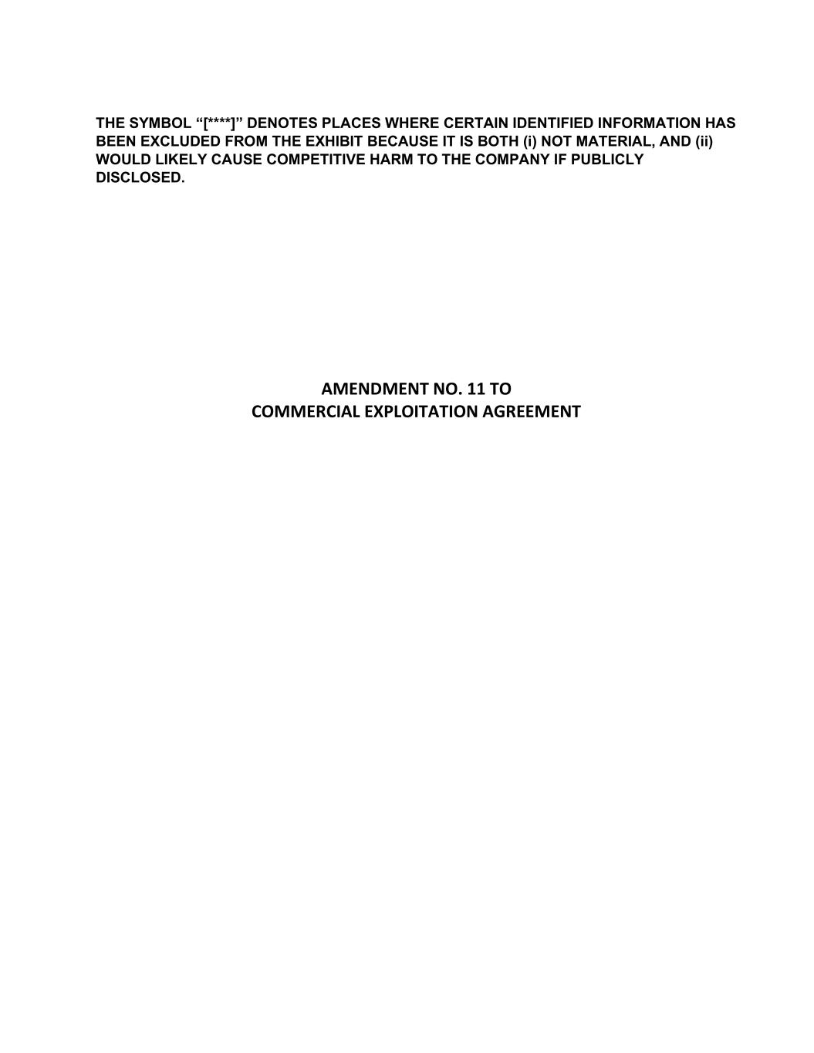

F-31
THE SYMBOL “[****]” DENOTES PLACES WHERE CERTAIN IDENTIFIED INFORMATION HAS BEEN EXCLUDED FROM THE EXHIBIT BECAUSE IT IS BOTH (i) NOT MATERIAL, AND (ii) WOULD LIKELY CAUSE COMPETITIVE HARM TO THE COMPANY IF PUBLICLY DISCLOSED. AMENDMENT NO. 11 TO COMMERCIAL EXPLOITATION AGREEMENT

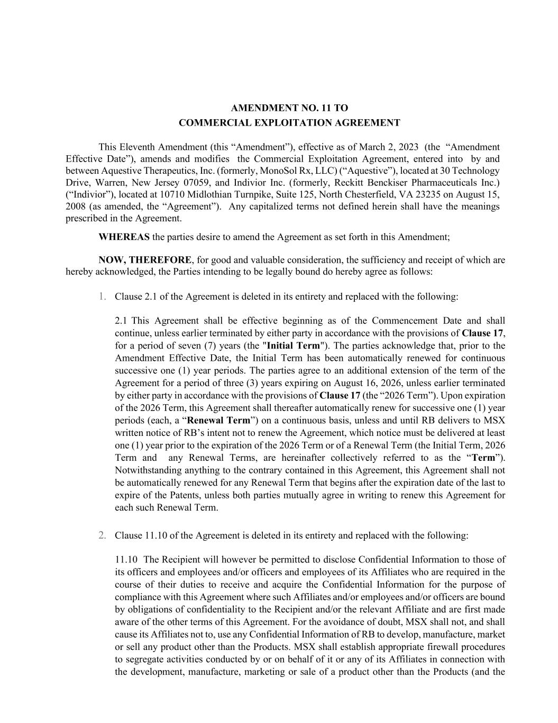
AMENDMENT NO. 11 TO COMMERCIAL EXPLOITATION AGREEMENT This Eleventh Amendment (this “Amendment”), effective as of March 2, 2023 (the “Amendment Effective Date”), amends and modifies the Commercial Exploitation Agreement, entered into by and between Aquestive Therapeutics, Inc. (formerly, MonoSol Rx, LLC) (“Aquestive”), located at 30 Technology Drive, Warren, New Jersey 07059, and Indivior Inc. (formerly, Reckitt Benckiser Pharmaceuticals Inc.) (“Indivior”), located at 10710 Midlothian Turnpike, Suite 125, North Chesterfield, VA 23235 on August 15, 2008 (as amended, the “Agreement”). Any capitalized terms not defined herein shall have the meanings prescribed in the Agreement. WHEREAS the parties desire to amend the Agreement as set forth in this Amendment; NOW, THEREFORE, for good and valuable consideration, the sufficiency and receipt of which are hereby acknowledged, the Parties intending to be legally bound do hereby agree as follows: 1. Clause 2.1 of the Agreement is deleted in its entirety and replaced with the following: 2.1 This Agreement shall be effective beginning as of the Commencement Date and shall continue, unless earlier terminated by either party in accordance with the provisions of Clause 17, for a period of seven (7) years (the "Initial Term"). The parties acknowledge that, prior to the Amendment Effective Date, the Initial Term has been automatically renewed for continuous successive one (1) year periods. The parties agree to an additional extension of the term of the Agreement for a period of three (3) years expiring on August 16, 2026, unless earlier terminated by either party in accordance with the provisions of Clause 17 (the “2026 Term”). Upon expiration of the 2026 Term, this Agreement shall thereafter automatically renew for successive one (1) year periods (each, a “Renewal Term”) on a continuous basis, unless and until RB delivers to MSX written notice of RB’s intent not to renew the Agreement, which notice must be delivered at least one (1) year prior to the expiration of the 2026 Term or of a Renewal Term (the Initial Term, 2026 Term and any Renewal Terms, are hereinafter collectively referred to as the “Term”). Notwithstanding anything to the contrary contained in this Agreement, this Agreement shall not be automatically renewed for any Renewal Term that begins after the expiration date of the last to expire of the Patents, unless both parties mutually agree in writing to renew this Agreement for each such Renewal Term. 2. Clause 11.10 of the Agreement is deleted in its entirety and replaced with the following: 11.10 The Recipient will however be permitted to disclose Confidential Information to those of its officers and employees and/or officers and employees of its Affiliates who are required in the course of their duties to receive and acquire the Confidential Information for the purpose of compliance with this Agreement where such Affiliates and/or employees and/or officers are bound by obligations of confidentiality to the Recipient and/or the relevant Affiliate and are first made aware of the other terms of this Agreement. For the avoidance of doubt, MSX shall not, and shall cause its Affiliates not to, use any Confidential Information of RB to develop, manufacture, market or sell any product other than the Products. MSX shall establish appropriate firewall procedures to segregate activities conducted by or on behalf of it or any of its Affiliates in connection with the development, manufacture, marketing or sale of a product other than the Products (and the

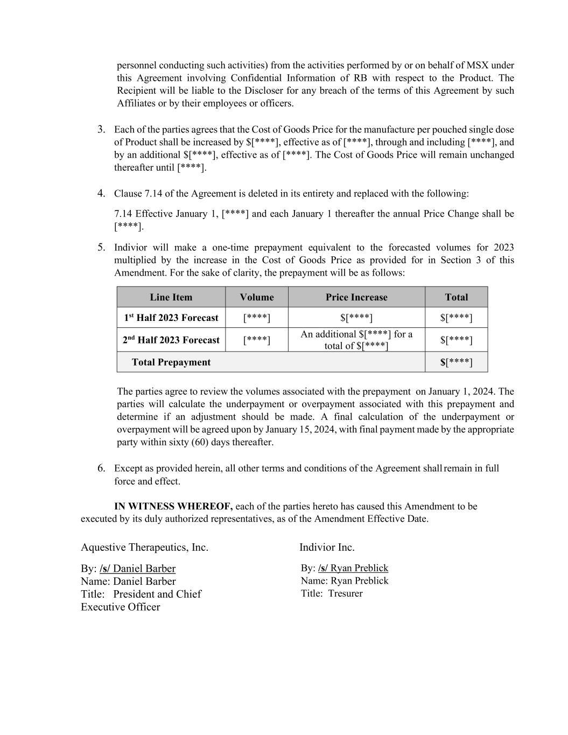
personnel conducting such activities) from the activities performed by or on behalf of MSX under this Agreement involving Confidential Information of RB with respect to the Product. The Recipient will be liable to the Discloser for any breach of the terms of this Agreement by such Affiliates or by their employees or officers. 3. Each of the parties agrees that the Cost of Goods Price for the manufacture per pouched single dose of Product shall be increased by $[****], effective as of [****], through and including [****], and by an additional $[****], effective as of [****]. The Cost of Goods Price will remain unchanged thereafter until [****]. 4. Clause 7.14 of the Agreement is deleted in its entirety and replaced with the following: 7.14 Effective January 1, [****] and each January 1 thereafter the annual Price Change shall be [****]. 5. Indivior will make a one-time prepayment equivalent to the forecasted volumes for 2023 multiplied by the increase in the Cost of Goods Price as provided for in Section 3 of this Amendment. For the sake of clarity, the prepayment will be as follows: Line Item Volume Price Increase Total 1st Half 2023 Forecast [****] $[****] $[****] 2nd Half 2023 Forecast [****] An additional $[****] for a total of $[****] $[****] Total Prepayment $[****] The parties agree to review the volumes associated with the prepayment on January 1, 2024. The parties will calculate the underpayment or overpayment associated with this prepayment and determine if an adjustment should be made. A final calculation of the underpayment or overpayment will be agreed upon by January 15, 2024, with final payment made by the appropriate party within sixty (60) days thereafter. 6. Except as provided herein, all other terms and conditions of the Agreement shall remain in full force and effect. IN WITNESS WHEREOF, each of the parties hereto has caused this Amendment to be executed by its duly authorized representatives, as of the Amendment Effective Date. Aquestive Therapeutics, Inc. Indivior Inc. By: /s/ Daniel Barber Name: Daniel Barber Title: President and Chief Executive Officer By: /s/ Ryan Preblick Name: Ryan Preblick Title: Tresurer

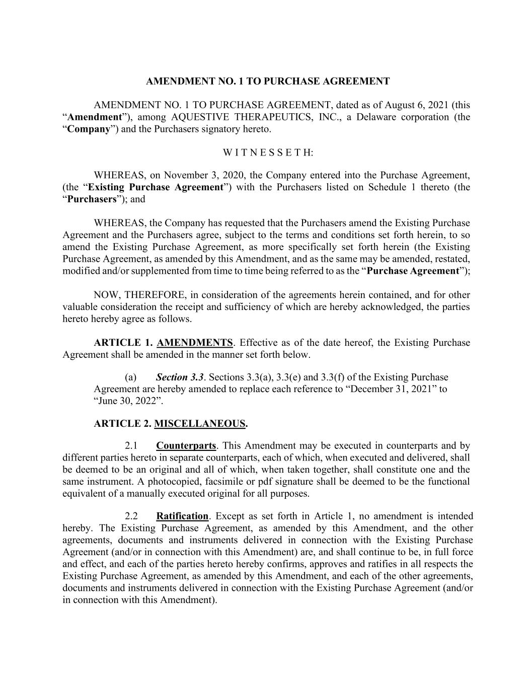
AMENDMENT NO. 1 TO PURCHASE AGREEMENT AMENDMENT NO. 1 TO PURCHASE AGREEMENT, dated as of August 6, 2021 (this “Amendment”), among AQUESTIVE THERAPEUTICS, INC., a Delaware corporation (the “Company”) and the Purchasers signatory hereto. W I T N E S S E T H: WHEREAS, on November 3, 2020, the Company entered into the Purchase Agreement, (the “Existing Purchase Agreement”) with the Purchasers listed on Schedule 1 thereto (the “Purchasers”); and WHEREAS, the Company has requested that the Purchasers amend the Existing Purchase Agreement and the Purchasers agree, subject to the terms and conditions set forth herein, to so amend the Existing Purchase Agreement, as more specifically set forth herein (the Existing Purchase Agreement, as amended by this Amendment, and as the same may be amended, restated, modified and/or supplemented from time to time being referred to as the “Purchase Agreement”); NOW, THEREFORE, in consideration of the agreements herein contained, and for other valuable consideration the receipt and sufficiency of which are hereby acknowledged, the parties hereto hereby agree as follows. ARTICLE 1. AMENDMENTS. Effective as of the date hereof, the Existing Purchase Agreement shall be amended in the manner set forth below. (a) Section 3.3. Sections 3.3(a), 3.3(e) and 3.3(f) of the Existing Purchase Agreement are hereby amended to replace each reference to “December 31, 2021” to “June 30, 2022”. ARTICLE 2. MISCELLANEOUS. 2.1 Counterparts. This Amendment may be executed in counterparts and by different parties hereto in separate counterparts, each of which, when executed and delivered, shall be deemed to be an original and all of which, when taken together, shall constitute one and the same instrument. A photocopied, facsimile or pdf signature shall be deemed to be the functional equivalent of a manually executed original for all purposes. 2.2 Ratification. Except as set forth in Article 1, no amendment is intended hereby. The Existing Purchase Agreement, as amended by this Amendment, and the other agreements, documents and instruments delivered in connection with the Existing Purchase Agreement (and/or in connection with this Amendment) are, and shall continue to be, in full force and effect, and each of the parties hereto hereby confirms, approves and ratifies in all respects the Existing Purchase Agreement, as amended by this Amendment, and each of the other agreements, documents and instruments delivered in connection with the Existing Purchase Agreement (and/or in connection with this Amendment).

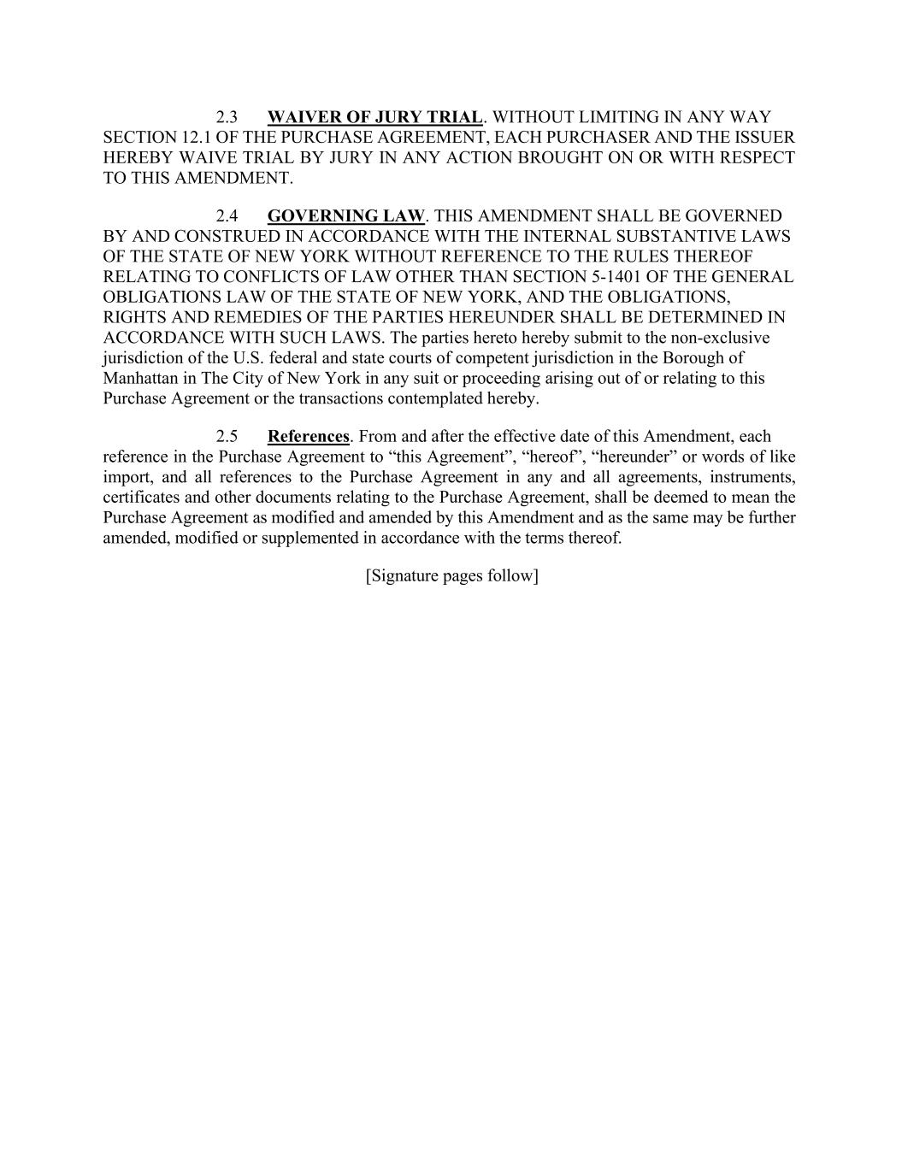
2.3 WAIVER OF JURY TRIAL. WITHOUT LIMITING IN ANY WAY SECTION 12.1 OF THE PURCHASE AGREEMENT, EACH PURCHASER AND THE ISSUER HEREBY WAIVE TRIAL BY JURY IN ANY ACTION BROUGHT ON OR WITH RESPECT TO THIS AMENDMENT. 2.4 GOVERNING LAW. THIS AMENDMENT SHALL BE GOVERNED BY AND CONSTRUED IN ACCORDANCE WITH THE INTERNAL SUBSTANTIVE LAWS OF THE STATE OF NEW YORK WITHOUT REFERENCE TO THE RULES THEREOF RELATING TO CONFLICTS OF LAW OTHER THAN SECTION 5-1401 OF THE GENERAL OBLIGATIONS LAW OF THE STATE OF NEW YORK, AND THE OBLIGATIONS, RIGHTS AND REMEDIES OF THE PARTIES HEREUNDER SHALL BE DETERMINED IN ACCORDANCE WITH SUCH LAWS. The parties hereto hereby submit to the non-exclusive jurisdiction of the U.S. federal and state courts of competent jurisdiction in the Borough of Manhattan in The City of New York in any suit or proceeding arising out of or relating to this Purchase Agreement or the transactions contemplated hereby. 2.5 References. From and after the effective date of this Amendment, each reference in the Purchase Agreement to “this Agreement”, “hereof”, “hereunder” or words of like import, and all references to the Purchase Agreement in any and all agreements, instruments, certificates and other documents relating to the Purchase Agreement, shall be deemed to mean the Purchase Agreement as modified and amended by this Amendment and as the same may be further amended, modified or supplemented in accordance with the terms thereof. [Signature pages follow]

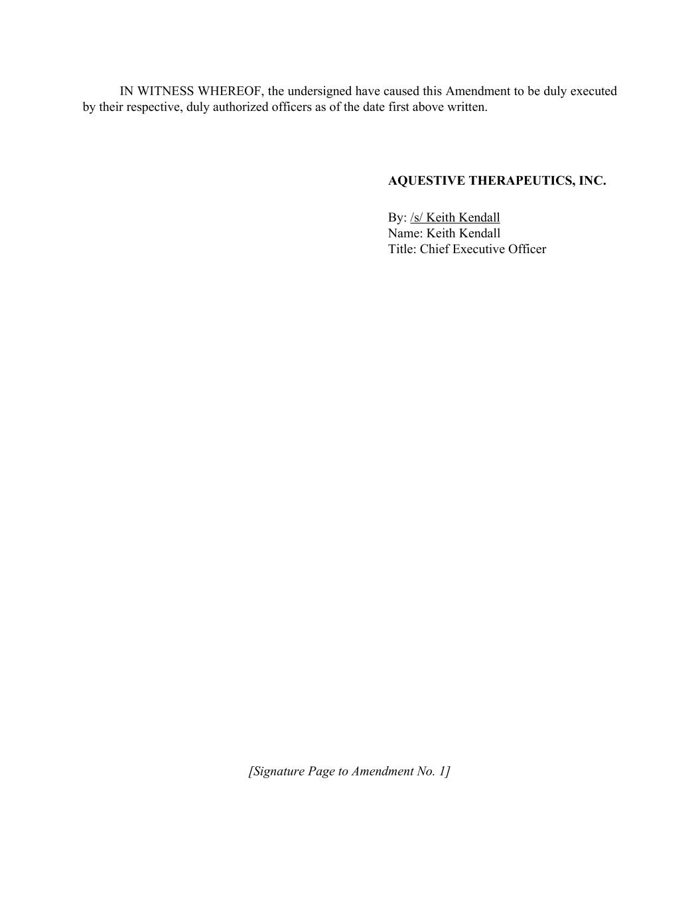
IN WITNESS WHEREOF, the undersigned have caused this Amendment to be duly executed by their respective, duly authorized officers as of the date first above written. AQUESTIVE THERAPEUTICS, INC. By: /s/ Keith Kendall Name: Keith Kendall Title: Chief Executive Officer [Signature Page to Amendment No. 1]

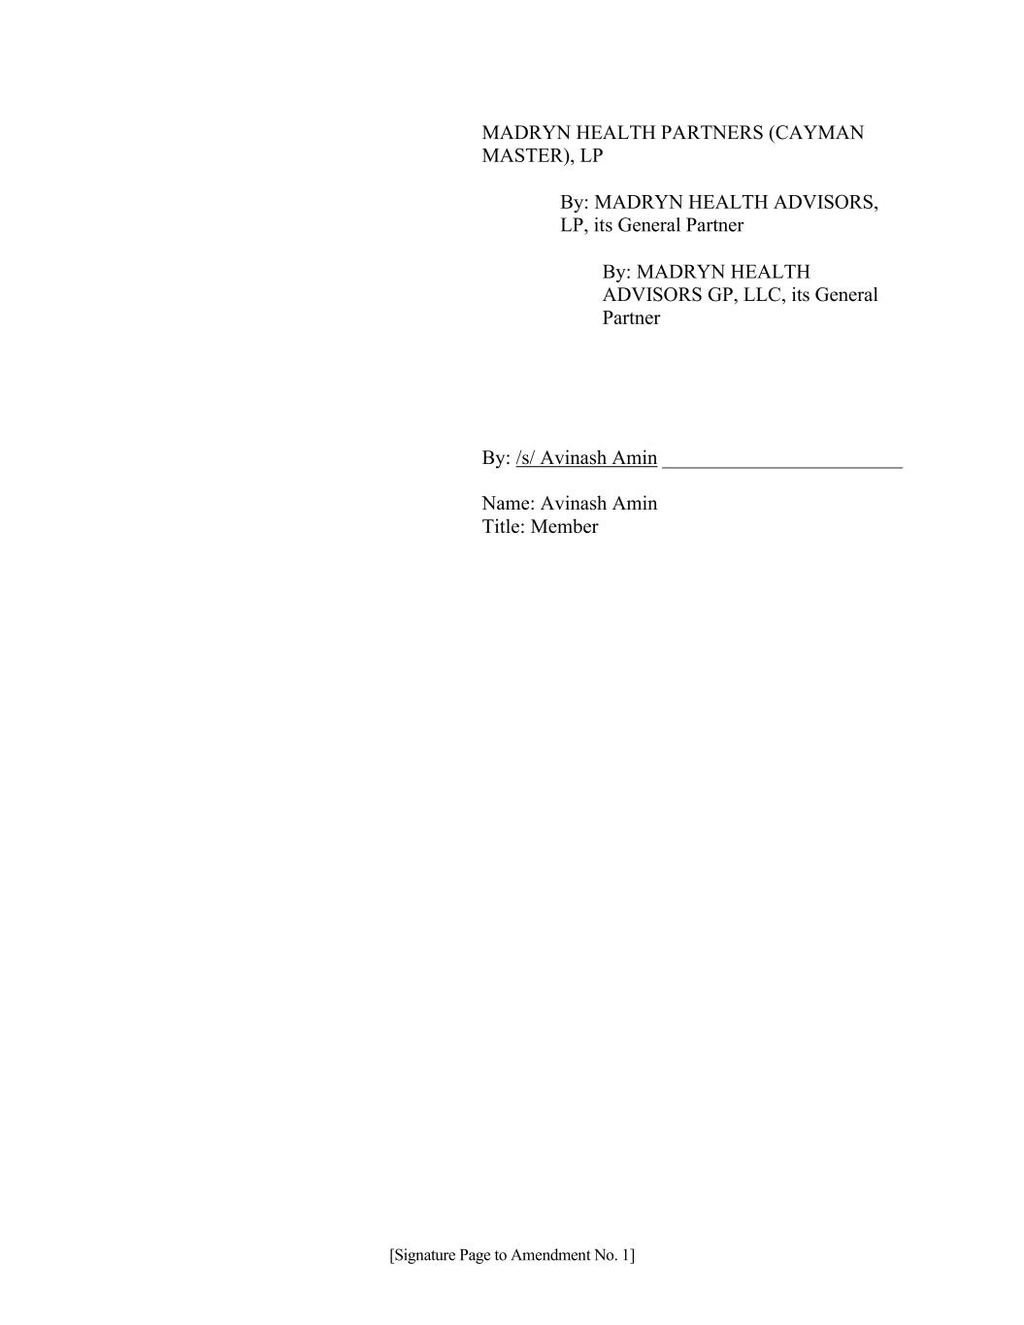
MADRYN HEALTH PARTNERS (CAYMAN MASTER), LP By: MADRYN HEALTH ADVISORS, LP, its General Partner By: MADRYN HEALTH ADVISORS GP, LLC, its General Partner By: /s/ Avinash Amin ________________________ Name: Avinash Amin Title: Member [Signature Page to Amendment No. 1]

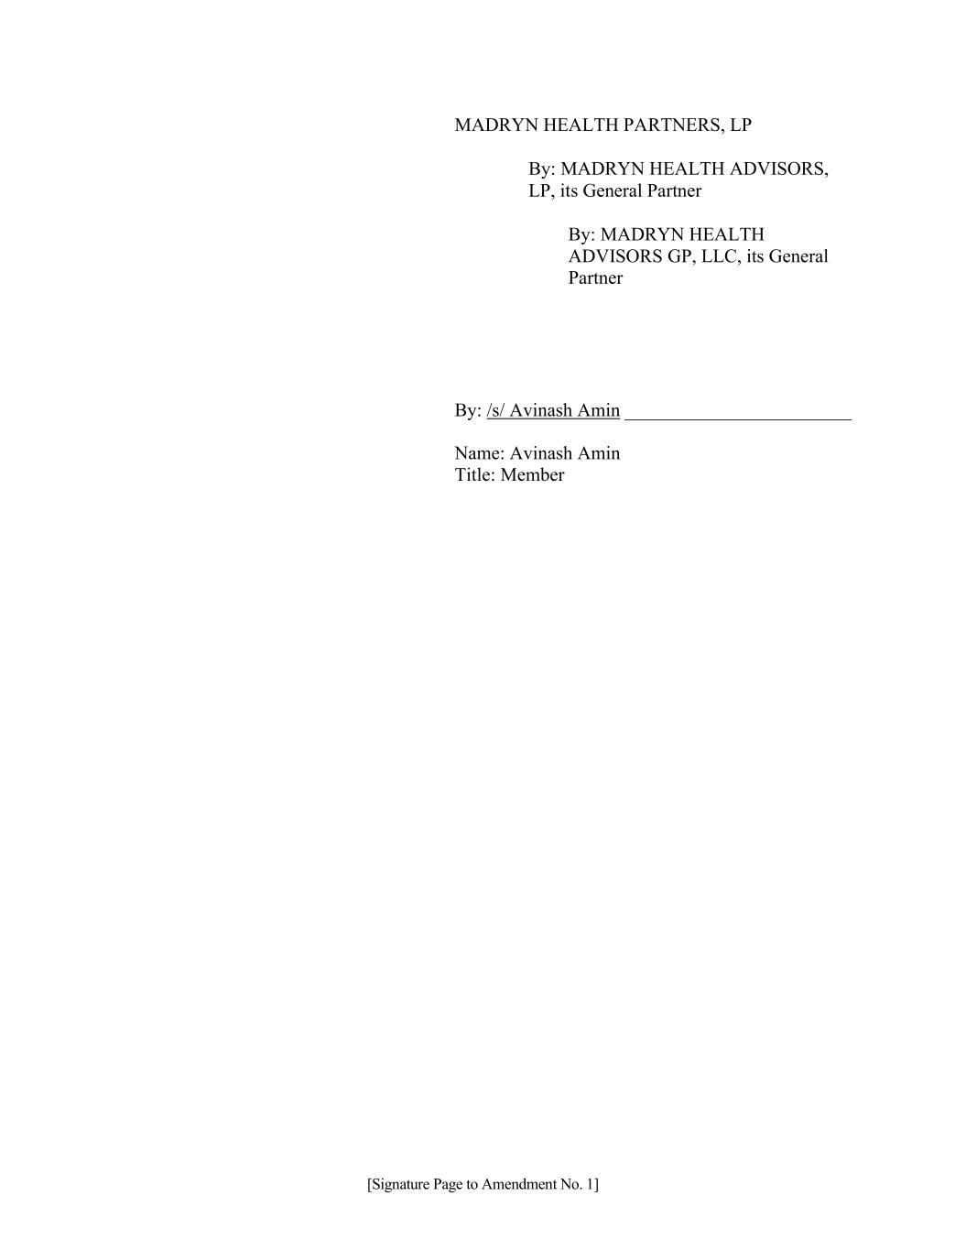
MADRYN HEALTH PARTNERS, LP By: MADRYN HEALTH ADVISORS, LP, its General Partner By: MADRYN HEALTH ADVISORS GP, LLC, its General Partner By: /s/ Avinash Amin ________________________ Name: Avinash Amin Title: Member [Signature Page to Amendment No. 1]

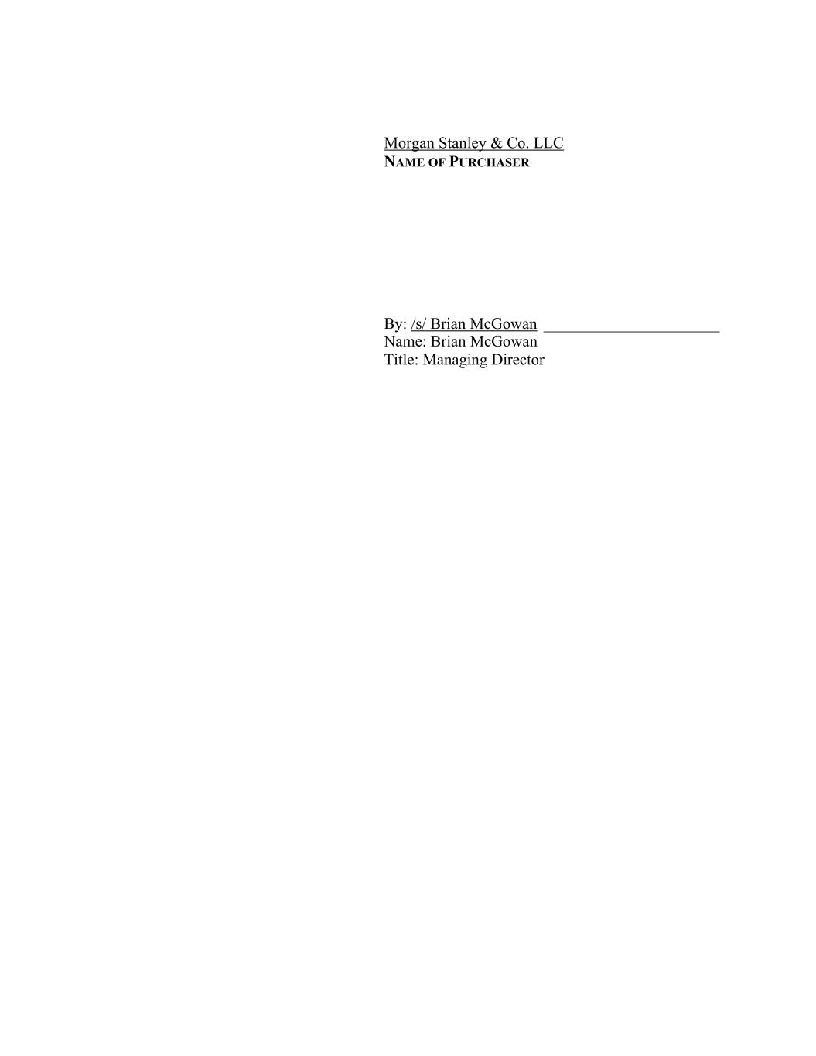
Morgan Stanley & Co. LLC NAME OF PURCHASER By: /s/ Brian McGowan ______________________ Name: Brian McGowan Title: Managing Director

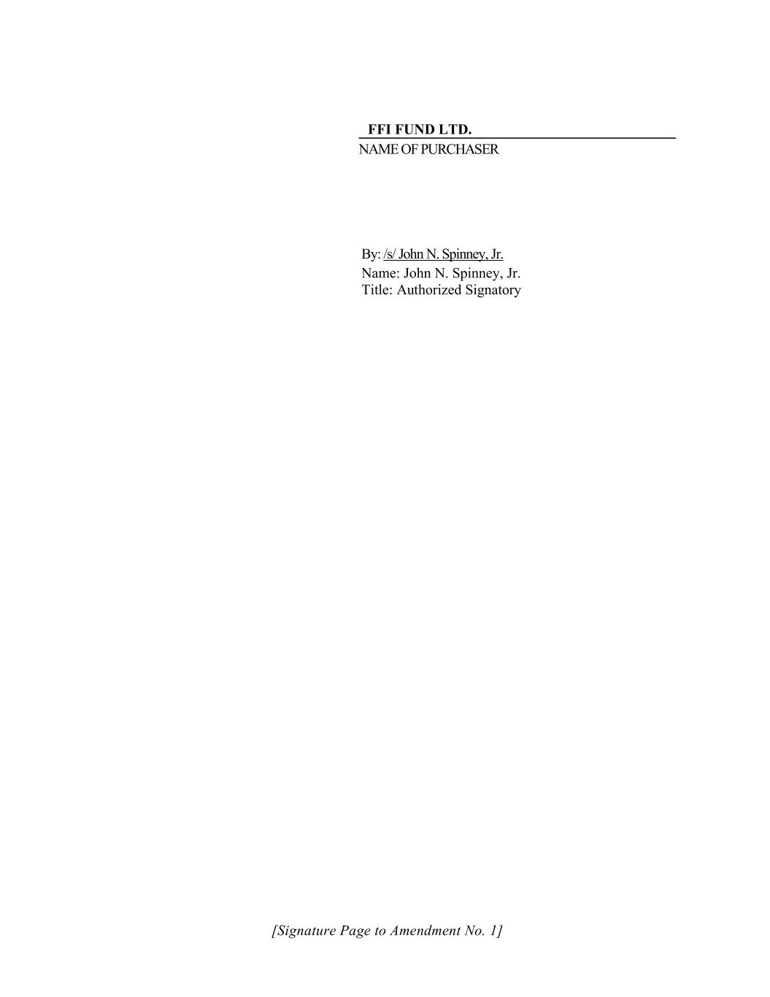
FFI FUND LTD. NAME OF PURCHASER By: /s/ John N. Spinney, Jr. Name: John N. Spinney, Jr. Title: Authorized Signatory [Signature Page to Amendment No. 1]

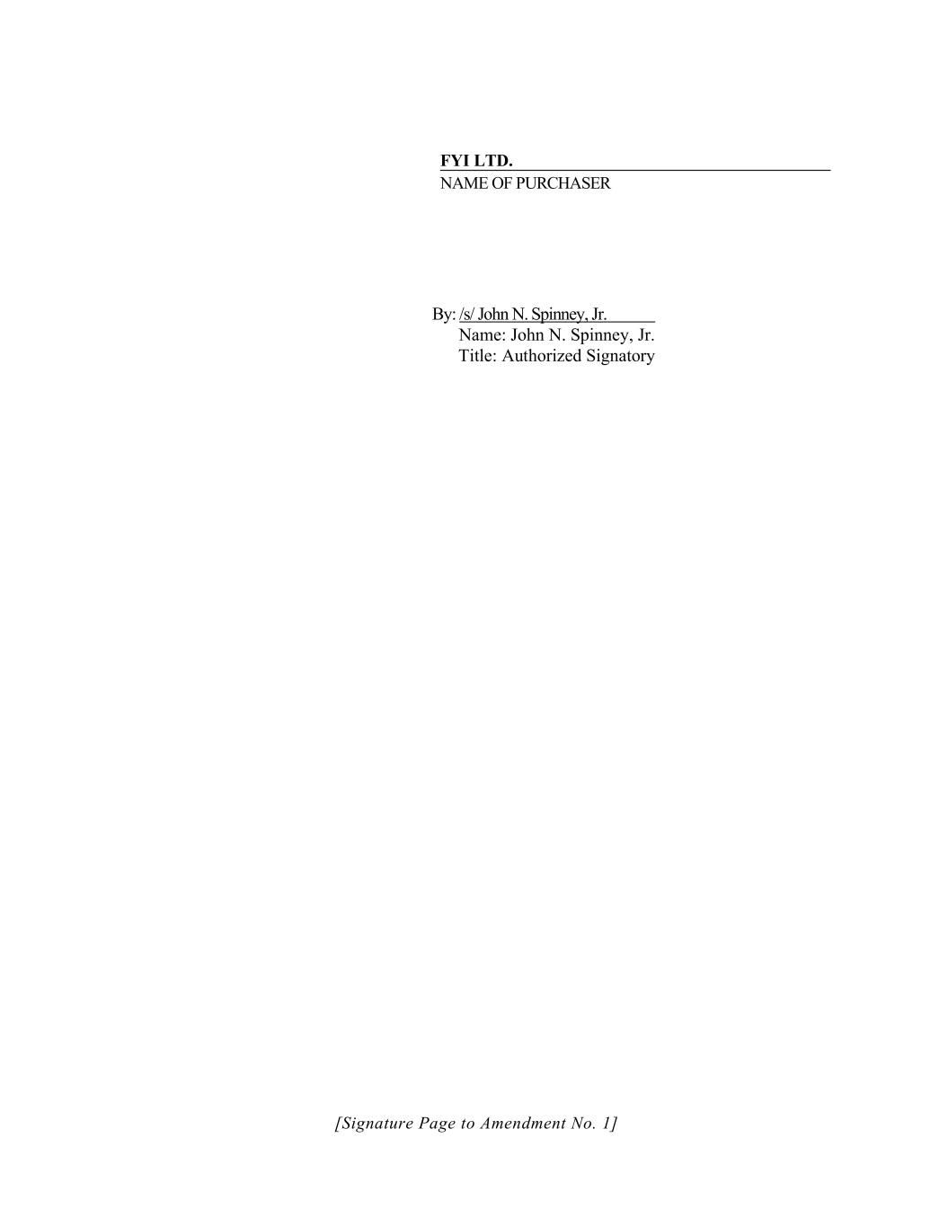
FYI LTD. NAME OF PURCHASER By: /s/ John N. Spinney, Jr. Name: John N. Spinney, Jr. Title: Authorized Signatory [Signature Page to Amendment No. 1]

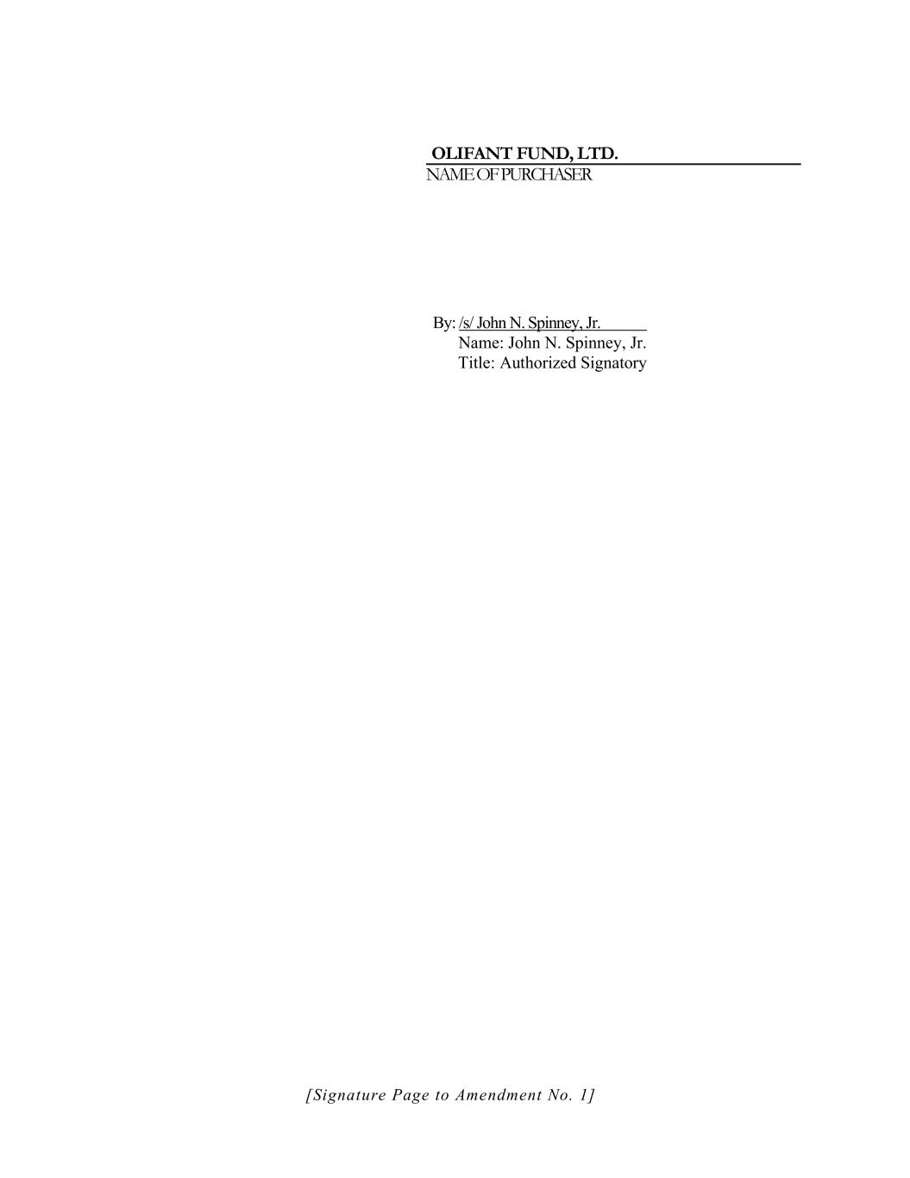
OLIFANT FUND, LTD. NAME OF PURCHASER By: /s/ John N. Spinney, Jr. Name: John N. Spinney, Jr. Title: Authorized Signatory [Signature Page to Amendment No. 1]

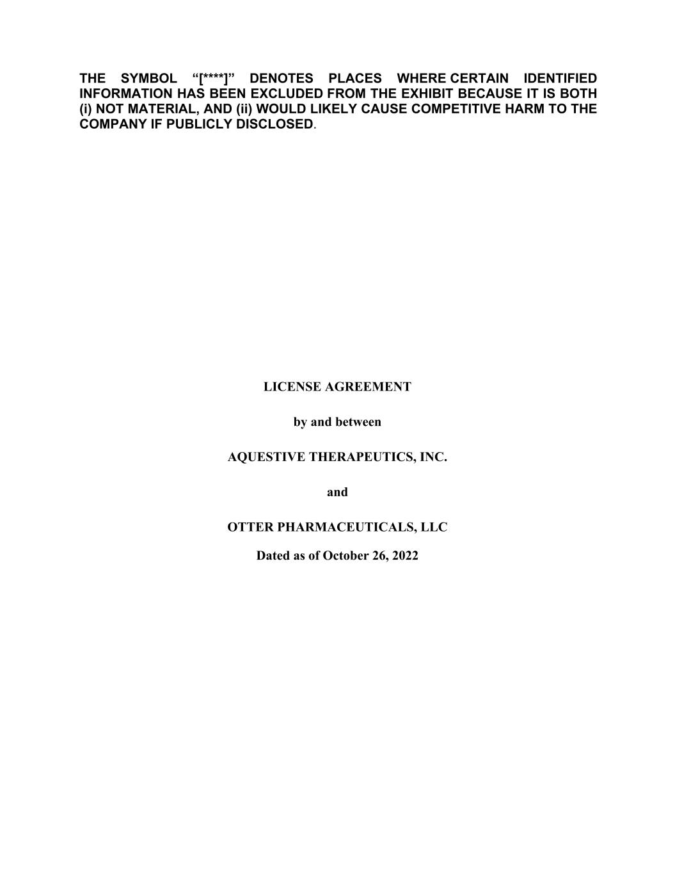
THE SYMBOL “[****]” DENOTES PLACES WHERE CERTAIN IDENTIFIED INFORMATION HAS BEEN EXCLUDED FROM THE EXHIBIT BECAUSE IT IS BOTH (i) NOT MATERIAL, AND (ii) WOULD LIKELY CAUSE COMPETITIVE HARM TO THE COMPANY IF PUBLICLY DISCLOSED. LICENSE AGREEMENT by and between AQUESTIVE THERAPEUTICS, INC. and OTTER PHARMACEUTICALS, LLC Dated as of October 26, 2022

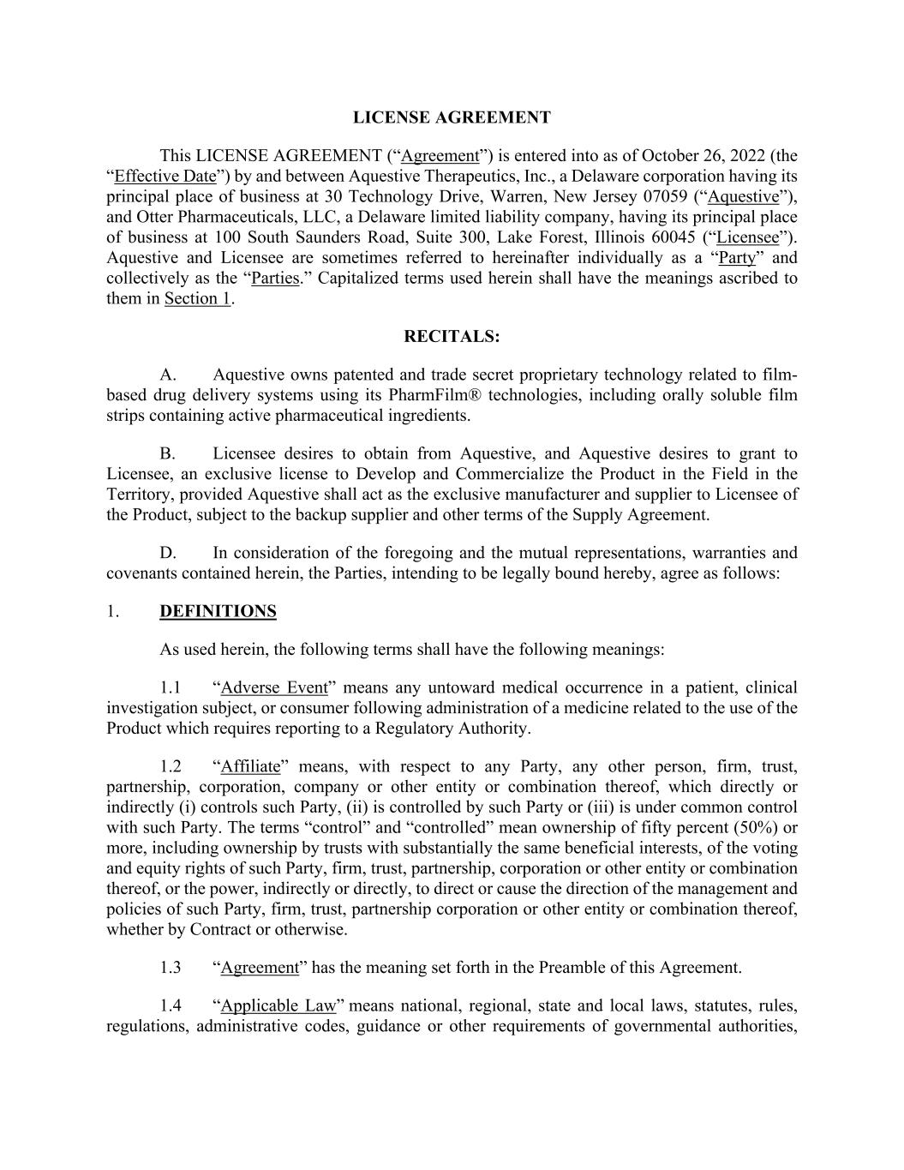
LICENSE AGREEMENT This LICENSE AGREEMENT (“Agreement”) is entered into as of October 26, 2022 (the “Effective Date”) by and between Aquestive Therapeutics, Inc., a Delaware corporation having its principal place of business at 30 Technology Drive, Warren, New Jersey 07059 (“Aquestive”), and Otter Pharmaceuticals, LLC, a Delaware limited liability company, having its principal place of business at 100 South Saunders Road, Suite 300, Lake Forest, Illinois 60045 (“Licensee”). Aquestive and Licensee are sometimes referred to hereinafter individually as a “Party” and collectively as the “Parties.” Capitalized terms used herein shall have the meanings ascribed to them in Section 1. RECITALS: A. Aquestive owns patented and trade secret proprietary technology related to film- based drug delivery systems using its PharmFilm® technologies, including orally soluble film strips containing active pharmaceutical ingredients. B. Licensee desires to obtain from Aquestive, and Aquestive desires to grant to Licensee, an exclusive license to Develop and Commercialize the Product in the Field in the Territory, provided Aquestive shall act as the exclusive manufacturer and supplier to Licensee of the Product, subject to the backup supplier and other terms of the Supply Agreement. D. In consideration of the foregoing and the mutual representations, warranties and covenants contained herein, the Parties, intending to be legally bound hereby, agree as follows: 1. DEFINITIONS As used herein, the following terms shall have the following meanings: 1.1 “Adverse Event” means any untoward medical occurrence in a patient, clinical investigation subject, or consumer following administration of a medicine related to the use of the Product which requires reporting to a Regulatory Authority. 1.2 “Affiliate” means, with respect to any Party, any other person, firm, trust, partnership, corporation, company or other entity or combination thereof, which directly or indirectly (i) controls such Party, (ii) is controlled by such Party or (iii) is under common control with such Party. The terms “control” and “controlled” mean ownership of fifty percent (50%) or more, including ownership by trusts with substantially the same beneficial interests, of the voting and equity rights of such Party, firm, trust, partnership, corporation or other entity or combination thereof, or the power, indirectly or directly, to direct or cause the direction of the management and policies of such Party, firm, trust, partnership corporation or other entity or combination thereof, whether by Contract or otherwise. 1.3 “Agreement” has the meaning set forth in the Preamble of this Agreement. 1.4 “Applicable Law” means national, regional, state and local laws, statutes, rules, regulations, administrative codes, guidance or other requirements of governmental authorities,

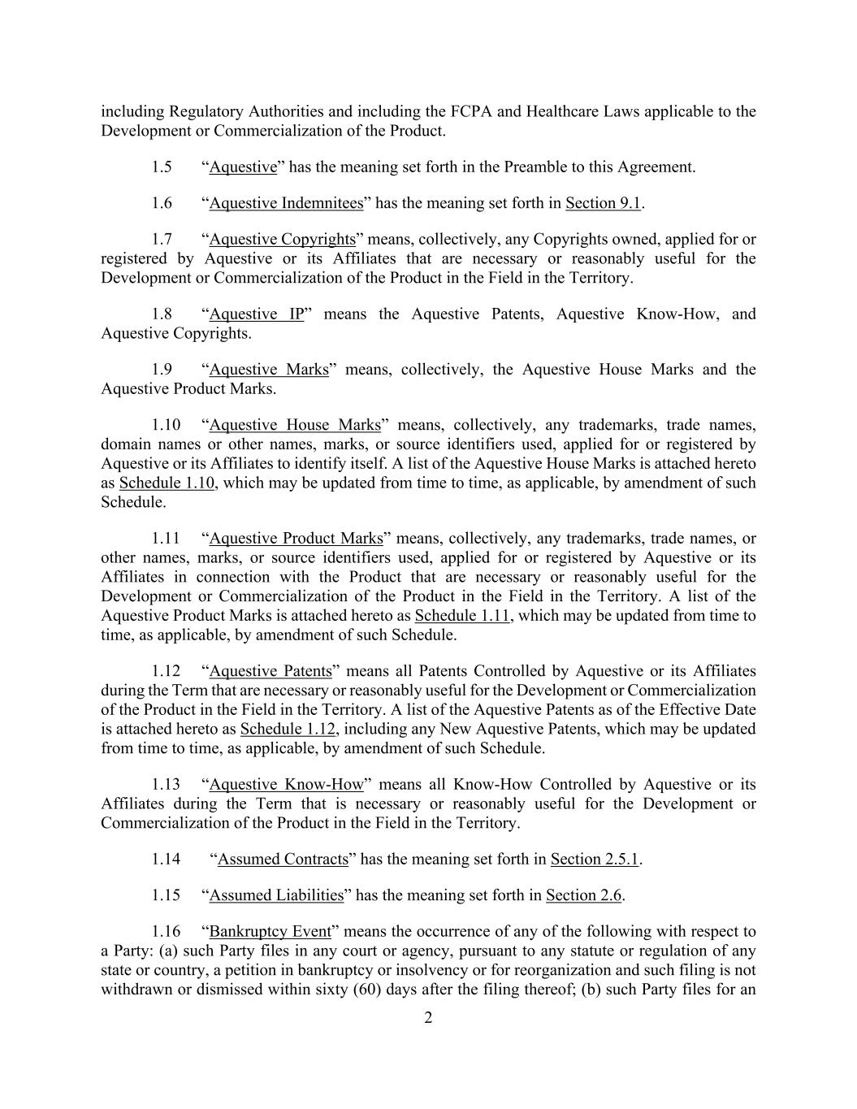
2 including Regulatory Authorities and including the FCPA and Healthcare Laws applicable to the Development or Commercialization of the Product. 1.5 “Aquestive” has the meaning set forth in the Preamble to this Agreement. 1.6 “Aquestive Indemnitees” has the meaning set forth in Section 9.1. 1.7 “Aquestive Copyrights” means, collectively, any Copyrights owned, applied for or registered by Aquestive or its Affiliates that are necessary or reasonably useful for the Development or Commercialization of the Product in the Field in the Territory. 1.8 “Aquestive IP” means the Aquestive Patents, Aquestive Know-How, and Aquestive Copyrights. 1.9 “Aquestive Marks” means, collectively, the Aquestive House Marks and the Aquestive Product Marks. 1.10 “Aquestive House Marks” means, collectively, any trademarks, trade names, domain names or other names, marks, or source identifiers used, applied for or registered by Aquestive or its Affiliates to identify itself. A list of the Aquestive House Marks is attached hereto as Schedule 1.10, which may be updated from time to time, as applicable, by amendment of such Schedule. 1.11 “Aquestive Product Marks” means, collectively, any trademarks, trade names, or other names, marks, or source identifiers used, applied for or registered by Aquestive or its Affiliates in connection with the Product that are necessary or reasonably useful for the Development or Commercialization of the Product in the Field in the Territory. A list of the Aquestive Product Marks is attached hereto as Schedule 1.11, which may be updated from time to time, as applicable, by amendment of such Schedule. 1.12 “Aquestive Patents” means all Patents Controlled by Aquestive or its Affiliates during the Term that are necessary or reasonably useful for the Development or Commercialization of the Product in the Field in the Territory. A list of the Aquestive Patents as of the Effective Date is attached hereto as Schedule 1.12, including any New Aquestive Patents, which may be updated from time to time, as applicable, by amendment of such Schedule. 1.13 “Aquestive Know-How” means all Know-How Controlled by Aquestive or its Affiliates during the Term that is necessary or reasonably useful for the Development or Commercialization of the Product in the Field in the Territory. 1.14 “Assumed Contracts” has the meaning set forth in Section 2.5.1. 1.15 “Assumed Liabilities” has the meaning set forth in Section 2.6. 1.16 “Bankruptcy Event” means the occurrence of any of the following with respect to a Party: (a) such Party files in any court or agency, pursuant to any statute or regulation of any state or country, a petition in bankruptcy or insolvency or for reorganization and such filing is not withdrawn or dismissed within sixty (60) days after the filing thereof; (b) such Party files for an

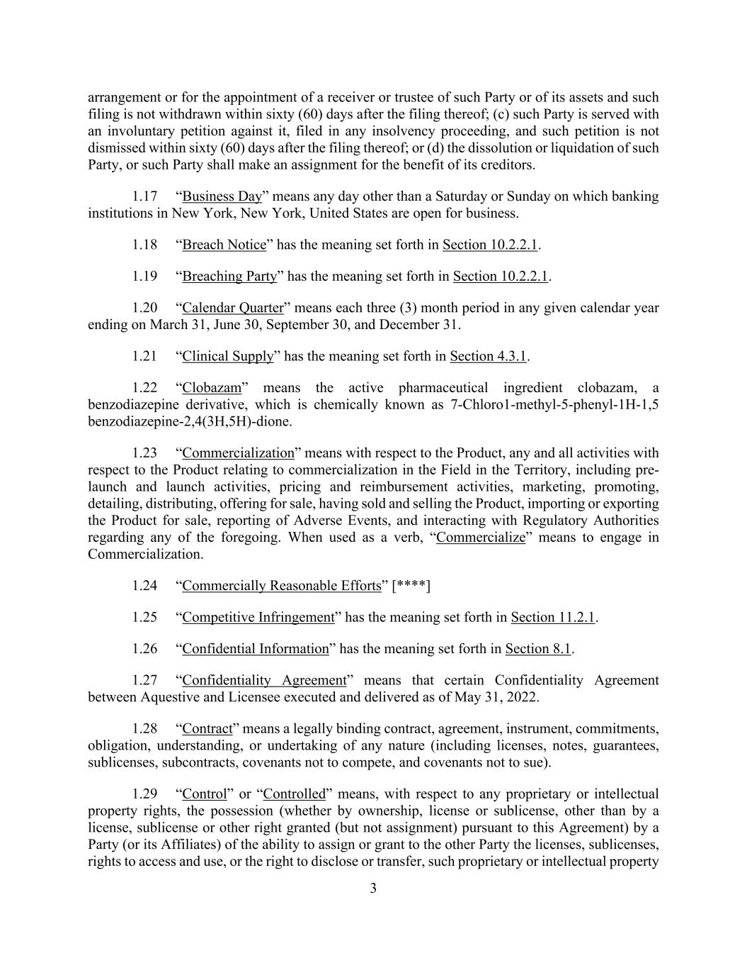
3 arrangement or for the appointment of a receiver or trustee of such Party or of its assets and such filing is not withdrawn within sixty (60) days after the filing thereof; (c) such Party is served with an involuntary petition against it, filed in any insolvency proceeding, and such petition is not dismissed within sixty (60) days after the filing thereof; or (d) the dissolution or liquidation of such Party, or such Party shall make an assignment for the benefit of its creditors. 1.17 “Business Day” means any day other than a Saturday or Sunday on which banking institutions in New York, New York, United States are open for business. 1.18 “Breach Notice” has the meaning set forth in Section 10.2.2.1. 1.19 “Breaching Party” has the meaning set forth in Section 10.2.2.1. 1.20 “Calendar Quarter” means each three (3) month period in any given calendar year ending on March 31, June 30, September 30, and December 31. 1.21 “Clinical Supply” has the meaning set forth in Section 4.3.1. 1.22 “Clobazam” means the active pharmaceutical ingredient clobazam, a benzodiazepine derivative, which is chemically known as 7-Chloro1-methyl-5-phenyl-1H-1,5 benzodiazepine-2,4(3H,5H)-dione. 1.23 “Commercialization” means with respect to the Product, any and all activities with respect to the Product relating to commercialization in the Field in the Territory, including pre- launch and launch activities, pricing and reimbursement activities, marketing, promoting, detailing, distributing, offering for sale, having sold and selling the Product, importing or exporting the Product for sale, reporting of Adverse Events, and interacting with Regulatory Authorities regarding any of the foregoing. When used as a verb, “Commercialize” means to engage in Commercialization. 1.24 “Commercially Reasonable Efforts” [****] 1.25 “Competitive Infringement” has the meaning set forth in Section 11.2.1. 1.26 “Confidential Information” has the meaning set forth in Section 8.1. 1.27 “Confidentiality Agreement” means that certain Confidentiality Agreement between Aquestive and Licensee executed and delivered as of May 31, 2022. 1.28 “Contract” means a legally binding contract, agreement, instrument, commitments, obligation, understanding, or undertaking of any nature (including licenses, notes, guarantees, sublicenses, subcontracts, covenants not to compete, and covenants not to sue). 1.29 “Control” or “Controlled” means, with respect to any proprietary or intellectual property rights, the possession (whether by ownership, license or sublicense, other than by a license, sublicense or other right granted (but not assignment) pursuant to this Agreement) by a Party (or its Affiliates) of the ability to assign or grant to the other Party the licenses, sublicenses, rights to access and use, or the right to disclose or transfer, such proprietary or intellectual property

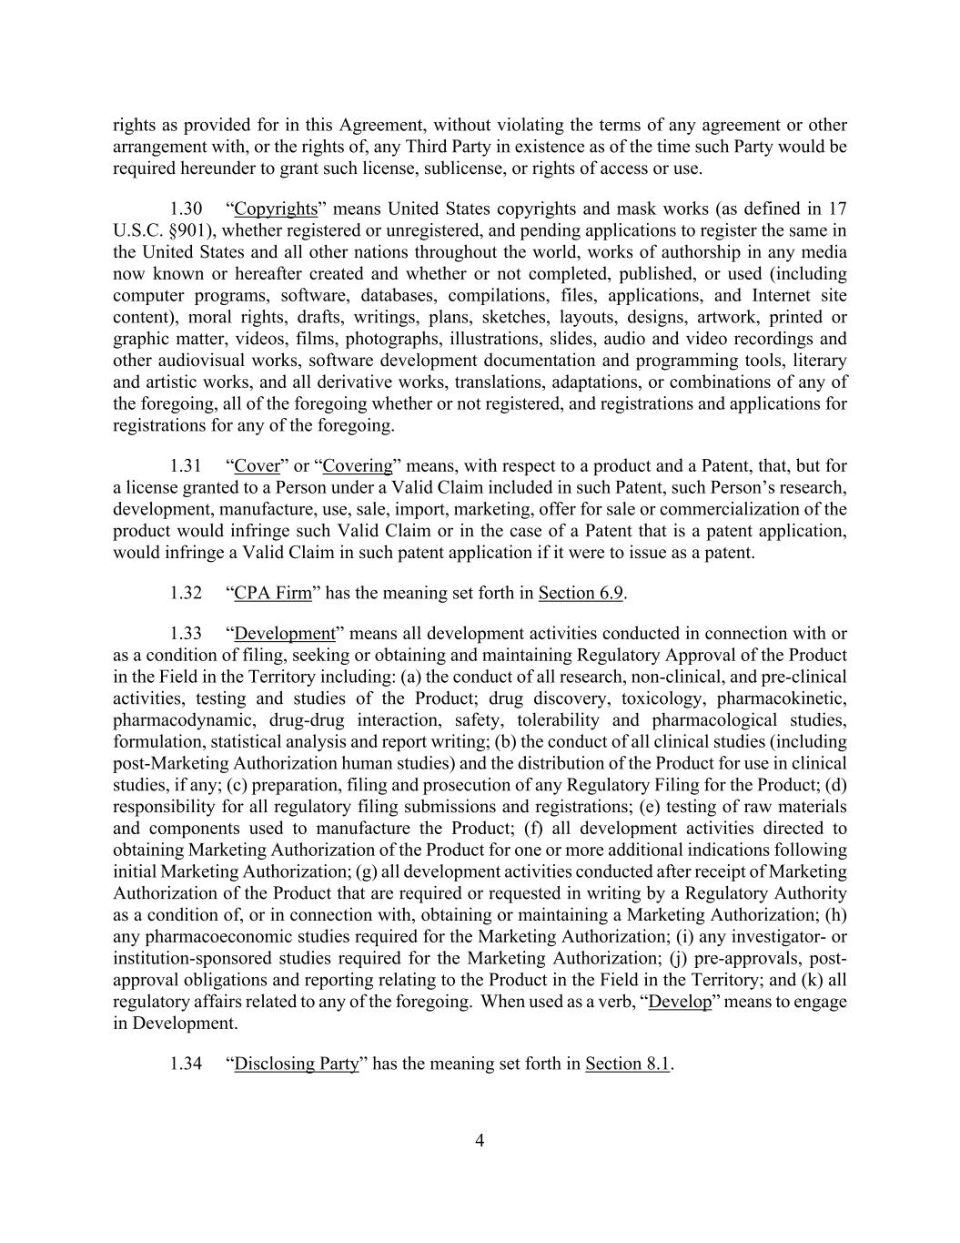
4 rights as provided for in this Agreement, without violating the terms of any agreement or other arrangement with, or the rights of, any Third Party in existence as of the time such Party would be required hereunder to grant such license, sublicense, or rights of access or use. 1.30 “Copyrights” means United States copyrights and mask works (as defined in 17 U.S.C. §901), whether registered or unregistered, and pending applications to register the same in the United States and all other nations throughout the world, works of authorship in any media now known or hereafter created and whether or not completed, published, or used (including computer programs, software, databases, compilations, files, applications, and Internet site content), moral rights, drafts, writings, plans, sketches, layouts, designs, artwork, printed or graphic matter, videos, films, photographs, illustrations, slides, audio and video recordings and other audiovisual works, software development documentation and programming tools, literary and artistic works, and all derivative works, translations, adaptations, or combinations of any of the foregoing, all of the foregoing whether or not registered, and registrations and applications for registrations for any of the foregoing. 1.31 “Cover” or “Covering” means, with respect to a product and a Patent, that, but for a license granted to a Person under a Valid Claim included in such Patent, such Person’s research, development, manufacture, use, sale, import, marketing, offer for sale or commercialization of the product would infringe such Valid Claim or in the case of a Patent that is a patent application, would infringe a Valid Claim in such patent application if it were to issue as a patent. 1.32 “CPA Firm” has the meaning set forth in Section 6.9. 1.33 “Development” means all development activities conducted in connection with or as a condition of filing, seeking or obtaining and maintaining Regulatory Approval of the Product in the Field in the Territory including: (a) the conduct of all research, non-clinical, and pre-clinical activities, testing and studies of the Product; drug discovery, toxicology, pharmacokinetic, pharmacodynamic, drug-drug interaction, safety, tolerability and pharmacological studies, formulation, statistical analysis and report writing; (b) the conduct of all clinical studies (including post-Marketing Authorization human studies) and the distribution of the Product for use in clinical studies, if any; (c) preparation, filing and prosecution of any Regulatory Filing for the Product; (d) responsibility for all regulatory filing submissions and registrations; (e) testing of raw materials and components used to manufacture the Product; (f) all development activities directed to obtaining Marketing Authorization of the Product for one or more additional indications following initial Marketing Authorization; (g) all development activities conducted after receipt of Marketing Authorization of the Product that are required or requested in writing by a Regulatory Authority as a condition of, or in connection with, obtaining or maintaining a Marketing Authorization; (h) any pharmacoeconomic studies required for the Marketing Authorization; (i) any investigator- or institution-sponsored studies required for the Marketing Authorization; (j) pre-approvals, post- approval obligations and reporting relating to the Product in the Field in the Territory; and (k) all regulatory affairs related to any of the foregoing. When used as a verb, “Develop” means to engage in Development. 1.34 “Disclosing Party” has the meaning set forth in Section 8.1.

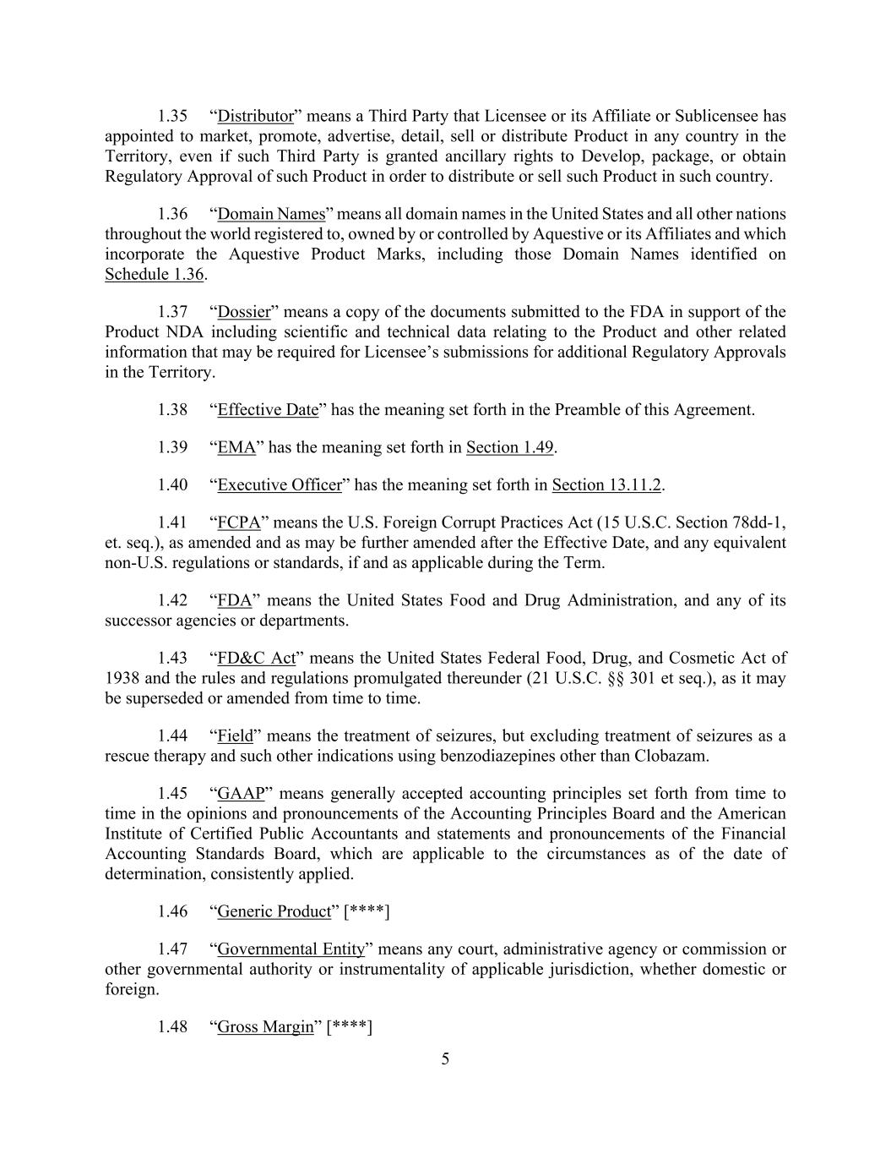
5 1.35 “Distributor” means a Third Party that Licensee or its Affiliate or Sublicensee has appointed to market, promote, advertise, detail, sell or distribute Product in any country in the Territory, even if such Third Party is granted ancillary rights to Develop, package, or obtain Regulatory Approval of such Product in order to distribute or sell such Product in such country. 1.36 “Domain Names” means all domain names in the United States and all other nations throughout the world registered to, owned by or controlled by Aquestive or its Affiliates and which incorporate the Aquestive Product Marks, including those Domain Names identified on Schedule 1.36. 1.37 “Dossier” means a copy of the documents submitted to the FDA in support of the Product NDA including scientific and technical data relating to the Product and other related information that may be required for Licensee’s submissions for additional Regulatory Approvals in the Territory. 1.38 “Effective Date” has the meaning set forth in the Preamble of this Agreement. 1.39 “EMA” has the meaning set forth in Section 1.49. 1.40 “Executive Officer” has the meaning set forth in Section 13.11.2. 1.41 “FCPA” means the U.S. Foreign Corrupt Practices Act (15 U.S.C. Section 78dd-1, et. seq.), as amended and as may be further amended after the Effective Date, and any equivalent non-U.S. regulations or standards, if and as applicable during the Term. 1.42 “FDA” means the United States Food and Drug Administration, and any of its successor agencies or departments. 1.43 “FD&C Act” means the United States Federal Food, Drug, and Cosmetic Act of 1938 and the rules and regulations promulgated thereunder (21 U.S.C. §§ 301 et seq.), as it may be superseded or amended from time to time. 1.44 “Field” means the treatment of seizures, but excluding treatment of seizures as a rescue therapy and such other indications using benzodiazepines other than Clobazam. 1.45 “GAAP” means generally accepted accounting principles set forth from time to time in the opinions and pronouncements of the Accounting Principles Board and the American Institute of Certified Public Accountants and statements and pronouncements of the Financial Accounting Standards Board, which are applicable to the circumstances as of the date of determination, consistently applied. 1.46 “Generic Product” [****] 1.47 “Governmental Entity” means any court, administrative agency or commission or other governmental authority or instrumentality of applicable jurisdiction, whether domestic or foreign. 1.48 “Gross Margin” [****]

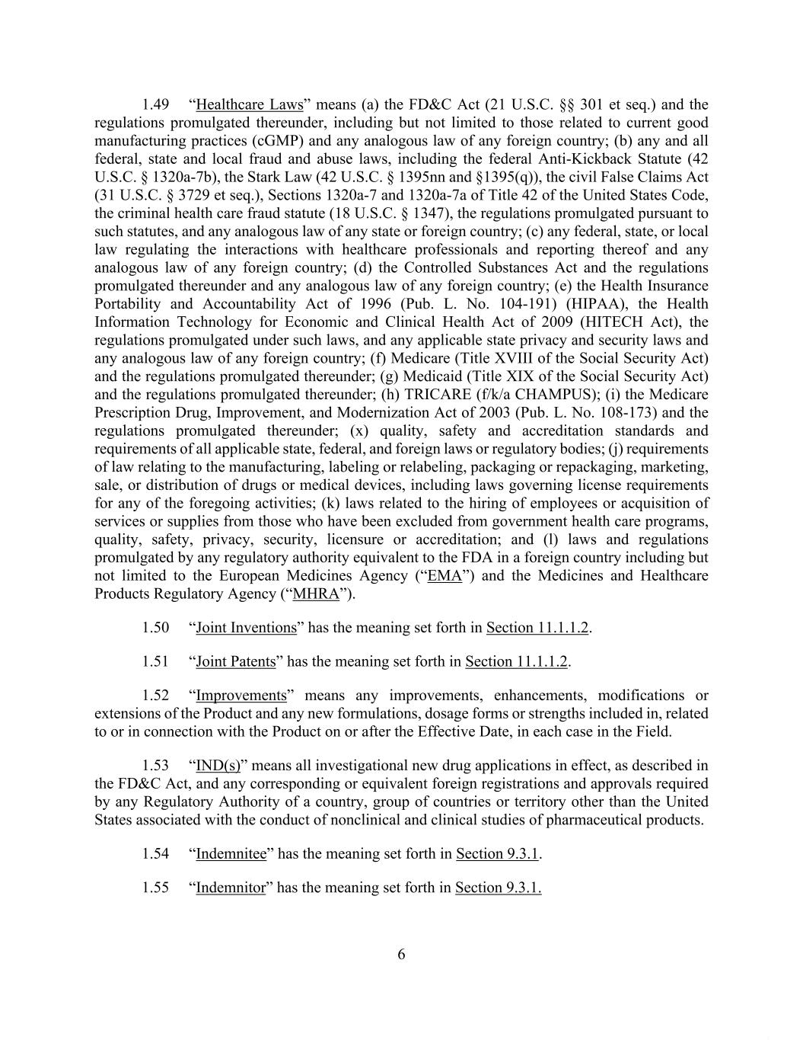
6 1.49 “Healthcare Laws” means (a) the FD&C Act (21 U.S.C. §§ 301 et seq.) and the regulations promulgated thereunder, including but not limited to those related to current good manufacturing practices (cGMP) and any analogous law of any foreign country; (b) any and all federal, state and local fraud and abuse laws, including the federal Anti-Kickback Statute (42 U.S.C. § 1320a-7b), the Stark Law (42 U.S.C. § 1395nn and §1395(q)), the civil False Claims Act (31 U.S.C. § 3729 et seq.), Sections 1320a-7 and 1320a-7a of Title 42 of the United States Code, the criminal health care fraud statute (18 U.S.C. § 1347), the regulations promulgated pursuant to such statutes, and any analogous law of any state or foreign country; (c) any federal, state, or local law regulating the interactions with healthcare professionals and reporting thereof and any analogous law of any foreign country; (d) the Controlled Substances Act and the regulations promulgated thereunder and any analogous law of any foreign country; (e) the Health Insurance Portability and Accountability Act of 1996 (Pub. L. No. 104-191) (HIPAA), the Health Information Technology for Economic and Clinical Health Act of 2009 (HITECH Act), the regulations promulgated under such laws, and any applicable state privacy and security laws and any analogous law of any foreign country; (f) Medicare (Title XVIII of the Social Security Act) and the regulations promulgated thereunder; (g) Medicaid (Title XIX of the Social Security Act) and the regulations promulgated thereunder; (h) TRICARE (f/k/a CHAMPUS); (i) the Medicare Prescription Drug, Improvement, and Modernization Act of 2003 (Pub. L. No. 108-173) and the regulations promulgated thereunder; (x) quality, safety and accreditation standards and requirements of all applicable state, federal, and foreign laws or regulatory bodies; (j) requirements of law relating to the manufacturing, labeling or relabeling, packaging or repackaging, marketing, sale, or distribution of drugs or medical devices, including laws governing license requirements for any of the foregoing activities; (k) laws related to the hiring of employees or acquisition of services or supplies from those who have been excluded from government health care programs, quality, safety, privacy, security, licensure or accreditation; and (l) laws and regulations promulgated by any regulatory authority equivalent to the FDA in a foreign country including but not limited to the European Medicines Agency (“EMA”) and the Medicines and Healthcare Products Regulatory Agency (“MHRA”). 1.50 “Joint Inventions” has the meaning set forth in Section 11.1.1.2. 1.51 “Joint Patents” has the meaning set forth in Section 11.1.1.2. 1.52 “Improvements” means any improvements, enhancements, modifications or extensions of the Product and any new formulations, dosage forms or strengths included in, related to or in connection with the Product on or after the Effective Date, in each case in the Field. 1.53 “IND(s)” means all investigational new drug applications in effect, as described in the FD&C Act, and any corresponding or equivalent foreign registrations and approvals required by any Regulatory Authority of a country, group of countries or territory other than the United States associated with the conduct of nonclinical and clinical studies of pharmaceutical products. 1.54 “Indemnitee” has the meaning set forth in Section 9.3.1. 1.55 “Indemnitor” has the meaning set forth in Section 9.3.1.

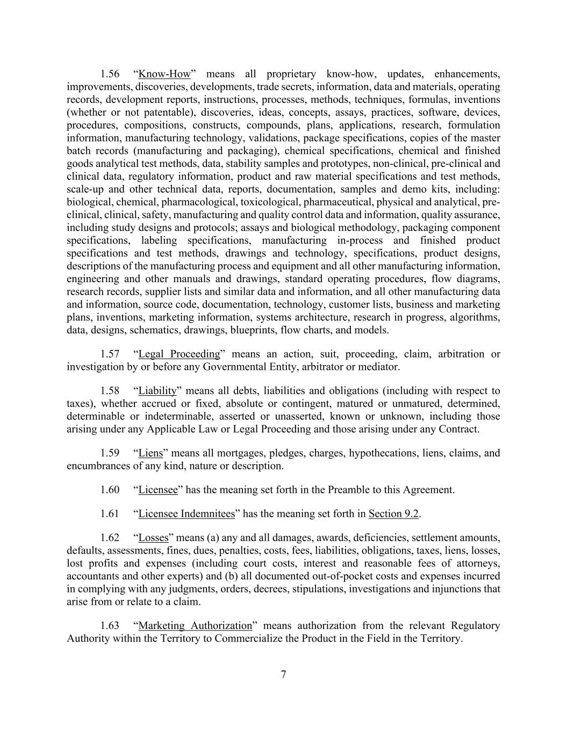
7 1.56 “Know-How” means all proprietary know-how, updates, enhancements, improvements, discoveries, developments, trade secrets, information, data and materials, operating records, development reports, instructions, processes, methods, techniques, formulas, inventions (whether or not patentable), discoveries, ideas, concepts, assays, practices, software, devices, procedures, compositions, constructs, compounds, plans, applications, research, formulation information, manufacturing technology, validations, package specifications, copies of the master batch records (manufacturing and packaging), chemical specifications, chemical and finished goods analytical test methods, data, stability samples and prototypes, non-clinical, pre-clinical and clinical data, regulatory information, product and raw material specifications and test methods, scale-up and other technical data, reports, documentation, samples and demo kits, including: biological, chemical, pharmacological, toxicological, pharmaceutical, physical and analytical, pre- clinical, clinical, safety, manufacturing and quality control data and information, quality assurance, including study designs and protocols; assays and biological methodology, packaging component specifications, labeling specifications, manufacturing in-process and finished product specifications and test methods, drawings and technology, specifications, product designs, descriptions of the manufacturing process and equipment and all other manufacturing information, engineering and other manuals and drawings, standard operating procedures, flow diagrams, research records, supplier lists and similar data and information, and all other manufacturing data and information, source code, documentation, technology, customer lists, business and marketing plans, inventions, marketing information, systems architecture, research in progress, algorithms, data, designs, schematics, drawings, blueprints, flow charts, and models. 1.57 “Legal Proceeding” means an action, suit, proceeding, claim, arbitration or investigation by or before any Governmental Entity, arbitrator or mediator. 1.58 “Liability” means all debts, liabilities and obligations (including with respect to taxes), whether accrued or fixed, absolute or contingent, matured or unmatured, determined, determinable or indeterminable, asserted or unasserted, known or unknown, including those arising under any Applicable Law or Legal Proceeding and those arising under any Contract. 1.59 “Liens” means all mortgages, pledges, charges, hypothecations, liens, claims, and encumbrances of any kind, nature or description. 1.60 “Licensee” has the meaning set forth in the Preamble to this Agreement. 1.61 “Licensee Indemnitees” has the meaning set forth in Section 9.2. 1.62 “Losses” means (a) any and all damages, awards, deficiencies, settlement amounts, defaults, assessments, fines, dues, penalties, costs, fees, liabilities, obligations, taxes, liens, losses, lost profits and expenses (including court costs, interest and reasonable fees of attorneys, accountants and other experts) and (b) all documented out-of-pocket costs and expenses incurred in complying with any judgments, orders, decrees, stipulations, investigations and injunctions that arise from or relate to a claim. 1.63 “Marketing Authorization” means authorization from the relevant Regulatory Authority within the Territory to Commercialize the Product in the Field in the Territory.

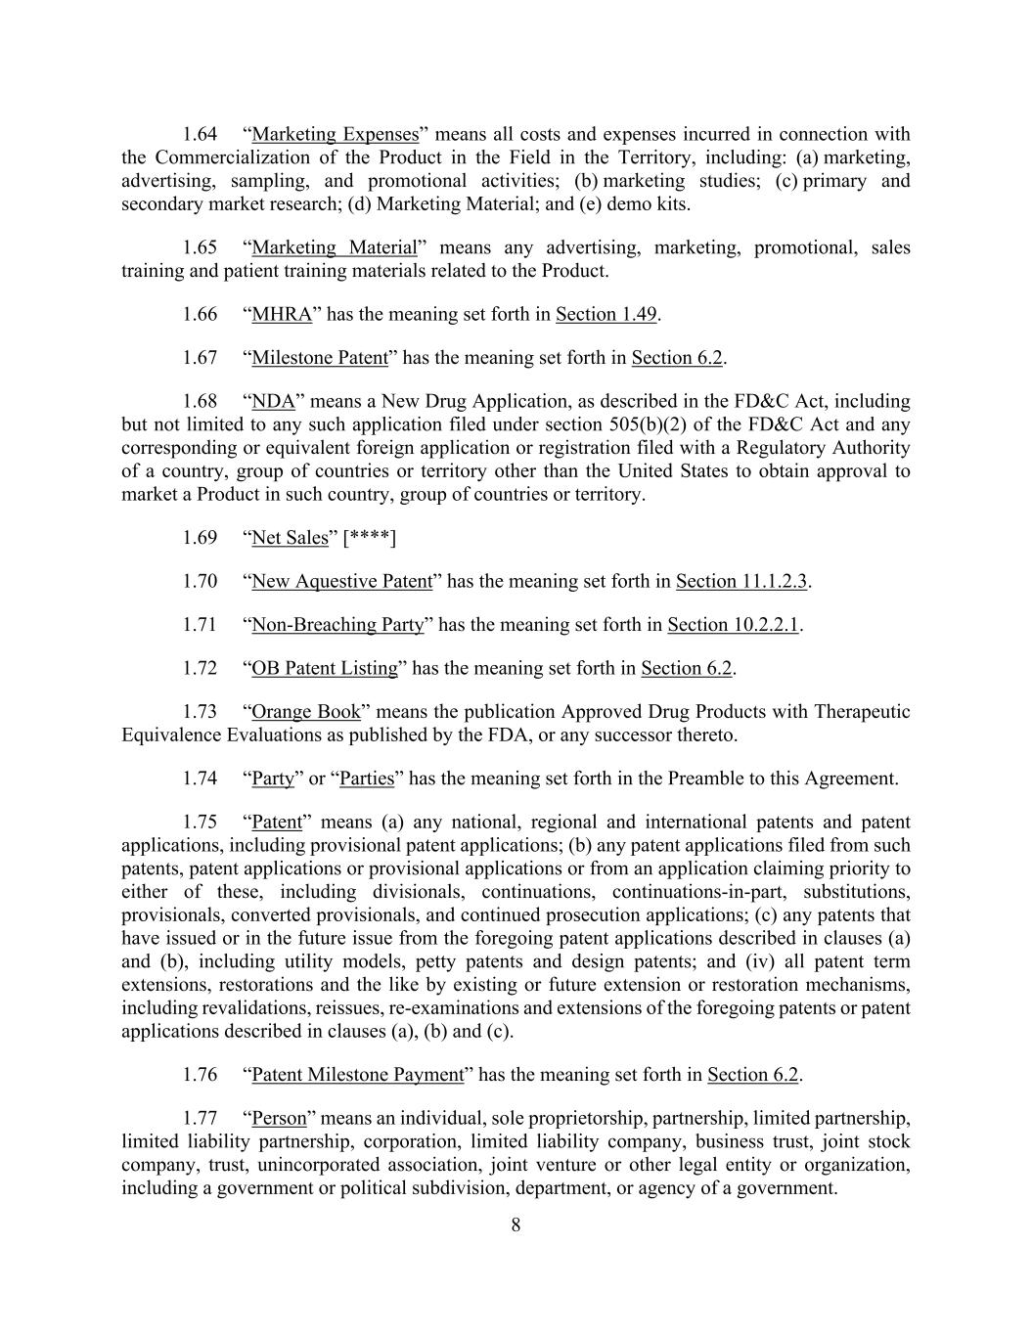
8 1.64 “Marketing Expenses” means all costs and expenses incurred in connection with the Commercialization of the Product in the Field in the Territory, including: (a) marketing, advertising, sampling, and promotional activities; (b) marketing studies; (c) primary and secondary market research; (d) Marketing Material; and (e) demo kits. 1.65 “Marketing Material” means any advertising, marketing, promotional, sales training and patient training materials related to the Product. 1.66 “MHRA” has the meaning set forth in Section 1.49. 1.67 “Milestone Patent” has the meaning set forth in Section 6.2. 1.68 “NDA” means a New Drug Application, as described in the FD&C Act, including but not limited to any such application filed under section 505(b)(2) of the FD&C Act and any corresponding or equivalent foreign application or registration filed with a Regulatory Authority of a country, group of countries or territory other than the United States to obtain approval to market a Product in such country, group of countries or territory. 1.69 “Net Sales” [****] 1.70 “New Aquestive Patent” has the meaning set forth in Section 11.1.2.3. 1.71 “Non-Breaching Party” has the meaning set forth in Section 10.2.2.1. 1.72 “OB Patent Listing” has the meaning set forth in Section 6.2. 1.73 “Orange Book” means the publication Approved Drug Products with Therapeutic Equivalence Evaluations as published by the FDA, or any successor thereto. 1.74 “Party” or “Parties” has the meaning set forth in the Preamble to this Agreement. 1.75 “Patent” means (a) any national, regional and international patents and patent applications, including provisional patent applications; (b) any patent applications filed from such patents, patent applications or provisional applications or from an application claiming priority to either of these, including divisionals, continuations, continuations-in-part, substitutions, provisionals, converted provisionals, and continued prosecution applications; (c) any patents that have issued or in the future issue from the foregoing patent applications described in clauses (a) and (b), including utility models, petty patents and design patents; and (iv) all patent term extensions, restorations and the like by existing or future extension or restoration mechanisms, including revalidations, reissues, re-examinations and extensions of the foregoing patents or patent applications described in clauses (a), (b) and (c). 1.76 “Patent Milestone Payment” has the meaning set forth in Section 6.2. 1.77 “Person” means an individual, sole proprietorship, partnership, limited partnership, limited liability partnership, corporation, limited liability company, business trust, joint stock company, trust, unincorporated association, joint venture or other legal entity or organization, including a government or political subdivision, department, or agency of a government.

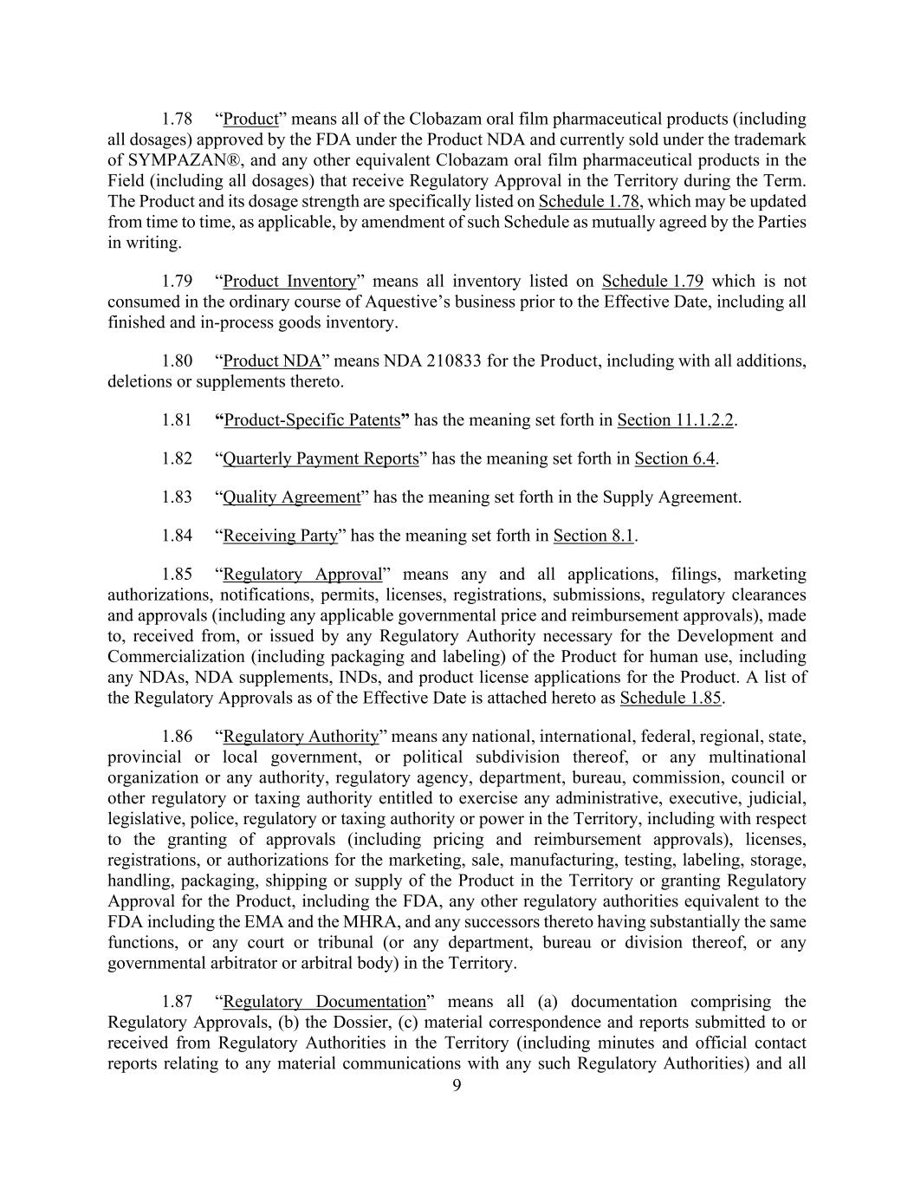
9 1.78 “Product” means all of the Clobazam oral film pharmaceutical products (including all dosages) approved by the FDA under the Product NDA and currently sold under the trademark of SYMPAZAN®, and any other equivalent Clobazam oral film pharmaceutical products in the Field (including all dosages) that receive Regulatory Approval in the Territory during the Term. The Product and its dosage strength are specifically listed on Schedule 1.78, which may be updated from time to time, as applicable, by amendment of such Schedule as mutually agreed by the Parties in writing. 1.79 “Product Inventory” means all inventory listed on Schedule 1.79 which is not consumed in the ordinary course of Aquestive’s business prior to the Effective Date, including all finished and in-process goods inventory. 1.80 “Product NDA” means NDA 210833 for the Product, including with all additions, deletions or supplements thereto. 1.81 “Product-Specific Patents” has the meaning set forth in Section 11.1.2.2. 1.82 “Quarterly Payment Reports” has the meaning set forth in Section 6.4. 1.83 “Quality Agreement” has the meaning set forth in the Supply Agreement. 1.84 “Receiving Party” has the meaning set forth in Section 8.1. 1.85 “Regulatory Approval” means any and all applications, filings, marketing authorizations, notifications, permits, licenses, registrations, submissions, regulatory clearances and approvals (including any applicable governmental price and reimbursement approvals), made to, received from, or issued by any Regulatory Authority necessary for the Development and Commercialization (including packaging and labeling) of the Product for human use, including any NDAs, NDA supplements, INDs, and product license applications for the Product. A list of the Regulatory Approvals as of the Effective Date is attached hereto as Schedule 1.85. 1.86 “Regulatory Authority” means any national, international, federal, regional, state, provincial or local government, or political subdivision thereof, or any multinational organization or any authority, regulatory agency, department, bureau, commission, council or other regulatory or taxing authority entitled to exercise any administrative, executive, judicial, legislative, police, regulatory or taxing authority or power in the Territory, including with respect to the granting of approvals (including pricing and reimbursement approvals), licenses, registrations, or authorizations for the marketing, sale, manufacturing, testing, labeling, storage, handling, packaging, shipping or supply of the Product in the Territory or granting Regulatory Approval for the Product, including the FDA, any other regulatory authorities equivalent to the FDA including the EMA and the MHRA, and any successors thereto having substantially the same functions, or any court or tribunal (or any department, bureau or division thereof, or any governmental arbitrator or arbitral body) in the Territory. 1.87 “Regulatory Documentation” means all (a) documentation comprising the Regulatory Approvals, (b) the Dossier, (c) material correspondence and reports submitted to or received from Regulatory Authorities in the Territory (including minutes and official contact reports relating to any material communications with any such Regulatory Authorities) and all

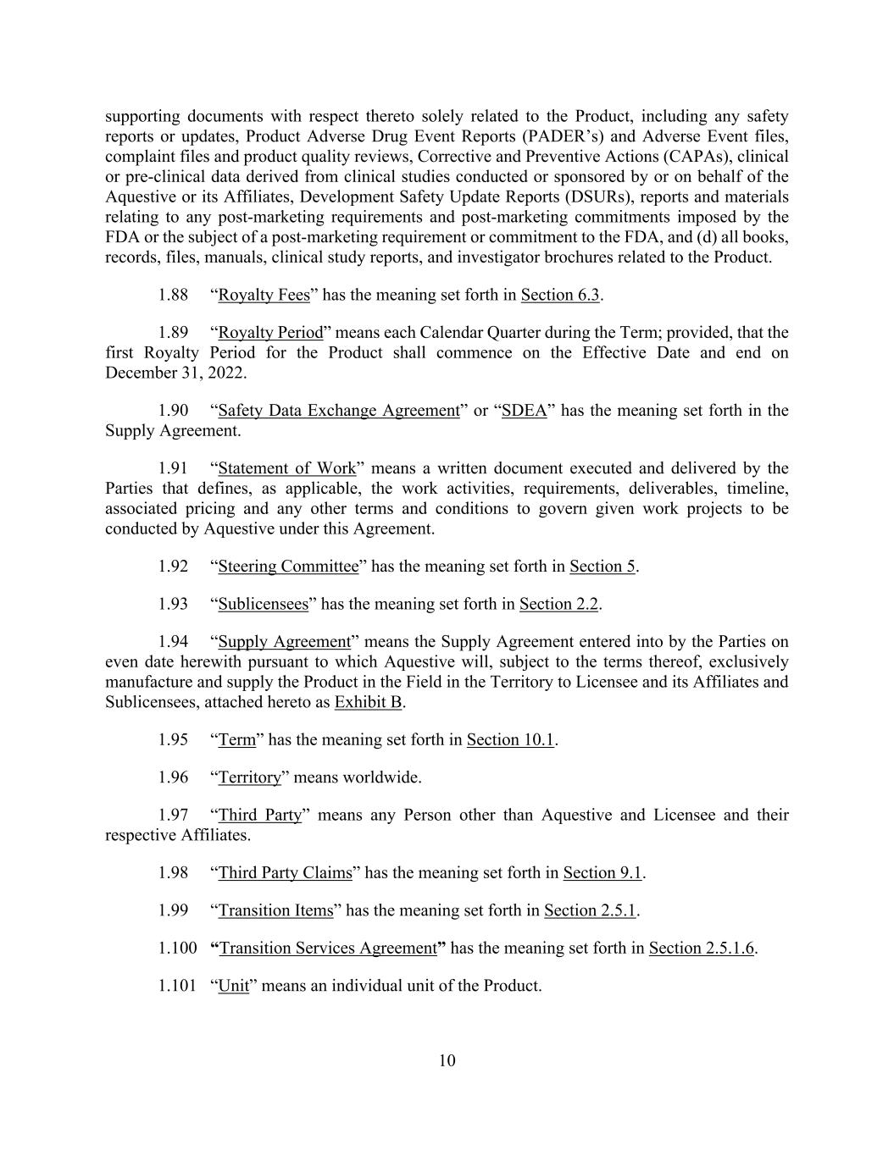
10 supporting documents with respect thereto solely related to the Product, including any safety reports or updates, Product Adverse Drug Event Reports (PADER’s) and Adverse Event files, complaint files and product quality reviews, Corrective and Preventive Actions (CAPAs), clinical or pre-clinical data derived from clinical studies conducted or sponsored by or on behalf of the Aquestive or its Affiliates, Development Safety Update Reports (DSURs), reports and materials relating to any post-marketing requirements and post-marketing commitments imposed by the FDA or the subject of a post-marketing requirement or commitment to the FDA, and (d) all books, records, files, manuals, clinical study reports, and investigator brochures related to the Product. 1.88 “Royalty Fees” has the meaning set forth in Section 6.3. 1.89 “Royalty Period” means each Calendar Quarter during the Term; provided, that the first Royalty Period for the Product shall commence on the Effective Date and end on December 31, 2022. 1.90 “Safety Data Exchange Agreement” or “SDEA” has the meaning set forth in the Supply Agreement. 1.91 “Statement of Work” means a written document executed and delivered by the Parties that defines, as applicable, the work activities, requirements, deliverables, timeline, associated pricing and any other terms and conditions to govern given work projects to be conducted by Aquestive under this Agreement. 1.92 “Steering Committee” has the meaning set forth in Section 5. 1.93 “Sublicensees” has the meaning set forth in Section 2.2. 1.94 “Supply Agreement” means the Supply Agreement entered into by the Parties on even date herewith pursuant to which Aquestive will, subject to the terms thereof, exclusively manufacture and supply the Product in the Field in the Territory to Licensee and its Affiliates and Sublicensees, attached hereto as Exhibit B. 1.95 “Term” has the meaning set forth in Section 10.1. 1.96 “Territory” means worldwide. 1.97 “Third Party” means any Person other than Aquestive and Licensee and their respective Affiliates. 1.98 “Third Party Claims” has the meaning set forth in Section 9.1. 1.99 “Transition Items” has the meaning set forth in Section 2.5.1. 1.100 “Transition Services Agreement” has the meaning set forth in Section 2.5.1.6. 1.101 “Unit” means an individual unit of the Product.

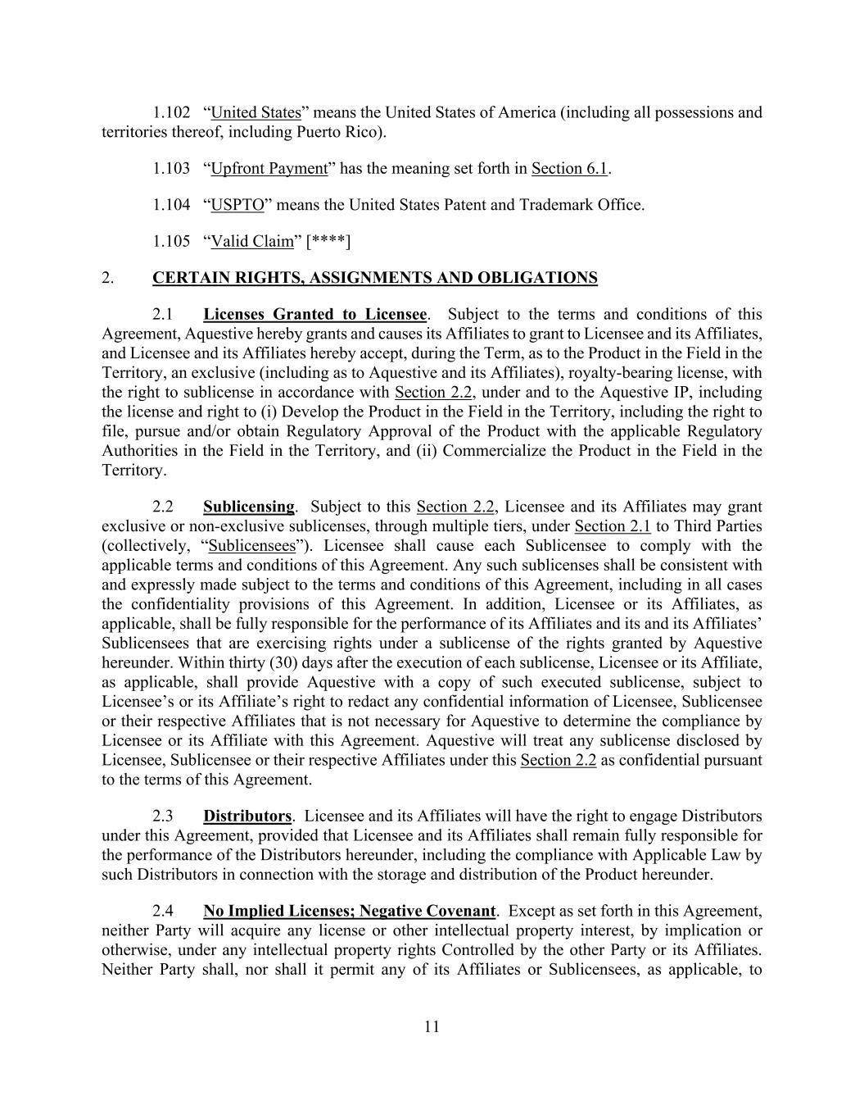
11 1.102 “United States” means the United States of America (including all possessions and territories thereof, including Puerto Rico). 1.103 “Upfront Payment” has the meaning set forth in Section 6.1. 1.104 “USPTO” means the United States Patent and Trademark Office. 1.105 “Valid Claim” [****] 2. CERTAIN RIGHTS, ASSIGNMENTS AND OBLIGATIONS 2.1 Licenses Granted to Licensee. Subject to the terms and conditions of this Agreement, Aquestive hereby grants and causes its Affiliates to grant to Licensee and its Affiliates, and Licensee and its Affiliates hereby accept, during the Term, as to the Product in the Field in the Territory, an exclusive (including as to Aquestive and its Affiliates), royalty-bearing license, with the right to sublicense in accordance with Section 2.2, under and to the Aquestive IP, including the license and right to (i) Develop the Product in the Field in the Territory, including the right to file, pursue and/or obtain Regulatory Approval of the Product with the applicable Regulatory Authorities in the Field in the Territory, and (ii) Commercialize the Product in the Field in the Territory. 2.2 Sublicensing. Subject to this Section 2.2, Licensee and its Affiliates may grant exclusive or non-exclusive sublicenses, through multiple tiers, under Section 2.1 to Third Parties (collectively, “Sublicensees”). Licensee shall cause each Sublicensee to comply with the applicable terms and conditions of this Agreement. Any such sublicenses shall be consistent with and expressly made subject to the terms and conditions of this Agreement, including in all cases the confidentiality provisions of this Agreement. In addition, Licensee or its Affiliates, as applicable, shall be fully responsible for the performance of its Affiliates and its and its Affiliates’ Sublicensees that are exercising rights under a sublicense of the rights granted by Aquestive hereunder. Within thirty (30) days after the execution of each sublicense, Licensee or its Affiliate, as applicable, shall provide Aquestive with a copy of such executed sublicense, subject to Licensee’s or its Affiliate’s right to redact any confidential information of Licensee, Sublicensee or their respective Affiliates that is not necessary for Aquestive to determine the compliance by Licensee or its Affiliate with this Agreement. Aquestive will treat any sublicense disclosed by Licensee, Sublicensee or their respective Affiliates under this Section 2.2 as confidential pursuant to the terms of this Agreement. 2.3 Distributors. Licensee and its Affiliates will have the right to engage Distributors under this Agreement, provided that Licensee and its Affiliates shall remain fully responsible for the performance of the Distributors hereunder, including the compliance with Applicable Law by such Distributors in connection with the storage and distribution of the Product hereunder. 2.4 No Implied Licenses; Negative Covenant. Except as set forth in this Agreement, neither Party will acquire any license or other intellectual property interest, by implication or otherwise, under any intellectual property rights Controlled by the other Party or its Affiliates. Neither Party shall, nor shall it permit any of its Affiliates or Sublicensees, as applicable, to

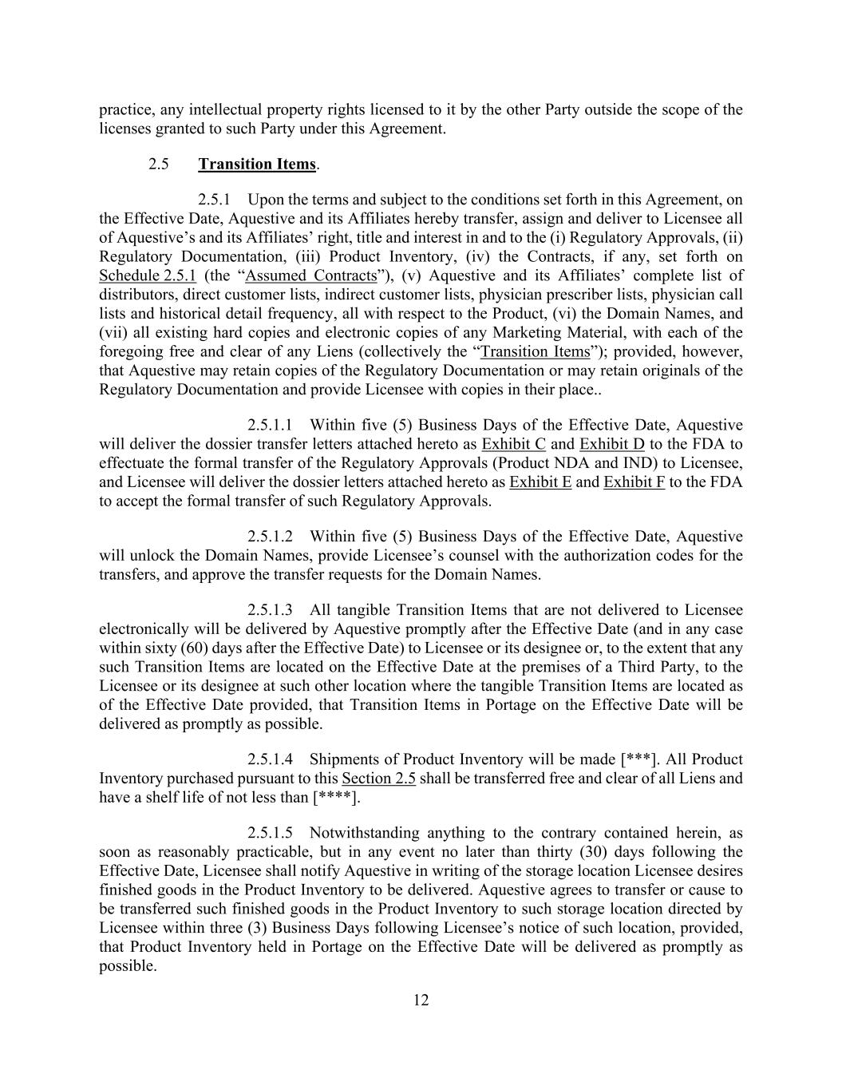
12 practice, any intellectual property rights licensed to it by the other Party outside the scope of the licenses granted to such Party under this Agreement. 2.5 Transition Items. 2.5.1 Upon the terms and subject to the conditions set forth in this Agreement, on the Effective Date, Aquestive and its Affiliates hereby transfer, assign and deliver to Licensee all of Aquestive’s and its Affiliates’ right, title and interest in and to the (i) Regulatory Approvals, (ii) Regulatory Documentation, (iii) Product Inventory, (iv) the Contracts, if any, set forth on Schedule 2.5.1 (the “Assumed Contracts”), (v) Aquestive and its Affiliates’ complete list of distributors, direct customer lists, indirect customer lists, physician prescriber lists, physician call lists and historical detail frequency, all with respect to the Product, (vi) the Domain Names, and (vii) all existing hard copies and electronic copies of any Marketing Material, with each of the foregoing free and clear of any Liens (collectively the “Transition Items”); provided, however, that Aquestive may retain copies of the Regulatory Documentation or may retain originals of the Regulatory Documentation and provide Licensee with copies in their place.. 2.5.1.1 Within five (5) Business Days of the Effective Date, Aquestive will deliver the dossier transfer letters attached hereto as Exhibit C and Exhibit D to the FDA to effectuate the formal transfer of the Regulatory Approvals (Product NDA and IND) to Licensee, and Licensee will deliver the dossier letters attached hereto as Exhibit E and Exhibit F to the FDA to accept the formal transfer of such Regulatory Approvals. 2.5.1.2 Within five (5) Business Days of the Effective Date, Aquestive will unlock the Domain Names, provide Licensee’s counsel with the authorization codes for the transfers, and approve the transfer requests for the Domain Names. 2.5.1.3 All tangible Transition Items that are not delivered to Licensee electronically will be delivered by Aquestive promptly after the Effective Date (and in any case within sixty (60) days after the Effective Date) to Licensee or its designee or, to the extent that any such Transition Items are located on the Effective Date at the premises of a Third Party, to the Licensee or its designee at such other location where the tangible Transition Items are located as of the Effective Date provided, that Transition Items in Portage on the Effective Date will be delivered as promptly as possible. 2.5.1.4 Shipments of Product Inventory will be made [***]. All Product Inventory purchased pursuant to this Section 2.5 shall be transferred free and clear of all Liens and have a shelf life of not less than [****]. 2.5.1.5 Notwithstanding anything to the contrary contained herein, as soon as reasonably practicable, but in any event no later than thirty (30) days following the Effective Date, Licensee shall notify Aquestive in writing of the storage location Licensee desires finished goods in the Product Inventory to be delivered. Aquestive agrees to transfer or cause to be transferred such finished goods in the Product Inventory to such storage location directed by Licensee within three (3) Business Days following Licensee’s notice of such location, provided, that Product Inventory held in Portage on the Effective Date will be delivered as promptly as possible.

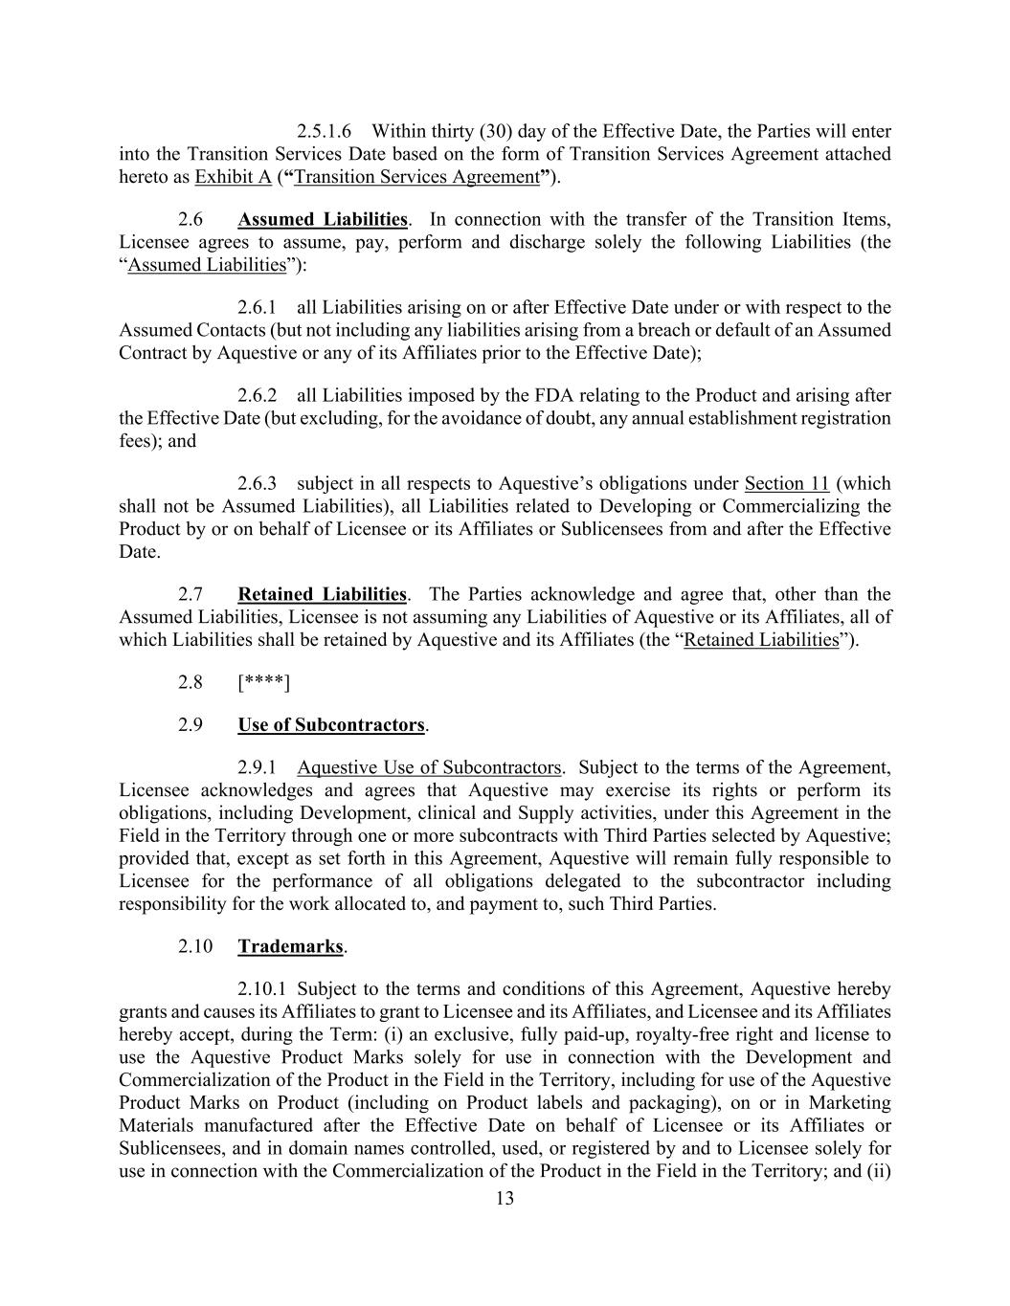
13 2.5.1.6 Within thirty (30) day of the Effective Date, the Parties will enter into the Transition Services Date based on the form of Transition Services Agreement attached hereto as Exhibit A (“Transition Services Agreement”). 2.6 Assumed Liabilities. In connection with the transfer of the Transition Items, Licensee agrees to assume, pay, perform and discharge solely the following Liabilities (the “Assumed Liabilities”): 2.6.1 all Liabilities arising on or after Effective Date under or with respect to the Assumed Contacts (but not including any liabilities arising from a breach or default of an Assumed Contract by Aquestive or any of its Affiliates prior to the Effective Date); 2.6.2 all Liabilities imposed by the FDA relating to the Product and arising after the Effective Date (but excluding, for the avoidance of doubt, any annual establishment registration fees); and 2.6.3 subject in all respects to Aquestive’s obligations under Section 11 (which shall not be Assumed Liabilities), all Liabilities related to Developing or Commercializing the Product by or on behalf of Licensee or its Affiliates or Sublicensees from and after the Effective Date. 2.7 Retained Liabilities. The Parties acknowledge and agree that, other than the Assumed Liabilities, Licensee is not assuming any Liabilities of Aquestive or its Affiliates, all of which Liabilities shall be retained by Aquestive and its Affiliates (the “Retained Liabilities”). 2.8 [****] 2.9 Use of Subcontractors. 2.9.1 Aquestive Use of Subcontractors. Subject to the terms of the Agreement, Licensee acknowledges and agrees that Aquestive may exercise its rights or perform its obligations, including Development, clinical and Supply activities, under this Agreement in the Field in the Territory through one or more subcontracts with Third Parties selected by Aquestive; provided that, except as set forth in this Agreement, Aquestive will remain fully responsible to Licensee for the performance of all obligations delegated to the subcontractor including responsibility for the work allocated to, and payment to, such Third Parties. 2.10 Trademarks. 2.10.1 Subject to the terms and conditions of this Agreement, Aquestive hereby grants and causes its Affiliates to grant to Licensee and its Affiliates, and Licensee and its Affiliates hereby accept, during the Term: (i) an exclusive, fully paid-up, royalty-free right and license to use the Aquestive Product Marks solely for use in connection with the Development and Commercialization of the Product in the Field in the Territory, including for use of the Aquestive Product Marks on Product (including on Product labels and packaging), on or in Marketing Materials manufactured after the Effective Date on behalf of Licensee or its Affiliates or Sublicensees, and in domain names controlled, used, or registered by and to Licensee solely for use in connection with the Commercialization of the Product in the Field in the Territory; and (ii)

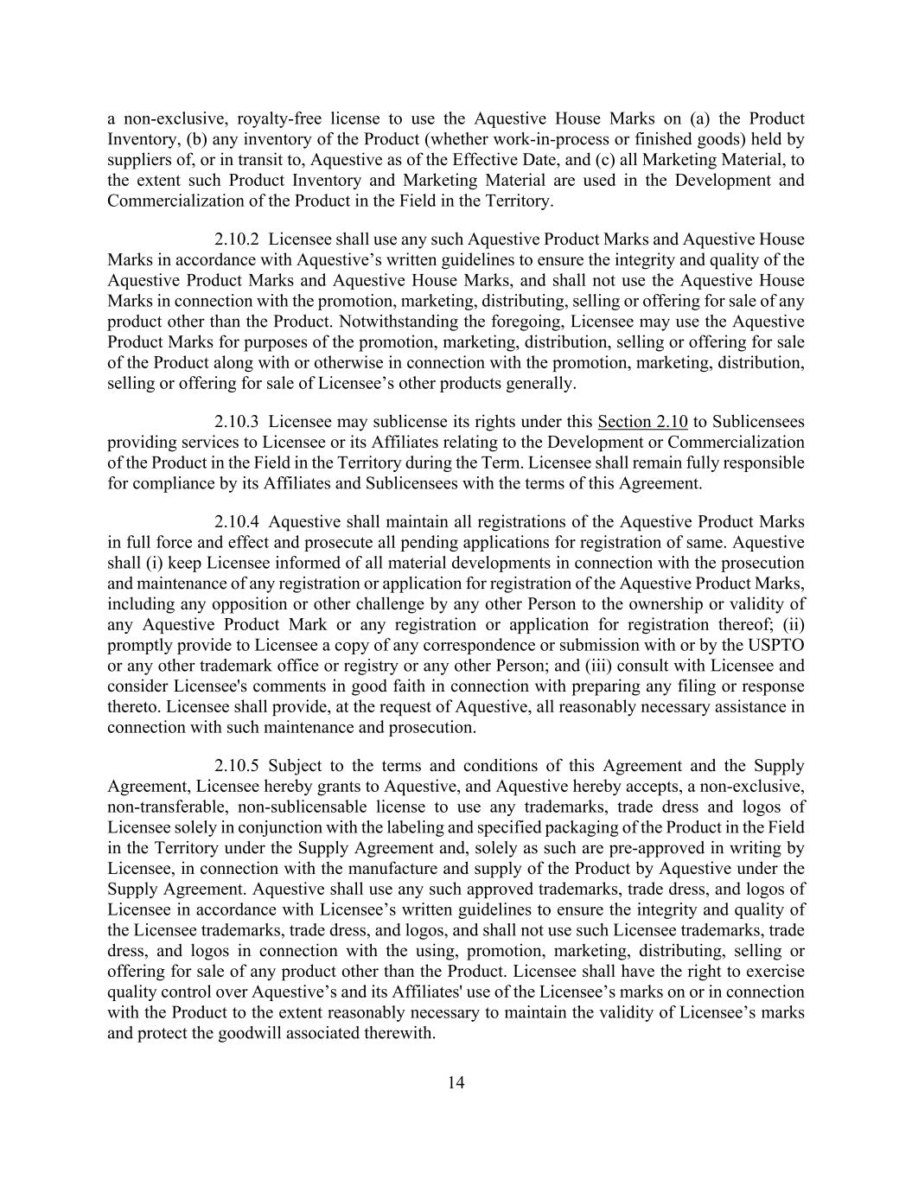
14 a non-exclusive, royalty-free license to use the Aquestive House Marks on (a) the Product Inventory, (b) any inventory of the Product (whether work-in-process or finished goods) held by suppliers of, or in transit to, Aquestive as of the Effective Date, and (c) all Marketing Material, to the extent such Product Inventory and Marketing Material are used in the Development and Commercialization of the Product in the Field in the Territory. 2.10.2 Licensee shall use any such Aquestive Product Marks and Aquestive House Marks in accordance with Aquestive’s written guidelines to ensure the integrity and quality of the Aquestive Product Marks and Aquestive House Marks, and shall not use the Aquestive House Marks in connection with the promotion, marketing, distributing, selling or offering for sale of any product other than the Product. Notwithstanding the foregoing, Licensee may use the Aquestive Product Marks for purposes of the promotion, marketing, distribution, selling or offering for sale of the Product along with or otherwise in connection with the promotion, marketing, distribution, selling or offering for sale of Licensee’s other products generally. 2.10.3 Licensee may sublicense its rights under this Section 2.10 to Sublicensees providing services to Licensee or its Affiliates relating to the Development or Commercialization of the Product in the Field in the Territory during the Term. Licensee shall remain fully responsible for compliance by its Affiliates and Sublicensees with the terms of this Agreement. 2.10.4 Aquestive shall maintain all registrations of the Aquestive Product Marks in full force and effect and prosecute all pending applications for registration of same. Aquestive shall (i) keep Licensee informed of all material developments in connection with the prosecution and maintenance of any registration or application for registration of the Aquestive Product Marks, including any opposition or other challenge by any other Person to the ownership or validity of any Aquestive Product Mark or any registration or application for registration thereof; (ii) promptly provide to Licensee a copy of any correspondence or submission with or by the USPTO or any other trademark office or registry or any other Person; and (iii) consult with Licensee and consider Licensee's comments in good faith in connection with preparing any filing or response thereto. Licensee shall provide, at the request of Aquestive, all reasonably necessary assistance in connection with such maintenance and prosecution. 2.10.5 Subject to the terms and conditions of this Agreement and the Supply Agreement, Licensee hereby grants to Aquestive, and Aquestive hereby accepts, a non-exclusive, non-transferable, non-sublicensable license to use any trademarks, trade dress and logos of Licensee solely in conjunction with the labeling and specified packaging of the Product in the Field in the Territory under the Supply Agreement and, solely as such are pre-approved in writing by Licensee, in connection with the manufacture and supply of the Product by Aquestive under the Supply Agreement. Aquestive shall use any such approved trademarks, trade dress, and logos of Licensee in accordance with Licensee’s written guidelines to ensure the integrity and quality of the Licensee trademarks, trade dress, and logos, and shall not use such Licensee trademarks, trade dress, and logos in connection with the using, promotion, marketing, distributing, selling or offering for sale of any product other than the Product. Licensee shall have the right to exercise quality control over Aquestive’s and its Affiliates' use of the Licensee’s marks on or in connection with the Product to the extent reasonably necessary to maintain the validity of Licensee’s marks and protect the goodwill associated therewith.

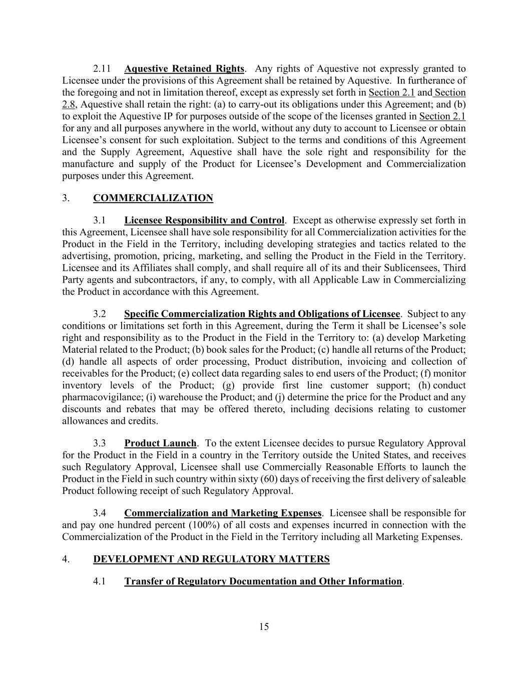
15 2.11 Aquestive Retained Rights. Any rights of Aquestive not expressly granted to Licensee under the provisions of this Agreement shall be retained by Aquestive. In furtherance of the foregoing and not in limitation thereof, except as expressly set forth in Section 2.1 and Section 2.8, Aquestive shall retain the right: (a) to carry-out its obligations under this Agreement; and (b) to exploit the Aquestive IP for purposes outside of the scope of the licenses granted in Section 2.1 for any and all purposes anywhere in the world, without any duty to account to Licensee or obtain Licensee’s consent for such exploitation. Subject to the terms and conditions of this Agreement and the Supply Agreement, Aquestive shall have the sole right and responsibility for the manufacture and supply of the Product for Licensee’s Development and Commercialization purposes under this Agreement. 3. COMMERCIALIZATION 3.1 Licensee Responsibility and Control. Except as otherwise expressly set forth in this Agreement, Licensee shall have sole responsibility for all Commercialization activities for the Product in the Field in the Territory, including developing strategies and tactics related to the advertising, promotion, pricing, marketing, and selling the Product in the Field in the Territory. Licensee and its Affiliates shall comply, and shall require all of its and their Sublicensees, Third Party agents and subcontractors, if any, to comply, with all Applicable Law in Commercializing the Product in accordance with this Agreement. 3.2 Specific Commercialization Rights and Obligations of Licensee. Subject to any conditions or limitations set forth in this Agreement, during the Term it shall be Licensee’s sole right and responsibility as to the Product in the Field in the Territory to: (a) develop Marketing Material related to the Product; (b) book sales for the Product; (c) handle all returns of the Product; (d) handle all aspects of order processing, Product distribution, invoicing and collection of receivables for the Product; (e) collect data regarding sales to end users of the Product; (f) monitor inventory levels of the Product; (g) provide first line customer support; (h) conduct pharmacovigilance; (i) warehouse the Product; and (j) determine the price for the Product and any discounts and rebates that may be offered thereto, including decisions relating to customer allowances and credits. 3.3 Product Launch. To the extent Licensee decides to pursue Regulatory Approval for the Product in the Field in a country in the Territory outside the United States, and receives such Regulatory Approval, Licensee shall use Commercially Reasonable Efforts to launch the Product in the Field in such country within sixty (60) days of receiving the first delivery of saleable Product following receipt of such Regulatory Approval. 3.4 Commercialization and Marketing Expenses. Licensee shall be responsible for and pay one hundred percent (100%) of all costs and expenses incurred in connection with the Commercialization of the Product in the Field in the Territory including all Marketing Expenses. 4. DEVELOPMENT AND REGULATORY MATTERS 4.1 Transfer of Regulatory Documentation and Other Information.

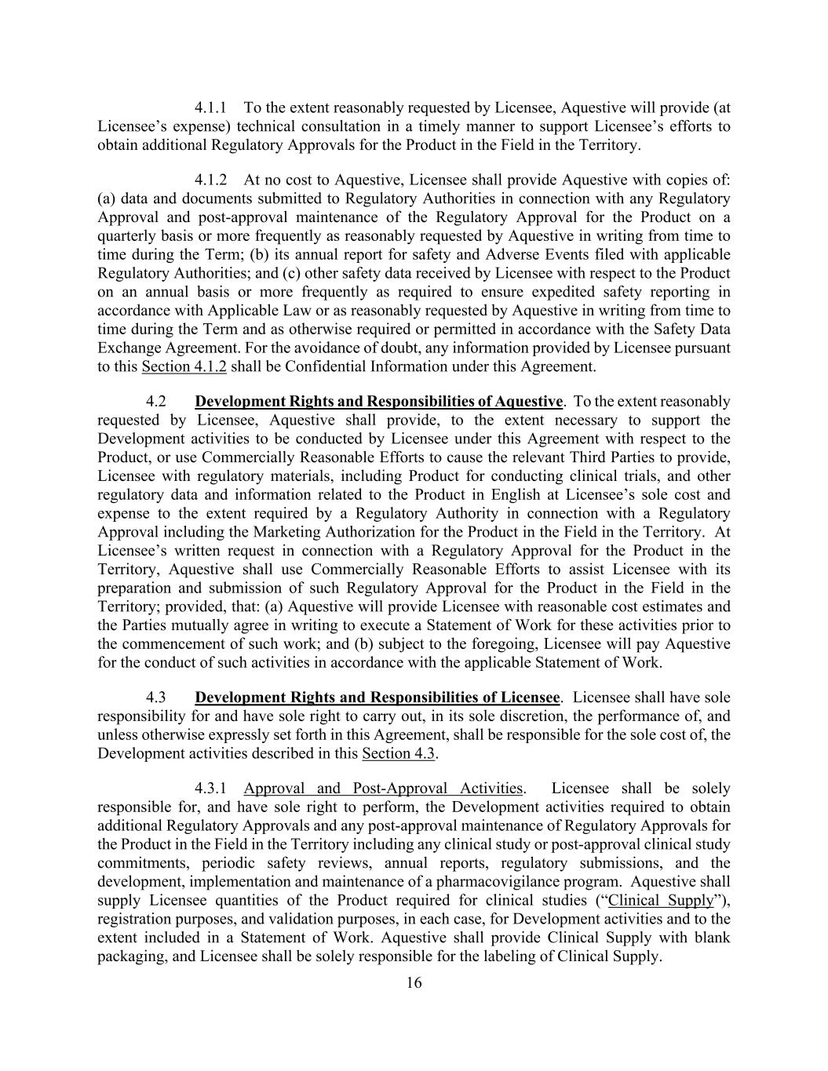
16 4.1.1 To the extent reasonably requested by Licensee, Aquestive will provide (at Licensee’s expense) technical consultation in a timely manner to support Licensee’s efforts to obtain additional Regulatory Approvals for the Product in the Field in the Territory. 4.1.2 At no cost to Aquestive, Licensee shall provide Aquestive with copies of: (a) data and documents submitted to Regulatory Authorities in connection with any Regulatory Approval and post-approval maintenance of the Regulatory Approval for the Product on a quarterly basis or more frequently as reasonably requested by Aquestive in writing from time to time during the Term; (b) its annual report for safety and Adverse Events filed with applicable Regulatory Authorities; and (c) other safety data received by Licensee with respect to the Product on an annual basis or more frequently as required to ensure expedited safety reporting in accordance with Applicable Law or as reasonably requested by Aquestive in writing from time to time during the Term and as otherwise required or permitted in accordance with the Safety Data Exchange Agreement. For the avoidance of doubt, any information provided by Licensee pursuant to this Section 4.1.2 shall be Confidential Information under this Agreement. 4.2 Development Rights and Responsibilities of Aquestive. To the extent reasonably requested by Licensee, Aquestive shall provide, to the extent necessary to support the Development activities to be conducted by Licensee under this Agreement with respect to the Product, or use Commercially Reasonable Efforts to cause the relevant Third Parties to provide, Licensee with regulatory materials, including Product for conducting clinical trials, and other regulatory data and information related to the Product in English at Licensee’s sole cost and expense to the extent required by a Regulatory Authority in connection with a Regulatory Approval including the Marketing Authorization for the Product in the Field in the Territory. At Licensee’s written request in connection with a Regulatory Approval for the Product in the Territory, Aquestive shall use Commercially Reasonable Efforts to assist Licensee with its preparation and submission of such Regulatory Approval for the Product in the Field in the Territory; provided, that: (a) Aquestive will provide Licensee with reasonable cost estimates and the Parties mutually agree in writing to execute a Statement of Work for these activities prior to the commencement of such work; and (b) subject to the foregoing, Licensee will pay Aquestive for the conduct of such activities in accordance with the applicable Statement of Work. 4.3 Development Rights and Responsibilities of Licensee. Licensee shall have sole responsibility for and have sole right to carry out, in its sole discretion, the performance of, and unless otherwise expressly set forth in this Agreement, shall be responsible for the sole cost of, the Development activities described in this Section 4.3. 4.3.1 Approval and Post-Approval Activities. Licensee shall be solely responsible for, and have sole right to perform, the Development activities required to obtain additional Regulatory Approvals and any post-approval maintenance of Regulatory Approvals for the Product in the Field in the Territory including any clinical study or post-approval clinical study commitments, periodic safety reviews, annual reports, regulatory submissions, and the development, implementation and maintenance of a pharmacovigilance program. Aquestive shall supply Licensee quantities of the Product required for clinical studies (“Clinical Supply”), registration purposes, and validation purposes, in each case, for Development activities and to the extent included in a Statement of Work. Aquestive shall provide Clinical Supply with blank packaging, and Licensee shall be solely responsible for the labeling of Clinical Supply.

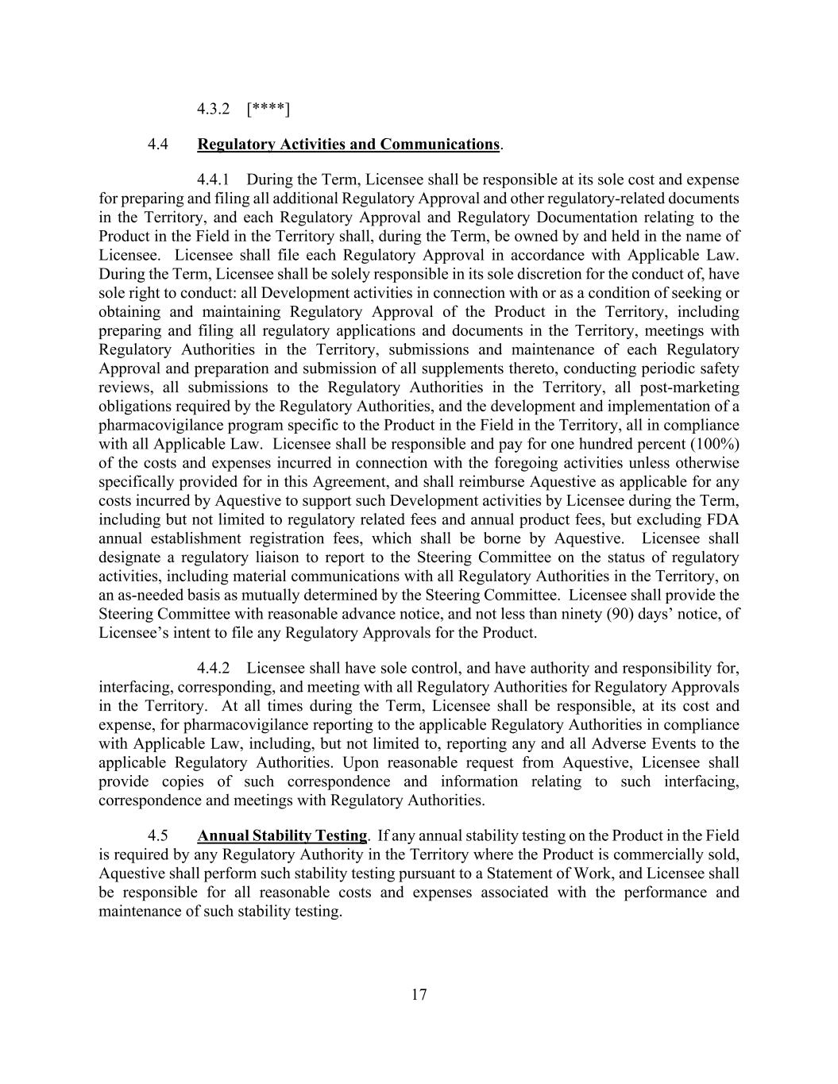
17 4.3.2 [****] 4.4 Regulatory Activities and Communications. 4.4.1 During the Term, Licensee shall be responsible at its sole cost and expense for preparing and filing all additional Regulatory Approval and other regulatory-related documents in the Territory, and each Regulatory Approval and Regulatory Documentation relating to the Product in the Field in the Territory shall, during the Term, be owned by and held in the name of Licensee. Licensee shall file each Regulatory Approval in accordance with Applicable Law. During the Term, Licensee shall be solely responsible in its sole discretion for the conduct of, have sole right to conduct: all Development activities in connection with or as a condition of seeking or obtaining and maintaining Regulatory Approval of the Product in the Territory, including preparing and filing all regulatory applications and documents in the Territory, meetings with Regulatory Authorities in the Territory, submissions and maintenance of each Regulatory Approval and preparation and submission of all supplements thereto, conducting periodic safety reviews, all submissions to the Regulatory Authorities in the Territory, all post-marketing obligations required by the Regulatory Authorities, and the development and implementation of a pharmacovigilance program specific to the Product in the Field in the Territory, all in compliance with all Applicable Law. Licensee shall be responsible and pay for one hundred percent (100%) of the costs and expenses incurred in connection with the foregoing activities unless otherwise specifically provided for in this Agreement, and shall reimburse Aquestive as applicable for any costs incurred by Aquestive to support such Development activities by Licensee during the Term, including but not limited to regulatory related fees and annual product fees, but excluding FDA annual establishment registration fees, which shall be borne by Aquestive. Licensee shall designate a regulatory liaison to report to the Steering Committee on the status of regulatory activities, including material communications with all Regulatory Authorities in the Territory, on an as-needed basis as mutually determined by the Steering Committee. Licensee shall provide the Steering Committee with reasonable advance notice, and not less than ninety (90) days’ notice, of Licensee’s intent to file any Regulatory Approvals for the Product. 4.4.2 Licensee shall have sole control, and have authority and responsibility for, interfacing, corresponding, and meeting with all Regulatory Authorities for Regulatory Approvals in the Territory. At all times during the Term, Licensee shall be responsible, at its cost and expense, for pharmacovigilance reporting to the applicable Regulatory Authorities in compliance with Applicable Law, including, but not limited to, reporting any and all Adverse Events to the applicable Regulatory Authorities. Upon reasonable request from Aquestive, Licensee shall provide copies of such correspondence and information relating to such interfacing, correspondence and meetings with Regulatory Authorities. 4.5 Annual Stability Testing. If any annual stability testing on the Product in the Field is required by any Regulatory Authority in the Territory where the Product is commercially sold, Aquestive shall perform such stability testing pursuant to a Statement of Work, and Licensee shall be responsible for all reasonable costs and expenses associated with the performance and maintenance of such stability testing.

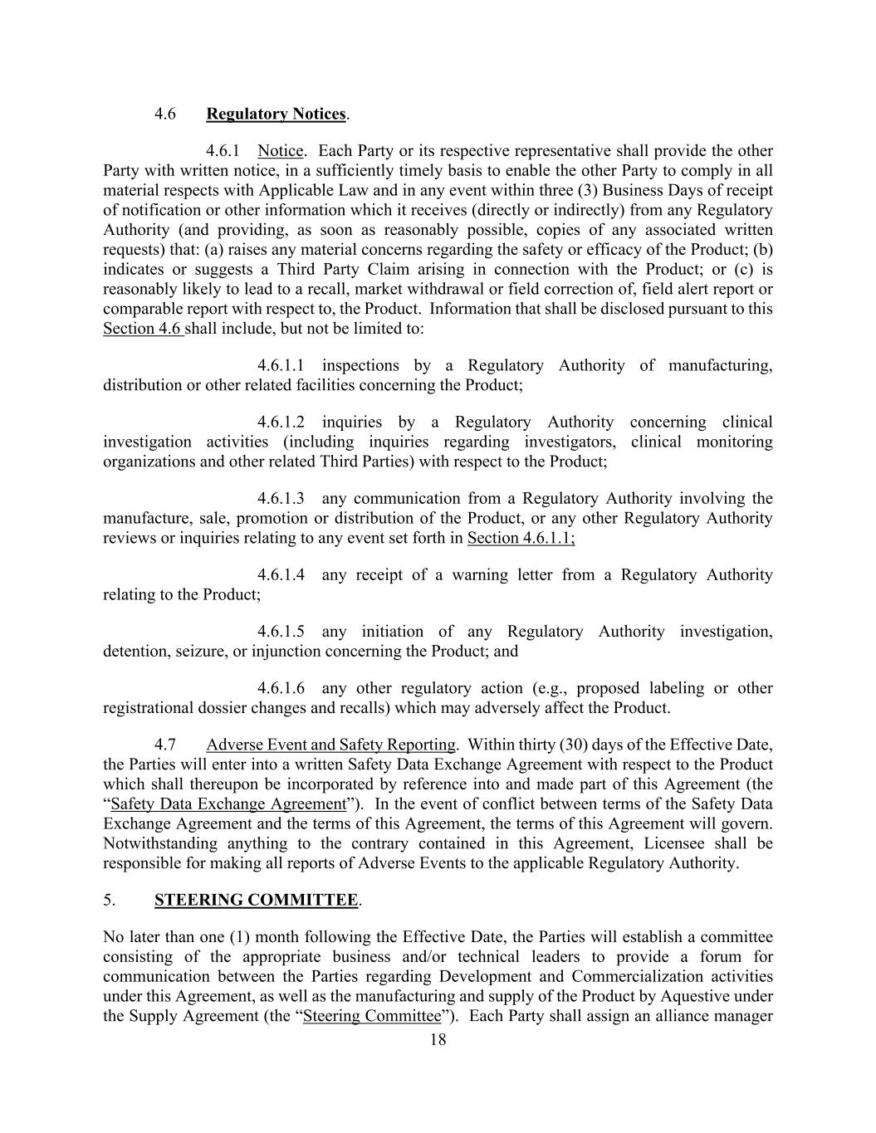
18 4.6 Regulatory Notices. 4.6.1 Notice. Each Party or its respective representative shall provide the other Party with written notice, in a sufficiently timely basis to enable the other Party to comply in all material respects with Applicable Law and in any event within three (3) Business Days of receipt of notification or other information which it receives (directly or indirectly) from any Regulatory Authority (and providing, as soon as reasonably possible, copies of any associated written requests) that: (a) raises any material concerns regarding the safety or efficacy of the Product; (b) indicates or suggests a Third Party Claim arising in connection with the Product; or (c) is reasonably likely to lead to a recall, market withdrawal or field correction of, field alert report or comparable report with respect to, the Product. Information that shall be disclosed pursuant to this Section 4.6 shall include, but not be limited to: 4.6.1.1 inspections by a Regulatory Authority of manufacturing, distribution or other related facilities concerning the Product; 4.6.1.2 inquiries by a Regulatory Authority concerning clinical investigation activities (including inquiries regarding investigators, clinical monitoring organizations and other related Third Parties) with respect to the Product; 4.6.1.3 any communication from a Regulatory Authority involving the manufacture, sale, promotion or distribution of the Product, or any other Regulatory Authority reviews or inquiries relating to any event set forth in Section 4.6.1.1; 4.6.1.4 any receipt of a warning letter from a Regulatory Authority relating to the Product; 4.6.1.5 any initiation of any Regulatory Authority investigation, detention, seizure, or injunction concerning the Product; and 4.6.1.6 any other regulatory action (e.g., proposed labeling or other registrational dossier changes and recalls) which may adversely affect the Product. 4.7 Adverse Event and Safety Reporting. Within thirty (30) days of the Effective Date, the Parties will enter into a written Safety Data Exchange Agreement with respect to the Product which shall thereupon be incorporated by reference into and made part of this Agreement (the “Safety Data Exchange Agreement”). In the event of conflict between terms of the Safety Data Exchange Agreement and the terms of this Agreement, the terms of this Agreement will govern. Notwithstanding anything to the contrary contained in this Agreement, Licensee shall be responsible for making all reports of Adverse Events to the applicable Regulatory Authority. 5. STEERING COMMITTEE. No later than one (1) month following the Effective Date, the Parties will establish a committee consisting of the appropriate business and/or technical leaders to provide a forum for communication between the Parties regarding Development and Commercialization activities under this Agreement, as well as the manufacturing and supply of the Product by Aquestive under the Supply Agreement (the “Steering Committee”). Each Party shall assign an alliance manager

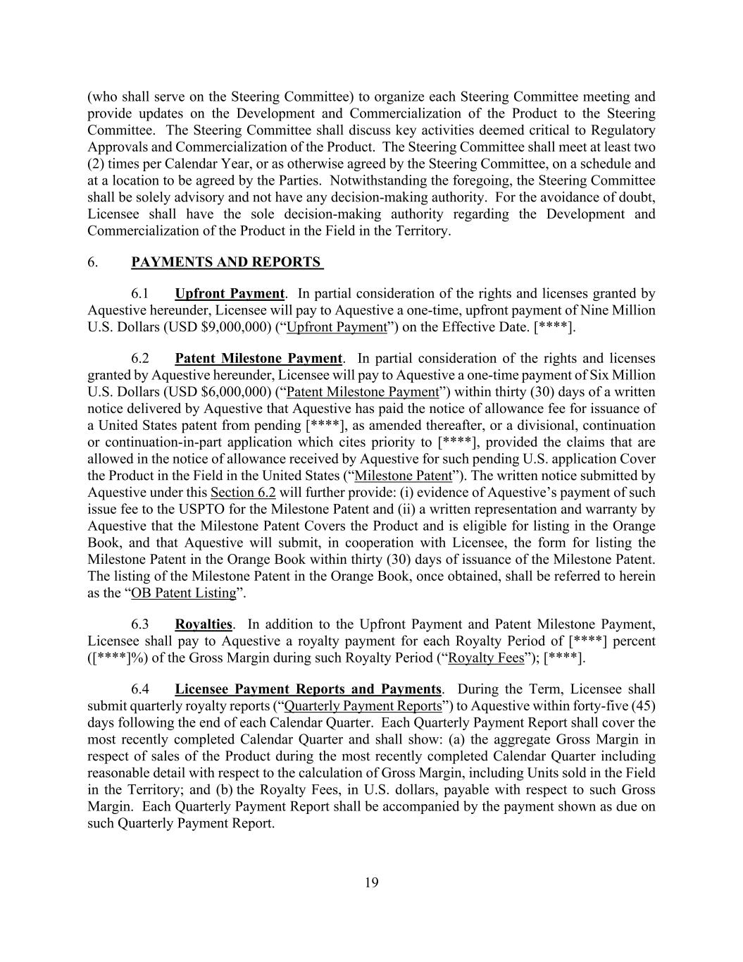
19 (who shall serve on the Steering Committee) to organize each Steering Committee meeting and provide updates on the Development and Commercialization of the Product to the Steering Committee. The Steering Committee shall discuss key activities deemed critical to Regulatory Approvals and Commercialization of the Product. The Steering Committee shall meet at least two (2) times per Calendar Year, or as otherwise agreed by the Steering Committee, on a schedule and at a location to be agreed by the Parties. Notwithstanding the foregoing, the Steering Committee shall be solely advisory and not have any decision-making authority. For the avoidance of doubt, Licensee shall have the sole decision-making authority regarding the Development and Commercialization of the Product in the Field in the Territory. 6. PAYMENTS AND REPORTS 6.1 Upfront Payment. In partial consideration of the rights and licenses granted by Aquestive hereunder, Licensee will pay to Aquestive a one-time, upfront payment of Nine Million U.S. Dollars (USD $9,000,000) (“Upfront Payment”) on the Effective Date. [****]. 6.2 Patent Milestone Payment. In partial consideration of the rights and licenses granted by Aquestive hereunder, Licensee will pay to Aquestive a one-time payment of Six Million U.S. Dollars (USD $6,000,000) (“Patent Milestone Payment”) within thirty (30) days of a written notice delivered by Aquestive that Aquestive has paid the notice of allowance fee for issuance of a United States patent from pending [****], as amended thereafter, or a divisional, continuation or continuation-in-part application which cites priority to [****], provided the claims that are allowed in the notice of allowance received by Aquestive for such pending U.S. application Cover the Product in the Field in the United States (“Milestone Patent”). The written notice submitted by Aquestive under this Section 6.2 will further provide: (i) evidence of Aquestive’s payment of such issue fee to the USPTO for the Milestone Patent and (ii) a written representation and warranty by Aquestive that the Milestone Patent Covers the Product and is eligible for listing in the Orange Book, and that Aquestive will submit, in cooperation with Licensee, the form for listing the Milestone Patent in the Orange Book within thirty (30) days of issuance of the Milestone Patent. The listing of the Milestone Patent in the Orange Book, once obtained, shall be referred to herein as the “OB Patent Listing”. 6.3 Royalties. In addition to the Upfront Payment and Patent Milestone Payment, Licensee shall pay to Aquestive a royalty payment for each Royalty Period of [****] percent ([****]%) of the Gross Margin during such Royalty Period (“Royalty Fees”); [****]. 6.4 Licensee Payment Reports and Payments. During the Term, Licensee shall submit quarterly royalty reports (“Quarterly Payment Reports”) to Aquestive within forty-five (45) days following the end of each Calendar Quarter. Each Quarterly Payment Report shall cover the most recently completed Calendar Quarter and shall show: (a) the aggregate Gross Margin in respect of sales of the Product during the most recently completed Calendar Quarter including reasonable detail with respect to the calculation of Gross Margin, including Units sold in the Field in the Territory; and (b) the Royalty Fees, in U.S. dollars, payable with respect to such Gross Margin. Each Quarterly Payment Report shall be accompanied by the payment shown as due on such Quarterly Payment Report.

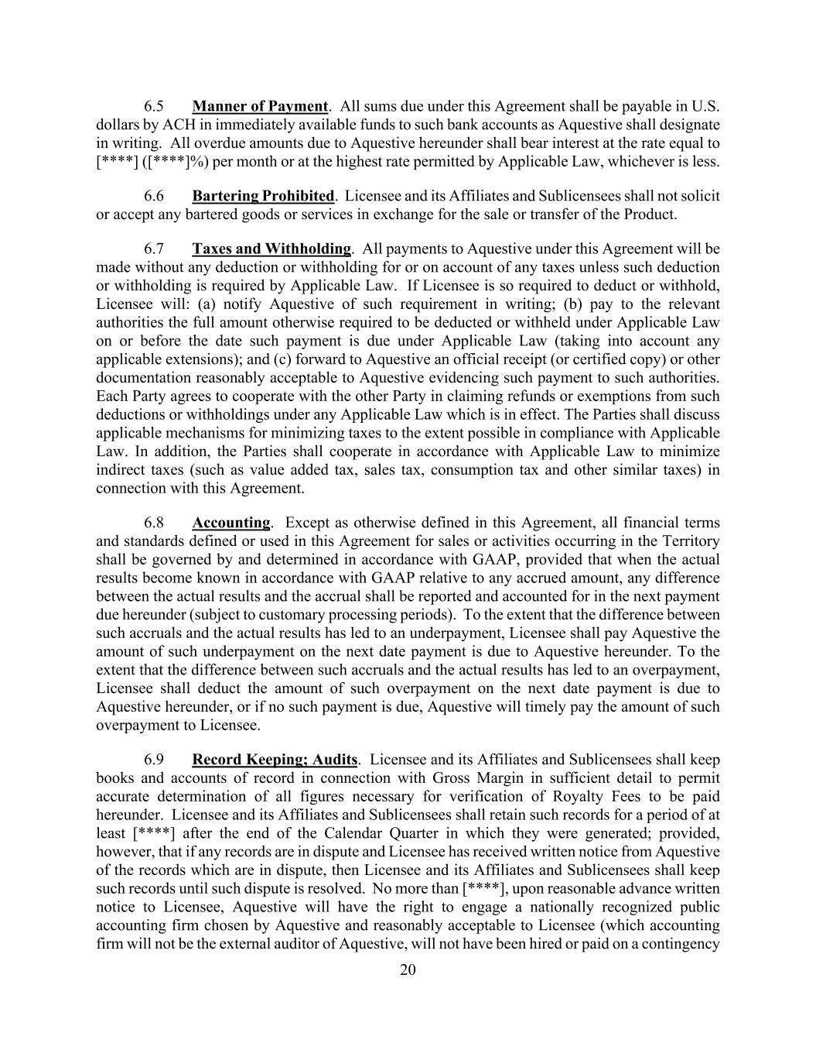
20 6.5 Manner of Payment. All sums due under this Agreement shall be payable in U.S. dollars by ACH in immediately available funds to such bank accounts as Aquestive shall designate in writing. All overdue amounts due to Aquestive hereunder shall bear interest at the rate equal to [****] ([****]%) per month or at the highest rate permitted by Applicable Law, whichever is less. 6.6 Bartering Prohibited. Licensee and its Affiliates and Sublicensees shall not solicit or accept any bartered goods or services in exchange for the sale or transfer of the Product. 6.7 Taxes and Withholding. All payments to Aquestive under this Agreement will be made without any deduction or withholding for or on account of any taxes unless such deduction or withholding is required by Applicable Law. If Licensee is so required to deduct or withhold, Licensee will: (a) notify Aquestive of such requirement in writing; (b) pay to the relevant authorities the full amount otherwise required to be deducted or withheld under Applicable Law on or before the date such payment is due under Applicable Law (taking into account any applicable extensions); and (c) forward to Aquestive an official receipt (or certified copy) or other documentation reasonably acceptable to Aquestive evidencing such payment to such authorities. Each Party agrees to cooperate with the other Party in claiming refunds or exemptions from such deductions or withholdings under any Applicable Law which is in effect. The Parties shall discuss applicable mechanisms for minimizing taxes to the extent possible in compliance with Applicable Law. In addition, the Parties shall cooperate in accordance with Applicable Law to minimize indirect taxes (such as value added tax, sales tax, consumption tax and other similar taxes) in connection with this Agreement. 6.8 Accounting. Except as otherwise defined in this Agreement, all financial terms and standards defined or used in this Agreement for sales or activities occurring in the Territory shall be governed by and determined in accordance with GAAP, provided that when the actual results become known in accordance with GAAP relative to any accrued amount, any difference between the actual results and the accrual shall be reported and accounted for in the next payment due hereunder (subject to customary processing periods). To the extent that the difference between such accruals and the actual results has led to an underpayment, Licensee shall pay Aquestive the amount of such underpayment on the next date payment is due to Aquestive hereunder. To the extent that the difference between such accruals and the actual results has led to an overpayment, Licensee shall deduct the amount of such overpayment on the next date payment is due to Aquestive hereunder, or if no such payment is due, Aquestive will timely pay the amount of such overpayment to Licensee. 6.9 Record Keeping; Audits. Licensee and its Affiliates and Sublicensees shall keep books and accounts of record in connection with Gross Margin in sufficient detail to permit accurate determination of all figures necessary for verification of Royalty Fees to be paid hereunder. Licensee and its Affiliates and Sublicensees shall retain such records for a period of at least [****] after the end of the Calendar Quarter in which they were generated; provided, however, that if any records are in dispute and Licensee has received written notice from Aquestive of the records which are in dispute, then Licensee and its Affiliates and Sublicensees shall keep such records until such dispute is resolved. No more than [****], upon reasonable advance written notice to Licensee, Aquestive will have the right to engage a nationally recognized public accounting firm chosen by Aquestive and reasonably acceptable to Licensee (which accounting firm will not be the external auditor of Aquestive, will not have been hired or paid on a contingency

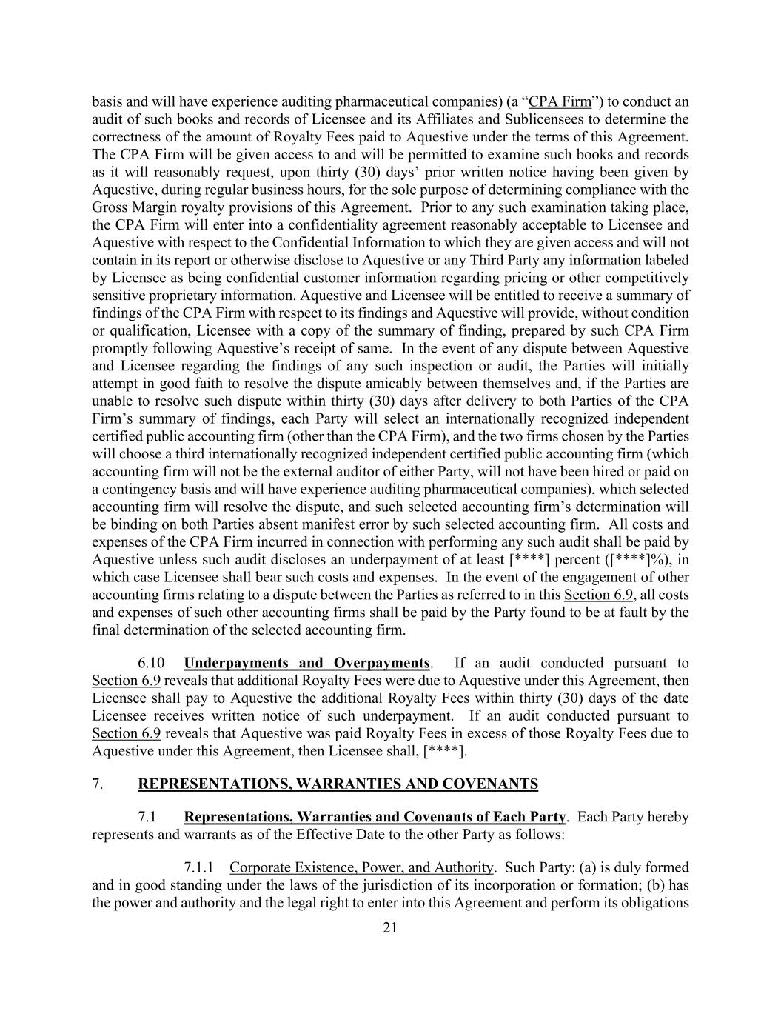
21 basis and will have experience auditing pharmaceutical companies) (a “CPA Firm”) to conduct an audit of such books and records of Licensee and its Affiliates and Sublicensees to determine the correctness of the amount of Royalty Fees paid to Aquestive under the terms of this Agreement. The CPA Firm will be given access to and will be permitted to examine such books and records as it will reasonably request, upon thirty (30) days’ prior written notice having been given by Aquestive, during regular business hours, for the sole purpose of determining compliance with the Gross Margin royalty provisions of this Agreement. Prior to any such examination taking place, the CPA Firm will enter into a confidentiality agreement reasonably acceptable to Licensee and Aquestive with respect to the Confidential Information to which they are given access and will not contain in its report or otherwise disclose to Aquestive or any Third Party any information labeled by Licensee as being confidential customer information regarding pricing or other competitively sensitive proprietary information. Aquestive and Licensee will be entitled to receive a summary of findings of the CPA Firm with respect to its findings and Aquestive will provide, without condition or qualification, Licensee with a copy of the summary of finding, prepared by such CPA Firm promptly following Aquestive’s receipt of same. In the event of any dispute between Aquestive and Licensee regarding the findings of any such inspection or audit, the Parties will initially attempt in good faith to resolve the dispute amicably between themselves and, if the Parties are unable to resolve such dispute within thirty (30) days after delivery to both Parties of the CPA Firm’s summary of findings, each Party will select an internationally recognized independent certified public accounting firm (other than the CPA Firm), and the two firms chosen by the Parties will choose a third internationally recognized independent certified public accounting firm (which accounting firm will not be the external auditor of either Party, will not have been hired or paid on a contingency basis and will have experience auditing pharmaceutical companies), which selected accounting firm will resolve the dispute, and such selected accounting firm’s determination will be binding on both Parties absent manifest error by such selected accounting firm. All costs and expenses of the CPA Firm incurred in connection with performing any such audit shall be paid by Aquestive unless such audit discloses an underpayment of at least [****] percent ([****]%), in which case Licensee shall bear such costs and expenses. In the event of the engagement of other accounting firms relating to a dispute between the Parties as referred to in this Section 6.9, all costs and expenses of such other accounting firms shall be paid by the Party found to be at fault by the final determination of the selected accounting firm. 6.10 Underpayments and Overpayments. If an audit conducted pursuant to Section 6.9 reveals that additional Royalty Fees were due to Aquestive under this Agreement, then Licensee shall pay to Aquestive the additional Royalty Fees within thirty (30) days of the date Licensee receives written notice of such underpayment. If an audit conducted pursuant to Section 6.9 reveals that Aquestive was paid Royalty Fees in excess of those Royalty Fees due to Aquestive under this Agreement, then Licensee shall, [****]. 7. REPRESENTATIONS, WARRANTIES AND COVENANTS 7.1 Representations, Warranties and Covenants of Each Party. Each Party hereby represents and warrants as of the Effective Date to the other Party as follows: 7.1.1 Corporate Existence, Power, and Authority. Such Party: (a) is duly formed and in good standing under the laws of the jurisdiction of its incorporation or formation; (b) has the power and authority and the legal right to enter into this Agreement and perform its obligations

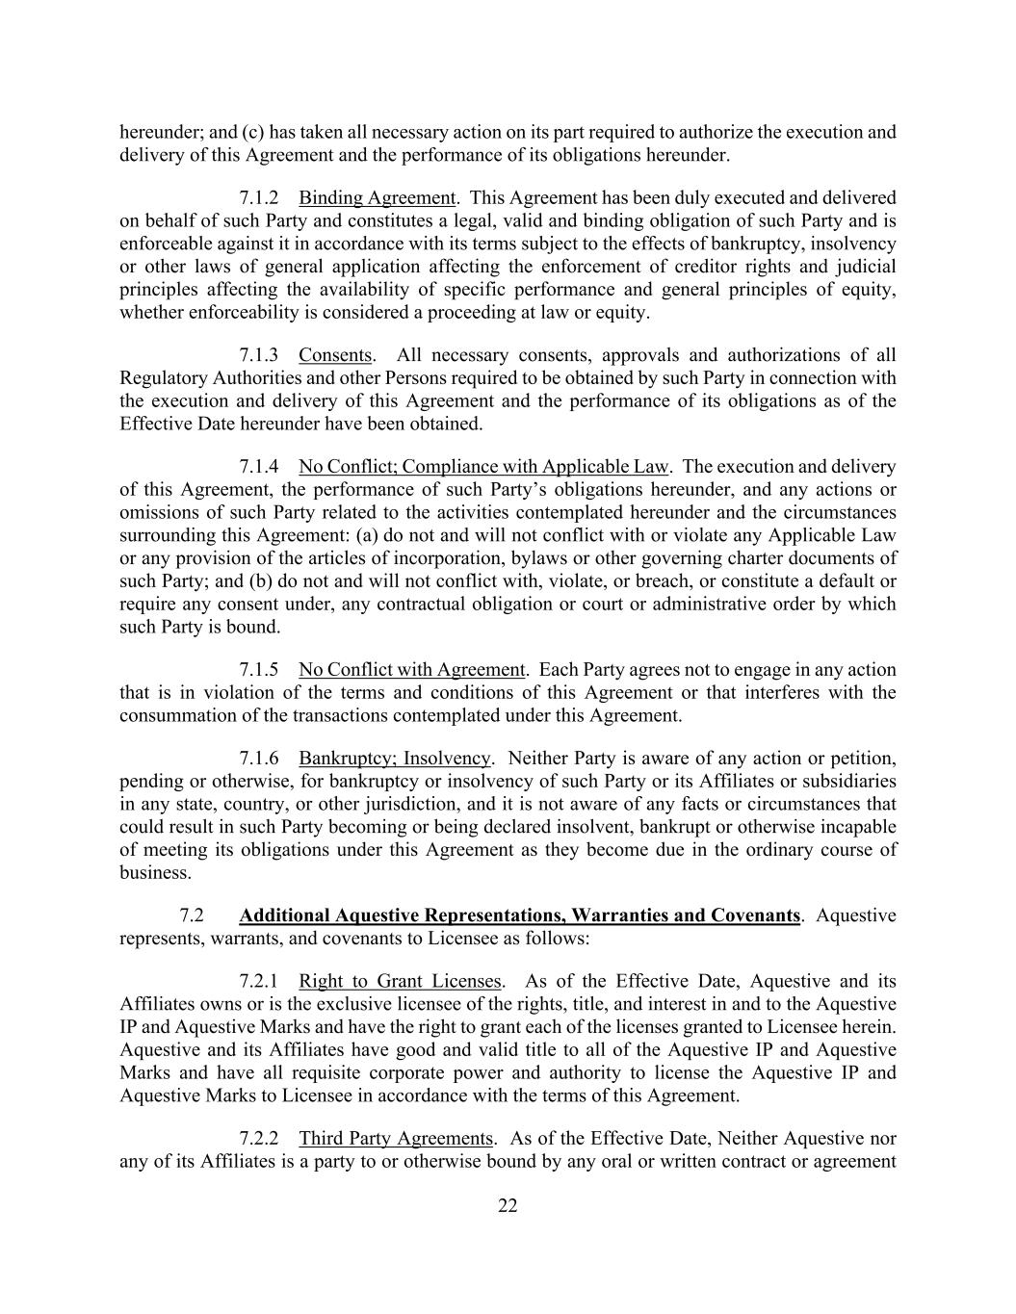
22 hereunder; and (c) has taken all necessary action on its part required to authorize the execution and delivery of this Agreement and the performance of its obligations hereunder. 7.1.2 Binding Agreement. This Agreement has been duly executed and delivered on behalf of such Party and constitutes a legal, valid and binding obligation of such Party and is enforceable against it in accordance with its terms subject to the effects of bankruptcy, insolvency or other laws of general application affecting the enforcement of creditor rights and judicial principles affecting the availability of specific performance and general principles of equity, whether enforceability is considered a proceeding at law or equity. 7.1.3 Consents. All necessary consents, approvals and authorizations of all Regulatory Authorities and other Persons required to be obtained by such Party in connection with the execution and delivery of this Agreement and the performance of its obligations as of the Effective Date hereunder have been obtained. 7.1.4 No Conflict; Compliance with Applicable Law. The execution and delivery of this Agreement, the performance of such Party’s obligations hereunder, and any actions or omissions of such Party related to the activities contemplated hereunder and the circumstances surrounding this Agreement: (a) do not and will not conflict with or violate any Applicable Law or any provision of the articles of incorporation, bylaws or other governing charter documents of such Party; and (b) do not and will not conflict with, violate, or breach, or constitute a default or require any consent under, any contractual obligation or court or administrative order by which such Party is bound. 7.1.5 No Conflict with Agreement. Each Party agrees not to engage in any action that is in violation of the terms and conditions of this Agreement or that interferes with the consummation of the transactions contemplated under this Agreement. 7.1.6 Bankruptcy; Insolvency. Neither Party is aware of any action or petition, pending or otherwise, for bankruptcy or insolvency of such Party or its Affiliates or subsidiaries in any state, country, or other jurisdiction, and it is not aware of any facts or circumstances that could result in such Party becoming or being declared insolvent, bankrupt or otherwise incapable of meeting its obligations under this Agreement as they become due in the ordinary course of business. 7.2 Additional Aquestive Representations, Warranties and Covenants. Aquestive represents, warrants, and covenants to Licensee as follows: 7.2.1 Right to Grant Licenses. As of the Effective Date, Aquestive and its Affiliates owns or is the exclusive licensee of the rights, title, and interest in and to the Aquestive IP and Aquestive Marks and have the right to grant each of the licenses granted to Licensee herein. Aquestive and its Affiliates have good and valid title to all of the Aquestive IP and Aquestive Marks and have all requisite corporate power and authority to license the Aquestive IP and Aquestive Marks to Licensee in accordance with the terms of this Agreement. 7.2.2 Third Party Agreements. As of the Effective Date, Neither Aquestive nor any of its Affiliates is a party to or otherwise bound by any oral or written contract or agreement

23 that conflicts with, or limits the scope of, any of the rights or licenses granted to Licensee hereunder or that will result in any Third Party obtaining any interest in, or that would give to any Third Party any right to assert any claim in or with respect to, any of Licensee’s rights under this Agreement. 7.2.3 Third Party Licenses. As of the Effective Date, no Third Party license agreements exist related to the Product worldwide. 7.2.4 Compliance with Applicable Law. Aquestive shall comply with and maintain, and shall cause its Affiliates to comply with and maintain, in force all licenses, consents, permits and authorizations necessary to perform its obligations under this Agreement and shall perform its obligations under this Agreement in compliance with Applicable Law, in each case in all material respects. 7.2.5 No Debarment. None of Aquestive or its Affiliates have employed or otherwise used in any capacity, and will not employ or otherwise use in any capacity, the services of any Person debarred under United States law, including Section 21 U.S.C. 335a, or any foreign equivalent thereof. 7.2.6 Intellectual Property. 7.2.6.1 Aquestive Intellectual Property Status. (i) All Aquestive Product Marks and Aquestive Patents listed on Schedule 1.11 and Schedule 1.12, respectively, are, as of the Effective Date, in full force and effect, valid, subsisting and enforceable, have been properly assigned to Aquestive, and inventorship of each Patent is properly identified on such Patents; (ii) none of the Aquestive Product Marks and Aquestive Patents listed on Schedule 1.11 and Schedule 1.12, respectively, is currently involved in any interference, reissue, reexamination, opposition, challenge or litigation proceeding, and neither Aquestive nor any of its Affiliates has received any written notice from any Person of such actual or threatened proceeding; (iii) no Aquestive Patents and Aquestive Product Marks listed on Schedule 1.11 and Schedule 1.12, respectively, as of the Effective Date, have been found by a court or administrative body of competent jurisdiction to be invalid or unenforceable; (iv) Aquestive and any other Third Party having responsibility for prosecuting any of the Aquestive Product Marks and Aquestive Patents listed on Schedule 1.11 and Schedule 1.12, respectively, have filed and prosecuted the Aquestive Patents and Aquestive Product Marks in good faith and in compliance with all applicable rules, policies, and procedures of the USPTO and all foreign patent offices, as applicable, in all material respects, and are subsisting; (v) as of the Effective Date, Aquestive has not committed any act, or failed to commit any required act, that would reasonably be expected to cause any Aquestive Product Marks and Aquestive Patents listed on Schedule 1.11 and Schedule 1.12, respectively, to expire prematurely or be declared invalid or unenforceable, or that estops the enforcement of such rights against any Third Party; and (vi) as of the Effective Date, Aquestive has timely paid all application, registration, maintenance and renewal fees in respect of the Aquestive Product Marks and Aquestive Patents listed on Schedule 1.11 and Schedule 1.12, respectively. 7.2.6.2 Control. Aquestive Controls all rights, title and interests in and to the Aquestive IP and Aquestive Marks, and Aquestive has the legal right and authority, and has all rights, authorizations and consents necessary, to grant to Licensee the licenses granted under this Agreement.

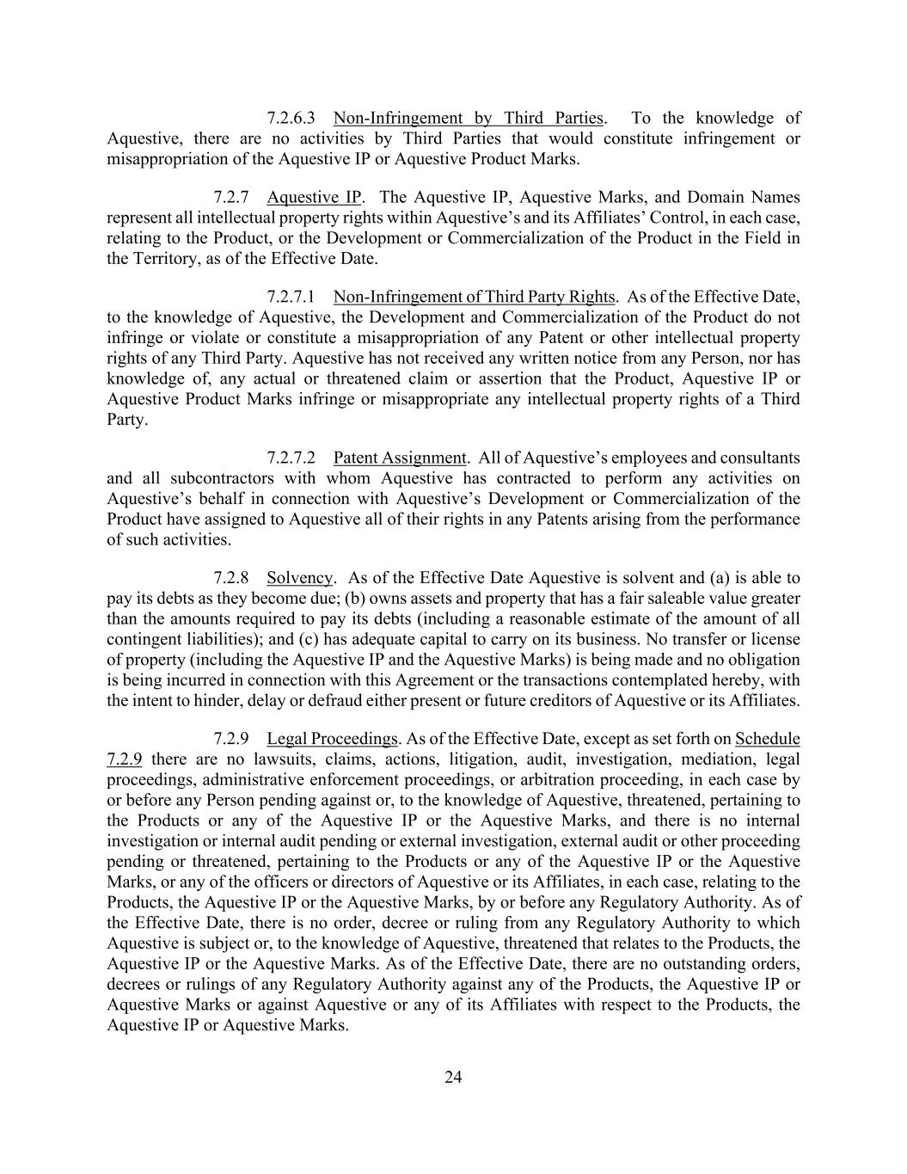
24 7.2.6.3 Non-Infringement by Third Parties. To the knowledge of Aquestive, there are no activities by Third Parties that would constitute infringement or misappropriation of the Aquestive IP or Aquestive Product Marks. 7.2.7 Aquestive IP. The Aquestive IP, Aquestive Marks, and Domain Names represent all intellectual property rights within Aquestive’s and its Affiliates’ Control, in each case, relating to the Product, or the Development or Commercialization of the Product in the Field in the Territory, as of the Effective Date. 7.2.7.1 Non-Infringement of Third Party Rights. As of the Effective Date, to the knowledge of Aquestive, the Development and Commercialization of the Product do not infringe or violate or constitute a misappropriation of any Patent or other intellectual property rights of any Third Party. Aquestive has not received any written notice from any Person, nor has knowledge of, any actual or threatened claim or assertion that the Product, Aquestive IP or Aquestive Product Marks infringe or misappropriate any intellectual property rights of a Third Party. 7.2.7.2 Patent Assignment. All of Aquestive’s employees and consultants and all subcontractors with whom Aquestive has contracted to perform any activities on Aquestive’s behalf in connection with Aquestive’s Development or Commercialization of the Product have assigned to Aquestive all of their rights in any Patents arising from the performance of such activities. 7.2.8 Solvency. As of the Effective Date Aquestive is solvent and (a) is able to pay its debts as they become due; (b) owns assets and property that has a fair saleable value greater than the amounts required to pay its debts (including a reasonable estimate of the amount of all contingent liabilities); and (c) has adequate capital to carry on its business. No transfer or license of property (including the Aquestive IP and the Aquestive Marks) is being made and no obligation is being incurred in connection with this Agreement or the transactions contemplated hereby, with the intent to hinder, delay or defraud either present or future creditors of Aquestive or its Affiliates. 7.2.9 Legal Proceedings. As of the Effective Date, except as set forth on Schedule 7.2.9 there are no lawsuits, claims, actions, litigation, audit, investigation, mediation, legal proceedings, administrative enforcement proceedings, or arbitration proceeding, in each case by or before any Person pending against or, to the knowledge of Aquestive, threatened, pertaining to the Products or any of the Aquestive IP or the Aquestive Marks, and there is no internal investigation or internal audit pending or external investigation, external audit or other proceeding pending or threatened, pertaining to the Products or any of the Aquestive IP or the Aquestive Marks, or any of the officers or directors of Aquestive or its Affiliates, in each case, relating to the Products, the Aquestive IP or the Aquestive Marks, by or before any Regulatory Authority. As of the Effective Date, there is no order, decree or ruling from any Regulatory Authority to which Aquestive is subject or, to the knowledge of Aquestive, threatened that relates to the Products, the Aquestive IP or the Aquestive Marks. As of the Effective Date, there are no outstanding orders, decrees or rulings of any Regulatory Authority against any of the Products, the Aquestive IP or Aquestive Marks or against Aquestive or any of its Affiliates with respect to the Products, the Aquestive IP or Aquestive Marks.

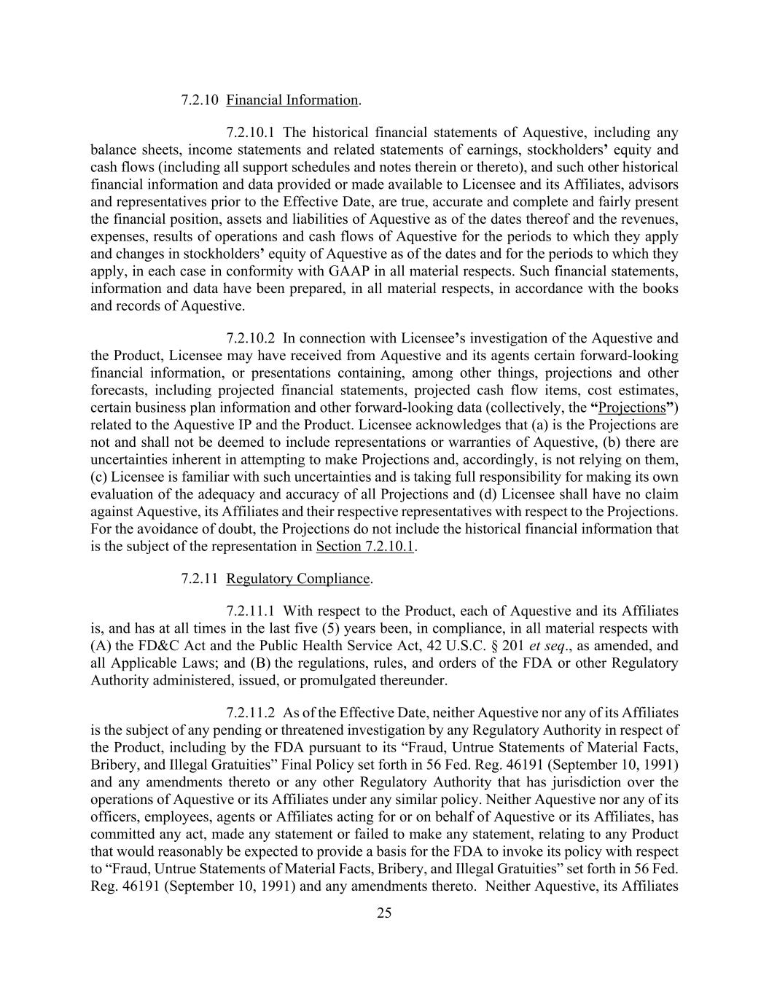
25 7.2.10 Financial Information. 7.2.10.1 The historical financial statements of Aquestive, including any balance sheets, income statements and related statements of earnings, stockholders’ equity and cash flows (including all support schedules and notes therein or thereto), and such other historical financial information and data provided or made available to Licensee and its Affiliates, advisors and representatives prior to the Effective Date, are true, accurate and complete and fairly present the financial position, assets and liabilities of Aquestive as of the dates thereof and the revenues, expenses, results of operations and cash flows of Aquestive for the periods to which they apply and changes in stockholders’ equity of Aquestive as of the dates and for the periods to which they apply, in each case in conformity with GAAP in all material respects. Such financial statements, information and data have been prepared, in all material respects, in accordance with the books and records of Aquestive. 7.2.10.2 In connection with Licensee’s investigation of the Aquestive and the Product, Licensee may have received from Aquestive and its agents certain forward-looking financial information, or presentations containing, among other things, projections and other forecasts, including projected financial statements, projected cash flow items, cost estimates, certain business plan information and other forward-looking data (collectively, the “Projections”) related to the Aquestive IP and the Product. Licensee acknowledges that (a) is the Projections are not and shall not be deemed to include representations or warranties of Aquestive, (b) there are uncertainties inherent in attempting to make Projections and, accordingly, is not relying on them, (c) Licensee is familiar with such uncertainties and is taking full responsibility for making its own evaluation of the adequacy and accuracy of all Projections and (d) Licensee shall have no claim against Aquestive, its Affiliates and their respective representatives with respect to the Projections. For the avoidance of doubt, the Projections do not include the historical financial information that is the subject of the representation in Section 7.2.10.1. 7.2.11 Regulatory Compliance. 7.2.11.1 With respect to the Product, each of Aquestive and its Affiliates is, and has at all times in the last five (5) years been, in compliance, in all material respects with (A) the FD&C Act and the Public Health Service Act, 42 U.S.C. § 201 et seq., as amended, and all Applicable Laws; and (B) the regulations, rules, and orders of the FDA or other Regulatory Authority administered, issued, or promulgated thereunder. 7.2.11.2 As of the Effective Date, neither Aquestive nor any of its Affiliates is the subject of any pending or threatened investigation by any Regulatory Authority in respect of the Product, including by the FDA pursuant to its “Fraud, Untrue Statements of Material Facts, Bribery, and Illegal Gratuities” Final Policy set forth in 56 Fed. Reg. 46191 (September 10, 1991) and any amendments thereto or any other Regulatory Authority that has jurisdiction over the operations of Aquestive or its Affiliates under any similar policy. Neither Aquestive nor any of its officers, employees, agents or Affiliates acting for or on behalf of Aquestive or its Affiliates, has committed any act, made any statement or failed to make any statement, relating to any Product that would reasonably be expected to provide a basis for the FDA to invoke its policy with respect to “Fraud, Untrue Statements of Material Facts, Bribery, and Illegal Gratuities” set forth in 56 Fed. Reg. 46191 (September 10, 1991) and any amendments thereto. Neither Aquestive, its Affiliates

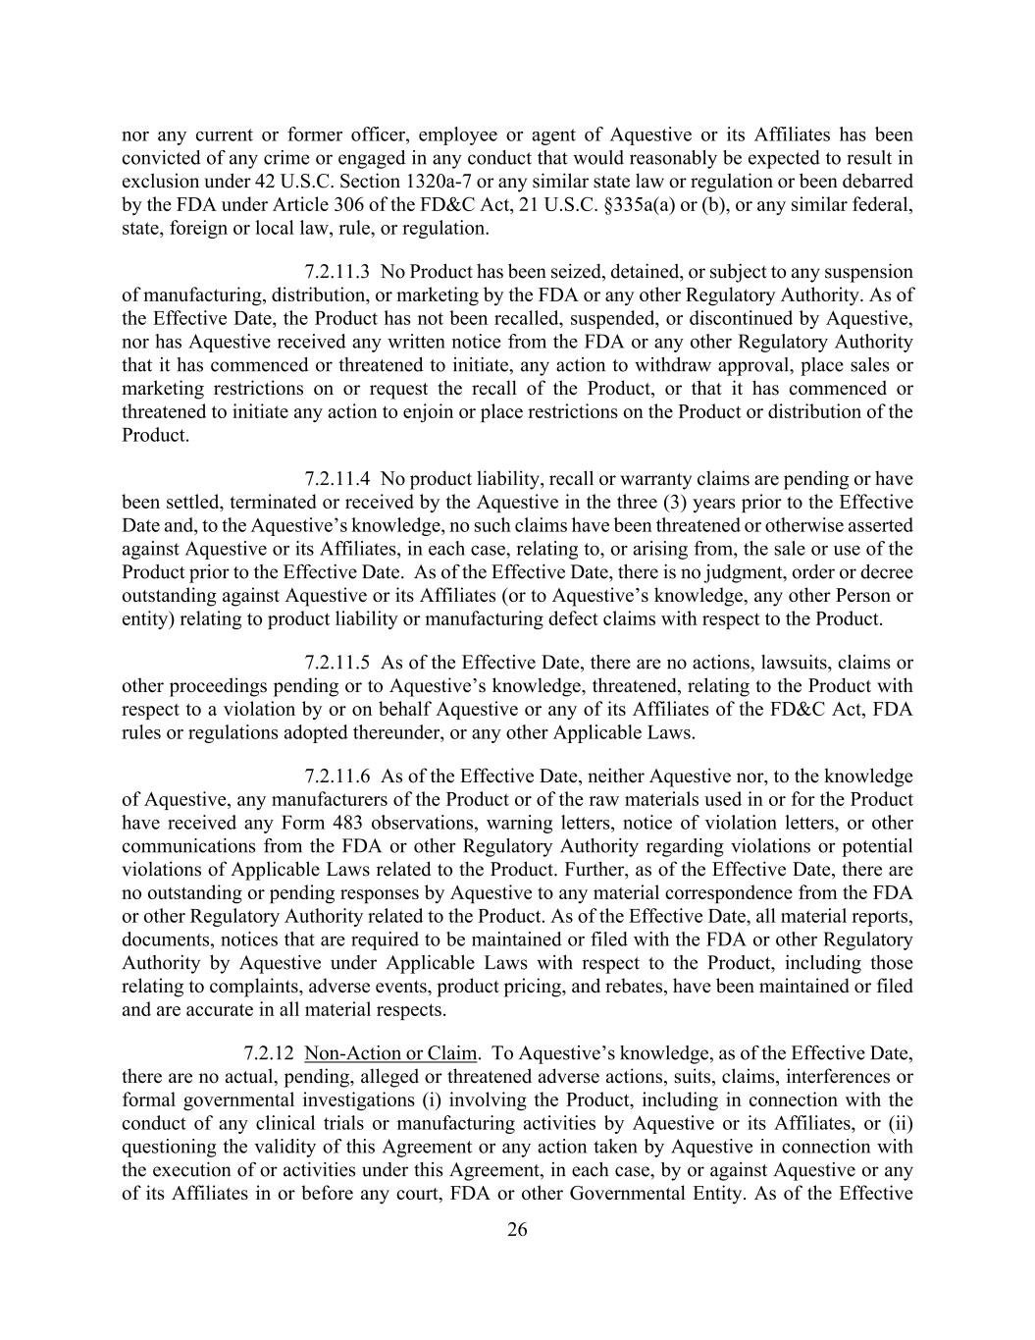
26 nor any current or former officer, employee or agent of Aquestive or its Affiliates has been convicted of any crime or engaged in any conduct that would reasonably be expected to result in exclusion under 42 U.S.C. Section 1320a-7 or any similar state law or regulation or been debarred by the FDA under Article 306 of the FD&C Act, 21 U.S.C. §335a(a) or (b), or any similar federal, state, foreign or local law, rule, or regulation. 7.2.11.3 No Product has been seized, detained, or subject to any suspension of manufacturing, distribution, or marketing by the FDA or any other Regulatory Authority. As of the Effective Date, the Product has not been recalled, suspended, or discontinued by Aquestive, nor has Aquestive received any written notice from the FDA or any other Regulatory Authority that it has commenced or threatened to initiate, any action to withdraw approval, place sales or marketing restrictions on or request the recall of the Product, or that it has commenced or threatened to initiate any action to enjoin or place restrictions on the Product or distribution of the Product. 7.2.11.4 No product liability, recall or warranty claims are pending or have been settled, terminated or received by the Aquestive in the three (3) years prior to the Effective Date and, to the Aquestive’s knowledge, no such claims have been threatened or otherwise asserted against Aquestive or its Affiliates, in each case, relating to, or arising from, the sale or use of the Product prior to the Effective Date. As of the Effective Date, there is no judgment, order or decree outstanding against Aquestive or its Affiliates (or to Aquestive’s knowledge, any other Person or entity) relating to product liability or manufacturing defect claims with respect to the Product. 7.2.11.5 As of the Effective Date, there are no actions, lawsuits, claims or other proceedings pending or to Aquestive’s knowledge, threatened, relating to the Product with respect to a violation by or on behalf Aquestive or any of its Affiliates of the FD&C Act, FDA rules or regulations adopted thereunder, or any other Applicable Laws. 7.2.11.6 As of the Effective Date, neither Aquestive nor, to the knowledge of Aquestive, any manufacturers of the Product or of the raw materials used in or for the Product have received any Form 483 observations, warning letters, notice of violation letters, or other communications from the FDA or other Regulatory Authority regarding violations or potential violations of Applicable Laws related to the Product. Further, as of the Effective Date, there are no outstanding or pending responses by Aquestive to any material correspondence from the FDA or other Regulatory Authority related to the Product. As of the Effective Date, all material reports, documents, notices that are required to be maintained or filed with the FDA or other Regulatory Authority by Aquestive under Applicable Laws with respect to the Product, including those relating to complaints, adverse events, product pricing, and rebates, have been maintained or filed and are accurate in all material respects. 7.2.12 Non-Action or Claim. To Aquestive’s knowledge, as of the Effective Date, there are no actual, pending, alleged or threatened adverse actions, suits, claims, interferences or formal governmental investigations (i) involving the Product, including in connection with the conduct of any clinical trials or manufacturing activities by Aquestive or its Affiliates, or (ii) questioning the validity of this Agreement or any action taken by Aquestive in connection with the execution of or activities under this Agreement, in each case, by or against Aquestive or any of its Affiliates in or before any court, FDA or other Governmental Entity. As of the Effective

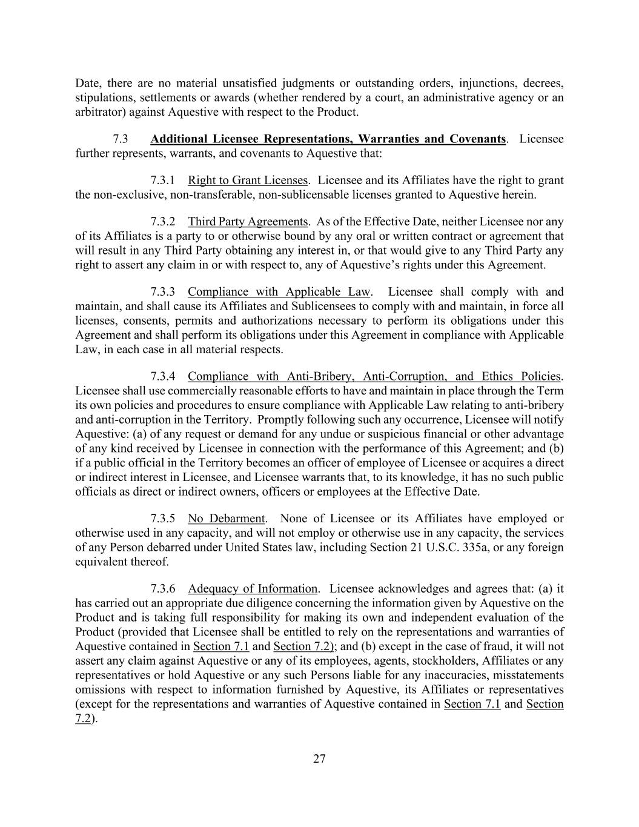
27 Date, there are no material unsatisfied judgments or outstanding orders, injunctions, decrees, stipulations, settlements or awards (whether rendered by a court, an administrative agency or an arbitrator) against Aquestive with respect to the Product. 7.3 Additional Licensee Representations, Warranties and Covenants. Licensee further represents, warrants, and covenants to Aquestive that: 7.3.1 Right to Grant Licenses. Licensee and its Affiliates have the right to grant the non-exclusive, non-transferable, non-sublicensable licenses granted to Aquestive herein. 7.3.2 Third Party Agreements. As of the Effective Date, neither Licensee nor any of its Affiliates is a party to or otherwise bound by any oral or written contract or agreement that will result in any Third Party obtaining any interest in, or that would give to any Third Party any right to assert any claim in or with respect to, any of Aquestive’s rights under this Agreement. 7.3.3 Compliance with Applicable Law. Licensee shall comply with and maintain, and shall cause its Affiliates and Sublicensees to comply with and maintain, in force all licenses, consents, permits and authorizations necessary to perform its obligations under this Agreement and shall perform its obligations under this Agreement in compliance with Applicable Law, in each case in all material respects. 7.3.4 Compliance with Anti-Bribery, Anti-Corruption, and Ethics Policies. Licensee shall use commercially reasonable efforts to have and maintain in place through the Term its own policies and procedures to ensure compliance with Applicable Law relating to anti-bribery and anti-corruption in the Territory. Promptly following such any occurrence, Licensee will notify Aquestive: (a) of any request or demand for any undue or suspicious financial or other advantage of any kind received by Licensee in connection with the performance of this Agreement; and (b) if a public official in the Territory becomes an officer of employee of Licensee or acquires a direct or indirect interest in Licensee, and Licensee warrants that, to its knowledge, it has no such public officials as direct or indirect owners, officers or employees at the Effective Date. 7.3.5 No Debarment. None of Licensee or its Affiliates have employed or otherwise used in any capacity, and will not employ or otherwise use in any capacity, the services of any Person debarred under United States law, including Section 21 U.S.C. 335a, or any foreign equivalent thereof. 7.3.6 Adequacy of Information. Licensee acknowledges and agrees that: (a) it has carried out an appropriate due diligence concerning the information given by Aquestive on the Product and is taking full responsibility for making its own and independent evaluation of the Product (provided that Licensee shall be entitled to rely on the representations and warranties of Aquestive contained in Section 7.1 and Section 7.2); and (b) except in the case of fraud, it will not assert any claim against Aquestive or any of its employees, agents, stockholders, Affiliates or any representatives or hold Aquestive or any such Persons liable for any inaccuracies, misstatements omissions with respect to information furnished by Aquestive, its Affiliates or representatives (except for the representations and warranties of Aquestive contained in Section 7.1 and Section 7.2).

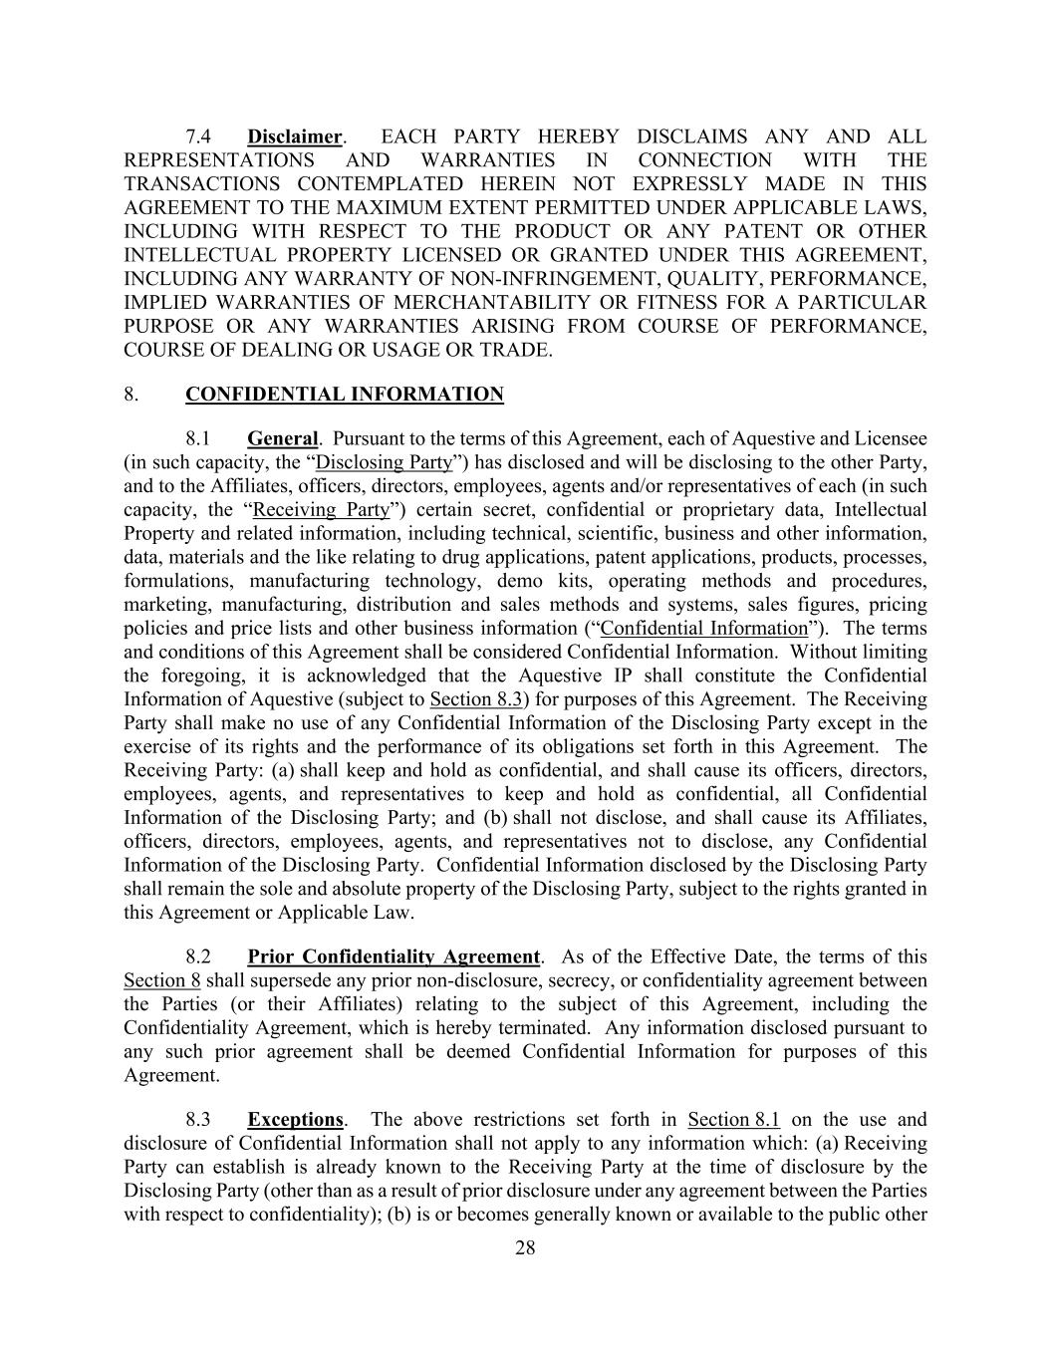
28 7.4 Disclaimer. EACH PARTY HEREBY DISCLAIMS ANY AND ALL REPRESENTATIONS AND WARRANTIES IN CONNECTION WITH THE TRANSACTIONS CONTEMPLATED HEREIN NOT EXPRESSLY MADE IN THIS AGREEMENT TO THE MAXIMUM EXTENT PERMITTED UNDER APPLICABLE LAWS, INCLUDING WITH RESPECT TO THE PRODUCT OR ANY PATENT OR OTHER INTELLECTUAL PROPERTY LICENSED OR GRANTED UNDER THIS AGREEMENT, INCLUDING ANY WARRANTY OF NON-INFRINGEMENT, QUALITY, PERFORMANCE, IMPLIED WARRANTIES OF MERCHANTABILITY OR FITNESS FOR A PARTICULAR PURPOSE OR ANY WARRANTIES ARISING FROM COURSE OF PERFORMANCE, COURSE OF DEALING OR USAGE OR TRADE. 8. CONFIDENTIAL INFORMATION 8.1 General. Pursuant to the terms of this Agreement, each of Aquestive and Licensee (in such capacity, the “Disclosing Party”) has disclosed and will be disclosing to the other Party, and to the Affiliates, officers, directors, employees, agents and/or representatives of each (in such capacity, the “Receiving Party”) certain secret, confidential or proprietary data, Intellectual Property and related information, including technical, scientific, business and other information, data, materials and the like relating to drug applications, patent applications, products, processes, formulations, manufacturing technology, demo kits, operating methods and procedures, marketing, manufacturing, distribution and sales methods and systems, sales figures, pricing policies and price lists and other business information (“Confidential Information”). The terms and conditions of this Agreement shall be considered Confidential Information. Without limiting the foregoing, it is acknowledged that the Aquestive IP shall constitute the Confidential Information of Aquestive (subject to Section 8.3) for purposes of this Agreement. The Receiving Party shall make no use of any Confidential Information of the Disclosing Party except in the exercise of its rights and the performance of its obligations set forth in this Agreement. The Receiving Party: (a) shall keep and hold as confidential, and shall cause its officers, directors, employees, agents, and representatives to keep and hold as confidential, all Confidential Information of the Disclosing Party; and (b) shall not disclose, and shall cause its Affiliates, officers, directors, employees, agents, and representatives not to disclose, any Confidential Information of the Disclosing Party. Confidential Information disclosed by the Disclosing Party shall remain the sole and absolute property of the Disclosing Party, subject to the rights granted in this Agreement or Applicable Law. 8.2 Prior Confidentiality Agreement. As of the Effective Date, the terms of this Section 8 shall supersede any prior non-disclosure, secrecy, or confidentiality agreement between the Parties (or their Affiliates) relating to the subject of this Agreement, including the Confidentiality Agreement, which is hereby terminated. Any information disclosed pursuant to any such prior agreement shall be deemed Confidential Information for purposes of this Agreement. 8.3 Exceptions. The above restrictions set forth in Section 8.1 on the use and disclosure of Confidential Information shall not apply to any information which: (a) Receiving Party can establish is already known to the Receiving Party at the time of disclosure by the Disclosing Party (other than as a result of prior disclosure under any agreement between the Parties with respect to confidentiality); (b) is or becomes generally known or available to the public other

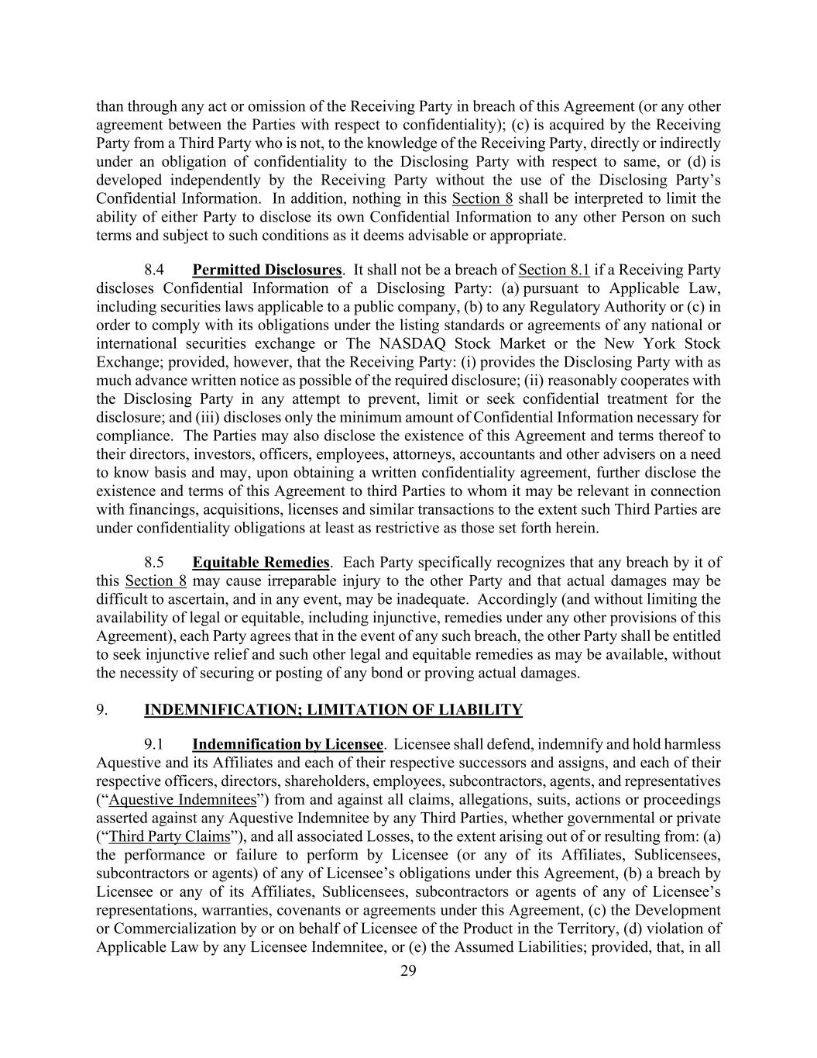
29 than through any act or omission of the Receiving Party in breach of this Agreement (or any other agreement between the Parties with respect to confidentiality); (c) is acquired by the Receiving Party from a Third Party who is not, to the knowledge of the Receiving Party, directly or indirectly under an obligation of confidentiality to the Disclosing Party with respect to same, or (d) is developed independently by the Receiving Party without the use of the Disclosing Party’s Confidential Information. In addition, nothing in this Section 8 shall be interpreted to limit the ability of either Party to disclose its own Confidential Information to any other Person on such terms and subject to such conditions as it deems advisable or appropriate. 8.4 Permitted Disclosures. It shall not be a breach of Section 8.1 if a Receiving Party discloses Confidential Information of a Disclosing Party: (a) pursuant to Applicable Law, including securities laws applicable to a public company, (b) to any Regulatory Authority or (c) in order to comply with its obligations under the listing standards or agreements of any national or international securities exchange or The NASDAQ Stock Market or the New York Stock Exchange; provided, however, that the Receiving Party: (i) provides the Disclosing Party with as much advance written notice as possible of the required disclosure; (ii) reasonably cooperates with the Disclosing Party in any attempt to prevent, limit or seek confidential treatment for the disclosure; and (iii) discloses only the minimum amount of Confidential Information necessary for compliance. The Parties may also disclose the existence of this Agreement and terms thereof to their directors, investors, officers, employees, attorneys, accountants and other advisers on a need to know basis and may, upon obtaining a written confidentiality agreement, further disclose the existence and terms of this Agreement to third Parties to whom it may be relevant in connection with financings, acquisitions, licenses and similar transactions to the extent such Third Parties are under confidentiality obligations at least as restrictive as those set forth herein. 8.5 Equitable Remedies. Each Party specifically recognizes that any breach by it of this Section 8 may cause irreparable injury to the other Party and that actual damages may be difficult to ascertain, and in any event, may be inadequate. Accordingly (and without limiting the availability of legal or equitable, including injunctive, remedies under any other provisions of this Agreement), each Party agrees that in the event of any such breach, the other Party shall be entitled to seek injunctive relief and such other legal and equitable remedies as may be available, without the necessity of securing or posting of any bond or proving actual damages. 9. INDEMNIFICATION; LIMITATION OF LIABILITY 9.1 Indemnification by Licensee. Licensee shall defend, indemnify and hold harmless Aquestive and its Affiliates and each of their respective successors and assigns, and each of their respective officers, directors, shareholders, employees, subcontractors, agents, and representatives (“Aquestive Indemnitees”) from and against all claims, allegations, suits, actions or proceedings asserted against any Aquestive Indemnitee by any Third Parties, whether governmental or private (“Third Party Claims”), and all associated Losses, to the extent arising out of or resulting from: (a) the performance or failure to perform by Licensee (or any of its Affiliates, Sublicensees, subcontractors or agents) of any of Licensee’s obligations under this Agreement, (b) a breach by Licensee or any of its Affiliates, Sublicensees, subcontractors or agents of any of Licensee’s representations, warranties, covenants or agreements under this Agreement, (c) the Development or Commercialization by or on behalf of Licensee of the Product in the Territory, (d) violation of Applicable Law by any Licensee Indemnitee, or (e) the Assumed Liabilities; provided, that, in all

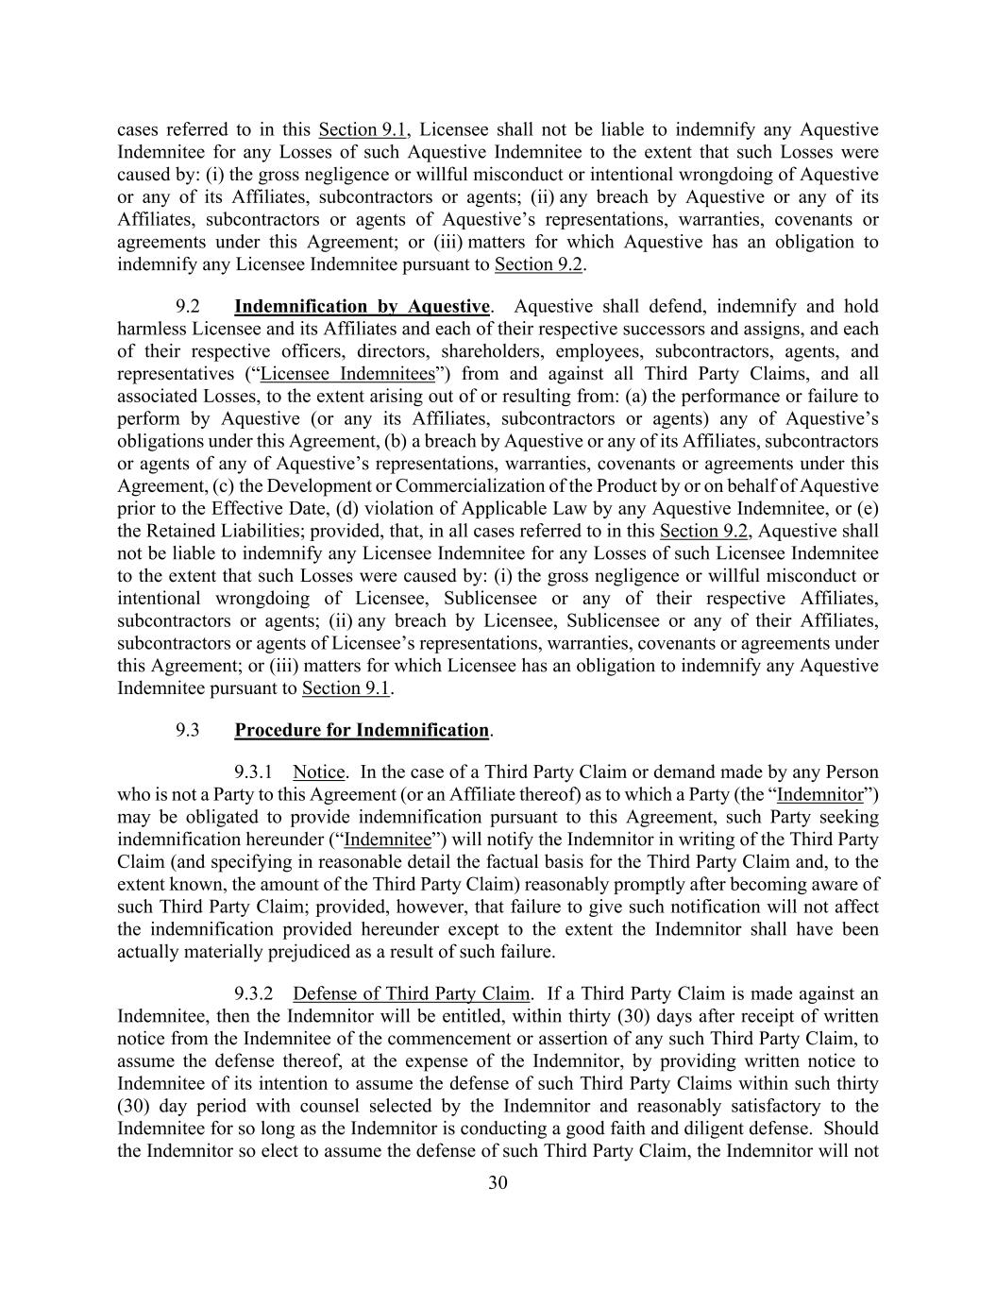
30 cases referred to in this Section 9.1, Licensee shall not be liable to indemnify any Aquestive Indemnitee for any Losses of such Aquestive Indemnitee to the extent that such Losses were caused by: (i) the gross negligence or willful misconduct or intentional wrongdoing of Aquestive or any of its Affiliates, subcontractors or agents; (ii) any breach by Aquestive or any of its Affiliates, subcontractors or agents of Aquestive’s representations, warranties, covenants or agreements under this Agreement; or (iii) matters for which Aquestive has an obligation to indemnify any Licensee Indemnitee pursuant to Section 9.2. 9.2 Indemnification by Aquestive. Aquestive shall defend, indemnify and hold harmless Licensee and its Affiliates and each of their respective successors and assigns, and each of their respective officers, directors, shareholders, employees, subcontractors, agents, and representatives (“Licensee Indemnitees”) from and against all Third Party Claims, and all associated Losses, to the extent arising out of or resulting from: (a) the performance or failure to perform by Aquestive (or any its Affiliates, subcontractors or agents) any of Aquestive’s obligations under this Agreement, (b) a breach by Aquestive or any of its Affiliates, subcontractors or agents of any of Aquestive’s representations, warranties, covenants or agreements under this Agreement, (c) the Development or Commercialization of the Product by or on behalf of Aquestive prior to the Effective Date, (d) violation of Applicable Law by any Aquestive Indemnitee, or (e) the Retained Liabilities; provided, that, in all cases referred to in this Section 9.2, Aquestive shall not be liable to indemnify any Licensee Indemnitee for any Losses of such Licensee Indemnitee to the extent that such Losses were caused by: (i) the gross negligence or willful misconduct or intentional wrongdoing of Licensee, Sublicensee or any of their respective Affiliates, subcontractors or agents; (ii) any breach by Licensee, Sublicensee or any of their Affiliates, subcontractors or agents of Licensee’s representations, warranties, covenants or agreements under this Agreement; or (iii) matters for which Licensee has an obligation to indemnify any Aquestive Indemnitee pursuant to Section 9.1. 9.3 Procedure for Indemnification. 9.3.1 Notice. In the case of a Third Party Claim or demand made by any Person who is not a Party to this Agreement (or an Affiliate thereof) as to which a Party (the “Indemnitor”) may be obligated to provide indemnification pursuant to this Agreement, such Party seeking indemnification hereunder (“Indemnitee”) will notify the Indemnitor in writing of the Third Party Claim (and specifying in reasonable detail the factual basis for the Third Party Claim and, to the extent known, the amount of the Third Party Claim) reasonably promptly after becoming aware of such Third Party Claim; provided, however, that failure to give such notification will not affect the indemnification provided hereunder except to the extent the Indemnitor shall have been actually materially prejudiced as a result of such failure. 9.3.2 Defense of Third Party Claim. If a Third Party Claim is made against an Indemnitee, then the Indemnitor will be entitled, within thirty (30) days after receipt of written notice from the Indemnitee of the commencement or assertion of any such Third Party Claim, to assume the defense thereof, at the expense of the Indemnitor, by providing written notice to Indemnitee of its intention to assume the defense of such Third Party Claims within such thirty (30) day period with counsel selected by the Indemnitor and reasonably satisfactory to the Indemnitee for so long as the Indemnitor is conducting a good faith and diligent defense. Should the Indemnitor so elect to assume the defense of such Third Party Claim, the Indemnitor will not

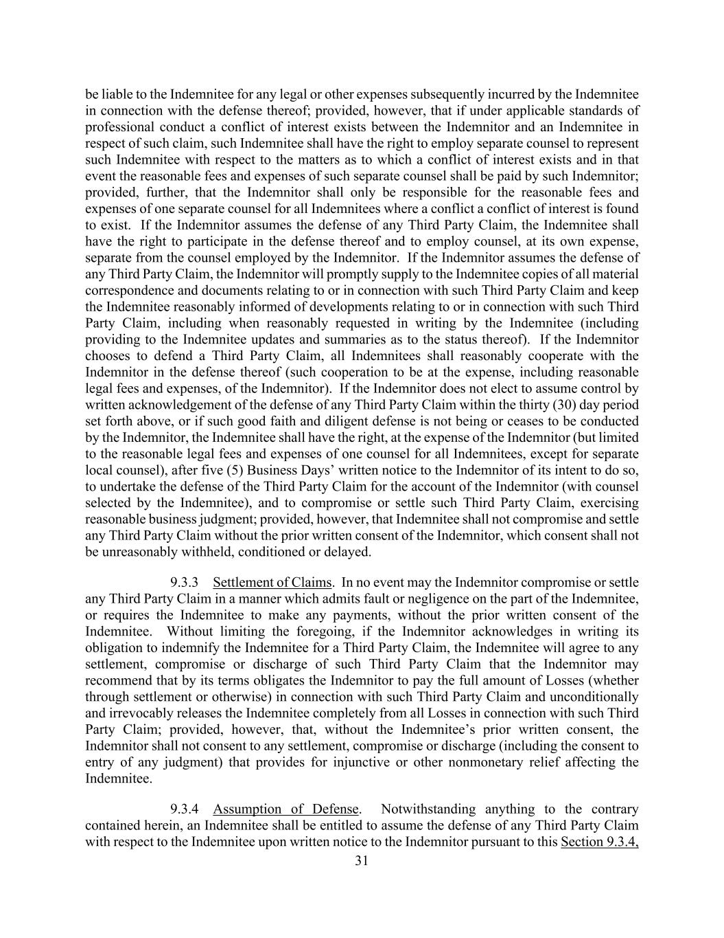
31 be liable to the Indemnitee for any legal or other expenses subsequently incurred by the Indemnitee in connection with the defense thereof; provided, however, that if under applicable standards of professional conduct a conflict of interest exists between the Indemnitor and an Indemnitee in respect of such claim, such Indemnitee shall have the right to employ separate counsel to represent such Indemnitee with respect to the matters as to which a conflict of interest exists and in that event the reasonable fees and expenses of such separate counsel shall be paid by such Indemnitor; provided, further, that the Indemnitor shall only be responsible for the reasonable fees and expenses of one separate counsel for all Indemnitees where a conflict a conflict of interest is found to exist. If the Indemnitor assumes the defense of any Third Party Claim, the Indemnitee shall have the right to participate in the defense thereof and to employ counsel, at its own expense, separate from the counsel employed by the Indemnitor. If the Indemnitor assumes the defense of any Third Party Claim, the Indemnitor will promptly supply to the Indemnitee copies of all material correspondence and documents relating to or in connection with such Third Party Claim and keep the Indemnitee reasonably informed of developments relating to or in connection with such Third Party Claim, including when reasonably requested in writing by the Indemnitee (including providing to the Indemnitee updates and summaries as to the status thereof). If the Indemnitor chooses to defend a Third Party Claim, all Indemnitees shall reasonably cooperate with the Indemnitor in the defense thereof (such cooperation to be at the expense, including reasonable legal fees and expenses, of the Indemnitor). If the Indemnitor does not elect to assume control by written acknowledgement of the defense of any Third Party Claim within the thirty (30) day period set forth above, or if such good faith and diligent defense is not being or ceases to be conducted by the Indemnitor, the Indemnitee shall have the right, at the expense of the Indemnitor (but limited to the reasonable legal fees and expenses of one counsel for all Indemnitees, except for separate local counsel), after five (5) Business Days’ written notice to the Indemnitor of its intent to do so, to undertake the defense of the Third Party Claim for the account of the Indemnitor (with counsel selected by the Indemnitee), and to compromise or settle such Third Party Claim, exercising reasonable business judgment; provided, however, that Indemnitee shall not compromise and settle any Third Party Claim without the prior written consent of the Indemnitor, which consent shall not be unreasonably withheld, conditioned or delayed. 9.3.3 Settlement of Claims. In no event may the Indemnitor compromise or settle any Third Party Claim in a manner which admits fault or negligence on the part of the Indemnitee, or requires the Indemnitee to make any payments, without the prior written consent of the Indemnitee. Without limiting the foregoing, if the Indemnitor acknowledges in writing its obligation to indemnify the Indemnitee for a Third Party Claim, the Indemnitee will agree to any settlement, compromise or discharge of such Third Party Claim that the Indemnitor may recommend that by its terms obligates the Indemnitor to pay the full amount of Losses (whether through settlement or otherwise) in connection with such Third Party Claim and unconditionally and irrevocably releases the Indemnitee completely from all Losses in connection with such Third Party Claim; provided, however, that, without the Indemnitee’s prior written consent, the Indemnitor shall not consent to any settlement, compromise or discharge (including the consent to entry of any judgment) that provides for injunctive or other nonmonetary relief affecting the Indemnitee. 9.3.4 Assumption of Defense. Notwithstanding anything to the contrary contained herein, an Indemnitee shall be entitled to assume the defense of any Third Party Claim with respect to the Indemnitee upon written notice to the Indemnitor pursuant to this Section 9.3.4,

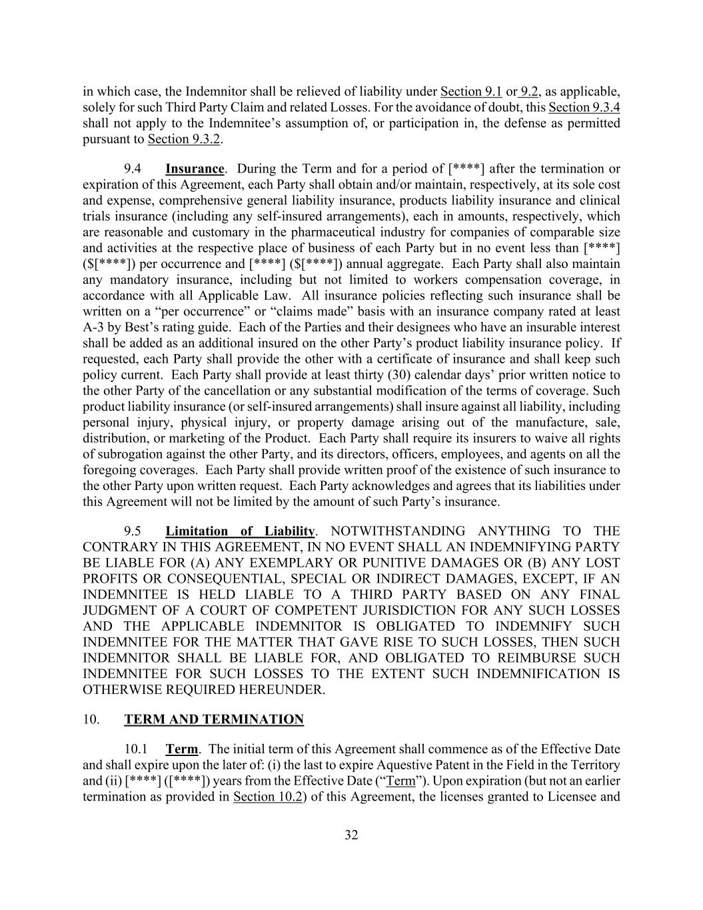
32 in which case, the Indemnitor shall be relieved of liability under Section 9.1 or 9.2, as applicable, solely for such Third Party Claim and related Losses. For the avoidance of doubt, this Section 9.3.4 shall not apply to the Indemnitee’s assumption of, or participation in, the defense as permitted pursuant to Section 9.3.2. 9.4 Insurance. During the Term and for a period of [****] after the termination or expiration of this Agreement, each Party shall obtain and/or maintain, respectively, at its sole cost and expense, comprehensive general liability insurance, products liability insurance and clinical trials insurance (including any self-insured arrangements), each in amounts, respectively, which are reasonable and customary in the pharmaceutical industry for companies of comparable size and activities at the respective place of business of each Party but in no event less than [****] ($[****]) per occurrence and [****] ($[****]) annual aggregate. Each Party shall also maintain any mandatory insurance, including but not limited to workers compensation coverage, in accordance with all Applicable Law. All insurance policies reflecting such insurance shall be written on a “per occurrence” or “claims made” basis with an insurance company rated at least A-3 by Best’s rating guide. Each of the Parties and their designees who have an insurable interest shall be added as an additional insured on the other Party’s product liability insurance policy. If requested, each Party shall provide the other with a certificate of insurance and shall keep such policy current. Each Party shall provide at least thirty (30) calendar days’ prior written notice to the other Party of the cancellation or any substantial modification of the terms of coverage. Such product liability insurance (or self-insured arrangements) shall insure against all liability, including personal injury, physical injury, or property damage arising out of the manufacture, sale, distribution, or marketing of the Product. Each Party shall require its insurers to waive all rights of subrogation against the other Party, and its directors, officers, employees, and agents on all the foregoing coverages. Each Party shall provide written proof of the existence of such insurance to the other Party upon written request. Each Party acknowledges and agrees that its liabilities under this Agreement will not be limited by the amount of such Party’s insurance. 9.5 Limitation of Liability. NOTWITHSTANDING ANYTHING TO THE CONTRARY IN THIS AGREEMENT, IN NO EVENT SHALL AN INDEMNIFYING PARTY BE LIABLE FOR (A) ANY EXEMPLARY OR PUNITIVE DAMAGES OR (B) ANY LOST PROFITS OR CONSEQUENTIAL, SPECIAL OR INDIRECT DAMAGES, EXCEPT, IF AN INDEMNITEE IS HELD LIABLE TO A THIRD PARTY BASED ON ANY FINAL JUDGMENT OF A COURT OF COMPETENT JURISDICTION FOR ANY SUCH LOSSES AND THE APPLICABLE INDEMNITOR IS OBLIGATED TO INDEMNIFY SUCH INDEMNITEE FOR THE MATTER THAT GAVE RISE TO SUCH LOSSES, THEN SUCH INDEMNITOR SHALL BE LIABLE FOR, AND OBLIGATED TO REIMBURSE SUCH INDEMNITEE FOR SUCH LOSSES TO THE EXTENT SUCH INDEMNIFICATION IS OTHERWISE REQUIRED HEREUNDER. 10. TERM AND TERMINATION 10.1 Term. The initial term of this Agreement shall commence as of the Effective Date and shall expire upon the later of: (i) the last to expire Aquestive Patent in the Field in the Territory and (ii) [****] ([****]) years from the Effective Date (“Term”). Upon expiration (but not an earlier termination as provided in Section 10.2) of this Agreement, the licenses granted to Licensee and

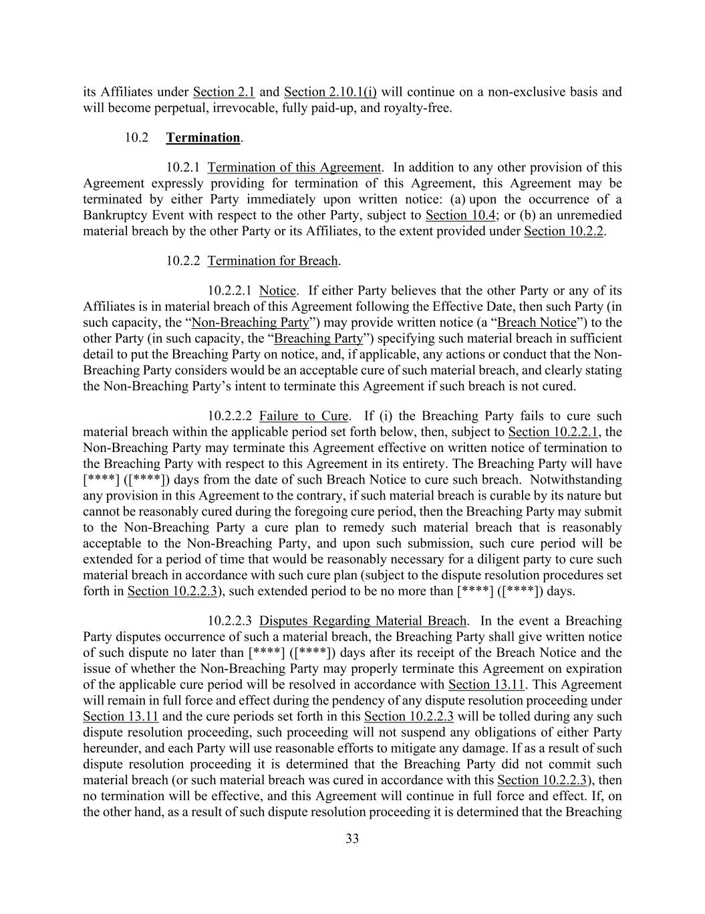
33 its Affiliates under Section 2.1 and Section 2.10.1(i) will continue on a non-exclusive basis and will become perpetual, irrevocable, fully paid-up, and royalty-free. 10.2 Termination. 10.2.1 Termination of this Agreement. In addition to any other provision of this Agreement expressly providing for termination of this Agreement, this Agreement may be terminated by either Party immediately upon written notice: (a) upon the occurrence of a Bankruptcy Event with respect to the other Party, subject to Section 10.4; or (b) an unremedied material breach by the other Party or its Affiliates, to the extent provided under Section 10.2.2. 10.2.2 Termination for Breach. 10.2.2.1 Notice. If either Party believes that the other Party or any of its Affiliates is in material breach of this Agreement following the Effective Date, then such Party (in such capacity, the “Non-Breaching Party”) may provide written notice (a “Breach Notice”) to the other Party (in such capacity, the “Breaching Party”) specifying such material breach in sufficient detail to put the Breaching Party on notice, and, if applicable, any actions or conduct that the Non- Breaching Party considers would be an acceptable cure of such material breach, and clearly stating the Non-Breaching Party’s intent to terminate this Agreement if such breach is not cured. 10.2.2.2 Failure to Cure. If (i) the Breaching Party fails to cure such material breach within the applicable period set forth below, then, subject to Section 10.2.2.1, the Non-Breaching Party may terminate this Agreement effective on written notice of termination to the Breaching Party with respect to this Agreement in its entirety. The Breaching Party will have [****] ([****]) days from the date of such Breach Notice to cure such breach. Notwithstanding any provision in this Agreement to the contrary, if such material breach is curable by its nature but cannot be reasonably cured during the foregoing cure period, then the Breaching Party may submit to the Non-Breaching Party a cure plan to remedy such material breach that is reasonably acceptable to the Non-Breaching Party, and upon such submission, such cure period will be extended for a period of time that would be reasonably necessary for a diligent party to cure such material breach in accordance with such cure plan (subject to the dispute resolution procedures set forth in Section 10.2.2.3), such extended period to be no more than [****] ([****]) days. 10.2.2.3 Disputes Regarding Material Breach. In the event a Breaching Party disputes occurrence of such a material breach, the Breaching Party shall give written notice of such dispute no later than [****] ([****]) days after its receipt of the Breach Notice and the issue of whether the Non-Breaching Party may properly terminate this Agreement on expiration of the applicable cure period will be resolved in accordance with Section 13.11. This Agreement will remain in full force and effect during the pendency of any dispute resolution proceeding under Section 13.11 and the cure periods set forth in this Section 10.2.2.3 will be tolled during any such dispute resolution proceeding, such proceeding will not suspend any obligations of either Party hereunder, and each Party will use reasonable efforts to mitigate any damage. If as a result of such dispute resolution proceeding it is determined that the Breaching Party did not commit such material breach (or such material breach was cured in accordance with this Section 10.2.2.3), then no termination will be effective, and this Agreement will continue in full force and effect. If, on the other hand, as a result of such dispute resolution proceeding it is determined that the Breaching

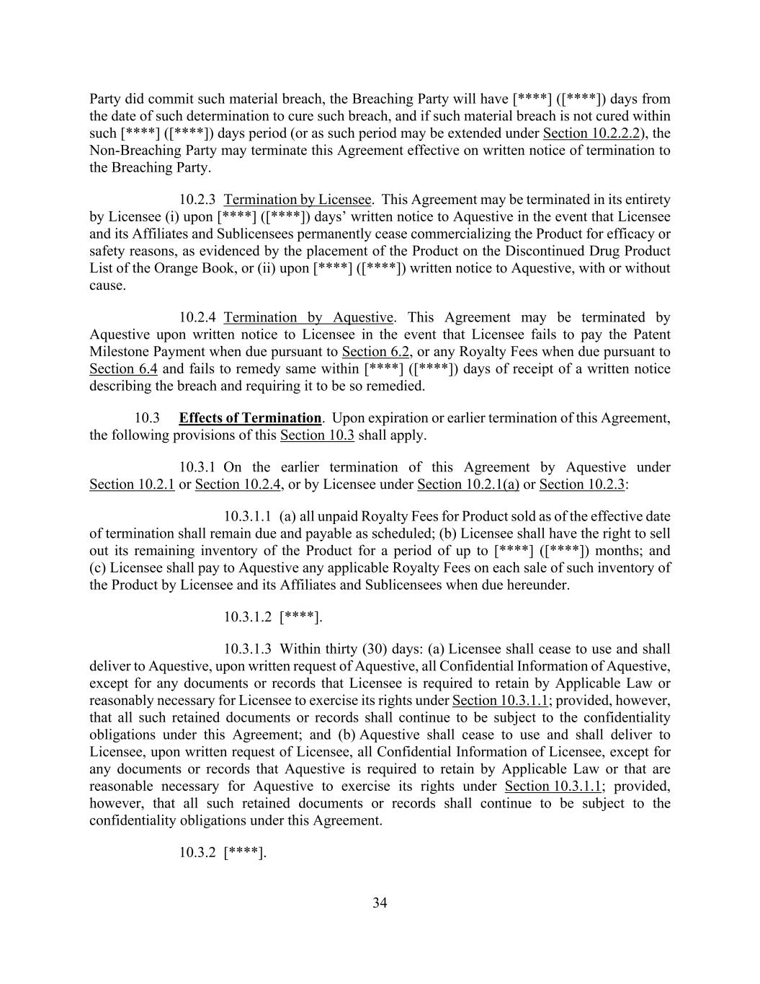
34 Party did commit such material breach, the Breaching Party will have [****] ([****]) days from the date of such determination to cure such breach, and if such material breach is not cured within such [****] ([****]) days period (or as such period may be extended under Section 10.2.2.2), the Non-Breaching Party may terminate this Agreement effective on written notice of termination to the Breaching Party. 10.2.3 Termination by Licensee. This Agreement may be terminated in its entirety by Licensee (i) upon [****] ([****]) days’ written notice to Aquestive in the event that Licensee and its Affiliates and Sublicensees permanently cease commercializing the Product for efficacy or safety reasons, as evidenced by the placement of the Product on the Discontinued Drug Product List of the Orange Book, or (ii) upon [****] ([****]) written notice to Aquestive, with or without cause. 10.2.4 Termination by Aquestive. This Agreement may be terminated by Aquestive upon written notice to Licensee in the event that Licensee fails to pay the Patent Milestone Payment when due pursuant to Section 6.2, or any Royalty Fees when due pursuant to Section 6.4 and fails to remedy same within [****] ([****]) days of receipt of a written notice describing the breach and requiring it to be so remedied. 10.3 Effects of Termination. Upon expiration or earlier termination of this Agreement, the following provisions of this Section 10.3 shall apply. 10.3.1 On the earlier termination of this Agreement by Aquestive under Section 10.2.1 or Section 10.2.4, or by Licensee under Section 10.2.1(a) or Section 10.2.3: 10.3.1.1 (a) all unpaid Royalty Fees for Product sold as of the effective date of termination shall remain due and payable as scheduled; (b) Licensee shall have the right to sell out its remaining inventory of the Product for a period of up to [****] ([****]) months; and (c) Licensee shall pay to Aquestive any applicable Royalty Fees on each sale of such inventory of the Product by Licensee and its Affiliates and Sublicensees when due hereunder. 10.3.1.2 [****]. 10.3.1.3 Within thirty (30) days: (a) Licensee shall cease to use and shall deliver to Aquestive, upon written request of Aquestive, all Confidential Information of Aquestive, except for any documents or records that Licensee is required to retain by Applicable Law or reasonably necessary for Licensee to exercise its rights under Section 10.3.1.1; provided, however, that all such retained documents or records shall continue to be subject to the confidentiality obligations under this Agreement; and (b) Aquestive shall cease to use and shall deliver to Licensee, upon written request of Licensee, all Confidential Information of Licensee, except for any documents or records that Aquestive is required to retain by Applicable Law or that are reasonable necessary for Aquestive to exercise its rights under Section 10.3.1.1; provided, however, that all such retained documents or records shall continue to be subject to the confidentiality obligations under this Agreement. 10.3.2 [****].

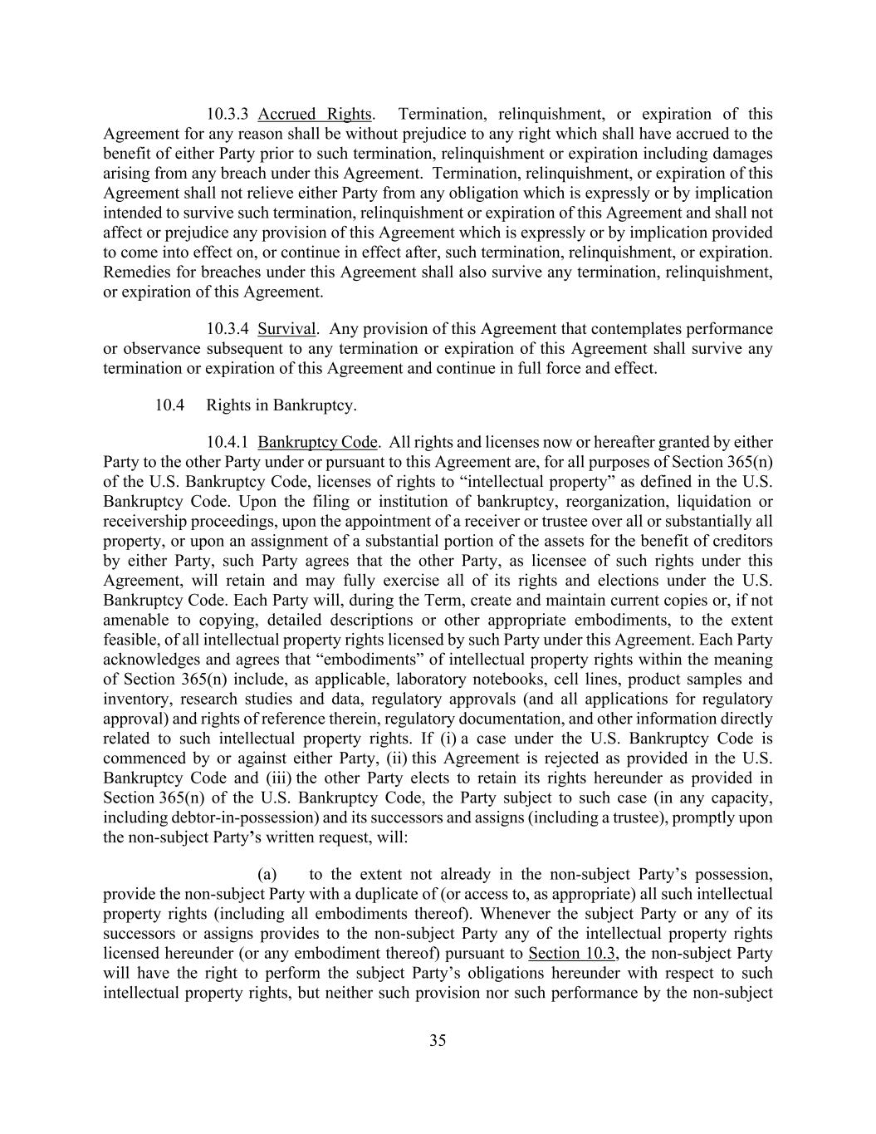
35 10.3.3 Accrued Rights. Termination, relinquishment, or expiration of this Agreement for any reason shall be without prejudice to any right which shall have accrued to the benefit of either Party prior to such termination, relinquishment or expiration including damages arising from any breach under this Agreement. Termination, relinquishment, or expiration of this Agreement shall not relieve either Party from any obligation which is expressly or by implication intended to survive such termination, relinquishment or expiration of this Agreement and shall not affect or prejudice any provision of this Agreement which is expressly or by implication provided to come into effect on, or continue in effect after, such termination, relinquishment, or expiration. Remedies for breaches under this Agreement shall also survive any termination, relinquishment, or expiration of this Agreement. 10.3.4 Survival. Any provision of this Agreement that contemplates performance or observance subsequent to any termination or expiration of this Agreement shall survive any termination or expiration of this Agreement and continue in full force and effect. 10.4 Rights in Bankruptcy. 10.4.1 Bankruptcy Code. All rights and licenses now or hereafter granted by either Party to the other Party under or pursuant to this Agreement are, for all purposes of Section 365(n) of the U.S. Bankruptcy Code, licenses of rights to “intellectual property” as defined in the U.S. Bankruptcy Code. Upon the filing or institution of bankruptcy, reorganization, liquidation or receivership proceedings, upon the appointment of a receiver or trustee over all or substantially all property, or upon an assignment of a substantial portion of the assets for the benefit of creditors by either Party, such Party agrees that the other Party, as licensee of such rights under this Agreement, will retain and may fully exercise all of its rights and elections under the U.S. Bankruptcy Code. Each Party will, during the Term, create and maintain current copies or, if not amenable to copying, detailed descriptions or other appropriate embodiments, to the extent feasible, of all intellectual property rights licensed by such Party under this Agreement. Each Party acknowledges and agrees that “embodiments” of intellectual property rights within the meaning of Section 365(n) include, as applicable, laboratory notebooks, cell lines, product samples and inventory, research studies and data, regulatory approvals (and all applications for regulatory approval) and rights of reference therein, regulatory documentation, and other information directly related to such intellectual property rights. If (i) a case under the U.S. Bankruptcy Code is commenced by or against either Party, (ii) this Agreement is rejected as provided in the U.S. Bankruptcy Code and (iii) the other Party elects to retain its rights hereunder as provided in Section 365(n) of the U.S. Bankruptcy Code, the Party subject to such case (in any capacity, including debtor-in-possession) and its successors and assigns (including a trustee), promptly upon the non-subject Party’s written request, will: (a) to the extent not already in the non-subject Party’s possession, provide the non-subject Party with a duplicate of (or access to, as appropriate) all such intellectual property rights (including all embodiments thereof). Whenever the subject Party or any of its successors or assigns provides to the non-subject Party any of the intellectual property rights licensed hereunder (or any embodiment thereof) pursuant to Section 10.3, the non-subject Party will have the right to perform the subject Party’s obligations hereunder with respect to such intellectual property rights, but neither such provision nor such performance by the non-subject

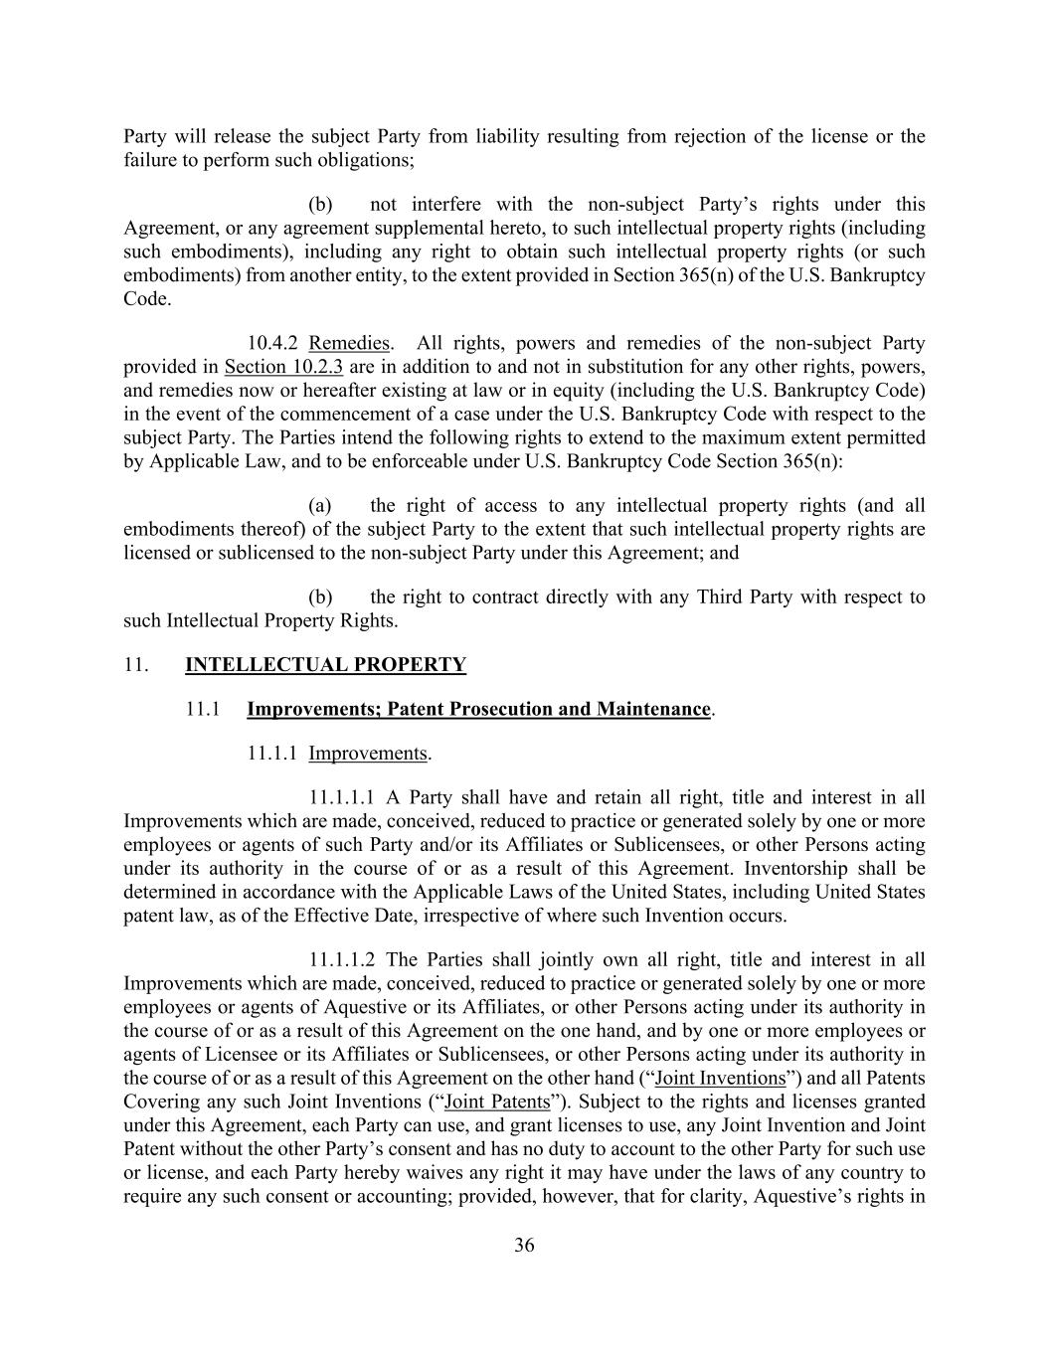
36 Party will release the subject Party from liability resulting from rejection of the license or the failure to perform such obligations; (b) not interfere with the non-subject Party’s rights under this Agreement, or any agreement supplemental hereto, to such intellectual property rights (including such embodiments), including any right to obtain such intellectual property rights (or such embodiments) from another entity, to the extent provided in Section 365(n) of the U.S. Bankruptcy Code. 10.4.2 Remedies. All rights, powers and remedies of the non-subject Party provided in Section 10.2.3 are in addition to and not in substitution for any other rights, powers, and remedies now or hereafter existing at law or in equity (including the U.S. Bankruptcy Code) in the event of the commencement of a case under the U.S. Bankruptcy Code with respect to the subject Party. The Parties intend the following rights to extend to the maximum extent permitted by Applicable Law, and to be enforceable under U.S. Bankruptcy Code Section 365(n): (a) the right of access to any intellectual property rights (and all embodiments thereof) of the subject Party to the extent that such intellectual property rights are licensed or sublicensed to the non-subject Party under this Agreement; and (b) the right to contract directly with any Third Party with respect to such Intellectual Property Rights. 11. INTELLECTUAL PROPERTY 11.1 Improvements; Patent Prosecution and Maintenance. 11.1.1 Improvements. 11.1.1.1 A Party shall have and retain all right, title and interest in all Improvements which are made, conceived, reduced to practice or generated solely by one or more employees or agents of such Party and/or its Affiliates or Sublicensees, or other Persons acting under its authority in the course of or as a result of this Agreement. Inventorship shall be determined in accordance with the Applicable Laws of the United States, including United States patent law, as of the Effective Date, irrespective of where such Invention occurs. 11.1.1.2 The Parties shall jointly own all right, title and interest in all Improvements which are made, conceived, reduced to practice or generated solely by one or more employees or agents of Aquestive or its Affiliates, or other Persons acting under its authority in the course of or as a result of this Agreement on the one hand, and by one or more employees or agents of Licensee or its Affiliates or Sublicensees, or other Persons acting under its authority in the course of or as a result of this Agreement on the other hand (“Joint Inventions”) and all Patents Covering any such Joint Inventions (“Joint Patents”). Subject to the rights and licenses granted under this Agreement, each Party can use, and grant licenses to use, any Joint Invention and Joint Patent without the other Party’s consent and has no duty to account to the other Party for such use or license, and each Party hereby waives any right it may have under the laws of any country to require any such consent or accounting; provided, however, that for clarity, Aquestive’s rights in

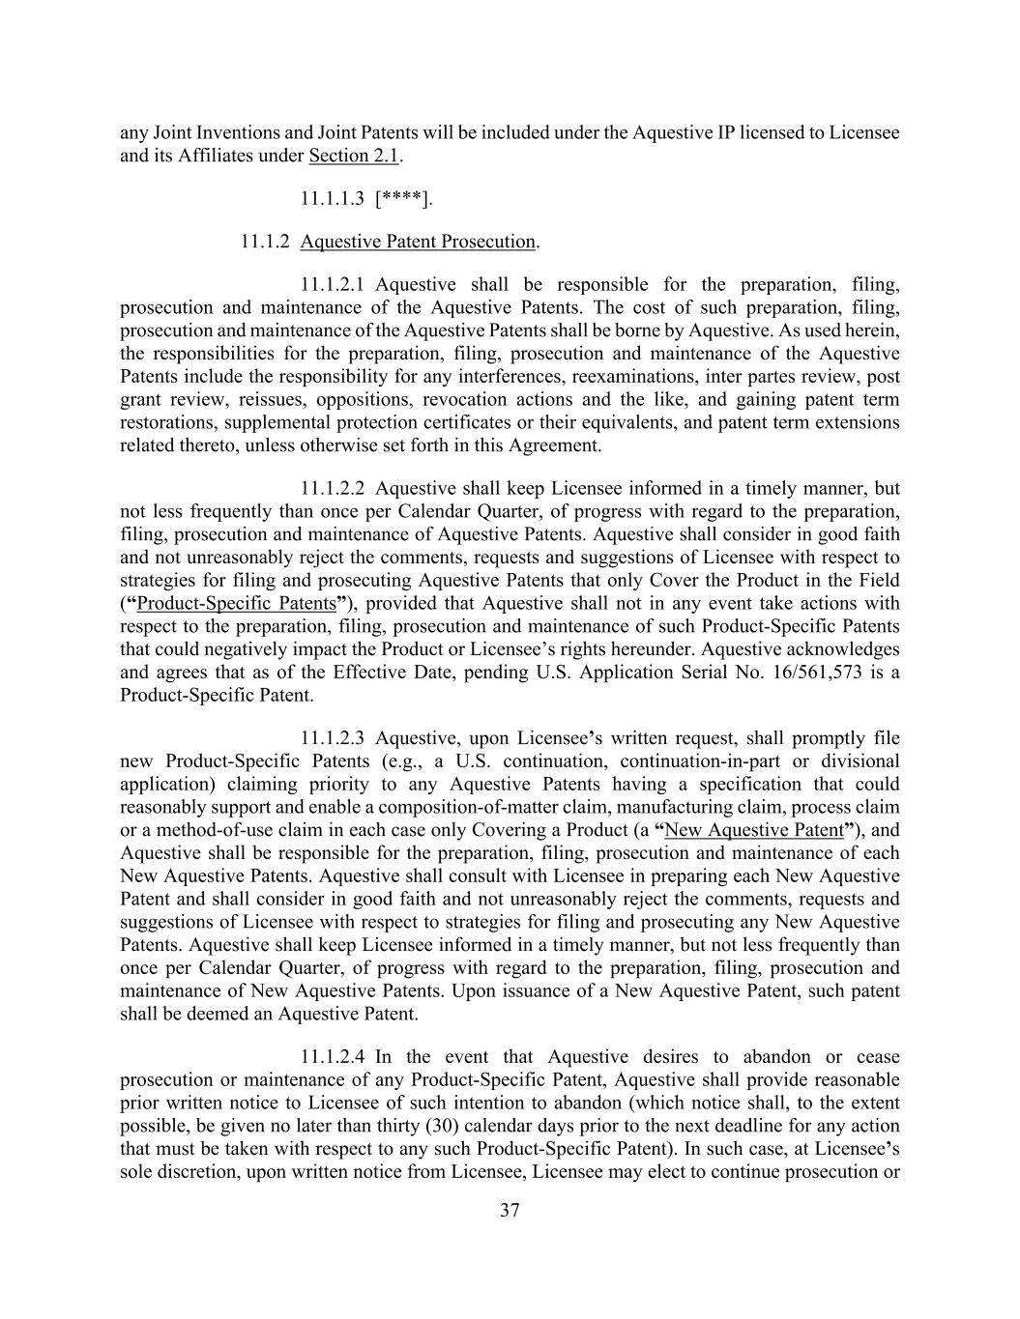
37 any Joint Inventions and Joint Patents will be included under the Aquestive IP licensed to Licensee and its Affiliates under Section 2.1. 11.1.1.3 [****]. 11.1.2 Aquestive Patent Prosecution. 11.1.2.1 Aquestive shall be responsible for the preparation, filing, prosecution and maintenance of the Aquestive Patents. The cost of such preparation, filing, prosecution and maintenance of the Aquestive Patents shall be borne by Aquestive. As used herein, the responsibilities for the preparation, filing, prosecution and maintenance of the Aquestive Patents include the responsibility for any interferences, reexaminations, inter partes review, post grant review, reissues, oppositions, revocation actions and the like, and gaining patent term restorations, supplemental protection certificates or their equivalents, and patent term extensions related thereto, unless otherwise set forth in this Agreement. 11.1.2.2 Aquestive shall keep Licensee informed in a timely manner, but not less frequently than once per Calendar Quarter, of progress with regard to the preparation, filing, prosecution and maintenance of Aquestive Patents. Aquestive shall consider in good faith and not unreasonably reject the comments, requests and suggestions of Licensee with respect to strategies for filing and prosecuting Aquestive Patents that only Cover the Product in the Field (“Product-Specific Patents”), provided that Aquestive shall not in any event take actions with respect to the preparation, filing, prosecution and maintenance of such Product-Specific Patents that could negatively impact the Product or Licensee’s rights hereunder. Aquestive acknowledges and agrees that as of the Effective Date, pending U.S. Application Serial No. 16/561,573 is a Product-Specific Patent. 11.1.2.3 Aquestive, upon Licensee’s written request, shall promptly file new Product-Specific Patents (e.g., a U.S. continuation, continuation-in-part or divisional application) claiming priority to any Aquestive Patents having a specification that could reasonably support and enable a composition-of-matter claim, manufacturing claim, process claim or a method-of-use claim in each case only Covering a Product (a “New Aquestive Patent”), and Aquestive shall be responsible for the preparation, filing, prosecution and maintenance of each New Aquestive Patents. Aquestive shall consult with Licensee in preparing each New Aquestive Patent and shall consider in good faith and not unreasonably reject the comments, requests and suggestions of Licensee with respect to strategies for filing and prosecuting any New Aquestive Patents. Aquestive shall keep Licensee informed in a timely manner, but not less frequently than once per Calendar Quarter, of progress with regard to the preparation, filing, prosecution and maintenance of New Aquestive Patents. Upon issuance of a New Aquestive Patent, such patent shall be deemed an Aquestive Patent. 11.1.2.4 In the event that Aquestive desires to abandon or cease prosecution or maintenance of any Product-Specific Patent, Aquestive shall provide reasonable prior written notice to Licensee of such intention to abandon (which notice shall, to the extent possible, be given no later than thirty (30) calendar days prior to the next deadline for any action that must be taken with respect to any such Product-Specific Patent). In such case, at Licensee’s sole discretion, upon written notice from Licensee, Licensee may elect to continue prosecution or

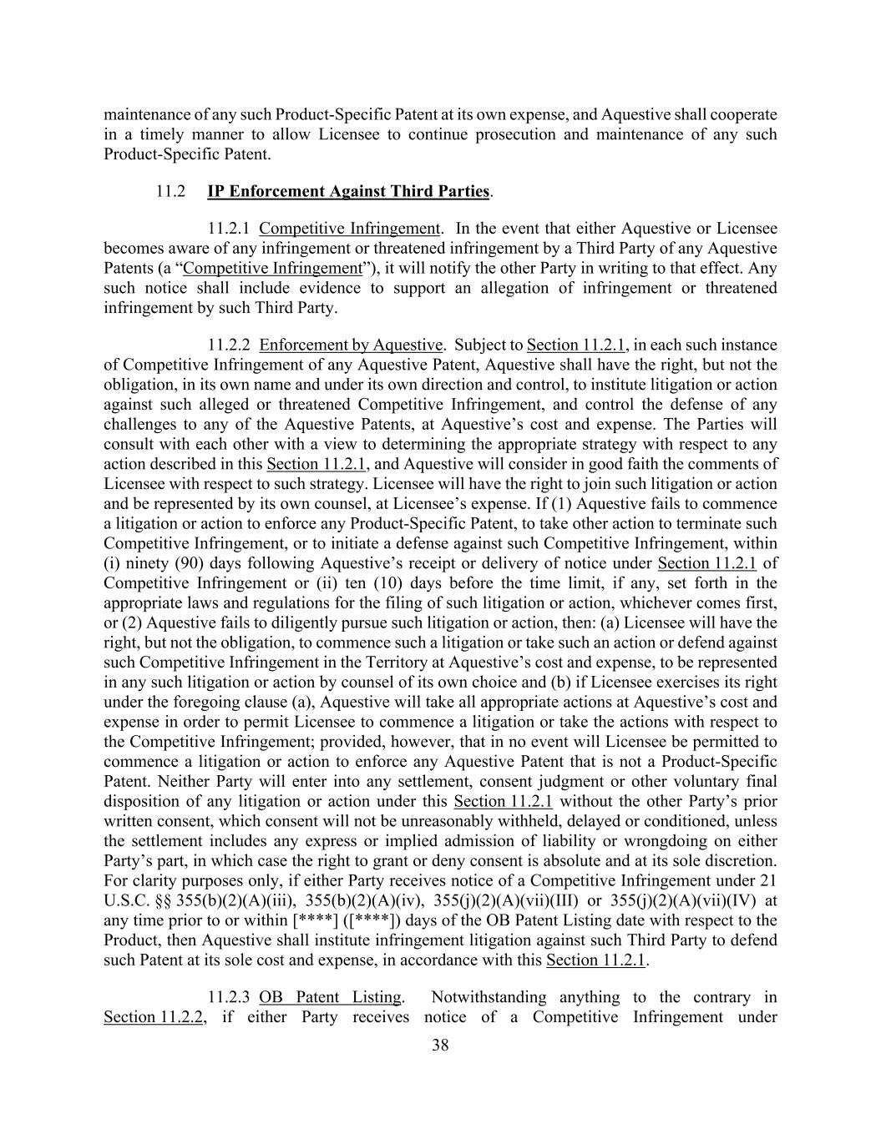
38 maintenance of any such Product-Specific Patent at its own expense, and Aquestive shall cooperate in a timely manner to allow Licensee to continue prosecution and maintenance of any such Product-Specific Patent. 11.2 IP Enforcement Against Third Parties. 11.2.1 Competitive Infringement. In the event that either Aquestive or Licensee becomes aware of any infringement or threatened infringement by a Third Party of any Aquestive Patents (a “Competitive Infringement”), it will notify the other Party in writing to that effect. Any such notice shall include evidence to support an allegation of infringement or threatened infringement by such Third Party. 11.2.2 Enforcement by Aquestive. Subject to Section 11.2.1, in each such instance of Competitive Infringement of any Aquestive Patent, Aquestive shall have the right, but not the obligation, in its own name and under its own direction and control, to institute litigation or action against such alleged or threatened Competitive Infringement, and control the defense of any challenges to any of the Aquestive Patents, at Aquestive’s cost and expense. The Parties will consult with each other with a view to determining the appropriate strategy with respect to any action described in this Section 11.2.1, and Aquestive will consider in good faith the comments of Licensee with respect to such strategy. Licensee will have the right to join such litigation or action and be represented by its own counsel, at Licensee’s expense. If (1) Aquestive fails to commence a litigation or action to enforce any Product-Specific Patent, to take other action to terminate such Competitive Infringement, or to initiate a defense against such Competitive Infringement, within (i) ninety (90) days following Aquestive’s receipt or delivery of notice under Section 11.2.1 of Competitive Infringement or (ii) ten (10) days before the time limit, if any, set forth in the appropriate laws and regulations for the filing of such litigation or action, whichever comes first, or (2) Aquestive fails to diligently pursue such litigation or action, then: (a) Licensee will have the right, but not the obligation, to commence such a litigation or take such an action or defend against such Competitive Infringement in the Territory at Aquestive’s cost and expense, to be represented in any such litigation or action by counsel of its own choice and (b) if Licensee exercises its right under the foregoing clause (a), Aquestive will take all appropriate actions at Aquestive’s cost and expense in order to permit Licensee to commence a litigation or take the actions with respect to the Competitive Infringement; provided, however, that in no event will Licensee be permitted to commence a litigation or action to enforce any Aquestive Patent that is not a Product-Specific Patent. Neither Party will enter into any settlement, consent judgment or other voluntary final disposition of any litigation or action under this Section 11.2.1 without the other Party’s prior written consent, which consent will not be unreasonably withheld, delayed or conditioned, unless the settlement includes any express or implied admission of liability or wrongdoing on either Party’s part, in which case the right to grant or deny consent is absolute and at its sole discretion. For clarity purposes only, if either Party receives notice of a Competitive Infringement under 21 U.S.C. §§ 355(b)(2)(A)(iii), 355(b)(2)(A)(iv), 355(j)(2)(A)(vii)(III) or 355(j)(2)(A)(vii)(IV) at any time prior to or within [****] ([****]) days of the OB Patent Listing date with respect to the Product, then Aquestive shall institute infringement litigation against such Third Party to defend such Patent at its sole cost and expense, in accordance with this Section 11.2.1. 11.2.3 OB Patent Listing. Notwithstanding anything to the contrary in Section 11.2.2, if either Party receives notice of a Competitive Infringement under

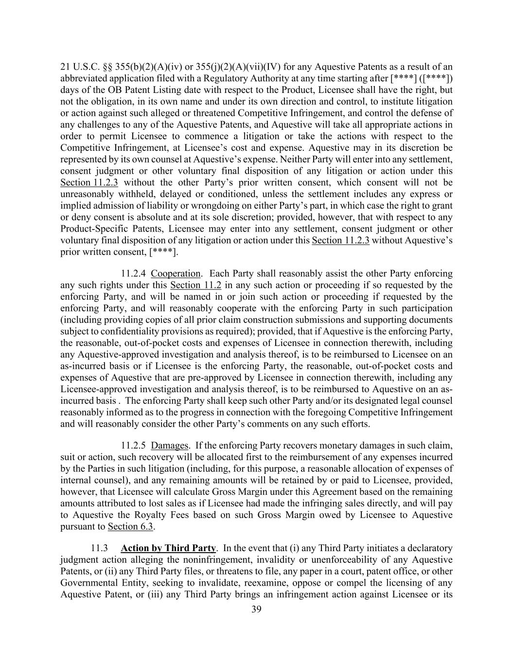
39 21 U.S.C. §§ 355(b)(2)(A)(iv) or 355(j)(2)(A)(vii)(IV) for any Aquestive Patents as a result of an abbreviated application filed with a Regulatory Authority at any time starting after [****] ([****]) days of the OB Patent Listing date with respect to the Product, Licensee shall have the right, but not the obligation, in its own name and under its own direction and control, to institute litigation or action against such alleged or threatened Competitive Infringement, and control the defense of any challenges to any of the Aquestive Patents, and Aquestive will take all appropriate actions in order to permit Licensee to commence a litigation or take the actions with respect to the Competitive Infringement, at Licensee’s cost and expense. Aquestive may in its discretion be represented by its own counsel at Aquestive’s expense. Neither Party will enter into any settlement, consent judgment or other voluntary final disposition of any litigation or action under this Section 11.2.3 without the other Party’s prior written consent, which consent will not be unreasonably withheld, delayed or conditioned, unless the settlement includes any express or implied admission of liability or wrongdoing on either Party’s part, in which case the right to grant or deny consent is absolute and at its sole discretion; provided, however, that with respect to any Product-Specific Patents, Licensee may enter into any settlement, consent judgment or other voluntary final disposition of any litigation or action under this Section 11.2.3 without Aquestive’s prior written consent, [****]. 11.2.4 Cooperation. Each Party shall reasonably assist the other Party enforcing any such rights under this Section 11.2 in any such action or proceeding if so requested by the enforcing Party, and will be named in or join such action or proceeding if requested by the enforcing Party, and will reasonably cooperate with the enforcing Party in such participation (including providing copies of all prior claim construction submissions and supporting documents subject to confidentiality provisions as required); provided, that if Aquestive is the enforcing Party, the reasonable, out-of-pocket costs and expenses of Licensee in connection therewith, including any Aquestive-approved investigation and analysis thereof, is to be reimbursed to Licensee on an as-incurred basis or if Licensee is the enforcing Party, the reasonable, out-of-pocket costs and expenses of Aquestive that are pre-approved by Licensee in connection therewith, including any Licensee-approved investigation and analysis thereof, is to be reimbursed to Aquestive on an as- incurred basis . The enforcing Party shall keep such other Party and/or its designated legal counsel reasonably informed as to the progress in connection with the foregoing Competitive Infringement and will reasonably consider the other Party’s comments on any such efforts. 11.2.5 Damages. If the enforcing Party recovers monetary damages in such claim, suit or action, such recovery will be allocated first to the reimbursement of any expenses incurred by the Parties in such litigation (including, for this purpose, a reasonable allocation of expenses of internal counsel), and any remaining amounts will be retained by or paid to Licensee, provided, however, that Licensee will calculate Gross Margin under this Agreement based on the remaining amounts attributed to lost sales as if Licensee had made the infringing sales directly, and will pay to Aquestive the Royalty Fees based on such Gross Margin owed by Licensee to Aquestive pursuant to Section 6.3. 11.3 Action by Third Party. In the event that (i) any Third Party initiates a declaratory judgment action alleging the noninfringement, invalidity or unenforceability of any Aquestive Patents, or (ii) any Third Party files, or threatens to file, any paper in a court, patent office, or other Governmental Entity, seeking to invalidate, reexamine, oppose or compel the licensing of any Aquestive Patent, or (iii) any Third Party brings an infringement action against Licensee or its

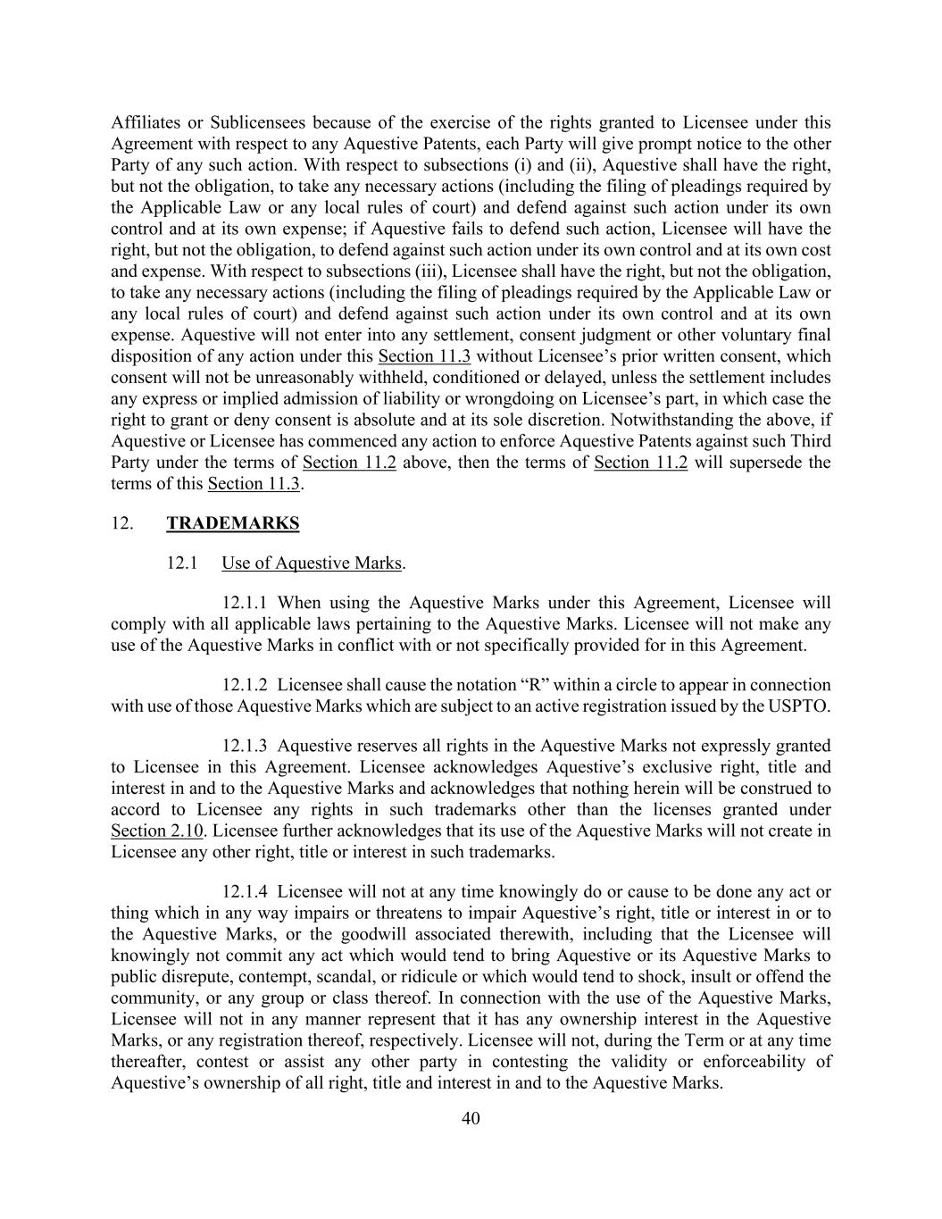
40 Affiliates or Sublicensees because of the exercise of the rights granted to Licensee under this Agreement with respect to any Aquestive Patents, each Party will give prompt notice to the other Party of any such action. With respect to subsections (i) and (ii), Aquestive shall have the right, but not the obligation, to take any necessary actions (including the filing of pleadings required by the Applicable Law or any local rules of court) and defend against such action under its own control and at its own expense; if Aquestive fails to defend such action, Licensee will have the right, but not the obligation, to defend against such action under its own control and at its own cost and expense. With respect to subsections (iii), Licensee shall have the right, but not the obligation, to take any necessary actions (including the filing of pleadings required by the Applicable Law or any local rules of court) and defend against such action under its own control and at its own expense. Aquestive will not enter into any settlement, consent judgment or other voluntary final disposition of any action under this Section 11.3 without Licensee’s prior written consent, which consent will not be unreasonably withheld, conditioned or delayed, unless the settlement includes any express or implied admission of liability or wrongdoing on Licensee’s part, in which case the right to grant or deny consent is absolute and at its sole discretion. Notwithstanding the above, if Aquestive or Licensee has commenced any action to enforce Aquestive Patents against such Third Party under the terms of Section 11.2 above, then the terms of Section 11.2 will supersede the terms of this Section 11.3. 12. TRADEMARKS 12.1 Use of Aquestive Marks. 12.1.1 When using the Aquestive Marks under this Agreement, Licensee will comply with all applicable laws pertaining to the Aquestive Marks. Licensee will not make any use of the Aquestive Marks in conflict with or not specifically provided for in this Agreement. 12.1.2 Licensee shall cause the notation “R” within a circle to appear in connection with use of those Aquestive Marks which are subject to an active registration issued by the USPTO. 12.1.3 Aquestive reserves all rights in the Aquestive Marks not expressly granted to Licensee in this Agreement. Licensee acknowledges Aquestive’s exclusive right, title and interest in and to the Aquestive Marks and acknowledges that nothing herein will be construed to accord to Licensee any rights in such trademarks other than the licenses granted under Section 2.10. Licensee further acknowledges that its use of the Aquestive Marks will not create in Licensee any other right, title or interest in such trademarks. 12.1.4 Licensee will not at any time knowingly do or cause to be done any act or thing which in any way impairs or threatens to impair Aquestive’s right, title or interest in or to the Aquestive Marks, or the goodwill associated therewith, including that the Licensee will knowingly not commit any act which would tend to bring Aquestive or its Aquestive Marks to public disrepute, contempt, scandal, or ridicule or which would tend to shock, insult or offend the community, or any group or class thereof. In connection with the use of the Aquestive Marks, Licensee will not in any manner represent that it has any ownership interest in the Aquestive Marks, or any registration thereof, respectively. Licensee will not, during the Term or at any time thereafter, contest or assist any other party in contesting the validity or enforceability of Aquestive’s ownership of all right, title and interest in and to the Aquestive Marks.

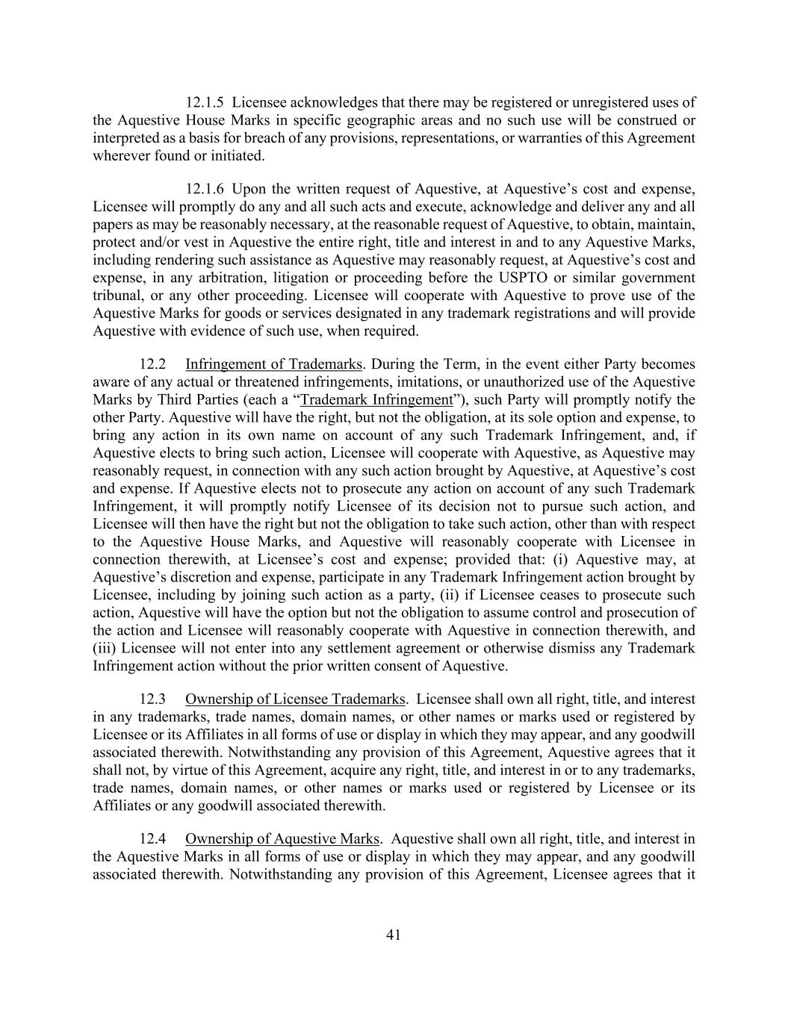
41 12.1.5 Licensee acknowledges that there may be registered or unregistered uses of the Aquestive House Marks in specific geographic areas and no such use will be construed or interpreted as a basis for breach of any provisions, representations, or warranties of this Agreement wherever found or initiated. 12.1.6 Upon the written request of Aquestive, at Aquestive’s cost and expense, Licensee will promptly do any and all such acts and execute, acknowledge and deliver any and all papers as may be reasonably necessary, at the reasonable request of Aquestive, to obtain, maintain, protect and/or vest in Aquestive the entire right, title and interest in and to any Aquestive Marks, including rendering such assistance as Aquestive may reasonably request, at Aquestive’s cost and expense, in any arbitration, litigation or proceeding before the USPTO or similar government tribunal, or any other proceeding. Licensee will cooperate with Aquestive to prove use of the Aquestive Marks for goods or services designated in any trademark registrations and will provide Aquestive with evidence of such use, when required. 12.2 Infringement of Trademarks. During the Term, in the event either Party becomes aware of any actual or threatened infringements, imitations, or unauthorized use of the Aquestive Marks by Third Parties (each a “Trademark Infringement”), such Party will promptly notify the other Party. Aquestive will have the right, but not the obligation, at its sole option and expense, to bring any action in its own name on account of any such Trademark Infringement, and, if Aquestive elects to bring such action, Licensee will cooperate with Aquestive, as Aquestive may reasonably request, in connection with any such action brought by Aquestive, at Aquestive’s cost and expense. If Aquestive elects not to prosecute any action on account of any such Trademark Infringement, it will promptly notify Licensee of its decision not to pursue such action, and Licensee will then have the right but not the obligation to take such action, other than with respect to the Aquestive House Marks, and Aquestive will reasonably cooperate with Licensee in connection therewith, at Licensee’s cost and expense; provided that: (i) Aquestive may, at Aquestive’s discretion and expense, participate in any Trademark Infringement action brought by Licensee, including by joining such action as a party, (ii) if Licensee ceases to prosecute such action, Aquestive will have the option but not the obligation to assume control and prosecution of the action and Licensee will reasonably cooperate with Aquestive in connection therewith, and (iii) Licensee will not enter into any settlement agreement or otherwise dismiss any Trademark Infringement action without the prior written consent of Aquestive. 12.3 Ownership of Licensee Trademarks. Licensee shall own all right, title, and interest in any trademarks, trade names, domain names, or other names or marks used or registered by Licensee or its Affiliates in all forms of use or display in which they may appear, and any goodwill associated therewith. Notwithstanding any provision of this Agreement, Aquestive agrees that it shall not, by virtue of this Agreement, acquire any right, title, and interest in or to any trademarks, trade names, domain names, or other names or marks used or registered by Licensee or its Affiliates or any goodwill associated therewith. 12.4 Ownership of Aquestive Marks. Aquestive shall own all right, title, and interest in the Aquestive Marks in all forms of use or display in which they may appear, and any goodwill associated therewith. Notwithstanding any provision of this Agreement, Licensee agrees that it

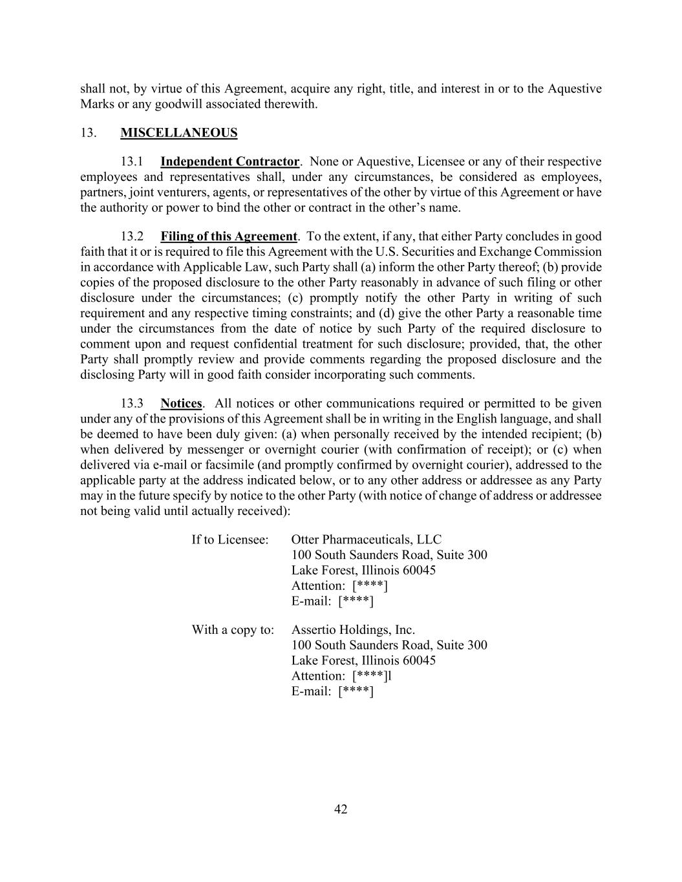
42 shall not, by virtue of this Agreement, acquire any right, title, and interest in or to the Aquestive Marks or any goodwill associated therewith. 13. MISCELLANEOUS 13.1 Independent Contractor. None or Aquestive, Licensee or any of their respective employees and representatives shall, under any circumstances, be considered as employees, partners, joint venturers, agents, or representatives of the other by virtue of this Agreement or have the authority or power to bind the other or contract in the other’s name. 13.2 Filing of this Agreement. To the extent, if any, that either Party concludes in good faith that it or is required to file this Agreement with the U.S. Securities and Exchange Commission in accordance with Applicable Law, such Party shall (a) inform the other Party thereof; (b) provide copies of the proposed disclosure to the other Party reasonably in advance of such filing or other disclosure under the circumstances; (c) promptly notify the other Party in writing of such requirement and any respective timing constraints; and (d) give the other Party a reasonable time under the circumstances from the date of notice by such Party of the required disclosure to comment upon and request confidential treatment for such disclosure; provided, that, the other Party shall promptly review and provide comments regarding the proposed disclosure and the disclosing Party will in good faith consider incorporating such comments. 13.3 Notices. All notices or other communications required or permitted to be given under any of the provisions of this Agreement shall be in writing in the English language, and shall be deemed to have been duly given: (a) when personally received by the intended recipient; (b) when delivered by messenger or overnight courier (with confirmation of receipt); or (c) when delivered via e-mail or facsimile (and promptly confirmed by overnight courier), addressed to the applicable party at the address indicated below, or to any other address or addressee as any Party may in the future specify by notice to the other Party (with notice of change of address or addressee not being valid until actually received): If to Licensee: Otter Pharmaceuticals, LLC 100 South Saunders Road, Suite 300 Lake Forest, Illinois 60045 Attention: [****] E-mail: [****] With a copy to: Assertio Holdings, Inc. 100 South Saunders Road, Suite 300 Lake Forest, Illinois 60045 Attention: [****]l E-mail: [****]

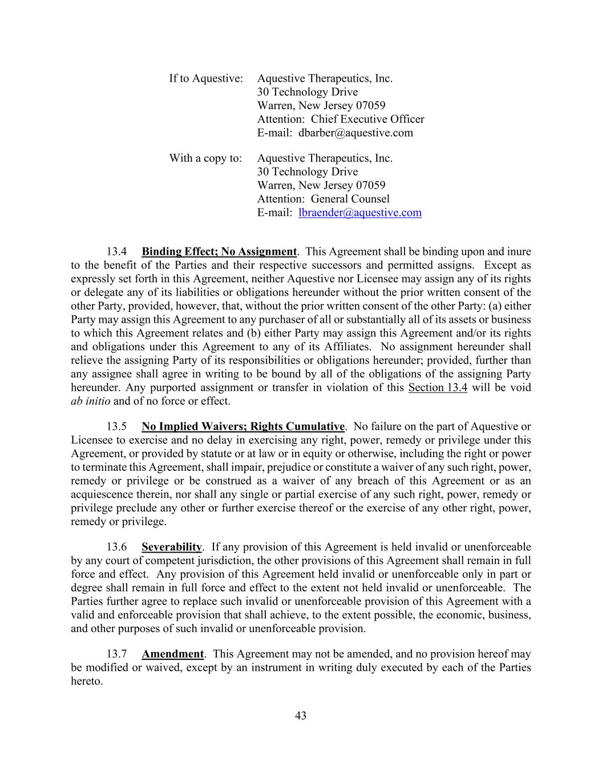
43 If to Aquestive: Aquestive Therapeutics, Inc. 30 Technology Drive Warren, New Jersey 07059 Attention: Chief Executive Officer E-mail: dbarber@aquestive.com With a copy to: Aquestive Therapeutics, Inc. 30 Technology Drive Warren, New Jersey 07059 Attention: General Counsel E-mail: lbraender@aquestive.com 13.4 Binding Effect; No Assignment. This Agreement shall be binding upon and inure to the benefit of the Parties and their respective successors and permitted assigns. Except as expressly set forth in this Agreement, neither Aquestive nor Licensee may assign any of its rights or delegate any of its liabilities or obligations hereunder without the prior written consent of the other Party, provided, however, that, without the prior written consent of the other Party: (a) either Party may assign this Agreement to any purchaser of all or substantially all of its assets or business to which this Agreement relates and (b) either Party may assign this Agreement and/or its rights and obligations under this Agreement to any of its Affiliates. No assignment hereunder shall relieve the assigning Party of its responsibilities or obligations hereunder; provided, further than any assignee shall agree in writing to be bound by all of the obligations of the assigning Party hereunder. Any purported assignment or transfer in violation of this Section 13.4 will be void ab initio and of no force or effect. 13.5 No Implied Waivers; Rights Cumulative. No failure on the part of Aquestive or Licensee to exercise and no delay in exercising any right, power, remedy or privilege under this Agreement, or provided by statute or at law or in equity or otherwise, including the right or power to terminate this Agreement, shall impair, prejudice or constitute a waiver of any such right, power, remedy or privilege or be construed as a waiver of any breach of this Agreement or as an acquiescence therein, nor shall any single or partial exercise of any such right, power, remedy or privilege preclude any other or further exercise thereof or the exercise of any other right, power, remedy or privilege. 13.6 Severability. If any provision of this Agreement is held invalid or unenforceable by any court of competent jurisdiction, the other provisions of this Agreement shall remain in full force and effect. Any provision of this Agreement held invalid or unenforceable only in part or degree shall remain in full force and effect to the extent not held invalid or unenforceable. The Parties further agree to replace such invalid or unenforceable provision of this Agreement with a valid and enforceable provision that shall achieve, to the extent possible, the economic, business, and other purposes of such invalid or unenforceable provision. 13.7 Amendment. This Agreement may not be amended, and no provision hereof may be modified or waived, except by an instrument in writing duly executed by each of the Parties hereto.

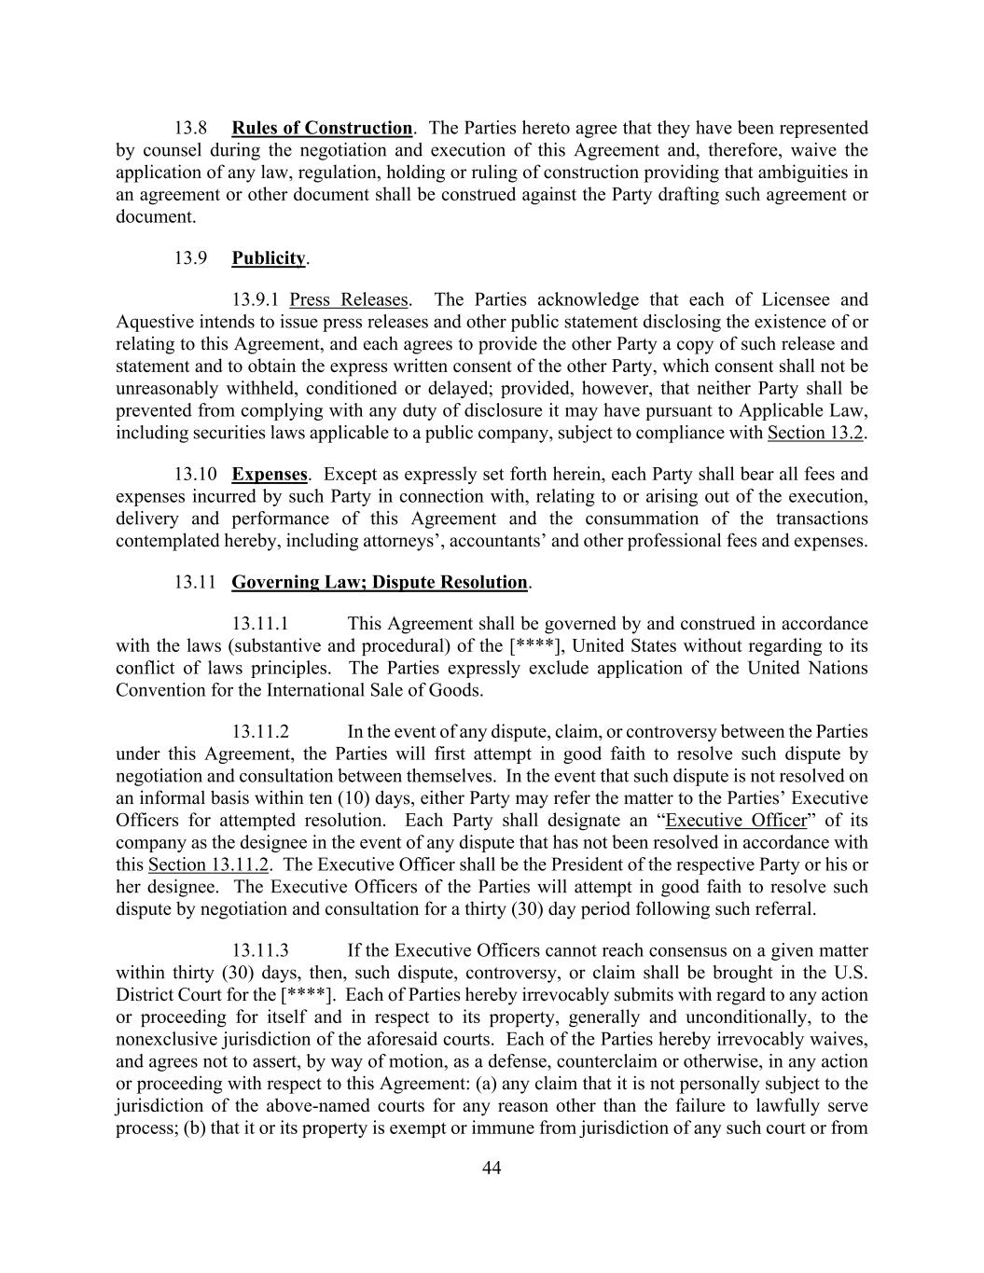
44 13.8 Rules of Construction. The Parties hereto agree that they have been represented by counsel during the negotiation and execution of this Agreement and, therefore, waive the application of any law, regulation, holding or ruling of construction providing that ambiguities in an agreement or other document shall be construed against the Party drafting such agreement or document. 13.9 Publicity. 13.9.1 Press Releases. The Parties acknowledge that each of Licensee and Aquestive intends to issue press releases and other public statement disclosing the existence of or relating to this Agreement, and each agrees to provide the other Party a copy of such release and statement and to obtain the express written consent of the other Party, which consent shall not be unreasonably withheld, conditioned or delayed; provided, however, that neither Party shall be prevented from complying with any duty of disclosure it may have pursuant to Applicable Law, including securities laws applicable to a public company, subject to compliance with Section 13.2. 13.10 Expenses. Except as expressly set forth herein, each Party shall bear all fees and expenses incurred by such Party in connection with, relating to or arising out of the execution, delivery and performance of this Agreement and the consummation of the transactions contemplated hereby, including attorneys’, accountants’ and other professional fees and expenses. 13.11 Governing Law; Dispute Resolution. 13.11.1 This Agreement shall be governed by and construed in accordance with the laws (substantive and procedural) of the [****], United States without regarding to its conflict of laws principles. The Parties expressly exclude application of the United Nations Convention for the International Sale of Goods. 13.11.2 In the event of any dispute, claim, or controversy between the Parties under this Agreement, the Parties will first attempt in good faith to resolve such dispute by negotiation and consultation between themselves. In the event that such dispute is not resolved on an informal basis within ten (10) days, either Party may refer the matter to the Parties’ Executive Officers for attempted resolution. Each Party shall designate an “Executive Officer” of its company as the designee in the event of any dispute that has not been resolved in accordance with this Section 13.11.2. The Executive Officer shall be the President of the respective Party or his or her designee. The Executive Officers of the Parties will attempt in good faith to resolve such dispute by negotiation and consultation for a thirty (30) day period following such referral. 13.11.3 If the Executive Officers cannot reach consensus on a given matter within thirty (30) days, then, such dispute, controversy, or claim shall be brought in the U.S. District Court for the [****]. Each of Parties hereby irrevocably submits with regard to any action or proceeding for itself and in respect to its property, generally and unconditionally, to the nonexclusive jurisdiction of the aforesaid courts. Each of the Parties hereby irrevocably waives, and agrees not to assert, by way of motion, as a defense, counterclaim or otherwise, in any action or proceeding with respect to this Agreement: (a) any claim that it is not personally subject to the jurisdiction of the above-named courts for any reason other than the failure to lawfully serve process; (b) that it or its property is exempt or immune from jurisdiction of any such court or from

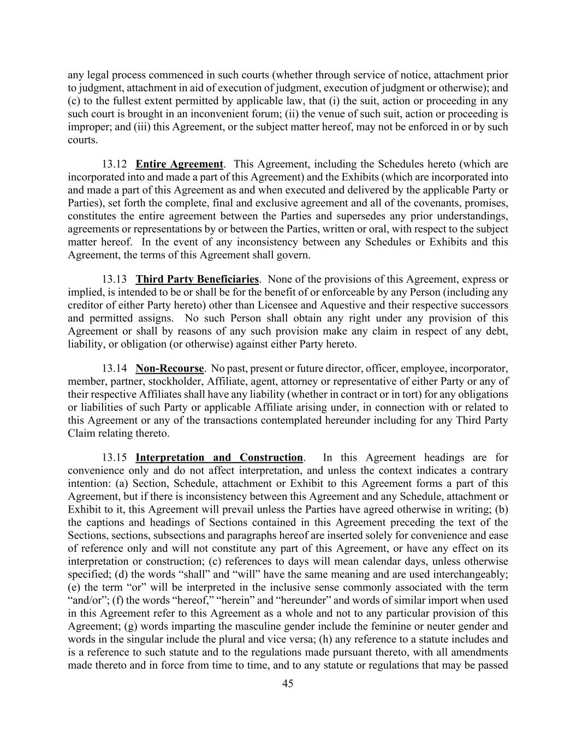
45 any legal process commenced in such courts (whether through service of notice, attachment prior to judgment, attachment in aid of execution of judgment, execution of judgment or otherwise); and (c) to the fullest extent permitted by applicable law, that (i) the suit, action or proceeding in any such court is brought in an inconvenient forum; (ii) the venue of such suit, action or proceeding is improper; and (iii) this Agreement, or the subject matter hereof, may not be enforced in or by such courts. 13.12 Entire Agreement. This Agreement, including the Schedules hereto (which are incorporated into and made a part of this Agreement) and the Exhibits (which are incorporated into and made a part of this Agreement as and when executed and delivered by the applicable Party or Parties), set forth the complete, final and exclusive agreement and all of the covenants, promises, constitutes the entire agreement between the Parties and supersedes any prior understandings, agreements or representations by or between the Parties, written or oral, with respect to the subject matter hereof. In the event of any inconsistency between any Schedules or Exhibits and this Agreement, the terms of this Agreement shall govern. 13.13 Third Party Beneficiaries. None of the provisions of this Agreement, express or implied, is intended to be or shall be for the benefit of or enforceable by any Person (including any creditor of either Party hereto) other than Licensee and Aquestive and their respective successors and permitted assigns. No such Person shall obtain any right under any provision of this Agreement or shall by reasons of any such provision make any claim in respect of any debt, liability, or obligation (or otherwise) against either Party hereto. 13.14 Non-Recourse. No past, present or future director, officer, employee, incorporator, member, partner, stockholder, Affiliate, agent, attorney or representative of either Party or any of their respective Affiliates shall have any liability (whether in contract or in tort) for any obligations or liabilities of such Party or applicable Affiliate arising under, in connection with or related to this Agreement or any of the transactions contemplated hereunder including for any Third Party Claim relating thereto. 13.15 Interpretation and Construction. In this Agreement headings are for convenience only and do not affect interpretation, and unless the context indicates a contrary intention: (a) Section, Schedule, attachment or Exhibit to this Agreement forms a part of this Agreement, but if there is inconsistency between this Agreement and any Schedule, attachment or Exhibit to it, this Agreement will prevail unless the Parties have agreed otherwise in writing; (b) the captions and headings of Sections contained in this Agreement preceding the text of the Sections, sections, subsections and paragraphs hereof are inserted solely for convenience and ease of reference only and will not constitute any part of this Agreement, or have any effect on its interpretation or construction; (c) references to days will mean calendar days, unless otherwise specified; (d) the words “shall” and “will” have the same meaning and are used interchangeably; (e) the term “or” will be interpreted in the inclusive sense commonly associated with the term “and/or”; (f) the words “hereof,” “herein” and “hereunder” and words of similar import when used in this Agreement refer to this Agreement as a whole and not to any particular provision of this Agreement; (g) words imparting the masculine gender include the feminine or neuter gender and words in the singular include the plural and vice versa; (h) any reference to a statute includes and is a reference to such statute and to the regulations made pursuant thereto, with all amendments made thereto and in force from time to time, and to any statute or regulations that may be passed

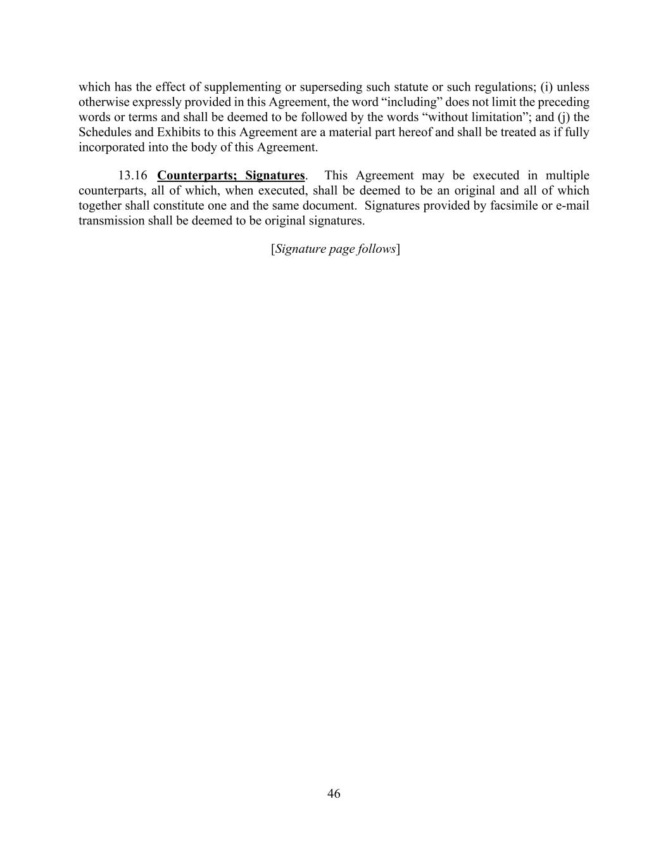
46 which has the effect of supplementing or superseding such statute or such regulations; (i) unless otherwise expressly provided in this Agreement, the word “including” does not limit the preceding words or terms and shall be deemed to be followed by the words “without limitation”; and (j) the Schedules and Exhibits to this Agreement are a material part hereof and shall be treated as if fully incorporated into the body of this Agreement. 13.16 Counterparts; Signatures. This Agreement may be executed in multiple counterparts, all of which, when executed, shall be deemed to be an original and all of which together shall constitute one and the same document. Signatures provided by facsimile or e-mail transmission shall be deemed to be original signatures. [Signature page follows]

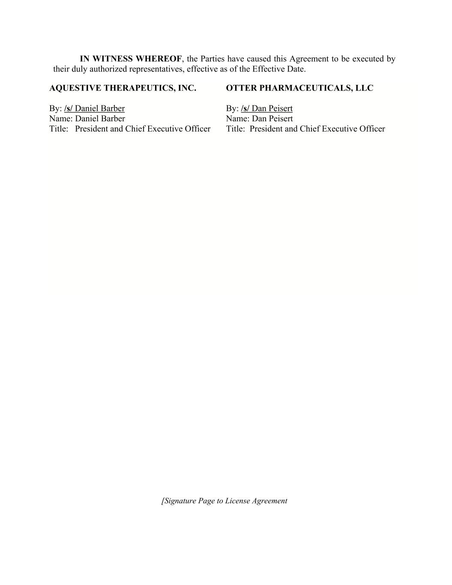
IN WITNESS WHEREOF, the Parties have caused this Agreement to be executed by their duly authorized representatives, effective as of the Effective Date. AQUESTIVE THERAPEUTICS, INC. By: /s/ Daniel Barber Name: Daniel Barber Title: President and Chief Executive Officer OTTER PHARMACEUTICALS, LLC By: /s/ Dan Peisert Name: Dan Peisert Title: President and Chief Executive Officer [Signature Page to License Agreement



Exhibit 23.1

Consent of Independent Registered Public Accounting Firm

We consent to the incorporation by reference in the registration statements (No. 333-226399, 333-251984, 333-262051, and 333-269292) on Form S-8 and (No. 333-251979 and 333-254775) on Form S-3 of our report dated March 31, 2023, with respect to the consolidated financial statements of Aquestive Therapeutics, Inc..

/s/ KPMG LLP

New York, New York
March 31, 2023

Exhibit 31.1

Certification of Principal Executive Officer of Aquestive Therapeutics, Inc.
Pursuant to Section 302 of the Sarbanes-Oxley Act of 2002

I, Daniel Barber, certify that:

1.I have reviewed this Annual Report on Form 10-K of Aquestive Therapeutics, Inc.;

2.Based on my knowledge, this report does not contain any untrue statement of a material fact or omit to state a material fact necessary to make the statements made, in light of the circumstances under which such statements were made, not misleading with respect to the period covered by this report;

3.Based on my knowledge, the financial statements, and other financial information included in this report, fairly present in all material respects the financial condition, results of operations and cash flows of the registrant as of, and for, the periods presented in this report;

4.The registrant’s other certifying officer and I are responsible for establishing and maintaining disclosure controls and procedures (as defined in Exchange Act Rules 13a-15(e) and 15d-15(e)) and internal control over financial reporting (as defined in Exchange Act Rules 13a-15(f) and 15d-15(f)) for the registrant and have:

a)Designed such disclosure controls and procedures, or caused such disclosure controls and procedures to be designed under our supervision, to ensure that material information relating to the registrant, including its consolidated subsidiaries, is made known to us by others within those entities, particularly during the period in which this report is being prepared;

b)Designed such internal control over financial reporting, or caused such internal control over financial reporting to be designed under our supervision, to provide reasonable assurance regarding the reliability of financial reporting and the preparation of financial statements for external purposes in accordance with generally accepted accounting principles;

c)Evaluated the effectiveness of the registrant’s disclosure controls and procedures and presented in this report our conclusions about the effectiveness of the disclosure controls and procedures, as of the end of the period covered by this report based on such evaluation; and

d)Disclosed in this report any change in the registrant’s internal control over financial reporting that occurred during the registrant’s most recent fiscal quarter (the registrant’s fourth fiscal quarter in the case of an annual report) that has materially affected, or is reasonably likely to materially affect, the registrant’s internal control over financial reporting; and

5.The registrant’s other certifying officer and I have disclosed, based on our most recent evaluation of internal control over financial reporting, to the registrant’s auditors and the audit committee of the registrant’s board of directors (or persons performing the equivalent functions):

a)All significant deficiencies and material weaknesses in the design or operation of internal control over financial reporting which are reasonably likely to adversely affect the registrant’s ability to record, process, summarize and report financial information; and

b)Any fraud, whether or not material, that involves management or other employees who have a significant role in the registrant’s internal control over financial reporting.

Date: March 31, 2023
/s/ Daniel Barber
Daniel Barber
President and Chief Executive Officer
(Principal Executive Officer)

Exhibit 31.2

Certification of Principal
Financial Officer of Aquestive Therapeutics, Inc.
Pursuant to Section 302 of the Sarbanes-Oxley Act of 2002

I, A. Ernest Toth, Jr., certify that:

1.I have reviewed this Annual Report on Form 10-K of Aquestive Therapeutics, Inc.;

2.Based on my knowledge, this report does not contain any untrue statement of a material fact or omit to state a material fact necessary to make the statements made, in light of the circumstances under which such statements were made, not misleading with respect to the period covered by this report;

3.Based on my knowledge, the financial statements, and other financial information included in this report, fairly present in all material respects the financial condition, results of operations and cash flows of the registrant as of, and for, the periods presented in this report;

4.The registrant’s other certifying officer and I are responsible for establishing and maintaining disclosure controls and procedures (as defined in Exchange Act Rules 13a-15(e) and 15d-15(e)) and internal control over financial reporting (as defined in Exchange Act Rules 13a-15(f) and 15d-15(f)) for the registrant and have:

a)Designed such disclosure controls and procedures, or caused such disclosure controls and procedures to be designed under our supervision, to ensure that material information relating to the registrant, including its consolidated subsidiaries, is made known to us by others within those entities, particularly during the period in which this report is being prepared;

b)Designed such internal control over financial reporting, or caused such internal control over financial reporting to be designed under our supervision, to provide reasonable assurance regarding the reliability of financial reporting and the preparation of financial statements for external purposes in accordance with generally accepted accounting principles;

c)Evaluated the effectiveness of the registrant’s disclosure controls and procedures and presented in this report our conclusions about the effectiveness of the disclosure controls and procedures, as of the end of the period covered by this report based on such evaluation; and

d)Disclosed in this report any change in the registrant’s internal control over financial reporting that occurred during the registrant’s most recent fiscal quarter (the registrant’s fourth fiscal quarter in the case of an annual report) that has materially affected, or is reasonably likely to materially affect, the registrant’s internal control over financial reporting; and

5.The registrant’s other certifying officer and I have disclosed, based on our most recent evaluation of internal control over financial reporting, to the registrant’s auditors and the audit committee of the registrant’s board of directors (or persons performing the equivalent functions):

a)All significant deficiencies and material weaknesses in the design or operation of internal control over financial reporting which are reasonably likely to adversely affect the registrant’s ability to record, process, summarize and report financial information; and

b)Any fraud, whether or not material, that involves management or other employees who have a significant role in the registrant’s internal control over financial reporting.

Date: March 31, 2023
/s/ A. ERNEST TOTH, JR.
A.Ernest Toth, Jr.
Chief Financial Officer
(Principal Financial Officer)

Exhibit 32.1

Certification of Principal Executive Officer
Pursuant to 18 U.S.C. Section 1350, as Adopted
Pursuant to Section 906 of the Sarbanes-Oxley Act of 2002

Pursuant to the requirement set forth in Rule 13a-14(b) of the Securities Exchange Act of 1934, as amended (the “Exchange Act”), and Section 1350 of Chapter 63 of Title 18 of the United States Code (18 U.S.C. §1350), I, Daniel Barber, Chief Executive Officer of Aquestive Therapeutics, Inc., (the “Company”), hereby certify that, to the best of my knowledge:

1.The Company’s Annual Report on Form 10-K for the year ended December 31, 2022, to which this Certification is attached as Exhibit 32.1 (the “Annual Report”), fully complies with the requirements of Section 13(a) or Section 15(d) of the Exchange Act; and

2.The information contained in the Annual Report fairly presents, in all material respects, the financial condition of the Company at the end of the period covered by the Annual Report and the results of operations of the Company for the period covered by the Annual Report.

Dated: March 31, 2023
/s/ Daniel Barber
Daniel Barber
President and Chief Executive Officer
(Principal Executive Officer)

This certification accompanies the Form 10-K to which it relates, is not deemed filed with the Securities and Exchange Commission and is not to be incorporated by reference into any filing of Aquestive Therapeutics, Inc. under the Securities Act of 1933, as amended, or the Securities Exchange Act of 1934, as amended (whether made before or after the date of the Form 10-K), irrespective of any general incorporation language contained in such filing.

Exhibit 32.2

Certification of Principal Financial Officer
Pursuant to 18 U.S.C. Section 1350, as Adopted
Pursuant to Section 906 of the Sarbanes-Oxley Act of 2002

Pursuant to the requirement set forth in Rule 13a-14(b) of the Securities Exchange Act of 1934, as amended (the “Exchange Act”), and Section 1350 of Chapter 63 of Title 18 of the United States Code (18 U.S.C. §1350), I, A. Ernest Toth, Jr., Chief Financial Officer of Aquestive Therapeutics, Inc., (the “Company”), hereby certify that, to the best of my knowledge:

1.The Company’s Annual Report on Form 10-K for the year ended December 31, 2022, to which this Certification is attached as Exhibit 32.2 (the “Annual Report”), fully complies with the requirements of Section 13(a) or Section 15(d) of the Exchange Act; and

2.The information contained in the Annual Report fairly presents, in all material respects, the financial condition of the Company at the end of the period covered by the Annual Report and the results of operations of the Company for the period covered by the Annual Report.

Dated: March 31, 2023
/s/ A. ERNEST TOTH, JR
A.Ernest Toth, Jr.
Chief Financial Officer
(Principal Financial Officer)

This certification accompanies the Form 10-K to which it relates, is not deemed filed with the Securities and Exchange Commission and is not to be incorporated by reference into any filing of Aquestive Therapeutics, Inc. under the Securities Act of 1933, as amended, or the Securities Exchange Act of 1934, as amended (whether made before or after the date of the Form 10-K), irrespective of any general incorporation language contained in such filing.

