UNITED STATES

SECURITIES AND EXCHANGE COMMISSION

Washington, D.C. 20549

FORM 10-Q

- QUARTERLY REPORT PURSUANT TO SECTION 13 OR 15(d) OF THE SECURITIES EXCHANGE ACT OF 1934

For the quarterly period ended June 30, 2022

OR

- TRANSITION REPORT PURSUANT TO SECTION 13 OR 15(d) OF THE SECURITIES EXCHANGE ACT OF 1934

For the transition period from _____ to _____

Commission File Number: 001-38599

Aquestive Therapeutics, Inc.

(Exact Name of Registrant as Specified in its Charter)

Delaware | 30 Technology Drive, Warren, NJ 07059 |  |  | 82-3827296
(State or other jurisdiction of Incorporation or | ( 908) 941-1900 |  |  | (I.R.S. Employer Identification Number)
organization)
(Address, Zip Code and Telephone Number of Registrant’s Principal Executive Offices)
 | Securities registered pursuant to Section 12(b) of the Act:
Title of each class |  | Trading Symbol(s) |  | Name of each exchange on which registered
Common Stock, par value $0.001 per share |  | AQST |  | NASDAQ Global Market

Securities registered pursuant to Section 12(g) of the Act: None

Indicate by check mark whether the registrant: (1) has filed all reports required to be filed by Section 13 or 15(d) of the Securities Exchange Act of 1934 during the preceding 12 months (or for such shorter period that the registrant was required to file such reports), and (2) has been subject to such filing requirements for the past 90 days. ☒ Yes ☐ No

Indicate by check mark whether the registrant has submitted electronically every Interactive Data File required to be submitted pursuant to Rule 405 of Regulation S-T (§232.405 of this chapter) during the preceding 12 months (or for such shorter period that the registrant was required to submit such files). ☒ Yes ☐ No

Indicate by check mark whether the registrant is a large accelerated filer, an accelerated filer, a non-accelerated filer, a smaller reporting company or an emerging growth company. See the definitions of “large accelerated filer,” “accelerated filer”, “smaller reporting company” and “emerging growth company” in Rule 12b-2 of the Securities Exchange Act of 1934.

Large accelerated filer | ☐ | Accelerated filer | ☐
Non-accelerated filer | ☒ | Smaller reporting company | ☒
 |  | Emerging growth company | ☒

If an emerging growth company, indicate by check mark if the registrant has elected not to use the extended transition period for complying with any new or revised financial accounting standards provided pursuant to Section 13(a) of the Exchange Act. ☐

Indicate by check mark whether the registrant is a shell company (as defined in Rule 12b-2 of the Exchange Act). ☐ Yes ☒ No

The number of outstanding shares of the registrant’s common stock, par value of $0.001 per share, as of the close of business on July 25, 2022 was 53,350,654.

Table of Content

AQUESTIVE THERAPEUTICS, INC.

FORM 10-Q

TABLE OF CONTENTS

 |  |  |  |  |  |  |  |  |  |  |  |  |  |  |  |  |  |  | Page No.
 | PART I – FINANCIAL INFORMATION
 | Item 1. |  | Financial Statements (Unaudited)
 |  |  | Condensed Consolidated Balance Sheets as of June 30, 2022 and December 31, 2021 |  |  |  |  |  |  |  |  |  |  |  |  |  |  |  | 3
 |  |  | Condensed Consolidated Statements of Operations and Comprehensive Loss for the three and six months ended June 30, 2022 and 2021 |  |  |  |  |  |  |  |  |  |  |  |  |  |  |  | 4
 |  |  | Condensed Consolidated Statements of Changes in Stockholders’ Deficit for the three and six months ended June 30, 2022 and 2021 |  |  |  |  |  |  |  |  |  |  |  |  |  |  |  | 5
 |  |  | Condensed Consolidated Statements of Cash Flows for the six months ended June 30, 2022 and 2021 |  |  |  |  |  |  |  |  |  |  |  |  |  |  |  | 6
 |  |  | Notes to Unaudited Condensed Consolidated Financial Statements |  |  |  |  |  |  |  |  |  |  |  |  |  |  |  | 7
 | Item 2. |  | Management’s Discussion and Analysis of Financial Condition and Results of Operations |  |  |  |  |  |  |  |  |  |  |  |  |  |  |  | 30
 | Item 3. |  | Quantitative and Qualitative Disclosures about Market Risk |  |  |  |  |  |  |  |  |  |  |  |  |  |  |  | 45
 | Item 4. |  | Controls and Procedures |  |  |  |  |  |  |  |  |  |  |  |  |  |  |  | 45
 | PART II – OTHER INFORMATION
 | Item 1. |  | Legal Proceedings |  |  |  |  |  |  |  |  |  |  |  |  |  |  |  | 45
 | Item 1A. |  | Risk Factors |  |  |  |  |  |  |  |  |  |  |  |  |  |  |  | 45
 | Item 2. |  | Unregistered Sales of Equity Securities and Use of Proceeds |  |  |  |  |  |  |  |  |  |  |  |  |  |  |  | 47
 | Item 3. |  | Defaults Upon Senior Securities |  |  |  |  |  |  |  |  |  |  |  |  |  |  |  | 48
 | Item 4. |  | Mine Safety Disclosures |  |  |  |  |  |  |  |  |  |  |  |  |  |  |  | 48
 | Item 5. |  | Other Information |  |  |  |  |  |  |  |  |  |  |  |  |  |  |  | 48
 | Item 6. |  | Exhibits |  |  |  |  |  |  |  |  |  |  |  |  |  |  |  | 49
 | SIGNATURES |  |  |  |  |  |  |  |  |  |  |  |  |  |  |  |  |  | 50
 |  |  | 2

Table of Content

PART I – FINANCIAL INFORMATION
Item 1. FINANCIAL STATEMENTS (Unaudited)
 | AQUESTIVE THERAPEUTICS, INC.
 | Condensed Consolidated Balance Sheets
 | (In thousands, except share and per share amounts)
 | (Unaudited)
 |  |  | June 30, |  |  | December 31,
 |  |  | 2022 |  |  | 2021
 | Assets
 | Current assets:
 | Cash and cash equivalents | $ | 17,695 |  | $ | 28,024
 | Trade and other receivables, net |  | 19,165 |  |  | 12,120
 | Inventories, net |  | 5,008 |  |  | 4,038
 | Prepaid expenses and other current assets |  | 1,637 |  |  | 3,077
 | Total current assets |  | 43,505 |  |  | 47,259
 | Property and equipment, net |  | 4,569 |  |  | 5,055
 | Right-of-use assets, net |  | 2,314 |  |  | 2,725
 | Intangible assets, net |  | 25 |  |  | 51
 | Other non-current assets |  | 5,897 |  |  | 6,903
 | Total assets | $ | 56,310 |  | $ | 61,993
 | Liabilities and stockholders’ deficit
 | Current liabilities:
 | Accounts payable | $ | 8,887 |  | $ | 8,314
 | Accrued expenses |  | 7,042 |  |  | 8,736
 | Lease liabilities, current |  | 913 |  |  | 899
 | Deferred revenue, current |  | 1,599 |  |  | 765
 | Liability related to the sale of future revenue, current |  | 1,445 |  |  | 1,225
 | Loans payable, current |  | 9,750 |  |  | 2,025
 | Total current liabilities |  | 29,636 |  |  | 21,964
 | Loans payable, net |  | 43,821 |  |  | 51,551
 | Liability related to the sale of future revenue, net |  | 61,839 |  |  | 59,059
 | Lease liabilities |  | 1,502 |  |  | 1,946
 | Deferred revenue |  | 13,490 |  |  | 7,122
 | Other non-current liabilities |  | 2,379 |  |  | 2,485
 | Total liabilities |  | 152,667 |  |  | 144,127
 | Contingencies (Note 19)
 | Stockholders’ deficit:
 | Common stock, $0.001 par value. Authorized 250,000,000 shares; 53,343,989 and 41,228,736 shares issued and outstanding at June 30, |  | 53 |  |  | 41
 | 2022 and December 31, 2021, respectively |  | 53 |  |  | 41
 | Additional paid-in capital |  | 189,908 |  |  | 174,621
 | Accumulated deficit |  | (286,318) |  |  | (256,796)
 | Total stockholders’ deficit |  | (96,357) |  |  | (82,134)
 | Total liabilities and stockholders’ deficit | $ | 56,310 |  | $ | 61,993

See accompanying notes to the condensed consolidated financial statements.

3

Table of Content

AQUESTIVE THERAPEUTICS, INC.

Condensed Consolidated Statements of Operations and Comprehensive Loss

(In thousands, except share and per share data amounts)

(Unaudited)

 |  | Three Months Ended |  |  |  |  |  | Six Months Ended
 |  | June 30, |  |  |  |  |  | June 30,
 |  | 2022 |  |  | 2021 |  |  | 2022 |  |  | 2021
Revenues | $ | 13,265 |  | $ | 15,345 |  | $ | 25,535 |  | $ | 26,467
Costs and expenses:
Manufacture and supply |  | 5,242 |  |  | 4,466 |  |  | 9,456 |  |  | 7,223
Research and development |  | 5,198 |  |  | 4,262 |  |  | 9,971 |  |  | 7,921
Selling, general and administrative |  | 15,587 |  |  | 13,134 |  |  | 28,608 |  |  | 26,365
Total costs and expenses |  | 26,027 |  |  | 21,862 |  |  | 48,035 |  |  | 41,509
Loss from operations |  | (12,762) |  |  | (6,517) |  |  | (22,500) |  |  | (15,042)
Other income/ (expenses):
Interest expense |  | (1,635) |  |  | (2,757) |  |  | (3,253) |  |  | (5,518)
Interest expense related to the sale of future revenue, net |  | (1,937) |  |  | (3,466) |  |  | (3,798) |  |  | (6,800)
Interest and other income, net |  | 32 |  |  | 373 |  |  | 29 |  |  | 321
Net loss before income taxes |  | (16,302) |  |  | (12,367) |  |  | (29,522) |  |  | (27,039)
Income taxes |  | — |  |  | — |  |  | — |  |  | —
Net loss | $ | (16,302) |  | $ | (12,367) |  | $ | (29,522) |  | $ | (27,039)
Comprehensive loss | $ | (16,302) |  | $ | (12,367) |  | $ | (29,522) |  | $ | (27,039)
Net loss per share - basic and diluted | $ | (0.36) |  | $ | (0.33) |  | $ | (0.68) |  | $ | (0.74)
Weighted-average number of common shares outstanding - basic and diluted |  | 45,462,516 |  |  | 37,065,300 |  |  | 43,475,198 |  |  | 36,318,437

See accompanying notes to the condensed consolidated financial statements.

4

Table of Content

AQUESTIVE THERAPEUTICS, INC.

Condensed Consolidated Statements of Changes in Stockholders’ Deficit

(In thousands, except share amounts)

(Unaudited)

 |  | Common Stock |  |  |  |  |  |  |  |  |  | Additional |  |  |  |  |  |  |  |  |  | Total
 |  |  |  |  |  |  |  |  |  |  |  | Paid-in |  |  |  |  | Accumulated |  |  |  |  | Stockholders’
 |  | Shares |  |  |  |  | Amount
 |  |  |  |  |  |  |  |  |  |  |  | Capital |  |  |  |  | Deficit |  |  |  |  | Equity/Deficit
Balance at December 31, 2021 |  | 41,228,736 |  | $ |  |  | 41 |  | $ |  |  | 174,621 |  | $ |  |  | (256,796) |  |  |  | $ | (82,134)
Common Stock issued under public equity offering |  | 391,652 |  |  |  |  | — |  |  |  |  | 1,360 |  |  |  |  | — |  |  |  |  | 1,360
Costs of common stock issued under public equity offering |  | — |  |  |  |  | — |  |  |  |  | (62) |  |  |  |  | — |  |  |  |  | (62)
Share-based compensation expense |  | — |  |  |  |  | — |  |  |  |  | 913 |  |  |  |  | — |  |  |  |  | 913
Other |  | — |  |  |  |  | — |  |  |  |  | 1 |  |  |  |  | (1) |  |  |  |  | —
Net loss |  | — |  |  |  |  | — |  |  |  |  | — |  |  |  |  | (13,220) |  |  |  |  | (13,220)
Balance at March 31, 2022 |  | 41,620,388 |  |  |  |  | 41 |  |  |  |  | 176,833 |  |  |  |  | (270,017) |  |  |  |  | (93,143)
Fair value of warrants issued |  | — |  |  |  |  | — |  |  |  |  | 5,874 |  |  |  |  | — |  |  |  |  | 5,874
Common Stock issued under private equity offering |  | 6,686,491 |  |  |  |  | 7 |  |  |  |  | 4,622 |  |  |  |  | — |  |  |  |  | 4,629
Costs of common stock issued under private equity offering |  | — |  |  |  |  | — |  |  |  |  | (824) |  |  |  |  | — |  |  |  |  | (824)
Common Stock issued upon warrant exercises |  | 4,000,000 |  |  |  |  | 4 |  |  |  |  | (4) |  |  |  |  | — |  |  |  |  | —
Common Stock issued under public equity offering |  | 1,013,226 |  |  |  |  | 1 |  |  |  |  | 1,251 |  |  |  |  | — |  |  |  |  | 1,252
Costs of common stock issued under public equity offering |  | — |  |  |  |  | — |  |  |  |  | (77) |  |  |  |  | — |  |  |  |  | (77)
Shares issued under employee stock purchase plan |  | 23,884 |  |  |  |  | — |  |  |  |  | 15 |  |  |  |  | — |  |  |  |  | 15
Share-based compensation expense |  | — |  |  |  |  | — |  |  |  |  | 2,219 |  |  |  |  | — |  |  |  |  | 2,219
Vested restricted stock units |  | — |  |  |  |  | — |  |  |  |  | — |  |  |  |  | — |  |  |  |  | —
Other |  | — |  |  |  |  | — |  |  |  |  | (1) |  |  |  |  | 1 |  |  |  |  | —
Net loss |  | — |  |  |  |  | — |  |  |  |  | — |  |  |  |  | (16,302) |  |  |  |  | (16,302)
Balance at June 30, 2022 |  | 53,343,989 |  |  |  | $ | 53 |  |  |  | $ | 189,908 |  |  |  | $ | (286,318) |  |  |  | $ | (96,357)
Balance at December 31,2020 |  | 34,569,254 |  | $ |  |  | 35 |  | $ |  |  | 137,725 |  | $ |  |  | (186,257) |  | $ |  |  | (48,497)
Common Stock issued under public equity offering |  | 1,672,104 |  |  |  |  | 1 |  |  |  |  | 10,196 |  |  |  |  | — |  |  |  |  | 10,197
Costs of common stock issued under public equity offering |  | — |  |  |  |  | — |  |  |  |  | (306) |  |  |  |  | — |  |  |  |  | (306)
Share-based compensation expense |  | — |  |  |  |  | — |  |  |  |  | 1,507 |  |  |  |  | — |  |  |  |  | 1,507
Other |  | — |  |  |  |  | — |  |  |  |  | (27) |  |  |  |  | — |  |  |  |  | (27)
Net loss |  | — |  |  |  |  | — |  |  |  |  | — |  |  |  |  | (14,672) |  |  |  |  | (14,672)
Balance at March 31, 2021 |  | 36,241,358 |  |  |  |  | 36 |  |  |  |  | 149,095 |  |  |  |  | (200,929) |  |  |  |  | (51,798)
Common Stock issued under public equity offering |  | 2,304,949 |  |  |  |  | 3 |  |  |  |  | 9,238 |  |  |  |  | — |  |  |  |  | 9,241
Costs of common stock issued under public equity offering |  | — |  |  |  |  | — |  |  |  |  | (627) |  |  |  |  | — |  |  |  |  | (627)
Shares issued under employee stock purchase plan |  | 19,270 |  |  |  |  | — |  |  |  |  | 76 |  |  |  |  | — |  |  |  |  | 76
Share-based compensation expense |  | — |  |  |  |  | — |  |  |  |  | 1,710 |  |  |  |  | — |  |  |  |  | 1,710
Vested restricted stock units |  | 2,665 |  |  |  |  | — |  |  |  |  | (4) |  |  |  |  | — |  |  |  |  | (4)
Net loss |  | — |  |  |  |  | — |  |  |  |  | — |  |  |  |  | (12,367) |  |  |  |  | (12,367)
Balance at June 30, 2021 |  | 38,568,242 |  |  |  |  | 39 |  |  |  |  | 159,488 |  |  |  |  | (213,296) |  |  |  |  | (53,769)

See accompanying notes to the condensed consolidated financial statements.

5

Table of Content

AQUESTIVE THERAPEUTICS, INC.

Condensed Consolidated Statements of Cash Flows

(In thousands)

(Unaudited)

Six Months Ended
June 30,

Operating activities: | 2022 |  |  |  | 2021
Net loss | $ | (29,522) |  | $ | (27,039)
Adjustments to reconcile net loss to net cash used for operating activities:
Depreciation, amortization, and impairment |  | 1,394 |  |  | 1,497
Share-based compensation |  | 3,132 |  |  | 3,228
Amortization of debt issuance costs and discounts |  | 109 |  |  | 2,388
Interest expense related to the sale of future revenue, net |  | 3,722 |  |  | 6,729
Other, net |  | (161) |  |  | (125)
Changes in operating assets and liabilities:
Trade and other receivables, net |  | (6,949) |  |  | (5,392)
Inventories, net |  | (970) |  |  | (378)
Prepaid expenses and other assets |  | 2,446 |  |  | 2,532
Accounts payable |  | 574 |  |  | 1,011
Accrued expenses and other liabilities |  | (2,021) |  |  | (2,971)
Deferred revenue |  | 7,202 |  |  | 2,667
Net cash used for operating activities |  | (21,044) |  |  | (15,853)
Investing activities:
Capital expenditures |  | (781) |  |  | (297)
Net cash used for investing activities |  | (781) |  |  | (297)
Financing activities:
Proceeds from common stock issued under public equity offering, net |  | 2,473 |  |  | 18,505
Proceeds from common stock issued under private equity offering, net |  | 3,805 |  |  | —
Proceeds from issuance and exercise of warrants |  | 5,878 |  |  | —
Proceeds from shares issued under employee stock purchase plan |  | 15 |  |  | 76
Premium paid to retire debt |  | (675) |  |  | —
Payments for taxes on share-based compensation |  | — |  |  | (4)
Net cash provided by financing activities |  | 11,496 |  |  | 18,577
Net (decrease) increase in cash and cash equivalents |  | (10,329) |  |  | 2,427
Cash and cash equivalents at beginning of period |  | 28,024 |  |  | 31,807
Cash and cash equivalents at end of period | $ | 17,695 |  | $ | 34,234
Supplemental disclosures of cash flow information:
Cash payments for interest | $ | 1,609 |  | $ | 3,219

See accompanying notes to the condensed consolidated financial statements.

6

Table of Content

AQUESTIVE THERAPEUTICS, INC.

Notes to Condensed Consolidated Financial Statements

(Unaudited, in thousands, except share and per share information)

Note 1. Company Overview and Basis of Presentation

(A) Company Overview

Aquestive Therapeutics, Inc. (together with its subsidiary, “Aquestive” or “the Company”) is a pharmaceutical company advancing medicines to solve patients’ problems with current standards of care, providing transformative products to improve their lives. The Company is developing orally administered products to deliver complex molecules, providing novel alternatives to invasive and inconvenient standard of care therapies. The Company has five products on the U.S. market, four licensed products and one stand-alone proprietary product to date, Sympazan® (clobazam) oral film for the treatment of seizures associated with Lennox-Gastaut Syndrome. Our licensees market their products in the U.S. and around the world. The Company also collaborates with pharmaceutical companies to bring new molecules to market using proprietary, best-in-class technologies, like PharmFilm®, and has proven drug development and commercialization capabilities. The Company is advancing a late-stage proprietary product pipeline focused on treating diseases of the central nervous system, or CNS, and an earlier stage pipeline for the treatment of severe allergic reactions, including anaphylaxis. The Company's production facilities are located in Portage, Indiana, and our corporate headquarters, sales and commercialization operations and primary research laboratory facilities are based in Warren, New Jersey.

(B) Equity Transactions

Equity Offering of Common Stock

On September 11, 2019, the Company established an “At-The-Market” (ATM) facility pursuant to which the Company may offer up to $25,000 of shares of common stock. On November 20, 2020, the Company began utilizing the ATM facility.

On March 26, 2021, the Company filed a prospectus supplement to offer up to an additional $50,000 of shares of common stock under the ATM facility. For the six months ended June 30, 2022, the Company sold 1,404,878 shares which provided net proceeds of approximately $2,473 after deducting commissions and other transaction costs of $139. For the six months ended June 30, 2021, the Company sold 3,977,053 shares which provided net proceeds of approximately $18,505 after deducting commissions and other transaction costs of $933. This ATM facility has approximately $34,791 available at June 30, 2022.

On April 12, 2022, the Company entered into a purchase agreement ("Lincoln Park Purchase Agreement") with Lincoln Park Capital Fund, LLC ("Lincoln Park"), which provides that, upon the terms and subject to the conditions and limitations set forth in the Lincoln Park Purchase Agreement, the Company has the right, but not the obligation, to sell to Lincoln Park up to $40,000 worth of shares of its common stock from time to time over the 36-month term of the Lincoln Park Purchase Agreement. The Lincoln Park Purchase Agreement contains an ownership limitation such that we will not issue, and Lincoln Park will not purchase, shares of common stock if it would result in their beneficial ownership exceeding 9.99%. Lincoln Park has covenanted under the Lincoln Park Purchase Agreement not to cause or engage in any manner whatsoever, any direct or indirect short selling or hedging of the Company's common stock. For the six months ended June 30, 2022, the Company sold 1,611,181 shares including commitment shares, which provided proceeds of approximately $1,987 in connection with the Lincoln Park Purchase Agreement. On April 13, 2022, the Company filed a prospectus supplement in connection with this offering.

On June 6, 2022, the Company entered into securities purchase agreements ("Securities Purchase Agreements") with certain purchasers. The Securities Purchase Agreements provided for the sale and issuance by the Company of an aggregate of: (i) 4,850,000 shares of the Company’s common stock, (ii) pre-funded warrants to purchase up to 4,000,000 shares of common stock and (iii) common stock warrants to purchase up to 8,850,000 shares of common stock. The Company received net proceeds of approximately $7,796, after deducting placement agent fees and expenses and estimated offering expenses payable by the Company. The Company intends to use the net proceeds from the offering for general corporate purposes. On June 8, 2022, the Company filed a prospectus supplement in connection with this equity offering.

(C) Basis of Presentation

The accompanying interim unaudited condensed consolidated financial statements were prepared in conformity with U.S. generally accepted accounting principles (“U.S. GAAP”) and with Article 10 of Regulation S-X for interim financial reporting. In compliance with those rules, certain information and footnote disclosures normally included in annual consolidated financial

7

Table of Content

statements prepared in accordance with U.S. GAAP have been condensed or omitted. These condensed consolidated financial statements should be read in conjunction with the Company’s audited consolidated financial statements and related notes for the fiscal year ended December 31, 2021 included in the Company’s Annual Report on Form 10-K filed with the SEC on March 8, 2022 (the “2021 Annual Report on Form 10-K”). As included herein, the condensed consolidated balance sheet as of December 31, 2021 is derived from the audited consolidated financial statements as of that date. In the opinion of management, all adjustments (consisting only of normal recurring adjustments) considered necessary for a fair statement of the results of interim periods have been included. The accompanying financial statements reflect certain reclassifications from previously issued financial statements to conform to the current presentation. The Company has evaluated subsequent events for disclosure through the date of issuance of the accompanying unaudited condensed financial statements.

Any reference in these notes to applicable guidance refers to the authoritative U.S. GAAP as found in the Accounting Standards Codification (“ASC”) and Accounting Standards Updates (“ASU”) of the Financial Accounting Standards Board (“FASB”).

Note 2. Summary of Significant Accounting Policies

(A) Recent Accounting Pronouncements

As an emerging growth company, the Company has elected to take advantage of the extended transition period afforded by the Jumpstart Our Business Startups Act for the implementation of new or revised accounting standards and, as a result, the Company will comply with new or revised accounting standards no later than the relevant dates on which adoption of such standards is required for emerging growth companies. The Company believes that the impact of recently issued accounting standards that are not yet effective will not have a material impact on its financial position or results of operations upon adoption.

Recent Accounting Pronouncements Not Adopted as of June 30, 2022:

In June 2016, the FASB issued ASU 2016-13, Financial Instruments – Credit Losses (Topic 326), amending existing guidance on the accounting for credit losses on financial instruments within its scope. The guidance provides for use of a forward-looking expected loss model for estimating credit losses, replacing the incurred loss model that is based on past events and current conditions. The new guidance also changes the impairment model for available-for-sale debt securities, requiring the use of an allowance to record estimated credit losses (and subsequent recoveries). The new guidance is effective for the Company beginning after December 15, 2022. The Company does not expect the new accounting guidance to have a material impact on the Company's consolidated financial statements.

In August 2020, the FASB issued ASU 2020-06, Debt-Debt with Conversion and Other Options (Subtopic 470-20) and Derivatives and Hedging-Contracts in Entity’s Own Equity (Subtopic 815-40): Accounting for Convertible Instruments and Contracts in an Entity’s Own Equity. This Accounting Standards Update was issued to address the complexity in accounting for certain financial instruments with characteristics of liabilities and equity. Among other provisions, the amendments in this ASU significantly change the guidance on the issuer’s accounting for convertible instruments and the guidance on the derivative scope exception for contracts in an entity’s own equity such that fewer conversion features will require separate recognition, and fewer freestanding instruments, like warrants, will require liability treatment. More specifically, the ASU reduces the number of models that may be used to account for convertible instruments from five to three, amends diluted EPS calculations for convertible instruments, modifies the requirements for a contract that may be settled in an entity’s own shares to be classified in equity and requires expanded disclosures intended to increase transparency. These amendments will be effective for the Company beginning January 1, 2024, with early adoption of the amendments permitted. The Company is currently evaluating the impact from the adoption of ASU 2020-06 on its consolidated financial statements.

In May 2021, the FASB issued ASU 2021-04, Earnings Per Share (Topic 260), Debt—Modifications and Extinguishments (Subtopic 470-50), Compensation—Stock Compensation (Topic 718), and Derivatives and Hedging—Contracts in Entity’s Own Equity (Subtopic 815-40) Issuer’s Accounting for Certain Modifications or Exchanges of Freestanding Equity-Classified Written Call Options. The accounting standard update was issued to clarify and reduce diversity in an issuer’s accounting for modifications or exchanges of freestanding equity-classified written call options that remain equity classified after modification or exchange. The new accounting guidance is effective for the Company beginning after December 15, 2022. Early adoption is permitted. The Company does not expect the new accounting guidance to have a material impact on the Company's consolidated financial statements.

8

Table of Content

In June 2022, the FASB issued ASU 2022-03, Fair Value Measurement (Topic 820): Fair Value Measurement of Equity Securities Subject to Contractual Sale Restrictions. This Accounting Standards Update was issued to clarify the guidance in Topic 820, Fair Value Measurement, when measuring the fair value of an equity security subject to contractual restrictions that prohibit the sale of an equity security, and to introduce new disclosure requirements for such equity securities. These amendments will be effective for the Company beginning January 1, 2024, with early adoption of the amendments permitted. The Company is currently evaluating the impact from the adoption of ASU 2020-06 on its consolidated financial statements.

Note 3. Risks and Uncertainties

These consolidated financial statements have been prepared in accordance with U.S. GAAP assuming the Company will continue as a going concern. The going concern assumption contemplates the realization of assets and satisfaction of liabilities in the normal course of business. However, substantial doubt about the Company’s ability to continue as a going concern exists.

The Company assesses liquidity in terms of its ability to generate cash to fund its operating, investing and financing activities. The Company’s cash requirements for 2022 and beyond include expenses related to continuing development and clinical evaluation of its products, manufacture and supply costs, costs of regulatory filings, patent prosecution expenses and litigation expenses, expenses related to commercialization of its products, as well as costs to comply with the requirements of being a public company operating in a highly regulated industry. As of June 30, 2022, the Company had $17,695 of cash and cash equivalents.

The Company has experienced a history of net losses. The Company's accumulated deficits totaled $286,318 as of June 30, 2022. The net losses and accumulated deficits were partially offset by gross margins from sales of commercialized licensed and proprietary products, license fees, milestone and royalty payments from commercial licensees and co-development parties. The Company's funding requirements have been met by its cash and cash equivalents, as well as its existing equity and debt offerings, including the Senior Secured Notes due 2025 (the "12.5% Notes"). However, the Company will require additional liquidity to continue its operations over the next 12 months.

The Company began utilizing its ATM facility in November 2020. Since inception to June 30, 2022, the Company sold 8,886,297 shares which generated net cash proceeds of approximately $38,306, net of commissions and other transaction costs of $1,903. For the six months ended June 30, 2022, the Company sold 1,404,878 shares which provided net proceeds of approximately $2,473, net of commissions and other transaction costs of $139. This ATM facility has approximately $34,791 available at June 30, 2022.

The Company’s ability to execute its business objectives and achieve profitability over the longer term cannot be assured. The Company's on-going business, existing cash and equivalents, expense management activities as well as access to the equity capital markets, including through its ATM facility and under the Lincoln Park Purchase Agreement, provide near term funding opportunities for the Company. However, there can be no assurance that the Company will be able to obtain sufficient additional liquidity when needed or under acceptable terms, if at all.

The financial statements do not include any adjustments related to the recoverability and classification of recorded asset amounts or the amounts and classification of liabilities that might be necessary should the Company be unable to continue as a going concern.

Note 4. Revenues and Trade Receivables, Net

The Company’s revenues include (i) sales of manufactured products pursuant to contracts with commercialization licensees, (ii) sales of its proprietary clobazam-based Sympazan oral film product, (iii) license and royalty revenues and (iv) co-development and research fees generally in the form of milestone payments. The Company recognizes revenue to reflect the transfer of promised goods or services to customers in an amount that reflects the consideration to which the Company expects to be entitled in exchange for those goods or services. To achieve this core principle, a five-step model is applied that includes (1) identifying the contract with a customer, (2) identifying the performance obligation in the contract, (3) determining the transaction price, (4) allocating the transaction price to the performance obligations, and (5) recognizing when, or as, an entity satisfies a performance obligation.

Performance Obligations

A performance obligation is a promise in a contract to transfer a distinct good or service to the customer and is the unit of account in the current revenue recognition standard. A contract’s transaction price is allocated to each distinct performance obligation and recognized as revenue when, or as, the performance obligation is satisfied. At contract inception, the Company

9

Table of Content

assesses the goods promised in its contracts with customers and identify a performance obligation for each promise to transfer to the customer a distinct good. When identifying performance obligations, the Company considers all goods or services promised in a contract regardless of whether explicitly stated in the contract or implied by customary business practice. The Company's performance obligations consist mainly of transferring of goods and services identified in the contracts, purchase orders or invoices.

Manufacture and supply revenue – this revenue is derived from products manufactured exclusively for specific customers according to their strictly-defined specifications, subject only to specified quality control inspections. Accordingly, at the point in time when quality control requirements are satisfied, revenue net of related discounts is recorded.

Proprietary product sales, net - this net revenue is recognized when product is shipped and title passes to the customer, typically at time of delivery. At the time of sale, estimates for various revenue allowances are recorded based on historical trends and judgmental estimates. For sales of Sympazan, returns allowances and prompt pay discounts are estimated based on contract terms and historical return rates, if available, and these estimates are recorded as a reduction of receivables. Similarly determined estimates are recorded relating to wholesaler service fees, co-pay support redemptions, Medicare, Medicaid and other rebates, and these estimates are reflected as a component of accrued liabilities. Once all related variable considerations are resolved and uncertainties as to collectable amounts are eliminated, estimates are adjusted to actual allowance amounts. Provisions for these estimated amounts are reviewed and adjusted on no less than a quarterly basis.

License and Royalty Revenue – license revenues are determined based on an assessment of whether the license is distinct from any other performance obligations that may be included in the underlying licensing arrangement. If the customer is able to benefit from the license without provision of any other performance obligations by the Company and the license is thereby viewed as a distinct or functional license, the Company then determines whether the customer has acquired a right to use the license or a right to access the license. For functional licenses that do not require further development or other ongoing activities by the Company, the customer is viewed as acquiring the right to use the license as, and when, transferred and revenues are generally recorded at a point in time, subject to contingencies or constraints. For symbolic licenses providing substantial value only in conjunction with other performance obligations to be provided by the Company, revenues are generally recorded over the term of the license agreement. Such other obligations provided by the Company generally include manufactured products, additional development services or other deliverables that are contracted to be provided during the license term. Payments received in excess of amounts ratably or otherwise earned are deferred and recognized over the term of the license or as contingencies or other performance obligations are met.

Royalty revenue is estimated and recognized when sales under supply agreements with commercial licensees are recorded, absent any contractual constraints or collectability uncertainties.

Co-development and Research Fees – co-development and research fees are earned through performance of specific tasks, activities or completion of stages of development defined within a contractual development or feasibility study agreement with a customer. The nature of these performance obligations, broadly referred to as milestones or deliverables, are usually dependent on the scope and structure of the project as contracted, as well as the complexity of the product and the specific regulatory approval path necessary for that product. Accordingly, the duration of the Company’s research and development projects may range from several months to approximately three years. Although each contractual arrangement is unique, common milestones included in these arrangements include those for the performance of efficacy and other tests, reports of findings, formulation of initial prototypes, production of stability clinical and/or scale-up batches, and stability testing of those batches. Additional milestones may be established and linked to clinical results of the product submission and/or approval of the product by the FDA and the commercial launch of the product.

Revenue recognition arising from milestone payments is dependent upon the facts and circumstances surrounding the milestone payments. Milestone payments based on a non-sales metric such as a development-based milestone (e.g., an NDA filing or obtaining regulatory approval) represent variable consideration and are included in the transaction price subject to any constraints. If the milestone payments relate to future development, the timing of recognition depends upon historical experience and the significance a third party has on the outcome. For milestone payments to be received upon the achievement of a sales threshold, the revenue from the milestone payments is recognized at the later of when the actual sales are incurred or the performance obligation to which the sales relate to has been satisfied.

Contract Assets - in certain situations, customer contractual payment terms provide for invoicing in arrears. Accordingly, some, or all performance obligations may be completely satisfied before the customer may be invoiced under such agreements. In these situations, billing occurs after revenue recognition, which results in a contract asset supported by the estimated value of the completed portion of the performance obligation. These contract assets are reflected as a component of other receivables within Trade and other receivables within the Condensed Consolidated Balance Sheet. As of June 30, 2022,

10

Table of Content

and December 31, 2021, such contract assets were $3,474 and $3,087, respectively, consisting primarily of products and services provided under specific contracts to customers for which earnings processes have been met prior to shipment of goods or full delivery of completed services.

Contract Liabilities - in certain situations, customer contractual payment terms are structured to permit invoicing in advance of delivery of a good or service. In such instances, the customer’s cash payment may be received before satisfaction of some, or any, performance obligations that are specified. In these situations, billing occurs in advance of revenue recognition, which results in contract liabilities. These contract liabilities are reflected as deferred revenue within the Condensed Consolidated Balance Sheet. As remaining performance obligations are satisfied, an appropriate portion of the deferred revenue balance is credited to earnings. As of June 30, 2022, and December 31, 2021, such contract liabilities were $15,089 and $7,887, respectively.

The Company’s revenues were comprised of the following:
 | Three Months Ended |  |  |  |  |  |  | Six Months Ended
 |  | June 30, |  |  |  |  |  | June 30,
 | 2022 |  |  | 2021 |  |  |  | 2022 |  |  | 2021
Manufacture and supply revenue | $ | 9,874 |  | $ | 10,665 |  | $ | 19,045 |  | $ | 17,176
License and royalty revenue |  | 552 |  |  | 2,311 |  |  | 1,058 |  |  | 4,672
Co-development and research fees |  | 241 |  |  | 456 |  |  | 644 |  |  | 894
Proprietary product sales, net |  | 2,598 |  |  | 1,913 |  |  | 4,788 |  |  | 3,725
Total revenues | $ | 13,265 |  | $ | 15,345 |  | $ | 25,535 |  | $ | 26,467
Disaggregation of Revenue
The following table provides disaggregated net revenue by geographic area:
 | Three Months Ended |  |  |  |  |  |  | Six Months Ended
 |  | June 30, |  |  |  |  |  | June 30,
 | 2022 |  |  | 2021 |  |  |  | 2022 |  |  | 2021
United States | $ | 11,257 |  | $ | 13,107 |  | $ | 22,338 |  | $ | 22,957
Ex-United States |  | 2,008 |  |  | 2,238 |  |  | 3,197 |  |  | 3,510
Total revenues | $ | 13,265 |  | $ | 15,345 |  | $ | 25,535 |  | $ | 26,467

Ex-United States revenues are derived primarily from Indivior Inc. ("Indivior") for product manufactured for markets outside of the United States.

Trade and other receivables, net consist of the following:

 |  | June 30, |  |  |  | December 31,
 | 2022 |  |  |  |  | 2021
Trade receivables |  | $ | 16,240 |  | $ | 9,678
Contract and other receivables |  |  | 3,474 |  |  | 3,087
Less: allowance for doubtful accounts |  |  | (40) |  |  | (40)
Less: sales-related allowances |  |  | (509) |  |  | (605)
Trade and other receivables, net |  | $ | 19,165 |  | $ | 12,120
 | 11

Table of Content

The following table presents the changes in the allowance for doubtful accounts:
 | June 30, |  |  |  | December 31,
 | 2022 |  |  |  | 2021
Allowance for doubtful accounts at beginning of the period | $ | 40 |  | $ | 40
Additions charged to expense |  | — |  |  | —
Write-downs charged against the allowance |  | — |  |  | —
Allowance for doubtful accounts at end of the period | $ | 40 |  | $ | 40

Sales Related Allowances and Accruals

Revenues from sales of products are recorded net of prompt payment discounts, wholesaler service fees, returns allowances, rebates and co-pay support redemptions. These reserves are based on estimates of the amounts earned or to be claimed on the related sales. These amounts are treated as variable consideration, estimated and recognized as a reduction of the transaction price at the time of the sale. The Company includes these estimated amounts in the transaction price to the extent it is probable that a significant reversal of cumulative revenue recognized for such transaction will not occur, or when the uncertainty associated with the variable consideration is resolved. The calculation of some of these items requires management to make estimates based on sales data, historical return data, contracts and other related information that may become known in the future. The adequacy of these provisions is reviewed on a quarterly basis.

The following table provides a summary of activity with respect to sales related allowances and accruals for the six months ended June 30, 2022:

 |  | Total Sales Related Allowances
Balance at December 31, 2021 | $ | 605
Provision |  | 529
Payments / credits |  | (625)
Balance at June 30, 2022 | $ | 509

Total reductions of gross product sales from sales-related allowances and accruals were $529 for the six months ended June 30, 2022. Accruals for returns allowances and prompt pay discounts are reflected as a direct reduction of trade receivables and accruals for wholesaler service fees, co-pay support redemptions and rebates as current liabilities. The accrued balances relative to these provisions included in Trade and other receivables, net and Accounts payable and accrued expenses were $509 and $2,656, respectively, as of June 30, 2022 and $605 and $2,224, respectively, as of December 31, 2021.

Concentration of Major Customers

Customers are considered major customers when net revenue exceeds 10% of total revenue for the period or outstanding receivable balances exceed 10% of total receivables. For the six months ended June 30, 2022, Indivor exceeded the 10% threshold for revenue and represented approximately 77% of total revenue. As of June 30, 2022, Indivior and Haisco Pharmaceutical Group Co., Ltd. ("Haisco") exceeded the 10% threshold for outstanding receivables and represented 38% and 37%, respectively, of outstanding receivables. For the six months ended June 30, 2021, Indivior exceeded the 10% threshold for revenue and represented approximately 68% of total revenue. As of December 31, 2021, two customers exceeded the 10% threshold for outstanding receivables which were Indivior and Cardinal Health Inc. which represented 51% and 12%, respectively, of total trade and other receivables. See Note 5 for details on the Company's licensing and supply agreement with Haisco.

Note 5. Material Agreements

Commercial Exploitation Agreement with Indivior

In August 2008, the Company entered into a Commercial Exploitation Agreement with Reckitt Benckiser Pharmaceuticals, Inc. (with subsequent amendments, collectively, the “Indivior License Agreement”). Reckitt Benckiser Pharmaceuticals, Inc. was later succeeded to in interest by Indivior Inc. Pursuant to the Indivior License Agreement, the

12

Table of Content

Company agreed to manufacture and supply Indivior’s requirements for Suboxone®, a sublingual film formulation, both inside and outside the United States on an exclusive basis.

Under the terms of the Indivior License Agreement, the Company is required to manufacture Suboxone in accordance with current Good Manufacturing Practice standards and according to the specifications and processes set forth in the related quality agreements with Indivior. Additionally, the Company is required to obtain active pharmaceutical ingredients ("API") for the manufacture of Suboxone directly from Indivior. The Indivior License Agreement specifies a minimum annual threshold quantity of Suboxone that the Company is obligated to fill and requires Indivior to provide the Company with a forecast of its requirements at various specified times throughout the year.

The Indivior License Agreement provides for payment by Indivior of a purchase price per unit that is subject to adjustment based on the Company’s ability to satisfy minimum product thresholds. In addition to the purchase price for the Suboxone supplied, Indivior is required to make certain single digit percentage royalty payments tied to net sales (as provided for in the Indivior License Agreement) in each of the United States and in the rest of the world subject to annual maximum amounts and limited to the life of the related United States or international patents. In 2012, Indivior exercised its right to buy out its future royalty obligations in the United States under the Indivior License Agreement. Indivior remains obligated to pay royalties for all sales outside the United States.

The Indivior License Agreement contains customary contractual termination provisions, including with respect to a filing for bankruptcy or corporate dissolution, an invalidation of the intellectual property surrounding Suboxone, and commission of a material breach of the Indivior License Agreement by either party. Additionally, Indivior may terminate the Indivior License Agreement if the FDA or other applicable regulatory authority declares the Company’s manufacturing site to no longer be suitable for the manufacture of Suboxone or Suboxone is no longer suitable to be manufactured due to health or safety reasons. The initial term of the Indivior License Agreement was seven years from the commencement date. Thereafter, the Indivior License Agreement automatically renews for successive one-year periods, unless either party provides the other with written notice of its intent not to renew at least one year prior to the expiration of the initial or renewal term.

Supplemental Agreement with Indivior

On September 24, 2017, the Company entered into an agreement with Indivior (the "Indivior Supplemental Agreement"). Pursuant to the Indivior Supplemental Agreement, the Company conveyed to Indivior all existing and future rights in the settlement of various ongoing patent enforcement legal actions and disputes related to the Suboxone product. The Company also conveyed to Indivior the right to sublicense manufacturing and marketing capabilities to enable an Indivior licensed generic buprenorphine product to be produced and sold by parties unrelated to Indivior or Aquestive. Under the Indivior Supplemental Agreement, the Company is entitled to receive certain payments from Indivior commencing on the date of the agreement through January 1, 2023. Once paid, all payments made under the Indivior Supplemental Agreement are non-refundable. Through February 20, 2019, the at-risk launch date of the competing generic products of Dr. Reddy’s Labs and Alvogen, the Company received an aggregate of $40,750 from Indivior under the Indivior Supplemental Agreement. Further payments under the Indivior Supplemental Agreement are suspended until adjudication of related patent infringement litigation is finalized. If such litigation is successful, in addition to the amounts already received as described in the foregoing, the Company may receive up to an additional $34,250, consisting of (i) up to $33,000 in the aggregate from any combination of (a) performance or event-based milestone payments and (b) single digit percentage royalties on net revenue earned by Indivior on sales of Suboxone and (ii) an additional $1,250 that was earned through the issuance of additional process patent rights to the Company. The aggregate payments under this Indivior Supplemental Agreement are capped at $75,000.

All payments made by Indivior to the Company pursuant to the Indivior Supplemental Agreement are in addition to, and not in place of, any amounts owed by Indivior to the Company pursuant to the Indivior License Agreement. Indivior’s payment obligations under the Indivior Supplemental Agreement are subject to certain factors affecting the market for Suboxone and may terminate prior to January 1, 2023 in the event certain contingencies relating to that market occur.

License Agreement with Sunovion Pharmaceuticals, Inc.

On April 1, 2016, the Company entered into a license agreement with Cynapsus Therapeutics Inc. (the "Sunovion License Agreement"). Cynapsus Therapeutics was later succeeded to in interest by Sunovion Pharmaceuticals, Inc. ("Sunovion"). Pursuant to the Sunovion License Agreement, Sunovion obtained an exclusive, worldwide license (with the right to sub-license) to certain intellectual property, including existing and future patents and patent applications, covering all oral films containing apomorphine for the treatment of off episodes in Parkinson’s disease patients. Sunovion used this intellectual property to develop its apomorphine product KYNMOBI®, which was approved by the FDA on May 21, 2020 and commercially launched by Sunovion in September 2020. The FDA approval triggered Sunovion's obligation to remit a payment of $4,000 which was received in September 2020 and was included in License and royalty revenues for the year ended December 31, 2020.

13

Table of Content

In consideration of the rights granted to Sunovion under the Sunovion License Agreement, the Company has received aggregate payments totaling $22,000 to date. In addition to the upfront payment of $5,000, the Company has also earned an aggregate of $17,000 in connection with specified regulatory and development milestones in the United States and Europe (the “Initial Milestone Payments”). As a result of the Monetization Agreement, the Company is no longer entitled to receive the remaining contingent royalty or milestone payments related to net sales thresholds of KYNMOBI.. During the second quarter of 2020, the Company recorded minimum royalty revenue of $8,000 for minimum royalties which was reflected in License and royalty revenue.

Effective March 16, 2020, the Company entered into a first amendment (the "First Amendment") to the Sunovion License Agreement. The First Amendment provides for the following: (i) inclusion of the United Kingdom and any other country currently in the European Union (EU) that later withdraws as a member country of the EU for purpose of determining the satisfaction of the condition triggering the obligation to pay the third milestone due under the Sunovion License Agreement, (ii) extension of the date after which Sunovion has the right to terminate the Sunovion License Agreement for convenience from December 31 2024 to March 31, 2028, (iii) modification of the effective inception date of the first minimum annual royalty due from Sunovion to the Company from January 1, 2020 to April 1, 2020, and (iv) modification of the termination provisions to reflect the Company's waiver of the right to terminate the Sunovion License Agreement in the event that KYNMOBI was not commercialized by January 1, 2020. The Sunovion License Agreement will continue until terminated by Sunovion in accordance with the termination provisions of the First Amendment. The Sunovion License Agreement continues (on a country-by-country basis) until the expiration of all applicable licensed patents. Upon termination of the Sunovion License Agreement, all rights to intellectual property granted to Sunovion to develop and commercialize apomorphine-based products will revert to the Company.

On October 23, 2020, the Company entered into a Second Amendment to the Sunovion License Agreement for the purpose of clarifying the rights and obligations of Sunovion and the Company with respect to the prosecution and maintenance of the patents covered under the Sunovion License Agreement and to provide that, on and after March 31, 2028, in respect of any jurisdiction or jurisdictions covered under the Sunovion License Agreement, Sunovion may terminate its rights to the licensed Patents under the Sunovion License Agreement upon 180 days prior written notice.

Effective as of July 23, 2021, the Company entered into a Third Amendment to the Sunovion License Agreement for the purpose of clarifying the definition of the term "Field" and certain sublicense rights and obligations of the parties under the Sunovion License Agreement, including the rights of European sublicensees upon termination of the Sunovion License Agreement.

Purchase and Sale Agreement with an affiliate of Marathon Asset Management ("Marathon")

On November 3, 2020, the Company entered into a Purchase and Sale Agreement (the "Monetization Agreement") with MAM Pangolin Royalty, LLC, an affiliate of Marathon Asset Management ("Marathon"). Under the terms of the Monetization Agreement, the Company sold all of its contractual rights to receive royalties and milestone payments due under the Sunovion License Agreement related to Sunovion's apomorphine product, KYNMOBI. KYNMOBI, an apomorphine film therapy for the treatment of off episodes in Parkinson’s disease patients, received approval from the FDA on May 21, 2020. In exchange for the sale of these rights, the Company received an upfront payment of $40,000 and an additional payment of $10,000 through the achievement of the first milestone. The Company has received an aggregate amount of $50,000 through June 30, 2022 under the Monetization Agreement.

Under the Monetization Agreement, additional aggregate contingent payments of up to $75,000 may be due to us upon the achievement of worldwide royalty and other commercial targets within a specified timeframe, which could result in total potential proceeds of $125,000. Based on the current forecast by Sunovion of estimated KYNMOBI sales as of June 30, 2022, the Company may not receive any of the additional aggregate contingent payments under the Monetization agreement. See Note 15 Sale of Future Revenue for further details on the accounting for the Monetization Agreement.

Agreement to Terminate CLA with KemPharm

In March 2012, the Company entered into an agreement with KemPharm, Inc. (“KemPharm”), to terminate a Collaboration and License Agreement entered into by the Company and KemPharm in April 2011. Under the termination arrangement, the Company has the right to participate in any and all value that KemPharm may derive from the commercialization or any other monetization of KP-415 and KP-484 compounds or their derivatives. Among these monetization transactions are those related to any business combinations involving KemPharm and collaborations, royalty arrangements, or other transactions from which KemPharm may realize value from these compounds. The Company received payment of $500 under this arrangement during June 2020 in connection with the FDA's acceptance of a New Drug Application ("NDA") filing for KP-415. On March 2, 2021 KemPharm announced FDA approval of KP 415 (AZTARYSTM) a new once-

14

Table of Content

daily treatment for ADHD. During the second quarter of 2021, the Company received $2,000 of milestone payments in connection with the FDA approval and other regulatory activities.

Licensing and Supply Agreement with Haisco for Exservan™ (Riluzole Oral Film) for ALS Treatment in China

The Company entered into a License, Development and Supply Agreement with Haisco, a Chinese limited company listed on the Shenzhen Stock Exchange effective as of March 3, 2022 ("Haisco Agreement"), pursuant to which Aquestive granted Haisco an exclusive license to develop and commercialize Exservan™ (riluzole oral film) for the treatment of amyotrophic lateral sclerosis, or ALS (“Exservan"), in China and Aquestive will serve as the exclusive sole manufacturer and supplier for Exservan in China. Under the Haisco Agreement, Haisco is obligated to pay the Company a $7,000 upfront cash payment, regulatory milestone payments, and double-digit royalties on net sales of Exservan in China, and the Company will earn manufacturing revenue upon the sale of Exservan in China, as the exclusive supplier of Exservan. Effective as of July 7, 2022, the Company and Haisco amended the terms of the Haisco Agreement which amendment provides that the due date of the $7 upfront payment due from Haisco under the Haisco Agreement will be the first to occur of: (i) the date that Haisco receives an official written confirmation from the Chinese equivalent of the FDA (the "NMPA") that the NMPA will receive and accept a Regulatory Approval Application with respect to Exservan in China that recognizes the Company as the Marketing Authorization Holder ("MAH"), and (ii) 21 business days after Haisco receives a copy of a written acknowledgement from the FDA that the U.S. NDA for Exservan was transferred to the Company from a third-party licensee of Exservan in the United States. The amendment further provides that the Haisco Agreement may be terminated by Haisco upon written notice to the Company if the Company is not the holder of the NDA for Exservan in the United States within six months from the effective date of the amendment and Haisco has not received an official written confirmation from the NMPA that the NMPA accepts a Regulatory Approval Application with respect to Exservan that recognizes the Company as the MAH in China. We may not receive any payments under the Haisco Agreement. Refer to Note 20 and Part II, Item 1A. Risk Factors for details.

Compensatory Arrangements of Certain Officers

On May 17, 2022, the Company announced that Keith J. Kendall, President and Chief Executive Officer of the Company, was leaving the Company and Board of Directors effective May 17, 2022. In connection with his departure, Mr. Kendall and the Company entered into a Separation Agreement, including a Consulting Agreement (collectively, the “Separation Agreement”) dated as of May 17, 2022. Pursuant to the Separation Agreement, Mr. Kendall’s employment with the Company ceased effective as of May 17, 2022 (the “Termination Date”). The Separation Agreement provides Mr. Kendall with the following principal severance benefits, contingent upon Mr. Kendall execution and delivery of a customary release of claims: (i) a cash payment consisting of the sum of any previously unpaid base salary through the Termination Date and any accrued and unused vacation time for the 2022 calendar year; (ii) a cash payment consisting of his pro-rata portion of his target bonus in the amount of $279,863; (iii) a cash payment in the amount of $150,000, representing 90 days of his base pay in lieu of the required notice period under Mr. Kendall’s employment agreement, (iv) severance payments consisting of (a) a cash payment of $262,500, which represents an acceleration of the first three installments of Mr. Kendall’s 18-month severance he is entitled to under his employment agreement, (b) monthly severance payments of $52,571.43 per month for the first through the seventh months following the Termination Date, (c) $69,500 paid for the eighth month after the Termination Date, and (d) monthly severance payments of $87,500 for the ninth through eighteenth months following the Termination Date, (v) accelerated vesting of unvested outstanding equity awards, with options remaining exercisable for the duration of the stated term of each award, and (vi) continuing coverage under the Company’s group health and life insurance plans at the same levels and on the same terms and conditions as are provided to similarly-situated executives, for a period of 18 months. Under the terms of the Separation Agreement, Mr. Kendall will serve as a consultant to the Company, on an as-needed basis providing transition services, strategic planning, financial planning, merger and acquisition advice and consultation, for a period from the Separation Date to December 31, 2022. For these services, Mr. Kendall will receive a consulting fee of $10,000 per month.

Note 6. Financial Instruments – Fair Value Measurements

Certain assets and liabilities are reported on a recurring basis at fair value. Fair value is defined as the exchange price that would be received for an asset or paid to transfer a liability (an exit price) in the principal or most advantageous market for the asset or liability in an orderly transaction between market participants on the measurement date. Valuation techniques used to measure fair value must maximize the use of observable inputs and minimize the use of unobservable inputs. Financial assets and liabilities carried at fair value are to be classified and disclosed in one of the following three levels of the fair value hierarchy, of which the first two are considered observable and the last is considered unobservable:

- Level 1 — Observable quoted prices in active markets for identical assets or liabilities.

- Level 2 — Observable prices that are based on inputs not quoted on active markets but corroborated by market data.

15

Table of Content

- Level 3 — Unobservable inputs that are supported by little or no market activity, such as pricing models, discounted cash flow methodologies and similar techniques.

The carrying amounts reported in the balance sheets for trade and other receivables, prepaid and other current assets, accounts payable and accrued expenses, and deferred revenue approximate their fair values based on the short-term maturity of these assets and liabilities.

The Company granted warrants to certain note holders in connection with its debt repayment and debt refinancing during 2020 and 2019, respectively. Those warrants were valued based on Level 3 inputs and their fair value was based primarily on an independent third-party appraisal prepared as of the grant date consistent with generally accepted valuation methods of the Uniform Standards of Professional Appraisal Practice, the American Society of Appraisers and the American Institute of Certified Public Accountants’ Accounting and Valuation Guide, Valuation of Privately-Held Company Equity Securities Issued as Compensation. See Note 14 Warrants for further information on these warrants.

The Company's 12.5% Senior Secured Notes contain a repurchase offer or put option which gives holders of the option the right, but not the obligation, to require the Company to redeem on the Notes up to a capped portion of milestone payments resulting from the Monetization Agreement. This put option was valued based on Level 3 inputs and its fair value was based primarily on an independent third-party appraisal consistent with generally accepted valuation methods of the Uniform Standards of Professional Appraisal Practice, the American Society of Appraisers and the American Institute of Certified Public Accountants Accounting and Valuation Guide. See Note 13 12.5% Senior Secured Notes and Loans Payable for further discussion.

In June 2022, the Company issued pre-funded warrants to purchase up to 4,000,000 shares of common stock and common stock warrants to purchase up to 8,850,000 shares of common stock in connection with its Securities Purchase Agreements with certain purchasers. Those warrants were valued based on Level 3 inputs and their fair value was based primarily on an independent third-party appraisal prepared as of the grant date consistent with generally accepted valuation methods of the Uniform Standards of Professional Appraisal Practice, the American Society of Appraisers and the American Institute of Certified Public Accountants’ Accounting and Valuation Guide. See Note 14 Warrants for further information on these warrants.

Note 7. Inventories, Net
The components of Inventory, net are as follows:
 | June 30, |  |  |  | December 31,
 | 2022 |  |  |  | 2021
Raw material | $ | 1,524 |  | $ | 1,442
Packaging material |  | 1,795 |  |  | 1,414
Finished goods |  | 1,689 |  |  | 1,182
Total inventory, net | $ | 5,008 |  | $ | 4,038

16

Table of Content

Note 8. Property and Equipment, Net
 | Useful |  |  | June 30, |  |  | December 31,
 | Lives |  |  | 2022 |  |  | 2021
Machinery | 3-15 years |  | $ | 19,412 |  | $ | 19,250
Furniture and fixtures | 3-15 years |  |  | 769 |  |  | 769
Leasehold improvements | (a) |  |  | 21,265 |  |  | 21,265
Computer, network equipment and software | 3-7 years |  |  | 2,469 |  |  | 2,469
Construction in progress |  |  |  | 1,780 |  |  | 1,162
 |  |  |  | 45,695 |  |  | 44,915
Less: accumulated depreciation and amortization |  |  |  | (41,126) |  |  | (39,860)
Total property and equipment, net |  |  | $ | 4,569 |  | $ | 5,055

(a) Leasehold improvements are amortized over the shorter of the lease term or their estimated useful lives.

Total depreciation, amortization, and impairment related to property and equipment was $655 and $728 for the three-month periods ended June 30, 2022 and 2021, respectively. For the respective six-month periods, these expenses totaled $1,369 and $1,471.

Note 9. Right-of-Use Assets and Lease Obligations

The Company leases all realty used as its production and warehouse facilities, corporate headquarters, commercialization operations center and research and laboratory facilities. None of these three leases include the characteristics specified in ASC 842, Leases, that require classification as financing leases and, accordingly, these leases are accounted for as operating leases. These leases provide remaining terms between 0.8 and 4.3 years, including renewal options expected to be exercised to extend the lease periods.

The Company does not recognize a right-to use asset and lease liability for short-term leases, which have terms of 12 months or less on its consolidated balance sheet. For longer-term lease arrangements that are recognized on the Company's consolidated balance sheet, the right-of-use asset and lease liability is initially measured at the commencement date based upon the present value of the lease payments due under the lease. These payments represent the combination of the fixed lease and fixed non-lease components that are due under the arrangement. The costs of associated with the Company's short-term leases, as well as variable costs relating to the Company's lease arrangements, are not material to the consolidated financial results.

The implicit interest rates of the Company's lease arrangements are generally not readily determinable and as such, the Company applies an incremental borrowing rate, which is established based upon the information available at the lease commencement date, to determine the present value of lease payments due under an arrangement. Measurement of the operating lease liability reflects an estimated discount rate of 16.9% applied to minimum lease payments, including expected renewals, based on the incremental borrowing rate experienced in the Company’s collateralized debt refinancing.

Right-of-use assets recorded upon adoption of ASC 842 totaled $4,048. The Company's lease costs are recorded in manufacture and supply, research and development and selling, general and administrative expenses in its consolidated statements of income. For the three and six-months ended June 30, 2022, total operating lease expenses totaled $424 and $843, respectively, including variable lease expenses such as common area maintenance and operating costs of $127 and $223, respectively. For the three and six-months ended June 30, 2021, total operating lease expenses totaled $430 and $863, respectively, including variable lease expenses such as common area maintenance and operating costs of $116 and $235, respectively.

Maturities of the Company’s operating lease liabilities are as follows:

17

Table of Content

Remainder of 2022 |  |  |  | $ | 649
2023 |  |  |  |  | 945
2024 |  |  |  |  | 565
2025 |  |  |  |  | 565
2026 |  |  |  |  | 424
Total future lease payments |  |  |  |  | 3,148
Less: imputed interest |  |  |  |  | (733)
Total operating lease liabilities |  |  |  | $ | 2,415
Note 10. Intangible Assets, Net
The following table provides the components of identifiable intangible assets, all of which are finite lived:
 |  | June 30, |  |  | December 31,
 |  | 2022 |  |  | 2021
Purchased technology-based intangible | $ | 2,358 |  | $ | 2,358
Purchased patent |  | 509 |  |  | 509
 |  | 2,867 |  |  | 2,867
Less: accumulated amortization |  | (2,842) |  |  | (2,816)
Intangible assets, net |  | 25 |  |  | 51

Amortization expense was $12 and $12 for each of the three-month periods ended June 30, 2022 and 2021. For the corresponding six-month periods, these expenses totaled $25 and $25, respectively.

During the remaining life of the purchased patent, estimated remaining amortization expense is $25 in 2022.

Note 11. Other non-current Assets
The following table provides the components of other non-current assets:
 | June 30, |  |  |  | December 31,
 | 2022 |  |  |  | 2021
Royalty receivable |  | 5,000 |  |  | 6,000
Other |  | 897 |  |  | 903
Total other non-current assets | $ | 5,897 |  | $ | 6,903

During the second quarter of 2020, under the Sunovion License Agreement, the Company recognized $8,000 of royalty revenue and corresponding royalty receivable, related to the eight $1,000 annual minimum guaranteed royalty that is due. In connection with the Monetization Agreement, the Company performed an assessment under ASC 860 Transfer and Servicing to determine whether the existing receivable was transferred to Marathon and concluded it was not transferred. Royalty receivable consists of five annual minimum payments due from Sunovion, the last of which is due in March 2028. The current portion of the royalty receivable is included in Trade and other receivables, net. See Note 15 Sale of Future Revenue for further details on how this receivable relates to the Monetization Agreement transaction.

18

Table of Content

Note 12. Accrued Expenses
Accrued expenses consisted of the following:
 | June 30, |  |  |  | December 31,
 | 2022 |  |  |  | 2021
Accrued compensation | $ | 3,928 |  | $ | 5,965
Real estate and personal property taxes |  | 267 |  |  | 349
Accrued distribution expenses |  | 2,656 |  |  | 2,224
Other |  | 191 |  |  | 198
Total accrued expenses | $ | 7,042 |  | $ | 8,736

Note 13. 12.5 % Senior Secured Notes and Loans Payable

12.5% Senior Secured Notes

On July 15, 2019, the Company completed a private placement of up to $100,000 aggregate principal of its 12.5% Senior Secured Notes due 2025 (the “12.5% Notes”) and issued warrants for 2,000,000 shares of common stock (the “Warrants”), at $0.001 par value per share.

Upon closing of the indenture for the 12.5% Notes (the "Base Indenture"), the Company issued $70,000 of the 12.5% Notes (the “Initial Notes”) along with the Warrants and rights of first offer (the “First Offer Rights”) to the noteholders participating in this transaction. Issuance of the Initial Notes and Warrants provided net proceeds of $66,082.

On November 3, 2020, the Company entered into the First Supplemental Indenture (the "First Supplemental Indenture" and, together with all other subsequent supplemental indentures and the Base Indenture, collectively, the "Indenture") by and among the Company and U.S. Bank National Association, as Trustee (the "Trustee") and Collateral Agent thereunder to the Base Indenture, by and between the Company and the Trustee. Under the Second Supplemental Indenture, the Company repaid $22,500 of its $70,000 outstanding 12.5% Notes from the upfront proceeds received under the Monetization Agreement. Further, the Company entered into an additional Purchase Agreement with its lenders whereby the Company issued in aggregate $4,000 of additional 12.5% Notes (the "Additional Notes") in lieu of paying a prepayment premium to two lenders on the early repayment of the 12.5% Notes discussed above. The result of these two transactions reduced the net balance of the Company's 12.5% Senior Notes outstanding in the aggregate to $51,500 at December 31, 2020, and such aggregate principal amount remains outstanding as of June 30, 2022. The $4,000 principal issuance will be repaid proportionally over the same maturities as the other 12.5% Notes. The Company also paid to one of its lenders a $2,250 premium as result of the early retirement of debt.

The Company accounted for the $22,500 debt repayment as a debt modification of the 12.5% Notes. The fees paid to lenders inclusive of (i) $2,250 early premium prepayment and (ii) $4,000 issuance of Additional Notes in lieu of paying a prepayment penalty were recorded as additional debt discount, amortized over the remaining life of the 12.5% Notes using the effective interest method. Loan origination costs of $220 associated with the Additional Notes were expensed as incurred. Existing deferred discounts and loan origination fees on the 12.5% Notes are amortized as an adjustment of interest expense over the remaining term of modified debt using the effective interest method.

The First Supplemental Indenture contains a provision whereby, as the Company receives any cash proceeds from the Monetization Agreement, each noteholder has the right to require the Company to redeem all or any part of such noteholder's outstanding 12.5% Notes at a repurchase price in cash equal to 112.5% of the principal amount, plus accrued and unpaid interest. This repurchase offer is capped at 30% of the cash proceeds received by the Company as the contingent milestones are attained, if any, up through June 30, 2025. A valuation study was performed by an independent third party appraiser and updated as of June 30, 2022. Based on the valuation study, the put option was valued at $105 and has been recorded in Other non-current liabilities. The embedded put option is deemed to be a derivative under ASC 815 Derivatives and Hedging, which requires the recording of the embedded put option at fair value and subject to remeasurement at each reporting period. In addition, as of the closing of this transaction, the Company issued to the holders of the 12.5% Notes warrants to purchase 143,000 shares of its common stock.

On August 6, 2021, pursuant to the Third Supplemental Indenture, the holders of the 12.5% Notes extended to June 30, 2022 from December 31, 2021, the Company's ability to access, at the Company's option, $30,000 of 12.5% Notes re-openers

19

Table of Content

under the Indenture. Under the Third Supplemental Indenture, the first $10,000 of 12.5% Notes re-openers represented a commitment of such amount by current holders of 12.5% Notes, at the option of the Company, contingent upon FDA approval of the Company's product candidate Libervant (diazepam) Buccal Film for the management of seizure clusters ("First Additional Securities"). In addition, under the Third Supplemental Indenture, a second $20,000 12.5% Notes re-opener represented a right, at the Company's option, to market to current holders of the Company's 12.5% Notes, and or other lenders, additional 12.5% Notes up to such amount, contingent upon FDA approval of Libervant for U.S. market access ("Second Additional Securities"). If and to the extent that the Company accesses these re-openers, it will grant warrants to purchase up to 714,000 shares of common stock, with the strike price calculated based on the 30-day volume weighted average closing price of the Company's common stock at the warrant grant date.

On May 13, 2022, pursuant to the Fifth Supplemental Indenture, the holders of the 12.5% Notes further extended to March 31, 2023 from June 30, 2022, the Company's ability to access, at the Company's option, $30,000 of 12.5% Notes re-openers under the Indenture. The Fifth Supplemental Indenture also provided that the Company's access to the First Additional Securities and Second Additional Securities is subject to the full approval of Libervant by the U.S Food and Drug Administration for sale in the United States, which full approval includes U.S. market access for Libervant. In addition, the Fifth Supplemental Indenture provides that the holders of 12.5% Notes have the right, but not the obligation, to purchase the First Additional Securities and Second Additional Securities.

A debt maturity table is presented below:

Remainder of 2022 | $ | —
2023 |  | 18,025
2024 |  | 21,888
2025 |  | 11,587
Total | $ | 51,500

The 12.5% Notes provide a stated fixed interest rate of 12.5%, payable quarterly in arrears, with the initial quarterly principal repayment of 12.5% Notes due on September 30, 2021 and the final quarterly payment due at maturity on June 30, 2025. Principal payments are scheduled to increase annually from 10% of the face amount of the debt then outstanding during the first four quarters to 40% of the 12.5% Notes during the final four quarters. As of June 30, 2022, the Company recorded its principal payments as Loans payable, net on its Condensed Consolidated Balance Sheet.

The Company may elect, at its option, to redeem the 12.5% Notes at any time at premiums that range from 101.56% of outstanding principal if prepayment occurs on or after the fifth anniversary of the issue date of the Initial Notes to 112.50% if payment occurs during the third year after the issuance of the Notes. The Indenture also includes change of control provisions under which the Company may be required to redeem the 12.5% Notes at 101% of the remaining principal plus accrued interest at the election of the noteholders.

On September 30, 2021, the Company entered into a waiver agreement (the “Waiver”) with the holders of the 12.5% Notes pursuant to which the principal payment due under the 12.5% Notes on September 30, 2021 was deferred in order to provide sufficient time for the finalization and execution of the Fourth Supplemental Indenture (the “Fourth Supplemental Indenture”).

On October 7, 2021, the Company entered into the Fourth Supplemental Indenture by and among the Company and U.S. Bank National Association, as Trustee (the “Trustee”) and collateral agent thereunder, to the Indenture, dated as of July 15, 2019 (the “Base Indenture” and, as supplemented by the First Supplemental Indenture, the Second Supplemental Indenture, and the Third Supplemental Indenture, the “Indenture”), by and between the Company and the Trustee in connection with the 12.5% Senior Secured Notes due 2025 of the Company (the “Notes”). Pursuant to the Fourth Supplemental Indenture, the amortization schedule for the Notes has been amended to provide for the date of the first amortization payment to be extended to March 30, 2023. The Fourth Supplemental Indenture did not change the maturity date of the Notes or the interest payment obligation due under the Notes. In connection with the Fourth Supplemental Indenture, the Company entered into a Consent Fee Letter with the holders of the Notes (the “Consent Fee Letter”), pursuant to which the Company has agreed to pay the holders of the Notes an additional cash payment ("Consent Fee") of $2,700 in the aggregate, payable in four quarterly payments beginning May 15, 2022. The Company has recorded the current portion of the Consent Fee as Loans payable, current, on its Consolidated Balance Sheet. Additionally, the Company recognized a loss on the extinguishment of debt of $13,822 for fees and expenses related to the Fourth Supplemental Indenture during the fourth quarter of 2021.

20

Table of Content

The Company capitalizes legal and other third-party costs incurred in connection with obtaining debt as deferred debt issuance costs and applies the unamortized portion as a reduction of the outstanding face amount of the related loan. Similarly, the Company amortizes debt discounts, such as those represented by warrants issued to its lenders, and offsets those as a direct reduction of its outstanding debt. Amortization expense arising from deferred debt issuance costs and debt discounts related to the 12.5% Notes for the three and six months ended June 30, 2022 were $4 and $8, respectively, while comparative amortization expenses for the three and six months ended June 30, 2021 were $1,165 and $2,317, respectively. Unamortized deferred debt issuance costs and deferred debt discounts totaled $35 and $43 as of June 30, 2022 and December 31, 2021, respectively.

Collateral for the loan under the 12.5% Notes consists of a first priority lien on substantially all property and assets, including intellectual property of the Company. This secured obligation provides payment rights that are senior to all existing and future subordinated indebtedness of the Company and provides Lenders with perfected security interests in substantially all of the Company’s assets.

Note 14. Warrants

Warrants that were issued in conjunction with the Initial Notes (the “Initial Warrants”) and Additional Notes (the “Additional Warrants”) expire on June 30, 2025 and entitle the noteholders to purchase up to 2,143,000 shares of the Company's common stock at $0.001 per share and included specified registration rights. Management estimated the fair value of the Initial Warrants to be $6,800 and the Additional Warrants to be $735, each based on an assessment by an independent third-party appraiser. The fair value of the respective warrants is treated as a debt discount, amortizable over the term of the respective warrants, with the unamortized 12.5% Notes portion applied to reduce the aggregate principal amount of the 12.5% Notes in the Company’s unaudited condensed balance sheet. Additionally, since the warrants issued do not provide warrant redemption or put rights within the control of the holders that could require the Company to make a payment of cash or other assets to satisfy the obligations under the warrants, except in the case of a “cash change in control”, the fair value attributed to the warrants is presented in Additional Paid-in Capital in the Company’s unaudited condensed balance sheet. There were no warrants exercised during the six-months ended June 30, 2022 or 2021, respectively.

In June 2022, the Company issued pre-funded warrants and common stock warrants to certain purchasers in connection with the Securities Purchase Agreements. The pre-funded warrants will expire when exercised in full and entitle purchasers to purchase up to 4,000,000 shares of the Company's common stock at $0.0001 per share. The common stock warrants expire on June 8, 2027 and entitle the purchasers to purchase up to 8,850,000 shares of the Company's common stock at a price ranging from $0.96 to $1.09 per share. Management estimated the fair value of the pre-funded warrants and common stock warrants to be $5,874 based on an assessment by an independent third-party appraiser. The fair value of the pre-funded and common stock warrants is treated as equity and presented in Additional Paid-in Capital in the Company’s unaudited condensed balance sheet. The pre-funded warrants were fully exercised and no common stock warrants issued pursuant to the Securities Purchase Agreements were exercised during the six-months ended June 30, 2022.

Note 15. Sale of Future Revenue

On November 3, 2020, the Company entered into the Monetization Agreement with Marathon. Under the terms of the Monetization Agreement, the Company sold all of its contractual rights to receive royalties and milestone payments due under the Sunovion License Agreement related to Sunovion's apomorphine product, KYNMOBI®. KYNMOBI, an apomorphine film therapy for the treatment of off episodes in Parkinson’s disease patients, received approval from the FDA on May 21, 2020. In exchange for the sale of these rights, the Company received an upfront payment of $40,000 and an additional payment of $10,000 through the achievement of the first milestone. The Company has received an aggregate amount of $50,000 through June 30, 2022 under the Monetization Agreement.

Under the Monetization Agreement, additional aggregate contingent payments of up to $75,000 may be due to the Company upon the achievement of worldwide royalty and other commercial targets within a specified timeframe, which could result in total potential proceeds of $125,000.

The Company recorded the upfront proceeds of $40,000 and subsequent first milestone of $10,000, reduced by $2,909 of transaction costs, as a liability related to the sale of future revenue that will be amortized using the effective interest method over the life of the Monetization Agreement. As future contingent payments are received, they will increase the balance of the liability related to the sale of future revenue. Although the Company sold all of its rights to receive royalties and milestones, as a result of ongoing obligations related to the generation of these royalties, the Company will account for these royalties as revenue. Its ongoing obligations include the maintenance and defense of the intellectual property and to provide assistance to Marathon in executing a new license agreement for KYNMOBI in the event Sunovion terminates the Sunovion License

21

Table of Content

Agreement in one or more jurisdictions of the licensed territory under the Sunovion License Agreement. The accounting liabilities, as adjusted over time, resulting from this transaction and any non-cash interest expenses associated to those liabilities do not and will not represent any obligation to pay or any potential future use of cash.

During the second quarter of 2020, under the Sunovion License Agreement, the Company recognized $8,000 of royalty revenue and corresponding royalty receivable, related to the $1,000 annual minimum guaranteed royalty that is due. In connection with the Monetization Agreement, the Company performed an assessment under ASC 860, Transfer and Servicing to determine whether the existing receivable was transferred to Marathon and concluded that the receivable was not transferred.

As royalties are remitted to Marathon from Sunovion, the collection of the royalty receivable and balance of the liability related to the sale of future revenue will be effectively repaid over the life of the agreement. In order to determine the amortization of the liability related to the sale of future revenue, the Company is required to estimate the total amount of future royalty and milestone payments to Marathon over the life of the Monetization Agreement and contingent milestone payments from Marathon to the Company. The sum of future royalty payments less the $50,000 in proceeds received and future contingent payments will be recorded as interest expense over the life of the Monetization Agreement. At execution, the estimate of this total interest expense resulted in an effective annual interest rate of approximately 24.9%. This estimate contains significant assumptions that impact both the amount recorded at execution and the interest expense that will be recognized over the life of the Monetization Agreement. The Company will periodically assess the estimated royalty and milestone payments to Marathon from Sunovion and contingent milestone payments from Marathon to the Company. To the extent the amount or timing of such payments is materially different from the original estimates, an adjustment will be recorded prospectively to increase or decrease interest expense. There are a number of factors that could materially affect the amount and timing of royalty and milestone payments to Marathon from Sunovion, and correspondingly, the amount of interest expense recorded by the Company, most of which are not under the Company's control. Such factors include, but are not limited to, changing standards of care, the initiation of competing products, manufacturing or other delays, generic competition, intellectual property matters, adverse events that result in government health authority imposed restrictions on the use of products, significant changes in foreign exchange rates as the royalties remitted to Marathon are made in U.S. dollars (USD) while a portion of the underlying sales of KYNMOBI will be made in currencies other than USD, and other events or circumstances that are not currently foreseen. Changes to any of these factors could result in increases or decreases to both royalty revenue and interest expense related to the sale of future revenue. Based on the current forecast by Sunovion of estimated KYNMOBI sales as of June 30, 2022, the Company may not receive any of the additional aggregate contingent payments under the Monetization Agreement.

The following table shows the activity of the liability related to the sale of future revenue for the six months ended June 30, 2022:
Liability related to the sale of future revenue, net at December 31, 2021 | $ | 60,284
Royalties related to the sale of future revenue |  | (823)
Amortization of issuance costs |  | 101
Interest expense related to the sale of future revenue |  | 3,722
Liability related to the sale of future revenue, net (includes current portion of $1,445) | $ | 63,284

22

Table of Content

Note 16. Net Loss Per Share

Basic net loss per share is calculated by dividing net loss by the weighted-average number of common shares.

As a result of the Company’s net loss incurred for the three and six months ended June 30, 2022 and 2021, all potentially dilutive instruments outstanding would have anti-dilutive effects on per-share calculations for the periods. Therefore, basic and diluted net loss per share were the same for all periods presented as reflected below.

Numerator:

Net loss

Denominator:

Weighted-average number of common shares – basic Loss per common share – basic and diluted

 | Three Months Ended |  |  |  |  |  | Six Months Ended
 | June 30, |  |  |  |  |  | June 30,
 | 2022 |  |  | 2021 |  |  | 2022 |  |  | 2021
$ | (16,302) |  | $ | (12,367) |  | $ | (29,522) |  | $ | (27,039)
 | 45,462,516 |  |  | 37,065,300 |  |  | 43,475,198 |  |  | 36,318,437
$ | (0.36) |  | $ | (0.33) |  | $ | (0.68) |  | $ | (0.74)

As of June 30, 2022 and 2021, respectively, the Company’s potentially dilutive instruments included 5,284,447 and 4,431,267 options to purchase common shares and 169,950 and 7,757 unvested restricted stock units that were excluded from the computation of diluted weighted average shares outstanding because these securities had an antidilutive impact due to the losses reported. Similarly excluded as of June 30, 2022 and 2021, were potentially dilutive warrants for the purchase of 10,564,429 and 1,571,429 shares of common stock for the respective periods.

Note 17. Share-Based Compensation

The Company recognized share-based compensation in its Condensed Consolidated Statements of Operations and Comprehensive Loss during 2022 and 2021 as follows:

 | Three Months Ended |  |  |  |  |  |  | Six Months Ended
 |  | June 30, |  |  |  |  |  | June 30,
 | 2022 |  |  | 2021 |  |  |  | 2022 |  |  | 2021
Manufacture and supply | $ | 45 |  | $ | 71 |  | $ | 93 |  | $ | 153
Research and development |  | 162 |  |  | 208 |  |  | 331 |  |  | 440
Selling, general and administrative |  | 2,014 |  |  | 1,442 |  |  | 2,710 |  |  | 2,635
Total share-based compensation expenses | $ | 2,221 |  | $ | 1,721 |  | $ | 3,134 |  | $ | 3,228
Share-based compensation from:
Restricted stock units | $ | 39 |  | $ | 43 |  | $ | 39 |  | $ | 81
Stock options |  | 2,180 |  |  | 1,667 |  |  | 3,093 |  |  | 3,136
Employee stock purchase plan |  | 2 |  |  | 11 |  |  | 2 |  |  | 11
Total share-based compensation expenses | $ | 2,221 |  | $ | 1,721 |  | $ | 3,134 |  | $ | 3,228

Share-Based Compensation Equity Awards

The following tables provide information about the Company’s restricted stock unit and stock option activity during the six-month period ended June 30, 2022:

23

Table of Content

 |  |  |  |  |  |  |  |  |  | Weighted
 |  |  |  |  | Number of |  |  |  |  | Average
 | Restricted Stock Unit Awards (RSUs): |  |  |  |  |  |  |  |  | Grant Date Fair
 |  |  |  |  | Units |  |  |  |  | Value
 |  |  |  |  | (in thousands)
 | Unvested as of December 31, 2021 |  |  |  | — |  |  | $ |  | —
 | Granted |  |  | 192 |  |  |  | $ |  | 2.38
 | Vested |  |  |  | — |  |  | $ |  | —
 | Forfeited |  |  | (22) |  |  |  | $ |  | 2.24
 | Unvested as of June 30, 2022 |  |  | 170 |  |  |  | $ |  | 2.39
 | Vested and expected to vest as of June 30, 2022 |  |  |  |  |  |  | $ |  | 2.39
 |  |  |  | 154 |  |  |  |  |  | 2.39
 | Stock Option Awards: |  |  |  | Number of |  |  |  |  | Weighted Average
 |  |  |  |  | Options |  |  |  |  | Exercise Price
 |  |  |  |  | (in thousands)
 | Outstanding as of December 31, 2021 |  |  | 4,146 |  |  |  | $ |  | 7.28
 | Granted |  |  | 1,250 |  |  |  | $ |  | 2.37
 | Exercised, Forfeited, Expired |  |  | (112) |  |  |  | $ |  | 5.96
 | Outstanding as of June 30, 2022 |  |  |  | 5,284 |  |  | $ |  | 6.14
 | Vested and expected to vest as of June 30, 2022 |  |  |  | 5,155 |  |  | $ |  | 6.22
 | Exercisable as of June 30, 2022 |  |  | 3,461 |  |  |  | $ |  | 7.65

As of June 30, 2022, $334 of unrecognized compensation expense related to unvested restricted stock units is expected to be recognized over a weighted average period of 2.71 years from the date of grant.

The fair values of stock options granted during the six months ended June 30, 2022 were estimated using the Black-Scholes pricing model based on the following assumptions:

Expected dividend yield |  | —%
Expected volatility |  | 100%
Expected term (years) | 5.5 | - | 6.1
Risk-free interest rate | 2.0 % | - | 3.2%

The weighted average grant date fair value of stock options granted during the six months ended June 30, 2022 was $1.88. During the six-month period ended June 30, 2022, stock options were granted with an exercise price ranging from $0.71 to $2.55 and accordingly, given the Company’s share price of $0.64 at June 30, 2022, the intrinsic value provided by certain shares granted during this period was de minimus.

As of June 30, 2022, $2,866 of unrecognized compensation expense related to non-vested stock options is expected to be recognized over a weighted average period of 1.88 years from the date of grant.

Employee Stock Purchase Plan

The Company's Employee Stock Purchase Plan ("ESPP"), as amended and restated effective as of January 1, 2019, features two six-month offering periods per year, running from January 1 to June 30 and July 1 to December 31. Under the ESPP, employees may elect to purchase the Company’s common stock at the lower of 85% of the fair value of shares on either the first or last day of the offering period. During the six months ended June 30, 2022 and 2021, respectively, 23,884 and 19,270 shares were purchased and issued through the ESPP at total discounts of $2 and $11.

24

Table of Content

Note 18. Income Taxes

The Company has accounted for income taxes under the asset and liability method, which requires deferred tax assets and liabilities to be recognized for the estimated future tax consequences attributable to differences between financial statement carrying amounts and respective tax bases of existing assets and liabilities, as well as net operating loss carryforwards and research and development credits. Valuation allowances are provided if it is more likely than not that some portion or all of the deferred tax asset will not be realized.

The Company’s tax provision for interim periods is determined using an estimate of its annual effective tax rate, adjusted for discrete items. For the three months ended June 30, 2022 and 2021, the Company recorded no income tax benefit from its pretax losses of $16,302 and $12,367. Similarly for the six months ended June 30, 2022 and 2021, the Company recorded no income tax benefit from its pretax losses of $29,522 and $27,039.

The primary factor impacting the effective tax rate for the three and six months ended June 30, 2022 is the anticipated full year operating loss which will require full valuation allowances against any associated net deferred tax assets.

Note 19. Contingencies

Litigation and Contingencies

From time to time, the Company has been and may again become involved in legal proceedings arising in the course of its business, including product liability, intellectual property, commercial litigation, or environmental or other regulatory matters.

Patent-Related Litigation

Indivior Inc., Indivior UK Ltd., and Aquestive Therapeutics, Inc. v. Dr. Reddy’s Labs. S.A. and Dr. Reddy’s Labs., Inc.

On February 7, 2018, the Company and Indivior Inc. and Indivior UK Ltd. (collectively, “Indivior”) initiated a lawsuit against Dr. Reddy’s Laboratories S.A. and Dr. Reddy’s Laboratories, Inc. (collectively, “Dr. Reddy’s”) asserting infringement of U.S. Patent No. 9,855,221 (the "221 patent”). On April 3, 2018, the Company and Indivior initiated a separate lawsuit against Dr. Reddy’s asserting infringement of U.S. Patent No. 9,931,305 (the "’305 patent”). On May 29, 2018, the lawsuits regarding the ’221 and ’305 patents were consolidated which was originally initiated by Indivior against Dr. Reddy’s asserting infringement of U.S. Patent No. 9,687,454 (the "’454 patent”). On February 19, 2019, the Court granted the parties’ agreed stipulation to drop the ’221 patent from the case. On January 8, 2020, the Court entered a stipulated order of non-infringement of the ’305 patent based on the Court’s claim construction ruling, and the Company and Indivior preserved the right to appeal the claim construction ruling. On June 28, 2022, pursuant to a settlement agreement between the parties, the Court entered a Stipulation and Order of Dismissal, dismissing all claims and counterclaims with prejudice.

Indivior Inc., Indivior UK Ltd., and Aquestive Therapeutics, Inc. v. Teva Pharmaceuticals USA, Inc.

On February 7, 2018, the Company and Indivior initiated a lawsuit against Teva Pharmaceuticals USA, Inc. (“Teva”) asserting infringement of the ’221 patent. On April 3, 2018, the Company and Indivior initiated a separate lawsuit against Teva asserting infringement of the ’305 patent. On May 29, 2018, the lawsuits regarding the ’221 and ’305 patents were consolidated which was originally initiated by Indivior against Teva asserting infringement of the ’454 patent. The parties agreed that the case would be governed by the final judgment against Dr. Reddy’s (described above). The Company is not able to determine or predict the ultimate outcome of this proceeding or provide a reasonable estimate or range of estimates of the possible outcome or losses, if any, in this matter.

Indivior Inc., Indivior UK Ltd., and Aquestive Therapeutics, Inc. v. Alvogen Pine Brook LLC,

On September 14, 2017, Indivior initiated a lawsuit against Alvogen Pine Brook LLC (“Alvogen”) asserting infringement of the ’454 patent. On February 7, 2018, the Company and Indivior filed an Amended Complaint, adding the Company as a plaintiff and asserting infringement of U.S. Patent No. 9,855,221 (the "’221 patent”). On April 3, 2018, the Company and Indivior initiated a separate lawsuit against Alvogen asserting infringement of the ’305 patent. On May 29, 2018, the cases were consolidated . On February 26, 2019, the Court granted the parties’ agreed stipulation to drop the ’221 patent from the case. On January 9, 2020, the Court entered a stipulated order of non-infringement of the ’305 patent based on the Court’s claim construction ruling, and the Company and Indivior preserved the right to appeal the claim construction ruling.

On November 21, 2019, Alvogen filed an amended answer and counterclaims asserting monopolization, attempted monopolization, and conspiracy to monopolize against us and Indivior under federal and New Jersey antitrust laws. The court

25

Table of Content

denied the Company's motion to dismiss Alvogen’s counterclaims on August 24, 2020. On November 2, 2020, Alvogen filed a second amended answer and counterclaims, removing its allegations of monopolization and attempted monopolization against us and asserting only conspiracy to monopolize against us. Fact discovery on Alvogen’s antitrust counterclaims concluded on January 29, 2021. Expert discovery concluded on October 8, 2021, and dispositive motions were filed on October 26, 2021. There is no trial date set. The Company is not able to determine or predict the ultimate outcome of this proceeding or provide a reasonable estimate or range of estimates of the possible outcome or losses, if any, in this matter.

Reckitt Benckiser Pharmaceuticals, Inc. and MonoSol Rx, LLC v. BioDelivery Sciences International, Inc. and Quintiles Commercials US, Inc. (BDSI 2014 Lawsuit)

On September 22, 2014, the Company and RB initiated a lawsuit against BioDelivery Sciences International, Inc. ("BDSI") and Quintiles Commercial US, Inc. (“Quintiles”) asserting infringement of U.S. Patent No. 8,765,167 (the "’167 patent”) in the District of New Jersey (Civil Action No. 3:14-cv-5892). On July 22, 2015, the case was transferred to the Eastern District of North Carolina. BDSI filed requests for inter partes review (“IPR”) of the ’167 patent before the Patent Trial and Appeal Board (“PTAB”), and on May 6, 2016, the Court stayed the case pending the outcome and final determination of the IPR proceedings. On March 24, 2016, the PTAB issued final written decisions finding the ’167 patent was not unpatentable, and the United States Court of Appeals for the Federal Circuit (“Federal Circuit”) remanded those decisions for further proceedings before the PTAB. Following the PTAB’s February 7, 2019 decision on remand denying institution, BDSI appealed that decision to the Federal Circuit. The Federal Circuit granted the Company's motion to dismiss the appeal, and denied BDSI’s request for rehearing en banc. BDSI filed a petition for writ of certiorari to the Supreme Court of the United States (“Supreme Court”), which the Supreme Court denied on October 5, 2020. On April 15, 2021, the Court lifted the stay of the litigation in the Eastern District of North Carolina. On April 29, 2021, BDSI filed a renewed motion to dismiss the complaint. In response, the Company and RB filed an amended complaint on May 18, 2021, which, among other things, removed Quintiles as a defendant. On June 3, 2021, BDSI filed a notice withdrawing its motion to dismiss the original complaint. On July 7, 2021, the Court entered a scheduling order in the case. Under the current scheduling order, the parties have completed their exchange of preliminary infringement and validity contentions, have completed claim construction briefing, and are proceeding with fact discovery. The Court may schedule a claim construction hearing, and the remainder of the schedule is dependent on the timing of the Court’s ruling on claim construction. The Company is not able to determine or predict the ultimate outcome of this proceeding or provide a reasonable estimate or range of estimates of the possible outcome or losses, if any, in this matter.

Aquestive Therapeutics, Inc. v. BioDelivery Sciences International, Inc.

On November 11, 2019, the Company initiated a lawsuit against BDSI asserting infringement of the ’167 patent in the Eastern District of North Carolina. On April 1, 2020, the Court denied BDSI’s motion to stay and its motion to dismiss the complaint. On April 16, 2020, BDSI filed its Answer and Counterclaims to the complaint, including counterclaims for non-infringement, invalidity, and unenforceability of the ’167 patent. On May 7, 2020, the Company filed a Motion to Dismiss BDSI’s unenforceability counterclaim and a Motion to Strike BDSI’s corresponding affirmative defenses. On May 28, 2020, BDSI amended its counterclaims and filed an Answer and Amended Counterclaims, which included additional allegations in support of BDSI’s unenforceability counterclaim. On June 25, 2020, the Company filed a Motion to Dismiss BDSI’s Amended Counterclaim for unenforceability and a Motion to Strike BDSI’s corresponding affirmative defense of unenforceability, which BDSI opposed. On March 16, 2021, the Court issued an order granting-in-part and denying-in-part Aquestive’s motion to dismiss BDSI’s counterclaims asserting unenforceability of the ’167 patent. Aquestive filed its answer to the remaining portions of BDSI’s counterclaims on April 6, 2021. BDSI also filed on April 6, 2021 a renewed motion to dismiss Aquestive’s complaint, which Aquestive opposed. On August 10, 2021, the Court entered an order denying BDSI’s motion to dismiss. On July 7, 2021, the Court entered a scheduling order in the case, including the same operative dates as the Court included in the scheduling order for the BDSI 2014 Lawsuit described above, and the parties are proceeding under that same schedule. The Company is not able to determine or predict the ultimate outcome of this proceeding or provide a reasonable estimate or range of estimates of the possible outcome or losses, if any, in this matter.

Antitrust Litigation

State of Wisconsin, et al. v. Indivior Inc., Reckitt Benckiser Healthcare (UK) Ltd., Indivior PLC, and MonoSol Rx, LLC,

On September 22, 2016, forty-one states and the District of Columbia, or the States, brought a lawsuit against Indivior and us in the U.S. District Court for the Eastern District of Pennsylvania alleging violations of federal and state antitrust statutes and state unfair trade and consumer protection laws relating to Indivior’s launch of Suboxone Sublingual Film in 2010 and seeking an injunction, civil penalties, and disgorgement. After filing the lawsuit, the case was consolidated for pre-trial purposes with the In re Suboxone (Buprenorphine Hydrochloride and Naloxone) Antitrust Litigation, MDL No. 2445, or the Suboxone MDL, a multidistrict litigation relating to putative class actions on behalf of various private plaintiffs against Indivior relating to its launch of Suboxone Sublingual Film. While the Company was not named as a defendant in the original Suboxone MDL cases, the action brought by the States alleges that the Company participated in an antitrust conspiracy with Indivior in connection with Indivior’s launch of Suboxone Sublingual Film and engaged in related conduct in violation of federal and state antitrust law. The Company moved to dismiss the States’ conspiracy claims, but by order dated October 30, 2017, the Court

26

Table of Content

denied the Company's motion to dismiss. The Company filed an answer denying the States’ claims on November 20, 2017. Daubert motions were filed on September 28, 2020, and oppositions were filed on October 19, 2020. On February 19, 2021, the Court issued an order denying all Daubert motions. On March 8, 2021, Aquestive filed a motion for summary judgment, and briefing on summary judgment motions was completed on May 28, 2021. The hearing on Aquestive’s motion for summary judgment was held on May 18, 2022, and the parties are awaiting the Court’s ruling on

the motion. No trial date has yet been set. The Company is not able to determine or predict the ultimate outcome of this proceeding or provide a reasonable estimate or range of estimates of the possible outcome or loss, if any, in this matter.

Humana and Centene Actions

Humana Inc. v. Indivior Inc, Indivior Solutions Inc., Indivior PLC, Reckitt Benckiser Healthcare (UK) Ltd., and Aquestive Therapeutics, Inc.

Centene Corporation, Wellcare Health Plans, Inc., New York Quality Healthcare Corporation d/b/a Fidelis Care, and Health Net, LLC v. Indivior Inc, Indivior Solutions Inc., Indivior PLC, Reckitt Benckiser Healthcare (UK) Ltd., and Aquestive Therapeutics, Inc.

On September 18, 2020, Humana, Inc. (“Humana”), a health insurance payor, filed a lawsuit against us and Indivior in the Eastern District of Pennsylvania alleging facts similar to those at issue in the Antitrust Case and the Suboxone MDL described above, which lawsuit was assigned to the same judge that is presiding over Antitrust Case and Suboxone MDL. Humana’s Complaint alleges five causes of action against us, including conspiracy to violate the RICO Act, fraud under state law, unfair and deceptive trade practices under state law, insurance fraud, and unjust enrichment.

On September 21, 2020, Centene Corporation (“Centene”) and other related insurance payors filed a similar lawsuit against us and Indivior in the Eastern District of Missouri. The counsel representing Humana is also representing Centene. On September 21, 2020, the Centene action was provisionally transferred to the Eastern District of Pennsylvania by the United States Judicial Panel on Multidistrict Litigation. On January 15, 2021, the Company filed a motion to dismiss the Centene and Humana complaints. The Court in the Eastern District of Pennsylvania dismissed all complaints against the defendants in these matters on July 22, 2021. On August 20, 2021, Centene and Humana appealed the decision to the U.S. Appeals Court for the Third Circuit (“Third Circuit”). Also, on August 20, 2021, Humana filed a complaint in state court in Kentucky, alleging the same causes of action previously filed in the federal case in the Eastern District of Pennsylvania. That state court action is stayed pending resolution of the federal appeal in the Third Circuit. The Third Circuit appeal is fully briefed and oral argument was held on March 31, 2022. The parties are awaiting a ruling from the Third Circuit on the appeal. The Company is not able to determine or predict the ultimate outcome of this proceeding or provide a reasonable estimate or range of estimates of the possible outcome or loss, if any, in this matter.

California Litigation

Neurelis, Inc. v. Aquestive Therapeutics, Inc.

On December 5, 2019, Neurelis Inc. filed a lawsuit against us in the Superior Court of California, County of San Diego alleging the following three causes of action: (1) Unfair Competition under California Business and Professional Code § 17200 (“UCL”); (2) Defamation; and (3) Malicious Prosecution. Neurelis filed a First Amended Complaint on December 9, 2019, alleging the same three causes of action. The Company filed a Motion to Strike Neurelis’s Complaint under California’s anti-SLAPP (“strategic lawsuit against public participation”) statute on January 31, 2020, which Neurelis opposed. On August 6, 2020, the Court issued an order granting in part and denying in part the Company's anti-SLAPP motion. The Company filed a notice of appeal to the California Court of Appeal on September 1, 2020, and Neurelis filed a notice of cross-appeal on October 5, 2020. The Company filed its opening appeal brief on January 27, 2021, and briefing on the appeal ended on July 6, 2021. The Appeals Court held oral argument on the appeal on October 14, 2021, and issued its ruling on November 17, 2021. Under the ruling, the Court struck the entirety of the malicious prosecution claim and struck portions of the UCL and defamation claims. Aquestive filed a motion for attorney fees related to the anti-SLAPP motion on February 11, 2022. On April 12, 2022, Neurelis filed a Second Amended Complaint in response to the Court of Appeal's decision. The Second Amended Complaint also added a cause of action for Trade Libel. On May 3, 2022, Aquestive filed a "demurer" challenge to the sufficiency of the allegations of the Second Amended Complaint. Oral argument on Aquestive's motion for attorney fees related to the anti-SLAPP motion and on the Second Amended Complaint and demurer challenge was held on June 17, 2022. The Court entered an order granting Aquestive’s motion for attorney fees, awarding $156 and ordering Neurelis to pay the fees within 60 days of June 17, 2022. The Court denied Aquestive’s demurrer and the parties are proceeding with discovery on the claims in the Second Amended

Complaint. No trial date has been set. Company is not able to determine or predict the ultimate outcome of this proceeding or provide a reasonable estimate or range of estimates of the possible outcome or loss, if any, in this matter.

Neurelis IPR Litigation

27

Table of Content

In the first quarter of 2019, Aquestive requested institution of three Inter Partes Reviews (“IPRs”) against Neurelis’ Orange Book method of treatment patent, US Patent No. 9,763,876 (‘876 Patent) for nasal administration of benzodiazepines (diazepam). The PTAB denied two of the requests and instituted the third request, which challenged all claims of the Neurelis ‘876 Patent. On August 6, 2020, the PTAB issued its final written decision finding all challenged claims of the ’876 Patent to be unpatentable. Neurelis appealed the decision to the U.S. Court of the Federal Circuit. On October 7, 2021, the Federal Circuit Court issued a per curium decision affirming the PTAB's final decision that the '876 Patent was unpatentable. The Federal Circuit Court issued a mandate closing the appeal period and an IPR Certificate was subsequently issued by the United States Patent and Trademark Office on January 21, 2022. No further appeals are available on this matter.

Federal Securities Class Action

Deanna Lewakowski v. Aquestive Therapeutics, Inc., et al.

On March 1, 2021, a securities class action lawsuit was filed in the United States District Court of the District of New Jersey alleging that the Company and certain of its officers engaged in violations of the federal securities laws relating to public statements made by the Company regarding the FDA approval of Libervant. Following the court’s appointment of a lead plaintiff, an amended complaint was filed by the plaintiffs on June 25, 2021. Defendants filed a motion to dismiss on August 16, 2021, which became fully briefed as of November 1, 2021. There is no date set for a hearing on the motion to dismiss and no trial date has yet been set. The Company is not able to determine or predict the ultimate outcome of this proceeding or provide a reasonable estimate or range of estimates of the possible outcome or loss, if any, in this matter.

Shareholder Derivative Litigation

Loreen Niewenhuis v. Keith Kendall, et al.

On December 15, 2021, a purported Aquestive shareholder instituted a derivative action captioned Loreen Niewenhuis v. Keith Kendall, et al. in the United States District Court for the District of New Jersey, purportedly on behalf of the Company, against certain current and former officers and directors of the Company. The case was designated as related to the pending federal securities class action Deanna Lewakowski v. Aquestive Therapeutics, Inc., referenced above, and accepted by the same judge presiding over the class action. The complaint in this matter alleges claims for breach of fiduciary duty and contribution. The factual allegations that form the basis of these claims are similar to the disclosure-related allegations asserted in the class action. On April 4, 2022, the plaintiff filed an amended complaint asserting the same claims against the same defendants. The Company filed a motion to dismiss the amended complaint on April 25, 2022, which became fully briefed as of June 27, 2022. The Company is not able to determine or predict the ultimate outcome of this proceeding or provide a reasonable estimate or range of estimates of the possible outcome or loss, if any, in this matter.

Note 20. Subsequent Events

Nasdaq Stock Market Notification

On July 14, 2022, the Company received a notice from the Nasdaq Stock Market (“Nasdaq”) that the Company is not in compliance with Nasdaq’s Listing Rule 5450(a)(1), as the minimum bid price of the Company’s common stock has been below $1.00 per share for 30 consecutive business days (the “Minimum Bid Price Requirement”). The notification of noncompliance has no immediate effect on the listing or trading of the Company’s common stock on The Nasdaq Global Market. The Company has 180 calendar days, or until January 10, 2023, to regain compliance with the Minimum Bid Price Requirement. To regain compliance, the minimum bid price of the Company’s common stock must meet or exceed $1.00 per share for a minimum of ten consecutive business days during this 180-calendar day grace period. In the event the Company does not regain compliance with the Minimum Bid Price Requirement by January 10, 2023, the Company may be eligible for an additional 180-calendar day compliance period if it elects to transfer to The Nasdaq Capital Market to take advantage of the additional compliance period offered on that market. If the Company does not regain compliance with the Minimum Bid Price Requirement by the end of the compliance period (or the second compliance period, if applicable), the Company’s common stock will become subject to delisting. In the event that the Company receives notice that its common stock is being delisted, the Nasdaq listing rules permit the Company to appeal a delisting determination by the Staff to a hearings panel. The Company intends to monitor the closing bid price of its common stock and may, if appropriate, consider available options to regain compliance with the Minimum Bid Price Requirement, including initiating a reverse stock split. However, there can be no assurance that the Company will be able to regain compliance with the Minimum Bid Price Requirement or will otherwise be in compliance with other Nasdaq Listing Rules.

28

Table of Content

Haisco Receivable

Effective as of July 7, 2022, the Company and Haisco amended the terms of the Haisco Agreement, pursuant to which Haisco Agreement Aquestive granted Haisco an exclusive license to develop and commercialize Exservan™ (riluzole oral film) for the treatment of amyotrophic lateral sclerosis, or ALS, in China and Aquestive will serve as the exclusive sole manufacturer and supplier for Exservan in China. The amendment provides that the due date of the $7,000 upfront payment due from Haisco under the Haisco Agreement will be the first to occur of: (i) the date that Haisco receives an official written confirmation from the NMPA that the NMPA will receive and accept a Regulatory Approval Application with respect to Exservan in China that recognizes the Company as the MAH, and (ii) 21 business days after Haisco receives a copy of a written acknowledgement from the FDA that the U.S. NDA for Exservan was transferred to the Company from a third-party licensee of Exservan in the United States. The amendment further provides that the Haisco Agreement may be terminated by Haisco upon written notice to the Company if the Company is not the holder of the NDA for Exservan in the United States within six months from the effective date of the amendment and Haisco has not received an official written confirmation from the NMPA that the NMPA accepts a Regulatory Approval Application with respect to Exservan that recognizes the Company as the MAH in China.

29

Table of Content

Item 2. Management’s Discussion and Analysis of Financial Condition and Results of Operations

You should read this section in conjunction with our unaudited condensed interim consolidated financial statements and related notes included in Part I Item 1 of this Quarterly Report on Form 10-Q and our audited consolidated financial statements and related notes thereto and management’s discussion and analysis of financial condition and results of operations for the years ended December 31, 2021 and 2020 included in our 2021 Annual Report on Form 10-K. All dollar amounts are stated in thousands except for share data.

Forward-Looking Statements

This Quarterly Report on Form 10-Q and certain other communications made by us include forward-looking statements within the meaning of the Private Securities Litigation Reform Act of 1995. Words such as “believe,” “anticipate,” “plan,” “expect,” “estimate,” “intend,” “may,” “will,” or the negative of those terms, and similar expressions are intended to identify forward-looking statements.

These forward-looking statements include, but are not limited to, statements regarding the advancement and related timing of Libervant™, AQST-109 and AQST-108 through the regulatory and development pipeline; the focus on growing our commercial sales of Sympazan® and continuing to manufacture Suboxone®, Exservan® and other licensed products; the ability to address the concerns identified in the FDA's Complete Response Letter dated September 25, 2020 regarding the New Drug Application ("NDA") for Libervant and obtain FDA approval of Libervant for U.S. market access; the ability to obtain approval from the NMPA of the Marketing Authorization for the sale of Exservan in China and to transfer the NDA for Exservan to the Company from a third-party licensee of Exservan in the United States, and the risk of receiving payments under the Haisco Agreement relating thereto; clinical trial timing and plans for AQST-109 and AQST-108; the ability to fund our business operations; and business strategies, market opportunities, and other statements that are not historical facts. These forward-looking statements are also subject to the uncertain impact of the COVID-19 global pandemic on our business including with respect to our clinical trials including site initiation, patient enrollment and timing and adequacy of clinical trials; on regulatory submissions and regulatory reviews and approvals of our product candidates; pharmaceutical ingredients and other raw materials supply chain, manufacture and distribution; sale of and demand for our products; our liquidity and availability of capital resources, customer demand for our products and services; customers' ability to pay for goods and services; and ongoing availability of an appropriate labor force and skilled professionals. Given these uncertainties, we are unable to provide assurance that operations can be maintained as planned prior to the COVID-19 pandemic.

These forward-looking statements are also based on our current expectations and beliefs and are subject to a number of risks and uncertainties that could cause actual results to differ materially from those described in the forward-looking statements. Such risks and uncertainties include, but are not limited to, risks associated with our development work, including any delays or changes to the timing, cost and success of our product development activities and clinical trials; risk of delays in regulatory advancement through the FDA of Libervant and our other drug candidates or failure to receive approval, including the failure to receive orphan drug exclusivity; risk of our ability to demonstrate to the FDA “clinical superiority” within the meaning of the FDA regulations of Libervant relative to FDA-approved diazepam rectal gel and nasal spray products including by establishing a major contribution to patient care within the meaning of FDA regulations relative to the approved products as well as risks related to other potential pathways or positions which are or may in the future be advanced to the FDA to overcome the seven year orphan drug exclusivity granted by the FDA for the approved nasal spray product of a competitor in the U.S. and there can be no assurance that we will be successful; risk that a competitor obtains FDA orphan drug exclusivity for a product with the same active moiety as any of our other drug products for which we are seeking FDA approval and that such earlier approved competitor orphan drug blocks such other product candidates in the U.S. for seven years for the same indication; risk in obtaining market access for Libervant and our other product candidates for other reasons; risk inherent in commercializing a new product (including technology risks, financial risks, market risks and implementation risks and regulatory limitations) and the related risk of the failure to obtain such approval on our ability to access additional funding under the 12.5% Notes; risks and uncertainties concerning the revenue stream from the monetization of our royalty rights for the product KYNMOBI®, as well as the achievement of royalty targets worldwide or in any jurisdiction and certain other commercial targets required for contingent payments under the KYNMOBI monetization transaction; risk of development of our sales and marketing capabilities; risk of sufficient capital and cash resources, including access to available debt and equity financing, including under the Company's ATM and the Lincoln Park Purchase Agreement, and revenues from operations, to satisfy all of our short-term and longer-term cash requirements and other cash needs, at the times and in the amounts needed; risk of failure to satisfy all financial and other debt covenants and of any default; short-term and long-term liquidity and cash requirements, cash funding and cash burn; risk related to government claims against Indivior for which we license, manufacture and sell Suboxone® and which accounts for the substantial part of our current operating revenues; risks related to the outsourcing of certain marketing and other operational and staff functions to third parties; risk of the rate and degree of market

30

Table of Content

acceptance of our product and product candidates; the success of any competing products including generics, risk of the size and growth of our product markets; risk of compliance with all FDA and other governmental and customer requirements for our manufacturing facilities; risks associated with intellectual property rights and infringement claims relating to our products; risk of unexpected patent developments; risk of legislation and regulatory actions and changes in laws or regulations affecting our business including relating to our products and products candidates and product pricing, reimbursement or access therefore; risk of loss of significant customers; risks related to claims and legal proceedings including patent infringement, securities, investigative, product safety or efficacy and antitrust litigation matters; risk of product recalls and withdrawals; the COVID-19 pandemic and its impact on our business; uncertainties related to general economic, political, business, industry, regulatory and market conditions and other unusual items; and other uncertainties affecting us including those described in the "Risk Factors" section and in other sections included in this Annual Report on Form 10-K, in our Quarterly Reports on Form 10-Q, and in our Current Reports on Form 8-K filed with the Securities and Exchange Commission (SEC). Given these uncertainties, you should not place undue reliance on these forward-looking statements, which speak only as the date made. All subsequent forward-looking statements attributable to us or any person acting on our behalf are expressly qualified in their entirety by this cautionary statement. We assume no obligation to update forward-looking statements, or outlook or guidance after the date of this Quarterly Report on Form 10-Q whether as a result of new information, future events or otherwise, except as may be required by applicable law. Readers should not rely on the forward-looking statements included in this Quarterly Report on Form 10-Q as representing our views as of any date after the date of the filing of this Quarterly Report on Form 10-Q whether as a result of new information, future events or otherwise, except as may be required by applicable law.

These forward-looking statements involve known and unknown risks, uncertainties and other factors that may cause our actual results, levels of activity, performance or achievements to differ materially from those expressed or implied by these statements. These factors include the matters discussed and referenced in the risk factors of our 2021 Annual Report on Form 10-K.

Overview

We are a pharmaceutical company advancing medicines to solve patients’ problems with current standards of care and provide transformative products to improve their lives. We are developing orally administered products to deliver complex molecules, providing novel alternatives to invasive and inconvenient standard of care therapies. Aquestive has five commercialized products on the U.S. market, four licensed products and one stand-alone proprietary product to date, Sympazan® (clobazam) oral film for the treatment of seizures associated with Lennox-Gastaut Syndrome. Our licensees market their products in the U.S. and around the world. The Company also collaborates with pharmaceutical companies to bring new molecules to market using proprietary, best-in-class technologies, like PharmFilm®, and has proven drug development and commercialization capabilities. The Company is advancing a late-stage proprietary product pipeline focused on treating diseases of the central nervous system, or CNS, and an earlier stage pipeline for the treatment of severe allergic reactions, including anaphylaxis. Our production facilities are located in Portage, Indiana, and our corporate headquarters, sales and commercialization operations and primary research laboratory facilities are based in Warren, New Jersey.

We manufacture licensed and proprietary products at our FDA, Australian Government Department of Health's Therapeutics Goods Administration, or TGA, and Drug Enforcement Agency, or DEA, inspected facilities and anticipate that our current manufacturing capacity is sufficient for commercial quantities of our products and product candidates currently in development. Not all collaborative or licensed products of the Company that may be commercially launched in the future will necessarily be manufactured by us, such as the case with KYNMOBI®.

Proprietary CNS Product Portfolio

We have initially focused our proprietary product pipeline on certain difficult to treat CNS diseases. Our two most advanced assets within our proprietary CNS portfolio, focused on epilepsy, are as follows:

- Sympazan® – an oral soluble film formulation of clobazam used for the treatment of seizures associated with a rare, intractable form of epilepsy known as Lennox-Gastaut syndrome, or LGS, was approved by the FDA on November 1, 2018. We commercially launched Sympazan in December 2018. Sympazan was launched as a precursor and complement to our product candidate Libervant and continues to progress on key performance metrics including prescriber growth, repeat prescribers, quarterly growth in retail shipments and pharmacy claims reimbursements.

- Libervant™ – a buccally, or inside of the cheek, administered soluble film formulation of diazepam is our most advanced proprietary investigational product candidate. Aquestive is developing Libervant as an alternative to device-dependent rescue therapies currently available to patients with refractory epilepsy, which are a rectal gel and nasal sprays. In late September 2020, we received a complete response letter ("CRL") from the FDA focusing on doses

31

Table of Content

tested in certain weight groups. At a Type A meeting with the FDA in November 2020, the FDA confirmed that the issues identified in the CRL may be addressed by utilizing modeling and simulations for an updated dosing regimen. We submitted a revised weight-based dosing regimen with modeling and simulations in December 2020. In February 2021, the FDA provided feedback on the December 2020 submission which provided clarity regarding the information that the Agency expected to see in our population pharmacokinetic ('PK") model and the presentation of safety data as it relates specifically to the patient population included in the studies. In June 2021, we resubmitted our New Drug Application ("NDA") to the FDA. In July 2021, the FDA accepted our resubmission filing of the NDA and assigned a Prescription Drug User Fee Act ("PDUFA") target goal date of December 23, 2021. In addition to responding to a number of information requests, the FDA concluded a Postmarketing Adverse Drug Experience (PADE) reporting audit, requested and received additional information about the patent coverage for the product, approved for use the trade name for Libervant, and made recommendations for changes in language related to our packaging. We also completed labeling negotiations of the prescribing information and no additional information was required by the FDA from the Company. Concurrently, we spoke with the FDA Office of Orphan Products Development ("OOPD") and provided additional information supplementing our original correspondence to OOPD. On December 20, 2021, we received notification from the FDA that it was not ready to act by the PDUFA date of December 23, 2021 for the Company’s NDA for Libervant and was unable to provide an estimate of the timing of an expected action. Subsequent to the FDA notification, we have had several interactions with the Agency. The Center for Drug Evaluation and Research ("CDER") indicated in correspondence to the Company that CDER had finished its review of the NDA submission and did not require additional information from the Company at this time and that it is actively engaged with other groups in the Agency to reach a decision on the Company's NDA for Libervant based on the regulatory issues related to the approvability of the application. Based on our communications with the Agency, we believe that the regulatory issues at hand are related to orphan drug exclusivity, which are being reviewed by OOPD and the Office of Chief Counsel. The Agency did not provide a timeline or commitment for resolution but reiterated that the Agency did not require additional information from the Company at this time. We appreciate the complexity of the related issues and are prepared to respond to the Agency, if and when needed. We continue to believe that we have provided a strong set of facts supporting a decision by the FDA of clinical superiority to prior approved drugs in that Libervant represents a major contribution to patient care as compared to the device driven rectal and nasal spray alternatives. Preparations are advancing with payer and sales force planning underway for the commercial launch of Libervant, if approved by the FDA for U.S. market access, as soon as possible after approval. We anticipate that capital available within our existing debt facility will be available to support the launch of this product, if approved by the FDA for U.S. market access. However, overcoming the orphan drug marketing exclusivity is difficult to establish, with limited precedent, and there can be no assurance that the FDA will agree with our position seeking to overcome such marketing exclusivity and approve Libervant for U.S. market access. Further, there can be no assurance that a competitor will not obtain other FDA marketing exclusivity that blocks U.S. market access for Libervant. Any failure to obtain FDA approval to demonstrate clinical superiority or obtain U.S. market access for Libervant would have a material adverse effect on our business, financial condition and results of operations in 2022 and later. More details on this product approval are described in the “Competition” section of Item I. Business of our 2021 Annual Report on Form 10-K.

Complex Molecule Portfolio

We have also developed a proprietary pipeline of complex molecule-based product candidates as alternatives to invasively administered standard of care injectable therapeutics addressing large market opportunities beyond CNS indications.

The active programs in our complex molecule pipeline portfolio are:

- AQST-109 – the first and only orally delivered epinephrine product candidate that has shown clinical results comparable to autoinjectors (such as EpiPen® and Auvi-Q®) for the emergency treatment of allergic reactions, including anaphylaxis. Epinephrine is the standard of care in the treatment of anaphylaxis and is currently administered via intramuscular injection including auto-injectors, such as EpiPen® and Auvi-Q®, which require patients or caregivers to inject epinephrine into their thighs during an emergency allergic reaction. As a result of this route of administration, many patients and their caregivers are reluctant to use currently available products. However, AQST-109 would, if approved by the FDA, allow a patient to simply place a dissolvable strip, approximately the size and weight of a postage stamp, under the tongue, providing an appropriate medication where it is needed, when it is needed and in a form preferred by patients.

We completed a first-in-human Phase 1 clinical trial for AQST-109 in Canada. This Phase 1 randomized, single-ascending dose study was performed in order to assess the safety, tolerability, and pharmacologic profile of

32

Table of Content

AQST-109. On February 25, 2022, we reported positive topline data from Part 1 of our crossover study of AQST-109, EPIPHAST, a randomized, open-label, three-part adaptive design, crossover study in healthy adult subjects comparing the pharmacokinetics and pharmacodynamics of epinephrine delivered via AQST-109 oral film compared to intramuscular injection of epinephrine. The EPIPHAST study was also conducted in Canada. In Part 1 of the EPIPHAST study, multiple oral film formulations and dosage strengths of AQST-109 were evaluated. The lead formulation of AQST-109 has shown clinically meaningful blood concentrations when delivered in two different physical configurations, with a median Tmax of 13.5 minutes and 22.5 minutes, respectively. Part 1 also showed arithmetic mean maximum concentrations (Cmax) of 771 pg/mL and 580 pg/mL for the two configurations, or geometric mean Cmax values of 258pg/mL and 268pg/mL for the two configurations, respectively. These geometric mean Cmax and median Tmax values are consistent with those previously reported for approved injectable epinephrine devices such as EpiPen®. Under the EPIPHAST study, the healthy volunteers were also exposed to a 0.5mg intramuscular injection (IM) of epinephrine, allowing for a comparison with the pharmacokinetics, safety, and tolerability of the higher end of the approved dosage range of epinephrine, consistent with guidance received from the FDA in a written response to our Investigational New Drug Application (IND) for AQST-109. The findings show that these two configurations of the selected AQST-109 formulation can deliver clinically meaningful blood concentrations of epinephrine sooner than that observed with the higher dose of epinephrine IM injection, and in line with existing epinephrine autoinjectors. In addition, dosing with AQST-109 resulted in changes in blood pressure and heart rate that were comparable to epinephrine auto-injectors. The EPIPHAST trial indicated that treatment was well tolerated, with no serious adverse events, significant medical events, or treatment-related severe adverse events reported. On February 24, 2022, the FDA cleared our IND, allowing for clinical investigation of AQST-109 in the U.S. The FDA confirmed that 505(b)(2) approval pathway is acceptable for the development of AQST-109. The FDA granted Fast Track designation in March 2022 to AQST-109 for the emergency treatment of allergic reactions, including anaphylaxis.

In April 2022, we reported positive topline results from Part 2 of the EPIPHAST study for AQST-109. Part 2 is a randomized, crossover design comparing AQST-109 12mg to epinephrine IM 0.3mg. Utilizing a replicate crossover design, Part 2 confirmed in a larger population of 24 healthy subjects the key pharmacokinetic (PK) and pharmacodynamic measures observed in Part 1 of the EPIPHAST study and the first-in-human PK study. The median time to maximum concentration (Tmax) was observed to be 15 minutes for AQST-109, compared to 50 minutes for the epinephrine 0.3mg intra-muscular (IM) injection.

In July 2022, we reported positive topline results from the final two arms of Part 3 of the EPIPHAST study for AQST-109. The purpose of Part 3 was to continue to study the administration of the film under a variety of conditions to further characterize its pharmacokinetics, pharmacodynamics, and safety. The final two arms were designed to assess the impact of (1) administering the film sublingually two minutes after consuming a peanut butter sandwich and (2) swallowing the film whole immediately with water. Part 3 study results demonstrated consistent Tmax of 12 minutes with sublingual administration of AQST-109 epinephrine oral film, after consuming a peanut butter sandwich. Part 3 study results also showed an unexpectedly high level of gastrointestinal absorption after swallowing AQST-109 whole immediately with water.

Aquestive is conducting its EPIHPHAST II study comparing AQST-109 to epi 0.3mg IM injection (repeat dose) and AQST-109 to EpiPen 0.3mg (single dose). This data, along with the data from the complete EPIPHAST study, will be the basis for the End-of-Phase 2 meeting with the FDA that the Company plans to request in the fourth quarter 2022. This study will be designed to show the direct comparison of AQST-109 to EpiPen. We expect to move forward with the manufacture of registration batches, have an additional meeting with the FDA and, based on those studies, begin pivotal studies of AQST-109 by the end of 2022.

- AQST-108 – is a sublingual film formulation delivering systemic epinephrine that is also in development by Aquestive for the treatment of conditions other than anaphylaxis. AQST-108 is composed of the prodrug dipivefrin which is enzymatically cleaved systemically into epinephrine after administration. Dipivefrin is currently available outside of the U.S. for ophthalmic indications. Based on top-line results of a recent second Phase 1 PK trial in 28 healthy adult volunteers, AQST-108 was generally well-tolerated, with systemic adverse events observed that are consistent with the known adverse events profile for epinephrine. We are on track to request a pre-IND meeting for AQST-108 with the FDA in 2022 and plan to disclose the indication and path forward for development, once we have received feedback from the agency.

33

Table of Content

- AQST-305 – is a sublingual film formulation of octreotide, a small peptide that has a similar pharmacological profile to natural somatostatin, for the treatment of acromegaly, as well as severe diarrhea and flushing associated with carcinoid syndrome. Acromegaly is a hormone disorder that results in the overproduction of growth hormone in middle-aged adults. Octreotide is the standard of care for the treatment of acromegaly. The current market leader, Sandostatin, is administered via deep subcutaneous or intramuscular injections once a month. This monthly treatment regimen can result in loss of efficacy toward the end of the monthly treatment cycle. We are developing AQST-305 as a non-invasive, pain-free alternative to Sandostatin to reduce treatment burden, healthcare costs and the potential loss of efficacy in the treatment cycle. AQST-305 has shown promising preclinical and human proof of concept results. While we focus our efforts on Libervant, AQST-109, and AQST-108, in the short-term, we have taken the necessary steps to prepare AQST-305 for additional research trials.

Licensed Commercial Products and Product Candidates

Our portfolio also includes products and product candidates that we have licensed, or will seek to license, or for which we have licensed our intellectual property for commercialization. In the years ended December 31, 2021 and 2020, our licensed product portfolio generated $42.3 million and $40.2 million in revenue to Aquestive, respectively. Those products include:

- Suboxone® – a sublingual film formulation of buprenorphine and naloxone, respectively an opioid agonist and antagonist, that is marketed in the United States and internationally for the treatment of opioid dependence. Suboxone Sublingual Film was launched by our licensee, Indivior Inc., or Indivior, in 2010. Suboxone is the most prescribed branded product in its category and was the first sublingual film product for the treatment of opioid dependence. We are the sole and exclusive supplier and manufacturer of Suboxone Sublingual Film and have produced over 2.2 billion doses of Suboxone since its launch in 2010. As of June 30, 2022, Suboxone branded products retain approximately 36% film market share as generic film-based products have penetrated this market. We have filed patent infringement lawsuits against certain companies relating to generic film-based products for buprenorphine-naloxone. More details regarding these lawsuits are described in the unaudited financial statements, Note 19. Contingencies, contained herein.

- ExservanTM (riluzole) – an oral film formulation of riluzole, has been developed for the treatment of amyotrophic lateral sclerosis (ALS). We believe that Exservan can bring meaningful assistance to patients who are diagnosed with ALS and face difficulties swallowing traditional forms of medication. Exservan was approved by the FDA on November 22, 2019. During the fourth quarter of 2019, we announced the grant of a license to Zambon S.p.A. ("Zambon") for the development and commercialization of Exservan in the European Union (EU) for the treatment of ALS. Zambon is a multinational pharmaceutical company with a focus on the CNS therapeutic area. Under the terms of the license agreement with Zambon, an upfront payment was paid to Aquestive for the development and commercialization rights of Exservan in the EU, and Aquestive will be paid development and sales milestone payments and low double-digit royalties on net sales of the product in the EU. Zambon is responsible for the regulatory approval and marketing of Exservan in the countries where Zambon seeks to market the product, and Aquestive will be responsible for the development and manufacture of the product.

In January 2021, we announced our exclusive license to Mitsubishi Tanabe Pharma Holdings America, Inc. ("MTHA") for the commercialization in the United States of Exservan. MTHA is a multinational pharmaceutical company with a focus on patients with ALS. Under the terms of the MTHA license agreement, upfront payments were paid to Aquestive with additional payments due upon the occurrence of certain milestone events in advance of launch. Aquestive will also be paid double-digit royalties on net sales of the product in the United States and will earn revenue pursuant to the exclusive supply agreement. The product launched in June 2021. Exservan may potentially fulfill a critical need for ALS patients, given it can be administered safely and easily, twice daily, without water.

In March 2022, we announced the grant of an exclusive license to Haisco Pharmaceutical Group Co., Ltd. ("Haisco") for Haisco to develop and commercialize Exservan for the treatment of ALS in China. Haisco is a China-based public pharmaceutical company. Haisco will lead the regulatory and commercialization activities for Exservan in China. Aquestive will serve as the exclusive sole manufacturer and supplier for Exservan in China. Under the Haisco Agreement, Haisco is obligated to pay Aquestive an upfront cash payment, regulatory milestone payments, and double-digit royalties on net sales of Exservan in China and Aquestive will earn manufacturing revenue on the sale of Exservan in China as the exclusive supplier of Exservan in China.

- KYNMOBI®– a sublingual film formulation of apomorphine, which is a dopamine agonist, was developed to treat episodic off-periods in Parkinson’s disease. We licensed our intellectual property to Cynapsus Therapeutics, Inc., a company that was acquired by Sunovion Pharmaceuticals Inc., or Sunovion, for the commercialization of KYNMOBI under an Agreement dated April 1, 2016, as amended (the "Sunovion License Agreement"). KYNMOBI was approved

34

Table of Content

by the FDA on May 21, 2020 and commercially launched by Sunovion in September 2020. On November 3, 2020, we entered into a Purchase and Sale Agreement (the "Monetization Agreement") with MAM Pangolin Royalty, LLC, an affiliate of Marathon Asset Management ("Marathon"). Under the terms of the Monetization Agreement, we sold all of our contractual rights to receive royalties and milestone payments due under the Sunovion License Agreement related to Sunovion's apomorphine product, KYNMOBI. We received an aggregate amount of $50,000 through June 30, 2022 under the Monetization Agreement. Under the Monetization Agreement, additional aggregate contingent payments of up to $75,000 may be due us upon the achievement of worldwide royalty and other commercial targets within a specified timeframe, which could result in total potential gross proceeds under the Monetization Agreement of $125,000. Based on the current forecast by Sunovion of estimated KYNMOBI sales as of June 30, 2022, the Company may not receive any of the additional aggregate contingent payments under the Monetization agreement.

- Zuplenz – an oral soluble film formulation of ondansetron, a 5-HT antagonist, was developed for the treatment of nausea and vomiting associated with chemotherapy and post-operative recovery. Ondansetron is available as branded and generic products as intravenous injections, intramuscular injections, orally dissolving tablets, oral solution tablets, and film. We licensed commercial rights for Zuplenz to Hypera in Brazil. We licensed commercial rights for Zuplenz to Fortovia Therapeutics Inc. (previously Midatech Pharma PLC, "Fortovia") in the United States, Canada, and China. Fortovia launched Zuplenz in the United States in 2015. We had been the sole and exclusive manufacturer of Zuplenz for Fortovia. On August 31, 2020 Fortovia filed a Chapter 11 bankruptcy proceeding in the Bankruptcy Court for the Eastern District of North Carolina. On January 29, 2021, the Bankruptcy Court approved an agreement pursuant to which the license and supply agreement between Aquestive and Fortovia was terminated, and all rights to commercialize Zuplenz returned to us, effective January 30, 2021. While not expected to be a material product for us, we are seeking a new partner to commercialize Zuplenz in the United States.

- AzstarysTM – an FDA-approved, once-daily product for the treatment of attention deficit hyperactivity disorder (ADHD) in patients age six years or older. AZSTARYS consists of serdexmethylphenidate, KemPharm’s prodrug of d-methylphenidate (d-MPH), co-formulated with immediate release d-MPH. In March 2012, the Company entered into an agreement with KemPharm, Inc. (“KemPharm”), to terminate a Collaboration and License Agreement entered into by the Company and KemPharm in April 2011. Under this termination arrangement, the Company has the right to participate in any and all value that KemPharm may derive from the commercialization or any other monetization of KP-415 and KP-484 compounds or their derivatives. Among these monetization transactions are those related to any business combinations involving KemPharm and collaborations, royalty arrangements, or other transactions from which KemPharm may realize value from these compounds. During September 2019, the Company received $1,000 from its 10% share of milestone payments paid to KemPharm, under its licensing of KP-415 and KP-484 to a third party. The Company also received payment of $500 under this arrangement, which was included in License and royalty revenues for the year ended December 31, 2020, in connection with the FDA's acceptance of a New Drug Application ("NDA") filing for KP-415. On March 2, 2021, KemPharm announced FDA approval of KP 415 (AZTARYSTM) a new once-daily treatment for ADHD. For the year ended December 31, 2021, the Company received payment of $2,000 under this arrangement, which was included in License and royalty revenues.

Business Update Regarding COVID-19

The current COVID-19 pandemic has continued to present substantial health and economic risks, uncertainties and challenges to our business, the U.S. and global economies and financial markets. It is not currently possible to predict how long the pandemic will last or the time it will take for the economy to return to prior levels. The extent to which COVID-19 impacts our business, operations, clinical trials, regulatory approval process, capital, financial and monetization markets, financial results and financial condition, and those of our suppliers, distributors, customers and other third parties necessary to our business including those involved in the regulatory approval process, will depend on future developments, which are highly uncertain and cannot be predicted with certainty or clarity, including the duration and continuing severity of the outbreak, resurgence of the outbreak, continued or additional government actions to contain COVID-19, timing or efficacy of any vaccine, and new information that will emerge concerning the short-term and long-term impact of COVID-19.

To date, we have been able to continue to manufacture and supply our products and currently do not anticipate any significant interruption in supply, although we continue to monitor this situation closely and there is no assurance that disruptions or delay will not occur as a result of COVID-19. We are also monitoring demand for our products, which could be negatively impacted during the COVID-19 pandemic, as well as the financial condition of our customers and licensees, one of whom delayed remittance of certain payments due to us for development services provided but ultimately made such payments.

Our office-based colleagues have generally been working from home since March 2020. With additional protections and protocols, we have maintained appropriate and necessary staffing levels at both our laboratory and manufacturing sites. While we previously suspended in-person interactions by our sales and marketing personnel and engaged remotely to support our commercialization efforts, our sales and marketing practices continue to evolve in accordance with changing local rules and

35

Table of Content

regulations. We believe the opportunity for in-person interactions with healthcare providers should increase as the vaccination rate continues to grow. The landscape continues to evolve as localities reestablish and or ease restrictions, as the case may be, with the rise and fall of new case rates and the pace of vaccinations.

Critical Accounting Policies and Use of Estimates

There have been no material changes to our critical accounting policies and use of estimates as previously disclosed in our 2021 Annual Report on Form 10-K.

JOBS Act

On April 5, 2012, the Jumpstart Our Business Startups Act, or the JOBS Act, was enacted. The JOBS Act provides that, among other things, an emerging growth company can take advantage of an extended transition period for complying with new or revised accounting standards. As an emerging growth company, we have elected to take advantage of the extended transition period afforded by the JOBS Act for the implementation of new or revised accounting standards and, as a result, we will comply with new or revised accounting standards not later than on the relevant dates on which adoption of such standards is required for emerging growth companies.

In addition, we intend to rely on the other exemptions and reduced reporting requirements provided by the JOBS Act, subject to certain conditions contained therein and, as a result, we are not required to, among other things, (i) provide an auditor’s attestation report on our system of internal controls over financial reporting pursuant to Section 404(b) of the Sarbanes-Oxley Act of 2002, (ii) provide all of the compensation disclosure that may be required of non-emerging growth public companies under the Dodd-Frank Wall Street Reform and Consumer Protection Act, or (iii) disclose certain executive compensation-related items such as the correlation between executive compensation and performance and comparisons of the Chief Executive Officer’s compensation to median employee compensation. These exemptions will apply for a period of five years following the consummation of our IPO or until we no longer meet the requirements of being an emerging growth company, whichever is earlier.

We are also a “smaller reporting company,” meaning that we are not an investment company, an asset-backed issuer, or a majority-owned subsidiary of a parent company that is not a “smaller reporting company,” and have either: (i) a public float of less than $250 million or (ii) annual revenues of less than $100 million during the most recently completed fiscal year and (A) no public float or (B) a public float of less than $700 million. As a “smaller reporting company,” we are subject to reduced disclosure obligations in our SEC filings compared to other issuers, including with respect to disclosure obligations regarding executive compensation in our periodic reports and proxy statements and certain reduced financial disclosures in our periodic reports.

Financial Operations Overview

Revenues

Our revenues to date have been earned from our manufactured products made to order for licensees, as well as revenue from our self-developed, self-commercialized proprietary product, Sympazan®. Revenues are also earned from our product development services provided under contracts with customers, and from the licensing of our intellectual property. These activities generate revenues in four primary categories: manufacture and supply revenue, co-development and research fees, license and royalty revenue, and proprietary product sales, net.

Manufacture and Supply Revenue

We manufacture based on receipt of purchase orders from our licensees, and our licensees have an obligation to accept these orders once quality assurance validates the quality of the manufactured product with agreed upon technical specifications. Our licensees are responsible for all other aspects of commercialization of these products and we have no role, either direct or indirect, in our customers' commercialization activities, including those related to marketing, pricing, sales, payor access and regulatory operations.

We expect future manufacture and supply revenue from licensed products to be based on volume demand for existing licensed products, and for manufacturing and supply rights under license and supply agreements for existing or new agreements for successful product development collaborations.

36

Table of Content

Co-development and Research Fees

We work with our licensees to co-develop pharmaceutical products. In this regard, we earn fees through performance of specific tasks, activities, or completion of stages of development defined within a contractual arrangement with the relevant licensee. The nature and extent of these performance obligations, broadly referred to as milestones or deliverables, are usually dependent on the scope and structure of the project as contracted, as well as the complexity of the product and the specific regulatory approval path necessary for that product.

License and Royalty Revenue

We realize revenue from licenses of our intellectual property. For licenses that do not require further development or other ongoing activities by us, our licensee has acquired the right to use the licensed intellectual property for self-development of their product candidate, for manufacturing, commercialization or other specified purposes, upon the effective transfer of those rights, and related revenues are generally recorded at a point in time, subject to contingencies or constraints, if any. For licenses that may provide substantial value only in conjunction with other performance obligations to be provided by us, such as development services or the manufacture of specific products, revenues are generally recorded over the term of the license agreement. We also earn royalties based on our licensees' sales of products that use our intellectual property that are marketed and sold in the countries where we have patented technology rights. Royalty revenue related to the sale of future revenue is described further in this section under Critical Accounting Policies and Use of Estimates "Royalty Revenue and Interest Expense related to Sale of Future Revenue".

Proprietary Product Sales, Net

We commercialized our first proprietary CNS product, Sympazan, in December 2018. We currently sell Sympazan through wholesalers for distribution through retail and specialty pharmacies. Revenues from sales of proprietary product are recorded net of prompt payment discounts, wholesaler service fees, returns allowances, rebates and co-pay support redemptions, each of which are described in more detail below. These reserves are based on estimates of the amounts earned or to be claimed on the related sales. These amounts are treated as variable consideration, estimated and recognized as a reduction of the transaction price at the time of the sale. We include these estimated amounts in connection with the transaction price to the extent it is probable that a significant reversal of cumulative revenue recognized for such transaction will not occur, or when the uncertainty associated with the variable consideration is resolved. The calculation of some of these items requires management to make estimates based on sales data, historical return data, contracts and other related information that may become known in the future. The adequacy of these provisions is reviewed on a quarterly basis.

Costs and Expenses

Our costs and expenses are primarily the result of the following activities: generation of manufacture and supply revenues; development of our pipeline of proprietary product candidates; and selling, general and administrative expenses, including pre-launch and post-launch commercialization efforts, intellectual property procurement, protection, prosecution and litigation expenses, corporate management functions, medical and clinical affairs administration; public company costs, share-based compensation expenses and interest on our corporate borrowings. We primarily record our costs and expenses in the following categories:

Manufacture and Supply Costs and Expenses

Manufacture and supply costs and expenses are primarily incurred from the manufacture of our commercialized licensed pharmaceutical products and for our self-developed, self-commercialized, approved proprietary product, including raw materials, direct labor and overhead costs principally in our Portage, Indiana facilities. Our material costs include the costs of raw materials used in the production of our proprietary dissolving film and primary packaging materials. Direct labor costs consist of payroll costs (including taxes and benefits) of employees engaged in production activities. Overhead costs principally consist of indirect payroll, facilities rent, utilities and depreciation for leasehold improvements and production machinery and equipment. These costs can increase, or decrease, based on the costs of materials, purchased at market pricing, and the amount of direct labor required to produce a product, along with the allocation of fixed overhead, which is dependent on production volume.

Our manufacture and supply costs and expenses are impacted by our customers’ supply requirements. Costs of production reflect the costs of raw materials that are purchased at market prices and production efficiency (measured by the cost of a salable unit). These costs can increase or decrease based on the amount of direct labor and materials required to produce a product and the allocation of fixed overhead, which is dependent on the levels of production.

37

Table of Content

We expect to continue to seek to rationalize and manage costs to reflect the declining production volumes of Suboxone. We reduced the cost of manufacturing and supply in late 2019 and continued throughout 2020 and in 2021 in order to recognize the declining volume of Suboxone that will continue declining in 2022. We expect our manufacture and supply costs and expenses to decrease over the next several years due to the decline in Suboxone volumes as the generics in that market continue to take market share, modestly offset by the commercialization of our proprietary product, Sympazan launched in December 2018. In addition to our proprietary products coming online, we may add licensee products which may need additional resources to manufacture. If such growth should occur for higher volume product opportunities such as Suboxone, we would incur increased costs associated with hiring additional personnel to support the increased manufacturing and supply costs arising from higher manufactured volumes from proprietary and licensed products.

Research and Development Expenses

Since our inception, we have focused significant resources on our research and development activities. Research and development expenses primarily consist of:

- employee-related expenses, including compensation, benefits, share-based compensation and travel expense;

- external research and development expenses incurred under arrangements with third parties, such as contract research organizations, investigational sites and consultants;

- the cost of acquiring, developing and manufacturing clinical study materials; and

- costs associated with preclinical and clinical activities and regulatory operations.

We expect our research and development expenses to continue to be significant over the next several years as we continue to develop existing product candidates such as AQST-109 AQST-108, AQST-305 and others, and we identify and develop or acquire additional product candidates and technologies. We may hire or engage additional skilled colleagues or third parties to perform these activities, conduct clinical trials and ultimately seek regulatory approvals for any product candidate that successfully completes those clinical trials.

Selling, General and Administrative Expenses

Selling, general and administrative expenses consist primarily of salaries, benefits, share-based compensation, commercialization and marketing costs and other related costs for executive, finance, selling and operational personnel. Other costs include facility and related costs not otherwise included in research and development expenses such as: professional fees for patent-related and other legal expenses, consulting, tax and accounting services; insurance; selling; market research; advisory board and key opinion leaders; depreciation; and general corporate expenses, inclusive of IT systems related costs.

A significant portion of selling, general and administrative expenses relates to the sale and marketing of our proprietary product, Sympazan. Sympazan is the precursor and complement to the launch of Libervant, assuming that it is approved and granted U.S. market access by the FDA. We believe there is a very high degree of overlap and correlation between prescribers of Sympazan and the likely prescribers of an approved Libervant. While Sympazan continues to grow, we will continue to rationalize its contribution to move towards profitability while continuing to introduce epilepsy prescribers and patients to Aquestive and PharmFilm® technology in advance of the anticipated launch of Libervant, assuming FDA approval for U.S. market access, which cannot be assured. The current commercial organization would begin the launch of Libervant, subject to its approval for U.S. market access, shortly after its approval. Until a Libervant launch is certain, we do not plan to increase the costs of our commercial organization and expect to continue to improve the efficiency of the Sympazan commercial investments.

Our general and administrative costs include costs related to accounting, audit, legal regulatory, and tax-related services required to maintain compliance with exchange listing and SEC regulations, director and officer insurance costs, and investor and public relations costs. We continue to incur significant costs in seeking to protect our intellectual property rights, including significant litigation costs in connection with seeking to enforce our rights concerning third parties’ at-risk launch of generic products.

We continue to manage business costs to appropriately reflect the declining state of Suboxone revenue, the marketing and sales costs related to Sympazan and other external factors affecting our business, including the continuing impact of the COVID-19 pandemic, as we continue to focus on our core business:

38

Table of Content

- Seeking to obtain the approval and subsequent launch of Libervant, subject to approval by the FDA for U.S. market access, which cannot be assured;

- Continuing the development of AQST-109 and AQST-108 along the 505(b)(2) pathway; and

- Growing the revenue contribution from Sympazan as a first step to position Aquestive in the epilepsy community.

Interest Expense

Interest expense consists of interest costs on our 12.5% Notes at a fixed rate of 12.5%, payable quarterly, as well as amortization of loan costs and the debt discount. The 12.5% Notes are discussed in Note 13, 12.5 % Senior Secured Notes and Loans Payable, to our consolidated financial statements. See Liquidity and Capital Resources below for further detail on our 12.5% Notes.

Royalties and Interest Expense related to the Sale of Future Revenue

On November 3, 2020, we entered into a Purchase and Sale Agreement (the "Monetization Agreement") with MAM Pangolin Royalty, LLC, an affiliate of Marathon Asset Management ("Marathon"). Under the terms of the Monetization Agreement, we sold all of our contractual rights to receive royalties and milestone payments due under the Sunovion License Agreement related to Sunovion's apomorphine product, KYNMOBI®. KYNMOBI, an apomorphine film therapy for the treatment of off episodes in Parkinson’s disease patients, received approval from the U.S. FDA on May 21, 2020. In exchange for the sale of these rights, we received an upfront payment of $40,000 and an additional payment of $10,000 through the achievement of the first milestone, and recorded these payments as a liability related to the sale of future revenue that will be amortized using the effective interest method over the life of the Monetization Agreement.. Although we sold all of our rights to receive royalties and milestones, as a result of our ongoing obligations related to the generation of these royalties, we will account for these royalties as revenue. We have received an aggregate amount of $50,000 through June 30, 2022 under the Monetization Agreement.

Under the Monetization Agreement, additional aggregate contingent payments of up to $75,000 may be due to us upon the achievement of worldwide royalty and other commercial targets within a specified timeframe, which could result in total potential proceeds of $125,000. Based on the current forecast by Sunovion of estimated KYNMOBI sales as of June 30, 2022, the Company may not receive any of the additional aggregate contingent payments under the Monetization agreement.

During the second quarter of 2020, under the Sunovion License Agreement, we recognized $8,000 of royalty revenue and corresponding royalty receivable, related to the eight $1,000 annual minimum guaranteed royalty that is due. In connection with the Monetization Agreement, we performed an assessment under ASC 860, Transfer and Servicing to determine whether the existing receivable was transferred to Marathon and concluded that the receivable was not transferred. See Note 15 for further detail on the sale of future revenue.

Interest Income and other income (expense), net

Interest income and other income (expense), net consists of earnings derived from an interest-bearing account and other miscellaneous income and expense items. The interest-bearing account has no minimum amount to be maintained in the account nor any fixed length of period for which interest is earned.

Results of Operations

Comparison of the Three and Six Months Ended June 30, 2022 and 2021

Revenues:

The following table sets forth our revenue data for the periods indicated.

39

Table of Content

 |  | Three Months Ended |  |  |  |  |  | Change |  |  |  |  | Six Months Ended June 30, |  |  |  |  |  |  | Change
 |  | June 30,
(In thousands, except %) |  | 2022 |  |  | 2021 |  |  | $ |  |  | % |  |  | 2022 |  |  | 2021 |  |  | $ |  |  | %
Manufacture and supply revenue | $ | 9,874 |  | $ | 10,665 |  | $ | (791) |  |  | (7)% |  | $ | 19,045 |  | $ | 17,176 |  | $ | 1,869 |  |  | 11 %
License and royalty revenue |  | 552 |  |  | 2,311 |  |  | (1,759) |  |  | (76)% |  |  | 1,058 |  |  | 4,672 |  |  | (3,614) |  |  | (77)%
Co-development and research fees |  | 241 |  |  | 456 |  |  | (215) |  |  | (47)% |  |  | 644 |  |  | 894 |  |  | (250) |  |  | (28)%
Proprietary product sales, net |  | 2,598 |  |  | 1,913 |  |  | 685 |  |  | 36 % |  |  | 4,788 |  |  | 3,725 |  |  | 1,063 |  |  | 29 %
Total revenues | $ | 13,265 |  | $ | 15,345 |  | $ | (2,080) |  |  | (14)% |  | $ | 25,535 |  | $ | 26,467 |  | $ | (932) |  |  | (4)%

For the three months ended June 30, 2022, total revenues decreased 14% or $2,080 compared to same period in the prior year. For the six months ended June 30, 2022, total revenues decreased 4% or $932 compared to same period in the prior year. The decrease was primarily due to lower revenue from license and royalty as well as co-development and research fees.

Manufacture and supply revenue decreased 7% or $791 for the three months ended June 30, 2022 compared to the same period in the prior year due to a decline in Suboxone manufacturing volume. Manufacture and supply revenue increased 11% or $1,869 for the six months ended June 30, 2022 compared to the same period in the prior year. This increase was due to higher Suboxone manufacturing volume.

License and royalty revenue decreased 76% or $1,759 for the three months ended June 30, 2022 compared to the same period in the prior year. License and royalty revenue decreased 77% or $3,614 for the six months ended June 30, 2022 compared to the same period in the prior year. This decrease was primarily due to the remaining deferred revenue of $2,098 from the terminated license and supply agreement with Fortovia Therapeutics Inc., as well as milestone revenue earned from KemPharm, Inc. of $2,000 that were recognized in 2021 and did not reoccur in 2022.

Co-development and research fees decreased 47% or $215 for the three months ended June 30, 2022 compared to the same period in the prior year. Co-development and research fees decreased 28% or $250 for the six months ended June 30, 2022 compared to the same period in the prior year. The decrease was driven by the timing of the achievement of research and development performance obligations and are expected to fluctuate from one reporting period to the next.

Proprietary product sales, net increased 36% or $685 for the three months ended June 30, 2022 compared to the same period in the prior year. Proprietary product sales, net increased 29% or 1,063 for the six months ended June 30, 2022 compared to the same period in the prior year. The increase was due to a steady rise in acceptance with the medical and patient communities over time which led to increased prescriptions for Sympazan, our proprietary product.

Expenses and Other:
 |  | Three Months Ended |  |  |  |  |  | Change |  |  |  |  | Six Months Ended June 30, |  |  |  |  |  |  | Change
 |  | June 30,
(In thousands, except %) |  | 2022 |  |  | 2021 |  |  | $ |  |  | % |  |  | 2022 |  |  | 2021 |  |  | $ |  |  | %
Manufacture and supply | $ | 5,242 |  | $ | 4,466 |  | $ | 776 |  |  | 17 % |  | $ | 9,456 |  | $ | 7,223 |  | $ | 2,233 |  |  | 31 %
Research and development |  | 5,198 |  |  | 4,262 |  |  | 936 |  |  | 22 % |  |  | 9,971 |  |  | 7,921 |  |  | 2,050 |  |  | 26 %
Selling, general and administrative |  | 15,587 |  |  | 13,134 |  |  | 2,453 |  |  | 19 % |  |  | 28,608 |  |  | 26,365 |  |  | 2,243 |  |  | 9 %
Interest expense |  | 1,635 |  |  | 2,757 |  |  | (1,122) |  |  | (41)% |  |  | 3,253 |  |  | 5,518 |  |  | (2,265) |  |  | (41)%
Interest expense related to the sale of future revenue, net |  | 1,937 |  |  | 3,466 |  |  | (1,529) |  |  | (44)% |  |  | 3,798 |  |  | 6,800 |  |  | (3,002) |  |  | (44)%
Interest and other income, net |  | (32) |  |  | (373) |  |  | 341 |  |  | 91 % |  |  | (29) |  |  | (321) |  |  | 292 |  |  | 91 %

Manufacture and supply costs and expenses increased 17% or $776 for the three months ended June 30, 2022 compared to the same period in the prior year. The increase was due to higher costs related to raw material and production. Manufacture and supply costs and expenses increased 31% or $2,233 for the six months ended June 30, 2022 compared to the same period in the prior year. The increase was to support volume growth, along with higher costs related to raw material and production.

40

Table of Content

Research and development expenses increased 22% or $936 for the three months ended June 30, 2022 compared to the same period in the prior year. Research and development expenses increased 26% or 2,050 for the six months ended June 30, 2022 compared to the same period in the prior year. Research and development expenses are driven primarily by the timing of clinical trial and other product development activities associated with our pipeline.

Selling, general and administrative expenses increased 19% or $2,453 for the three months ended June 30, 2022 as compared to the same period in the prior year. Selling, general and administrative expenses increased 9% or 2,243 for the six months ended June 30, 2022 as compared to the same period in the prior year. The increase was related to severance cost of $2,336 recorded during the three months ended June 30, 2022 and litigation expense that arose through the course of business during the three and six months ended June 30, 2022.

Interest expense decreased 41% or $1,122 and 41% or $2,265 for the three and six months ended June 30, 2022, compared to the same respective periods in the prior year. The decrease was driven by a loss on the extinguishment of debt that was recognized in connection with the Fourth Supplemental Indenture to the 12.5 % Senior Secured Notes during the fourth quarter of 2021, which resulted in a lower net carrying value of debt in 2022.

Interest expense related to the sale of future revenue, net was $1,937 and 3,798 for the three and six months ended June 30, 2022. This amount is due to the accounting associated with the sale of future revenue related to KYNMOBI® sold to Marathon on November 3, 2020 and does not represent a monetary obligation or cash outflow at any time during the life of the transaction. Based on the current forecast by Sunovion of estimated KYNMOBI sales as of June 30, 2022, the Company may not receive any of the additional aggregate contingent payments under the Monetization agreement. This current forecast resulted in a decrease to the interest expense related to the sale of future revenue. See Note 15 for details.

Interest and other income, net increased $341 and $292 for the three and six months ended June 30, 2022 compared to the same period in the prior year. This was due to the fair value adjustment of the put option related to the 12.5% Notes. See Note 13 for details.

Liquidity and Capital Resources

Sources of Liquidity

The Company's on-going business, existing cash and equivalents, expense management activities as well as access to the equity capital markets, including through our ATM facility and under the Lincoln Park Purchase Agreement, potentially provide near term funding opportunities for the Company. In addition, pursuant to the Fifth Supplemental Indenture, the holders of the 12.5% Notes extended to March 31, 2023 from June 30, 2022 our ability to access, at our option, up to $30,000 of 12.5% Notes re-openers under the Indenture, subject to the Company obtaining FDA approval of Libervant for U.S. market access, and that the holders of 12.5% Notes have the right, but not the obligation, to purchase the $30,000 12.5% Notes re-openers.

We had $17,695 in cash and cash equivalents as of June 30, 2022. However, the Company’s ability to fund the execution of our business objectives cannot be assured.

On November 3, 2020, we entered into a Purchase and Sale Agreement (the "Monetization Agreement") with MAM Pangolin Royalty, LLC, an affiliate of Marathon Asset Management ("Marathon"). Under the terms of the Monetization Agreement, we sold all of our contractual rights to receive royalties and milestone payments due under the Sunovion License Agreement related to Sunovion's apomorphine product, KYNMOBI®. KYNMOBI, an apomorphine film therapy for the treatment of off episodes in Parkinson’s disease patients, received approval from the FDA on May 21, 2020. In exchange for the sale of these rights, we received an upfront payment of $40,000 and an additional payment of $10,000 through the achievement of the first milestone. We have received an aggregate amount of $50,000 through June 30, 2022 under the Monetization Agreement.

Under the Monetization Agreement, additional aggregate contingent payments of up to $75,000 may be due to us upon the achievement of worldwide royalty and other commercial targets within a specified timeframe, which could result in total potential proceeds of $125,000. Based on the current forecast by Sunovion of estimated KYNMOBI sales as of June 30, 2022, the Company may not receive any of the additional aggregate contingent payments under the Monetization agreement.

With the upfront proceeds of the monetization, we repaid $22,500 of the 12.5% Notes, and issued $4,000 of new 12.5% Notes in lieu of paying a prepayment premium on the early repayment of the 12.5% Notes, reducing the aggregate principal balance of 12.5% Notes outstanding to $51,500. In addition, as of the closing of this transaction, we issued to the holders of the 12.5% Notes warrants to purchase 143,000 shares of our common stock.

41

Table of Content

On September 30, 2021, the Company entered into a waiver agreement (the “Waiver”) with the holders of the 12.5% Notes pursuant to which the principal payment due under the 12.5% Notes on September 30, 2021 was deferred in order to provide sufficient time for the execution of the Fourth Supplemental Indenture (the “Fourth Supplemental Indenture”). On October 7, 2021, the Company entered into the Fourth Supplemental Indenture, by and among the Company and the Trustee and collateral agent thereunder, to the Indenture in connection with the 12.5% Notes. Pursuant to the Fourth Supplemental Indenture, the amortization schedule for the 12.5% Notes was amended to provide for the date of the first amortization payment to be extended to March 30, 2023. The Fourth Supplemental Indenture did not change the maturity date of the Notes or the interest payment obligation due under the Notes. In connection with the Fourth Supplemental Indenture, the Company entered into a Consent Fee Letter with the holders of the 12.5% Notes, pursuant to which the Company agreed to pay the holders of the 12.5% Notes an additional cash payment of $2,700 in the aggregate, payable in four quarterly payments beginning May 15, 2022.

On May 13, 2022, pursuant to the Fifth Supplemental Indenture, the holders of the 12.5% Notes further extended to March 31, 2023 from June 30, 2022, the Company's ability to access, at the Company's option, $30,000 of 12.5% Notes re-openers under the Indenture. The Fifth Supplemental Indenture also provided that the Company will only be able to access the re-openers upon FDA approval of Libervant for U.S. market access, and that the holders of 12.5% Notes have the right, but not the obligation, to purchase the re-openers. If and to the extent that we access these re-openers, we will grant warrants to the holders of the 12.5% Notes to purchase up to 714,000 shares of the Company's common stock, with the strike price calculated based on the 30-day volume weighted average closing price of our common stock at the warrant grant date.

In 2019, we established an “At-The-Market” (ATM) facility pursuant to which we may offer up to $25,000 of shares of common stock. In the first quarter of 2021, we filed a prospectus supplement to offer up to an additional $50,000 of shares of common stock under the ATM facility. Since inception to June 30, 2022, we sold 8,886,297 shares which generated net cash proceeds of approximately $38,306, net of commissions and other transaction costs of $1,903. For the six months ended June 30, 2022, we sold 1,404,878 shares which provided net proceeds of approximately $2,473, net of commissions and other transaction costs of $139. This ATM facility has approximately $34,791 available at June 30, 2022.

On April 12, 2022, we entered into the Lincoln Park Purchase Agreement, which provides that, upon the terms and subject to the conditions and limitations under the Lincoln Park Purchase Agreement, we have the right, but not the obligation, to sell to Lincoln Park up to $40,000 worth of shares of our common stock from time to time over the 36-month term of the Lincoln Park Purchase Agreement. The Lincoln Park Purchase Agreement contains an ownership limitation such that we will not issue, and Lincoln Park will not purchase, shares of common stock if it would result in their beneficial ownership exceeding 9.99%. Lincoln Park has covenanted under the Lincoln Park Purchase Agreement not to cause or engage in any manner whatsoever, any direct or indirect short selling or hedging of our common stock. For the six months ended June 30, 2022, the Company sold 1,611,181 shares including commitment shares, which provided proceeds of approximately $1,987 in connection with the Lincoln Park Purchase Agreement. On April 13, 2022, the Company filed a prospectus supplement in connection with this offering.

On June 6, 2022, we entered into securities purchase agreements ("Securities Purchase Agreements") with certain purchasers. The Securities Purchase Agreements provide for the sale and issuance by us of an aggregate of: (i) 4,850,000 shares of common stock, (ii) pre-funded warrants to purchase up to 4,000,000 shares of common stock and (iii) common stock warrants to purchase up to 8,850,000 shares of common stock. We received net proceeds of approximately $7,796, after deducting placement agent fees and expenses and estimated offering expenses payable by us. The pre-funded warrants were fully exercised and no common stock warrants issued pursuant to the Securities Purchase Agreements were exercised during the six-months ended June 30, 2022.

Cash Flows
Six Months Ended June 30, 2022 and 2021
(in thousands) |  | 2022 |  |  | 2021
Net cash (used for) operating activities | $ | (21,044) |  | $ | (15,853)
Net cash (used for) investing activities |  | (781) |  |  | (297)
Net cash provided by financing activities |  | 11,496 |  |  | 18,577
Net decrease in cash and cash equivalents | $ | (10,329) |  | $ | 2,427

Net Cash (Used for) Operating Activities

42

Table of Content

Net cash used for operating activities for the six months ended June 30, 2022 increased by $5,191 compared to the same period in the prior year. The increase was related to a higher net loss of $2,483 and lower non-cash operating expenses of $5,521, offset by changes in operating assets and liabilities of $2,813. The lower non-cash operating expenses were primarily due to less interest expense related to sale of future revenue ($3,007) and less amortization of debt issuance costs ($2,279). The change in operating assets and liabilities was primarily due to higher trade and other receivables, as well as increased deferred revenue related to a License, Development and Supply Agreement that we entered into with Haisco.

Net Cash (Used for) Investing Activities

Net cash used for investing activities for the six months ended June 30, 2022 increased by $484 compared to the same period in the prior year. The use of cash was related to capital expenditures.

Net Cash (Used for) Financing Activities

Net cash provided for financing activities for the six months ended June 30, 2022 decreased by $7,081 compared to the same period in the prior year. The decrease was due to less share purchase proceeds under the ATM facility in 2022, partially offset by proceeds from issuance of common stocks and warrants under private equity offerings in 2022. See Note 1 for details.

Funding Requirements

The Company's on-going business, existing cash and equivalents, expense management activities as well as access to the equity capital markets, including through our ATM facility and under the Lincoln Park Purchase Agreement, potentially provide near term funding opportunities for the Company. In addition, there is up to $30,000 available under the existing debt facility upon the full approval of Libervant by the FDA for U.S. market access. We can provide no assurance that any of these sources of funding, either individually or in combination, will be available on reasonable terms, if at all, or sufficient to fund our business objectives. In addition, we may be required to utilize available financial resources sooner than expected. We have based our expectation on assumptions that could change or prove to be inaccurate, due to unrelated factors including factors arising in the capital markets, asset monetization markets, regulatory approval process, including the full approval of Libervant by the FDA for U.S. market access, and regulatory oversight and other factors. Key factors and assumptions inherent in our planned continued operations and anticipated growth include, without limitation, those related to the following:

- the effects of the COVID-19 pandemic on our operations, operations of our key suppliers and third-party clinical and other service providers, our colleagues and contractors and debt equity and other capital markets;

- continued ability of our customers to pay, in a timely manner, for presently contracted and future anticipated orders for our manufactured goods, Suboxone, Sympazan and Exservan, including effects of generics and other competitive pressures as currently envisioned;

- continued ability of our customers to pay, in a timely manner, for presently contracted and future anticipated orders for provided co-development and feasibility services, as well as regulatory support services for recently licensed products, such as Exservan;

- access to debt or equity markets if, and at the time, needed for any necessary future funding;

- full FDA approval of our drug candidate Libervant for U.S. market access;

- our ability to issue up to $30,000 in additional 12.5% Notes, which is contingent upon approval of Libervant by the FDA for U.S. market access;

- continuing review and appropriate adjustment of our cost structure consistent with our anticipated revenues and funding;

- continued growth and market penetration of Sympazan within expected commercialization cost levels for this product, including anticipated patient and physician acceptance and our ability to obtain adequate price and payment support from government agencies and other private medical insurers;

- effective commercialization within anticipated cost levels and expected ramp-up timeframes of our product candidate Libervant, if approved for U.S. market access by the FDA;

43

Table of Content

- infrastructure and administrative costs at expected levels to support operations as an FDA and highly regulated public company;

- a manageable level of costs for ongoing efforts to protect our intellectual property rights, including litigation costs in connection with seeking to enforce our rights concerning third parties' "at-risk" launch of generic products;

- continued compliance with all covenants under our 12.5% Notes;

- absence of significant unforeseen cash requirements;

- our ability to access funding through the Company's ATM facility and under the Lincoln Park Purchase Agreement; and

- our ability to collect the upfront payment due from Haisco.

We expect to continue to manage business costs to appropriately reflect the anticipated general decline in Suboxone revenue, the marketing and sales costs related to Sympazan, the proceeds from the KYNMOBI Monetization Agreement, and other external resources or factors affecting our business including, if available, any future potential issuances of additional 12.5% Notes under the Indenture, net proceeds or future equity financing, other future access to the capital markets or other potential available sources of liquidity, as well as the uncertainties associated with the coronavirus pandemic. In doing so, we plan to continue to focus on the core drivers of value for our stockholders, including, more importantly, continued investments in our ongoing product development and planned commercialization activities in support of Libervant, AQST-109 and AQST-108. Until profitability is achieved, if at all, additional capital and/or other financing or funding will be required, which could be material, to further advance the development and commercialization of Libervant, AQST-109 and AQST-108, if approved by the FDA for U.S. market access, and to meet our other cash requirements, including debt service. We plan to conservatively manage our pre-launch spending as to both timing and level relating to Libervant, including cost rationalization associated with marketing and selling Sympazan. In this regard, absent spending on launch activities for Libervant, we expect to continue to spend similar or less on commercialization in 2022 compared to 2021. Even as such, we expect to incur losses and negative cash flows for the foreseeable future and, therefore, we expect to be dependent upon external financing and funding to achieve our operating plan.

The sufficiency of our short-term and longer-term liquidity is directly impacted by our level of operating revenues and our ability to achieve our operating plan for revenues, regulatory approval in the time period planned for our late-stage proprietary products and our ability to monetize other royalty streams or other licensed rights within planned timeframes. Although we may also be entitled to further potential milestones, royalty and other payments under our Indivior Supplemental Agreement, which are suspended and may only be reinstated if Indivior successfully adjudicates or settles the related patent infringement litigation, and under the Monetization Agreement, there can be no assurance when, or if, any such payments may be realized. Our operating revenues have fluctuated in the past and can be expected to fluctuate in the future. We expect to incur significant operating losses and negative operating cash flows for the foreseeable future, and we have a significant level of debt on which we have substantial ongoing debt repayment and debt service obligations and have principal repayments related to our 12.5% Notes due through the debt maturity date, which is further discussed in Note 13. A substantial portion of our current and past revenues has been dependent upon our licensing, manufacturing and sales with one customer, Indivior, which is expected to continue while we commercialize our own proprietary products and it could take significantly longer than planned to achieve anticipated levels of cash flows to help fund our operations and cash needs from sales of our proprietary products.

To the extent that we raise additional funds by issuance of equity securities, our stockholders would experience further dilution and the terms of these securities could include liquidation or other preferences (if and to the extent permitted under the Indenture) that would adversely affect our stockholders’ rights. Our ability to secure additional equity financing could be significantly impacted by numerous factors including our operating performance and prospects, positive or negative developments in the regulatory approval process for our proprietary products, timely achievement of regulatory approval of our late-stage proprietary products, our existing level of debt which is secured by substantially all of our assets, restriction under the Indenture, and general financial market conditions, and there can be no assurance that we will continue to be successful in raising capital or that any such needed financing will be available, available on favorable or acceptable terms or at the times, or in the amounts needed, if at all. Additionally, while the potential economic impact brought on by and the duration of the coronavirus pandemic is difficult to assess or predict, the significant impact of the coronavirus pandemic on the global financial markets, and on our own stock trading price, may reduce our ability to access additional capital, which would negatively impact our short-term and longer-term liquidity.

44

Table of Content

If adequate funds are not available for our short-term or longer-term liquidity needs and cash requirements as and when needed, we would be required to engage in expense management activities such as reducing staff, delaying, significantly scaling back, or even discontinuing some or all of our current or planned research and development programs and clinical and other product development activities, or reducing our planned commercialization efforts and otherwise significantly reducing our other spending and adjusting our operating plan, and we would need to seek to take other steps intended to improve our liquidity. We also may be required to evaluate additional licensing opportunities, if any become available, of our proprietary product candidate programs that we currently plan to self-commercialize or explore other potential liquidity opportunities or other alternatives or options or strategic alternatives, although we cannot assure that any of these actions would be available or available on reasonable terms.

See also the risk factors below concerning the significant risks and uncertainties concerning our business, operations, financial results and capital resources associated with the impact of the global coronavirus pandemic.

Off-Balance Sheet Arrangements

During the period presented, we did not have any material off-balance sheet arrangements, nor do we have any relationships with unconsolidated entities or financial partnerships, such as entries often referred to as structured finance or special purpose entities.

Item 3. Quantitative and Qualitative Disclosures about Market Risk

As a “smaller reporting company” as defined by Item 10 of Regulation S-K promulgated by the SEC under the U.S. Securities Act of 1933, as amended, we are not required to provide the information required by this Item 3.

Item 4. Controls and Procedures

Management’s Evaluation of our Disclosure Controls and Procedures

We maintain disclosure controls and procedures that are designed to ensure that information required to be disclosed in the reports that we file or submit under the Exchange Act is (1) recorded, processed, summarized and reported within the time periods specified in the SEC’s rules and forms, and (2) accumulated and communicated to our management, including to our principal executive officer and principal financial officer, to allow timely decisions regarding required disclosure.

As of June 30, 2022, our management, with the participation of our principal executive officer and principal financial officer, evaluated the effectiveness of our disclosure controls and procedures (as defined in Rules 13a-15(b) and 13a-15(e) under the Exchange Act). Our management recognizes that any controls and procedures, no matter how well designed and operated, can provide only reasonable assurance of achieving their objectives, and management necessarily applies its judgment in evaluating the cost-benefit relationship of possible controls and procedures. Our principal executive officer and principal financial officer have concluded based upon the evaluation described above that, as of June 30, 2022, our disclosure controls and procedures were effective at the reasonable assurance level.

Internal Control Over Financial Reporting

There were no changes in our internal control over financial reporting (as defined in Rule 13a-15(f) and 15d-15(f) under the Exchange Act), identified in connection with the evaluation of such internal control that occurred during our last fiscal quarter, that have materially affected, or are reasonably likely to materially affect, our internal control over financial reporting.

PART II - OTHER INFORMATION

Item 1. Legal Proceedings

For more information on Legal Proceedings, see Part I Item I. Financial Statements (Unaudited), Note 19. Contingencies.

Item 1A. Risk Factors

You should carefully review and consider the information regarding certain risks and uncertainties facing the Company that could have a material adverse effect on the Company’s business prospects, financial condition, results of operations, liquidity and available capital resources set forth in Part I, Item 1A of the Company’s 2021 Annual Report on Form 10-K.

45

Table of Content

We will need substantial additional capital to fund our operations, which may not be available on acceptable terms, if at all.

The Company’s cash requirements for 2022 and beyond include expenses related to continuing development and clinical evaluation of its products, manufacture and supply costs, costs of regulatory filings, patent prosecution expenses and litigation expenses, expenses related to commercialization of our products, as well as costs to comply with the requirements of being a public company operating in a highly regulated industry. As of June 30, 2022, we had $17.7 million of cash and cash equivalents.

On November 3, 2020, we entered into a Purchase and Sale Agreement (the "Monetization Agreement") with MAM Pangolin Royalty, LLC, an affiliate of Marathon Asset Management ("Marathon"). Under the terms of the Monetization Agreement, we sold all of our contractual rights to receive royalties and milestone payments due under the Sunovion License Agreement related to Sunovion's apomorphine product, KYNMOBI. KYNMOBI, an apomorphine film therapy for the treatment of off episodes in Parkinson’s disease patients, received approval from the U.S. Food and Drug Administration (FDA) on May 21, 2020. We have received an aggregate amount of $50.0 million through December 31, 2021 under the Monetization Agreement.

Under the Monetization Agreement, additional aggregate contingent payments of up to $75.0 million may be due to us upon the achievement of worldwide royalty and other commercial targets within a specified timeframe, which could result in total potential proceeds of $125.0 million. Based on the current forecast of estimated KYNMOBI sales as of June 30, 2022, the Company may not receive any of the additional aggregate contingent payments under the Monetization agreement.

With the upfront proceeds of the monetization, we repaid $22.5 million of the Senior Secured Notes due 2025 (the "12.5% Notes"), and issued $4.0 million of new 12.5% Notes in lieu of paying a prepayment premium on the early repayment of the 12.5% Notes, reducing the aggregate principal balance of 12.5% Notes outstanding to $51.5 million, and such aggregate principal amount remains outstanding as of June 30, 2022. In addition, the holders of the 12.5% Notes agreed to extend to March 31, 2023 from June 30, 2022, our ability to access, at our option, subject to certain conditions, an additional $30.0 million of 12.5% Notes re-openers under the Indenture. If and to the extent that we access these re-openers, we will grant warrants to purchase up to 714,000 shares of common stock, with the strike price calculated based on the 30-day volume weighted average closing price of our common stock at the warrant grant date. In addition, as of the closing of this monetization transaction, we issued to the holders of the 12.5% Notes warrants to purchase 143,000 shares of our common stock.

On October 7, 2021, we entered into the Fourth Supplemental Indenture in connection with the 12.5% Notes. Pursuant to the Fourth Supplemental Indenture, the amortization schedule for the 12.5% Notes has been amended to provide for the date of the first amortization payment to be extended to March 30, 2023. The Fourth Supplemental Indenture did not change the maturity date of June 30, 2025 or the interest payment obligation due under the Notes.

On May 13, 2022, pursuant to the Fifth Supplemental Indenture, the holders of the 12.5% Notes further extended to March 31, 2023 from June 30, 2022, our ability to access, at our option, $30.0 million of 12.5% Notes re-openers under the Indenture. The Fifth Supplemental Indenture also provided that the Company's access to re-openers is subject to the full approval of Libervant by the U.S Food and Drug Administration for sale in the United States, which full approval includes U.S. market access for Libervant. In addition, the Fifth Supplemental Indenture provided that the holders of 12.5% Notes have the right, but not the obligation, to purchase the re-openers.

In 2019, we established an “at-the-market” (ATM) facility, under which, from time to time, we may offer and sell shares of our common stock. In April 2022, we entered into a Purchase Agreement with Lincoln Park, under which, from time to time, we may cause Lincoln Park to purchase shares of our common stock.

We may not be able to raise additional capital or secure other funding on terms acceptable to us, or at all, and any failure to raise additional capital or other funding as and when needed for our cash requirements would have a negative impact on our business, financial condition and prospects and on our ability to execute and achieve our business plan.

If adequate funds are not available for our liquidity needs and cash requirements as and when needed, or at all, we would be required to engage in expense management activities such as reducing staff, delaying, significantly scaling back, or even discontinuing some or all of our current or planned research and development programs and clinical and other product development activities, or reducing our planned commercialization efforts and otherwise significantly reducing our other spending and adjusting our operating plan, and we would need to seek to take other steps intended to improve our liquidity. We also may be required to evaluate additional licensing opportunities, if any become available, of our proprietary product candidate programs that we currently plan to self-commercialize or explore other potential liquidity opportunities or other alternatives or options or strategic alternatives, although we cannot assure that any of these actions would be available or available on reasonable terms. If we do not have sufficient funds to continue operations, we could be required to seek

46

Table of Content

bankruptcy protection or other alternatives that would likely result in our stockholders losing most if not all of their investment in us.

We may not receive any payments under our License Agreement with Haisco Pharmaceutical Group Co., Ltd. ("Haisco").

In March 2022, we announced the grant of an exclusive license (the “Haisco Agreement”) to Haisco for Haisco to develop and commercialize Exservan for the treatment of ALS in China. Under the Haisco Agreement, Haisco is obligated to pay us an upfront cash payment, regulatory milestone payments, and double-digit royalties on net sales of Exservan in China and we will earn manufacturing revenue on the sale of Exservan in China as the exclusive supplier of Exservan in China if approved for marketing and sale.

Pursuant to the Haisco Agreement, Haisco has been appointed to serve as our agent for matters relating to the commercialization of Exservan in China, including obtaining approval to market and sell (“Marketing Authorization”) Exservan in China. Subsequent to the execution of the Haisco Agreement in March 2022, the Chinese equivalent of the FDA (the “NMPA”) raised an issue regarding the named holder of the U.S. New Drug Application (NDA) for Exservan in relation to the application for Marketing Authorization of Exservan in China. It is not clear whether the NMPA will require that Aquestive be the holder of the NDA in order to approve the Marketing Authorization for Exservan in China, or whether the NMPA will find that Aquestive’s qualifications as the exclusive licensor, manufacturer and innovator of Exservan will be sufficient for the NMPA to approve Aquestive as the drug sponsor for Exservan in China and grant the Marketing Authorization for Exservan in China. Prior to entering into the Haisco Agreement, the Company had assigned the NDA for Exservan to another third-party in connection with a license agreement in the U.S. for Exservan and is not currently the named holder of the NDA. As a result of this issue, we have not received the $7 million upfront payment that was due from Haisco under the Haisco Agreement. Effective as of July 7, 2022, the Company and Haisco amended the terms of the Haisco Agreement to provide that the due date of the $7 million upfront payment due from Haisco under the Haisco Agreement will be the first to occur of: (i) the date that Haisco receives an official written confirmation from the NMPA that NMPA will receive and accept a Regulatory Approval Application with respect to Exservan in China that recognizes the Company as the MAH, and (ii) 21 business days after Haisco receives a copy of a written acknowledgement from the FDA that the U.S. NDA for Exservan was transferred to the Company from a third-party licensee of Exservan in the United States. The amendment further provides that the Haisco Agreement may be terminated by Haisco upon written notice to the Company if the Company is not the holder of the NDA for Exservan in the United States within six months from the effective date of the amendment and Haisco has not received an official written confirmation from the NMPA that the NMPA accepts a Regulatory Approval Application with respect to Exservan that recognizes the Company as the MAH in China. There is no assurance that the Company will receive the $7 million upfront payment due from Haisco, or that there will be any other contribution to the Company of cash payments, royalties or manufacturing revenue on launch of the product in China if we are not able to resolve this issue with the NMPA or obtain the approval from the FDA of the transfer of the NDA to the Company.

The sale of our common stock through our ATM sales agreement or our Lincoln Park Purchase Agreement may cause substantial dilution to our existing stockholders, and such sales, or the anticipation of such sales, may cause the price of our common stock to decline.

In 2019, we established an “at-the-market” (ATM) facility, under which, from time to time, we may offer and sell shares of our common stock. In April 2022, we entered into a Purchase Agreement with Lincoln Park (the “Purchase Agreement”), under which, from time to time, we may cause Lincoln Park to purchase shares of our common stock. Although we have the right to control whether we sell any shares, if at all, under these agreements, and we generally have the right to control the timing and amount of any such sales, we are subject to certain restrictions, including those that limit the number of shares we may sell. In particular, with respect to the Purchase Agreement, we may not sell more than 8,323,114 shares to Lincoln Park, which we refer to as the Exchange Cap, unless we obtain stockholder approval to issue shares in excess of the Exchange Cap or the average price per share of shares issued to Lincoln Park equals or exceeds $2.16, and we may not sell shares to Lincoln Park if it would result in Lincoln Park beneficially owning more than 9.99% of our then outstanding shares of common stock. Accordingly, we may not be able to utilize the ATM sales agreement or the Purchase Agreement to raise additional capital when, or in the amounts, we desire.

Our historical financial statements have been prepared under the assumption that we will continue as a going concern.

Our historical financial statements have been prepared under the assumption that we will continue as a going concern. Our ability to continue as a going concern is dependent upon our ability to obtain additional financing or other capital, reduce expenditures, and, ultimately, generate revenue. Our financial statements do not include any adjustments that might result from the outcome of this uncertainty. However, if adequate funds are not available to us when we need them, we will be required to curtail our operations, which would, in turn, further raise substantial doubt about our ability to continue as a going concern.

Item 2. Unregistered Sales of Equity Securities and Use of Proceeds

47

Table of Content

None.

Item 3. Defaults Upon Senior Securities

None.

Item 4. Mine Safety Disclosures

Not applicable.

Item 5. Other Information

None.

48

Table of Content

Item 6. Exhibits

The exhibits listed below are filed or furnished as part of this report.

 | Number |  |  | Description
10.1 |  |  |  | Executive Employment Agreement between the Company and Daniel Barber, effective on July 15, 2022.
31.1 |  |  |  | Certification of Principal Executive Officer Pursuant to Rules 13a-14(a) and 15d-14(a), as amended, under the Securities Exchange Act of 1934, as Adopted Pursuant to
 |  |  |  | Section 302 of the Sarbanes-Oxley Act of 2002 (filed herewith).
31.2 |  |  |  | Certification of Principal Financial Officer Pursuant to Rules 13a-14(a) and 15d-14(a), as amended, under the Securities Exchange Act of 1934, as Adopted Pursuant to Section
 |  |  |  | 302 of the Sarbanes-Oxley Act of 2002 (filed herewith).
32.1 |  |  |  | Certification of Principal Executive Officer Pursuant to 18 U.S.C. Section 1350, as Adopted Pursuant to Section 906 of the Sarbanes-Oxley Act of 2002 (furnished herewith).
32.2 |  |  |  | Certification of Principal Financial Officer Pursuant to 18 U.S.C. Section 1350, as Adopted Pursuant to Section 906 of the Sarbanes-Oxley Act of 2002 (furnished herewith).
 | 101.INS |  |  | XBRL Instance Document
 | 101.SCH |  |  | XBRL Taxonomy Extension Schema Document
 | 101.CAL |  |  | XBRL Taxonomy Extension Calculation Linkbase Document
 | 101.DEF |  |  | XBRL Taxonomy Extension Definition Linkbase Document
 | 101.LAB |  |  | XBRL Taxonomy Extension Label Linkbase Document
 | 101.PRE |  |  | XBRL Taxonomy Extension Presentation Linkbase Document
- Cover Page Interactive Data File (formatted as Inline XBRL document and contained in exhibit 101)

49

Table of Content

SIGNATURES

Pursuant to the requirements of the Securities Act of 1934, the Registrant has duly caused this report to be signed on its behalf by the undersigned, thereunto duly authorized, in the County of Somerset, State of New Jersey.

 |  | Aquestive Therapeutics, Inc.
 |  | (REGISTRANT)
Date: | August 2, 2022 | /s/ Daniel Barber
 |  | Daniel Barber
 |  | President and Chief Executive Officer
 |  | (Principal Executive Officer)
Date: | August 2, 2022 | /s/ A. Ernest Toth, Jr.
 |  | A. Ernest Toth, Jr.
 |  | Chief Financial Officer
 |  | (Principal Financial Officer)

50

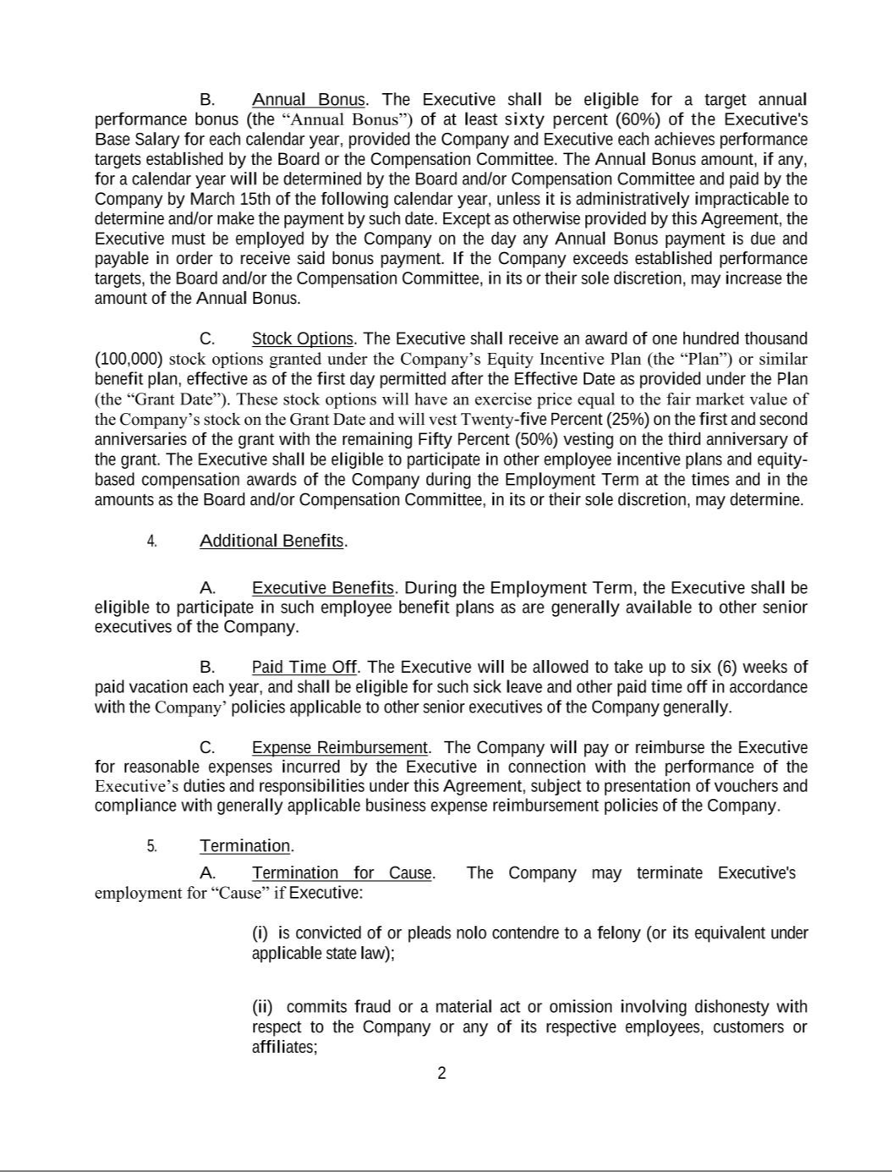

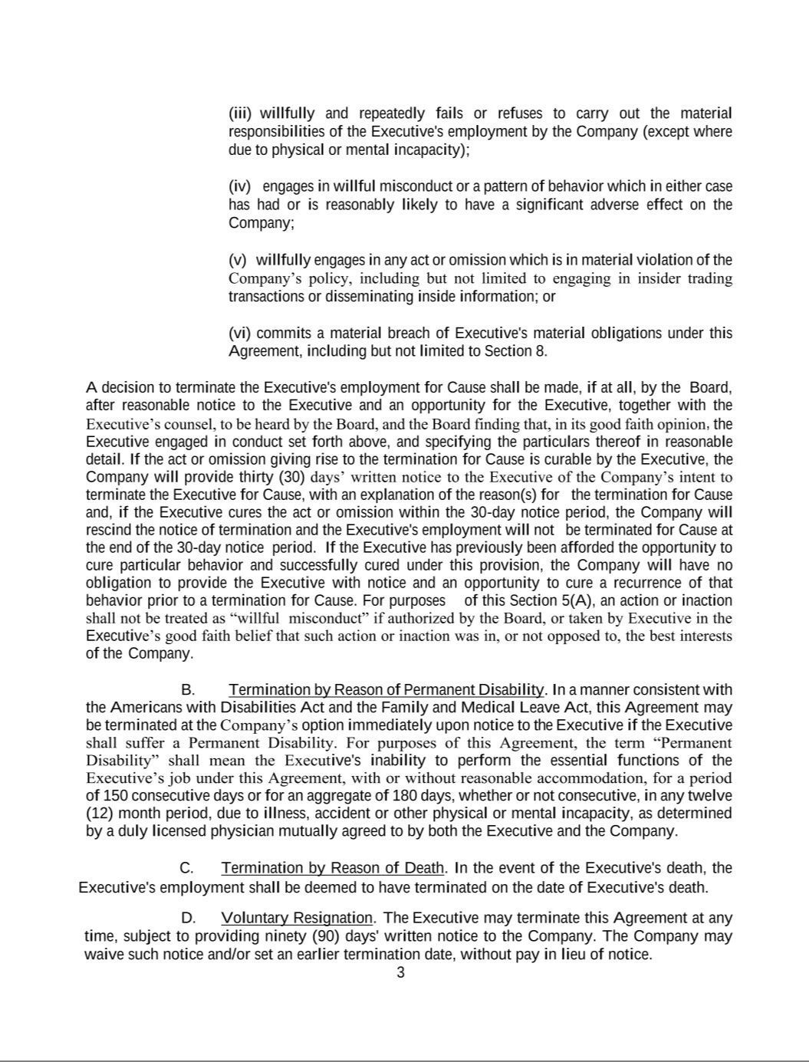

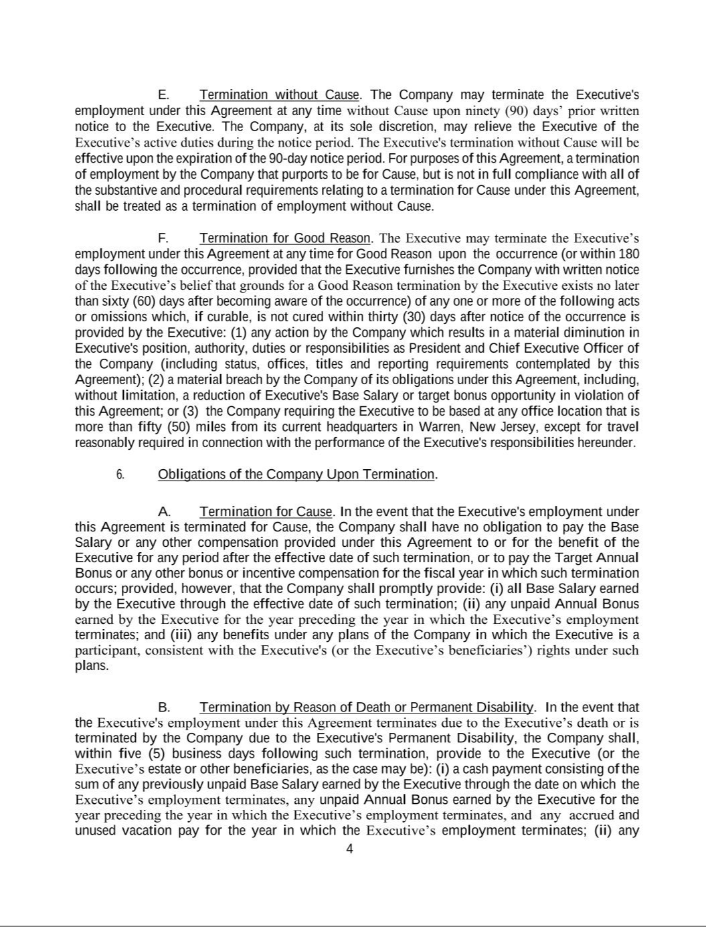

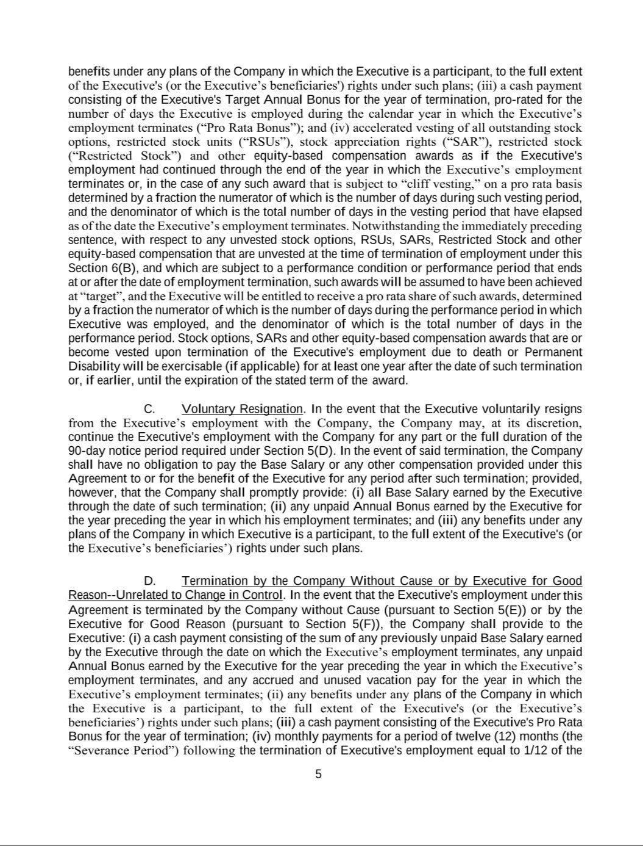

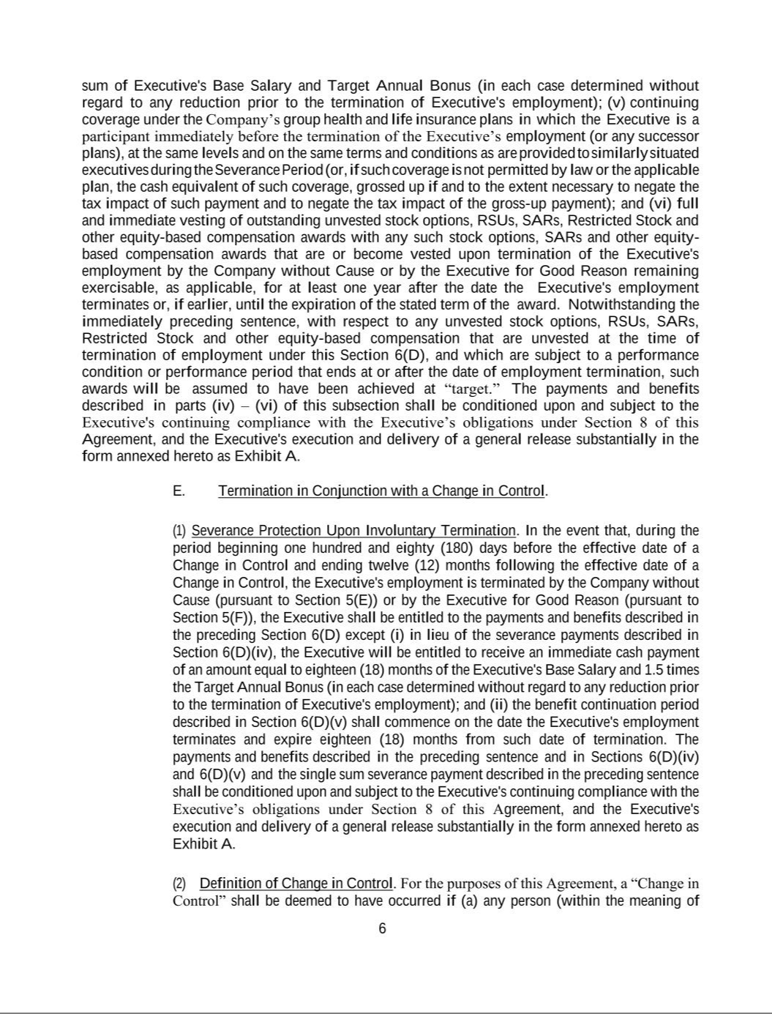

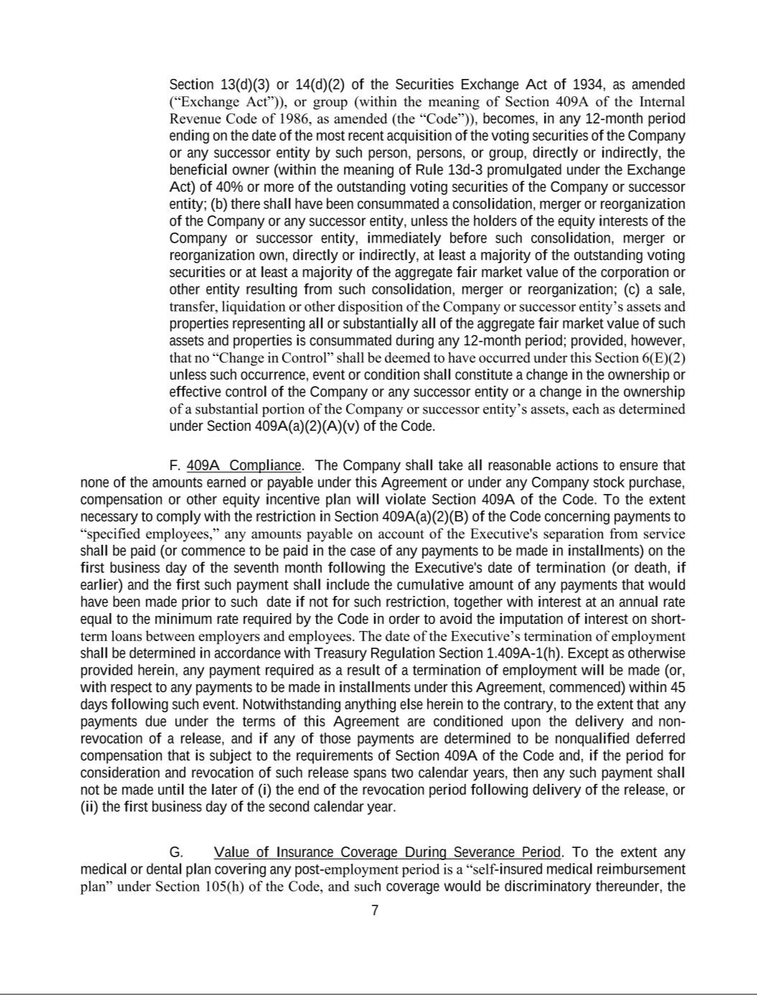

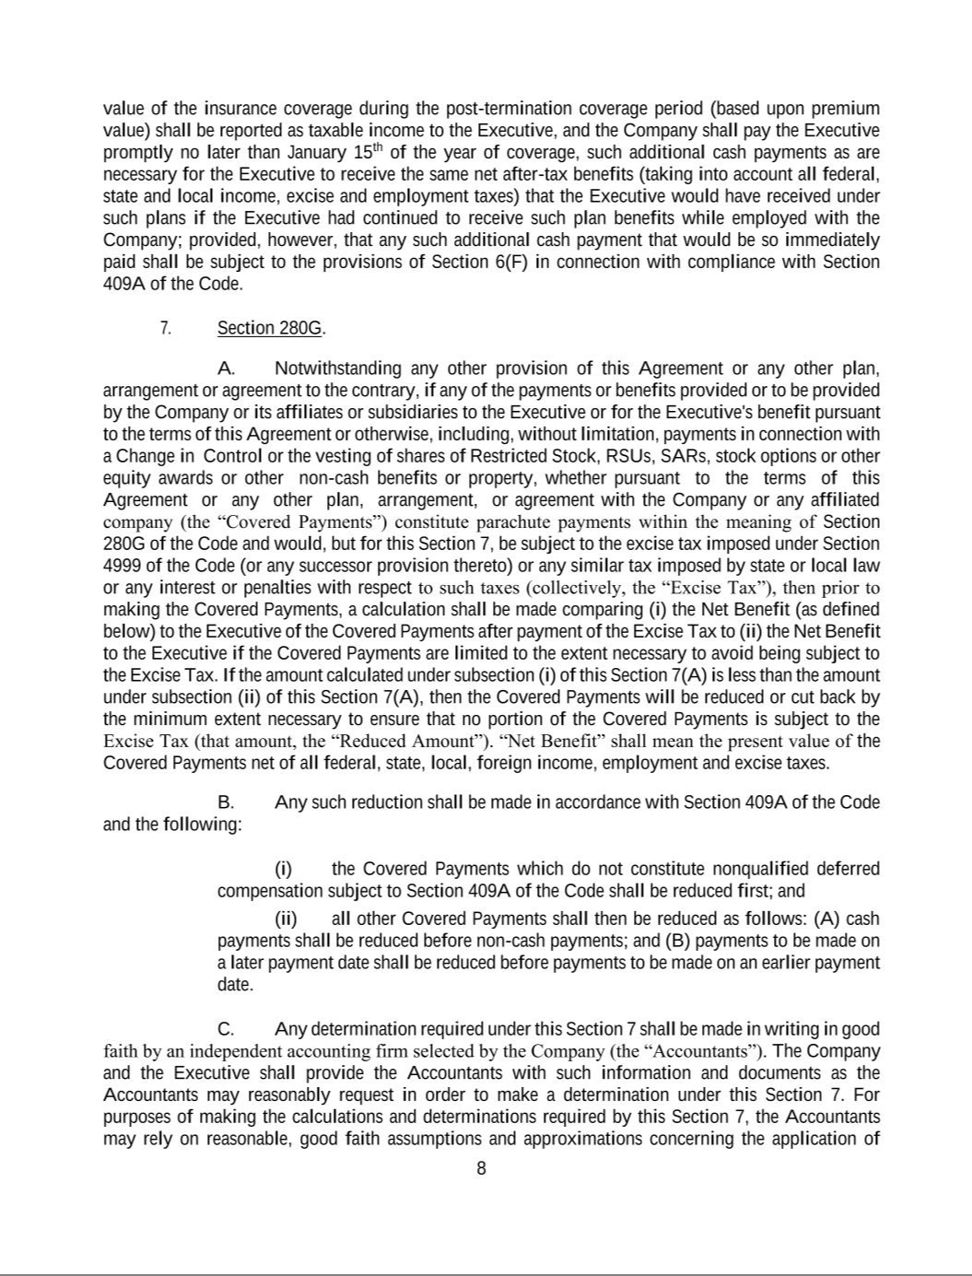

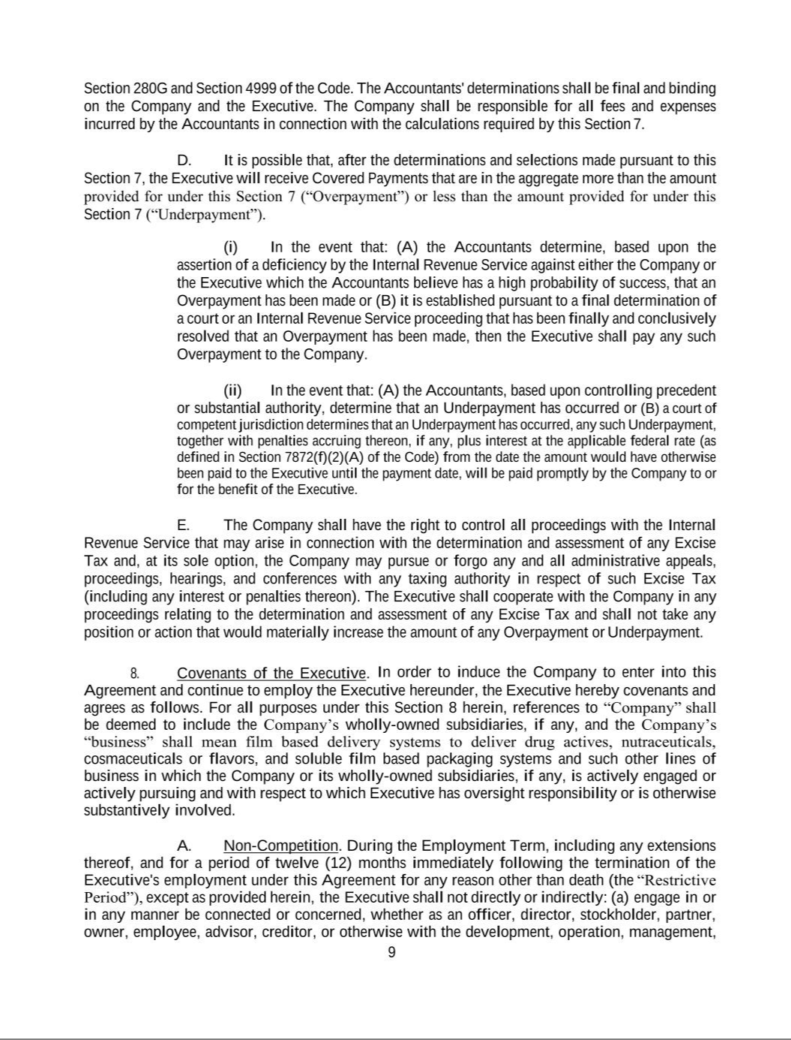

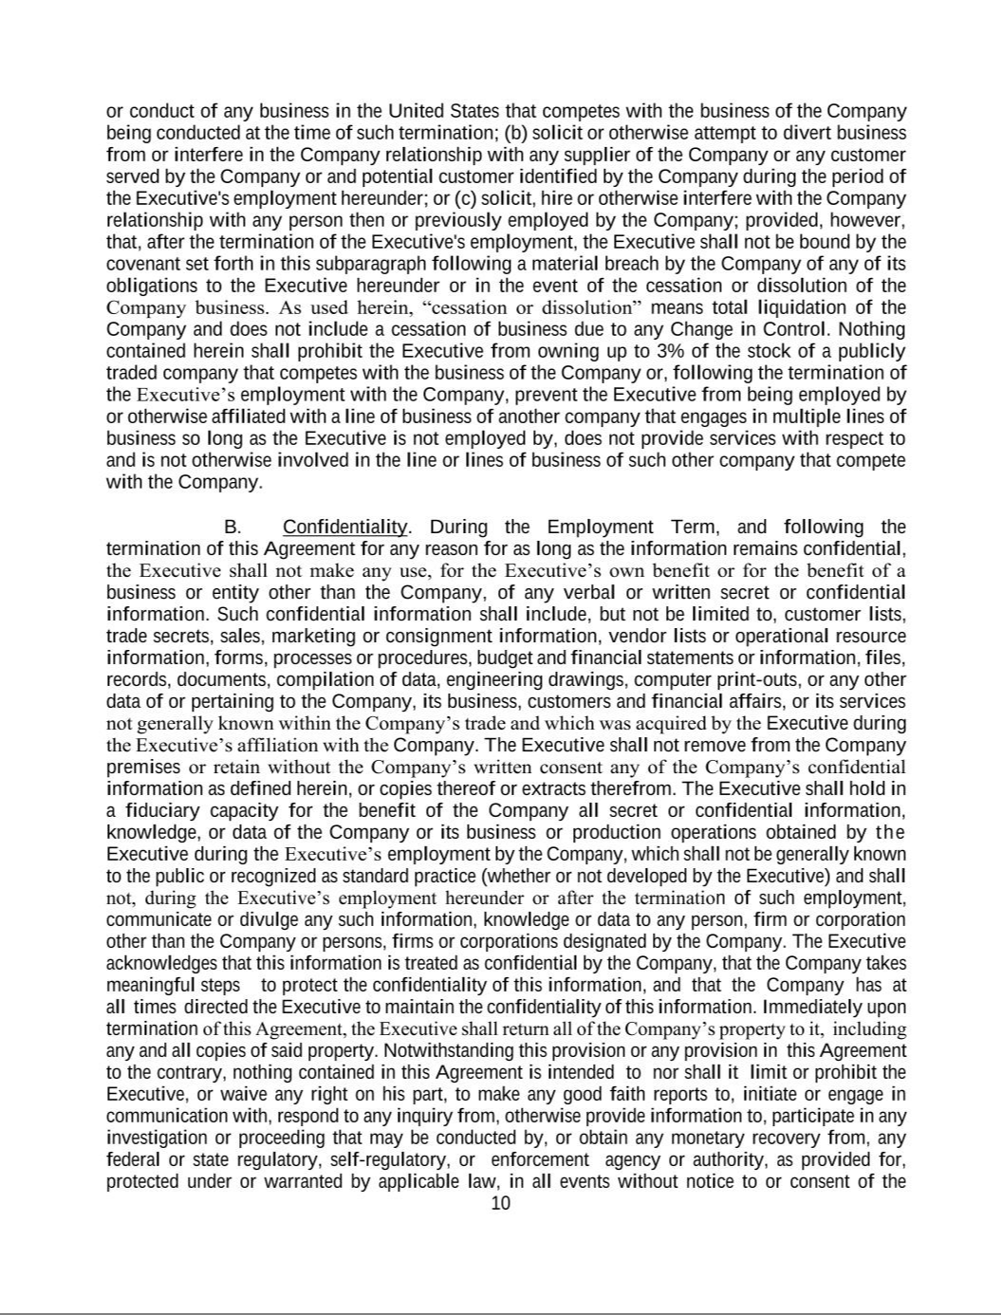

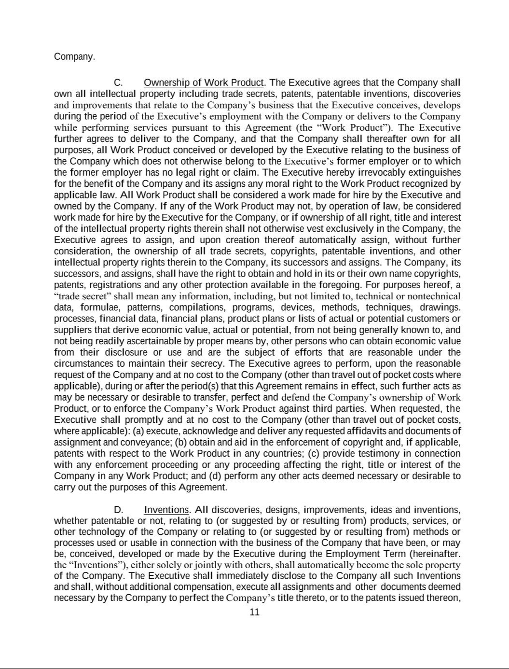

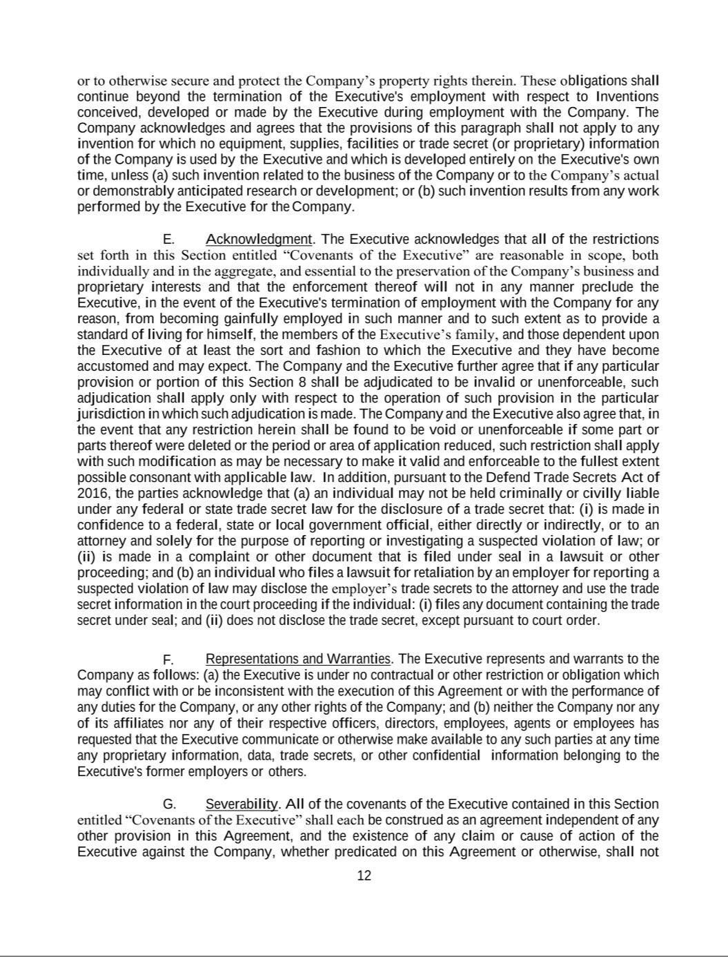

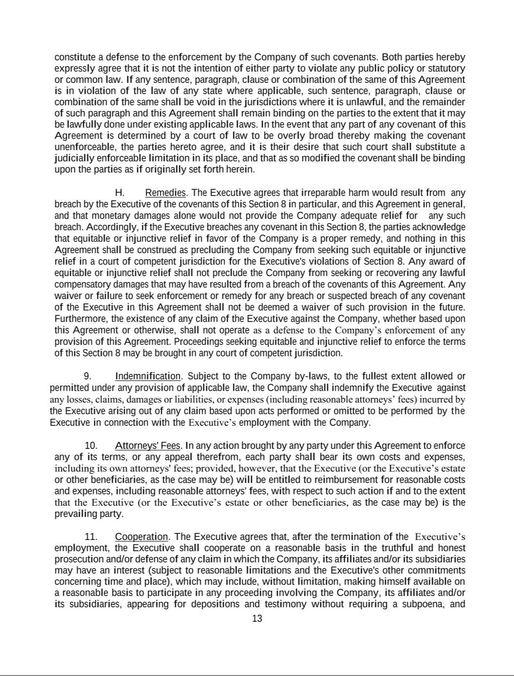

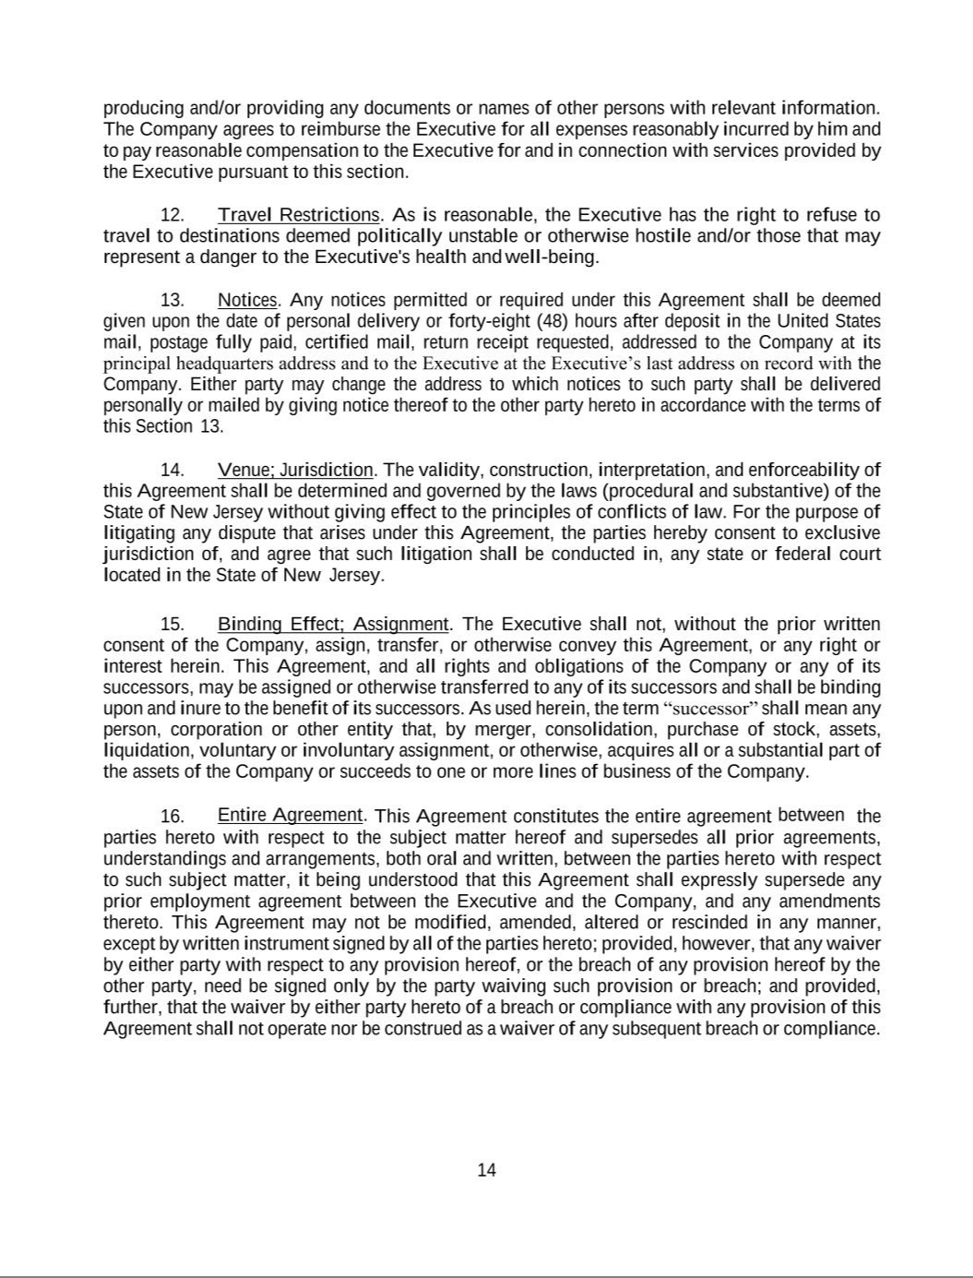

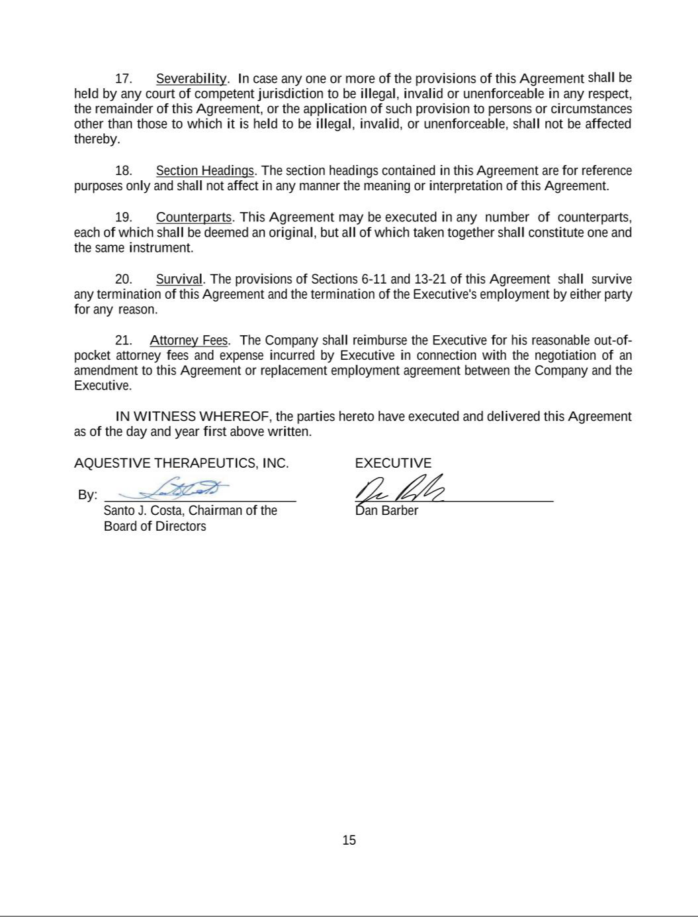

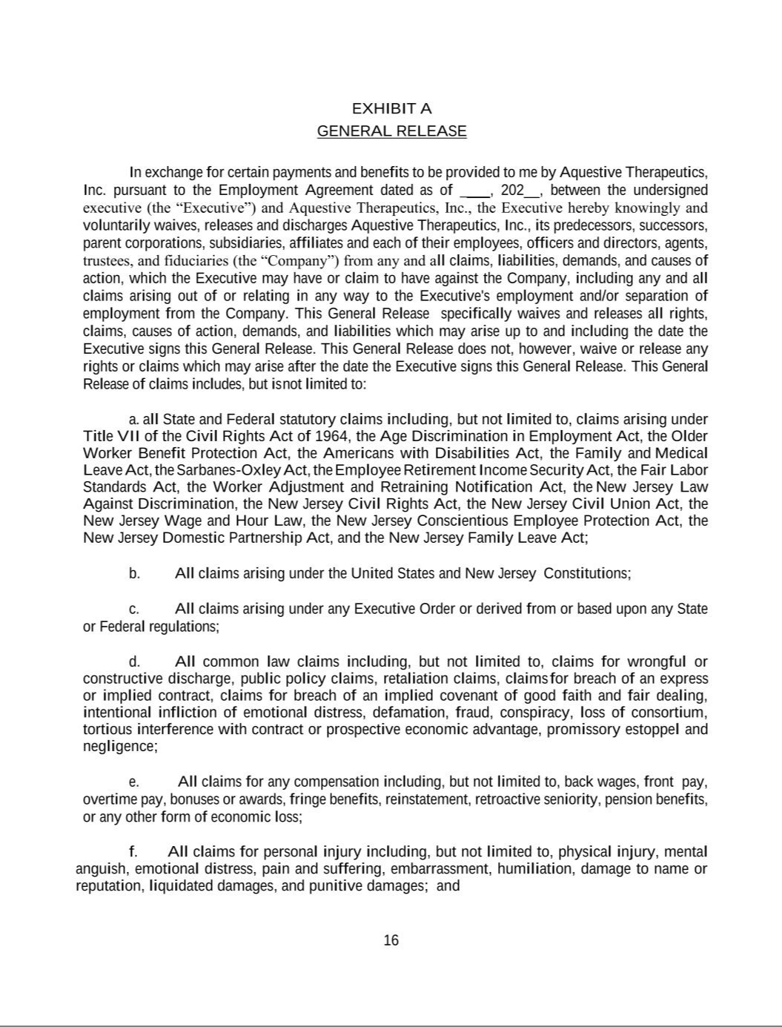

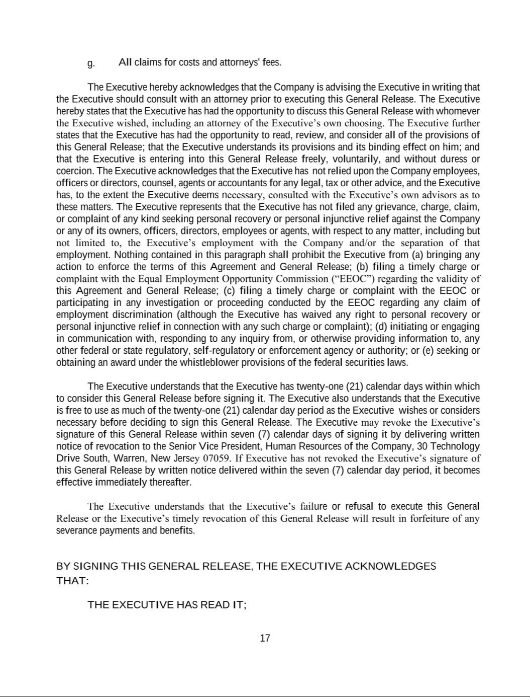

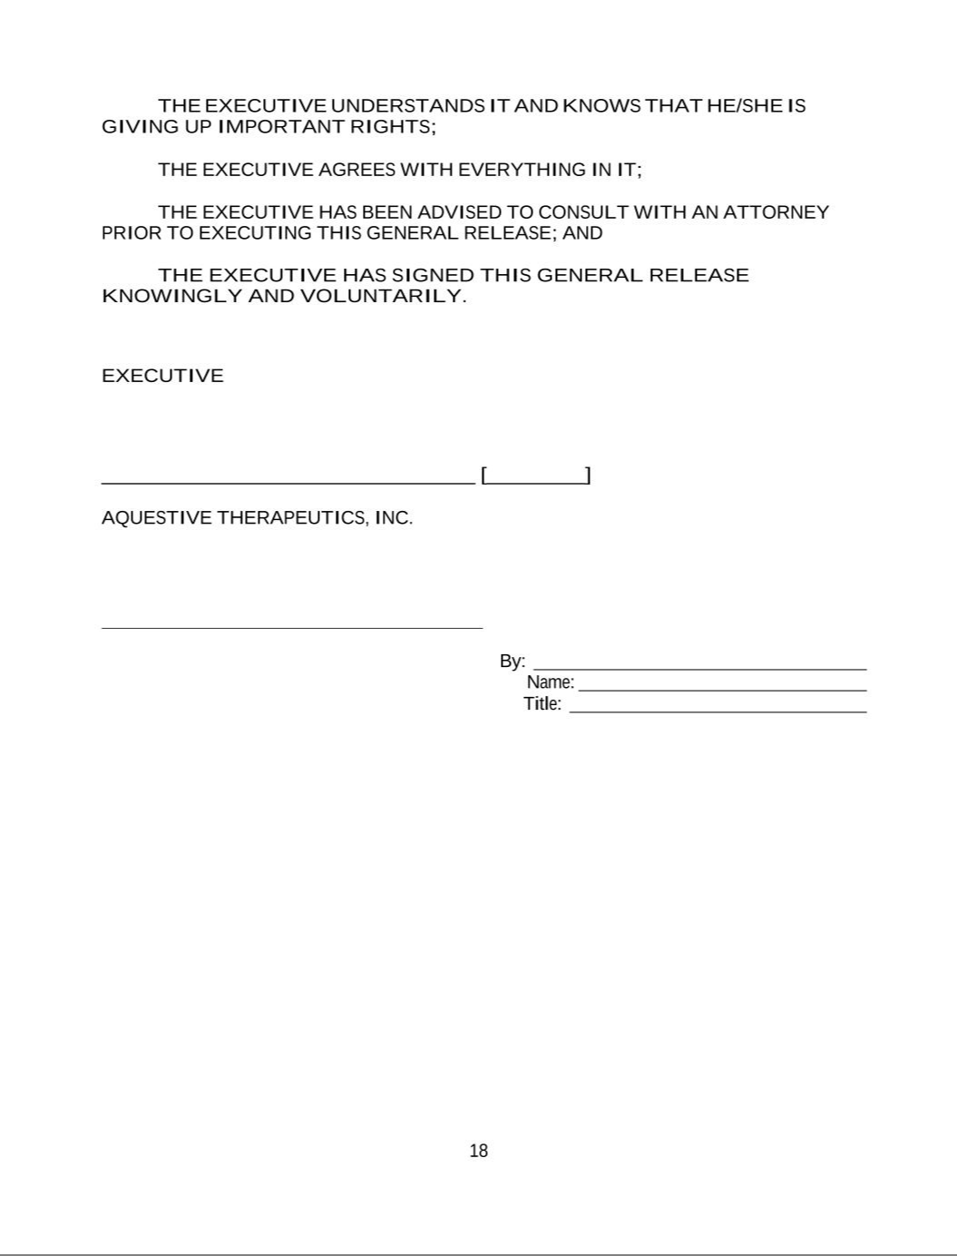

Exhibit 31.1

Certification of Principal Executive Officer of Aquestive Therapeutics, Inc.

Pursuant to Section 302 of the Sarbanes-Oxley Act of 2002

I, Daniel Barber, certify that:

- I have reviewed this Quarterly Report on Form 10-Q of Aquestive Therapeutics, Inc.;

- Based on my knowledge, this report does not contain any untrue statement of a material fact or omit to state a material fact necessary to make the statements made, in light of the circumstances under which such statements were made, not misleading with respect to the period covered by this report;

- Based on my knowledge, the consolidated financial statements, and other financial information included in this report, fairly present in all material respects the financial condition, consolidated results of operations and consolidated cash flows of the registrant as of, and for, the periods presented in this report;

- The registrant’s other certifying officer and I are responsible for establishing and maintaining disclosure controls and procedures (as defined in Exchange Act Rules 13a-15(e) and 15d-15(e)) and internal control over financial reporting (as defined in Exchange Act Rules 13a-15(f) and 15d-15(f)) for the registrant and have:

  - Designed such disclosure controls and procedures, or caused such disclosure controls and procedures to be designed under our supervision, to ensure that material information relating to the registrant, including its consolidated subsidiaries, is made known to us by others within those entities, particularly during the period in which this report is being prepared;

  - Designed such internal control over financial reporting, or caused such internal control over financial reporting to be designed under our supervision, to provide reasonable assurance regarding the reliability of financial reporting and the preparation of financial statements for external purposes in accordance with generally accepted accounting principles;

  - Evaluated the effectiveness of the registrant’s disclosure controls and procedures and presented in this report our conclusions about the effectiveness of the disclosure controls and procedures, as of the end of the period covered by this report based on such evaluation; and

  - Disclosed in this report any change in the registrant’s internal control over financial reporting that occurred during the registrant’s most recent fiscal quarter (the registrant’s fourth fiscal quarter in the case of an annual report) that has materially affected, or is reasonably likely to materially affect, the registrant’s internal control over financial reporting; and

- The registrant’s other certifying officer and I have disclosed, based on our most recent evaluation of internal control over financial reporting, to the registrant’s auditors and the audit committee of registrant’s board of directors (or persons performing the equivalent functions):

  - All significant deficiencies and material weaknesses in the design or operation of internal control over financial reporting which are reasonably likely to adversely affect the registrant’s ability to record, process, summarize and report financial information; and

  - Any fraud, whether or not material, that involves management or other employees who have a significant role in the registrant’s internal control over financial reporting.

Date: August 2, 2022

/s/ Daniel Barber

Daniel Barber

President and Chief Executive Officer
(Principal Executive Officer)

Exhibit 31.2

Certification of Principal Financial and Accounting Officer of Aquestive Therapeutics, Inc.

Pursuant to Section 302 of the Sarbanes-Oxley Act of 2002

I, A. Ernest Toth, Jr, certify that:

- I have reviewed this Quarterly Report on Form 10-Q of Aquestive Therapeutics, Inc.;

- Based on my knowledge, this report does not contain any untrue statement of a material fact or omit to state a material fact necessary to make the statements made, in light of the circumstances under which such statements were made, not misleading with respect to the period covered by this report;

- Based on my knowledge, the consolidated financial statements, and other financial information included in this report, fairly present in all material respects the financial condition, consolidated results of operations and consolidated cash flows of the registrant as of, and for, the periods presented in this report;

- The registrant’s other certifying officer and I are responsible for establishing and maintaining disclosure controls and procedures (as defined in Exchange Act Rules 13a-15(e) and 15d-15(e)) and internal control over financial reporting (as defined in Exchange Act Rules 13a-15(f) and 15d-15(f)) for the registrant and have:

  - Designed such disclosure controls and procedures, or caused such disclosure controls and procedures to be designed under our supervision, to ensure that material information relating to the registrant, including its consolidated subsidiaries, is made known to us by others within those entities, particularly during the period in which this report is being prepared;

  - Designed such internal control over financial reporting, or caused such internal control over financial reporting to be designed under our supervision, to provide reasonable assurance regarding the reliability of financial reporting and the preparation of financial statements for external purposes in accordance with generally accepted accounting principles;

  - Evaluated the effectiveness of the registrant’s disclosure controls and procedures and presented in this report our conclusions about the effectiveness of the disclosure controls and procedures, as of the end of the period covered by this report based on such evaluation; and

  - Disclosed in this report any change in the registrant’s internal control over financial reporting that occurred during the registrant’s most recent fiscal quarter (the registrant’s fourth fiscal quarter in the case of an annual report) that has materially affected, or is reasonably likely to materially affect, the registrant’s internal control over financial reporting; and

- The registrant’s other certifying officer and I have disclosed, based on our most recent evaluation of internal control over financial reporting, to the registrant’s auditors and the audit committee of registrant’s board of directors (or persons performing the equivalent functions):

  - All significant deficiencies and material weaknesses in the design or operation of internal control over financial reporting which are reasonably likely to adversely affect the registrant’s ability to record, process, summarize and report financial information; and

  - Any fraud, whether or not material, that involves management or other employees who have a significant role in the registrant’s internal control over financial reporting.

Date: August 2, 2022

/s/ A. ERNEST TOTH, JR.

A. Ernest Toth, Jr.

Chief Financial Officer
(Principal Financial Officer)

Exhibit 32.1

Certification of Principal Executive Officer

Pursuant to 18 U.S.C. Section 1350, as Adopted

Pursuant to Section 906 of the Sarbanes-Oxley Act of 2002

Pursuant to the requirement set forth in Rule 13a-14(b) of the Securities Exchange Act of 1934, as amended (the “Exchange Act”), and Section 1350 of Chapter 63 of Title 18 of the United States Code (18 U.S.C. §1350), I, Daniel Barber, President and Chief Executive Officer of Aquestive Therapeutics, Inc. (the “Company”), hereby certify that, to the best of my knowledge:

- The Company’s Quarterly Report on Form 10-Q for the period-ended June 30, 2022, to which this Certification is attached as Exhibit 32.1 (the “Quarterly Report”), fully complies with the requirements of Section 13(a) or Section 15(d) of the Exchange Act; and

- The information contained in the Quarterly Report fairly presents, in all material respects, the financial condition of the Company at the end of the period covered by the Quarterly Report and the results of operations of the Company for the period covered by the Quarterly Report.

Date: August 2, 2022

/s/ Daniel Barber

Daniel Barber

President and Chief Executive Officer
(Principal Executive Officer)

This certification accompanies the Form 10-Q to which it relates, is not deemed filed with the Securities and Exchange Commission and is not to be incorporated by reference into any filing of Aquestive Therapeutics, Inc. under the Securities Act of 1933, as amended, or the Exchange Act (whether made before or after the date of the Quarterly Report), irrespective of any general incorporation language contained in such filing.

Exhibit 32.2

Certification of Principal Financial and Accounting Officer

Pursuant to 18 U.S.C. Section 1350, as Adopted

Pursuant to Section 906 of the Sarbanes-Oxley Act of 2002

Pursuant to the requirement set forth in Rule 13a-14(b) of the Securities Exchange Act of 1934, as amended (the “Exchange Act”), and Section 1350 of Chapter 63 of Title 18 of the United States Code (18 U.S.C. §1350), I, A. Ernest Toth, Jr., Chief Financial Officer of Aquestive Therapeutics, Inc. (the “Company”), hereby certify that, to the best of my knowledge:

- The Company’s Quarterly Report on Form 10-Q for the period-ended June 30, 2022, to which this Certification is attached as Exhibit 32.2 (the “Quarterly Report”), fully complies with the requirements of Section 13(a) or Section 15(d) of the Exchange Act; and

- The information contained in the Quarterly Report fairly presents, in all material respects, the financial condition of the Company at the end of the period covered by the Quarterly Report and the results of operations of the Company for the period covered by the Quarterly Report.

Date: August 2, 2022

/s/ A. ERNEST TOTH, JR

A. Ernest Toth, Jr.

Chief Financial Officer
(Principal Financial Officer)

This certification accompanies the Form 10-Q to which it relates, is not deemed filed with the Securities and Exchange Commission and is not to be incorporated by reference into any filing of Aquestive Therapeutics, Inc. under the Securities Act of 1933, as amended, or the Exchange Act (whether made before or after the date of the Quarterly Report), irrespective of any general incorporation language contained in such filing.

