UNITED STATES
SECURITIES AND EXCHANGE COMMISSION
Washington, DC 20549

FORM 8-K

CURRENT REPORT

PURSUANT TO SECTION 13 OR 15(d) OF THE
SECURITIES EXCHANGE ACT OF 1934

Date of Report (Date of earliest event reported): October 15, 2026
Aquestive Therapeutics, Inc.
(Exact name of Registrant as specified in its charter)
Delaware |  |  | 001-38599 |  |  | 82-3827296
(State or other jurisdiction of incorporation) |  |  | (Commission File Number) |  |  | (I.R.S. Employer Identification No.)

184 Liberty Corner Road, Suite 305,
Warren, NJ 07059
(908) 941-1900
(Address, Including Zip Code, and Telephone Number, Including Area Code, of Registrant’s Principal Executive Offices)

Not Applicable
(Former name or former address, if changed since last report)

________________________________________________________________________________________________________________________
Check the appropriate box below if the Form 8-K filing is intended to simultaneously satisfy the filing obligation of the registrant under any of the following provisions:
☐ |  |  | Written communications pursuant to Rule 425 under the Securities Act (17 CFR 230.425)
☐ |  |  | Soliciting material pursuant to Rule 14a-12 under the Exchange Act (17 CFR 240.14a-12)
☐ |  |  | Pre-commencement communications pursuant to Rule 14d-2(b) under the Exchange Act (17 CFR 240.14d-2(b))
☐ |  |  | Pre-commencement communications pursuant to Rule 13e-4(c) under the Exchange Act (17 CFR 240.13e-4(c))

Securities registered pursuant to Section 12(b) of the Act:

Title of each class |  |  | Trading Symbol(s) |  |  | Name of each exchange on which  registered
Common Stock, par value $0.001 per share |  |  | AQST |  |  | Nasdaq Global Market

Indicate by check mark whether the registrant is an emerging growth company as defined in Rule 405 of the Securities Act of 1933 (§230.405 of this chapter) or Rule 12b-2 of the Securities Exchange Act of 1934 (§240.12b-2 of this chapter).
Emerging growth company |  |  | ☐
If an emerging growth company, indicate by check mark if the registrant has elected not to use the extended transition period for complying with any new or revised financial accounting standards provided pursuant to Section 13(a) of the Exchange Act. ☐

Item 5.03 |  |  | Amendments to Articles of Incorporation or Bylaws; Change in Fiscal Year.
On October 15, 2026, the Board of Directors (the “Board”) of Aquestive Therapeutics, Inc. (the “Company”), in connection with its periodic review of corporate governance matters, approved and adopted amended and restated bylaws (the "Amended Bylaws"), effective October 15, 2026. The Amended Bylaws supersede the previously existing Amended and Restated Bylaws of the Company (the "Prior Bylaws"). Specifically, Article I, Section 11 of the Prior Bylaws, which sets forth requirements for stockholder nominations of candidates for election to the Board, has been amended to eliminate the requirement that the proposing stockholder provide information concerning certain relationships between the nominating stockholder and any Stockholder Associated Person (as defined in the Amended Bylaws), on the one hand, and “others acting in concert with” the proposed nominee, any member of the immediate family of the proposed nominee, and the proposed nominee’s respective affiliates and associates, on the other hand. Corresponding revisions were approved to the definition of “Stockholder Associated Person” to eliminate persons “acting in concert with” nominating stockholders or beneficial owners of Aquestive stock on whose behalf stockholder nominations or proposals are brought. In addition, the Prior Bylaws were amended to make certain technical, conforming and non-substantive changes.

The foregoing description of the Amended Bylaws is qualified in its entirety by reference to the full text of the Amended Bylaws which are filed as Exhibit 3.1 and incorporated herein by reference.

Item 9.01 |  |  | Financial Statements and Exhibits.
(d) Exhibits.

Exhibit Number |  |  |  |  |  | Description
3.1 |  |  |  |  |  | Amended and Restated Bylaws of Aquestive Therapeutics, Inc. adopted on October 15, 2026.
104 |  |  |  |  |  | Cover Page Interaction Data File (embedded within the Inline XBRL document)

SIGNATURE

Pursuant to the requirements of the Securities Exchange Act of 1934, as amended, the Registrant has duly caused this report to be signed on its behalf by the undersigned hereunto duly authorized.

Dated: October 19, 2026 |  |  | Aquestive Therapeutics, Inc.
 |  |  | By: |  |  | /s/ A. Ernest Toth, Jr
 |  |  |  |  |  | Name: A. Ernest Toth, Jr.
 |  |  |  |  |  | Title: Chief Financial Officer

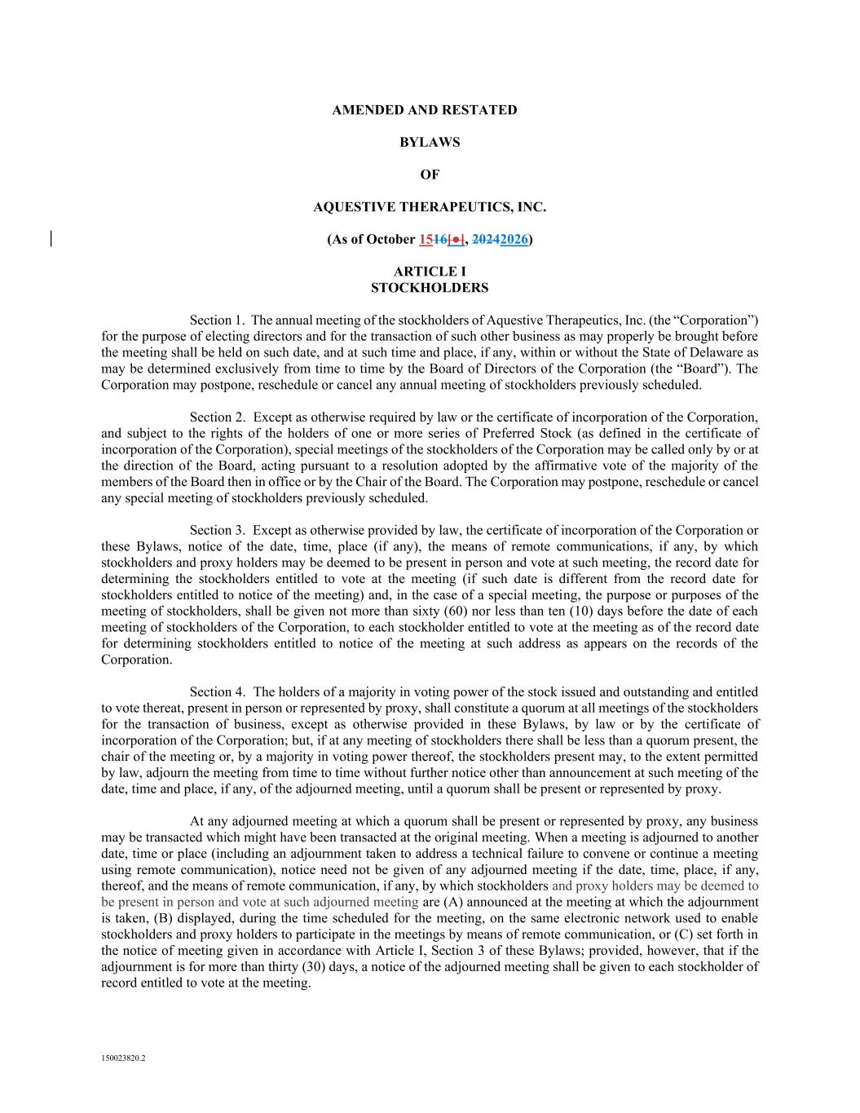

150023820.2 AMENDED AND RESTATED BYLAWS OF AQUESTIVE THERAPEUTICS, INC. (As of October 1516[●], 20242026) ARTICLE I STOCKHOLDERS Section 1. The annual meeting of the stockholders of Aquestive Therapeutics, Inc. (the “Corporation”) for the purpose of electing directors and for the transaction of such other business as may properly be brought before the meeting shall be held on such date, and at such time and place, if any, within or without the State of Delaware as may be determined exclusively from time to time by the Board of Directors of the Corporation (the “Board”). The Corporation may postpone, reschedule or cancel any annual meeting of stockholders previously scheduled. Section 2. Except as otherwise required by law or the certificate of incorporation of the Corporation, and subject to the rights of the holders of one or more series of Preferred Stock (as defined in the certificate of incorporation of the Corporation), special meetings of the stockholders of the Corporation may be called only by or at the direction of the Board, acting pursuant to a resolution adopted by the affirmative vote of the majority of the members of the Board then in office or by the Chair of the Board. The Corporation may postpone, reschedule or cancel any special meeting of stockholders previously scheduled. Section 3. Except as otherwise provided by law, the certificate of incorporation of the Corporation or these Bylaws, notice of the date, time, place (if any), the means of remote communications, if any, by which stockholders and proxy holders may be deemed to be present in person and vote at such meeting, the record date for determining the stockholders entitled to vote at the meeting (if such date is different from the record date for stockholders entitled to notice of the meeting) and, in the case of a special meeting, the purpose or purposes of the meeting of stockholders, shall be given not more than sixty (60) nor less than ten (10) days before the date of each meeting of stockholders of the Corporation, to each stockholder entitled to vote at the meeting as of the record date for determining stockholders entitled to notice of the meeting at such address as appears on the records of the Corporation. Section 4. The holders of a majority in voting power of the stock issued and outstanding and entitled to vote thereat, present in person or represented by proxy, shall constitute a quorum at all meetings of the stockholders for the transaction of business, except as otherwise provided in these Bylaws, by law or by the certificate of incorporation of the Corporation; but, if at any meeting of stockholders there shall be less than a quorum present, the chair of the meeting or, by a majority in voting power thereof, the stockholders present may, to the extent permitted by law, adjourn the meeting from time to time without further notice other than announcement at such meeting of the date, time and place, if any, of the adjourned meeting, until a quorum shall be present or represented by proxy. At any adjourned meeting at which a quorum shall be present or represented by proxy, any business may be transacted which might have been transacted at the original meeting. When a meeting is adjourned to another date, time or place (including an adjournment taken to address a technical failure to convene or continue a meeting using remote communication), notice need not be given of any adjourned meeting if the date, time, place, if any, thereof, and the means of remote communication, if any, by which stockholders and proxy holders may be deemed to be present in person and vote at such adjourned meeting are (A) announced at the meeting at which the adjournment is taken, (B) displayed, during the time scheduled for the meeting, on the same electronic network used to enable stockholders and proxy holders to participate in the meetings by means of remote communication, or (C) set forth in the notice of meeting given in accordance with Article I, Section 3 of these Bylaws; provided, however, that if the adjournment is for more than thirty (30) days, a notice of the adjourned meeting shall be given to each stockholder of record entitled to vote at the meeting.

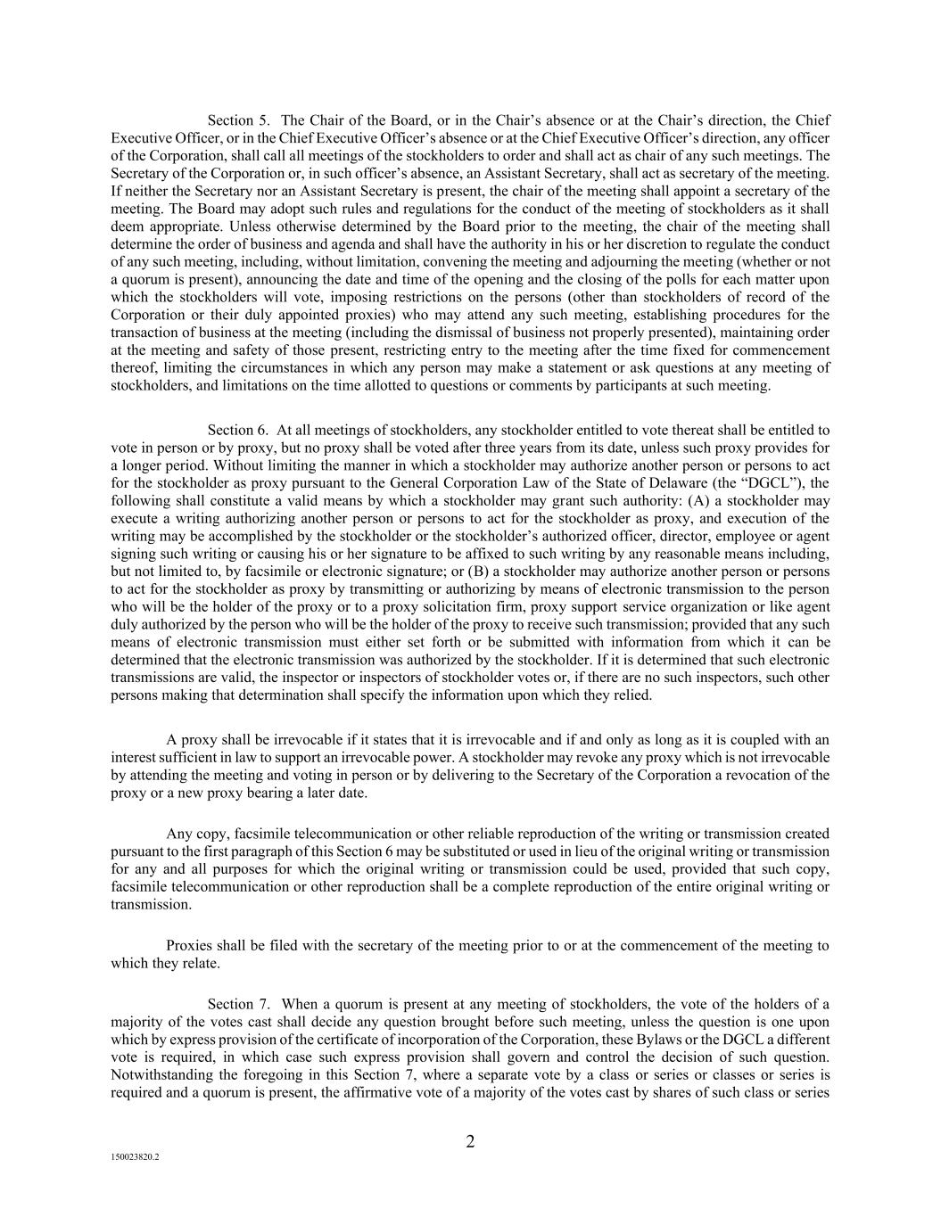
2 150023820.2 Section 5. The Chair of the Board, or in the Chair’s absence or at the Chair’s direction, the Chief Executive Officer, or in the Chief Executive Officer’s absence or at the Chief Executive Officer’s direction, any officer of the Corporation, shall call all meetings of the stockholders to order and shall act as chair of any such meetings. The Secretary of the Corporation or, in such officer’s absence, an Assistant Secretary, shall act as secretary of the meeting. If neither the Secretary nor an Assistant Secretary is present, the chair of the meeting shall appoint a secretary of the meeting. The Board may adopt such rules and regulations for the conduct of the meeting of stockholders as it shall deem appropriate. Unless otherwise determined by the Board prior to the meeting, the chair of the meeting shall determine the order of business and agenda and shall have the authority in his or her discretion to regulate the conduct of any such meeting, including, without limitation, convening the meeting and adjourning the meeting (whether or not a quorum is present), announcing the date and time of the opening and the closing of the polls for each matter upon which the stockholders will vote, imposing restrictions on the persons (other than stockholders of record of the Corporation or their duly appointed proxies) who may attend any such meeting, establishing procedures for the transaction of business at the meeting (including the dismissal of business not properly presented), maintaining order at the meeting and safety of those present, restricting entry to the meeting after the time fixed for commencement thereof, limiting the circumstances in which any person may make a statement or ask questions at any meeting of stockholders, and limitations on the time allotted to questions or comments by participants at such meeting. Section 6. At all meetings of stockholders, any stockholder entitled to vote thereat shall be entitled to vote in person or by proxy, but no proxy shall be voted after three years from its date, unless such proxy provides for a longer period. Without limiting the manner in which a stockholder may authorize another person or persons to act for the stockholder as proxy pursuant to the General Corporation Law of the State of Delaware (the “DGCL”), the following shall constitute a valid means by which a stockholder may grant such authority: (A) a stockholder may execute a writing authorizing another person or persons to act for the stockholder as proxy, and execution of the writing may be accomplished by the stockholder or the stockholder’s authorized officer, director, employee or agent signing such writing or causing his or her signature to be affixed to such writing by any reasonable means including, but not limited to, by facsimile or electronic signature; or (B) a stockholder may authorize another person or persons to act for the stockholder as proxy by transmitting or authorizing by means of electronic transmission to the person who will be the holder of the proxy or to a proxy solicitation firm, proxy support service organization or like agent duly authorized by the person who will be the holder of the proxy to receive such transmission; provided that any such means of electronic transmission must either set forth or be submitted with information from which it can be determined that the electronic transmission was authorized by the stockholder. If it is determined that such electronic transmissions are valid, the inspector or inspectors of stockholder votes or, if there are no such inspectors, such other persons making that determination shall specify the information upon which they relied. A proxy shall be irrevocable if it states that it is irrevocable and if and only as long as it is coupled with an interest sufficient in law to support an irrevocable power. A stockholder may revoke any proxy which is not irrevocable by attending the meeting and voting in person or by delivering to the Secretary of the Corporation a revocation of the proxy or a new proxy bearing a later date. Any copy, facsimile telecommunication or other reliable reproduction of the writing or transmission created pursuant to the first paragraph of this Section 6 may be substituted or used in lieu of the original writing or transmission for any and all purposes for which the original writing or transmission could be used, provided that such copy, facsimile telecommunication or other reproduction shall be a complete reproduction of the entire original writing or transmission. Proxies shall be filed with the secretary of the meeting prior to or at the commencement of the meeting to which they relate. Section 7. When a quorum is present at any meeting of stockholders, the vote of the holders of a majority of the votes cast shall decide any question brought before such meeting, unless the question is one upon which by express provision of the certificate of incorporation of the Corporation, these Bylaws or the DGCL a different vote is required, in which case such express provision shall govern and control the decision of such question. Notwithstanding the foregoing in this Section 7, where a separate vote by a class or series or classes or series is required and a quorum is present, the affirmative vote of a majority of the votes cast by shares of such class or series

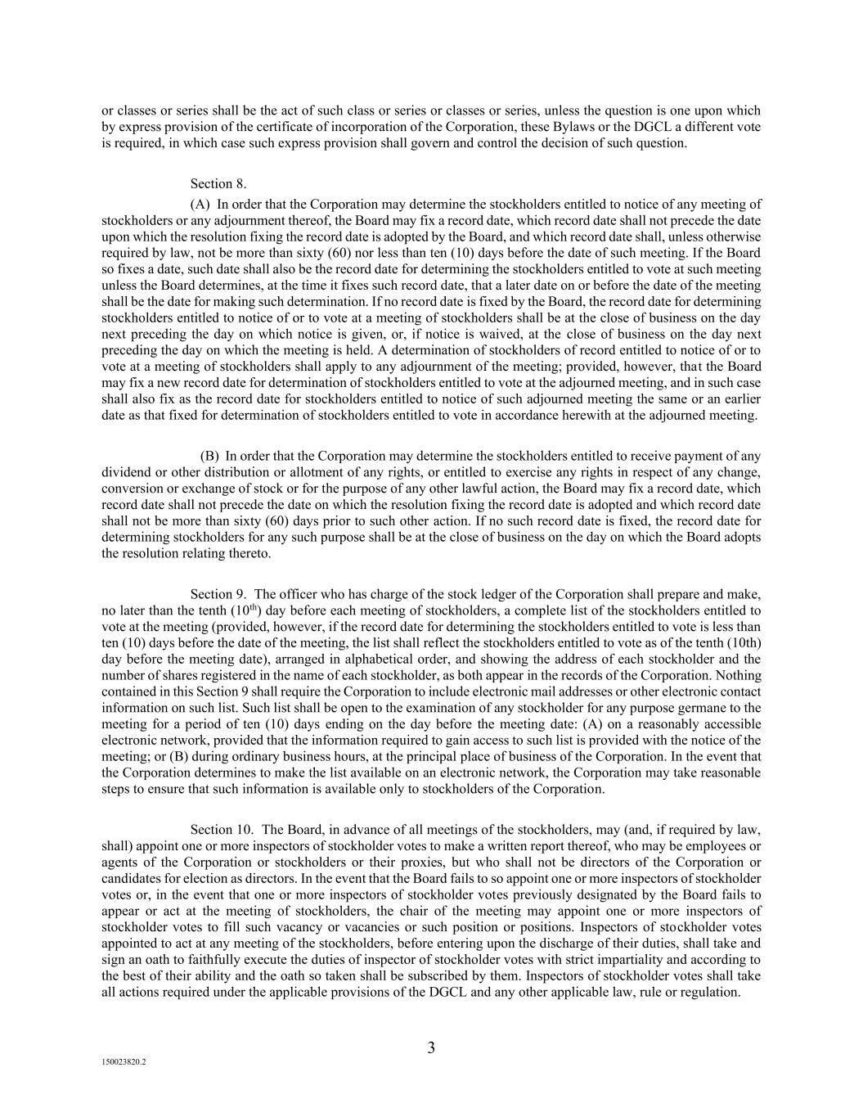
3 150023820.2 or classes or series shall be the act of such class or series or classes or series, unless the question is one upon which by express provision of the certificate of incorporation of the Corporation, these Bylaws or the DGCL a different vote is required, in which case such express provision shall govern and control the decision of such question. Section 8. (A) In order that the Corporation may determine the stockholders entitled to notice of any meeting of stockholders or any adjournment thereof, the Board may fix a record date, which record date shall not precede the date upon which the resolution fixing the record date is adopted by the Board, and which record date shall, unless otherwise required by law, not be more than sixty (60) nor less than ten (10) days before the date of such meeting. If the Board so fixes a date, such date shall also be the record date for determining the stockholders entitled to vote at such meeting unless the Board determines, at the time it fixes such record date, that a later date on or before the date of the meeting shall be the date for making such determination. If no record date is fixed by the Board, the record date for determining stockholders entitled to notice of or to vote at a meeting of stockholders shall be at the close of business on the day next preceding the day on which notice is given, or, if notice is waived, at the close of business on the day next preceding the day on which the meeting is held. A determination of stockholders of record entitled to notice of or to vote at a meeting of stockholders shall apply to any adjournment of the meeting; provided, however, that the Board may fix a new record date for determination of stockholders entitled to vote at the adjourned meeting, and in such case shall also fix as the record date for stockholders entitled to notice of such adjourned meeting the same or an earlier date as that fixed for determination of stockholders entitled to vote in accordance herewith at the adjourned meeting. (B) In order that the Corporation may determine the stockholders entitled to receive payment of any dividend or other distribution or allotment of any rights, or entitled to exercise any rights in respect of any change, conversion or exchange of stock or for the purpose of any other lawful action, the Board may fix a record date, which record date shall not precede the date on which the resolution fixing the record date is adopted and which record date shall not be more than sixty (60) days prior to such other action. If no such record date is fixed, the record date for determining stockholders for any such purpose shall be at the close of business on the day on which the Board adopts the resolution relating thereto. Section 9. The officer who has charge of the stock ledger of the Corporation shall prepare and make, no later than the tenth (10th) day before each meeting of stockholders, a complete list of the stockholders entitled to vote at the meeting (provided, however, if the record date for determining the stockholders entitled to vote is less than ten (10) days before the date of the meeting, the list shall reflect the stockholders entitled to vote as of the tenth (10th) day before the meeting date), arranged in alphabetical order, and showing the address of each stockholder and the number of shares registered in the name of each stockholder, as both appear in the records of the Corporation. Nothing contained in this Section 9 shall require the Corporation to include electronic mail addresses or other electronic contact information on such list. Such list shall be open to the examination of any stockholder for any purpose germane to the meeting for a period of ten (10) days ending on the day before the meeting date: (A) on a reasonably accessible electronic network, provided that the information required to gain access to such list is provided with the notice of the meeting; or (B) during ordinary business hours, at the principal place of business of the Corporation. In the event that the Corporation determines to make the list available on an electronic network, the Corporation may take reasonable steps to ensure that such information is available only to stockholders of the Corporation. Section 10. The Board, in advance of all meetings of the stockholders, may (and, if required by law, shall) appoint one or more inspectors of stockholder votes to make a written report thereof, who may be employees or agents of the Corporation or stockholders or their proxies, but who shall not be directors of the Corporation or candidates for election as directors. In the event that the Board fails to so appoint one or more inspectors of stockholder votes or, in the event that one or more inspectors of stockholder votes previously designated by the Board fails to appear or act at the meeting of stockholders, the chair of the meeting may appoint one or more inspectors of stockholder votes to fill such vacancy or vacancies or such position or positions. Inspectors of stockholder votes appointed to act at any meeting of the stockholders, before entering upon the discharge of their duties, shall take and sign an oath to faithfully execute the duties of inspector of stockholder votes with strict impartiality and according to the best of their ability and the oath so taken shall be subscribed by them. Inspectors of stockholder votes shall take all actions required under the applicable provisions of the DGCL and any other applicable law, rule or regulation.

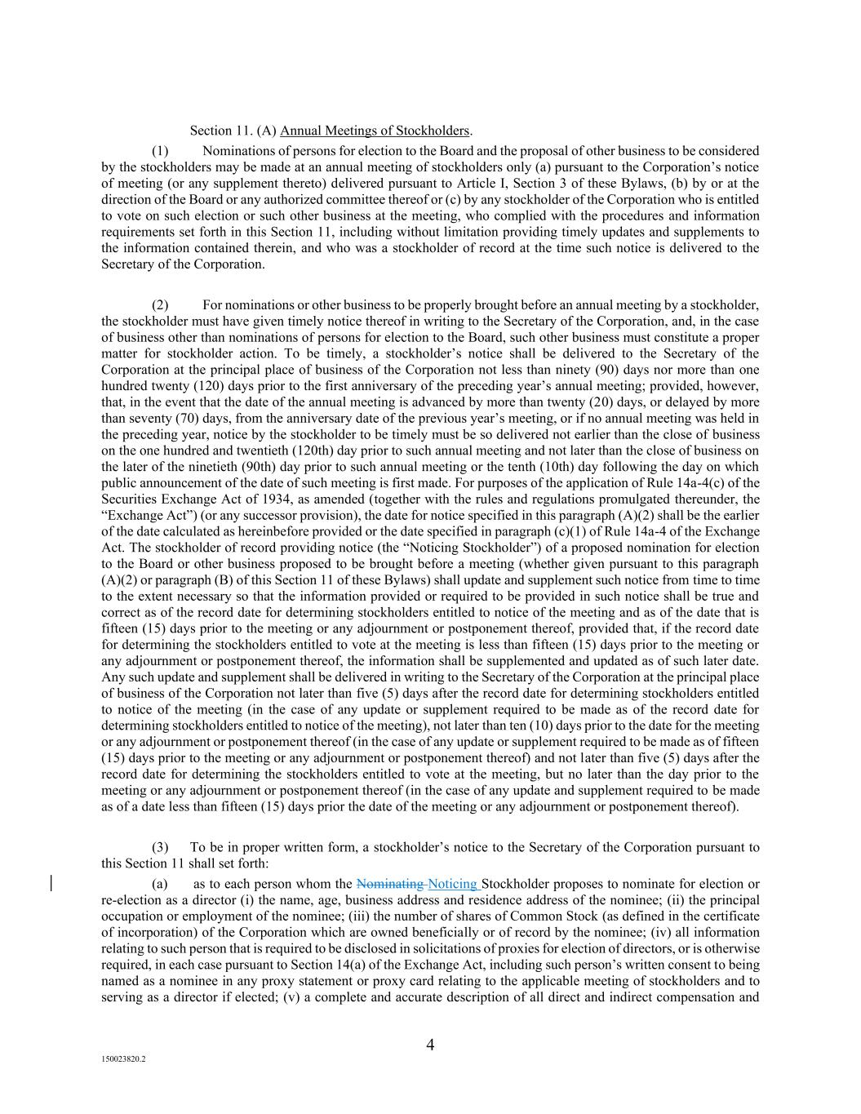
4 150023820.2 Section 11. (A) Annual Meetings of Stockholders. (1) Nominations of persons for election to the Board and the proposal of other business to be considered by the stockholders may be made at an annual meeting of stockholders only (a) pursuant to the Corporation’s notice of meeting (or any supplement thereto) delivered pursuant to Article I, Section 3 of these Bylaws, (b) by or at the direction of the Board or any authorized committee thereof or (c) by any stockholder of the Corporation who is entitled to vote on such election or such other business at the meeting, who complied with the procedures and information requirements set forth in this Section 11, including without limitation providing timely updates and supplements to the information contained therein, and who was a stockholder of record at the time such notice is delivered to the Secretary of the Corporation. (2) For nominations or other business to be properly brought before an annual meeting by a stockholder, the stockholder must have given timely notice thereof in writing to the Secretary of the Corporation, and, in the case of business other than nominations of persons for election to the Board, such other business must constitute a proper matter for stockholder action. To be timely, a stockholder’s notice shall be delivered to the Secretary of the Corporation at the principal place of business of the Corporation not less than ninety (90) days nor more than one hundred twenty (120) days prior to the first anniversary of the preceding year’s annual meeting; provided, however, that, in the event that the date of the annual meeting is advanced by more than twenty (20) days, or delayed by more than seventy (70) days, from the anniversary date of the previous year’s meeting, or if no annual meeting was held in the preceding year, notice by the stockholder to be timely must be so delivered not earlier than the close of business on the one hundred and twentieth (120th) day prior to such annual meeting and not later than the close of business on the later of the ninetieth (90th) day prior to such annual meeting or the tenth (10th) day following the day on which public announcement of the date of such meeting is first made. For purposes of the application of Rule 14a-4(c) of the Securities Exchange Act of 1934, as amended (together with the rules and regulations promulgated thereunder, the “Exchange Act”) (or any successor provision), the date for notice specified in this paragraph (A)(2) shall be the earlier of the date calculated as hereinbefore provided or the date specified in paragraph (c)(1) of Rule 14a-4 of the Exchange Act. The stockholder of record providing notice (the “Noticing Stockholder”) of a proposed nomination for election to the Board or other business proposed to be brought before a meeting (whether given pursuant to this paragraph (A)(2) or paragraph (B) of this Section 11 of these Bylaws) shall update and supplement such notice from time to time to the extent necessary so that the information provided or required to be provided in such notice shall be true and correct as of the record date for determining stockholders entitled to notice of the meeting and as of the date that is fifteen (15) days prior to the meeting or any adjournment or postponement thereof, provided that, if the record date for determining the stockholders entitled to vote at the meeting is less than fifteen (15) days prior to the meeting or any adjournment or postponement thereof, the information shall be supplemented and updated as of such later date. Any such update and supplement shall be delivered in writing to the Secretary of the Corporation at the principal place of business of the Corporation not later than five (5) days after the record date for determining stockholders entitled to notice of the meeting (in the case of any update or supplement required to be made as of the record date for determining stockholders entitled to notice of the meeting), not later than ten (10) days prior to the date for the meeting or any adjournment or postponement thereof (in the case of any update or supplement required to be made as of fifteen (15) days prior to the meeting or any adjournment or postponement thereof) and not later than five (5) days after the record date for determining the stockholders entitled to vote at the meeting, but no later than the day prior to the meeting or any adjournment or postponement thereof (in the case of any update and supplement required to be made as of a date less than fifteen (15) days prior the date of the meeting or any adjournment or postponement thereof). (3) To be in proper written form, a stockholder’s notice to the Secretary of the Corporation pursuant to this Section 11 shall set forth: (a) as to each person whom the Nominating Noticing Stockholder proposes to nominate for election or re-election as a director (i) the name, age, business address and residence address of the nominee; (ii) the principal occupation or employment of the nominee; (iii) the number of shares of Common Stock (as defined in the certificate of incorporation) of the Corporation which are owned beneficially or of record by the nominee; (iv) all information relating to such person that is required to be disclosed in solicitations of proxies for election of directors, or is otherwise required, in each case pursuant to Section 14(a) of the Exchange Act, including such person’s written consent to being named as a nominee in any proxy statement or proxy card relating to the applicable meeting of stockholders and to serving as a director if elected; (v) a complete and accurate description of all direct and indirect compensation and

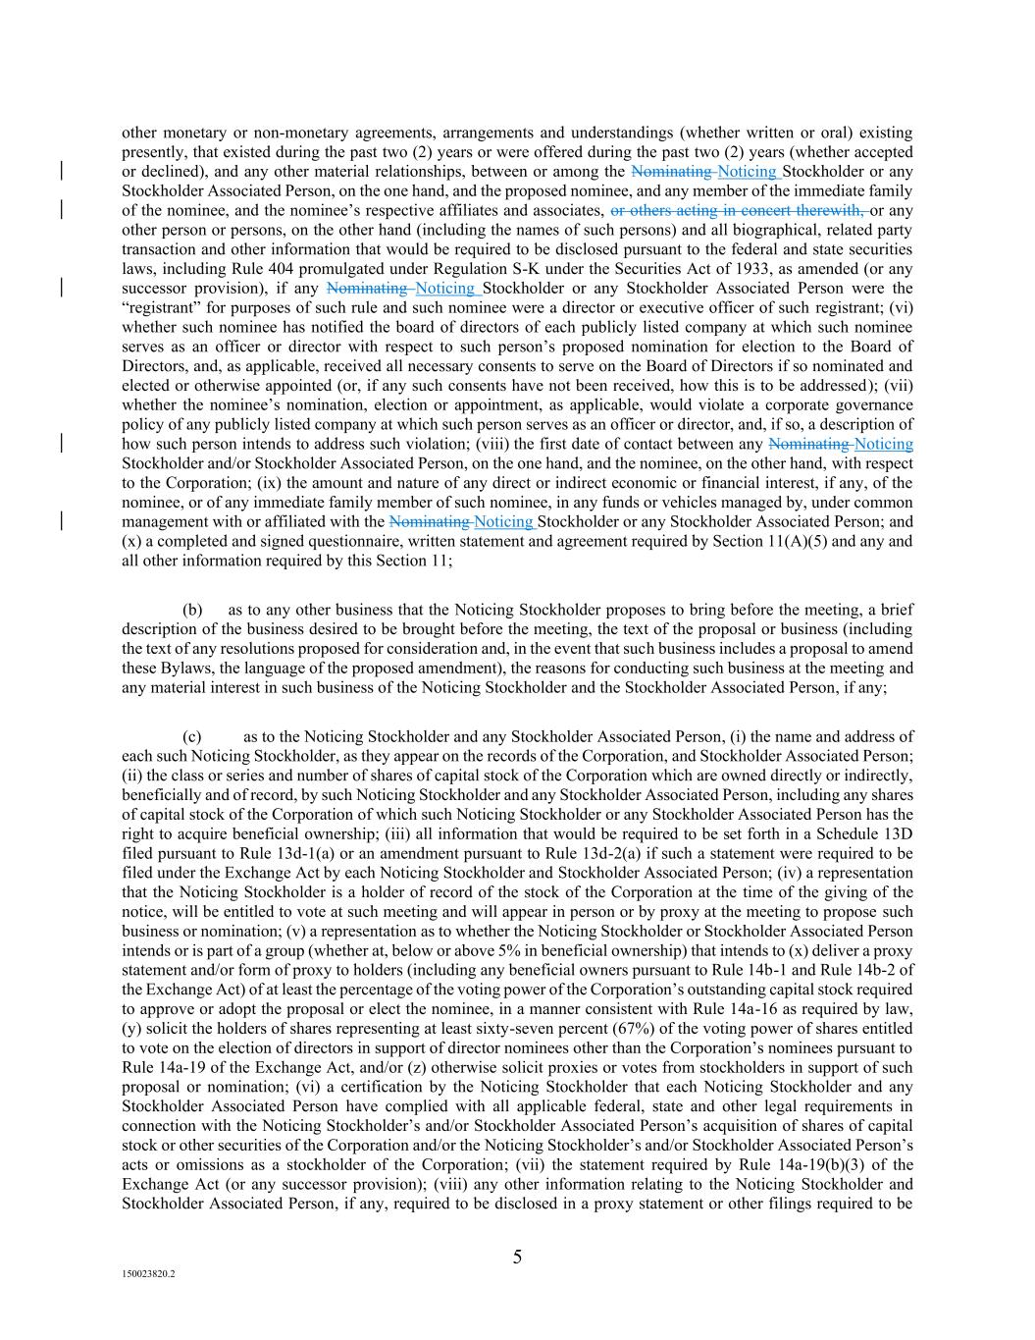
5 150023820.2 other monetary or non-monetary agreements, arrangements and understandings (whether written or oral) existing presently, that existed during the past two (2) years or were offered during the past two (2) years (whether accepted or declined), and any other material relationships, between or among the Nominating Noticing Stockholder or any Stockholder Associated Person, on the one hand, and the proposed nominee, and any member of the immediate family of the nominee, and the nominee’s respective affiliates and associates, or others acting in concert therewith, or any other person or persons, on the other hand (including the names of such persons) and all biographical, related party transaction and other information that would be required to be disclosed pursuant to the federal and state securities laws, including Rule 404 promulgated under Regulation S-K under the Securities Act of 1933, as amended (or any successor provision), if any Nominating Noticing Stockholder or any Stockholder Associated Person were the “registrant” for purposes of such rule and such nominee were a director or executive officer of such registrant; (vi) whether such nominee has notified the board of directors of each publicly listed company at which such nominee serves as an officer or director with respect to such person’s proposed nomination for election to the Board of Directors, and, as applicable, received all necessary consents to serve on the Board of Directors if so nominated and elected or otherwise appointed (or, if any such consents have not been received, how this is to be addressed); (vii) whether the nominee’s nomination, election or appointment, as applicable, would violate a corporate governance policy of any publicly listed company at which such person serves as an officer or director, and, if so, a description of how such person intends to address such violation; (viii) the first date of contact between any Nominating Noticing Stockholder and/or Stockholder Associated Person, on the one hand, and the nominee, on the other hand, with respect to the Corporation; (ix) the amount and nature of any direct or indirect economic or financial interest, if any, of the nominee, or of any immediate family member of such nominee, in any funds or vehicles managed by, under common management with or affiliated with the Nominating Noticing Stockholder or any Stockholder Associated Person; and (x) a completed and signed questionnaire, written statement and agreement required by Section 11(A)(5) and any and all other information required by this Section 11; (b) as to any other business that the Noticing Stockholder proposes to bring before the meeting, a brief description of the business desired to be brought before the meeting, the text of the proposal or business (including the text of any resolutions proposed for consideration and, in the event that such business includes a proposal to amend these Bylaws, the language of the proposed amendment), the reasons for conducting such business at the meeting and any material interest in such business of the Noticing Stockholder and the Stockholder Associated Person, if any; (c) as to the Noticing Stockholder and any Stockholder Associated Person, (i) the name and address of each such Noticing Stockholder, as they appear on the records of the Corporation, and Stockholder Associated Person; (ii) the class or series and number of shares of capital stock of the Corporation which are owned directly or indirectly, beneficially and of record, by such Noticing Stockholder and any Stockholder Associated Person, including any shares of capital stock of the Corporation of which such Noticing Stockholder or any Stockholder Associated Person has the right to acquire beneficial ownership; (iii) all information that would be required to be set forth in a Schedule 13D filed pursuant to Rule 13d-1(a) or an amendment pursuant to Rule 13d-2(a) if such a statement were required to be filed under the Exchange Act by each Noticing Stockholder and Stockholder Associated Person; (iv) a representation that the Noticing Stockholder is a holder of record of the stock of the Corporation at the time of the giving of the notice, will be entitled to vote at such meeting and will appear in person or by proxy at the meeting to propose such business or nomination; (v) a representation as to whether the Noticing Stockholder or Stockholder Associated Person intends or is part of a group (whether at, below or above 5% in beneficial ownership) that intends to (x) deliver a proxy statement and/or form of proxy to holders (including any beneficial owners pursuant to Rule 14b-1 and Rule 14b-2 of the Exchange Act) of at least the percentage of the voting power of the Corporation’s outstanding capital stock required to approve or adopt the proposal or elect the nominee, in a manner consistent with Rule 14a-16 as required by law, (y) solicit the holders of shares representing at least sixty-seven percent (67%) of the voting power of shares entitled to vote on the election of directors in support of director nominees other than the Corporation’s nominees pursuant to Rule 14a-19 of the Exchange Act, and/or (z) otherwise solicit proxies or votes from stockholders in support of such proposal or nomination; (vi) a certification by the Noticing Stockholder that each Noticing Stockholder and any Stockholder Associated Person have complied with all applicable federal, state and other legal requirements in connection with the Noticing Stockholder’s and/or Stockholder Associated Person’s acquisition of shares of capital stock or other securities of the Corporation and/or the Noticing Stockholder’s and/or Stockholder Associated Person’s acts or omissions as a stockholder of the Corporation; (vii) the statement required by Rule 14a-19(b)(3) of the Exchange Act (or any successor provision); (viii) any other information relating to the Noticing Stockholder and Stockholder Associated Person, if any, required to be disclosed in a proxy statement or other filings required to be

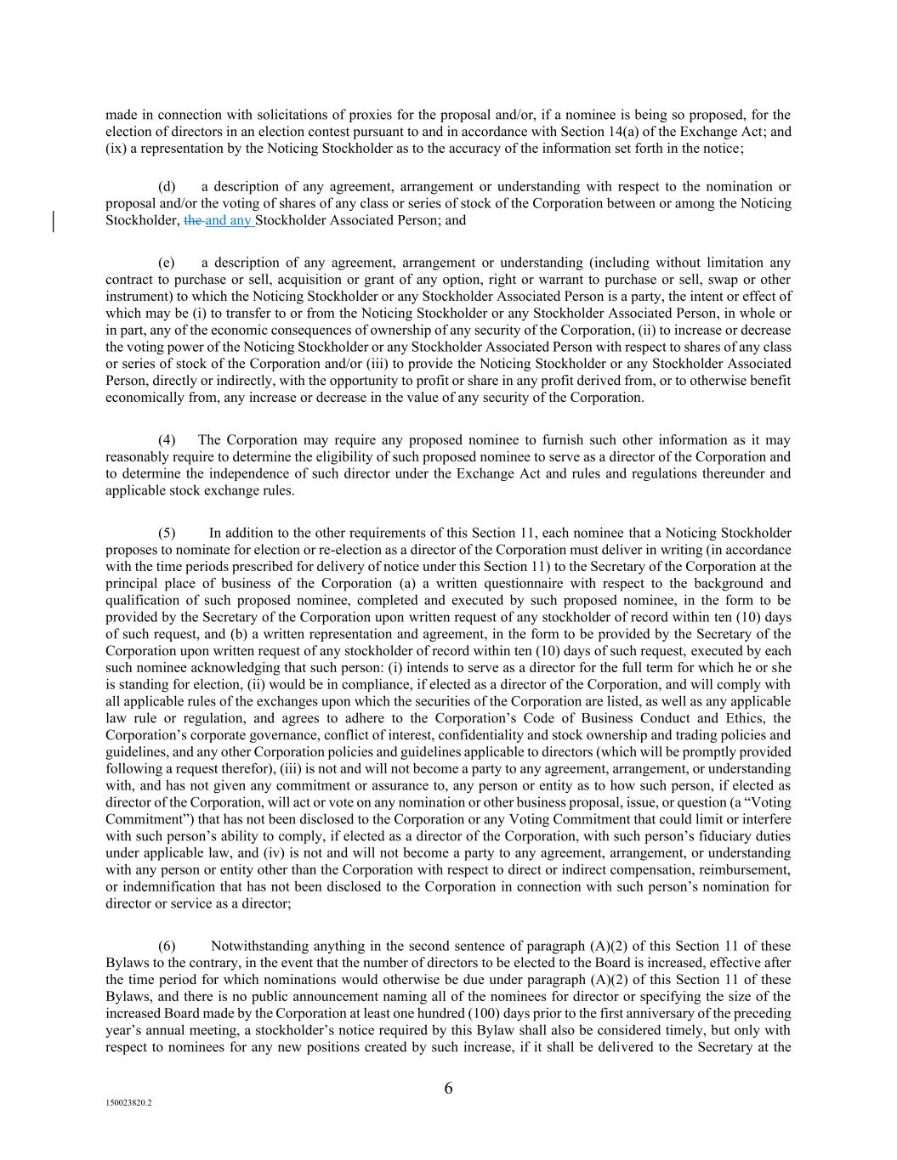
6 150023820.2 made in connection with solicitations of proxies for the proposal and/or, if a nominee is being so proposed, for the election of directors in an election contest pursuant to and in accordance with Section 14(a) of the Exchange Act; and (ix) a representation by the Noticing Stockholder as to the accuracy of the information set forth in the notice; (d) a description of any agreement, arrangement or understanding with respect to the nomination or proposal and/or the voting of shares of any class or series of stock of the Corporation between or among the Noticing Stockholder, the and any Stockholder Associated Person; and (e) a description of any agreement, arrangement or understanding (including without limitation any contract to purchase or sell, acquisition or grant of any option, right or warrant to purchase or sell, swap or other instrument) to which the Noticing Stockholder or any Stockholder Associated Person is a party, the intent or effect of which may be (i) to transfer to or from the Noticing Stockholder or any Stockholder Associated Person, in whole or in part, any of the economic consequences of ownership of any security of the Corporation, (ii) to increase or decrease the voting power of the Noticing Stockholder or any Stockholder Associated Person with respect to shares of any class or series of stock of the Corporation and/or (iii) to provide the Noticing Stockholder or any Stockholder Associated Person, directly or indirectly, with the opportunity to profit or share in any profit derived from, or to otherwise benefit economically from, any increase or decrease in the value of any security of the Corporation. (4) The Corporation may require any proposed nominee to furnish such other information as it may reasonably require to determine the eligibility of such proposed nominee to serve as a director of the Corporation and to determine the independence of such director under the Exchange Act and rules and regulations thereunder and applicable stock exchange rules. (5) In addition to the other requirements of this Section 11, each nominee that a Noticing Stockholder proposes to nominate for election or re-election as a director of the Corporation must deliver in writing (in accordance with the time periods prescribed for delivery of notice under this Section 11) to the Secretary of the Corporation at the principal place of business of the Corporation (a) a written questionnaire with respect to the background and qualification of such proposed nominee, completed and executed by such proposed nominee, in the form to be provided by the Secretary of the Corporation upon written request of any stockholder of record within ten (10) days of such request, and (b) a written representation and agreement, in the form to be provided by the Secretary of the Corporation upon written request of any stockholder of record within ten (10) days of such request, executed by each such nominee acknowledging that such person: (i) intends to serve as a director for the full term for which he or she is standing for election, (ii) would be in compliance, if elected as a director of the Corporation, and will comply with all applicable rules of the exchanges upon which the securities of the Corporation are listed, as well as any applicable law rule or regulation, and agrees to adhere to the Corporation’s Code of Business Conduct and Ethics, the Corporation’s corporate governance, conflict of interest, confidentiality and stock ownership and trading policies and guidelines, and any other Corporation policies and guidelines applicable to directors (which will be promptly provided following a request therefor), (iii) is not and will not become a party to any agreement, arrangement, or understanding with, and has not given any commitment or assurance to, any person or entity as to how such person, if elected as director of the Corporation, will act or vote on any nomination or other business proposal, issue, or question (a “Voting Commitment”) that has not been disclosed to the Corporation or any Voting Commitment that could limit or interfere with such person’s ability to comply, if elected as a director of the Corporation, with such person’s fiduciary duties under applicable law, and (iv) is not and will not become a party to any agreement, arrangement, or understanding with any person or entity other than the Corporation with respect to direct or indirect compensation, reimbursement, or indemnification that has not been disclosed to the Corporation in connection with such person’s nomination for director or service as a director; (6) Notwithstanding anything in the second sentence of paragraph (A)(2) of this Section 11 of these Bylaws to the contrary, in the event that the number of directors to be elected to the Board is increased, effective after the time period for which nominations would otherwise be due under paragraph (A)(2) of this Section 11 of these Bylaws, and there is no public announcement naming all of the nominees for director or specifying the size of the increased Board made by the Corporation at least one hundred (100) days prior to the first anniversary of the preceding year’s annual meeting, a stockholder’s notice required by this Bylaw shall also be considered timely, but only with respect to nominees for any new positions created by such increase, if it shall be delivered to the Secretary at the

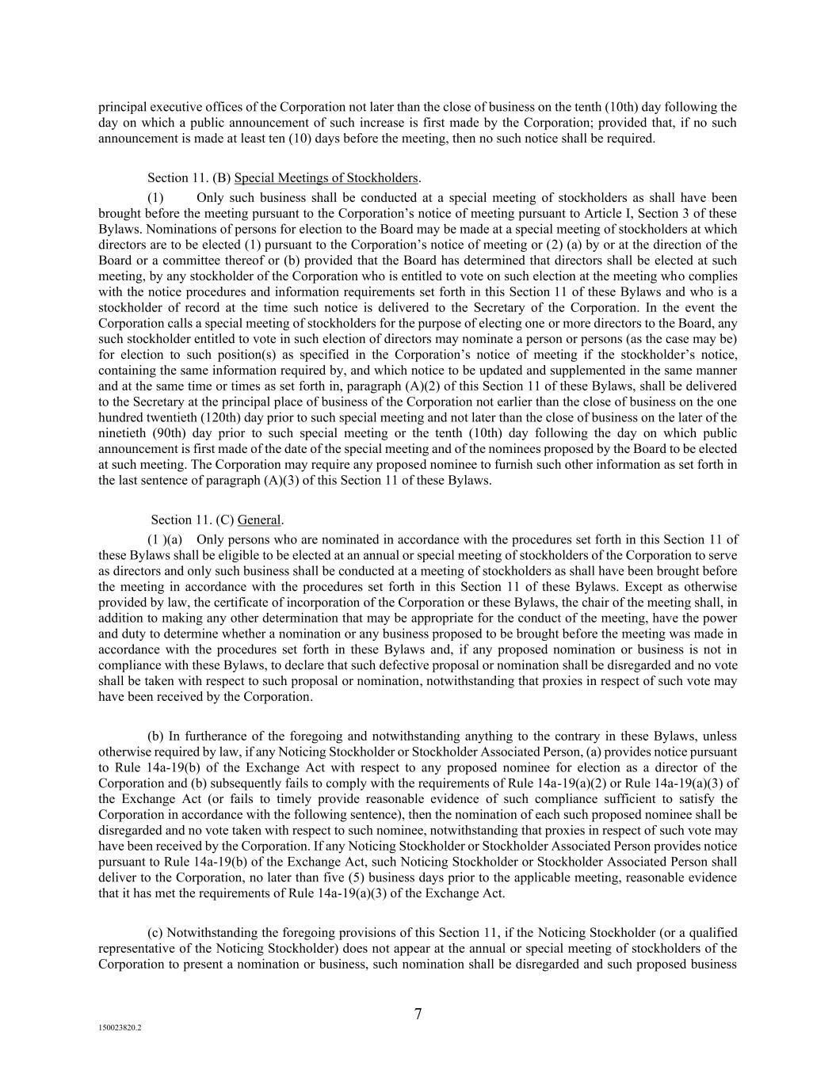
7 150023820.2 principal executive offices of the Corporation not later than the close of business on the tenth (10th) day following the day on which a public announcement of such increase is first made by the Corporation; provided that, if no such announcement is made at least ten (10) days before the meeting, then no such notice shall be required. Section 11. (B) Special Meetings of Stockholders. (1) Only such business shall be conducted at a special meeting of stockholders as shall have been brought before the meeting pursuant to the Corporation’s notice of meeting pursuant to Article I, Section 3 of these Bylaws. Nominations of persons for election to the Board may be made at a special meeting of stockholders at which directors are to be elected (1) pursuant to the Corporation’s notice of meeting or (2) (a) by or at the direction of the Board or a committee thereof or (b) provided that the Board has determined that directors shall be elected at such meeting, by any stockholder of the Corporation who is entitled to vote on such election at the meeting who complies with the notice procedures and information requirements set forth in this Section 11 of these Bylaws and who is a stockholder of record at the time such notice is delivered to the Secretary of the Corporation. In the event the Corporation calls a special meeting of stockholders for the purpose of electing one or more directors to the Board, any such stockholder entitled to vote in such election of directors may nominate a person or persons (as the case may be) for election to such position(s) as specified in the Corporation’s notice of meeting if the stockholder’s notice, containing the same information required by, and which notice to be updated and supplemented in the same manner and at the same time or times as set forth in, paragraph (A)(2) of this Section 11 of these Bylaws, shall be delivered to the Secretary at the principal place of business of the Corporation not earlier than the close of business on the one hundred twentieth (120th) day prior to such special meeting and not later than the close of business on the later of the ninetieth (90th) day prior to such special meeting or the tenth (10th) day following the day on which public announcement is first made of the date of the special meeting and of the nominees proposed by the Board to be elected at such meeting. The Corporation may require any proposed nominee to furnish such other information as set forth in the last sentence of paragraph (A)(3) of this Section 11 of these Bylaws. Section 11. (C) General. (1 )(a) Only persons who are nominated in accordance with the procedures set forth in this Section 11 of these Bylaws shall be eligible to be elected at an annual or special meeting of stockholders of the Corporation to serve as directors and only such business shall be conducted at a meeting of stockholders as shall have been brought before the meeting in accordance with the procedures set forth in this Section 11 of these Bylaws. Except as otherwise provided by law, the certificate of incorporation of the Corporation or these Bylaws, the chair of the meeting shall, in addition to making any other determination that may be appropriate for the conduct of the meeting, have the power and duty to determine whether a nomination or any business proposed to be brought before the meeting was made in accordance with the procedures set forth in these Bylaws and, if any proposed nomination or business is not in compliance with these Bylaws, to declare that such defective proposal or nomination shall be disregarded and no vote shall be taken with respect to such proposal or nomination, notwithstanding that proxies in respect of such vote may have been received by the Corporation. (b) In furtherance of the foregoing and notwithstanding anything to the contrary in these Bylaws, unless otherwise required by law, if any Noticing Stockholder or Stockholder Associated Person, (a) provides notice pursuant to Rule 14a-19(b) of the Exchange Act with respect to any proposed nominee for election as a director of the Corporation and (b) subsequently fails to comply with the requirements of Rule 14a-19(a)(2) or Rule 14a-19(a)(3) of the Exchange Act (or fails to timely provide reasonable evidence of such compliance sufficient to satisfy the Corporation in accordance with the following sentence), then the nomination of each such proposed nominee shall be disregarded and no vote taken with respect to such nominee, notwithstanding that proxies in respect of such vote may have been received by the Corporation. If any Noticing Stockholder or Stockholder Associated Person provides notice pursuant to Rule 14a-19(b) of the Exchange Act, such Noticing Stockholder or Stockholder Associated Person shall deliver to the Corporation, no later than five (5) business days prior to the applicable meeting, reasonable evidence that it has met the requirements of Rule 14a-19(a)(3) of the Exchange Act. (c) Notwithstanding the foregoing provisions of this Section 11, if the Noticing Stockholder (or a qualified representative of the Noticing Stockholder) does not appear at the annual or special meeting of stockholders of the Corporation to present a nomination or business, such nomination shall be disregarded and such proposed business

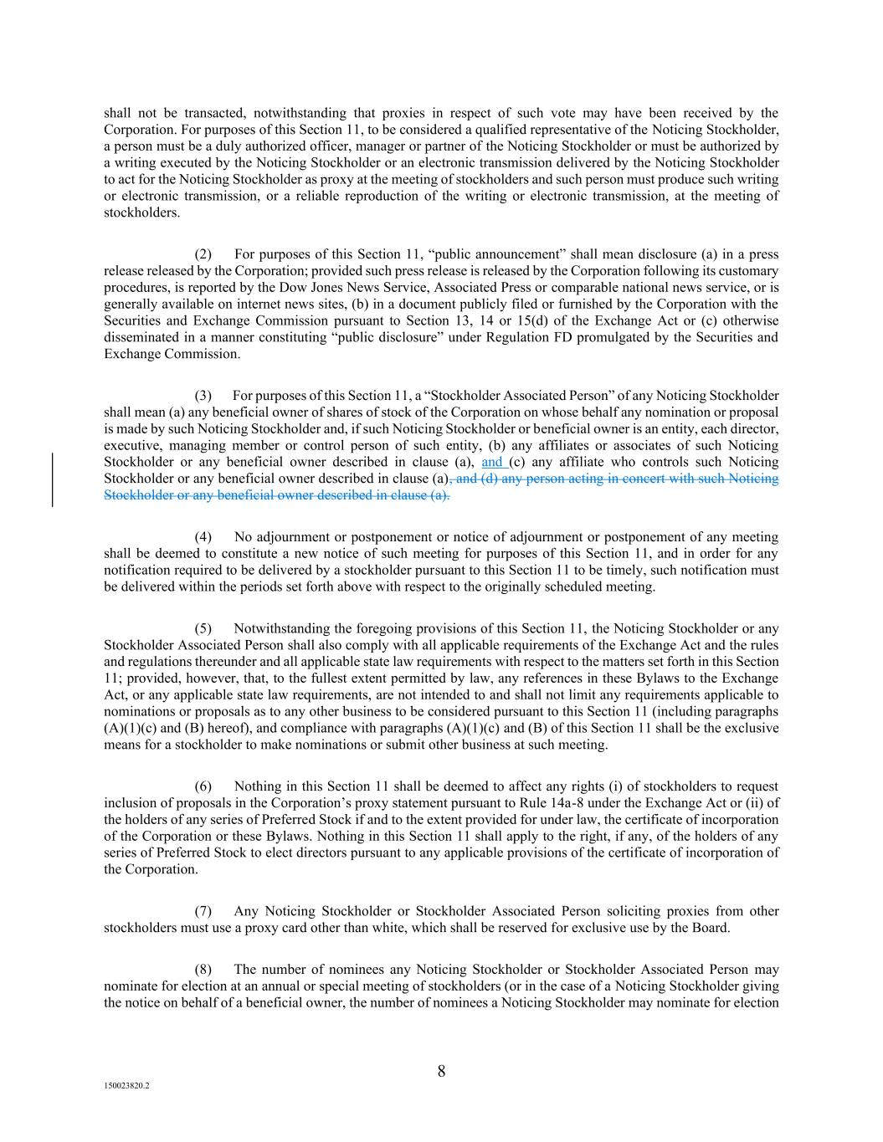
8 150023820.2 shall not be transacted, notwithstanding that proxies in respect of such vote may have been received by the Corporation. For purposes of this Section 11, to be considered a qualified representative of the Noticing Stockholder, a person must be a duly authorized officer, manager or partner of the Noticing Stockholder or must be authorized by a writing executed by the Noticing Stockholder or an electronic transmission delivered by the Noticing Stockholder to act for the Noticing Stockholder as proxy at the meeting of stockholders and such person must produce such writing or electronic transmission, or a reliable reproduction of the writing or electronic transmission, at the meeting of stockholders. (2) For purposes of this Section 11, “public announcement” shall mean disclosure (a) in a press release released by the Corporation; provided such press release is released by the Corporation following its customary procedures, is reported by the Dow Jones News Service, Associated Press or comparable national news service, or is generally available on internet news sites, (b) in a document publicly filed or furnished by the Corporation with the Securities and Exchange Commission pursuant to Section 13, 14 or 15(d) of the Exchange Act or (c) otherwise disseminated in a manner constituting “public disclosure” under Regulation FD promulgated by the Securities and Exchange Commission. (3) For purposes of this Section 11, a “Stockholder Associated Person” of any Noticing Stockholder shall mean (a) any beneficial owner of shares of stock of the Corporation on whose behalf any nomination or proposal is made by such Noticing Stockholder and, if such Noticing Stockholder or beneficial owner is an entity, each director, executive, managing member or control person of such entity, (b) any affiliates or associates of such Noticing Stockholder or any beneficial owner described in clause (a), and (c) any affiliate who controls such Noticing Stockholder or any beneficial owner described in clause (a), and (d) any person acting in concert with such Noticing Stockholder or any beneficial owner described in clause (a). (4) No adjournment or postponement or notice of adjournment or postponement of any meeting shall be deemed to constitute a new notice of such meeting for purposes of this Section 11, and in order for any notification required to be delivered by a stockholder pursuant to this Section 11 to be timely, such notification must be delivered within the periods set forth above with respect to the originally scheduled meeting. (5) Notwithstanding the foregoing provisions of this Section 11, the Noticing Stockholder or any Stockholder Associated Person shall also comply with all applicable requirements of the Exchange Act and the rules and regulations thereunder and all applicable state law requirements with respect to the matters set forth in this Section 11; provided, however, that, to the fullest extent permitted by law, any references in these Bylaws to the Exchange Act, or any applicable state law requirements, are not intended to and shall not limit any requirements applicable to nominations or proposals as to any other business to be considered pursuant to this Section 11 (including paragraphs (A)(1)(c) and (B) hereof), and compliance with paragraphs (A)(1)(c) and (B) of this Section 11 shall be the exclusive means for a stockholder to make nominations or submit other business at such meeting. (6) Nothing in this Section 11 shall be deemed to affect any rights (i) of stockholders to request inclusion of proposals in the Corporation’s proxy statement pursuant to Rule 14a-8 under the Exchange Act or (ii) of the holders of any series of Preferred Stock if and to the extent provided for under law, the certificate of incorporation of the Corporation or these Bylaws. Nothing in this Section 11 shall apply to the right, if any, of the holders of any series of Preferred Stock to elect directors pursuant to any applicable provisions of the certificate of incorporation of the Corporation. (7) Any Noticing Stockholder or Stockholder Associated Person soliciting proxies from other stockholders must use a proxy card other than white, which shall be reserved for exclusive use by the Board. (8) The number of nominees any Noticing Stockholder or Stockholder Associated Person may nominate for election at an annual or special meeting of stockholders (or in the case of a Noticing Stockholder giving the notice on behalf of a beneficial owner, the number of nominees a Noticing Stockholder may nominate for election

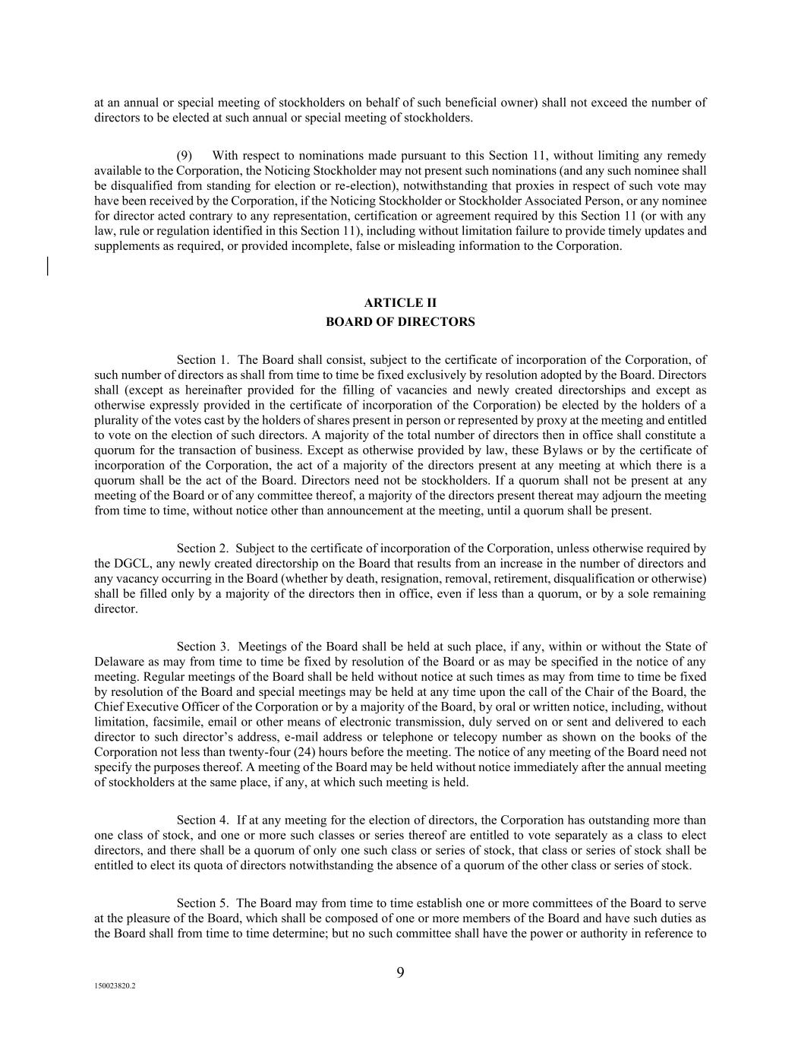
9 150023820.2 at an annual or special meeting of stockholders on behalf of such beneficial owner) shall not exceed the number of directors to be elected at such annual or special meeting of stockholders. (9) With respect to nominations made pursuant to this Section 11, without limiting any remedy available to the Corporation, the Noticing Stockholder may not present such nominations (and any such nominee shall be disqualified from standing for election or re-election), notwithstanding that proxies in respect of such vote may have been received by the Corporation, if the Noticing Stockholder or Stockholder Associated Person, or any nominee for director acted contrary to any representation, certification or agreement required by this Section 11 (or with any law, rule or regulation identified in this Section 11), including without limitation failure to provide timely updates and supplements as required, or provided incomplete, false or misleading information to the Corporation. ARTICLE II BOARD OF DIRECTORS Section 1. The Board shall consist, subject to the certificate of incorporation of the Corporation, of such number of directors as shall from time to time be fixed exclusively by resolution adopted by the Board. Directors shall (except as hereinafter provided for the filling of vacancies and newly created directorships and except as otherwise expressly provided in the certificate of incorporation of the Corporation) be elected by the holders of a plurality of the votes cast by the holders of shares present in person or represented by proxy at the meeting and entitled to vote on the election of such directors. A majority of the total number of directors then in office shall constitute a quorum for the transaction of business. Except as otherwise provided by law, these Bylaws or by the certificate of incorporation of the Corporation, the act of a majority of the directors present at any meeting at which there is a quorum shall be the act of the Board. Directors need not be stockholders. If a quorum shall not be present at any meeting of the Board or of any committee thereof, a majority of the directors present thereat may adjourn the meeting from time to time, without notice other than announcement at the meeting, until a quorum shall be present. Section 2. Subject to the certificate of incorporation of the Corporation, unless otherwise required by the DGCL, any newly created directorship on the Board that results from an increase in the number of directors and any vacancy occurring in the Board (whether by death, resignation, removal, retirement, disqualification or otherwise) shall be filled only by a majority of the directors then in office, even if less than a quorum, or by a sole remaining director. Section 3. Meetings of the Board shall be held at such place, if any, within or without the State of Delaware as may from time to time be fixed by resolution of the Board or as may be specified in the notice of any meeting. Regular meetings of the Board shall be held without notice at such times as may from time to time be fixed by resolution of the Board and special meetings may be held at any time upon the call of the Chair of the Board, the Chief Executive Officer of the Corporation or by a majority of the Board, by oral or written notice, including, without limitation, facsimile, email or other means of electronic transmission, duly served on or sent and delivered to each director to such director’s address, e-mail address or telephone or telecopy number as shown on the books of the Corporation not less than twenty-four (24) hours before the meeting. The notice of any meeting of the Board need not specify the purposes thereof. A meeting of the Board may be held without notice immediately after the annual meeting of stockholders at the same place, if any, at which such meeting is held. Section 4. If at any meeting for the election of directors, the Corporation has outstanding more than one class of stock, and one or more such classes or series thereof are entitled to vote separately as a class to elect directors, and there shall be a quorum of only one such class or series of stock, that class or series of stock shall be entitled to elect its quota of directors notwithstanding the absence of a quorum of the other class or series of stock. Section 5. The Board may from time to time establish one or more committees of the Board to serve at the pleasure of the Board, which shall be composed of one or more members of the Board and have such duties as the Board shall from time to time determine; but no such committee shall have the power or authority in reference to

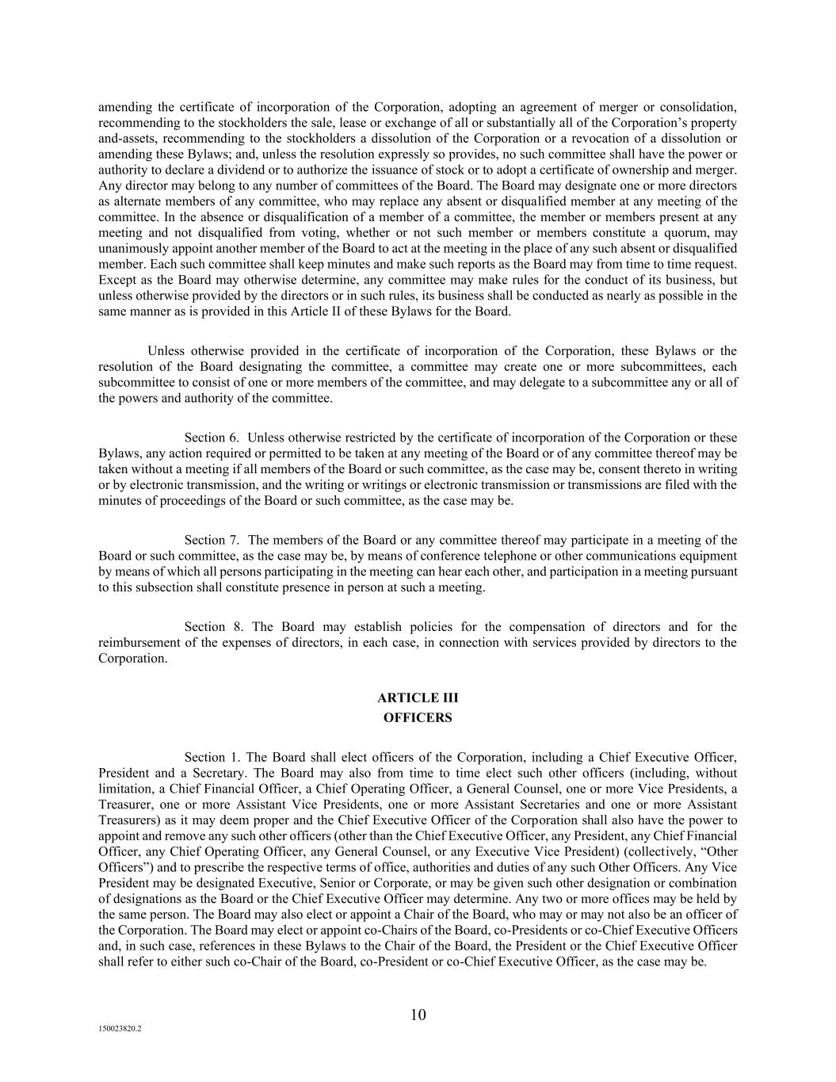
10 150023820.2 amending the certificate of incorporation of the Corporation, adopting an agreement of merger or consolidation, recommending to the stockholders the sale, lease or exchange of all or substantially all of the Corporation’s property and-assets, recommending to the stockholders a dissolution of the Corporation or a revocation of a dissolution or amending these Bylaws; and, unless the resolution expressly so provides, no such committee shall have the power or authority to declare a dividend or to authorize the issuance of stock or to adopt a certificate of ownership and merger. Any director may belong to any number of committees of the Board. The Board may designate one or more directors as alternate members of any committee, who may replace any absent or disqualified member at any meeting of the committee. In the absence or disqualification of a member of a committee, the member or members present at any meeting and not disqualified from voting, whether or not such member or members constitute a quorum, may unanimously appoint another member of the Board to act at the meeting in the place of any such absent or disqualified member. Each such committee shall keep minutes and make such reports as the Board may from time to time request. Except as the Board may otherwise determine, any committee may make rules for the conduct of its business, but unless otherwise provided by the directors or in such rules, its business shall be conducted as nearly as possible in the same manner as is provided in this Article II of these Bylaws for the Board. Unless otherwise provided in the certificate of incorporation of the Corporation, these Bylaws or the resolution of the Board designating the committee, a committee may create one or more subcommittees, each subcommittee to consist of one or more members of the committee, and may delegate to a subcommittee any or all of the powers and authority of the committee. Section 6. Unless otherwise restricted by the certificate of incorporation of the Corporation or these Bylaws, any action required or permitted to be taken at any meeting of the Board or of any committee thereof may be taken without a meeting if all members of the Board or such committee, as the case may be, consent thereto in writing or by electronic transmission, and the writing or writings or electronic transmission or transmissions are filed with the minutes of proceedings of the Board or such committee, as the case may be. Section 7. The members of the Board or any committee thereof may participate in a meeting of the Board or such committee, as the case may be, by means of conference telephone or other communications equipment by means of which all persons participating in the meeting can hear each other, and participation in a meeting pursuant to this subsection shall constitute presence in person at such a meeting. Section 8. The Board may establish policies for the compensation of directors and for the reimbursement of the expenses of directors, in each case, in connection with services provided by directors to the Corporation. ARTICLE III OFFICERS Section 1. The Board shall elect officers of the Corporation, including a Chief Executive Officer, President and a Secretary. The Board may also from time to time elect such other officers (including, without limitation, a Chief Financial Officer, a Chief Operating Officer, a General Counsel, one or more Vice Presidents, a Treasurer, one or more Assistant Vice Presidents, one or more Assistant Secretaries and one or more Assistant Treasurers) as it may deem proper and the Chief Executive Officer of the Corporation shall also have the power to appoint and remove any such other officers (other than the Chief Executive Officer, any President, any Chief Financial Officer, any Chief Operating Officer, any General Counsel, or any Executive Vice President) (collectively, “Other Officers”) and to prescribe the respective terms of office, authorities and duties of any such Other Officers. Any Vice President may be designated Executive, Senior or Corporate, or may be given such other designation or combination of designations as the Board or the Chief Executive Officer may determine. Any two or more offices may be held by the same person. The Board may also elect or appoint a Chair of the Board, who may or may not also be an officer of the Corporation. The Board may elect or appoint co-Chairs of the Board, co-Presidents or co-Chief Executive Officers and, in such case, references in these Bylaws to the Chair of the Board, the President or the Chief Executive Officer shall refer to either such co-Chair of the Board, co-President or co-Chief Executive Officer, as the case may be.

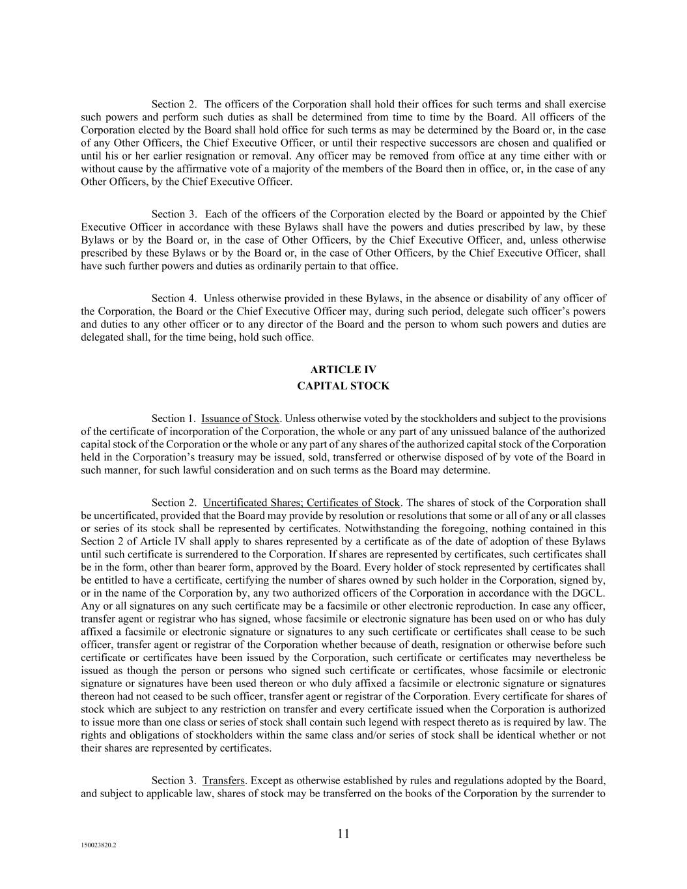
11 150023820.2 Section 2. The officers of the Corporation shall hold their offices for such terms and shall exercise such powers and perform such duties as shall be determined from time to time by the Board. All officers of the Corporation elected by the Board shall hold office for such terms as may be determined by the Board or, in the case of any Other Officers, the Chief Executive Officer, or until their respective successors are chosen and qualified or until his or her earlier resignation or removal. Any officer may be removed from office at any time either with or without cause by the affirmative vote of a majority of the members of the Board then in office, or, in the case of any Other Officers, by the Chief Executive Officer. Section 3. Each of the officers of the Corporation elected by the Board or appointed by the Chief Executive Officer in accordance with these Bylaws shall have the powers and duties prescribed by law, by these Bylaws or by the Board or, in the case of Other Officers, by the Chief Executive Officer, and, unless otherwise prescribed by these Bylaws or by the Board or, in the case of Other Officers, by the Chief Executive Officer, shall have such further powers and duties as ordinarily pertain to that office. Section 4. Unless otherwise provided in these Bylaws, in the absence or disability of any officer of the Corporation, the Board or the Chief Executive Officer may, during such period, delegate such officer’s powers and duties to any other officer or to any director of the Board and the person to whom such powers and duties are delegated shall, for the time being, hold such office. ARTICLE IV CAPITAL STOCK Section 1. Issuance of Stock. Unless otherwise voted by the stockholders and subject to the provisions of the certificate of incorporation of the Corporation, the whole or any part of any unissued balance of the authorized capital stock of the Corporation or the whole or any part of any shares of the authorized capital stock of the Corporation held in the Corporation’s treasury may be issued, sold, transferred or otherwise disposed of by vote of the Board in such manner, for such lawful consideration and on such terms as the Board may determine. Section 2. Uncertificated Shares; Certificates of Stock. The shares of stock of the Corporation shall be uncertificated, provided that the Board may provide by resolution or resolutions that some or all of any or all classes or series of its stock shall be represented by certificates. Notwithstanding the foregoing, nothing contained in this Section 2 of Article IV shall apply to shares represented by a certificate as of the date of adoption of these Bylaws until such certificate is surrendered to the Corporation. If shares are represented by certificates, such certificates shall be in the form, other than bearer form, approved by the Board. Every holder of stock represented by certificates shall be entitled to have a certificate, certifying the number of shares owned by such holder in the Corporation, signed by, or in the name of the Corporation by, any two authorized officers of the Corporation in accordance with the DGCL. Any or all signatures on any such certificate may be a facsimile or other electronic reproduction. In case any officer, transfer agent or registrar who has signed, whose facsimile or electronic signature has been used on or who has duly affixed a facsimile or electronic signature or signatures to any such certificate or certificates shall cease to be such officer, transfer agent or registrar of the Corporation whether because of death, resignation or otherwise before such certificate or certificates have been issued by the Corporation, such certificate or certificates may nevertheless be issued as though the person or persons who signed such certificate or certificates, whose facsimile or electronic signature or signatures have been used thereon or who duly affixed a facsimile or electronic signature or signatures thereon had not ceased to be such officer, transfer agent or registrar of the Corporation. Every certificate for shares of stock which are subject to any restriction on transfer and every certificate issued when the Corporation is authorized to issue more than one class or series of stock shall contain such legend with respect thereto as is required by law. The rights and obligations of stockholders within the same class and/or series of stock shall be identical whether or not their shares are represented by certificates. Section 3. Transfers. Except as otherwise established by rules and regulations adopted by the Board, and subject to applicable law, shares of stock may be transferred on the books of the Corporation by the surrender to

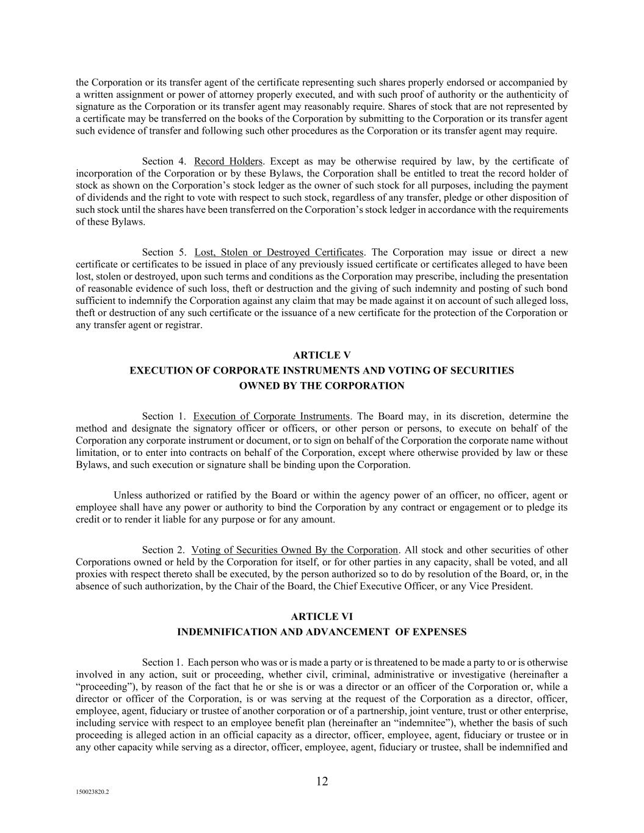
12 150023820.2 the Corporation or its transfer agent of the certificate representing such shares properly endorsed or accompanied by a written assignment or power of attorney properly executed, and with such proof of authority or the authenticity of signature as the Corporation or its transfer agent may reasonably require. Shares of stock that are not represented by a certificate may be transferred on the books of the Corporation by submitting to the Corporation or its transfer agent such evidence of transfer and following such other procedures as the Corporation or its transfer agent may require. Section 4. Record Holders. Except as may be otherwise required by law, by the certificate of incorporation of the Corporation or by these Bylaws, the Corporation shall be entitled to treat the record holder of stock as shown on the Corporation’s stock ledger as the owner of such stock for all purposes, including the payment of dividends and the right to vote with respect to such stock, regardless of any transfer, pledge or other disposition of such stock until the shares have been transferred on the Corporation’s stock ledger in accordance with the requirements of these Bylaws. Section 5. Lost, Stolen or Destroyed Certificates. The Corporation may issue or direct a new certificate or certificates to be issued in place of any previously issued certificate or certificates alleged to have been lost, stolen or destroyed, upon such terms and conditions as the Corporation may prescribe, including the presentation of reasonable evidence of such loss, theft or destruction and the giving of such indemnity and posting of such bond sufficient to indemnify the Corporation against any claim that may be made against it on account of such alleged loss, theft or destruction of any such certificate or the issuance of a new certificate for the protection of the Corporation or any transfer agent or registrar. ARTICLE V EXECUTION OF CORPORATE INSTRUMENTS AND VOTING OF SECURITIES OWNED BY THE CORPORATION Section 1. Execution of Corporate Instruments. The Board may, in its discretion, determine the method and designate the signatory officer or officers, or other person or persons, to execute on behalf of the Corporation any corporate instrument or document, or to sign on behalf of the Corporation the corporate name without limitation, or to enter into contracts on behalf of the Corporation, except where otherwise provided by law or these Bylaws, and such execution or signature shall be binding upon the Corporation. Unless authorized or ratified by the Board or within the agency power of an officer, no officer, agent or employee shall have any power or authority to bind the Corporation by any contract or engagement or to pledge its credit or to render it liable for any purpose or for any amount. Section 2. Voting of Securities Owned By the Corporation. All stock and other securities of other Corporations owned or held by the Corporation for itself, or for other parties in any capacity, shall be voted, and all proxies with respect thereto shall be executed, by the person authorized so to do by resolution of the Board, or, in the absence of such authorization, by the Chair of the Board, the Chief Executive Officer, or any Vice President. ARTICLE VI INDEMNIFICATION AND ADVANCEMENT OF EXPENSES Section 1. Each person who was or is made a party or is threatened to be made a party to or is otherwise involved in any action, suit or proceeding, whether civil, criminal, administrative or investigative (hereinafter a “proceeding”), by reason of the fact that he or she is or was a director or an officer of the Corporation or, while a director or officer of the Corporation, is or was serving at the request of the Corporation as a director, officer, employee, agent, fiduciary or trustee of another corporation or of a partnership, joint venture, trust or other enterprise, including service with respect to an employee benefit plan (hereinafter an “indemnitee”), whether the basis of such proceeding is alleged action in an official capacity as a director, officer, employee, agent, fiduciary or trustee or in any other capacity while serving as a director, officer, employee, agent, fiduciary or trustee, shall be indemnified and

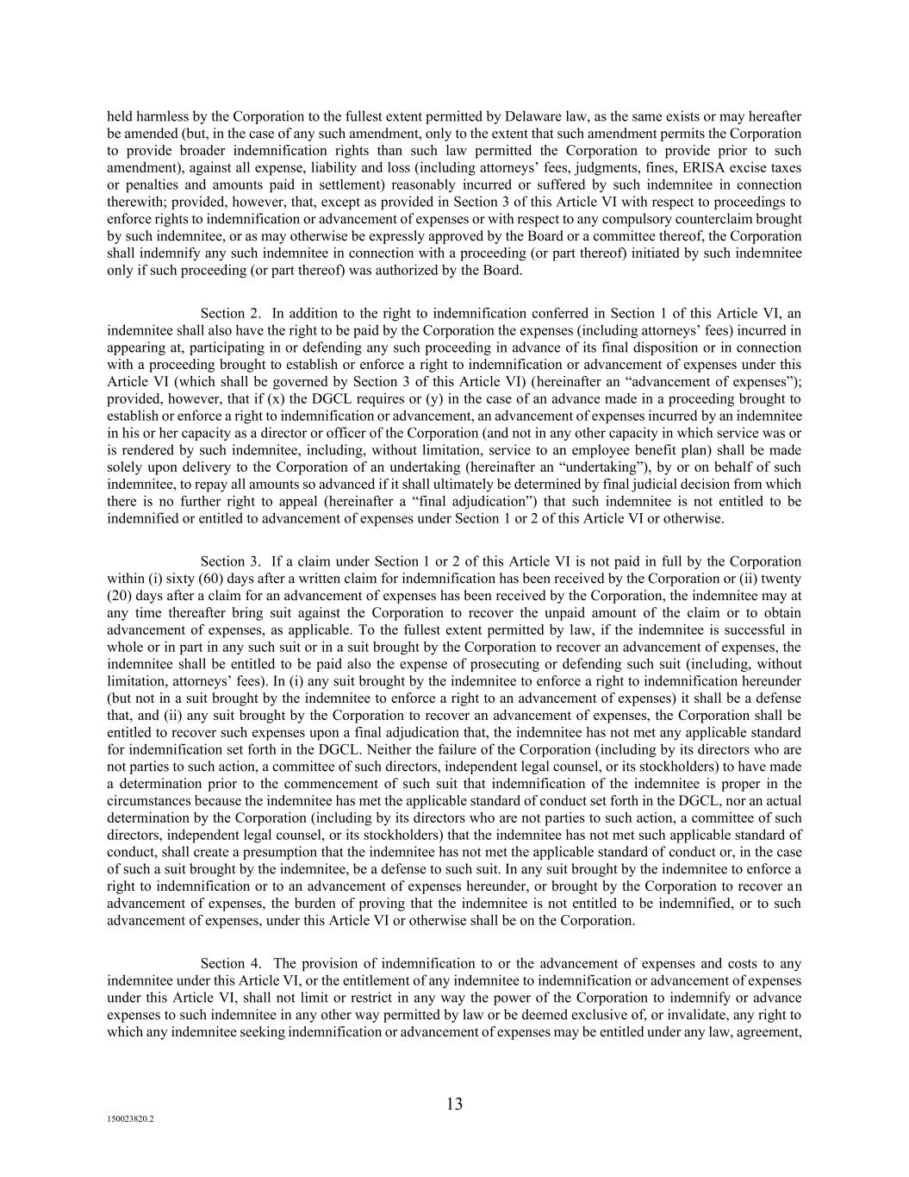
13 150023820.2 held harmless by the Corporation to the fullest extent permitted by Delaware law, as the same exists or may hereafter be amended (but, in the case of any such amendment, only to the extent that such amendment permits the Corporation to provide broader indemnification rights than such law permitted the Corporation to provide prior to such amendment), against all expense, liability and loss (including attorneys’ fees, judgments, fines, ERISA excise taxes or penalties and amounts paid in settlement) reasonably incurred or suffered by such indemnitee in connection therewith; provided, however, that, except as provided in Section 3 of this Article VI with respect to proceedings to enforce rights to indemnification or advancement of expenses or with respect to any compulsory counterclaim brought by such indemnitee, or as may otherwise be expressly approved by the Board or a committee thereof, the Corporation shall indemnify any such indemnitee in connection with a proceeding (or part thereof) initiated by such indemnitee only if such proceeding (or part thereof) was authorized by the Board. Section 2. In addition to the right to indemnification conferred in Section 1 of this Article VI, an indemnitee shall also have the right to be paid by the Corporation the expenses (including attorneys’ fees) incurred in appearing at, participating in or defending any such proceeding in advance of its final disposition or in connection with a proceeding brought to establish or enforce a right to indemnification or advancement of expenses under this Article VI (which shall be governed by Section 3 of this Article VI) (hereinafter an “advancement of expenses”); provided, however, that if (x) the DGCL requires or (y) in the case of an advance made in a proceeding brought to establish or enforce a right to indemnification or advancement, an advancement of expenses incurred by an indemnitee in his or her capacity as a director or officer of the Corporation (and not in any other capacity in which service was or is rendered by such indemnitee, including, without limitation, service to an employee benefit plan) shall be made solely upon delivery to the Corporation of an undertaking (hereinafter an “undertaking”), by or on behalf of such indemnitee, to repay all amounts so advanced if it shall ultimately be determined by final judicial decision from which there is no further right to appeal (hereinafter a “final adjudication”) that such indemnitee is not entitled to be indemnified or entitled to advancement of expenses under Section 1 or 2 of this Article VI or otherwise. Section 3. If a claim under Section 1 or 2 of this Article VI is not paid in full by the Corporation within (i) sixty (60) days after a written claim for indemnification has been received by the Corporation or (ii) twenty (20) days after a claim for an advancement of expenses has been received by the Corporation, the indemnitee may at any time thereafter bring suit against the Corporation to recover the unpaid amount of the claim or to obtain advancement of expenses, as applicable. To the fullest extent permitted by law, if the indemnitee is successful in whole or in part in any such suit or in a suit brought by the Corporation to recover an advancement of expenses, the indemnitee shall be entitled to be paid also the expense of prosecuting or defending such suit (including, without limitation, attorneys’ fees). In (i) any suit brought by the indemnitee to enforce a right to indemnification hereunder (but not in a suit brought by the indemnitee to enforce a right to an advancement of expenses) it shall be a defense that, and (ii) any suit brought by the Corporation to recover an advancement of expenses, the Corporation shall be entitled to recover such expenses upon a final adjudication that, the indemnitee has not met any applicable standard for indemnification set forth in the DGCL. Neither the failure of the Corporation (including by its directors who are not parties to such action, a committee of such directors, independent legal counsel, or its stockholders) to have made a determination prior to the commencement of such suit that indemnification of the indemnitee is proper in the circumstances because the indemnitee has met the applicable standard of conduct set forth in the DGCL, nor an actual determination by the Corporation (including by its directors who are not parties to such action, a committee of such directors, independent legal counsel, or its stockholders) that the indemnitee has not met such applicable standard of conduct, shall create a presumption that the indemnitee has not met the applicable standard of conduct or, in the case of such a suit brought by the indemnitee, be a defense to such suit. In any suit brought by the indemnitee to enforce a right to indemnification or to an advancement of expenses hereunder, or brought by the Corporation to recover an advancement of expenses, the burden of proving that the indemnitee is not entitled to be indemnified, or to such advancement of expenses, under this Article VI or otherwise shall be on the Corporation. Section 4. The provision of indemnification to or the advancement of expenses and costs to any indemnitee under this Article VI, or the entitlement of any indemnitee to indemnification or advancement of expenses under this Article VI, shall not limit or restrict in any way the power of the Corporation to indemnify or advance expenses to such indemnitee in any other way permitted by law or be deemed exclusive of, or invalidate, any right to which any indemnitee seeking indemnification or advancement of expenses may be entitled under any law, agreement,

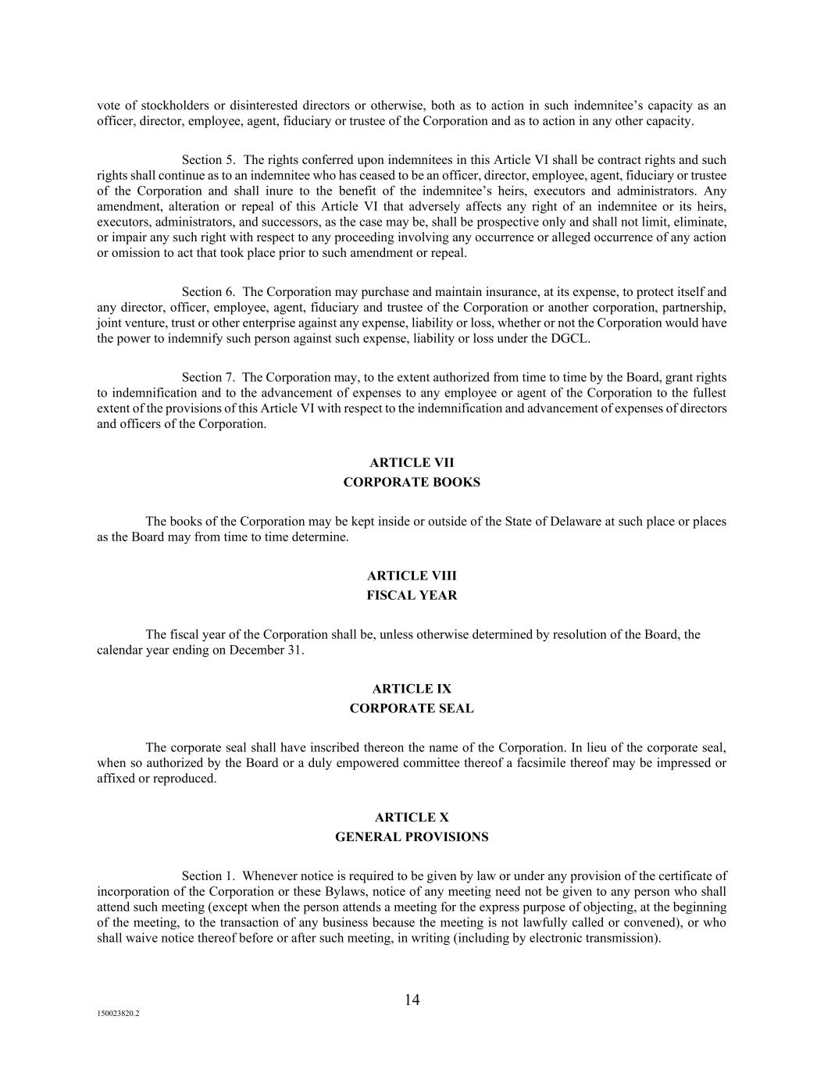
14 150023820.2 vote of stockholders or disinterested directors or otherwise, both as to action in such indemnitee’s capacity as an officer, director, employee, agent, fiduciary or trustee of the Corporation and as to action in any other capacity. Section 5. The rights conferred upon indemnitees in this Article VI shall be contract rights and such rights shall continue as to an indemnitee who has ceased to be an officer, director, employee, agent, fiduciary or trustee of the Corporation and shall inure to the benefit of the indemnitee’s heirs, executors and administrators. Any amendment, alteration or repeal of this Article VI that adversely affects any right of an indemnitee or its heirs, executors, administrators, and successors, as the case may be, shall be prospective only and shall not limit, eliminate, or impair any such right with respect to any proceeding involving any occurrence or alleged occurrence of any action or omission to act that took place prior to such amendment or repeal. Section 6. The Corporation may purchase and maintain insurance, at its expense, to protect itself and any director, officer, employee, agent, fiduciary and trustee of the Corporation or another corporation, partnership, joint venture, trust or other enterprise against any expense, liability or loss, whether or not the Corporation would have the power to indemnify such person against such expense, liability or loss under the DGCL. Section 7. The Corporation may, to the extent authorized from time to time by the Board, grant rights to indemnification and to the advancement of expenses to any employee or agent of the Corporation to the fullest extent of the provisions of this Article VI with respect to the indemnification and advancement of expenses of directors and officers of the Corporation. ARTICLE VII CORPORATE BOOKS The books of the Corporation may be kept inside or outside of the State of Delaware at such place or places as the Board may from time to time determine. ARTICLE VIII FISCAL YEAR The fiscal year of the Corporation shall be, unless otherwise determined by resolution of the Board, the calendar year ending on December 31. ARTICLE IX CORPORATE SEAL The corporate seal shall have inscribed thereon the name of the Corporation. In lieu of the corporate seal, when so authorized by the Board or a duly empowered committee thereof a facsimile thereof may be impressed or affixed or reproduced. ARTICLE X GENERAL PROVISIONS Section 1. Whenever notice is required to be given by law or under any provision of the certificate of incorporation of the Corporation or these Bylaws, notice of any meeting need not be given to any person who shall attend such meeting (except when the person attends a meeting for the express purpose of objecting, at the beginning of the meeting, to the transaction of any business because the meeting is not lawfully called or convened), or who shall waive notice thereof before or after such meeting, in writing (including by electronic transmission).

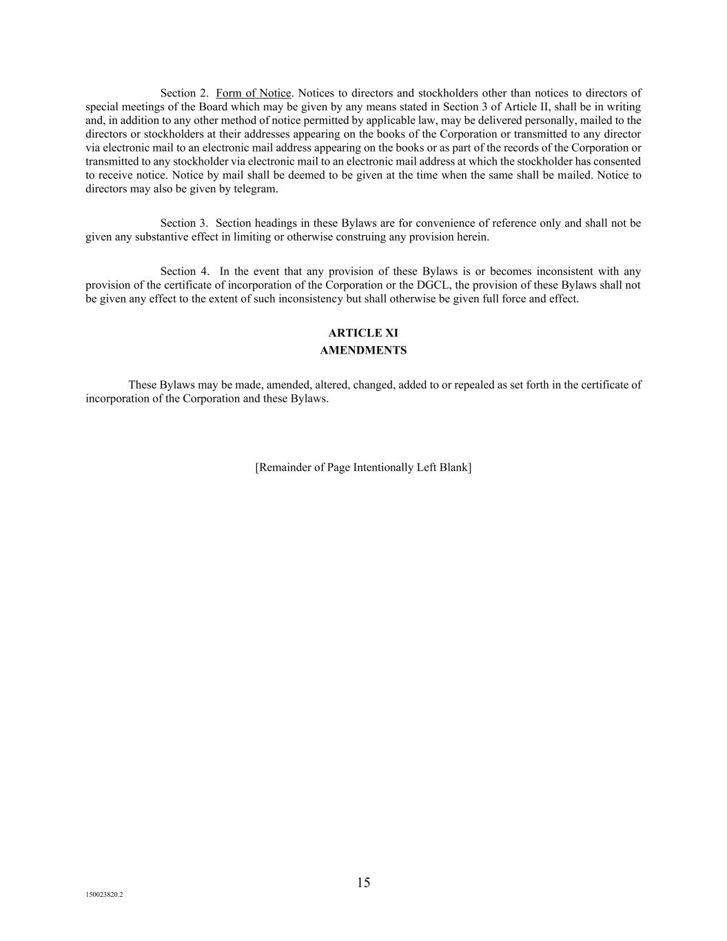
15 150023820.2 Section 2. Form of Notice. Notices to directors and stockholders other than notices to directors of special meetings of the Board which may be given by any means stated in Section 3 of Article II, shall be in writing and, in addition to any other method of notice permitted by applicable law, may be delivered personally, mailed to the directors or stockholders at their addresses appearing on the books of the Corporation or transmitted to any director via electronic mail to an electronic mail address appearing on the books or as part of the records of the Corporation or transmitted to any stockholder via electronic mail to an electronic mail address at which the stockholder has consented to receive notice. Notice by mail shall be deemed to be given at the time when the same shall be mailed. Notice to directors may also be given by telegram. Section 3. Section headings in these Bylaws are for convenience of reference only and shall not be given any substantive effect in limiting or otherwise construing any provision herein. Section 4. In the event that any provision of these Bylaws is or becomes inconsistent with any provision of the certificate of incorporation of the Corporation or the DGCL, the provision of these Bylaws shall not be given any effect to the extent of such inconsistency but shall otherwise be given full force and effect. ARTICLE XI AMENDMENTS These Bylaws may be made, amended, altered, changed, added to or repealed as set forth in the certificate of incorporation of the Corporation and these Bylaws. [Remainder of Page Intentionally Left Blank]

