UNITED STATES
SECURITIES AND EXCHANGE COMMISSION
Washington, DC 20549

FORM 8-K

CURRENT REPORT

PURSUANT TO SECTION 13 OR 15(d) OF THE
SECURITIES EXCHANGE ACT OF 1934

Date of Report (Date of earliest event reported): August 10, 2026
Aquestive Therapeutics, Inc.
(Exact name of Registrant as specified in its charter)
Delaware |  |  | 001-38599 |  |  | 82-3827296
(State or other jurisdiction of incorporation) |  |  | (Commission File Number) |  |  | (I.R.S. Employer Identification No.)

30 Technology Drive
Warren, NJ 07059
(908) 941-1900
(Address, Including Zip Code, and Telephone Number, Including Area Code, of Registrant’s Principal Executive Offices)

Not Applicable
(Former name or former address, if changed since last report)

________________________________________________________________________________________________________________________
Check the appropriate box below if the Form 8-K filing is intended to simultaneously satisfy the filing obligation of the registrant under any of the following provisions:
☐ |  |  | Written communications pursuant to Rule 425 under the Securities Act (17 CFR 230.425)
☐ |  |  | Soliciting material pursuant to Rule 14a-12 under the Exchange Act (17 CFR 240.14a-12)
☐ |  |  | Pre-commencement communications pursuant to Rule 14d-2(b) under the Exchange Act (17 CFR 240.14d-2(b))
☐ |  |  | Pre-commencement communications pursuant to Rule 13e-4(c) under the Exchange Act (17 CFR 240.13e-4(c))

Securities registered pursuant to Section 12(b) of the Act:

Title of each class |  |  | Trading Symbol(s) |  |  | Name of each exchange on which  registered
Common Stock, par value $0.001 per share |  |  | AQST |  |  | Nasdaq Global Market

Indicate by check mark whether the registrant is an emerging growth company as defined in Rule 405 of the Securities Act of 1933 (§230.405 of this chapter) or Rule 12b-2 of the Securities Exchange Act of 1934 (§240.12b-2 of this chapter).
Emerging growth company |  |  | ☐
If an emerging growth company, indicate by check mark if the registrant has elected not to use the extended transition period for complying with any new or revised financial accounting standards provided pursuant to Section 13(a) of the Exchange Act. ☐

Item 7.01 |  |  | Regulation FD Disclosure.

On August 10, 2026, Aquestive Therapeutics, Inc. (the “Company”) is furnishing information, in the form of an investor presentation, to be given at meetings with institutional investors, analysts and others. A copy of the Company’s investor presentation is attached hereto as Exhibit 99.2 to this Current Report on Form 8-K. This information may be amended or updated at any time and from time to time through another Current Report on Form 8-K, a later Company filing or other means. The investor presentation is available on the Events and Presentations page of the Investors section of the Company’s website located at www.aquestive.com, although the Company reserves the right to discontinue that availability at any time. The information on, or accessible through, the Company’s website is not incorporated by reference into this Current Report on Form 8-K.

The information in this Item 7.01, including Exhibit 99.2, is being furnished and shall not be deemed “filed” for purposes of Section 18 of the Securities Exchange Act of 1934, as amended (the “Exchange Act”), or otherwise subject to the liabilities of that Section, nor shall it be deemed incorporated by reference into any filing of the Company under the Securities Act of 1933, as amended, or the Exchange Act, whether made before or after the date hereof, regardless of any general incorporation language in such filing, except as expressly set forth by specific reference in such filing. The furnishing of the information in this Item 7.01 shall not be deemed an admission as to the materiality of any information required to be disclosed solely to satisfy the requirements of Regulation FD.

Item 8.01 |  |  | Other Events.

On August 10, 2026, Aquestive Therapeutics, Inc. (the “Company”) issued a press release announcing the results from its human factors validation study and pharmacokinetic study for Anaphylm™ (dibutepinephrine) sublingual film, conducted in support of the Company’s planned resubmission of its New Drug Application to the U.S. Food and Drug Administration for the treatment of Type 1 allergic reactions, including anaphylaxis. A copy of the Company’s press release is attached hereto as Exhibit 99.1 and is incorporated into this Item 8.01 by reference.

Item 9.01 |  |  | Financial Statements and Exhibits.
(d) Exhibits.

Exhibit Number |  |  |  |  |  | Description
99.1 |  |  |  |  |  | Aquestive Therapeutics, Inc. Press Release, dated August 10, 2026
99.2 |  |  |  |  |  | Aquestive Therapeutics, Inc. Investor Presentation, dated August 10, 2026
104 |  |  |  |  |  | Cover Page Interaction Data File (embedded within the Inline XBRL document)

SIGNATURE

Pursuant to the requirements of the Securities Exchange Act of 1934, as amended, the Registrant has duly caused this report to be signed on its behalf by the undersigned hereunto duly authorized.

Dated: August 10, 2026 |  |  | Aquestive Therapeutics, Inc.
 |  |  | By: |  |  | /s/ A. Ernest Toth, Jr
 |  |  |  |  |  | Name: A. Ernest Toth, Jr.
 |  |  |  |  |  | Title: Chief Financial Officer

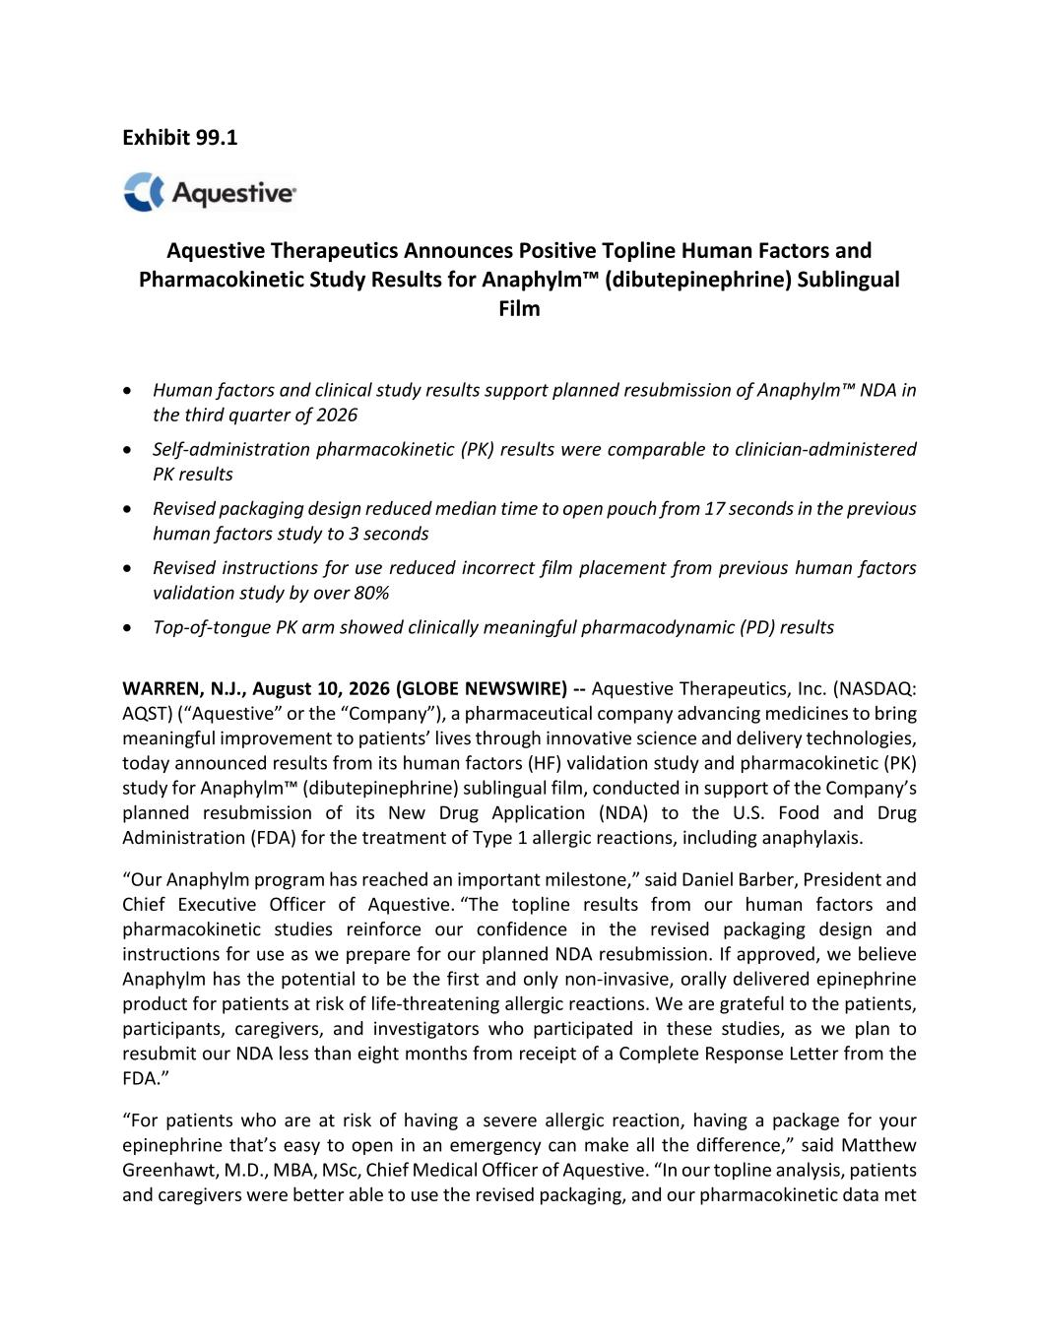

Exhibit 99.1 Aquestive Therapeutics Announces Positive Topline Human Factors and Pharmacokinetic Study Results for Anaphylm™ (dibutepinephrine) Sublingual Film • Human factors and clinical study results support planned resubmission of Anaphylm™ NDA in the third quarter of 2026 • Self-administration pharmacokinetic (PK) results were comparable to clinician-administered PK results • Revised packaging design reduced median time to open pouch from 17 seconds in the previous human factors study to 3 seconds • Revised instructions for use reduced incorrect film placement from previous human factors validation study by over 80% • Top-of-tongue PK arm showed clinically meaningful pharmacodynamic (PD) results WARREN, N.J., August 10, 2026 (GLOBE NEWSWIRE) -- Aquestive Therapeutics, Inc. (NASDAQ: AQST) (“Aquestive” or the “Company”), a pharmaceutical company advancing medicines to bring meaningful improvement to patients’ lives through innovative science and delivery technologies, today announced results from its human factors (HF) validation study and pharmacokinetic (PK) study for Anaphylm™ (dibutepinephrine) sublingual film, conducted in support of the Company’s planned resubmission of its New Drug Application (NDA) to the U.S. Food and Drug Administration (FDA) for the treatment of Type 1 allergic reactions, including anaphylaxis. “Our Anaphylm program has reached an important milestone,” said Daniel Barber, President and Chief Executive Officer of Aquestive. “The topline results from our human factors and pharmacokinetic studies reinforce our confidence in the revised packaging design and instructions for use as we prepare for our planned NDA resubmission. If approved, we believe Anaphylm has the potential to be the first and only non-invasive, orally delivered epinephrine product for patients at risk of life-threatening allergic reactions. We are grateful to the patients, participants, caregivers, and investigators who participated in these studies, as we plan to resubmit our NDA less than eight months from receipt of a Complete Response Letter from the FDA.” “For patients who are at risk of having a severe allergic reaction, having a package for your epinephrine that’s easy to open in an emergency can make all the difference,” said Matthew Greenhawt, M.D., MBA, MSc, Chief Medical Officer of Aquestive. “In our topline analysis, patients and caregivers were better able to use the revised packaging, and our pharmacokinetic data met

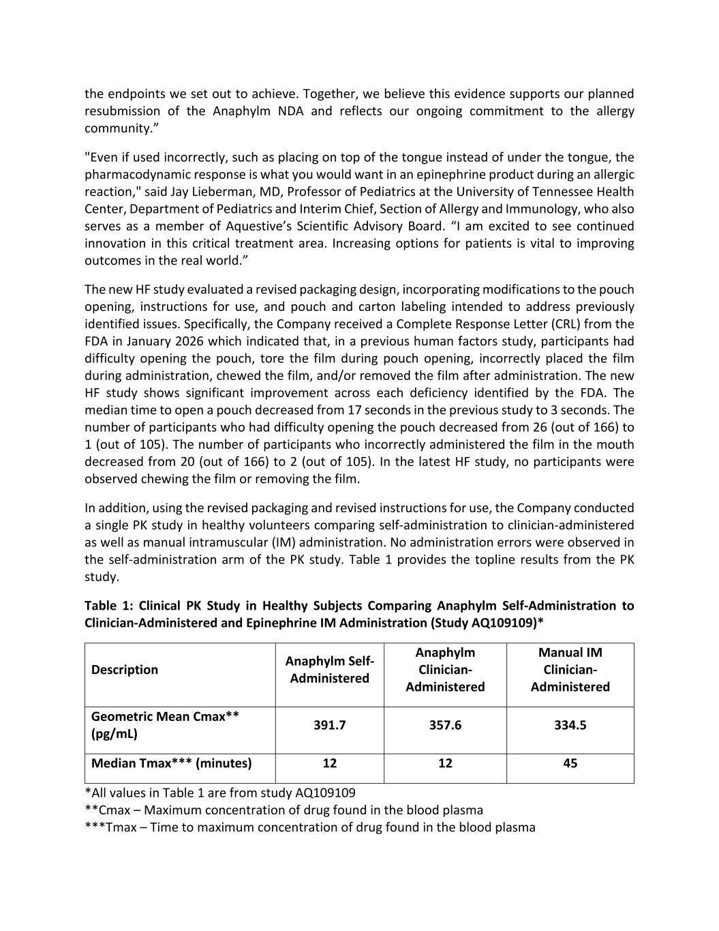
the endpoints we set out to achieve. Together, we believe this evidence supports our planned resubmission of the Anaphylm NDA and reflects our ongoing commitment to the allergy community.” "Even if used incorrectly, such as placing on top of the tongue instead of under the tongue, the pharmacodynamic response is what you would want in an epinephrine product during an allergic reaction," said Jay Lieberman, MD, Professor of Pediatrics at the University of Tennessee Health Center, Department of Pediatrics and Interim Chief, Section of Allergy and Immunology, who also serves as a member of Aquestive’s Scientific Advisory Board. “I am excited to see continued innovation in this critical treatment area. Increasing options for patients is vital to improving outcomes in the real world.” The new HF study evaluated a revised packaging design, incorporating modifications to the pouch opening, instructions for use, and pouch and carton labeling intended to address previously identified issues. Specifically, the Company received a Complete Response Letter (CRL) from the FDA in January 2026 which indicated that, in a previous human factors study, participants had difficulty opening the pouch, tore the film during pouch opening, incorrectly placed the film during administration, chewed the film, and/or removed the film after administration. The new HF study shows significant improvement across each deficiency identified by the FDA. The median time to open a pouch decreased from 17 seconds in the previous study to 3 seconds. The number of participants who had difficulty opening the pouch decreased from 26 (out of 166) to 1 (out of 105). The number of participants who incorrectly administered the film in the mouth decreased from 20 (out of 166) to 2 (out of 105). In the latest HF study, no participants were observed chewing the film or removing the film. In addition, using the revised packaging and revised instructions for use, the Company conducted a single PK study in healthy volunteers comparing self-administration to clinician-administered as well as manual intramuscular (IM) administration. No administration errors were observed in the self-administration arm of the PK study. Table 1 provides the topline results from the PK study. Table 1: Clinical PK Study in Healthy Subjects Comparing Anaphylm Self-Administration to Clinician-Administered and Epinephrine IM Administration (Study AQ109109)* Description Anaphylm Self- Administered Anaphylm Clinician- Administered Manual IM Clinician- Administered Geometric Mean Cmax** (pg/mL) 391.7 357.6 334.5 Median Tmax*** (minutes) 12 12 45 *All values in Table 1 are from study AQ109109 **Cmax – Maximum concentration of drug found in the blood plasma ***Tmax – Time to maximum concentration of drug found in the blood plasma

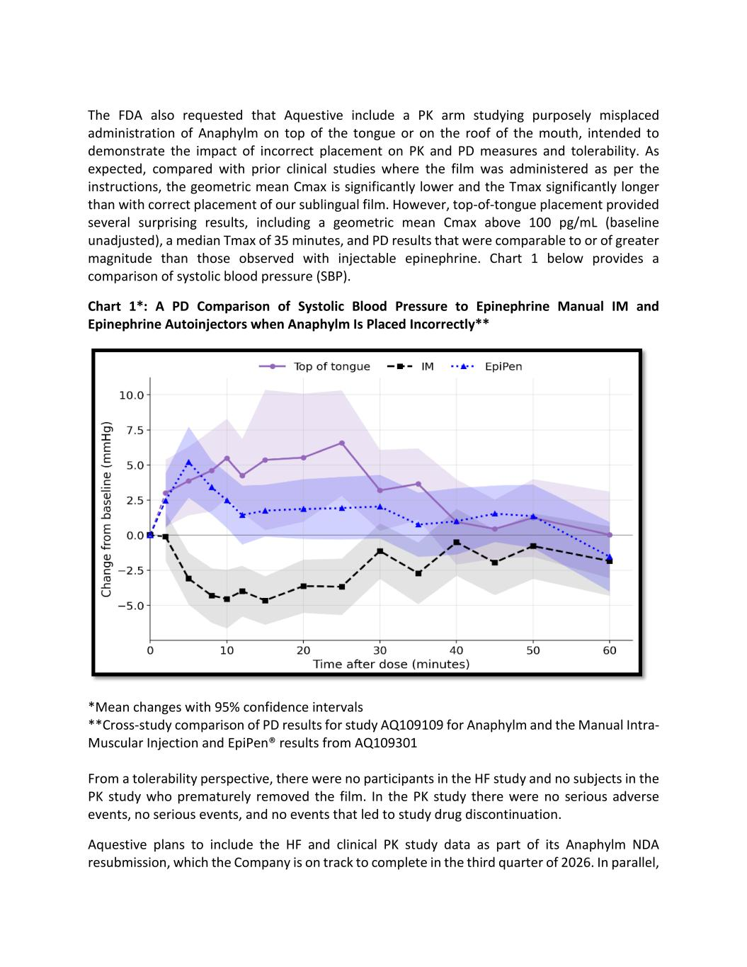
The FDA also requested that Aquestive include a PK arm studying purposely misplaced administration of Anaphylm on top of the tongue or on the roof of the mouth, intended to demonstrate the impact of incorrect placement on PK and PD measures and tolerability. As expected, compared with prior clinical studies where the film was administered as per the instructions, the geometric mean Cmax is significantly lower and the Tmax significantly longer than with correct placement of our sublingual film. However, top-of-tongue placement provided several surprising results, including a geometric mean Cmax above 100 pg/mL (baseline unadjusted), a median Tmax of 35 minutes, and PD results that were comparable to or of greater magnitude than those observed with injectable epinephrine. Chart 1 below provides a comparison of systolic blood pressure (SBP). Chart 1*: A PD Comparison of Systolic Blood Pressure to Epinephrine Manual IM and Epinephrine Autoinjectors when Anaphylm Is Placed Incorrectly** *Mean changes with 95% confidence intervals **Cross-study comparison of PD results for study AQ109109 for Anaphylm and the Manual Intra- Muscular Injection and EpiPen® results from AQ109301 From a tolerability perspective, there were no participants in the HF study and no subjects in the PK study who prematurely removed the film. In the PK study there were no serious adverse events, no serious events, and no events that led to study drug discontinuation. Aquestive plans to include the HF and clinical PK study data as part of its Anaphylm NDA resubmission, which the Company is on track to complete in the third quarter of 2026. In parallel,

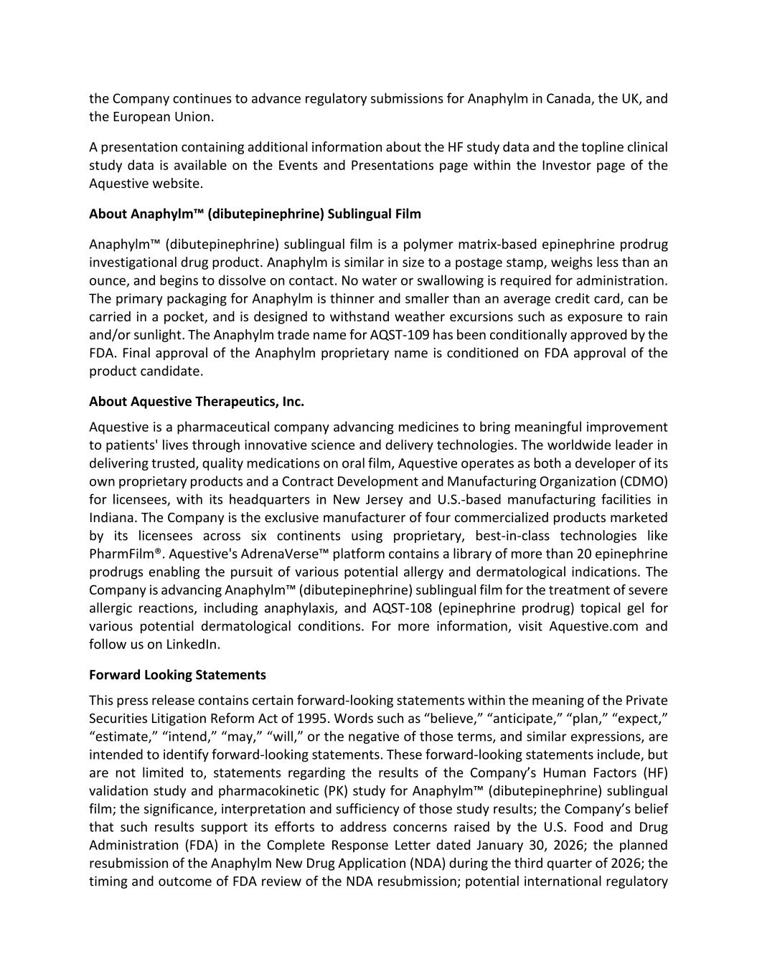
the Company continues to advance regulatory submissions for Anaphylm in Canada, the UK, and the European Union. A presentation containing additional information about the HF study data and the topline clinical study data is available on the Events and Presentations page within the Investor page of the Aquestive website. About Anaphylm™ (dibutepinephrine) Sublingual Film Anaphylm™ (dibutepinephrine) sublingual film is a polymer matrix-based epinephrine prodrug investigational drug product. Anaphylm is similar in size to a postage stamp, weighs less than an ounce, and begins to dissolve on contact. No water or swallowing is required for administration. The primary packaging for Anaphylm is thinner and smaller than an average credit card, can be carried in a pocket, and is designed to withstand weather excursions such as exposure to rain and/or sunlight. The Anaphylm trade name for AQST-109 has been conditionally approved by the FDA. Final approval of the Anaphylm proprietary name is conditioned on FDA approval of the product candidate. About Aquestive Therapeutics, Inc. Aquestive is a pharmaceutical company advancing medicines to bring meaningful improvement to patients' lives through innovative science and delivery technologies. The worldwide leader in delivering trusted, quality medications on oral film, Aquestive operates as both a developer of its own proprietary products and a Contract Development and Manufacturing Organization (CDMO) for licensees, with its headquarters in New Jersey and U.S.-based manufacturing facilities in Indiana. The Company is the exclusive manufacturer of four commercialized products marketed by its licensees across six continents using proprietary, best-in-class technologies like PharmFilm®. Aquestive's AdrenaVerse™ platform contains a library of more than 20 epinephrine prodrugs enabling the pursuit of various potential allergy and dermatological indications. The Company is advancing Anaphylm™ (dibutepinephrine) sublingual film for the treatment of severe allergic reactions, including anaphylaxis, and AQST-108 (epinephrine prodrug) topical gel for various potential dermatological conditions. For more information, visit Aquestive.com and follow us on LinkedIn. Forward Looking Statements This press release contains certain forward-looking statements within the meaning of the Private Securities Litigation Reform Act of 1995. Words such as “believe,” “anticipate,” “plan,” “expect,” “estimate,” “intend,” “may,” “will,” or the negative of those terms, and similar expressions, are intended to identify forward-looking statements. These forward-looking statements include, but are not limited to, statements regarding the results of the Company’s Human Factors (HF) validation study and pharmacokinetic (PK) study for Anaphylm™ (dibutepinephrine) sublingual film; the significance, interpretation and sufficiency of those study results; the Company’s belief that such results support its efforts to address concerns raised by the U.S. Food and Drug Administration (FDA) in the Complete Response Letter dated January 30, 2026; the planned resubmission of the Anaphylm New Drug Application (NDA) during the third quarter of 2026; the timing and outcome of FDA review of the NDA resubmission; potential international regulatory

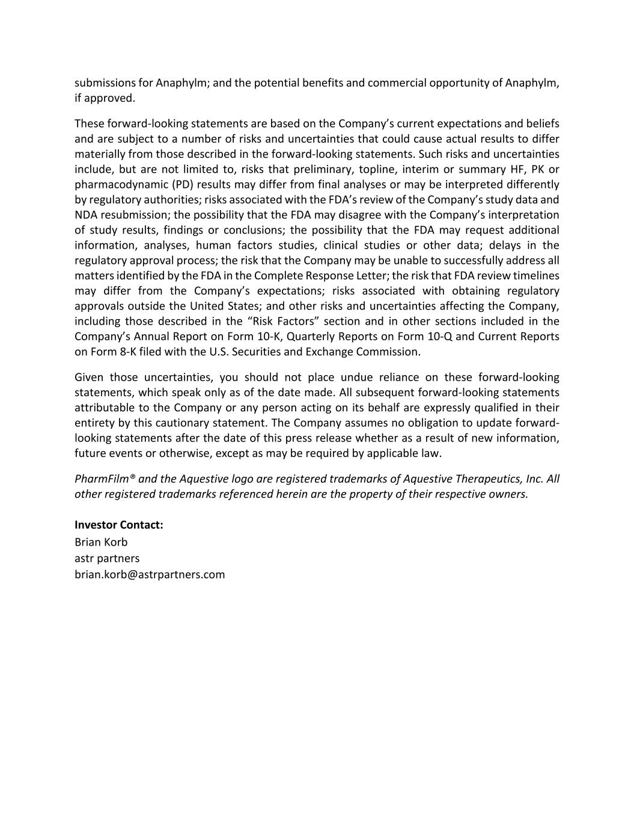
submissions for Anaphylm; and the potential benefits and commercial opportunity of Anaphylm, if approved. These forward-looking statements are based on the Company’s current expectations and beliefs and are subject to a number of risks and uncertainties that could cause actual results to differ materially from those described in the forward-looking statements. Such risks and uncertainties include, but are not limited to, risks that preliminary, topline, interim or summary HF, PK or pharmacodynamic (PD) results may differ from final analyses or may be interpreted differently by regulatory authorities; risks associated with the FDA’s review of the Company’s study data and NDA resubmission; the possibility that the FDA may disagree with the Company’s interpretation of study results, findings or conclusions; the possibility that the FDA may request additional information, analyses, human factors studies, clinical studies or other data; delays in the regulatory approval process; the risk that the Company may be unable to successfully address all matters identified by the FDA in the Complete Response Letter; the risk that FDA review timelines may differ from the Company’s expectations; risks associated with obtaining regulatory approvals outside the United States; and other risks and uncertainties affecting the Company, including those described in the “Risk Factors” section and in other sections included in the Company’s Annual Report on Form 10-K, Quarterly Reports on Form 10-Q and Current Reports on Form 8-K filed with the U.S. Securities and Exchange Commission. Given those uncertainties, you should not place undue reliance on these forward-looking statements, which speak only as of the date made. All subsequent forward-looking statements attributable to the Company or any person acting on its behalf are expressly qualified in their entirety by this cautionary statement. The Company assumes no obligation to update forward- looking statements after the date of this press release whether as a result of new information, future events or otherwise, except as may be required by applicable law. PharmFilm® and the Aquestive logo are registered trademarks of Aquestive Therapeutics, Inc. All other registered trademarks referenced herein are the property of their respective owners. Investor Contact: Brian Korb astr partners brian.korb@astrpartners.com

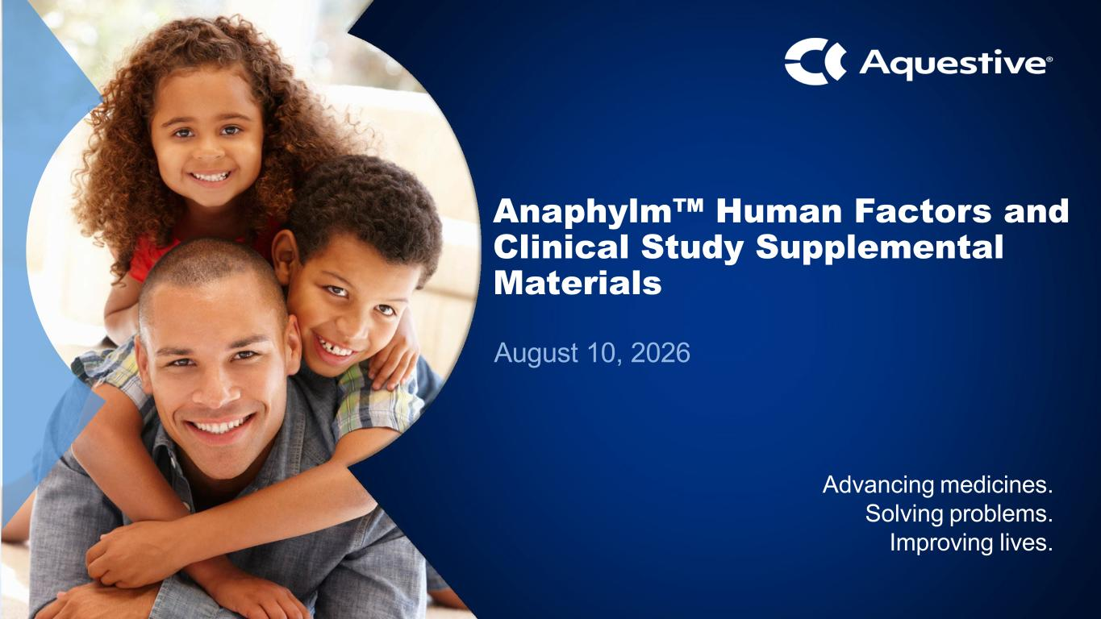
1 September 2024 Advancing medicines. Solving problems Advancing medicines. Solving problems. Improving lives. Anaphylm Human Factors and Clinical Study Supplemental Materials August 10, 2026

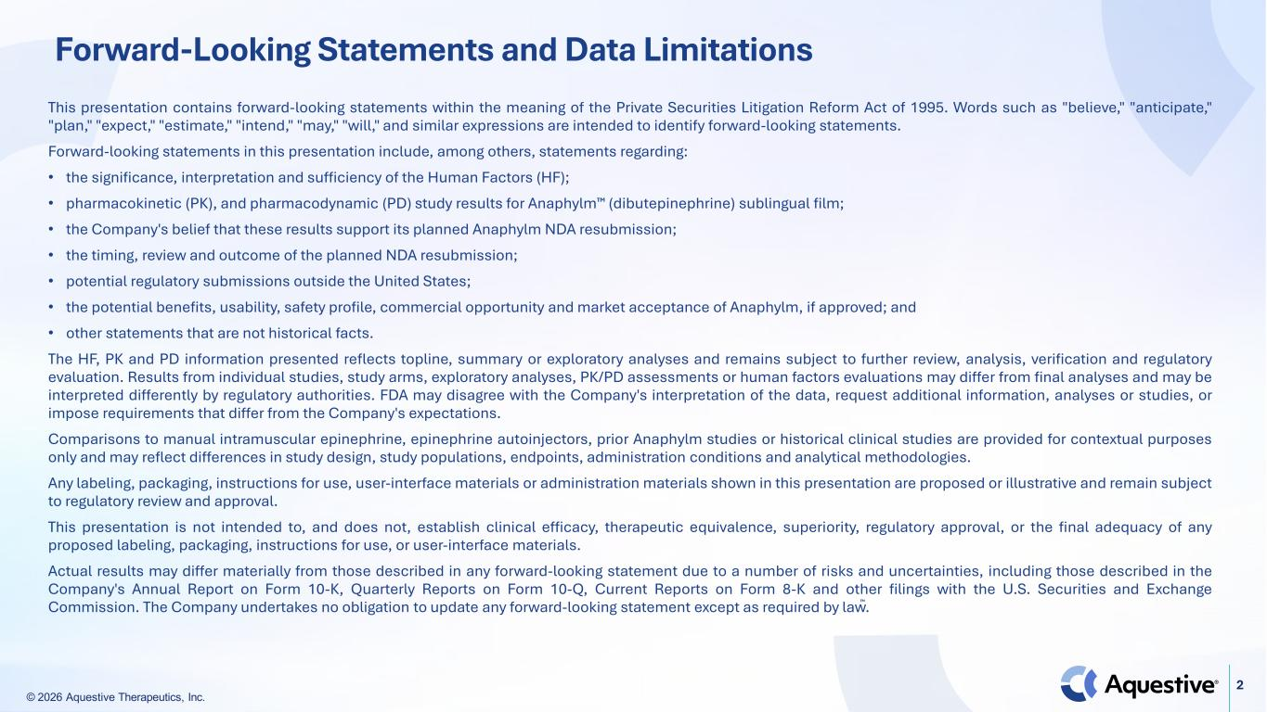
© 2026 Aquestive Therapeutics, Inc. 2 Forward-Looking Statements and Data Limitations This presentation contains forward-looking statements within the meaning of the Private Securities Litigation Reform Act of 1995. Words such as "believe," "anticipate," "plan," "expect," "estimate," "intend," "may," "will," and similar expressions are intended to identify forward-looking statements. Forward-looking statements in this presentation include, among others, statements regarding: • the significance, interpretation and sufficiency of the Human Factors (HF); • pharmacokinetic (PK), and pharmacodynamic (PD) study results for Anaphylm (dibutepinephrine) sublingual film; • the Company's belief that these results support its planned Anaphylm NDA resubmission; • the timing, review and outcome of the planned NDA resubmission; • potential regulatory submissions outside the United States; • the potential benefits, usability, safety profile, commercial opportunity and market acceptance of Anaphylm, if approved; and • other statements that are not historical facts. The HF, PK and PD information presented reflects topline, summary or exploratory analyses and remains subject to further review, analysis, verification and regulatory evaluation. Results from individual studies, study arms, exploratory analyses, PK/PD assessments or human factors evaluations may differ from final analyses and may be interpreted differently by regulatory authorities. FDA may disagree with the Company's interpretation of the data, request additional information, analyses or studies, or impose requirements that differ from the Company's expectations. Comparisons to manual intramuscular epinephrine, epinephrine autoinjectors, prior Anaphylm studies or historical clinical studies are provided for contextual purposes only and may reflect differences in study design, study populations, endpoints, administration conditions and analytical methodologies. Any labeling, packaging, instructions for use, user-interface materials or administration materials shown in this presentation are proposed or illustrative and remain subject to regulatory review and approval. This presentation is not intended to, and does not, establish clinical efficacy, therapeutic equivalence, superiority, regulatory approval, or the final adequacy of any proposed labeling, packaging, instructions for use, or user-interface materials. Actual results may differ materially from those described in any forward-looking statement due to a number of risks and uncertainties, including those described in the Company's Annual Report on Form 10-K, Quarterly Reports on Form 10-Q, Current Reports on Form 8-K and other filings with the U.S. Securities and Exchange Commission. The Company undertakes no obligation to update any forward-looking statement except as required by law.

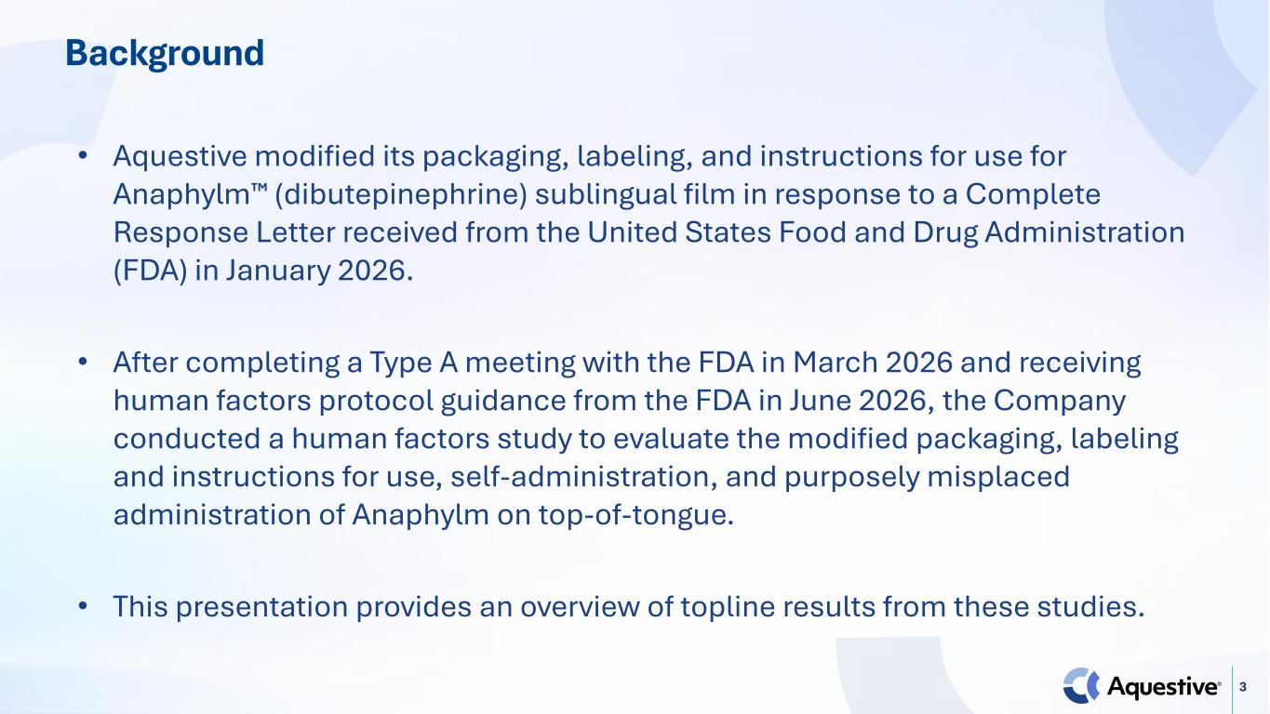
3 Background • Aquestive modified its packaging, labeling, and instructions for use for Anaphylm (dibutepinephrine) sublingual film in response to a Complete Response Letter received from the United States Food and Drug Administration (FDA) in January 2026. • After completing a Type A meeting with the FDA in March 2026 and receiving human factors protocol guidance from the FDA in June 2026, the Company conducted a human factors study to evaluate the modified packaging, labeling and instructions for use, self-administration, and purposely misplaced administration of Anaphylm on top-of-tongue. • This presentation provides an overview of topline results from these studies.

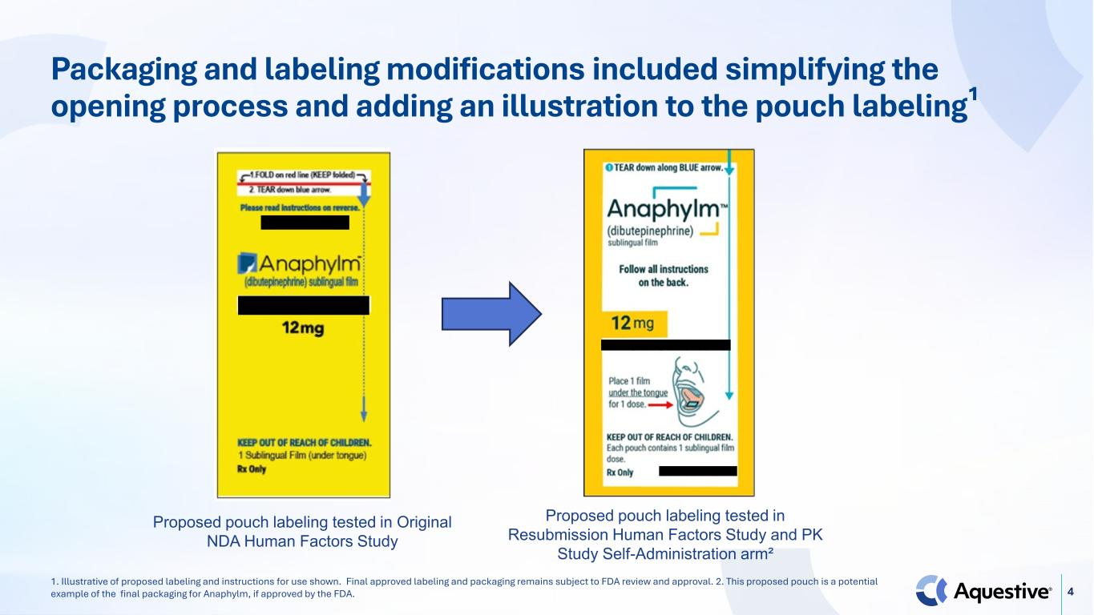
4 Packaging and labeling modifications included simplifying the opening process and adding an illustration to the pouch labeling¹ Proposed pouch labeling tested in Original NDA Human Factors Study Proposed pouch labeling tested in Resubmission Human Factors Study and PK Study Self-Administration arm² 1. Illustrative of proposed labeling and instructions for use shown. Final approved labeling and packaging remains subject to FDA review and approval. 2. This proposed pouch is a potential example of the final packaging for Anaphylm, if approved by the FDA.


Human Factors Results

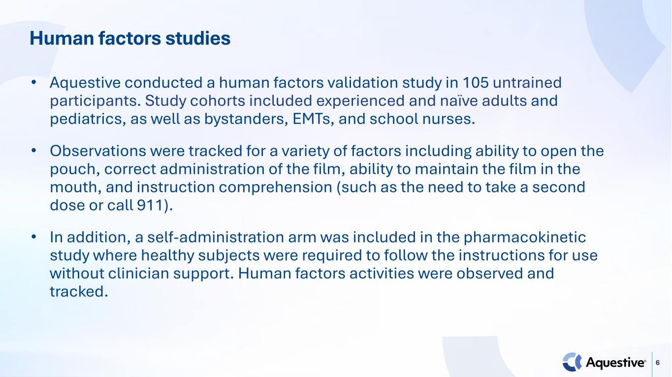
6 Human factors studies • Aquestive conducted a human factors validation study in 105 untrained participants. Study cohorts included experienced and naïve adults and pediatrics, as well as bystanders, EMTs, and school nurses. • Observations were tracked for a variety of factors including ability to open the pouch, correct administration of the film, ability to maintain the film in the mouth, and instruction comprehension (such as the need to take a second dose or call 911). • In addition, a self-administration arm was included in the pharmacokinetic study where healthy subjects were required to follow the instructions for use without clinician support. Human factors activities were observed and tracked.

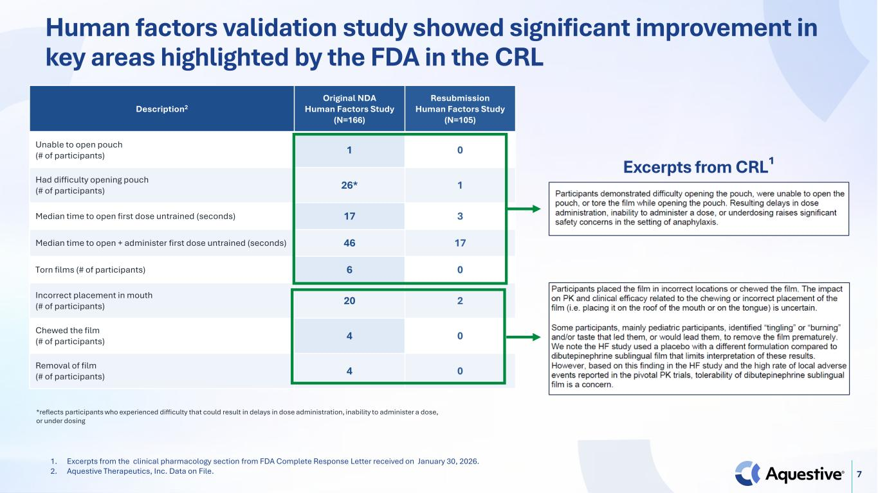
7 Human factors validation study showed significant improvement in key areas highlighted by the FDA in the CRL Description2 Original NDA Human Factors Study (N=166) Resubmission Human Factors Study (N=105) Unable to open pouch (# of participants) 1 0 Had difficulty opening pouch (# of participants) 26* 1 Median time to open first dose untrained (seconds) 17 3 Median time to open + administer first dose untrained (seconds) 46 17 Torn films (# of participants) 6 0 Incorrect placement in mouth (# of participants) 20 2 Chewed the film (# of participants) 4 0 Removal of film (# of participants) 4 0 *reflects participants who experienced difficulty that could result in delays in dose administration, inability to administer a dose, or under dosing 1. Excerpts from the clinical pharmacology section from FDA Complete Response Letter received on January 30, 2026. 2. Aquestive Therapeutics, Inc. Data on File. Excerpts from CRL¹

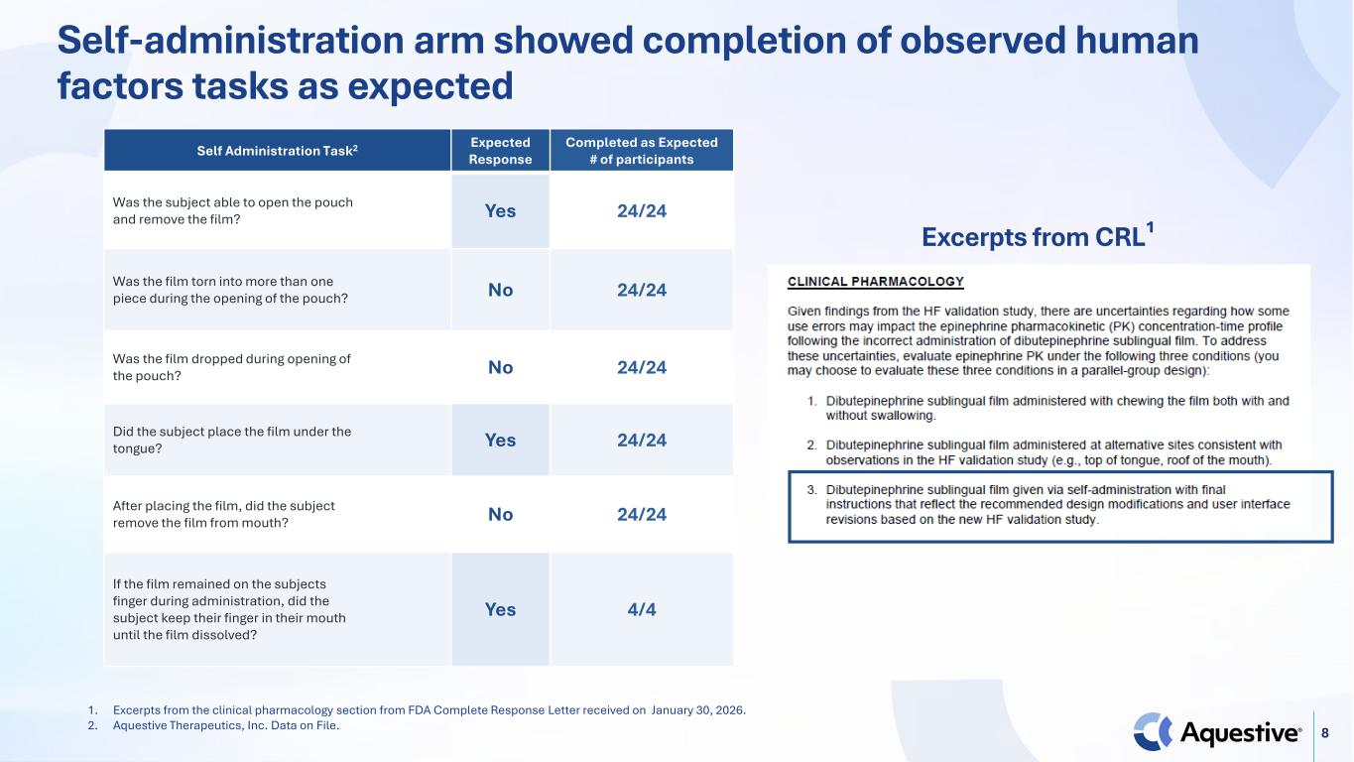
8 Self-administration arm showed completion of observed human factors tasks as expected 1. Excerpts from the clinical pharmacology section from FDA Complete Response Letter received on January 30, 2026. 2. Aquestive Therapeutics, Inc. Data on File. Self Administration Task2 Expected Response Completed as Expected # of participants Was the subject able to open the pouch and remove the film? Yes 24/24 Was the film torn into more than one piece during the opening of the pouch? No 24/24 Was the film dropped during opening of the pouch? No 24/24 Did the subject place the film under the tongue? Yes 24/24 After placing the film, did the subject remove the film from mouth? No 24/24 If the film remained on the subjects finger during administration, did the subject keep their finger in their mouth until the film dissolved? Yes 4/4 Excerpts from CRL¹


Topline Clinical Study Results

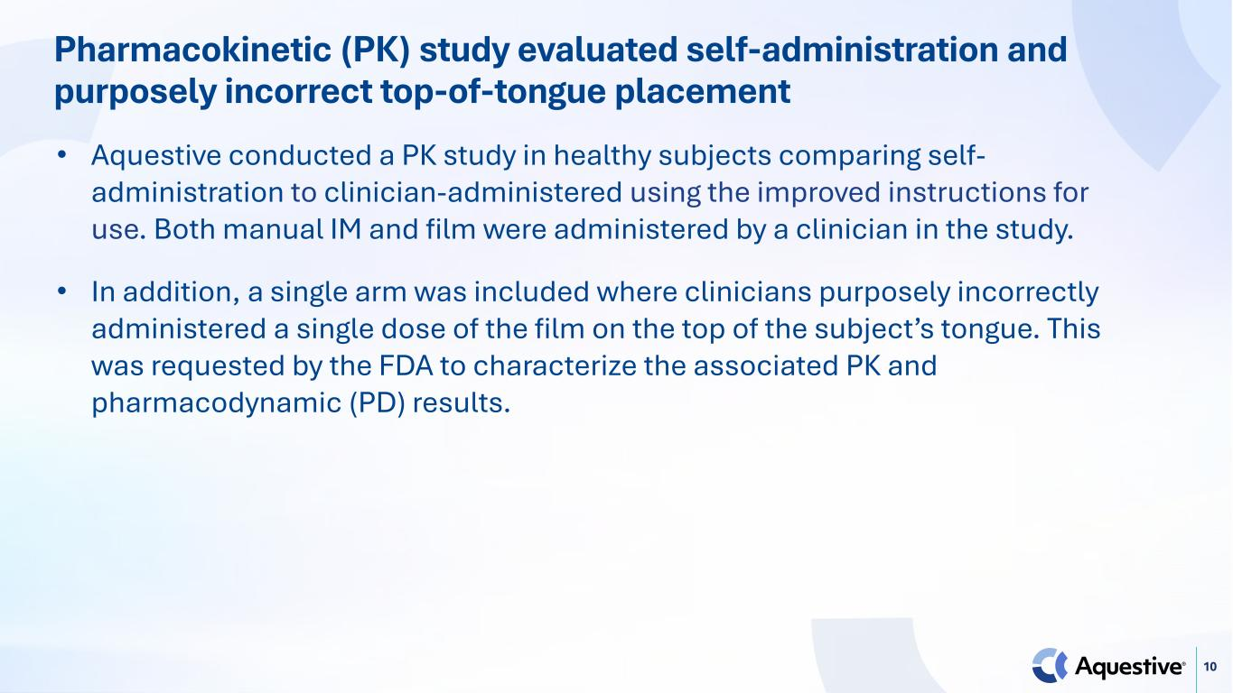
10 Pharmacokinetic (PK) study evaluated self-administration and purposely incorrect top-of-tongue placement • Aquestive conducted a PK study in healthy subjects comparing self- administration to clinician-administered using the improved instructions for use. Both manual IM and film were administered by a clinician in the study. • In addition, a single arm was included where clinicians purposely incorrectly administered a single dose of the film on the top of the subject’s tongue. This was requested by the FDA to characterize the associated PK and pharmacodynamic (PD) results.

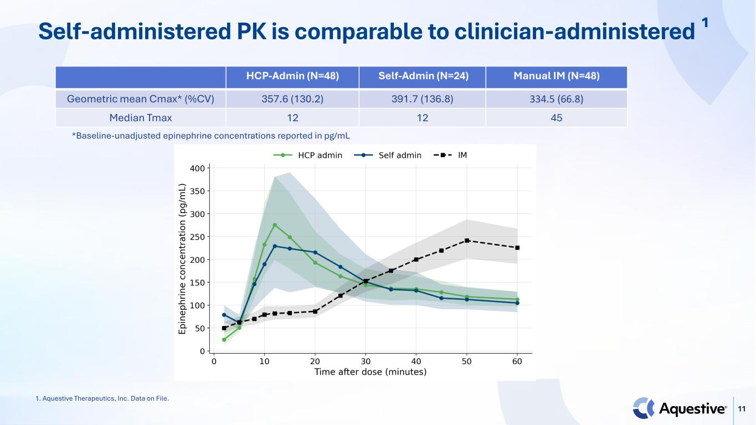
11 Self-administered PK is comparable to clinician-administered ¹ HCP-Admin (N=48) Self-Admin (N=24) Manual IM (N=48) Geometric mean Cmax* (%CV) 357.6 (130.2) 391.7 (136.8) 334.5 (66.8) Median Tmax 12 12 45 *Baseline-unadjusted epinephrine concentrations reported in pg/mL 1. Aquestive Therapeutics, Inc. Data on File.

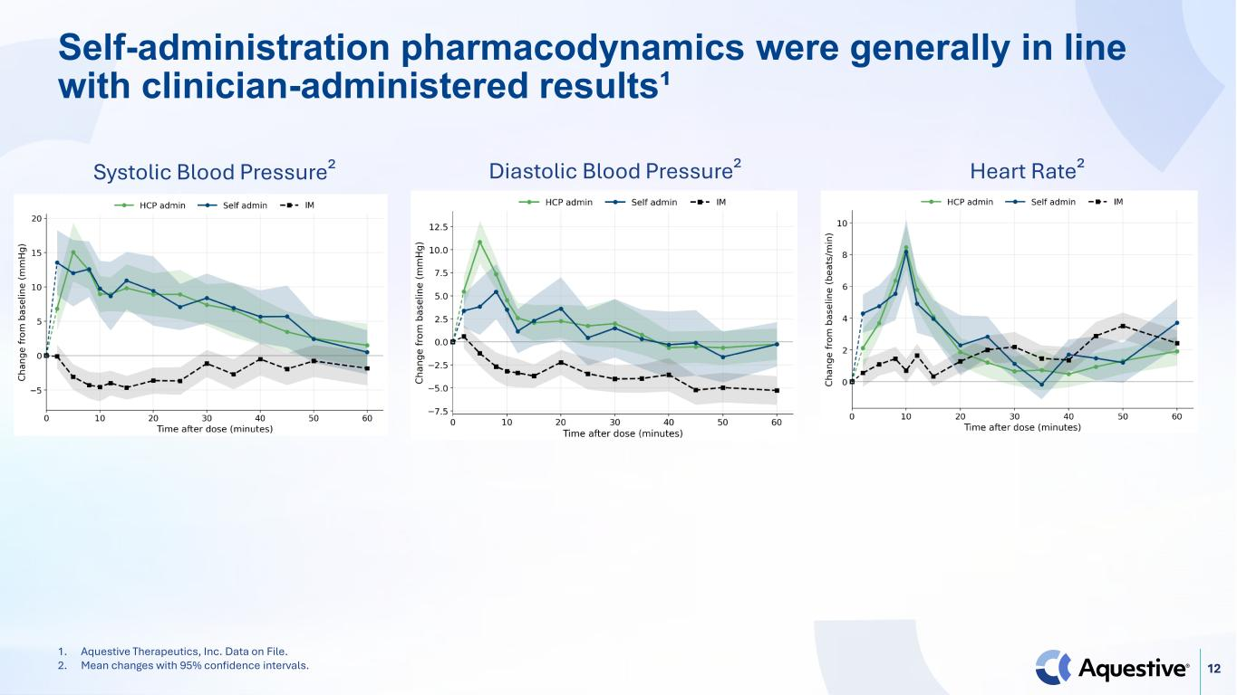
12 Self-administration pharmacodynamics were generally in line with clinician-administered results¹ Systolic Blood Pressure² Diastolic Blood Pressure² Heart Rate² 1. Aquestive Therapeutics, Inc. Data on File. 2. Mean changes with 95% confidence intervals.

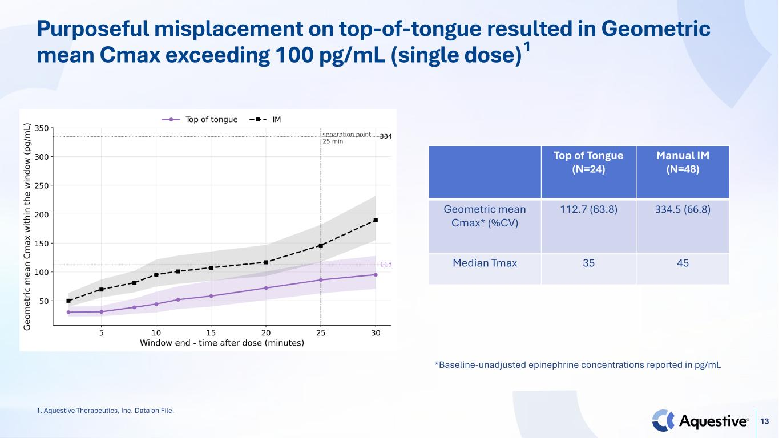
13 Purposeful misplacement on top-of-tongue resulted in Geometric mean Cmax exceeding 100 pg/mL (single dose)¹ Top of Tongue (N=24) Manual IM (N=48) Geometric mean Cmax* (%CV) 112.7 (63.8) 334.5 (66.8) Median Tmax 35 45 *Baseline-unadjusted epinephrine concentrations reported in pg/mL 1. Aquestive Therapeutics, Inc. Data on File.

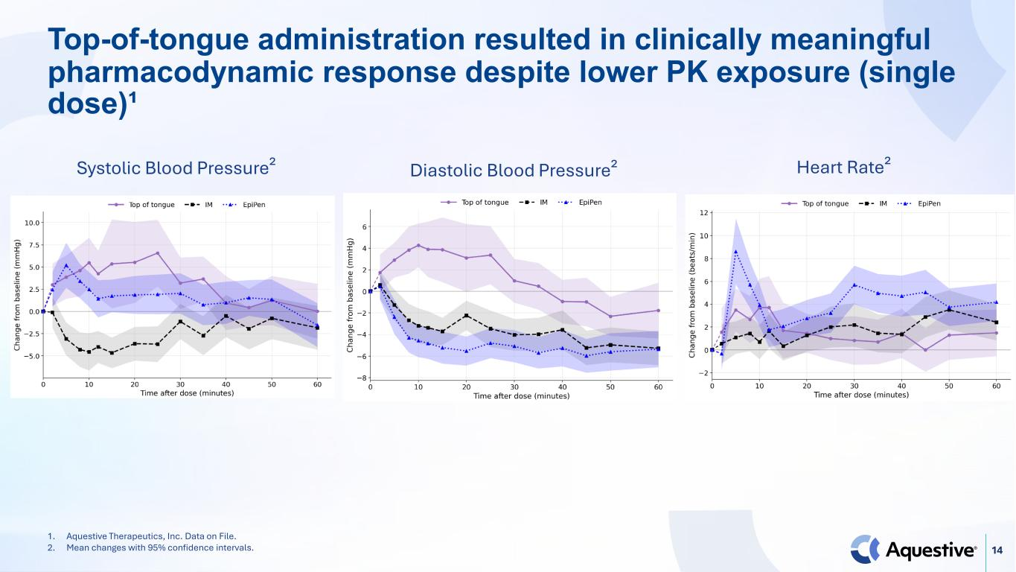
14 Top-of-tongue administration resulted in clinically meaningful pharmacodynamic response despite lower PK exposure (single dose)¹ Systolic Blood Pressure² Diastolic Blood Pressure² Heart Rate² 1. Aquestive Therapeutics, Inc. Data on File. 2. Mean changes with 95% confidence intervals.

