UNITED STATES
SECURITIES AND EXCHANGE COMMISSION
Washington, DC 20549

FORM 8-K

CURRENT REPORT

PURSUANT TO SECTION 13 OR 15(d) OF THE
SECURITIES EXCHANGE ACT OF 1934

Date of Report (Date of earliest event reported): September 29, 2026
Aquestive Therapeutics, Inc.
(Exact name of Registrant as specified in its charter)
Delaware |  |  | 001-38599 |  |  | 82-3827296
(State or other jurisdiction of incorporation) |  |  | (Commission File Number) |  |  | (I.R.S. Employer Identification No.)

30 Technology Drive
Warren, NJ 07059
(908) 941-1900
(Address, Including Zip Code, and Telephone Number, Including Area Code, of Registrant’s Principal Executive Offices)

Not Applicable
(Former name or former address, if changed since last report)

________________________________________________________________________________________________________________________
Check the appropriate box below if the Form 8-K filing is intended to simultaneously satisfy the filing obligation of the registrant under any of the following provisions:
☐ |  |  | Written communications pursuant to Rule 425 under the Securities Act (17 CFR 230.425)
☐ |  |  | Soliciting material pursuant to Rule 14a-12 under the Exchange Act (17 CFR 240.14a-12)
☐ |  |  | Pre-commencement communications pursuant to Rule 14d-2(b) under the Exchange Act (17 CFR 240.14d-2(b))
☐ |  |  | Pre-commencement communications pursuant to Rule 13e-4(c) under the Exchange Act (17 CFR 240.13e-4(c))

Securities registered pursuant to Section 12(b) of the Act:

Title of each class |  |  | Trading Symbol(s) |  |  | Name of each exchange on which  registered
Common Stock, par value $0.001 per share |  |  | AQST |  |  | Nasdaq Global Market

Indicate by check mark whether the registrant is an emerging growth company as defined in Rule 405 of the Securities Act of 1933 (§230.405 of this chapter) or Rule 12b-2 of the Securities Exchange Act of 1934 (§240.12b-2 of this chapter).
Emerging growth company |  |  | ☐
If an emerging growth company, indicate by check mark if the registrant has elected not to use the extended transition period for complying with any new or revised financial accounting standards provided pursuant to Section 13(a) of the Exchange Act. ☐

Item 5.02 |  |  | Departure of Directors or Certain Officers; Election of Directors; Appointment of Certain Officers; Compensatory Arrangements of Certain Officers.
On September 29, 2026, Aquestive Therapeutics, Inc. (the “Company”) announced that the Board of Directors of the Company (the “Board”) has elected Richard J. Daly as a director of the Company, effective October 14, 2026.
Mr. Daly will serve as a Class I director with a term expiring at the Company’s 2028 Annual Meeting of Stockholders and until his successor is duly elected and qualified, or until his earlier death, resignation or removal. The Company announced Mr. Daly’s election in a press release dated September 29, 2026. A copy of the press release is filed as Exhibit 99.1 to this Current Report on Form 8-K and is incorporated herein by reference.
Mr. Daly was recommended to the Board for election by the Nominating and Corporate Governance Committee of the Board (the “Nominating Committee”) after the Nominating Committee considered all candidates, including their backgrounds, relevant experience and professional and personal reputations. The Nominating Committee conducted a formal search for director candidates with the assistance of an independent global executive search firm and considered recommendations from members of the Board and management of the Company.
The Board has affirmatively determined that Mr. Daly has no material relationship with the Company that would affect his independence and that he qualifies as an “independent director” under the applicable listing rules of The Nasdaq Stock Market LLC.
Mr. Daly will participate in the Company’s non-employee director compensation program, a description of which is set forth in the Company’s definitive proxy statement for its 2026 Annual Meeting of Stockholders, filed with the Securities and Exchange Commission on April 24, 2026, under the caption “Non-Employee Director Compensation,” and is incorporated herein by reference.
In accordance with the Company’s non-employee director compensation program and Equity Grant Policy, Mr. Daly will be granted an initial award of 57,000 stock options to purchase shares of the Company’s common stock, par value $0.001 per share (the “Common Stock”), under the Company’s 2018 Equity Incentive Plan, as amended. The stock options will be granted effective as of the second full trading day following the Company’s next public release of quarterly or annual earnings (the “Grant Date”), will have an exercise price equal to the closing market price of the Common Stock on The Nasdaq Global Market on the Grant Date, will vest in annual one-third increments commencing on the first anniversary of the Grant Date and will otherwise have the terms set forth in the stock option agreement between the Company and Mr. Daly evidencing the award.
The selection of Mr. Daly to serve as a member of the Board was not made pursuant to any arrangements or understandings between Mr. Daly and any other person pursuant to which he was selected as a director. There are no family relationships between Mr. Daly and any director or executive officer of the Company, and Mr. Daly has no direct or indirect material interest in any transaction or currently proposed transaction that would be required to be disclosed under Item 404(a) of Regulation S-K.
In connection with Mr. Daly’s election, the Board approved an increase in the number of directorships of the Board from seven to eight, effective October 14, 2026. Following Mr. Daly’s election, the Board will consist of eight directors, seven of whom are independent directors.

Item 9.01 |  |  | Financial Statements and Exhibits.

(d) Exhibits.

Exhibit Number |  |  |  |  |  | Description
99.1 |  |  |  |  |  | Aquestive Therapeutics, Inc. Press Release, dated September 29, 2026
104 |  |  |  |  |  | Cover Page Interaction Data File (embedded within the Inline XBRL document)

SIGNATURE

Pursuant to the requirements of the Securities Exchange Act of 1934, as amended, the Registrant has duly caused this report to be signed on its behalf by the undersigned hereunto duly authorized.

Dated: September 29, 2026 |  |  | Aquestive Therapeutics, Inc.
 |  |  | By: |  |  | /s/ A. Ernest Toth, Jr
 |  |  |  |  |  | Name: A. Ernest Toth, Jr.
 |  |  |  |  |  | Title: Chief Financial Officer

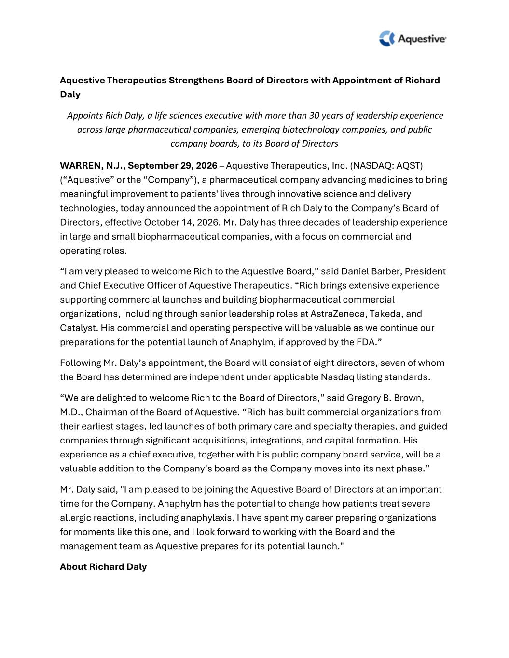

Aquestive Therapeutics Strengthens Board of Directors with Appointment of Richard Daly Appoints Rich Daly, a life sciences executive with more than 30 years of leadership experience across large pharmaceutical companies, emerging biotechnology companies, and public company boards, to its Board of Directors WARREN, N.J., September 29, 2026 – Aquestive Therapeutics, Inc. (NASDAQ: AQST) (“Aquestive” or the “Company”), a pharmaceutical company advancing medicines to bring meaningful improvement to patients' lives through innovative science and delivery technologies, today announced the appointment of Rich Daly to the Company’s Board of Directors, effective October 14, 2026. Mr. Daly has three decades of leadership experience in large and small biopharmaceutical companies, with a focus on commercial and operating roles. “I am very pleased to welcome Rich to the Aquestive Board,” said Daniel Barber, President and Chief Executive Officer of Aquestive Therapeutics. “Rich brings extensive experience supporting commercial launches and building biopharmaceutical commercial organizations, including through senior leadership roles at AstraZeneca, Takeda, and Catalyst. His commercial and operating perspective will be valuable as we continue our preparations for the potential launch of Anaphylm, if approved by the FDA.” Following Mr. Daly’s appointment, the Board will consist of eight directors, seven of whom the Board has determined are independent under applicable Nasdaq listing standards. “We are delighted to welcome Rich to the Board of Directors,” said Gregory B. Brown, M.D., Chairman of the Board of Aquestive. “Rich has built commercial organizations from their earliest stages, led launches of both primary care and specialty therapies, and guided companies through significant acquisitions, integrations, and capital formation. His experience as a chief executive, together with his public company board service, will be a valuable addition to the Company’s board as the Company moves into its next phase.” Mr. Daly said, "I am pleased to be joining the Aquestive Board of Directors at an important time for the Company. Anaphylm has the potential to change how patients treat severe allergic reactions, including anaphylaxis. I have spent my career preparing organizations for moments like this one, and I look forward to working with the Board and the management team as Aquestive prepares for its potential launch." About Richard Daly

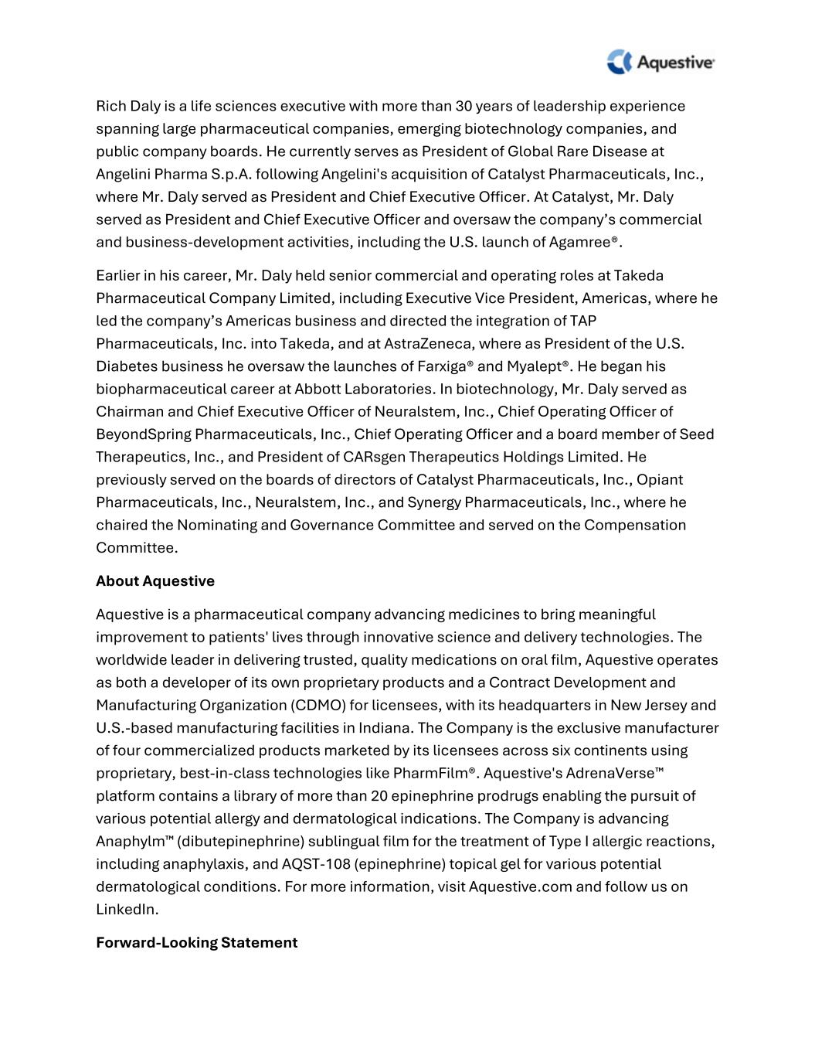
Rich Daly is a life sciences executive with more than 30 years of leadership experience spanning large pharmaceutical companies, emerging biotechnology companies, and public company boards. He currently serves as President of Global Rare Disease at Angelini Pharma S.p.A. following Angelini's acquisition of Catalyst Pharmaceuticals, Inc., where Mr. Daly served as President and Chief Executive Officer. At Catalyst, Mr. Daly served as President and Chief Executive Officer and oversaw the company’s commercial and business-development activities, including the U.S. launch of Agamree®. Earlier in his career, Mr. Daly held senior commercial and operating roles at Takeda Pharmaceutical Company Limited, including Executive Vice President, Americas, where he led the company’s Americas business and directed the integration of TAP Pharmaceuticals, Inc. into Takeda, and at AstraZeneca, where as President of the U.S. Diabetes business he oversaw the launches of Farxiga® and Myalept®. He began his biopharmaceutical career at Abbott Laboratories. In biotechnology, Mr. Daly served as Chairman and Chief Executive Officer of Neuralstem, Inc., Chief Operating Officer of BeyondSpring Pharmaceuticals, Inc., Chief Operating Officer and a board member of Seed Therapeutics, Inc., and President of CARsgen Therapeutics Holdings Limited. He previously served on the boards of directors of Catalyst Pharmaceuticals, Inc., Opiant Pharmaceuticals, Inc., Neuralstem, Inc., and Synergy Pharmaceuticals, Inc., where he chaired the Nominating and Governance Committee and served on the Compensation Committee. About Aquestive Aquestive is a pharmaceutical company advancing medicines to bring meaningful improvement to patients' lives through innovative science and delivery technologies. The worldwide leader in delivering trusted, quality medications on oral film, Aquestive operates as both a developer of its own proprietary products and a Contract Development and Manufacturing Organization (CDMO) for licensees, with its headquarters in New Jersey and U.S.-based manufacturing facilities in Indiana. The Company is the exclusive manufacturer of four commercialized products marketed by its licensees across six continents using proprietary, best-in-class technologies like PharmFilm®. Aquestive's AdrenaVerse™ platform contains a library of more than 20 epinephrine prodrugs enabling the pursuit of various potential allergy and dermatological indications. The Company is advancing Anaphylm™ (dibutepinephrine) sublingual film for the treatment of Type I allergic reactions, including anaphylaxis, and AQST-108 (epinephrine) topical gel for various potential dermatological conditions. For more information, visit Aquestive.com and follow us on LinkedIn. Forward-Looking Statement

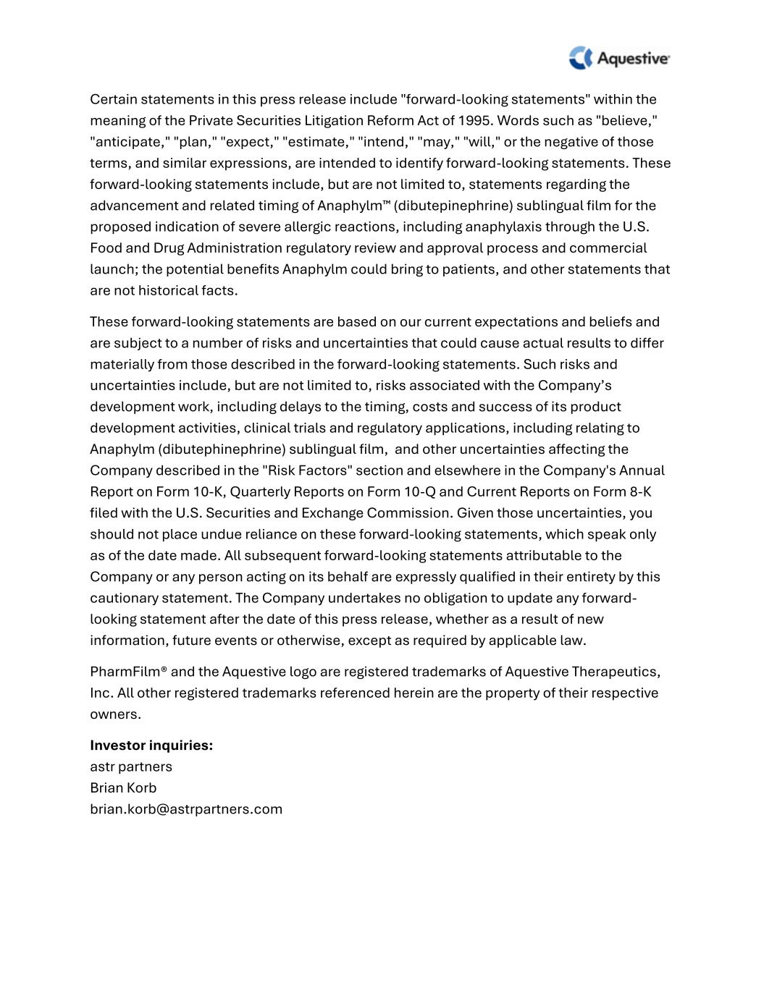
Certain statements in this press release include "forward-looking statements" within the meaning of the Private Securities Litigation Reform Act of 1995. Words such as "believe," "anticipate," "plan," "expect," "estimate," "intend," "may," "will," or the negative of those terms, and similar expressions, are intended to identify forward-looking statements. These forward-looking statements include, but are not limited to, statements regarding the advancement and related timing of Anaphylm™ (dibutepinephrine) sublingual film for the proposed indication of severe allergic reactions, including anaphylaxis through the U.S. Food and Drug Administration regulatory review and approval process and commercial launch; the potential benefits Anaphylm could bring to patients, and other statements that are not historical facts. These forward-looking statements are based on our current expectations and beliefs and are subject to a number of risks and uncertainties that could cause actual results to differ materially from those described in the forward-looking statements. Such risks and uncertainties include, but are not limited to, risks associated with the Company’s development work, including delays to the timing, costs and success of its product development activities, clinical trials and regulatory applications, including relating to Anaphylm (dibutephinephrine) sublingual film, and other uncertainties affecting the Company described in the "Risk Factors" section and elsewhere in the Company's Annual Report on Form 10-K, Quarterly Reports on Form 10-Q and Current Reports on Form 8-K filed with the U.S. Securities and Exchange Commission. Given those uncertainties, you should not place undue reliance on these forward-looking statements, which speak only as of the date made. All subsequent forward-looking statements attributable to the Company or any person acting on its behalf are expressly qualified in their entirety by this cautionary statement. The Company undertakes no obligation to update any forward- looking statement after the date of this press release, whether as a result of new information, future events or otherwise, except as required by applicable law. PharmFilm® and the Aquestive logo are registered trademarks of Aquestive Therapeutics, Inc. All other registered trademarks referenced herein are the property of their respective owners. Investor inquiries: astr partners Brian Korb brian.korb@astrpartners.com

