UNITED STATES

SECURITIES AND EXCHANGE COMMISSION

Washington, D.C. 20549

FORM 10-Q

- QUARTERLY REPORT PURSUANT TO SECTION 13 OR 15(d) OF THE SECURITIES EXCHANGE ACT OF 1934

For the quarterly period ended September 30, 2024

OR

- TRANSITION REPORT PURSUANT TO SECTION 13 OR 15(d) OF THE SECURITIES EXCHANGE ACT OF 1934

For the transition period from _____ to _____

Commission File Number: 001-38599

Aquestive Therapeutics, Inc.

(Exact Name of Registrant as Specified in its Charter)

Delaware | 30 Technology Drive, Warren, NJ 07059 |  |  | 82-3827296
(State or other jurisdiction of Incorporation or | ( 908) 941-1900 |  |  | (I.R.S. Employer Identification Number)
organization)
(Address, Zip Code and Telephone Number of Registrant’s Principal Executive Offices)
 | Securities registered pursuant to Section 12(b) of the Act:
Title of each class |  | Trading Symbol(s) |  | Name of each exchange on which registered
Common Stock, par value $0.001 per share |  | AQST |  | NASDAQ Global Market

Securities registered pursuant to Section 12(g) of the Act: None

Indicate by check mark whether the registrant: (1) has filed all reports required to be filed by Section 13 or 15(d) of the Securities Exchange Act of 1934 during the preceding 12 months (or for such shorter period that the registrant was required to file such reports), and (2) has been subject to such filing requirements for the past 90 days. ☒ Yes ☐ No

Indicate by check mark whether the registrant has submitted electronically every Interactive Data File required to be submitted pursuant to Rule 405 of Regulation S-T (§232.405 of this chapter) during the preceding 12 months (or for such shorter period that the registrant was required to submit such files). ☒ Yes ☐ No

Indicate by check mark whether the registrant is a large accelerated filer, an accelerated filer, a non-accelerated filer, a smaller reporting company or an emerging growth company. See the definitions of “large accelerated filer,” “accelerated filer”, “smaller reporting company” and “emerging growth company” in Rule 12b-2 of the Securities Exchange Act of 1934.

Large accelerated filer | ☐ | Accelerated filer | ☐
Non-accelerated filer | ☒ | Smaller reporting company | ☒
 |  | Emerging growth company | ☐

If an emerging growth company, indicate by check mark if the registrant has elected not to use the extended transition period for complying with any new or revised financial accounting standards provided pursuant to Section 13(a) of the Exchange Act. ☐

Indicate by check mark whether the registrant is a shell company (as defined in Rule 12b-2 of the Exchange Act). ☐ Yes ☒ No

The number of outstanding shares of the registrant’s common stock, par value of $0.001 per share (the "Common Stock"), as of the close of business on November 1, 2024 was 91,178,193.

Table of Contents
 |  |  |  |  |  |  |  |  |  |  |  | AQUESTIVE THERAPEUTICS, INC.
 |  |  |  |  |  |  |  |  |  |  |  |  |  | FORM 10-Q
 |  |  |  |  |  |  |  |  |  |  |  |  |  | TABLE OF CONTENTS
 |  |  |  |  |  |  |  |  |  |  |  |  |  |  |  |  |  |  |  | Page No.
 | PART I – FINANCIAL INFORMATION
 | Item 1. |  |  | Financial Statements (Unaudited)
 |  |  |  | Condensed Balance Sheets as of September 30, 2024 and December 31, 2023 |  |  |  |  |  |  |  |  |  |  |  |  |  |  |  | 5
 |  |  |  | Condensed Statements of Operations and Comprehensive (Loss) Income for the three and nine months ended September 30, 2024 and 2023 |  |  |  |  |  |  |  |  |  |  |  |  |  |  |  | 6
 |  |  |  | Condensed Statements of Changes in Stockholders’ Deficit for the three and nine months ended September 30, 2024 and 2023 |  |  |  |  |  |  |  |  |  |  |  |  |  |  |  | 7
 |  |  |  | Condensed Statements of Cash Flows for the nine months ended September 30, 2024 and 2023 |  |  |  |  |  |  |  |  |  |  |  |  |  |  |  | 9
 |  |  |  | Notes to Unaudited Condensed Financial Statements |  |  |  |  |  |  |  |  |  |  |  |  |  |  |  | 10
 | Item 2. |  |  | Management’s Discussion and Analysis of Financial Condition and Results of Operations |  |  |  |  |  |  |  |  |  |  |  |  |  |  |  | 32
 | Item 3. |  |  | Quantitative and Qualitative Disclosures about Market Risk |  |  |  |  |  |  |  |  |  |  |  |  |  |  |  | 50
 | Item 4. |  |  | Controls and Procedures |  |  |  |  |  |  |  |  |  |  |  |  |  |  |  | 50
 | PART II – OTHER INFORMATION
 | Item 1. |  |  | Legal Proceedings |  |  |  |  |  |  |  |  |  |  |  |  |  |  |  | 51
 | Item 1A. |  |  | Risk Factors |  |  |  |  |  |  |  |  |  |  |  |  |  |  |  | 51
 | Item 2. |  |  | Unregistered Sales of Equity Securities and Use of Proceeds |  |  |  |  |  |  |  |  |  |  |  |  |  |  |  | 51
 | Item 3. |  |  | Defaults Upon Senior Securities |  |  |  |  |  |  |  |  |  |  |  |  |  |  |  | 51
 | Item 4. |  |  | Mine Safety Disclosures |  |  |  |  |  |  |  |  |  |  |  |  |  |  |  | 51
 | Item 5. |  |  | Other Information |  |  |  |  |  |  |  |  |  |  |  |  |  |  |  | 51
 | Item 6. |  |  | Exhibits |  |  |  |  |  |  |  |  |  |  |  |  |  |  |  | 51
 | SIGNATURES |  |  |  |  |  |  |  |  |  |  |  |  |  |  |  |  |  |  | 52
 |  |  |  | 2

Table of Contents

GLOSSARY OF TERMS, ABBREVIATIONS AND ACRONYMS

The following terms, abbreviations and acronyms are used to identify frequently used terms and phrases that may be used in this report (dollar amounts in thousands):

 | TERM | DEFINITION
 | 12.5% Notes | 12.5% Senior Secured Notes due 2025
 | 13.5% Notes | 13.5% Senior Secured Notes
 | ACAAI | American College of Allergy Asthma and Immunology
 | ABL facility | Asset-based borrowing facility
 | ADHD | Attention deficit hyperactivity disorder
 | Adrenaverse™ | Epinephrine prodrug platform currently comprised of Anaphylm™ and AQST-108
 | ALS | Amyotrophic lateral sclerosis
 | ANVISA | Brazilian Health Regulatory Agency
 | API | Active Pharmaceutical Ingredients
 | Aquestive | Aquestive Therapeutics, Inc.
 | AQST | NASDAQ ticker symbol for Aquestive Therapeutics, Inc.
 | ASC | Accounting Standards Codification
 | Assertio | Assertio Holdings, Inc.
 | Assertio Agreement | License Agreement between Aquestive and Otter Pharmaceuticals, LLC, a subsidiary of Assertio Holdings, Inc.
 | ASU | Accounting Standards Updates
 | ATM facility | At-The-Market facility for the purchase of AQST Common Stock, then in effect
 | Base Indenture | Indenture for the 12.5% Notes
 | CMC | Chemistry, Manufacturing, Controls
 | CNS | Central Nervous System
 | Common Stock | Common Stock, par value $0.001 per share, of the Company
 | Common Stock Warrants | Warrants issued with private placement of up to $100,000 aggregate principal of 12.5% Notes originally due 2025
 | Company | Aquestive Therapeutics, Inc.
 | CRO | Contract research organization
 | EMA | European Medicines Agency
 | ESPP | Employee Stock Purchase Plan
 | EU | European Union
 | Exchange Act | Securities Exchange Act of 1934
 | Existing Warrants | Common Stock Purchase Warrants with the holder of the remaining 5,000,000 warrants
 | FASB | Financial Accounting Standards Board
 | FDA | U.S. Food and Drug Administration
 | First Amendment | First amendment to the Sunovion License Agreement
 | Fortovia | Fortovia Therapeutics Inc. (previously Midatech Pharma PLC)
 | GAAP | Generally Accepted Accounting Principles
 | Haisco | Haisco Pharmaceutical Group Co., Ltd.
 | Haisco Agreement | License, Development and Supply Agreement with Haisco, a Chinese limited company listed on the Shenzhen Stock Exchange
 | Hypera | Hypera Pharma
 | Indenture Agreement | Agreement governing the 13.5% Senior Secured Notes
 | Indivior | Indivior Inc. (formerly, Reckitt Benckiser Pharmaceuticals Inc)
 | Indivior Amendment 11 | Amendment No. 11 to the Indivior License Agreement
 | Indivior License Agreement | Commercial Exploitation Agreement with Reckitt Benckiser Pharmaceuticals, Inc. (with subsequent amendments collectively)
 | Lincoln Park | Lincoln Park Capital Fund, LLC

Table of Contents
 | Lincoln Park Purchase Agreement |  | Purchase Agreement with Lincoln Park Capital Fund, LLC
 | Marathon |  | Marathon Asset Management
 | Monetization Agreement |  | Purchase and Sale Agreement between Aquestive and Sunovion
 | MSSP |  | Managed Security Services Provider
 | MTPA or Mitsubishi |  | Mitsubishi Tanabe Pharma America, Inc. (formerly, Mitsubishi Tanabe Pharma Holdings America, Inc.)
 | N/M |  | Not Meaningful, used in percentage changes
 | NASDAQ |  | The NASDAQ Stock Market
 | NDA |  | New Drug Application
 | New Warrants |  | Warrants to purchase 2,750,000 shares of Common Stock
 | Offering |  | $45,000 aggregate principal amount of 13.5% Notes due November 1, 2028.
 | PD |  | Pharmacodynamics
 | Pharmanovia |  | Atnahs Pharma UK Limited, a company registered in England and Wales
 | Pharmanovia Agreement |  | License and Supply Agreement with Atnahs Pharma UK Limited,
 | Pharmanovia Amendment |  | Amended License and Supply Agreement with Atnahs Pharma UK Limited as of March 27, 2023
 | PK |  | Pharmacokinetic
 | PTO |  | United States Patent and Trademark Office
 | PDUFA |  | Prescription Drug User Fee Act
 | Pre-IND |  | Pre-Investigational New Drug
 | Royalty Obligations |  | Liability related to the Royalty Rights Agreements
 | Royalty Rights Agreements |  | Royalty Rights Agreements, component of 13.5% Senior Secured Notes
 | RSU |  | Restricted Stock Unit
 | SEC |  | Securities and Exchange Commission
 | Securities Purchase Agreements |  | Securities Purchase Agreements with certain purchasers entered into on June 6, 2022
 | Separation Agreement |  | Separation Agreement, including a Consulting Agreement with Keith J. Kendall
 | Sunovion |  | Sunovion Pharmaceuticals Inc
 | Sunovion License Agreement |  | KYNMOBI Commercialization Agreement
 | Territory |  | Certain countries of the European Union, the United Kingdom, Switzerland, Norway and the Middle East and North Africa under the
 |  |  | Pharmanovia Agreement
 | TEVA |  | Teva Pharmaceuticals USA, Inc.
 | TGA |  | Australian Government Department of Health’s Therapeutics Goods Administration
 | Underwritten Public Offering |  | Capital raise of gross proceeds of $77,519, including partial exercise of the underwriters' option for $2,519
 | Zambon |  | Zambon S.p.A.
 | Zevra |  | Zevra Therapeutics, Inc. (formerly KemPharm, Inc.)

Table of Contents
PART I – FINANCIAL INFORMATION
Item 1. FINANCIAL STATEMENTS (Unaudited)
 |  | AQUESTIVE THERAPEUTICS, INC.
 |  | Condensed Balance Sheets
 |  | (In thousands, except share and per share amounts)
 |  | (Unaudited)
 |  |  |  | September 30, |  |  | December 31,
 |  |  |  | 2024 |  |  | 2023
 | Assets
 | Current assets:
 | Cash and cash equivalents |  | $ | 77,893 |  | $ | 23,872
 | Trade and other receivables, net |  |  | 9,684 |  |  | 8,471
 | Inventories |  |  | 7,021 |  |  | 6,769
 | Prepaid expenses and other current assets |  |  | 1,972 |  |  | 1,854
 | Total current assets |  |  | 96,570 |  |  | 40,966
 | Property and equipment, net |  |  | 3,848 |  |  | 4,179
 | Right-of-use assets, net |  |  | 5,310 |  |  | 5,557
 | Intangible assets, net |  |  | — |  |  | 1,278
 | Other non-current assets |  |  | 4,230 |  |  | 5,438
 | Total assets |  | $ | 109,958 |  | $ | 57,418
 | Liabilities and stockholders’ deficit
 | Current liabilities:
 | Accounts payable |  | $ | 7,572 |  | $ | 8,926
 | Accrued expenses |  |  | 5,025 |  |  | 6,497
 | Lease liabilities, current |  |  | 482 |  |  | 390
 | Deferred revenue, current |  |  | 1,048 |  |  | 1,551
 | Liability related to the sale of future revenue, current |  |  | 1,000 |  |  | 922
 | Loans payable, current |  |  | 25 |  |  | 22
 | Total current liabilities |  |  | 15,152 |  |  | 18,308
 | Notes payable, net |  |  | 31,253 |  |  | 27,508
 | Royalty obligations, net |  |  | 18,835 |  |  | 14,761
 | Liability related to the sale of future revenue, net |  |  | 62,730 |  |  | 63,568
 | Lease liabilities |  |  | 5,109 |  |  | 5,399
 | Deferred revenue, net of current portion |  |  | 20,266 |  |  | 32,345
 | Other non-current liabilities |  |  | 2,033 |  |  | 2,016
 | Total liabilities |  |  | 155,378 |  |  | 163,905
 | Contingencies (Note 19)
 | Stockholders’ deficit:
 | Common stock, $0.001 par value. Authorized 250,000,000 shares; 91,178,193 and 68,533,085 shares issued and outstanding at
 | September 30, 2024 and December 31, 2023, respectively |  |  | 91 |  |  | 69
 | Additional paid-in capital |  |  | 300,648 |  |  | 212,521
 | Accumulated deficit |  |  | (346,159) |  |  | (319,077)
 | Total stockholders’ deficit |  |  | (45,420) |  |  | (106,487)
 | Total liabilities and stockholders’ deficit |  | $ | 109,958 |  | $ | 57,418

See accompanying notes to the condensed financial statements.

5

Table of Contents

AQUESTIVE THERAPEUTICS, INC.

Condensed Statements of Operations and Comprehensive (Loss) Income

(In thousands, except share and per share data amounts)

(Unaudited)

 |  | Three Months Ended September 30, |  |  |  |  |  | Nine Months Ended
 |  |  |  |  |  |  |  | September 30,
 |  | 2024 |  |  | 2023 |  |  | 2024 |  |  | 2023
Revenues | $ | 13,542 |  | $ | 13,002 |  | $ | 45,694 |  | $ | 37,377
Costs and expenses:
Manufacture and supply |  | 4,437 |  |  | 4,798 |  |  | 13,352 |  |  | 16,152
Research and development |  | 5,269 |  |  | 3,196 |  |  | 15,363 |  |  | 10,216
Selling, general and administrative |  | 12,126 |  |  | 7,385 |  |  | 34,171 |  |  | 22,200
Total costs and expenses |  | 21,832 |  |  | 15,379 |  |  | 62,886 |  |  | 48,568
Loss from operations |  | (8,290) |  |  | (2,377) |  |  | (17,192) |  |  | (11,191)
Other income/(expenses):
Interest expense |  | (2,780) |  |  | (1,256) |  |  | (8,343) |  |  | (4,064)
Interest expense related to royalty obligations |  | (1,359) |  |  | — |  |  | (4,075) |  |  | —
Interest expense related to the sale of future revenue |  | (59) |  |  | (56) |  |  | (175) |  |  | (163)
Interest income and other income, net |  | 979 |  |  | 1,514 |  |  | 2,703 |  |  | 16,156
Loss on extinguishment of debt |  | — |  |  | — |  |  | — |  |  | (353)
Net (loss) income before income taxes |  | (11,509) |  |  | (2,175) |  |  | (27,082) |  |  | 385
Income taxes (benefit) expense |  | — |  |  | (140) |  |  | — |  |  | 144
Net (loss) income | $ | (11,509) |  | $ | (2,035) |  | $ | (27,082) |  | $ | 241
Comprehensive (loss) income | $ | (11,509) |  | $ | (2,035) |  | $ | (27,082) |  | $ | 241
(Loss) earnings per share attributable to common stockholders:
Basic (in dollars per share) | $ | (0.13) |  | $ | (0.03) |  | $ | (0.32) |  | $ | —
Diluted (in dollars per share) | $ | (0.13) |  | $ | (0.03) |  | $ | (0.32) |  | $ | —
Weighted average common shares outstanding:
Basic (in shares) |  | 91,082,081 |  |  | 64,678,761 |  |  | 85,224,263 |  |  | 59,252,768
Diluted (in shares) |  | 91,082,081 |  |  | 64,678,761 |  |  | 85,224,263 |  |  | 61,513,736

See accompanying notes to the condensed financial statements.

6

Table of Contents

AQUESTIVE THERAPEUTICS, INC.

Condensed Statements of Changes in Stockholders’ Deficit

Three Months Ended March 31, 2024, June 30, 2024 and September 30, 2024

(In thousands, except share amounts)

(Unaudited)

 | Common Stock |  |  |  |  |  | Additional |  |  |  |  |  | Total
 |  |  |  |  |  |  | Paid-in |  |  | Accumulated |  |  | Stockholders’
 | Shares |  |  | Amount |  |  | Capital |  |  | Deficit |  |  | Deficit
Balance at December 31, 2023 | 68,533,085 |  | $ | 69 |  | $ | 212,521 |  | $ | (319,077) |  | $ | (106,487)
Common Stock issued under public equity offering-ATM | 4,557,220 |  |  | 4 |  |  | 12,381 |  |  | — |  |  | 12,385
Costs of common stock issued under public equity offering-ATM | — |  |  | — |  |  | (410) |  |  | — |  |  | (410)
Common Stock issued under public equity offering | 16,666,667 |  |  | 17 |  |  | 74,983 |  |  | — |  |  | 75,000
Costs of common stock issued under public equity offering | — |  |  | — |  |  | (5,187) |  |  | — |  |  | (5,187)
Share-based compensation expense | — |  |  | — |  |  | 1,580 |  |  | — |  |  | 1,580
Vested restricted stock units, net | 490,359 |  |  | — |  |  | (893) |  |  | — |  |  | (893)
Options exercised, net | 231,400 |  |  | — |  |  | 539 |  |  | — |  |  | 539
Net loss | — |  |  | — |  |  | — |  |  | (12,828) |  |  | (12,828)
Balance at March 31, 2024 | 90,478,731 |  | $ | 90 |  | $ | 295,514 |  | $ | (331,905) |  | $ | (36,301)
Costs of common stock issued under public equity offering-ATM | — |  |  | — |  |  | (158) |  |  | — |  |  | (158)
Common Stock issued under public equity offering | 559,801 |  |  | 1 |  |  | 2,519 |  |  | — |  |  | 2,520
Costs of common stock issued under public equity offering | — |  |  | — |  |  | (359) |  |  | — |  |  | (359)
Shares issued under employee stock purchase plan | 17,716 |  |  | — |  |  | 46 |  |  | — |  |  | 46
Share-based compensation expense | — |  |  | — |  |  | 1,523 |  |  | — |  |  | 1,523
Vested restricted stock units, net | 3,512 |  |  | — |  |  | (5) |  |  | — |  |  | (5)
Net loss | — |  |  | — |  |  | — |  |  | (2,745) |  |  | (2,745)
Balance at June 30, 2024 | 91,059,760 |  | $ | 91 |  | $ | 299,080 |  | $ | (334,650) |  | $ | (35,479)
Share-based compensation expense | — |  |  | — |  |  | 1,577 |  |  | — |  |  | 1,577
Vested restricted stock units, net | (7,192) |  |  | — |  |  | (202) |  |  | — |  |  | (202)
Options exercised, net | 125,625 |  |  | — |  |  | 193 |  |  | — |  |  | 193
Net loss | — |  |  | — |  |  | — |  |  | (11,509) |  |  | (11,509)
Balance at September 30, 2024 | 91,178,193 |  | $ | 91 |  | $ | 300,648 |  | $ | (346,159) |  | $ | (45,420)

7

Table of Contents

AQUESTIVE THERAPEUTICS, INC.

Condensed Statements of Changes in Stockholders’ Deficit

Three Months Ended March 31, 2023, June 30, 2023 and September 30, 2023

(In thousands, except share amounts)

(Unaudited)

 | Common Stock |  |  |  |  |  | Additional |  |  |  |  |  | Total
 |  |  |  |  |  |  | Paid-in |  |  | Accumulated |  |  | Stockholders’
 | Shares |  |  | Amount |  |  | Capital |  |  | Deficit |  |  | Deficit
Balance at December 31, 2022 | 54,827,734 |  | $ | 55 |  | $ | 192,598 |  | $ | (311,207) |  | $ | (118,554)
Common Stock issued under public equity offering | 1,078,622 |  |  | 1 |  |  | 992 |  |  | — |  |  | 993
Costs of common stock issued under public equity offering | — |  |  | — |  |  | (77) |  |  | — |  |  | (77)
Share-based compensation expense | — |  |  | — |  |  | 344 |  |  | — |  |  | 344
Vested restricted stock units, net | 16,005 |  |  | — |  |  | (8) |  |  | — |  |  | (8)
Other | — |  |  | — |  |  | (1) |  |  | — |  |  | (1)
Net income | — |  |  | — |  |  | — |  |  | 8,068 |  |  | 8,068
Balance at March 31, 2023 | 55,922,361 |  | $ | 56 |  | $ | 193,848 |  | $ | (303,139) |  | $ | (109,235)
Common Stock issued upon warrant exercises | 3,689,452 |  |  | 4 |  |  | 3,538 |  |  | — |  |  | 3,542
Common Stock issued under public equity offering | 1,981,937 |  |  | 2 |  |  | 4,407 |  |  | — |  |  | 4,409
Costs of common stock issued under public equity offering | — |  |  | — |  |  | (235) |  |  | — |  |  | (235)
Shares issued under employee stock purchase plan | 18,699 |  |  | — |  |  | 31 |  |  | — |  |  | 31
Share-based compensation expense | — |  |  | — |  |  | 631 |  |  | — |  |  | 631
Vested restricted stock units, net | 3,510 |  |  | — |  |  | (3) |  |  | — |  |  | (3)
Other | — |  |  | — |  |  | 1 |  |  | — |  |  | 1
Net loss | — |  |  | — |  |  | — |  |  | (5,792) |  |  | (5,792)
Balance at June 30, 2023 | 61,615,959 |  | $ | 62 |  | $ | 202,218 |  | $ | (308,931) |  | $ | (106,651)
Common Stock issued upon warrant exercises | 5,000,000 |  |  | 5 |  |  | 4,795 |  |  | — |  |  | 4,800
Common Stock issued under public equity offering | 124,181 |  |  | — |  |  | 264 |  |  | — |  |  | 264
Costs of common stock issued under public equity offering | — |  |  | — |  |  | (80) |  |  | — |  |  | (80)
Share-based compensation expense | — |  |  | — |  |  | 774 |  |  | — |  |  | 774
Options Exercised | 625 |  |  | — |  |  | 1 |  |  | — |  |  | 1
Net loss | — |  |  | — |  |  | — |  |  | (2,035) |  |  | (2,035)
Balance at September 30, 2023 | 66,740,765 |  | $ | 67 |  | $ | 207,972 |  | $ | (310,966) |  | $ | (102,927)

See accompanying notes to the condensed financial statements.

8

Table of Contents
 | AQUESTIVE THERAPEUTICS, INC.
 | Condensed Statements of Cash Flows
 | (In thousands)
 | (Unaudited)
 |  | Nine Months Ended
 |  |  | September 30,
Operating activities: |  | 2024 |  |  | 2023
Net (loss) income |  | $ | (27,082) |  | $ | 241
Adjustments to reconcile net (loss) income to net cash used for operating activities:
Depreciation, amortization, and impairment |  |  | 571 |  |  | 878
Gain on contract termination |  |  | (300) |  |  | —
Share-based compensation |  |  | 4,696 |  |  | 1,749
Amortization of debt issuance costs and discounts |  |  | 8,015 |  |  | 174
Other, net |  |  | 71 |  |  | (239)
Changes in operating assets and liabilities:
Trade and other receivables, net |  |  | (1,228) |  |  | (3,177)
Inventories |  |  | (252) |  |  | (1,299)
Prepaid expenses and other assets |  |  | 1,083 |  |  | 1,217
Accounts payable |  |  | 146 |  |  | 48
Accrued expenses and other liabilities |  |  | (2,408) |  |  | (3,469)
Deferred revenue |  |  | (12,582) |  |  | 2,439
Net cash used for operating activities |  |  | (29,270) |  |  | (1,438)
Investing activities:
Capital expenditures |  |  | (144) |  |  | (979)
Net cash used for investing activities |  |  | (144) |  |  | (979)
Financing activities:
Proceeds from common stock issued under public equity offering, net - ATM |  |  | 11,817 |  |  | 5,274
Proceeds from common stock issued under public equity offering, net |  |  | 71,974 |  |  | —
Proceeds from issuance and exercise of warrants |  |  | — |  |  | 8,342
Proceeds from shares issued under employee stock purchase plan |  |  | 30 |  |  | 31
Proceeds from exercise of stock options, net |  |  | 732 |  |  | —
Repayment of debt principal including lease liabilities |  |  | (18) |  |  | (12,548)
Premium paid to retire debt |  |  | — |  |  | (1,027)
Payments for taxes on share-based compensation |  |  | (1,100) |  |  | (11)
Net cash provided by financing activities |  |  | 83,435 |  |  | 61
Net increase (decrease) in cash and cash equivalents |  |  | 54,021 |  |  | (2,356)
Cash and cash equivalents:
Cash and cash equivalents at beginning of period |  |  | 23,872 |  |  | 27,273
Cash and cash equivalents at end of period |  | $ | 77,893 |  | $ | 24,917
Supplemental disclosures of cash flow information:
Cash payments for income taxes |  | $ | 305 |  | $ | —
Cash payments for interest |  | $ | 5,566 |  | $ | 2,827

See accompanying notes to the condensed financial statements.

9

Table of Contents

AQUESTIVE THERAPEUTICS, INC.

Notes to Condensed Financial Statements

(Unaudited, in thousands, except share and per share information)

Note 1. Company Overview and Basis of Presentation

(A) Company Overview

Aquestive Therapeutics, Inc. is a pharmaceutical company advancing medicines to bring meaningful improvement to patients’ lives through innovative science and delivery technologies. The Company is developing pharmaceutical products to deliver complex molecules through alternative administrations to invasive and inconvenient standard of care therapies. The Company has a proprietary commercial product, Libervant® (diazepam) Buccal Film for the acute treatment of intermittent, stereotypic episodes of frequent seizure activity (i.e., seizure clusters, acute repetitive seizures) that are distinct from a patient’s usual seizure pattern in patients with epilepsy between two and five years of age, which was launched in April 2024. The Company is advancing a product pipeline for the treatment of severe allergic reactions, including anaphylaxis, under the trade name "Anaphylm™", and its Adrenaverse epinephrine prodrug pipeline platform. The Company has five licensed commercialized products which are marketed by its licensees in the U.S. and around the world. The Company is the exclusive manufacturer of these licensed products. The Company also collaborates with pharmaceutical companies to bring new molecules to market using proprietary, best-in-class technologies, like PharmFilm®, and has proven drug development and commercialization capabilities. The Company’s production facilities are located in Portage, Indiana, and its corporate headquarters and primary research laboratory facilities are based in Warren, New Jersey.

(B) Equity Transactions

Equity Offering of Common Stock

The Company established its first ATM facility in September 2019, and since inception to September 30, 2024, the Company has sold 19,857,518 shares of Common Stock which has generated net cash proceeds of approximately $60,558, net of commissions and other transactions costs of $3,085. On April 3, 2024, the Company filed a new shelf registration statement on Form S-3 to register the offer and sale of up to $250,000 worth of shares of Common Stock ("Registration Statement No. 333-278498" or the "2024 Registration Statement"), that was declared effective by the SEC on April 23, 2024. Included as part of the 2024 Registration Statement was a $100,000 ATM facility pursuant to the Amended Equity Distribution Agreement with Piper Sandler & Co. (successor to Piper Jaffray & Co.).

During the three months ended September 30, 2024, there were no shares of Common Stock sold under the ATM facility. For the nine months ended September 30, 2024, the Company sold 4,557,220 shares of Common Stock under the ATM facility which provided net proceeds of approximately $11,855 after deducting commissions and other transaction costs of $530. For the nine months ended September 30, 2023, the Company sold 3,184,740 shares under the ATM facility which provided net proceeds of approximately $5,274 after deducting commissions and other transaction costs of $392.

On April 12, 2022, the Company entered into the Lincoln Park Purchase Agreement, which provides that, upon the terms and subject to the conditions and limitations set forth in the Lincoln Park Purchase Agreement, the Company has the right, but not the obligation, to sell to Lincoln Park up to $40,000 worth of shares of Common Stock from time to time over the 36-month term of the Lincoln Park Purchase Agreement. The Lincoln Park Purchase Agreement contains an ownership limitation such that the Company will not issue, and Lincoln Park will not purchase, shares of Common Stock if it would result in Lincoln Park’s beneficial ownership exceeding 9.99% of the Company’s then outstanding Common Stock. Lincoln Park has covenanted under the Lincoln Park Purchase Agreement not to cause or engage in any manner whatsoever, any direct or indirect short selling or hedging of the Company’s Common Stock. In 2022, the Company sold 1,600,000 shares, in addition to 236,491 commitment shares, which provided proceeds of approximately $1,987 in connection with the Lincoln Park Purchase Agreement. The Company did not sell shares in connection with the Lincoln Park Purchase Agreement in 2023 or for the nine months ended September 30, 2024. The Company has no current intent to use the Lincoln Park facility.

On March 22, 2024, the Company completed the Underwritten Public Offering of 16,666,667 shares of its common stock at the public offering price of $4.50 per share. In addition, pursuant to the partial exercise of the underwriters' option, on April 22, 2024, the Company sold an additional 559,801 shares of Common Stock. Net proceeds from the Underwritten Public Offering, including the exercise of underwriters' option were $72,868, after deducting underwriting discounts of $4,651. In addition to the underwriting discounts related to this offering, the Company incurred professional fees and other costs totaling $894 as of September 30, 2024.

(C) Basis of Presentation

The accompanying interim unaudited condensed financial statements were prepared in conformity with U.S. GAAP and with Article 10 of Regulation S-X for interim financial reporting. In compliance with those rules, certain information and

10

Table of Contents

footnote disclosures normally included in annual financial statements prepared in accordance with U.S. GAAP have been condensed or omitted. These condensed financial statements should be read in conjunction with the Company’s audited consolidated financial statements and related notes for the fiscal year ended December 31, 2023 included in the Company’s Annual Report on Form 10-K filed with the SEC on March 5, 2024 (the “2023 Annual Report on Form 10-K”). As included herein, the Condensed Balance Sheet as of December 31, 2023 is derived from the audited consolidated financial statements as of that date. In the opinion of management, all adjustments (consisting only of normal recurring adjustments) considered necessary for a fair presentation of the results of interim periods have been included. The accompanying condensed financial statements reflect certain reclassifications from previously issued financial statements to conform to the current presentation. The Company has evaluated subsequent events for disclosure through the date of issuance of the accompanying unaudited condensed financial statements.

Any reference in the Notes to applicable guidance refers to the authoritative U.S. GAAP as found in the ASC and ASU of FASB.

As of March 31, 2024, the Company dissolved its subsidiaries and no longer prepares its financial statements on a consolidated basis. The dissolution of the subsidiaries did not have a material impact on the Company’s unaudited condensed financial statements as of September 30, 2024 or the audited consolidated financial statements as of December 31, 2023.

Note 2. Summary of Significant Accounting Policies

Recent Accounting Pronouncements

As of December 31, 2023, the Company is no longer an “emerging growth company,” but remains a “smaller reporting company”. The Company complies with new or revised accounting standards by the relevant dates on which adoption of such standards is required for smaller reporting companies.

From time to time, new accounting pronouncements are issued by the FASB and adopted by the Company as of the specified effective date. Unless otherwise discussed, the Company believes that the impact of recently issued standards that are not yet effective will not have a material impact on its financial position or results of operations upon adoption.

Recent Accounting Pronouncements Adopted as of September 30, 2024:

In August 2020, the FASB issued ASU 2020-06, Debt-Debt with Conversion and Other Options (Subtopic 470-20) and Derivatives and Hedging-Contracts in Entity’s Own Equity (Subtopic 815-40): Accounting for Convertible Instruments and Contracts in an Entity’s Own Equity. This Accounting Standards Update was issued to address the complexity in accounting for certain financial instruments with characteristics of liabilities and equity. Among other provisions, the amendments in this ASU significantly change the guidance on the issuer’s accounting for convertible instruments and the guidance on the derivative scope exception for contracts in an entity’s own equity such that fewer conversion features will require separate recognition, and fewer freestanding instruments, like warrants, will require liability treatment. More specifically, the ASU reduces the number of models that may be used to account for convertible instruments from five to three, amends diluted EPS calculations for convertible instruments, modifies the requirements for a contract that may be settled in an entity’s own shares to be classified in equity and requires expanded disclosures intended to increase transparency. The Company adopted the new guidance on January 1, 2024. The adoption of this guidance did not have a material impact on the Company’s condensed financial statements.

In June 2022, the FASB issued ASU 2022-03, Fair Value Measurement (Topic 820): Fair Value Measurement of Equity Securities Subject to Contractual Sale Restrictions. This Accounting Standards Update was issued to clarify the guidance in Topic 820, Fair Value Measurement, when measuring the fair value of an equity security subject to contractual restrictions that prohibit the sale of an equity security, and to introduce new disclosure requirements for such equity securities. The Company adopted the new guidance on January 1, 2024. The adoption of this guidance did not have a material impact on the Company’s condensed financial statements.

Recent Accounting Pronouncements Not Adopted as of September 30, 2024:

In November 2023, the FASB issued ASU 2023-07, Segment Reporting (Topic 280): Improvements to Reportable Segment Disclosures ASU 2023-07, which requires all public entities, including public entities with a single reportable segment, to provide in interim and annual periods one or more measures of segment profit or loss used by the chief operating decision maker to allocate resources and assess performance. Additionally, the standard requires disclosures of significant segment expenses and other segment items as well as incremental qualitative disclosures. The guidance in this update is effective for fiscal years beginning after December 15, 2023, and interim periods after December 15, 2024. The Company is currently evaluating the effects of this pronouncement on its related disclosures.

In December 2023, the FASB issued ASU 2023-09—Income Taxes (Topic 740)—Improvements to Income Tax Disclosures. This Accounting Standards Update was issued to enhance the transparency and decision usefulness of income tax

11

Table of Contents

disclosures. The ASU requires that public business entities on an annual basis (1) disclose specific categories in the rate reconciliation and (2) provide additional information for reconciling items that meet a quantitative threshold (if the effect of those reconciling items is equal to or greater than 5 percent of the amount computed by multiplying pretax income (or loss) by the applicable statutory income tax rate). It further requires disclosure on an annual basis of the following information about income taxes paid: 1. The amount of income taxes paid (net of refunds received) disaggregated by federal (national), state, and foreign taxes 2. The amount of income taxes paid (net of refunds received) disaggregated by individual jurisdictions in which income taxes paid (net of refunds received) is equal to or greater than 5 percent of total income taxes paid (net of refunds received). Additionally, it requires the following information disclosure: 1. Income (or loss) from continuing operations before income tax expense (or benefit) disaggregated between domestic and foreign 2. Income tax expense (or benefit) from continuing operations disaggregated by federal (national), state, and foreign. The ASU eliminates certain current disclosure requirements. These disclosure requirements will be effective for the Company beginning January 1, 2025, with early adoption of the amendments permitted. The Company is currently evaluating the impact from the adoption of ASU 2023-09 on disclosures to its condensed financial statements.

Note 3. Risks and Uncertainties

The Company assesses liquidity in terms of its ability to generate cash to fund its operating, investing and financing activities. The Company’s cash requirements for the remainder of 2024 and beyond include expenses related to continuing development and clinical evaluation of its products, manufacture and supply costs, costs of regulatory filings, patent prosecution expenses and litigation expenses, expenses related to commercialization of its products, as well as costs to comply with the requirements of being a public company operating in a highly regulated industry. As of September 30, 2024, the Company had $77,893 of cash and cash equivalents.

The Company has experienced a history of net losses. The Company’s accumulated deficits totaled $346,159 as of September 30, 2024. The net losses and accumulated deficits were partially offset by gross margins from sales of commercialized licensed and proprietary products, license fees, milestone and royalty payments from commercial licensees and co-development parties. The Company’s funding requirements have been met by its cash and cash equivalents, as well as its equity and debt offerings, including the 13.5% Senior Secured Notes as further discussed in Note 13, Long-Term Debt, the ATM facility and other equity offerings, including the Underwritten Public Offering as discussed in Note 1, Part B Equity Transactions.

While the Company’s ability to execute its business objectives and achieve profitability over the longer term cannot be assured, the Company’s on-going business, existing cash and cash equivalents, expense management activities, including, but not limited to the ceasing of R&D activities, as well as access to the equity capital markets through its ATM facility and under the Lincoln Park Purchase Agreement, provide near term liquidity for the Company to fund its operating needs for at least the next twelve months as it continues to execute its business strategy.

Note 4. Revenues and Trade Receivables, Net

The Company’s revenues include (i) sales of manufactured products pursuant to contracts with commercialization licensees, (ii) license and royalty revenues, (iii) co-development and research fees generally in the form of milestone payments, and (iv) sales of its proprietary CNS product, Libervant, for patients between two to five years of age. The Company recognizes revenue to reflect the transfer of promised goods or services to customers in an amount that reflects the consideration to which the Company expects to be entitled in exchange for those goods or services. To achieve this core principle, a five-step model is applied that includes (1) identifying the contract with a customer, (2) identifying the performance obligation in the contract, (3) determining the transaction price, (4) allocating the transaction price to the performance obligations, and (5) recognizing when, or as, an entity satisfies a performance obligation.

Performance Obligations

A performance obligation is a promise in a contract to transfer a distinct good or service to the customer and is the unit of account in the current revenue recognition standard. A contract’s transaction price is allocated to each distinct performance obligation and recognized as revenue when, or as, the performance obligation is satisfied. At contract inception, the Company assesses the goods promised in its contracts with customers and identifies a performance obligation for each promise to transfer to the customer a distinct good. When identifying performance obligations, the Company considers all goods or services promised in a contract regardless of whether explicitly stated in the contract or implied by customary business practice. The Company’s performance obligations consist mainly of transferring goods and services identified in the contracts, purchase orders, invoices or statements of work.

Manufacture and supply revenue – this revenue is derived from products manufactured exclusively for specific customers according to their strictly-defined specifications, subject only to specified quality control inspections. Accordingly, at the point in time when quality control requirements are satisfied, revenue net of related discounts is recorded.

12

Table of Contents

License and Royalty Revenue – license revenues are determined based on an assessment of whether the license is distinct from any other performance obligations that may be included in the underlying licensing arrangement. If the customer is able to benefit from the license without provision of any other performance obligations by the Company and the license is thereby viewed as a distinct or functional license, the Company then determines whether the customer has acquired a right to use the license or a right to access the license. For functional licenses that do not require further development or other ongoing activities by the Company, the customer is viewed as acquiring the right to use the license as, and when, transferred and revenues are generally recorded at a point in time, subject to contingencies or constraints. For symbolic licenses providing substantial value only in conjunction with other performance obligations to be provided by the Company, revenues are generally recorded over the term of the license agreement. Such other obligations provided by the Company generally include manufactured products, additional development services or other deliverables that are contracted to be provided during the license term. Payments received in excess of amounts ratably or otherwise earned are deferred and recognized over the term of the license or as contingencies or other performance obligations are met.

Royalty revenue is estimated and recognized when sales under supply agreements with commercial licensees are recorded, absent any contractual constraints or collectability uncertainties.

Royalties based on sales of licensed products have been recorded in this manner.

Revenue recognition arising from milestone payments is dependent upon the facts and circumstances surrounding the milestone payments. Milestone payments based on a non-sales metric such as a development-based milestone (i.e., an NDA filing or obtaining regulatory approval) represent variable consideration and are included in the transaction price subject to any constraints. If the milestone payments relate to future development, the timing of recognition depends upon historical experience and the significance a third party has on the outcome. For milestone payments to be received upon the achievement of a sales threshold, the revenue from the milestone payments is recognized at the later of when the actual sales occur or the performance obligation to which the sales relate to has been satisfied.

Co-development and Research Fees – co-development and research fees are earned through performance of specific tasks, activities or completion of stages of development defined within a contractual development or feasibility study agreement with a customer. The nature of these performance obligations, broadly referred to as milestones or deliverables, are usually dependent on the scope and structure of the project as contracted, as well as the complexity of the product and the specific regulatory approval path necessary for that product. Accordingly, the duration of the Company’s research and development projects may range from several months to approximately three years. Although each contractual arrangement is unique, common milestones included in these arrangements include those for the performance of efficacy and other tests, reports of findings, formulation of initial prototypes, production of stability clinical and/or scale-up batches, and stability testing of those batches. Additional milestones may be established and linked to clinical results of the product submission and/or approval of the product by the FDA and the commercial launch of the product.

Proprietary product revenue, net - this net revenue is recognized when product is shipped and title passes to the customer, typically at time of delivery. At the time of sale, estimates for various revenue allowances are recorded based on historical trends and judgmental estimates. For sales of Libervant for patients between two to five years of age, returns allowances and prompt pay discounts are estimated based on contract terms and historical return rates, if available, and these estimates are recorded as a reduction of receivables. Similarly determined estimates are recorded relating to wholesaler service fees, co-pay support redemptions, and other rebates, and these estimates are reflected as a component of accrued liabilities. Once all related variable considerations are resolved and uncertainties as to collectable amounts are eliminated, estimates are adjusted to actual allowance amounts. Provisions for these estimated amounts are reviewed and adjusted on no less than a quarterly basis.

Contract Assets - in certain situations, customer contractual payment terms provide for invoicing in arrears. Accordingly, some, or all performance obligations may be completely satisfied before the customer may be invoiced under such agreements. In these situations, billing occurs after revenue recognition, which results in a contract asset supported by the estimated value of the completed portion of the performance obligation. These contract assets are reflected as a component of other receivables within Trade and other receivables within the Condensed Balance Sheets. As of September 30, 2024, and December 31, 2023, such contract assets were $654 and $1,662, respectively, consisting primarily of products and services provided under specific contracts to customers for which earnings processes have been met prior to shipment of goods or full delivery of completed services, as well as estimated receivables from contracts with third parties.

Contract Liabilities - in certain situations, customer contractual payment terms are structured to permit invoicing in advance of delivery of a good or service. In such instances, the customer’s cash payment may be received before satisfaction of some, or any, performance obligations that are specified. In these situations, billing occurs in advance of revenue recognition, which results in contract liabilities. These contract liabilities are reflected as deferred revenue within the Condensed Balance Sheets. As remaining performance obligations are satisfied, an appropriate portion of the deferred revenue balance is credited to earnings. As of September 30, 2024 and December 31, 2023, such contract liabilities were $21,314 and $33,896, respectively.

13

Table of Contents

Costs to obtain contracts - in certain situations, the Company may incur incremental costs of obtaining a contract with a customer. These costs, if expected to be recovered, are recognized as an asset and reflected as other assets within the Condensed Balance Sheets. The asset is amortized on a systematic basis that is consistent with the transfer to the customer of the goods or services to which the asset relates. As of September 30, 2024 and December 31, 2023, such costs to obtain contracts were $488 and $715, respectively.

The Company’s revenues were comprised of the following:
 | Three Months Ended September 30, |  |  |  |  |  |  | Nine Months Ended
 |  |  |  |  |  |  |  | September 30,
 | 2024 |  |  |  | 2023 |  |  | 2024 |  |  | 2023
Manufacture and supply revenue | $ | 10,671 |  | $ | 11,409 |  | $ | 29,312 |  | $ | 32,807
License and royalty revenue |  | 2,162 |  |  | 1,103 |  |  | 14,514 |  |  | 3,503
Co-development and research fees |  | 492 |  |  | 490 |  |  | 1,651 |  |  | 1,067
Proprietary product revenue, net |  | 217 |  |  | — |  |  | 217 |  |  | —
Total revenues | $ | 13,542 |  | $ | 13,002 |  | $ | 45,694 |  | $ | 37,377
Disaggregation of Revenue
The following table provides disaggregated net revenue by geographic area:
 | Three Months Ended September 30, |  |  |  |  |  |  | Nine Months Ended
 |  |  |  |  |  |  |  | September 30,
 | 2024 |  |  |  | 2023 |  |  | 2024 |  |  | 2023
United States | $ | 10,528 |  | $ | 9,894 |  | $ | 30,598 |  | $ | 25,372
Ex-United States |  | 3,014 |  |  | 3,108 |  |  | 15,096 |  |  | 12,005
Total revenues | $ | 13,542 |  | $ | 13,002 |  | $ | 45,694 |  | $ | 37,377

For the three months ended September 30, 2024, United States revenues were derived primarily from Indivior (manufacture and supply revenue, and co-development and research fees), and a customer whose license and royalty revenue was previously recorded as deferred revenue and now recognized due to the termination of a contract. Ex-United States revenues were derived primarily from Indivior (manufacture and supply revenue, license and royalty revenue and co-development and research fees), and Hypera (manufacture and supply revenue) for revenue markets outside of the United States.

For the nine months ended September 30, 2024, United States revenues were derived primarily from Indivior (manufacture and supply revenue, and co-development and research fees), MTPA (license and royalty revenue that was previously recorded as deferred revenue and now recognized due to the termination of the contract), Assertio (manufacture and supply revenue, license and royalty revenue and co-development and research fees), and a customer whose license and royalty revenue was previously recorded as deferred revenue and now recognized due to the termination of a contract. Ex-United States revenues were derived primarily from Indivior (manufacture and supply revenue, license and royalty revenue and co-development and research fees), Haisco (license and royalty revenue that was previously recorded as deferred revenue and now recognized due to the termination of the contract), and Hypera (manufacture and supply revenue, license and royalty revenue) for revenue markets outside of the United States.

For the three months ended September 30, 2023, United States revenues were derived primarily from Indivior (manufacture and supply revenue, and co-development and research fees), and Assertio (manufacture and supply revenue and license and royalty revenue). Ex-United States revenues were derived primarily from Indivior (manufacture and supply revenue, license and royalty revenue and co-developm ent and research fees).

For the nine months ended September 30, 2023, United States revenues were derived primarily from Indivior (manufacture and supply revenue, and co-development and research fees), Assertio (manufacture and supply revenue, and license and royalty revenue), and Zevra (license and royalty revenue). Ex-United States revenues were derived primarily from Indivior (manufacture and supply revenue, license and royalty revenue and co-development and research fees) and Hypera (manufacture and supply revenue and license and royalty revenue) for revenue markets outside of the United States.

14

Table of Contents
Trade and other receivables, net consist of the following:
 |  |  |  | September 30, |  |  |  |  | December 31,
 |  |  |  | 2024 |  |  |  |  | 2023
Trade receivables |  |  | $ | 7,715 |  |  |  | $ | 5,570
Contract and other receivables |  |  |  | 1,997 |  |  |  |  | 2,915
Less: allowance for doubtful accounts |  |  |  | — |  |  |  |  | (14)
Less: sales-related allowances |  |  |  | (28) |  |  |  |  | —
Trade and other receivables, net |  |  | $ | 9,684 |  |  |  | $ | 8,471
The following table presents the changes in the allowance for doubtful accounts:
 |  |  |  | September 30, |  |  |  |  | December 31,
 |  |  |  | 2024 |  |  |  |  | 2023
Allowance for doubtful accounts at beginning of the period |  | $ |  | 14 |  |  | $ |  | 40
Allowance expense (reduction) |  |  |  | (14) |  |  |  |  | (26)
Allowance for doubtful accounts at end of the period |  | $ |  | — |  |  | $ |  | 14

Sales-Related Allowances

Revenues from sales of products are recorded net of prompt payment discounts, wholesaler service fees, returns allowances, rebates and co-pay support redemptions. These reserves are based on estimates of the amounts earned or to be claimed on the related sales. These amounts are treated as variable consideration, estimated and recognized as a reduction of the transaction price at the time of the sale. The Company includes these estimated amounts in the transaction price to the extent it is probable that a significant reversal of cumulative revenue recognized for such transaction will not occur, or when the uncertainty associated with the variable consideration is resolved. The calculation of some of these items requires management to make estimates based on sales data, historical return data, contracts and other related information that may become known in the future. The adequacy of these provisions is reviewed on a quarterly basis.

The following tables provides a summary of activity with respect to sales-related allowances:
 | September 30, |  |  |  | December 31,
 | 2024 |  |  |  | 2023
Balance at beginning of period | $ | — |  | $ | 669
Provision |  | 45 |  |  | —
Payments / credits |  | (17) |  |  | (87)
Reclassifications |  | — |  |  | (582)
Balance at end of period | $ | 28 |  | $ | —

Accruals for returns allowances and prompt pay discounts are reflected as a direct reduction of trade receivables and accruals for wholesaler service fees, co-pay support redemptions and other rebates as current liabilities. The accrued balances relative to these provisions included in Trade and other receivables, net and accrued expenses were $28 and $640, respectively, as of September 30, 2024, and $0 and $645, respectively, as of December 31, 2023. See Note 12, Accrued Expenses.

Concentration of Major Customers

Customers are considered major customers when net revenue exceeds 10% of total revenue for the period or outstanding receivable balances exceed 10% of total receivables. For the nine months ended September 30, 2024, Indivior and Haisco, represented approximately 59% and 15%, and of total revenue, including the one-time recognition of deferred revenue for Haisco, respectively. As of September 30, 2024, Indivior exceeded the 10% threshold for outstanding receivable balances and represented approximately 67% of total trade and other receivables. For the nine months ended September 30, 2023, Indivior represented approximately 79% of total revenue. As of December 31, 2023, Indivior and Zevra Therapeutics, Inc. represented 65% and 13% of total trade and other receivables, respectively.

Note 5. Material Agreements

Commercial Exploitation Agreement with Indivior

In August 2008, the Company entered into the Indivior License Agreement (with subsequent amendments) with Reckitt Benckiser Pharmaceuticals, Inc. which was later succeeded to in interest by Indivior. Pursuant to the Indivior License Agreement, the Company agreed to manufacture and supply Indivior’s requirements for Suboxone®, a sublingual film formulation, both inside and outside the United States on an exclusive basis.

15

Table of Contents

Under the terms of the Indivior License Agreement, the Company is required to manufacture Suboxone in accordance with current Good Manufacturing Practice standards and according to the specifications and processes set forth in the related quality agreements the Company entered into with Indivior. Additionally, the Company is required to obtain API for the manufacture of Suboxone directly from Indivior. The Indivior License Agreement specifies a minimum annual threshold quantity of Suboxone that the Company is obligated to fill and requires Indivior to provide the Company with a forecast of its requirements at various specified times throughout the year. The Indivior License Agreement provides for payment by Indivior of an agreed upon purchase price per unit until January 1, 2025 and, thereafter, that is subject to annual adjustments based on changes in an agreed upon price index. In addition to the purchase price for the Suboxone supplied, Indivior is required to make certain single digit percentage royalty payments tied to net sales value (as provided for in the Indivior License Agreement) outside of the U.S., subject to annual maximum amounts and limited to the life of the related patents.

The Indivior License Agreement contains customary contractual termination provisions, including with respect to a filing for bankruptcy or corporate dissolution, an invalidation of the intellectual property surrounding Suboxone, and commission of a material breach of the Indivior License Agreement by either party. Additionally, Indivior may terminate the Indivior License Agreement if the FDA or other applicable regulatory authority declares the Company’s manufacturing site to no longer be suitable for the manufacture of Suboxone or Suboxone is no longer suitable to be manufactured due to health or safety reasons. The initial term of the Indivior License Agreement was seven years from the commencement date. Thereafter, the Indivior License Agreement automatically renewed for successive one year periods.

Effective as of March 2, 2023, the Company and Indivior entered into the Indivior Agreement to the Indivior License Amendment. The Indivior Amendment was entered into for the primary purpose of amending the Agreement as follows: (i) extending the term of the Agreement until August 16, 2026 and thereafter providing for automatic renewal terms of successive one year periods unless Indivior delivers notice to the Company, at least twelve months prior to the expiration of the then current term, of Indivior’s intent not to renew, subject to the earlier termination rights of the parties under the Agreement, and providing that the Agreement will not automatically renew for any renewal term beginning after the expiration of the last to expire of the product patents covered under the Indivior License Agreement; and (ii) agreeing to transfer pricing and payment terms for supplied product under the Indivior License Agreement. During the nine months ended September 30, 2023, in consideration of the agreements between the parties, the Company received a payment of $11,482 from Indivior, of which amount $5,482 represented: (a) payment of the portion of a 2022 price increase that had not been previously paid and (b) an estimated payment in 2023 for certain price increases. During the nine months ended September 30, 2023, the Company recognized $4,396, of which $1,682 was related to the 2022 price increases, in Manufacture and supply revenue and $6,000 in Interest income and other income, net on the Condensed Statements of Operations and Comprehensive (Loss) Income. As of December 31, 2023, the $5,482 price increase had been fully recognized in Manufacture and supply revenue; there were no retroactive price adjustments included in Manufacture and supply revenue for the nine months ended September 30, 2024.

Supplemental Agreement with Indivior

On September 24, 2017, the Company entered into an agreement with Indivior, or the Indivior Supplemental Agreement. Pursuant to the Indivior Supplemental Agreement, the Company conveyed to Indivior all existing and future rights in the settlement of various ongoing patent enforcement legal actions and disputes related to the Suboxone product. The Company also conveyed to Indivior the right to sublicense manufacturing and marketing capabilities to enable an Indivior licensed generic buprenorphine product to be produced and sold by parties unrelated to Indivior or Aquestive. Under the Indivior Supplemental Agreement, the Company was entitled to receive certain payments from Indivior commencing on the date of the Indivior Supplemental Agreement through January 1, 2023. Once paid, all payments made under the Indivior Supplemental Agreement are non-refundable. Through February 20, 2019, the at-risk launch date of the competing generic products of Dr. Reddy’s Labs and Alvogen, the Company received an aggregate of $40,750 from Indivior under the Indivior Supplemental Agreement. Further payments under the Indivior Supplemental Agreement were suspended until adjudication of related patent infringement litigation is finalized. No further payments are due to the Company under the Indivior Supplemental Agreement. See Note 19, Contingencies for details.

All payments made by Indivior to the Company pursuant to the Indivior Supplemental Agreement were in addition to, and not in place of, any amounts owed by Indivior to the Company pursuant to the Indivior License Agreement.

License Agreement with Sunovion Pharmaceuticals, Inc.

On April 1, 2016, the Company entered into a license agreement with Cynapsus Therapeutics Inc. (which was later succeeded to in interest by Sunovion), referred to as the Sunovion License Agreement, pursuant to which Sunovion obtained an exclusive, worldwide license (with the right to sub-license) to certain intellectual property, including existing and future patents and patent applications, covering all oral films containing apomorphine for the treatment of off episodes in Parkinson’s disease patients. Sunovion used this intellectual property to develop its apomorphine product KYNMOBI®, which was approved by the FDA on May 21, 2020. This approval triggered Sunovion’s obligation to remit a payment of $4,000, due on the earlier of: (a) the first day of product availability at a pharmacy in the United States; or (b) within six months of FDA approval of the product.

16

Table of Contents

This amount was received as of September 30, 2020 and was included in License and royalty revenues for the twelve months ended December 31, 2020.

Effective March 16, 2020, the Company entered into the First Amendment to the Sunovion License Agreement. The Amendment was entered into for the primary purpose of amending the Sunovion License Agreement as follows: (i) including the United Kingdom and any other country currently in the EU which later withdraws as a member country in the EU for purpose of determining the satisfaction of the condition triggering the obligation to pay the third milestone due under the Sunovion License Agreement, (ii) extending the date after which Sunovion has the right to terminate the Sunovion License Agreement for convenience from December 31, 2024 to March 31, 2028, (iii) modifying the effective inception date of the first minimum annual royalty due from Sunovion to the Company form January 1, 2020 to April 1, 2020, and (iv) modifying the termination provision to reflect the Company’s waiver of the right to terminate the Sunovion License Agreement in the event that KYNMOBI was not commercialized by January 1, 2020. This Sunovion License Agreement will continue until terminated by Sunovion in accordance with the termination provisions of the Amendment to the Sunovion License Agreement. The Sunovion License Agreement continues (on a country-by-country basis) until the expiration of all applicable licensed patents unless earlier terminated under the termination provisions contained therein. Upon termination of the Sunovion License Agreement, all rights to intellectual property granted to Sunovion to develop and commercialize apomorphine-based products will revert to the Company.

On October 23, 2020, the Company amended the Sunovion License Agreement to clarify the parties' agreement with respect to certain provisions in the Sunovion License Agreement, specifically the date after which Sunovion has the right to terminate the Sunovion License Agreement and the rights and obligations of the parties regarding the prosecution and maintenance of the Company’s patents covered under the Sunovion License Agreement.

In consideration of the rights granted to Sunovion under the Sunovion License Agreement, the Company received aggregate payments totaling $22,000 to date. In addition to the upfront payment of $5,000, the Company has also earned an aggregate of $17,000 in connection with specified regulatory and development milestones in the United States and Europe (the “Initial Milestone Payments”), all of which have been received to date. With the Monetization Agreement (defined below) entered into on November 3, 2020 relating to KYNMOBI as described in the paragraph below, the Company is no longer entitled to receive any payments under the Sunovion License Agreement.

Purchase and Sale Agreement with an affiliate of Marathon

On November 3, 2020, the Company entered into the Monetization Agreement with Marathon. Under the terms of the Monetization Agreement, the Company sold to Marathon all of its contractual rights to receive royalties and milestone payments due under the Sunovion License Agreement related to Sunovion’s apomorphine product, KYNMOBI. In exchange for the sale of these rights, the Company received an upfront payment from Marathon of $40,000 and an additional payment of $10,000 through the achievement of the first milestone. The Company has received an aggregate amount of $50,000 through September 30, 2024 under the Monetization Agreement.

Under the Monetization Agreement, additional contingent payments of up to $75,000 may be due to the Company upon the achievement of worldwide royalty and other commercial targets within a specified timeframe, which could result in total potential proceeds of $125,000. In June 2023, Sunovion announced that it had voluntarily withdrawn KYNMOBI from the U.S. and Canadian markets; therefore, the Company likely will not receive any of the additional contingent payments under the Monetization agreement. See Note 15, Sale of Future Revenue for further details on the accounting for the Monetization Agreement.

Agreement to Terminate CLA with Zevra Therapeutics, Inc. (formerly KemPharm)

In March 2012, the Company entered into an agreement with Zevra to terminate a Collaboration and License Agreement entered into by the Company and Zevra in April 2011. Under this termination arrangement, the Company has the right to participate in any and all value that Zevra may derive from the commercialization or any other monetization of Zevra’s KP-415 and KP-484 compounds or their derivatives. Among these monetization transactions are those related to any business combinations involving Zevra and collaborations, royalty arrangements, or other transactions from which Zevra may realize value from these compounds, including the product Azstarys®.
Licensing and Supply Agreement with Haisco for Exservan™ (Riluzole Oral Film) for ALS Treatment in China

The Company entered into the Haisco Agreement with Haisco, a Chinese limited company listed on the Shenzhen Stock Exchange, effective as of March 3, 2022, pursuant to which Aquestive granted Haisco an exclusive license to develop and commercialize Exservan™ (riluzole oral film) for the treatment of ALS in China. Under the terms of the Haisco Agreement, Aquestive was the exclusive sole manufacturer and supplier for Exservan in China. Under the Haisco Agreement, as amended, the Company received a $7,000 upfront cash payment in September 2022 and was entitled to receive regulatory milestone payments and double-digit royalties on net sales of Exservan in China and earn manufacturing revenue upon the sale of Exservan in China. In June 2024, the Haisco Agreement was terminated, and the Company will not receive any contingent

17

Table of Contents

payments under the Haisco Agreement. The termination agreement released all parties from any existing or ongoing obligations. Commissions of $134 that had been capitalized were expensed immediately in Selling, general, and administrative expenses on the Condensed Statements of Operations and Comprehensive (Loss) Income. The Company recognized deferred revenue of $7,000 for the upfront payment received in September 2022 on the Company's condensed financial statements for the nine months ended September 30, 2024.

Compensatory Arrangements of Certain Officers

On May 17, 2022, the Company announced that Keith J. Kendall, former President and Chief Executive Officer of the Company, was leaving the Company and the Company’s Board of Directors, effective May 17, 2022. In connection with his departure, Mr. Kendall and the Company entered into a Separation Agreement, including a Consulting Agreement, dated as of May 17, 2022. Under the Separation Agreement, in addition to other severance benefits already received by Mr. Kendall in 2022, Mr. Kendall received a monthly severance payment for eighteen months following the Termination Date, or November 22, 2023. During the first quarter of 2023, net severance payments made to Mr. Kendall totaled approximately $274. By the end of December 31, 2023, all payments due to Mr. Kendall were made.

Licensing and Supply Agreement with Atnahs Pharma UK Limited

The Company entered into the Pharmanovia Agreement, effective as of September 26, 2022, pursuant to which the Company granted Pharmanovia an exclusive license to certain of the Company’s intellectual property to develop and commercialize Libervant™ (diazepam) Buccal Film for the treatment of prolonged or acute, convulsive seizures in all ages in the Territory (as defined in the Pharmanovia Agreement) during the term of the Pharmanovia Agreement. Under the Pharmanovia Agreement, Pharmanovia will lead the regulatory and commercialization activities for Libervant in the Territory and the Company will serve as the exclusive sole manufacturer and supplier of Libervant in the Territory. Pursuant to the Pharmanovia Agreement, the Company received $3,500 upon agreement execution and, upon the occurrence of certain conditions set forth in the Pharmanovia Agreement, will receive additional milestone payments and profit shares, as well as manufacturing fees and royalty fees through the expiration of the Pharmanovia Agreement.

Effective March 27, 2023, the Company amended the Pharmanovia Agreement to expand the scope of territory for the license of Libervant to cover the rest of the world, excluding the U.S., Canada and China. Under the Pharmanovia Amendment, Pharmanovia will be responsible for seeking applicable regulatory approval in the expanded territories, which includes Latin America, Africa and Asia Pacific. Pursuant to the terms of the Pharmanovia Amendment, the Company received a non-refundable payment of $2,000 from Pharmanovia in connection with the execution of the Pharmanovia Amendment.

Licensing Agreement with Assertio Holdings, Inc.

Effective as of October 26, 2022, the Company entered into the Assertio Agreement to license Sympazan® (clobazam) oral film for the adjunctive treatment of seizures associated with Lennox‐Gastaut syndrome in patients aged two years of age and older. Under the terms of the Assertio Agreement, the Company granted to Assertio an exclusive, worldwide license of its intellectual property for Sympazan during the term of the Assertio License Agreement for an upfront payment of $9,000. In addition, Aquestive received a $6,000 milestone payment subsequent to Aquestive’s receipt of a notice of allowance from the PTO of the Company’s patent application U.S. Serial No. 16/561,573, and payment by the Company of the related allowance fee. The Company received the notice of allowance from the PTO and paid the related allowance fee on October 27, 2022. Further, under the Assertio Agreement, the Company will receive royalties from Assertio for the sale of the product through the expiration of the Assertio Agreement. The Company also entered into a long-term supply agreement with Assertio for Sympazan pursuant to which the Company is the exclusive sole worldwide manufacturer and supplier of the product and will receive manufacturing fees from Assertio for the product through the expiration of such supply agreement.

Licensing Agreement with Mitsubishi Tanabe Pharma America, Inc.

In January 2021, the Company announced that Aquestive granted an exclusive license to MTPA for the commercialization in the United States of Exservan. MTPA is a multinational pharmaceutical company with a focus on patients with ALS. The product was launched by MTPA in June 2021. Under the terms of the MTPA license agreement, Aquestive was the exclusive manufacturer and supplier of Exservan for MTPA in the United States. In June 2024, under the Second Amendment to the License and Supply Agreement, MTPA and the Company mutually agreed to terminate the agreement. As of June 30, 2024 and as part of the termination, the parties were released from any existing or ongoing obligations (except for the limited post-termination obligations). Upon termination, deferred revenue of $3,317 was recognized for milestone payments that had been received. Commissions of $57 that had been capitalized were expensed immediately in Selling, general, and administrative expenses on the Condensed Statements of Operations and Comprehensive (Loss) Income for the nine months ended September 30, 2024.

18

Table of Contents

Note 6. Financial Instruments – Fair Value Measurements

Certain assets and liabilities are reported on a recurring basis at fair value. Fair value is defined as the exchange price that would be received for an asset or paid to transfer a liability (an exit price) in the principal or most advantageous market for the asset or liability in an orderly transaction between market participants on the measurement date. Valuation techniques used to measure fair value must maximize the use of observable inputs and minimize the use of unobservable inputs. Financial assets and liabilities carried at fair value are to be classified and disclosed in one of the following three levels of the fair value hierarchy, of which the first two are considered observable and the last is considered unobservable:

- Level 1 — Observable quoted prices in active markets for identical assets or liabilities.

- Level 2 — Observable prices that are based on inputs not quoted on active markets but corroborated by market data.

- Level 3 — Unobservable inputs that are supported by little or no market activity, such as pricing models, discounted cash flow methodologies and similar techniques.

The carrying amounts reported in the balance sheets for trade and other receivables, prepaid and other current assets, accounts payable and accrued expenses, and deferred revenue approximate their fair values based on the short-term maturity of these assets and liabilities.

The Company granted warrants to certain noteholders in connection with its debt repayment and debt refinancing during 2020 and 2019, respectively. Those warrants were valued based on Level 3 inputs and their fair value was based primarily on an independent third-party appraisal prepared as of the grant date consistent with generally accepted valuation methods of the Uniform Standards of Professional Appraisal Practice, the American Society of Appraisers and the American Institute of Certified Public Accountants’ Accounting and Valuation Guide, Valuation of Privately-Held Company Equity Securities Issued as Compensation. See Note 14, Warrants for further information on these warrants.

The Company’s 12.5% Senior Secured Notes contained a repurchase offer or put option which gave holders of the option the right, but not the obligation, to require the Company to redeem the 12.5% Notes up to a capped portion of milestone payments resulting from the Monetization Agreement. This put option was valued based on Level 3 inputs and its fair value was based primarily on an independent third-party appraisal consistent with generally accepted valuation methods of the Uniform Standards of Professional Appraisal Practice, the American Society of Appraisers and the American Institute of Certified Public Accountants Accounting and Valuation Guide. See Note 13, Long-Term Debt for further discussion.

In June 2022, the Company issued pre-funded warrants to purchase up to 4,000,000 shares of Common Stock and Common Stock Warrants to purchase up to 8,850,000 shares of Common Stock in connection with its Securities Purchase Agreements with certain purchasers. Those warrants were valued based on Level 3 inputs and their fair value was based primarily on an independent third-party appraisal prepared as of the grant date consistent with generally accepted valuation methods of the Uniform Standards of Professional Appraisal Practice, the American Society of Appraisers and the American Institute of Certified Public Accountants’ Accounting and Valuation Guide. See Note 14, Warrants for further information on these warrants.

On August 1, 2023, the Company entered into the Letter Agreement with the Exercising Holder of the remaining warrants to purchase 5,000,000 of the shares of Common Stock. Pursuant to the Letter Agreement, the Exercising Holder and the Company agreed that the Exercising Holder would exercise all of its Existing Warrants for shares of Common Stock underlying the Existing Warrants at $0.96 per share of Common Stock, the current exercise price of the Existing Warrants. Under the Letter Agreement, in consideration of the Exercising Holder exercising the Existing Warrants, the Company issued to the Exercising Holder New Warrants to purchase up to an aggregate of 2,750,000 shares of Common Stock at $2.60 per share. Those warrants were valued based on Level 3 inputs and their fair value was based primarily on an independent third-party appraisal prepared as of the grant date consistent with generally accepted valuation methods of the Uniform Standards of Professional Appraisal Practice, the American Society of Appraisers and the American Institute of Certified Public Accountants’ Accounting and Valuation Guide. See Note 14, Warrants for further information on these warrants.

On November 1, 2023, in connection with the issuance of the 13.5% Notes, the Company and the Note Holders entered into the Royalty Right Agreements dated as of November 1, 2023, which provided the Note Holders:

- a tiered royalty between 1.0% and 2.0% of annual worldwide net sales of Anaphylm™ (epinephrine) Sublingual Film for a period of eight years from the first sale of Anaphylm on a global basis, and
- a tiered royalty between 1.0% to 2.0% of annual worldwide net sales of Libervant™ (diazepam) Buccal Film until the earlier of (1) the first sale of Anaphylm and (2) eight years from the first sale of Libervant.

Those Royalty Agreements were valued based on Level 3 inputs and their fair value was based primarily on internal management estimates developed based on third-party data and reflect management’s judgements, the then current market conditions, and forecasts. The initial fair value measurement of the Royalty Right Agreements was determined based on

19

Table of Contents

significant unobservable inputs, including the discount rate, estimated probabilities of success, and the estimated amount of future sales of Anaphylm and Libervant. See Note 13, Long-Term Debt for further discussion.

Note 7. | Inventories
 | The components of Inventory are as follows:
 |  |  |  |  |  | September 30, |  |  |  |  | December 31,
 |  |  |  |  |  | 2024 |  |  |  |  | 2023
Raw material |  |  |  |  | $ | 3,240 |  |  |  | $ | 2,118
Packaging material |  |  |  |  |  | 2,731 |  |  |  |  | 3,028
Finished goods |  |  |  |  |  | 1,050 |  |  |  |  | 1,623
Total inventory |  |  |  |  | $ | 7,021 |  |  |  | $ | 6,769
Note 8. | Property and Equipment, Net
 |  | Useful |  |  |  | September 30, |  |  |  |  | December 31,
 |  | Lives |  |  |  | 2024 |  |  |  |  | 2023
Machinery |  | 3-15 years |  | $ |  | 20,317 |  |  | $ |  | 20,248
Furniture and fixtures |  | 3-15 years |  |  |  | 769 |  |  |  |  | 769
Leasehold improvements |  | (a) |  |  |  | 21,386 |  |  |  |  | 21,386
Computer, network equipment and software |  | 3-7 years |  |  |  | 2,685 |  |  |  |  | 2,627
Construction in progress |  |  |  |  |  | 2,049 |  |  |  |  | 2,033
 |  |  |  |  |  | 47,206 |  |  |  |  | 47,063
Less: accumulated depreciation and amortization |  |  |  |  |  | (43,358) |  |  |  |  | (42,884)
Total property and equipment, net |  |  |  | $ |  | 3,848 |  |  | $ |  | 4,179

(a) Leasehold improvements are amortized over the shorter of the lease term or their estimated useful lives.

Total depreciation, amortization, and impairment related to property and equipment was $159 and $218 for the three months ended September 30, 2024 and 2023, respectively. For the respective nine month periods, these expenses totaled $493 and $760.

Note 9. Right-of-Use Assets and Lease Obligations

The Company leases all realty used at its production and warehouse facilities, corporate headquarters, commercialization operations center and research and laboratory facilities. None of these three leases include the characteristics specified in ASC 842, Leases, which require classification as financing leases and, accordingly, these leases are accounted for as operating leases. These leases, as amended, provide remaining terms between 3.5 years and 9.0 years, including renewal options expected to be exercised to extend the lease periods.

During the year ended December 31, 2023, the Company recognized a lease supporting its manufacturing facilities as a finance lease. Commitments under finance leases are not significant, and are included in Property and equipment, net, and Notes payable, net on the Condensed Balance Sheets.

The Company does not recognize a right-to use asset and lease liability for short-term leases, which have terms of 12 months or less on its Condensed Balance Sheets. For longer-term lease arrangements that are recognized on the Company’s Condensed Balance Sheets, the right-of-use asset and lease liability is initially measured at the commencement date based upon the present value of the lease payments due under the lease. These payments represent the combination of the fixed lease and fixed non-lease components that are due under the arrangement. The costs associated with the Company’s short-term leases, as well as variable costs relating to the Company’s lease arrangements, are not material to the Company’s financial results.

The implicit interest rates of the Company’s lease arrangements are generally not readily determinable and as such, the Company applies an incremental borrowing rate, which is established based upon the information available at the lease commencement date, to determine the present value of lease payments due under an arrangement. Measurement of the operating lease liability reflects a range of an estimated discount rate of 14.8% to 15.6% applied to minimum lease payments, including expected renewals, based on the incremental borrowing rate experienced in the Company’s collateralized debt refinancing.

The Company’s lease costs are recorded in manufacture and supply, research and development and selling, general and administrative expenses in its Condensed Statements of Operations and Comprehensive (Loss) Income. For the three and nine months ended September 30, 2024, total operating lease expenses totaled $457 and $1,345, respectively, including variable

20

Table of Contents

lease expenses such as common area maintenance and operating costs of $123 and $349, respectively. For the three and nine months ended September 30, 2023, total operating lease expenses totaled $438 and $1,308, respectively, including variable lease expenses such as common area maintenance and operating costs of $109 and $338, respectively.

The Company’s payments due under its operating leases are as follows:
Remainder of 2024 |  |  |  | $ |  | 317
2025 |  |  |  |  |  | 1,284
2026 |  |  |  |  |  | 1,318
2027 |  |  |  |  |  | 1,346
2028 and thereafter |  |  |  |  |  | 5,095
Total future lease payments |  |  |  |  |  | 9,360
Less: imputed interest |  |  |  |  |  | (3,769)
Total operating lease liabilities |  |  |  | $ |  | 5,591
Note 10. Intangible Assets, Net
The following table provides the components of identifiable intangible assets, all of which are finite lived:
 |  | September 30, |  |  |  | December 31,
 |  | 2024 |  |  |  | 2023
Purchased intangible | $ | 3,858 |  |  | $ | 3,858
Purchased patent |  | 509 |  |  |  | 509
 |  | 4,367 |  |  |  | 4,367
Less: accumulated amortization |  | (4,367) |  |  |  | (3,089)
Intangible assets, net | $ | — |  |  | $ | 1,278

Amortization expense was $39 for the three months ended September 30, 2023. There was no amortization expense incurred during the three months ended September 30, 2024. For the nine months ended September 30, 2024 and 2023, these expenses totaled $78 and $117, respectively. In June 2024, in connection with a termination of an agreement, the Company recorded a gain on termination of the contract in the amount of $1,500, which was partially offset by an adjustment to the remaining balance of $1,200 of the intangible asset. The net gain of $300 was recorded within Other income, net on the Condensed Statements of Operations and Comprehensive (Loss) Income for the nine months ended September 30, 2024. See Note 5, Material Agreements.

Note 11. Other Non-current Assets
The following table provides the components of other non-current assets:
 |  | September 30, |  |  | December 31,
 |  | 2024 |  |  | 2023
Royalty receivable | $ | 3,000 |  | $ | 4,000
Other |  | 1,230 |  |  | 1,438
Total other non-current assets | $ | 4,230 |  | $ | 5,438

During the second quarter of 2020, under the Sunovion License Agreement, the Company recognized $8,000 of royalty revenue and corresponding royalty receivable, related to the eight $1,000 annual minimum guaranteed royalty payments that are due to the Company. In connection with the Monetization Agreement, the Company performed an assessment under ASC 860, Transfer and Servicing to determine whether the existing receivable was transferred to Marathon and concluded it was not transferred. As of September 30, 2024 and December 31, 2023, Royalty receivable consists of four and five, respectively, annual minimum payments due from Sunovion, the last of which is due in March 2028. The current portion of the royalty receivable is included in Trade and other receivables, net. See Note 15, Sale of Future Revenue for further details on how this receivable relates to the Monetization Agreement transaction.

Non-current portion of commissions capitalized under ASC 340, Other Assets and Deferred Costs, is recorded within Other non-current assets on the Condensed Balance Sheets. Commissions of $191 were expensed in Selling, general, and administrative expenses on the Condensed Statements of Operations and Comprehensive (Loss) Income for the nine months ended September 30, 2024 due to the termination of the underlying contracts.

21

Table of Contents
Note 12. Accrued Expenses
Accrued expenses consisted of the following:
 |  |  | September 30, |  |  | December 31,
 |  |  | 2024 |  |  | 2023
Accrued compensation |  | $ | 3,457 |  | $ | 4,202
Real estate and personal property taxes |  |  | 473 |  |  | 337
Accrued distribution expenses and sales returns provision |  |  | 640 |  |  | 645
Interest payable |  |  | 17 |  |  | 1,013
Other |  |  | 438 |  |  | 300
Total accrued expenses |  | $ | 5,025 |  | $ | 6,497

The reduction in Accrued compensation is related to payments of accrued bonuses during the nine months ended September 30, 2024, partially offset by the current year accrual of bonuses.

The decrease in Interest payable is mostly due to the timing of interest payments on the 13.5% Senior Notes. The third quarter 2024 interest payment on the 13.5% Senior Notes was made on September 30, 2024. As of December 31, 2023, interest payable on the 13.5% Senior Notes was due on January 2, 2024. See Note 13, Long-Term Debt , for discussion of 13.5% Notes and related interest payable.

Accrued distribution expenses and sales returns provision mostly represent estimated liabilities for wholesaler service fees, co-pay support redemptions and other rebates related to the proprietary product Libervant. and returns and other expenses related to the proprietary product Sympazan (prior to outlicensing to Assertio in October 2022).

Note 13. Long-Term Debt

12.5% Senior Secured Notes

On July 15, 2019, the Company completed a private placement of up to $100,000 aggregate principal of its 12.5% Notes which were due 2025 and issued Warrants to purchase 2,000,000 shares of Common Stock at $0.001 par value per share.

Upon closing of the Base Indenture, the Company issued $70,000 of the 12.5% Notes (the “Initial Notes”) along with the Warrants and rights of first offer (the “First Offer Rights”) to the noteholders participating in this transaction. Issuance of the Initial Notes and Warrants provided net proceeds of $66,082.

On November 3, 2020, the Company entered into the First Supplemental Indenture (the “First Supplemental Indenture” and, together with all other subsequent supplemental indentures and the Base Indenture, collectively, the “Indenture”) by and among the Company and U.S. Bank National Association, as Trustee (the “Trustee”) and Collateral Agent thereunder to the Base Indenture, by and between the Company and the Trustee. Under the Second Supplemental Indenture, the Company repaid $22,500 of its $70,000 outstanding 12.5% Notes from the upfront proceeds received under the Monetization Agreement. Further, the Company entered into an additional Purchase Agreement with its noteholders whereby the Company issued in aggregate $4,000 of additional 12.5% Notes (the “Additional Notes”) in lieu of paying a prepayment premium to two noteholders on the early repayment of the 12.5% Notes discussed above. The result of these two transactions reduced the net balance of the Company’s 12.5% Notes outstanding in the aggregate to $51,500 at December 31, 2020. The $4,000 principal issuance would be repaid proportionally over the same maturities as the other 12.5% Notes. The Company also paid to one of its noteholders a $2,250 premium as result of the early retirement of debt.

The Company accounted for the $22,500 debt repayment as a debt modification of the 12.5% Notes. The fees paid to noteholders inclusive of (i) a $2,250 early premium prepayment and (ii) $4,000 issuance of Additional Notes in lieu of paying a prepayment penalty were recorded as additional debt discount, amortized over the remaining life of the 12.5% Notes using the effective interest method. Loan origination costs of $220 associated with the Additional Notes were expensed as incurred. Existing deferred discounts and loan origination fees on the 12.5% Notes are amortized as an adjustment of interest expense over the remaining term of modified debt using the effective interest method.

The First Supplemental Indenture contained a provision whereby, as the Company receives any cash proceeds from the Monetization Agreement, each noteholder had the right to require the Company to redeem all or any part of such noteholder’s outstanding 12.5% Notes at a repurchase price in cash equal to 112.5% of the principal amount, plus accrued and unpaid interest. This repurchase offer was capped at 30% of the cash proceeds received by the Company as the contingent milestones were attained, if any, up through June 30, 2025. The embedded put option was deemed to be a derivative under ASC 815, Derivatives and Hedging, which required the recording of the embedded put option at fair value subject to remeasurement at each reporting period. Accordingly, a valuation study was performed by an independent third party appraiser and updated in June 30, 2023. Based on the valuation study, the put option was valued at $0. The put option fair value decreased by $45 and

22

Table of Contents

was recorded in interest income and other income, net on the Condensed Statements of Operations and Comprehensive (Loss) Income for the nine months ended September 30, 2023. There was no change in fair value during the three months ended September 30, 2023. In addition, as of the closing of this transaction, the Company issued to the holders of the 12.5% Notes warrants to purchase 143,000 shares of the Company’s Common Stock. As of September 30, 2024, the put option is no longer in place due to the refinancing of the 12.5% Notes.

On October 7, 2021, the Company entered into the Fourth Supplemental Indenture, pursuant to which the amortization schedule for the 12.5% Notes was amended to provide for the date of the first principal payment to be extended from September 30, 2021 to March 30, 2023. The Fourth Supplemental Indenture did not change the maturity date of the 12.5% Notes or the interest payment obligation due under the 12.5% Notes. In connection with the Fourth Supplemental Indenture, the Company entered into a Consent Fee Letter with the holders of the 12.5% Notes (the “Consent Fee Letter”), pursuant to which the Company agreed to pay the holders of the 12.5% Notes an additional cash payment ("Consent Fee") of $2,700 in the aggregate, payable in four quarterly payments beginning May 15, 2022. The last Consent Fee installment of $675 was made in February 2023.

The 12.5% Notes provided a stated fixed interest rate of 12.5%, payable quarterly in arrears, with the final quarterly principal repayment of the 12.5% Notes due at maturity on June 30,

2025.

The Company could have elected, at its option, to redeem the 12.5% Notes at any time at premiums that range from 101.56% of outstanding principal if prepayment occurs on or after the fifth anniversary of the issue date of the Initial Notes to 112.50% if payment occurs during the third year after the issuance of the 12.5% Notes. The Indenture also included change of control provisions under which the Company would have been required to redeem the 12.5% Notes at 101% of the remaining principal plus accrued interest at the election of the noteholders.

During the nine months ended September 30 2023, the Company redeemed $5,647 of its outstanding 12.5% Notes. The Company also paid $353 in prepayment premium as result of the early retirement of debt which was reflected as a loss on extinguishment of debt on the Company's Condensed Statements of Operations and Comprehensive (Loss) Income for the nine months ended September 30, 2023. The prepayments along with the scheduled principal payments of $6,878 during the nine months ended September 30, 2023 reduced the net balance of the 12.5% Notes outstanding in the aggregate to $38,975 as of September 30, 2023.

Amortization expense arising from amortization of deferred debt issuance costs and debt discounts related to the 12.5% Notes for the three and nine months ended September 30, 2023 was $3 and $11, respectively.

On November 1, 2023, the Company issued the 13.5% Notes, as described below, and used most of the proceeds from the issuance to repay the outstanding principal balance under the 12.5% Notes of $36,014, including accrued and unpaid interest and a redemption fee.

13.5% Senior Secured Notes

On November 1, 2023, the Company entered into an Indenture Agreement with certain institutional investors (the “Note Holders”) and issued $45,000 aggregate principal amount of its 13.5% Notes due 2028. The Company received net proceeds of approximately $4,326 from this transaction after the repayment of the 12.5% Notes and deduction of debt discount, and debt issuance costs.

The 13.5% Notes are senior secured obligations of the Company and mature on November 1, 2028. The 13.5% Notes bear interest at a fixed rate of 13.5% per year, payable quarterly commencing on December 30, 2023; the first interest payment was due and paid on January 2, 2024. On each payment date commencing on June 30, 2026, the Company will pay an installment of principal of the 13.5% Notes pursuant to a fixed amortization schedule, along with the applicable Exit Fee. The Exit Fee totals $2,000.

The Company may, at its option, redeem the 13.5% Notes in full or in part:

- if such redemption occurs prior to November 1, 2025, at a redemption price equal to 100% of the principal amount plus accrued and unpaid interest, plus the applicable Exit Fee, plus an Applicable Premium which is the greater of

  - 1.0% of the principal redeemed; and

  - the amount, if any, by which the present value of the principal to be redeemed on November 1, 2025, plus all required interest due on such date, computed using a discount rate equal to the Treasury Rate, plus 100 basis points, exceeds the amount of principal to be redeemed; and

- if such redemption occurs after November 1, 2025, the redemption price is equal to 108.5% of the principal amount plus accrued and unpaid interest, plus the applicable Exit Fee.

23

Table of Contents

If the Company undergoes a change of control, the Note Holders may require the Company to repurchase for cash all or any portion of the 13.5% Notes at a change of control repurchase price equal at 108.5% plus the Exit Fee of the remaining principal, plus accrued interest at the election of the Note Holders.

The Indenture permits the Company, upon the continuing satisfaction of certain conditions, including that the Company has at least $100,000 of net revenues for the most recently completed twelve calendar month period, to enter into an ABL facility not to exceed $10,000. The ABL Facility may be collateralized only by assets of the Company constituting inventory, accounts receivable, and the proceeds thereof.

In connection with the issuance of 13.5% Notes, the Company and the Note Holders entered into the Royalty Right Agreements dated as of November 1, 2023, which provides Note Holders:

- a tiered royalty between 1.0% and 2.0% of annual worldwide net sales of Anaphylm™ (epinephrine) Sublingual Film for a period of 8 years from the first sale of Anaphylm on a global basis, and

- a tiered royalty between 1.0% to 2.0% of annual worldwide net sales of Libervant™ (diazepam) Buccal Film until the earlier of (1) the first sale of Anaphylm and (2) eight years from the first sale of Libervant.

Both the 13.5% Notes and Royalty Right Agreements, represent freestanding instruments which were issued in conjunction with each other. They are classified as debt within the scope of ASC 470, Debt and are subsequently measured on an amortized cost basis.

The initial fair value measurement of the Royalty Right Agreements was determined based on significant unobservable inputs, including the discount rate, estimated probabilities of success, and the estimated amount of future sales of Anaphylm and Libervant. These inputs are derived using internal management estimates developed based on third-party data and reflect management’s judgements, current market conditions, and forecasts.

The Royalty Right Agreements’ fair value is estimated by applying probability-weighted cash flows for future sales, which are then discounted to present value. Changes to fair value of the Royalty Rights Agreements can result from changes to one or a number of the aforementioned inputs. A significant change in unobservable inputs could result in a material increase or decrease to the effective interest rate of the Royalty Right Agreements liability. As of September 30, 2024, there were no material changes to the significant unobservable inputs used to recognize the Royalty Right Agreements liability.

The following table summarizes the significant unobservable inputs used in the initial fair value measurement of the Royalty Right Agreements:

 | Valuation Methodology |  | Significant Unobservable Input |  | Weighted Average (range, if applicable)
 | Probability weighted |  | Discount Rate |  | 15%
Royalty Right Agreements |  |  | Probability of Success |  | 75%
Royalty Right Agreements | income approach |  |  |  | 75%
 |  |  | Projected Years of Payments |  | 2025 - 2033

Since the Royalty Right Agreements were issued in connection with the 13.5% Notes, the Company allocated the proceeds to the two instruments based on their relative fair values. The Company allocated approximately $13,856 to the Royalty Right Agreements. The Company determined the allocated fair value by calculating the present value of estimated future royalties to be paid to Note Holders over the life of the arrangement.

The excess of future estimated royalty payments of $56,926 over the $13,856 of allocated fair value is recognized as a discount related to the Royalty Right Agreements and is amortized as interest expense using the effective interest method.

At inception, the allocated amounts of $13,856 when combined with the Exit Fee of $2,000, original issue discount of $1,125 and debt issuance costs of $3,517, resulted in a debt discount of $20,498. The debt discount is being amortized over the term of 13.5% Notes using the effective interest method.

Amortization expense arising from the discounts related to the 13.5% Notes for the three and nine months ended September 30, 2024 was $1,254 and $3,765, respectively. Amortization expense arising from the discounts related to the Royalty Right Agreements for the three and nine months ended September 30, 2024 was $1,359 and $4,075, respectively.

Unamortized discounts totaled $13,900 and $17,665 for the 13.5% Notes and $38,091 and $42,165 for the Royalty obligations as of September 30, 2024 and December 31, 2023, respectively.

24

Table of Contents
Long-term notes and unamortized debt discount balances are as follows:
 |  |  | September 30, |  |  | December 31,
 |  |  | 2024 |  |  | 2023
Total outstanding notes |  | $ | 45,000 |  | $ | 45,000
Unamortized discount, including Exit Fee |  |  | (13,900) |  |  | (17,665)
Notes payable, long-term |  |  | 31,100 |  |  | 27,335
Finance lease, long-term |  |  | 153 |  |  | 173
Notes payable, net |  | $ | 31,253 |  | $ | 27,508
 |  |  | September 30, |  |  | December 31,
 |  |  | 2024 |  |  | 2023
Royalty obligations |  | $ | 56,926 |  | $ | 56,926
Unamortized discount |  |  | (38,091) |  |  | (42,165)
Royalty obligations, net |  | $ | 18,835 |  | $ | 14,761
The current portion of royalty obligations payable is not material as of September 30, 2024.
Scheduled principal payments on the 13.5% Notes as of September 30, 2024 are as follows:
Remainder of 2024 |  |  |  |  | $ | —
2025 |  |  |  |  |  | —
2026 |  |  |  |  |  | 9,540
2027 |  |  |  |  |  | 14,535
2028 |  |  |  |  |  | 20,925
Total |  |  |  |  | $ | 45,000

Note 14. Warrants

Warrants Issued to 12.5% Senior Secured Noteholders

Warrants that were issued in conjunction with the Initial Notes (the “Initial Warrants”) and Additional Notes (the “Additional Warrants”) expire on June 30, 2025 and entitled the noteholders to purchase up to 2,143,000 shares of Common Stock and included specified registration rights. Management estimated the fair value of the Initial Warrants to be $6,800 and the Additional Warrants to be $735, each based on an assessment by an independent third-party appraiser. The fair value of the respective warrants was treated as a debt discount, amortizable over the term of the respective warrants, with the unamortized 12.5% Notes portion applied to reduce the aggregate principal amount of the 12.5% Notes. Additionally, since the Initial Warrants and Additional Warrants issued do not provide warrant redemption or put rights within the control of the holders that could require the Company to make a payment of cash or other assets to satisfy the obligations under the warrants, except in the case of a “cash change in control”, the fair value attributed to the warrants is presented in Additional Paid-in Capital in the Company’s unaudited Condensed Balance Sheets. There were no warrants exercised as it relates to the Initial Warrants and the Additional Warrants during the nine months ended September 30, 2024 and 2023, respectively. Warrants to purchase a total of 1,714,429 shares of Common Stock with exercise prices of $4.25 and $5.38 for 1,571,429 warrants and 143,000 warrants, respectively, remain outstanding as of September 30, 2024 and December 31, 2023. See Note 13, Long-Term Debt.

Warrants Issued Under Securities Purchase Agreements

In June 2022, the Company issued pre-funded warrants and Common Stock warrants to certain purchasers in connection with the Securities Purchase Agreements. The pre-funded warrants entitled purchasers to purchase up to 4,000,000 shares of Common Stock and were exercised in full during the year ended December 31, 2022. The Common Stock warrants expire on June 8, 2027 and entitled the purchasers to purchase up to 8,850,000 shares of Common Stock at an exercise price of $0.96 per share. Management estimated the fair value of the pre-funded warrants and Common Stock warrants to be $5,874 based on an assessment by an independent third-party appraiser. The fair value of the pre-funded and Common Stock warrants is treated as equity and presented in Additional Paid-in Capital in the Company’s unaudited Condensed Balance Sheets. On June 14, 2023, 3,689,452 Common Stock warrants issued pursuant to the Securities Purchase Agreements were exercised with proceeds of approximately $3,542.

On August 1, 2023, the Company entered into the Letter Agreement with the Exercising Holder of 5,000,000 of the remaining Common Stock Warrants. Pursuant to the Letter Agreement, the Exercising Holder and the Company agreed that the

25

Table of Contents

Exercising Holder would exercise all of its Existing Warrants for shares of Common Stock underlying the Existing Warrants at $0.96 per share of Common Stock, the current exercise price of the Existing Warrants. Under the Letter Agreement, in consideration of the Exercising Holder exercising the Existing Warrants, the Company issued to the Exercising Holder New Warrants to purchase up to an aggregate of 2,750,000 shares of Common Stock. The New Warrants became exercisable after February 2, 2024, expire on February 2, 2029 and are issuable only for cash, subject to exception if the shares of Common Stock underlying the New Warrants are not registered in accordance with the terms of the Letter Agreement, in which case the New Warrants may also be exercised, in whole or in part, at such time by means of a "cashless exercise". The New Warrants have an exercise price of $2.60 per share. Management estimated the fair value of the warrants to be $4,671 based on an assessment by an independent third-party appraiser. The fair value of the New Warrants is treated as equity and is presented in Additional Paid-in Capital in the Company’s Condensed Balance Sheets.

On August 2, 2023, 5,000,000 of the Existing Warrants were exercised pursuant to the Securities Purchase Agreement with the Exercising Holder, with the Company receiving gross proceeds therefrom of $4,800. In total, 8,689,452 Common Stock warrants issued pursuant to the Securities Purchase Agreements with net proceeds of approximately $8,307 were exercised during the year ended December 31, 2023. The Company incurred $35 in relation to this transaction.

There were no warrants issued or exercised as it relates to the Warrants Issued Under Securities Purchase Agreements during the nine months ended September 30, 2024.

In addition to the warrants to purchase 2,750,000 shares of Common Stock described above, there remain outstanding warrants to purchase 160,548 shares of Common Stock at an exercise price of $0.96 and warrants to purchase 1,714,429 shares of Common Stock outstanding related to the original issuance of the 12.5% Notes prior to the debt refinancing described above in this Note 14, with exercise prices of $4.25 and $5.38 for 1,571,429 warrants and 143,000 warrants, respectively.

Note 15. Sale of Future Revenue

On November 3, 2020, the Company entered into the Monetization Agreement with Marathon. Under the terms of the Monetization Agreement, the Company sold all of its contractual rights to receive royalties and milestone payments due under the Sunovion License Agreement related to Sunovion’s apomorphine product, KYNMOBI, an apomorphine film therapy for the treatment of off episodes in Parkinson’s disease patients, which received approval from the FDA on May 21, 2020. In exchange for the sale of these rights, the Company received an upfront payment of $40,000 and an additional payment of $10,000 through the achievement of the first milestone. The Company has received an aggregate amount of $50,000 through September 30, 2024 under the Monetization Agreement.

Under the Monetization Agreement, additional contingent payments of up to $75,000 may be due to the Company upon the achievement of worldwide royalty and other commercial targets within a specified timeframe, which could result in total potential proceeds of $125,000.

The Company recorded the upfront proceeds of $40,000 and subsequent first milestone of $10,000, reduced by $2,909 of transaction costs, as a liability related to the sale of future revenue that will be amortized using the effective interest method over the life of the Monetization Agreement. As future contingent payments are received, they will increase the balance of the liability related to the sale of future revenue. Although the Company sold all of its rights to receive royalties and milestones, as a result of ongoing obligations related to the generation of these royalties, the Company will account for these royalties as revenue. Its ongoing obligations include the maintenance and defense of the intellectual property and to provide assistance to Marathon in executing a new license agreement for KYNMOBI in the event Sunovion terminates the Sunovion License Agreement in one or more jurisdictions of the licensed territory under the Sunovion License Agreement. The accounting liabilities, as adjusted over time, resulting from this transaction and any non-cash interest expenses associated with those liabilities do not and will not represent any obligation to pay or any potential future use of cash.

During the second quarter of 2020, under the Sunovion License Agreement, the Company recognized $8,000 of royalty revenue and corresponding royalty receivable, related to the $1,000 annual minimum guaranteed royalty that is due. In connection with the Monetization Agreement, the Company performed an assessment under ASC 860, Transfer and Servicing to determine whether the existing receivable was transferred to Marathon and concluded that the receivable was not transferred.

As royalties are remitted to Marathon from Sunovion, the collection of the royalty receivable and balance of the liability related to the sale of future revenue will be effectively repaid over the life of the agreement. In order to determine the amortization of the liability related to the sale of future revenue, the Company is required to estimate the total amount of future royalty and milestone payments to Marathon over the life of the Monetization Agreement and contingent milestone payments from Marathon to the Company. The sum of future royalty payments less the $50,000 in proceeds received and future contingent payments has been recorded as interest expense over the life of the Monetization Agreement. At execution, the estimate of this total interest expense resulted in an effective annual interest rate of approximately 24.9%. This estimate contained significant assumptions that impact both the amount recorded at execution and the interest expense that will be recognized over the life of the Monetization Agreement. The Company assesses the estimated royalty and milestone payments

26

Table of Contents

to Marathon from Sunovion and contingent milestone payments from Marathon to the Company. To the extent the amount or timing of such payments is materially different from the original estimates, an adjustment will be recorded prospectively to increase or decrease interest expense. There are a number of factors that could materially affect the amount and timing of royalty and milestone payments to Marathon from Sunovion and, correspondingly, the amount of interest expense recorded by the Company, most of which are not under the Company’s control. Such factors include, but are not limited to, changing standards of care, the initiation of competing products, manufacturing or other delays, generic competition, intellectual property matters, adverse events that result in government health authority imposed restrictions on the use of products, significant changes in foreign exchange rates as the royalties remitted to Marathon are made in U.S. dollars (USD) while a portion of the underlying sales of KYNMOBI will be made in currencies other than USD, and other events or circumstances that are not currently foreseen. Changes to any of these factors could result in increases or decreases to both royalty revenue and interest expense related to the sale of future revenue.

In June 2023, Sunovion announced that it had voluntarily withdrawn KYNMOBI from the U.S. and Canadian markets. Therefore, the Company likely will not receive any of the additional contingent payments under the Monetization agreement. Further, the Company discontinued recording interest expense related to the sale of future revenue during the fourth quarter of 2022.

The following table shows the activity of the liability related to the sale of future revenue:
 |  | September 30, |  |  | December 31,
 |  | 2024 |  |  | 2023
Liability related to the sale of future revenue, net at beginning of the period | $ | 64,490 |  | $ | 65,259
Royalties related to the sale of future revenue |  | (935) |  |  | (989)
Amortization of issuance costs |  | 175 |  |  | 220
Liability related to the sale of future revenue, net at end of the period (includes current portion of $1,000 and $922, respectively) | $ | 63,730 |  | $ | 64,490

Note 16. Net (Loss) Earnings Per Share

Basic net (loss) earnings per share is calculated by dividing net (loss) income by the weighted-average number of common shares.

The following table reconciles the basic to diluted weighted average shares outstanding for the three and nine months ended September 30, 2024 and 2023. Diluted EPS is adjusted by the effect of dilutive securities, including options and awards under the Company’s equity compensation plans, warrants and ESPP. As a result of the Company’s net loss incurred for the three months ended September 30, 2024 and 2023, and for the nine months ended September 30, 2024. all potentially dilutive instruments outstanding would have anti-dilutive effects on per-share calculations. Therefore, basic and diluted net loss per share are the same for the three months ended September 30, 2024 and 2023 and the nine months ended September 30, 2024 as reflected below.

 |  |  | Three Months Ended |  |  |  |  |  | Nine Months Ended
 |  |  | September 30, |  |  |  |  |  | September 30,
 |  |  | 2024 |  |  | 2023 |  |  | 2024 |  |  | 2023
Numerator:
Net (loss) income | $ |  | (11,509) |  | $ | (2,035) |  | $ | (27,082) |  | $ | 241
Denominator:
Weighted-average number of common shares – basic |  |  | 91,082,081 |  |  | 64,678,761 |  |  | 85,224,263 |  |  | 59,252,768
Effect of stock options ^{(a)} |  |  | — |  |  | — |  |  | — |  |  | 57,471
Effect of restricted stock units ^{(b)} |  |  | — |  |  | — |  |  | — |  |  | 654,682
Effect of warrants ^{(c)} |  |  | — |  |  | — |  |  | — |  |  | 1,547,751
Effect of Employee Stock Purchase Plan ^{(d)} |  |  | — |  |  | — |  |  | — |  |  | 1,064
Weighted-average number of common shares – diluted |  |  | 91,082,081 |  |  | 64,678,761 |  |  | 85,224,263 |  |  | 61,513,736
(Loss) Earnings per share attributable to common stockholders:
(Loss) Earnings per common share – basic | $ |  | (0.13) |  | $ | (0.03) |  | $ | (0.32) |  | $ | —
(Loss) Earnings per common share – diluted | $ |  | (0.13) |  | $ | (0.03) |  | $ | (0.32) |  | $ | —
 | 27

Table of Contents

- For the three months ended September 30, 2024 and 2023, outstanding stock options to purchase 6,301,364 and 5,912,647 shares of Common Stock, respectively, were anti-dilutive and excluded from the computation of diluted EPS. For the nine months ended September 30, 2024 and 2023, outstanding stock options to purchase 6,301,364 and 5,339,130 shares of Common Stock, respectively, were anti-dilutive and excluded from the computation of diluted EPS.

- For the three months ended September 30, 2024 and 2023, outstanding restricted stock units of 3,910,376 and 3,280,313 shares of Common Stock, respectively, were anti-dilutive and excluded from the computation of diluted EPS. For the nine months ended September 30, 2024 and 2023, outstanding restricted stock units of 3,910,376 and 605,650. shares of Common Stock, respectively, were anti-dilutive and excluded from the computation of diluted EPS.

- For the three months ended September 30, 2024 and 2023, outstanding warrants to purchase 4,624,977 and 4,464,429 shares of Common Stock, respectively, were anti-dilutive and excluded from the computation of diluted EPS. For the nine months ended September 30, 2024 and 2023, outstanding warrants to purchase 4,624,977 and 4,464,429 shares of Common Stock, respectively, were anti-dilutive and excluded from the computation of diluted EPS.

- For the three and nine months ended September 30, 2024 and the three months ended September 30, 2023, the estimated effects of ESPP awards were not material.

Note 17. Share-Based Compensation

The Company recognized share-based compensation in its unaudited Condensed Statements of Operations and Comprehensive (Loss) Income during 2024 and 2023 as follows:

 | Three Months Ended |  |  |  |  |  |  | Nine Months Ended
 |  | September 30, |  |  |  |  |  | September 30,
 | 2024 |  |  | 2023 |  |  |  | 2024 |  |  | 2023
Manufacture and supply | $ | 102 |  | $ | 59 |  | $ | 271 |  | $ | 155
Research and development |  | 310 |  |  | 105 |  |  | 788 |  |  | 277
Selling, general and administrative |  | 1,165 |  |  | 610 |  |  | 3,637 |  |  | 1,334
Total share-based compensation expenses | $ | 1,577 |  | $ | 774 |  | $ | 4,696 |  | $ | 1,766
Share-based compensation from:
Restricted stock units | $ | 1,049 |  | $ | 312 |  | $ | 2,982 |  | $ | 532
Stock options |  | 528 |  |  | 462 |  |  | 1,698 |  |  | 1,217
Employee stock purchase plan (ESPP) |  | — |  |  | — |  |  | 16 |  |  | 17
Total share-based compensation expenses | $ | 1,577 |  | $ | 774 |  | $ | 4,696 |  | $ | 1,766

Share-Based Compensation Equity Awards

The following tables provide information about the Company’s restricted stock unit and stock option activity during the nine month period ended September 30, 2024:

 |  |  |  |  |  | Weighted
 |  |  | Number of |  |  | Average
 | Restricted Stock Unit Awards (RSUs) - Service-based: |  | Number of |  |  | Grant Date Fair
 |  |  | Units |  |  | Value
 |  |  | (in thousands)
 | Unvested as of December 31, 2023 |  | 1,948 | $ |  | 0.97
 | Granted |  | 1,430 | $ |  | 5.54
 | Vested |  | (607) | $ |  | 0.96
 | Forfeited |  | (43) | $ |  | 1.58
 | Unvested as of September 30, 2024 |  | 2,728 | $ |  | 3.36
 | Expected to vest as of September 30, 2024 |  |  | $ |  | 3.33
 |  |  | 2,539 |  |  | 3.33

As of September 30, 2024, $6,677 of total unrecognized compensation expenses related to unvested service-based restricted stock units are expected to be recognized over a remaining weighted average period of 1.96 years. The service-based restricted stock units granted to employees are subject to a three-year graduated vesting schedule and are not subject to performance-based criteria other than continued employment.

28

Table of Contents
 |  |  |  |  |  |  | Weighted
 |  |  |  | Number of |  |  | Average
 | Restricted Stock Unit Awards (RSUs) - Market conditions vesting-based: |  |  | Number of |  |  | Grant Date Fair
 |  |  |  | Units |  |  | Value
 |  |  |  | (in thousands)
 | Unvested as of December 31, 2023 |  |  | 1,332 | $ |  | 2.40
 | Vested |  |  | (150) |  |  | 2.40
 | Forfeited |  |  | — |  |  | —
 | Unvested as of September 30, 2024 |  |  | 1,182 | $ |  | 2.40
 | Expected to vest as of September 30, 2024 |  |  | 1,089 | $ |  | 2.40

As of September 30, 2024, $1,451 of unrecognized compensation expense related to unvested market condition vesting- based restricted stock units are expected to be recognized over a remaining weighted average period of 1.59 years.

The market conditions vesting-based restricted stock units vest based on a Performance Price measured as the 30-day average of the closing prices of the Company’s common stock as reported on the NASDAQ Stock Market immediately prior to and including the last calendar day of the three-year performance period (which ends on the third anniversary of the grant date). To the extent the Performance Price is less than $1.75, the Vesting Percentage will be zero. To the extent the Performance Price is $1.75, the Vesting Percentage will be 50%. To the extent the Performance Price is $1.76 or greater, but less than $2.50, the Vesting Percentage will be a prorated amount between 50.01% and 99.99%, based on straight-line interpolation. To the extent the Performance Price is $2.50, the Vesting Percentage will be 100%. To the extent the Performance Price is $2.51 or greater, but less than $3.25, the Vesting Percentage will be a prorated amount between 100.01% and 149.99%, based on straight-line interpolation. To the extent the Performance Price is $3.25 or greater, the Vesting Percentage will be 150%. In no event will the Vesting Percentage exceed 150%.

2022 Inducement Equity Incentive Plan

In accordance with NASDAQ Listing Rule 5635(c)(4), the Company adopted the 2022 Equity Inducement Plan approved by the Compensation Committee of the Board of Directors of the Company effective as of July 29, 2022. There were no awards outstanding under this Plan as of September 30, 2024.

 |  |  |  | Number of |  |  | Weighted Average
 | Stock Option Awards: |  |  | Options |  |  | Exercise Price
 |  |  | (in thousands)
 | Outstanding as of December 31, 2023 |  |  |  | 5,733 | $ |  | 5.58
 | Granted |  |  |  | 1,024 |  |  | 4.83
 | Exercised |  |  |  | (357) |  |  | 2.05
 | Forfeited/Expired |  |  |  | (99) |  |  | 3.84
 | Outstanding as of September 30, 2024 |  |  |  | 6,301 | $ |  | 5.68
 | Expected to vest as of September 30, 2024 |  |  |  |  | $ |  | 5.70
 |  |  |  |  | 6,210 |  |  | 5.70
 | Exercisable as of September 30, 2024 |  |  |  | 4,688 | $ |  | 6.36
The fair values of stock options granted were estimated using the Black-Scholes pricing model based on the following assumptions:
 |  |  |  |  | Nine Months Ended
 |  |  |  |  | September 30,
 | Expected dividend yield |  |  |  |  |  | —%
 | Expected volatility |  | 104% |  |  | - |  | 107%
 | Expected term (years) |  | 5.5 |  |  | - |  | 6.1
 | Risk-free interest rate |  | 4.1% |  |  | - |  | 4.5%

The weighted average grant date fair value of stock options granted during the nine months ended September 30, 2024 was $3.98. During the nine months ended September 30, 2024, stock options were granted with a weighted average exercise price of $4.83 and accordingly, given the Company’s share price of $4.98 at September 30, 2024, the intrinsic value provided by certain shares granted during this period was de minimis.

29

Table of Contents

As of September 30, 2024, $3,559 of unrecognized compensation expense related to non-vested stock options is expected to be recognized over a remaining weighted average period of 1.56

years.

Note 18. Income Taxes

The Company has accounted for income taxes under the asset and liability method, which requires deferred tax assets and liabilities to be recognized for the estimated future tax consequences attributable to differences between financial statement carrying amounts and respective tax bases of existing assets and liabilities, as well as net operating loss carryforwards and research and development credits. Valuation allowances are provided if it is more likely than not that some portion or all of the deferred tax asset will not be realized.

The Company’s tax provision for interim periods is determined using an estimate of its annual effective tax rate, adjusted for discrete items. For the three and nine months ended September 30, 2024, the effective income tax rate was 0%, and the Company recorded no income tax expense from its pretax losses of $11,509 and $27,082, respectively. For the three and nine months ended September 30, 2023, the effective income tax rate was 6.4% and 37.4%, respectively, and the Company recorded ($140) and $144 from its pretax (loss) income of ($2,175) and $385, respectively.

The primary factors impacting the effective tax rate for nine months ended September 30, 2024 is the anticipated full year pre-tax book loss and a full valuation allowance against any associated net deferred tax assets.

Note 19. Contingencies

From time to time, the Company has been and may again become involved in legal proceedings arising in the course of its business, including product liability, intellectual property, securities, civil tort, and commercial litigation, and environmental or other regulatory matters.

Kentucky Litigation - Humana

Humana Inc. v. Indivior Inc, Indivior Solutions Inc., Indivior PLC, Reckitt Benckiser Group plc, Reckitt Benckiser Healthcare (UK) Ltd., and Aquestive Therapeutics, Inc.

On August 20, 2021, Humana filed a complaint in state court in Kentucky, alleging conspiracy to violate the RICO Act, fraud under state law, unfair and deceptive trade practices under state law, insurance fraud, and unjust enrichment against the Company relating to Indivior’s launch of Suboxone Sublingual Film in 2010. The Humana action was stayed pending related litigation, and the stay was lifted on October 30, 2023. On February 23, 2024, the Company filed a motion to dismiss the Complaint. Oral argument on the Company's motion to dismiss is currently set for December 9, 2024. No discovery schedule has been set in the action and there is no trial date set in this case. The Company is not able to determine or predict the ultimate outcome of the state court action in Kentucky by Humana or provide a reasonable estimate or range of estimates of the possible outcome or loss, if any, in this matter.

California Litigation

Neurelis, Inc. v. Aquestive Therapeutics, Inc.

On December 5, 2019, Neurelis Inc. filed a lawsuit against the Company in the Superior Court of California, County of San Diego alleging the following three causes of action: (1) Unfair Competition under California Business and Professional Code § 17200 (“UCL”); (2) Defamation; and (3) Malicious Prosecution. Neurelis filed a First Amended Complaint on December 9, 2019, alleging the same three causes of action. The Company filed a Motion to Strike Neurelis’s Complaint under California’s anti-SLAPP (“strategic lawsuit against public participation”) statute on January 31, 2020, which Neurelis opposed. On August 6, 2020, the Court issued an order granting in part and denying in part the Company’s anti-SLAPP motion. The parties cross-appealed the ruling to the California Court of Appeal. The appeals court held oral argument on the appeal on October 14, 2021, and issued its ruling on November 17, 2021. Under the ruling, the court struck the entirety of the malicious prosecution claim and struck portions of the UCL and defamation claims. On April 12, 2022, Neurelis filed a Second Amended Complaint in response to the Court of Appeal’s decision. The Second Amended Complaint also added a cause of action for Trade Libel. On May 3, 2022, the Company filed a "demurrer" challenge to the sufficiency of the allegations of the Second Amended Complaint. Oral argument on the Company’s motion for attorney fees related to the anti-SLAPP motion and on the Second Amended Complaint and demurer challenge was held on June 17, 2022. The Court entered an order granting the Company’s motion for attorney fees, awarding $156 and ordering Neurelis to pay the fees within 60 days of June 17, 2022. The Court denied the Company’s demurrer and the parties proceeded with discovery on the claims in the Second Amended Complaint. The plaintiff filed a motion to file a third amended complaint, which the Court granted on November 17, 2023. The Third Amended Complaint alleges additional facts but includes the same claims as the Second Amended Complaint. Trial in this matter is scheduled for March 7, 2025. The Company is not able to determine or predict the ultimate outcome of this proceeding or provide a reasonable estimate or range of estimates of the possible outcome or loss, if any, in this matter.

30

Table of Contents

Neurelis FDA Lawsuit

Neurelis v. Califf, et al., U.S. District court for the District of Columbia

In May 2024, Neurelis Inc. filed a complaint in the U.S. District Court for the District of Columbia against the U.S. Food and Drug Administration, the U.S. Department of Health and Human Services, and certain government officials. The complaint in this matter alleges that the defendants violated the Administrative Procedure Act by approving Aquestive’s New Drug Application for Libervant™ for epilepsy patients aged between two and five years, and asks the Court to vacate that approval and enjoin the defendants from approving Libervant™ for this pediatric patient population until January 10, 2027, the scheduled date for the expiration of the orphan drug market exclusivity granted to the nasal spray product of Neurelis, Inc. by the FDA. Aquestive intervened in the litigation to defend the approval of Libervant™ for this pediatric patient population and on June 25, 2024, the Court entered a scheduling order governing further proceedings in the case. Pursuant to that order, Neurelis filed a motion for summary judgment on August 19, 2024; Aquestive and the federal defendants each filed their own cross-motions for summary judgment and opposed Neurelis’s motion for summary judgment on September 18, 2024; Neurelis filed its combined reply brief in support of its motion for summary judgment and in opposition to the defendants’ cross-motions on October 9, 2024; and Aquestive and the federal defendants filed their closing briefs on October 30, 2024. No oral argument date has been set in this case. The Company is not able to determine or predict the ultimate outcome of this proceeding or provide a reasonable estimate or range of estimates of the possible outcome or loss, if any, in this matter.

Suboxone Product Liability Litigation

As of October 21, 2024, the Company was named as a defendant in over 560 product liability lawsuits, along with Indivior and several other named defendants, in which the individual plaintiffs in those cases allege that their use of Suboxone® Sublingual Film, a prescription drug product for opioid use disorder, caused them dental injuries. On February 2, 2024, this litigation became a Multidistrict Litigation (“MDL") consolidated in the United States District Court for the Northern District of Ohio. One case alleging the same allegations as contained in the MDL has been filed in a state court in the State of New Jersey. The parties to the MDL have agreed to a tolling of unfiled claimants in several states. Indivior has agreed to defend the Company in these litigation matters. No discovery schedule or trial date has been set in the MDL matter. The Company is not able to determine or predict the ultimate outcome of this litigation or provide a reasonable estimate or range of estimates of the possible outcome or loss, if any, in this matter

As of October 15, 2024, the Company was named as a defendant in three proposed class action lawsuits filed in Canada, along with Indivior and several other named defendants, in which the individual plaintiffs in those cases allege that their use of Suboxone® products caused them dental injuries. Two of these cases have been filed in British Columbia, and the plaintiffs in those cases are seeking assignment of a case management judge. The anticipated next step in British Columbia will involve applications by the plaintiffs to determine which of the two cases will proceed towards a certification hearing and which will be stayed. The third case has been filed in Quebec, and is proceeding towards an authorization hearing (date to be set). The authorization and certification hearings are where the Courts will determine if the cases will proceed as class actions. No discovery schedule or trial dates have been set, as all the Canadian cases are pre-certification/pre-authorization. Given the early stages of these proceedings, the Company is not able to determine or predict the ultimate outcome of this litigation or provide a reasonable estimate or range of estimates of the possible outcome or loss, if any, in this matter.

31

Table of Contents

Item 2. Management’s Discussion and Analysis of Financial Condition and Results of Operations

You should read this section in conjunction with our unaudited condensed interim financial statements and related notes included in Part I Item 1 of this Quarterly Report on Form 10-Q and our audited financial statements and related notes thereto and management’s discussion and analysis of financial condition and results of operations for the years ended December 31, 2023 and 2022 included in our 2023 Annual Report on Form 10-K. All dollar amounts are stated in thousands except for share data.

Forward-Looking Statements

This Quarterly Report on Form 10-Q and certain other communications made by us include forward-looking statements within the meaning of the Private Securities Litigation Reform Act of 1995. Words such as “believe,” “anticipate,” “plan,” “expect,” “estimate,” “intend,” “may,” “will,” or the negative of those terms, and similar expressions are intended to identify forward-looking statements.

These forward-looking statements include, but are not limited to, statements regarding the advancement and related timing of our product candidate Anaphylm™ (epinephrine) Sublingual Film through clinical development and approval by the U.S. Food and Drug Administration (FDA), including the timing of submission of supporting and pediatric clinical studies, holding a pre-New Drug Application (NDA) meeting with the FDA and filing the NDA for Anaphylm with the FDA, and the following launch of Anaphylm, if approved by the FDA; that the results of the Company’s clinical studies for Anaphylm are sufficient to support submission of the NDA for approval of Anaphylm by the FDA; that Anaphylm will be the first and only oral administration of epinephrine and accepted as an alternative to existing standards of care, if Anaphylm is approved by the FDA; the expected growth of the U.S. epinephrine market including in value and the opportunity such growth presents to the Company should Anaphylm be approved by the FDA; the advancement and related timing of our Adrenaverse pipeline epinephrine prodrug product candidates, including AQST-108, through clinical development and FDA regulatory approval process, including holding a pre-IND meeting with the FDA for AQST-108 and the following launch of AQST-108, if approved by the FDA; the potential sale or outlicensing of Anaphylm, Libervant or other product candidates; the advancement and related timing of our product candidate Libervant® (diazepam) Buccal Film for the indicated epilepsy patient population aged between six and eleven years through clinical development and FDA regulatory approval and the following launch of Libervant for this patient population if approved by the FDA; the approval for U.S. market access of Libervant for this patient population aged six years and older and overcoming the orphan drug market exclusivity of an FDA approved nasal spray product of another company extending to January 2027 for Libervant for these epilepsy patients six years of age and older; the advancement, growth and related timing of our Adrenaverse™ pipeline of epinephrine prodrug product candidates, including AQST-108 (epinephrine) Topical Gel, through clinical development including design and timing of clinical studies including those necessary to support the targeted indication of alopecia areata for AQST-108, and holding a pre-investigational new drug application meeting (IND) with the FDA, and the following launch of AQST-108, if approved by the FDA; the commercial opportunity of Libervant, Anaphylm, AQST-108 and our other product candidates, including potential revenues (including projected peak annual sales) generated from commercialization of these products and product candidates should these product candidates be approved by the FDA; the potential growth of our patent portfolio including the extension of patent protection for Anaphylm should the pending patents be approved by the U.S. Patent and Trademark Office (PTO); the potential benefits our products and product candidates could bring to patients; our cash and financial position, including with respect to our 2024 financial outlook; and business strategies, market opportunities, and other statements that are not historical facts.

These forward-looking statements are based on our current expectations and beliefs and are subject to a number of risks and uncertainties that could cause actual results to differ materially from those described in the forward-looking statements. Such risks and uncertainties include, but are not limited to, risks associated with our development work, including any delays or changes to the timing, cost and success of our product development activities and clinical trials and plans, including those relating to Anaphylm (including for pediatric patients), AQST-108, and the Company's other product candidates; risks associated with the Company’s distribution work for Libervant, including any delays or changes to the timing, cost and success of Company's distribution activities and expansion of market access to patients aged two to five for Libervant; risk of delays in advancement of the regulatory approval process through the FDA of our product candidates, including the filing of the respective NDAs, including for Anaphylm, AQST-108, Libervant for patients aged between six and eleven and other product candidates, or failure to receive FDA approval at all of any of these product candidates; risk of the Company’s ability to generate sufficient clinical data for approval of our product candidates, including with respect to our PK/PD comparability submission for FDA approval of Anaphylm; risk of the Company’s ability to address the FDA’s comments on the Company’s future clinical trials and other concerns identified in the FDA Type C meeting minutes for Anaphylm, including the risk that the FDA may require additional clinical studies for approval of Anaphylm; risk of the success of any competing products; risk that we may not overcome the seven year orphan drug market exclusivity granted by the FDA for the approved nasal spray product of another company in the U.S. in order for Libervant to be granted U.S. market access for patients aged six years and older until the expiration of the orphan drug market exclusivity period of the nasal spray product due to expire in January 2027, or for other reasons; risk of loss of U.S. market approval of Libervant for patients aged between two and five resulting from a legal challenge relating to U.S. orphan drug market exclusivity by the owner of the approved nasal spray

32

Table of Contents

product with respect to the FDA’s approval for U.S. market access of Libervant for this pediatric patient population, or for other reasons; risks and uncertainties inherent in commercializing a new product (including technology risks, financial risks, market risks and implementation risks and regulatory limitations); risk of development of a sales and marketing capability for commercialization of our product Libervant and other product candidates, including Anaphylm and AQST-108; the potential impact on the value of the Company of the sale or outlicensing of our product and product candidates, including Libervant and Anaphylm and other product candidates; risk of sufficient capital and cash resources, including sufficient access to available debt and equity financing, including under our ATM facility, and revenues from operations, to satisfy all of our short-term and longer-term liquidity and cash requirements and other cash needs, at the times and in the amounts needed, including to fund commercialization activities relating to Libervant for patients between two and five years of age and to fund future clinical development and commercial activities for our product candidates, including Anaphylm, AQST-108 and Libervant for patients aged between six and eleven, should these product candidates be approved by the FDA, and for Libervant patients of six years and older upon expiration of the orphan drug marketing exclusivity period of the nasal spray product; risk that our manufacturing capabilities will be sufficient to support demand for Libervant for patients between two and five years of age and for older patients, should Libervant receive U.S. market access for these older patients, and for demand for our licensed products in the U.S. and abroad; risk of eroding market share for Suboxone® and risk as a sunsetting product, which accounts for the substantial part of our current operating revenue; risk of default of our debt instruments; risks related to the outsourcing of certain sales, marketing and other operational and staff functions to third parties; risk of the rate and degree of market acceptance in the U.S. and abroad of Libervant for epilepsy patients between two and five years of age, and for older epilepsy patients if approved for U.S. market access and after the expiration of the orphan drug market exclusivity period in January 2027; risk of the rate and degree of market acceptance in the U.S. and abroad of Libervant and Anaphylm, AQST-108 and our other product candidates, should these product candidates be approved by the FDA, and for our licensed products in the U.S. and abroad; risk of the success of any competing products including generics; risk of the size and growth of our product markets; risk of compliance with all FDA and other governmental and customer requirements for our manufacturing facilities; risks associated with intellectual property rights and infringement claims relating to our products; risk that our patent applications for our product candidates, including for Anaphylm, will not be timely issued, or issued at all, by the PTO; risk of unexpected patent developments; risk of legislation and regulatory actions and changes in laws or regulations affecting our business including relating to our products and product candidates and product pricing, reimbursement or access therefor; risk of loss of significant customers; risks related to claims and legal proceedings against Aquestive including patent infringement, securities, business torts, investigative, product safety or efficacy and antitrust litigation matters; risk of product recalls and withdrawals; risks related to any disruptions in our information technology networks and systems, including the impact of cybersecurity attacks; risk of increased cybersecurity attacks and data accessibility disruptions due to remote working arrangements; risk of adverse developments affecting the financial services industry; risks related to inflation and rising interest rates; risks related to the impact of the COVID-19 global pandemic and other pandemic diseases on our business, including with respect to our clinical trials and the site initiation, patient enrollment and timing and adequacy of those clinical trials, regulatory submissions and regulatory reviews and approvals of our product candidates, availability of pharmaceutical ingredients and other raw materials used in our products and product candidates, supply chain, manufacture and distribution of our products and product candidates; risks and uncertainties related to general economic, political (including the Ukraine and Israel wars and other acts of war and terrorism), business, industry, regulatory, financial and market conditions and other unusual items; and other uncertainties affecting us including those described in the "Risk Factors" section and in other sections included in this Quarterly Report on Form 10-Q. These forward-looking statements involve known and unknown risks, uncertainties and other factors that may cause our actual results, levels of activity, performance or achievements to differ materially from those expressed or implied by these statements. These factors include the matters discussed and referenced in the risk factors of the Company’s 2023 Annual Report on Form 10‑K and our other Quarterly Reports on Form 10‑Q and in our Current Reports on Form 8-K and our other filings with the SEC. Given these uncertainties, you should not place undue reliance on these forward-looking statements, which speak only as the date made. All subsequent forward-looking statements attributable to us or any person acting on our behalf are expressly qualified in their entirety by this cautionary statement. We assume no obligation to update forward-looking statements, or outlook or guidance after the date of this Quarterly Report on Form 10-Q, whether as a result of new information, future events or otherwise, except as may be required by applicable law. Readers should not rely on the forward-looking statements included in this Quarterly Report on Form 10-Q as representing our views as of any date after the date of the filing of this Quarterly Report on Form 10‑Q.

Unless the context requires otherwise, references in this Quarterly Report on Form 10-Q to “Aquestive,” the "Company,” “we,” “us,” and “our” refer to Aquestive Therapeutics, Inc. Overview

Aquestive is a pharmaceutical company advancing medicines to bring meaningful improvement to patients’ lives through innovative science and delivery technologies. We are developing pharmaceutical products to deliver complex molecules through administrations that are alternatives to invasive and inconvenient standard of care therapies. We have a proprietary commercial product, Libervant® (diazepam) Buccal Film for the acute treatment of intermittent, stereotypic episodes of frequent seizure activity (i.e., seizure clusters, acute repetitive seizures) that are distinct from a patient’s usual seizure pattern in patients with epilepsy between two and five years of age, which was launched in April 2024. We are advancing a product pipeline for the treatment of severe allergic reactions, including anaphylaxis, under the trade name

33

Table of Contents

"Anaphylm™", and our Adrenaverse epinephrine prodrug pipeline platform. We have five licensed commercial products that are marketed by our licensees in the U.S. and around the world. We are the exclusive manufacturer of these licensed products. Aquestive also collaborates with pharmaceutical companies to bring new molecules to market using proprietary, best-in-class technologies, like PharmFilm®, and has proven drug development and commercialization capabilities. Our production facilities are located in Portage, Indiana, and our corporate headquarters and primary research laboratory facilities are based in Warren, New Jersey.

We manufacture licensed products at our facilities and anticipate that our current manufacturing capacity is sufficient for commercial quantities of our licensed products, proprietary product and product candidates currently in development. Our facilities have been inspected by the FDA, TGA, and DEA, and are subject to inspection by all applicable health agencies, including ANVISA and EMA. Not all collaborative or licensed products of the Company that may be commercially launched in the future will necessarily be manufactured by us.

Complex Molecule Portfolio

We have developed a proprietary pipeline of complex molecule-based product candidates as alternatives to invasively administered standard of care therapeutics addressing large market opportunities. The active programs in our complex molecule pipeline portfolio are:

- Anaphylm™ (epinephrine) Sublingual Film – the first and only non-device based, orally delivered epinephrine product candidate that has shown clinical results comparable to auto-injectors (such as EpiPen® and Auvi-Q®) for the emergency treatment of allergic reactions, including anaphylaxis. Epinephrine is the standard of care in the treatment of anaphylaxis and is typically administered via intramuscular injection (IM) including auto-injectors, such as EpiPen and Auvi-Q, which require patients or their caregivers to inject epinephrine into the patient’s thigh during an emergency allergic reaction. As a result of this route of administration, many patients and their caregivers are reluctant to use injectable products. In August 2024, a nasal spray device was approved by the FDA for the treatment of severe allergic reactions including anaphylaxis. However, Anaphylm would, if approved by the FDA, allow a patient to simply place a dissolvable strip, approximately the size and weight of a postage stamp, under the tongue, providing an appropriate medication where it is needed, when it is needed and in a form preferred by patients.

The FDA conditionally accepted the proprietary name Anaphylm™ (pronounced “ana-film”) as the proposed brand name for Anaphylm. Final approval of the Anaphylm proprietary name is conditioned on FDA approval of Anaphylm, if any.

On February 24, 2022, following a Phase 1 clinical study conducted by the Company, the FDA cleared our IND for Anaphylm, allowing for clinical investigation of Anaphylm in the U.S. The FDA confirmed that the 505(b)(2) regulatory approval pathway is acceptable for the development of Anaphylm. The FDA granted Fast Track designation of Anaphylm in March 2022.

Throughout 2022 and 2023, we reported positive topline data from several clinical studies evaluating multiple oral film formulations and dosage strengths of Anaphylm in healthy adult subjects, including cross over studies comparing the PK and PD of epinephrine delivered via Anaphylm compared to current standards of care, EpiPen® and manual intramuscular (IM) injectors. These studies demonstrated that treatment with Anaphylm was well tolerated, with no serious adverse events, significant medical events, or treatment-related severe adverse events reported. The data from these clinical studies formed the basis for the End-of-Phase 2 (EoP2) meeting with the FDA in December of 2022, which provided clarity as to the FDA’s expectations regarding key clinical program areas for design of revised dosing instructions expected for use in our pivotal clinical trial.

In the fourth quarter of 2023, we received comments from the FDA on its protocol for our pivotal clinical study for Anaphylm, which comments indicated that our proposed endpoints, sample size, and statistical analysis for the proposed pivotal clinical study were reasonable and provided clarity on PK sustainability with repeat-dose requirements. We incorporated the FDA’s feedback into the pivotal clinical study design, which study commenced in Q4 2023.

In January 2024, we successfully completed a Type C meeting with the FDA in which the FDA found that we had adequately addressed the FDA’s previous concerns noted in the EoP2 meeting, including addressing (1) the impact of any product hold time, (2) the potential for emesis (vomiting), and (3) the impact of potential mouth conditions such as angioedema (swelling), by removing product hold time from the administration instructions and providing additional information on how to characterize emesis in our NDA submission with the FDA. Regarding mouth conditions, the FDA recommended administering Anaphylm after oral exposure to a known allergen and assessing PK performance thereunder. This study replaced our previously planned angioedema study. In those comments, the FDA did not outline any new clinical development requirements for the Anaphylm program. The FDA reserved judgement on the sufficiency of the Anaphylm clinical development program until completion of ongoing and planned studies, the

34

Table of Contents

results of which are expected to be presented at a pre-NDA meeting with the FDA, which is scheduled for the fourth quarter of 2024.

In March 2024, we released topline data from our pivotal clinical study for Anaphylm. The two-part, Phase 3, single-center, open-label, randomized study was designed to compare the PK and PD of single and repeat doses of Anaphylm versus single and repeat doses of the IM injection and epinephrine autoinjectors (EpiPen® and Auvi-Q®) in healthy adult subjects. The results of this study demonstrated that the primary endpoint of epinephrine PK biocomparability of the single administration of Anaphylm to the single administration of Adrenalin (epinephrine IM injection) and autoinjectors in healthy adult subjects was met, as well as the secondary endpoints which included evaluating the PK sustainability of Anaphylm following repeat administration and the safety and tolerability of Anaphylm following single and repeat administrations versus epinephrine IM injection and epinephrine autoinjectors.

In June 2024, we reported positive topline PK data from the temperature / pH study of Anaphylm™. The single-dose, five-period, randomized crossover study was designed to compare the PK and PD of Anaphylm just after consuming normal water at different temperatures (hot, cold, and room temperature) as well as water of different pHs (acidic- lemon water, and basic-baking soda water). The most consumed beverages, such as soda, milk, coffee, and juice, have acidity between lemon water and normal water. The primary PK parameters were the maximum amount of epinephrine measured in plasma (Cmax) and exposure, or the area under the curve (AUC), at predefined time points after dosing, in 30 healthy adult subjects. Topline PK and PD data from the study showed no statistically significant difference in PK and PD results between the different groups based on temperature and pH variability in the mouth.

In July 2024, we reported positive topline data from the self-administration PK study of Anaphylm. The single-dose, three-period, randomized crossover study was designed to compare the PK and PD of Anaphylm self-administered, Anaphylm healthcare provider (HCP)-administered, and Adrenalin manual intramuscular (IM) injection HCP- administered. The primary PK parameters were the maximum amount of epinephrine measured in plasma (Cmax) and exposure, or the area under the curve (AUC), at predefined time points after dosing in 36 healthy adult subjects. The median time to maximum concentration (Tmax) was 15 minutes for both the Anaphylm self-administered and HCP-administered arms, while the median Tmax for the Adrenalin IM HCP administered arm was 50 minutes post administration. Also, there was no statistical difference between the Anaphylm self-administered and HCP- administered arms of the study based on a comparison of epinephrine exposures across the first 60 minutes post-administration. Topline PD data from the study showed no difference in the median increase in systolic blood pressure, diastolic blood pressure, and heart rate whether Anaphylm is self-administered or HCP-administered.

In October 2024, we reported positive topline data from the oral allergy syndrome challenge study (now referred to as the "OASIS" study), meeting both primary and secondary endpoints. The two-part study demonstrated that Anaphylm maintained its PK and PD profile during allergen-induced oral physiological changes. In addition, following allergen exposure where 94% of subjects exhibited moderate to severe symptoms per the pre-defined oral severity score, rapid symptom resolution was observed beginning as early as two minutes post-administration. The median time to complete symptom resolution was twelve minutes compared to seventy-four minutes at screening baseline, with 50% of all symptoms across all subjects resolving by five minutes. The mean time of symptom resolution for edema, which affected approximately twenty-five percent of subjects, was five minutes after Anaphylm administration. The PK profile remained consistent, with median time to peak drug concentration (Tmax) maintained at twelve minutes and comparable geometric mean maximum concentration (Cmax) values between allergen-exposed and non-exposed cohorts. The safety profile was favorable, with all adverse events classified as mild to moderate and resolving without medical intervention.

Also in October 2024, at the ACAAI 2024 Annual Meeting in Boston, we presented results from a subsequent analysis of our pivotal study data demonstrating Anaphylm's consistent PK and PD profile regardless of variable placement or intraoral movement. The analysis showed that 87.5% of subjects maintained consistent film placement during disintegration. In the 12.5% of subjects where movement was noted, there were no significant differences in Cmax and Tmax. These findings further demonstrate that initial placement or subsequent movement of the sublingual film had no impact on epinephrine PK or PD comparability to epinephrine autoinjectors.

We recently received positive pre-NDA written response feedback from the FDA to the proposed CMC submission for Anaphylm. In addition, a clinically focused pre-NDA meeting with the FDA is scheduled for the fourth quarter of 2024. We are planning on initiating a full product launch of Anaphylm, if approved by the FDA, in the first quarter of 2026. This is based on commencing the pediatric study in subjects from the ages of 7 to 17 (weight greater than or equal to 30 kgs) in the fourth quarter of 2024 and completing an NDA submission with the FDA in the first quarter of 2025.

35

Table of Contents

- AQST-108 (epinephrine) topical gel – Our product candidate, AQST‑108 is composed of the prodrug dipivefrin which is enzymatically cleaved into epinephrine after administration. AQST‑108, is a topically delivered adrenergic agonist prodrug, which we believe has the potential to support the re-establishment of immune privilege in the hair follicle and we are pursuing its development for the treatment of alopecia areata. We completed the first human clinical study for AQST108 The two-part study was designed to assess the safety and local tolerability of AQST-108. Part 1 was designed as a single ascending dose escalation study to assess the safety and pharmacokinetics of five different dose levels. The 1.0% dose of AQST-108 was chosen based on the down selection from the highest dose to move into the Part 2 study of the development program. In Part 2, three formulations based on excipient variations were evaluated in twelve healthy subjects. In Parts 1 and 2, no serious adverse events or topical adverse events were observed. In Part 2, the calculated percentage of AQST-108 observed in the skin remained consistent across all studied formulations and zero post dose AQST-108 concentrations in plasma were observed. We outlined the design of our planned Phase 2a study to assess the safety and efficacy of AQST-108 in mild to moderate alopecia areata patients at our investor day presentation on September 27, 2024. We have scheduled an IND meeting with the FDA in the fourth quarter of 2024 to align on the Phase 2a study design and plan to commence the Phase 2a study in the second quarter of 2025.

Proprietary CNS Product

We believe the application of our proprietary PharmFilm® technology is particularly valuable and relevant to patients suffering from certain CNS disorders to meet patients’ unmet medical needs and to solve patients’ therapeutic problems. Additionally, our know-how and proprietary position have broad application beyond CNS, and we plan to explore the applications of PharmFilm in other disease areas. Our most advanced asset within our proprietary CNS portfolio, focused in epilepsy, is as follows:

- Libervant® – a buccally, or inside of the cheek, administered soluble film formulation of diazepam is our most advanced proprietary product. Aquestive developed Libervant as an alternative to device-dependent rescue therapies currently available to patients with refractory epilepsy, which are a rectal gel and nasal sprays.

On April 26, 2024, the FDA approved Libervant for U.S. market access for the acute treatment of intermittent, stereotypic episodes of frequent seizure activity (i.e., seizure clusters, acute repetitive seizures) that are distinct from a patient’s usual seizure pattern in patients with epilepsy between two and five years of age. Libervant is the first and only orally administered rescue product for the treatment of seizure cluster in patients between ages two and five. The only other current FDA approved product for these epilepsy patients between two and five years of age is a diazepam rectal gel. In October 2024, Libervant 5mg, 7.5mg, 10mg, 12.5mg and 15 mg for patients between two to five years of age became available through multiple retail distribution channels. Market access activities have broadened coverage. Libervant is available nationwide with retail distribution capabilities in place. For Medicaid patients, Libervant is available in all states. Commercial patient access to Libervant continues to expand based on health plan reviews and Pharmacy Benefit Manager agreements.

Prior to the FDA approval of Libervant for patients between two to five years old, the FDA granted tentative approval in August 2022 for Libervant for the same indication in patients with epilepsy 12 years of age and older, finding that Libervant had met all required quality, safety, and efficacy standards for approval. However, due to an existing FDA regulatory grant of orphan drug market exclusivity for a diazepam nasal spray product sold by another company for use in patients 6 years of age and older, the FDA determined that Libervant was not yet eligible for marketing in the United States for this patient population of 12 years of age and older. We expect to file for FDA approval of these epilepsy patients aged between six and twelve years prior to the expiration of the orphan drug marketing exclusivity block of the nasal spray product. As a result of the orphan drug marketing exclusivity granted by the FDA to the nasal spray product, the FDA cannot give final approval for U.S. market access for Libervant for any age group of 6 and above until the expiration or inapplicability of the orphan drug market exclusivity, including, for example, by a reversal of the FDA’s decision and determination that Libervant is “clinically superior” to Valtoco. However, overcoming the orphan drug marketing exclusivity determination is difficult to establish, with limited precedent, and there can be no assurance that the FDA will agree with our position seeking to overcome such market exclusivity and approve Libervant for U.S. market access for this age group of six years and older earlier than January 2027, the scheduled date for expiration of orphan drug market exclusivity. See “Licensed Commercial Products, Product Candidates and Other Products – Libervant” for a discussion of the licensing arrangement for Libervant.

Licensed Commercial Products, Product Candidates and Other Products

Our portfolio also includes other products and product candidates that we have licensed, or will seek to license, or for which we have licensed our intellectual property for commercialization.

In the years ended December 31, 2023 and 2022, our licensed product portfolio generated $50.6 million and $47.7 million in revenue to Aquestive, respectively. In the nine months ended

September 30, 2024 and 2023, our licensed product portfolio generated $45,694 and $37,377 in revenue to Aquestive, respectively. Those products include:

36

Table of Contents

- Suboxone® – a sublingual film formulation of buprenorphine and naloxone, respectively an opioid agonist and antagonist, that is marketed in the United States and internationally for the treatment of opioid dependence. Suboxone was launched by our licensee, Indivior, in 2010. Suboxone is the most prescribed branded product in its category and was the first sublingual film product for the treatment of opioid dependence. We are the sole and exclusive supplier and manufacturer of Suboxone and have produced over 2.7 billion doses of Suboxone since its launch in 2010. As of September 30, 2024, Suboxone branded products retain approximately 28% film market share as generic film-based products have penetrated this market. We have filed patent infringement lawsuits against certain companies relating to generic film-based products for buprenorphine-naloxone. More details regarding these lawsuits are described in the accompanying unaudited condensed financial statements, Note 19, Contingencies, contained herein.

- Exservan® – an oral film formulation of riluzole, has been developed by the Company for the treatment of ALS. We believe that Exservan can bring meaningful assistance to patients who are diagnosed with ALS and face difficulties swallowing traditional forms of medication. Exservan was approved by the FDA on November 22, 2019. During the fourth quarter of 2019, we announced the grant of a license to Zambon for the development and commercialization of Exservan in the European Union (or EU) for the treatment of ALS. Zambon is a multinational pharmaceutical company with a focus on the CNS therapeutic area. Under the terms of the license agreement with Zambon, an upfront payment was paid to Aquestive for the development and commercialization rights of Exservan in the EU, and Aquestive will be paid development and sales milestone payments and low double-digit royalties on net sales of the product in the EU. Zambon is responsible for the regulatory approval and marketing of Exservan in the countries where Zambon seeks to market the product, which it markets as Emylif®, and Aquestive is responsible for the development and manufacture of the product. During the second quarter of 2023, Aquestive received a $0.5 million milestone payment in connection with the first commercial sale in the first country in the licensed territory for Exservan pursuant to the terms of the license agreement with Zambon.

In January 2021, we announced that the Company granted an exclusive license to MTPA for the commercialization in the United States of Exservan. MTPA is a multinational pharmaceutical company with a focus on patients with ALS. The product was launched by MTPA in June 2021. Under the terms of the MTPA license agreement, Aquestive was the exclusive manufacturer and supplier of Exservan for MTPA in the United States. Exservan was developed to potentially fulfill a critical need for ALS patients, given it can be administered safely and easily, twice daily, without water. In June 2024, the Company and MTPA mutually agreed to terminate the MTPA Licensing Agreement. See Note 5, Material Agreements to our accompanying unaudited condensed financial statements for details.

In March 2022, we announced the grant of an exclusive license to Haisco for Haisco to develop and commercialize Exservan for the treatment of ALS in China. Haisco is a China-based public pharmaceutical company. Haisco led the regulatory and commercialization activities for Exservan in China. Aquestive was the exclusive sole manufacturer and supplier for Exservan in China. Under the terms of license agreement with Haisco, as amended, Aquestive received a $7.0 million upfront payment in September 2022, and was to receive regulatory milestone payments, double-digit royalties on net sales of Exservan in China, and earn manufacturing revenue upon the sale of Exservan in China. In June 2024, the Company and Haisco mutually agreed to terminate the Haisco Agreement. See Note 5, Material Agreements to our accompanying unaudited condensed financial statements for details.

- KYNMOBI®– a sublingual film formulation of apomorphine, which is a dopamine agonist, was developed to treat episodic off-periods in Parkinson’s disease. We licensed our intellectual property to Cynapsus Therapeutics, Inc., a company that was acquired by Sunovion for the commercialization of KYNMOBI under the Sunovion License Agreement. KYNMOBI was approved by the FDA on May 21, 2020 and commercially launched by Sunovion in September 2020. On November 3, 2020, we entered into the Monetization Agreement. Under the terms of the Monetization Agreement, we sold all of our contractual rights to receive royalties and milestone payments due under the Sunovion License Agreement related to Sunovion’s apomorphine product, KYNMOBI. In June 2023, Sunovion announced that it had voluntarily withdrawn KYNMOBI from the U.S. and Canadian markets.

- Zuplenz® – an oral soluble film formulation of ondansetron, a 5-HT antagonist, was developed for the treatment of nausea and vomiting associated with chemotherapy and post-operative recovery. Ondansetron is available as branded and generic products as intravenous injections, intramuscular injections, orally dissolving tablets, oral solution tablets, and film. We licensed commercial rights for Zuplenz to Hypera in Brazil (which Hypera markets as Ondif®). Hypera received approval to market Zuplenz in Brazil from ANVISA on February 21, 2022. Aquestive manufactures and supplies Ondif to Hypera. We licensed commercial rights for Zuplenz to Fortovia in the United States, Canada, and China. Fortovia launched Zuplenz in the United States in 2015. We had been the sole and exclusive manufacturer of Zuplenz for Fortovia. On August 31, 2020, Fortovia filed a Chapter 11 bankruptcy proceeding in the Bankruptcy Court for the Eastern District of North Carolina. On January 29, 2021, the Bankruptcy Court approved an agreement pursuant to which the license and supply agreement between Aquestive and Fortovia was terminated, and all rights to commercialize Zuplenz returned to us, effective January 30, 2021. The Company submitted a request for voluntary

37

Table of Contents

withdrawal of NDA 022524, Zuplenz, as the product is no longer marketed in the U.S. The request is currently being processed by FDA.

- Azstarys® – an FDA-approved, once-daily product for the treatment of ADHD in patients age six years or older. AZSTARYS consists of serdexmethylphenidate, a prodrug of d-methylphenidate (d-MPH), co-formulated with immediate release d-MPH. In March 2012, the Company entered into an agreement with Zevra (formerly KemPharm, Inc.) to terminate a Collaboration and License Agreement entered into by the Company and Zevra in April 2011. Under this termination arrangement, the Company has the right to participate in any and all value that Zevra may derive from the commercialization or any other monetization of KP-415 and KP-484 compounds or their derivatives. Among these monetization transactions are those related to any business combinations involving Zevra and collaborations, royalty arrangements, or other transactions from which Zevra may realize value from these compounds, including the product Azstarys. On March 2, 2021, Zevra announced FDA approval of Azstarys for the treatment of ADHD. Pursuant to the terms of the March 2012 agreement with Zevra, the Company has begun to receive milestone revenues for Azstarys.

- Libervant® - The Company entered into the Pharmanovia Agreement with Pharmanovia, effective as of September 26, 2022, pursuant to which the Company granted Pharmanovia an exclusive license to certain of the Company’s intellectual property to develop and commercialize Libervant for the treatment of prolonged or acute, convulsive seizures in all ages in the Territory during the term of the Pharmanovia Agreement. Under the Pharmanovia Agreement, Pharmanovia will lead the regulatory and commercialization activities for Libervant in the Territory and the Company will serve as the exclusive sole manufacturer and supplier of Libervant in the Territory. The Company received $3.5 million upon agreement execution. Effective March 27, 2023, the Company amended the Pharmanovia Agreement to expand the scope of the licensed territory for Libervant to cover the rest of the world, excluding the U.S., Canada and China. Pharmanovia will be responsible for seeking appropriate regulatory approval in the expanded territories. Pursuant to the terms of the Pharmanovia Amendment, the Company received a non-refundable payment of $2.0 million from Pharmanovia on execution of the Pharmanovia Amendment.

- Sympazan® – an oral soluble film formulation of clobazam used for the treatment of seizures associated with a rare, intractable form of epilepsy known as Lennox-Gastaut syndrome, or LGS, in patients aged two years of age or older, was approved by the FDA on November 1, 2018. We commercially launched Sympazan in December 2018. On October 26, 2022, the Company entered into the Assertio Agreement with Otter Pharmaceuticals, LLC, a subsidiary of Assertio Holdings, Inc., pursuant to which the Company granted an exclusive, worldwide license of its intellectual property for Sympazan to Assertio during the term of that agreement for an upfront payment of $9.0 million. Additionally, the Company subsequently received from Assertio a $6.0 million milestone payment upon the Company's receipt of a notice of allowance from the United States Patent and Trademark Office of its patent application U.S. Serial No. 16/561,573, and payment of the related allowance fee. The Company is the exclusive sole manufacturer and supplier of Sympazan for Assertio and receives manufacturing fees from Assertio for the product through the expiration of such supply agreement.

Critical Accounting Policies and Use of Estimates

There have been no material changes to our critical accounting policies and use of estimates as previously disclosed in our 2023 Annual Report on Form 10-K.

JOBS Act and Smaller Reporting Company

As of December 31, 2023, we were no longer an “emerging growth company,” as defined in the United States JOBS Act. While we were an emerging growth company, we were able to take advantage of exemptions from various reporting requirements that are applicable to other public companies that are not “emerging growth companies,” including exemption from compliance with the auditor attestation requirements of Section 404(b) of the Sarbanes-Oxley Act, reduced disclosure obligations regarding executive compensation in our periodic reports and proxy statements, and exemptions from the requirements of holding a non-binding advisory vote on executive compensation. Even though we are no longer an emerging growth company, we remain exempt from the auditor attestation requirements of Section 404(b) of the Sarbanes-Oxley Act pursuant to rules of the SEC.

We remain a “smaller reporting company”, meaning we are not an investment company, an asset-backed issuer, or a majority-owned subsidiary of a parent company that is not a "smaller reporting company" which allows us to take advantage of many of the same exemptions from disclosure requirements including reduced disclosure obligations regarding executive compensation in our periodic reports and proxy statements and certain reduced financial disclosures in our periodic reports. In addition, we are eligible to remain a smaller reporting company, for so long as we have a public float (based on our Common Stock equity) of less than $250 million measured as of the last business day of our most recently completed second fiscal quarter or a public float (based on our Common Stock equity) of less than $700 million as of such date and annual revenues of

38

Table of Contents

less than $100 million during the most recently completed fiscal year. We cannot predict if investors will find our Common Stock less attractive because we may rely on these exemptions. If some investors find our Common Stock less attractive as a result of these disclosure exemptions, there may be a less active trading market for our Common Stock and our stock price may be more volatile.

Financial Operations Overview

Revenues

Our revenues to date have been earned from our manufactured products made to order for licensees. Revenues are also earned from our product development services provided under contracts with customers, and from the licensing of our intellectual property. These activities generate revenues in four primary categories: manufacture and supply revenue, license and royalty revenue, co-development and research fees, and proprietary product revenue, net.

Manufacture and Supply Revenue

We manufacture based on receipt of purchase orders from our licensees, and our licensees have an obligation to accept these orders once quality assurance validates the quality of the manufactured product with agreed upon technical specifications. With the exception of our license of Exservan, our licensees are responsible for all other aspects of commercialization of these products, and we have no role, either direct or indirect, in our customers’ commercialization activities, including those related to marketing, pricing, sales, payor access and regulatory operations.

We expect future manufacture and supply revenue from licensed products to be based on volume demand for existing licensed products, and for manufacturing and supply rights under license and supply agreements for existing or new agreements for successful product development collaborations.

License and Royalty Revenue

We realize revenue from licenses of our intellectual property. For licenses that do not require further development or other ongoing activities by us, our licensee has acquired the right to use the licensed intellectual property for self-development of their product candidate, for manufacturing, commercialization or other specified purposes, upon the effective transfer of those rights, and related revenues are generally recorded at a point in time, subject to contingencies or constraints, if any. For licenses that may provide substantial value only in conjunction with other performance obligations to be provided by us, such as development services or the manufacture of specific products, revenues are generally recorded over the term of the license agreement. We also earn royalties based on our licensees’ sales of products that use our intellectual property that are marketed and sold in the countries where we have patented technology rights.

Co-development and Research

Co-development and research fees are earned through performance of specific tasks, activities or completion of stages of development defined within a contractual development or feasibility study agreement with a customer. The nature of these performance obligations, broadly referred to as milestones or deliverables, are usually dependent on the scope and structure of the project as contracted, as well as the complexity of the product and the specific regulatory approval path necessary for that product. Accordingly, the duration of our research and development projects may range from several months to approximately three years. Although each contractual arrangement is unique, common milestones included in these arrangements include those for the performance of efficacy and other tests, reports of findings, formulation of initial prototypes, production of stability clinical and/or scale-up batches, and stability testing of those batches. Additional milestones may be established and linked to clinical results of the product submission and/or approval of the product by the FDA and the commercial launch of the product.

Proprietary product revenue, net

This net revenue is recognized when product is shipped and title passes to the customer, typically at time of delivery. At the time of sale, estimates for various revenue allowances are recorded based on historical trends and judgmental estimates. For sales of Libervant for patients between two to five years of age, returns allowances and prompt pay discounts are estimated based on contract terms and historical return rates, if available, and these estimates are recorded as a reduction of receivables. Similarly determined estimates are recorded relating to wholesaler service fees, co-pay support redemptions, and other rebates, and these estimates are reflected as a component of accrued liabilities. Once all related variable considerations are resolved and uncertainties as to collectable amounts are eliminated, estimates are adjusted to actual allowance amounts. Provisions for these estimated amounts are reviewed and adjusted on no less than a quarterly basis.

Costs and Expenses

Our costs and expenses are primarily the result of the following activities: generation of manufacture and supply revenues; development of our pipeline of proprietary product candidates; and selling, general and administrative expenses, including pre-launch and post-launch commercialization efforts, intellectual property procurement, protection, prosecution and litigation expenses, corporate management functions, medical and clinical affairs administration; public company costs, share-

39

Table of Contents

based compensation expenses and interest on our corporate borrowings. We primarily record our costs and expenses in the following categories:

Manufacture and supply costs and expenses

Manufacture and supply costs and expenses are primarily incurred from the manufacture of our commercialized licensed pharmaceutical products, including raw materials, direct labor and overhead costs principally in our Portage, Indiana facilities. Our material costs include the costs of raw materials used in the production of our proprietary dissolving film and primary packaging materials. Direct labor costs consist of payroll costs (including taxes and benefits) of employees engaged in production activities. Overhead costs principally consist of indirect payroll, facilities rent, utilities and depreciation for leasehold improvements and production machinery and equipment. These costs can increase, or decrease, based on the costs of materials, purchased at market pricing, and the amount of direct labor required to produce a product, along with the allocation of fixed overhead, which is dependent on production volume.

Our manufacture and supply costs and expenses are impacted by our customers’ supply requirements. Costs of production reflect the costs of raw materials that are purchased at market prices and production efficiency (measured by the cost of a salable unit). These costs can increase or decrease based on the amount of direct labor and materials required to produce a product and the allocation of fixed overhead, which is dependent on the levels of production.

We expect to continue to seek to rationalize and manage costs to prepare for a potential decline in Suboxone volumes as the generics in that market continue to take market share, at least partially offset by anticipated manufacturing revenue of our proprietary and licensed products. In addition to our proprietary products coming online, we may add licensee products which may need additional resources to manufacture. If such growth should occur for higher volume product opportunities such as Suboxone and Ondansetron, we would incur increased costs associated with hiring additional personnel to support the increased manufacturing and supply costs arising from higher manufactured volumes from licensed products.

Research and development expenses

Since our inception, we have focused significant resources on our research and development activities. Research and development expenses primarily consist of:

- employee-related expenses, including compensation, benefits, share-based compensation and travel expense;

- external research and development expenses incurred under arrangements with third parties, such as CROs, investigational sites and consultants;

- the cost of acquiring, developing and manufacturing clinical study materials; and

- costs associated with preclinical and clinical activities and regulatory operations.

We expect our research and development expenses to continue to be significant over the next several years as we continue to develop existing product candidates such as Anaphylm, AQST-108 and others, and as we identify and develop or acquire additional product candidates and technologies. We may hire or engage additional skilled colleagues or third parties to perform these activities, conduct clinical trials and ultimately seek regulatory approvals for any product candidate that successfully completes those clinical trials.

Selling, general and administrative expenses

Selling, general and administrative expenses consist primarily of salaries, benefits, share-based compensation, other related costs for executive, finance, and operational personnel. Other costs include facility and related costs not otherwise included in research and development expenses such as: professional fees for patent-related and other legal expenses, regulatory fees, consulting, tax and accounting services; insurance; market research; advisory board and key opinion leaders; depreciation; and general corporate expenses, inclusive of IT systems related costs. In addition, these expenses also include warehousing, distribution, selling and business development, engineering, and other costs.

Our general and administrative costs include costs related to accounting, audit, legal regulatory, and tax-related services required to maintain compliance with exchange listing and SEC regulations, director and officer insurance costs, and investor and public relations costs. We continue to incur significant costs in seeking to protect our intellectual property rights, including significant litigation costs in connection with seeking to enforce our rights concerning third parties’ at-risk launch of generic products.

We will continue to manage business costs to prepare for a potential future decline in Suboxone revenue and other external factors affecting our business, as we continue to focus on our core business:

- Continuing the development of Anaphylm and AQST-108; and

40

Table of Contents

- Commercializing Libervant after approval from the FDA on April 26, 2024 for the acute treatment of intermittent, stereotypic episodes of frequent seizure activity that are distinct from a patient’s usual seizure pattern in pediatric patients with epilepsy between two and five years of age.

Interest expense

Interest expense consists of interest costs on the outstanding balances of our 12.5% Notes and 13.5% Notes at a fixed rate of 12.5% and 13.5%, respectively, payable quarterly, as well as amortization of loan costs and debt discounts. The redemption of 12.5% Notes and the issuance of 13.5% Notes are discussed in Note 13, Long-Term Debt, to our Condensed Financial Statements. See Liquidity and Capital Resources below for further detail on our 12.5% Notes and 13.5% Notes.

Interest expense related to royalty obligations

In connection with the issuance of the 13.5% Notes, we entered into the Royalty Rights Agreements with each of the Note Holders granting the Note Holders a tiered royalty between 1.0% and 2.0% of annual worldwide net sales of Anaphylm (epinephrine) Sublingual Film for a period of eight years from the first sale of Anaphylm on a global basis. The Note Holders are also entitled to a tiered royalty between 1.0% to 2.0% of annual worldwide net sales of Libervant (diazepam) Buccal Film until the earlier of (1) the first sale of Anaphylm and (2) eight years from the first sale of Libervant. These royalty agreements are classified as debt, and the value of the $45,000 13.5% Notes has been allocated between debt and the Royalty Obligations based on their relative fair market values. The excess of future estimated royalty payments of $56,926 over the $13,856 of the allocated fair value is recognized as a discount related to the Royalty Right Agreements and is amortized as interest expense using the effective interest method. The 13.5% Notes are discussed in Note 13, Long-Term Debt to our Condensed Financial Statements.

Interest expense related to the sale of future revenue

On November 3, 2020, we entered into the Monetization Agreement with Marathon. Under the terms of the Monetization Agreement, we sold to Marathon all of our contractual rights to receive royalties and milestone payments due under the Sunovion License Agreement related to Sunovion’s apomorphine product, KYNMOBI, an apomorphine film therapy for the treatment of off episodes in Parkinson’s disease patients, which received approval from the FDA on May 21, 2020. In exchange for the sale of these rights, we received an upfront payment from Marathon of $40,000 and an additional payment of $10,000 through the achievement of the first milestone. We have received an aggregate amount of $50,000 through September 30, 2024 under the Monetization Agreement.

Under the Monetization Agreement, additional contingent payments of up to $75,000 may be due to us upon the achievement of worldwide royalty and other commercial targets within a specified timeframe, which could result in total potential proceeds of $125,000. In June 2023, Sunovion announced that it has voluntarily withdrawn KYNMOBI from the U.S. and Canadian markets. Therefore, we likely will not receive any of the additional contingent payments under the Monetization agreement. We discontinued recording interest expense related to the sale of future revenue under the Monetization agreement in the fourth quarter of 2022.

During the second quarter of 2020, under the Sunovion License Agreement, we recognized $8,000 of royalty revenue and corresponding royalty receivable, related to the $1,000 annual minimum guaranteed royalty that is due in each of the subsequent eight years. In connection with the Monetization Agreement, we performed an assessment under ASC 860, Transfer and Servicing to determine whether the existing receivable was transferred to Marathon and concluded that the receivable was not transferred. See Note 15, Sale of Future Revenue, to our Condensed Financial Statements for further detail.

Interest income and other income, net

Interest income and other income, net consists of earnings derived from an interest-bearing account, investments in money market Treasury mutual funds and other miscellaneous income and expense items. The interest-bearing account and money market Treasury mutual funds have no minimum amounts to be maintained in the accounts nor any fixed length of period for which interest and dividends are earned.

41

Table of Contents

Results of Operations

Comparison of the Three and Nine Months Ended September 30, 2024 and 2023

Revenues:

The following table sets forth our revenue data for the periods indicated.

 |  | Three Months Ended |  |  |  |  |  | Change |  |  |  |  |  | Nine Months Ended September |  |  |  |  |  |  |  | Change
 |  | September 30, |  |  |  |  |  |  |  |  |  |  |  |  |  | 30,
(In thousands, except %) |  | 2024 |  |  | 2023 |  |  | $ |  |  | % |  |  |  | 2024 |  |  |  | 2023 |  |  | $ |  |  | %
Manufacture and supply revenue | $ | 10,671 |  | $ | 11,409 |  | $ | (738) |  |  | (6 %) |  |  | $ | 29,312 |  |  | $ | 32,807 |  | $ | (3,495) |  |  | (11 %)
License and royalty revenue |  | 2,162 |  |  | 1,103 |  |  | 1,059 |  |  | 96 | % |  |  | 14,514 |  |  |  | 3,503 |  |  | 11,011 |  |  | 314 | %
Co-development and research fees |  | 492 |  |  | 490 |  |  | 2 |  |  | — | % |  |  | 1,651 |  |  |  | 1,067 |  |  | 584 |  |  | 55 | %
Proprietary product revenue, net |  | 217 |  |  | — |  |  | 217 |  |  | N/M |  |  |  | 217 |  |  |  | — |  |  | 217 |  |  | N/M
Total revenues | $ | 13,542 |  | $ | 13,002 |  | $ | 540 |  |  | 4 | % |  | $ | 45,694 |  |  | $ | 37,377 |  | $ | 8,317 |  |  | 22 | %

Three Months Ended September 30, 2024 Compared to Three Months Ended September 30, 2023

For the three months ended September 30, 2024, total revenues increased 4%, or $540 compared to the same period in the prior year primarily due to a certain one-time increase in license and royalty revenue, partially offset by decreases in manufacture and supply revenue.

Manufacture and supply revenue decreased approximately 6%, or $738 for the three months ended September 30, 2024 compared to the same period in the prior year. This decrease was primarily due to a 13%, or $1,412 decrease in Suboxone revenues and a $690 decrease in Sympazan revenues, partially offset by a $1,123 increase in Ondif revenue that was attributable to an increase in volume.

License and royalty revenue increased 96%, or $1,059 for the three months ended September 30, 2024 compared to the same period in the prior year. This increase was primarily due to the one-time recognition of deferred revenue of $1,227 due to the termination of a licensing and supply agreement.

Co-development and research fees for the three months ended September 30, 2024 remained relatively consistent compared to the same period in the prior year.

Proprietary product revenue, net increased by $217 for the three months ended September 30, 2024 compared to the same period in the prior year due to the launch of Libervant for patients between two to five years of age.

Nine Months Ended September 30, 2024 Compared to Nine Months Ended September 30, 2023

For the nine months ended September 30, 2024, total revenues increased 22%, or $8,317 compared to the same period in the prior year. The increase was primarily due to certain one-time increases in license and royalty revenue and increases in co-development and research fees, partially offset by decreases in manufacture and supply revenue.

Manufacture and supply revenue decreased approximately 11%, or $3,495 for the nine months ended September 30, 2024 compared to the same period in the prior year. This decrease was primarily due to a 39%, or $1,329 decrease in Ondif revenue attributable to a decrease in volume and a 7%, or $1,902 decrease in Suboxone revenue mainly due to retroactive price increases in the prior period that were not present in 2024. These decreases were partially offset by a $684 increase in Exservan revenues from Zambon. As part of the Indivior Amendment 11 to the Commercial Exploitation Agreement, we received retroactive price increases related to 2022 Suboxone purchases in the amount of $1,682 which was recognized in Manufacture and supply revenue in the nine months ended September 30, 2023. There were no retroactive price adjustments included in Manufacture and supply revenue for the nine months ended September 30, 2024.

License and royalty revenue increased 314%, or $11,011 for the nine months ended September 30, 2024 compared to the same period in the prior year. This increase was primarily due to the one-time recognition of deferred revenues of $11,544 due to the terminations of licensing and supply agreements. These increases were partially offset by a $500 decrease in license revenue recognized in the prior period for Azstarys from Zevra.

Co-development and research fees increased 55% or $584 for the nine months ended September 30, 2024 compared to the same period in the prior year. The increase was driven by the timing of the achievement of Co-development and research performance obligations which are expected to fluctuate among reporting periods.

Proprietary product revenue, net increased by $217 for the nine months ended September 30, 2024 compared to the same period in the prior year due to the launch of Libervant for patients between two to five years of age.

42

Table of Contents

Expenses, Interest Income and Other Income:

The following table sets forth our expenses and income for the periods indicated.

 |  | Three Months |  |  |  |  |  |  |  |  |  |  |  |  | Nine Months
 |  | Ended |  |  |  |  |  | Change |  |  |  |  |  |  | Ended |  |  |  |  |  | Change
 |  | September 30, |  |  |  |  |  |  |  |  |  |  |  |  | September 30,
(In thousands, except %) |  | 2024 |  |  | 2023 |  |  | $ |  |  | % |  |  |  | 2024 |  |  | 2023 |  |  | $ |  |  | %
Manufacture and supply | $ | 4,437 |  | $ | 4,798 |  | $ | (361) |  |  | (8 %) |  |  | $ | 13,352 |  | $ | 16,152 |  | $ | (2,800) |  |  | (17 %)
Research and development |  | 5,269 |  |  | 3,196 |  |  | 2,073 |  |  | 65 | % |  |  | 15,363 |  |  | 10,216 |  |  | 5,147 |  |  | 50 | %
Selling, general and administrative |  | 12,126 |  |  | 7,385 |  |  | 4,741 |  |  | 64 | % |  |  | 34,171 |  |  | 22,200 |  |  | 11,971 |  |  | 54 | %
Interest expense |  | 2,780 |  |  | 1,256 |  |  | 1,524 |  |  | 121 | % |  |  | 8,343 |  |  | 4,064 |  |  | 4,279 |  |  | 105 | %
Interest expense related to royalty obligations |  | 1,359 |  |  | — |  |  | 1,359 |  |  | N/M |  |  |  | 4,075 |  |  | — |  |  | 4,075 |  |  | N/M
Interest expense related to the sale of future revenue |  | 59 |  |  | 56 |  |  | 3 |  |  | 5 | % |  |  | 175 |  |  | 163 |  |  | 12 |  |  | 7 | %
Interest income and other income, net |  | (979) |  |  | (1,514) |  |  | 535 |  |  | (35) % |  |  |  | (2,703) |  |  | (16,156) |  |  | 13,453 |  |  | (83) %
Loss on extinguishment of debt |  | — |  |  | — |  |  | — |  |  | — | % |  |  | — |  |  | (353) |  |  | 353 |  |  | N/M

Three Months Ended September 30, 2024 Compared to Three Months Ended September 30, 2023

Manufacture and supply costs and expenses decreased 8% or $361 for the three months ended September 30, 2024 compared to the same period in the prior year. The decrease was largely due to lower volume of strips sold, changes in product mix and lower direct production costs.

Research and development expenses increased 65% or $2,073 for the three months ended September 30, 2024 compared to the same period in the prior year. The increase in Research and development expenses is primarily due to clinical trial costs and product research expenses associated with the continued advancement of the Anaphylm program, and an increase in share-based compensation. The tables below provide a breakdown of the major costs included in total Research and development expenses and project costs by type of expense for each of the main clinical development projects in which we are engaged for each period presented:

 | Three Months
 |  | Ended |  |  |  |  |  | Change
 | September 30,
(In thousands) | 2024 |  |  | 2023 |  |  |  | $ |  |  | %
Clinical Trials | $ | 2,107 |  | $ | 817 |  | $ | 1,290 |  |  | 158 %
Development and Manufacturing |  | 44 |  |  | 229 |  |  | (185) |  |  | (81 %)
Product Research Expenses |  | 426 |  |  | 79 |  |  | 347 |  |  | 439 %
Total Project Expenses |  | 2,577 |  |  | 1,125 |  |  | 1,452 |  |  | 129 %
Preclinical |  | 313 |  |  | 206 |  |  | 107 |  |  | 52 %
R&D personnel costs |  | 1,574 |  |  | 1,525 |  |  | 49 |  |  | 3 %
Consulting and outside services |  | 180 |  |  | 75 |  |  | 105 |  |  | 140 %
Share-based compensation |  | 310 |  |  | 104 |  |  | 206 |  |  | 198 %
Depreciation/amortization |  | 16 |  |  | 22 |  |  | (6) |  |  | (27 %)
All other R&D |  | 299 |  |  | 139 |  |  | 160 |  |  | 115 %
Total |  | 5,269 |  |  | 3,196 |  | $ | 2,073 |  |  | 65 %

43

Table of Contents

The details of the project expenses are as follows:

 |  |  |  |  |  |  |  |  |  |  | Three Months Ended September 30,
 |  | 2024 |  |  | 2023 | % |  | 2024 |  |  | 2023 | % |  | 2024 |  | 2023 |  | % |  | 2024 |  |  | 2023
 |  |  |  |  |  | % |  |  |  |  |  | % |  |  |  |  |  | % |  |  |  |  |  | %
 |  | Total |  |  |  | inc / |  | Anaphylm |  |  |  | inc / |  | AQST-108 |  |  |  | inc / |  | Libervant |  |  |  | inc /
 |  |  |  |  |  | dec |  |  |  |  |  | dec |  |  |  |  |  | dec |  |  |  |  |  | dec
Clinical Trials | $ | 2,107 |  | $ | 817 | 158 % | $ | 2,107 |  | $ | 817 | 158 % | $ | — |  | $ | — | N/M | $ | — |  | $ | — | N/M
Development and Manufacturing |  | 44 |  |  | 229 | (81 %) |  | 68 |  |  | 229 | (70 %) |  | (5) |  |  | — | N/M |  | (19) |  |  | — | N/M
Product Research Expenses |  | 426 |  |  | 79 | 439 % |  | 426 |  |  | 79 | 439 % |  | — |  |  | — | N/M |  | — |  |  | — | N/M
Total Project Expenses | $ | 2,577 |  | $ | 1,125 | 129 % | $ | 2,601 |  | $ | 1,125 | 131 % | $ | (5) |  | $ | — | N/M | $ | (19) |  | $ | — | N/M

Three Months Ended September 30, 2024 Compared to Three Months Ended September 30, 2023

Total project expenses for Anaphylm increased 131%, or $1,476 over the comparable period in 2023. Anaphylm clinical trial expenses and product research expenses increased $1,290 and $347, respectively, over the comparable period in 2023, partially offset by decreases in development and manufacturing of $161. Clinical trial expenses for Anaphylm of $2,107 were primarily due to clinical trial costs associated with the continued advancement of the Anaphylm program. Product research expenses for Anaphylm increased $347, or 439%, primarily related to expenses incurred for the preparation of the NDA filing. During the three months ended September 30, 2023, clinical trial expenses for Anaphylm of $817 were related to the activities leading up to the Phase 3 PK Study.

R&D share-based compensation increased by $206, or 198% primarily related to the effect of new grants in 2024 to R&D personnel. All other R&D expenses include rent, utilities, maintenance and other expenses and fees.

Selling, general and administrative expenses increased 64% or $4,741 for the three months ended September 30, 2024 as compared to the same period in the prior year. The increase primarily represents higher personnel costs of approximately $900, higher consulting and market access costs of $890, higher share-based compensation expenses of $555, higher regulatory and licensing fees of $520 related to the regulatory fee for Libervant, higher expenses of $1,484 due to a change in the allocation of manufacture and supply costs compared to the prior period and other expenses, partially offset by decreases in other general and administrative costs including insurance expense.

Interest expense increased 121% or $1,524 for the three months ended September 30, 2024 compared to the same period in the prior year. The increase was mostly driven by the increased amortization of debt issuance costs and discounts on the 13.5% Notes refinancing in November 2023 for the three months ended September 30, 2024 compared to the three months ended September 30, 2023.

Interest expense related to royalty obligations represents amortization of the discount on the royalty obligations. For the three months ended September 30, 2024, the amount was $1,359.

This amount is due to the accounting associated with the royalty obligations as part of the 13.5% Notes issuance. There were no expenses related to the royalty obligations in the same period in 2023.

Interest expense related to the sale of future revenue was $59 and $56 for the three months ended September 30, 2024 and September 30, 2023, respectively, and represents amortization of the issuance costs. These amounts are due to the accounting associated with the sale of future revenue related to KYNMOBI royalties sold to Marathon on November 3, 2020 and do not represent or imply a monetary obligation or cash outflow at any time during the life of the transaction. In June 2023, Sunovion announced that it had voluntarily withdrawn KYNMOBI from the U.S. and Canadian markets. Therefore, the Company likely will not receive any of the additional contingent payments under the Monetization agreement. As a result, the Company discontinued recording interest expense related to the sale of future revenue in the fourth quarter of 2022. See Note 15, Sale of Future Revenue to our Condensed Financial Statements for details.

Interest income and other income, net was $979 for the three months ended September 30, 2024 which primarily represents higher investment income due to higher cash balances invested in interest-bearing and dividend-earning money market accounts. Interest income and other income, net was $1,514 for the three months ended September 30, 2023 which primarily represented the receipt of the Employee Retention Tax Credit refund.

44

Table of Contents

Nine Months Ended September 30, 2024 Compared to Nine Months Ended September 30, 2023

Manufacture and supply costs and expenses decreased 17% or $2,800 for the nine months ended September 30, 2024 compared to the same period in the prior year. The decrease was largely due to lower volume of strips sold, changes in product mix, and lower direct production costs.

Research and development expenses increased 50% or $5,147 for the nine months ended September 30, 2024 compared to the same period in the prior year. The increase in Research and development expenses is primarily due to clinical trial costs associated with the continued advancement of the Anaphylm and AQST-108 programs, increases in personnel costs, and an increase in share-based compensation. The tables below provide a breakdown of the major costs included in total Research and development expenses and project costs by type of expense for each of the main clinical development projects in which we are engaged for each period presented:

 |  | Nine Months Ended |  |  |  |  |  | Change
 |  | September 30,
(In thousands) |  | 2024 |  |  | 2023 |  |  | $ |  |  | %
Clinical Trials | $ | 7,194 |  | $ | 3,397 |  | $ | 3,797 |  |  | 112 %
Development and Manufacturing |  | 238 |  |  | 550 |  |  | (312) |  |  | (57 %)
Product Research Expenses |  | 798 |  |  | 503 |  |  | 295 |  |  | 59 %
Total Project Expenses |  | 8,230 |  |  | 4,450 |  |  | 3,780 |  |  | 85 %
Preclinical |  | 550 |  |  | 327 |  |  | 223 |  |  | 68 %
R&D personnel costs |  | 4,839 |  |  | 4,332 |  |  | 507 |  |  | 12 %
Consulting and outside services |  | 239 |  |  | 278 |  |  | (39) |  |  | (14 %)
Share-based compensation |  | 788 |  |  | 277 |  |  | 511 |  |  | 184 %
Depreciation/amortization |  | 54 |  |  | 70 |  |  | (16) |  |  | (23 %)
All other R&D |  | 663 |  |  | 482 |  |  | 181 |  |  | 38 %
Total | $ | 15,363 |  | $ | 10,216 |  | $ | 5,147 |  |  | 50 %

The details of the project expenses are as follows:

 |  |  |  |  |  |  |  |  |  |  | Nine Months Ended September 30,
 |  | 2024 |  |  | 2023 | % |  | 2024 |  |  | 2023 | % |  | 2024 |  | 2023 |  | % |  | 2024 |  |  | 2023
 |  |  |  |  |  | % |  |  |  |  |  | % |  |  |  |  |  | % |  |  |  |  |  | %
 |  | Total |  |  |  | inc / |  | Anaphylm |  |  |  | inc / |  | AQST-108 |  |  |  | inc / |  | Libervant |  |  |  | inc /
 |  |  |  |  |  | dec |  |  |  |  |  | dec |  |  |  |  |  | dec |  |  |  |  |  | dec
Clinical Trials | $ | 7,194 |  | $ | 3,397 | 112 % | $ | 6,591 |  | $ | 3,381 | 95 % | $ | 586 |  | $ | — | N/M | $ | 17 |  | $ | 16 | 6%
Development and Manufacturing |  | 238 |  |  | 550 | (57 %) |  | 247 |  |  | 550 | (55 %) |  | 10 |  |  | — | N/M |  | (19) |  |  | — | N/M
Product Research Expenses |  | 798 |  |  | 503 | 59 % |  | 610 |  |  | 288 | 112 % |  | 188 |  |  | — | N/M |  | — |  |  | 215 | N/M
Total Project Expenses | $ | 8,230 |  | $ | 4,450 | 85 % | $ | 7,448 |  | $ | 4,219 | 77 % | $ | 784 |  | $ | — | N/M | $ | (2) |  | $ | 231 | N/M

Nine Months Ended September 30, 2024 Compared to Nine Months Ended September 30, 2023

Total project expenses for Anaphylm increased 77%, or $3,229 over the comparable period in 2023. Clinical trial expenses and product research expenses for Anaphylm increased $3,210 and $322, respectively, over the comparable period in 2023 offset by decreases in development and manufacturing of $303. Clinical trial expenses for Anaphylm of $6,591 were primarily due to clinical trial costs associated with the continued advancement of the Anaphylm program. Clinical trial expenses for Anaphylm of $3,381 were related to the activities leading up to the Phase 3 PK Study. Total project expenses for AQST-108 increased $784 over the comparable period in 2023 and were related to feasibility work for AQST-108. During the nine months ended September 30, 2023, product research expenses for Libervant of $215 were primarily due to data integration and modeling work.

R&D personnel costs increased by 12%, or $507, for the nine months ended September 30, 2024. as compared to the same period in 2023, due to additional headcount. R&D share-based compensation increased by $511, or 184%, which was

45

Table of Contents

primarily related to awards granted to our Chief Medical Officer upon his commencement of employment and the effect of new grants in 2024 to R&D personnel. All other R&D expenses include rent, utilities, maintenance and other expenses and fees.

Selling, general and administrative expenses increased 54% or $11,971 for the nine months ended September 30, 2024 as compared to the same period in the prior year. The increase primarily represents higher personnel costs of approximately $2,500, higher consulting and market access costs of approximately $1,830, higher share-based compensation expenses of $1,800, one-time severance costs of approximately $1,100, higher regulatory and licensing fees of approximately $880 related to the regulatory fee for Libervant, higher expenses of $4,100 due to a year-over-year change in the allocation of manufacture and supply costs, and other expenses, partially offset by lower legal fees of $940 and decreases in other general and administrative costs including insurance expense.

Interest expense increased 105% or $4,279 for the nine months ended September 30, 2024 as compared to the same period in the prior year. The increase was mostly driven by the increased amortization of debt issuance costs and discounts on the 13.5% Notes refinancing in November 2023 for the nine months ended September 30, 2024 compared to the nine months ended September 30, 2023.

Interest expense related to royalty obligations represents amortization of the discount on the royalty obligations. For the nine months ended September 30, 2024, the amount was $4,075. This amount is due to the accounting associated with the royalty obligations as part of the 13.5% Notes issuance. There were no expenses related to the royalty obligations in the same period in 2023.

Interest expense related to the sale of future revenue was $175 and $163 for the nine months ended September 30, 2024 and 2023, respectively, and represents amortization of the issuance costs. These amounts are due to the accounting associated with the sale of future revenue related to KYNMOBI royalties sold to Marathon on November 3, 2020 and do not represent or imply a monetary obligation or cash outflow at any time during the life of the transaction. In June 2023, Sunovion announced that it had voluntarily withdrawn KYNMOBI from the U.S. and Canadian markets. Therefore, the Company likely will not receive any of the additional contingent payments under the Monetization agreement. As a result, the Company discontinued recording interest expense related to the sale of future revenue in the fourth quarter of 2022. See Note 15, Sale of Future Revenue to our Condensed Financial Statements for details.

Interest and other income, net was $2,703 and 16,156 for the nine months ended September 30, 2024 and 2023, respectively. The decrease by $13,453 is due to other income of $6,000 related to the Amendment 11 to the Indivior Commercial Exploitation Agreement, $8,500 related to the patent litigation settlement with BioDelivery Sciences International, Inc. and the receipt of the ERTC, which were recognized in the nine months ended September 30, 2023 and did not occur during the comparable period. During the nine months ended September 30, 2024, we recognized a gain of $1,500 on the termination of a license and supply agreement, which was partially offset by the adjustment of $1,200 to the remaining balance of the intangible asset due to the termination of the agreement; we also recognized higher interest income by $2,100 due to higher cash balances invested in interest-bearing and dividend-earning money market accounts.

Liquidity and Capital Resources

Sources of Liquidity

We had $77,893 in cash and cash equivalents as of September 30, 2024. While our ability to execute our business objectives and achieve profitability over the longer term cannot be assured, our on-going business, existing cash and cash equivalents, expense management activities, as well as access to the equity capital markets, including through the ATM facility and under the Lincoln Park Purchase Agreement, provide near term liquidity for us to fund our operating needs for at least the next twelve months as we continue to execute our business strategy. As discussed below, on November 1, 2023, we issued $45,000 in aggregate principal amount of 13.5% Notes due November 1, 2028. A portion of the net proceeds from this transaction was used to redeem all of the outstanding 12.5% Notes and to pay expenses relating to that offering, with the balance of the proceeds to be used for general corporate purposes.

On October 7, 2021, we entered into the Fourth Supplemental Indenture, pursuant to which the amortization schedule for the 12.5% Notes was amended to provide for the date of the first amortization payment to be extended to March 30, 2023. The Fourth Supplemental Indenture did not change the maturity date of the 12.5% Notes or the interest payment obligation due under the 12.5 Notes. In connection with the Fourth Supplemental Indenture, we entered into a Consent Fee Letter with the holders of the 12.5% Notes, pursuant to which we agreed to pay the holders of the
12.5% Notes an additional cash payment of $2,700 in the aggregate, payable in four quarterly payments beginning May 15, 2022. The last quarterly payment was made during the three months ended March 31, 2023.

During the nine months ended September 30, 2023, we redeemed $5,647 of our outstanding 12.5% Notes. We also paid $353 in prepayment premium as result of the early retirement of debt which was reflected as a loss on extinguishment of debt in our Condensed Statements of Operations and Comprehensive (Loss) Income for the nine months ended September 30,

46

Table of Contents

2023. The prepayments along with the scheduled principal payments of $6,878 during the nine months ended September 30, 2023 reduced the net balance of the 12.5% Notes outstanding in the aggregate to $38,975 as of September 30, 2023.

We established our first ATM facility in September 2019, and since inception to September 30, 2024, we have sold 19,857,518 shares of Common Stock which has generated net cash proceeds of approximately $60,558, net of commissions and other transactions costs of $3,085. On April 3, 2024, we filed a new shelf registration statement on Form S-3 to register the offer and sale of up to $250,000 worth of shares of Common Stock ("Registration Statement No. 333-278498" or the "2024 Registration Statement"), that was declared effective by the SEC on April 23, 2024. Included as part of the 2024 Registration Statement was a $100,000 ATM facility pursuant to the Amended Equity Distribution Agreement with Piper Sandler & Co.

During the three months ended September 30, 2024, there were no shares of Common Stock sold under the ATM facility. For the nine months ended September 30, 2024, we sold 4,557,220 shares of Common Stock under the ATM facility which provided net proceeds of approximately $11,855 after deducting commissions and other transaction costs of $530. For the nine months ended September 30, 2023, we sold 3,184,740 shares under the ATM facility which provided net proceeds of approximately $5,274 after deducting commissions and other transaction costs of $392.

On April 12, 2022, we entered into the Lincoln Park Purchase Agreement, which provides that, upon the terms and subject to the conditions and limitations under the Lincoln Park Purchase Agreement, we have the right, but not the obligation, to sell to Lincoln Park up to $40,000 worth of shares of our Common Stock from time to time over the 36-month term of the Lincoln Park Purchase Agreement. The Lincoln Park Purchase Agreement contains an ownership limitation such that we will not issue, and Lincoln Park will not purchase, shares of Common Stock if it would result in their beneficial ownership exceeding 9.99%. Lincoln Park has covenanted under the Lincoln Park Purchase Agreement not to cause or engage in any manner whatsoever, any direct or indirect short selling or hedging of our Common Stock. In 2022, we sold 1,600,000 shares in addition to 236,491 commitment shares, which provided proceeds of approximately $1,987 in connection with the Lincoln Park Purchase Agreement. We did not sell shares in connection with the Lincoln Park Purchase Agreement in 2023 or in the nine months ended September 30, 2024. We have no current intent to use the Lincoln Park facility.

On June 6, 2022, we entered into the Securities Purchase Agreements with certain purchasers. The Securities Purchase Agreements provide for the sale and issuance by us of an aggregate of:

- 4,850,000 shares of Common Stock, (ii) pre-funded warrants to purchase up to 4,000,000 shares of Common Stock and (iii) Common Stock warrants to purchase up to 8,850,000 shares of Common Stock. The pre-funded warrants were fully exercised in 2022. In June 2023, 3,689,452 Common Stock warrants issued pursuant to the Securities Purchase Agreements were exercised with proceeds of approximately $3,542.

In August 2023, we entered into the Letter Agreement with the Exercising Holder of 5,000,000 of the remaining Common Stock Warrants. Pursuant to the Letter Agreement, the Exercising Holder and Aquestive agreed that the Exercising Holder would exercise all of its Existing Warrants at the then current exercise price of the Existing Warrants. The Exercising Holder subsequently exercised the Existing Warrants, with Aquestive receiving gross proceeds of $4,800. We also issued to the Exercising Holder New Warrants to purchase up to an aggregate of 2,750,000 shares of Common Stock. The New Warrants are exercisable after February 2, 2024, expire on February 2, 2029 and are exercisable only for cash, unless the shares of Common Stock underlying the New Warrants are not registered in accordance with the terms of the Letter Agreement, in which case the New Warrants may also be exercised by means of a "cashless exercise". The New Warrants have an exercise price of $2.60 per share.

On November 1, 2023, we issued $45,000 aggregate principal amount of its 13.5% Notes due November 1, 2028. A portion of the net proceeds from that offering was used to redeem all of the outstanding 12.5% Notes and to pay expenses relating to that offering, with the balance of the proceeds to be used for general corporate purposes. Interest on the 13.5% Notes accrues at a rate of 13.5% per annum and is payable quarterly in arrears on March 30, June 30, September 30 and December 30 of each year commencing on December 30, 2023. The 13.5% Notes are interest-only until June 30, 2026, whereupon on such date and each payment date thereafter we will also pay an installment of principal of the 13.5% Notes pursuant to a fixed amortization schedule, along with a portion of an Exit Fee determined as of the applicable date of prepayment, payment, acceleration, repurchase or redemption, as the case may be.

On March 22, 2024, we completed the Underwritten Public Offering of 16,666,667 shares of our common stock at the public offering price of $4.50 per share. In addition, pursuant to the partial exercise of the underwriters' option, on April 22, 2024, we sold an additional 559,801 shares of Common Stock. Net proceeds from the Underwritten Public Offering, including the exercise of underwriters' option were $72,868, after deducting underwriting discounts of $4,651. In addition to the underwriting discounts related to this offering, we incurred professional fees and other costs totaling $894 as of September 30, 2024.

47

Table of Contents
Nine Months Ended September 30, 2024 and 2023
 |  |  | Nine Months Ended
 |  |  | September 30,
(in thousands) |  |  | 2024 |  |  | 2023
Net cash used for operating activities |  | $ | (29,270) |  | $ | (1,438)
Net cash used for investing activities |  |  | (144) |  |  | (979)
Net cash provided by financing activities |  |  | 83,435 |  |  | 61
Net increase (decrease) in cash and cash equivalents |  | $ | 54,021 |  | $ | (2,356)

Net cash used for operating activities

Net cash used for operating activities for the nine months ended September 30, 2024 increased by $27,832 compared to the same period in the prior year. The increase in cash used for operating activities was primarily related to the change in net (loss) income of $27,323 and deferred revenue of $15,021, which was attributed to the recognition of deferred revenues due to the termination of license and supply agreements during the nine months ended September 30, 2024, partially offset by decreases in trade and other receivables of $1,949. Other changes were mainly due to higher amortization of debt issuance costs and discounts of $7,841 on the 13.5% Notes refinancing in November 2023 and an increase in share-based compensation of $2,947 as compared with the nine months ended September 30, 2023.

Net cash used for investing activities

Net cash used for investing activities for the nine months ended September 30, 2024 decreased by $835 compared to the same period in the prior year. The use of cash was related to capital expenditures.

Net cash provided by financing activities

Net cash provided by financing activities for the nine months ended September 30, 2024 increased by $83,374 compared to the same period in the prior year. The increase was primarily related to the Underwritten Public Offering which provided net proceeds of $71,974, higher ATM proceeds of $6,543 due to higher volumes and Common Stock prices as compared to the nine months ended September 30, 2023. These increases during the nine months ended September 30, 2024 were also due to absence of 12.5% Notes principal payments and premium paid to retire debt partially offset by no proceeds received from the issuance and exercise of the warrants as compared to the same period in the prior year.

Funding Requirements

Our on-going business, existing cash and equivalents, expense management activities as well as access to the equity capital markets, including through our ATM facility, potentially provide near term funding opportunities for Aquestive, see “Liquidity and Capital Resources”. On November 1, 2023, we issued $45,000 in aggregate principal amount of the 13.5% Notes due November 1, 2028. A portion of the net proceeds from that offering were used to redeem all of the outstanding 12.5% Notes and to pay expenses relating to that offering, with the balance of the proceeds to be used for general corporate purposes.

On March 22, 2024, we completed the Underwritten Public Offering of 16,666,667 shares of our common stock at the public offering price of $4.50 per share. In addition, pursuant to the partial exercise of the underwriters' option, on April 22, 2024, we sold an additional 559,801 shares of Common Stock. Net proceeds from the Underwritten Public Offering, including the exercise of underwriters' option were $72,868 after deducting underwriting discounts of $4,651. In addition to the underwriting discounts related to this offering, we incurred professional fees and other costs totaling $894 as of September 30, 2024.

We intend to use the net proceeds received from these transactions, together with the Company’s existing cash and cash equivalents, primarily to advance the development and commercialization of the Company's product pipeline, including Libervant, for the treatment of seizure clusters in epilepsy patients between two and five years of age, and Anaphylm, and for working capital, capital expenditures and general corporate purposes. We can provide no assurance that any of these sources of funding, either individually or in combination, will be available on reasonable terms, if at all, or sufficient to fund our business objectives. In addition, we may be required to utilize available financial resources sooner than expected. We have based our expectation on assumptions that could change or prove to be inaccurate, due to unrelated factors including factors arising in the capital markets, asset monetization markets, regulatory approval process, and regulatory oversight and other factors. Key factors and assumptions inherent in our planned continued operations and anticipated growth include, without limitation, those related to the following:

48

Table of Contents

- continued ability of our customers to pay, in a timely manner, for presently contracted and future anticipated orders for our manufactured products, including effects of generics and other competitive pressures as currently envisioned;

- continued ability of our customers to pay, in a timely manner, for presently contracted and future anticipated orders for provided co-development and feasibility services, as well as regulatory support services for recently licensed products;

- access to debt or equity markets if, and at the time, needed for any necessary future funding, including our ability to access funding through our ATM facility and under the Lincoln Park Purchase Agreement, should we choose to access those facilities;

- continuing review and appropriate adjustment of our cost structure consistent with our anticipated revenues and funding;

- continued growth and market penetration of Sympazan, including anticipated patient and physician acceptance and our licensee’s ability to obtain adequate reimbursement and payment support from government agencies and other private medical insurers;

- effective commercialization within anticipated cost levels and expected ramp-up timeframes of our product Libervant for pediatric patients between two and five years of age;

- infrastructure and administrative costs at expected levels to support operations as an FDA and highly regulated public company;

- a manageable level of costs for ongoing efforts to protect our intellectual property rights and litigation matters in which we are involved;

- continued compliance with all covenants under our 13.5% Notes, including our ability to comply with our debt service obligations as required thereunder; and

- absence of significant unforeseen cash requirements.

We expect to continue to manage business costs to appropriately reflect the anticipated general decline in Suboxone revenue, and other external resources or factors affecting our business including, if available, future equity financing, other future access to the capital markets or other potential available sources of liquidity. In doing so, we plan to continue to focus on the core drivers of value for our stockholders, including, more importantly, continued investments in our ongoing product development activities in support of Anaphylm and AQST-108. Until profitability is achieved, if at all, additional capital and/or other financing or funding will be required, which could be material, to further advance the commercialization of Libervant for pediatric patients between two and five years of age and development and commercialization of Anaphylm and AQST-108, if approved by the FDA, and to meet our other cash requirements, including debt service, specifically our 13.5% Notes. We plan to conservatively manage our launch spending as to both timing and level relating to Libervant in light of the approval of Libervant by the FDA for patients between two and five years of age. Even as such, we expect to incur losses and negative cash flows for the foreseeable future and, therefore, we expect to be dependent upon external financing and funding to achieve our operating plan.

The sufficiency of our short-term and longer-term liquidity is directly impacted by our level of operating revenues and our ability to achieve our operating plan for revenues, regulatory approval in the time period planned for our product candidates and our ability to monetize other royalty streams or other licensed rights within planned timeframes, and there can be no assurance that we will be successful in any monetization transaction. Our operating revenues have fluctuated in the past and can be expected to fluctuate in the future. We expect to incur significant operating losses and negative operating cash flows for the foreseeable future, and we have a significant level of debt on which we have substantial ongoing interest payments, have principal repayments related to our 13.5% Notes starting in June 2026 through the debt maturity date and royalty obligation payments projected to be made from the fourth quarter of 2024 to 2033, which are further discussed in Note 13, Long-Term Debt to our Condensed Financial Statements. A substantial portion of our current and past revenues has been dependent upon our licensing, manufacturing and sales with one customer, Indivior, which is expected to continue, and it could take significantly longer than planned to achieve anticipated levels of cash flows to help fund our operations and cash needs.

To the extent that we raise additional funds by issuance of equity securities, our stockholders would experience further dilution, and the terms of these securities could include liquidation or other preferences (if and to the extent permitted under the Indenture) that would adversely affect our stockholders’ rights. Our ability to secure additional equity financing could be significantly impacted by numerous factors including our operating performance and prospects, positive or negative developments in the regulatory approval process for our product candidates, our existing level of debt which is secured by substantially all of our assets under the Indenture, and general financial market conditions, and there can be no assurance that

49

Table of Contents

we will continue to be successful in raising capital or that any such needed financing will be available on favorable or acceptable terms, if at all.

If adequate funds are not available for our short-term or longer-term liquidity needs and cash requirements as and when needed, we would be required to engage in expense management activities such as reducing staff, delaying, significantly scaling back, or even discontinuing some or all of our current or planned launch activities and research and development programs and clinical and other product development activities, and otherwise significantly reducing our other spending and adjusting our operating plan, and we would need to seek to take other steps intended to improve our liquidity. We also may seek outlicensing opportunities for our proprietary products and product candidate programs that we currently plan to self-commercialize, including for Libervant and Anaphylm, or explore other potential liquidity options or strategic opportunities. Such strategic opportunities could include asset sales, outlicensing or other monetization opportunities of our proprietary products and product candidates, including Libervant and Anaphylm, although we cannot assure that any of these actions or opportunities would be available or available on reasonable terms. While an outlicensing of our proprietary products and product candidates, if approved by the FDA, could limit our exposure to the costs of commercialization of the product and provide a potential source of royalty and milestone revenues, the benefit from the potential of additional future value that could result from our independent commercialization of these products and product candidates, assuming a successful launch of our proprietary products and product candidates, if approved by the FDA, would likely be limited. In addition, in the event of any such asset sales or outlicensing transactions, the future growth of the Company would be dependent on continued successful development or our early stage product candidates and/or asset acquisitions or other strategic transactions for the Company. There is no assurance that any such outlicensing or other strategic opportunities will be available or available on reasonable terms.

Off-Balance Sheet Arrangements

During the period presented, we did not have any material off-balance sheet arrangements, nor do we have any relationships with unconsolidated entities or financial partnerships, such as entities often referred to as structured finance or special purpose entities.

Item 3. Quantitative and Qualitative Disclosures about Market Risk

As a “smaller reporting company” as defined by Item 10 of Regulation S-K promulgated by the SEC under the U.S. Securities Act of 1933, as amended, we are not required to provide the information required by this Item 3.

Item 4. Controls and Procedures

Management’s Evaluation of our Disclosure Controls and Procedures

We maintain disclosure controls and procedures that are designed to ensure that information required to be disclosed in the reports that we file or submit under the Exchange Act is (1) recorded, processed, summarized and reported within the time periods specified in the SEC’s rules and forms, and (2) accumulated and communicated to our management, including to our principal executive officer and principal financial officer, to allow timely decisions regarding required disclosure.

As of September 30, 2024, our management, with the participation of our principal executive officer and principal financial officer, evaluated the effectiveness of our disclosure controls and procedures (as defined in Rules 13a-15(b) and 13a-15(e) under the Exchange Act). Our management recognizes that any controls and procedures, no matter how well designed and operated, can provide only reasonable assurance of achieving their objectives, and management necessarily applies its judgment in evaluating the cost-benefit relationship of possible controls and procedures. Our principal executive officer and principal financial officer have concluded based upon the evaluation described above that, as of September 30, 2024, our disclosure controls and procedures were effective at a reasonable assurance level.

Internal Control Over Financial Reporting

There were no changes in our internal control over financial reporting (as defined in Rule 13a-15(f) and 15d-15(f) under the Exchange Act), identified in connection with the evaluation of such internal control that occurred during our last fiscal quarter, that have materially affected, or are reasonably likely to materially affect, our internal control over financial reporting.

50

Table of Contents

PART II - OTHER INFORMATION

Item 1. Legal Proceedings

For more information on Legal Proceedings, see Part I Item I. Financial Statements (Unaudited), Note 19, Contingencies.

Item 1A. Risk Factors

You should carefully review and consider the information regarding certain risks and uncertainties facing the Company that could have a material adverse effect on our business prospects, financial condition, results of operations, liquidity and available capital resources set forth in Part I, Item 1A of Aquestive’s 2023 Annual Report on Form 10-K.

Item 2. Unregistered Sales of Equity Securities, Use of Proceeds, and Issuer Purchases of Equity Securities

None.

Item 3. Defaults Upon Senior Securities

None.

Item 4. Mine Safety Disclosures

Not applicable.

Item 5. Other Information

Chief Executive Officer Daniel Barber adopted a written sales plan intended to satisfy the affirmative defense conditions of Rule 10b5-1(c) of the Exchange Act (the "Barber Plan") on June 14, 2024. The Barber Plan commenced on September 13, 2024 and ends on September 30, 2025. The maximum number of shares to be sold under the Barber Plan is 650,055 shares and no shares have been sold as of the date of this Report; the actual number of shares sold will be dependent on the satisfaction of certain conditions set forth in the Barber Plan.

Senior Vice President Peter Boyd adopted a written sales plan intended to satisfy the affirmative defense conditions of Rule 10b5-1(c) of the Exchange Act (the "Boyd Plan") on September 11, 2024. The Boyd Plan commences on December 13, 2024 and ends on December 12, 2025. The maximum number of shares to be sold under the Boyd Plan is 35,000 shares; the actual number of shares sold will be dependent on the satisfaction of certain conditions set forth in the Boyd Plan.

Item 6. Exhibits

The exhibits listed below are filed or furnished as part of this report.

 | Number |  |  | Description
3.1 |  |  |  | Amended and Restated Certificate of Incorporation, dated as of July 27, 2018 (filed as Exhibit 3.1 to the Current Report on Form 8-K of the Company, as filed on July 27,
 |  |  |  | 2018, and incorporated by reference herein).
3.2* |  |  |  | Amended and Restated Bylaws, dated as of October 16, 2024 (filed herewith).
31.1* |  |  |  | Certification of Principal Executive Officer Pursuant to Rules 13a-14(a) and 15d-14(a), as amended, under the Securities Exchange Act of 1934, as Adopted Pursuant to
 |  |  |  | Section 302 of the Sarbanes-Oxley Act of 2002 (filed herewith).
31.2* |  |  |  | Certification of Principal Financial Officer Pursuant to Rules 13a-14(a) and 15d-14(a), as amended, under the Securities Exchange Act of 1934, as Adopted Pursuant to Section
 |  |  |  | 302 of the Sarbanes-Oxley Act of 2002 (filed herewith).
32.1* |  |  |  | Certification of Principal Executive Officer Pursuant to 18 U.S.C. Section 1350, as Adopted Pursuant to Section 906 of the Sarbanes-Oxley Act of 2002 (furnished herewith).
32.2* |  |  |  | Certification of Principal Financial Officer Pursuant to 18 U.S.C. Section 1350, as Adopted Pursuant to Section 906 of the Sarbanes-Oxley Act of 2002 (furnished herewith).
 | 101.INS* |  |  | XBRL Instance Document
 | 101.SCH* |  |  | XBRL Taxonomy Extension Schema Document
 | 101.CAL* |  |  | XBRL Taxonomy Extension Calculation Linkbase Document
 | 101.DEF* |  |  | XBRL Taxonomy Extension Definition Linkbase Document
 | 101.LAB* |  |  | XBRL Taxonomy Extension Label Linkbase Document
 | 101.PRE* |  |  | XBRL Taxonomy Extension Presentation Linkbase Document
104* |  |  |  | Cover Page Interactive Data File (formatted as Inline XBRL document and contained in exhibit 101)
* Filed herewith.
 |  |  |  | 51

Table of Contents

SIGNATURES

Pursuant to the requirements of the Securities Exchange Act of 1934, as amended, the Registrant has duly caused this report to be signed on its behalf by the undersigned, thereunto duly authorized, in the County of Somerset, State of New Jersey.

 |  |  | Aquestive Therapeutics, Inc.
 |  |  | (REGISTRANT)
Date: | November 4, 2024 |  | /s/ Daniel Barber
 |  |  | Daniel Barber
 |  |  | President and Chief Executive Officer
 |  |  | (Principal Executive Officer)
Date: | November 4, 2024 |  | /s/ A. Ernest Toth, Jr.
 |  |  | A. Ernest Toth, Jr.
 |  |  | Chief Financial Officer
 |  |  | (Principal Financial Officer)
 |  | 52

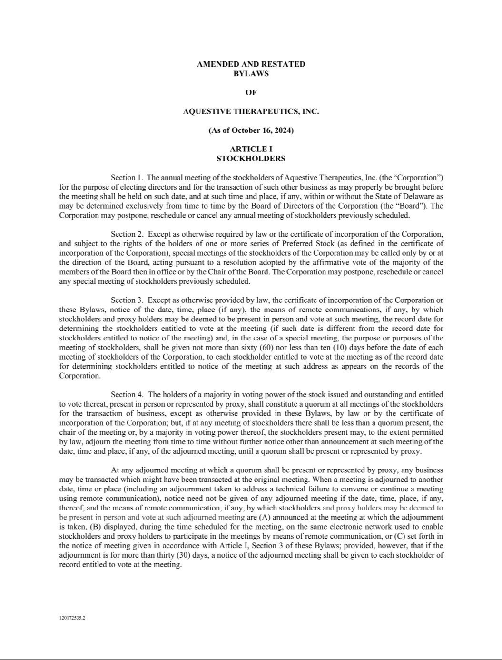

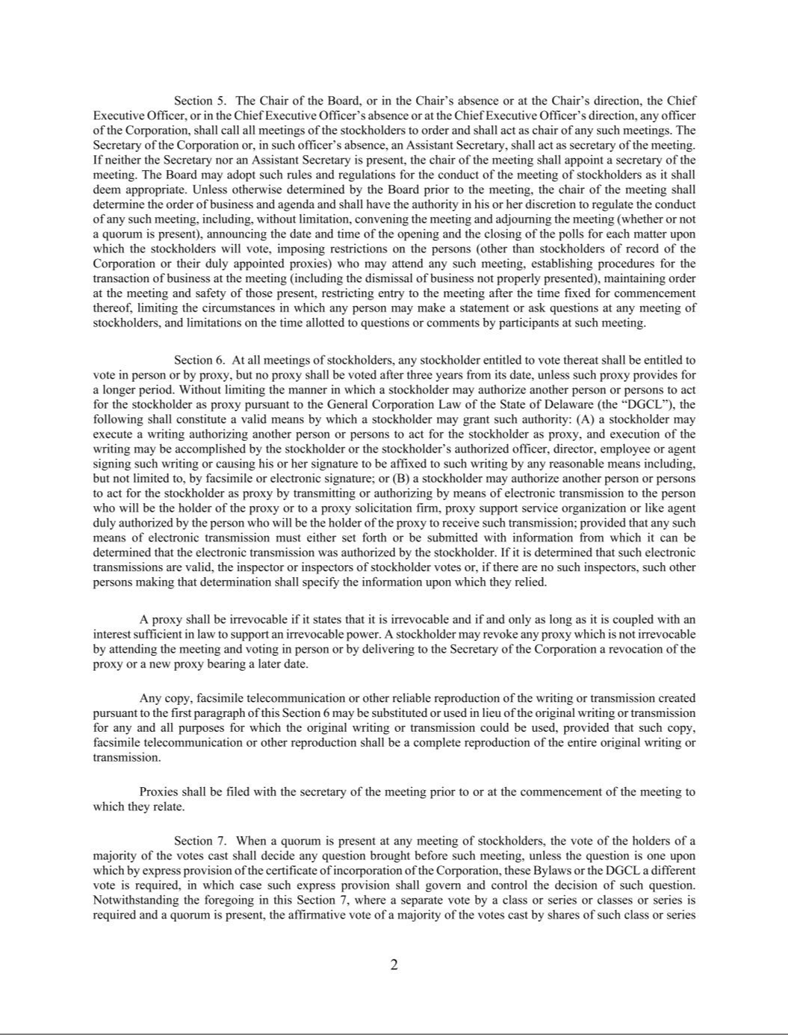

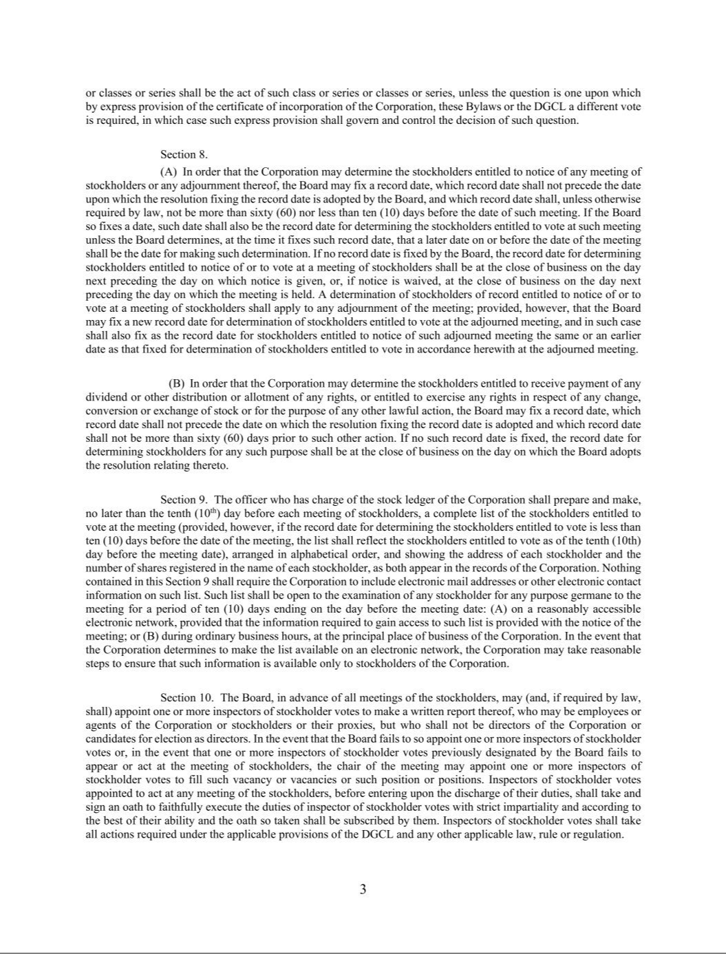

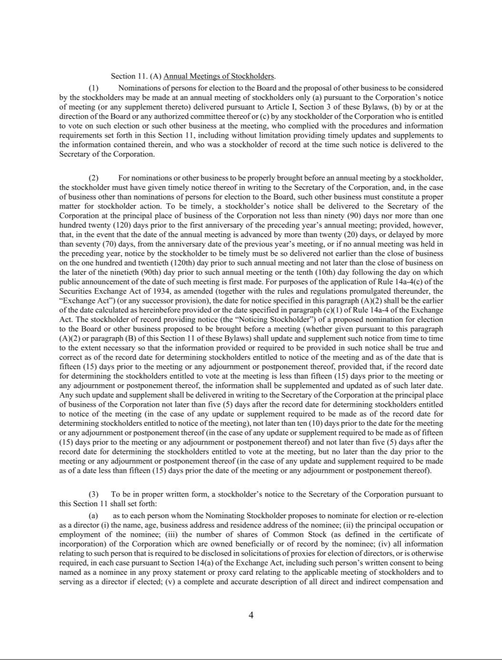

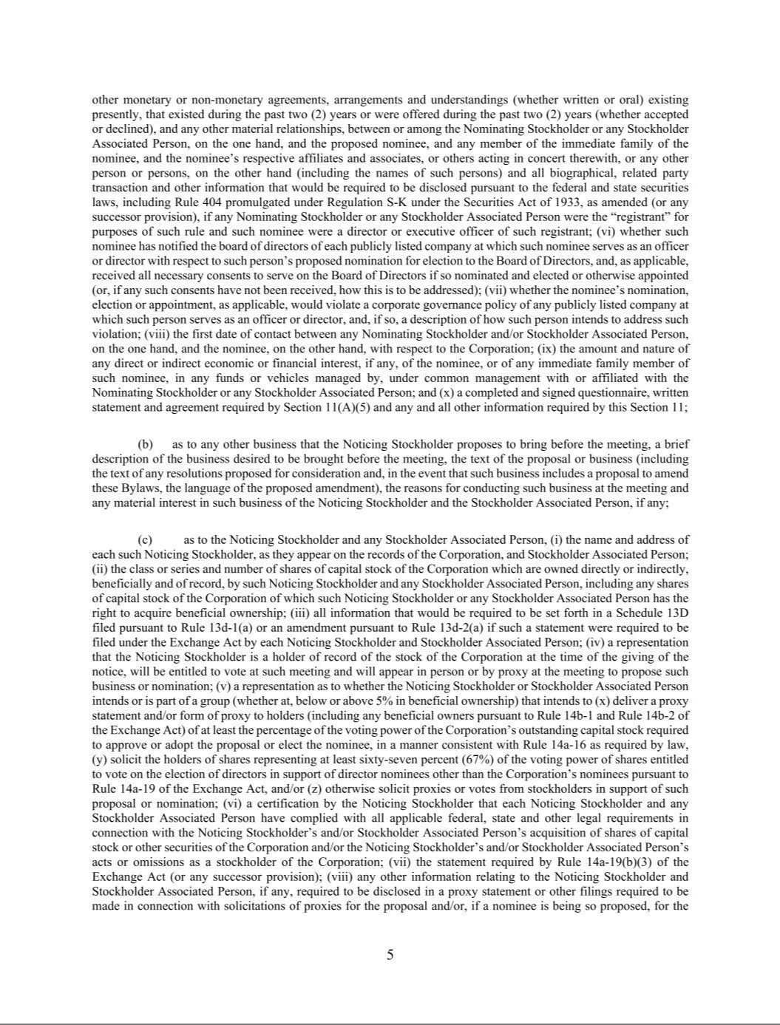

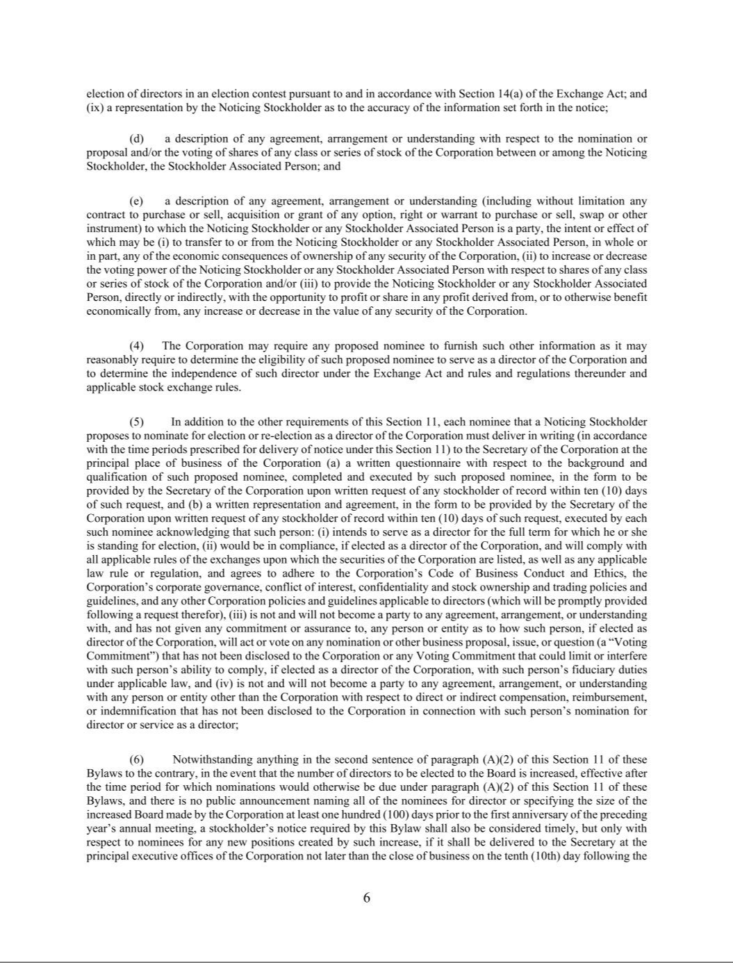

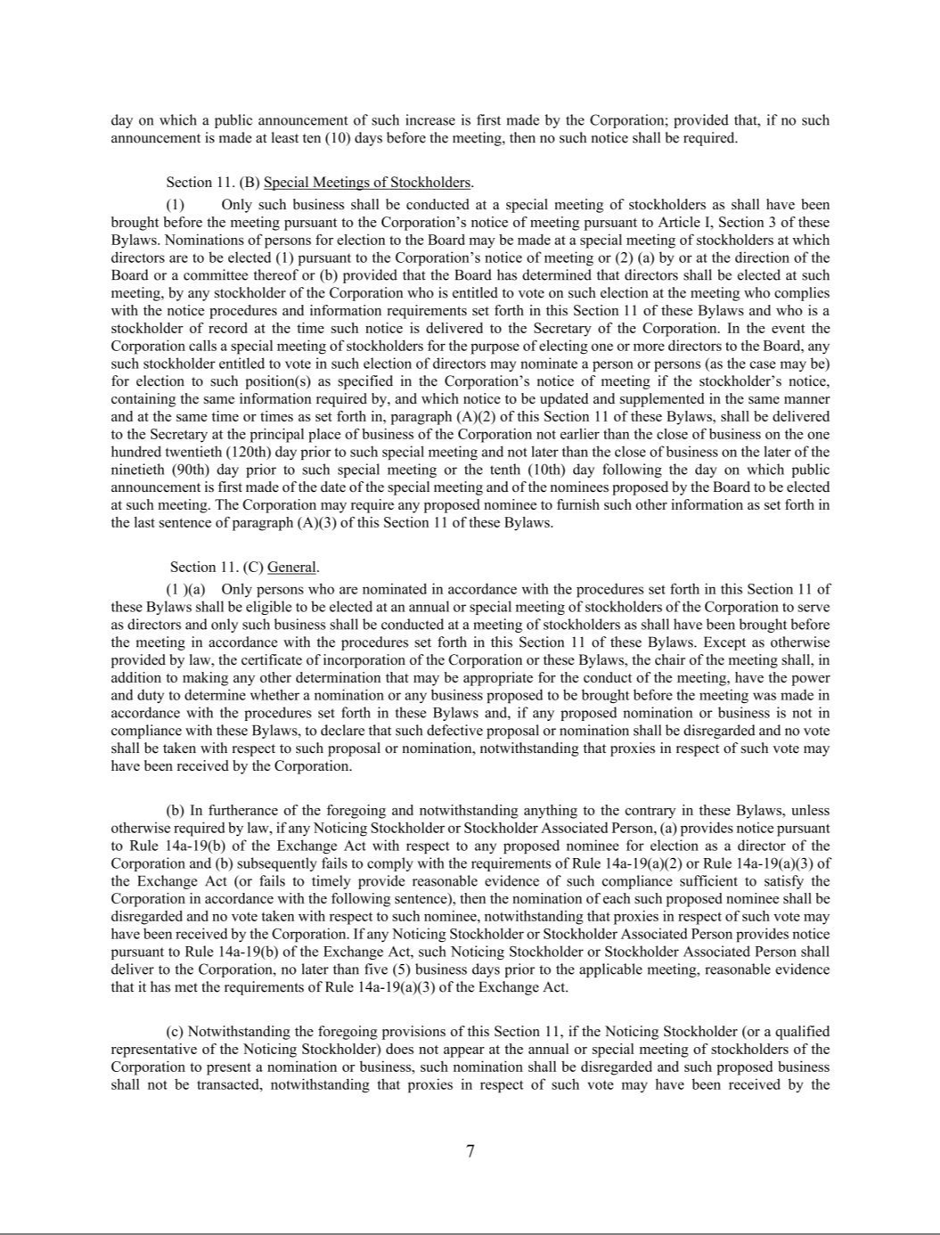

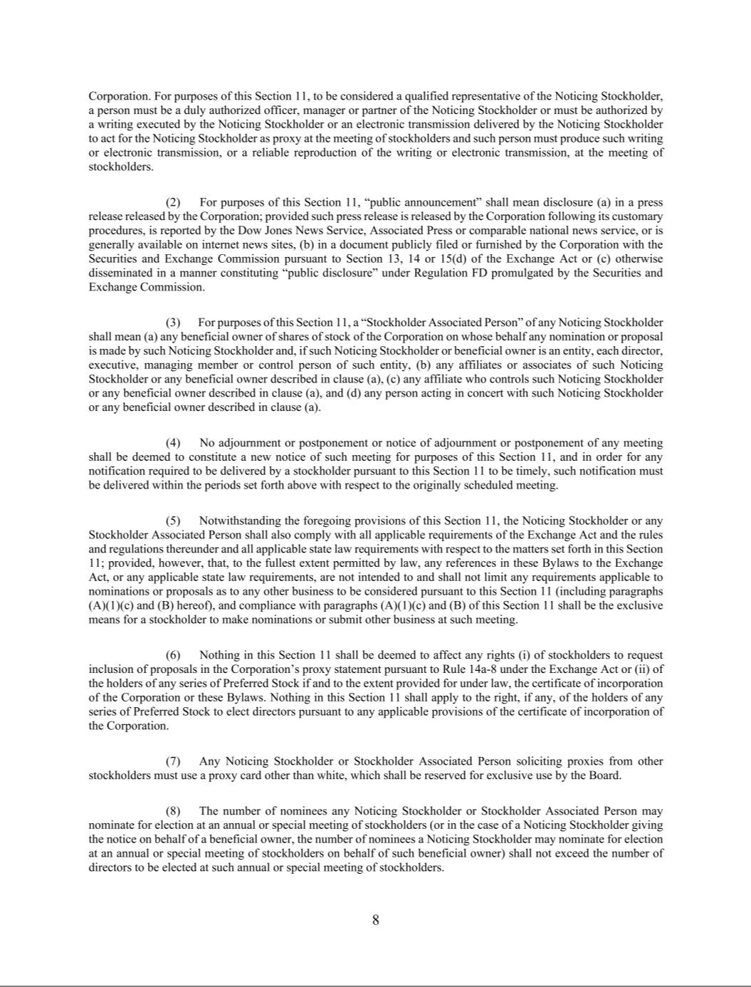

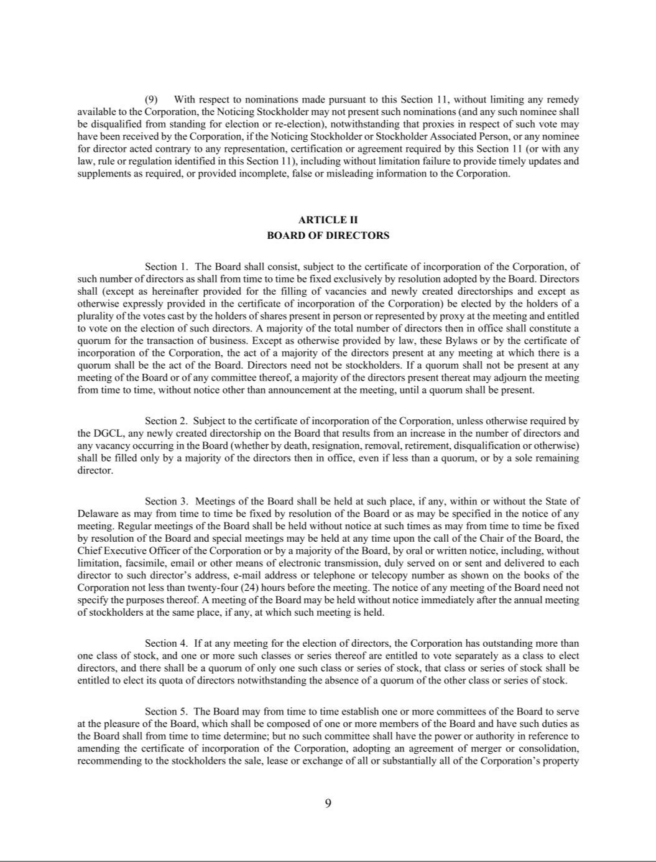

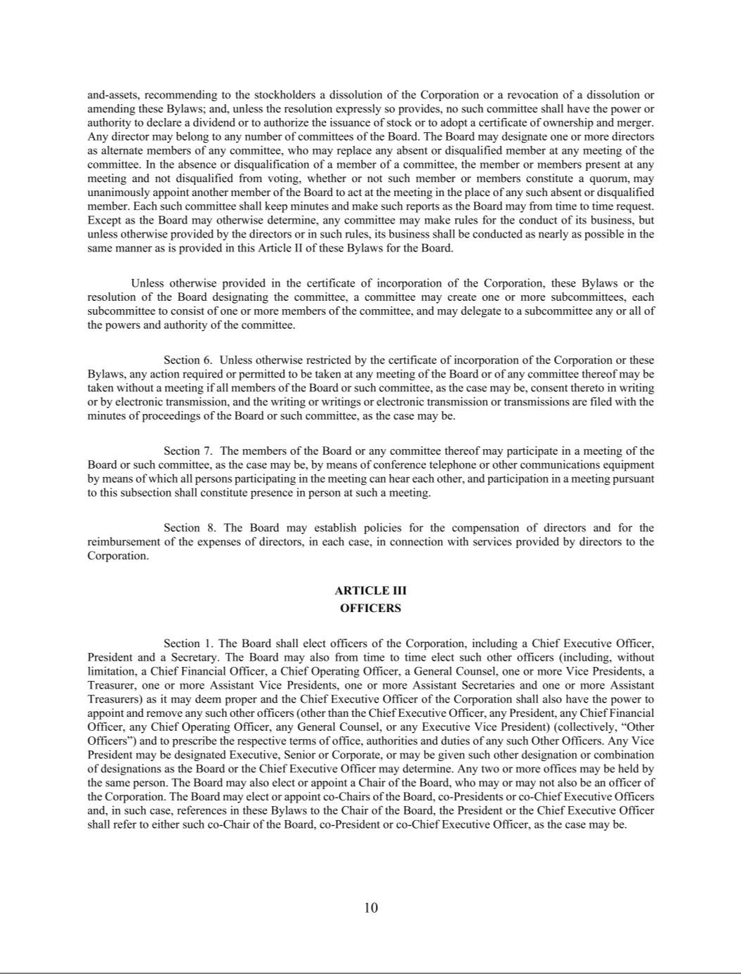

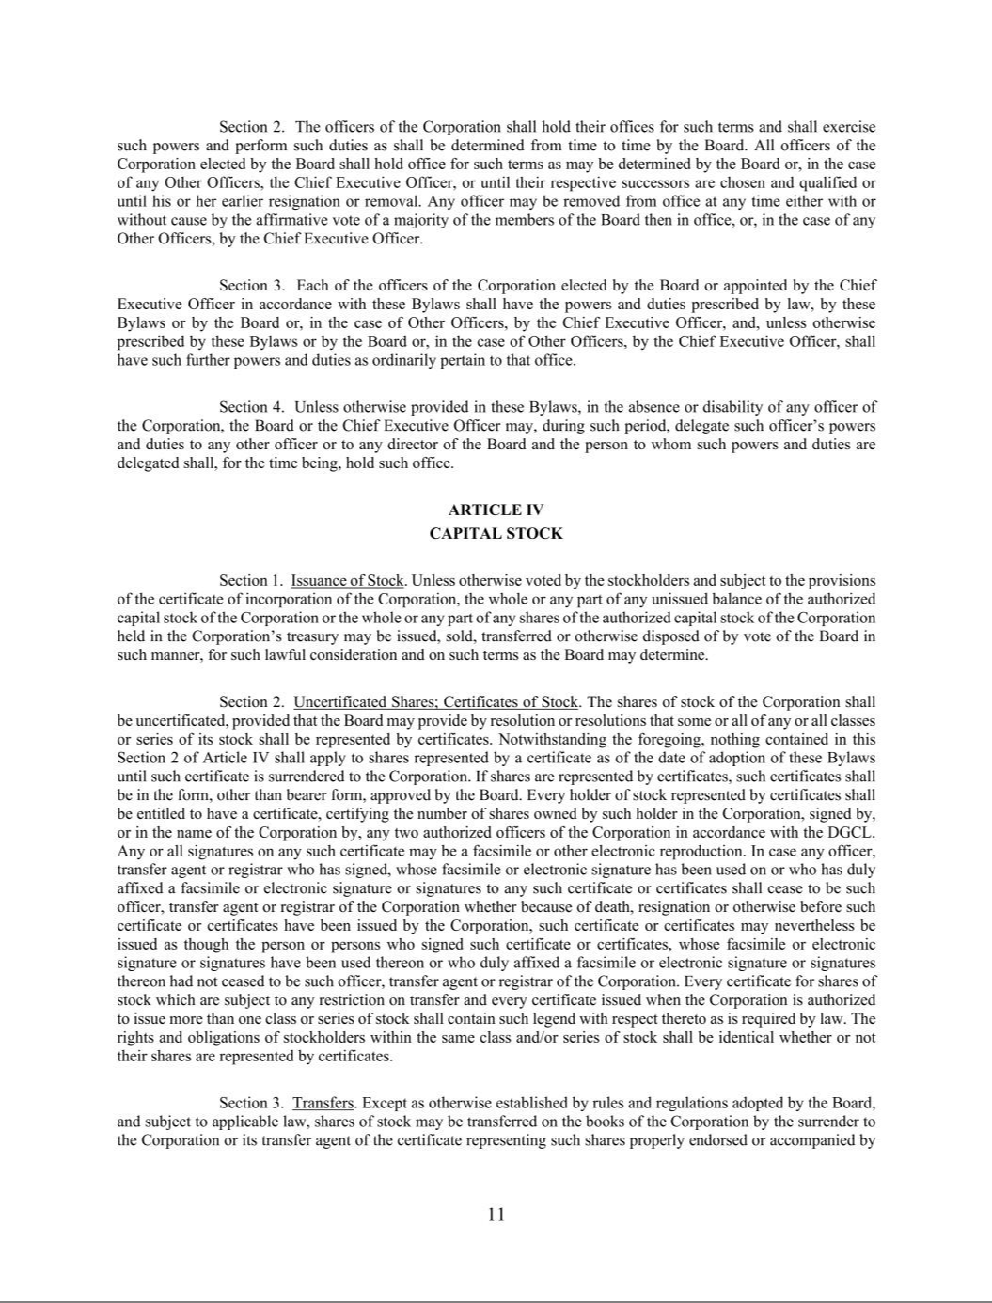

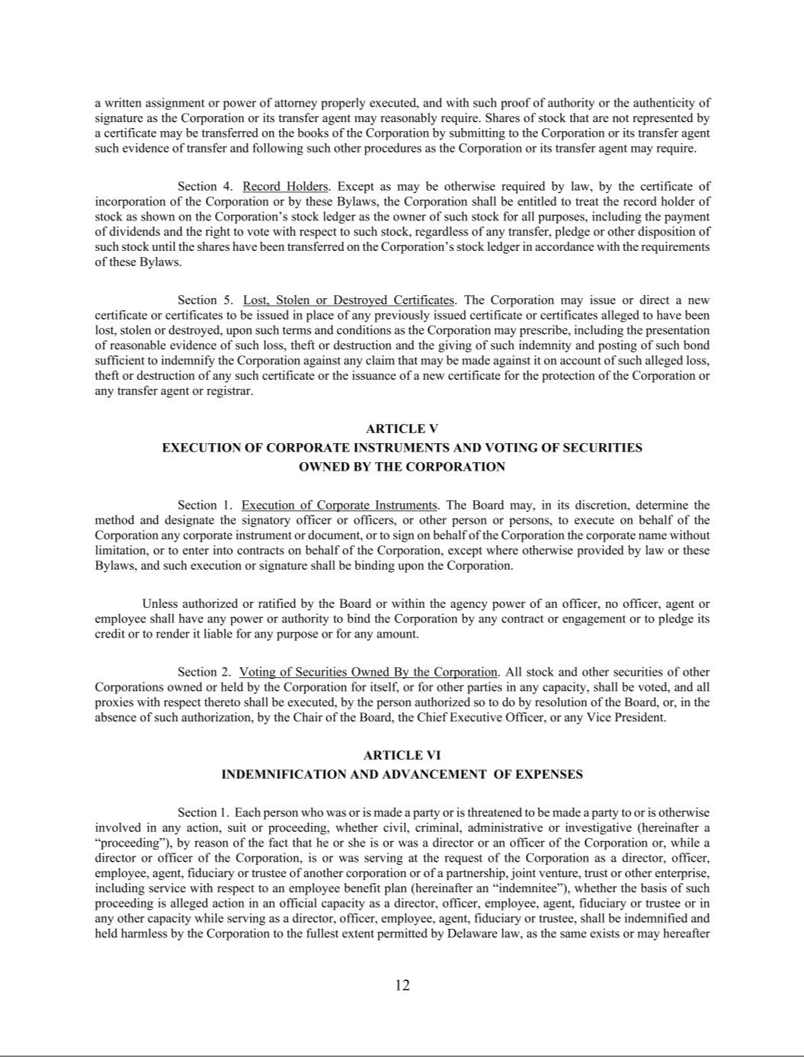

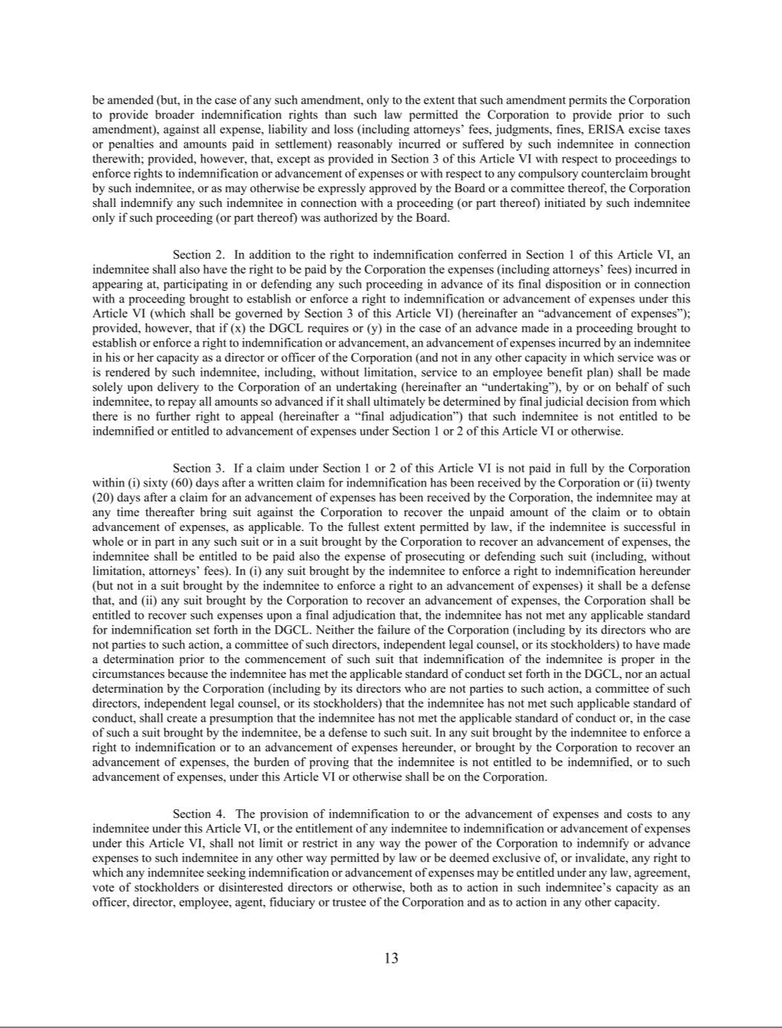

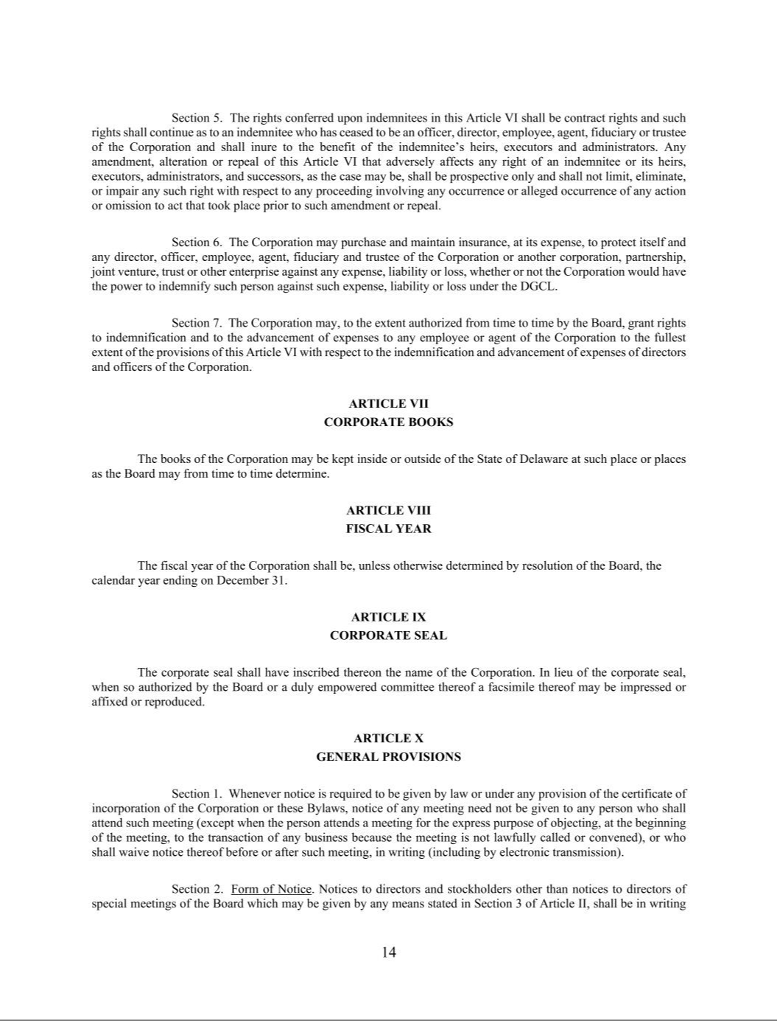

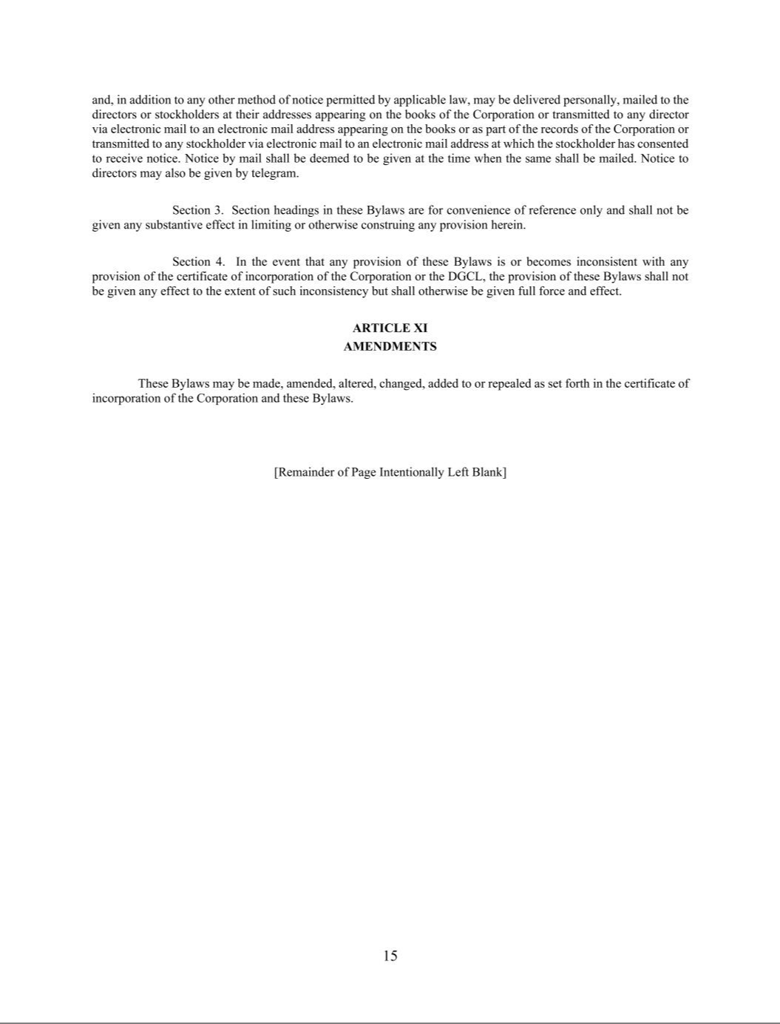

Exhibit 31.1

Certification of Principal Executive Officer of Aquestive Therapeutics, Inc.

Pursuant to Section 302 of the Sarbanes-Oxley Act of 2002

I, Daniel Barber, certify that:

- I have reviewed this Quarterly Report on Form 10-Q of Aquestive Therapeutics, Inc.;

- Based on my knowledge, this report does not contain any untrue statement of a material fact or omit to state a material fact necessary to make the statements made, in light of the circumstances under which such statements were made, not misleading with respect to the period covered by this report;

- Based on my knowledge, the consolidated financial statements, and other financial information included in this report, fairly present in all material respects the financial condition, consolidated results of operations and consolidated cash flows of the registrant as of, and for, the periods presented in this report;

- The registrant’s other certifying officer and I are responsible for establishing and maintaining disclosure controls and procedures (as defined in Exchange Act Rules 13a-15(e) and 15d-15(e)) and internal control over financial reporting (as defined in Exchange Act Rules 13a-15(f) and 15d-15(f)) for the registrant and have:

  - Designed such disclosure controls and procedures, or caused such disclosure controls and procedures to be designed under our supervision, to ensure that material information relating to the registrant, including its consolidated subsidiaries, is made known to us by others within those entities, particularly during the period in which this report is being prepared;

  - Designed such internal control over financial reporting, or caused such internal control over financial reporting to be designed under our supervision, to provide reasonable assurance regarding the reliability of financial reporting and the preparation of financial statements for external purposes in accordance with generally accepted accounting principles;

  - Evaluated the effectiveness of the registrant’s disclosure controls and procedures and presented in this report our conclusions about the effectiveness of the disclosure controls and procedures, as of the end of the period covered by this report based on such evaluation; and

  - Disclosed in this report any change in the registrant’s internal control over financial reporting that occurred during the registrant’s most recent fiscal quarter (the registrant’s fourth fiscal quarter in the case of an annual report) that has materially affected, or is reasonably likely to materially affect, the registrant’s internal control over financial reporting; and

- The registrant’s other certifying officer and I have disclosed, based on our most recent evaluation of internal control over financial reporting, to the registrant’s auditors and the audit committee of registrant’s board of directors (or persons performing the equivalent functions):

  - All significant deficiencies and material weaknesses in the design or operation of internal control over financial reporting which are reasonably likely to adversely affect the registrant’s ability to record, process, summarize and report financial information; and

  - Any fraud, whether or not material, that involves management or other employees who have a significant role in the registrant’s internal control over financial reporting.

Date: November 4, 2024

/s/ Daniel Barber

Daniel Barber

President and Chief Executive Officer
(Principal Executive Officer)

Exhibit 31.2

Certification of Principal Financial and Accounting Officer of Aquestive Therapeutics, Inc.

Pursuant to Section 302 of the Sarbanes-Oxley Act of 2002

I, A. Ernest Toth, Jr, certify that:

- I have reviewed this Quarterly Report on Form 10-Q of Aquestive Therapeutics, Inc.;

- Based on my knowledge, this report does not contain any untrue statement of a material fact or omit to state a material fact necessary to make the statements made, in light of the circumstances under which such statements were made, not misleading with respect to the period covered by this report;

- Based on my knowledge, the consolidated financial statements, and other financial information included in this report, fairly present in all material respects the financial condition, consolidated results of operations and consolidated cash flows of the registrant as of, and for, the periods presented in this report;

- The registrant’s other certifying officer and I are responsible for establishing and maintaining disclosure controls and procedures (as defined in Exchange Act Rules 13a-15(e) and 15d-15(e)) and internal control over financial reporting (as defined in Exchange Act Rules 13a-15(f) and 15d-15(f)) for the registrant and have:

  - Designed such disclosure controls and procedures, or caused such disclosure controls and procedures to be designed under our supervision, to ensure that material information relating to the registrant, including its consolidated subsidiaries, is made known to us by others within those entities, particularly during the period in which this report is being prepared;

  - Designed such internal control over financial reporting, or caused such internal control over financial reporting to be designed under our supervision, to provide reasonable assurance regarding the reliability of financial reporting and the preparation of financial statements for external purposes in accordance with generally accepted accounting principles;

  - Evaluated the effectiveness of the registrant’s disclosure controls and procedures and presented in this report our conclusions about the effectiveness of the disclosure controls and procedures, as of the end of the period covered by this report based on such evaluation; and

  - Disclosed in this report any change in the registrant’s internal control over financial reporting that occurred during the registrant’s most recent fiscal quarter (the registrant’s fourth fiscal quarter in the case of an annual report) that has materially affected, or is reasonably likely to materially affect, the registrant’s internal control over financial reporting; and

- The registrant’s other certifying officer and I have disclosed, based on our most recent evaluation of internal control over financial reporting, to the registrant’s auditors and the audit committee of registrant’s board of directors (or persons performing the equivalent functions):

  - All significant deficiencies and material weaknesses in the design or operation of internal control over financial reporting which are reasonably likely to adversely affect the registrant’s ability to record, process, summarize and report financial information; and

  - Any fraud, whether or not material, that involves management or other employees who have a significant role in the registrant’s internal control over financial reporting.

Date: November 4, 2024

/s/ A. ERNEST TOTH, JR.

A. Ernest Toth, Jr.

Chief Financial Officer
(Principal Financial Officer)

Exhibit 32.1

Certification of Principal Executive Officer

Pursuant to 18 U.S.C. Section 1350, as Adopted

Pursuant to Section 906 of the Sarbanes-Oxley Act of 2002

Pursuant to the requirement set forth in Rule 13a-14(b) of the Securities Exchange Act of 1934, as amended (the “Exchange Act”), and Section 1350 of Chapter 63 of Title 18 of the United States Code (18 U.S.C. §1350), I, Daniel Barber, President and Chief Executive Officer of Aquestive Therapeutics, Inc. (the “Company”), hereby certify that, to the best of my knowledge:

- The Company’s Quarterly Report on Form 10-Q for the period-ended September 30, 2024, to which this Certification is attached as Exhibit 32.1 (the “Quarterly Report”), fully complies with the requirements of Section 13(a) or Section 15(d) of the Exchange Act; and

- The information contained in the Quarterly Report fairly presents, in all material respects, the financial condition of the Company at the end of the period covered by the Quarterly Report and the results of operations of the Company for the period covered by the Quarterly Report.

Date: November 4, 2024

/s/ Daniel Barber

Daniel Barber

President and Chief Executive Officer
(Principal Executive Officer)

This certification accompanies the Form 10-Q to which it relates, is not deemed filed with the Securities and Exchange Commission and is not to be incorporated by reference into any filing of Aquestive Therapeutics, Inc. under the Securities Act of 1933, as amended, or the Exchange Act (whether made before or after the date of the Quarterly Report), irrespective of any general incorporation language contained in such filing.

Exhibit 32.2

Certification of Principal Financial and Accounting Officer

Pursuant to 18 U.S.C. Section 1350, as Adopted

Pursuant to Section 906 of the Sarbanes-Oxley Act of 2002

Pursuant to the requirement set forth in Rule 13a-14(b) of the Securities Exchange Act of 1934, as amended (the “Exchange Act”), and Section 1350 of Chapter 63 of Title 18 of the United States Code (18 U.S.C. §1350), I, A. Ernest Toth, Jr., Chief Financial Officer of Aquestive Therapeutics, Inc. (the “Company”), hereby certify that, to the best of my knowledge:

- The Company’s Quarterly Report on Form 10-Q for the period-ended September 30, 2024, to which this Certification is attached as Exhibit 32.2 (the “Quarterly Report”), fully complies with the requirements of Section 13(a) or Section 15(d) of the Exchange Act; and

- The information contained in the Quarterly Report fairly presents, in all material respects, the financial condition of the Company at the end of the period covered by the Quarterly Report and the results of operations of the Company for the period covered by the Quarterly Report.

Date: November 4, 2024

/s/ A. ERNEST TOTH, JR

A. Ernest Toth, Jr.

Chief Financial Officer
(Principal Financial Officer)

This certification accompanies the Form 10-Q to which it relates, is not deemed filed with the Securities and Exchange Commission and is not to be incorporated by reference into any filing of Aquestive Therapeutics, Inc. under the Securities Act of 1933, as amended, or the Exchange Act (whether made before or after the date of the Quarterly Report), irrespective of any general incorporation language contained in such filing.

