UNITED STATES
SECURITIES AND EXCHANGE COMMISSION
Washington, D.C. 20549

FORM 10-Q

☒ |  |  | QUARTERLY REPORT PURSUANT TO SECTION 13 OR 15(d) OF THE SECURITIES EXCHANGE ACT OF 1934

For the quarterly period ended September 30, 2025

OR
☐ |  |  | TRANSITION REPORT PURSUANT TO SECTION 13 OR 15(d) OF THE SECURITIES EXCHANGE ACT OF 1934

For the transition period from _____ to _____

Commission File Number: 001-38599
Aquestive Therapeutics, Inc.
(Exact Name of Registrant as Specified in its Charter)

Delaware |  |  | 30 Technology Drive, Warren, NJ 07059 |  |  | 82-3827296
(State or other jurisdiction of Incorporation or organization) |  |  | ( 908) 941-1900 |  |  | (I.R.S. Employer Identification Number)

(Address, Zip Code and Telephone Number of Registrant’s Principal Executive Offices)

Securities registered pursuant to Section 12(b) of the Act:

Title of each class |  |  | Trading Symbol(s) |  |  | Name of each exchange on which registered
Common Stock, par value $0.001 per share |  |  | AQST |  |  | Nasdaq Global Market

Securities registered pursuant to Section 12(g) of the Act: None

Indicate by check mark whether the registrant: (1) has filed all reports required to be filed by Section 13 or 15(d) of the Securities Exchange Act of 1934 during the preceding 12 months (or for such shorter period that the registrant was required to file such reports), and (2) has been subject to such filing requirements for the past 90 days. ☒ Yes ☐ No

Indicate by check mark whether the registrant has submitted electronically every Interactive Data File required to be submitted pursuant to Rule 405 of Regulation S-T (§232.405 of this chapter) during the preceding 12 months (or for such shorter period that the registrant was required to submit such files). ☒ Yes ☐ No

Indicate by check mark whether the registrant is a large accelerated filer, an accelerated filer, a non-accelerated filer, a smaller reporting company or an emerging growth company. See the definitions of “large accelerated filer,” “accelerated filer”, “smaller reporting company” and “emerging growth company” in Rule 12b-2 of the Securities Exchange Act of 1934.

 |  |  | Large accelerated filer |  |  | ☐ |  |  | Accelerated filer |  |  | ☐
 |  |  | Non-accelerated filer |  |  | ☒ |  |  | Smaller reporting company |  |  | ☒
 |  |  |  |  |  |  |  |  | Emerging growth company |  |  | ☐

If an emerging growth company, indicate by check mark if the registrant has elected not to use the extended transition period for complying with any new or revised financial accounting standards provided pursuant to Section 13(a) of the Exchange Act. ☐

Indicate by check mark whether the registrant is a shell company (as defined in Rule 12b-2 of the Exchange Act). ☐ Yes ☒ No

The number of outstanding shares of the registrant’s common stock, par value of $0.001 per share (the "Common Stock"), as of the close of business on November 3, 2025 was 122,003,113.

Table of Contents
AQUESTIVE THERAPEUTICS, INC.
FORM 10-Q
TABLE OF CONTENTS

 |  |  |  |  |  | Page No.
PART I – FINANCIAL INFORMATION
Item 1. |  |  | Financial Statements (Unaudited)
 |  |  | Condensed Balance Sheets as of September 30, 2025 and December 31, 2024 |  |  | 1
 |  |  | Condensed Statements of Operations and Comprehensive Loss for the three and nine months ended September 30, 2025 and 2024 |  |  | 2
 |  |  | Condensed Statements of Changes in Stockholders’ Deficit for the three and nine months ended September 30, 2025 and 2024 |  |  | 3
 |  |  | Condensed Statements of Cash Flows for the nine months ended September 30, 2025 and 2024 |  |  | 5
 |  |  | Notes to Unaudited Condensed Financial Statements |  |  | 6
Item 2. |  |  | Management’s Discussion and Analysis of Financial Condition and Results of Operations |  |  | 29
Item 3. |  |  | Quantitative and Qualitative Disclosures about Market Risk |  |  | 46
Item 4. |  |  | Controls and Procedures |  |  | 46
PART II – OTHER INFORMATION
Item 1. |  |  | Legal Proceedings |  |  | 48
Item 1A. |  |  | Risk Factors |  |  | 48
Item 2. |  |  | Unregistered Sales of Equity Securities and Use of Proceeds |  |  | 51
Item 3. |  |  | Defaults Upon Senior Securities |  |  | 51
Item 4. |  |  | Mine Safety Disclosures |  |  | 51
Item 5. |  |  | Other Information |  |  | 51
Item 6. |  |  | Exhibits |  |  | 52
SIGNATURES |  |  |  |  |  | 53

Table of Contents
GLOSSARY OF TERMS, ABBREVIATIONS AND ACRONYMS

The following terms, abbreviations and acronyms are used to identify frequently used terms and phrases that may be used in this report (dollar amounts in thousands):

TERM |  |  | DEFINITION
12.5% Notes |  |  | 12.5% Senior Secured Notes redeemed on November 1, 2023
13.5% Notes |  |  | 13.5% Senior Secured Notes
2024 Underwritten Public Offering |  |  | Capital raise of gross proceeds of $77,519, including partial exercise of the underwriters' option for $2,519
2025 Underwritten Public Offering |  |  | Capital raise of gross proceeds of $85,000
ACAAI |  |  | American College of Allergy Asthma and Immunology
ABL facility |  |  | Asset-based borrowing facility
ADHD |  |  | Attention deficit hyperactivity disorder
Adrenaverse™ |  |  | Epinephrine prodrug platform currently comprised of Anaphylm™ and AQST-108
ALS |  |  | Amyotrophic lateral sclerosis
ANVISA |  |  | Brazilian Health Regulatory Agency
API |  |  | Active Pharmaceutical Ingredients
Aquestive |  |  | Aquestive Therapeutics, Inc.
AQST |  |  | Nasdaq ticker symbol for Aquestive Therapeutics, Inc.
ASC |  |  | Accounting Standards Codification
Assertio |  |  | Assertio Holdings, Inc.
Assertio Agreement |  |  | License Agreement between Aquestive and Otter Pharmaceuticals, LLC, a subsidiary of Assertio Holdings, Inc.
ARS |  |  | Acute Repetitive Seizures
ASU |  |  | Accounting Standards Updates
ATM facility |  |  | At-The-Market facility for the purchase of AQST Common Stock, then in effect
CEO |  |  | Chief Executive Officer
CNS |  |  | Central Nervous System
CODM |  |  | Chief Operating Decision Maker
Common Stock |  |  | Common Stock, par value $0.001 per share, of the Company
Common Stock Warrants |  |  | Warrants issued with private placement of up to $100,000 aggregate principal of 12.5% Notes originally due 2025
Company |  |  | Aquestive Therapeutics, Inc.
DEA |  |  | Drug Enforcement Administration
EMA |  |  | European Medicines Agency
EOP2 |  |  | End-of-phase 2
EPS |  |  | Earnings per share
ESPP |  |  | Employee Stock Purchase Plan
EU |  |  | European Union
Exchange Act |  |  | Securities Exchange Act of 1934
Existing Warrants |  |  | Common Stock Purchase Warrants with the holder of the remaining 5,000,000 warrants
FASB |  |  | Financial Accounting Standards Board
FDA |  |  | U.S. Food and Drug Administration
FDAAA |  |  | Food and Drug Administration Amendments Act of 2007
First Amendment |  |  | First amendment to the Sunovion License Agreement
GAAP |  |  | Generally Accepted Accounting Principles
Haisco |  |  | Haisco Pharmaceutical Group Co., Ltd.
Haisco Agreement |  |  | License, Development and Supply Agreement with Haisco, a Chinese limited company listed on the Shenzhen Stock Exchange
Hypera |  |  | Hypera Pharma, CosMed Industria De Cosmeticos E Medicamentos S.A

Table of Contents
IND |  |  | Investigational New Drug
Indenture Agreement |  |  | Agreement governing the 13.5% Senior Secured Notes
Indivior |  |  | Indivior Inc. (formerly, Reckitt Benckiser Pharmaceuticals Inc)
Indivior Amendment |  |  | Amendment No. 11 to the Indivior License Agreement
Indivior License Agreement |  |  | Commercial Exploitation Agreement with Reckitt Benckiser Pharmaceuticals, Inc. (with subsequent amendments collectively)
Marathon |  |  | Marathon Asset Management
Monetization Agreement |  |  | Purchase and Sale Agreement between Aquestive and Sunovion
MTPA or Mitsubishi |  |  | Mitsubishi Tanabe Pharma America, Inc. (formerly, Mitsubishi Tanabe Pharma Holdings America, Inc.)
N/M |  |  | Not Meaningful, used in percentage changes
Nasdaq |  |  | The Nasdaq Stock Market
NDA |  |  | New Drug Application
New Warrants |  |  | Warrants to purchase 2,750,000 shares of Common Stock
ODE |  |  | Orphan Drug Exclusivity
Offering |  |  | $45,000 aggregate principal amount of 13.5% Notes due November 1, 2028.
PD |  |  | Pharmacodynamics
Pharmanovia |  |  | Atnahs Pharma UK Limited, a company registered in England and Wales
Pharmanovia Agreement |  |  | License and Supply Agreement with Atnahs Pharma UK Limited,
Pharmanovia Amendment |  |  | Amended License and Supply Agreement with Atnahs Pharma UK Limited as of March 27, 2023
PK |  |  | Pharmacokinetic
PTO |  |  | United States Patent and Trademark Office
PDUFA |  |  | Prescription Drug User Fee Act
Pre-IND |  |  | Pre-Investigational New Drug
Purchase Agreement |  |  | Purchase and sale agreement with funds managed by RTW Investments LP
Purchaser |  |  | RTW Investments LP
Purchase Price |  |  | $75,000
R&D |  |  | Research and development
Royalty Obligations |  |  | Liability related to the Royalty Rights Agreements
Royalty Rights Agreements |  |  | Royalty Rights Agreements, component of 13.5% Senior Secured Notes
RSU |  |  | Restricted Stock Unit
SEC |  |  | Securities and Exchange Commission
Securities Purchase Agreements |  |  | Securities Purchase Agreements with certain purchasers entered into on June 6, 2022
Sunovion |  |  | Sunovion Pharmaceuticals Inc
Sunovion License Agreement |  |  | KYNMOBI Commercialization Agreement
Territory |  |  | Certain countries of the European Union, the United Kingdom, Switzerland, Norway and the Middle East and North Africa under the Pharmanovia Agreement
TGA |  |  | Australian Government Department of Health’s Therapeutics Goods Administration
Zambon |  |  | Zambon S.p.A.
Zevra |  |  | Zevra Therapeutics, Inc. (formerly KemPharm, Inc.)

Table of Contents
PART I – FINANCIAL INFORMATION

Item 1. FINANCIAL STATEMENTS (Unaudited)

AQUESTIVE THERAPEUTICS, INC.
Condensed Balance Sheets
(In thousands, except share and per share amounts)
(Unaudited)
 |  |  | September 30,  2025 |  |  |  |  |  | December 31,  2024
Assets
Current assets:
Cash and cash equivalents |  |  | $ | 129,063 |  |  |  |  | $ | 71,546
Trade and other receivables, net |  |  | 11,801 |  |  |  |  |  | 7,344
Inventories |  |  | 7,884 |  |  |  |  |  | 6,044
Prepaid expenses and other current assets |  |  | 2,925 |  |  |  |  |  | 3,286
Total current assets |  |  | 151,673 |  |  |  |  |  | 88,220
Property and equipment, net |  |  | 3,918 |  |  |  |  |  | 3,799
Right-of-use assets, net |  |  | 4,769 |  |  |  |  |  | 5,182
Other non-current assets |  |  | 3,199 |  |  |  |  |  | 4,223
Total assets |  |  | $ | 163,559 |  |  |  |  | $ | 101,424
Liabilities and stockholders’ deficit
Current liabilities:
Accounts payable |  |  | $ | 10,865 |  |  |  |  | $ | 10,287
Accrued expenses |  |  | 5,128 |  |  |  |  |  | 5,907
Lease liabilities, current |  |  | 601 |  |  |  |  |  | 510
Deferred revenue, current |  |  | 1,092 |  |  |  |  |  | 1,048
Liability related to the sale of future revenue, current |  |  | 1,000 |  |  |  |  |  | 1,000
Royalty obligations, current |  |  | 561 |  |  |  |  |  | 87
Loans payable, current |  |  | 6,327 |  |  |  |  |  | 26
Total current liabilities |  |  | 25,574 |  |  |  |  |  | 18,865
Notes payable, net |  |  | 29,940 |  |  |  |  |  | 32,500
Royalty obligations, net |  |  | 23,948 |  |  |  |  |  | 20,129
Liability related to the sale of future revenue, net |  |  | 61,977 |  |  |  |  |  | 62,718
Lease liabilities |  |  | 4,508 |  |  |  |  |  | 4,968
Deferred revenue, net of current portion |  |  | 19,663 |  |  |  |  |  | 20,005
Other non-current liabilities |  |  | 2,058 |  |  |  |  |  | 2,395
Total liabilities |  |  | 167,668 |  |  |  |  |  | 161,580
Contingencies (Note 20)
Stockholders’ deficit:
Common stock, $0.001 par value. Authorized 250,000,000 shares; 121,658,113 and 91,413,742 shares issued and outstanding at September 30, 2025 and December 31, 2024, respectively |  |  | 121 |  |  |  |  |  | 91
Additional paid-in capital |  |  | 410,908 |  |  |  |  |  | 302,967
Accumulated deficit |  |  | (415,138) |  |  |  |  |  | (363,214)
Total stockholders’ deficit |  |  | (4,109) |  |  |  |  |  | (60,156)
Total liabilities and stockholders’ deficit |  |  | $ | 163,559 |  |  |  |  | $ | 101,424
See accompanying notes to the condensed financial statements.

1
Table of Contents
AQUESTIVE THERAPEUTICS, INC.
Condensed Statements of Operations and Comprehensive Loss
(In thousands, except share and per share data amounts)
(Unaudited)

 |  |  | Three Months Ended September 30, |  |  |  |  |  |  |  |  |  |  |  | Nine Months Ended  September 30,
 |  |  | 2025 |  |  |  |  |  | 2024 |  |  |  |  |  | 2025 |  |  |  |  |  | 2024
Revenues |  |  | $ | 12,807 |  |  |  |  | $ | 13,542 |  |  |  |  | $ | 31,530 |  |  |  |  | $ | 45,694
Costs and expenses:
Manufacture and supply |  |  | 4,506 |  |  |  |  |  | 4,437 |  |  |  |  |  | 12,719 |  |  |  |  |  | 13,352
Research and development |  |  | 4,530 |  |  |  |  |  | 5,269 |  |  |  |  |  | 13,996 |  |  |  |  |  | 15,363
Selling, general and administrative |  |  | 15,250 |  |  |  |  |  | 12,126 |  |  |  |  |  | 47,027 |  |  |  |  |  | 34,171
Total costs and expenses |  |  | 24,286 |  |  |  |  |  | 21,832 |  |  |  |  |  | 73,742 |  |  |  |  |  | 62,886
Loss from operations |  |  | (11,479) |  |  |  |  |  | (8,290) |  |  |  |  |  | (42,212) |  |  |  |  |  | (17,192)
Other income/(expenses):
Interest expense |  |  | (2,779) |  |  |  |  |  | (2,780) |  |  |  |  |  | (8,342) |  |  |  |  |  | (8,343)
Interest expense related to royalty obligations |  |  | (1,433) |  |  |  |  |  | (1,359) |  |  |  |  |  | (4,304) |  |  |  |  |  | (4,075)
Interest expense related to the sale of future revenue |  |  | (61) |  |  |  |  |  | (59) |  |  |  |  |  | (181) |  |  |  |  |  | (175)
Interest income and other income, net |  |  | 306 |  |  |  |  |  | 979 |  |  |  |  |  | 3,115 |  |  |  |  |  | 2,703
Net loss before income taxes |  |  | (15,446) |  |  |  |  |  | (11,509) |  |  |  |  |  | (51,924) |  |  |  |  |  | (27,082)
Net loss |  |  | $ | (15,446) |  |  |  |  | $ | (11,509) |  |  |  |  | $ | (51,924) |  |  |  |  | $ | (27,082)
Comprehensive loss |  |  | $ | (15,446) |  |  |  |  | $ | (11,509) |  |  |  |  | $ | (51,924) |  |  |  |  | $ | (27,082)
Loss per share attributable to common stockholders:
Basic and diluted (in dollars per share) |  |  | $ | (0.14) |  |  |  |  | $ | (0.13) |  |  |  |  | $ | (0.51) |  |  |  |  | $ | (0.32)
Weighted average common shares outstanding:
Basic and diluted (in shares) |  |  | 110,584,371 |  |  |  |  |  | 91,082,081 |  |  |  |  |  | 101,857,974 |  |  |  |  |  | 85,224,263

See accompanying notes to the condensed financial statements.

2
Table of Contents
AQUESTIVE THERAPEUTICS, INC.
Condensed Statements of Changes in Stockholders’ Deficit
Three and Nine Months Ended September 30, 2025
(In thousands, except share amounts)
(Unaudited)
 |  |  | Common Stock |  |  |  |  |  |  |  |  |  |  |  | Additional  Paid-in  Capital |  |  |  |  |  | Accumulated  Deficit |  |  |  |  |  | Total  Stockholders’  Deficit
 |  |  | Shares |  |  |  |  |  | Amount
Balance at December 31, 2024 |  |  | 91,413,742 |  |  |  |  |  | $ | 91 |  |  |  |  | $ | 302,967 |  |  |  |  | $ | (363,214) |  |  |  |  | $ | (60,156)
Common Stock issued under public equity offering-ATM |  |  | 7,457,627 |  |  |  |  |  | 8 |  |  |  |  |  | 21,992 |  |  |  |  |  | — |  |  |  |  |  | 22,000
Costs of common stock issued under public equity offering-ATM |  |  | — |  |  |  |  |  | — |  |  |  |  |  | (729) |  |  |  |  |  | — |  |  |  |  |  | (729)
Share-based compensation expense |  |  | — |  |  |  |  |  | — |  |  |  |  |  | 1,587 |  |  |  |  |  | — |  |  |  |  |  | 1,587
Vested restricted stock units, net |  |  | 445,784 |  |  |  |  |  | — |  |  |  |  |  | (702) |  |  |  |  |  | — |  |  |  |  |  | (702)
Net loss |  |  | — |  |  |  |  |  | — |  |  |  |  |  | — |  |  |  |  |  | (22,930) |  |  |  |  |  | (22,930)
Balance at March 31, 2025 |  |  | 99,317,153 |  |  |  |  |  | 99 |  |  |  |  |  | 325,115 |  |  |  |  |  | (386,144) |  |  |  |  |  | (60,930)
Costs of common stock issued under public equity offering-ATM |  |  | — |  |  |  |  |  | — |  |  |  |  |  | (34) |  |  |  |  |  | — |  |  |  |  |  | (34)
Shares issued under employee stock purchase plan |  |  | 18,056 |  |  |  |  |  | — |  |  |  |  |  | 59 |  |  |  |  |  | — |  |  |  |  |  | 59
Share-based compensation expense |  |  | — |  |  |  |  |  | — |  |  |  |  |  | 1,875 |  |  |  |  |  | — |  |  |  |  |  | 1,875
Vested restricted stock units, net |  |  | 10,561 |  |  |  |  |  | — |  |  |  |  |  | (19) |  |  |  |  |  | — |  |  |  |  |  | (19)
Options exercised, net |  |  | 7,500 |  |  |  |  |  | — |  |  |  |  |  | 7 |  |  |  |  |  | — |  |  |  |  |  | 7
Net loss |  |  | — |  |  |  |  |  | — |  |  |  |  |  | — |  |  |  |  |  | (13,548) |  |  |  |  |  | (13,548)
Balance at June 30, 2025 |  |  | 99,353,270 |  |  |  |  |  | 99 |  |  |  |  |  | 327,003 |  |  |  |  |  | (399,692) |  |  |  |  |  | (72,590)
Common Stock issued under public equity offering |  |  | 21,250,000 |  |  |  |  |  | 21 |  |  |  |  |  | 84,979 |  |  |  |  |  | — |  |  |  |  |  | 85,000
Costs of common stock issued under public equity offering |  |  | — |  |  |  |  |  | — |  |  |  |  |  | (5,537) |  |  |  |  |  | — |  |  |  |  |  | (5,537)
Costs of common stock issued under public equity offering-ATM |  |  | — |  |  |  |  |  | — |  |  |  |  |  | (10) |  |  |  |  |  | — |  |  |  |  |  | (10)
Share-based compensation expense |  |  | — |  |  |  |  |  | — |  |  |  |  |  | 2,777 |  |  |  |  |  | — |  |  |  |  |  | 2,777
Vested restricted stock units, net |  |  | 304,843 |  |  |  |  |  | — |  |  |  |  |  | (72) |  |  |  |  |  | — |  |  |  |  |  | (72)
Options exercised, net |  |  | 200,000 |  |  |  |  |  | — |  |  |  |  |  | 339 |  |  |  |  |  | — |  |  |  |  |  | 339
Common stock issued upon warrant exercises |  |  | 550,000 |  |  |  |  |  | 1 |  |  |  |  |  | 1,429 |  |  |  |  |  | — |  |  |  |  |  | 1,430
Net loss |  |  | — |  |  |  |  |  | — |  |  |  |  |  | — |  |  |  |  |  | (15,446) |  |  |  |  |  | (15,446)
Balance at September 30, 2025 |  |  | 121,658,113 |  |  |  |  |  | $ | 121 |  |  |  |  | $ | 410,908 |  |  |  |  | $ | (415,138) |  |  |  |  | $ | (4,109)

3
Table of Contents
AQUESTIVE THERAPEUTICS, INC.
Condensed Statements of Changes in Stockholders’ Deficit
Three and Nine Months Ended September 30, 2024
(In thousands, except share amounts)
(Unaudited)
 |  |  | Common Stock |  |  |  |  |  |  |  |  |  |  |  | Additional  Paid-in  Capital |  |  |  |  |  | Accumulated  Deficit |  |  |  |  |  | Total  Stockholders’  Deficit
 |  |  | Shares |  |  |  |  |  | Amount
Balance at December 31, 2023 |  |  | 68,533,085 |  |  |  |  |  | $ | 69 |  |  |  |  | $ | 212,521 |  |  |  |  | $ | (319,077) |  |  |  |  | $ | (106,487)
Common Stock issued under public equity offering-ATM |  |  | 4,557,220 |  |  |  |  |  | 4 |  |  |  |  |  | 12,381 |  |  |  |  |  | — |  |  |  |  |  | 12,385
Costs of common stock issued under public equity offering-ATM |  |  | — |  |  |  |  |  | — |  |  |  |  |  | (410) |  |  |  |  |  | — |  |  |  |  |  | (410)
Common Stock issued under public equity offering |  |  | 16,666,667 |  |  |  |  |  | 17 |  |  |  |  |  | 74,983 |  |  |  |  |  | — |  |  |  |  |  | 75,000
Costs of common stock issued under public equity offering |  |  | — |  |  |  |  |  | — |  |  |  |  |  | (5,187) |  |  |  |  |  | — |  |  |  |  |  | (5,187)
Share-based compensation expense |  |  | — |  |  |  |  |  | — |  |  |  |  |  | 1,580 |  |  |  |  |  | — |  |  |  |  |  | 1,580
Vested restricted stock units, net |  |  | 490,359 |  |  |  |  |  | — |  |  |  |  |  | (893) |  |  |  |  |  | — |  |  |  |  |  | (893)
Options exercised, net |  |  | 231,400 |  |  |  |  |  | — |  |  |  |  |  | 539 |  |  |  |  |  | — |  |  |  |  |  | 539
Net loss |  |  | — |  |  |  |  |  | — |  |  |  |  |  | — |  |  |  |  |  | (12,828) |  |  |  |  |  | (12,828)
Balance at March 31, 2024 |  |  | 90,478,731 |  |  |  |  |  | 90 |  |  |  |  |  | 295,514 |  |  |  |  |  | (331,905) |  |  |  |  |  | (36,301)
Costs of common stock issued under public equity offering-ATM |  |  | — |  |  |  |  |  | — |  |  |  |  |  | (158) |  |  |  |  |  | — |  |  |  |  |  | (158)
Common Stock issued under public equity offering |  |  | 559,801 |  |  |  |  |  | 1 |  |  |  |  |  | 2,519 |  |  |  |  |  | — |  |  |  |  |  | 2,520
Costs of common stock issued under public equity offering |  |  | — |  |  |  |  |  | — |  |  |  |  |  | (359) |  |  |  |  |  | — |  |  |  |  |  | (359)
Shares issued under employee stock purchase plan |  |  | 17,716 |  |  |  |  |  | — |  |  |  |  |  | 46 |  |  |  |  |  | — |  |  |  |  |  | 46
Share-based compensation expense |  |  | — |  |  |  |  |  | — |  |  |  |  |  | 1,523 |  |  |  |  |  | — |  |  |  |  |  | 1,523
Vested restricted stock units, net |  |  | 3,512 |  |  |  |  |  | — |  |  |  |  |  | (5) |  |  |  |  |  | — |  |  |  |  |  | (5)
Net loss |  |  | — |  |  |  |  |  | — |  |  |  |  |  | — |  |  |  |  |  | (2,745) |  |  |  |  |  | (2,745)
Balance at June 30, 2024 |  |  | 91,059,760 |  |  |  |  |  | 91 |  |  |  |  |  | 299,080 |  |  |  |  |  | (334,650) |  |  |  |  |  | (35,479)
Share-based compensation expense |  |  | — |  |  |  |  |  | — |  |  |  |  |  | 1,577 |  |  |  |  |  | — |  |  |  |  |  | 1,577
Vested restricted stock units, net |  |  | (7,192) |  |  |  |  |  | — |  |  |  |  |  | (202) |  |  |  |  |  | — |  |  |  |  |  | (202)
Options exercised, net |  |  | 125,625 |  |  |  |  |  | — |  |  |  |  |  | 193 |  |  |  |  |  | — |  |  |  |  |  | 193
Net loss |  |  | — |  |  |  |  |  | — |  |  |  |  |  | — |  |  |  |  |  | (11,509) |  |  |  |  |  | (11,509)
Balance at September 30, 2024 |  |  | 91,178,193 |  |  |  |  |  | $ | 91 |  |  |  |  | $ | 300,648 |  |  |  |  | $ | (346,159) |  |  |  |  | $ | (45,420)

See accompanying notes to the condensed financial statements.

4
Table of Contents
AQUESTIVE THERAPEUTICS, INC.
Condensed Statements of Cash Flows
(In thousands)
(Unaudited)
Nine Months Ended
September 30,
 |  |  | 2025 |  |  |  |  |  | 2024
Operating activities:
Net loss |  |  | $ | (51,924) |  |  |  |  | $ | (27,082)
Adjustments to reconcile net loss to net cash used for operating activities:
Depreciation, amortization, and impairment |  |  | 418 |  |  |  |  |  | 571
Gain on contract termination |  |  | — |  |  |  |  |  | (300)
Share-based compensation |  |  | 6,248 |  |  |  |  |  | 4,696
Amortization of debt issuance costs and discounts |  |  | 8,246 |  |  |  |  |  | 8,015
Other, net |  |  | — |  |  |  |  |  | 71
Changes in operating assets and liabilities:
Trade and other receivables, net |  |  | (4,413) |  |  |  |  |  | (1,228)
Inventories |  |  | (1,840) |  |  |  |  |  | (252)
Prepaid expenses and other assets |  |  | 1,383 |  |  |  |  |  | 1,083
Accounts payable |  |  | 276 |  |  |  |  |  | 146
Accrued expenses and other liabilities |  |  | (2,058) |  |  |  |  |  | (2,408)
Deferred revenue |  |  | (299) |  |  |  |  |  | (12,582)
Net cash used for operating activities |  |  | (43,963) |  |  |  |  |  | (29,270)
Investing activities:
Capital expenditures |  |  | (477) |  |  |  |  |  | (144)
Net cash used for investing activities |  |  | (477) |  |  |  |  |  | (144)
Financing activities:
Proceeds from common stock issued under public equity offering-ATM, net |  |  | 21,227 |  |  |  |  |  | 11,817
Proceeds from common stock issued under public equity offering, net |  |  | 79,728 |  |  |  |  |  | 71,974
Proceeds from shares issued under employee stock purchase plan |  |  | 50 |  |  |  |  |  | 30
Proceeds from exercise of stock options, net |  |  | 346 |  |  |  |  |  | 732
Proceeds from exercise of warrants, net |  |  | 1,430 |  |  |  |  |  | —
Repayment of debt principal including lease liabilities |  |  | (21) |  |  |  |  |  | (18)
Payments for royalty obligations |  |  | (11) |  |  |  |  |  | —
Payments for taxes on share-based compensation |  |  | (792) |  |  |  |  |  | (1,100)
Net cash provided by financing activities |  |  | 101,957 |  |  |  |  |  | 83,435
Net increase in cash and cash equivalents |  |  | 57,517 |  |  |  |  |  | 54,021
Cash and cash equivalents:
Cash and cash equivalents at beginning of period |  |  | 71,546 |  |  |  |  |  | 23,872
Cash and cash equivalents at end of period |  |  | $ | 129,063 |  |  |  |  | $ | 77,893
Supplemental disclosures of cash flow information:
Cash payments for interest |  |  | $ | 4,574 |  |  |  |  | $ | 5,566
Cash payments for income taxes |  |  | $ | — |  |  |  |  | $ | 305
Non-cash investing activities: capital expenditures in Accounts Payable |  |  | $ | 40 |  |  |  |  | $ | —
Costs associated with public offering in Accounts Payable |  |  | $ | 265 |  |  |  |  | $ | —
See accompanying notes to the condensed financial statements.

5
Table of Contents
AQUESTIVE THERAPEUTICS, INC.
Notes to Condensed Financial Statements
(Unaudited, in thousands, except share and per share information)

Note 1. Company Overview and Basis of Presentation
(A) Company Overview
Aquestive Therapeutics, Inc. is a pharmaceutical company advancing medicines to bring meaningful improvement to patients’ lives through innovative science and delivery technologies. The Company is developing pharmaceutical products to deliver complex molecules through alternative administrations to invasive and inconvenient standard of care therapies. The Company is advancing a product pipeline for the treatment of severe allergic reactions, including anaphylaxis, under the Anaphylm™ trade name, and its Adrenaverse™ epinephrine prodrug pipeline platform. The Company has four licensed commercialized products which are marketed by its licensees in the U.S. and around the world. The Company is the exclusive manufacturer of these licensed products. The Company also collaborates with pharmaceutical companies to bring new molecules to market using proprietary, best-in-class technologies, like PharmFilm®, and has proven drug development and commercialization capabilities. The Company’s production facilities are located in Portage, Indiana, and its corporate headquarters and primary research laboratory facilities are based in Warren, New Jersey.
(B) Equity Transactions
ATM Facility
The Company established its first ATM facility in September 2019, and since inception to September 30, 2025, the Company has sold 27,315,145 shares of Common Stock under its ATM facility which has generated net cash proceeds of approximately $81,785, net of commissions and other transactions costs of $3,858. On April 3, 2024, the Company filed a new shelf registration statement on Form S-3, the 2024 Registration Statement, which was declared effective by the SEC on April 23, 2024. Included as part of the 2024 Registration Statement are (i) a base prospectus registering the offer, issuance and sale of up to $250,000 worth of Common Stock, preferred stock, debt securities, warrants, rights and units and (ii) a $100,000 ATM facility prospectus. During the three months ended September 30, 2025, there were no shares of Common Stock sold under the ATM facility. For the nine months ended September 30, 2025, the Company sold 7,457,627 shares of Common Stock pursuant to the ATM prospectus and the Amended Equity Distribution Agreement with Piper Sandler & Co. (successor to Piper Jaffray & Co.), which provided net proceeds of approximately $21,261 after deducting commissions and other transaction costs of $739. During the three months ended September 30, 2024, there were no shares of Common Stock sold under the ATM facility. For the nine months ended September 30, 2024, the Company sold 4,557,220 shares under the ATM facility which provided net proceeds of approximately $11,855 after deducting commissions and other transaction costs of $530. The remaining authorized balance of the ATM facility was $78,000 as of September 30, 2025.
Underwritten Public Offerings
On March 22, 2024, the Company completed an underwritten public offering of 16,666,667 shares of its common stock at the public offering price of $4.50 per share. In addition, pursuant to the partial exercise of the underwriters' option, on April 22, 2024, the Company sold an additional 559,801 shares of Common Stock. Net proceeds from the 2024 Underwritten Public Offering, including the exercise of underwriters' option were $72,868, after deducting underwriting discounts of $4,651. In addition to the underwriting discounts related to this offering, the Company incurred professional fees and other costs totaling $894.
On August 14, 2025, the Company completed an underwritten public offering of 21,250,000 shares of its common stock at the public offering price of $4.00 per share. Net proceeds from the 2025 Underwritten Public Offering were $79,900, after deducting underwriting discounts of $5,100. In addition to the underwriting discounts related to this offering, the Company incurred estimated professional fees and other costs totaling $437.
(C) Basis of Presentation
The accompanying interim condensed financial statements were prepared in conformity with U.S. GAAP and with Article 10 of Regulation S-X for interim financial reporting. In compliance with those rules, certain information and footnote disclosures normally included in annual financial statements prepared in accordance with U.S. GAAP have been condensed or omitted. These condensed financial statements should be read in conjunction with the Company’s audited financial statements and related notes for the fiscal year ended December 31, 2024 included in the Company’s Annual Report on Form 10-K filed with the SEC on March 5, 2025 (the “2024 Annual Report on Form 10-K”). As included herein, the Condensed Balance Sheet as of December 31, 2024 is derived from the audited financial statements as of that date. In the opinion of management, all adjustments (consisting only of normal recurring adjustments) considered necessary for a fair presentation of the results of interim periods have been included. The accompanying condensed financial statements reflect certain reclassifications from
6
Table of Contents
previously issued financial statements to conform to the current presentation. The Company has evaluated subsequent events for disclosure through the date of issuance of the accompanying condensed financial statements.
Any reference in the Notes to applicable guidance refers to the authoritative U.S. GAAP as found in the ASC and ASU of FASB.

Note 2. Summary of Significant Accounting Policies
Recent Accounting Pronouncements
From time to time, new accounting pronouncements are issued by the FASB and adopted by the Company as of the specified effective date. Unless otherwise discussed, the Company believes that the impact of recently issued standards that are not yet effective will not have a material impact on its financial position or results of operations upon adoption.
Recent Accounting Pronouncements Adopted as of September 30, 2025:
In November 2023, the FASB issued ASU 2023-07, Segment Reporting (Topic 280): Improvements to Reportable Segment Disclosures ASU 2023-07, which requires all public entities, including public entities with a single reportable segment, to provide in interim and annual periods one or more measures of segment profit or loss used by the CODM to allocate resources and assess performance. Additionally, the standard requires disclosures of significant segment expenses and other segment items as well as incremental qualitative disclosures. The guidance in this update is effective for fiscal years beginning after December 15, 2023, and interim periods after December 15, 2024. The Company adopted the new disclosure requirements as of December 31, 2024. Refer to Note 4, Segment Reporting for the required disclosure.
In August 2020, the FASB issued ASU 2020-06, Debt-Debt with Conversion and Other Options (Subtopic 470-20) and Derivatives and Hedging-Contracts in Entity’s Own Equity (Subtopic 815-40): Accounting for Convertible Instruments and Contracts in an Entity’s Own Equity. This ASU was issued to address the complexity in accounting for certain financial instruments with characteristics of liabilities and equity. Among other provisions, the amendments in this ASU significantly change the guidance on the issuer’s accounting for convertible instruments and the guidance on the derivative scope exception for contracts in an entity’s own equity such that fewer conversion features will require separate recognition, and fewer freestanding instruments, like warrants, will require liability treatment. More specifically, the ASU reduces the number of models that may be used to account for convertible instruments from five to three, amends diluted EPS calculations for convertible instruments, modifies the requirements for a contract that may be settled in an entity’s own shares to be classified in equity and requires expanded disclosures intended to increase transparency. The Company adopted the new guidance on January 1, 2024. The adoption of this guidance did not have a material impact on the Company’s financial statements.
In June 2022, the FASB issued ASU 2022-03, Fair Value Measurement (Topic 820): Fair Value Measurement of Equity Securities Subject to Contractual Sale Restrictions. This ASU was issued to clarify the guidance in Topic 820, Fair Value Measurement, when measuring the fair value of an equity security subject to contractual restrictions that prohibit the sale of an equity security, and to introduce new disclosure requirements for such equity securities. The Company adopted the new guidance on January 1, 2024. The adoption of this guidance did not have a material impact on the Company’s financial statements.
Recent Accounting Pronouncements Not Adopted as of September 30, 2025:
In November 2024, the FASB issued ASU 2024-03, Income Statement—Reporting Comprehensive Income—Expense Disaggregation Disclosures (Subtopic 220-40): Disaggregation of Income Statement Expenses. ASU 2024-03 will require the Company to disclose the amounts of purchases of inventory, employee compensation, depreciation and intangible asset amortization, as applicable, included in certain expense captions in the Statements of Operations, and Comprehensive Loss as well as qualitatively describe the remaining amounts included in those captions. ASU 2024-03 will also require the Company to disclose both the amount and the Company’s definition of selling expenses. These disclosure requirements will be effective for the Company for fiscal years beginning after December 15, 2026, and for interim periods within fiscal years beginning after December 15, 2027. The Company is currently evaluating the impact from the adoption of ASU 2024-03 on disclosures to its financial statements.
In December 2023, the FASB issued ASU 2023-09—Income Taxes (Topic 740)—Improvements to Income Tax Disclosures. This ASU was issued to enhance the transparency and decision usefulness of income tax disclosures. The ASU requires that public business entities on an annual basis (1) disclose specific categories in the rate reconciliation and (2) provide additional information for reconciling items that meet a quantitative threshold (if the effect of those reconciling items is equal to or greater than 5 percent of the amount computed by multiplying pretax income (or loss) by the applicable statutory income tax rate). It further requires disclosure on an annual basis of the following information about income taxes paid: 1. The amount of income taxes paid (net of refunds received) disaggregated by federal (national), state, and foreign taxes 2. The amount of income taxes paid (net of refunds received) disaggregated by individual jurisdictions in which income taxes paid (net of refunds received) is equal to or greater than 5 percent of total income taxes paid (net of refunds received). Additionally, it requires the
7
Table of Contents
following information disclosure: 1. Income (or loss) from continuing operations before income tax expense (or benefit) disaggregated between domestic and foreign 2. Income tax expense (or benefit) from continuing operations disaggregated by federal (national), state, and foreign. The ASU eliminates certain current disclosure requirements. These disclosure requirements will be effective for the Company for fiscal years beginning after December 15, 2025, with early adoption of the amendments permitted. The Company will be adopting this ASU for the year ended December 31, 2025 and will update its disclosures to its financial statements accordingly.

Note 3. Risks and Uncertainties
The Company assesses liquidity in terms of its ability to generate cash to fund its operating, investing and financing activities. The Company’s cash requirements for the remainder of 2025 and beyond include expenses related to continuing development and clinical evaluation of its products, manufacture and supply costs, costs of regulatory filings, patent prosecution expenses and litigation expenses, expenses related to commercialization of its products, as well as costs to comply with the requirements of being a public company operating in a highly regulated industry. As of September 30, 2025, the Company had $129,063 of cash and cash equivalents.
The Company has experienced a history of net losses. The Company’s accumulated deficits totaled $415,138 as of September 30, 2025. The net losses and accumulated deficits were partially offset by gross margins from sales of commercialized licensed and proprietary products, license fees, milestone and royalty payments from commercial licensees and co-development parties. The Company’s funding requirements have been met by its cash and cash equivalents, as well as its equity and debt offerings, including the 13.5% Senior Secured Notes as further discussed in Note 14, Long-Term Debt, the ATM facility and other equity offerings, including the underwritten public offerings as discussed in Note 1 Part B, Equity Transactions.
While the Company’s ability to execute its business objectives and achieve profitability over the longer term cannot be assured, the Company’s on-going business, existing cash and cash equivalents, expense management activities including, but not limited to, the ceasing of R&D activities, as well as access to the equity capital markets through its ATM facility, provide near term liquidity for the Company to fund its operating needs for at least the next twelve months as it continues to execute its business strategy.

Note 4. Segment Reporting

Operating segments are defined as components of an entity for which separate discrete financial information is available for evaluation by the CODM in deciding how to allocate resources and in assessing performance. For the nine months ended September 30, 2025 and 2024, the Company has identified one operating and reportable segment. The Company defines its operating segment based on internally reported financial information that is regularly reviewed by the CODM to analyze financial performance, make decisions, and allocate resources. The Company's CEO is the CODM. The Company manages its operations as a single segment for purposes of assessing performance and making operating decisions. This segment encompasses the development and advancement of a product pipeline for the treatment of severe allergic reactions, including anaphylaxis, and the Adrenaverse epinephrine prodrug pipeline platform. Additionally, the Company serves as the exclusive manufacturer for its proprietary product, Libervant, while it had U.S. market access, and four licensed commercialized products.
The CODM reviews the segment's profit or loss based on net loss reported on the Condensed Statements of Operations and Comprehensive Loss. The CODM also considers forecast-to-actual variances on a monthly basis for expenses deemed significant. Furthermore, the CODM reviews the segment's assets based on total assets reported on the Condensed Balance Sheets. All long-lived assets are held in the United States. While the Company generated $12,807 and $13,542 in revenues for the three months ended September 30, 2025 and 2024, respectively, and $31,530 and $45,694 in revenues for the nine months ended September 30, 2025 and 2024, respectively, management expects the Company to continue to incur significant expenses and operating losses for the foreseeable future as it advances product candidates through all stages of development and clinical trials, ultimately seeking regulatory approval and commencing commercialization activities for Anaphylm, if approved by the FDA. The CODM uses cash forecast models to guide investment decisions and assess entity-wide operating results and performance. Net loss is used to monitor budget and rolling forecasts versus actual results. The CODM views specific categories within R&D expenses, selling expenses, and general and administrative expenses as significant due to their direct correlation with cash burn and profitability.
8
Table of Contents
The following table reconciles reported revenues to net loss under the significant expense principle for the three and nine months ended September 30, 2025 and 2024:
 |  |  | Three Months Ended September 30, |  |  |  |  |  |  |  |  |  |  |  | Nine Months Ended  September 30,
 |  |  | 2025 |  |  |  |  |  | 2024 |  |  |  |  |  | 2025 |  |  |  |  |  | 2024
Revenues |  |  | $ | 12,807 |  |  |  |  | $ | 13,542 |  |  |  |  | $ | 31,530 |  |  |  |  | $ | 45,694
Costs and expenses:
Total Manufacture and Supply Expenses |  |  | 4,506 |  |  |  |  |  | 4,437 |  |  |  |  |  | 12,719 |  |  |  |  |  | 13,352
R&D Project expenses:
Anaphylm project expenses |  |  | 912 |  |  |  |  |  | 2,601 |  |  |  |  |  | 4,604 |  |  |  |  |  | 7,448
AQST-108 project expenses |  |  | (131) |  |  |  |  |  | (5) |  |  |  |  |  | 254 |  |  |  |  |  | 784
Libervant project expenses |  |  | — |  |  |  |  |  | (19) |  |  |  |  |  | — |  |  |  |  |  | (2)
R&D other expenses:
Personnel costs1 |  |  | 3,001 |  |  |  |  |  | 1,884 |  |  |  |  |  | 7,351 |  |  |  |  |  | 5,627
Other2 |  |  | 748 |  |  |  |  |  | 808 |  |  |  |  |  | 1,787 |  |  |  |  |  | 1,506
Total Research and Development Expenses |  |  | 4,530 |  |  |  |  |  | 5,269 |  |  |  |  |  | 13,996 |  |  |  |  |  | 15,363
Selling expenses:
Personnel costs3 |  |  | 805 |  |  |  |  |  | 598 |  |  |  |  |  | 2,108 |  |  |  |  |  | 1,784
Other4 |  |  | 3,110 |  |  |  |  |  | 1,369 |  |  |  |  |  | 8,283 |  |  |  |  |  | 2,324
Total Selling expenses |  |  | 3,915 |  |  |  |  |  | 1,967 |  |  |  |  |  | 10,391 |  |  |  |  |  | 4,108
General & Administrative expenses:
Personnel costs5 |  |  | 5,017 |  |  |  |  |  | 4,906 |  |  |  |  |  | 15,025 |  |  |  |  |  | 14,485
Other6 |  |  | 6,318 |  |  |  |  |  | 5,253 |  |  |  |  |  | 21,611 |  |  |  |  |  | 15,578
Total General and Administrative Expenses |  |  | 11,335 |  |  |  |  |  | 10,159 |  |  |  |  |  | 36,636 |  |  |  |  |  | 30,063
Total Selling, General and Administrative Expenses |  |  | 15,250 |  |  |  |  |  | 12,126 |  |  |  |  |  | 47,027 |  |  |  |  |  | 34,171
Total costs and expenses |  |  | 24,286 |  |  |  |  |  | 21,832 |  |  |  |  |  | 73,742 |  |  |  |  |  | 62,886
Loss from operations |  |  | (11,479) |  |  |  |  |  | (8,290) |  |  |  |  |  | (42,212) |  |  |  |  |  | (17,192)
Other income/(expenses), net |  |  | (3,967) |  |  |  |  |  | (3,219) |  |  |  |  |  | (9,712) |  |  |  |  |  | (9,890)
Net loss before income taxes |  |  | (15,446) |  |  |  |  |  | (11,509) |  |  |  |  |  | (51,924) |  |  |  |  |  | (27,082)
Net loss |  |  | $ | (15,446) |  |  |  |  | $ | (11,509) |  |  |  |  | $ | (51,924) |  |  |  |  | $ | (27,082)
Comprehensive loss |  |  | $ | (15,446) |  |  |  |  | $ | (11,509) |  |  |  |  | $ | (51,924) |  |  |  |  | $ | (27,082)
1 - R&D Personnel costs include payroll expenses, share-based compensation expenses and severance
2 - Other Research and Development expenses include preclinical, consulting, maintenance, and testing fees
3 - Selling Personnel costs include payroll expenses and severance
4 - Other Selling expenses include commercialization and other related expenses
5 - G&A Personnel costs include payroll expenses, share-based compensation expenses and severance
6 - Other General and Administrative expenses include legal/patent fees, insurance fees, IT expenses, investor relations expenses, regulatory fees, facility and other costs

Note 5. Revenues and Trade Receivables, Net
The Company’s revenues include (i) sales of manufactured products pursuant to contracts with commercialization licensees, (ii) license and royalty revenues, (iii) co-development and research fees generally in the form of milestone payments, and (iv) sales of its proprietary CNS product, Libervant, for patients between two to five years of age while Libervant had U.S. market access through April 2025. The Company recognizes revenue to reflect the transfer of promised goods or services to customers in an amount that reflects the consideration to which the Company expects to be entitled in exchange for those goods
9
Table of Contents
or services. To achieve this core principle, a five-step model is applied that includes (1) identifying the contract with a customer, (2) identifying the performance obligation in the contract, (3) determining the transaction price, (4) allocating the transaction price to the performance obligations, and (5) recognizing when, or as, an entity satisfies a performance obligation.
Performance Obligations - a performance obligation is a promise in a contract to transfer a distinct good or service to the customer and is the unit of account in the current revenue recognition standard. A contract’s transaction price is allocated to each distinct performance obligation and recognized as revenue when, or as, the performance obligation is satisfied. At contract inception, the Company assesses the goods promised in its contracts with customers and identifies a performance obligation for each promise to transfer to the customer a distinct good. When identifying performance obligations, the Company considers all goods or services promised in a contract regardless of whether explicitly stated in the contract or implied by customary business practice. The Company’s performance obligations consist mainly of transferring goods and services identified in the contracts, purchase orders, invoices or statements of work.
Manufacture and supply revenue – this revenue is derived from products manufactured exclusively for specific customers according to their strictly-defined specifications, subject only to specified quality control inspections. Accordingly, at the point in time when quality control requirements are satisfied, revenue net of related discounts is recorded.
License and Royalty Revenue – license revenues are determined based on an assessment of whether the license is distinct from any other performance obligations that may be included in the underlying licensing arrangement. If the customer is able to benefit from the license without provision of any other performance obligations by the Company and the license is thereby viewed as a distinct or functional license, the Company then determines whether the customer has acquired a right to use the license or a right to access the license. For functional licenses that do not require further development or other ongoing activities by the Company, the customer is viewed as acquiring the right to use the license as, and when, transferred and revenues are generally recorded at a point in time, subject to contingencies or constraints. For symbolic licenses providing substantial value only in conjunction with other performance obligations to be provided by the Company, revenues are generally recorded over the term of the license agreement. Such other obligations provided by the Company generally include manufactured products, additional development services or other deliverables that are contracted to be provided during the license term. Payments received in excess of amounts ratably or otherwise earned are deferred and recognized over the term of the license or as contingencies or other performance obligations are met.
Royalty revenue is estimated and recognized when sales under supply agreements with commercial licensees are recorded, absent any contractual constraints or collectability uncertainties. Royalties based on sales of licensed products have been recorded in this manner.
Revenue recognition arising from milestone payments is dependent upon the facts and circumstances surrounding the milestone payments. Milestone payments based on a non-sales metric such as a development-based milestone (i.e., an NDA filing or obtaining regulatory approval) represent variable consideration and are included in the transaction price subject to any constraints. If the milestone payments relate to future development, the timing of recognition depends upon historical experience and the significance a third party has on the outcome. For milestone payments to be received upon the achievement of a sales threshold, the revenue from the milestone payments is recognized at the later of when the actual sales occur or the performance obligation to which the sales relate to has been satisfied.
Co-development and Research Fees – co-development and research fees are earned through performance of specific tasks, activities or completion of stages of development defined within a contractual development or feasibility study agreement with a customer. The nature of these performance obligations, broadly referred to as milestones or deliverables, are usually dependent on the scope and structure of the project as contracted, as well as the complexity of the product and the specific regulatory approval path necessary for that product. Accordingly, the duration of the Company’s R&D projects may range from several months to approximately three years. Although each contractual arrangement is unique, common milestones included in these arrangements include those for the performance of efficacy and other tests, reports of findings, formulation of initial prototypes, production of stability clinical and/or scale-up batches, and stability testing of those batches. Additional milestones may be established and linked to clinical results of the product submission and/or approval of the product by the FDA and the commercial launch of the product.
Proprietary product revenue, net - this net revenue is recognized when product is shipped and title passes to the customer, typically at time of delivery. At the time of sale, estimates for various revenue allowances are recorded based on historical trends and judgmental estimates. For sales of Libervant for patients between two to five years of age while Libervant had U.S. market access through April 2025, returns allowances and prompt pay discounts are estimated based on contract terms and historical return rates, if available, and these estimates are recorded as a reduction of receivables. Once receivables are collected, allowances are reclassified and treated as accrued liabilities. Similarly determined estimates are recorded relating to wholesaler service fees, co-pay support redemptions, and other rebates, and these estimates are reflected as a component of accrued liabilities. Once related variable considerations are resolved and uncertainties as to incurred amounts are eliminated,
10
Table of Contents
estimates are adjusted to actual allowance amounts. Provisions for these estimated amounts are reviewed and adjusted on no less than a quarterly basis.
Contract Assets - in certain situations, customer contractual payment terms provide for invoicing in arrears. Accordingly, some, or all performance obligations may be completely satisfied before the customer may be invoiced under such agreements. In these situations, billing occurs after revenue recognition, which results in a contract asset supported by the estimated value of the completed portion of the performance obligation. These contract assets are reflected as a component of other receivables within Trade and other receivables within the Condensed Balance Sheets. As of September 30, 2025, and December 31, 2024, such contract assets were $678 and $578, respectively, consisting primarily of products and services provided under specific contracts to customers for which earnings processes have been met prior to shipment of goods or full delivery of completed services, as well as estimated receivables from contracts with third parties.
Contract Liabilities - in certain situations, customer contractual payment terms are structured to permit invoicing in advance of delivery of a good or service. In such instances, the customer’s cash payment may be received before satisfaction of some, or any, performance obligations that are specified. In these situations, billing occurs in advance of revenue recognition, which results in contract liabilities. These contract liabilities are reflected as deferred revenue within the Condensed Balance Sheets. As remaining performance obligations are satisfied, an appropriate portion of the deferred revenue balance is credited to earnings. As of September 30, 2025 and December 31, 2024, such contract liabilities were $20,755 and $21,053, respectively.
Costs to Obtain Contracts - in certain situations, the Company may incur incremental costs of obtaining a contract with a customer. These costs, if expected to be recovered, are recognized as an asset and reflected as other assets within the Condensed Balance Sheets. The asset is amortized on a systematic basis that is consistent with the transfer to the customer of the goods or services to which the asset relates. As of September 30, 2025 and December 31, 2024, such costs to obtain contracts were $457 and $480, respectively.
The Company's revenues were comprised of the following:
 |  |  | Three Months Ended September 30, |  |  |  |  |  |  |  |  |  |  |  | Nine Months Ended  September 30,
 |  |  | 2025 |  |  |  |  |  | 2024 |  |  |  |  |  | 2025 |  |  |  |  |  | 2024
Manufacture and supply revenue |  |  | $ | 11,467 |  |  |  |  | $ | 10,671 |  |  |  |  | $ | 28,243 |  |  |  |  | $ | 29,312
License and royalty revenuea |  |  | 1,038 |  |  |  |  |  | 2,162 |  |  |  |  |  | 2,667 |  |  |  |  |  | 14,514
Co-development and research fees |  |  | 302 |  |  |  |  |  | 492 |  |  |  |  |  | 1,098 |  |  |  |  |  | 1,651
Proprietary product revenue, net |  |  | — |  |  |  |  |  | 217 |  |  |  |  |  | (478) |  |  |  |  |  | 217
Total revenues |  |  | $ | 12,807 |  |  |  |  | $ | 13,542 |  |  |  |  | $ | 31,530 |  |  |  |  | $ | 45,694
(a) License and royalty revenue decreased 52%, or $1,124 for the three months ended September 30, 2025 compared to the same period in the prior year primarily due to the one-time recognition of deferred revenue of $1,227 due to the termination of a license and supply agreement in the prior year. License and royalty revenue decreased 82%, or $11,847 for the nine months ended September 30, 2025 compared to the same period in the prior year primarily due to the one-time recognition of deferred revenues of $11,544 due to the termination of licensing and supply agreements.
The following table provides disaggregated net revenue by geographic area:
 |  |  | Three Months Ended September 30, |  |  |  |  |  |  |  |  |  |  |  | Nine Months Ended  September 30,
 |  |  | 2025 |  |  |  |  |  | 2024 |  |  |  |  |  | 2025 |  |  |  |  |  | 2024
United States |  |  | $ | 10,123 |  |  |  |  | $ | 10,528 |  |  |  |  | $ | 20,215 |  |  |  |  | $ | 30,598
Ex-United States |  |  | 2,684 |  |  |  |  |  | 3,014 |  |  |  |  |  | 11,315 |  |  |  |  |  | 15,096
Total revenues |  |  | $ | 12,807 |  |  |  |  | $ | 13,542 |  |  |  |  | $ | 31,530 |  |  |  |  | $ | 45,694
For the three and nine months ended September 30, 2025, United States revenues were derived primarily from Indivior (manufacture and supply revenue, and co-development and research fees), and Assertio (manufacture and supply revenue, license and royalty revenue and co-development and research fees). Ex-United States revenues were derived primarily from Hypera (manufacture and supply revenue, and license and royalty revenue), and Indivior (manufacture and supply revenue, license and royalty revenue and co-development and research fees) for revenue markets outside of the United States.
For the three months ended September 30, 2024, United States revenues were derived primarily from Indivior (manufacture and supply revenue, and co-development and research fees), and a customer whose license and royalty revenue was previously recorded as deferred revenue and now recognized due to the termination of a contract. Ex-United States revenues were derived primarily from Indivior (manufacture and supply revenue, license and royalty revenue and co-
11
Table of Contents
development and research fees), and Hypera (manufacture and supply revenue) for revenue markets outside of the United States.
For the nine months ended September 30, 2024, United States revenues were derived primarily from Indivior (manufacture and supply revenue, and co-development and research fees), MTPA (license and royalty revenue that was previously recorded as deferred revenue and now recognized due to the termination of the contract), Assertio (manufacture and supply revenue, license and royalty revenue and co-development and research fees), and a customer whose license and royalty revenue was previously recorded as deferred revenue and now recognized due to the termination of a contract. Ex-United States revenues were derived primarily from Indivior (manufacture and supply revenue, license and royalty revenue and co-development and research fees), Haisco (license and royalty revenue that was previously recorded as deferred revenue and now recognized due to the termination of the contract), and Hypera (manufacture and supply revenue, license and royalty revenue) for revenue markets outside of the United States.
Trade and other receivables, net consist of the following:
 |  |  | September 30,  2025 |  |  |  |  |  | December 31,  2024
Trade receivables |  |  | $ | 9,477 |  |  |  |  | $ | 4,919
Contract and other receivables |  |  | 2,324 |  |  |  |  |  | 2,473
Less: sales-related allowances |  |  | (582) |  |  |  |  |  | (48)
Reclassification into Accrued distribution expenses and sales-related allowances |  |  | 582 |  |  |  |  |  | —
Trade and other receivables, net |  |  | $ | 11,801 |  |  |  |  | $ | 7,344
Contract and other receivables totaled $2,324 and $2,473 as of September 30, 2025 and December 31, 2024, respectively, consisting primarily of contract assets and other receivables. Contract assets consist of products and services provided under specific contracts to customers for which earnings processes have been met prior to shipment of goods or full delivery of completed services, as well as estimated receivables from contracts with third parties. Other receivables include the current portion related to the Monetization royalty receivable and other receivables. Sales-related allowances as of September 30, 2025 and December 31, 2024 were estimated in relation to revenues recognized for sales of Libervant for patients between two to five years of age while Libervant had U.S. market access.
Allowance for Credit Losses
The Company maintains an allowance for credit losses on accounts receivable, which is recorded as a reduction to accounts receivable. Changes in the allowance are classified as Selling, general and administrative expenses in the Statements of Operations and Comprehensive Loss. The Company assesses collectability by reviewing accounts receivable on a collective basis where similar characteristics exist and on an individual basis when it identifies specific customers with known disputes or collectability issues. In determining the amount of the allowance for credit losses, the Company considers historical collectability based on past due status. It also considers customer-specific information, current market conditions and reasonable and supportable forecasts of future economic conditions to inform adjustments to historical loss data. On an ongoing basis, management evaluates the adequacy of these reserves. The allowance for credit losses was $0 as of September 30, 2025 and December 31, 2024.
The following table presents the changes in the allowance for credit losses:
 |  |  | September 30,  2025 |  |  |  |  |  | December 31,  2024
Balance at beginning of the period |  |  | $ | — |  |  |  |  | $ | 14
Allowance reduction |  |  | — |  |  |  |  |  | (14)
Balance at end of the period |  |  | $ | — |  |  |  |  | $ | —

Sales-Related Allowances
Revenues from sales of products are recorded net of prompt payment discounts, wholesaler service fees, returns allowances, chargebacks, rebates and co-pay support redemptions. These reserves are based on estimates of the amounts earned or to be claimed on the related sales. These amounts are treated as variable consideration, estimated and recognized as a reduction of the transaction price at the time of the sale. The Company includes these estimated amounts in the transaction price to the extent it is probable that a significant reversal of cumulative revenue recognized for such transaction will not occur, or when the uncertainty associated with the variable consideration is resolved. The calculation of some of these items requires management to make estimates based on sales data, historical return data, contracts and other related information that may become known in the future. The adequacy of these provisions is reviewed on no less than a quarterly basis.
12
Table of Contents
The following tables provides a summary of activity with respect to sales-related allowances:
 |  |  | September 30,  2025 |  |  |  |  |  | December 31,  2024
Balance at beginning of period |  |  | $ | 48 |  |  |  |  | $ | —
Provision |  |  | 568 |  |  |  |  |  | 71
Payments / credits |  |  | (34) |  |  |  |  |  | (23)
Reclassification into Accrued distribution expenses and sales-related allowances |  |  | (582) |  |  |  |  |  | —
Balance at end of period |  |  | $ | — |  |  |  |  | $ | 48
Accruals for returns allowances and prompt pay discounts are reflected as a direct reduction of trade receivables as of September 30, 2025 and December 31, 2024 and accruals for wholesaler service fees, co-pay support redemptions and other rebates are reflected as current liabilities. The accrued balances relative to these provisions included in Trade and other receivables, net and accrued expenses were $0 and $924, respectively, as of September 30, 2025, and $48 and $665, respectively, as of December 31, 2024. See Note 13, Accrued Expenses.
Concentration of Major Customers
Customers are considered major customers when net revenue exceeds 10% of total revenue for the period or outstanding receivable balances exceed 10% of total receivables. For the nine months ended September 30, 2025, Indivior and Hypera, represented approximately 72% and 18%, of total revenue, respectively. As of September 30, 2025, Indivior and Hypera exceeded the 10% threshold for outstanding receivable balances and represented approximately 76% and 12% of total trade and other receivables, respectively. For the nine months ended September 30, 2024, Indivior and Haisco exceeded the 10% threshold for revenue and represented approximately 59% and 15% of total revenue, including the one-time recognition of deferred revenue, respectively. As of December 31, 2024, Indivior and Hypera exceeded the 10% threshold for outstanding receivable balances and represented 41% and 16% of total trade and other receivables, respectively.

Note 6. Material Agreements
Purchase and Sale agreement with RTW Investments LP
On August 13, 2025, the Company entered into a purchase and sale agreement with funds managed by RTW Investments LP. Under the terms of the Purchase Agreement, in exchange for the Purchaser's payment to the Company of a purchase price of $75,000, upon approval of Anaphylm by the FDA by a specified date, the refinancing of the Company’s existing 13.5% Notes and certain other customary conditions, the Company agreed to a sale of assigned interests to the Purchaser, including a right for the Purchaser to tiered revenue share payments ranging from 7.5% to 1.0% of net sales as defined in the Purchase Agreement (and 9.5% for the subsequent calendar year period if net sales do not achieve specified level in a calendar year period beginning in 2027) in the United States. Revenue share payments commence in the first fiscal quarter in which the first commercial sale of Anaphylm in the United States after the closing of the transaction. Revenue share payments will cease upon the Purchaser's receipt of $187,500 by December 31, 2035 or $225,000 thereafter. The Purchase Agreement contains customary affirmative and negative covenants, including covenants that limit or restrict the Company’s ability to, among other things, incur indebtedness (which restrictions are eliminated after the achievement by the Purchaser of a specified return on its investment), and other provisions customary for transactions of this nature, in each case subject to certain exceptions set forth in the Purchase Agreement.
Commercial Exploitation Agreement with Indivior
In August 2008, the Company entered into the Indivior License Agreement (with subsequent amendments) with Reckitt Benckiser Pharmaceuticals, Inc. who was later succeeded to in interest by Indivior. Pursuant to the Indivior License Agreement, the Company agreed to manufacture and supply Indivior’s requirements for Suboxone®, a sublingual film formulation, both inside and outside the United States on an exclusive basis.
Under the terms of the Indivior License Agreement, the Company is required to manufacture Suboxone in accordance with current Good Manufacturing Practice standards and according to the specifications and processes set forth in the related quality agreements the Company entered into with Indivior. Additionally, the Company is required to obtain API for the manufacture of Suboxone directly from Indivior. The Indivior License Agreement specifies a minimum annual threshold quantity of Suboxone that the Company is obligated to fill and requires Indivior to provide the Company with a forecast of its requirements at various specified times throughout the year. The Indivior License Agreement provides for payment by Indivior of an agreed upon purchase price per unit until January 1, 2025 and, thereafter, that is subject to annual adjustments based on changes in an agreed upon price index. In addition to the purchase price for the Suboxone supplied, Indivior is required to make certain single digit percentage royalty payments tied to net sales value (as provided for in the Indivior License Agreement) outside of the U.S., subject to annual maximum amounts and limited to the life of the related patents.
13
Table of Contents
The Indivior License Agreement contains customary contractual termination provisions, including with respect to a filing for bankruptcy or corporate dissolution, an invalidation of the intellectual property surrounding Suboxone, and commission of a material breach of the Indivior License Agreement by either party. Additionally, Indivior may terminate the Indivior License Agreement if the FDA or other applicable regulatory authority declares the Company’s manufacturing site to no longer be suitable for the manufacture of Suboxone or Suboxone is no longer suitable to be manufactured due to health or safety reasons. The initial term of the Indivior License Agreement was seven years from the commencement date. Thereafter, the Indivior License Agreement automatically renewed for successive one-year periods.
Effective as of March 2, 2023, the Company and Indivior entered into the Indivior Amendment to the Indivior License Agreement. The Indivior Amendment was entered into for the primary purpose of amending the Agreement as follows: (i) extending the term of the Agreement until August 16, 2026 and thereafter providing for automatic renewal terms of successive one-year periods unless Indivior delivers notice to the Company, at least twelve months prior to the expiration of the then current term, of Indivior’s intent not to renew, subject to the earlier termination rights of the parties under the Agreement, and providing that the Agreement will not automatically renew for any renewal term beginning after the expiration of the last to expire of the product patents covered under the Indivior License Agreement; and (ii) agreeing to transfer pricing and payment terms for supplied product under the Indivior License Agreement.
License Agreement with Sunovion Pharmaceuticals, Inc.
On April 1, 2016, the Company entered into a license agreement with Cynapsus Therapeutics Inc. (which was later succeeded to in interest by Sunovion), referred to as the Sunovion License Agreement, pursuant to which Sunovion obtained an exclusive, worldwide license (with the right to sub-license) to certain intellectual property, including existing and future patents and patent applications, covering all oral films containing apomorphine for the treatment of off episodes in Parkinson’s disease patients. Sunovion used this intellectual property to develop its apomorphine product KYNMOBI, which was approved by the FDA on May 21, 2020. This approval triggered Sunovion’s obligation to remit a payment of $4,000, due on the earlier of: (a) the first day of product availability at a pharmacy in the United States; or (b) within six months of FDA approval of the product. This amount was received as of September 30, 2020 and was included in License and royalty revenues for the twelve months ended December 31, 2020.
Effective March 16, 2020, the Company entered into the First Amendment. The First Amendment was entered into for the primary purpose of amending the Sunovion License Agreement as follows: (i) including the United Kingdom and any other country currently in the EU which later withdraws as a member country in the EU for purpose of determining the satisfaction of the condition triggering the obligation to pay the third milestone due under the Sunovion License Agreement, (ii) extending the date after which Sunovion has the right to terminate the Sunovion License Agreement for convenience from December 31, 2024 to March 31, 2028, (iii) modifying the effective inception date of the first minimum annual royalty due from Sunovion to the Company form January 1, 2020 to April 1, 2020, and (iv) modifying the termination provision to reflect the Company’s waiver of the right to terminate the Sunovion License Agreement in the event that KYNMOBI was not commercialized by January 1, 2020. This Sunovion License Agreement will continue until terminated by Sunovion in accordance with the termination provisions of the First Amendment. The Sunovion License Agreement continues (on a country-by-country basis) until the expiration of all applicable licensed patents unless earlier terminated under the termination provisions contained therein. Upon termination of the Sunovion License Agreement, all rights to intellectual property granted to Sunovion to develop and commercialize apomorphine-based products will revert to the Company.
On October 23, 2020, the Company amended the Sunovion License Agreement to clarify the parties' agreement with respect to certain provisions in the Sunovion License Agreement, specifically the date after which Sunovion has the right to terminate the Sunovion License Agreement and the rights and obligations of the parties regarding the prosecution and maintenance of the Company’s patents covered under the Sunovion License Agreement.
In consideration of the rights granted to Sunovion under the Sunovion License Agreement, the Company received aggregate payments totaling $22,000 to date. In addition to the upfront payment of $5,000, the Company has also earned an aggregate of $17,000 in connection with specified regulatory and development milestones in the United States and Europe (the “Initial Milestone Payments”), all of which have been received to date. With the Monetization Agreement (defined below) entered into on November 3, 2020 relating to KYNMOBI as described in the paragraph below, the Company is no longer entitled to receive any payments under the Sunovion License Agreement.
Purchase and Sale Agreement with an affiliate of Marathon
On November 3, 2020, the Company entered into the Monetization Agreement with Marathon. Under the terms of the Monetization Agreement, the Company sold to Marathon all of its contractual rights to receive royalties and milestone payments due under the Sunovion License Agreement related to Sunovion’s apomorphine product, KYNMOBI. In exchange for the sale of these rights, the Company received an upfront payment from Marathon of $40,000 and an additional payment of $10,000 through the achievement of the first milestone. The Company has received an aggregate amount of $50,000 through September 30, 2025 under the Monetization Agreement.
14
Table of Contents
Under the Monetization Agreement, additional contingent payments of up to $75,000 may be due to the Company upon the achievement of worldwide royalty and other commercial targets within a specified timeframe, which could result in total potential proceeds of $125,000. In June 2023, Sunovion announced that it had voluntarily withdrawn KYNMOBI from the U.S. and Canadian markets; therefore, the Company likely will not receive any of the additional contingent payments under the Monetization agreement. See Note 16, Sale of Future Revenue for further details on the accounting for the Monetization Agreement.
Agreement to Terminate CLA with Zevra Therapeutics, Inc. (formerly KemPharm)
In March 2012, the Company entered into an agreement with Zevra to terminate a Collaboration and License Agreement entered into by the Company and Zevra in April 2011. Under this termination arrangement, the Company has the right to participate in any and all value that Zevra may derive from the commercialization or any other monetization of KP-415 and KP-484 compounds or their derivatives. Among these monetization transactions are those related to any business combinations involving Zevra and collaborations, royalty arrangements, or other transactions from which Zevra may realize value from these compounds, including the product Azstarys®.
Licensing and Supply Agreement with Haisco for Exservan™ (Riluzole Oral Film) for ALS Treatment in China
The Company entered into the Haisco Agreement with Haisco, effective as of March 3, 2022, pursuant to which Aquestive granted Haisco an exclusive license to develop and commercialize Exservan™ (riluzole oral film) for the treatment of ALS in China. Under the terms of the Haisco Agreement, Aquestive was the exclusive sole manufacturer and supplier for Exservan in China. Under the Haisco Agreement, as amended, the Company received a $7,000 upfront cash payment in September 2022 and was entitled to receive regulatory milestone payments and double-digit royalties on net sales of Exservan in China and earn manufacturing revenue upon the sale of Exservan in China. In June 2024, the Haisco Agreement was terminated, and the Company will not receive any contingent payments under the Haisco Agreement. The termination agreement released all parties from any existing or ongoing obligations. Commissions of $134 that had been capitalized were expensed immediately in Selling, general, and administrative expenses on the Condensed Statements of Operations and Comprehensive Loss for the nine months ended September 30, 2024. The Company recognized previously deferred revenue of $7,000 for the upfront payment received in September 2022 on the Company's condensed financial statements for the nine months ended September 30, 2024.
Licensing and Supply Agreement with Atnahs Pharma UK Limited (Pharmanovia)
The Company entered into the Pharmanovia Agreement, effective as of September 26, 2022, pursuant to which the Company granted Pharmanovia an exclusive license to certain of the Company’s intellectual property to develop and commercialize Libervant® (diazepam) Buccal Film for the treatment of prolonged or acute, convulsive seizures in all ages in the Territory during the term of the Pharmanovia Agreement. Under the Pharmanovia Agreement, Pharmanovia will lead the regulatory and commercialization activities for Libervant in the Territory and the Company will serve as the exclusive sole manufacturer and supplier of Libervant in the Territory. Pursuant to the Pharmanovia Agreement, the Company received $3,500 upon agreement execution and, upon the occurrence of certain conditions set forth in the Pharmanovia Agreement, will receive additional milestone payments and profit shares, as well as manufacturing fees and royalty fees through the expiration of the Pharmanovia Agreement.
Effective March 27, 2023, the Company amended the Pharmanovia Agreement to expand the scope of territory for the license of Libervant to cover the rest of the world, excluding the U.S., Canada and China. Under the Pharmanovia Amendment, Pharmanovia will be responsible for seeking applicable regulatory approval in the expanded territories, which include Latin America, Africa and Asia Pacific. Pursuant to the terms of the Pharmanovia Amendment, the Company received a non-refundable payment of $2,000 from Pharmanovia in connection with the execution of the Pharmanovia Amendment.
Licensing Agreement with Assertio Holdings, Inc.
Effective as of October 26, 2022, the Company entered into the Assertio Agreement to license Sympazan® (clobazam) oral film for the adjunctive treatment of seizures associated with Lennox‐Gastaut syndrome in patients aged two years of age and older. Under the terms of the Assertio Agreement, the Company granted to Assertio an exclusive, worldwide license of its intellectual property for Sympazan to Assertio during the term of the Assertio License Agreement for an upfront payment of $9,000. In addition, Aquestive received a $6,000 milestone payment subsequent to Aquestive’s receipt of a notice of allowance from the PTO of the Company’s patent application U.S. Serial No. 16/561,573, and payment by the Company of the related allowance fee. The Company received the notice of allowance from the PTO and paid the related allowance fee on October 27, 2022. Further, under the Assertio Agreement, the Company will receive royalties from Assertio for the sale of the product through the expiration of the Assertio Agreement. The Company also entered into a long-term supply agreement with Assertio for Sympazan pursuant to which the Company is the exclusive sole worldwide manufacturer and supplier of the product and will receive manufacturing fees from Assertio for the product through the expiration of such supply agreement.
15
Table of Contents
Licensing Agreement with Mitsubishi Tanabe Pharma America, Inc.
In January 2021, the Company announced that Aquestive granted an exclusive license to MTPA for the commercialization of Exservan in the United States. MTPA is a multinational pharmaceutical company with a focus on patients with ALS. The product was launched by MTPA in June 2021. Under the terms of the MTPA license agreement, Aquestive was the exclusive manufacturer and supplier of Exservan for MTPA in the United States. In June 2024, under the Second Amendment to the License and Supply Agreement, MTPA and the Company mutually agreed to terminate the agreement. As of June 30, 2024 and as part of the termination, the parties were released from any existing or ongoing obligations (except for certain limited non-material post-termination obligations). Upon termination, previously deferred revenue of $3,317 was recognized for milestone payments that had been received on the Company's condensed financial statements for the nine months ended September 30, 2024. Commissions of $57 that had been capitalized were expensed immediately in Selling, general, and administrative expenses on the Condensed Statements of Operations and Comprehensive Loss for the nine months ended September 30, 2024.

Note 7. Financial Instruments – Fair Value Measurements
Certain assets and liabilities are reported on a recurring basis at fair value. Fair value is defined as the exchange price that would be received for an asset or paid to transfer a liability (an exit price) in the principal or most advantageous market for the asset or liability in an orderly transaction between market participants on the measurement date. Valuation techniques used to measure fair value must maximize the use of observable inputs and minimize the use of unobservable inputs. Financial assets and liabilities carried at fair value are to be classified and disclosed in one of the following three levels of the fair value hierarchy, of which the first two are considered observable and the last is considered unobservable:
•Level 1 — Observable quoted prices in active markets for identical assets or liabilities.
•Level 2 — Observable prices that are based on inputs not quoted on active markets but corroborated by market data.
•Level 3 — Unobservable inputs that are supported by little or no market activity, such as pricing models, discounted cash flow methodologies and similar techniques.
The carrying amounts reported in the Condensed Balance Sheets for Trade and other receivables, prepaid and other current assets, accounts payable and accrued expenses, and deferred revenue approximate their fair values based on the short-term maturity of these assets and liabilities.
The Company granted warrants to certain noteholders in connection with its debt repayment and debt refinancing of the 12.5% Notes during 2020 and 2019, respectively. Those warrants were valued based on Level 3 inputs and their fair value was based primarily on an independent third-party appraisal prepared as of the grant date consistent with generally accepted valuation methods of the Uniform Standards of Professional Appraisal Practice, the American Society of Appraisers and the American Institute of Certified Public Accountants’ Accounting and Valuation Guide, Valuation of Privately-Held Company Equity Securities Issued as Compensation. The warrants expired on June 30, 2025. See Note 15, Warrants for further information on these warrants.
In June 2022, the Company issued pre-funded warrants to purchase up to 4,000,000 shares of Common Stock and Common Stock Warrants to purchase up to 8,850,000 shares of Common Stock in connection with its Securities Purchase Agreements with certain purchasers. Those warrants were valued based on Level 3 inputs and their fair value was based primarily on an independent third-party appraisal prepared as of the grant date consistent with generally accepted valuation methods of the Uniform Standards of Professional Appraisal Practice, the American Society of Appraisers and the American Institute of Certified Public Accountants’ Accounting and Valuation Guide. See Note 15, Warrants for further information on these warrants.
On August 1, 2023, the Company entered into the Letter Agreement with the Exercising Holder of the remaining warrants to purchase 5,000,000 of the shares of Common Stock. Pursuant to the Letter Agreement, the Exercising Holder and the Company agreed that the Exercising Holder would exercise all of its Existing Warrants for shares of Common Stock underlying the Existing Warrants at $0.96 per share of Common Stock, the current exercise price of the Existing Warrants. Under the Letter Agreement, in consideration of the Exercising Holder exercising the Existing Warrants, the Company issued to the Exercising Holder new warrants to purchase up to an aggregate of 2,750,000 shares of new warrants at $2.60 per share. Those warrants were valued based on Level 3 inputs and their fair value was based primarily on an independent third-party appraisal prepared as of the grant date consistent with generally accepted valuation methods of the Uniform Standards of Professional Appraisal Practice, the American Society of Appraisers and the American Institute of Certified Public Accountants’ Accounting and Valuation Guide. See Note 15, Warrants for further information on these warrants.
On November 1, 2023, in connection with the issuance of the 13.5% Notes, the Company and the Note Holders entered into the Royalty Right Agreements dated as of November 1, 2023, which provides the Note Holders:
16
Table of Contents
a.a tiered royalty between 1.0% and 2.0% of annual worldwide net sales of Anaphylm™ (epinephrine) Sublingual Film for a period of eight years from the first sale of Anaphylm on a global basis, and
b.a tiered royalty between 1.0% to 2.0% of annual worldwide net sales of Libervant® (diazepam) Buccal Film until the earlier of (1) the first sale of Anaphylm and (2) eight years from the first sale of Libervant.
Those Royalty Agreements were valued based on Level 3 inputs and their fair value was based primarily on internal management estimates developed based on third-party data and reflect management’s judgements, current market conditions, and forecasts. The initial fair value measurement of the Royalty Right Agreements was determined based on significant unobservable inputs, including the discount rate, estimated probabilities of success, and the estimated amount of future sales of Anaphylm and Libervant. See Note 14, Long-Term Debt for further discussion.

Note 8. Inventories
The components of Inventory are as follows:
 |  |  | September 30,  2025 |  |  |  |  |  | December 31,  2024
Raw material |  |  | $ | 3,676 |  |  |  |  | $ | 3,266
Packaging material |  |  | 2,789 |  |  |  |  |  | 2,135
Finished goods |  |  | 1,419 |  |  |  |  |  | 643
Total inventory |  |  | $ | 7,884 |  |  |  |  | $ | 6,044

Note 9. Property and Equipment, Net
 |  |  | Useful  Lives |  |  |  |  |  | September 30,  2025 |  |  |  |  |  | December 31,  2024
Machinery |  |  | 3-15 years |  |  |  |  |  | $ | 20,383 |  |  |  |  | $ | 20,317
Furniture and fixtures |  |  | 3-15 years |  |  |  |  |  | 769 |  |  |  |  |  | 769
Leasehold improvements |  |  | (a) |  |  |  |  |  | 21,419 |  |  |  |  |  | 21,419
Computer, network equipment and software |  |  | 3-7 years |  |  |  |  |  | 2,830 |  |  |  |  |  | 2,685
Construction in progress |  |  |  |  |  |  |  |  | 2,416 |  |  |  |  |  | 2,110
 |  |  |  |  |  |  |  |  | 47,817 |  |  |  |  |  | 47,300
Less: accumulated depreciation and amortization |  |  |  |  |  |  |  |  | (43,899) |  |  |  |  |  | (43,501)
Total property and equipment, net |  |  |  |  |  |  |  |  | $ | 3,918 |  |  |  |  | $ | 3,799
(a)Leasehold improvements are amortized over the shorter of the lease term or their estimated useful lives.
For the three months ended September 30, 2025 and 2024, total depreciation and amortization related to property and equipment was $139 and $159, respectively. For the nine months ended September 30, 2025 and 2024, these expenses totaled $418 and $493, respectively.

Note 10. Right-of-Use Assets and Lease Obligations
The Company leases all realty used at its production and warehouse facilities, corporate headquarters, commercialization operations center and research and laboratory facilities. None of these three leases include the characteristics specified in ASC 842, Leases, which require classification as financing leases and, accordingly, these leases are accounted for as operating leases. These leases, as amended, provide remaining terms between 2.5 years and 8.0 years, including renewal options expected to be exercised to extend the lease periods. Commitments under finance leases are not significant, and are included in Property and equipment, net, and Notes Payable, net on the Condensed Balance Sheets.
The Company does not recognize a right-to-use asset and lease liability for short-term leases, which have terms of 12 months or less on its Condensed Balance Sheets. For longer-term lease arrangements that are recognized on the Company’s Condensed Balance Sheets, the right-of-use asset and lease liability is initially measured at the commencement date based upon the present value of the lease payments due under the lease. These payments represent the combination of the fixed lease and fixed non-lease components that are due under the arrangement. The costs associated with the Company’s short-term leases, as well as variable costs relating to the Company’s lease arrangements, are not material to the Company’s financial results.
The implicit interest rates of the Company’s lease arrangements are generally not readily determinable and as such, the Company applies an incremental borrowing rate, which is established based upon the information available at the lease commencement date, to determine the present value of lease payments due under an arrangement. Measurement of the operating lease liability reflects a range of an estimated discount rate of 14.8% to 15.6% applied to minimum lease payments,
17
Table of Contents
including expected renewals, based on the incremental borrowing rate experienced in the Company’s collateralized debt refinancing.
The Company’s lease costs are recorded in manufacture and supply, R&D and selling, general and administrative expenses in its Condensed Statements of Operations and Comprehensive Loss. For the three and nine months ended September 30, 2025, total operating lease expenses totaled $451 and $1,335, respectively including variable lease expenses such as common area maintenance and operating costs of $118 and $335, respectively. For the three and nine months ended September 30, 2024, total operating lease expenses totaled $457 and $1,345, respectively including variable lease expenses such as common area maintenance and operating costs of $123 and $349, respectively.
The Company’s payments due under its operating leases are as follows:
Remainder of 2025 |  |  | $ | 327
2026 |  |  | 1,318
2027 |  |  | 1,346
2028 |  |  | 1,180
2029 and thereafter |  |  | 3,915
Total future lease payments |  |  | 8,086
Less: imputed interest |  |  | (2,977)
Total operating lease liabilities |  |  | $ | 5,109

Note 11. Intangible Assets, Net
The following table provides the components of identifiable intangible assets, all of which are finite lived:
 |  |  | September 30,  2025 |  |  |  |  |  | December 31,  2024
Purchased intangible |  |  | $ | 3,858 |  |  |  |  | $ | 3,858
Purchased patent |  |  | 509 |  |  |  |  |  | 509
 |  |  | 4,367 |  |  |  |  |  | 4,367
Less: accumulated amortization |  |  | (4,367) |  |  |  |  |  | (4,367)
Intangible assets, net |  |  | $ | — |  |  |  |  | $ | —
There was no amortization expense incurred during the three and nine months ended September 30, 2025 and during the three months ended September 30, 2024. For the nine months ended September 30, 2024, these expenses totaled $78. In June 2024, in connection with a termination of an agreement, the Company recorded a gain on termination of the contract in the amount of $1,500, which was partially offset by an adjustment to the remaining balance of $1,200 of the intangible asset. The net gain of $300 was recorded within Other income, net on the Statements of Operations and Comprehensive Loss for the nine month periods ended September 30, 2024. See Note 6, Material Agreements.

Note 12. Other Non-current Assets
The following table provides the components of other non-current assets:
 |  |  | September 30,  2025 |  |  |  |  |  | December 31,  2024
Royalty receivable |  |  | $ | 2,000 |  |  |  |  | $ | 3,000
Other |  |  | 1,199 |  |  |  |  |  | 1,223
Total other non-current assets |  |  | $ | 3,199 |  |  |  |  | $ | 4,223
During the second quarter of 2020, under the Sunovion License Agreement, the Company recognized $8,000 of royalty revenue and corresponding royalty receivable, related to the eight $1,000 annual minimum guaranteed royalty payments that are due to the Company. In connection with the Monetization Agreement, the Company performed an assessment under ASC 860, Transfer and Servicing to determine whether the existing receivable was transferred to Marathon and concluded it was not transferred. As of September 30, 2025 and December 31, 2024, Royalty receivable consists of three and four, respectively, annual minimum payments due from Sunovion, the last of which is due in March 2028. The current portion of the royalty receivable is included in Trade and other receivables, net. See Note 16, Sale of Future Revenue for further details on how this receivable relates to the Monetization Agreement transaction.
18
Table of Contents
Non-current portion of costs to obtain contracts capitalized under ASC 340, Other Assets and Deferred Costs, is recorded within Other non-current assets on the Condensed Balance Sheets as of September 30, 2025 and December 31, 2024. Commissions of $191 were expensed in Selling, general, and administrative expenses on the Condensed Statements of Operations and Comprehensive Loss for the nine months ended September 30, 2024 due to the termination of contracts.

Note 13. Accrued Expenses
Accrued expenses consisted of the following:
 |  |  | September 30,  2025 |  |  |  |  |  | December 31,  2024
Accrued compensation |  |  | $ | 3,694 |  |  |  |  | $ | 4,732
Real estate and personal property taxes |  |  | 410 |  |  |  |  |  | 365
Accrued distribution expenses and sales returns provision |  |  | 924 |  |  |  |  |  | 665
Interest payable |  |  | 17 |  |  |  |  |  | 17
Other |  |  | 83 |  |  |  |  |  | 128
Total accrued expenses |  |  | $ | 5,128 |  |  |  |  | $ | 5,907
The reduction in Accrued compensation is mostly related to payments of accrued bonuses during the nine months ended September 30, 2025, partially offset by the current year accrual of bonuses. The increase in Accrued distribution expenses and sales return provision reflects a reclassification from Trade receivables and other receivables, net. Refer to Note 5, Revenues and Trade Receivables, Net. Accrued distribution expenses and sales returns provision mostly represent estimated liabilities for returns, wholesaler service fees, co-pay support redemptions and other rebates related to the proprietary product Libervant and returns and other expenses related to the proprietary product Sympazan (prior to outlicensing to Assertio in October 2022).

Note 14. Long-Term Debt
13.5% Senior Secured Notes
On November 1, 2023, the Company entered into an Indenture Agreement with certain institutional investors (the “Note Holders”) and issued $45,000 aggregate principal amount of its 13.5% Notes due 2028. The Company received net proceeds of approximately $4,326 from this transaction after the repayment of the 12.5% Notes and deduction of debt discount, and debt issuance costs.
The 13.5% Notes are senior secured obligations of the Company and mature on November 1, 2028. The 13.5% Notes bear interest at a fixed rate of 13.5% per year, payable quarterly commencing on December 30, 2023. On each payment date commencing on June 30, 2026, the Company will pay an installment of principal of the 13.5% Notes pursuant to a fixed amortization schedule, along with the applicable Exit Fee. The Exit Fee totals $2,000.
The Company may, at its option, redeem the 13.5% Notes in full or in part:
a.if such redemption occurs prior to November 1, 2025, at a redemption price equal to 100% of the principal amount plus accrued and unpaid interest, plus the applicable Exit Fee, plus an Applicable Premium which is the greater of
i.1.0% of the principal redeemed; and
ii.the amount, if any, by which the present value of the principal to be redeemed on November 1, 2025, plus all required interest due on such date, computed using a discount rate equal to the Treasury Rate, plus 100 basis points, exceeds the amount of principal to be redeemed; and
b.if such redemption occurs after November 1, 2025, the redemption price is equal to 108.5% of the principal amount plus accrued and unpaid interest, plus the applicable Exit Fee.
If the Company undergoes a change of control, the Note Holders may require the Company to repurchase for cash all or any portion of the 13.5% Notes at a change of control repurchase price equal at 108.5% plus the Exit Fee of the remaining principal, plus accrued interest at the election of the Note Holders.
The Indenture permits the Company, upon the continuing satisfaction of certain conditions, including that the Company has at least $100,000 of net revenues for the most recently completed twelve calendar month period, to enter into an ABL facility not to exceed $10,000. The ABL Facility may be collateralized only by assets of the Company constituting inventory, accounts receivable, and the proceeds thereof.
In connection with the issuance of 13.5% Notes, the Company and the Note Holders entered into the Royalty Right Agreements dated as of November 1, 2023, which provides Note Holders:
19
Table of Contents
a.a tiered royalty between 1.0% and 2.0% of annual worldwide net sales of Anaphylm™ (epinephrine) Sublingual Film for a period of eight years from the first sale of Anaphylm on a global basis, and
b.a tiered royalty between 1.0% to 2.0% of annual worldwide net sales of Libervant® (diazepam) Buccal Film until the earlier of (1) the first sale of Anaphylm and (2) eight years from the first sale of Libervant.
Both the 13.5% Notes and Royalty Right Agreements, represent freestanding instruments which were issued in conjunction with each other. They are classified as debt within the scope of ASC 470, Debt and are subsequently measured on an amortized cost basis.
The initial fair value measurement of the Royalty Right Agreements was determined based on significant unobservable inputs, including the discount rate, estimated probabilities of success, and the estimated amount of future sales of Anaphylm and Libervant. These inputs are derived using internal management estimates developed based on third-party data and reflect management’s judgements, current market conditions, and forecasts.
The Royalty Right Agreements’ fair value is estimated by applying probability-weighted cash flows for future sales, which are then discounted to present value. Changes to fair value of the Royalty Rights Agreements can result from changes to one or a number of the aforementioned inputs. A significant change in unobservable inputs could result in a material increase or decrease to the effective interest rate of the Royalty Right Agreements liability.
The following table summarizes the significant unobservable inputs used in the fair value measurement of the Royalty Right Agreements:
 |  |  | Valuation Methodology |  |  |  |  |  | Significant Unobservable Input |  |  |  |  |  | Weighted Average (range, if applicable)
 |  |  |  |  |  |  |  |  | Discount Rate |  |  |  |  |  | 15%
Royalty Right Agreements |  |  | Probability weighted  income approach |  |  |  |  |  | Probability of Success |  |  |  |  |  | 75%
 |  |  |  |  |  |  |  |  | Projected Years of Payments |  |  |  |  |  | 2025 |  |  | - |  |  | 2034
Management has updated the projected years of payments to 2034 and the effective interest rate by 0.56% as of December 31, 2024. The Company periodically re-assesses the projections and, to the extent the future projections are greater or less than its previous estimates or the estimated timing of such payments is materially different than its previous estimates, the Company will adjust the effective interest calculation. As of September 30, 2025, there were no material changes to the significant unobservable inputs used to recognize the Royalty Right Agreements liability.
Since the Royalty Right Agreements were issued in connection with the 13.5% Notes, the Company allocated the proceeds to the two instruments based on their relative fair values. The Company allocated approximately $13,856 to the Royalty Right Agreements. The Company determined the allocated fair value by calculating the present value of estimated future royalties to be paid to Note Holders over the life of the arrangement.
The excess of future estimated royalty payments of $56,926 over the $13,856 of allocated fair value is recognized as a discount related to the Royalty Right Agreements and is amortized as interest expense using the effective interest method.
The allocated amounts of $13,856 when combined with the Exit Fee of $2,000, original issue discount of $1,125 and debt issuance costs of $3,517, resulted in a debt discount of $20,498. The debt discount is being amortized over the term of 13.5% Notes using the effective interest method.
Amortization expense arising from the discounts related to the 13.5% Notes for the three and nine months ended September 30, 2025 was $1,254 and $3,762, respectively. Amortization expense arising from the discounts related to the Royalty Right Agreements for the three and nine months ended September 30, 2025 was $1,434 and $4,305, respectively.
Amortization expense arising from the discounts related to the 13.5% Notes for the three and nine months ended September 30, 2024 was $1,254 and $3,765, respectively. Amortization expense arising from the discounts related to the Royalty Right Agreements for the three and nine months ended September 30, 2024 was $1,359 and $4,075, respectively.
Unamortized discounts totaled $8,884 for the 13.5% Notes and $32,401 for the Royalty obligations as of September 30, 2025. Unamortized discounts totaled $12,646 for the 13.5% Notes and $36,706 for the Royalty obligations as of December 31, 2024, respectively.
20
Table of Contents
Long-term notes and unamortized debt discount balances are as follows:
 |  |  | September 30, |  |  |  |  |  | December 31,
 |  |  | 2025 |  |  |  |  |  | 2024
Total Outstanding notes |  |  | $ | 45,000 |  |  |  |  | $ | 45,000
Unamortized discount, including Exit Fee |  |  | (8,884) |  |  |  |  |  | (12,646)
Notes payable, current |  |  | (6,298) |  |  |  |  |  | —
Notes payable, long-term |  |  | 29,818 |  |  |  |  |  | 32,354
Finance lease |  |  | 122 |  |  |  |  |  | 146
Notes payable, net |  |  | $ | 29,940 |  |  |  |  | $ | 32,500
 |  |  | September 30, |  |  |  |  |  | December 31,
 |  |  | 2025 |  |  |  |  |  | 2024
Total Royalty obligations |  |  | $ | 56,910 |  |  |  |  | $ | 56,922
Unamortized discount |  |  | (32,401) |  |  |  |  |  | (36,706)
Current portion of royalty obligation |  |  | (561) |  |  |  |  |  | (87)
Royalty obligations, long term |  |  | $ | 23,948 |  |  |  |  | $ | 20,129
Scheduled principal payments on the 13.5% Notes as of September 30, 2025 are as follows:
2025 |  |  | —
2026 |  |  | 9,540
2027 |  |  | 14,535
2028 |  |  | 20,925
Total |  |  | $ | 45,000

Note 15. Warrants
Warrants Issued to 12.5% Senior Secured Noteholders
Warrants that were issued in conjunction with the Initial Notes (the “Initial Warrants”) and Additional Notes (the “Additional Warrants”) entitled the noteholders to purchase up to 2,143,000 shares of Common Stock and included specified registration rights. Management estimated the fair value of the Initial Warrants to be $6,800 and the Additional Warrants to be $735, each based on an assessment by an independent third-party appraiser. The fair value of the respective warrants was treated as a debt discount, amortizable over the term of the respective warrants, with the unamortized 12.5% Notes portion applied to reduce the aggregate principal amount of the 12.5% Notes. The 12.5% Notes were refinanced with the 13.5% Notes on November 1, 2023. Additionally, since the Initial Warrants and Additional Warrants issued do not provide warrant redemption or put rights within the control of the holders that could require the Company to make a payment of cash or other assets to satisfy the obligations under the warrants, except in the case of a “cash change in control”, the fair value attributed to the warrants is presented in Additional Paid-in Capital in the Company’s Condensed Balance Sheets. There were no warrants exercised as it relates to the Initial Warrants and the Additional Warrants during the nine months ended September 30, 2025 and 2024, respectively.
Warrants to purchase a total of 1,683,784 shares of Common Stock with exercise prices of $4.25 and $5.38 for 1,571,429 warrants and 112,355 warrants, respectively, remained outstanding as of December 31, 2024.
The Initial Warrants and Additional Warrants expired on June 30, 2025.
Warrants Issued Under Securities Purchase Agreements
In June 2022, the Company issued pre-funded warrants and Common Stock warrants to certain purchasers in connection with the Securities Purchase Agreements. The pre-funded warrants entitled purchasers to purchase up to 4,000,000 shares of Common Stock and were exercised in full during the year ended December 31, 2022. The Common Stock warrants expire on June 8, 2027 and entitled the purchasers to purchase up to 8,850,000 shares of Common Stock at an exercise price of $0.96 per share. Management estimated the fair value of the pre-funded warrants and Common Stock warrants to be $5,874 based on an assessment by an independent third-party appraiser. The fair value of the pre-funded and Common Stock warrants is treated as equity and presented in Additional Paid-in Capital in the Company’s Condensed Balance Sheets. On June 14, 2023, 3,689,452 Common Stock warrants issued pursuant to the Securities Purchase Agreements were exercised with proceeds of approximately $3,542.
21
Table of Contents
On August 1, 2023, the Company entered into the Letter Agreement with the Exercising Holder of 5,000,000 of the remaining Common Stock Warrants. Pursuant to the Letter Agreement, the Exercising Holder and the Company agreed that the Exercising Holder would exercise all of its Existing Warrants for shares of Common Stock underlying the Existing Warrants at $0.96 per share of Common Stock, the current exercise price of the Existing Warrants. Under the Letter Agreement, in consideration of the Exercising Holder exercising the Existing Warrants, the Company issued to the Exercising Holder New Warrants to purchase up to an aggregate of 2,750,000 shares of Common Stock. The New Warrants became exercisable after February 2, 2024, expire on February 2, 2029 and are issuable only for cash, subject to exception if the shares of Common Stock underlying the New Warrants are not registered in accordance with the terms of the Letter Agreement, in which case the New Warrants may also be exercised, in whole or in part, at such time by means of a "cashless exercise". The New Warrants have an exercise price of $2.60 per share. Management estimated the fair value of the warrants to be $4,671 based on an assessment by an independent third-party appraiser. The fair value of the New Warrants is treated as equity and is presented in Additional Paid-in Capital in the Company’s Condensed Balance Sheets.
During the nine months ended September 30, 2025, 550,000 shares were issued upon the exercise of warrants, with the Company receiving proceeds of $1,430 as it relates to the Warrants issued under Securities Purchase Agreements. There were no warrants issued or exercised as it relates to the Warrants issued under Securities Purchase Agreements during the nine months ended September 30, 2024.
As of September 30, 2025, in addition to the remaining warrants to purchase 2,200,000 shares of Common Stock with an exercise price of $2.60 per share described above, there remain outstanding warrants to purchase 160,548 shares of Common Stock at an exercise price of $0.96.

Note 16. Sale of Future Revenue
On November 3, 2020, the Company entered into the Monetization Agreement with Marathon. Under the terms of the Monetization Agreement, the Company sold all of its contractual rights to receive royalties and milestone payments due under the Sunovion License Agreement related to Sunovion’s apomorphine product, KYNMOBI, an apomorphine film therapy for the treatment of off episodes in Parkinson’s disease patients, which received approval from the FDA on May 21, 2020. In exchange for the sale of these rights, the Company received an upfront payment of $40,000 and an additional payment of $10,000 through the achievement of the first milestone. The Company has received an aggregate amount of $50,000 through September 30, 2025 under the Monetization Agreement.
Under the Monetization Agreement, additional contingent payments of up to $75,000 may be due to the Company upon the achievement of worldwide royalty and other commercial targets within a specified timeframe, which could result in total potential proceeds of $125,000.
The Company recorded the upfront proceeds of $40,000 and subsequent first milestone of $10,000, reduced by $2,909 of transaction costs, as a liability related to the sale of future revenue that will be amortized using the effective interest method over the life of the Monetization Agreement. As future contingent payments are received, they will increase the balance of the liability related to the sale of future revenue. Although the Company sold all of its rights to receive royalties and milestones, as a result of ongoing obligations related to the generation of these royalties, the Company will account for these royalties as revenue. Its ongoing obligations include the maintenance and defense of the intellectual property and to provide assistance to Marathon in executing a new license agreement for KYNMOBI in the event Sunovion terminates the Sunovion License Agreement in one or more jurisdictions of the licensed territory under the Sunovion License Agreement. The accounting liabilities, as adjusted over time, resulting from this transaction and any non-cash interest expenses associated with those liabilities do not and will not represent any obligation to pay or any potential future use of cash.
During the second quarter of 2020, under the Sunovion License Agreement, the Company recognized $8,000 of royalty revenue and corresponding royalty receivable, related to the $1,000 annual minimum guaranteed royalty that is due. In connection with the Monetization Agreement, the Company performed an assessment under ASC 860, Transfer and Servicing to determine whether the existing receivable was transferred to Marathon and concluded that the receivable was not transferred.
As royalties are remitted to Marathon from Sunovion, the collection of the royalty receivable and balance of the liability related to the sale of future revenue will be effectively repaid over the life of the agreement. In order to determine the amortization of the liability related to the sale of future revenue, the Company is required to estimate the total amount of future royalty and milestone payments to Marathon over the life of the Monetization Agreement and contingent milestone payments from Marathon to the Company. The sum of future royalty payments less the $50,000 in proceeds received and future contingent payments has been recorded as interest expense over the life of the Monetization Agreement. At execution, the estimate of this total interest expense resulted in an effective annual interest rate of approximately 24.9%. This estimate contained significant assumptions that impact both the amount recorded at execution and the interest expense that will be recognized over the life of the Monetization Agreement. The Company assesses the estimated royalty and milestone payments to Marathon from Sunovion and contingent milestone payments from Marathon to the Company. To the extent the amount or timing of such payments is materially different from the original estimates, an adjustment will be recorded prospectively to
22
Table of Contents
increase or decrease interest expense. There are a number of factors that could materially affect the amount and timing of royalty and milestone payments to Marathon from Sunovion and, correspondingly, the amount of interest expense recorded by the Company, most of which are not under the Company’s control. Such factors include, but are not limited to, changing standards of care, the initiation of competing products, manufacturing or other delays, generic competition, intellectual property matters, adverse events that result in government health authority imposed restrictions on the use of products, significant changes in foreign exchange rates as the royalties remitted to Marathon are made in U.S. dollars (USD) while a portion of the underlying sales of KYNMOBI will be made in currencies other than USD, and other events or circumstances that are not currently foreseen. Changes to any of these factors could result in increases or decreases to both royalty revenue and interest expense related to the sale of future revenue.
In June 2023, Sunovion announced that it had voluntarily withdrawn KYNMOBI from the U.S. and Canadian markets. Therefore, the Company likely will not receive any of the additional contingent payments under the Monetization agreement. Further, the Company discontinued recording interest expense related to the sale of future revenue during the fourth quarter of 2022.
The following table shows the activity of the liability related to the sale of future revenue:
 |  |  | September 30, |  |  |  |  |  | December 31,
 |  |  | 2025 |  |  |  |  |  | 2024
Liability related to the sale of future revenue, net at beginning of the period |  |  | $ | 63,718 |  |  |  |  | $ | 64,490
Royalties related to the sale of future revenue |  |  | (922) |  |  |  |  |  | (1,008)
Amortization of issuance costs |  |  | 181 |  |  |  |  |  | 236
Liability related to the sale of future revenue, net at end of the period (includes current portion of $1,000 and $1,000, respectively) |  |  | $ | 62,977 |  |  |  |  | $ | 63,718

Note 17. Net Loss Per Share
Basic net loss per share is calculated by dividing net loss by the weighted-average number of common shares.
Diluted EPS is adjusted by the effect of dilutive securities, including options and awards under the Company’s equity compensation plans, warrants and ESPP. As a result of the Company’s net loss incurred for the three and nine months ended September 30, 2025 and 2024, all potentially dilutive instruments outstanding would have anti-dilutive effects on per-share calculations. Therefore, basic and diluted net loss per share are the same for the three and nine months ended September 30, 2025 and 2024 as reflected below.
 |  |  | Three Months Ended  September 30, |  |  |  |  |  |  |  |  |  |  |  | Nine Months Ended  September 30,
 |  |  | 2025 |  |  |  |  |  | 2024 |  |  |  |  |  | 2025 |  |  |  |  |  | 2024
Numerator:
Net loss |  |  | $ | (15,446) |  |  |  |  | $ | (11,509) |  |  |  |  | $ | (51,924) |  |  |  |  | $ | (27,082)
Denominator:
Weighted-average number of common shares – basic and diluted |  |  | 110,584,371 |  |  |  |  |  | 91,082,081 |  |  |  |  |  | 101,857,974 |  |  |  |  |  | 85,224,263
Loss per common share – basic and diluted |  |  | $ | (0.14) |  |  |  |  | $ | (0.13) |  |  |  |  | $ | (0.51) |  |  |  |  | $ | (0.32)
(a)For the three and nine months ended September 30, 2025 and 2024, outstanding stock options of 6,940,167 and 6,301,364 to purchase shares of Common Stock, respectively, were anti-dilutive.
(b)For the three and nine months ended September 30, 2025 and 2024, outstanding restricted stock units of 4,672,451 and 3,910,376 to purchase shares of Common Stock, respectively, were anti-dilutive.
(c)For the three and nine months ended September 30, 2025 and 2024, outstanding warrants of 2,360,548 and 4,624,977 to purchase shares of Common Stock, respectively, were anti-dilutive.

23
Table of Contents
Note 18. Share-Based Compensation
The Company recognized share-based compensation in its Condensed Statements of Operations and Comprehensive Loss during the three and nine month periods ended September 30, 2025 and 2024 as follows:
 |  |  | Three Months Ended  September 30, |  |  |  |  |  |  |  |  |  |  |  | Nine Months Ended  September 30,
 |  |  | 2025 |  |  |  |  |  | 2024 |  |  |  |  |  | 2025 |  |  |  |  |  | 2024
Manufacture and supply |  |  | $ | 130 |  |  |  |  | $ | 102 |  |  |  |  | $ | 358 |  |  |  |  | $ | 271
Research and development |  |  | 1,310 |  |  |  |  |  | 310 |  |  |  |  |  | 2,048 |  |  |  |  |  | 788
Selling, general and administrative |  |  | 1,337 |  |  |  |  |  | 1,165 |  |  |  |  |  | 3,842 |  |  |  |  |  | 3,637
Total share-based compensation expenses |  |  | $ | 2,777 |  |  |  |  | $ | 1,577 |  |  |  |  | $ | 6,248 |  |  |  |  | $ | 4,696
Share-based compensation from:
Restricted stock units |  |  | $ | 1,997 |  |  |  |  | $ | 1,049 |  |  |  |  | $ | 4,506 |  |  |  |  | $ | 2,982
Stock options |  |  | 780 |  |  |  |  |  | 528 |  |  |  |  |  | 1,733 |  |  |  |  |  | 1,698
Employee stock purchase plan (ESPP) |  |  | — |  |  |  |  |  | — |  |  |  |  |  | 9 |  |  |  |  |  | 16
Total share-based compensation expenses |  |  | $ | 2,777 |  |  |  |  | $ | 1,577 |  |  |  |  | $ | 6,248 |  |  |  |  | $ | 4,696
Share-Based Compensation Equity Awards
The following tables provide information about the Company’s restricted stock unit and stock option activity during the nine month period ended September 30, 2025:
Restricted Stock Units
The following tables summarize the Company’s awards of service-based and market conditions vesting-based restricted stock units for the nine month period ended September 30, 2025:
Restricted Stock Unit Awards (RSUs) - Service-based: |  |  | Number of  Units |  |  |  |  |  | Weighted  Average  Grant Date Fair  Value
 |  |  | (in thousands)
Unvested as of December 31, 2024 |  |  | 2,610 |  |  |  |  |  | $ | 3.38
Granted |  |  | 1,481 |  |  |  |  |  | $ | 2.67
Vested |  |  | (1,054) |  |  |  |  |  | $ | 3.03
Forfeited |  |  | (145) |  |  |  |  |  | $ | 3.31
Unvested as of September 30, 2025 |  |  | 2,892 |  |  |  |  |  | $ | 3.15
Expected to vest as of September 30, 2025 |  |  | 2,717 |  |  |  |  |  | $ | 3.14
As of September 30, 2025, $5,872 of total unrecognized compensation expenses related to unvested service-based restricted stock units are expected to be recognized over a remaining weighted average period of 1.69 years. The service-based restricted stock units granted to employees are subject to a three-year graduated vesting schedule and are not subject to performance-based criteria other than continued employment.
24
Table of Contents
Restricted Stock Unit Awards (RSUs) - Market conditions vesting-based: |  |  | Number of  Units |  |  |  |  |  | Weighted  Average  Grant Date Fair  Value
 |  |  | (in thousands)
Unvested as of December 31, 2024 |  |  | 1,082 |  |  |  |  |  | $ | 2.40
Granted |  |  | 784 |  |  |  |  |  | 2.51
Vested |  |  | — |  |  |  |  |  | —
Forfeited |  |  | (86) |  |  |  |  |  | —
Unvested as of September 30, 2025 |  |  | 1,780 |  |  |  |  |  | $ | 2.56
Expected to vest as of September 30, 2025 |  |  | 1,666 |  |  |  |  |  | $ | 2.55
As of September 30, 2025, $1,866 of unrecognized compensation expense related to unvested market condition vesting- based restricted stock units are expected to be recognized over a remaining weighted average period of 1.31 years.
The 2023 market conditions vesting-based restricted stock units vest based on a Performance Price measured as the 30-day average of the closing prices of the Company’s common stock as reported on the Nasdaq Stock Market immediately prior to and including the last calendar day of the three-year performance period (which ends on the third anniversary of the grant date). To the extent the Performance Price is less than $1.75, the Vesting Percentage will be zero. To the extent the Performance Price is $1.75, the Vesting Percentage will be 50%. To the extent the Performance Price is $1.76 or greater, but less than $2.50, the Vesting Percentage will be a prorated amount between 50.01% and 99.99%, based on straight-line interpolation. To the extent the Performance Price is $2.50, the Vesting Percentage will be 100%. To the extent the Performance Price is $2.51 or greater, but less than $3.25, the Vesting Percentage will be a prorated amount between 100.01% and 149.99%, based on straight-line interpolation. To the extent the Performance Price is $3.25 or greater, the Vesting Percentage will be 150%. In no event will the Vesting Percentage exceed 150%.
The 2025 market conditions vesting-based restricted stock units were measured over a three-year performance period. The performance period is split into two pricing periods. The first pricing period commences on the grant date and ends on the calendar day immediately proceeding the second anniversary of the grant date. The second pricing period commences on the second anniversary of the grant date and ends on the third anniversary of the grant date, The performance price for the first pricing period is calculated based on the 30-day average price observed for the last 30 days of the first pricing period. The performance price for the second pricing period is calculated based on the highest 30-day average for any 30-day period throughout the second pricing period. To the extent the Performance Price is less than $6.00, the Vesting Percentage will be zero. To the extent the Performance Price is $6.00, the Vesting Percentage will be 50%. To the extent the Performance Price is $6.01 or greater, but less than $7.00, the Vesting Percentage will be a prorated amount between 50.01% and 99.99%, based on straight-line interpolation. To the extent the Performance Price is $7.00, the Vesting Percentage will be 100%. To the extent the Performance Price is $7.01 or greater, but less than $8.00, the Vesting Percentage will be a prorated amount between 100.01% and 149.99%, based on straight-line interpolation. To the extent the Performance Price is $8.00 or greater, the Vesting Percentage will be 150%. In no event will the Vesting Percentage exceed 150%.
The Company’s estimates of the fair value of the 2025 market conditions vesting-based awards at their grant or valuation dates were based on a Monte Carlo simulation and considered various variables and the following assumptions:
Nine Months Ended
September 30, 2025
Expected dividend yield |  |  | 0%
Expected volatility |  |  | 91.5%
Risk-free interest rate |  |  | 3.9%
Stock price at grant date |  |  | $2.65
2022 Inducement Equity Incentive Plan
In accordance with Nasdaq Listing Rule 5635(c)(4), the Company adopted the 2022 Equity Inducement Plan approved by the Compensation Committee of the Board of Directors of the Company effective as of July 29, 2022.
25
Table of Contents
Stock Option Awards: |  |  | Number of  Options |  |  |  |  |  | Weighted Average  Exercise Price
 |  |  | (in thousands)
Outstanding as of December 31, 2024 |  |  | 6,301 |  |  |  |  |  | $ | 5.68
Granted |  |  | 990 |  |  |  |  |  | 2.84
Exercised |  |  | (207) |  |  |  |  |  | 1.67
Forfeited/Expired |  |  | (144) |  |  |  |  |  | 4.70
Outstanding as of September 30, 2025 |  |  | 6,940 |  |  |  |  |  | $ | 5.42
Expected to vest as of September 30, 2025 |  |  | 6,848 |  |  |  |  |  | $ | 5.44
Exercisable as of September 30, 2025 |  |  | 5,444 |  |  |  |  |  | $ | 5.89
The fair values of stock options granted were estimated using the Black-Scholes pricing model based on the following assumptions:
Nine Months Ended
September 30, 2025
Expected dividend yield |  |  | —% |  |  | — |  |  | —%
Expected volatility |  |  | 97% |  |  | — |  |  | 100%
Expected term (years) |  |  | 5.5 |  |  | — |  |  | 6.1
Risk-free interest rate |  |  | 4.1% |  |  | — |  |  | 4.2%
The weighted average grant date fair value of stock options granted during the nine months ended September 30, 2025 was $2.27. During the nine months ended September 30, 2025, stock options were granted with a weighted average exercise price of $2.84.
As of September 30, 2025, $3,365 of unrecognized compensation expense related to non-vested stock options is expected to be recognized over a remaining weighted average period of 1.71 years.

Note 19. Income Taxes
The Company has accounted for income taxes under the asset and liability method, which requires deferred tax assets and liabilities to be recognized for the estimated future tax consequences attributable to differences between financial statement carrying amounts and respective tax bases of existing assets and liabilities, as well as net operating loss carryforwards and R&D credits. Valuation allowances are provided if it is more likely than not that some portion or all of the deferred tax asset will not be realized.
The Company’s tax provision for interim periods is determined using an estimate of its annual effective tax rate, adjusted for discrete items. For the three and nine months ended September 30, 2025, the effective income tax rate was 0%, and the Company recorded no income tax expense from its pretax losses of $15,446 and $51,924, respectively. For the three and nine months ended September 30, 2024, the effective income tax rate was 0%, and the Company recorded no income tax expense from its pretax losses of $11,509 and $27,082, respectively.
The primary factors impacting the effective tax rate for the three and nine months ended September 30, 2025 is the anticipated full year pre-tax book loss and a full valuation allowance against any associated net deferred tax assets.
On July 4, 2025, the President signed H.R. 1, the Budget Reconciliation Bill, into law. The legislation includes several changes to federal tax law that generally allow for more favorable deductibility of certain business expenses beginning in 2025, including the restoration of immediate expensing of domestic R&D expenditures, reinstatement of 100% bonus depreciation, and more favorable rules for determining the limitation on business interest expense.
These changes were reflected in the income tax provision for the three and nine months ended September 30, 2025. As the result of the Company maintaining a full valuation allowance against its U.S. federal and state deferred tax assets, the changes introduced by this legislation did not result in a material impact to the Company’s income tax provision or deferred tax balances for the current reporting period. The Company will continue to monitor the potential future impacts of the legislation, including any changes to its valuation allowance assessment, as further guidance becomes available and as facts and circumstances evolve.

26
Table of Contents
Note 20. Contingencies
From time to time, the Company has been and may again become involved in legal proceedings arising in the course of its business, including product liability, intellectual property, securities, civil tort, and commercial litigation, and environmental or other regulatory matters.
California Litigation
Neurelis, Inc. v. Aquestive Therapeutics, Inc.
On December 5, 2019, Neurelis, Inc. ("Neurelis") filed a lawsuit against the Company in the Superior Court of California, County of San Diego alleging the following three causes of action: (1) Unfair Competition under California Business and Professional Code § 17200 (“UCL”); (2) Defamation; and (3) Malicious Prosecution. Neurelis filed a First Amended Complaint on December 9, 2019, alleging the same three causes of action. The Company filed a Motion to Strike Neurelis’s Complaint under California’s anti-SLAPP (“strategic lawsuit against public participation”) statute on January 31, 2020, which Neurelis opposed. On August 6, 2020, the Court issued an order granting in part and denying in part the Company’s anti-SLAPP motion. The parties cross-appealed the ruling to the California Court of Appeal. The appeals court held oral argument on the appeal on October 14, 2021, and issued its ruling on November 17, 2021. Under the ruling, the court struck the entirety of the malicious prosecution claim and struck portions of the UCL and defamation claims. On April 12, 2022, Neurelis filed a Second Amended Complaint in response to the Court of Appeal’s decision. The Second Amended Complaint also added a cause of action for Trade Libel. On May 3, 2022, the Company filed a "demurrer" challenge to the sufficiency of the allegations of the Second Amended Complaint. Oral argument on the Company’s motion for attorney fees related to the anti-SLAPP motion and on the Second Amended Complaint and demurer challenge was held on June 17, 2022. The Court entered an order granting the Company’s motion for attorney fees, awarding $156 and ordering Neurelis to pay the fees within 60 days of June 17, 2022. The Court denied the Company’s demurrer and the parties proceeded with discovery on the claims in the Second Amended Complaint. The plaintiff filed a motion to file a Third Amended Complaint, which the Court granted on November 17, 2023. The Third Amended Complaint alleges additional facts but includes the same claims as the Second Amended Complaint. The trial in this matter is scheduled for January 5, 2026. The Company is not able to determine or predict the ultimate outcome of this proceeding or provide a reasonable estimate or range of estimates of the possible outcome or loss, if any, in this matter.
Neurelis FDA Lawsuit
Neurelis v. Califf, et al., U.S. District court for the District of Columbia
In May 2024, Neurelis filed a complaint in the U.S. District Court for the District of Columbia against the U.S. Food and Drug Administration, the U.S. Department of Health and Human Services, and certain government officials. The complaint in this matter alleges that the defendants violated the Administrative Procedure Act by approving the Company's NDA for Libervant for ARS patients aged between two and five years, and asked the Court to vacate that approval and enjoin the defendants from approving Libervant for this pediatric patient population until January 10, 2027, the scheduled date for the expiration of the U.S. orphan drug market exclusivity granted by the FDA to the Valtoco nasal spray product of Neurelis. The Company intervened in this litigation to defend the approval of Libervant for this ARS pediatric patient population and, on June 25, 2024, the Court entered a scheduling order governing further proceedings in the case. Pursuant to that order, Neurelis filed a motion for summary judgment on August 19, 2024; the Company and the federal defendants each filed their own cross-motions for summary judgment and opposed Neurelis’s motion for summary judgment on September 18, 2024. Neurelis filed its combined reply brief in support of its motion for summary judgment and in opposition to the defendants’ cross-motions on October 9, 2024, and the Company and the federal defendants filed their closing briefs on October 30, 2024. Following the FDA's award of ODE to Libervant for ARS patients between two and five years of age, Neurelis filed a motion for preliminary injunction requesting an expedited order to vacate FDA's approval and enjoining the sale of Libervant. On February 14, 2025, the Court ruled in favor of Neurelis, granting its summary judgment motion, and against the FDA's and the Company's cross-motions for summary judgment. In an accompanying opinion, the Court directed the FDA to vacate the approval of Libervant. Because the Court entered a final appealable judgment in favor of Neurelis, Neurelis' motion for an expedited preliminary injunction was denied as moot by the Court. On February 18, 2025, the Company filed an appeal of the District Court's decision with the U.S. Circuit Court of Appeals for the District of Columbia (the "DC Appellate Court") and, on the same day, filed an emergency motion with the District Court to stay its order pending a decision on the appeal with the DC Appellate Court. The District Court denied the motion for a stay. On March 27, 2025, the DC Appellate Court denied the Company's emergency motion for stay. The FDA filed an appeal of the District Court's decision to the DC Appellate Court and the Company withdrew its appeal. As a result of the District Court's ruling, the FDA converted the approval of Libervant to a "tentative approval" and the Company has ceased marketing activities in the United States. The Company is communicating with the FDA on a path forward for approval of Libervant for ARS patients aged between two and five years, but the Company has not yet received any decision from the FDA on market access for these Libervant pediatric patients. No dates have been set for arguments on the appeal proceedings at the DC Appellate Court. The Company is not able to determine or predict the ultimate outcome of these
27
Table of Contents
proceedings or provide a reasonable estimate or range of estimates of the possible outcome or loss, if any, in this matter or whether the FDA will grant U.S. market access to Libervant for ARS patients aged between two and five years in advance of the ODE expiration period.
Suboxone Product Liability Litigation
The Company was named as a defendant in a multitude of product liability lawsuits, along with Indivior and several other named defendants, in which the individual plaintiffs in those cases allege that their use of Suboxone® Sublingual Film, a prescription drug product for opioid use disorder, caused them dental injuries. On February 2, 2024, this litigation became a Multidistrict Litigation (“MDL") consolidated in the U.S District Court for the Northern District of Ohio. One case alleging the same allegations as contained in the MDL has been filed in a state court in the State of New Jersey. The parties to the MDL have agreed to a tolling of unfiled claimants in several states. Indivior has agreed to defend the Company in these litigation matters. Discovery is underway and no trial date has been set in the MDL matter. The Company's motion to dismiss the MDL matter was granted as to all claims by plaintiffs except design defect claims. The Company is not able to determine or predict the ultimate outcome of this litigation or provide a reasonable estimate or range of estimates of the possible outcome or loss, if any, in this matter.
The Company was named as a defendant in three proposed class action lawsuits filed in Canada, along with Indivior and several other named defendants, in which the individual plaintiffs in those cases allege that their use of Suboxone® products caused them dental injuries. Two of these cases have been filed in British Columbia, and the plaintiffs in those cases are seeking assignment of a case management judge. The anticipated next step in British Columbia will involve applications by the plaintiffs to determine which of the two cases will proceed towards a certification hearing and which will be stayed. The third case has been filed in Quebec and is proceeding towards an authorization hearing, the date of which has not yet been set. The authorization and certification hearings will determine whether the Courts will allow the cases to proceed as class actions. Pre-discovery and case management proceedings are underway and no trial date has yet been set. Given the early stages of these proceedings, the Company is not able to determine or predict the ultimate outcome of this litigation or provide a reasonable estimate or range of estimates of the possible outcome or loss, if any, in this litigation.

28
Table of Contents
Item 2. Management’s Discussion and Analysis of Financial Condition and Results of Operations
You should read this section in conjunction with our condensed interim financial statements and related notes included in Part I Item 1 of this Quarterly Report on Form 10-Q and our audited financial statements and related notes thereto and management’s discussion and analysis of financial condition and results of operations for the years ended December 31, 2024 and 2023 included in our 2024 Annual Report on Form 10-K. All dollar amounts are stated in thousands except for share data.

Forward-Looking Statements
This Quarterly Report on Form 10-Q and certain other communications made by us include forward-looking statements within the meaning of the Private Securities Litigation Reform Act of 1995. Words such as “believe,” “anticipate,” “plan,” “expect,” “estimate,” “intend,” “may,” “will,” or the negative of those terms, and similar expressions are intended to identify forward-looking statements.
Certain statements in Form 10-Q include “forward-looking statements” within the meaning of the Private Securities Litigation Reform Act of 1995. Words such as “believe,” “anticipate,” “plan,” “expect,” “estimate,” “intend,” “may,” “will,” or the negative of those terms, and similar expressions, are intended to identify forward-looking statements. These forward-looking statements include, but are not limited to, statements regarding the advancement and related timing of our product candidate Anaphylm™ (dibutepinephrine) Sublingual Film through clinical development and approval by the U.S. Food and Drug Administration (FDA), including whether the clinical data submitted to the FDA will be adequate enough for the FDA to approve Anaphylm; the commercial launch of Anaphylm, if approved by the FDA; timing of potential international regulatory filings for Anaphylm and market approval outside of the U.S. for our product candidates including Anaphylm and Libervant; that Anaphylm will be the first and only oral administration of epinephrine and accepted as an alternative to existing standards of care, if Anaphylm is approved by the FDA; the advancement, growth and related timing of our Adrenaverse™ pipeline of epinephrine prodrug product candidates, including AQST-108 (epinephrine) Topical Gel, through clinical development and FDA regulatory approval process; the potential benefits our products and product candidates could bring to patients; the achievement of clinical and commercial milestones; our future financial and operating results and financial position, including with respect to our 2025 financial outlook and estimated cash runway; and business strategies, market opportunities, and other statements that are not historical facts. These forward-looking statements are based on our current expectations and beliefs and are subject to a number of risks and uncertainties that could cause actual results to differ materially from those described in the forward-looking statements. Such risks and uncertainties include, but are not limited to, risks associated with our development work, including any delays or changes to the timing, cost and success of our product development activities and clinical trials and plans, including those relating to Anaphylm, AQST-108, and our other product candidates; risk of delays in advancement of the regulatory approval process through the FDA of our product candidates, including for Anaphylm and AQST-108, or failure to receive FDA approval at all of any of these product candidates; risk of government shutdown on the ability of the FDA to act on the approval of our product candidates, including Anaphylm; risk of the Company’s ability to generate sufficient clinical data for approval of our product candidates, including with respect to our PK/PD comparability submission for FDA approval of Anaphylm; risks associated with our ability to address the FDA’s comments on our NDA for Anaphylm, including the risk that the FDA may require additional clinical studies for approval of Anaphylm; risks associated with the success of any competing products, including generics; risks and uncertainties inherent in commercializing a new product (including technology risks, financial risks, market risks and implementation risks and regulatory limitations); risk of development of a sales and marketing capability for commercialization of our product candidates, including Anaphylm, Libervant and AQST-108, should these product candidates be approved by the FDA; risks associated with the potential impact on the value of the Company of the sale or outlicensing of our product and product candidates, including Libervant and Anaphylm and other product candidates; risk of sufficient capital and cash resources, including sufficient access to available debt and equity financing, including under our ATM facility, and revenues from operations, to satisfy all of our short-term and longer-term liquidity and cash requirements and other cash needs, at the times and in the amounts needed, including to commence principal payments on our 13.5% Notes in 2026, and to fund future clinical development and commercial activities for our product candidates, should these product candidates be approved by the FDA; risk of the impact of our obligations under the Purchase Agreement and the Royalty Rights Agreement, each of which require our payment to each counterparty of a portion of our revenues, on our ability to contribute to the funding of our operations and the payment of principal and interest on our debt; the risk of our obligations under the Purchase Agreement and the Royalty Rights Agreement impacting our ability to refinance our 13.5% Notes; risk that our manufacturing capabilities will be insufficient to support demand of our product candidates, if approved by the FDA, and our licensed products in the U.S. and abroad; risk of eroding market share for Suboxone® as a sunsetting product, which accounts for a substantial part of our current operating revenue; risk of default of our debt instruments; risks related to the outsourcing of certain sales, marketing and other operational and staff functions to third parties; risk of the rate and degree of market acceptance in the U.S. and abroad of Libervant, Anaphylm, AQST-108 and our other product candidates, should these product candidates be approved by the FDA, and for our licensed products in the U.S. and abroad; risk associated with the size and growth of our product markets; risk associated with our compliance with all FDA and other governmental and customer requirements for our manufacturing facilities; risks associated with intellectual property rights and infringement claims relating to our products; risk that our patent applications for our product candidates, including for
29
Table of Contents
Anaphylm and AQST-108, will not be timely issued, or issued at all, by the PTO; risk of unexpected patent developments; risk of legislation and regulatory actions and changes in laws or regulations affecting our business including relating to our products and product candidates and product pricing, reimbursement or access therefor; risk of loss of significant customers; risks related to claims and legal proceedings against us including patent infringement, securities, business torts, investigative, product safety or efficacy and antitrust litigation matters; risk of product recalls and withdrawals; risks related to any disruptions in our information technology networks and systems, including the impact of cybersecurity attacks; risk of increased cybersecurity attacks and data accessibility disruptions due to remote working arrangements; risk of adverse developments affecting the financial services industry; risks related to inflation and changing interest rates; risks related to the impact of other pandemic diseases on our business; risks and uncertainties related to general economic, political (including the Ukraine and Israel wars and other acts of war and terrorism), business, industry, regulatory, financial and market conditions and other unusual items; risks related to uncertainty about the current U.S. federal administration initiatives and their impact on our business, including imposition of tariffs and other trade restrictions; and other uncertainties affecting us including those described in the "Risk Factors" section and in other sections included in this Quarterly Report on Form 10-Q. These forward-looking statements involve known and unknown risks, uncertainties and other factors that may cause our actual results, levels of activity, performance or achievements to differ materially from those expressed or implied by these statements. These factors include the matters discussed and referenced in the risk factors of the Company’s 2024 Annual Report on Form 10-K and our other Quarterly Reports on Form 10-Q and in our Current Reports on Form 8-K and our other filings with the SEC. Given these uncertainties, you should not place undue reliance on these forward-looking statements, which speak only as the date made. All subsequent forward-looking statements attributable to us or any person acting on our behalf are expressly qualified in their entirety by this cautionary statement. We assume no obligation to update forward-looking statements, or outlook or guidance after the date of this Quarterly Report on Form 10-Q, whether as a result of new information, future events or otherwise, except as may be required by applicable law. Readers should not rely on the forward-looking statements included in this Quarterly Report on Form 10-Q as representing our views as of any date after the date of the filing of this Quarterly Report on Form 10-Q.
Unless the context requires otherwise, references in this Quarterly Report on Form 10-Q to “Aquestive,” the "Company,” “we,” “us,” and “our” refer to Aquestive Therapeutics, Inc.

Overview
Aquestive is a pharmaceutical company advancing medicines to bring meaningful improvement to patients' lives through innovative science and delivery technologies. We are developing pharmaceutical products to deliver complex molecules through administrations that are alternatives to invasive and inconvenient standard of care therapies. We are advancing a product pipeline for the treatment of severe allergic reactions, including anaphylaxis, under the "Anaphylm™" trade name, and our Adrenaverse™ epinephrine prodrug pipeline platform. We have four licensed commercialized products which are marketed by our licensees in the U.S. and around the world. We are the exclusive manufacturer of these licensed products. Aquestive also collaborates with pharmaceutical companies to bring new molecules to market using proprietary, best-in-class technologies, like PharmFilm®, and has proven drug development and commercialization capabilities. Our production facilities are located in Portage, Indiana, and our corporate headquarters and primary research laboratory facilities are based in Warren, New Jersey.
We manufacture licensed products at our facilities and anticipate that our current manufacturing capacity is sufficient for commercial quantities of our licensed products, proprietary product and product candidates currently in development. Our facilities have been inspected by the FDA, TGA, and DEA, and are subject to inspection by all applicable health agencies, including ANVISA and EMA. Not all collaborative or licensed products of the Company that may be commercially launched in the future will necessarily be manufactured by us.
Complex Molecule Portfolio
We have developed a proprietary pipeline of complex molecule-based product candidates as alternatives to invasively administered standard of care therapeutics addressing large market opportunities. The active programs in our complex molecule pipeline portfolio are:
•Anaphylm™ (dibutepinephrine) Sublingual Film – the first and only non-device based, orally delivered epinephrine product candidate in development that has shown clinical results comparable to auto-injectors (such as EpiPen® and Auvi-Q®) for the emergency treatment of allergic reactions, including anaphylaxis. Epinephrine is the standard of care in the treatment of anaphylaxis and is typically administered via intramuscular injection (IM), including manual auto-injectors such as EpiPen and Auvi-Q, which require patients or their caregivers to inject epinephrine into the patient’s thigh during an emergency allergic reaction. As a result of this route of administration, many patients and their caregivers are reluctant to use injectable products. In August 2024, a nasal spray device was approved by the FDA for the treatment of severe allergic reactions, including anaphylaxis. However, Anaphylm would, if approved by the FDA, allow a patient to simply place a dissolvable strip, approximately the size and weight of a postage stamp, under the tongue, providing an appropriate medication where it is needed and when it is needed.
30
Table of Contents
The FDA conditionally accepted the proprietary name Anaphylm™ (pronounced “ana-film”) as the proposed brand name for Anaphylm. Final approval of the Anaphylm proprietary name is conditioned on FDA approval of Anaphylm, if any.
On February 24, 2022, following a Phase 1 clinical study conducted by the Company outside of the U.S., the FDA cleared our IND for Anaphylm, allowing for clinical investigation of Anaphylm in the U.S. The FDA confirmed that the 505(b)(2) regulatory approval pathway is acceptable for the development of Anaphylm. The FDA granted Fast Track designation of Anaphylm in March 2022.
Throughout 2022 and 2023, we reported positive topline data from several clinical studies evaluating multiple oral film formulations and dosage strengths of Anaphylm in healthy adult subjects, including cross over studies comparing the PK and PD of epinephrine delivered via Anaphylm compared to current standards of care, EpiPen and IM injectors. These studies demonstrated that treatment with Anaphylm was well tolerated, with no serious adverse events, significant medical events, or treatment-related severe adverse events reported. The data from these clinical studies formed the basis for the EOP2 meeting with the FDA in December of 2022, which provided clarity as to the FDA’s expectations regarding key clinical program areas for design of revised dosing instructions expected for use in our pivotal clinical trial.
In the fourth quarter of 2023, we received comments from the FDA on the protocol for our pivotal clinical study for Anaphylm, which comments indicated that our proposed endpoints, sample size, and statistical analysis for the proposed pivotal clinical study were reasonable and provided clarity on PK sustainability with repeat-dose requirements. We incorporated the FDA’s feedback into the pivotal clinical study design, which study commenced in in the fourth quarter of 2023.
In January 2024, we completed a Type C meeting with the FDA in which the FDA found that we had adequately addressed the FDA’s previous concerns noted in the EOP2 meeting, including addressing (1) the impact of any product hold time, (2) the potential for emesis (vomiting), and (3) the impact of potential mouth conditions such as angioedema (swelling), by removing product hold time from the administration instructions and providing additional information on how to characterize emesis in our NDA submission with the FDA. Regarding mouth conditions, the FDA recommended administering Anaphylm after oral exposure to a known allergen and assessing PK performance thereunder. This study replaced our previously planned angioedema study. In those comments, the FDA did not outline any new clinical development requirements for the Anaphylm program. The FDA reserved judgment on the sufficiency of the Anaphylm clinical development program until completion of ongoing and planned studies, the results of which were presented at a pre-NDA interaction with the FDA on November 22, 2024.

In March 2024, we released topline data from our pivotal clinical study for Anaphylm. The two-part, Phase 3, single-center, open-label, randomized study was designed to compare the PK and PD of single and repeat doses of Anaphylm versus single and repeat doses of the IM injection and epinephrine autoinjectors (EpiPen® and Auvi-Q®) in healthy adult subjects. The results of this study demonstrated that the primary endpoint, epinephrine PK biocomparability of the single administration of Anaphylm to the single administration of Adrenalin (epinephrine IM injection) and epinephrine autoinjectors in healthy adult subjects was met. The study also met its secondary endpoints, which included evaluating the PK sustainability of Anaphylm following repeat administration, as well as its safety and tolerability of Anaphylm following single and repeat administrations versus epinephrine IM injection and epinephrine autoinjectors.
In June 2024, we reported positive topline PK data from the Company's temperature / pH study of Anaphylm. The single-dose, five-period, randomized crossover study was designed to compare the PK and PD of Anaphylm just after consuming normal water at different temperatures (hot, cold, and room temperature) as well as water of different pHs (acidic- lemon water, and basic- baking soda water). The most consumed beverages, such as soda, milk, coffee, and juice, have acidity between lemon water and normal water. The primary PK parameters were the maximum amount of epinephrine measured in plasma (Cmax) and exposure, or the area under the curve (AUC), at predefined time points after dosing, in 30 healthy adult subjects. Topline PK and PD data from the study showed no statistically significant difference in PK and PD results between the different groups based on temperature and pH variability in the mouth.
In July 2024, we reported positive topline data from the self-administration PK study of Anaphylm. The single-dose, three-period, randomized crossover study was designed to compare the PK and PD of Anaphylm self-administered, Anaphylm healthcare provider (HCP)-administered, and Adrenalin IM injection HCP- administered. The primary PK parameters were the Cmax and the AUC exposures, at predefined time points after dosing in 36 healthy adult subjects. The median time to maximum concentration (Tmax) was 15 minutes for both the Anaphylm self-administered and HCP-administered arms, while the median Tmax for the Adrenalin IM injection HCP-administered arm was 50 minutes post-administration. Also, there was no statistical difference between the Anaphylm self-administered and
31
Table of Contents
HCP- administered arms of the study based on a comparison of epinephrine exposures across the first 60 minutes post-administration. Topline PD data from the study showed no difference in the median increase in systolic blood pressure, diastolic blood pressure, and heart rate whether Anaphylm was self-administered or HCP-administered.
In October 2024, we reported positive topline data from an oral allergy syndrome challenge study (now referred to as the "OASIS" study), meeting both primary and secondary endpoints. The two-part study demonstrated that Anaphylm's PK and PD profile during allergen-induced oral physiological changes was consistent with its profile without an allergen challenge. In addition, following allergen exposure where 94% of subjects exhibited moderate to severe symptoms per the predefined oral severity score, rapid symptom resolution was observed beginning as early as 2 minutes post-administration. The median time to complete symptom resolution was 12 minutes compared to 74 minutes at screening baseline, with 50% of all symptoms across all subjects resolving by 5 minutes. The mean time of symptom resolution for edema, which affected approximately 25% of subjects, was 5 minutes after Anaphylm administration. The PK profile remained consistent, with median Tmax maintained at 12 minutes and comparable Cmax values between allergen-exposed and non-exposed cohorts. The safety profile was favorable, with all adverse events classified as mild to moderate and resolving without medical intervention.
Also in October 2024, at the ACAAI 2024 Annual Meeting in Boston, we presented results from a subsequent analysis of our pivotal study data demonstrating Anaphylm's consistent PK and PD profile regardless of variable placement or intraoral movement. The analysis showed that 87.5% of subjects maintained consistent film placement during disintegration. In the 12.5% of subjects where movement was noted, there were no significant differences in Cmax and Tmax. These findings further demonstrate that initial placement or subsequent movement of the sublingual film had no impact on epinephrine PK or PD comparability to epinephrine autoinjectors.
On November 22, 2024, we received positive pre-NDA written response feedback from the FDA prior to our planned NDA submission in the first quarter of 2025. The FDA did not indicate in those responses that any additional adult clinical trials would be necessary for submitting the NDA for Anaphylm, although there can be no guarantee that the FDA will not require that additional clinical studies be performed for approval of Anaphylm. In addition, the FDA agreed with our planned NDA content and format for the submission, planned safety evaluation, and planned pediatric trial. The FDA also provided further guidance on additional data views to be included in the planned NDA submission and continued to emphasize its focus on PK sustainability for a single dose. In addition, the FDA requested minor modifications to the pediatric trial protocol, which requested modifications were incorporated in the final pediatric trial protocol. Finally, the FDA noted that due to the new route of administration and the data supporting this route of administration, an advisory committee meeting may be necessary prior to FDA approval, although the FDA recently confirmed as more fully described below that it would not hold an advisory committee.
The pediatric study in subjects from the ages of 7 to 17 (weight greater than or equal to 30 kgs) was completed with positive topline data reported on April 1, 2025. A total of thirty-two patients completed the study. The PK results were consistent with previous adult studies. Anaphylm was shown to be safe and well-tolerated with no serious adverse events reported.
We completed the NDA submission to the FDA in the first quarter of 2025. On June 16, 2025, the NDA submission was accepted by the FDA and a PDUFA target action date of January 31, 2026 was assigned. We are planning on initiating a product launch of Anaphylm, if approved by the FDA, in the first quarter of 2026. The Company is concurrently pursuing regulatory strategies outside the United States. We are actively engaged in discussions with Health Canada to discuss our planned submission for an Anaphylm Marketing Authorization. The Company submitted the initial briefing book to EMA and plans to submit a Marketing Authorization Application as soon as possible.
On September 4, 2025, the FDA informed the Company that an advisory committee meeting would not be required for Anaphylm. The PDUFA target action date for Anaphylm remains January 31, 2026.
On October 8, 2025, we announced the United States Patent and Trademark Office has issued two additional U.S. patents related to Anaphylm, extending patent protection for the product into 2037.
•AQST-108 (epinephrine) Topical Gel – Our product candidate, AQST-108 is generated from our Adrenaverse™ platform which contains a library of over twenty epinephrine prodrug product candidates intended to control absorption and conversion rates across a variety of possible dosage forms and delivery sites. Epinephrine plays a critical role in immune suppression but, until now, its role has been limited due to issues in the absorption and conversion of epinephrine in the human body. We believe that our Adrenaverse platform has demonstrated the ability to harness the therapeutic potential of epinephrine through highly differentiated prodrug formulations, which can achieve absorption, provide sustained local exposure and avoid systemic exposure.
AQST-108 is composed of the prodrug dipivefrin which is enzymatically cleaved into epinephrine after administration. AQST-108, is a topically delivered adrenergic agonist prodrug, which we believe has the potential to support the re-
32
Table of Contents
establishment of immune privilege in the hair follicle and we are pursuing its development for the treatment of alopecia areata, which is an autoimmune disease leading to hair loss on the scalp, face and, in more severe cases, other body areas. We completed the first human clinical trial for AQST-108. The two-part trial was designed to assess the safety and local tolerability of AQST-108. Part 1 was designed as a single ascending dose escalation study to assess the safety and PK of five different dose levels. The 1.0% dose of AQST-108 was chosen based on the down selection from the highest dose to move into the Part 2 study of the development program. In Part 2, three formulations based on excipient variations were evaluated in twelve healthy subjects. In Parts 1 and 2, no serious adverse events or topical adverse events were observed. In Part 2, the calculated percentage of AQST-108 observed in the skin remained consistent across all studied formulations and zero post-dose AQST-108 concentrations in plasma were observed. We received pre-IND FDA feedback in the fourth quarter of 2024 to align on the Phase 2a clinical trial design. We are continuing pre-clinical development studies in advance of plans to open an IND in the fourth quarter of 2025 and initiate the Phase 2a clinical trial in the first half of 2026.
Proprietary CNS Product
We believe the application of our proprietary PharmFilm® technology is particularly valuable and relevant to patients suffering from certain CNS disorders to meet patients’ unmet medical needs and to solve patients’ therapeutic problems. Our most advanced asset within our proprietary CNS portfolio, focused in epilepsy, is as follows:
•Libervant® – a buccally, or inside of the cheek, administered soluble film formulation of diazepam, Libervant was developed as an alternative to device-dependent rescue therapies currently available to patients with refractory epilepsy, which are a rectal gel and nasal sprays.
On April 26, 2024, the FDA approved Libervant® (diazepam) Buccal Film for U.S. market access for the acute treatment of intermittent, stereotypic episodes of frequent seizure activity (i.e., seizure clusters, ARS) that are distinct from a patient’s usual seizure pattern in patients with epilepsy between two to five years of age. Libervant is the first and only orally administered rescue product for the treatment of seizure cluster in patients between ages two to five. The only other current FDA approved products for these ARS patients between two to five years of age is a diazepam rectal gel and a diazepam nasal spray. In October 2024, Libervant 5mg, 7.5mg, 10mg, 12.5mg and 15 mg for ARS patients between two and five years of age became available through multiple retail distribution channels. In the fourth quarter of 2024, the FDA granted seven years of ODE to Libervant for ARS patients between two to five years of age. Libervant was originally granted Orphan Drug Designation on November 10, 2016.
On February 14, 2025, in a lawsuit brought by Neurelis, Inc. ("Neurelis"), the owner of the FDA approved nasal spray Valtoco, against the FDA (Neurelis, Inc. v. Califf, for which the Company joined as a Defendant Intervenor) challenging the FDA's approval of Libervant for ARS patients aged between two and five years, the U.S. District for the District of Columbia issued a final appealable order entering a judgment in favor of Neurelis's motion for summary judgement and vacating the FDA’s approval of Libervant. The District Court's ruling was not based on grounds of safety or efficacy of Libervant, but rather on the grounds that the law granting ODE to the FDA approved nasal spray Valtoco for patients aged six years and older should be interpreted to extend to children aged two to five years, despite that Valtoco was not approved by the FDA to treat these younger patients at the time the FDA approved Libervant for this pediatric age group. The FDA is appealing this ruling. As a result of the District Court ruling, the FDA converted the approval of Libervant for patients aged between two and five years to a "tentative approval" and Aquestive has ceased marketing activities for Libervant in the United States.
On February 24, 2025, Aquestive filed a request with the FDA that the FDA also confirm approval of Libervant for ARS patients aged between two and five years on the FDA regulatory grounds of clinical superiority over the other currently existing FDA approved ARS drugs. FDA’s orphan drug regulations define a “clinically superior” drug as “a drug shown to provide a significant therapeutic advantage over and above that provided by an approved orphan drug (that is otherwise the same drug)” in one of three ways: the basis of greater efficacy or safety, or providing a major contribution to patient care. The FDA has taken this request under advisement and has not yet provided a response to the Company.
Prior to the FDA approval of Libervant for ARS patients between two to five years, the FDA granted tentative approval in August 2022 for Libervant for the same indication in patients with epilepsy 12 years of age and older, finding that Libervant had met all required quality, safety, and efficacy standards for approval. However, due to the existing FDA regulatory grant of ODE for Valtoco for use in ARS patients 6 years of age and older, the FDA determined that Libervant was not yet eligible for marketing in the United States for this patient population of 12 years of age and older. We expect to file for FDA approval for use of Libervant for these ARS patients aged between 6 and 11 years prior to the expiration of the ODE for Valtoco. However, as a result of the ODE granted by the FDA to Valtoco and the District Court's ruling, the FDA cannot give final approval for U.S. market access for Libervant for any age group until the expiration of the ODE or a determination by the FDA of inapplicability of the ODE for
33
Table of Contents
Libervant, unless the District Court's ruling vacating the FDA approval of Libervant for ARS patients aged between two and five years is overturned on appeal. In the event that the District Court's ruling is reversed without further right of appeal, and the tentative approval of Libervant for ARS patients aged between two and five is converted to a final approval by the FDA, the Company would only be able to market Libervant for ARS patients aged between two and five years and would continue to be restricted from market access of Libervant for older ARS patients until the expiration of the ODE for Valtoco. However, overcoming the orphan drug marketing exclusivity determination is difficult to establish, with limited precedent, and there can be no assurance that the FDA will agree with our position seeking to overcome such market exclusivity and approve Libervant for U.S. market access for any age group earlier than January 2027, the scheduled date for expiration of ODE for Valtoco. See “Licensed Commercial Products, Product Candidates and Other Products – Libervant” for a discussion of the licensing arrangement for Libervant.
Licensed Commercial Products, Product Candidates and Other Products
Our portfolio also includes other products and product candidates that we have licensed, or will seek to license, or for which we have licensed our intellectual property for commercialization. In the nine months ended September 30, 2025 and 2024, our licensed product portfolio generated $31,530 and $45,694 in revenue to Aquestive, respectively. Those products include:
•Suboxone® – a sublingual film formulation of buprenorphine and naloxone, respectively an opioid agonist and antagonist, that is marketed in the United States and internationally for the treatment of opioid dependence. Suboxone was launched by our licensee, Indivior, in 2010. Suboxone is the most prescribed branded product in its category and was the first sublingual film product for the treatment of opioid dependence. We are the sole and exclusive supplier and manufacturer of Suboxone and have produced over 2.9 billion doses of Suboxone since its launch in 2010. As of September 30, 2025, Suboxone branded products retain approximately 25% film market share as generic film-based products have penetrated this market.
•Emylif® – an oral film formulation of riluzole, has been developed by Aquestive for the treatment of ALS. We believe that Emylif can bring meaningful assistance to patients who are diagnosed with ALS and face difficulties swallowing traditional forms of medication. This product was originally approved and marketed in the U.S. under the name Exservan. Exservan was approved by the FDA on November 22, 2019. We submitted a request for voluntary withdrawal of the NDA as the product is no longer marketed in the U.S. and the NDA was officially withdrawn on February 14, 2025.
During the fourth quarter of 2019, we announced the grant of a license to Zambon for the development and commercialization of Exservan in the EU for the treatment of ALS which it markets as Emylif. Zambon is a multinational pharmaceutical company with a focus on the CNS therapeutic area. Under the terms of the license agreement with Zambon, an upfront payment was paid to Aquestive for the development and commercialization rights of Emylif in the EU, and Aquestive will be paid development and sales milestone payments and low double-digit royalties on net sales of the product in the EU. Zambon is responsible for the regulatory approval and marketing of Emylif in the countries where Zambon seeks to market the product and Aquestive is responsible for the development and manufacture of the product. During the second quarter of 2025, Aquestive earned a $500 milestone payment in connection with the sale of Emylif pursuant to the terms of the license agreement with Zambon.
In January 2021, we announced that we granted an exclusive license to MTPA for the commercialization in the United States of Exservan. MTPA is a multinational pharmaceutical company with a focus on patients with ALS. The product was launched by MTPA in June 2021. Under the terms of the MTPA license agreement, Aquestive was the exclusive manufacturer and supplier of Exservan for MTPA in the United States. In June 2024, the Company and MTPA mutually agreed to terminate the MTPA Licensing Agreement. See Note 6, Material Agreements to our accompanying condensed financial statements for details.
In March 2022, we announced the grant of an exclusive license to Haisco for Haisco to develop and commercialize Exservan for the treatment of ALS in China. Haisco is a China-based public pharmaceutical company. Haisco lead the regulatory and commercialization activities for Exservan in China. Aquestive was the exclusive sole manufacturer and supplier for Exservan in China. Under the terms of the license agreement with Haisco, as amended, Aquestive received a $7,000 upfront payment in September 2022, and was to receive regulatory milestone payments, double-digit royalties on net sales of Exservan in China, and earn manufacturing revenue upon the sale of Exservan in China. In June 2024, Aquestive and Haisco mutually agreed to terminate the Haisco Agreement. See Note 6, Material Agreements to our accompanying condensed financial statements for details.
•Ondif® – an oral soluble film formulation of ondansetron, a 5-HT antagonist, was developed for the treatment of nausea and vomiting associated with chemotherapy and post-operative recovery. Ondansetron is available as branded and generic products as intravenous injections, intramuscular injections, orally dissolving tablets, oral solution tablets, and film. We licensed commercial rights for this product to Hypera in Brazil (which Hypera markets as Ondif). Hypera
34
Table of Contents
received approval to market Ondif in Brazil from ANVISA on February 21, 2022. Aquestive manufactures and supplies Ondif to Hypera. This product was originally approved and marketed in the U.S. under the name Zuplenz®. We submitted a request for voluntary withdrawal of the NDA for Zuplenz, as the product is no longer marketed in the U.S. In November 2024, the request for FDA withdrawal of the NDA for Zuplenz was completed.
•Libervant® - We entered into the Pharmanovia Agreement with Pharmanovia, effective as of September 26, 2022, pursuant to which we granted Pharmanovia an exclusive license to certain of our intellectual property to develop and commercialize Libervant for the treatment of prolonged or acute, convulsive seizures in all ages in certain countries of the Territory, as defined in the Pharmanovia Agreement, during the term of the Pharmanovia Agreement. Under the Pharmanovia Agreement, Pharmanovia will lead the regulatory and commercialization activities for Libervant in the Territory and Aquestive will serve as the exclusive sole manufacturer and supplier of Libervant in the Territory. We received $3,500 upon agreement execution. Effective March 27, 2023, we amended the Pharmanovia Agreement to expand the scope of the licensed territory for Libervant to cover the rest of the world, excluding the U.S., Canada and China. Pharmanovia will be responsible for seeking appropriate regulatory approval in the expanded territories. Pursuant to the terms of the Pharmanovia Amendment, we received a non-refundable payment of $2,000 from Pharmanovia on execution of the Pharmanovia Amendment.
•Sympazan® – an oral soluble film formulation of clobazam used for the treatment of seizures associated with a rare, intractable form of epilepsy known as Lennox-Gastaut syndrome, or LGS, in patients aged two years of age or older, was approved by the FDA on November 1, 2018. We commercially launched Sympazan in December 2018. On October 26, 2022, we entered into a License Agreement with Otter Pharmaceuticals, LLC, a subsidiary of Assertio Holdings, Inc., pursuant to which we granted an exclusive, worldwide license of its intellectual property for Sympazan to Assertio during the term of that agreement for an upfront payment of $9,000. Additionally, we subsequently received from Assertio a $6,000 milestone payment upon its receipt of a notice of allowance from the United States Patent and Trademark Office of its patent application U.S. Serial No. 16/561,573, and payment of the related allowance fee. Aquestive is the exclusive sole manufacturer and supplier of Sympazan for Assertio and will receive manufacturing fees from Assertio for the product through the expiration of such License Agreement.
•KYNMOBI®– a sublingual film formulation of apomorphine, which is a dopamine agonist, was developed to treat episodic off-periods in Parkinson’s disease. We licensed our intellectual property to Cynapsus Therapeutics, Inc., a company that was acquired by Sunovion for the commercialization of KYNMOBI under the Sunovion License Agreement. KYNMOBI was approved by the FDA on May 21, 2020 and commercially launched by Sunovion in September 2020. On November 3, 2020, we entered into the Monetization Agreement. Under the terms of the Monetization Agreement, we sold all of our contractual rights to receive royalties and milestone payments due under the Sunovion License Agreement related to Sunovion’s apomorphine product, KYNMOBI. In June 2023, Sunovion announced that it had voluntarily withdrawn KYNMOBI from the U.S. and Canadian markets.
•Azstarys® – an FDA-approved, once-daily product for the treatment of ADHD in patients age 6 years or older. AZSTARYS consists of serdexmethylphenidate, a prodrug of d-methylphenidate (d-MPH), co-formulated with immediate release d-MPH. In March 2012, we entered into an agreement with Zevra (formerly KemPharm, Inc.) to terminate a Collaboration and License Agreement entered into by the Company and Zevra in April 2011. Under this termination arrangement, we have the right to participate in any and all value that Zevra may derive from the commercialization or any other monetization of KP-415 and KP-484 compounds or their derivatives. Among these monetization transactions are those related to any business combinations involving Zevra and collaborations, royalty arrangements, or other transactions from which Zevra may realize value from these compounds, including the product Azstarys. On March 2, 2021, Zevra announced FDA approval of Azstarys for the treatment of ADHD. Pursuant to the terms of the March 2012 agreement with Zevra, we began to receive milestone and royalty revenues for Azstarys.

Critical Accounting Policies and Use of Estimates
There have been no material changes to our critical accounting policies and use of estimates as previously disclosed in our 2024 Annual Report on Form 10-K.
Smaller Reporting Company
We are a “smaller reporting company”, meaning we are not an investment company, an asset-backed issuer, or a majority-owned subsidiary of a parent company that is not a "smaller reporting company" which allows us to take advantage of certain exemptions from disclosure requirements including reduced disclosure obligations regarding executive compensation in our periodic reports and proxy statements and certain reduced financial disclosures in our periodic reports. In addition, we are eligible to remain a smaller reporting company, for so long as we have a public float (based on our Common Stock equity) of less than $250,000 measured as of the last business day of our most recently completed second fiscal quarter or a public float (based on our Common Stock equity) of less than $700,000 as of such date and annual revenues of less than $100,000 during
35
Table of Contents
the most recently completed fiscal year. We cannot predict if investors will find our Common Stock less attractive because we may rely on these exemptions. If some investors find our Common Stock less attractive as a result of these disclosure exemptions, there may be a less active trading market for our Common Stock and our stock price may be more volatile.

Financial Operations Overview
Revenues
Our revenues to date have been earned from our manufactured products made to order for licensees, as well as revenue from our self-developed, self-commercialized proprietary product, Libervant for ARS patients between two and five years of age which lost U.S. market access as a result of a court case challenging FDA's approval of Libervant in April 2025. Revenues are also earned from our product development services provided under contracts with customers, and from the licensing of our intellectual property. We generate revenues in four primary categories: manufacture and supply revenue, license and royalty revenue, co-development and research fees, and proprietary product revenue, net.
Manufacture and Supply Revenue
We manufacture based on receipt of purchase orders from our licensees, and our licensees have an obligation to accept these orders once quality assurance validates the quality of the manufactured product with agreed upon technical specifications. In most cases, our licensees are responsible for all other aspects of commercialization of these products, and we have no role, either direct or indirect, in our customers’ commercialization activities, including those related to marketing, pricing, sales, payor access and regulatory operations.
We expect future manufacture and supply revenue from licensed products to be based on volume demand for existing licensed products, and for manufacturing and supply rights under license and supply agreements for existing or new agreements for successful product development collaborations.
License and Royalty Revenue
We realize revenue from licenses of our intellectual property. For licenses that do not require further development or other ongoing activities by us, our licensee has acquired the right to use the licensed intellectual property for self-development of their product candidate, for manufacturing, commercialization or other specified purposes, upon the effective transfer of those rights, and related revenues are generally recorded at a point in time, subject to contingencies or constraints, if any. For licenses that may provide substantial value only in conjunction with other performance obligations to be provided by us, such as development services or the manufacture of specific products, revenues are generally recorded over the term of the license agreement. We also earn royalties based on our licensees’ sales of products that use our intellectual property that are marketed and sold in the countries where we have patented technology rights.
Co-development and Research Fees
Co-development and research fees are earned through performance of specific tasks, activities or completion of stages of development defined within a contractual development or feasibility study agreement with a customer. The nature of these performance obligations, broadly referred to as milestones or deliverables, are usually dependent on the scope and structure of the project as contracted, as well as the complexity of the product and the specific regulatory approval path necessary for that product. Accordingly, the duration of our R&D projects may range from several months to as long as three years. Although each contractual arrangement is unique, common milestones contained in these arrangements include those for the performance of efficacy and other tests, reports of findings, formulation of initial prototypes, production of stability clinical and/or scale-up batches, and stability testing of those batches. Additional milestones may be established and linked to clinical results of the product submission and/or approval of the product by the FDA and the commercial launch of the product.
Proprietary product revenue, net
This net revenue is recognized when product is shipped and title passes to the customer, typically at time of delivery. At the time of sale, estimates for various revenue allowances are recorded based on historical trends and judgmental estimates. For sales of Libervant for ARS patients between two to five years of age while Libervant had U.S. market access through April 2025, returns allowances and prompt pay discounts are estimated based on contract terms and historical return rates, if available, and these estimates are recorded as a reduction of receivables. Once receivables are collected, allowances are reclassified and treated as accrued liabilities. Similarly determined estimates are recorded relating to wholesaler service fees, co-pay support redemptions, and other rebates, and these estimates are reflected as a component of accrued liabilities. Once related variable considerations are resolved and uncertainties as to incurred amounts are eliminated, estimates are adjusted to actual allowance amounts. Provisions for these estimated amounts are reviewed and adjusted on no less than a quarterly basis.
Costs and Expenses
Our costs and expenses are primarily the result of the following activities: generation of manufacture and supply revenues; development of our pipeline of proprietary product candidates; and selling, general and administrative expenses,
36
Table of Contents
including pre-launch and post-launch commercialization efforts, intellectual property procurement, protection, prosecution and litigation expenses, corporate management functions, medical and clinical affairs administration; public company costs, share-based compensation expenses and interest on our corporate borrowings. We primarily record our costs and expenses in the following categories:
Manufacture and Supply Costs and Expenses
Manufacture and supply costs and expenses are primarily incurred from the manufacture of our commercialized licensed pharmaceutical products, including raw materials, direct labor and overhead costs principally in our Portage, Indiana facilities. Our material costs include the costs of raw materials used in the production of our proprietary dissolving film and primary packaging materials. Direct labor costs consist of payroll costs (including taxes and benefits) of employees engaged in production activities. Overhead costs principally consist of indirect payroll, facilities rent, utilities and depreciation for leasehold improvements and production machinery and equipment. These costs can increase, or decrease, based on the costs of materials, purchased at market pricing, and the amount of direct labor required to produce a product, along with the allocation of fixed overhead, which is dependent on production volume.
Our manufacture and supply costs and expenses are impacted by our customers’ supply requirements. Costs of production reflect the costs of raw materials that are purchased at market prices and production efficiency (measured by the cost of a salable unit). These costs can increase or decrease based on the amount of direct labor and materials required to produce a product and the allocation of fixed overhead, which is dependent on the levels of production.
In addition to our proprietary products coming online, we may add licensee products which may need additional resources to manufacture. If such growth should occur for higher volume product opportunities such as Suboxone and Ondif, we would incur increased costs associated with hiring additional personnel to support the increased manufacturing and supply costs arising from higher manufactured volumes from proprietary and licensed products.
Research and Development Expenses
Since our inception, we have focused significant resources on our R&D activities. R&D expenses primarily consist of:
•employee-related expenses, including compensation, benefits, share-based compensation and travel expense;
•external R&D expenses incurred under arrangements with third parties, such as CROs, investigational sites and consultants;
•the cost of acquiring, developing and manufacturing clinical study materials; and
•costs associated with preclinical and clinical activities and regulatory operations.
We expect our R&D expenses to continue to be significant over the next several years as we continue to develop existing product candidates such as Anaphylm, AQST-108, and others, and as we identify and develop or acquire additional product candidates and technologies. We may hire or engage additional skilled colleagues or third parties to perform these activities, conduct clinical trials and ultimately seek regulatory approvals for any product candidate that successfully completes those clinical trials.
Selling, General and Administrative Expenses
Selling, General and Administrative expenses consist primarily of salaries, benefits, share-based compensation, other related costs for executive, finance, and operational personnel. Other costs include facility and related costs not otherwise included in R&D expenses such as: professional fees for patent-related and other legal expenses, regulatory fees, consulting, tax and accounting services; insurance; market research; advisory board and key opinion leaders; depreciation; and general corporate expenses, inclusive of IT systems related costs. In addition, these expenses also include warehousing, distribution, selling and business development, and other costs.
Our general and administrative costs include costs related to accounting, audit, legal regulatory, and tax-related services required to maintain compliance with exchange listing and SEC regulations, director and officer insurance costs, and investor and public relations costs. We continue to incur significant costs in seeking to protect our intellectual property rights, including significant litigation costs in connection with seeking to enforce our rights concerning third parties’ at-risk launch of generic products.
We will continue to manage business costs to prepare for a potential future decline in Suboxone revenue and other external factors affecting our business. We continue to focus on our core business and regulatory and pre-commercial launch activities for Anaphylm.
37
Table of Contents
Interest Expense
Interest expense consists of interest costs on the outstanding balances of our 13.5% Notes at a fixed rate of 13.5%, payable quarterly, as well as amortization of issuance costs and debt discounts. The issuance of 13.5% Notes is discussed in Note 14, Long-Term Debt, to our Condensed Financial Statements. See Liquidity and Capital Resources below for further detail on our 13.5% Notes.
Interest Expense related to Royalty Obligations
In connection with the issuance of the 13.5% Notes, we entered into the Royalty Rights Agreements with each of the Note Holders granting the Note Holders a tiered royalty between 1.0% and 2.0% of annual worldwide net sales of Anaphylm for a period of eight years from the first sale of Anaphylm on a global basis. The Note Holders are also entitled to a tiered royalty between 1.0% to 2.0% of annual worldwide net sales of Libervant until the earlier of (1) the first sale of Anaphylm and (2) eight years from the first sale of Libervant. These royalty agreements are classified as debt, and the value of the $45,000 13.5% Notes has been allocated between debt and the Royalty Obligations based on their relative fair market values. The excess of future estimated royalty payments of $56,926 over the $13,856 of the allocated fair value is recognized as a discount related to the Royalty Right Agreements and is amortized as interest expense using the effective interest method. The 13.5% Notes are discussed in Note 14, Long-Term Debt to our Condensed Financial Statements.
Interest Expense related to the Sale of Future Revenue
On November 3, 2020, we entered into the Monetization Agreement with Marathon. Under the terms of the Monetization Agreement, we sold to Marathon all of our contractual rights to receive royalties and milestone payments due under the Sunovion License Agreement related to Sunovion’s apomorphine product, KYNMOBI, an apomorphine film therapy for the treatment of off episodes in Parkinson’s disease patients, which received approval from the FDA on May 21, 2020. In exchange for the sale of these rights, we received an upfront payment from Marathon of $40,000 and an additional payment of $10,000 through the achievement of the first milestone. We have received an aggregate amount of $50,000 through September 30, 2025 under the Monetization Agreement.
Under the Monetization Agreement, additional contingent payments of up to $75,000 may be due to us upon the achievement of worldwide royalty and other commercial targets within a specified timeframe, which could result in total potential proceeds of $125,000. In June 2023, Sunovion announced that it has voluntarily withdrawn KYNMOBI from the U.S. and Canadian markets, therefore, we likely will not receive any of the additional contingent payments under the Monetization agreement. We discontinued recording interest expense related to the sale of future revenue under the Monetization agreement in the fourth quarter of 2022.
During the second quarter of 2020, under the Sunovion License Agreement, we recognized $8,000 of royalty revenue and corresponding royalty receivable, related to the $1,000 annual minimum guaranteed royalty that is due in each of the subsequent eight years. In connection with the Monetization Agreement, we performed an assessment under ASC 860, Transfer and Servicing to determine whether the existing receivable was transferred to Marathon and concluded that the receivable was not transferred. See Note 16, Sale of Future Revenue, to our Condensed Financial Statements for further detail.
Interest Income and other income, net
Interest income and other income, net consists of earnings derived from an interest-bearing account, investments in money market Treasury mutual funds and other miscellaneous income and expense items. The interest-bearing account and money market Treasury mutual funds have no minimum amounts to be maintained in the accounts nor any fixed length of period for which interest and dividends are earned.

38
Table of Contents
Results of Operations
Comparison of the Three and Nine Months Ended September 30, 2025 and 2024
Revenues:
The following table sets forth our revenue data for the periods indicated.
 |  |  | Three Months Ended  September 30, |  |  |  |  |  |  |  |  |  |  |  | Change |  |  |  |  |  |  |  |  |  |  |  | Nine Months Ended September 30, |  |  |  |  |  |  |  |  |  |  |  | Change
(In thousands, except %) |  |  | 2025 |  |  |  |  |  | 2024 |  |  |  |  |  | $ |  |  |  |  |  | % |  |  |  |  |  | 2025 |  |  |  |  |  | 2024 |  |  |  |  |  | $ |  |  |  |  |  | %
Manufacture and supply revenue |  |  | $ | 11,467 |  |  |  |  | $ | 10,671 |  |  |  |  | $ | 796 |  |  |  |  | 7 |  | % |  |  |  | $ | 28,243 |  |  |  |  | $ | 29,312 |  |  |  |  | $ | (1,069) |  |  |  |  | (4 |  | %)
License and royalty revenue |  |  | 1,038 |  |  |  |  |  | 2,162 |  |  |  |  |  | (1,124) |  |  |  |  |  | (52) |  | % |  |  |  | 2,667 |  |  |  |  |  | 14,514 |  |  |  |  |  | (11,847) |  |  |  |  |  | (82) |  | %
Co-development and research fees |  |  | 302 |  |  |  |  |  | 492 |  |  |  |  |  | (190) |  |  |  |  |  | (39) |  | % |  |  |  | 1,098 |  |  |  |  |  | 1,651 |  |  |  |  |  | (553) |  |  |  |  |  | (33) |  | %
Proprietary product revenue, net |  |  | — |  |  |  |  |  | 217 |  |  |  |  |  | (217) |  |  |  |  |  | N/M |  |  |  |  |  | (478) |  |  |  |  |  | 217 |  |  |  |  |  | (695) |  |  |  |  |  | N/M
Total revenues |  |  | $ | 12,807 |  |  |  |  | $ | 13,542 |  |  |  |  | $ | (735) |  |  |  |  | (5) |  | % |  |  |  | $ | 31,530 |  |  |  |  | $ | 45,694 |  |  |  |  | $ | (14,164) |  |  |  |  | (31) |  | %
Three Months Ended September 30, 2025 Compared to Three Months Ended September 30, 2024
For the three months ended September 30, 2025, total revenues decreased 5%, or $735, compared to the same period in the prior year primarily due to decreases in license and royalty revenue partially offset by increases in manufacture and supply revenue.
Manufacture and supply revenue increased approximately 7%, or $796, for the three months ended September 30, 2025 compared to the same period in the prior year. This increase was primarily due to a $395 increase in Sympazan revenues, and a $380 increase in Suboxone revenues.
License and royalty revenue decreased 52%, or $1,124, for the three months ended September 30, 2025 compared to the same period in the prior year. This decrease was primarily due to the one-time recognition of deferred revenue of $1,227 due to the termination of a licensing and supply agreement in the prior year.
Co-development and research fees for the three months ended September 30, 2025 decreased 39%, or $190, for the three months ended September 30, 2025 compared to the same period in the prior year. This decrease was driven by the timing of the achievement of research and co-development performance obligations which are expected to fluctuate among reporting periods.
Proprietary product revenue, net decreased by $217 for the three months ended September 30, 2025 compared to the same period in the prior year. This decrease was primarily due to the withdrawal of Libervant from the market as U.S. market access ended in April 2025.

Nine Months Ended September 30, 2025 Compared to Nine Months Ended September 30, 2024
For the nine months ended September 30, 2025, total revenues decreased 31%, or $14,164, compared to the same period in the prior year primarily due to decreases in license and royalty revenue and manufacture and supply revenue.
Manufacture and supply revenue decreased approximately 4%, or $1,069, for the nine months ended September 30, 2025 compared to the same period in the prior year. This decrease was primarily due to a $4,518 decrease in Suboxone revenues, partially offset by a $3,484 increase in Ondif revenues.
License and royalty revenue decreased 82%, or $11,847, for the nine months ended September 30, 2025 compared to the same period in the prior year. This decrease was primarily due to the one-time recognition of deferred revenues of $11,544 due to the termination of licensing and supply agreements in the prior year.
Co-development and research fees for the nine months ended September 30, 2025 decreased 33%, or $553 compared to the same period in the prior year. This decrease was driven by the timing of the achievement of research and co-development performance obligations which are expected to fluctuate among reporting periods.
Proprietary product revenue, net decreased by $695 for the nine months ended September 30, 2025 compared to the same period in the prior year. This decrease was primarily due to the change in the estimated returns allowance provision due to the withdrawal of Libervant from the market as U.S. market access ended in April 2025.

39
Table of Contents
Expenses, Interest Income and Other Income:

The following table sets forth our expenses and income for the periods indicated.

 |  |  | Three Months  Ended  September 30, |  |  |  |  |  |  |  |  |  |  |  | Change |  |  |  |  |  |  |  |  |  |  |  | Nine Months  Ended  September 30, |  |  |  |  |  |  |  |  |  |  |  | Change
(In thousands, except %) |  |  | 2025 |  |  |  |  |  | 2024 |  |  |  |  |  | $ |  |  |  |  |  | % |  |  |  |  |  | 2025 |  |  |  |  |  | 2024 |  |  |  |  |  | $ |  |  |  |  |  | %
Manufacture and supply |  |  | $ | 4,506 |  |  |  |  | $ | 4,437 |  |  |  |  | $ | 69 |  |  |  |  | 2 |  | % |  |  |  | $ | 12,719 |  |  |  |  | $ | 13,352 |  |  |  |  | $ | (633) |  |  |  |  | (5 |  | %)
Research and development |  |  | 4,530 |  |  |  |  |  | 5,269 |  |  |  |  |  | (739) |  |  |  |  |  | (14) |  | % |  |  |  | 13,996 |  |  |  |  |  | 15,363 |  |  |  |  |  | (1,367) |  |  |  |  |  | (9) |  | %
Selling, general and administrative |  |  | 15,250 |  |  |  |  |  | 12,126 |  |  |  |  |  | 3,124 |  |  |  |  |  | 26 |  | % |  |  |  | 47,027 |  |  |  |  |  | 34,171 |  |  |  |  |  | 12,856 |  |  |  |  |  | 38 |  | %
Interest expense |  |  | 2,779 |  |  |  |  |  | 2,780 |  |  |  |  |  | (1) |  |  |  |  |  | — |  | % |  |  |  | 8,342 |  |  |  |  |  | 8,343 |  |  |  |  |  | (1) |  |  |  |  |  | — |  | %
Interest expense related to royalty obligations |  |  | 1,433 |  |  |  |  |  | 1,359 |  |  |  |  |  | 74 |  |  |  |  |  | 5 |  | % |  |  |  | 4,304 |  |  |  |  |  | 4,075 |  |  |  |  |  | 229 |  |  |  |  |  | 6 |  | %
Interest expense related to the sale of future revenue |  |  | 61 |  |  |  |  |  | 59 |  |  |  |  |  | 2 |  |  |  |  |  | 3 |  | % |  |  |  | 181 |  |  |  |  |  | 175 |  |  |  |  |  | 6 |  |  |  |  |  | 3 |  | %
Interest income and other income, net |  |  | (306) |  |  |  |  |  | (979) |  |  |  |  |  | 673 |  |  |  |  |  | (69) |  | % |  |  |  | (3,115) |  |  |  |  |  | (2,703) |  |  |  |  |  | (412) |  |  |  |  |  | 15 |  | %
Three Months Ended September 30, 2025 Compared to Three Months Ended September 30, 2024
Manufacture and supply costs and expenses for the three months ended September 30, 2025 were relatively consistent with the manufacture and supply revenues recognized during the comparable period.
Research and development expenses decreased 14% or $739 for the three months ended September 30, 2025 compared to the same period in the prior year. The decrease in Research and development expenses is primarily due to lower clinical trial costs associated with the continued advancement of the Anaphylm program, partially offset by increases in share-based compensation expense due to acceleration of compensation due to severance.
The tables below provide a breakdown of the major costs included in total R&D expenses and project costs by type of expense for each of the main clinical development projects in which we are engaged for each period presented:
 |  |  |  |  |  | Three Months  Ended  September 30, |  |  |  |  |  |  |  |  |  |  |  | Change
(In thousands) |  |  |  |  |  | 2025 |  |  |  |  |  | 2024 |  |  |  |  |  | $ |  |  |  |  |  | %
Clinical Trials |  |  |  |  |  | $ | 157 |  |  |  |  | $ | 2,107 |  |  |  |  | $ | (1,950) |  |  |  |  | (93) |  | %
Development and Manufacturing |  |  |  |  |  | 47 |  |  |  |  |  | 44 |  |  |  |  |  | 3 |  |  |  |  |  | 7 |  | %
Product Research Expenses |  |  |  |  |  | 577 |  |  |  |  |  | 426 |  |  |  |  |  | 151 |  |  |  |  |  | 35 |  | %
Total Project Expenses |  |  |  |  |  | 781 |  |  |  |  |  | 2,577 |  |  |  |  |  | (1,796) |  |  |  |  |  | (70) |  | %
Preclinical |  |  |  |  |  | 304 |  |  |  |  |  | 313 |  |  |  |  |  | (9) |  |  |  |  |  | (3 |  | %)
R&D personnel costs |  |  |  |  |  | 1,691 |  |  |  |  |  | 1,574 |  |  |  |  |  | 117 |  |  |  |  |  | 7 |  | %
Consulting and outside services |  |  |  |  |  | 80 |  |  |  |  |  | 180 |  |  |  |  |  | (100) |  |  |  |  |  | (56 |  | %)
Share-based compensation |  |  |  |  |  | 1,310 |  |  |  |  |  | 310 |  |  |  |  |  | 1,000 |  |  |  |  |  | 323 |  | %
Depreciation/amortization |  |  |  |  |  | 16 |  |  |  |  |  | 16 |  |  |  |  |  | — |  |  |  |  |  | — |  | %
All other R&D |  |  |  |  |  | 348 |  |  |  |  |  | 299 |  |  |  |  |  | 49 |  |  |  |  |  | 16 |  | %
Total |  |  |  |  |  | $ | 4,530 |  |  |  |  | $ | 5,269 |  |  |  |  | $ | (739) |  |  |  |  | (14 |  | %)
40
Table of Contents

The details of the project expenses are as follows:
 |  |  | Three Months Ended September 30,
 |  |  | 2025 |  |  |  |  |  | 2024 |  |  |  |  |  | 2025 |  |  |  |  |  | 2024 |  |  |  |  |  |  |  |  | 2025 |  |  |  |  |  | 2024 |  |  |  |  |  | 2025 |  |  |  |  |  | 2024
 |  |  | Total |  |  |  |  |  |  |  |  | %  inc /  dec |  |  | Anaphylm |  |  |  |  |  |  |  |  | %  inc /  dec |  |  |  |  |  | AQST-108 |  |  |  |  |  |  |  |  | %  inc /  dec |  |  | Libervant |  |  |  |  |  |  |  |  | %  inc /  dec
Clinical Trials |  |  | $ | 157 |  |  |  |  | $ | 2,107 |  | (93%) |  |  | $ | 315 |  |  |  |  | $ | 2,107 |  | (85)% |  |  |  |  |  | $ | (158) |  |  |  |  | $ | — |  | N/M |  |  | $ | — |  |  |  |  | $ | — |  | N/M
Development and Manufacturing |  |  | 47 |  |  |  |  |  | 44 |  |  | 7% |  |  | 20 |  |  |  |  |  | 68 |  |  | (71%) |  |  |  |  |  | 27 |  |  |  |  |  | (5) |  |  | N/M |  |  | — |  |  |  |  |  | (19) |  |  | N/M
Product Research Expenses |  |  | 577 |  |  |  |  |  | 426 |  |  | 35% |  |  | 577 |  |  |  |  |  | 426 |  |  | 35% |  |  |  |  |  | — |  |  |  |  |  | — |  |  | N/M |  |  | — |  |  |  |  |  | — |  |  | N/M
Total Project Expenses |  |  | $ | 781 |  |  |  |  | $ | 2,577 |  | (70%) |  |  | $ | 912 |  |  |  |  | $ | 2,601 |  | (65%) |  |  |  |  |  | $ | (131) |  |  |  |  | $ | (5) |  | N/M |  |  | $ | — |  |  |  |  | $ | (19) |  | N/M
Total project expenses for Anaphylm decreased 65%, or $1,689 over the comparable period in 2024. Anaphylm clinical trial expenses decreased $1,792, partially offset by increases in Anaphylm product research expenses of $151 due to the continued advancement of the Anaphylm program towards the PDUFA date of January 31, 2026. Total project expenses for AQST-108 decreased $126, over the comparable period in 2024. AQST-108 clinical trial expenses decreased $158 over the comparable period in 2024 due to a credit received from a vendor.
R&D share-based compensation increased by $1,000, or 323%, which was primarily due to acceleration of compensation due to severance. All other R&D expenses include rent, utilities, maintenance and other expenses and fees remained relatively unchanged.
Selling, general and administrative expenses increased 26% or $3,124 for the three months ended September 30, 2025 as compared to the same period in the prior year. The increase primarily represents higher commercial spending of approximately $1,780 in preparation for the launch of Anaphylm, higher legal fees of approximately $1,020, higher regulatory expenses related to Anaphylm of approximately $640, higher personnel costs of approximately $240, and higher share-based compensation expenses of approximately $170, partially offset by lower regulatory and licensing fees of $520 related to Libervant and lower consulting fees of approximately $160.
Interest expense was $2,779 and $2,780 for the three months ended September 30, 2025 and 2024, respectively. These amounts represent interest incurred on the outstanding 13.5% Notes, and amortization of the debt discount and capitalized debt issuance costs.
Interest expense related to amortization of the discount on the royalty obligations was $1,433 and $1,359 for the three months ended September 30, 2025 and 2024, respectively. These amounts are due to the accounting associated with the royalty obligations as part of the 13.5% Notes issuance.
Interest expense related to the sale of future revenue was $61 and $59 for the three months ended September 30, 2025 and 2024, respectively, and represents amortization of the issuance costs. These amounts are due to the accounting associated with the sale of future revenue related to KYNMOBI royalties sold to Marathon on November 3, 2020 and do not represent or imply a monetary obligation or cash outflow at any time during the life of the transaction. In June 2023, Sunovion announced that it had voluntarily withdrawn KYNMOBI from the U.S. and Canadian markets. Therefore, the Company likely will not receive any of the additional contingent payments under the Monetization agreement. As a result, the Company discontinued recording interest expense related to the sale of future revenue in the fourth quarter of 2022. See Note 16, Sale of Future Revenue to our Condensed Financial Statements for details.
Interest income and other income, net was $306 and $979 for the three months ended September 30, 2025 and 2024, respectively.

Nine Months Ended September 30, 2025 Compared to Nine Months Ended September 30, 2024
Manufacture and supply costs and expenses decreased 5% or $633 for the nine months ended September 30, 2025 compared to the same period in the prior year. The decrease was largely due to lower volume of strips sold and changes in product mix.
R&D expenses decreased 9% or $1,367 for the nine months ended September 30, 2025 compared to the same period in the prior year. The decrease in R&D expenses is primarily due to a decrease in clinical trial costs associated with the continued advancement of the Anaphylm program, partially offset by increases in share-based compensation, increases in product research expenses, and increases in personnel costs. The tables below provide a breakdown of the major costs included in total R&D
41
Table of Contents
expenses and project costs by type of expense for each of the main clinical development projects in which we are engaged for each period presented:
 |  |  |  |  |  |  | Nine Months Ended  September 30, |  |  |  |  |  |  |  |  |  |  |  | Change
(In thousands) |  |  |  |  |  |  | 2025 |  |  |  |  |  | 2024 |  |  |  |  |  | $ |  |  |  |  |  | %
Clinical Trials |  |  |  |  |  |  | $ | 3,260 |  |  |  |  | $ | 7,194 |  |  |  |  | $ | (3,934) |  |  |  |  | (55) |  | %
Development and Manufacturing |  |  |  |  |  |  | 148 |  |  |  |  |  | 238 |  |  |  |  |  | (90) |  |  |  |  |  | (38 |  | %)
Product Research Expenses |  |  |  |  |  |  | 1,450 |  |  |  |  |  | 798 |  |  |  |  |  | 652 |  |  |  |  |  | 82 |  | %
Total Project Expenses |  |  |  |  |  |  | 4,858 |  |  |  |  |  | 8,230 |  |  |  |  |  | (3,372) |  |  |  |  |  | (41) |  | %
Preclinical |  |  |  |  |  |  | 655 |  |  |  |  |  | 550 |  |  |  |  |  | 105 |  |  |  |  |  | 19 |  | %
R&D personnel costs |  |  |  |  |  |  | 5,303 |  |  |  |  |  | 4,839 |  |  |  |  |  | 464 |  |  |  |  |  | 10 |  | %
Consulting and outside services |  |  |  |  |  |  | 217 |  |  |  |  |  | 239 |  |  |  |  |  | (22) |  |  |  |  |  | (9 |  | %)
Share-based compensation |  |  |  |  |  |  | 2,048 |  |  |  |  |  | 788 |  |  |  |  |  | 1,260 |  |  |  |  |  | 160 |  | %
Depreciation/amortization |  |  |  |  |  |  | 47 |  |  |  |  |  | 54 |  |  |  |  |  | (7) |  |  |  |  |  | (13 |  | %)
All other R&D |  |  |  |  |  |  | 868 |  |  |  |  |  | 663 |  |  |  |  |  | 205 |  |  |  |  |  | 31 |  | %
Total |  |  |  |  |  |  | $ | 13,996 |  |  |  |  | $ | 15,363 |  |  |  |  | $ | (1,367) |  |  |  |  | (9 |  | %)

The details of the project expenses are as follows:
 |  |  | Nine Months Ended September 30,
 |  |  | 2025 |  |  |  |  |  | 2024 |  |  |  |  |  | 2025 |  |  |  |  |  | 2024 |  |  |  |  |  |  |  |  | 2025 |  |  |  |  |  | 2024 |  |  |  |  |  | 2025 |  |  |  |  |  | 2024
 |  |  | Total |  |  |  |  |  |  |  |  | %  inc /  dec |  |  | Anaphylm |  |  |  |  |  |  |  |  | %  inc /  dec |  |  |  |  |  | AQST-108 |  |  |  |  |  |  |  |  | %  inc /  dec |  |  | Libervant |  |  |  |  |  |  |  |  | %  inc /  dec
Clinical Trials |  |  | $ | 3,260 |  |  |  |  | $ | 7,194 |  | (55%) |  |  | $ | 3,059 |  |  |  |  | $ | 6,591 |  | (54)% |  |  |  |  |  | $ | 201 |  |  |  |  | $ | 586 |  | (66)% |  |  | $ | — |  |  |  |  | $ | 17 |  | N/M
Development and Manufacturing |  |  | 148 |  |  |  |  |  | 238 |  |  | (38%) |  |  | 95 |  |  |  |  |  | 247 |  |  | (62%) |  |  |  |  |  | 53 |  |  |  |  |  | 10 |  |  | 430% |  |  | — |  |  |  |  |  | (19) |  |  | N/M
Product Research Expenses |  |  | 1,450 |  |  |  |  |  | 798 |  |  | 82% |  |  | 1,450 |  |  |  |  |  | 610 |  |  | 138% |  |  |  |  |  | — |  |  |  |  |  | 188 |  |  | N/M |  |  | — |  |  |  |  |  | — |  |  | N/M
Total Project Expenses |  |  | $ | 4,858 |  |  |  |  | $ | 8,230 |  | (41%) |  |  | $ | 4,604 |  |  |  |  | $ | 7,448 |  | (38%) |  |  |  |  |  | $ | 254 |  |  |  |  | $ | 784 |  | (68)% |  |  | $ | — |  |  |  |  | $ | (2) |  | N/M
Total project expenses for Anaphylm decreased 38%, or $2,844 over the comparable period in 2024. Anaphylm clinical trial expenses decreased $3,532 over the comparable period in 2024, partially offset by increases in Anaphylm product research expenses of $840 due to the continued advancement of the Anaphylm program towards the PDUFA date of January 31, 2026. Total project expenses for AQST-108 decreased $530 over the comparable period in 2024 due to a credit received from a vendor and due to clinical study and feasibility work for AQST-108 performed in the prior year period.
R&D personnel costs increased by 10%, or $464, for the nine months ended September 30, 2025 as compared to the same period in 2024, mostly due to one-time severance expense. R&D share-based compensation increased by $1,260, or 160%, which was primarily due to acceleration of compensation due to severance.
Selling, general and administrative expenses increased 38% or $12,856 for the nine months ended September 30, 2025 as compared to the same period in the prior year. The increase primarily represents higher commercial spending of approximately $5,950 in preparation for the launch of Anaphylm, regulatory fees related to the Anaphylm PDUFA fee of approximately $4,310, higher personnel costs of approximately $1,070, higher regulatory expenses related to Anaphylm of approximately $1,010, higher share-based compensation expenses of approximately $700, higher legal fees of approximately $630, and higher regulatory and licensing fees of approximately $620 related to Libervant, partially offset by decreases in severance costs of approximately $1,100, and lower insurance expenses of approximately $560.
Interest expense was $8,342 and $8,343 for the nine months ended September 30, 2025 and 2024, respectively. These amounts represent interest incurred on the outstanding 13.5% Notes, and amortization of the debt discount and capitalized debt issuance costs.
Interest expense related to amortization of the discount on the royalty obligations was $4,304 and $4,075 for the nine months ended September 30, 2025 and 2024, respectively. These amounts are due to the accounting associated with the royalty obligations as part of the 13.5% Notes issuance.
42
Table of Contents
Interest expense related to the sale of future revenue was $181 and $175 for the nine months ended September 30, 2025 and 2024, respectively, and represents amortization of the issuance costs. These amounts are due to the accounting associated with the sale of future revenue related to KYNMOBI royalties sold to Marathon on November 3, 2020 and do not represent or imply a monetary obligation or cash outflow at any time during the life of the transaction. In June 2023, Sunovion announced that it had voluntarily withdrawn KYNMOBI from the U.S. and Canadian markets. Therefore, the Company likely will not receive any of the additional contingent payments under the Monetization agreement. As a result, the Company discontinued recording interest expense related to the sale of future revenue in the fourth quarter of 2022. See Note 16, Sale of Future Revenue to our Condensed Financial Statements for details.
Interest and other income, net was $3,115 and $2,703 for the nine months ended September 30, 2025 and 2024, respectively. The increase primarily represents a ERTC credit received in April 2025. In June 2024, the Company recorded a gain of $1,500 on the termination of a license and supply agreement, which was partially offset by the adjustment of $1,200 to the remaining balance of the intangible asset due to the termination of the agreement.

Liquidity and Capital Resources
Sources of Liquidity
We had $129,063 in cash and cash equivalents as of September 30, 2025. While our ability to execute our business objectives and achieve profitability over the longer term cannot be assured, our on-going business, existing cash and cash equivalents, expense management activities, potential asset sales or product outlicensing as well as access to the equity capital markets, including through the ATM facility, provide near term liquidity for us to fund our operating needs for at least the next twelve months as we continue to execute our business strategy.
We established our first ATM facility in September 2019, and since inception to September 30, 2025, we have sold 27,315,145 shares of Common Stock which has generated net cash proceeds of approximately $81,785, net of commissions and other transactions costs of $3,858. On April 3, 2024, we filed a new shelf registration statement on Form S-3 to register the offer and sale of up to $250,000 worth of shares of Common Stock, preferred stock, debt securities, warrants, rights and units ("Registration Statement No. 333-278498" or the "2024 Registration Statement"), that was effective by the SEC on April 23, 2024. Included as part of the 2024 Registration Statement was a $100,000 ATM facility prospectus covering the offering, issuance and sale of Common Stock pursuant to the Amended Equity Distribution Agreement with Piper Sandler & Co.
During the three months ended September 30, 2025, there were no shares of Common Stock sold under the ATM facility. For the nine months ended September 30, 2025, the Company sold 7,457,627 shares of Common Stock under the ATM facility, which provided net proceeds of approximately $21,261 after deducting commissions and other transaction costs of $739. During the three months ended September 30, 2024, there were no shares of Common Stock sold under the ATM facility. For the nine months ended September 30, 2024, the Company sold 4,557,220 shares under the ATM facility which provided net proceeds of approximately $11,855 after deducting commissions and other transaction costs of $530. The remaining authorized balance of the ATM facility was $78,000 as of September 30, 2025.
On June 6, 2022, we entered into the Securities Purchase Agreements with certain purchasers. The Securities Purchase Agreements provide for the sale and issuance by us of an aggregate of: (i) 4,850,000 shares of Common Stock, (ii) pre-funded warrants to purchase up to 4,000,000 shares of Common Stock and (iii) Common Stock warrants to purchase up to 8,850,000 shares of Common Stock. The pre-funded warrants were fully exercised in 2022. In June 2023, 3,689,452 Common Stock warrants issued pursuant to the Securities Purchase Agreements were exercised with proceeds of approximately $3,542.
In August 2023, we entered into the Letter Agreement with the Exercising Holder of 5,000,000 of the remaining Common Stock Warrants. Pursuant to the Letter Agreement, the Exercising Holder and Aquestive agreed that the Exercising Holder would exercise all of its Existing Warrants at the then current exercise price of the Existing Warrants. The Exercising Holder subsequently exercised the Existing Warrants, with Aquestive receiving gross proceeds of $4,800. We also issued to the Exercising Holder New Warrants to purchase up to an aggregate of 2,750,000 shares of Common Stock. The New Warrants are exercisable after February 2, 2024, expire on February 2, 2029 and are exercisable only for cash, unless the shares of Common Stock underlying the New Warrants are not registered in accordance with the terms of the Letter Agreement, in which case the New Warrants may also be exercised by means of a "cashless exercise". The New Warrants have an exercise price of $2.60 per share. During the nine months ended September 30, 2025, 550,000 shares were issued upon the exercise of warrants with the Company receiving proceeds of $1,430 as it relates to the Warrants issued under Securities Purchase Agreements.
On November 1, 2023, we issued $45,000 aggregate principal amount of its 13.5% Notes due November 1, 2028. A portion of the net proceeds from that offering was used to repay all of the outstanding 12.5% Notes and to pay expenses relating to that offering, with the balance of the proceeds to be used for general corporate purposes. Interest on the 13.5% Notes accrues at a rate of 13.5% per annum and is payable quarterly in arrears on March 30, June 30, September 30 and December 30 of each year commencing on December 30, 2023. The 13.5% Notes are interest-only until June 30, 2026, whereupon on such date and each payment date thereafter we will also pay an installment of principal of the 13.5% Notes pursuant to a fixed amortization
43
Table of Contents
schedule, along with a portion of an Exit Fee determined as of the applicable date of prepayment, payment, acceleration, repurchase or redemption, as the case may be.
On March 22, 2024, we completed an underwritten public offering of 16,666,667 shares of our common stock at the public offering price of $4.50 per share. In addition, pursuant to the partial exercise of the underwriters' option, on April 22, 2024, we sold an additional 559,801 shares of Common Stock. Net proceeds from the 2024 Underwritten Public Offering, including the exercise of underwriters' option, were $72,868, after deducting underwriting discounts of $4,651. In addition to the underwriting discounts related to this offering, we incurred professional fees and other costs totaling $894.
On August 13, 2025, we entered into a purchase and sale agreement with funds managed by RTW Investments LP. Under the terms of the Purchase Agreement, in exchange for the Purchaser's payment to the Company of a purchase price of $75,000, upon approval of Anaphylm by the FDA by a specified date, the refinancing of the Company’s existing 13.5% Notes and certain other customary conditions, the Company agreed to a sale of assigned interests to the Purchaser, including a right for the Purchaser to tiered revenue share payments ranging from 7.5% to 1.0% of net sales (as defined in the Purchase Agreement) (and 9.5% for the subsequent calendar year period if net sales do not achieve specified level in a calendar year period beginning in 2027) in the United States. Revenue share payments commence in the first fiscal quarter in which the first commercial sale of Anaphylm in the United States after the closing of the transaction. Revenue share payments will cease upon the Purchaser's receipt of $187,500 by December 31, 2035 or $225,000 thereafter. The Purchase Agreement contains customary affirmative and negative covenants, including covenants that limit or restrict the Company’s ability to, among other things, incur indebtedness (which restrictions are eliminated after the achievement by the Purchaser of a specified return on its investment), and other provisions customary for transactions of this nature, in each case subject to certain exceptions set forth in the Purchase Agreement.
On August 14, 2025, we completed an underwritten public offering of 21,250,000 shares of our common stock at the public offering price of $4.00 per share. Net proceeds from the 2025 Underwritten Public Offering were $79,900, after deducting underwriting discounts of $5,100. In addition to the underwriting discounts related to this offering, we incurred estimated professional fees and other costs totaling $437.

Nine Months Ended September 30, 2025 and 2024
Nine Months Ended
September 30,
(in thousands) |  |  | 2025 |  |  |  |  |  | 2024
Net cash used for operating activities |  |  | $ | (43,963) |  |  |  |  | $ | (29,270)
Net cash used for investing activities |  |  | (477) |  |  |  |  |  | (144)
Net cash provided by financing activities |  |  | 101,957 |  |  |  |  |  | 83,435
Net increase in cash and cash equivalents |  |  | $ | 57,517 |  |  |  |  | $ | 54,021
Net cash used for operating activities
Net cash used for operating activities for the nine months ended September 30, 2025 increased by $14,693 compared to the same period in the prior year. The increase in cash used for operating activities was primarily related to the increase in net loss of $24,842, increases in trade and other receivables of $3,185, and increases in inventories of $1,588, partially offset by changes in deferred revenue of $12,283 which were mostly attributed to the recognition of deferred revenues due to the termination of license and supply agreements during the nine months ended September 30, 2024. Other changes included an increase in share-based compensation of $1,552 as compared to the nine months ended September 30, 2024.
Net cash used for investing activities
Net cash used for investing activities for the nine months ended September 30, 2025 increased by $333 compared to the same period in the prior year. The use of cash was related to capital expenditures.
Net cash provided by financing activities
Net cash provided by financing activities for the nine months ended September 30, 2025 increased by $18,522 compared to the same period in the prior year. The increase was primarily related to net proceeds of $79,728 from the 2025 Underwritten Public Offering as compared to net proceeds of $71,974 from the 2024 Underwritten Public Offering received in the same period in the prior year, higher ATM proceeds of $9,410 due to higher volumes and Common Stock prices as compared to the nine months ended September 30, 2024, and $1,430 in net proceeds from exercise of warrants during the current year.
44
Table of Contents
Funding Requirements
Our on-going business, existing cash and equivalents, expense management activities as well as access to the equity capital markets, including through our ATM facility, and potential asset sales or product outlicensing potentially provide near term funding opportunities for Aquestive, see “Liquidity and Capital Resources”. On November 1, 2023, we issued $45,000 in aggregate principal amount of the 13.5% Notes due November 1, 2028. A portion of the net proceeds from the Offering were used to redeem all of the outstanding 12.5% Notes and to pay expenses relating to the Offering, with the balance of the proceeds to be used for general corporate purposes.
We have used and intend to continue to use our existing cash and cash equivalents, primarily to advance the development and commercialization of our product pipeline and for working capital, capital expenditures and general corporate purposes. We can provide no assurance that any sources of funding, either individually or in combination, will be available on reasonable terms, if at all, or sufficient to fund our business objectives. In addition, we may be required to utilize available financial resources sooner than expected. We have based our expectation on assumptions that could change or prove to be inaccurate, due to unrelated factors including factors arising in the capital markets, asset monetization markets, regulatory approval process, and regulatory oversight and other factors. Key factors and assumptions inherent in our planned continued operations and anticipated growth include, without limitation, those related to the following:
•continued ability of our customers to pay, in a timely manner, for presently contracted and future anticipated orders for our manufactured products, including effects of generics and other competitive pressures as currently envisioned;
•approval of Anaphylm by the FDA;
•continued ability of our customers to pay, in a timely manner, for presently contracted and future anticipated orders for provided co-development and feasibility services, as well as regulatory support services for recently licensed products;
•access to debt or equity markets if, and at the time, needed for any necessary future funding, including our ability to access funding through our ATM facility, should we choose to access this facility;
•continuing review and appropriate adjustment of our cost structure consistent with our anticipated revenues and funding;
•continued growth and market penetration of Sympazan, including anticipated patient and physician acceptance and our licensee’s ability to obtain adequate reimbursement and payment support from government agencies and other private medical insurers;
•infrastructure and administrative costs at expected levels to support operations as an FDA and highly regulated public company;
•a manageable level of costs for ongoing efforts to protect our intellectual property rights and litigation matters in which we are involved;
•continued compliance with all covenants under our 13.5% Notes, including our ability to comply with our debt service obligations as required thereunder; and
•absence of significant unforeseen cash requirements.
We expect to continue to manage business costs to appropriately reflect the anticipated general decline in Suboxone revenue, and other external resources or factors affecting our business including, if available, future equity financing, other future access to the capital markets or other potential available sources of liquidity. In doing so, we plan to continue to focus on the core drivers of value for our stockholders, including, more importantly, continued investments in our ongoing product development activities in support of Anaphylm and AQST-108. Until profitability is achieved, if at all, additional capital and/or other financing or funding will be required, which could be material, to develop and commercialize our product pipeline, including AQST-108 and, if approval of Anaphylm by the FDA is delayed beyond the scheduled PDUFA date, to fund additional development and commercial activities that may be required by the FDA for Anaphylm, and to meet our other cash requirements, including debt service, specifically our 13.5% Notes. Even as such, we expect to incur losses and negative cash flows for the foreseeable future and, therefore, we expect to be dependent upon external financing and funding to achieve our operating plan.
The sufficiency of our short-term and longer-term liquidity is directly impacted by our level of operating revenues and our ability to achieve our operating plan for revenues, regulatory approval in the time period planned for our product candidates and licensed rights within planned timeframes, and there can be no assurance that we will be successful in any transaction. Our operating revenues have fluctuated in the past and can be expected to fluctuate in the future. We expect to incur significant operating losses and negative operating cash flows for the foreseeable future, and we have a significant level of debt on which
45
Table of Contents
we have substantial ongoing interest payments, have principal repayments related to our 13.5% Notes starting in June 2026 through the debt maturity date and royalty obligation payments projected to be made from the fourth quarter of 2024 to 2034, which are further discussed in Note 14, Long-Term Debt to our Condensed Financial Statements. A substantial portion of our current and past revenues has been dependent upon our licensing, manufacturing and sales with one customer, Indivior, which is expected to continue, and it could take significantly longer than planned to achieve anticipated levels of cash flows to help fund our operations and cash needs.
We are currently engaging in plans to commercialize Anaphylm through our own sales force in the United States, should Anaphylm be approved by the FDA. We will need to raise significant funding to support the continued commercialization of Anaphylm over the long-term, in addition to the funds we may receive under the Purchase Agreement and the funds we received in the 2025 Underwritten Public Offering. To the extent such additional financing through debt or debt-like instruments is required, we may have increased repayment obligations and potential limits on our flexibility to raise additional debt. To the extent that we raise additional funds by issuance of equity securities, our stockholders would experience further dilution, and the terms of these securities could include liquidation or other preferences (if and to the extent permitted under the Indenture) that would adversely affect our stockholders’ rights. Our ability to secure additional equity financing could be significantly impacted by numerous factors including our operating performance and prospects, positive or negative developments in the regulatory approval process for our product candidates, our existing level of debt which is secured by substantially all of our assets under the Indenture, and general financial market conditions, and there can be no assurance that we will continue to be successful in raising capital or that any such needed financing will be available on favorable or acceptable terms, if at all.
If adequate funds are not available for our short-term or longer-term liquidity needs and cash requirements as and when needed, we would be required to engage in expense management activities such as reducing staff, delaying, significantly scaling back, or even discontinuing some or all of our current or planned launch activities and R&D programs and clinical and other product development activities, and otherwise significantly reducing our other spending and adjusting our operating plan, and we would need to seek to take other steps intended to improve our liquidity. We also may seek outlicensing opportunities for our proprietary products and product candidate programs that we currently plan to self-commercialize, including for Libervant and Anaphylm, or explore other potential liquidity options or strategic opportunities. Such strategic opportunities could include asset sales, outlicensing or other monetization opportunities of our proprietary products and product candidates, including Libervant and Anaphylm, although we cannot assure that any of these actions or opportunities would be available or available on acceptable terms. While an outlicensing of our proprietary products and product candidates, if approved by the FDA, could limit our exposure to the costs of commercialization of the product and provide a potential source of royalty and milestone revenues, the benefit from the potential of additional future value that could result from our independent commercialization of these products and product candidates, assuming a successful launch of our proprietary products and product candidates, if approved by the FDA, would likely be limited. In addition, in the event of any such asset sales or outlicensing transactions, the future growth of the Company would be dependent on continued successful development of our early stage product candidates and/or asset acquisitions or other strategic transactions for the Company. There is no assurance that any such outlicensing or other strategic opportunities will be available or available on reasonable terms.

Off-Balance Sheet Arrangements
During the period presented, we did not have any material off-balance sheet arrangements, nor do we have any relationships with unconsolidated entities or financial partnerships, such as entities often referred to as structured finance or special purpose entities.

Item 3. Quantitative and Qualitative Disclosures about Market Risk
As a “smaller reporting company” as defined by Item 10 of Regulation S-K promulgated by the SEC under the U.S. Securities Act of 1933, as amended, we are not required to provide the information required by this Item 3.

Item 4. Controls and Procedures
Management’s Evaluation of our Disclosure Controls and Procedures
We maintain disclosure controls and procedures that are designed to ensure that information required to be disclosed in the reports that we file or submit under the Exchange Act is (1) recorded, processed, summarized and reported within the time periods specified in the SEC’s rules and forms, and (2) accumulated and communicated to our management, including to our principal executive officer and principal financial officer, to allow timely decisions regarding required disclosure.
As of September 30, 2025, our management, with the participation of our principal executive officer and principal financial officer, evaluated the effectiveness of our disclosure controls and procedures (as defined in Rules 13a-15(b) and 13a-15(e) under the Exchange Act). Our management recognizes that any controls and procedures, no matter how well designed and operated, can provide only reasonable assurance of achieving their objectives, and management necessarily applies its judgment in evaluating the cost-benefit relationship of possible controls and procedures. Our principal executive
46
Table of Contents
officer and principal financial officer have concluded based upon the evaluation described above that, as of September 30, 2025, our disclosure controls and procedures were effective at a reasonable assurance level.
Internal Control Over Financial Reporting
There were no changes in our internal control over financial reporting (as defined in Rule 13a-15(f) and 15d-15(f) under the Exchange Act), identified in connection with the evaluation of such internal control that occurred during our last fiscal quarter, that have materially affected, or are reasonably likely to materially affect, our internal control over financial reporting.

47
Table of Contents
PART II - OTHER INFORMATION

Item 1. Legal Proceedings
For more information on Legal Proceedings, see Part I Item I. Financial Statements (Unaudited), Note 20, Contingencies.

Item 1A. Risk Factors
In addition to the other information set forth in this report, you should carefully review and consider the information regarding certain risks and uncertainties facing the Company that could have a material adverse effect on our business prospects, financial condition, results of operations, liquidity and available capital resources set forth in Part I, Item 1A of Aquestive’s 2024 Annual Report on Form 10-K and Part II, Item 1A of the Company's Quarterly Reports on Form 10-Q for the three months ended March 31, 2025 and the three months ended June 30, 2025.
The government shutdowns could delay FDA approval of our product candidates, which could have a material adverse impact on our business, financial condition and liquidity.

Our business is substantially dependent on timely regulatory action by the FDA, particularly for approval of Anaphylm, our lead product candidate. The FDA has assigned a PDUFA target action date of January 31, 2026 for Anaphylm, and we are planning to initiate a product launch in Q1 2026, if approved by the FDA. A government shutdown could significantly delay or disrupt the FDA's review and approval processes. During past government shutdowns, the FDA has suspended routine establishment inspections, delayed review of pending applications, and ceased communications with sponsors except for mission-critical activities. Any delay in FDA action on Anaphylm or our other product candidates could have significant consequences for our business. To date, we have not been advised by the FDA of any proposed delay by the FDA of Anaphylm related to the government shutdown.
In particular, we have entered into a purchase and sale agreement with RTW Investments LP under which we would receive $75,000 upon approval of Anaphylm by the FDA by a specified date. A government shutdown that delays FDA approval beyond this specified date could cause us to delay receipt of this payment, which would materially adversely affect our liquidity and ability to fund operations. In addition, we are currently engaging in plans to commercialize Anaphylm through our own sales force in the United States and will need to raise significant funding to support these commercialization efforts. Any delay in FDA approval would delay our commercialization timeline and could increase our costs. We have limited control over the timing, duration, or frequency of potential government shutdowns. Extended or repeated shutdowns could cause cumulative delays that could be difficult or impossible to recover. While the FDA has historically prioritized certain public health activities during shutdowns, there is no guarantee that review of our applications would be deemed a priority.
If the FDA does not conclude that our product candidates satisfy the requirements for the 505(b)(2) regulatory approval pathway, or if the requirements for approval of any of our product candidates under Section 505(b)(2) are not as we expect, the approval pathway for our product candidates will likely take significantly longer, cost significantly more and encounter significantly greater complications and risks than anticipated, and in any case may not be successful.
We intend to seek FDA approval through the 505(b)(2) regulatory pathway for each of our product candidates described in this report. The Drug Price Competition and Patent Term Restoration Act of 1984, also known as the Hatch-Waxman Act, added Section 505(b)(2) to the Federal Food, Drug, and Cosmetic Act, or FDCA. Section 505(b)(2) permits the filing of an NDA where at least some of the information required for approval comes from studies that were not conducted by or for the applicant.
If the FDA does not allow us to pursue the 505(b)(2) regulatory pathway for our product candidates as anticipated, we may need to conduct additional clinical trials, provide additional data and information and meet additional standards for regulatory approval. If this were to occur, the time and financial resources required to obtain FDA approval for our product candidates would likely substantially increase. Moreover, the inability to pursue the 505(b)(2) regulatory pathway could result in new competitive products reaching the market faster than our product candidates, which could materially adversely impact our competitive position and prospects. Even if we are permitted to pursue the 505(b)(2) regulatory pathway for a product candidate, we cannot assure you that we will receive the requisite or timely approvals for commercialization of such product candidate and we may receive negative feedback from the FDA during the review process, including deficiency letters, complete response letters, or requests for additional information that could significantly delay approval. A complete response letter from the FDA would require us to address the deficiencies identified before resubmission, potentially requiring additional clinical trials, reformulation, or other costly and time-consuming measures. Such regulatory setbacks could materially delay our ability to commercialize our product candidates and adversely impact our competitive position.
In addition, notwithstanding the approval of a number of products by the FDA under Section 505(b)(2) over the last few years, certain competitors and others have objected to the FDA’s interpretation of Section 505(b)(2). We expect that our competitors could file citizens’ petitions with the FDA in an attempt to persuade the FDA that our product candidates, or the

48
Table of Contents
clinical studies that support their approval, contain deficiencies. If the FDA’s interpretation of Section 505(b)(2) is successfully challenged, the FDA may be required to change its Section 505(b)(2) policies and practices, which could delay or even prevent the FDA from approving any NDA that we submit under Section 505(b)(2).
Our products or product candidates may cause adverse effects or have other properties that could delay or prevent their regulatory approval or limit the scope of any approved label or market acceptance, cause us to suspend or discontinue clinical trials, abandon product candidates, or result in significant negative consequences following marketing approval, if any.
As with many pharmaceutical and biological products, treatment with our products or product candidates may produce undesirable side effects or adverse reactions or events. Although the nature of our products or product candidates as containing active ingredients that have already been approved means that the side effects arising from the use of the active ingredient or class of drug in our products or product candidates is generally known, our products or product candidates may still cause undesirable side effects. These could be attributed to the active ingredient or class of drug or to our unique formulation of such products or product candidates, or other potentially harmful characteristics. Such characteristics could cause us, our IRBs, clinical trial sites, the FDA or other regulatory authorities to interrupt, delay or halt clinical trials and could result in a more condition and prospects significantly. Additionally, safety concerns identified during FDA review could result in the issuance of a complete response letter refusing approval until such concerns are adequately addressed, or could lead to requests for additional safety data, expanded clinical trials, or more restrictive labelling than initially proposed.
Further, if any of our products cause serious or unexpected side effects after receiving market approval, a number of potentially significant negative consequences could result, including:
•regulatory authorities may withdraw their approval of the product or impose restrictions on its distribution;
•the FDA may require implementation of a REMS;
•regulatory authorities may require the addition of labeling statements, such as warnings or contraindications;
•we may be required to change the way the product is administered or conduct additional clinical studies;
•we could be sued and held liable for substantial damages for harm caused to patients; and
•our reputation may suffer.
Any of the above described events could prevent us from achieving or maintaining market acceptance of the affected product or product candidate, significantly affect our revenues and profitability from such products, and could substantially increase the costs of commercializing our products and product candidates.
Our business is subject to extensive regulatory requirements and our approved products and product candidates that obtain regulatory approval will be subject to ongoing and continued regulatory review, which may result in significant expense and limit our ability to commercialize such products.
Even after a product is approved, we will remain subject to ongoing FDA and other regulatory requirements governing the labeling, packaging, storage, distribution, safety surveillance, advertising, promotion, import, export, record-keeping and reporting of safety and other post-market information. The holder of an approved NDA is obligated to monitor and report adverse events, or AEs, and any failure of a product to meet the specifications in the NDA. The holder of an approved NDA must also submit new or supplemental applications and obtain FDA approval for certain changes to the approved product, product labeling or manufacturing process. Advertising and promotional materials must comply with FDA rules and are subject to FDA review, in addition to other potentially applicable federal and state laws. In addition, the FDA may impose significant restrictions on the approved indicated uses for which the product may be marketed or on the conditions of approval. For example, a product’s approval may contain requirements for potentially costly post-approval studies and surveillance to monitor the safety and efficacy of the product, or the imposition of a REMS program.
The holder of an NDA is subject to payment of user fees and adherence to commitments made in the NDA. A manufacturer is also subject to continual review and periodic inspections by the FDA and other regulatory authorities for compliance with cGMPs. If we or a regulatory agency discovers previously unknown problems with a product, such as AEs of unanticipated severity or frequency, or problems with the facility where the product is manufactured, a regulatory agency may impose restrictions relative to that product or the manufacturing facility, including requiring product recall, notice to physicians, withdrawal of the product from the market or suspension of manufacturing.
If we or our products or product candidates or our manufacturing facilities fail to comply with applicable regulatory requirements, a regulatory agency may:

49
Table of Contents
•issue warning letters or untitled letters asserting that we are in violation of the law;
• issue a complete response letter or additional information requests;
•impose restrictions on the marketing or manufacturing of the product;
•seek an injunction or impose civil, criminal and/or administrative penalties, damages, assess monetary fines, require disgorgement, consider exclusion from participation in Medicare, Medicaid and other federal healthcare programs and require curtailment or restructuring of our operations;
•suspend or withdraw regulatory approval;
•suspend any ongoing clinical trials;
•refuse to approve a pending NDA or supplements to an NDA submitted by us;
•seize product; or
•refuse to allow us to enter into government contracts.
Similar post-market requirements may apply in foreign jurisdictions in which we may seek approval of our products. Any government investigation of alleged violations of law could require us to expend significant time and resources in response and could generate negative publicity. The occurrence of any event or penalty described above may inhibit our ability to market our products or commercialize our product candidates and generate revenues.
In addition, the FDA’s regulations, policies or guidance may change and new or additional statutes or government regulations in the United States and other jurisdictions may be enacted that could prevent or delay regulatory approval of our product candidates or further restrict or regulate post-approval activities. We cannot predict the likelihood, nature or extent of adverse government regulation that may arise from pending or future legislation or administrative action, either in the United States or abroad. If we are not able to achieve and maintain regulatory compliance, we may not be permitted to market or license our products and/or product candidates, which would materially adversely affect our ability to generate revenue and achieve or maintain profitability.
Regulatory approval is required for each of our products in each jurisdiction in which we intend to market or license such products, and the inability to obtain such approvals would limit our ability to realize their full market potential.
In order to market products outside of the United States, we or our licensees must comply with numerous and varying regulatory requirements of other countries regarding safety and efficacy. Clinical trials conducted in one country may not be accepted by regulatory authorities in other countries, and regulatory approval in one country does not mean that regulatory approval will be obtained in any other country. However, the failure to obtain regulatory approval in one jurisdiction may adversely impact the ability to obtain regulatory approval in another jurisdiction. Approval processes vary among countries and can involve additional product testing and validation and additional administrative review periods. Seeking foreign regulatory approval could result in difficulties and costs and require additional non-clinical studies or clinical trials which could be costly and time consuming. Regulatory requirements can vary widely from country to country and could delay or prevent the introduction of our products in those countries. If we or our licensees fail to comply with regulatory requirements in international markets or to obtain and maintain required approvals, or if regulatory approval in international markets is delayed, our target market will be reduced and our ability to realize the full market potential of our products will be harmed.
If we fail to develop, acquire or in-license other product candidates or products, our business and prospects will be limited.
Our long-term growth strategy is to develop and commercialize a portfolio of product candidates in addition to our existing products and product candidates. We may also acquire or in-license early to mid-stage new chemical entities, or NCEs. Although we have internal research and development capacity that we believe will enable us to make improvements to existing compounds, we do not have internal drug discovery capabilities to identify and develop entirely new chemical entities or compounds. As a result, our primary means of expanding our pipeline of product candidates is to develop improved formulations and administration methods for existing FDA-approved products and/or select and acquire or in-license product candidates for the treatment of therapeutic indications that complement or augment our current targets, or that otherwise fit into our development or strategic plans on terms that are acceptable to us. Developing new formulations of existing products or identifying, selecting and acquiring or in-licensing promising product candidates requires substantial technical, financial and human resources expertise. Efforts to do so may not result in the actual development, acquisition or in-license of a particular product candidate, potentially resulting in a diversion of our management’s time and the expenditure of significant resources with no resulting benefit. If we are unable to add additional product candidates to our pipeline, our long-term business and prospects will be limited.

50
Table of Contents
Public concern regarding the safety of any of our drug products could result in the inclusion of unfavorable information in our labeling or require us to undertake other activities that may entail additional costs.
Considering widely publicized events concerning the safety risk of certain drug products, the FDA, members of Congress, the Government Accountability Office, medical professionals and the general public have raised concerns about potential drug safety issues. These events have resulted in the withdrawal of drug products, revisions to drug labeling that further limit use of the drug products and the establishment of risk management programs that may, for example, restrict distribution of drug products after approval. The FDAAA grants significant expanded authority to the FDA, much of which is aimed at improving the safety of drug products before and after approval. In particular, the FDAAA authorizes the FDA to, among other things, require post-approval studies and clinical trials, mandate changes to drug labeling to reflect new safety information and require risk evaluation and mitigation strategies for certain drugs, including certain currently approved drugs. The FDAAA also significantly expands the federal government’s clinical trial registry and results databank, which we expect will result in significantly increased government oversight of clinical trials. Under the FDAAA, companies that violate these and other provisions of this law are subject to substantial civil monetary penalties, among other regulatory, civil and criminal penalties. The increased attention to drug safety issues may result in a more cautious approach by the FDA in its review of data from our clinical trials. Data from clinical trials may receive greater scrutiny, particularly with respect to safety, which may make the FDA or other regulatory authorities more likely to require additional preclinical studies or clinical trials. If the FDA requires us to provide additional clinical or preclinical data for any of our approved drug products, the indications for which that product candidate was approved may be limited or there may be specific warnings or limitations on dosing, and our efforts to commercialize any approved product may be otherwise adversely impacted.
Uncertainty about presidential administration initiatives could negatively impact our business, financial condition and results of operations.
There is significant uncertainty with respect to legislation, regulation and government policy at the federal level, as well as the state and local levels. Recent events, including the 2024 U.S. presidential election, have created a climate of heightened uncertainty and introduced new and difficult-to-quantify macroeconomic and political risks with potentially far-reaching implications. The presidential administration’s changes to U.S. policy may impact, among other things, the U.S. and global economy, international trade and relations, unemployment, immigration, taxes, healthcare, the U.S. regulatory environment, inflation and other areas. Although we cannot predict the impact, if any, of these changes to our business, they could adversely affect our business, financial condition, operating results and cash flows. Until we know what policy changes are made and how those changes impact our business and the business of our competitors over the long term, we will not know if, overall, we will benefit from them or be negatively affected by them.

Item 2. Unregistered Sales of Equity Securities, Use of Proceeds, and Issuer Purchases of Equity Securities
None.

Item 3. Defaults Upon Senior Securities
None.

Item 4. Mine Safety Disclosures
Not applicable.

Item 5. Other Information
Chief Executive Officer Daniel Barber adopted a written sales plan intended to satisfy the affirmative defense conditions of Rule 10b5-1(c) of the Exchange Act (the "Barber Plan") on September 15, 2025. The Barber Plan will commence on December 15, 2025 and ends on January 29, 2027. The maximum number of shares to be sold under the Barber Plan is 485,500 shares and no shares have been sold as of the date of this Report; the actual number of shares sold will be dependent on the satisfaction of certain conditions set forth in the Barber Plan.
Director Julie Krop adopted a written sales plan intended to satisfy the affirmative defense conditions of Rule 10b5-1(c) of the Exchange Act (the "Krop Plan") on September 15, 2025. The Krop Plan will commence on December 15, 2025 and ends on June 30, 2026. The maximum number of shares to be sold under the Krop Plan is 88,000 shares and no shares have been sold as of the date of this Report; the actual number of shares sold will be dependent on the satisfaction of certain conditions set forth in the Krop Plan.
Chief Operating Officer Cassie Jung terminated her 10b5-1 plan on October 21, 2025.

51
Table of Contents
Item 6. Exhibits
The exhibits listed below are filed or furnished as part of this report.
Number |  |  |  |  |  | Description
10.1* |  |  |  |  |  | Purchase and Sale Agreement by and between Aquestive Therapeutics, Inc. and 4010 Royalty Investments ICAV, dated as of August 13, 2025**
31.1* |  |  |  |  |  | Certification of Principal Executive Officer Pursuant to Rules 13a-14(a) and 15d-14(a), as amended, under the Securities Exchange Act of 1934, as Adopted Pursuant to Section 302 of the Sarbanes-Oxley Act of 2002 (filed herewith).
31.2* |  |  |  |  |  | Certification of Principal Financial Officer Pursuant to Rules 13a-14(a) and 15d-14(a), as amended, under the Securities Exchange Act of 1934, as Adopted Pursuant to Section 302 of the Sarbanes-Oxley Act of 2002 (filed herewith).
32.1* |  |  |  |  |  | Certification of Principal Executive Officer Pursuant to 18 U.S.C. Section 1350, as Adopted Pursuant to Section 906 of the Sarbanes-Oxley Act of 2002 (furnished herewith).
32.2* |  |  |  |  |  | Certification of Principal Financial Officer Pursuant to 18 U.S.C. Section 1350, as Adopted Pursuant to Section 906 of the Sarbanes-Oxley Act of 2002 (furnished herewith).
101.INS* |  |  |  |  |  | XBRL Instance Document
101.SCH* |  |  |  |  |  | XBRL Taxonomy Extension Schema Document
101.CAL* |  |  |  |  |  | XBRL Taxonomy Extension Calculation Linkbase Document
101.DEF* |  |  |  |  |  | XBRL Taxonomy Extension Definition Linkbase Document
101.LAB* |  |  |  |  |  | XBRL Taxonomy Extension Label Linkbase Document
101.PRE* |  |  |  |  |  | XBRL Taxonomy Extension Presentation Linkbase Document
104* |  |  |  |  |  | Cover Page Interactive Data File (formatted as Inline XBRL document and contained in exhibit 101)
* Filed herewith.
** Portions of this exhibit have been omitted pursuant to Item 601(b)(10)(iv) of Regulation S-K because such portions are both (i) not material and (ii) are the type that the registrant treats as private or confidential.

52
Table of Contents
SIGNATURES
Pursuant to the requirements of the Securities Exchange Act of 1934, as amended, the Registrant has duly caused this report to be signed on its behalf by the undersigned, thereunto duly authorized, in the County of Somerset, State of New Jersey.
Aquestive Therapeutics, Inc.
(REGISTRANT)
Date: |  |  | November 5, 2025 |  |  | /s/ Daniel Barber
 |  |  |  |  |  | Daniel Barber
 |  |  |  |  |  | President and Chief Executive Officer
 |  |  |  |  |  | (Principal Executive Officer)
Date: |  |  | November 5, 2025 |  |  | /s/ A. Ernest Toth, Jr.
 |  |  |  |  |  | A. Ernest Toth, Jr.
 |  |  |  |  |  | Chief Financial Officer
 |  |  |  |  |  | (Principal Financial Officer)
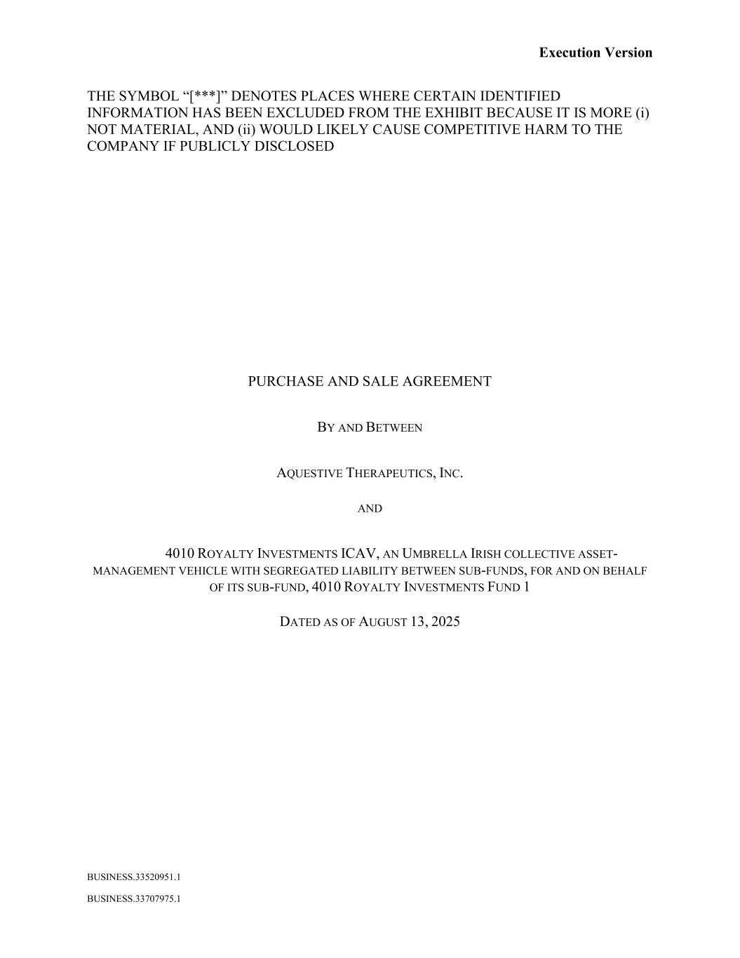
53
Execution Version BUSINESS.33520951.1 BUSINESS.33707975.1 THE SYMBOL “[***]” DENOTES PLACES WHERE CERTAIN IDENTIFIED INFORMATION HAS BEEN EXCLUDED FROM THE EXHIBIT BECAUSE IT IS MORE (i) NOT MATERIAL, AND (ii) WOULD LIKELY CAUSE COMPETITIVE HARM TO THE COMPANY IF PUBLICLY DISCLOSED PURCHASE AND SALE AGREEMENT BY AND BETWEEN AQUESTIVE THERAPEUTICS, INC. AND 4010 ROYALTY INVESTMENTS ICAV, AN UMBRELLA IRISH COLLECTIVE ASSET- MANAGEMENT VEHICLE WITH SEGREGATED LIABILITY BETWEEN SUB-FUNDS, FOR AND ON BEHALF OF ITS SUB-FUND, 4010 ROYALTY INVESTMENTS FUND 1 DATED AS OF AUGUST 13, 2025

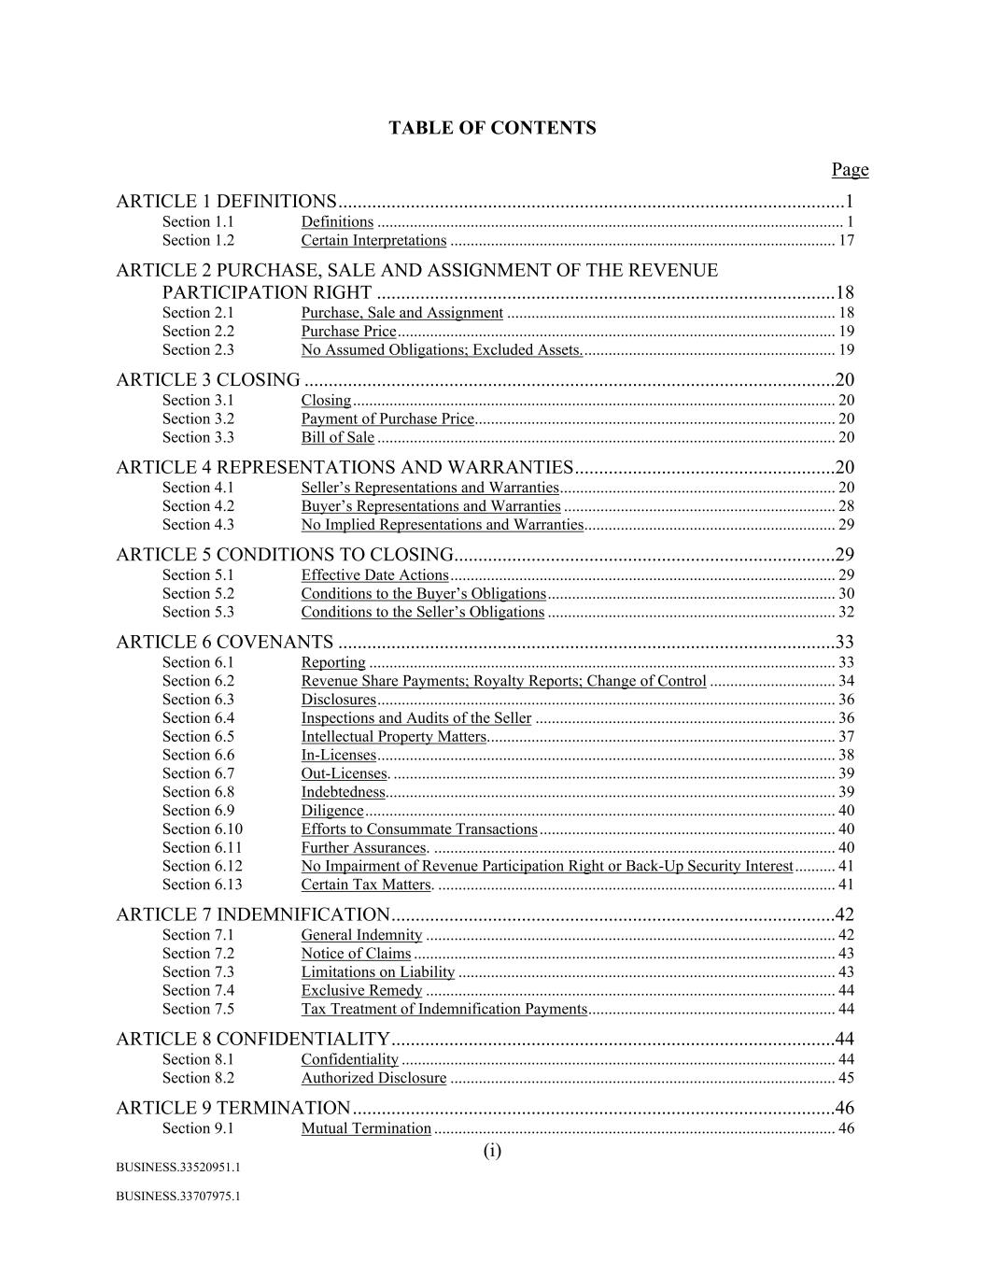
(i) BUSINESS.33520951.1 BUSINESS.33707975.1 TABLE OF CONTENTS Page ARTICLE 1 DEFINITIONS .........................................................................................................1 Section 1.1 Definitions ................................................................................................................... 1 Section 1.2 Certain Interpretations ............................................................................................... 17 ARTICLE 2 PURCHASE, SALE AND ASSIGNMENT OF THE REVENUE PARTICIPATION RIGHT ...............................................................................................18 Section 2.1 Purchase, Sale and Assignment ................................................................................. 18 Section 2.2 Purchase Price ............................................................................................................ 19 Section 2.3 No Assumed Obligations; Excluded Assets. .............................................................. 19 ARTICLE 3 CLOSING ..............................................................................................................20 Section 3.1 Closing ....................................................................................................................... 20 Section 3.2 Payment of Purchase Price ......................................................................................... 20 Section 3.3 Bill of Sale ................................................................................................................. 20 ARTICLE 4 REPRESENTATIONS AND WARRANTIES ......................................................20 Section 4.1 Seller’s Representations and Warranties .................................................................... 20 Section 4.2 Buyer’s Representations and Warranties ................................................................... 28 Section 4.3 No Implied Representations and Warranties .............................................................. 29 ARTICLE 5 CONDITIONS TO CLOSING...............................................................................29 Section 5.1 Effective Date Actions ............................................................................................... 29 Section 5.2 Conditions to the Buyer’s Obligations ....................................................................... 30 Section 5.3 Conditions to the Seller’s Obligations ....................................................................... 32 ARTICLE 6 COVENANTS .......................................................................................................33 Section 6.1 Reporting ................................................................................................................... 33 Section 6.2 Revenue Share Payments; Royalty Reports; Change of Control ............................... 34 Section 6.3 Disclosures ................................................................................................................. 36 Section 6.4 Inspections and Audits of the Seller .......................................................................... 36 Section 6.5 Intellectual Property Matters. ..................................................................................... 37 Section 6.6 In-Licenses ................................................................................................................. 38 Section 6.7 Out-Licenses. ............................................................................................................. 39 Section 6.8 Indebtedness............................................................................................................... 39 Section 6.9 Diligence .................................................................................................................... 40 Section 6.10 Efforts to Consummate Transactions ......................................................................... 40 Section 6.11 Further Assurances. ................................................................................................... 40 Section 6.12 No Impairment of Revenue Participation Right or Back-Up Security Interest .......... 41 Section 6.13 Certain Tax Matters. .................................................................................................. 41 ARTICLE 7 INDEMNIFICATION ............................................................................................42 Section 7.1 General Indemnity ..................................................................................................... 42 Section 7.2 Notice of Claims ........................................................................................................ 43 Section 7.3 Limitations on Liability ............................................................................................. 43 Section 7.4 Exclusive Remedy ..................................................................................................... 44 Section 7.5 Tax Treatment of Indemnification Payments ............................................................. 44 ARTICLE 8 CONFIDENTIALITY ............................................................................................44 Section 8.1 Confidentiality ........................................................................................................... 44 Section 8.2 Authorized Disclosure ............................................................................................... 45 ARTICLE 9 TERMINATION ....................................................................................................46 Section 9.1 Mutual Termination ................................................................................................... 46

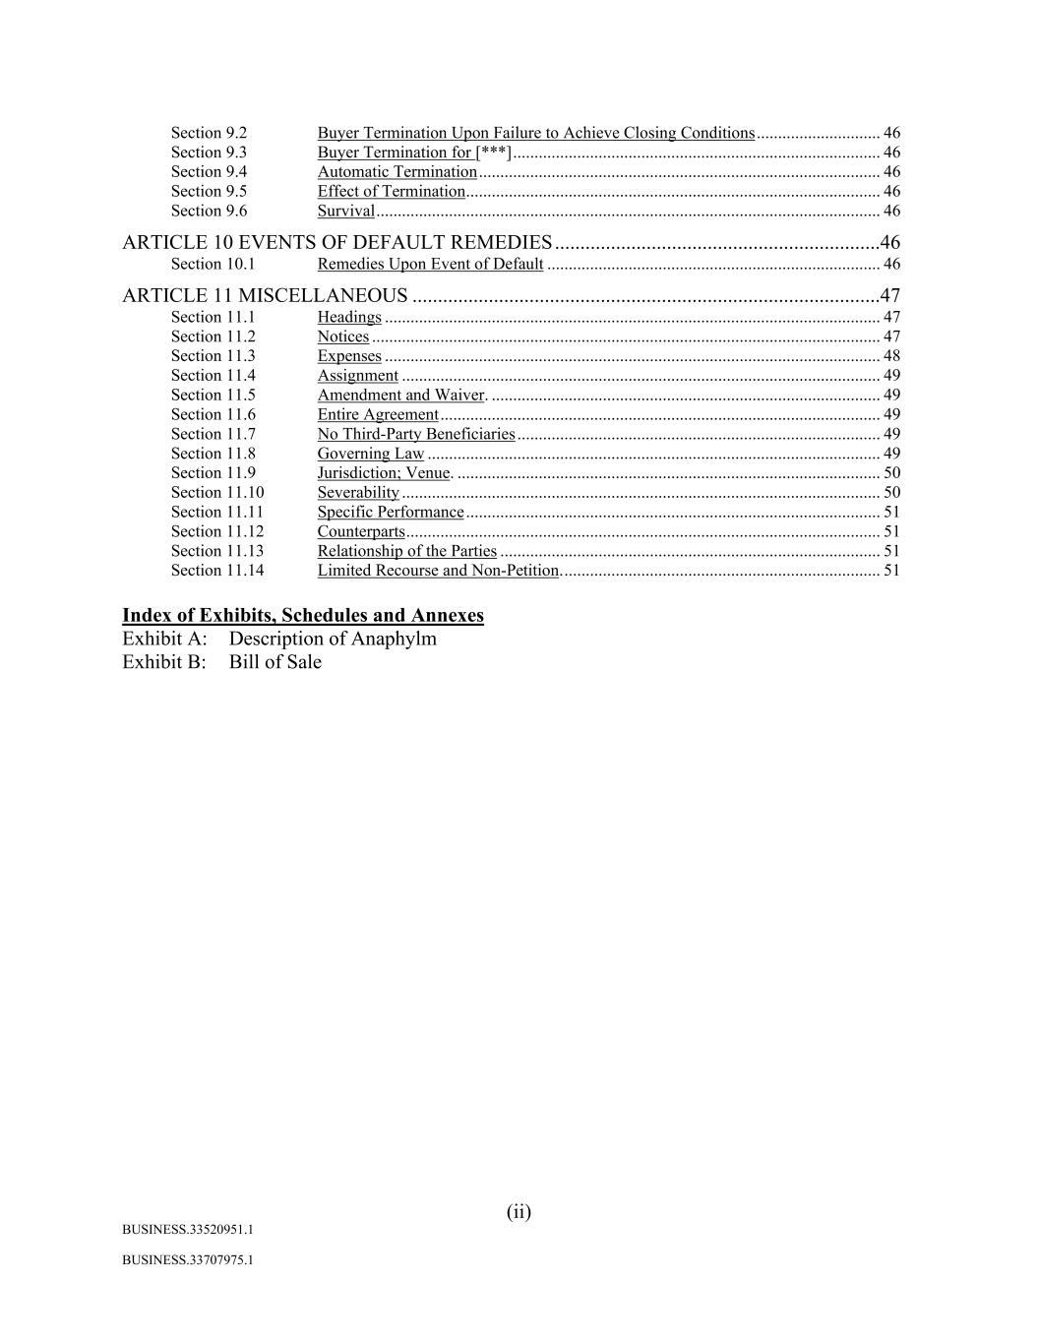
(ii) BUSINESS.33520951.1 BUSINESS.33707975.1 Section 9.2 Buyer Termination Upon Failure to Achieve Closing Conditions ............................. 46 Section 9.3 Buyer Termination for [***] ...................................................................................... 46 Section 9.4 Automatic Termination .............................................................................................. 46 Section 9.5 Effect of Termination ................................................................................................. 46 Section 9.6 Survival ...................................................................................................................... 46 ARTICLE 10 EVENTS OF DEFAULT REMEDIES ................................................................46 Section 10.1 Remedies Upon Event of Default .............................................................................. 46 ARTICLE 11 MISCELLANEOUS ............................................................................................47 Section 11.1 Headings .................................................................................................................... 47 Section 11.2 Notices ....................................................................................................................... 47 Section 11.3 Expenses .................................................................................................................... 48 Section 11.4 Assignment ................................................................................................................ 49 Section 11.5 Amendment and Waiver. ........................................................................................... 49 Section 11.6 Entire Agreement ....................................................................................................... 49 Section 11.7 No Third-Party Beneficiaries ..................................................................................... 49 Section 11.8 Governing Law .......................................................................................................... 49 Section 11.9 Jurisdiction; Venue. ................................................................................................... 50 Section 11.10 Severability ................................................................................................................ 50 Section 11.11 Specific Performance ................................................................................................. 51 Section 11.12 Counterparts ............................................................................................................... 51 Section 11.13 Relationship of the Parties ......................................................................................... 51 Section 11.14 Limited Recourse and Non-Petition. .......................................................................... 51 Index of Exhibits, Schedules and Annexes Exhibit A: Description of Anaphylm Exhibit B: Bill of Sale

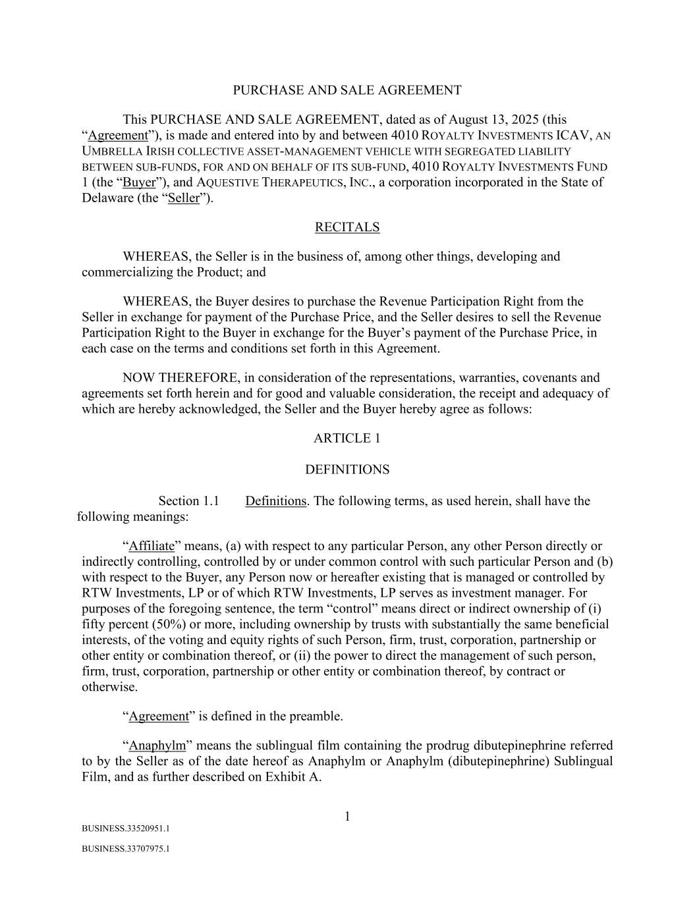
1 BUSINESS.33520951.1 BUSINESS.33707975.1 PURCHASE AND SALE AGREEMENT This PURCHASE AND SALE AGREEMENT, dated as of August 13, 2025 (this “Agreement”), is made and entered into by and between 4010 ROYALTY INVESTMENTS ICAV, AN UMBRELLA IRISH COLLECTIVE ASSET-MANAGEMENT VEHICLE WITH SEGREGATED LIABILITY BETWEEN SUB-FUNDS, FOR AND ON BEHALF OF ITS SUB-FUND, 4010 ROYALTY INVESTMENTS FUND 1 (the “Buyer”), and AQUESTIVE THERAPEUTICS, INC., a corporation incorporated in the State of Delaware (the “Seller”). RECITALS WHEREAS, the Seller is in the business of, among other things, developing and commercializing the Product; and WHEREAS, the Buyer desires to purchase the Revenue Participation Right from the Seller in exchange for payment of the Purchase Price, and the Seller desires to sell the Revenue Participation Right to the Buyer in exchange for the Buyer’s payment of the Purchase Price, in each case on the terms and conditions set forth in this Agreement. NOW THEREFORE, in consideration of the representations, warranties, covenants and agreements set forth herein and for good and valuable consideration, the receipt and adequacy of which are hereby acknowledged, the Seller and the Buyer hereby agree as follows: ARTICLE 1 DEFINITIONS Section 1.1 Definitions. The following terms, as used herein, shall have the following meanings: “Affiliate” means, (a) with respect to any particular Person, any other Person directly or indirectly controlling, controlled by or under common control with such particular Person and (b) with respect to the Buyer, any Person now or hereafter existing that is managed or controlled by RTW Investments, LP or of which RTW Investments, LP serves as investment manager. For purposes of the foregoing sentence, the term “control” means direct or indirect ownership of (i) fifty percent (50%) or more, including ownership by trusts with substantially the same beneficial interests, of the voting and equity rights of such Person, firm, trust, corporation, partnership or other entity or combination thereof, or (ii) the power to direct the management of such person, firm, trust, corporation, partnership or other entity or combination thereof, by contract or otherwise. “Agreement” is defined in the preamble. “Anaphylm” means the sublingual film containing the prodrug dibutepinephrine referred to by the Seller as of the date hereof as Anaphylm or Anaphylm (dibutepinephrine) Sublingual Film, and as further described on Exhibit A.

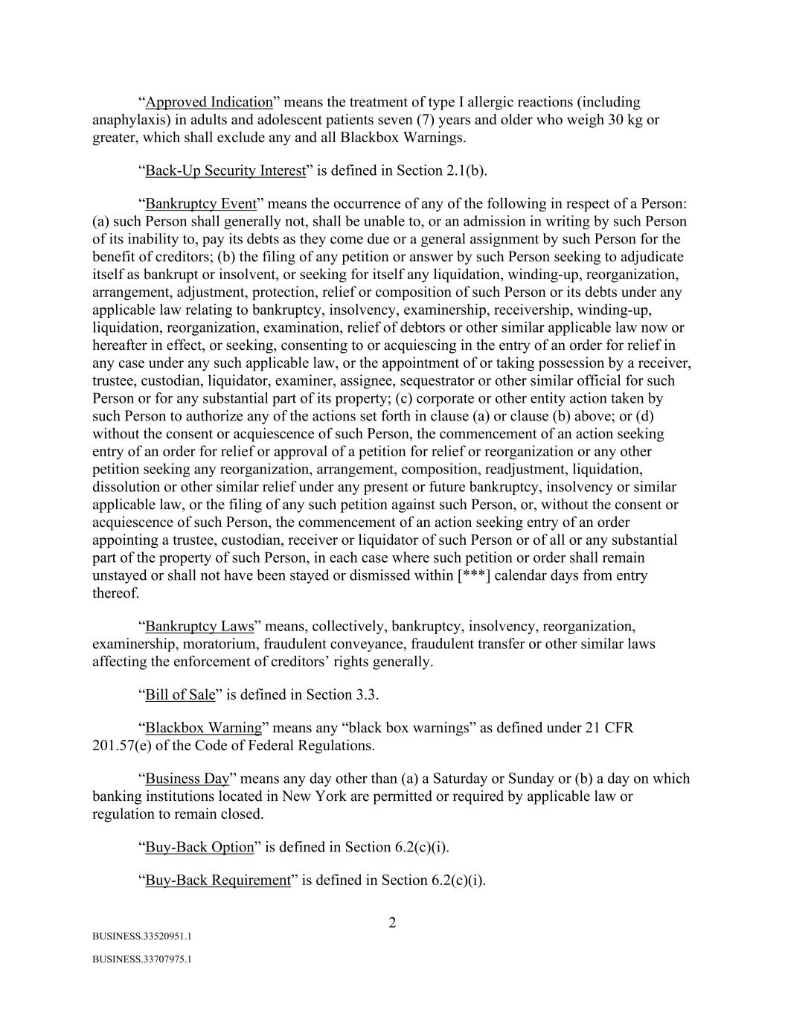
2 BUSINESS.33520951.1 BUSINESS.33707975.1 “Approved Indication” means the treatment of type I allergic reactions (including anaphylaxis) in adults and adolescent patients seven (7) years and older who weigh 30 kg or greater, which shall exclude any and all Blackbox Warnings. “Back-Up Security Interest” is defined in Section 2.1(b). “Bankruptcy Event” means the occurrence of any of the following in respect of a Person: (a) such Person shall generally not, shall be unable to, or an admission in writing by such Person of its inability to, pay its debts as they come due or a general assignment by such Person for the benefit of creditors; (b) the filing of any petition or answer by such Person seeking to adjudicate itself as bankrupt or insolvent, or seeking for itself any liquidation, winding-up, reorganization, arrangement, adjustment, protection, relief or composition of such Person or its debts under any applicable law relating to bankruptcy, insolvency, examinership, receivership, winding-up, liquidation, reorganization, examination, relief of debtors or other similar applicable law now or hereafter in effect, or seeking, consenting to or acquiescing in the entry of an order for relief in any case under any such applicable law, or the appointment of or taking possession by a receiver, trustee, custodian, liquidator, examiner, assignee, sequestrator or other similar official for such Person or for any substantial part of its property; (c) corporate or other entity action taken by such Person to authorize any of the actions set forth in clause (a) or clause (b) above; or (d) without the consent or acquiescence of such Person, the commencement of an action seeking entry of an order for relief or approval of a petition for relief or reorganization or any other petition seeking any reorganization, arrangement, composition, readjustment, liquidation, dissolution or other similar relief under any present or future bankruptcy, insolvency or similar applicable law, or the filing of any such petition against such Person, or, without the consent or acquiescence of such Person, the commencement of an action seeking entry of an order appointing a trustee, custodian, receiver or liquidator of such Person or of all or any substantial part of the property of such Person, in each case where such petition or order shall remain unstayed or shall not have been stayed or dismissed within [***] calendar days from entry thereof. “Bankruptcy Laws” means, collectively, bankruptcy, insolvency, reorganization, examinership, moratorium, fraudulent conveyance, fraudulent transfer or other similar laws affecting the enforcement of creditors’ rights generally. “Bill of Sale” is defined in Section 3.3. “Blackbox Warning” means any “black box warnings” as defined under 21 CFR 201.57(e) of the Code of Federal Regulations. “Business Day” means any day other than (a) a Saturday or Sunday or (b) a day on which banking institutions located in New York are permitted or required by applicable law or regulation to remain closed. “Buy-Back Option” is defined in Section 6.2(c)(i). “Buy-Back Requirement” is defined in Section 6.2(c)(i).

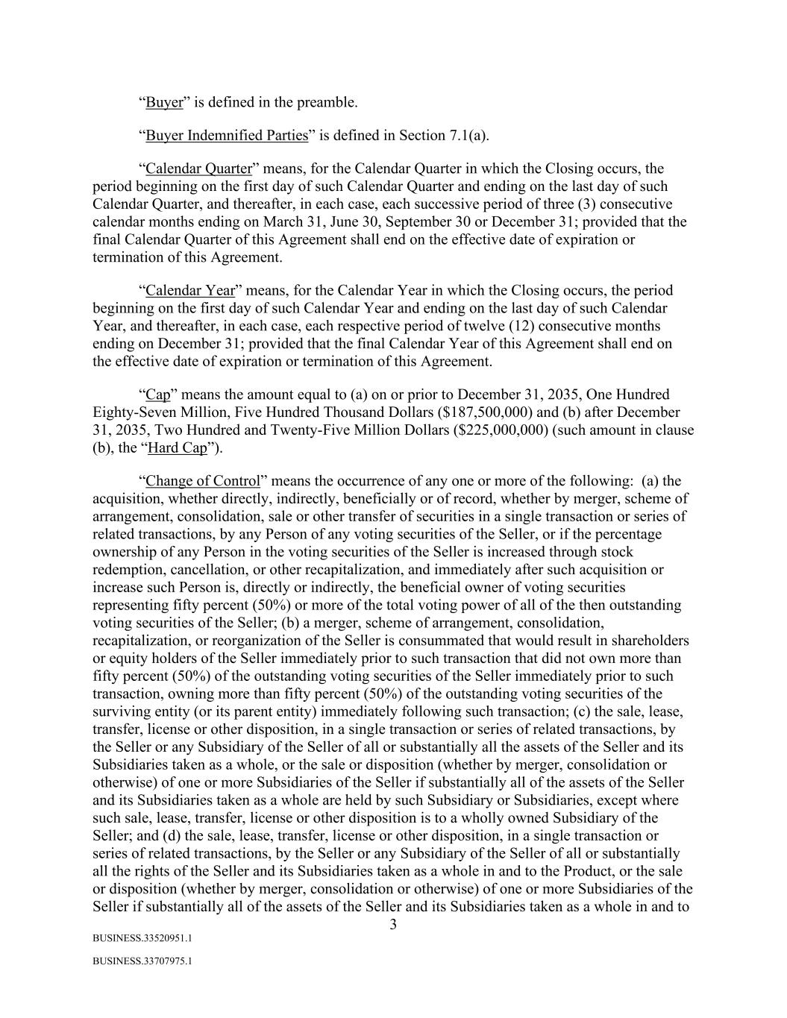
3 BUSINESS.33520951.1 BUSINESS.33707975.1 “Buyer” is defined in the preamble. “Buyer Indemnified Parties” is defined in Section 7.1(a). “Calendar Quarter” means, for the Calendar Quarter in which the Closing occurs, the period beginning on the first day of such Calendar Quarter and ending on the last day of such Calendar Quarter, and thereafter, in each case, each successive period of three (3) consecutive calendar months ending on March 31, June 30, September 30 or December 31; provided that the final Calendar Quarter of this Agreement shall end on the effective date of expiration or termination of this Agreement. “Calendar Year” means, for the Calendar Year in which the Closing occurs, the period beginning on the first day of such Calendar Year and ending on the last day of such Calendar Year, and thereafter, in each case, each respective period of twelve (12) consecutive months ending on December 31; provided that the final Calendar Year of this Agreement shall end on the effective date of expiration or termination of this Agreement. “Cap” means the amount equal to (a) on or prior to December 31, 2035, One Hundred Eighty-Seven Million, Five Hundred Thousand Dollars ($187,500,000) and (b) after December 31, 2035, Two Hundred and Twenty-Five Million Dollars ($225,000,000) (such amount in clause (b), the “Hard Cap”). “Change of Control” means the occurrence of any one or more of the following: (a) the acquisition, whether directly, indirectly, beneficially or of record, whether by merger, scheme of arrangement, consolidation, sale or other transfer of securities in a single transaction or series of related transactions, by any Person of any voting securities of the Seller, or if the percentage ownership of any Person in the voting securities of the Seller is increased through stock redemption, cancellation, or other recapitalization, and immediately after such acquisition or increase such Person is, directly or indirectly, the beneficial owner of voting securities representing fifty percent (50%) or more of the total voting power of all of the then outstanding voting securities of the Seller; (b) a merger, scheme of arrangement, consolidation, recapitalization, or reorganization of the Seller is consummated that would result in shareholders or equity holders of the Seller immediately prior to such transaction that did not own more than fifty percent (50%) of the outstanding voting securities of the Seller immediately prior to such transaction, owning more than fifty percent (50%) of the outstanding voting securities of the surviving entity (or its parent entity) immediately following such transaction; (c) the sale, lease, transfer, license or other disposition, in a single transaction or series of related transactions, by the Seller or any Subsidiary of the Seller of all or substantially all the assets of the Seller and its Subsidiaries taken as a whole, or the sale or disposition (whether by merger, consolidation or otherwise) of one or more Subsidiaries of the Seller if substantially all of the assets of the Seller and its Subsidiaries taken as a whole are held by such Subsidiary or Subsidiaries, except where such sale, lease, transfer, license or other disposition is to a wholly owned Subsidiary of the Seller; and (d) the sale, lease, transfer, license or other disposition, in a single transaction or series of related transactions, by the Seller or any Subsidiary of the Seller of all or substantially all the rights of the Seller and its Subsidiaries taken as a whole in and to the Product, or the sale or disposition (whether by merger, consolidation or otherwise) of one or more Subsidiaries of the Seller if substantially all of the assets of the Seller and its Subsidiaries taken as a whole in and to

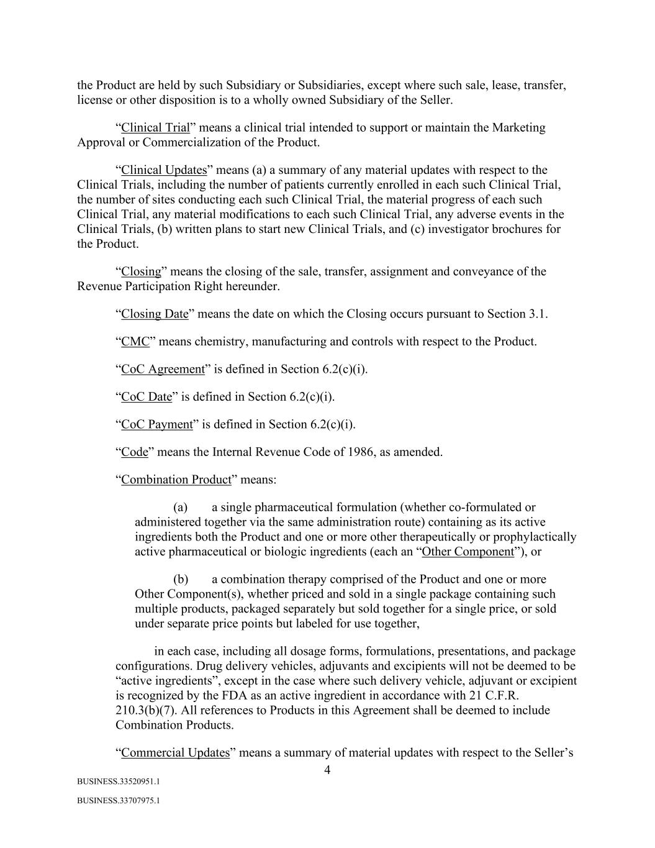
4 BUSINESS.33520951.1 BUSINESS.33707975.1 the Product are held by such Subsidiary or Subsidiaries, except where such sale, lease, transfer, license or other disposition is to a wholly owned Subsidiary of the Seller. “Clinical Trial” means a clinical trial intended to support or maintain the Marketing Approval or Commercialization of the Product. “Clinical Updates” means (a) a summary of any material updates with respect to the Clinical Trials, including the number of patients currently enrolled in each such Clinical Trial, the number of sites conducting each such Clinical Trial, the material progress of each such Clinical Trial, any material modifications to each such Clinical Trial, any adverse events in the Clinical Trials, (b) written plans to start new Clinical Trials, and (c) investigator brochures for the Product. “Closing” means the closing of the sale, transfer, assignment and conveyance of the Revenue Participation Right hereunder. “Closing Date” means the date on which the Closing occurs pursuant to Section 3.1. “CMC” means chemistry, manufacturing and controls with respect to the Product. “CoC Agreement” is defined in Section 6.2(c)(i). “CoC Date” is defined in Section 6.2(c)(i). “CoC Payment” is defined in Section 6.2(c)(i). “Code” means the Internal Revenue Code of 1986, as amended. “Combination Product” means: (a) a single pharmaceutical formulation (whether co-formulated or administered together via the same administration route) containing as its active ingredients both the Product and one or more other therapeutically or prophylactically active pharmaceutical or biologic ingredients (each an “Other Component”), or (b) a combination therapy comprised of the Product and one or more Other Component(s), whether priced and sold in a single package containing such multiple products, packaged separately but sold together for a single price, or sold under separate price points but labeled for use together, in each case, including all dosage forms, formulations, presentations, and package configurations. Drug delivery vehicles, adjuvants and excipients will not be deemed to be “active ingredients”, except in the case where such delivery vehicle, adjuvant or excipient is recognized by the FDA as an active ingredient in accordance with 21 C.F.R. 210.3(b)(7). All references to Products in this Agreement shall be deemed to include Combination Products. “Commercial Updates” means a summary of material updates with respect to the Seller’s

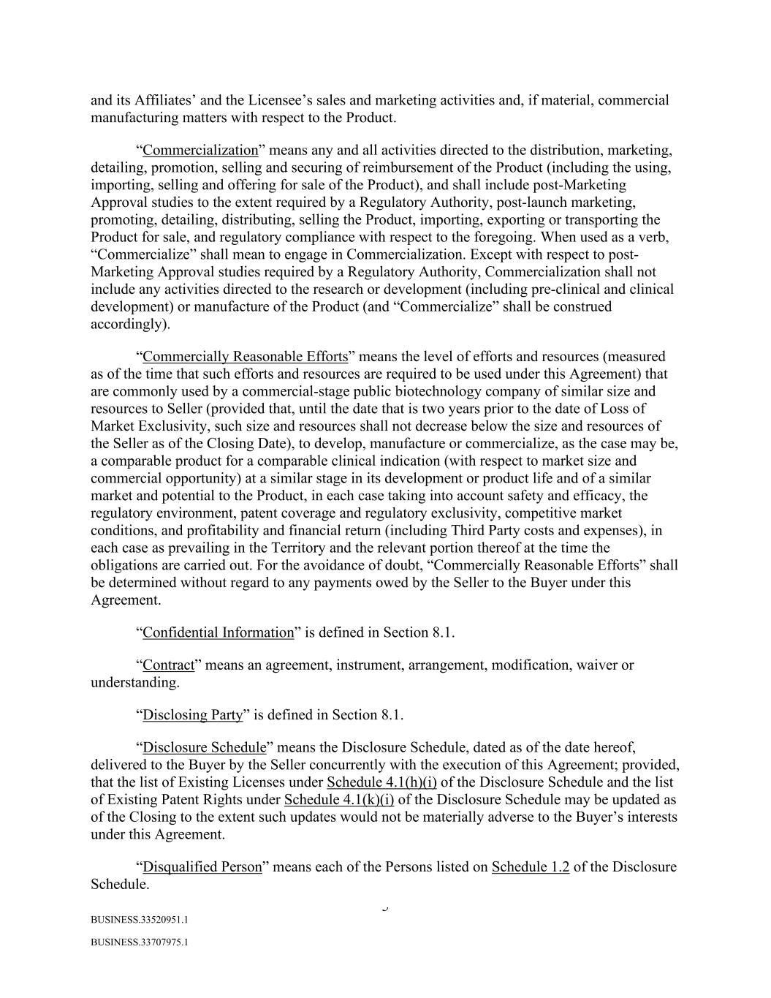
5 BUSINESS.33520951.1 BUSINESS.33707975.1 and its Affiliates’ and the Licensee’s sales and marketing activities and, if material, commercial manufacturing matters with respect to the Product. “Commercialization” means any and all activities directed to the distribution, marketing, detailing, promotion, selling and securing of reimbursement of the Product (including the using, importing, selling and offering for sale of the Product), and shall include post-Marketing Approval studies to the extent required by a Regulatory Authority, post-launch marketing, promoting, detailing, distributing, selling the Product, importing, exporting or transporting the Product for sale, and regulatory compliance with respect to the foregoing. When used as a verb, “Commercialize” shall mean to engage in Commercialization. Except with respect to post- Marketing Approval studies required by a Regulatory Authority, Commercialization shall not include any activities directed to the research or development (including pre-clinical and clinical development) or manufacture of the Product (and “Commercialize” shall be construed accordingly). “Commercially Reasonable Efforts” means the level of efforts and resources (measured as of the time that such efforts and resources are required to be used under this Agreement) that are commonly used by a commercial-stage public biotechnology company of similar size and resources to Seller (provided that, until the date that is two years prior to the date of Loss of Market Exclusivity, such size and resources shall not decrease below the size and resources of the Seller as of the Closing Date), to develop, manufacture or commercialize, as the case may be, a comparable product for a comparable clinical indication (with respect to market size and commercial opportunity) at a similar stage in its development or product life and of a similar market and potential to the Product, in each case taking into account safety and efficacy, the regulatory environment, patent coverage and regulatory exclusivity, competitive market conditions, and profitability and financial return (including Third Party costs and expenses), in each case as prevailing in the Territory and the relevant portion thereof at the time the obligations are carried out. For the avoidance of doubt, “Commercially Reasonable Efforts” shall be determined without regard to any payments owed by the Seller to the Buyer under this Agreement. “Confidential Information” is defined in Section 8.1. “Contract” means an agreement, instrument, arrangement, modification, waiver or understanding. “Disclosing Party” is defined in Section 8.1. “Disclosure Schedule” means the Disclosure Schedule, dated as of the date hereof, delivered to the Buyer by the Seller concurrently with the execution of this Agreement; provided, that the list of Existing Licenses under Schedule 4.1(h)(i) of the Disclosure Schedule and the list of Existing Patent Rights under Schedule 4.1(k)(i) of the Disclosure Schedule may be updated as of the Closing to the extent such updates would not be materially adverse to the Buyer’s interests under this Agreement. “Disqualified Person” means each of the Persons listed on Schedule 1.2 of the Disclosure Schedule.

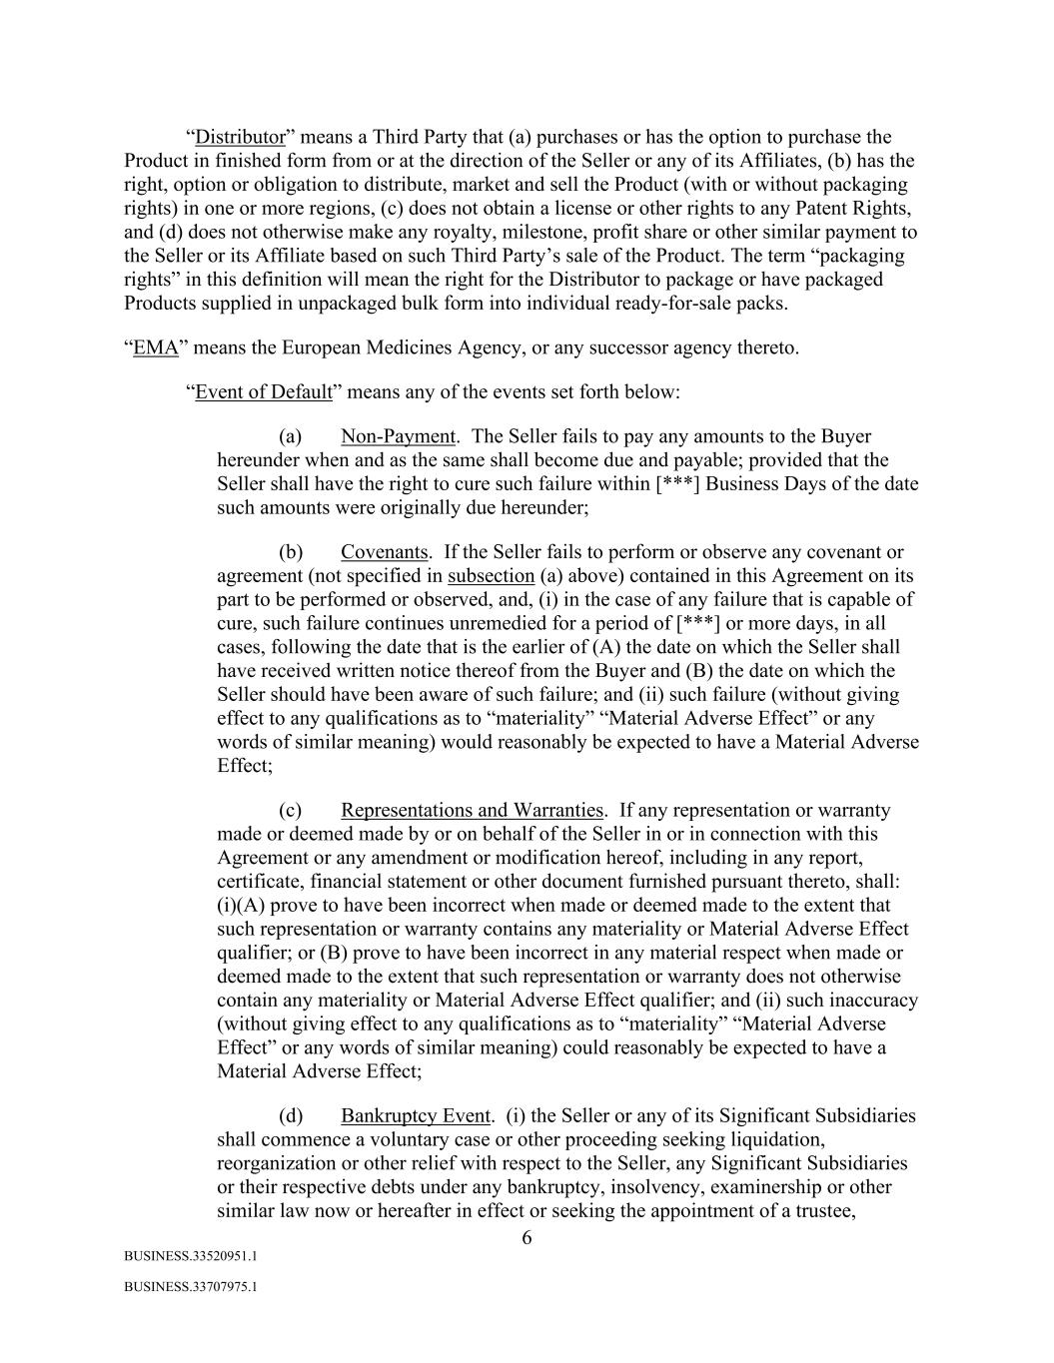
6 BUSINESS.33520951.1 BUSINESS.33707975.1 “Distributor” means a Third Party that (a) purchases or has the option to purchase the Product in finished form from or at the direction of the Seller or any of its Affiliates, (b) has the right, option or obligation to distribute, market and sell the Product (with or without packaging rights) in one or more regions, (c) does not obtain a license or other rights to any Patent Rights, and (d) does not otherwise make any royalty, milestone, profit share or other similar payment to the Seller or its Affiliate based on such Third Party’s sale of the Product. The term “packaging rights” in this definition will mean the right for the Distributor to package or have packaged Products supplied in unpackaged bulk form into individual ready-for-sale packs. “EMA” means the European Medicines Agency, or any successor agency thereto. “Event of Default” means any of the events set forth below: (a) Non-Payment. The Seller fails to pay any amounts to the Buyer hereunder when and as the same shall become due and payable; provided that the Seller shall have the right to cure such failure within [***] Business Days of the date such amounts were originally due hereunder; (b) Covenants. If the Seller fails to perform or observe any covenant or agreement (not specified in subsection (a) above) contained in this Agreement on its part to be performed or observed, and, (i) in the case of any failure that is capable of cure, such failure continues unremedied for a period of [***] or more days, in all cases, following the date that is the earlier of (A) the date on which the Seller shall have received written notice thereof from the Buyer and (B) the date on which the Seller should have been aware of such failure; and (ii) such failure (without giving effect to any qualifications as to “materiality” “Material Adverse Effect” or any words of similar meaning) would reasonably be expected to have a Material Adverse Effect; (c) Representations and Warranties. If any representation or warranty made or deemed made by or on behalf of the Seller in or in connection with this Agreement or any amendment or modification hereof, including in any report, certificate, financial statement or other document furnished pursuant thereto, shall: (i)(A) prove to have been incorrect when made or deemed made to the extent that such representation or warranty contains any materiality or Material Adverse Effect qualifier; or (B) prove to have been incorrect in any material respect when made or deemed made to the extent that such representation or warranty does not otherwise contain any materiality or Material Adverse Effect qualifier; and (ii) such inaccuracy (without giving effect to any qualifications as to “materiality” “Material Adverse Effect” or any words of similar meaning) could reasonably be expected to have a Material Adverse Effect; (d) Bankruptcy Event. (i) the Seller or any of its Significant Subsidiaries shall commence a voluntary case or other proceeding seeking liquidation, reorganization or other relief with respect to the Seller, any Significant Subsidiaries or their respective debts under any bankruptcy, insolvency, examinership or other similar law now or hereafter in effect or seeking the appointment of a trustee,

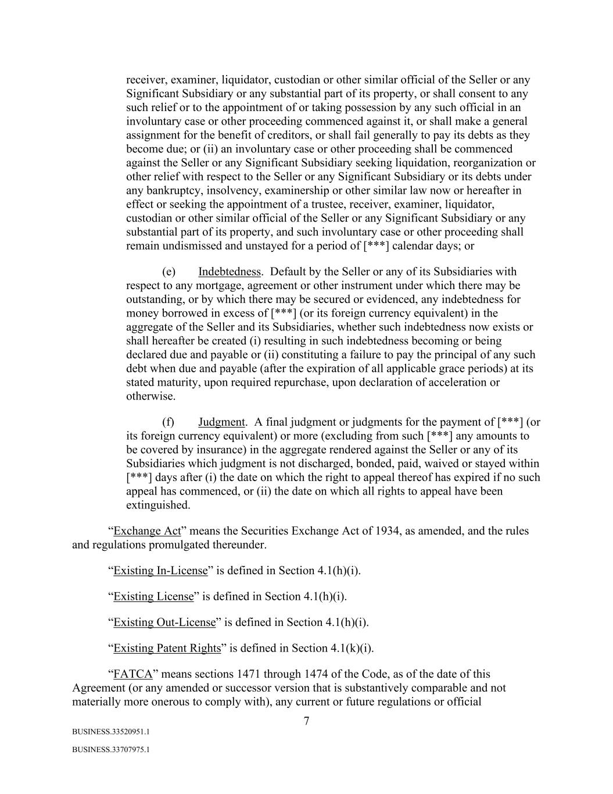
7 BUSINESS.33520951.1 BUSINESS.33707975.1 receiver, examiner, liquidator, custodian or other similar official of the Seller or any Significant Subsidiary or any substantial part of its property, or shall consent to any such relief or to the appointment of or taking possession by any such official in an involuntary case or other proceeding commenced against it, or shall make a general assignment for the benefit of creditors, or shall fail generally to pay its debts as they become due; or (ii) an involuntary case or other proceeding shall be commenced against the Seller or any Significant Subsidiary seeking liquidation, reorganization or other relief with respect to the Seller or any Significant Subsidiary or its debts under any bankruptcy, insolvency, examinership or other similar law now or hereafter in effect or seeking the appointment of a trustee, receiver, examiner, liquidator, custodian or other similar official of the Seller or any Significant Subsidiary or any substantial part of its property, and such involuntary case or other proceeding shall remain undismissed and unstayed for a period of [***] calendar days; or (e) Indebtedness. Default by the Seller or any of its Subsidiaries with respect to any mortgage, agreement or other instrument under which there may be outstanding, or by which there may be secured or evidenced, any indebtedness for money borrowed in excess of [***] (or its foreign currency equivalent) in the aggregate of the Seller and its Subsidiaries, whether such indebtedness now exists or shall hereafter be created (i) resulting in such indebtedness becoming or being declared due and payable or (ii) constituting a failure to pay the principal of any such debt when due and payable (after the expiration of all applicable grace periods) at its stated maturity, upon required repurchase, upon declaration of acceleration or otherwise. (f) Judgment. A final judgment or judgments for the payment of [***] (or its foreign currency equivalent) or more (excluding from such [***] any amounts to be covered by insurance) in the aggregate rendered against the Seller or any of its Subsidiaries which judgment is not discharged, bonded, paid, waived or stayed within [***] days after (i) the date on which the right to appeal thereof has expired if no such appeal has commenced, or (ii) the date on which all rights to appeal have been extinguished. “Exchange Act” means the Securities Exchange Act of 1934, as amended, and the rules and regulations promulgated thereunder. “Existing In-License” is defined in Section 4.1(h)(i). “Existing License” is defined in Section 4.1(h)(i). “Existing Out-License” is defined in Section 4.1(h)(i). “Existing Patent Rights” is defined in Section 4.1(k)(i). “FATCA” means sections 1471 through 1474 of the Code, as of the date of this Agreement (or any amended or successor version that is substantively comparable and not materially more onerous to comply with), any current or future regulations or official

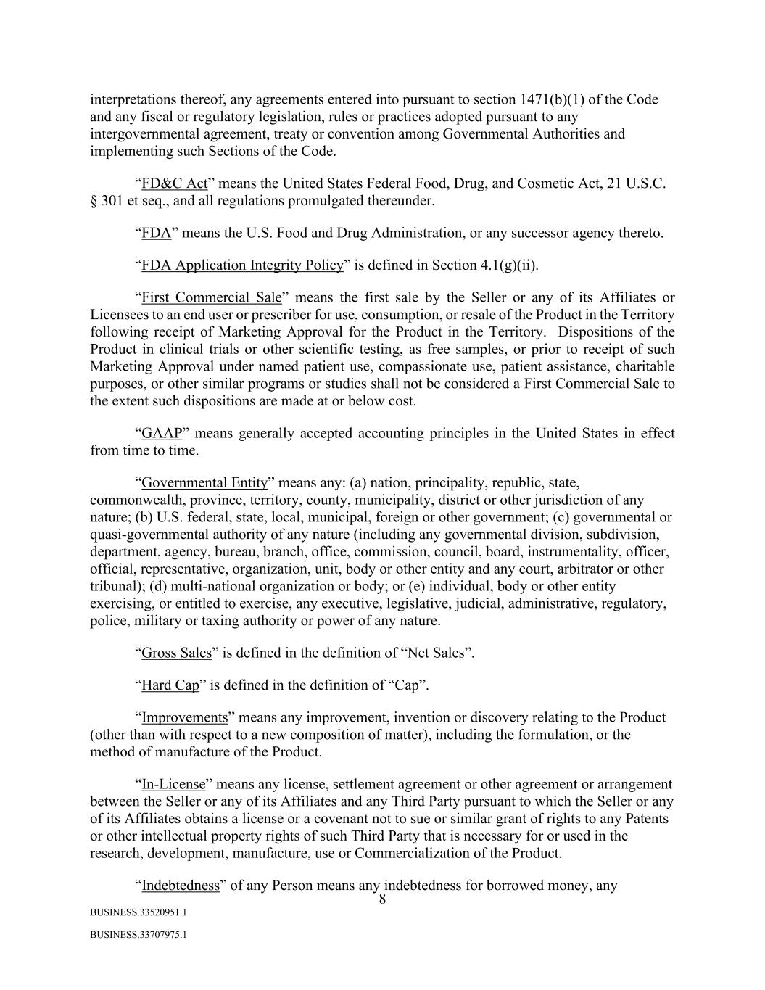
8 BUSINESS.33520951.1 BUSINESS.33707975.1 interpretations thereof, any agreements entered into pursuant to section 1471(b)(1) of the Code and any fiscal or regulatory legislation, rules or practices adopted pursuant to any intergovernmental agreement, treaty or convention among Governmental Authorities and implementing such Sections of the Code. “FD&C Act” means the United States Federal Food, Drug, and Cosmetic Act, 21 U.S.C. § 301 et seq., and all regulations promulgated thereunder. “FDA” means the U.S. Food and Drug Administration, or any successor agency thereto. “FDA Application Integrity Policy” is defined in Section 4.1(g)(ii). “First Commercial Sale” means the first sale by the Seller or any of its Affiliates or Licensees to an end user or prescriber for use, consumption, or resale of the Product in the Territory following receipt of Marketing Approval for the Product in the Territory. Dispositions of the Product in clinical trials or other scientific testing, as free samples, or prior to receipt of such Marketing Approval under named patient use, compassionate use, patient assistance, charitable purposes, or other similar programs or studies shall not be considered a First Commercial Sale to the extent such dispositions are made at or below cost. “GAAP” means generally accepted accounting principles in the United States in effect from time to time. “Governmental Entity” means any: (a) nation, principality, republic, state, commonwealth, province, territory, county, municipality, district or other jurisdiction of any nature; (b) U.S. federal, state, local, municipal, foreign or other government; (c) governmental or quasi-governmental authority of any nature (including any governmental division, subdivision, department, agency, bureau, branch, office, commission, council, board, instrumentality, officer, official, representative, organization, unit, body or other entity and any court, arbitrator or other tribunal); (d) multi-national organization or body; or (e) individual, body or other entity exercising, or entitled to exercise, any executive, legislative, judicial, administrative, regulatory, police, military or taxing authority or power of any nature. “Gross Sales” is defined in the definition of “Net Sales”. “Hard Cap” is defined in the definition of “Cap”. “Improvements” means any improvement, invention or discovery relating to the Product (other than with respect to a new composition of matter), including the formulation, or the method of manufacture of the Product. “In-License” means any license, settlement agreement or other agreement or arrangement between the Seller or any of its Affiliates and any Third Party pursuant to which the Seller or any of its Affiliates obtains a license or a covenant not to sue or similar grant of rights to any Patents or other intellectual property rights of such Third Party that is necessary for or used in the research, development, manufacture, use or Commercialization of the Product. “Indebtedness” of any Person means any indebtedness for borrowed money, any

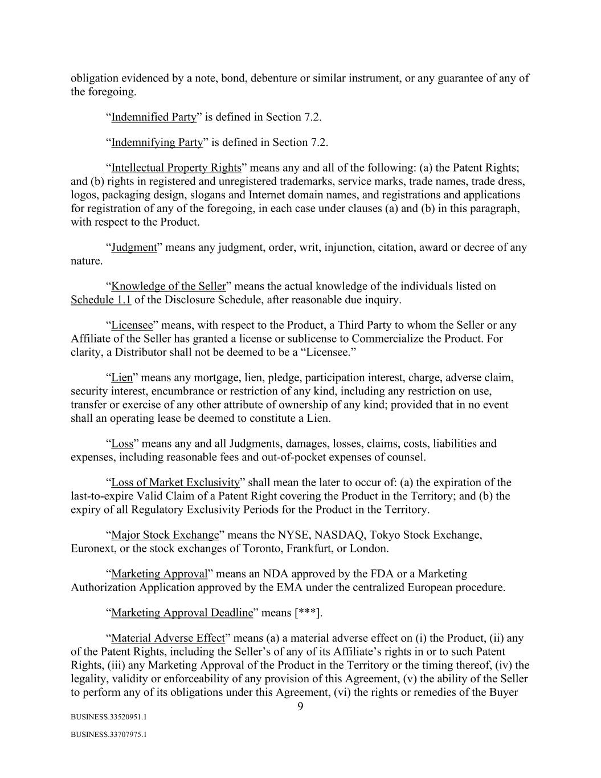
9 BUSINESS.33520951.1 BUSINESS.33707975.1 obligation evidenced by a note, bond, debenture or similar instrument, or any guarantee of any of the foregoing. “Indemnified Party” is defined in Section 7.2. “Indemnifying Party” is defined in Section 7.2. “Intellectual Property Rights” means any and all of the following: (a) the Patent Rights; and (b) rights in registered and unregistered trademarks, service marks, trade names, trade dress, logos, packaging design, slogans and Internet domain names, and registrations and applications for registration of any of the foregoing, in each case under clauses (a) and (b) in this paragraph, with respect to the Product. “Judgment” means any judgment, order, writ, injunction, citation, award or decree of any nature. “Knowledge of the Seller” means the actual knowledge of the individuals listed on Schedule 1.1 of the Disclosure Schedule, after reasonable due inquiry. “Licensee” means, with respect to the Product, a Third Party to whom the Seller or any Affiliate of the Seller has granted a license or sublicense to Commercialize the Product. For clarity, a Distributor shall not be deemed to be a “Licensee.” “Lien” means any mortgage, lien, pledge, participation interest, charge, adverse claim, security interest, encumbrance or restriction of any kind, including any restriction on use, transfer or exercise of any other attribute of ownership of any kind; provided that in no event shall an operating lease be deemed to constitute a Lien. “Loss” means any and all Judgments, damages, losses, claims, costs, liabilities and expenses, including reasonable fees and out-of-pocket expenses of counsel. “Loss of Market Exclusivity” shall mean the later to occur of: (a) the expiration of the last-to-expire Valid Claim of a Patent Right covering the Product in the Territory; and (b) the expiry of all Regulatory Exclusivity Periods for the Product in the Territory. “Major Stock Exchange” means the NYSE, NASDAQ, Tokyo Stock Exchange, Euronext, or the stock exchanges of Toronto, Frankfurt, or London. “Marketing Approval” means an NDA approved by the FDA or a Marketing Authorization Application approved by the EMA under the centralized European procedure. “Marketing Approval Deadline” means [***]. “Material Adverse Effect” means (a) a material adverse effect on (i) the Product, (ii) any of the Patent Rights, including the Seller’s of any of its Affiliate’s rights in or to such Patent Rights, (iii) any Marketing Approval of the Product in the Territory or the timing thereof, (iv) the legality, validity or enforceability of any provision of this Agreement, (v) the ability of the Seller to perform any of its obligations under this Agreement, (vi) the rights or remedies of the Buyer

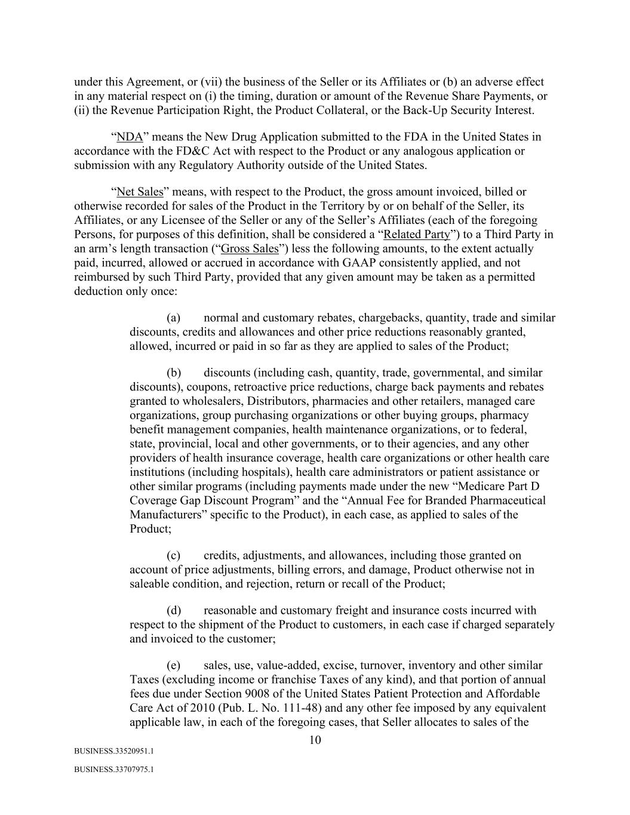
10 BUSINESS.33520951.1 BUSINESS.33707975.1 under this Agreement, or (vii) the business of the Seller or its Affiliates or (b) an adverse effect in any material respect on (i) the timing, duration or amount of the Revenue Share Payments, or (ii) the Revenue Participation Right, the Product Collateral, or the Back-Up Security Interest. “NDA” means the New Drug Application submitted to the FDA in the United States in accordance with the FD&C Act with respect to the Product or any analogous application or submission with any Regulatory Authority outside of the United States. “Net Sales” means, with respect to the Product, the gross amount invoiced, billed or otherwise recorded for sales of the Product in the Territory by or on behalf of the Seller, its Affiliates, or any Licensee of the Seller or any of the Seller’s Affiliates (each of the foregoing Persons, for purposes of this definition, shall be considered a “Related Party”) to a Third Party in an arm’s length transaction (“Gross Sales”) less the following amounts, to the extent actually paid, incurred, allowed or accrued in accordance with GAAP consistently applied, and not reimbursed by such Third Party, provided that any given amount may be taken as a permitted deduction only once: (a) normal and customary rebates, chargebacks, quantity, trade and similar discounts, credits and allowances and other price reductions reasonably granted, allowed, incurred or paid in so far as they are applied to sales of the Product; (b) discounts (including cash, quantity, trade, governmental, and similar discounts), coupons, retroactive price reductions, charge back payments and rebates granted to wholesalers, Distributors, pharmacies and other retailers, managed care organizations, group purchasing organizations or other buying groups, pharmacy benefit management companies, health maintenance organizations, or to federal, state, provincial, local and other governments, or to their agencies, and any other providers of health insurance coverage, health care organizations or other health care institutions (including hospitals), health care administrators or patient assistance or other similar programs (including payments made under the new “Medicare Part D Coverage Gap Discount Program” and the “Annual Fee for Branded Pharmaceutical Manufacturers” specific to the Product), in each case, as applied to sales of the Product; (c) credits, adjustments, and allowances, including those granted on account of price adjustments, billing errors, and damage, Product otherwise not in saleable condition, and rejection, return or recall of the Product; (d) reasonable and customary freight and insurance costs incurred with respect to the shipment of the Product to customers, in each case if charged separately and invoiced to the customer; (e) sales, use, value-added, excise, turnover, inventory and other similar Taxes (excluding income or franchise Taxes of any kind), and that portion of annual fees due under Section 9008 of the United States Patient Protection and Affordable Care Act of 2010 (Pub. L. No. 111-48) and any other fee imposed by any equivalent applicable law, in each of the foregoing cases, that Seller allocates to sales of the

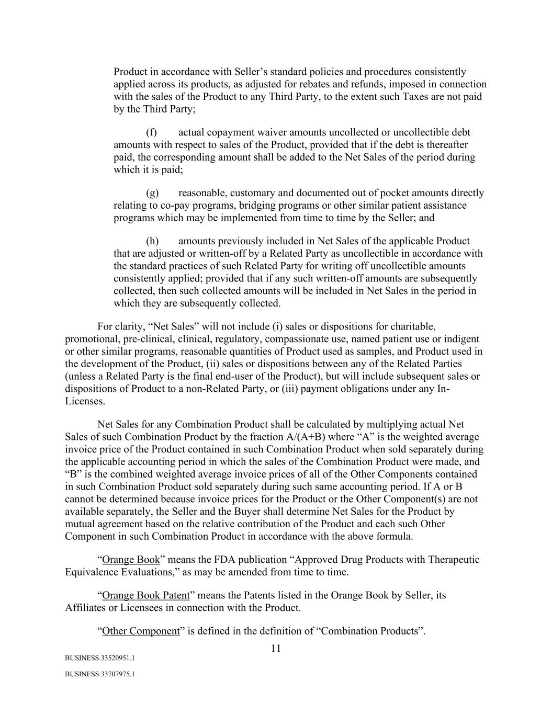
11 BUSINESS.33520951.1 BUSINESS.33707975.1 Product in accordance with Seller’s standard policies and procedures consistently applied across its products, as adjusted for rebates and refunds, imposed in connection with the sales of the Product to any Third Party, to the extent such Taxes are not paid by the Third Party; (f) actual copayment waiver amounts uncollected or uncollectible debt amounts with respect to sales of the Product, provided that if the debt is thereafter paid, the corresponding amount shall be added to the Net Sales of the period during which it is paid; (g) reasonable, customary and documented out of pocket amounts directly relating to co-pay programs, bridging programs or other similar patient assistance programs which may be implemented from time to time by the Seller; and (h) amounts previously included in Net Sales of the applicable Product that are adjusted or written-off by a Related Party as uncollectible in accordance with the standard practices of such Related Party for writing off uncollectible amounts consistently applied; provided that if any such written-off amounts are subsequently collected, then such collected amounts will be included in Net Sales in the period in which they are subsequently collected. For clarity, “Net Sales” will not include (i) sales or dispositions for charitable, promotional, pre-clinical, clinical, regulatory, compassionate use, named patient use or indigent or other similar programs, reasonable quantities of Product used as samples, and Product used in the development of the Product, (ii) sales or dispositions between any of the Related Parties (unless a Related Party is the final end-user of the Product), but will include subsequent sales or dispositions of Product to a non-Related Party, or (iii) payment obligations under any In- Licenses. Net Sales for any Combination Product shall be calculated by multiplying actual Net Sales of such Combination Product by the fraction A/(A+B) where “A” is the weighted average invoice price of the Product contained in such Combination Product when sold separately during the applicable accounting period in which the sales of the Combination Product were made, and “B” is the combined weighted average invoice prices of all of the Other Components contained in such Combination Product sold separately during such same accounting period. If A or B cannot be determined because invoice prices for the Product or the Other Component(s) are not available separately, the Seller and the Buyer shall determine Net Sales for the Product by mutual agreement based on the relative contribution of the Product and each such Other Component in such Combination Product in accordance with the above formula. “Orange Book” means the FDA publication “Approved Drug Products with Therapeutic Equivalence Evaluations,” as may be amended from time to time. “Orange Book Patent” means the Patents listed in the Orange Book by Seller, its Affiliates or Licensees in connection with the Product. “Other Component” is defined in the definition of “Combination Products”.

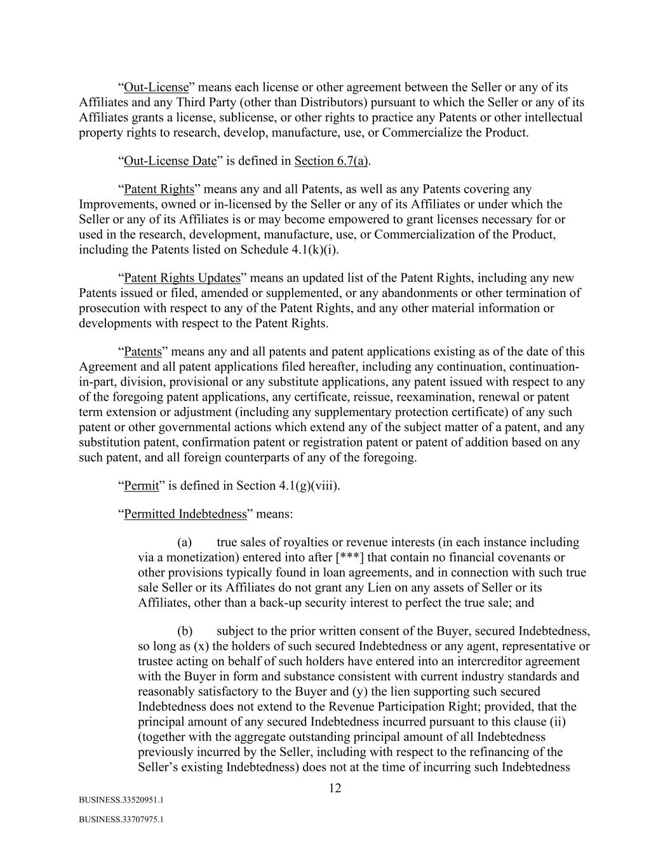
12 BUSINESS.33520951.1 BUSINESS.33707975.1 “Out-License” means each license or other agreement between the Seller or any of its Affiliates and any Third Party (other than Distributors) pursuant to which the Seller or any of its Affiliates grants a license, sublicense, or other rights to practice any Patents or other intellectual property rights to research, develop, manufacture, use, or Commercialize the Product. “Out-License Date” is defined in Section 6.7(a). “Patent Rights” means any and all Patents, as well as any Patents covering any Improvements, owned or in-licensed by the Seller or any of its Affiliates or under which the Seller or any of its Affiliates is or may become empowered to grant licenses necessary for or used in the research, development, manufacture, use, or Commercialization of the Product, including the Patents listed on Schedule 4.1(k)(i). “Patent Rights Updates” means an updated list of the Patent Rights, including any new Patents issued or filed, amended or supplemented, or any abandonments or other termination of prosecution with respect to any of the Patent Rights, and any other material information or developments with respect to the Patent Rights. “Patents” means any and all patents and patent applications existing as of the date of this Agreement and all patent applications filed hereafter, including any continuation, continuation- in-part, division, provisional or any substitute applications, any patent issued with respect to any of the foregoing patent applications, any certificate, reissue, reexamination, renewal or patent term extension or adjustment (including any supplementary protection certificate) of any such patent or other governmental actions which extend any of the subject matter of a patent, and any substitution patent, confirmation patent or registration patent or patent of addition based on any such patent, and all foreign counterparts of any of the foregoing. “Permit” is defined in Section 4.1(g)(viii). “Permitted Indebtedness” means: (a) true sales of royalties or revenue interests (in each instance including via a monetization) entered into after [***] that contain no financial covenants or other provisions typically found in loan agreements, and in connection with such true sale Seller or its Affiliates do not grant any Lien on any assets of Seller or its Affiliates, other than a back-up security interest to perfect the true sale; and (b) subject to the prior written consent of the Buyer, secured Indebtedness, so long as (x) the holders of such secured Indebtedness or any agent, representative or trustee acting on behalf of such holders have entered into an intercreditor agreement with the Buyer in form and substance consistent with current industry standards and reasonably satisfactory to the Buyer and (y) the lien supporting such secured Indebtedness does not extend to the Revenue Participation Right; provided, that the principal amount of any secured Indebtedness incurred pursuant to this clause (ii) (together with the aggregate outstanding principal amount of all Indebtedness previously incurred by the Seller, including with respect to the refinancing of the Seller’s existing Indebtedness) does not at the time of incurring such Indebtedness

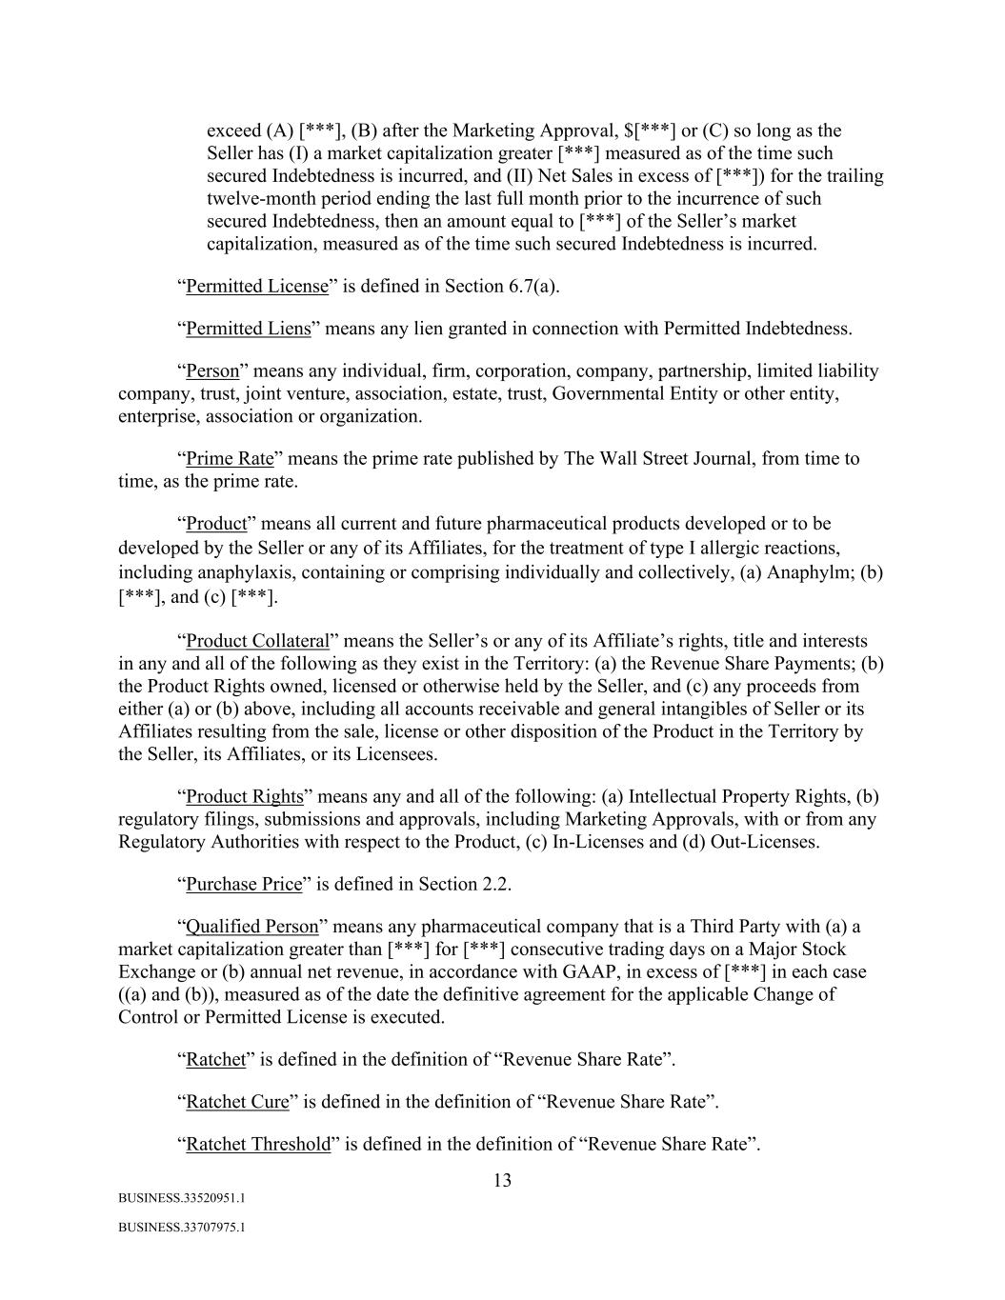
13 BUSINESS.33520951.1 BUSINESS.33707975.1 exceed (A) [***], (B) after the Marketing Approval, $[***] or (C) so long as the Seller has (I) a market capitalization greater [***] measured as of the time such secured Indebtedness is incurred, and (II) Net Sales in excess of [***]) for the trailing twelve-month period ending the last full month prior to the incurrence of such secured Indebtedness, then an amount equal to [***] of the Seller’s market capitalization, measured as of the time such secured Indebtedness is incurred. “Permitted License” is defined in Section 6.7(a). “Permitted Liens” means any lien granted in connection with Permitted Indebtedness. “Person” means any individual, firm, corporation, company, partnership, limited liability company, trust, joint venture, association, estate, trust, Governmental Entity or other entity, enterprise, association or organization. “Prime Rate” means the prime rate published by The Wall Street Journal, from time to time, as the prime rate. “Product” means all current and future pharmaceutical products developed or to be developed by the Seller or any of its Affiliates, for the treatment of type I allergic reactions, including anaphylaxis, containing or comprising individually and collectively, (a) Anaphylm; (b) [***], and (c) [***]. “Product Collateral” means the Seller’s or any of its Affiliate’s rights, title and interests in any and all of the following as they exist in the Territory: (a) the Revenue Share Payments; (b) the Product Rights owned, licensed or otherwise held by the Seller, and (c) any proceeds from either (a) or (b) above, including all accounts receivable and general intangibles of Seller or its Affiliates resulting from the sale, license or other disposition of the Product in the Territory by the Seller, its Affiliates, or its Licensees. “Product Rights” means any and all of the following: (a) Intellectual Property Rights, (b) regulatory filings, submissions and approvals, including Marketing Approvals, with or from any Regulatory Authorities with respect to the Product, (c) In-Licenses and (d) Out-Licenses. “Purchase Price” is defined in Section 2.2. “Qualified Person” means any pharmaceutical company that is a Third Party with (a) a market capitalization greater than [***] for [***] consecutive trading days on a Major Stock Exchange or (b) annual net revenue, in accordance with GAAP, in excess of [***] in each case ((a) and (b)), measured as of the date the definitive agreement for the applicable Change of Control or Permitted License is executed. “Ratchet” is defined in the definition of “Revenue Share Rate”. “Ratchet Cure” is defined in the definition of “Revenue Share Rate”. “Ratchet Threshold” is defined in the definition of “Revenue Share Rate”.

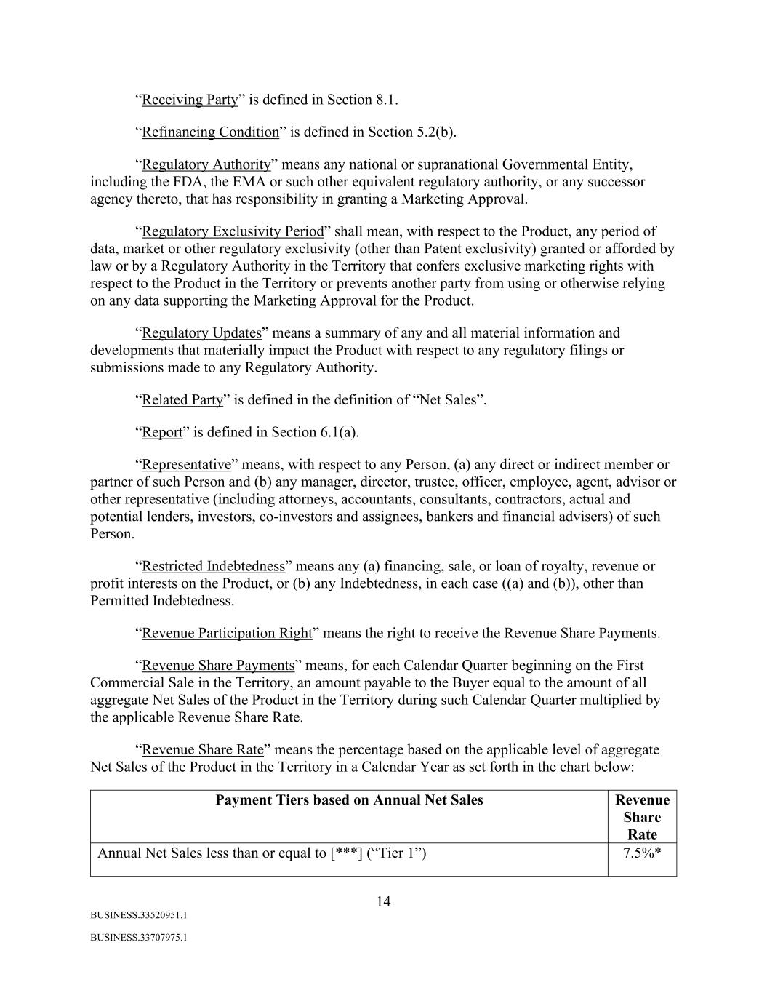
14 BUSINESS.33520951.1 BUSINESS.33707975.1 “Receiving Party” is defined in Section 8.1. “Refinancing Condition” is defined in Section 5.2(b). “Regulatory Authority” means any national or supranational Governmental Entity, including the FDA, the EMA or such other equivalent regulatory authority, or any successor agency thereto, that has responsibility in granting a Marketing Approval. “Regulatory Exclusivity Period” shall mean, with respect to the Product, any period of data, market or other regulatory exclusivity (other than Patent exclusivity) granted or afforded by law or by a Regulatory Authority in the Territory that confers exclusive marketing rights with respect to the Product in the Territory or prevents another party from using or otherwise relying on any data supporting the Marketing Approval for the Product. “Regulatory Updates” means a summary of any and all material information and developments that materially impact the Product with respect to any regulatory filings or submissions made to any Regulatory Authority. “Related Party” is defined in the definition of “Net Sales”. “Report” is defined in Section 6.1(a). “Representative” means, with respect to any Person, (a) any direct or indirect member or partner of such Person and (b) any manager, director, trustee, officer, employee, agent, advisor or other representative (including attorneys, accountants, consultants, contractors, actual and potential lenders, investors, co-investors and assignees, bankers and financial advisers) of such Person. “Restricted Indebtedness” means any (a) financing, sale, or loan of royalty, revenue or profit interests on the Product, or (b) any Indebtedness, in each case ((a) and (b)), other than Permitted Indebtedness. “Revenue Participation Right” means the right to receive the Revenue Share Payments. “Revenue Share Payments” means, for each Calendar Quarter beginning on the First Commercial Sale in the Territory, an amount payable to the Buyer equal to the amount of all aggregate Net Sales of the Product in the Territory during such Calendar Quarter multiplied by the applicable Revenue Share Rate. “Revenue Share Rate” means the percentage based on the applicable level of aggregate Net Sales of the Product in the Territory in a Calendar Year as set forth in the chart below: Payment Tiers based on Annual Net Sales Revenue Share Rate Annual Net Sales less than or equal to [***] (“Tier 1”) 7.5%*

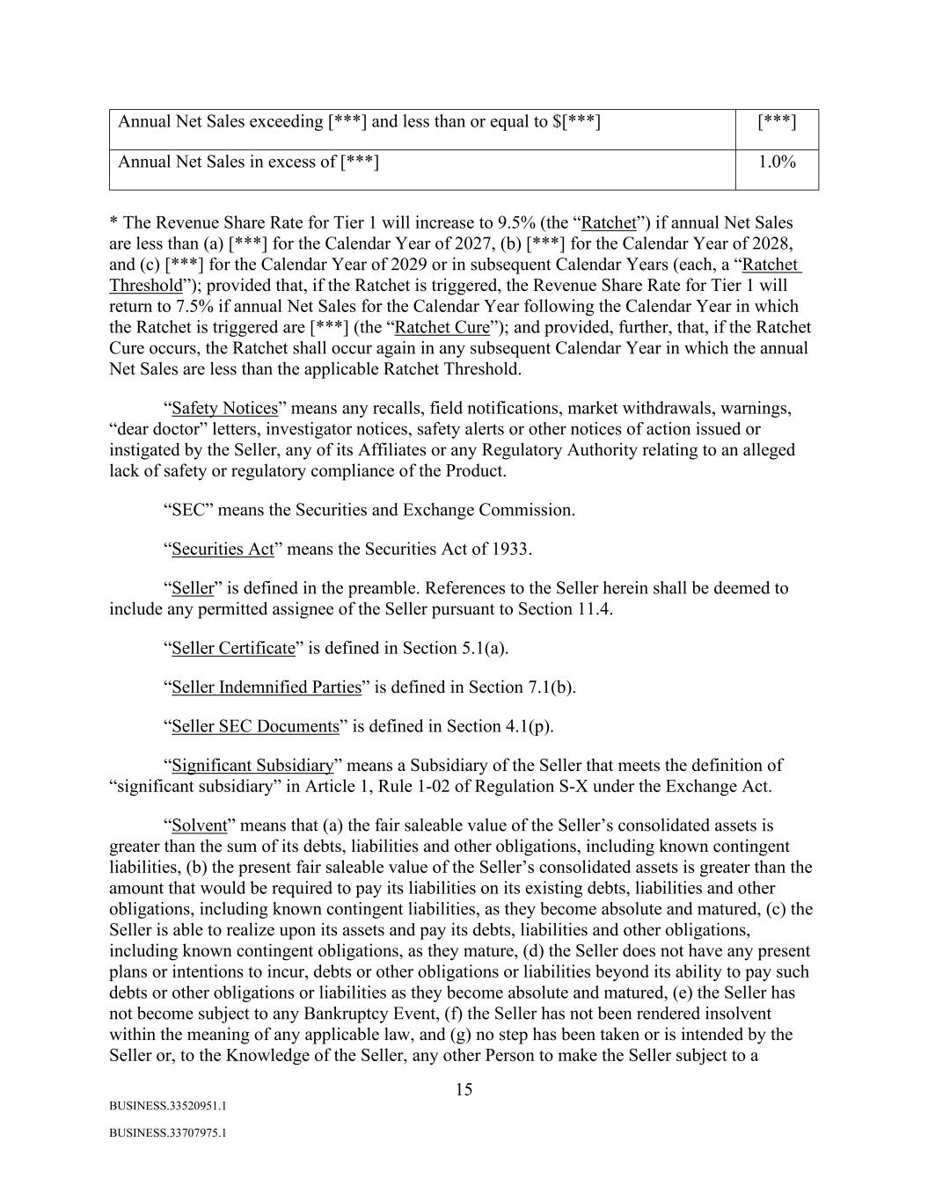
15 BUSINESS.33520951.1 BUSINESS.33707975.1 Annual Net Sales exceeding [***] and less than or equal to $[***] [***] Annual Net Sales in excess of [***] 1.0% * The Revenue Share Rate for Tier 1 will increase to 9.5% (the “Ratchet”) if annual Net Sales are less than (a) [***] for the Calendar Year of 2027, (b) [***] for the Calendar Year of 2028, and (c) [***] for the Calendar Year of 2029 or in subsequent Calendar Years (each, a “Ratchet Threshold”); provided that, if the Ratchet is triggered, the Revenue Share Rate for Tier 1 will return to 7.5% if annual Net Sales for the Calendar Year following the Calendar Year in which the Ratchet is triggered are [***] (the “Ratchet Cure”); and provided, further, that, if the Ratchet Cure occurs, the Ratchet shall occur again in any subsequent Calendar Year in which the annual Net Sales are less than the applicable Ratchet Threshold. “Safety Notices” means any recalls, field notifications, market withdrawals, warnings, “dear doctor” letters, investigator notices, safety alerts or other notices of action issued or instigated by the Seller, any of its Affiliates or any Regulatory Authority relating to an alleged lack of safety or regulatory compliance of the Product. “SEC” means the Securities and Exchange Commission. “Securities Act” means the Securities Act of 1933. “Seller” is defined in the preamble. References to the Seller herein shall be deemed to include any permitted assignee of the Seller pursuant to Section 11.4. “Seller Certificate” is defined in Section 5.1(a). “Seller Indemnified Parties” is defined in Section 7.1(b). “Seller SEC Documents” is defined in Section 4.1(p). “Significant Subsidiary” means a Subsidiary of the Seller that meets the definition of “significant subsidiary” in Article 1, Rule 1-02 of Regulation S-X under the Exchange Act. “Solvent” means that (a) the fair saleable value of the Seller’s consolidated assets is greater than the sum of its debts, liabilities and other obligations, including known contingent liabilities, (b) the present fair saleable value of the Seller’s consolidated assets is greater than the amount that would be required to pay its liabilities on its existing debts, liabilities and other obligations, including known contingent liabilities, as they become absolute and matured, (c) the Seller is able to realize upon its assets and pay its debts, liabilities and other obligations, including known contingent obligations, as they mature, (d) the Seller does not have any present plans or intentions to incur, debts or other obligations or liabilities beyond its ability to pay such debts or other obligations or liabilities as they become absolute and matured, (e) the Seller has not become subject to any Bankruptcy Event, (f) the Seller has not been rendered insolvent within the meaning of any applicable law, and (g) no step has been taken or is intended by the Seller or, to the Knowledge of the Seller, any other Person to make the Seller subject to a

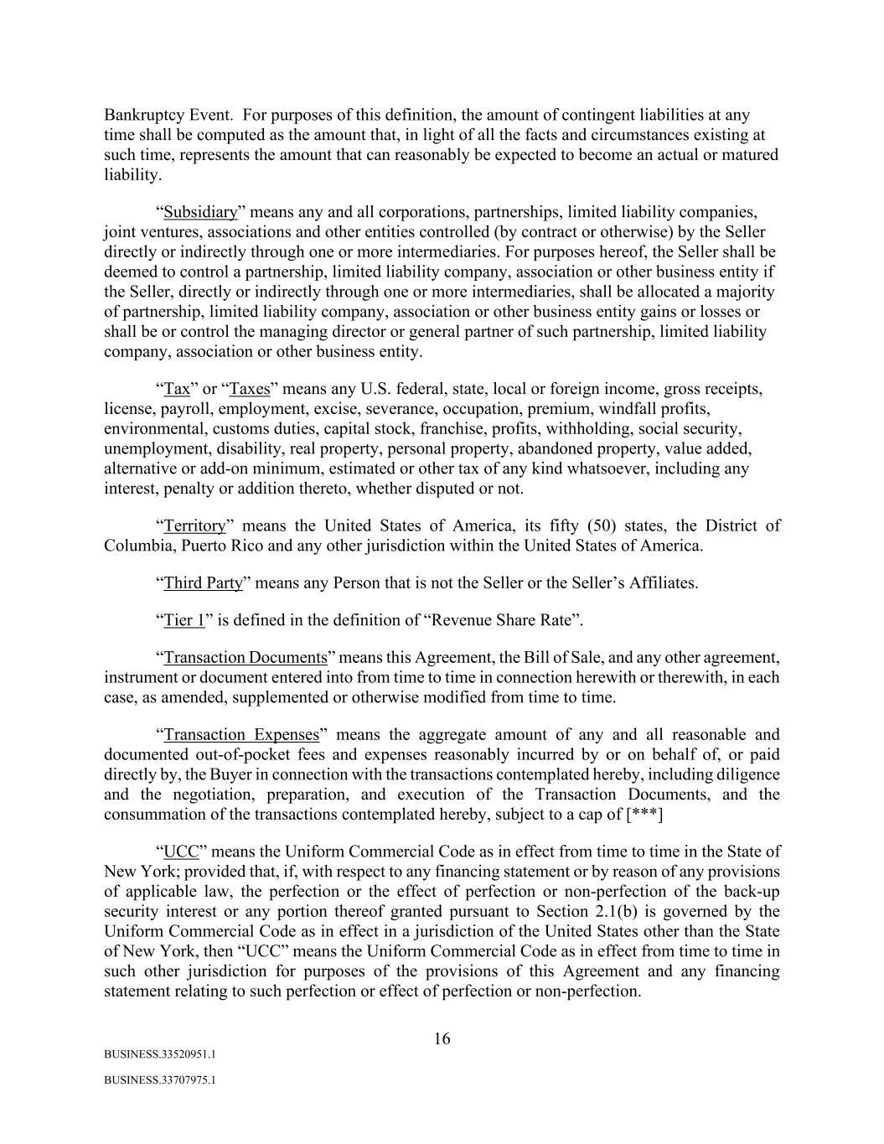
16 BUSINESS.33520951.1 BUSINESS.33707975.1 Bankruptcy Event. For purposes of this definition, the amount of contingent liabilities at any time shall be computed as the amount that, in light of all the facts and circumstances existing at such time, represents the amount that can reasonably be expected to become an actual or matured liability. “Subsidiary” means any and all corporations, partnerships, limited liability companies, joint ventures, associations and other entities controlled (by contract or otherwise) by the Seller directly or indirectly through one or more intermediaries. For purposes hereof, the Seller shall be deemed to control a partnership, limited liability company, association or other business entity if the Seller, directly or indirectly through one or more intermediaries, shall be allocated a majority of partnership, limited liability company, association or other business entity gains or losses or shall be or control the managing director or general partner of such partnership, limited liability company, association or other business entity. “Tax” or “Taxes” means any U.S. federal, state, local or foreign income, gross receipts, license, payroll, employment, excise, severance, occupation, premium, windfall profits, environmental, customs duties, capital stock, franchise, profits, withholding, social security, unemployment, disability, real property, personal property, abandoned property, value added, alternative or add-on minimum, estimated or other tax of any kind whatsoever, including any interest, penalty or addition thereto, whether disputed or not. “Territory” means the United States of America, its fifty (50) states, the District of Columbia, Puerto Rico and any other jurisdiction within the United States of America. “Third Party” means any Person that is not the Seller or the Seller’s Affiliates. “Tier 1” is defined in the definition of “Revenue Share Rate”. “Transaction Documents” means this Agreement, the Bill of Sale, and any other agreement, instrument or document entered into from time to time in connection herewith or therewith, in each case, as amended, supplemented or otherwise modified from time to time. “Transaction Expenses” means the aggregate amount of any and all reasonable and documented out-of-pocket fees and expenses reasonably incurred by or on behalf of, or paid directly by, the Buyer in connection with the transactions contemplated hereby, including diligence and the negotiation, preparation, and execution of the Transaction Documents, and the consummation of the transactions contemplated hereby, subject to a cap of [***] “UCC” means the Uniform Commercial Code as in effect from time to time in the State of New York; provided that, if, with respect to any financing statement or by reason of any provisions of applicable law, the perfection or the effect of perfection or non-perfection of the back-up security interest or any portion thereof granted pursuant to Section 2.1(b) is governed by the Uniform Commercial Code as in effect in a jurisdiction of the United States other than the State of New York, then “UCC” means the Uniform Commercial Code as in effect from time to time in such other jurisdiction for purposes of the provisions of this Agreement and any financing statement relating to such perfection or effect of perfection or non-perfection.

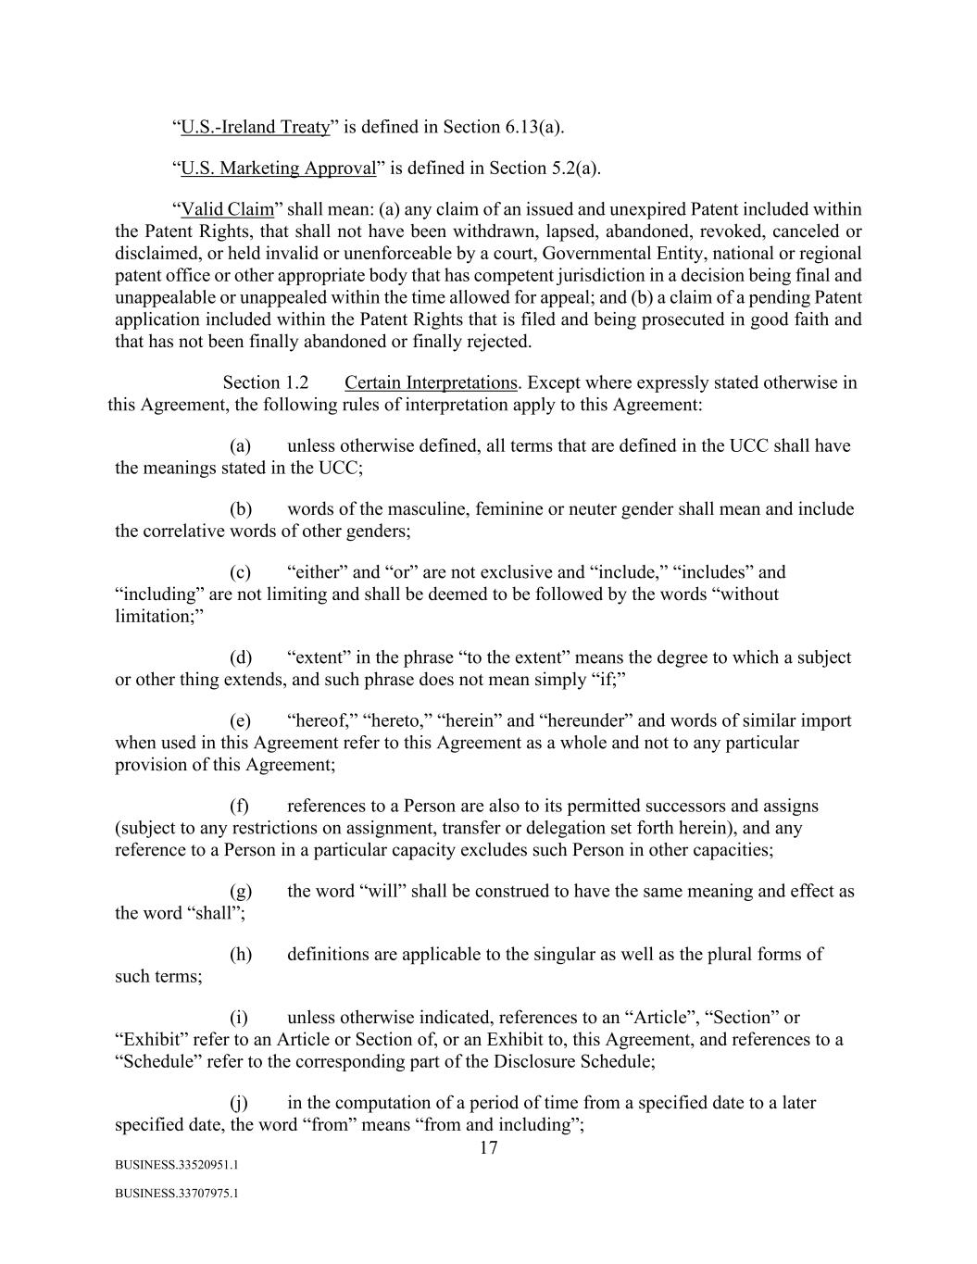
17 BUSINESS.33520951.1 BUSINESS.33707975.1 “U.S.-Ireland Treaty” is defined in Section 6.13(a). “U.S. Marketing Approval” is defined in Section 5.2(a). “Valid Claim” shall mean: (a) any claim of an issued and unexpired Patent included within the Patent Rights, that shall not have been withdrawn, lapsed, abandoned, revoked, canceled or disclaimed, or held invalid or unenforceable by a court, Governmental Entity, national or regional patent office or other appropriate body that has competent jurisdiction in a decision being final and unappealable or unappealed within the time allowed for appeal; and (b) a claim of a pending Patent application included within the Patent Rights that is filed and being prosecuted in good faith and that has not been finally abandoned or finally rejected. Section 1.2 Certain Interpretations. Except where expressly stated otherwise in this Agreement, the following rules of interpretation apply to this Agreement: (a) unless otherwise defined, all terms that are defined in the UCC shall have the meanings stated in the UCC; (b) words of the masculine, feminine or neuter gender shall mean and include the correlative words of other genders; (c) “either” and “or” are not exclusive and “include,” “includes” and “including” are not limiting and shall be deemed to be followed by the words “without limitation;” (d) “extent” in the phrase “to the extent” means the degree to which a subject or other thing extends, and such phrase does not mean simply “if;” (e) “hereof,” “hereto,” “herein” and “hereunder” and words of similar import when used in this Agreement refer to this Agreement as a whole and not to any particular provision of this Agreement; (f) references to a Person are also to its permitted successors and assigns (subject to any restrictions on assignment, transfer or delegation set forth herein), and any reference to a Person in a particular capacity excludes such Person in other capacities; (g) the word “will” shall be construed to have the same meaning and effect as the word “shall”; (h) definitions are applicable to the singular as well as the plural forms of such terms; (i) unless otherwise indicated, references to an “Article”, “Section” or “Exhibit” refer to an Article or Section of, or an Exhibit to, this Agreement, and references to a “Schedule” refer to the corresponding part of the Disclosure Schedule; (j) in the computation of a period of time from a specified date to a later specified date, the word “from” means “from and including”;

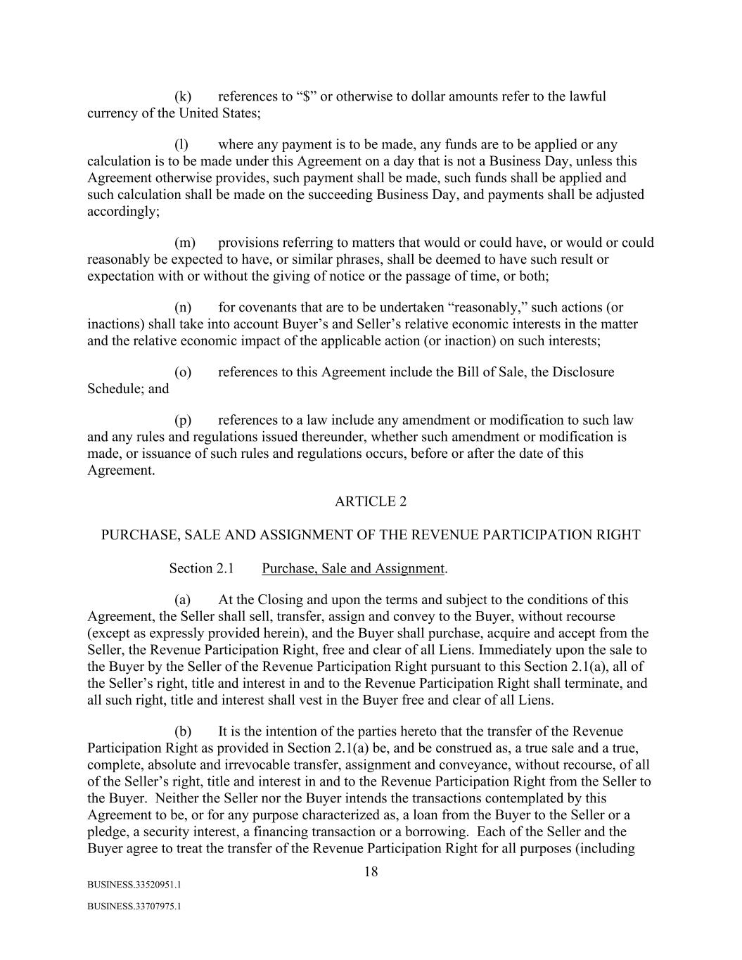
18 BUSINESS.33520951.1 BUSINESS.33707975.1 (k) references to “$” or otherwise to dollar amounts refer to the lawful currency of the United States; (l) where any payment is to be made, any funds are to be applied or any calculation is to be made under this Agreement on a day that is not a Business Day, unless this Agreement otherwise provides, such payment shall be made, such funds shall be applied and such calculation shall be made on the succeeding Business Day, and payments shall be adjusted accordingly; (m) provisions referring to matters that would or could have, or would or could reasonably be expected to have, or similar phrases, shall be deemed to have such result or expectation with or without the giving of notice or the passage of time, or both; (n) for covenants that are to be undertaken “reasonably,” such actions (or inactions) shall take into account Buyer’s and Seller’s relative economic interests in the matter and the relative economic impact of the applicable action (or inaction) on such interests; (o) references to this Agreement include the Bill of Sale, the Disclosure Schedule; and (p) references to a law include any amendment or modification to such law and any rules and regulations issued thereunder, whether such amendment or modification is made, or issuance of such rules and regulations occurs, before or after the date of this Agreement. ARTICLE 2 PURCHASE, SALE AND ASSIGNMENT OF THE REVENUE PARTICIPATION RIGHT Section 2.1 Purchase, Sale and Assignment. (a) At the Closing and upon the terms and subject to the conditions of this Agreement, the Seller shall sell, transfer, assign and convey to the Buyer, without recourse (except as expressly provided herein), and the Buyer shall purchase, acquire and accept from the Seller, the Revenue Participation Right, free and clear of all Liens. Immediately upon the sale to the Buyer by the Seller of the Revenue Participation Right pursuant to this Section 2.1(a), all of the Seller’s right, title and interest in and to the Revenue Participation Right shall terminate, and all such right, title and interest shall vest in the Buyer free and clear of all Liens. (b) It is the intention of the parties hereto that the transfer of the Revenue Participation Right as provided in Section 2.1(a) be, and be construed as, a true sale and a true, complete, absolute and irrevocable transfer, assignment and conveyance, without recourse, of all of the Seller’s right, title and interest in and to the Revenue Participation Right from the Seller to the Buyer. Neither the Seller nor the Buyer intends the transactions contemplated by this Agreement to be, or for any purpose characterized as, a loan from the Buyer to the Seller or a pledge, a security interest, a financing transaction or a borrowing. Each of the Seller and the Buyer agree to treat the transfer of the Revenue Participation Right for all purposes (including

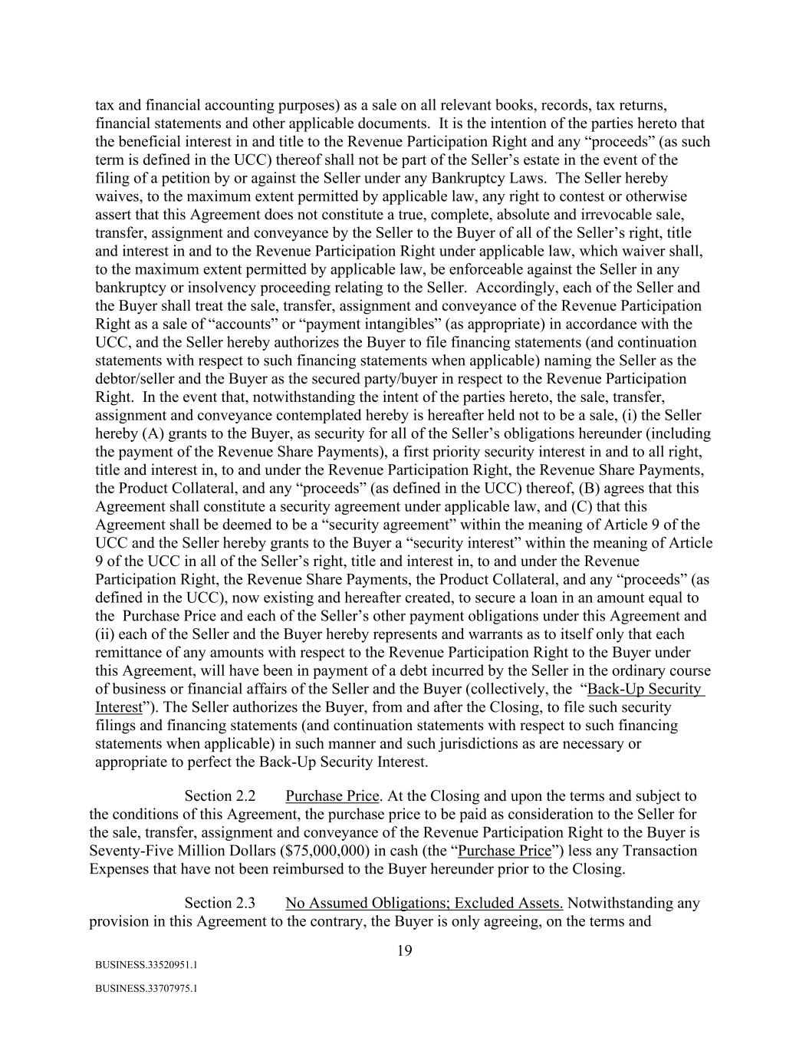
19 BUSINESS.33520951.1 BUSINESS.33707975.1 tax and financial accounting purposes) as a sale on all relevant books, records, tax returns, financial statements and other applicable documents. It is the intention of the parties hereto that the beneficial interest in and title to the Revenue Participation Right and any “proceeds” (as such term is defined in the UCC) thereof shall not be part of the Seller’s estate in the event of the filing of a petition by or against the Seller under any Bankruptcy Laws. The Seller hereby waives, to the maximum extent permitted by applicable law, any right to contest or otherwise assert that this Agreement does not constitute a true, complete, absolute and irrevocable sale, transfer, assignment and conveyance by the Seller to the Buyer of all of the Seller’s right, title and interest in and to the Revenue Participation Right under applicable law, which waiver shall, to the maximum extent permitted by applicable law, be enforceable against the Seller in any bankruptcy or insolvency proceeding relating to the Seller. Accordingly, each of the Seller and the Buyer shall treat the sale, transfer, assignment and conveyance of the Revenue Participation Right as a sale of “accounts” or “payment intangibles” (as appropriate) in accordance with the UCC, and the Seller hereby authorizes the Buyer to file financing statements (and continuation statements with respect to such financing statements when applicable) naming the Seller as the debtor/seller and the Buyer as the secured party/buyer in respect to the Revenue Participation Right. In the event that, notwithstanding the intent of the parties hereto, the sale, transfer, assignment and conveyance contemplated hereby is hereafter held not to be a sale, (i) the Seller hereby (A) grants to the Buyer, as security for all of the Seller’s obligations hereunder (including the payment of the Revenue Share Payments), a first priority security interest in and to all right, title and interest in, to and under the Revenue Participation Right, the Revenue Share Payments, the Product Collateral, and any “proceeds” (as defined in the UCC) thereof, (B) agrees that this Agreement shall constitute a security agreement under applicable law, and (C) that this Agreement shall be deemed to be a “security agreement” within the meaning of Article 9 of the UCC and the Seller hereby grants to the Buyer a “security interest” within the meaning of Article 9 of the UCC in all of the Seller’s right, title and interest in, to and under the Revenue Participation Right, the Revenue Share Payments, the Product Collateral, and any “proceeds” (as defined in the UCC), now existing and hereafter created, to secure a loan in an amount equal to the Purchase Price and each of the Seller’s other payment obligations under this Agreement and (ii) each of the Seller and the Buyer hereby represents and warrants as to itself only that each remittance of any amounts with respect to the Revenue Participation Right to the Buyer under this Agreement, will have been in payment of a debt incurred by the Seller in the ordinary course of business or financial affairs of the Seller and the Buyer (collectively, the “Back-Up Security Interest”). The Seller authorizes the Buyer, from and after the Closing, to file such security filings and financing statements (and continuation statements with respect to such financing statements when applicable) in such manner and such jurisdictions as are necessary or appropriate to perfect the Back-Up Security Interest. Section 2.2 Purchase Price. At the Closing and upon the terms and subject to the conditions of this Agreement, the purchase price to be paid as consideration to the Seller for the sale, transfer, assignment and conveyance of the Revenue Participation Right to the Buyer is Seventy-Five Million Dollars ($75,000,000) in cash (the “Purchase Price”) less any Transaction Expenses that have not been reimbursed to the Buyer hereunder prior to the Closing. Section 2.3 No Assumed Obligations; Excluded Assets. Notwithstanding any provision in this Agreement to the contrary, the Buyer is only agreeing, on the terms and

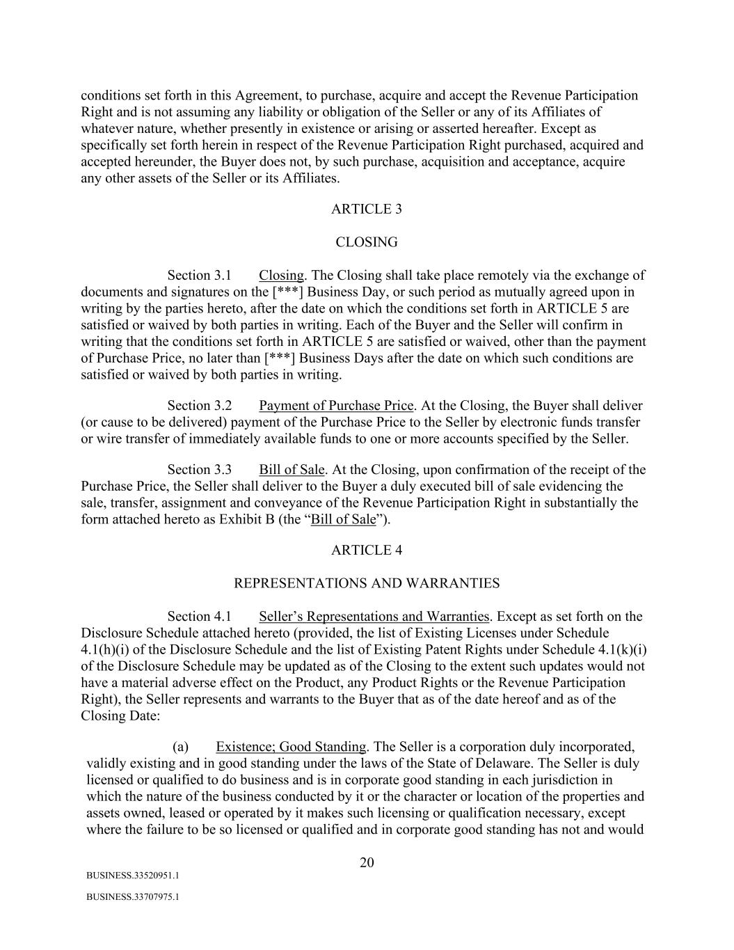
20 BUSINESS.33520951.1 BUSINESS.33707975.1 conditions set forth in this Agreement, to purchase, acquire and accept the Revenue Participation Right and is not assuming any liability or obligation of the Seller or any of its Affiliates of whatever nature, whether presently in existence or arising or asserted hereafter. Except as specifically set forth herein in respect of the Revenue Participation Right purchased, acquired and accepted hereunder, the Buyer does not, by such purchase, acquisition and acceptance, acquire any other assets of the Seller or its Affiliates. ARTICLE 3 CLOSING Section 3.1 Closing. The Closing shall take place remotely via the exchange of documents and signatures on the [***] Business Day, or such period as mutually agreed upon in writing by the parties hereto, after the date on which the conditions set forth in ARTICLE 5 are satisfied or waived by both parties in writing. Each of the Buyer and the Seller will confirm in writing that the conditions set forth in ARTICLE 5 are satisfied or waived, other than the payment of Purchase Price, no later than [***] Business Days after the date on which such conditions are satisfied or waived by both parties in writing. Section 3.2 Payment of Purchase Price. At the Closing, the Buyer shall deliver (or cause to be delivered) payment of the Purchase Price to the Seller by electronic funds transfer or wire transfer of immediately available funds to one or more accounts specified by the Seller. Section 3.3 Bill of Sale. At the Closing, upon confirmation of the receipt of the Purchase Price, the Seller shall deliver to the Buyer a duly executed bill of sale evidencing the sale, transfer, assignment and conveyance of the Revenue Participation Right in substantially the form attached hereto as Exhibit B (the “Bill of Sale”). ARTICLE 4 REPRESENTATIONS AND WARRANTIES Section 4.1 Seller’s Representations and Warranties. Except as set forth on the Disclosure Schedule attached hereto (provided, the list of Existing Licenses under Schedule 4.1(h)(i) of the Disclosure Schedule and the list of Existing Patent Rights under Schedule 4.1(k)(i) of the Disclosure Schedule may be updated as of the Closing to the extent such updates would not have a material adverse effect on the Product, any Product Rights or the Revenue Participation Right), the Seller represents and warrants to the Buyer that as of the date hereof and as of the Closing Date: (a) Existence; Good Standing. The Seller is a corporation duly incorporated, validly existing and in good standing under the laws of the State of Delaware. The Seller is duly licensed or qualified to do business and is in corporate good standing in each jurisdiction in which the nature of the business conducted by it or the character or location of the properties and assets owned, leased or operated by it makes such licensing or qualification necessary, except where the failure to be so licensed or qualified and in corporate good standing has not and would

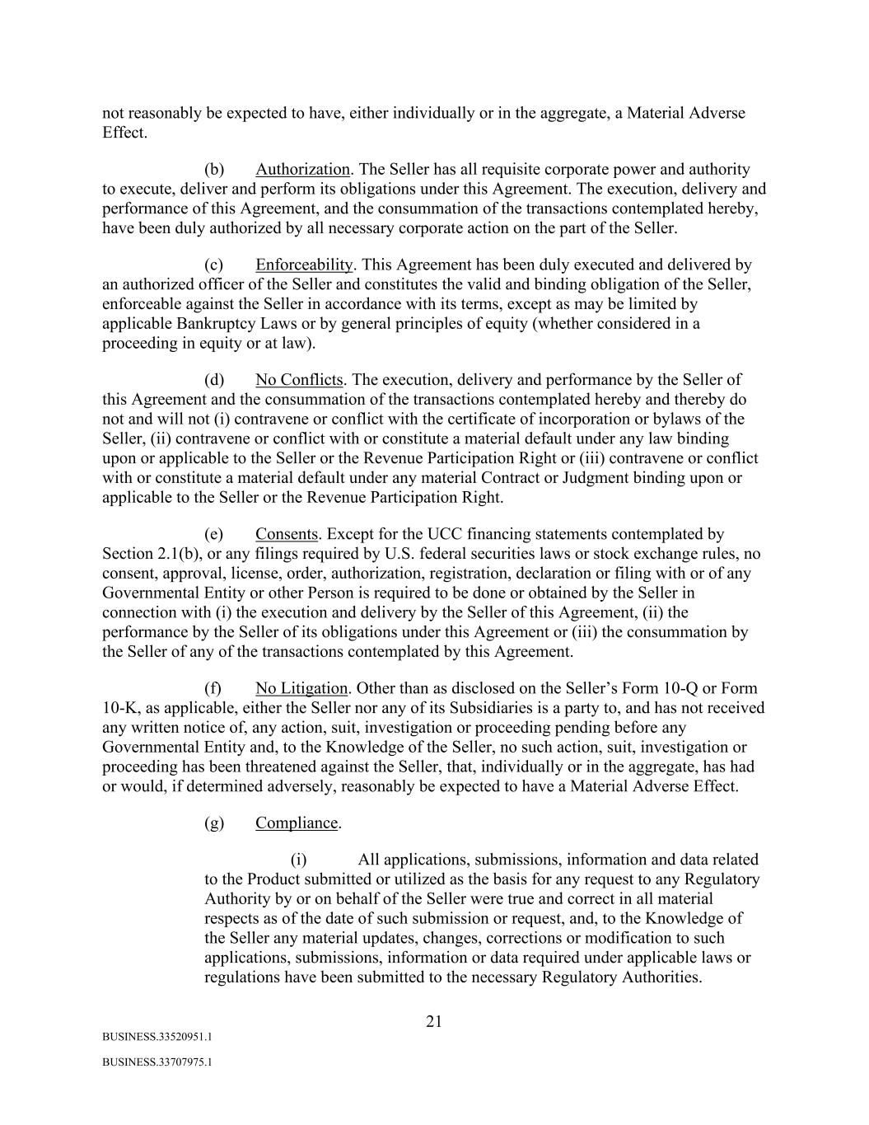
21 BUSINESS.33520951.1 BUSINESS.33707975.1 not reasonably be expected to have, either individually or in the aggregate, a Material Adverse Effect. (b) Authorization. The Seller has all requisite corporate power and authority to execute, deliver and perform its obligations under this Agreement. The execution, delivery and performance of this Agreement, and the consummation of the transactions contemplated hereby, have been duly authorized by all necessary corporate action on the part of the Seller. (c) Enforceability. This Agreement has been duly executed and delivered by an authorized officer of the Seller and constitutes the valid and binding obligation of the Seller, enforceable against the Seller in accordance with its terms, except as may be limited by applicable Bankruptcy Laws or by general principles of equity (whether considered in a proceeding in equity or at law). (d) No Conflicts. The execution, delivery and performance by the Seller of this Agreement and the consummation of the transactions contemplated hereby and thereby do not and will not (i) contravene or conflict with the certificate of incorporation or bylaws of the Seller, (ii) contravene or conflict with or constitute a material default under any law binding upon or applicable to the Seller or the Revenue Participation Right or (iii) contravene or conflict with or constitute a material default under any material Contract or Judgment binding upon or applicable to the Seller or the Revenue Participation Right. (e) Consents. Except for the UCC financing statements contemplated by Section 2.1(b), or any filings required by U.S. federal securities laws or stock exchange rules, no consent, approval, license, order, authorization, registration, declaration or filing with or of any Governmental Entity or other Person is required to be done or obtained by the Seller in connection with (i) the execution and delivery by the Seller of this Agreement, (ii) the performance by the Seller of its obligations under this Agreement or (iii) the consummation by the Seller of any of the transactions contemplated by this Agreement. (f) No Litigation. Other than as disclosed on the Seller’s Form 10-Q or Form 10-K, as applicable, either the Seller nor any of its Subsidiaries is a party to, and has not received any written notice of, any action, suit, investigation or proceeding pending before any Governmental Entity and, to the Knowledge of the Seller, no such action, suit, investigation or proceeding has been threatened against the Seller, that, individually or in the aggregate, has had or would, if determined adversely, reasonably be expected to have a Material Adverse Effect. (g) Compliance. (i) All applications, submissions, information and data related to the Product submitted or utilized as the basis for any request to any Regulatory Authority by or on behalf of the Seller were true and correct in all material respects as of the date of such submission or request, and, to the Knowledge of the Seller any material updates, changes, corrections or modification to such applications, submissions, information or data required under applicable laws or regulations have been submitted to the necessary Regulatory Authorities.

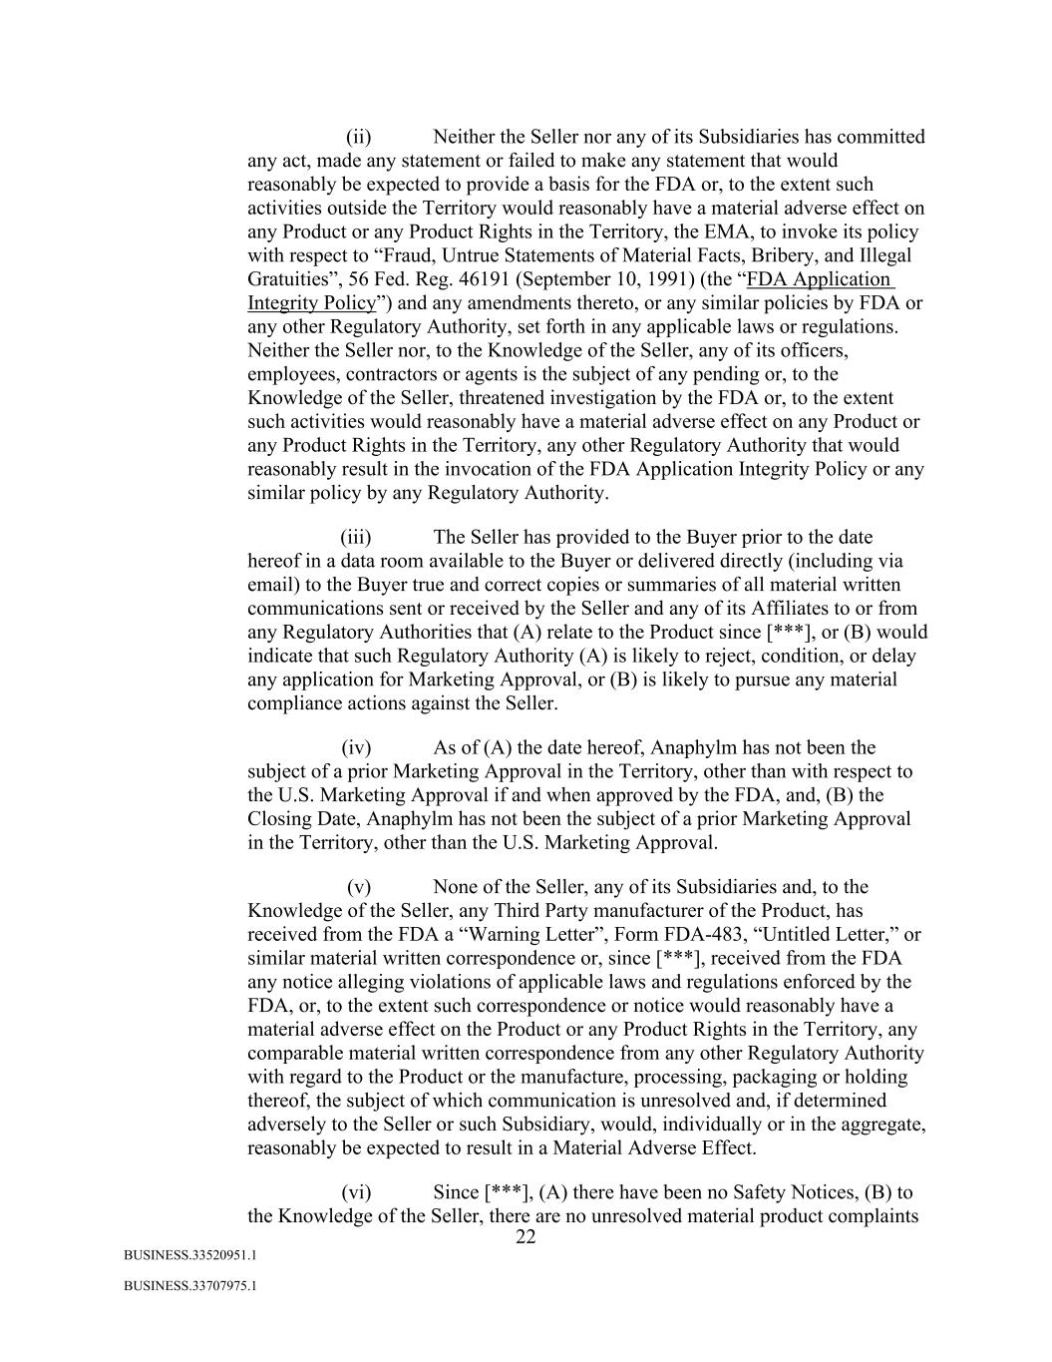
22 BUSINESS.33520951.1 BUSINESS.33707975.1 (ii) Neither the Seller nor any of its Subsidiaries has committed any act, made any statement or failed to make any statement that would reasonably be expected to provide a basis for the FDA or, to the extent such activities outside the Territory would reasonably have a material adverse effect on any Product or any Product Rights in the Territory, the EMA, to invoke its policy with respect to “Fraud, Untrue Statements of Material Facts, Bribery, and Illegal Gratuities”, 56 Fed. Reg. 46191 (September 10, 1991) (the “FDA Application Integrity Policy”) and any amendments thereto, or any similar policies by FDA or any other Regulatory Authority, set forth in any applicable laws or regulations. Neither the Seller nor, to the Knowledge of the Seller, any of its officers, employees, contractors or agents is the subject of any pending or, to the Knowledge of the Seller, threatened investigation by the FDA or, to the extent such activities would reasonably have a material adverse effect on any Product or any Product Rights in the Territory, any other Regulatory Authority that would reasonably result in the invocation of the FDA Application Integrity Policy or any similar policy by any Regulatory Authority. (iii) The Seller has provided to the Buyer prior to the date hereof in a data room available to the Buyer or delivered directly (including via email) to the Buyer true and correct copies or summaries of all material written communications sent or received by the Seller and any of its Affiliates to or from any Regulatory Authorities that (A) relate to the Product since [***], or (B) would indicate that such Regulatory Authority (A) is likely to reject, condition, or delay any application for Marketing Approval, or (B) is likely to pursue any material compliance actions against the Seller. (iv) As of (A) the date hereof, Anaphylm has not been the subject of a prior Marketing Approval in the Territory, other than with respect to the U.S. Marketing Approval if and when approved by the FDA, and, (B) the Closing Date, Anaphylm has not been the subject of a prior Marketing Approval in the Territory, other than the U.S. Marketing Approval. (v) None of the Seller, any of its Subsidiaries and, to the Knowledge of the Seller, any Third Party manufacturer of the Product, has received from the FDA a “Warning Letter”, Form FDA-483, “Untitled Letter,” or similar material written correspondence or, since [***], received from the FDA any notice alleging violations of applicable laws and regulations enforced by the FDA, or, to the extent such correspondence or notice would reasonably have a material adverse effect on the Product or any Product Rights in the Territory, any comparable material written correspondence from any other Regulatory Authority with regard to the Product or the manufacture, processing, packaging or holding thereof, the subject of which communication is unresolved and, if determined adversely to the Seller or such Subsidiary, would, individually or in the aggregate, reasonably be expected to result in a Material Adverse Effect. (vi) Since [***], (A) there have been no Safety Notices, (B) to the Knowledge of the Seller, there are no unresolved material product complaints

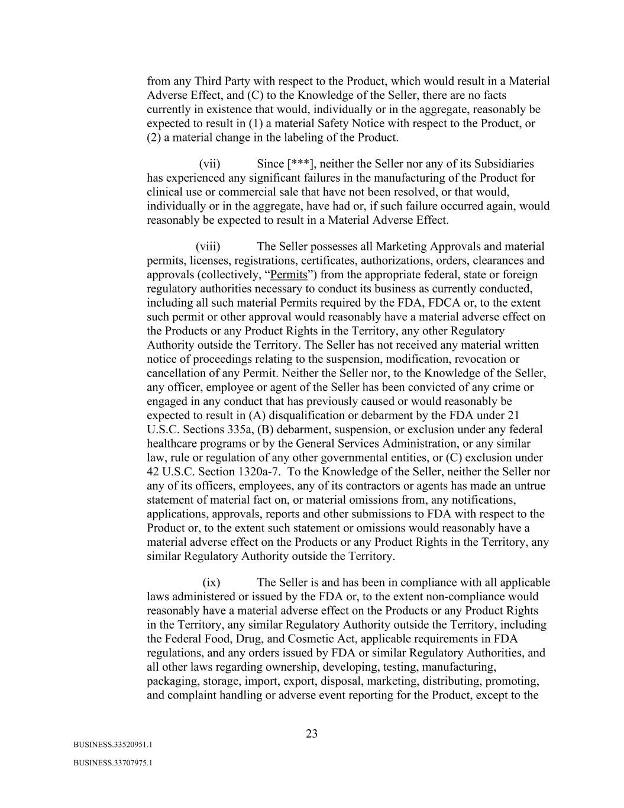
23 BUSINESS.33520951.1 BUSINESS.33707975.1 from any Third Party with respect to the Product, which would result in a Material Adverse Effect, and (C) to the Knowledge of the Seller, there are no facts currently in existence that would, individually or in the aggregate, reasonably be expected to result in (1) a material Safety Notice with respect to the Product, or (2) a material change in the labeling of the Product. (vii) Since [***], neither the Seller nor any of its Subsidiaries has experienced any significant failures in the manufacturing of the Product for clinical use or commercial sale that have not been resolved, or that would, individually or in the aggregate, have had or, if such failure occurred again, would reasonably be expected to result in a Material Adverse Effect. (viii) The Seller possesses all Marketing Approvals and material permits, licenses, registrations, certificates, authorizations, orders, clearances and approvals (collectively, “Permits”) from the appropriate federal, state or foreign regulatory authorities necessary to conduct its business as currently conducted, including all such material Permits required by the FDA, FDCA or, to the extent such permit or other approval would reasonably have a material adverse effect on the Products or any Product Rights in the Territory, any other Regulatory Authority outside the Territory. The Seller has not received any material written notice of proceedings relating to the suspension, modification, revocation or cancellation of any Permit. Neither the Seller nor, to the Knowledge of the Seller, any officer, employee or agent of the Seller has been convicted of any crime or engaged in any conduct that has previously caused or would reasonably be expected to result in (A) disqualification or debarment by the FDA under 21 U.S.C. Sections 335a, (B) debarment, suspension, or exclusion under any federal healthcare programs or by the General Services Administration, or any similar law, rule or regulation of any other governmental entities, or (C) exclusion under 42 U.S.C. Section 1320a-7. To the Knowledge of the Seller, neither the Seller nor any of its officers, employees, any of its contractors or agents has made an untrue statement of material fact on, or material omissions from, any notifications, applications, approvals, reports and other submissions to FDA with respect to the Product or, to the extent such statement or omissions would reasonably have a material adverse effect on the Products or any Product Rights in the Territory, any similar Regulatory Authority outside the Territory. (ix) The Seller is and has been in compliance with all applicable laws administered or issued by the FDA or, to the extent non-compliance would reasonably have a material adverse effect on the Products or any Product Rights in the Territory, any similar Regulatory Authority outside the Territory, including the Federal Food, Drug, and Cosmetic Act, applicable requirements in FDA regulations, and any orders issued by FDA or similar Regulatory Authorities, and all other laws regarding ownership, developing, testing, manufacturing, packaging, storage, import, export, disposal, marketing, distributing, promoting, and complaint handling or adverse event reporting for the Product, except to the

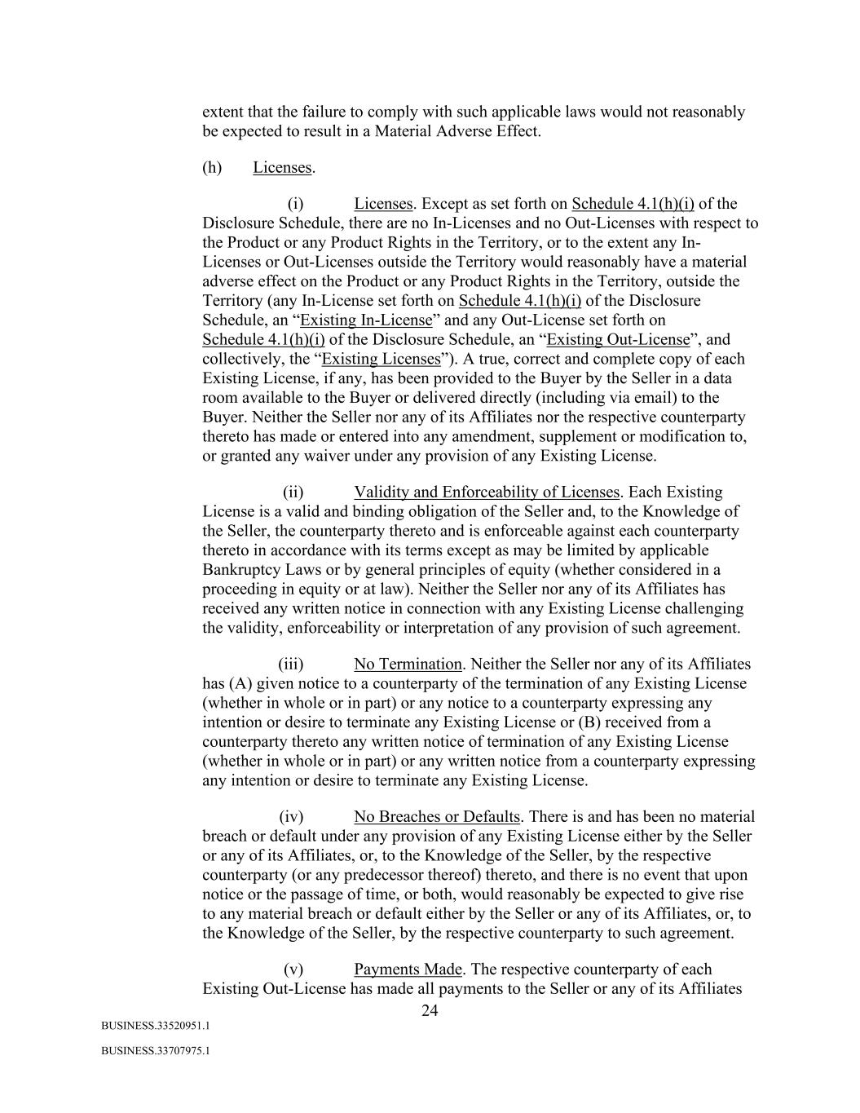
24 BUSINESS.33520951.1 BUSINESS.33707975.1 extent that the failure to comply with such applicable laws would not reasonably be expected to result in a Material Adverse Effect. (h) Licenses. (i) Licenses. Except as set forth on Schedule 4.1(h)(i) of the Disclosure Schedule, there are no In-Licenses and no Out-Licenses with respect to the Product or any Product Rights in the Territory, or to the extent any In- Licenses or Out-Licenses outside the Territory would reasonably have a material adverse effect on the Product or any Product Rights in the Territory, outside the Territory (any In-License set forth on Schedule 4.1(h)(i) of the Disclosure Schedule, an “Existing In-License” and any Out-License set forth on Schedule 4.1(h)(i) of the Disclosure Schedule, an “Existing Out-License”, and collectively, the “Existing Licenses”). A true, correct and complete copy of each Existing License, if any, has been provided to the Buyer by the Seller in a data room available to the Buyer or delivered directly (including via email) to the Buyer. Neither the Seller nor any of its Affiliates nor the respective counterparty thereto has made or entered into any amendment, supplement or modification to, or granted any waiver under any provision of any Existing License. (ii) Validity and Enforceability of Licenses. Each Existing License is a valid and binding obligation of the Seller and, to the Knowledge of the Seller, the counterparty thereto and is enforceable against each counterparty thereto in accordance with its terms except as may be limited by applicable Bankruptcy Laws or by general principles of equity (whether considered in a proceeding in equity or at law). Neither the Seller nor any of its Affiliates has received any written notice in connection with any Existing License challenging the validity, enforceability or interpretation of any provision of such agreement. (iii) No Termination. Neither the Seller nor any of its Affiliates has (A) given notice to a counterparty of the termination of any Existing License (whether in whole or in part) or any notice to a counterparty expressing any intention or desire to terminate any Existing License or (B) received from a counterparty thereto any written notice of termination of any Existing License (whether in whole or in part) or any written notice from a counterparty expressing any intention or desire to terminate any Existing License. (iv) No Breaches or Defaults. There is and has been no material breach or default under any provision of any Existing License either by the Seller or any of its Affiliates, or, to the Knowledge of the Seller, by the respective counterparty (or any predecessor thereof) thereto, and there is no event that upon notice or the passage of time, or both, would reasonably be expected to give rise to any material breach or default either by the Seller or any of its Affiliates, or, to the Knowledge of the Seller, by the respective counterparty to such agreement. (v) Payments Made. The respective counterparty of each Existing Out-License has made all payments to the Seller or any of its Affiliates

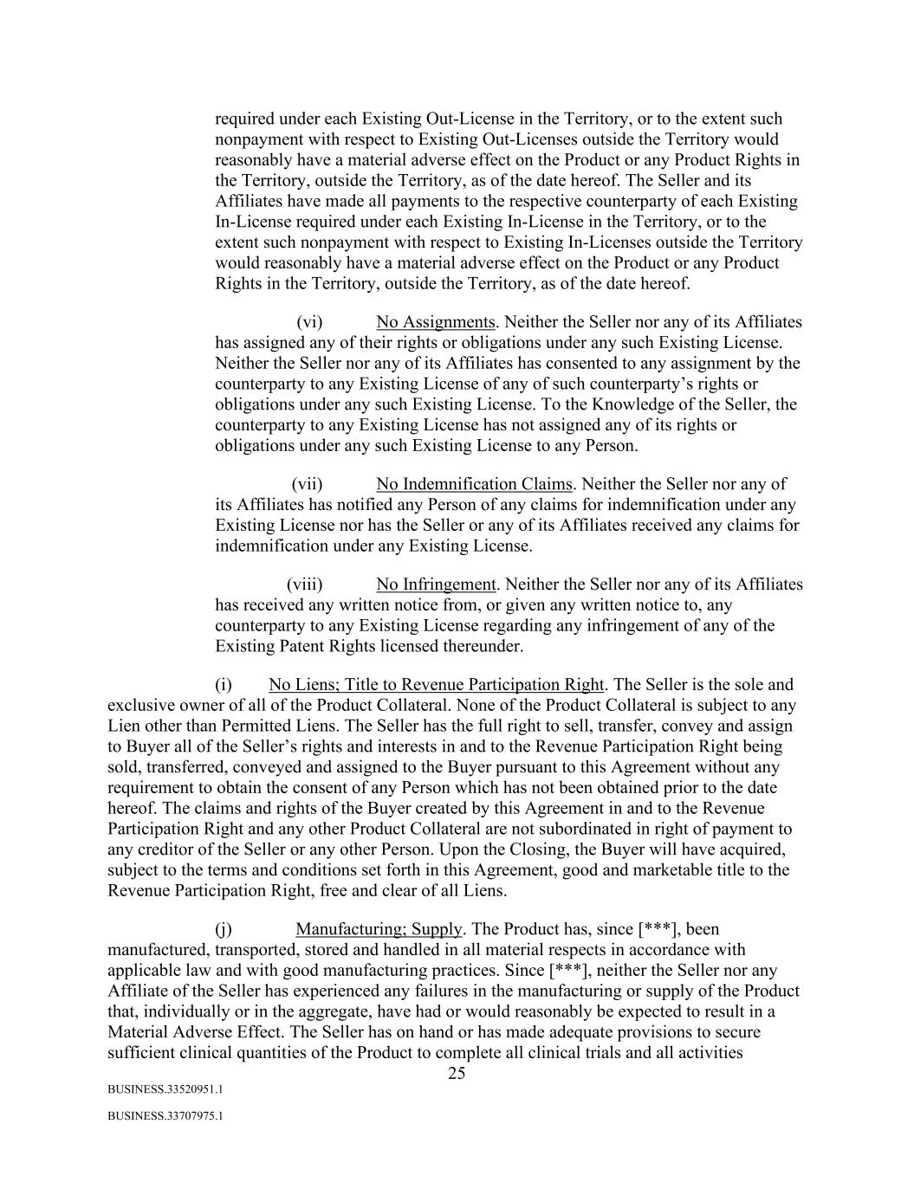
25 BUSINESS.33520951.1 BUSINESS.33707975.1 required under each Existing Out-License in the Territory, or to the extent such nonpayment with respect to Existing Out-Licenses outside the Territory would reasonably have a material adverse effect on the Product or any Product Rights in the Territory, outside the Territory, as of the date hereof. The Seller and its Affiliates have made all payments to the respective counterparty of each Existing In-License required under each Existing In-License in the Territory, or to the extent such nonpayment with respect to Existing In-Licenses outside the Territory would reasonably have a material adverse effect on the Product or any Product Rights in the Territory, outside the Territory, as of the date hereof. (vi) No Assignments. Neither the Seller nor any of its Affiliates has assigned any of their rights or obligations under any such Existing License. Neither the Seller nor any of its Affiliates has consented to any assignment by the counterparty to any Existing License of any of such counterparty’s rights or obligations under any such Existing License. To the Knowledge of the Seller, the counterparty to any Existing License has not assigned any of its rights or obligations under any such Existing License to any Person. (vii) No Indemnification Claims. Neither the Seller nor any of its Affiliates has notified any Person of any claims for indemnification under any Existing License nor has the Seller or any of its Affiliates received any claims for indemnification under any Existing License. (viii) No Infringement. Neither the Seller nor any of its Affiliates has received any written notice from, or given any written notice to, any counterparty to any Existing License regarding any infringement of any of the Existing Patent Rights licensed thereunder. (i) No Liens; Title to Revenue Participation Right. The Seller is the sole and exclusive owner of all of the Product Collateral. None of the Product Collateral is subject to any Lien other than Permitted Liens. The Seller has the full right to sell, transfer, convey and assign to Buyer all of the Seller’s rights and interests in and to the Revenue Participation Right being sold, transferred, conveyed and assigned to the Buyer pursuant to this Agreement without any requirement to obtain the consent of any Person which has not been obtained prior to the date hereof. The claims and rights of the Buyer created by this Agreement in and to the Revenue Participation Right and any other Product Collateral are not subordinated in right of payment to any creditor of the Seller or any other Person. Upon the Closing, the Buyer will have acquired, subject to the terms and conditions set forth in this Agreement, good and marketable title to the Revenue Participation Right, free and clear of all Liens. (j) Manufacturing; Supply. The Product has, since [***], been manufactured, transported, stored and handled in all material respects in accordance with applicable law and with good manufacturing practices. Since [***], neither the Seller nor any Affiliate of the Seller has experienced any failures in the manufacturing or supply of the Product that, individually or in the aggregate, have had or would reasonably be expected to result in a Material Adverse Effect. The Seller has on hand or has made adequate provisions to secure sufficient clinical quantities of the Product to complete all clinical trials and all activities

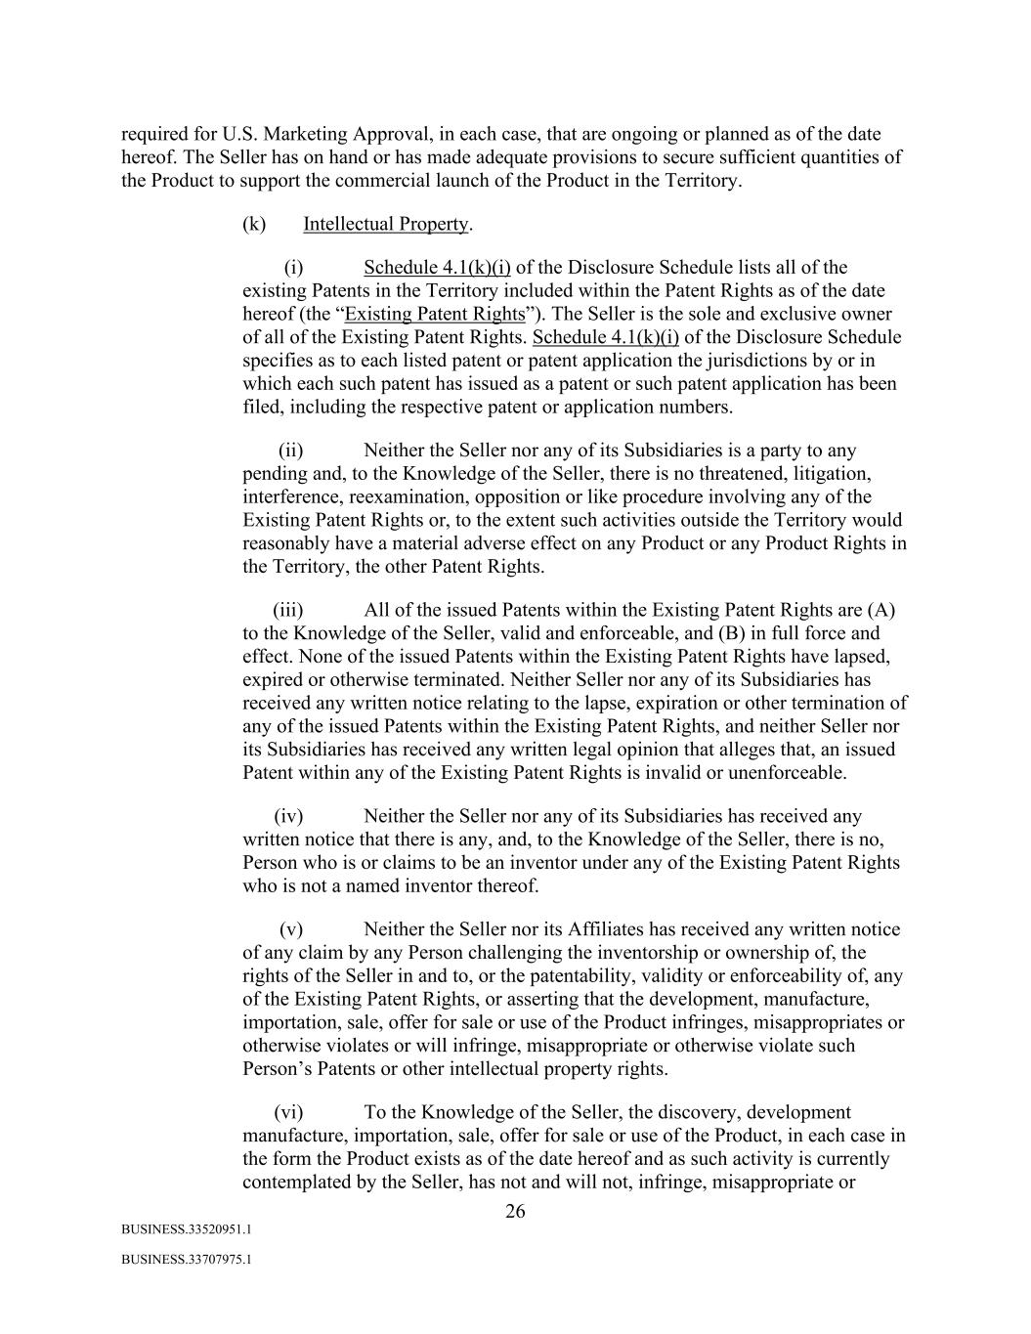
26 BUSINESS.33520951.1 BUSINESS.33707975.1 required for U.S. Marketing Approval, in each case, that are ongoing or planned as of the date hereof. The Seller has on hand or has made adequate provisions to secure sufficient quantities of the Product to support the commercial launch of the Product in the Territory. (k) Intellectual Property. (i) Schedule 4.1(k)(i) of the Disclosure Schedule lists all of the existing Patents in the Territory included within the Patent Rights as of the date hereof (the “Existing Patent Rights”). The Seller is the sole and exclusive owner of all of the Existing Patent Rights. Schedule 4.1(k)(i) of the Disclosure Schedule specifies as to each listed patent or patent application the jurisdictions by or in which each such patent has issued as a patent or such patent application has been filed, including the respective patent or application numbers. (ii) Neither the Seller nor any of its Subsidiaries is a party to any pending and, to the Knowledge of the Seller, there is no threatened, litigation, interference, reexamination, opposition or like procedure involving any of the Existing Patent Rights or, to the extent such activities outside the Territory would reasonably have a material adverse effect on any Product or any Product Rights in the Territory, the other Patent Rights. (iii) All of the issued Patents within the Existing Patent Rights are (A) to the Knowledge of the Seller, valid and enforceable, and (B) in full force and effect. None of the issued Patents within the Existing Patent Rights have lapsed, expired or otherwise terminated. Neither Seller nor any of its Subsidiaries has received any written notice relating to the lapse, expiration or other termination of any of the issued Patents within the Existing Patent Rights, and neither Seller nor its Subsidiaries has received any written legal opinion that alleges that, an issued Patent within any of the Existing Patent Rights is invalid or unenforceable. (iv) Neither the Seller nor any of its Subsidiaries has received any written notice that there is any, and, to the Knowledge of the Seller, there is no, Person who is or claims to be an inventor under any of the Existing Patent Rights who is not a named inventor thereof. (v) Neither the Seller nor its Affiliates has received any written notice of any claim by any Person challenging the inventorship or ownership of, the rights of the Seller in and to, or the patentability, validity or enforceability of, any of the Existing Patent Rights, or asserting that the development, manufacture, importation, sale, offer for sale or use of the Product infringes, misappropriates or otherwise violates or will infringe, misappropriate or otherwise violate such Person’s Patents or other intellectual property rights. (vi) To the Knowledge of the Seller, the discovery, development manufacture, importation, sale, offer for sale or use of the Product, in each case in the form the Product exists as of the date hereof and as such activity is currently contemplated by the Seller, has not and will not, infringe, misappropriate or

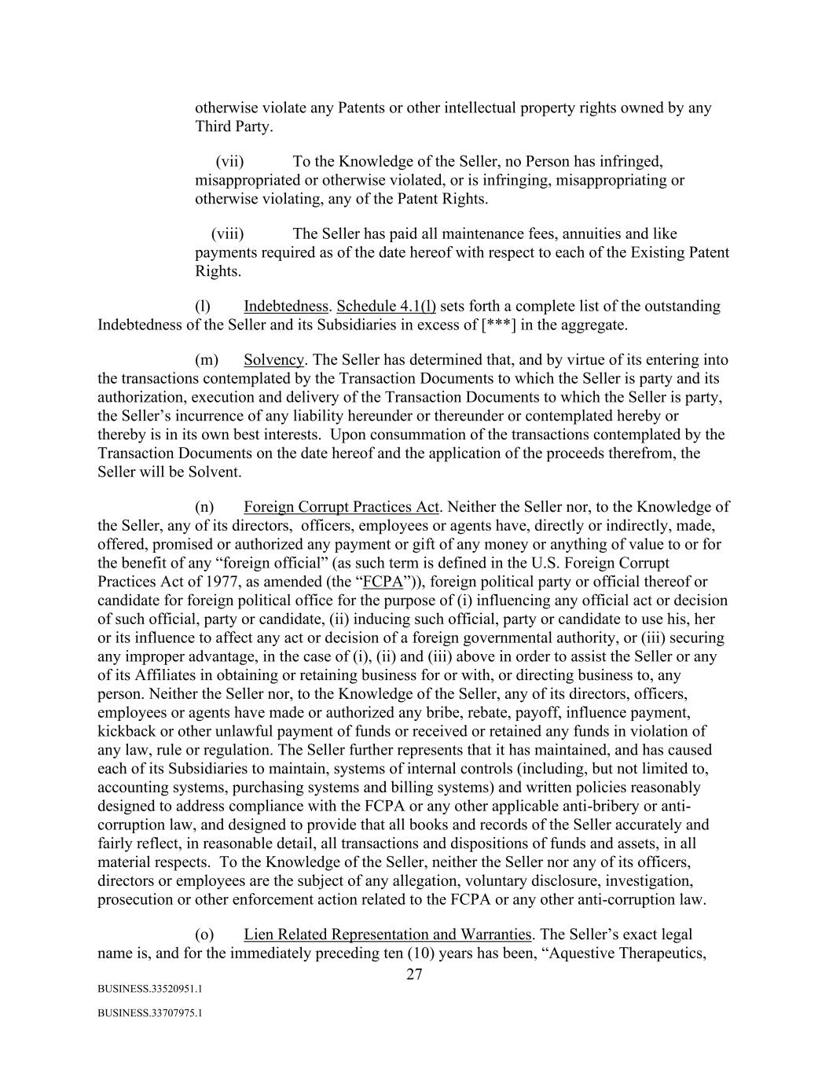
27 BUSINESS.33520951.1 BUSINESS.33707975.1 otherwise violate any Patents or other intellectual property rights owned by any Third Party. (vii) To the Knowledge of the Seller, no Person has infringed, misappropriated or otherwise violated, or is infringing, misappropriating or otherwise violating, any of the Patent Rights. (viii) The Seller has paid all maintenance fees, annuities and like payments required as of the date hereof with respect to each of the Existing Patent Rights. (l) Indebtedness. Schedule 4.1(l) sets forth a complete list of the outstanding Indebtedness of the Seller and its Subsidiaries in excess of [***] in the aggregate. (m) Solvency. The Seller has determined that, and by virtue of its entering into the transactions contemplated by the Transaction Documents to which the Seller is party and its authorization, execution and delivery of the Transaction Documents to which the Seller is party, the Seller’s incurrence of any liability hereunder or thereunder or contemplated hereby or thereby is in its own best interests. Upon consummation of the transactions contemplated by the Transaction Documents on the date hereof and the application of the proceeds therefrom, the Seller will be Solvent. (n) Foreign Corrupt Practices Act. Neither the Seller nor, to the Knowledge of the Seller, any of its directors, officers, employees or agents have, directly or indirectly, made, offered, promised or authorized any payment or gift of any money or anything of value to or for the benefit of any “foreign official” (as such term is defined in the U.S. Foreign Corrupt Practices Act of 1977, as amended (the “FCPA”)), foreign political party or official thereof or candidate for foreign political office for the purpose of (i) influencing any official act or decision of such official, party or candidate, (ii) inducing such official, party or candidate to use his, her or its influence to affect any act or decision of a foreign governmental authority, or (iii) securing any improper advantage, in the case of (i), (ii) and (iii) above in order to assist the Seller or any of its Affiliates in obtaining or retaining business for or with, or directing business to, any person. Neither the Seller nor, to the Knowledge of the Seller, any of its directors, officers, employees or agents have made or authorized any bribe, rebate, payoff, influence payment, kickback or other unlawful payment of funds or received or retained any funds in violation of any law, rule or regulation. The Seller further represents that it has maintained, and has caused each of its Subsidiaries to maintain, systems of internal controls (including, but not limited to, accounting systems, purchasing systems and billing systems) and written policies reasonably designed to address compliance with the FCPA or any other applicable anti-bribery or anti- corruption law, and designed to provide that all books and records of the Seller accurately and fairly reflect, in reasonable detail, all transactions and dispositions of funds and assets, in all material respects. To the Knowledge of the Seller, neither the Seller nor any of its officers, directors or employees are the subject of any allegation, voluntary disclosure, investigation, prosecution or other enforcement action related to the FCPA or any other anti-corruption law. (o) Lien Related Representation and Warranties. The Seller’s exact legal name is, and for the immediately preceding ten (10) years has been, “Aquestive Therapeutics,

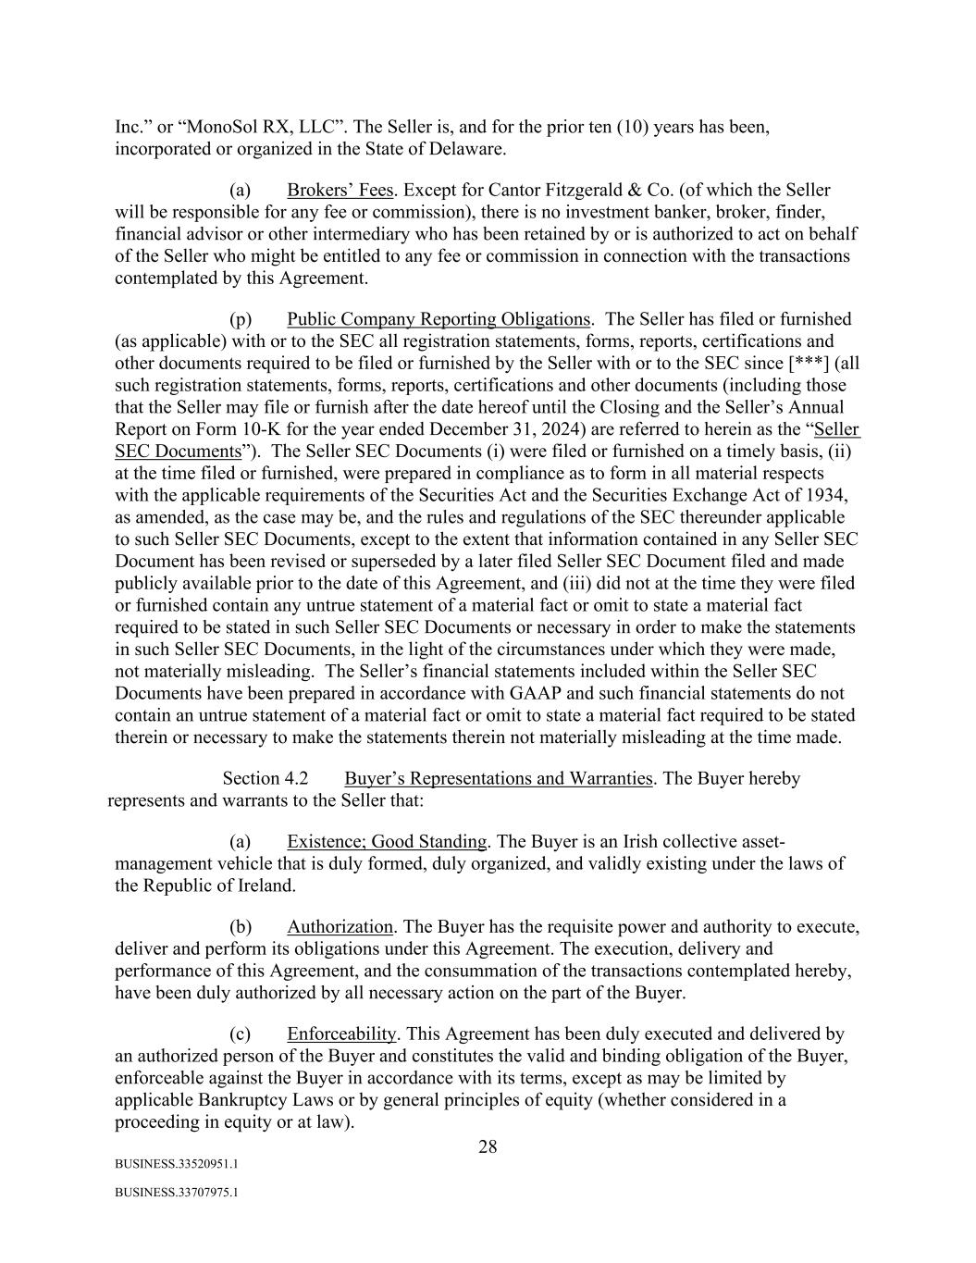
28 BUSINESS.33520951.1 BUSINESS.33707975.1 Inc.” or “MonoSol RX, LLC”. The Seller is, and for the prior ten (10) years has been, incorporated or organized in the State of Delaware. (a) Brokers’ Fees. Except for Cantor Fitzgerald & Co. (of which the Seller will be responsible for any fee or commission), there is no investment banker, broker, finder, financial advisor or other intermediary who has been retained by or is authorized to act on behalf of the Seller who might be entitled to any fee or commission in connection with the transactions contemplated by this Agreement. (p) Public Company Reporting Obligations. The Seller has filed or furnished (as applicable) with or to the SEC all registration statements, forms, reports, certifications and other documents required to be filed or furnished by the Seller with or to the SEC since [***] (all such registration statements, forms, reports, certifications and other documents (including those that the Seller may file or furnish after the date hereof until the Closing and the Seller’s Annual Report on Form 10-K for the year ended December 31, 2024) are referred to herein as the “Seller SEC Documents”). The Seller SEC Documents (i) were filed or furnished on a timely basis, (ii) at the time filed or furnished, were prepared in compliance as to form in all material respects with the applicable requirements of the Securities Act and the Securities Exchange Act of 1934, as amended, as the case may be, and the rules and regulations of the SEC thereunder applicable to such Seller SEC Documents, except to the extent that information contained in any Seller SEC Document has been revised or superseded by a later filed Seller SEC Document filed and made publicly available prior to the date of this Agreement, and (iii) did not at the time they were filed or furnished contain any untrue statement of a material fact or omit to state a material fact required to be stated in such Seller SEC Documents or necessary in order to make the statements in such Seller SEC Documents, in the light of the circumstances under which they were made, not materially misleading. The Seller’s financial statements included within the Seller SEC Documents have been prepared in accordance with GAAP and such financial statements do not contain an untrue statement of a material fact or omit to state a material fact required to be stated therein or necessary to make the statements therein not materially misleading at the time made. Section 4.2 Buyer’s Representations and Warranties. The Buyer hereby represents and warrants to the Seller that: (a) Existence; Good Standing. The Buyer is an Irish collective asset- management vehicle that is duly formed, duly organized, and validly existing under the laws of the Republic of Ireland. (b) Authorization. The Buyer has the requisite power and authority to execute, deliver and perform its obligations under this Agreement. The execution, delivery and performance of this Agreement, and the consummation of the transactions contemplated hereby, have been duly authorized by all necessary action on the part of the Buyer. (c) Enforceability. This Agreement has been duly executed and delivered by an authorized person of the Buyer and constitutes the valid and binding obligation of the Buyer, enforceable against the Buyer in accordance with its terms, except as may be limited by applicable Bankruptcy Laws or by general principles of equity (whether considered in a proceeding in equity or at law).

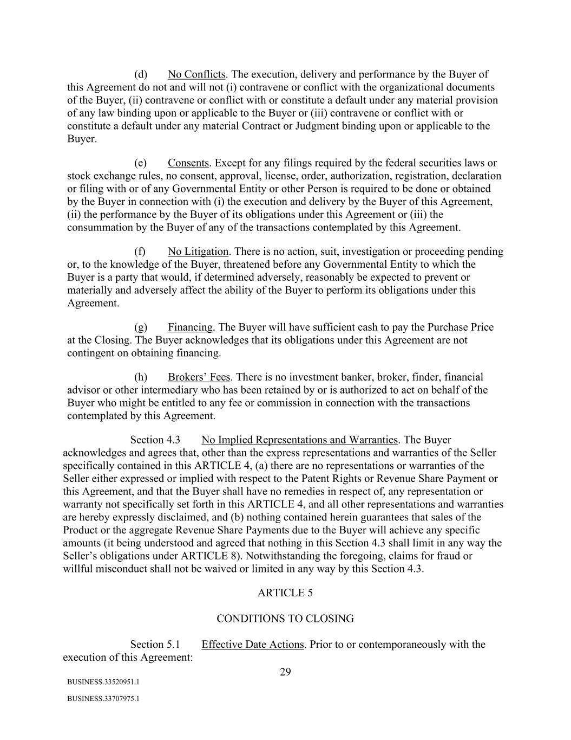
29 BUSINESS.33520951.1 BUSINESS.33707975.1 (d) No Conflicts. The execution, delivery and performance by the Buyer of this Agreement do not and will not (i) contravene or conflict with the organizational documents of the Buyer, (ii) contravene or conflict with or constitute a default under any material provision of any law binding upon or applicable to the Buyer or (iii) contravene or conflict with or constitute a default under any material Contract or Judgment binding upon or applicable to the Buyer. (e) Consents. Except for any filings required by the federal securities laws or stock exchange rules, no consent, approval, license, order, authorization, registration, declaration or filing with or of any Governmental Entity or other Person is required to be done or obtained by the Buyer in connection with (i) the execution and delivery by the Buyer of this Agreement, (ii) the performance by the Buyer of its obligations under this Agreement or (iii) the consummation by the Buyer of any of the transactions contemplated by this Agreement. (f) No Litigation. There is no action, suit, investigation or proceeding pending or, to the knowledge of the Buyer, threatened before any Governmental Entity to which the Buyer is a party that would, if determined adversely, reasonably be expected to prevent or materially and adversely affect the ability of the Buyer to perform its obligations under this Agreement. (g) Financing. The Buyer will have sufficient cash to pay the Purchase Price at the Closing. The Buyer acknowledges that its obligations under this Agreement are not contingent on obtaining financing. (h) Brokers’ Fees. There is no investment banker, broker, finder, financial advisor or other intermediary who has been retained by or is authorized to act on behalf of the Buyer who might be entitled to any fee or commission in connection with the transactions contemplated by this Agreement. Section 4.3 No Implied Representations and Warranties. The Buyer acknowledges and agrees that, other than the express representations and warranties of the Seller specifically contained in this ARTICLE 4, (a) there are no representations or warranties of the Seller either expressed or implied with respect to the Patent Rights or Revenue Share Payment or this Agreement, and that the Buyer shall have no remedies in respect of, any representation or warranty not specifically set forth in this ARTICLE 4, and all other representations and warranties are hereby expressly disclaimed, and (b) nothing contained herein guarantees that sales of the Product or the aggregate Revenue Share Payments due to the Buyer will achieve any specific amounts (it being understood and agreed that nothing in this Section 4.3 shall limit in any way the Seller’s obligations under ARTICLE 8). Notwithstanding the foregoing, claims for fraud or willful misconduct shall not be waived or limited in any way by this Section 4.3. ARTICLE 5 CONDITIONS TO CLOSING Section 5.1 Effective Date Actions. Prior to or contemporaneously with the execution of this Agreement:

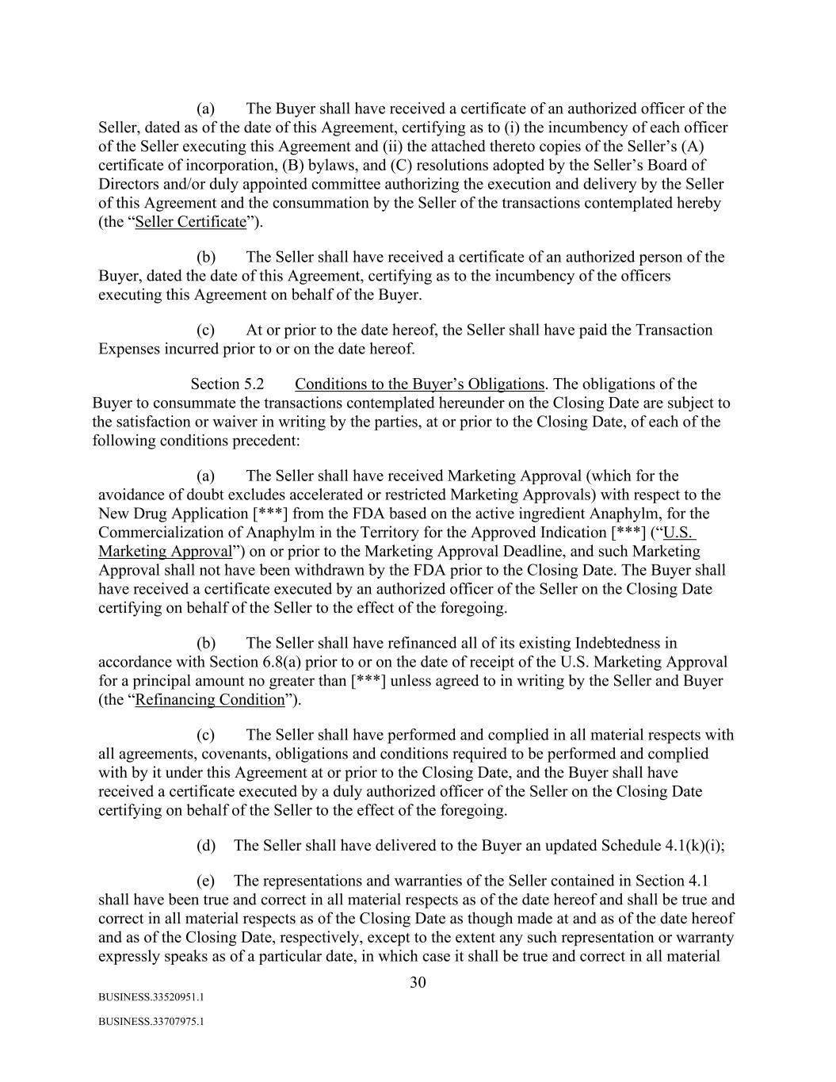
30 BUSINESS.33520951.1 BUSINESS.33707975.1 (a) The Buyer shall have received a certificate of an authorized officer of the Seller, dated as of the date of this Agreement, certifying as to (i) the incumbency of each officer of the Seller executing this Agreement and (ii) the attached thereto copies of the Seller’s (A) certificate of incorporation, (B) bylaws, and (C) resolutions adopted by the Seller’s Board of Directors and/or duly appointed committee authorizing the execution and delivery by the Seller of this Agreement and the consummation by the Seller of the transactions contemplated hereby (the “Seller Certificate”). (b) The Seller shall have received a certificate of an authorized person of the Buyer, dated the date of this Agreement, certifying as to the incumbency of the officers executing this Agreement on behalf of the Buyer. (c) At or prior to the date hereof, the Seller shall have paid the Transaction Expenses incurred prior to or on the date hereof. Section 5.2 Conditions to the Buyer’s Obligations. The obligations of the Buyer to consummate the transactions contemplated hereunder on the Closing Date are subject to the satisfaction or waiver in writing by the parties, at or prior to the Closing Date, of each of the following conditions precedent: (a) The Seller shall have received Marketing Approval (which for the avoidance of doubt excludes accelerated or restricted Marketing Approvals) with respect to the New Drug Application [***] from the FDA based on the active ingredient Anaphylm, for the Commercialization of Anaphylm in the Territory for the Approved Indication [***] (“U.S. Marketing Approval”) on or prior to the Marketing Approval Deadline, and such Marketing Approval shall not have been withdrawn by the FDA prior to the Closing Date. The Buyer shall have received a certificate executed by an authorized officer of the Seller on the Closing Date certifying on behalf of the Seller to the effect of the foregoing. (b) The Seller shall have refinanced all of its existing Indebtedness in accordance with Section 6.8(a) prior to or on the date of receipt of the U.S. Marketing Approval for a principal amount no greater than [***] unless agreed to in writing by the Seller and Buyer (the “Refinancing Condition”). (c) The Seller shall have performed and complied in all material respects with all agreements, covenants, obligations and conditions required to be performed and complied with by it under this Agreement at or prior to the Closing Date, and the Buyer shall have received a certificate executed by a duly authorized officer of the Seller on the Closing Date certifying on behalf of the Seller to the effect of the foregoing. (d) The Seller shall have delivered to the Buyer an updated Schedule 4.1(k)(i); (e) The representations and warranties of the Seller contained in Section 4.1 shall have been true and correct in all material respects as of the date hereof and shall be true and correct in all material respects as of the Closing Date as though made at and as of the date hereof and as of the Closing Date, respectively, except to the extent any such representation or warranty expressly speaks as of a particular date, in which case it shall be true and correct in all material

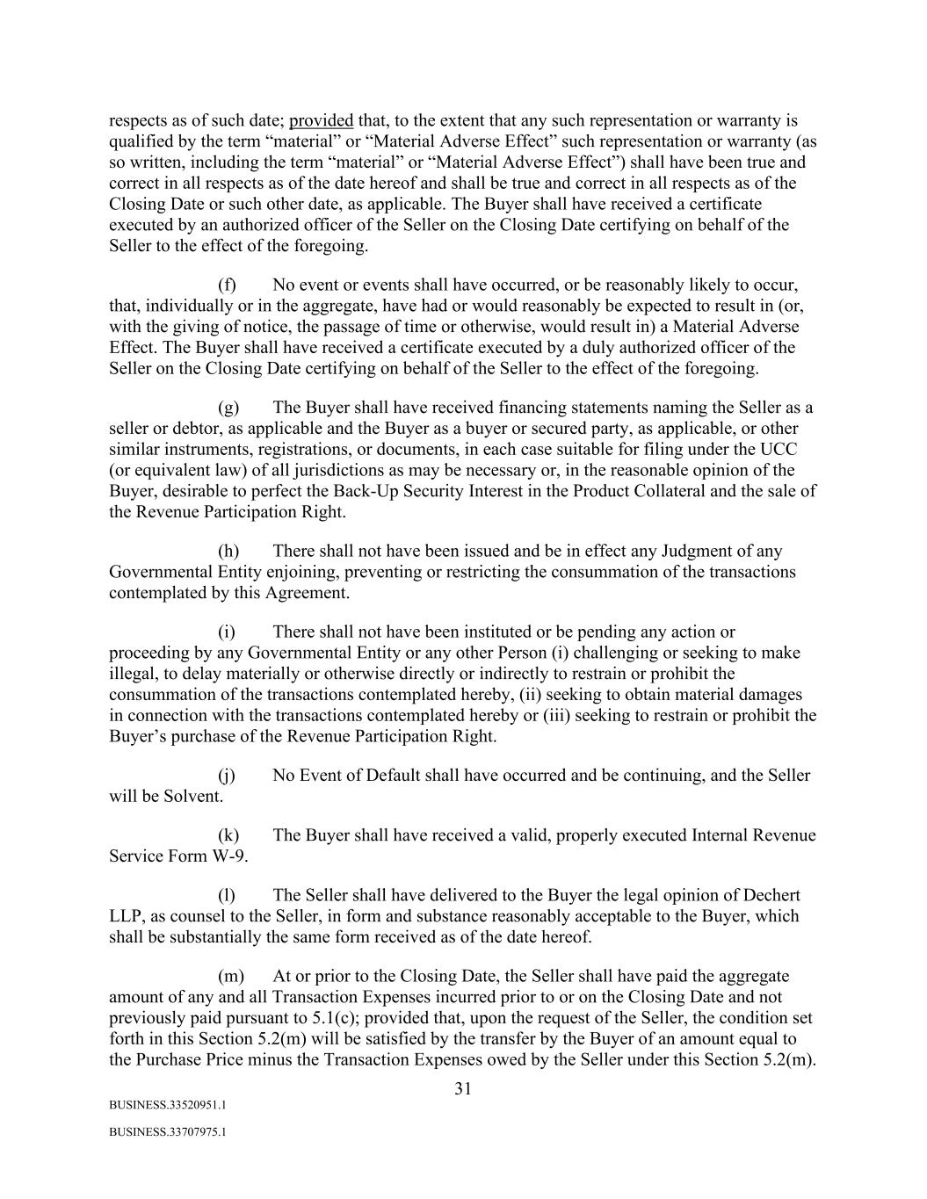
31 BUSINESS.33520951.1 BUSINESS.33707975.1 respects as of such date; provided that, to the extent that any such representation or warranty is qualified by the term “material” or “Material Adverse Effect” such representation or warranty (as so written, including the term “material” or “Material Adverse Effect”) shall have been true and correct in all respects as of the date hereof and shall be true and correct in all respects as of the Closing Date or such other date, as applicable. The Buyer shall have received a certificate executed by an authorized officer of the Seller on the Closing Date certifying on behalf of the Seller to the effect of the foregoing. (f) No event or events shall have occurred, or be reasonably likely to occur, that, individually or in the aggregate, have had or would reasonably be expected to result in (or, with the giving of notice, the passage of time or otherwise, would result in) a Material Adverse Effect. The Buyer shall have received a certificate executed by a duly authorized officer of the Seller on the Closing Date certifying on behalf of the Seller to the effect of the foregoing. (g) The Buyer shall have received financing statements naming the Seller as a seller or debtor, as applicable and the Buyer as a buyer or secured party, as applicable, or other similar instruments, registrations, or documents, in each case suitable for filing under the UCC (or equivalent law) of all jurisdictions as may be necessary or, in the reasonable opinion of the Buyer, desirable to perfect the Back-Up Security Interest in the Product Collateral and the sale of the Revenue Participation Right. (h) There shall not have been issued and be in effect any Judgment of any Governmental Entity enjoining, preventing or restricting the consummation of the transactions contemplated by this Agreement. (i) There shall not have been instituted or be pending any action or proceeding by any Governmental Entity or any other Person (i) challenging or seeking to make illegal, to delay materially or otherwise directly or indirectly to restrain or prohibit the consummation of the transactions contemplated hereby, (ii) seeking to obtain material damages in connection with the transactions contemplated hereby or (iii) seeking to restrain or prohibit the Buyer’s purchase of the Revenue Participation Right. (j) No Event of Default shall have occurred and be continuing, and the Seller will be Solvent. (k) The Buyer shall have received a valid, properly executed Internal Revenue Service Form W-9. (l) The Seller shall have delivered to the Buyer the legal opinion of Dechert LLP, as counsel to the Seller, in form and substance reasonably acceptable to the Buyer, which shall be substantially the same form received as of the date hereof. (m) At or prior to the Closing Date, the Seller shall have paid the aggregate amount of any and all Transaction Expenses incurred prior to or on the Closing Date and not previously paid pursuant to 5.1(c); provided that, upon the request of the Seller, the condition set forth in this Section 5.2(m) will be satisfied by the transfer by the Buyer of an amount equal to the Purchase Price minus the Transaction Expenses owed by the Seller under this Section 5.2(m).

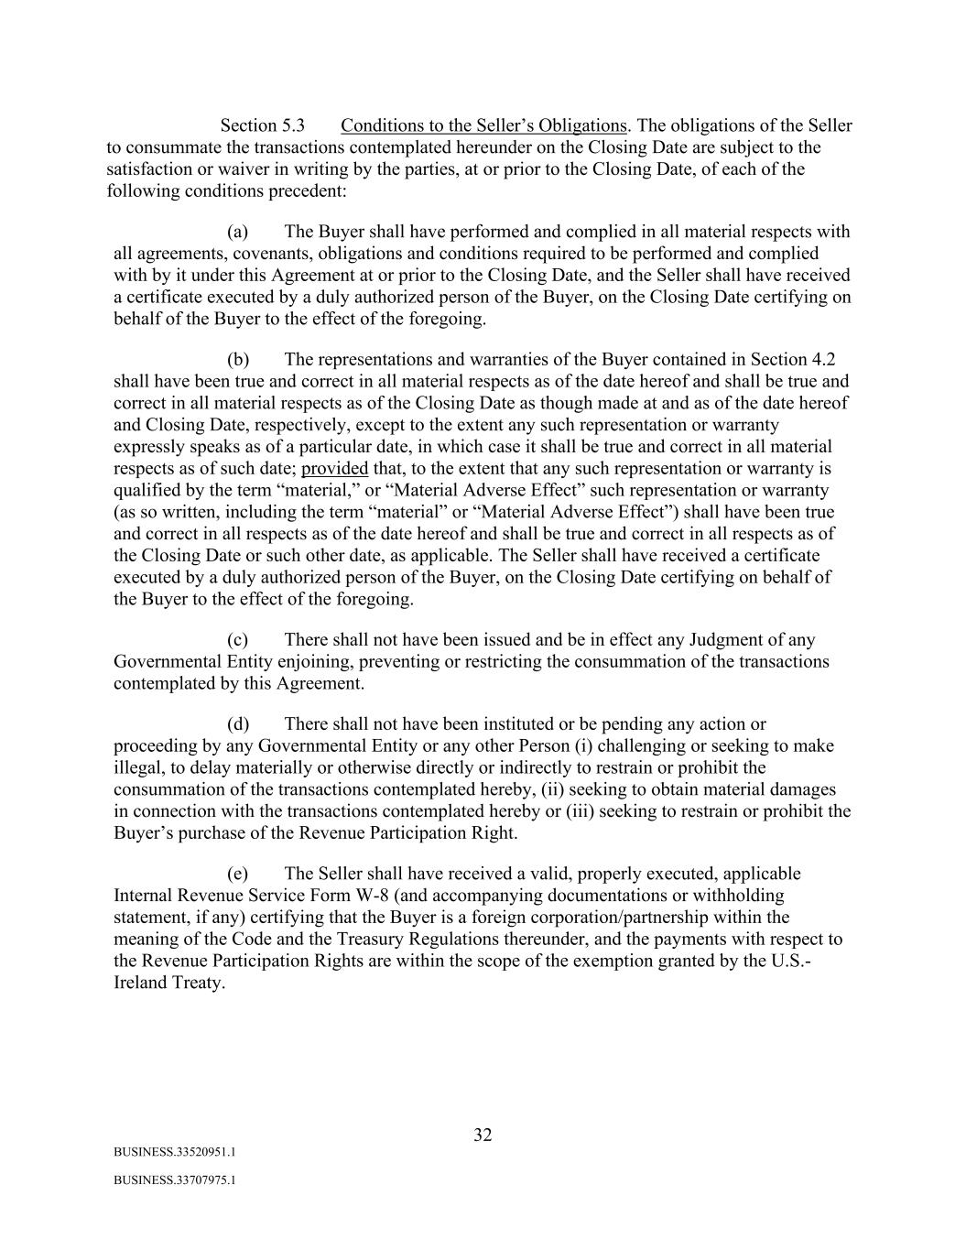
32 BUSINESS.33520951.1 BUSINESS.33707975.1 Section 5.3 Conditions to the Seller’s Obligations. The obligations of the Seller to consummate the transactions contemplated hereunder on the Closing Date are subject to the satisfaction or waiver in writing by the parties, at or prior to the Closing Date, of each of the following conditions precedent: (a) The Buyer shall have performed and complied in all material respects with all agreements, covenants, obligations and conditions required to be performed and complied with by it under this Agreement at or prior to the Closing Date, and the Seller shall have received a certificate executed by a duly authorized person of the Buyer, on the Closing Date certifying on behalf of the Buyer to the effect of the foregoing. (b) The representations and warranties of the Buyer contained in Section 4.2 shall have been true and correct in all material respects as of the date hereof and shall be true and correct in all material respects as of the Closing Date as though made at and as of the date hereof and Closing Date, respectively, except to the extent any such representation or warranty expressly speaks as of a particular date, in which case it shall be true and correct in all material respects as of such date; provided that, to the extent that any such representation or warranty is qualified by the term “material,” or “Material Adverse Effect” such representation or warranty (as so written, including the term “material” or “Material Adverse Effect”) shall have been true and correct in all respects as of the date hereof and shall be true and correct in all respects as of the Closing Date or such other date, as applicable. The Seller shall have received a certificate executed by a duly authorized person of the Buyer, on the Closing Date certifying on behalf of the Buyer to the effect of the foregoing. (c) There shall not have been issued and be in effect any Judgment of any Governmental Entity enjoining, preventing or restricting the consummation of the transactions contemplated by this Agreement. (d) There shall not have been instituted or be pending any action or proceeding by any Governmental Entity or any other Person (i) challenging or seeking to make illegal, to delay materially or otherwise directly or indirectly to restrain or prohibit the consummation of the transactions contemplated hereby, (ii) seeking to obtain material damages in connection with the transactions contemplated hereby or (iii) seeking to restrain or prohibit the Buyer’s purchase of the Revenue Participation Right. (e) The Seller shall have received a valid, properly executed, applicable Internal Revenue Service Form W-8 (and accompanying documentations or withholding statement, if any) certifying that the Buyer is a foreign corporation/partnership within the meaning of the Code and the Treasury Regulations thereunder, and the payments with respect to the Revenue Participation Rights are within the scope of the exemption granted by the U.S.- Ireland Treaty.

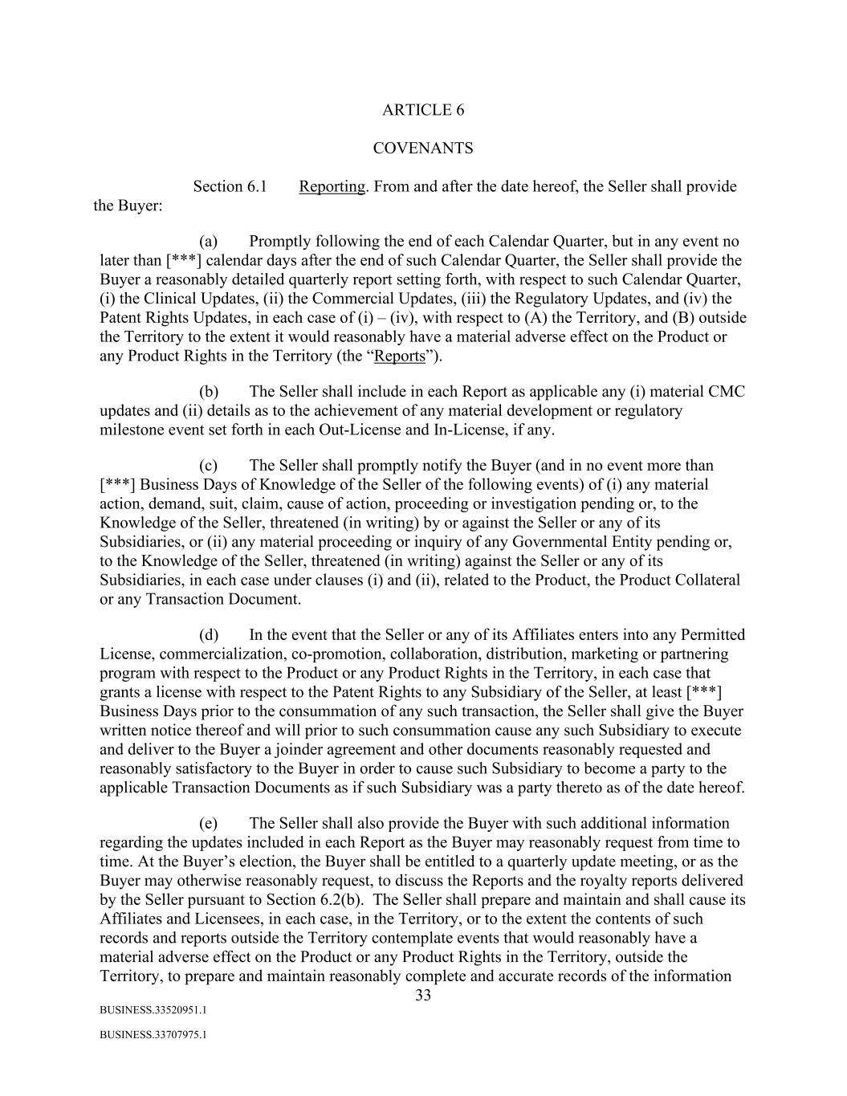
33 BUSINESS.33520951.1 BUSINESS.33707975.1 ARTICLE 6 COVENANTS Section 6.1 Reporting. From and after the date hereof, the Seller shall provide the Buyer: (a) Promptly following the end of each Calendar Quarter, but in any event no later than [***] calendar days after the end of such Calendar Quarter, the Seller shall provide the Buyer a reasonably detailed quarterly report setting forth, with respect to such Calendar Quarter, (i) the Clinical Updates, (ii) the Commercial Updates, (iii) the Regulatory Updates, and (iv) the Patent Rights Updates, in each case of (i) – (iv), with respect to (A) the Territory, and (B) outside the Territory to the extent it would reasonably have a material adverse effect on the Product or any Product Rights in the Territory (the “Reports”). (b) The Seller shall include in each Report as applicable any (i) material CMC updates and (ii) details as to the achievement of any material development or regulatory milestone event set forth in each Out-License and In-License, if any. (c) The Seller shall promptly notify the Buyer (and in no event more than [***] Business Days of Knowledge of the Seller of the following events) of (i) any material action, demand, suit, claim, cause of action, proceeding or investigation pending or, to the Knowledge of the Seller, threatened (in writing) by or against the Seller or any of its Subsidiaries, or (ii) any material proceeding or inquiry of any Governmental Entity pending or, to the Knowledge of the Seller, threatened (in writing) against the Seller or any of its Subsidiaries, in each case under clauses (i) and (ii), related to the Product, the Product Collateral or any Transaction Document. (d) In the event that the Seller or any of its Affiliates enters into any Permitted License, commercialization, co-promotion, collaboration, distribution, marketing or partnering program with respect to the Product or any Product Rights in the Territory, in each case that grants a license with respect to the Patent Rights to any Subsidiary of the Seller, at least [***] Business Days prior to the consummation of any such transaction, the Seller shall give the Buyer written notice thereof and will prior to such consummation cause any such Subsidiary to execute and deliver to the Buyer a joinder agreement and other documents reasonably requested and reasonably satisfactory to the Buyer in order to cause such Subsidiary to become a party to the applicable Transaction Documents as if such Subsidiary was a party thereto as of the date hereof. (e) The Seller shall also provide the Buyer with such additional information regarding the updates included in each Report as the Buyer may reasonably request from time to time. At the Buyer’s election, the Buyer shall be entitled to a quarterly update meeting, or as the Buyer may otherwise reasonably request, to discuss the Reports and the royalty reports delivered by the Seller pursuant to Section 6.2(b). The Seller shall prepare and maintain and shall cause its Affiliates and Licensees, in each case, in the Territory, or to the extent the contents of such records and reports outside the Territory contemplate events that would reasonably have a material adverse effect on the Product or any Product Rights in the Territory, outside the Territory, to prepare and maintain reasonably complete and accurate records of the information

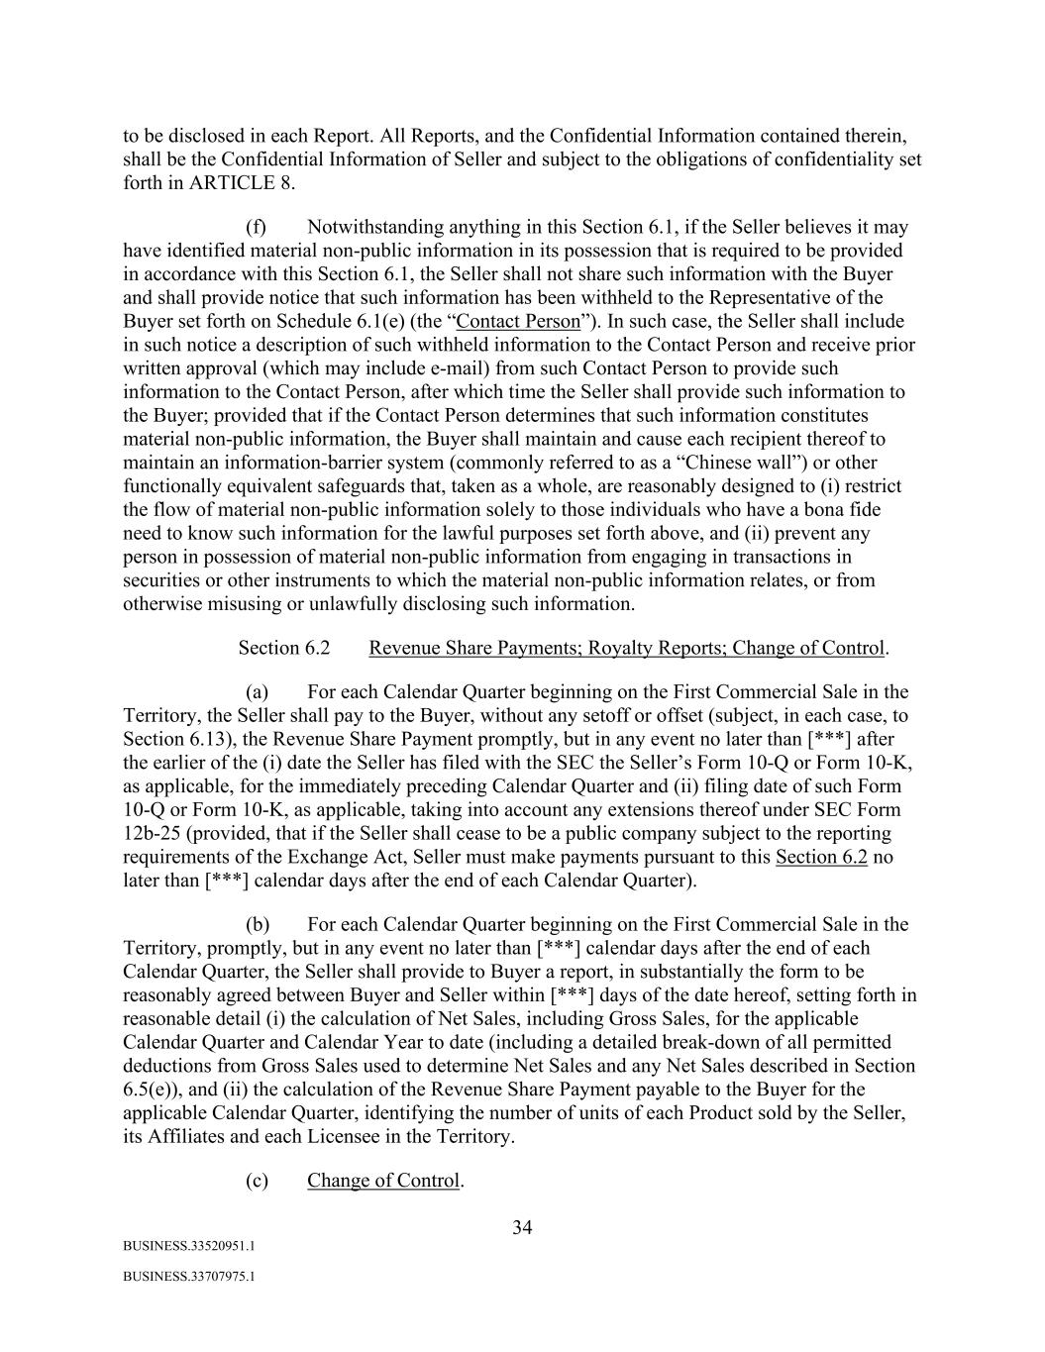
34 BUSINESS.33520951.1 BUSINESS.33707975.1 to be disclosed in each Report. All Reports, and the Confidential Information contained therein, shall be the Confidential Information of Seller and subject to the obligations of confidentiality set forth in ARTICLE 8. (f) Notwithstanding anything in this Section 6.1, if the Seller believes it may have identified material non-public information in its possession that is required to be provided in accordance with this Section 6.1, the Seller shall not share such information with the Buyer and shall provide notice that such information has been withheld to the Representative of the Buyer set forth on Schedule 6.1(e) (the “Contact Person”). In such case, the Seller shall include in such notice a description of such withheld information to the Contact Person and receive prior written approval (which may include e-mail) from such Contact Person to provide such information to the Contact Person, after which time the Seller shall provide such information to the Buyer; provided that if the Contact Person determines that such information constitutes material non-public information, the Buyer shall maintain and cause each recipient thereof to maintain an information-barrier system (commonly referred to as a “Chinese wall”) or other functionally equivalent safeguards that, taken as a whole, are reasonably designed to (i) restrict the flow of material non-public information solely to those individuals who have a bona fide need to know such information for the lawful purposes set forth above, and (ii) prevent any person in possession of material non-public information from engaging in transactions in securities or other instruments to which the material non-public information relates, or from otherwise misusing or unlawfully disclosing such information. Section 6.2 Revenue Share Payments; Royalty Reports; Change of Control. (a) For each Calendar Quarter beginning on the First Commercial Sale in the Territory, the Seller shall pay to the Buyer, without any setoff or offset (subject, in each case, to Section 6.13), the Revenue Share Payment promptly, but in any event no later than [***] after the earlier of the (i) date the Seller has filed with the SEC the Seller’s Form 10-Q or Form 10-K, as applicable, for the immediately preceding Calendar Quarter and (ii) filing date of such Form 10-Q or Form 10-K, as applicable, taking into account any extensions thereof under SEC Form 12b-25 (provided, that if the Seller shall cease to be a public company subject to the reporting requirements of the Exchange Act, Seller must make payments pursuant to this Section 6.2 no later than [***] calendar days after the end of each Calendar Quarter). (b) For each Calendar Quarter beginning on the First Commercial Sale in the Territory, promptly, but in any event no later than [***] calendar days after the end of each Calendar Quarter, the Seller shall provide to Buyer a report, in substantially the form to be reasonably agreed between Buyer and Seller within [***] days of the date hereof, setting forth in reasonable detail (i) the calculation of Net Sales, including Gross Sales, for the applicable Calendar Quarter and Calendar Year to date (including a detailed break-down of all permitted deductions from Gross Sales used to determine Net Sales and any Net Sales described in Section 6.5(e)), and (ii) the calculation of the Revenue Share Payment payable to the Buyer for the applicable Calendar Quarter, identifying the number of units of each Product sold by the Seller, its Affiliates and each Licensee in the Territory. (c) Change of Control.

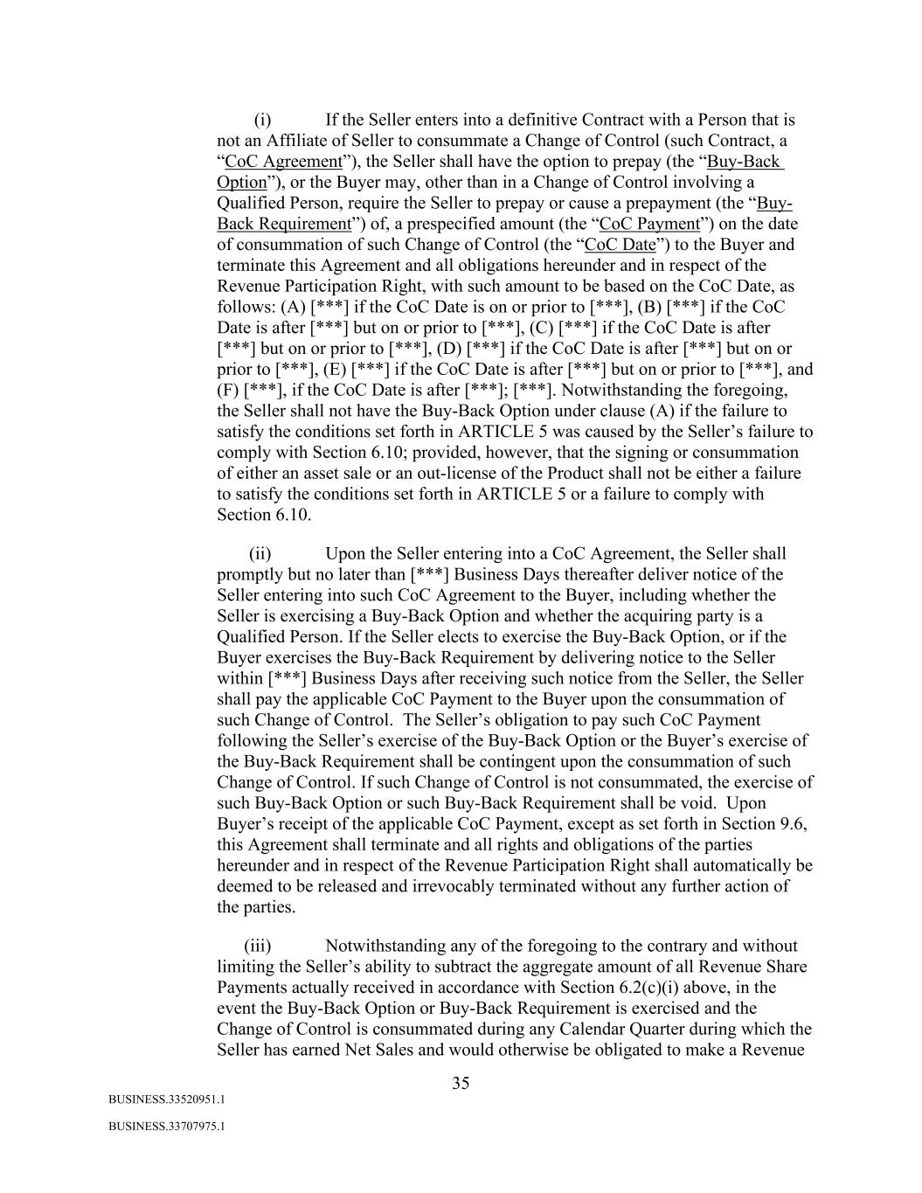
35 BUSINESS.33520951.1 BUSINESS.33707975.1 (i) If the Seller enters into a definitive Contract with a Person that is not an Affiliate of Seller to consummate a Change of Control (such Contract, a “CoC Agreement”), the Seller shall have the option to prepay (the “Buy-Back Option”), or the Buyer may, other than in a Change of Control involving a Qualified Person, require the Seller to prepay or cause a prepayment (the “Buy- Back Requirement”) of, a prespecified amount (the “CoC Payment”) on the date of consummation of such Change of Control (the “CoC Date”) to the Buyer and terminate this Agreement and all obligations hereunder and in respect of the Revenue Participation Right, with such amount to be based on the CoC Date, as follows: (A) [***] if the CoC Date is on or prior to [***], (B) [***] if the CoC Date is after [***] but on or prior to [***], (C) [***] if the CoC Date is after [***] but on or prior to [***], (D) [***] if the CoC Date is after [***] but on or prior to [***], (E) [***] if the CoC Date is after [***] but on or prior to [***], and (F) [***], if the CoC Date is after [***]; [***]. Notwithstanding the foregoing, the Seller shall not have the Buy-Back Option under clause (A) if the failure to satisfy the conditions set forth in ARTICLE 5 was caused by the Seller’s failure to comply with Section 6.10; provided, however, that the signing or consummation of either an asset sale or an out-license of the Product shall not be either a failure to satisfy the conditions set forth in ARTICLE 5 or a failure to comply with Section 6.10. (ii) Upon the Seller entering into a CoC Agreement, the Seller shall promptly but no later than [***] Business Days thereafter deliver notice of the Seller entering into such CoC Agreement to the Buyer, including whether the Seller is exercising a Buy-Back Option and whether the acquiring party is a Qualified Person. If the Seller elects to exercise the Buy-Back Option, or if the Buyer exercises the Buy-Back Requirement by delivering notice to the Seller within [***] Business Days after receiving such notice from the Seller, the Seller shall pay the applicable CoC Payment to the Buyer upon the consummation of such Change of Control. The Seller’s obligation to pay such CoC Payment following the Seller’s exercise of the Buy-Back Option or the Buyer’s exercise of the Buy-Back Requirement shall be contingent upon the consummation of such Change of Control. If such Change of Control is not consummated, the exercise of such Buy-Back Option or such Buy-Back Requirement shall be void. Upon Buyer’s receipt of the applicable CoC Payment, except as set forth in Section 9.6, this Agreement shall terminate and all rights and obligations of the parties hereunder and in respect of the Revenue Participation Right shall automatically be deemed to be released and irrevocably terminated without any further action of the parties. (iii) Notwithstanding any of the foregoing to the contrary and without limiting the Seller’s ability to subtract the aggregate amount of all Revenue Share Payments actually received in accordance with Section 6.2(c)(i) above, in the event the Buy-Back Option or Buy-Back Requirement is exercised and the Change of Control is consummated during any Calendar Quarter during which the Seller has earned Net Sales and would otherwise be obligated to make a Revenue

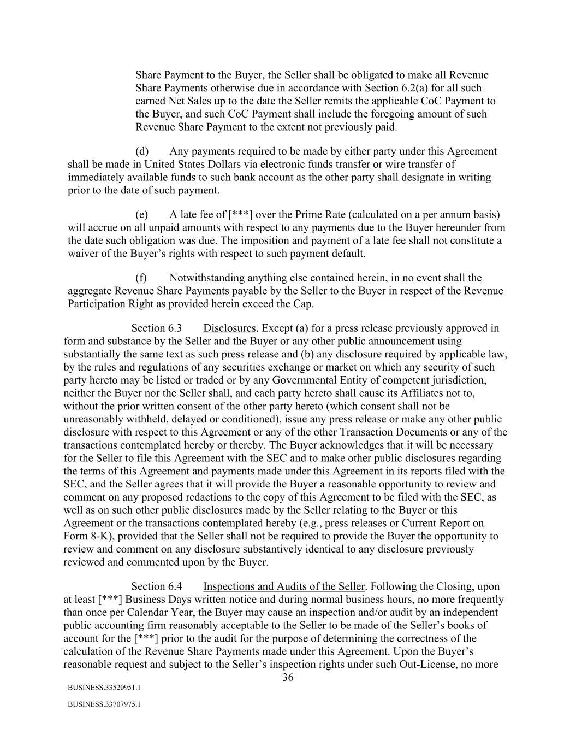
36 BUSINESS.33520951.1 BUSINESS.33707975.1 Share Payment to the Buyer, the Seller shall be obligated to make all Revenue Share Payments otherwise due in accordance with Section 6.2(a) for all such earned Net Sales up to the date the Seller remits the applicable CoC Payment to the Buyer, and such CoC Payment shall include the foregoing amount of such Revenue Share Payment to the extent not previously paid. (d) Any payments required to be made by either party under this Agreement shall be made in United States Dollars via electronic funds transfer or wire transfer of immediately available funds to such bank account as the other party shall designate in writing prior to the date of such payment. (e) A late fee of [***] over the Prime Rate (calculated on a per annum basis) will accrue on all unpaid amounts with respect to any payments due to the Buyer hereunder from the date such obligation was due. The imposition and payment of a late fee shall not constitute a waiver of the Buyer’s rights with respect to such payment default. (f) Notwithstanding anything else contained herein, in no event shall the aggregate Revenue Share Payments payable by the Seller to the Buyer in respect of the Revenue Participation Right as provided herein exceed the Cap. Section 6.3 Disclosures. Except (a) for a press release previously approved in form and substance by the Seller and the Buyer or any other public announcement using substantially the same text as such press release and (b) any disclosure required by applicable law, by the rules and regulations of any securities exchange or market on which any security of such party hereto may be listed or traded or by any Governmental Entity of competent jurisdiction, neither the Buyer nor the Seller shall, and each party hereto shall cause its Affiliates not to, without the prior written consent of the other party hereto (which consent shall not be unreasonably withheld, delayed or conditioned), issue any press release or make any other public disclosure with respect to this Agreement or any of the other Transaction Documents or any of the transactions contemplated hereby or thereby. The Buyer acknowledges that it will be necessary for the Seller to file this Agreement with the SEC and to make other public disclosures regarding the terms of this Agreement and payments made under this Agreement in its reports filed with the SEC, and the Seller agrees that it will provide the Buyer a reasonable opportunity to review and comment on any proposed redactions to the copy of this Agreement to be filed with the SEC, as well as on such other public disclosures made by the Seller relating to the Buyer or this Agreement or the transactions contemplated hereby (e.g., press releases or Current Report on Form 8-K), provided that the Seller shall not be required to provide the Buyer the opportunity to review and comment on any disclosure substantively identical to any disclosure previously reviewed and commented upon by the Buyer. Section 6.4 Inspections and Audits of the Seller. Following the Closing, upon at least [***] Business Days written notice and during normal business hours, no more frequently than once per Calendar Year, the Buyer may cause an inspection and/or audit by an independent public accounting firm reasonably acceptable to the Seller to be made of the Seller’s books of account for the [***] prior to the audit for the purpose of determining the correctness of the calculation of the Revenue Share Payments made under this Agreement. Upon the Buyer’s reasonable request and subject to the Seller’s inspection rights under such Out-License, no more

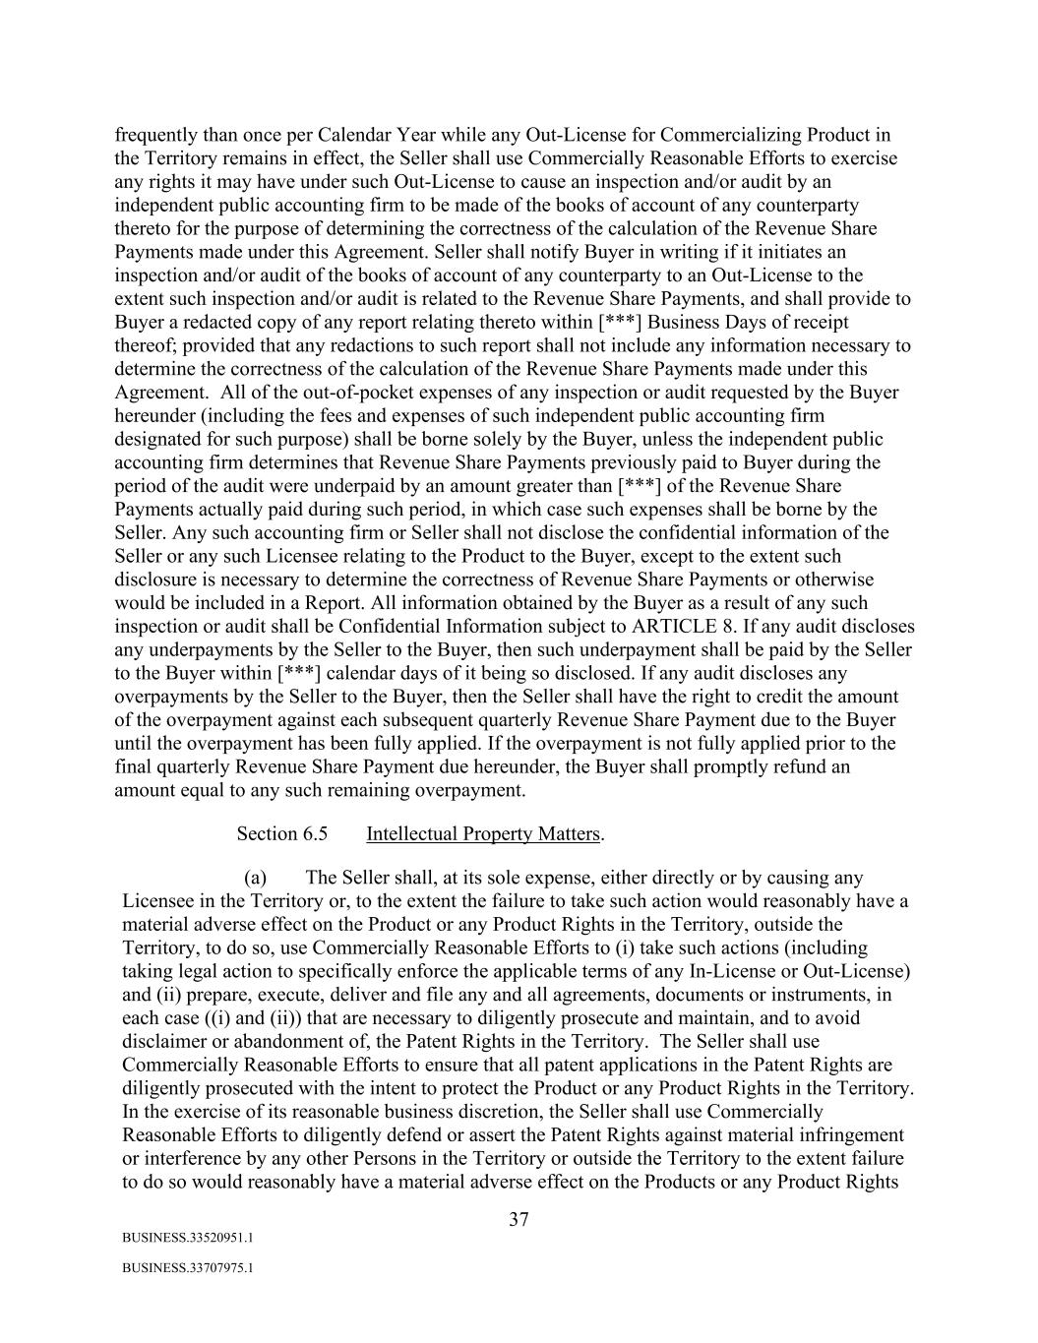
37 BUSINESS.33520951.1 BUSINESS.33707975.1 frequently than once per Calendar Year while any Out-License for Commercializing Product in the Territory remains in effect, the Seller shall use Commercially Reasonable Efforts to exercise any rights it may have under such Out-License to cause an inspection and/or audit by an independent public accounting firm to be made of the books of account of any counterparty thereto for the purpose of determining the correctness of the calculation of the Revenue Share Payments made under this Agreement. Seller shall notify Buyer in writing if it initiates an inspection and/or audit of the books of account of any counterparty to an Out-License to the extent such inspection and/or audit is related to the Revenue Share Payments, and shall provide to Buyer a redacted copy of any report relating thereto within [***] Business Days of receipt thereof; provided that any redactions to such report shall not include any information necessary to determine the correctness of the calculation of the Revenue Share Payments made under this Agreement. All of the out-of-pocket expenses of any inspection or audit requested by the Buyer hereunder (including the fees and expenses of such independent public accounting firm designated for such purpose) shall be borne solely by the Buyer, unless the independent public accounting firm determines that Revenue Share Payments previously paid to Buyer during the period of the audit were underpaid by an amount greater than [***] of the Revenue Share Payments actually paid during such period, in which case such expenses shall be borne by the Seller. Any such accounting firm or Seller shall not disclose the confidential information of the Seller or any such Licensee relating to the Product to the Buyer, except to the extent such disclosure is necessary to determine the correctness of Revenue Share Payments or otherwise would be included in a Report. All information obtained by the Buyer as a result of any such inspection or audit shall be Confidential Information subject to ARTICLE 8. If any audit discloses any underpayments by the Seller to the Buyer, then such underpayment shall be paid by the Seller to the Buyer within [***] calendar days of it being so disclosed. If any audit discloses any overpayments by the Seller to the Buyer, then the Seller shall have the right to credit the amount of the overpayment against each subsequent quarterly Revenue Share Payment due to the Buyer until the overpayment has been fully applied. If the overpayment is not fully applied prior to the final quarterly Revenue Share Payment due hereunder, the Buyer shall promptly refund an amount equal to any such remaining overpayment. Section 6.5 Intellectual Property Matters. (a) The Seller shall, at its sole expense, either directly or by causing any Licensee in the Territory or, to the extent the failure to take such action would reasonably have a material adverse effect on the Product or any Product Rights in the Territory, outside the Territory, to do so, use Commercially Reasonable Efforts to (i) take such actions (including taking legal action to specifically enforce the applicable terms of any In-License or Out-License) and (ii) prepare, execute, deliver and file any and all agreements, documents or instruments, in each case ((i) and (ii)) that are necessary to diligently prosecute and maintain, and to avoid disclaimer or abandonment of, the Patent Rights in the Territory. The Seller shall use Commercially Reasonable Efforts to ensure that all patent applications in the Patent Rights are diligently prosecuted with the intent to protect the Product or any Product Rights in the Territory. In the exercise of its reasonable business discretion, the Seller shall use Commercially Reasonable Efforts to diligently defend or assert the Patent Rights against material infringement or interference by any other Persons in the Territory or outside the Territory to the extent failure to do so would reasonably have a material adverse effect on the Products or any Product Rights

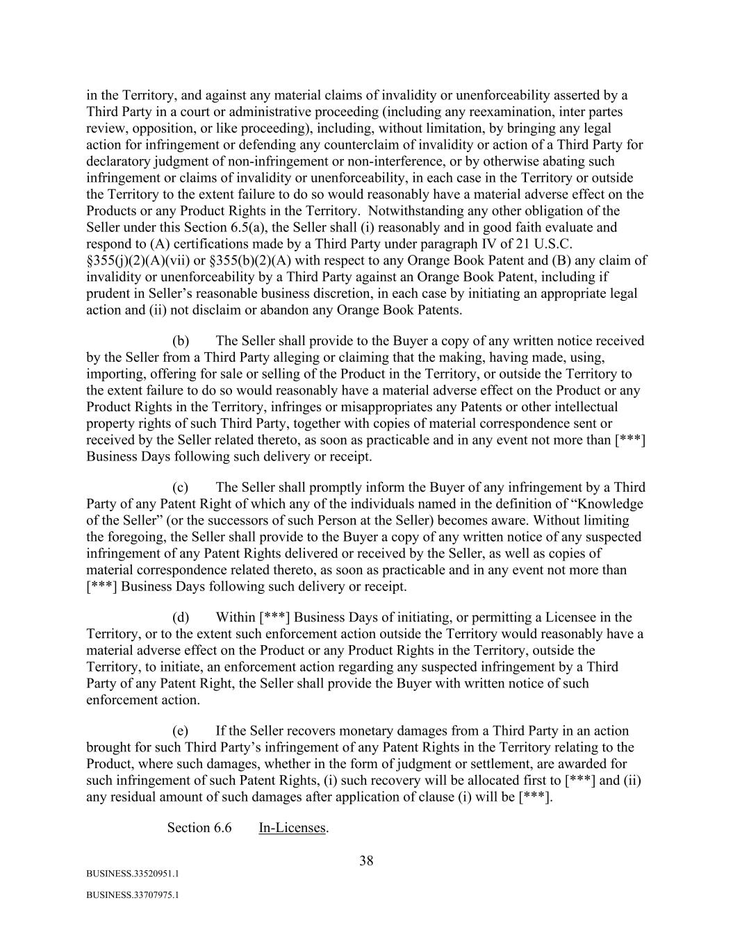
38 BUSINESS.33520951.1 BUSINESS.33707975.1 in the Territory, and against any material claims of invalidity or unenforceability asserted by a Third Party in a court or administrative proceeding (including any reexamination, inter partes review, opposition, or like proceeding), including, without limitation, by bringing any legal action for infringement or defending any counterclaim of invalidity or action of a Third Party for declaratory judgment of non-infringement or non-interference, or by otherwise abating such infringement or claims of invalidity or unenforceability, in each case in the Territory or outside the Territory to the extent failure to do so would reasonably have a material adverse effect on the Products or any Product Rights in the Territory. Notwithstanding any other obligation of the Seller under this Section 6.5(a), the Seller shall (i) reasonably and in good faith evaluate and respond to (A) certifications made by a Third Party under paragraph IV of 21 U.S.C. §355(j)(2)(A)(vii) or §355(b)(2)(A) with respect to any Orange Book Patent and (B) any claim of invalidity or unenforceability by a Third Party against an Orange Book Patent, including if prudent in Seller’s reasonable business discretion, in each case by initiating an appropriate legal action and (ii) not disclaim or abandon any Orange Book Patents. (b) The Seller shall provide to the Buyer a copy of any written notice received by the Seller from a Third Party alleging or claiming that the making, having made, using, importing, offering for sale or selling of the Product in the Territory, or outside the Territory to the extent failure to do so would reasonably have a material adverse effect on the Product or any Product Rights in the Territory, infringes or misappropriates any Patents or other intellectual property rights of such Third Party, together with copies of material correspondence sent or received by the Seller related thereto, as soon as practicable and in any event not more than [***] Business Days following such delivery or receipt. (c) The Seller shall promptly inform the Buyer of any infringement by a Third Party of any Patent Right of which any of the individuals named in the definition of “Knowledge of the Seller” (or the successors of such Person at the Seller) becomes aware. Without limiting the foregoing, the Seller shall provide to the Buyer a copy of any written notice of any suspected infringement of any Patent Rights delivered or received by the Seller, as well as copies of material correspondence related thereto, as soon as practicable and in any event not more than [***] Business Days following such delivery or receipt. (d) Within [***] Business Days of initiating, or permitting a Licensee in the Territory, or to the extent such enforcement action outside the Territory would reasonably have a material adverse effect on the Product or any Product Rights in the Territory, outside the Territory, to initiate, an enforcement action regarding any suspected infringement by a Third Party of any Patent Right, the Seller shall provide the Buyer with written notice of such enforcement action. (e) If the Seller recovers monetary damages from a Third Party in an action brought for such Third Party’s infringement of any Patent Rights in the Territory relating to the Product, where such damages, whether in the form of judgment or settlement, are awarded for such infringement of such Patent Rights, (i) such recovery will be allocated first to [***] and (ii) any residual amount of such damages after application of clause (i) will be [***]. Section 6.6 In-Licenses.

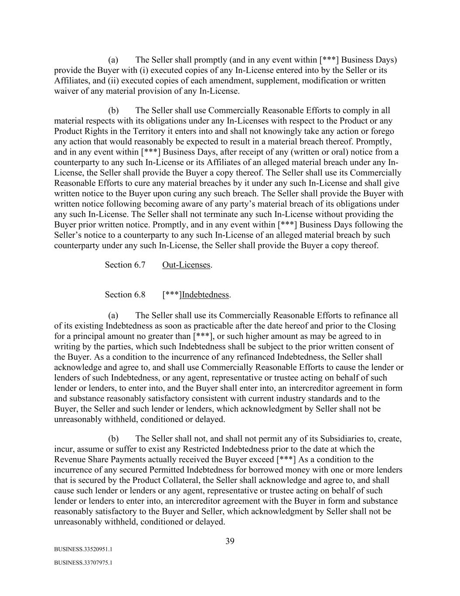
39 BUSINESS.33520951.1 BUSINESS.33707975.1 (a) The Seller shall promptly (and in any event within [***] Business Days) provide the Buyer with (i) executed copies of any In-License entered into by the Seller or its Affiliates, and (ii) executed copies of each amendment, supplement, modification or written waiver of any material provision of any In-License. (b) The Seller shall use Commercially Reasonable Efforts to comply in all material respects with its obligations under any In-Licenses with respect to the Product or any Product Rights in the Territory it enters into and shall not knowingly take any action or forego any action that would reasonably be expected to result in a material breach thereof. Promptly, and in any event within [***] Business Days, after receipt of any (written or oral) notice from a counterparty to any such In-License or its Affiliates of an alleged material breach under any In- License, the Seller shall provide the Buyer a copy thereof. The Seller shall use its Commercially Reasonable Efforts to cure any material breaches by it under any such In-License and shall give written notice to the Buyer upon curing any such breach. The Seller shall provide the Buyer with written notice following becoming aware of any party’s material breach of its obligations under any such In-License. The Seller shall not terminate any such In-License without providing the Buyer prior written notice. Promptly, and in any event within [***] Business Days following the Seller’s notice to a counterparty to any such In-License of an alleged material breach by such counterparty under any such In-License, the Seller shall provide the Buyer a copy thereof. Section 6.7 Out-Licenses. Section 6.8 [***]Indebtedness. (a) The Seller shall use its Commercially Reasonable Efforts to refinance all of its existing Indebtedness as soon as practicable after the date hereof and prior to the Closing for a principal amount no greater than [***], or such higher amount as may be agreed to in writing by the parties, which such Indebtedness shall be subject to the prior written consent of the Buyer. As a condition to the incurrence of any refinanced Indebtedness, the Seller shall acknowledge and agree to, and shall use Commercially Reasonable Efforts to cause the lender or lenders of such Indebtedness, or any agent, representative or trustee acting on behalf of such lender or lenders, to enter into, and the Buyer shall enter into, an intercreditor agreement in form and substance reasonably satisfactory consistent with current industry standards and to the Buyer, the Seller and such lender or lenders, which acknowledgment by Seller shall not be unreasonably withheld, conditioned or delayed. (b) The Seller shall not, and shall not permit any of its Subsidiaries to, create, incur, assume or suffer to exist any Restricted Indebtedness prior to the date at which the Revenue Share Payments actually received the Buyer exceed [***] As a condition to the incurrence of any secured Permitted Indebtedness for borrowed money with one or more lenders that is secured by the Product Collateral, the Seller shall acknowledge and agree to, and shall cause such lender or lenders or any agent, representative or trustee acting on behalf of such lender or lenders to enter into, an intercreditor agreement with the Buyer in form and substance reasonably satisfactory to the Buyer and Seller, which acknowledgment by Seller shall not be unreasonably withheld, conditioned or delayed.

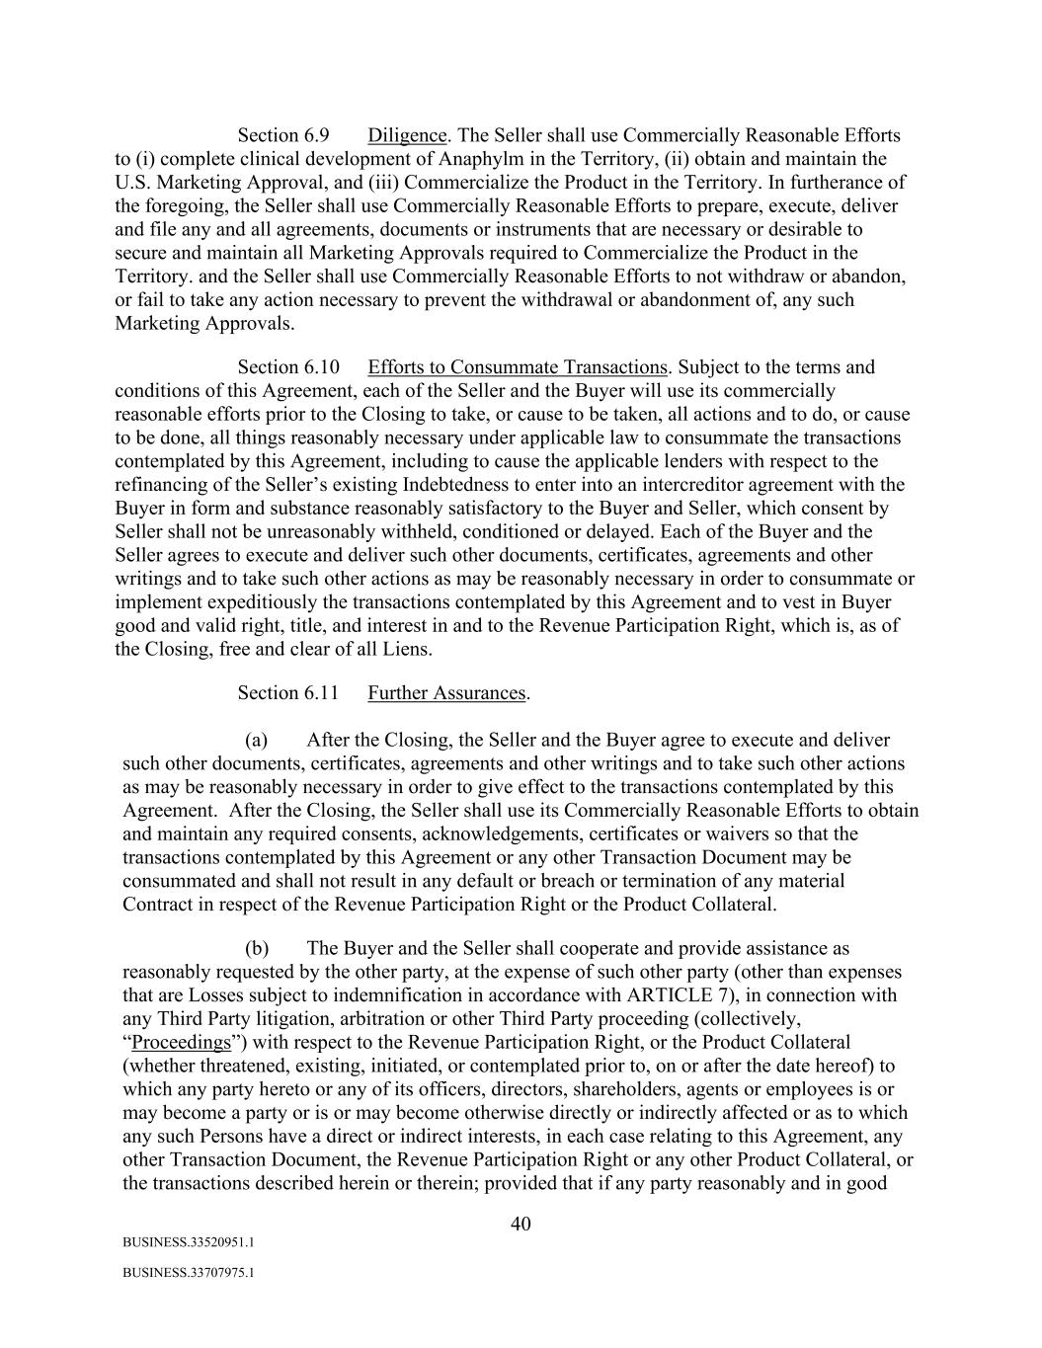
40 BUSINESS.33520951.1 BUSINESS.33707975.1 Section 6.9 Diligence. The Seller shall use Commercially Reasonable Efforts to (i) complete clinical development of Anaphylm in the Territory, (ii) obtain and maintain the U.S. Marketing Approval, and (iii) Commercialize the Product in the Territory. In furtherance of the foregoing, the Seller shall use Commercially Reasonable Efforts to prepare, execute, deliver and file any and all agreements, documents or instruments that are necessary or desirable to secure and maintain all Marketing Approvals required to Commercialize the Product in the Territory. and the Seller shall use Commercially Reasonable Efforts to not withdraw or abandon, or fail to take any action necessary to prevent the withdrawal or abandonment of, any such Marketing Approvals. Section 6.10 Efforts to Consummate Transactions. Subject to the terms and conditions of this Agreement, each of the Seller and the Buyer will use its commercially reasonable efforts prior to the Closing to take, or cause to be taken, all actions and to do, or cause to be done, all things reasonably necessary under applicable law to consummate the transactions contemplated by this Agreement, including to cause the applicable lenders with respect to the refinancing of the Seller’s existing Indebtedness to enter into an intercreditor agreement with the Buyer in form and substance reasonably satisfactory to the Buyer and Seller, which consent by Seller shall not be unreasonably withheld, conditioned or delayed. Each of the Buyer and the Seller agrees to execute and deliver such other documents, certificates, agreements and other writings and to take such other actions as may be reasonably necessary in order to consummate or implement expeditiously the transactions contemplated by this Agreement and to vest in Buyer good and valid right, title, and interest in and to the Revenue Participation Right, which is, as of the Closing, free and clear of all Liens. Section 6.11 Further Assurances. (a) After the Closing, the Seller and the Buyer agree to execute and deliver such other documents, certificates, agreements and other writings and to take such other actions as may be reasonably necessary in order to give effect to the transactions contemplated by this Agreement. After the Closing, the Seller shall use its Commercially Reasonable Efforts to obtain and maintain any required consents, acknowledgements, certificates or waivers so that the transactions contemplated by this Agreement or any other Transaction Document may be consummated and shall not result in any default or breach or termination of any material Contract in respect of the Revenue Participation Right or the Product Collateral. (b) The Buyer and the Seller shall cooperate and provide assistance as reasonably requested by the other party, at the expense of such other party (other than expenses that are Losses subject to indemnification in accordance with ARTICLE 7), in connection with any Third Party litigation, arbitration or other Third Party proceeding (collectively, “Proceedings”) with respect to the Revenue Participation Right, or the Product Collateral (whether threatened, existing, initiated, or contemplated prior to, on or after the date hereof) to which any party hereto or any of its officers, directors, shareholders, agents or employees is or may become a party or is or may become otherwise directly or indirectly affected or as to which any such Persons have a direct or indirect interests, in each case relating to this Agreement, any other Transaction Document, the Revenue Participation Right or any other Product Collateral, or the transactions described herein or therein; provided that if any party reasonably and in good

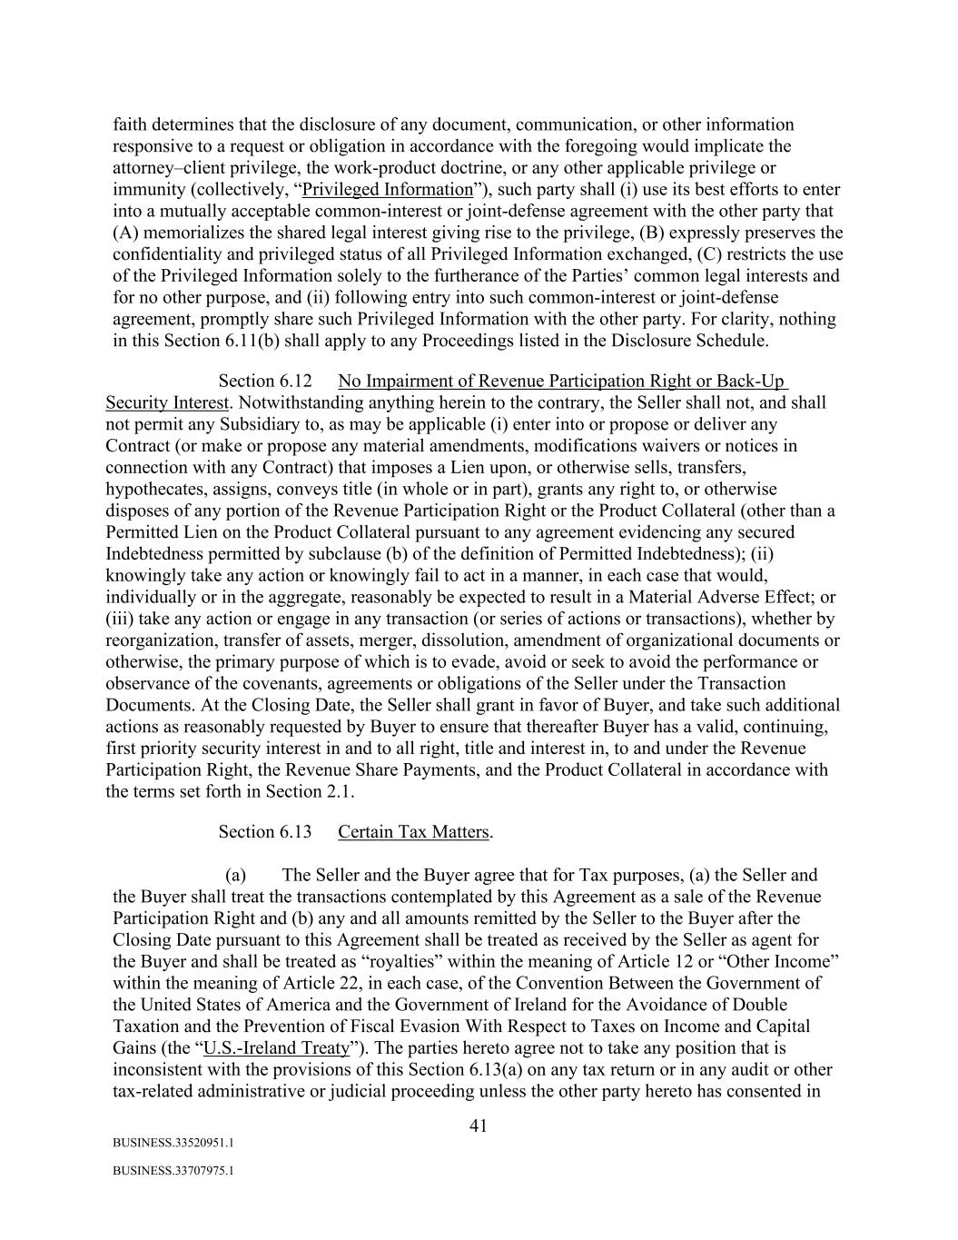
41 BUSINESS.33520951.1 BUSINESS.33707975.1 faith determines that the disclosure of any document, communication, or other information responsive to a request or obligation in accordance with the foregoing would implicate the attorney–client privilege, the work-product doctrine, or any other applicable privilege or immunity (collectively, “Privileged Information”), such party shall (i) use its best efforts to enter into a mutually acceptable common-interest or joint-defense agreement with the other party that (A) memorializes the shared legal interest giving rise to the privilege, (B) expressly preserves the confidentiality and privileged status of all Privileged Information exchanged, (C) restricts the use of the Privileged Information solely to the furtherance of the Parties’ common legal interests and for no other purpose, and (ii) following entry into such common-interest or joint-defense agreement, promptly share such Privileged Information with the other party. For clarity, nothing in this Section 6.11(b) shall apply to any Proceedings listed in the Disclosure Schedule. Section 6.12 No Impairment of Revenue Participation Right or Back-Up Security Interest. Notwithstanding anything herein to the contrary, the Seller shall not, and shall not permit any Subsidiary to, as may be applicable (i) enter into or propose or deliver any Contract (or make or propose any material amendments, modifications waivers or notices in connection with any Contract) that imposes a Lien upon, or otherwise sells, transfers, hypothecates, assigns, conveys title (in whole or in part), grants any right to, or otherwise disposes of any portion of the Revenue Participation Right or the Product Collateral (other than a Permitted Lien on the Product Collateral pursuant to any agreement evidencing any secured Indebtedness permitted by subclause (b) of the definition of Permitted Indebtedness); (ii) knowingly take any action or knowingly fail to act in a manner, in each case that would, individually or in the aggregate, reasonably be expected to result in a Material Adverse Effect; or (iii) take any action or engage in any transaction (or series of actions or transactions), whether by reorganization, transfer of assets, merger, dissolution, amendment of organizational documents or otherwise, the primary purpose of which is to evade, avoid or seek to avoid the performance or observance of the covenants, agreements or obligations of the Seller under the Transaction Documents. At the Closing Date, the Seller shall grant in favor of Buyer, and take such additional actions as reasonably requested by Buyer to ensure that thereafter Buyer has a valid, continuing, first priority security interest in and to all right, title and interest in, to and under the Revenue Participation Right, the Revenue Share Payments, and the Product Collateral in accordance with the terms set forth in Section 2.1. Section 6.13 Certain Tax Matters. (a) The Seller and the Buyer agree that for Tax purposes, (a) the Seller and the Buyer shall treat the transactions contemplated by this Agreement as a sale of the Revenue Participation Right and (b) any and all amounts remitted by the Seller to the Buyer after the Closing Date pursuant to this Agreement shall be treated as received by the Seller as agent for the Buyer and shall be treated as “royalties” within the meaning of Article 12 or “Other Income” within the meaning of Article 22, in each case, of the Convention Between the Government of the United States of America and the Government of Ireland for the Avoidance of Double Taxation and the Prevention of Fiscal Evasion With Respect to Taxes on Income and Capital Gains (the “U.S.-Ireland Treaty”). The parties hereto agree not to take any position that is inconsistent with the provisions of this Section 6.13(a) on any tax return or in any audit or other tax-related administrative or judicial proceeding unless the other party hereto has consented in

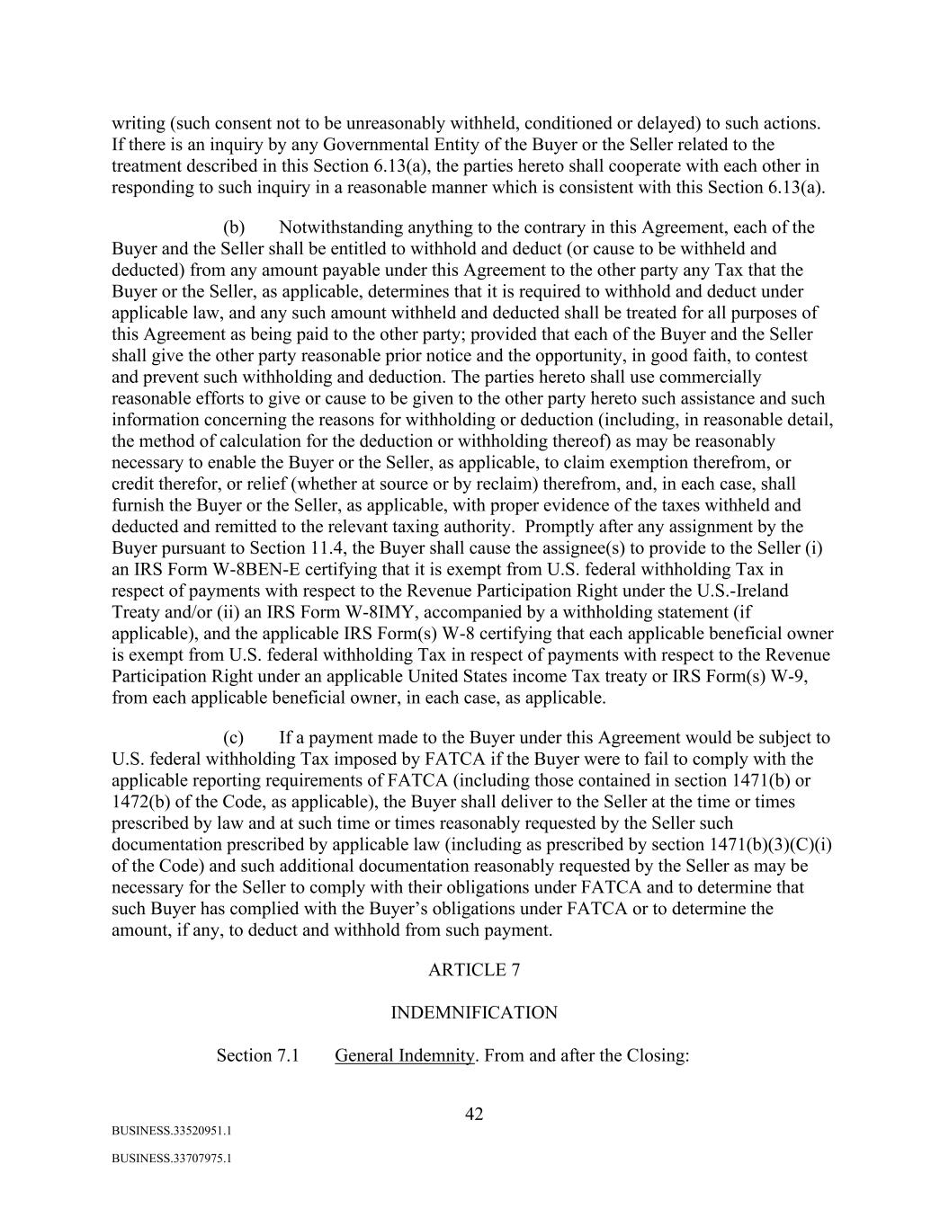
42 BUSINESS.33520951.1 BUSINESS.33707975.1 writing (such consent not to be unreasonably withheld, conditioned or delayed) to such actions. If there is an inquiry by any Governmental Entity of the Buyer or the Seller related to the treatment described in this Section 6.13(a), the parties hereto shall cooperate with each other in responding to such inquiry in a reasonable manner which is consistent with this Section 6.13(a). (b) Notwithstanding anything to the contrary in this Agreement, each of the Buyer and the Seller shall be entitled to withhold and deduct (or cause to be withheld and deducted) from any amount payable under this Agreement to the other party any Tax that the Buyer or the Seller, as applicable, determines that it is required to withhold and deduct under applicable law, and any such amount withheld and deducted shall be treated for all purposes of this Agreement as being paid to the other party; provided that each of the Buyer and the Seller shall give the other party reasonable prior notice and the opportunity, in good faith, to contest and prevent such withholding and deduction. The parties hereto shall use commercially reasonable efforts to give or cause to be given to the other party hereto such assistance and such information concerning the reasons for withholding or deduction (including, in reasonable detail, the method of calculation for the deduction or withholding thereof) as may be reasonably necessary to enable the Buyer or the Seller, as applicable, to claim exemption therefrom, or credit therefor, or relief (whether at source or by reclaim) therefrom, and, in each case, shall furnish the Buyer or the Seller, as applicable, with proper evidence of the taxes withheld and deducted and remitted to the relevant taxing authority. Promptly after any assignment by the Buyer pursuant to Section 11.4, the Buyer shall cause the assignee(s) to provide to the Seller (i) an IRS Form W-8BEN-E certifying that it is exempt from U.S. federal withholding Tax in respect of payments with respect to the Revenue Participation Right under the U.S.-Ireland Treaty and/or (ii) an IRS Form W-8IMY, accompanied by a withholding statement (if applicable), and the applicable IRS Form(s) W-8 certifying that each applicable beneficial owner is exempt from U.S. federal withholding Tax in respect of payments with respect to the Revenue Participation Right under an applicable United States income Tax treaty or IRS Form(s) W-9, from each applicable beneficial owner, in each case, as applicable. (c) If a payment made to the Buyer under this Agreement would be subject to U.S. federal withholding Tax imposed by FATCA if the Buyer were to fail to comply with the applicable reporting requirements of FATCA (including those contained in section 1471(b) or 1472(b) of the Code, as applicable), the Buyer shall deliver to the Seller at the time or times prescribed by law and at such time or times reasonably requested by the Seller such documentation prescribed by applicable law (including as prescribed by section 1471(b)(3)(C)(i) of the Code) and such additional documentation reasonably requested by the Seller as may be necessary for the Seller to comply with their obligations under FATCA and to determine that such Buyer has complied with the Buyer’s obligations under FATCA or to determine the amount, if any, to deduct and withhold from such payment. ARTICLE 7 INDEMNIFICATION Section 7.1 General Indemnity. From and after the Closing:

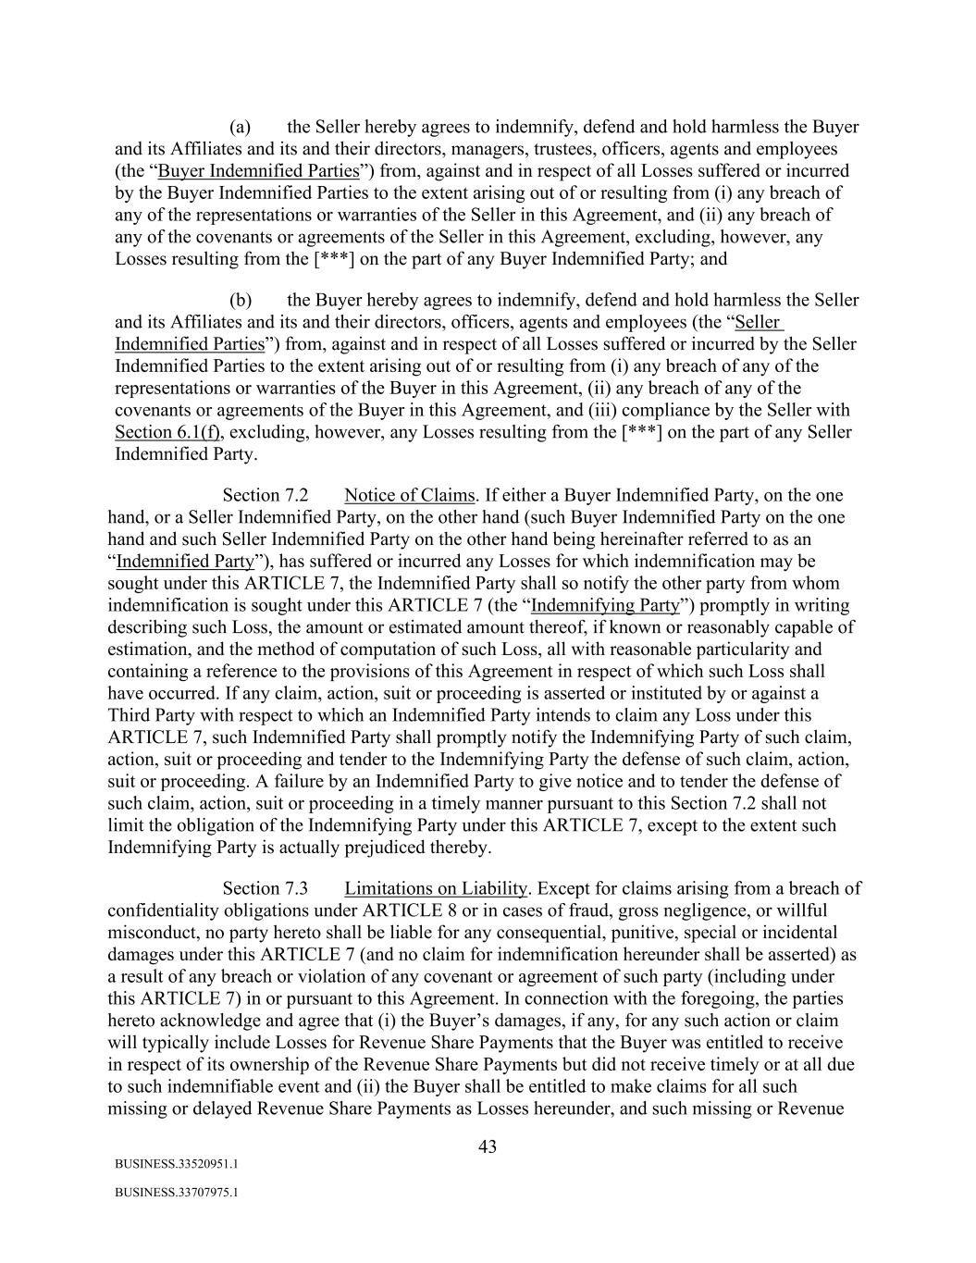
43 BUSINESS.33520951.1 BUSINESS.33707975.1 (a) the Seller hereby agrees to indemnify, defend and hold harmless the Buyer and its Affiliates and its and their directors, managers, trustees, officers, agents and employees (the “Buyer Indemnified Parties”) from, against and in respect of all Losses suffered or incurred by the Buyer Indemnified Parties to the extent arising out of or resulting from (i) any breach of any of the representations or warranties of the Seller in this Agreement, and (ii) any breach of any of the covenants or agreements of the Seller in this Agreement, excluding, however, any Losses resulting from the [***] on the part of any Buyer Indemnified Party; and (b) the Buyer hereby agrees to indemnify, defend and hold harmless the Seller and its Affiliates and its and their directors, officers, agents and employees (the “Seller Indemnified Parties”) from, against and in respect of all Losses suffered or incurred by the Seller Indemnified Parties to the extent arising out of or resulting from (i) any breach of any of the representations or warranties of the Buyer in this Agreement, (ii) any breach of any of the covenants or agreements of the Buyer in this Agreement, and (iii) compliance by the Seller with Section 6.1(f), excluding, however, any Losses resulting from the [***] on the part of any Seller Indemnified Party. Section 7.2 Notice of Claims. If either a Buyer Indemnified Party, on the one hand, or a Seller Indemnified Party, on the other hand (such Buyer Indemnified Party on the one hand and such Seller Indemnified Party on the other hand being hereinafter referred to as an “Indemnified Party”), has suffered or incurred any Losses for which indemnification may be sought under this ARTICLE 7, the Indemnified Party shall so notify the other party from whom indemnification is sought under this ARTICLE 7 (the “Indemnifying Party”) promptly in writing describing such Loss, the amount or estimated amount thereof, if known or reasonably capable of estimation, and the method of computation of such Loss, all with reasonable particularity and containing a reference to the provisions of this Agreement in respect of which such Loss shall have occurred. If any claim, action, suit or proceeding is asserted or instituted by or against a Third Party with respect to which an Indemnified Party intends to claim any Loss under this ARTICLE 7, such Indemnified Party shall promptly notify the Indemnifying Party of such claim, action, suit or proceeding and tender to the Indemnifying Party the defense of such claim, action, suit or proceeding. A failure by an Indemnified Party to give notice and to tender the defense of such claim, action, suit or proceeding in a timely manner pursuant to this Section 7.2 shall not limit the obligation of the Indemnifying Party under this ARTICLE 7, except to the extent such Indemnifying Party is actually prejudiced thereby. Section 7.3 Limitations on Liability. Except for claims arising from a breach of confidentiality obligations under ARTICLE 8 or in cases of fraud, gross negligence, or willful misconduct, no party hereto shall be liable for any consequential, punitive, special or incidental damages under this ARTICLE 7 (and no claim for indemnification hereunder shall be asserted) as a result of any breach or violation of any covenant or agreement of such party (including under this ARTICLE 7) in or pursuant to this Agreement. In connection with the foregoing, the parties hereto acknowledge and agree that (i) the Buyer’s damages, if any, for any such action or claim will typically include Losses for Revenue Share Payments that the Buyer was entitled to receive in respect of its ownership of the Revenue Share Payments but did not receive timely or at all due to such indemnifiable event and (ii) the Buyer shall be entitled to make claims for all such missing or delayed Revenue Share Payments as Losses hereunder, and such missing or Revenue

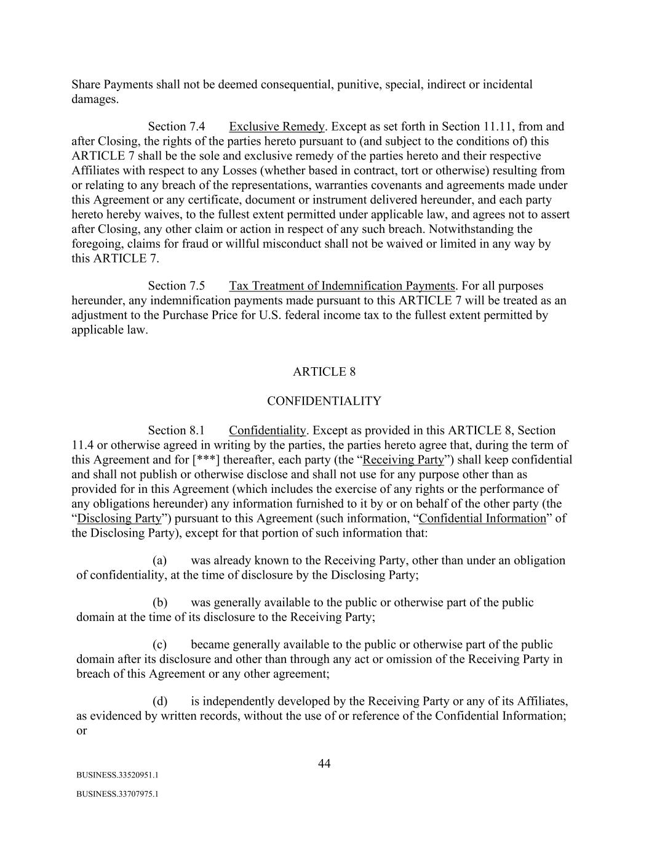
44 BUSINESS.33520951.1 BUSINESS.33707975.1 Share Payments shall not be deemed consequential, punitive, special, indirect or incidental damages. Section 7.4 Exclusive Remedy. Except as set forth in Section 11.11, from and after Closing, the rights of the parties hereto pursuant to (and subject to the conditions of) this ARTICLE 7 shall be the sole and exclusive remedy of the parties hereto and their respective Affiliates with respect to any Losses (whether based in contract, tort or otherwise) resulting from or relating to any breach of the representations, warranties covenants and agreements made under this Agreement or any certificate, document or instrument delivered hereunder, and each party hereto hereby waives, to the fullest extent permitted under applicable law, and agrees not to assert after Closing, any other claim or action in respect of any such breach. Notwithstanding the foregoing, claims for fraud or willful misconduct shall not be waived or limited in any way by this ARTICLE 7. Section 7.5 Tax Treatment of Indemnification Payments. For all purposes hereunder, any indemnification payments made pursuant to this ARTICLE 7 will be treated as an adjustment to the Purchase Price for U.S. federal income tax to the fullest extent permitted by applicable law. ARTICLE 8 CONFIDENTIALITY Section 8.1 Confidentiality. Except as provided in this ARTICLE 8, Section 11.4 or otherwise agreed in writing by the parties, the parties hereto agree that, during the term of this Agreement and for [***] thereafter, each party (the “Receiving Party”) shall keep confidential and shall not publish or otherwise disclose and shall not use for any purpose other than as provided for in this Agreement (which includes the exercise of any rights or the performance of any obligations hereunder) any information furnished to it by or on behalf of the other party (the “Disclosing Party”) pursuant to this Agreement (such information, “Confidential Information” of the Disclosing Party), except for that portion of such information that: (a) was already known to the Receiving Party, other than under an obligation of confidentiality, at the time of disclosure by the Disclosing Party; (b) was generally available to the public or otherwise part of the public domain at the time of its disclosure to the Receiving Party; (c) became generally available to the public or otherwise part of the public domain after its disclosure and other than through any act or omission of the Receiving Party in breach of this Agreement or any other agreement; (d) is independently developed by the Receiving Party or any of its Affiliates, as evidenced by written records, without the use of or reference of the Confidential Information; or

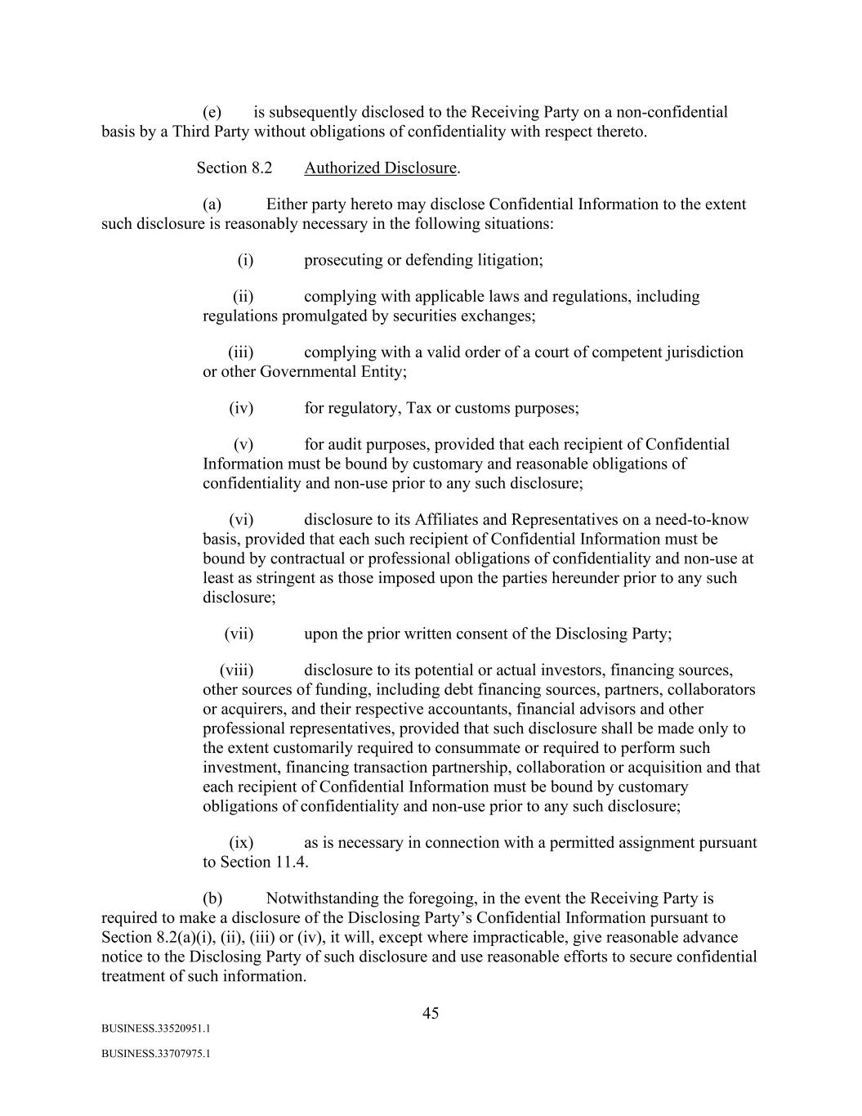
45 BUSINESS.33520951.1 BUSINESS.33707975.1 (e) is subsequently disclosed to the Receiving Party on a non-confidential basis by a Third Party without obligations of confidentiality with respect thereto. Section 8.2 Authorized Disclosure. (a) Either party hereto may disclose Confidential Information to the extent such disclosure is reasonably necessary in the following situations: (i) prosecuting or defending litigation; (ii) complying with applicable laws and regulations, including regulations promulgated by securities exchanges; (iii) complying with a valid order of a court of competent jurisdiction or other Governmental Entity; (iv) for regulatory, Tax or customs purposes; (v) for audit purposes, provided that each recipient of Confidential Information must be bound by customary and reasonable obligations of confidentiality and non-use prior to any such disclosure; (vi) disclosure to its Affiliates and Representatives on a need-to-know basis, provided that each such recipient of Confidential Information must be bound by contractual or professional obligations of confidentiality and non-use at least as stringent as those imposed upon the parties hereunder prior to any such disclosure; (vii) upon the prior written consent of the Disclosing Party; (viii) disclosure to its potential or actual investors, financing sources, other sources of funding, including debt financing sources, partners, collaborators or acquirers, and their respective accountants, financial advisors and other professional representatives, provided that such disclosure shall be made only to the extent customarily required to consummate or required to perform such investment, financing transaction partnership, collaboration or acquisition and that each recipient of Confidential Information must be bound by customary obligations of confidentiality and non-use prior to any such disclosure; (ix) as is necessary in connection with a permitted assignment pursuant to Section 11.4. (b) Notwithstanding the foregoing, in the event the Receiving Party is required to make a disclosure of the Disclosing Party’s Confidential Information pursuant to Section 8.2(a)(i), (ii), (iii) or (iv), it will, except where impracticable, give reasonable advance notice to the Disclosing Party of such disclosure and use reasonable efforts to secure confidential treatment of such information.

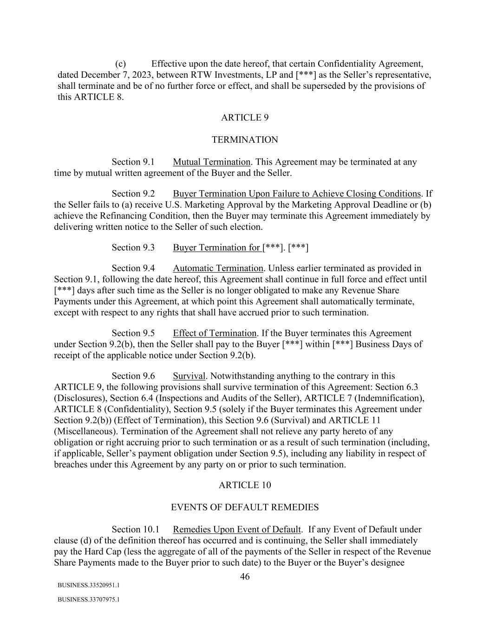
46 BUSINESS.33520951.1 BUSINESS.33707975.1 (c) Effective upon the date hereof, that certain Confidentiality Agreement, dated December 7, 2023, between RTW Investments, LP and [***] as the Seller’s representative, shall terminate and be of no further force or effect, and shall be superseded by the provisions of this ARTICLE 8. ARTICLE 9 TERMINATION Section 9.1 Mutual Termination. This Agreement may be terminated at any time by mutual written agreement of the Buyer and the Seller. Section 9.2 Buyer Termination Upon Failure to Achieve Closing Conditions. If the Seller fails to (a) receive U.S. Marketing Approval by the Marketing Approval Deadline or (b) achieve the Refinancing Condition, then the Buyer may terminate this Agreement immediately by delivering written notice to the Seller of such election. Section 9.3 Buyer Termination for [***]. [***] Section 9.4 Automatic Termination. Unless earlier terminated as provided in Section 9.1, following the date hereof, this Agreement shall continue in full force and effect until [***] days after such time as the Seller is no longer obligated to make any Revenue Share Payments under this Agreement, at which point this Agreement shall automatically terminate, except with respect to any rights that shall have accrued prior to such termination. Section 9.5 Effect of Termination. If the Buyer terminates this Agreement under Section 9.2(b), then the Seller shall pay to the Buyer [***] within [***] Business Days of receipt of the applicable notice under Section 9.2(b). Section 9.6 Survival. Notwithstanding anything to the contrary in this ARTICLE 9, the following provisions shall survive termination of this Agreement: Section 6.3 (Disclosures), Section 6.4 (Inspections and Audits of the Seller), ARTICLE 7 (Indemnification), ARTICLE 8 (Confidentiality), Section 9.5 (solely if the Buyer terminates this Agreement under Section 9.2(b)) (Effect of Termination), this Section 9.6 (Survival) and ARTICLE 11 (Miscellaneous). Termination of the Agreement shall not relieve any party hereto of any obligation or right accruing prior to such termination or as a result of such termination (including, if applicable, Seller’s payment obligation under Section 9.5), including any liability in respect of breaches under this Agreement by any party on or prior to such termination. ARTICLE 10 EVENTS OF DEFAULT REMEDIES Section 10.1 Remedies Upon Event of Default. If any Event of Default under clause (d) of the definition thereof has occurred and is continuing, the Seller shall immediately pay the Hard Cap (less the aggregate of all of the payments of the Seller in respect of the Revenue Share Payments made to the Buyer prior to such date) to the Buyer or the Buyer’s designee

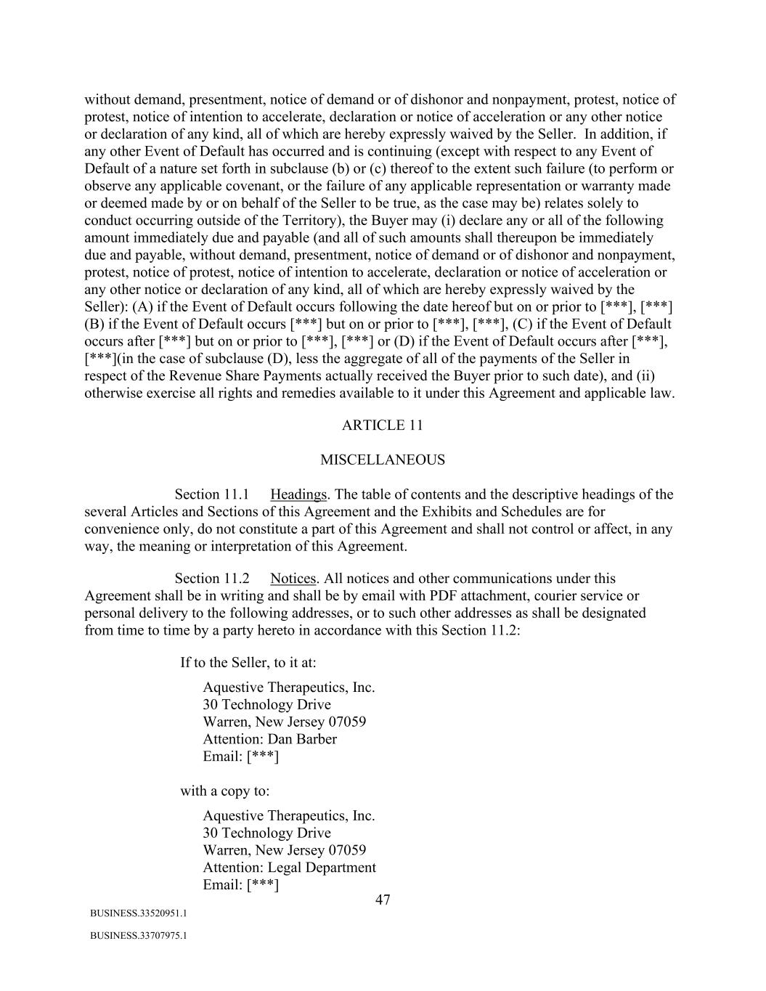
47 BUSINESS.33520951.1 BUSINESS.33707975.1 without demand, presentment, notice of demand or of dishonor and nonpayment, protest, notice of protest, notice of intention to accelerate, declaration or notice of acceleration or any other notice or declaration of any kind, all of which are hereby expressly waived by the Seller. In addition, if any other Event of Default has occurred and is continuing (except with respect to any Event of Default of a nature set forth in subclause (b) or (c) thereof to the extent such failure (to perform or observe any applicable covenant, or the failure of any applicable representation or warranty made or deemed made by or on behalf of the Seller to be true, as the case may be) relates solely to conduct occurring outside of the Territory), the Buyer may (i) declare any or all of the following amount immediately due and payable (and all of such amounts shall thereupon be immediately due and payable, without demand, presentment, notice of demand or of dishonor and nonpayment, protest, notice of protest, notice of intention to accelerate, declaration or notice of acceleration or any other notice or declaration of any kind, all of which are hereby expressly waived by the Seller): (A) if the Event of Default occurs following the date hereof but on or prior to [***], [***] (B) if the Event of Default occurs [***] but on or prior to [***], [***], (C) if the Event of Default occurs after [***] but on or prior to [***], [***] or (D) if the Event of Default occurs after [***], [***](in the case of subclause (D), less the aggregate of all of the payments of the Seller in respect of the Revenue Share Payments actually received the Buyer prior to such date), and (ii) otherwise exercise all rights and remedies available to it under this Agreement and applicable law. ARTICLE 11 MISCELLANEOUS Section 11.1 Headings. The table of contents and the descriptive headings of the several Articles and Sections of this Agreement and the Exhibits and Schedules are for convenience only, do not constitute a part of this Agreement and shall not control or affect, in any way, the meaning or interpretation of this Agreement. Section 11.2 Notices. All notices and other communications under this Agreement shall be in writing and shall be by email with PDF attachment, courier service or personal delivery to the following addresses, or to such other addresses as shall be designated from time to time by a party hereto in accordance with this Section 11.2: If to the Seller, to it at: Aquestive Therapeutics, Inc. 30 Technology Drive Warren, New Jersey 07059 Attention: Dan Barber Email: [***] with a copy to: Aquestive Therapeutics, Inc. 30 Technology Drive Warren, New Jersey 07059 Attention: Legal Department Email: [***]

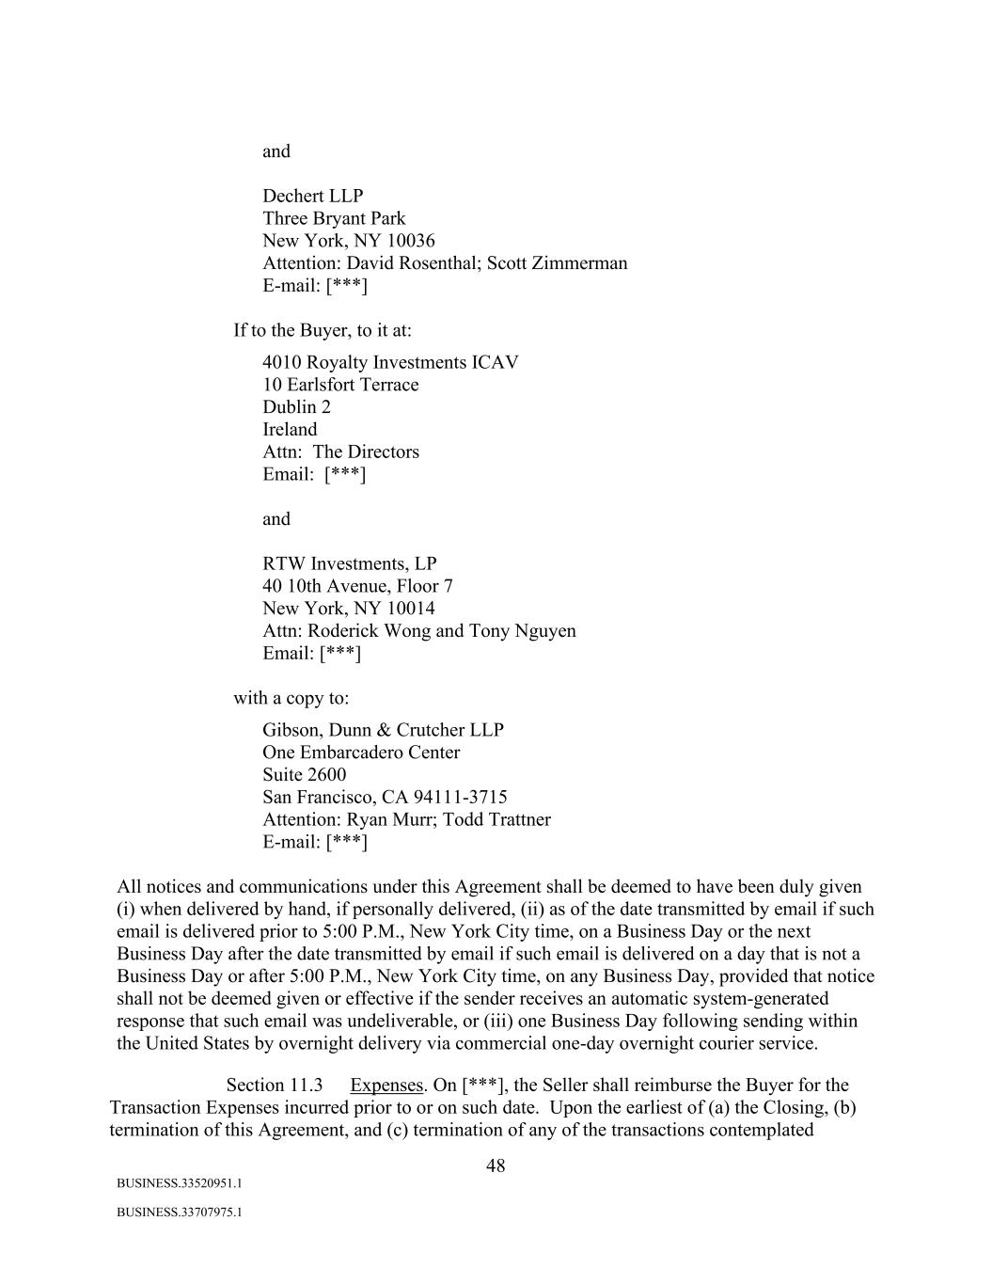
48 BUSINESS.33520951.1 BUSINESS.33707975.1 and Dechert LLP Three Bryant Park New York, NY 10036 Attention: David Rosenthal; Scott Zimmerman E-mail: [***] If to the Buyer, to it at: 4010 Royalty Investments ICAV 10 Earlsfort Terrace Dublin 2 Ireland Attn: The Directors Email: [***] and RTW Investments, LP 40 10th Avenue, Floor 7 New York, NY 10014 Attn: Roderick Wong and Tony Nguyen Email: [***] with a copy to: Gibson, Dunn & Crutcher LLP One Embarcadero Center Suite 2600 San Francisco, CA 94111-3715 Attention: Ryan Murr; Todd Trattner E-mail: [***] All notices and communications under this Agreement shall be deemed to have been duly given (i) when delivered by hand, if personally delivered, (ii) as of the date transmitted by email if such email is delivered prior to 5:00 P.M., New York City time, on a Business Day or the next Business Day after the date transmitted by email if such email is delivered on a day that is not a Business Day or after 5:00 P.M., New York City time, on any Business Day, provided that notice shall not be deemed given or effective if the sender receives an automatic system-generated response that such email was undeliverable, or (iii) one Business Day following sending within the United States by overnight delivery via commercial one-day overnight courier service. Section 11.3 Expenses. On [***], the Seller shall reimburse the Buyer for the Transaction Expenses incurred prior to or on such date. Upon the earliest of (a) the Closing, (b) termination of this Agreement, and (c) termination of any of the transactions contemplated

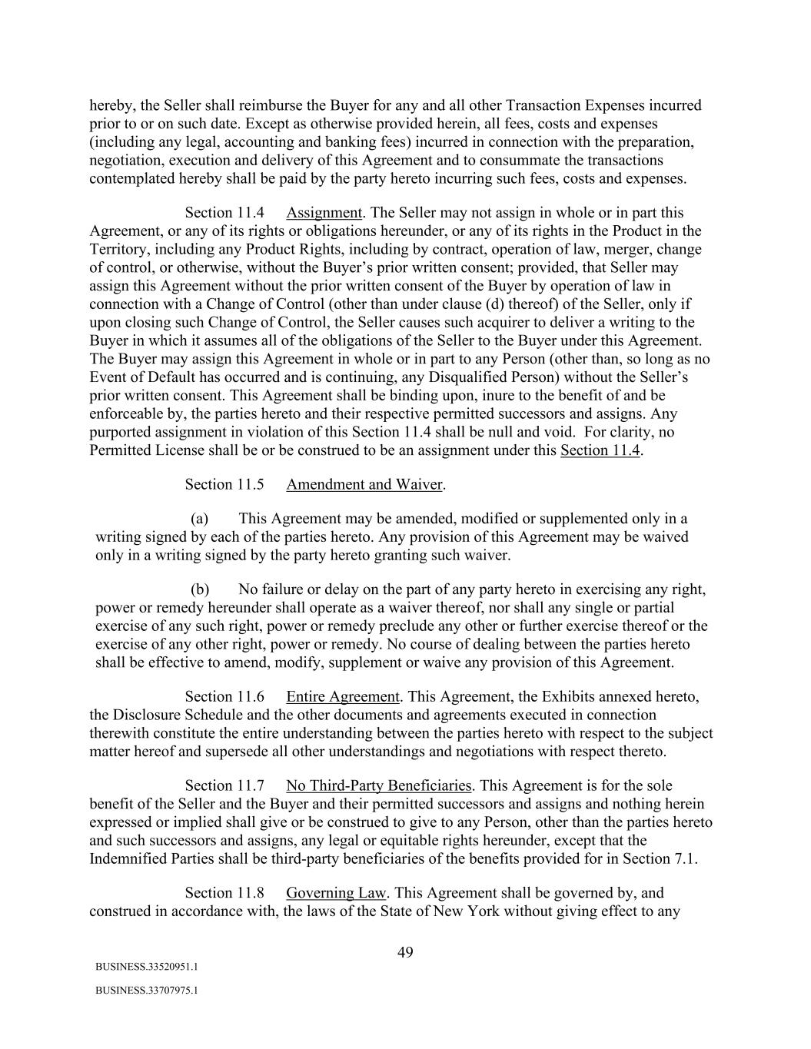
49 BUSINESS.33520951.1 BUSINESS.33707975.1 hereby, the Seller shall reimburse the Buyer for any and all other Transaction Expenses incurred prior to or on such date. Except as otherwise provided herein, all fees, costs and expenses (including any legal, accounting and banking fees) incurred in connection with the preparation, negotiation, execution and delivery of this Agreement and to consummate the transactions contemplated hereby shall be paid by the party hereto incurring such fees, costs and expenses. Section 11.4 Assignment. The Seller may not assign in whole or in part this Agreement, or any of its rights or obligations hereunder, or any of its rights in the Product in the Territory, including any Product Rights, including by contract, operation of law, merger, change of control, or otherwise, without the Buyer’s prior written consent; provided, that Seller may assign this Agreement without the prior written consent of the Buyer by operation of law in connection with a Change of Control (other than under clause (d) thereof) of the Seller, only if upon closing such Change of Control, the Seller causes such acquirer to deliver a writing to the Buyer in which it assumes all of the obligations of the Seller to the Buyer under this Agreement. The Buyer may assign this Agreement in whole or in part to any Person (other than, so long as no Event of Default has occurred and is continuing, any Disqualified Person) without the Seller’s prior written consent. This Agreement shall be binding upon, inure to the benefit of and be enforceable by, the parties hereto and their respective permitted successors and assigns. Any purported assignment in violation of this Section 11.4 shall be null and void. For clarity, no Permitted License shall be or be construed to be an assignment under this Section 11.4. Section 11.5 Amendment and Waiver. (a) This Agreement may be amended, modified or supplemented only in a writing signed by each of the parties hereto. Any provision of this Agreement may be waived only in a writing signed by the party hereto granting such waiver. (b) No failure or delay on the part of any party hereto in exercising any right, power or remedy hereunder shall operate as a waiver thereof, nor shall any single or partial exercise of any such right, power or remedy preclude any other or further exercise thereof or the exercise of any other right, power or remedy. No course of dealing between the parties hereto shall be effective to amend, modify, supplement or waive any provision of this Agreement. Section 11.6 Entire Agreement. This Agreement, the Exhibits annexed hereto, the Disclosure Schedule and the other documents and agreements executed in connection therewith constitute the entire understanding between the parties hereto with respect to the subject matter hereof and supersede all other understandings and negotiations with respect thereto. Section 11.7 No Third-Party Beneficiaries. This Agreement is for the sole benefit of the Seller and the Buyer and their permitted successors and assigns and nothing herein expressed or implied shall give or be construed to give to any Person, other than the parties hereto and such successors and assigns, any legal or equitable rights hereunder, except that the Indemnified Parties shall be third-party beneficiaries of the benefits provided for in Section 7.1. Section 11.8 Governing Law. This Agreement shall be governed by, and construed in accordance with, the laws of the State of New York without giving effect to any

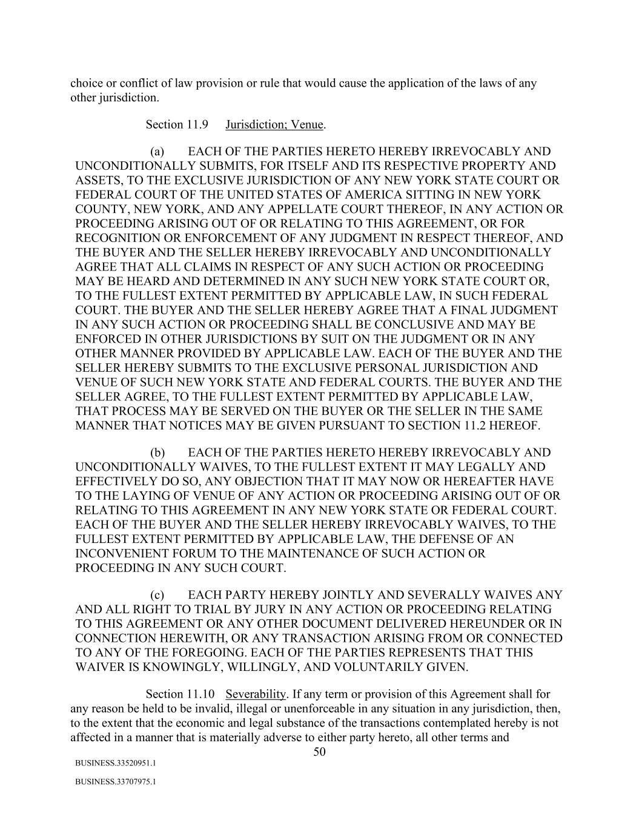
50 BUSINESS.33520951.1 BUSINESS.33707975.1 choice or conflict of law provision or rule that would cause the application of the laws of any other jurisdiction. Section 11.9 Jurisdiction; Venue. (a) EACH OF THE PARTIES HERETO HEREBY IRREVOCABLY AND UNCONDITIONALLY SUBMITS, FOR ITSELF AND ITS RESPECTIVE PROPERTY AND ASSETS, TO THE EXCLUSIVE JURISDICTION OF ANY NEW YORK STATE COURT OR FEDERAL COURT OF THE UNITED STATES OF AMERICA SITTING IN NEW YORK COUNTY, NEW YORK, AND ANY APPELLATE COURT THEREOF, IN ANY ACTION OR PROCEEDING ARISING OUT OF OR RELATING TO THIS AGREEMENT, OR FOR RECOGNITION OR ENFORCEMENT OF ANY JUDGMENT IN RESPECT THEREOF, AND THE BUYER AND THE SELLER HEREBY IRREVOCABLY AND UNCONDITIONALLY AGREE THAT ALL CLAIMS IN RESPECT OF ANY SUCH ACTION OR PROCEEDING MAY BE HEARD AND DETERMINED IN ANY SUCH NEW YORK STATE COURT OR, TO THE FULLEST EXTENT PERMITTED BY APPLICABLE LAW, IN SUCH FEDERAL COURT. THE BUYER AND THE SELLER HEREBY AGREE THAT A FINAL JUDGMENT IN ANY SUCH ACTION OR PROCEEDING SHALL BE CONCLUSIVE AND MAY BE ENFORCED IN OTHER JURISDICTIONS BY SUIT ON THE JUDGMENT OR IN ANY OTHER MANNER PROVIDED BY APPLICABLE LAW. EACH OF THE BUYER AND THE SELLER HEREBY SUBMITS TO THE EXCLUSIVE PERSONAL JURISDICTION AND VENUE OF SUCH NEW YORK STATE AND FEDERAL COURTS. THE BUYER AND THE SELLER AGREE, TO THE FULLEST EXTENT PERMITTED BY APPLICABLE LAW, THAT PROCESS MAY BE SERVED ON THE BUYER OR THE SELLER IN THE SAME MANNER THAT NOTICES MAY BE GIVEN PURSUANT TO SECTION 11.2 HEREOF. (b) EACH OF THE PARTIES HERETO HEREBY IRREVOCABLY AND UNCONDITIONALLY WAIVES, TO THE FULLEST EXTENT IT MAY LEGALLY AND EFFECTIVELY DO SO, ANY OBJECTION THAT IT MAY NOW OR HEREAFTER HAVE TO THE LAYING OF VENUE OF ANY ACTION OR PROCEEDING ARISING OUT OF OR RELATING TO THIS AGREEMENT IN ANY NEW YORK STATE OR FEDERAL COURT. EACH OF THE BUYER AND THE SELLER HEREBY IRREVOCABLY WAIVES, TO THE FULLEST EXTENT PERMITTED BY APPLICABLE LAW, THE DEFENSE OF AN INCONVENIENT FORUM TO THE MAINTENANCE OF SUCH ACTION OR PROCEEDING IN ANY SUCH COURT. (c) EACH PARTY HEREBY JOINTLY AND SEVERALLY WAIVES ANY AND ALL RIGHT TO TRIAL BY JURY IN ANY ACTION OR PROCEEDING RELATING TO THIS AGREEMENT OR ANY OTHER DOCUMENT DELIVERED HEREUNDER OR IN CONNECTION HEREWITH, OR ANY TRANSACTION ARISING FROM OR CONNECTED TO ANY OF THE FOREGOING. EACH OF THE PARTIES REPRESENTS THAT THIS WAIVER IS KNOWINGLY, WILLINGLY, AND VOLUNTARILY GIVEN. Section 11.10 Severability. If any term or provision of this Agreement shall for any reason be held to be invalid, illegal or unenforceable in any situation in any jurisdiction, then, to the extent that the economic and legal substance of the transactions contemplated hereby is not affected in a manner that is materially adverse to either party hereto, all other terms and

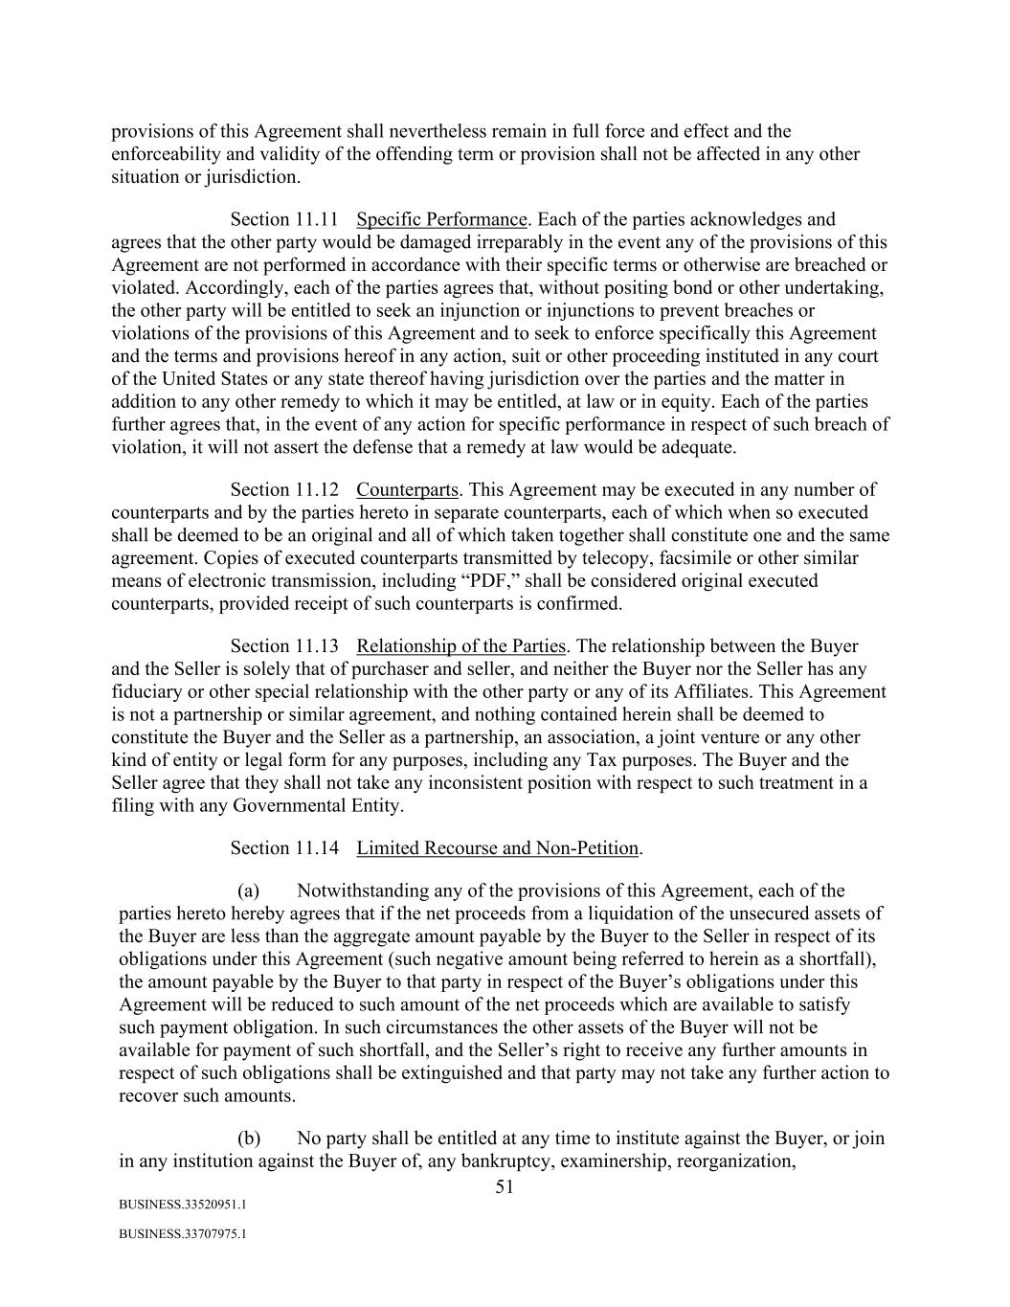
51 BUSINESS.33520951.1 BUSINESS.33707975.1 provisions of this Agreement shall nevertheless remain in full force and effect and the enforceability and validity of the offending term or provision shall not be affected in any other situation or jurisdiction. Section 11.11 Specific Performance. Each of the parties acknowledges and agrees that the other party would be damaged irreparably in the event any of the provisions of this Agreement are not performed in accordance with their specific terms or otherwise are breached or violated. Accordingly, each of the parties agrees that, without positing bond or other undertaking, the other party will be entitled to seek an injunction or injunctions to prevent breaches or violations of the provisions of this Agreement and to seek to enforce specifically this Agreement and the terms and provisions hereof in any action, suit or other proceeding instituted in any court of the United States or any state thereof having jurisdiction over the parties and the matter in addition to any other remedy to which it may be entitled, at law or in equity. Each of the parties further agrees that, in the event of any action for specific performance in respect of such breach of violation, it will not assert the defense that a remedy at law would be adequate. Section 11.12 Counterparts. This Agreement may be executed in any number of counterparts and by the parties hereto in separate counterparts, each of which when so executed shall be deemed to be an original and all of which taken together shall constitute one and the same agreement. Copies of executed counterparts transmitted by telecopy, facsimile or other similar means of electronic transmission, including “PDF,” shall be considered original executed counterparts, provided receipt of such counterparts is confirmed. Section 11.13 Relationship of the Parties. The relationship between the Buyer and the Seller is solely that of purchaser and seller, and neither the Buyer nor the Seller has any fiduciary or other special relationship with the other party or any of its Affiliates. This Agreement is not a partnership or similar agreement, and nothing contained herein shall be deemed to constitute the Buyer and the Seller as a partnership, an association, a joint venture or any other kind of entity or legal form for any purposes, including any Tax purposes. The Buyer and the Seller agree that they shall not take any inconsistent position with respect to such treatment in a filing with any Governmental Entity. Section 11.14 Limited Recourse and Non-Petition. (a) Notwithstanding any of the provisions of this Agreement, each of the parties hereto hereby agrees that if the net proceeds from a liquidation of the unsecured assets of the Buyer are less than the aggregate amount payable by the Buyer to the Seller in respect of its obligations under this Agreement (such negative amount being referred to herein as a shortfall), the amount payable by the Buyer to that party in respect of the Buyer’s obligations under this Agreement will be reduced to such amount of the net proceeds which are available to satisfy such payment obligation. In such circumstances the other assets of the Buyer will not be available for payment of such shortfall, and the Seller’s right to receive any further amounts in respect of such obligations shall be extinguished and that party may not take any further action to recover such amounts. (b) No party shall be entitled at any time to institute against the Buyer, or join in any institution against the Buyer of, any bankruptcy, examinership, reorganization,

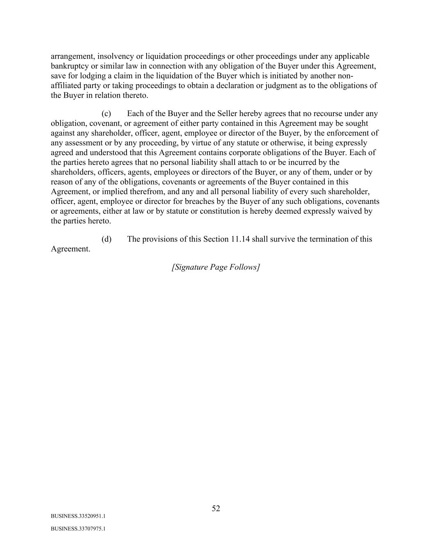
52 BUSINESS.33520951.1 BUSINESS.33707975.1 arrangement, insolvency or liquidation proceedings or other proceedings under any applicable bankruptcy or similar law in connection with any obligation of the Buyer under this Agreement, save for lodging a claim in the liquidation of the Buyer which is initiated by another non- affiliated party or taking proceedings to obtain a declaration or judgment as to the obligations of the Buyer in relation thereto. (c) Each of the Buyer and the Seller hereby agrees that no recourse under any obligation, covenant, or agreement of either party contained in this Agreement may be sought against any shareholder, officer, agent, employee or director of the Buyer, by the enforcement of any assessment or by any proceeding, by virtue of any statute or otherwise, it being expressly agreed and understood that this Agreement contains corporate obligations of the Buyer. Each of the parties hereto agrees that no personal liability shall attach to or be incurred by the shareholders, officers, agents, employees or directors of the Buyer, or any of them, under or by reason of any of the obligations, covenants or agreements of the Buyer contained in this Agreement, or implied therefrom, and any and all personal liability of every such shareholder, officer, agent, employee or director for breaches by the Buyer of any such obligations, covenants or agreements, either at law or by statute or constitution is hereby deemed expressly waived by the parties hereto. (d) The provisions of this Section 11.14 shall survive the termination of this Agreement. [Signature Page Follows]

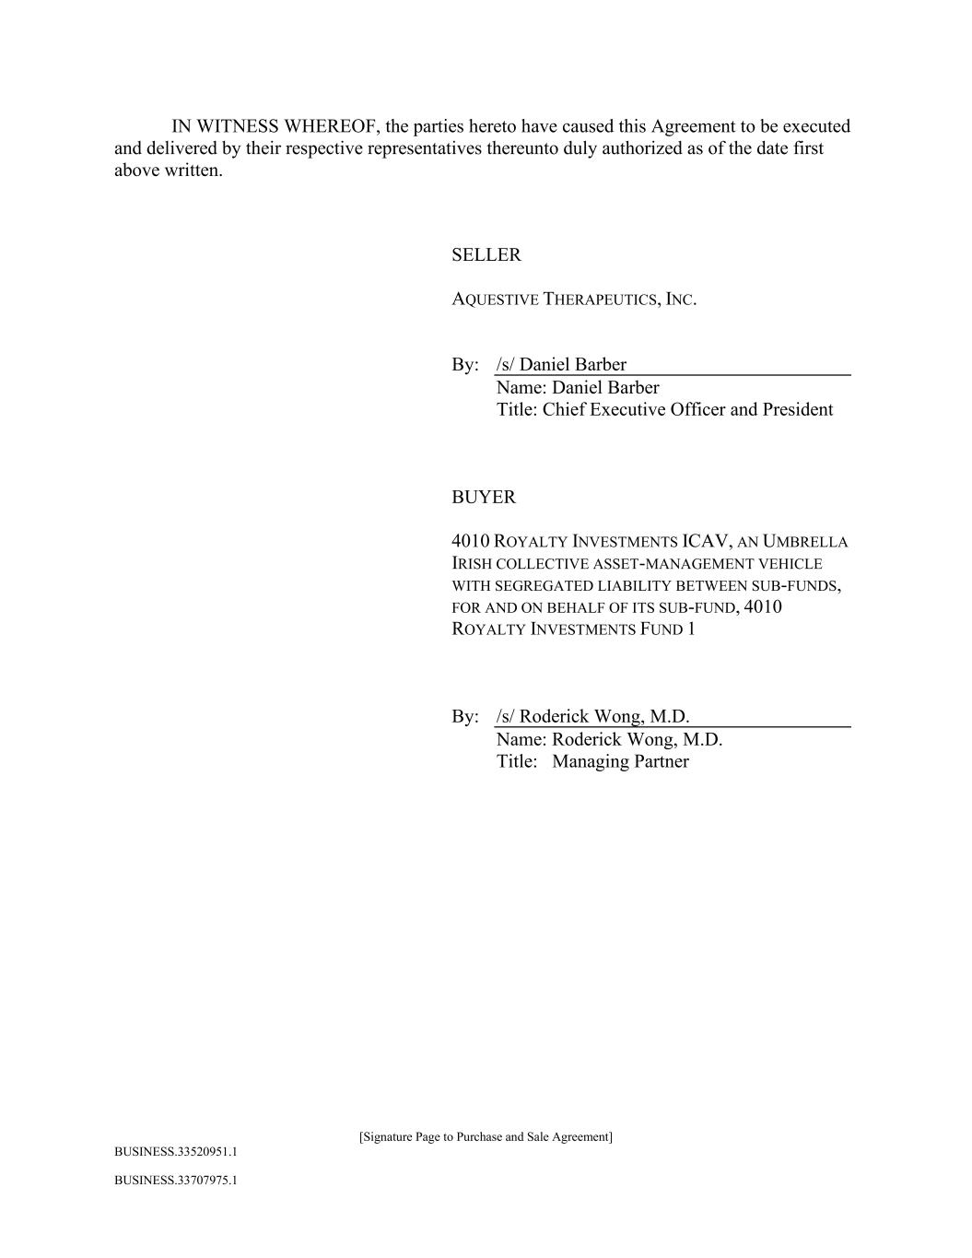
[Signature Page to Purchase and Sale Agreement] BUSINESS.33520951.1 BUSINESS.33707975.1 IN WITNESS WHEREOF, the parties hereto have caused this Agreement to be executed and delivered by their respective representatives thereunto duly authorized as of the date first above written. SELLER AQUESTIVE THERAPEUTICS, INC. By: /s/ Daniel Barber Name: Daniel Barber Title: Chief Executive Officer and President BUYER 4010 ROYALTY INVESTMENTS ICAV, AN UMBRELLA IRISH COLLECTIVE ASSET-MANAGEMENT VEHICLE WITH SEGREGATED LIABILITY BETWEEN SUB-FUNDS, FOR AND ON BEHALF OF ITS SUB-FUND, 4010 ROYALTY INVESTMENTS FUND 1 By: /s/ Roderick Wong, M.D. Name: Roderick Wong, M.D. Title: Managing Partner


BUSINESS.33520951.1 BUSINESS.33707975.1 Exhibit A Description of Anaphylm [***]


BUSINESS.33520951.1 BUSINESS.33707975.1 Exhibit B Form of Bill of Sale [***]

Exhibit 31.1

Certification of Principal Executive Officer of Aquestive Therapeutics, Inc.
Pursuant to Section 302 of the Sarbanes-Oxley Act of 2002

I, Daniel Barber, certify that:

1.I have reviewed this Quarterly Report on Form 10-Q of Aquestive Therapeutics, Inc.;

2.Based on my knowledge, this report does not contain any untrue statement of a material fact or omit to state a material fact necessary to make the statements made, in light of the circumstances under which such statements were made, not misleading with respect to the period covered by this report;

3.Based on my knowledge, the consolidated financial statements, and other financial information included in this report, fairly present in all material respects the financial condition, consolidated results of operations and consolidated cash flows of the registrant as of, and for, the periods presented in this report;

4.The registrant’s other certifying officer and I are responsible for establishing and maintaining disclosure controls and procedures (as defined in Exchange Act Rules 13a-15(e) and 15d-15(e)) and internal control over financial reporting (as defined in Exchange Act Rules 13a-15(f) and 15d-15(f)) for the registrant and have:

a.Designed such disclosure controls and procedures, or caused such disclosure controls and procedures to be designed under our supervision, to ensure that material information relating to the registrant, including its consolidated subsidiaries, is made known to us by others within those entities, particularly during the period in which this report is being prepared;

b.Designed such internal control over financial reporting, or caused such internal control over financial reporting to be designed under our supervision, to provide reasonable assurance regarding the reliability of financial reporting and the preparation of financial statements for external purposes in accordance with generally accepted accounting principles;

c.Evaluated the effectiveness of the registrant’s disclosure controls and procedures and presented in this report our conclusions about the effectiveness of the disclosure controls and procedures, as of the end of the period covered by this report based on such evaluation; and

d.Disclosed in this report any change in the registrant’s internal control over financial reporting that occurred during the registrant’s most recent fiscal quarter (the registrant’s fourth fiscal quarter in the case of an annual report) that has materially affected, or is reasonably likely to materially affect, the registrant’s internal control over financial reporting; and

5.The registrant’s other certifying officer and I have disclosed, based on our most recent evaluation of internal control over financial reporting, to the registrant’s auditors and the audit committee of registrant’s board of directors (or persons performing the equivalent functions):

a.All significant deficiencies and material weaknesses in the design or operation of internal control over financial reporting which are reasonably likely to adversely affect the registrant’s ability to record, process, summarize and report financial information; and

b.Any fraud, whether or not material, that involves management or other employees who have a significant role in the registrant’s internal control over financial reporting.

Date: November 5, 2025
/s/ Daniel Barber
Daniel Barber
President and Chief Executive Officer
(Principal Executive Officer)

Exhibit 31.2

Certification of Principal Financial and Accounting Officer of Aquestive Therapeutics, Inc.
Pursuant to Section 302 of the Sarbanes-Oxley Act of 2002

I, A. Ernest Toth, Jr, certify that:

1.I have reviewed this Quarterly Report on Form 10-Q of Aquestive Therapeutics, Inc.;

2.Based on my knowledge, this report does not contain any untrue statement of a material fact or omit to state a material fact necessary to make the statements made, in light of the circumstances under which such statements were made, not misleading with respect to the period covered by this report;

3.Based on my knowledge, the consolidated financial statements, and other financial information included in this report, fairly present in all material respects the financial condition, consolidated results of operations and consolidated cash flows of the registrant as of, and for, the periods presented in this report;

4.The registrant’s other certifying officer and I are responsible for establishing and maintaining disclosure controls and procedures (as defined in Exchange Act Rules 13a-15(e) and 15d-15(e)) and internal control over financial reporting (as defined in Exchange Act Rules 13a-15(f) and 15d-15(f)) for the registrant and have:

a.Designed such disclosure controls and procedures, or caused such disclosure controls and procedures to be designed under our supervision, to ensure that material information relating to the registrant, including its consolidated subsidiaries, is made known to us by others within those entities, particularly during the period in which this report is being prepared;

b.Designed such internal control over financial reporting, or caused such internal control over financial reporting to be designed under our supervision, to provide reasonable assurance regarding the reliability of financial reporting and the preparation of financial statements for external purposes in accordance with generally accepted accounting principles;

c.Evaluated the effectiveness of the registrant’s disclosure controls and procedures and presented in this report our conclusions about the effectiveness of the disclosure controls and procedures, as of the end of the period covered by this report based on such evaluation; and

d.Disclosed in this report any change in the registrant’s internal control over financial reporting that occurred during the registrant’s most recent fiscal quarter (the registrant’s fourth fiscal quarter in the case of an annual report) that has materially affected, or is reasonably likely to materially affect, the registrant’s internal control over financial reporting; and

5.The registrant’s other certifying officer and I have disclosed, based on our most recent evaluation of internal control over financial reporting, to the registrant’s auditors and the audit committee of registrant’s board of directors (or persons performing the equivalent functions):

a.All significant deficiencies and material weaknesses in the design or operation of internal control over financial reporting which are reasonably likely to adversely affect the registrant’s ability to record, process, summarize and report financial information; and

b.Any fraud, whether or not material, that involves management or other employees who have a significant role in the registrant’s internal control over financial reporting.

Date: November 5, 2025
/s/ A. ERNEST TOTH, JR.
A.Ernest Toth, Jr.
Chief Financial Officer
(Principal Financial Officer)

Exhibit 32.1

Certification of Principal Executive Officer
Pursuant to 18 U.S.C. Section 1350, as Adopted
Pursuant to Section 906 of the Sarbanes-Oxley Act of 2002

Pursuant to the requirement set forth in Rule 13a-14(b) of the Securities Exchange Act of 1934, as amended (the “Exchange Act”), and Section 1350 of Chapter 63 of Title 18 of the United States Code (18 U.S.C. §1350), I, Daniel Barber, President and Chief Executive Officer of Aquestive Therapeutics, Inc. (the “Company”), hereby certify that, to the best of my knowledge:

1.The Company’s Quarterly Report on Form 10-Q for the period-ended September 30, 2025, to which this Certification is attached as Exhibit 32.1 (the “Quarterly Report”), fully complies with the requirements of Section 13(a) or Section 15(d) of the Exchange Act; and

2.The information contained in the Quarterly Report fairly presents, in all material respects, the financial condition of the Company at the end of the period covered by the Quarterly Report and the results of operations of the Company for the period covered by the Quarterly Report.

Date: November 5, 2025

/s/ Daniel Barber
Daniel Barber
President and Chief Executive Officer
(Principal Executive Officer)

This certification accompanies the Form 10-Q to which it relates, is not deemed filed with the Securities and Exchange Commission and is not to be incorporated by reference into any filing of Aquestive Therapeutics, Inc. under the Securities Act of 1933, as amended, or the Exchange Act (whether made before or after the date of the Quarterly Report), irrespective of any general incorporation language contained in such filing.

Exhibit 32.2

Certification of Principal Financial and Accounting Officer
Pursuant to 18 U.S.C. Section 1350, as Adopted
Pursuant to Section 906 of the Sarbanes-Oxley Act of 2002

Pursuant to the requirement set forth in Rule 13a-14(b) of the Securities Exchange Act of 1934, as amended (the “Exchange Act”), and Section 1350 of Chapter 63 of Title 18 of the United States Code (18 U.S.C. §1350), I, A. Ernest Toth, Jr., Chief Financial Officer of Aquestive Therapeutics, Inc. (the “Company”), hereby certify that, to the best of my knowledge:

1.The Company’s Quarterly Report on Form 10-Q for the period-ended September 30, 2025, to which this Certification is attached as Exhibit 32.2 (the “Quarterly Report”), fully complies with the requirements of Section 13(a) or Section 15(d) of the Exchange Act; and

2.The information contained in the Quarterly Report fairly presents, in all material respects, the financial condition of the Company at the end of the period covered by the Quarterly Report and the results of operations of the Company for the period covered by the Quarterly Report.

Date: November 5, 2025

/s/ A. ERNEST TOTH, JR
A.Ernest Toth, Jr.
Chief Financial Officer
(Principal Financial Officer)

This certification accompanies the Form 10-Q to which it relates, is not deemed filed with the Securities and Exchange Commission and is not to be incorporated by reference into any filing of Aquestive Therapeutics, Inc. under the Securities Act of 1933, as amended, or the Exchange Act (whether made before or after the date of the Quarterly Report), irrespective of any general incorporation language contained in such filing.

