UNITED STATES
SECURITIES AND EXCHANGE COMMISSION
Washington, DC 20549

FORM 8-K

CURRENT REPORT

PURSUANT TO SECTION 13 OR 15(d) OF THE
SECURITIES EXCHANGE ACT OF 1934

Date of Report (Date of earliest event reported): October 13, 2026
Aquestive Therapeutics, Inc.
(Exact name of Registrant as specified in its charter)
Delaware |  |  | 001-38599 |  |  | 82-3827296
(State or other jurisdiction of incorporation) |  |  | (Commission File Number) |  |  | (I.R.S. Employer Identification No.)

30 Technology Drive
Warren, NJ 07059
(908) 941-1900
(Address, Including Zip Code, and Telephone Number, Including Area Code, of Registrant’s Principal Executive Offices)

Not Applicable
(Former name or former address, if changed since last report)

________________________________________________________________________________________________________________________
Check the appropriate box below if the Form 8-K filing is intended to simultaneously satisfy the filing obligation of the registrant under any of the following provisions:
☐ |  |  | Written communications pursuant to Rule 425 under the Securities Act (17 CFR 230.425)
☐ |  |  | Soliciting material pursuant to Rule 14a-12 under the Exchange Act (17 CFR 240.14a-12)
☐ |  |  | Pre-commencement communications pursuant to Rule 14d-2(b) under the Exchange Act (17 CFR 240.14d-2(b))
☐ |  |  | Pre-commencement communications pursuant to Rule 13e-4(c) under the Exchange Act (17 CFR 240.13e-4(c))

Securities registered pursuant to Section 12(b) of the Act:

Title of each class |  |  | Trading Symbol(s) |  |  | Name of each exchange on which  registered
Common Stock, par value $0.001 per share |  |  | AQST |  |  | Nasdaq Global Market

Indicate by check mark whether the registrant is an emerging growth company as defined in Rule 405 of the Securities Act of 1933 (§230.405 of this chapter) or Rule 12b-2 of the Securities Exchange Act of 1934 (§240.12b-2 of this chapter).
Emerging growth company |  |  | ☐
If an emerging growth company, indicate by check mark if the registrant has elected not to use the extended transition period for complying with any new or revised financial accounting standards provided pursuant to Section 13(a) of the Exchange Act. ☐

Item 1.01 |  |  | Entry into a Material Definitive Agreement.
On October 13, 2026, Aquestive Therapeutics, Inc. ("Aquestive" or the "Company") entered into a license agreement (the "License Agreement") with Eton Pharmaceuticals, Inc. ("Eton") pursuant to which the Company granted Eton exclusive U.S. rights to commercialize LIBERVANT® (diazepam) buccal film (the "Product") for the acute treatment of seizure clusters in patients with epilepsy, subject to applicable regulatory approvals. The Product has received tentative approval from the U.S. Food and Drug Administration ("FDA") for the acute treatment of intermittent, stereotypic episodes of frequent seizure activity (i.e., seizure clusters, acute repetitive seizures) that are distinct from a patient's usual seizure pattern in patients with epilepsy 2 to 5 years of age and ages 12 and older.

Under the terms of the License Agreement, the Company received an upfront license fee of $10.0 million from Eton. In addition, the Company is entitled to receive from Eton additional regulatory and commercial milestone payments of up to an aggregate of $47.5 million upon the achievement of specified milestones, including: $10.0 million upon first commercial sale in the United States, reduced to $5.0 million if full FDA approval permitting commercial sale for ages 2–5 has not been received; $2.5 million upon approval by the FDA of the Product for patients ages 6–11; and up to $35.0 million of commercial milestones tied to the Product's achievement of certain annual net sales levels in the United States.

The Company will also receive royalties on annual net sales of the Product at a mid-teens percentage rate from Eton.

In connection with the License Agreement, the Company also entered into a supply agreement with Eton (the "Supply Agreement") under which the Company will serve as the exclusive manufacturer and supplier of the Product to Eton, subject to specified exceptions. The Supply Agreement provides for an initial term of 20 years. At the conclusion of such initial term, the Supply Agreement will be subject to an automatic extension for succeeding three-year periods unless either party notifies the other of its desire not to renew at least two years prior to the end of the initial term or any succeeding term.

A copy of the press release announcing the transaction dated October 14, 2026 is attached as Exhibit 99.1 to this Current Report on Form 8-K.

Item 9.01 |  |  | Financial Statements and Exhibits.
(d) Exhibits.

Exhibit Number |  |  |  |  |  | Description
99.1 |  |  |  |  |  | Aquestive Therapeutics, Inc. Press Release, dated October 14, 2026
104 |  |  |  |  |  | Cover Page Interaction Data File (embedded within the Inline XBRL document)

SIGNATURE

Pursuant to the requirements of the Securities Exchange Act of 1934, as amended, the Registrant has duly caused this report to be signed on its behalf by the undersigned hereunto duly authorized.

Dated: October 14, 2026 |  |  | Aquestive Therapeutics, Inc.
 |  |  | By: |  |  | /s/ A. Ernest Toth, Jr
 |  |  |  |  |  | Name: A. Ernest Toth, Jr.
 |  |  |  |  |  | Title: Chief Financial Officer

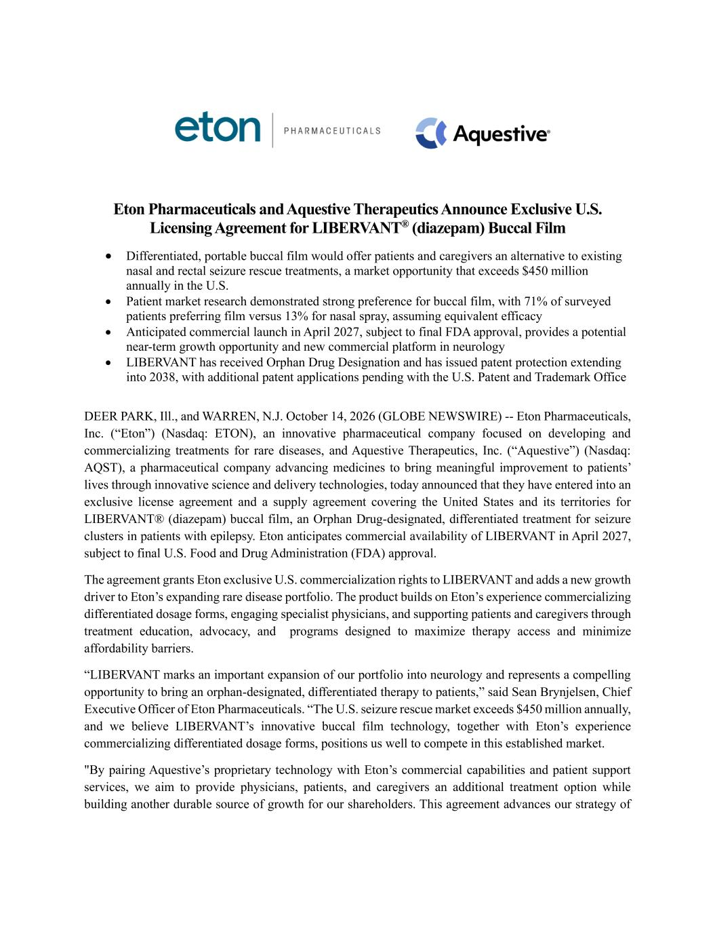

Eton Pharmaceuticals and Aquestive Therapeutics Announce Exclusive U.S. Licensing Agreement for LIBERVANT® (diazepam) Buccal Film • Differentiated, portable buccal film would offer patients and caregivers an alternative to existing nasal and rectal seizure rescue treatments, a market opportunity that exceeds $450 million annually in the U.S. • Patient market research demonstrated strong preference for buccal film, with 71% of surveyed patients preferring film versus 13% for nasal spray, assuming equivalent efficacy • Anticipated commercial launch in April 2027, subject to final FDA approval, provides a potential near-term growth opportunity and new commercial platform in neurology • LIBERVANT has received Orphan Drug Designation and has issued patent protection extending into 2038, with additional patent applications pending with the U.S. Patent and Trademark Office DEER PARK, Ill., and WARREN, N.J. October 14, 2026 (GLOBE NEWSWIRE) -- Eton Pharmaceuticals, Inc. (“Eton”) (Nasdaq: ETON), an innovative pharmaceutical company focused on developing and commercializing treatments for rare diseases, and Aquestive Therapeutics, Inc. (“Aquestive”) (Nasdaq: AQST), a pharmaceutical company advancing medicines to bring meaningful improvement to patients’ lives through innovative science and delivery technologies, today announced that they have entered into an exclusive license agreement and a supply agreement covering the United States and its territories for LIBERVANT® (diazepam) buccal film, an Orphan Drug-designated, differentiated treatment for seizure clusters in patients with epilepsy. Eton anticipates commercial availability of LIBERVANT in April 2027, subject to final U.S. Food and Drug Administration (FDA) approval. The agreement grants Eton exclusive U.S. commercialization rights to LIBERVANT and adds a new growth driver to Eton’s expanding rare disease portfolio. The product builds on Eton’s experience commercializing differentiated dosage forms, engaging specialist physicians, and supporting patients and caregivers through treatment education, advocacy, and programs designed to maximize therapy access and minimize affordability barriers. “LIBERVANT marks an important expansion of our portfolio into neurology and represents a compelling opportunity to bring an orphan-designated, differentiated therapy to patients,” said Sean Brynjelsen, Chief Executive Officer of Eton Pharmaceuticals. “The U.S. seizure rescue market exceeds $450 million annually, and we believe LIBERVANT’s innovative buccal film technology, together with Eton’s experience commercializing differentiated dosage forms, positions us well to compete in this established market. "By pairing Aquestive’s proprietary technology with Eton’s commercial capabilities and patient support services, we aim to provide physicians, patients, and caregivers an additional treatment option while building another durable source of growth for our shareholders. This agreement advances our strategy of

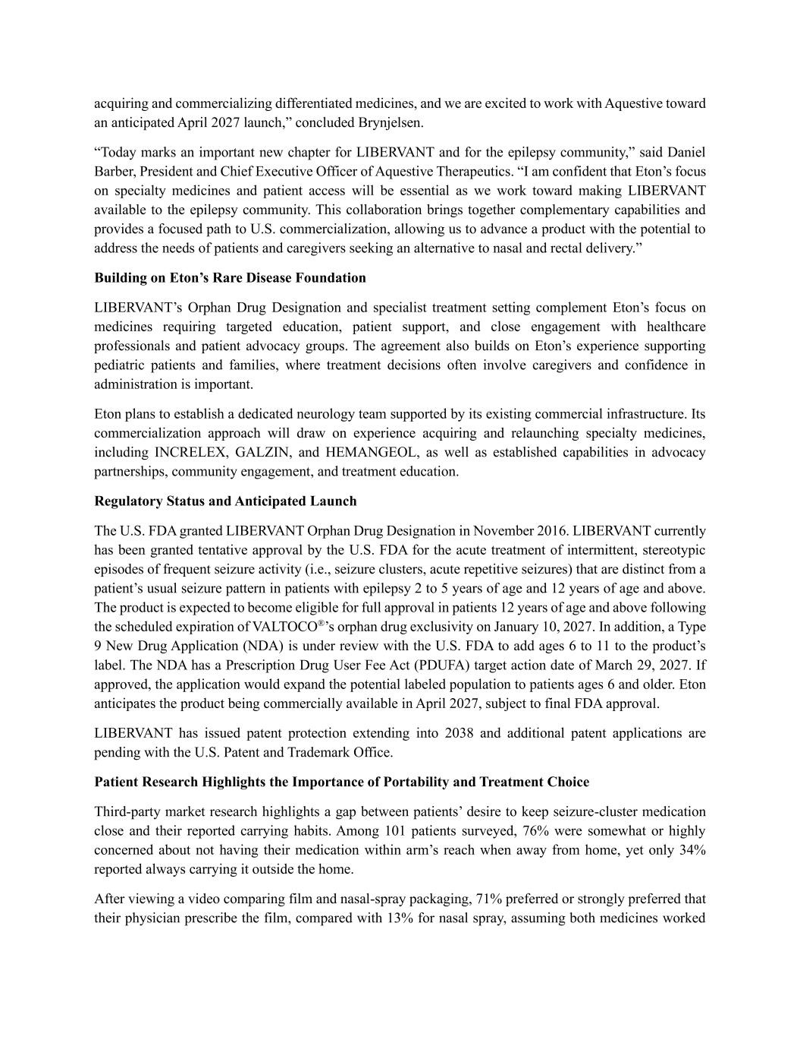
acquiring and commercializing differentiated medicines, and we are excited to work with Aquestive toward an anticipated April 2027 launch,” concluded Brynjelsen. “Today marks an important new chapter for LIBERVANT and for the epilepsy community,” said Daniel Barber, President and Chief Executive Officer of Aquestive Therapeutics. “I am confident that Eton’s focus on specialty medicines and patient access will be essential as we work toward making LIBERVANT available to the epilepsy community. This collaboration brings together complementary capabilities and provides a focused path to U.S. commercialization, allowing us to advance a product with the potential to address the needs of patients and caregivers seeking an alternative to nasal and rectal delivery.” Building on Eton’s Rare Disease Foundation LIBERVANT’s Orphan Drug Designation and specialist treatment setting complement Eton’s focus on medicines requiring targeted education, patient support, and close engagement with healthcare professionals and patient advocacy groups. The agreement also builds on Eton’s experience supporting pediatric patients and families, where treatment decisions often involve caregivers and confidence in administration is important. Eton plans to establish a dedicated neurology team supported by its existing commercial infrastructure. Its commercialization approach will draw on experience acquiring and relaunching specialty medicines, including INCRELEX, GALZIN, and HEMANGEOL, as well as established capabilities in advocacy partnerships, community engagement, and treatment education. Regulatory Status and Anticipated Launch The U.S. FDA granted LIBERVANT Orphan Drug Designation in November 2016. LIBERVANT currently has been granted tentative approval by the U.S. FDA for the acute treatment of intermittent, stereotypic episodes of frequent seizure activity (i.e., seizure clusters, acute repetitive seizures) that are distinct from a patient’s usual seizure pattern in patients with epilepsy 2 to 5 years of age and 12 years of age and above. The product is expected to become eligible for full approval in patients 12 years of age and above following the scheduled expiration of VALTOCO®’s orphan drug exclusivity on January 10, 2027. In addition, a Type 9 New Drug Application (NDA) is under review with the U.S. FDA to add ages 6 to 11 to the product’s label. The NDA has a Prescription Drug User Fee Act (PDUFA) target action date of March 29, 2027. If approved, the application would expand the potential labeled population to patients ages 6 and older. Eton anticipates the product being commercially available in April 2027, subject to final FDA approval. LIBERVANT has issued patent protection extending into 2038 and additional patent applications are pending with the U.S. Patent and Trademark Office. Patient Research Highlights the Importance of Portability and Treatment Choice Third-party market research highlights a gap between patients’ desire to keep seizure-cluster medication close and their reported carrying habits. Among 101 patients surveyed, 76% were somewhat or highly concerned about not having their medication within arm’s reach when away from home, yet only 34% reported always carrying it outside the home. After viewing a video comparing film and nasal-spray packaging, 71% preferred or strongly preferred that their physician prescribe the film, compared with 13% for nasal spray, assuming both medicines worked

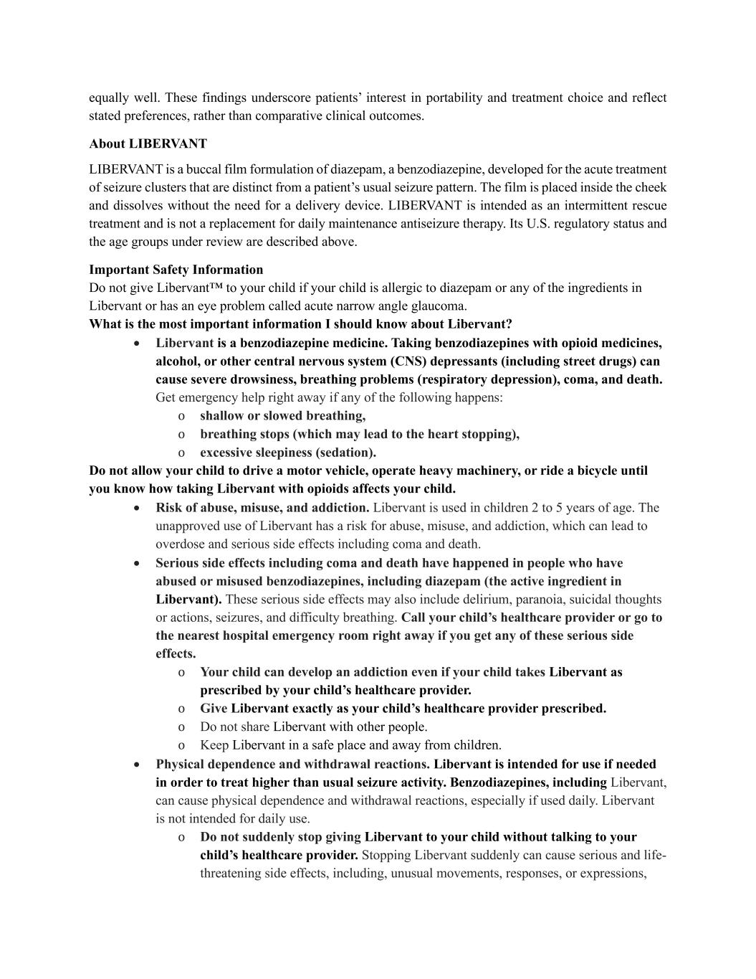
equally well. These findings underscore patients’ interest in portability and treatment choice and reflect stated preferences, rather than comparative clinical outcomes. About LIBERVANT LIBERVANT is a buccal film formulation of diazepam, a benzodiazepine, developed for the acute treatment of seizure clusters that are distinct from a patient’s usual seizure pattern. The film is placed inside the cheek and dissolves without the need for a delivery device. LIBERVANT is intended as an intermittent rescue treatment and is not a replacement for daily maintenance antiseizure therapy. Its U.S. regulatory status and the age groups under review are described above. Important Safety Information Do not give Libervant™ to your child if your child is allergic to diazepam or any of the ingredients in Libervant or has an eye problem called acute narrow angle glaucoma. What is the most important information I should know about Libervant? • Libervant is a benzodiazepine medicine. Taking benzodiazepines with opioid medicines, alcohol, or other central nervous system (CNS) depressants (including street drugs) can cause severe drowsiness, breathing problems (respiratory depression), coma, and death. Get emergency help right away if any of the following happens: o shallow or slowed breathing, o breathing stops (which may lead to the heart stopping), o excessive sleepiness (sedation). Do not allow your child to drive a motor vehicle, operate heavy machinery, or ride a bicycle until you know how taking Libervant with opioids affects your child. • Risk of abuse, misuse, and addiction. Libervant is used in children 2 to 5 years of age. The unapproved use of Libervant has a risk for abuse, misuse, and addiction, which can lead to overdose and serious side effects including coma and death. • Serious side effects including coma and death have happened in people who have abused or misused benzodiazepines, including diazepam (the active ingredient in Libervant). These serious side effects may also include delirium, paranoia, suicidal thoughts or actions, seizures, and difficulty breathing. Call your child’s healthcare provider or go to the nearest hospital emergency room right away if you get any of these serious side effects. o Your child can develop an addiction even if your child takes Libervant as prescribed by your child’s healthcare provider. o Give Libervant exactly as your child’s healthcare provider prescribed. o Do not share Libervant with other people. o Keep Libervant in a safe place and away from children. • Physical dependence and withdrawal reactions. Libervant is intended for use if needed in order to treat higher than usual seizure activity. Benzodiazepines, including Libervant, can cause physical dependence and withdrawal reactions, especially if used daily. Libervant is not intended for daily use. o Do not suddenly stop giving Libervant to your child without talking to your child’s healthcare provider. Stopping Libervant suddenly can cause serious and life- threatening side effects, including, unusual movements, responses, or expressions,

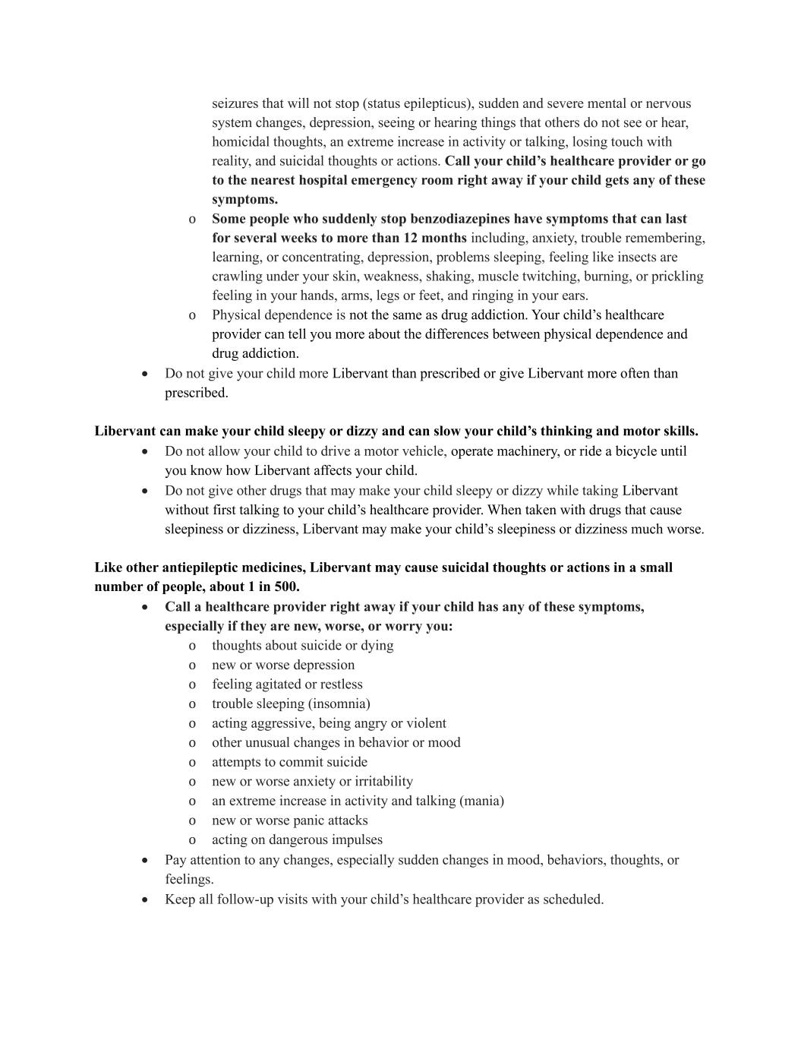
seizures that will not stop (status epilepticus), sudden and severe mental or nervous system changes, depression, seeing or hearing things that others do not see or hear, homicidal thoughts, an extreme increase in activity or talking, losing touch with reality, and suicidal thoughts or actions. Call your child’s healthcare provider or go to the nearest hospital emergency room right away if your child gets any of these symptoms. o Some people who suddenly stop benzodiazepines have symptoms that can last for several weeks to more than 12 months including, anxiety, trouble remembering, learning, or concentrating, depression, problems sleeping, feeling like insects are crawling under your skin, weakness, shaking, muscle twitching, burning, or prickling feeling in your hands, arms, legs or feet, and ringing in your ears. o Physical dependence is not the same as drug addiction. Your child’s healthcare provider can tell you more about the differences between physical dependence and drug addiction. • Do not give your child more Libervant than prescribed or give Libervant more often than prescribed. Libervant can make your child sleepy or dizzy and can slow your child’s thinking and motor skills. • Do not allow your child to drive a motor vehicle, operate machinery, or ride a bicycle until you know how Libervant affects your child. • Do not give other drugs that may make your child sleepy or dizzy while taking Libervant without first talking to your child’s healthcare provider. When taken with drugs that cause sleepiness or dizziness, Libervant may make your child’s sleepiness or dizziness much worse. Like other antiepileptic medicines, Libervant may cause suicidal thoughts or actions in a small number of people, about 1 in 500. • Call a healthcare provider right away if your child has any of these symptoms, especially if they are new, worse, or worry you: o thoughts about suicide or dying o new or worse depression o feeling agitated or restless o trouble sleeping (insomnia) o acting aggressive, being angry or violent o other unusual changes in behavior or mood o attempts to commit suicide o new or worse anxiety or irritability o an extreme increase in activity and talking (mania) o new or worse panic attacks o acting on dangerous impulses • Pay attention to any changes, especially sudden changes in mood, behaviors, thoughts, or feelings. • Keep all follow-up visits with your child’s healthcare provider as scheduled.

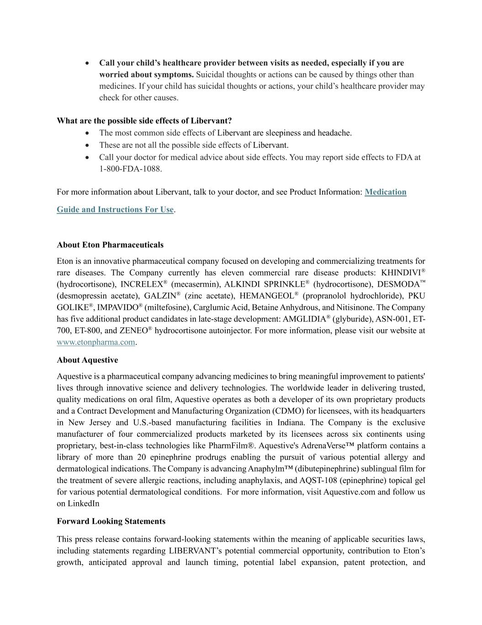
• Call your child’s healthcare provider between visits as needed, especially if you are worried about symptoms. Suicidal thoughts or actions can be caused by things other than medicines. If your child has suicidal thoughts or actions, your child’s healthcare provider may check for other causes. What are the possible side effects of Libervant? • The most common side effects of Libervant are sleepiness and headache. • These are not all the possible side effects of Libervant. • Call your doctor for medical advice about side effects. You may report side effects to FDA at 1-800-FDA-1088. For more information about Libervant, talk to your doctor, and see Product Information: Medication Guide and Instructions For Use. About Eton Pharmaceuticals Eton is an innovative pharmaceutical company focused on developing and commercializing treatments for rare diseases. The Company currently has eleven commercial rare disease products: KHINDIVI® (hydrocortisone), INCRELEX® (mecasermin), ALKINDI SPRINKLE® (hydrocortisone), DESMODA™ (desmopressin acetate), GALZIN® (zinc acetate), HEMANGEOL® (propranolol hydrochloride), PKU GOLIKE®, IMPAVIDO® (miltefosine), Carglumic Acid, Betaine Anhydrous, and Nitisinone. The Company has five additional product candidates in late-stage development: AMGLIDIA® (glyburide), ASN-001, ET- 700, ET-800, and ZENEO® hydrocortisone autoinjector. For more information, please visit our website at www.etonpharma.com. About Aquestive Aquestive is a pharmaceutical company advancing medicines to bring meaningful improvement to patients' lives through innovative science and delivery technologies. The worldwide leader in delivering trusted, quality medications on oral film, Aquestive operates as both a developer of its own proprietary products and a Contract Development and Manufacturing Organization (CDMO) for licensees, with its headquarters in New Jersey and U.S.-based manufacturing facilities in Indiana. The Company is the exclusive manufacturer of four commercialized products marketed by its licensees across six continents using proprietary, best-in-class technologies like PharmFilm®. Aquestive's AdrenaVerse™ platform contains a library of more than 20 epinephrine prodrugs enabling the pursuit of various potential allergy and dermatological indications. The Company is advancing Anaphylm™ (dibutepinephrine) sublingual film for the treatment of severe allergic reactions, including anaphylaxis, and AQST-108 (epinephrine) topical gel for various potential dermatological conditions. For more information, visit Aquestive.com and follow us on LinkedIn Forward Looking Statements This press release contains forward-looking statements within the meaning of applicable securities laws, including statements regarding LIBERVANT’s potential commercial opportunity, contribution to Eton’s growth, anticipated approval and launch timing, potential label expansion, patent protection, and

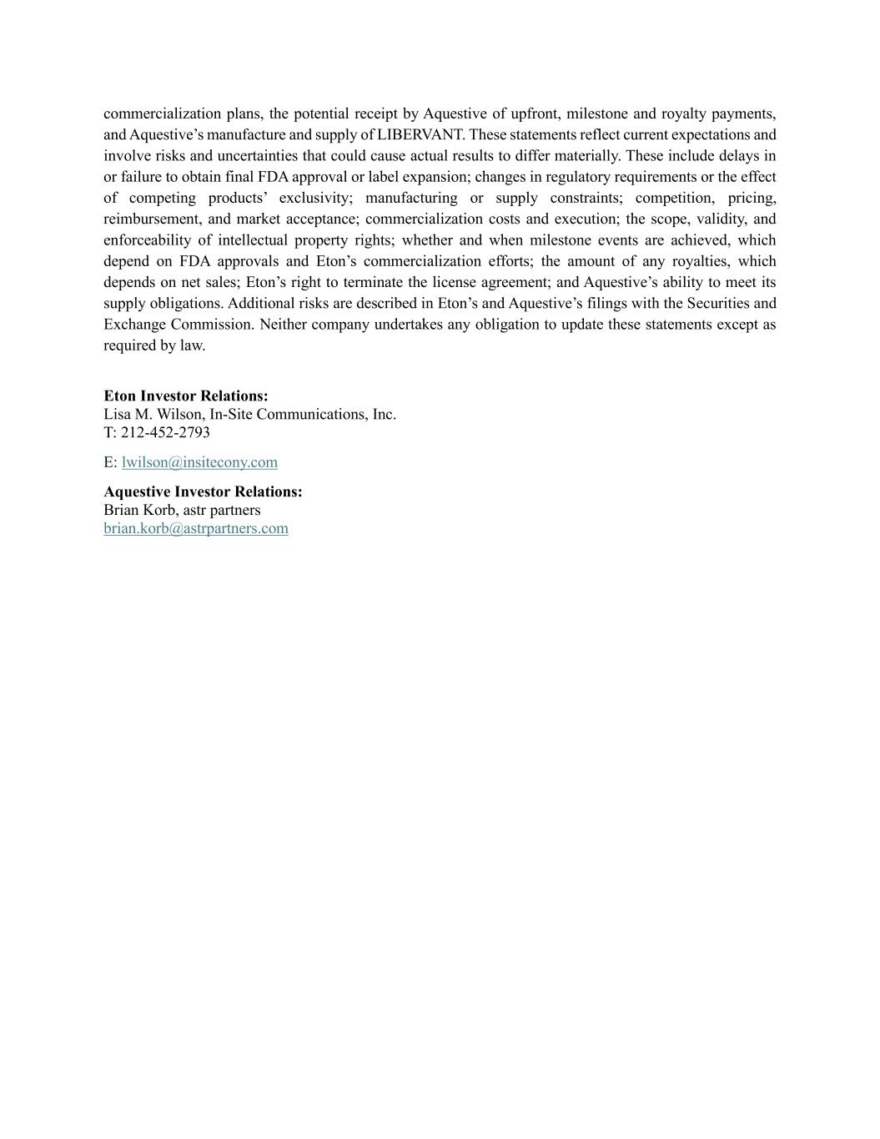
commercialization plans, the potential receipt by Aquestive of upfront, milestone and royalty payments, and Aquestive’s manufacture and supply of LIBERVANT. These statements reflect current expectations and involve risks and uncertainties that could cause actual results to differ materially. These include delays in or failure to obtain final FDA approval or label expansion; changes in regulatory requirements or the effect of competing products’ exclusivity; manufacturing or supply constraints; competition, pricing, reimbursement, and market acceptance; commercialization costs and execution; the scope, validity, and enforceability of intellectual property rights; whether and when milestone events are achieved, which depend on FDA approvals and Eton’s commercialization efforts; the amount of any royalties, which depends on net sales; Eton’s right to terminate the license agreement; and Aquestive’s ability to meet its supply obligations. Additional risks are described in Eton’s and Aquestive’s filings with the Securities and Exchange Commission. Neither company undertakes any obligation to update these statements except as required by law. Eton Investor Relations: Lisa M. Wilson, In-Site Communications, Inc. T: 212-452-2793 E: lwilson@insitecony.com Aquestive Investor Relations: Brian Korb, astr partners brian.korb@astrpartners.com

