UNITED STATES
SECURITIES AND EXCHANGE COMMISSION
Washington, DC 20549

FORM 8-K

CURRENT REPORT

PURSUANT TO SECTION 13 OR 15(d) OF THE
SECURITIES EXCHANGE ACT OF 1934

Date of Report (Date of earliest event reported): October 15, 2026
Aquestive Therapeutics, Inc.
(Exact name of Registrant as specified in its charter)
Delaware |  |  | 001-38599 |  |  | 82-3827296
(State or other jurisdiction of incorporation) |  |  | (Commission File Number) |  |  | (I.R.S. Employer Identification No.)

30 Technology Drive
Warren, NJ 07059
(908) 941-1900
(Address, Including Zip Code, and Telephone Number, Including Area Code, of Registrant’s Principal Executive Offices)

Not Applicable
(Former name or former address, if changed since last report)

________________________________________________________________________________________________________________________
Check the appropriate box below if the Form 8-K filing is intended to simultaneously satisfy the filing obligation of the registrant under any of the following provisions:
☐ |  |  | Written communications pursuant to Rule 425 under the Securities Act (17 CFR 230.425)
☐ |  |  | Soliciting material pursuant to Rule 14a-12 under the Exchange Act (17 CFR 240.14a-12)
☐ |  |  | Pre-commencement communications pursuant to Rule 14d-2(b) under the Exchange Act (17 CFR 240.14d-2(b))
☐ |  |  | Pre-commencement communications pursuant to Rule 13e-4(c) under the Exchange Act (17 CFR 240.13e-4(c))

Securities registered pursuant to Section 12(b) of the Act:

Title of each class |  |  | Trading Symbol(s) |  |  | Name of each exchange on which  registered
Common Stock, par value $0.001 per share |  |  | AQST |  |  | Nasdaq Global Market

Indicate by check mark whether the registrant is an emerging growth company as defined in Rule 405 of the Securities Act of 1933 (§230.405 of this chapter) or Rule 12b-2 of the Securities Exchange Act of 1934 (§240.12b-2 of this chapter).
Emerging growth company |  |  | ☐
If an emerging growth company, indicate by check mark if the registrant has elected not to use the extended transition period for complying with any new or revised financial accounting standards provided pursuant to Section 13(a) of the Exchange Act. ☐

Item 7.01 |  |  | Regulation FD Disclosure.
On October 15, 2026, Aquestive Therapeutics, Inc. ("Aquestive" or the "Company") issued a press release announcing that the U.S. Food and Drug Administration (FDA) has acknowledged its resubmission of the New Drug Application (NDA) for Anaphylm™ (dibutepinephrine) sublingual film for the treatment of Type I allergic reactions, including anaphylaxis, as complete and has assigned a Prescription Drug User Fee Act (PDUFA) goal date of March 16, 2027.

The information in this Item 7.01 (including Exhibit 99.1) shall not be deemed to be “filed” for purposes of, or otherwise subject to the liabilities of, Section 18 of the Exchange Act of 1934, as amended (the "Exchange Act"), nor shall it be deemed to be incorporated by reference in any filing under the Securities Act of 1933, as amended, or the Exchange Act, except as shall be expressly set forth by specific reference in any such filing.

Item 9.01 |  |  | Financial Statements and Exhibits.
(d) Exhibits.

Exhibit Number |  |  |  |  |  | Description
99.1 |  |  |  |  |  | Aquestive Therapeutics, Inc. Press Release, dated October 15, 2026
104 |  |  |  |  |  | Cover Page Interaction Data File (embedded within the Inline XBRL document)

SIGNATURE

Pursuant to the requirements of the Securities Exchange Act of 1934, as amended, the Registrant has duly caused this report to be signed on its behalf by the undersigned hereunto duly authorized.

Dated: October 15, 2026 |  |  | Aquestive Therapeutics, Inc.
 |  |  | By: |  |  | /s/ A. Ernest Toth, Jr
 |  |  |  |  |  | Name: A. Ernest Toth, Jr.
 |  |  |  |  |  | Title: Chief Financial Officer

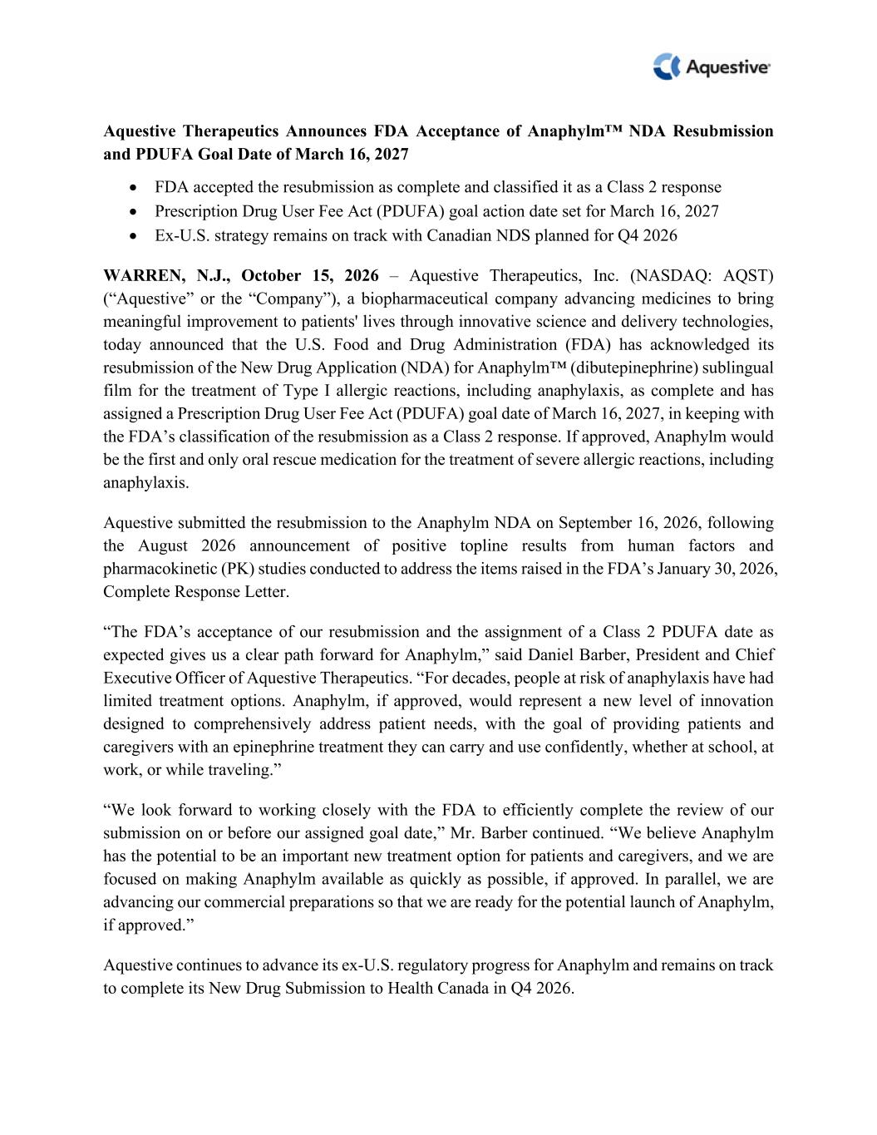

Aquestive Therapeutics Announces FDA Acceptance of Anaphylm™ NDA Resubmission and PDUFA Goal Date of March 16, 2027 • FDA accepted the resubmission as complete and classified it as a Class 2 response • Prescription Drug User Fee Act (PDUFA) goal action date set for March 16, 2027 • Ex-U.S. strategy remains on track with Canadian NDS planned for Q4 2026 WARREN, N.J., October 15, 2026 – Aquestive Therapeutics, Inc. (NASDAQ: AQST) (“Aquestive” or the “Company”), a biopharmaceutical company advancing medicines to bring meaningful improvement to patients' lives through innovative science and delivery technologies, today announced that the U.S. Food and Drug Administration (FDA) has acknowledged its resubmission of the New Drug Application (NDA) for Anaphylm™ (dibutepinephrine) sublingual film for the treatment of Type I allergic reactions, including anaphylaxis, as complete and has assigned a Prescription Drug User Fee Act (PDUFA) goal date of March 16, 2027, in keeping with the FDA’s classification of the resubmission as a Class 2 response. If approved, Anaphylm would be the first and only oral rescue medication for the treatment of severe allergic reactions, including anaphylaxis. Aquestive submitted the resubmission to the Anaphylm NDA on September 16, 2026, following the August 2026 announcement of positive topline results from human factors and pharmacokinetic (PK) studies conducted to address the items raised in the FDA’s January 30, 2026, Complete Response Letter. “The FDA’s acceptance of our resubmission and the assignment of a Class 2 PDUFA date as expected gives us a clear path forward for Anaphylm,” said Daniel Barber, President and Chief Executive Officer of Aquestive Therapeutics. “For decades, people at risk of anaphylaxis have had limited treatment options. Anaphylm, if approved, would represent a new level of innovation designed to comprehensively address patient needs, with the goal of providing patients and caregivers with an epinephrine treatment they can carry and use confidently, whether at school, at work, or while traveling.” “We look forward to working closely with the FDA to efficiently complete the review of our submission on or before our assigned goal date,” Mr. Barber continued. “We believe Anaphylm has the potential to be an important new treatment option for patients and caregivers, and we are focused on making Anaphylm available as quickly as possible, if approved. In parallel, we are advancing our commercial preparations so that we are ready for the potential launch of Anaphylm, if approved.” Aquestive continues to advance its ex-U.S. regulatory progress for Anaphylm and remains on track to complete its New Drug Submission to Health Canada in Q4 2026.

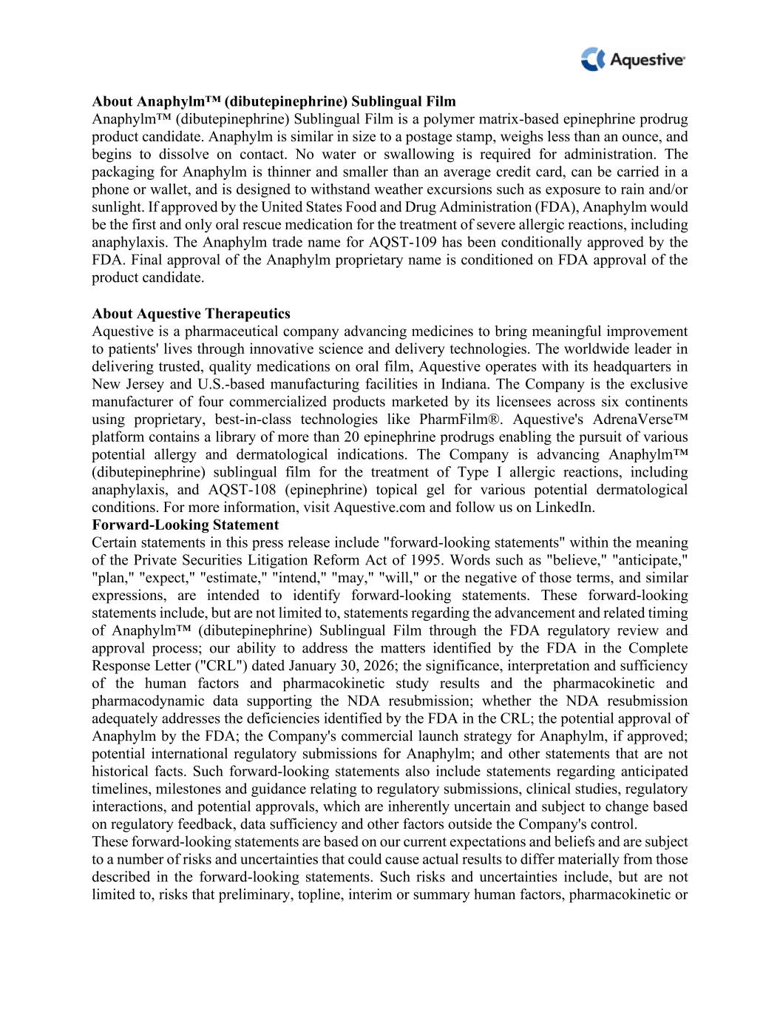
About Anaphylm™ (dibutepinephrine) Sublingual Film Anaphylm™ (dibutepinephrine) Sublingual Film is a polymer matrix-based epinephrine prodrug product candidate. Anaphylm is similar in size to a postage stamp, weighs less than an ounce, and begins to dissolve on contact. No water or swallowing is required for administration. The packaging for Anaphylm is thinner and smaller than an average credit card, can be carried in a phone or wallet, and is designed to withstand weather excursions such as exposure to rain and/or sunlight. If approved by the United States Food and Drug Administration (FDA), Anaphylm would be the first and only oral rescue medication for the treatment of severe allergic reactions, including anaphylaxis. The Anaphylm trade name for AQST-109 has been conditionally approved by the FDA. Final approval of the Anaphylm proprietary name is conditioned on FDA approval of the product candidate. About Aquestive Therapeutics Aquestive is a pharmaceutical company advancing medicines to bring meaningful improvement to patients' lives through innovative science and delivery technologies. The worldwide leader in delivering trusted, quality medications on oral film, Aquestive operates with its headquarters in New Jersey and U.S.-based manufacturing facilities in Indiana. The Company is the exclusive manufacturer of four commercialized products marketed by its licensees across six continents using proprietary, best-in-class technologies like PharmFilm®. Aquestive's AdrenaVerse™ platform contains a library of more than 20 epinephrine prodrugs enabling the pursuit of various potential allergy and dermatological indications. The Company is advancing Anaphylm™ (dibutepinephrine) sublingual film for the treatment of Type I allergic reactions, including anaphylaxis, and AQST-108 (epinephrine) topical gel for various potential dermatological conditions. For more information, visit Aquestive.com and follow us on LinkedIn. Forward-Looking Statement Certain statements in this press release include "forward-looking statements" within the meaning of the Private Securities Litigation Reform Act of 1995. Words such as "believe," "anticipate," "plan," "expect," "estimate," "intend," "may," "will," or the negative of those terms, and similar expressions, are intended to identify forward-looking statements. These forward-looking statements include, but are not limited to, statements regarding the advancement and related timing of Anaphylm™ (dibutepinephrine) Sublingual Film through the FDA regulatory review and approval process; our ability to address the matters identified by the FDA in the Complete Response Letter ("CRL") dated January 30, 2026; the significance, interpretation and sufficiency of the human factors and pharmacokinetic study results and the pharmacokinetic and pharmacodynamic data supporting the NDA resubmission; whether the NDA resubmission adequately addresses the deficiencies identified by the FDA in the CRL; the potential approval of Anaphylm by the FDA; the Company's commercial launch strategy for Anaphylm, if approved; potential international regulatory submissions for Anaphylm; and other statements that are not historical facts. Such forward-looking statements also include statements regarding anticipated timelines, milestones and guidance relating to regulatory submissions, clinical studies, regulatory interactions, and potential approvals, which are inherently uncertain and subject to change based on regulatory feedback, data sufficiency and other factors outside the Company's control. These forward-looking statements are based on our current expectations and beliefs and are subject to a number of risks and uncertainties that could cause actual results to differ materially from those described in the forward-looking statements. Such risks and uncertainties include, but are not limited to, risks that preliminary, topline, interim or summary human factors, pharmacokinetic or

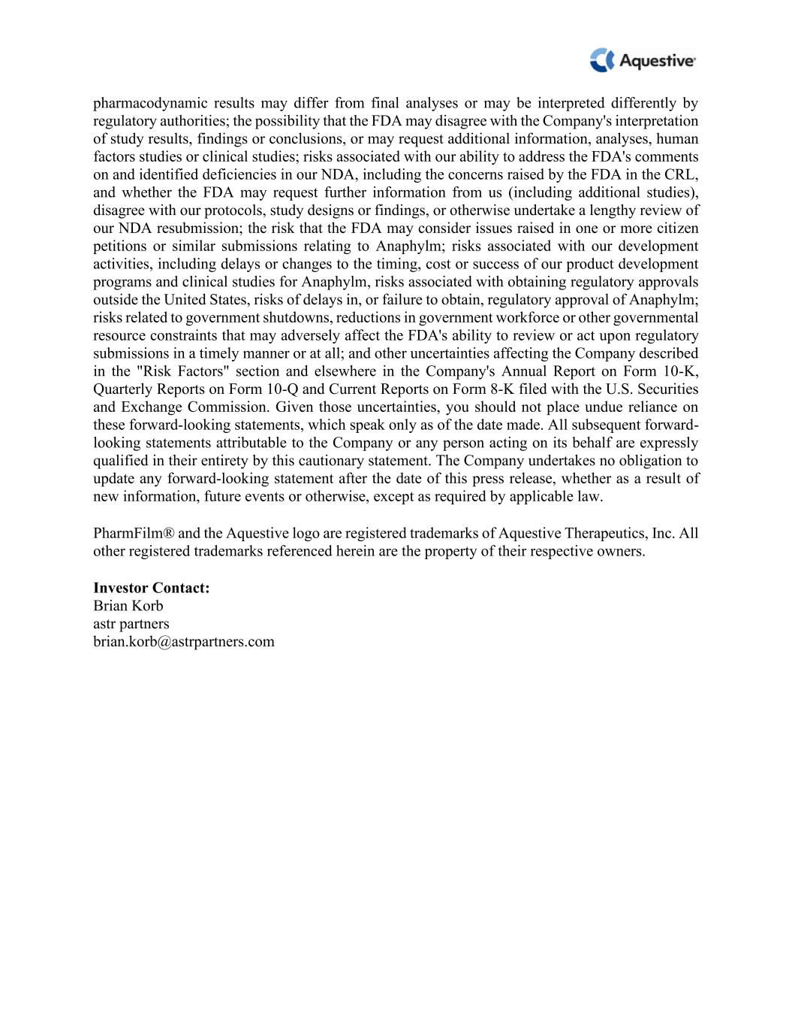
pharmacodynamic results may differ from final analyses or may be interpreted differently by regulatory authorities; the possibility that the FDA may disagree with the Company's interpretation of study results, findings or conclusions, or may request additional information, analyses, human factors studies or clinical studies; risks associated with our ability to address the FDA's comments on and identified deficiencies in our NDA, including the concerns raised by the FDA in the CRL, and whether the FDA may request further information from us (including additional studies), disagree with our protocols, study designs or findings, or otherwise undertake a lengthy review of our NDA resubmission; the risk that the FDA may consider issues raised in one or more citizen petitions or similar submissions relating to Anaphylm; risks associated with our development activities, including delays or changes to the timing, cost or success of our product development programs and clinical studies for Anaphylm, risks associated with obtaining regulatory approvals outside the United States, risks of delays in, or failure to obtain, regulatory approval of Anaphylm; risks related to government shutdowns, reductions in government workforce or other governmental resource constraints that may adversely affect the FDA's ability to review or act upon regulatory submissions in a timely manner or at all; and other uncertainties affecting the Company described in the "Risk Factors" section and elsewhere in the Company's Annual Report on Form 10-K, Quarterly Reports on Form 10-Q and Current Reports on Form 8-K filed with the U.S. Securities and Exchange Commission. Given those uncertainties, you should not place undue reliance on these forward-looking statements, which speak only as of the date made. All subsequent forward- looking statements attributable to the Company or any person acting on its behalf are expressly qualified in their entirety by this cautionary statement. The Company undertakes no obligation to update any forward-looking statement after the date of this press release, whether as a result of new information, future events or otherwise, except as required by applicable law. PharmFilm® and the Aquestive logo are registered trademarks of Aquestive Therapeutics, Inc. All other registered trademarks referenced herein are the property of their respective owners. Investor Contact: Brian Korb astr partners brian.korb@astrpartners.com

