UNITED STATES
SECURITIES AND EXCHANGE COMMISSION
Washington, DC 20549

FORM 8-K

CURRENT REPORT

PURSUANT TO SECTION 13 OR 15(d) OF THE
SECURITIES EXCHANGE ACT OF 1934

Date of Report (Date of earliest event reported): May 12, 2026
Aquestive Therapeutics, Inc.
(Exact name of Registrant as specified in its charter)
Delaware |  |  | 001-38599 |  |  | 82-3827296
(State or other jurisdiction of incorporation) |  |  | (Commission File Number) |  |  | (I.R.S. Employer Identification No.)

30 Technology Drive
Warren, NJ 07059
(908) 941-1900
(Address, Including Zip Code, and Telephone Number, Including Area Code, of Registrant’s Principal Executive Offices)

Not Applicable
(Former name or former address, if changed since last report)

________________________________________________________________________________________________________________________
Check the appropriate box below if the Form 8-K filing is intended to simultaneously satisfy the filing obligation of the registrant under any of the following provisions:
☐ |  |  | Written communications pursuant to Rule 425 under the Securities Act (17 CFR 230.425)
☐ |  |  | Soliciting material pursuant to Rule 14a-12 under the Exchange Act (17 CFR 240.14a-12)
☐ |  |  | Pre-commencement communications pursuant to Rule 14d-2(b) under the Exchange Act (17 CFR 240.14d-2(b))
☐ |  |  | Pre-commencement communications pursuant to Rule 13e-4(c) under the Exchange Act (17 CFR 240.13e-4(c))

Securities registered pursuant to Section 12(b) of the Act:

Title of each class |  |  | Trading Symbol(s) |  |  | Name of each exchange on which  registered
Common Stock, par value $0.001 per share |  |  | AQST |  |  | Nasdaq Global Market

Indicate by check mark whether the registrant is an emerging growth company as defined in Rule 405 of the Securities Act of 1933 (§230.405 of this chapter) or Rule 12b-2 of the Securities Exchange Act of 1934 (§240.12b-2 of this chapter).
Emerging growth company |  |  | ☐
If an emerging growth company, indicate by check mark if the registrant has elected not to use the extended transition period for complying with any new or revised financial accounting standards provided pursuant to Section 13(a) of the Exchange Act. ☐

Item 1.01 |  |  | Entry into a Material Definitive Agreement.
Credit Agreement and Guaranty
On May 12, 2026 (the “Effective Date”), Aquestive Therapeutics, Inc. (the “Company”) entered into a five-year term loan facility of up to $150.0 million (the “Term Loan”), consisting of a term loan in an aggregate principal amount of $55.0 million that was funded on the Effective Date (the “Tranche A Term Loan”), a term loan in an aggregate principal amount of $20.0 million available subject to certain terms and conditions (the “Tranche B Term Loan”), a term loan in an aggregate principal amount of $25.0 million available subject to certain terms and conditions (the “Tranche C Term Loan”), and a term loan advance available upon the mutual consent of the Lenders and subject to certain terms and conditions in an aggregate principal amount of up to $50.0 million (the “Tranche D Term Loan”), pursuant to a credit agreement and guaranty, dated as of the Effective Date (the “Credit Agreement”), with Oaktree Fund Administration, LLC, a Delaware limited liability company, as administrative agent (in such capacity, the “Agent”), and certain funds managed by each of Oaktree Capital Management, L.P. (“Oaktree”) party thereto (collectively, the “Lenders”). A portion of the proceeds of the Tranche A Term Loan was used by the Company on the Effective Date to repay in full the existing outstanding indebtedness owed by the Company to the noteholders under an indenture with U.S. Bank Trust Company, National Association (the “Indenture”). The remaining proceeds of the Tranche A Term Loan and proceeds of any additional tranches drawn will be used for general corporate and working capital purposes.
The Tranche B Term Loan may be borrowed by the Company, subject to customary terms and conditions, after the date the Company receives marketing approval from the United States Food and Drug Administration for its New Drug Application for Anaphylm™ (the “FDA Approval”) provided that such approval is received prior to June 30, 2027. The Tranche C Term Loan will be available, subject to customary terms and conditions (including the prior borrowing of the Tranche B Term Loan), during the period commencing following the date the Agent receives certification of the Company’s achievement of a specified net sales milestone by December 31, 2027. The Tranche D Term Loan will be made available upon the mutual consent of the Lenders and the Company.
The Company is required to maintain a minimum amount of unrestricted cash and/or permitted cash equivalent investments in controlled accounts, free and clear of all liens (subject to customary exclusions) equal to (a) $27,500,000 prior to the funding of the Tranche B Term Loan and (b) $15,000,000 after the funding of the Tranche B Term Loans. This amount may be further reduced on a dollar-for-dollar basis in an amount equal to prepayments required by the Agent if the Company fails to receive FDA Approval by December 31, 2027. In addition the Company is required to maintain a minimum amount of net sales (“Minimum Net Sales Covenant”) in the amounts agreed to and specified on the schedules to the Credit Agreement, which is tested only after the making of the Tranche B Term Loan. The Minimum Net Sales Covenant is not tested when (x) cash and/or permitted cash equivalent investments in controlled accounts, free and clear of all liens (subject to customary exclusions) is greater than 1.50x the outstanding principal of the Term Loans and (y) the market capitalization as of the last trading day of the applicable fiscal quarter is at least $500,000,000.
Each advance under the Credit Agreement accrues interest at a per annum rate equal to the three-month SOFR (with a floor of 2.75%) plus 6.25%, which interest rate will be reduced permanently by a per annum percentage equal to 0.25% with respect to the Tranche B Term Loans. The Company has the option during the first two years of the Term Loan to pay up to 200 basis points of interest thereon in kind. The Term Loan provides for interest-only payments on a quarterly basis until maturity. During the existence of an event of default, the applicable interest rate shall increase by 2.00% per annum (i) automatically during a payment or bankruptcy event of default or (ii) upon the request of the Majority Lenders (as defined in the Credit Agreement) during any other event of default. Amounts outstanding during an event of default are due upon demand from the Administrative Agent or the Majority Lenders.
Upon any repayment (whether at maturity, upon acceleration or by prepayment or otherwise), the Company shall pay an exit fee to the Lenders ranging from 1.00% to 2.00% depending on the date of such repayment (the “Exit Fee”). The Exit Fee is subject to a reduction specified in the Credit Agreement (x) if the Company achieves a specified net sales milestone by June 30, 2029 or if a payment is mandatory as a result of the Company failing to receive FDA Approval by December 31, 2027 or (y) if the applicable repayment is made in connection with a change of control on or prior to the second anniversary of the Effective Date.
The Company may voluntarily prepay the Term Loan in full or in part provided that the Company pays on the date of such prepayment (a) all outstanding principal to be prepaid plus accrued and unpaid interest, (b) a yield protection premium, which, (i) prior to and including the first anniversary of the Effective Date, includes a make-whole fee (as

calculated in the Credit Agreement) with respect to the interest that would have accrued on the aggregate principal amount of the Term Loans so prepaid up to (but not including) the first anniversary of the Effective Date and (ii) after the first anniversary of the Effective Date, a premium ranging from 5.00% to 1.00% depending on the date of such repayment (the “Prepayment Premium”). The Prepayment Premium is subject to a reduction specified in the Credit Agreement (x) if the Company achieves a specified net sales milestone by June 30, 2029 or if a payment is mandatory as a result of the Company failing to receive FDA Approval by December 31, 2027 or (y) if the applicable prepayment is made in connection with a change of control on or prior to the second anniversary of the Effective Date. The Prepayment Premium shall be 0% if paid after the fourth anniversary of the Effective Date.
The Company is required to maintain a minimum amount of unrestricted cash and/or permitted cash equivalent investments in controlled accounts, as set forth in the Credit Agreement, which amount lowers after the funding of the Tranche B Term Loans and if FDA approval is not received by December 31, 2027. In addition the Company is required to achieve a minimum amount of net sales (“Minimum Net Sales Covenant”) in the amounts agreed to and specified on the schedules to the Credit Agreement, which is tested only after the making of the Tranche B Term Loan. The Minimum Net Sales Covenant is not tested if the Company maintains specified cash levels or if it achieves a specified the market capitalization.
The Term Loan will be secured by a lien set forth in a security agreement (the “Security Agreement”) on substantially all of the assets of the Company, including intellectual property, subject to the rights of the Purchaser under the purchase and sale agreement dated August 13, 2025, as amended (the “Purchase Agreement”) with funds managed by RTW Investments LP (the “Purchaser”), and other customary exclusions and exceptions. The Company, the Agent and the Purchaser have entered into an intercreditor agreement governing the relative rights and priorities of the Lenders and the Purchaser with respect to the collateral and other assets of the Company, including with respect to liens, enforcement actions, and the application of proceeds.
The Credit Agreement contains customary representations and warranties, covenants and events of default, including two financial covenants: (i) commencing on the Effective Date, the Company is required to maintain certain levels of cash and cash equivalents and (ii) commencing with the later of (x) the first full fiscal quarter ending after the funding of the Tranche B Term Loan and (y) the four fiscal quarter period of the Company ending on December 31, 2027, the Company is required to maintain specified quarterly trailing twelve-month net sales from the sale of Anaphylm and other products developed for the treatment of type I allergic reactions in the United States; provided that such net sales covenant will be waived at any time (x) the Company’s balance of unrestricted cash (subject to certain permitted liens) and cash equivalents on the last business day of the applicable fiscal quarter is equal to or greater than 150% of the aggregate principal amount of outstanding Term Loans on such date or (y) the 30-day average of the Company’s market capitalization as of the last trading day of such fiscal quarter is at least $500 million. As contemplated above, the Company may be required, at the option of the Lenders, to pay down a portion of the loan balance if Anaphylm has not been approved by the FDA by December 31, 2027. The Credit Agreement also contains other customary provisions, such as expense reimbursement, as well as indemnification rights for the benefit of the Agent and the Lenders.
The Company agreed to issue warrants to the Lenders as more fully-described in Item 3.02 below.
The descriptions of the Credit Agreement and the Security Agreement contained herein are qualified in their entirety by reference to the those documents, which will be filed in a subsequent report under the Securities Exchange Act of 1934, as amended (the “Exchange Act”).
Item 1.02 |  |  | Termination of a Material Definitive Agreement.
In connection with the entry into the Credit Agreement, on the Initial Funding Date, the Company will be obligated to repay in full all outstanding indebtedness and terminate all commitments under the Indenture, the material terms of which have been disclosed previously. The aggregate principal amount of the notes outstanding under the Indenture is $45.0 million as of the Effective Date. The security interests in the Company’s assets under the Indenture will be terminated in connection with the discharge of the indebtedness thereunder. The Company did not incur any penalties, but did incur a prepayment fee and a final payment fee, as a result of the foregoing.

Item 2.02 |  |  | Results of Operations and Financial Condition.
On May 13, 2026, Aquestive Therapeutics, Inc. (the “Company”) issued a press release announcing its reported financial results for the first quarter ended March 31, 2026 and provided an update on recent developments in its business. A copy of the Company’s press release and the attached financial schedules are attached as Exhibit 99.1 to this Current Report On Form 8-K and incorporated in this Item 2.02 by reference.
The information in this Item 2.02 (including Exhibit 99.1) shall not be deemed to be “filed” for purposes of, or otherwise subject to the liabilities of Section 18 of the Exchange Act,nor shall it be deemed to be incorporated by reference in any filing under the Securities Act of 1933, as amended (the “Securities Act”), or the Exchange Act, except as shall be expressly set forth by specific reference in any such filing.
Item 2.03 |  |  | Creation of a Direct Financial Obligation or an Obligation under an Off-Balance Sheet Arrangement of the Registrant.
The information required by this Item 2.03 relating to the Credit Agreement is set forth under Item 1.01 of this Current Report on Form 8-K and is incorporated by reference herein.
Item 3.02 |  |  | Unregistered Sales of Equity Securities.
In connection with entering into the Credit Agreement, the Company entered into a warrant issuance agreement (the “Warrant Issuance Agreement”) pursuant to which the Company agreed to issue warrants (the “Warrants”) to purchase shares of its common stock (the “Warrant Shares”) in amounts equal to (i) (x) 1.75% of the aggregate principal amount of the Tranche A Term Loan (y) divided by the volume weighted average price for the 30 trading days prior to the Effective Date (the “Tranche A VWAP”) and (ii) for the Tranche B and Tranche C draw-downs, (x) 1.75% of the aggregate principal amount of the drawn-down tranche (y) divided by the lower of the (1) the Tranche A VWAP and (2) the VWAP for the 30 days prior to the funding of such tranche (the “Subsequent Tranche VWAP”). The exercise price of the warrants will be the Tranche A VWAP for the Tranche A Warrants and the lower of (1) the Tranche A VWAP for the Tranche A Warrants and (2) the Subsequent Tranche VWAP for the subsequent tranche draw-downs, and the warrants will have a term of five years from their initial issuance. The Company has agreed to register the Warrant Shares on the terms set forth in the Warrant Issuance Agreement.
The Warrants and the Warrant Shares issuable upon exercise thereof were offered and sold in reliance upon the exemption from registration provided by Section 4(a)(2) of the Securities Act of 1933, as amended (the “Securities Act”), as a transaction not involving a public offering. The descriptions of the Warrant Issuance Agreement and the Warrant contained herein are qualified in their entirety by reference to the those documents, which will be filed in a subsequent report under the Exchange Act.
Item 7.01 |  |  | Regulation FD Disclosure.
On May 12, 2026, the Company issued a Press Release announcing the refinancing of its existing debt facility with a new $150 million debt facility with funds managed by Oaktree, as described above. A copy of the press release is attached as Exhibit 99.2 to the Current Report and incorporated in this item 7.01 by reference.
The Company is furnishing this Current Report on Form 8-K in connection with the disclosure of information, in the form of a investor presentation, to be given at meetings with institutional investors, analysts and others. This information may be amended or updated at any time and from time to time through another Current Report on Form 8-K, a later Company filing or other means. A copy of the Company’s investor presentation is attached hereto as Exhibit 99.3 to this Current Report on Form 8-K and incorporated into this Item 7.01 by reference. The investor presentation is available on the Events and Presentations page in the Investors section of the Company’s website located at www.aquestive.com, although the Company reserves the right to discontinue that availability at any time.
The information in this Item 7.01 (including Exhibits 99.2 and 99.3) shall not be deemed to be “filed” for purposes of, or otherwise subject to the liabilities of Section 18 of the Exchange Act, nor shall it be deemed to be incorporated by reference in any filing under the Securities Act or the Exchange Act, except as shall be expressly set forth by specific reference in any such filing.

Item 9.01 |  |  | Financial Statements and Exhibits.

(d) Exhibits.

Exhibit Number |  |  |  |  |  | Description
99.1 |  |  |  |  |  | Press Release, dated May 13, 2026, announcing the Company’s reported financial results for the first quarter ended March 31, 2026 and providing an update on recent developments in its business.
99.2 |  |  |  |  |  | Aquestive Therapeutics, Inc. press release dated May 12, 2026.
99.3 |  |  |  |  |  | Aquestive Therapeutics, Inc. Q1 Earnings Supplemental Materials dated May 13, 2026.
104 |  |  |  |  |  | Cover Page Interaction Data File (embedded within the Inline XBRL document)

SIGNATURE

Pursuant to the requirements of the Securities Exchange Act of 1934, as amended, the Registrant has duly caused this report to be signed on its behalf by the undersigned hereunto duly authorized.

Dated: May 13, 2026 |  |  | Aquestive Therapeutics, Inc.
 |  |  | By: |  |  | /s/ A. Ernest Toth, Jr
 |  |  |  |  |  | Name: A. Ernest Toth, Jr.
 |  |  |  |  |  | Title: Chief Financial Officer

Exhibit 99.1



Aquestive Therapeutics Reports First Quarter 2026 Financial Results
and Provides Business Update

•Reaffirms guidance to resubmit Anaphylm™ (dibutepinephrine) sublingual film NDA in Q3 2026
•Affirms existing clinical data is sufficient for submitting regulatory applications in Canada, European Union, and the United Kingdom
•Completed AQST-108 phase 1 study in subjects with androgenic alopecia with no safety issues observed
•Entered into a $150 million debt facility with Oaktree Capital Management, L.P.
•Company to host investor call on May 14, 2026, at 8:00am ET

Warren, N.J., May 13, 2026 – Aquestive Therapeutics, Inc. (NASDAQ: AQST) ("Aquestive" or the "Company"), a pharmaceutical company advancing medicines to bring meaningful improvement to patients' lives through innovative science and delivery technologies, today announced financial results for the first quarter ended March 31, 2026, and provided a strategic business update.
“We made rapid and meaningful progress in the first quarter,” said Daniel Barber, President and Chief Executive Officer of Aquestive. “We successfully completed our Type A meeting with the FDA, aligning on the study designs needed to support resubmission of the Anaphylm NDA, which we continue to target for the third quarter of 2026. In parallel, our commercial readiness efforts continue. We are making the most of this time by driving awareness of Anaphylm among healthcare professionals. We are building momentum for our AdrenaVerse™ platform and are excited by the recent results from our AQST-108 phase 1 study. Financially, we have taken steps to further strengthen our balance sheet and extend our cash runway, and we believe we are well-positioned to execute on our key objectives in 2026 and beyond.”

Anaphylm™ (dibutepinephrine) sublingual film
Anaphylm is a no-needle, no-device epinephrine product candidate being developed for the treatment of Type I allergic reactions, including anaphylaxis. The Company believes Anaphylm has the potential to be the first and only non-invasive, orally delivered epinephrine product, if approved by the U.S. Food and Drug Administration (FDA).
In the first quarter of 2026, Aquestive successfully completed its Type A meeting with the FDA, aligning on the study designs for both the human factors validation and pharmacokinetics (PK) studies required to address the deficiencies identified in the Complete Response Letter (CRL) from the FDA dated January 30, 2026. The Company reaffirms its guidance to resubmit the Anaphylm New Drug Application (NDA) in the third quarter of 2026, subject to completion of the required studies and expected FDA response timelines. As previously disclosed, the CRL did not identify any chemistry, manufacturing, or controls (CMC) deficiencies, and clinical results supporting comparability to auto-injectors were not questioned. The Company will request an accelerated review upon resubmission, though no expedited review can be guaranteed.
In February 2026, Aquestive presented data at the American Academy of Allergy, Asthma & Immunology (AAAAI) Annual Meeting. Data presented demonstrated that Anaphylm achieved clinically relevant epinephrine plasma concentrations without the diastolic blood pressure dip associated with auto-injector administration, providing further clinical differentiation. Feedback from key opinion leaders (KOLs) and the broader allergy community continues to be positive, and physician enthusiasm for a non-invasive, non-device epinephrine treatment option remains strong.

Aquestive continues to advance its global regulatory strategy for Anaphylm. The Company remains on track to submit regulatory applications in Canada, the European Union and United Kingdom by utilizing its existing clinical data. The Company recently completed a meeting with the Medicines and Healthcare products Agency, which is the health regulatory agency for the United Kingdom. In addition, the Company submitted its initial Pediatric Investigation Plan (PIP) to the European Medicines Agency (EMA), an important step in preparing for full submission of the Company's Market Authorization Application for the European Union.
Aquestive has advanced its commercial infrastructure in preparation for a potential Anaphylm approval. The Company has expanded its planned field force to approximately 75 sales representatives - a 50% increase from its prior guidance of 50 representatives - better positioning the Company to reach patients and healthcare providers across the country. Current priorities include continued engagement with healthcare professionals through our recently expanded Medical Affairs team to increase Anaphylm awareness, market access preparation ahead of a potential approval, and active collaboration with leading patient advocacy organizations in the allergy community.

AQST-108 (epinephrine) topical gel
AQST-108 is a topical epinephrine prodrug gel product candidate being evaluated for potential dermatologic indications. Aquestive made meaningful clinical development progress with AQST-108 in the first quarter of 2026. The Company recently completed its second phase 1 clinical trial, which was designed to further characterize the safety, tolerability, and pharmacologic profile of the topical epinephrine prodrug gel. There were no drug related adverse events observed in the study and the data did not indicate signs of systemic absorption. In addition, Aquestive identified a biomarker signal through the suppression of the cytokine thymic stromal lymphopoietin (TSLP) when compared to placebo. The TSLP signaling pathway involves the activation of Janus Kinase (JAK) 1 and JAK2. This signal will be explored further in upcoming studies.
Building on the IND opening and supportive FDA feedback received in December 2025, Aquestive continues to believe AQST-108 has potential application across a variety of dermatological conditions, including alopecia areata, atopic dermatitis, rosacea, and psoriasis. Aquestive plans to further study AQST-108 by utilizing an atopic dermatitis study design in the upcoming months. This disciplined, data-driven approach is consistent with the Company’s strategy of maximizing the value of the AdrenaVerse™ platform while maintaining focus on the Anaphylm NDA resubmission.
Alopecia areata remains a significant unmet need, affecting an estimated 6.7 million people in the United States, with 43% classified as severe. JAK inhibitors, the current standard of care, are systemic agents carrying black box warnings in a market currently valued at over $1 billion. AQST-108’s topical, localized delivery profile may provide a differentiated option for these patients, if clinical development is successful.
Atopic dermatitis affects approximately 7%–10% of U.S. adults and 10–20% of children, making it one of the most common chronic inflammatory skin diseases in the U.S.
Aquestive’s AdrenaVerse platform comprises approximately 20 epinephrine prodrugs designed to enable control of absorption and conversion rates across a range of dosage forms and delivery sites. The Company remains excited by the AdrenaVerse platform’s long-term potential to address multiple indications.

Debt Refinancing
Aquestive entered into a new $150 million debt facility with Oaktree Capital Management, L.P., a leading life sciences debt provider. Refinancing the Company's existing debt will save the Company $45 million in principal payments over the next three years. Further, this new debt facility provides the Company with improved interest rate terms and principal payments that will not begin until maturity in 2031. In addition to the $55.0 million provided at signing, Aquestive will have the ability to access $20 million of capital in the event of FDA approval of Anaphylm. A third tranche of $25.0 million will be available upon the achievement of specified sales milestones, with the final tranche of up to $50.0 million available with the mutual consent of the lenders and the Company. This refinancing allows the Company to achieve one of the pre-approval requirements for Aquestive's $75 million strategic funding agreement with funds managed by RTW Investments, LP. With the new debt facility and the strategic RTW funding agreement, the Company expects to have $150 million in cash and cash equivalents for the launch of Anaphylm, if approved by the FDA in 2027.

Commercial Collaborations and Other
Aquestive continues to manufacture products for the licensing and supply collaborations that it has established. The Company manufactured approximately 33 million doses in the first quarter 2026, compared to approximately 27 million doses in the first quarter 2025. The Company continues to manufacture Indivior’s Suboxone® Sublingual Film product and the Company's other global collaborations, including Sympazan® (clobazam) oral film product for Cosette Pharmaceuticals, Inc. in the U.S., Ondif® (Ondansetron) oral film product for Hypera Pharma in Brazil and Emylif® (riluzole) oral film product by Zambon S.p.A in Europe. Aquestive’s manufacturing business remains steady.
On April 8, 2026, Cosette Pharmaceuticals, Inc. ("Cosette"), a United States-based, branded specialty pharmaceutical company, acquired the rights to Sympazan for the treatment of seizures associated with Lennox-Gastaut Syndrome in patients two years of age and older, from Assertio Holdings, Inc. ("Assertio"), including Assertio's rights under our License Agreement for Sympazan with Otter Pharmaceuticals, LLC, a subsidiary of Assertio (the "Assertio License Agreement"). Cosette will continue to purchase Sympazan® (clobazam) Oral Film Product and pay royalties and milestones to Aquestive under the Assertio License Agreement.
The Company, being a U.S. based manufacturer with intellectual property domiciled in the U.S., confirms that its supply chain currently remains largely unaffected by both implemented and proposed government tariffs, providing continued reliability and stability in production and global distribution for the near term.
Sales of royalty-based products, inclusive of Sympazan, contributed to the Company's revenue in the first quarter of 2025.
Libervant® (diazepam) buccal film remains tentatively approved until January 2027, the scheduled date of expiration of U.S. market orphan drug exclusivity of an FDA approved product of another company. Aquestive continues to believe that expanding patient access to non-invasive seizure rescue therapies is vital and remains committed to putting Libervant in the hands of patients when granted full approval for U.S. market access by the FDA.

First Quarter 2026 Financials
Total revenues increased to $14.4 million in the first quarter 2026 from $8.7 million in the first quarter 2025. The 66% increase was primarily driven by increases in license and royalty revenue and increases in manufacture and supply revenue.
License and royalty revenue increased to $5.4 million in the first quarter 2026 from $0.8 million in the first quarter 2025, primarily due to royalty revenue from Zevra.
Manufacture and supply revenue increased to $8.8 million in the first quarter 2026 from $7.2 million in the first quarter 2025, primarily due to increases in Suboxone revenues, partially offset by lower Ondif revenues.
Research and development expenses decreased to $4.2 million in the first quarter 2026 from $5.4 million in the first quarter 2025. The decrease in research and development expenses was primarily due to lower clinical trial costs associated with the Anaphylm development program, partially offset by increases in R&D personnel costs.
Selling, general and administrative expenses decreased to $11.0 million in the first quarter of 2026 from $19.1 million in the first quarter of 2025. The decrease primarily represents the one-time Anaphylm PDUFA fee of $4.3 million in the prior year period, lower legal fees of approximately $3.4 million, lower commercial spending of approximately $2.0 million, and lower regulatory and licensing fees of approximately $0.5 million, partially offset by higher severance costs of approximately $0.6 million, higher personnel costs of approximately $0.5 million and higher share-based compensation expenses of approximately $0.5 million.
Aquestive’s net loss for the first quarter 2026 was $8.1 million, or $0.07 for both basic and diluted loss per share, compared to the net loss in the first quarter 2025 of $22.9 million, or $0.24 for both basic and diluted loss per share. The decrease in net loss was primarily driven by decreases in selling, general and administrative expenses and research and development expenses and increases in revenues, partially offset by decreases in interest income and other income, net.

Non-GAAP adjusted EBITDA loss was $1.7 million in the first quarter 2026, compared to non-GAAP adjusted EBITDA loss of $17.6 million in the first quarter 2025.
Cash and cash equivalents were $110.7 million as of March 31, 2026.

2026 Outlook
Aquestive's full-year 2026 financial guidance remains unchanged.

The Company expects:
 |  |  |  | Guidance
Total revenue (in millions) |  |  |  | $46 to $50
Non-GAAP adjusted EBITDA loss (in millions) |  |  |  | $35 to $30

Tomorrow’s Conference Call and Webcast Reminder
The Company will host a conference call at 8:00 a.m. ET on Thursday, May 14, 2026.

In order to participate, please register in advance here to obtain a local or toll-free phone number and your personal pin.

A live webcast of the call will be available on Aquestive’s website at: First Quarter 2026 Earnings Call.

About Anaphylm™
Anaphylm™ (dibutepinephrine) sublingual film is a polymer matrix-based epinephrine prodrug product. Anaphylm is similar in size to a postage stamp, weighs less than an ounce, and begins to dissolve on contact. No water or swallowing is required for administration. The primary packaging for Anaphylm is thinner and smaller than an average credit card, can be carried in a pocket, and is designed to withstand weather excursions such as exposure to rain and/or sunlight. The Anaphylm trade name for AQST-109 has been conditionally approved by the FDA. Final approval of the Anaphylm proprietary name is conditioned on FDA approval of the product candidate.
About AQST-108
AQST-108 (epinephrine) topical gel is a topically delivered adrenergic agonist prodrug product candidate. Aquestive completed a first-in-human study for AQST-108 without any serious or topical adverse events observed. AQST-108 is based on Aquestive’s AdrenaVerse™ platform which contains a library of over twenty epinephrine prodrug products intended to control absorption and conversion rates across a variety of possible dosage forms and delivery sites.
About Libervant®
Libervant® (diazepam) buccal film is a buccally, or inside of the cheek, administered film formulation of diazepam, a benzodiazepine intended for the acute treatment of intermittent, stereotypic episodes of frequent seizure activity (i.e., seizure clusters, acute repetitive seizures) that are distinct from a patient’s usual seizure pattern in patients with epilepsy. Aquestive developed Libervant as an alternative to the device-based products currently available for patients with refractory epilepsy, including a rectal gel and nasal spray products. The FDA approval for U.S. market access received in April 2024 for Libervant was for these epilepsy patients between two and five years of age. However, the FDA converted this approval to a "tentative approval" due to a subsequent court ruling finding that the FDA did not have authority to approve Libervant for U.S. market access for patients aged between two and five years due to the existing orphan drug market exclusivity granted by the FDA to an intranasal spray of another company. The FDA granted tentative approval in August 2022 for Libervant for treatment of these epilepsy patients twelve years of age and older. U.S. market access for Libervant patients is currently subject to the expiration of the existing orphan drug market exclusivity of the previously FDA approved drug scheduled to occur in January 2027.

Important Safety Information
Do not give Libervant to your child between the ages of two and five if your child is allergic to diazepam or any of the ingredients in Libervant or has an eye problem called acute narrow angle glaucoma.

What is the most important information I should know about Libervant?

•Libervant is a benzodiazepine medicine. Taking benzodiazepines with opioid medicines, alcohol, or other central nervous system (CNS) depressants (including street drugs) can cause severe drowsiness, breathing problems (respiratory depression), coma, and death. Get emergency help right away if any of the following happens:
◦shallow or slowed breathing,
◦breathing stops (which may lead to the heart stopping),
◦excessive sleepiness (sedation).

Do not allow your child to drive a motor vehicle, operate heavy machinery, or ride a bicycle until you know how taking Libervant with opioids affects your child.
•Risk of abuse, misuse, and addiction. Libervant is used in children 2 to 5 years of age. The unapproved use of Libervant has a risk for abuse, misuse, and addiction, which can lead to overdose and serious side effects including coma and death.
•Serious side effects including coma and death have happened in people who have abused or misused benzodiazepines, including diazepam (the active ingredient in Libervant). These serious side effects may also include delirium, paranoia, suicidal thoughts or actions, seizures, and difficulty breathing. Call your child’s healthcare provider or go to the nearest hospital emergency room right away if you get any of these serious side effects.
◦Your child can develop an addiction even if your child takes Libervant as prescribed by your child’s healthcare provider.
◦Give Libervant exactly as your child’s healthcare provider prescribed.
◦Do not share Libervant with other people.
◦Keep Libervant in a safe place and away from children.
•Physical dependence and withdrawal reactions. Libervant is intended for use if needed in order to treat higher than usual seizure activity. Benzodiazepines, including Libervant, can cause physical dependence and withdrawal reactions, especially if used daily. Libervant is not intended for daily use.
◦Do not suddenly stop giving Libervant to your child without talking to your child’s healthcare provider. Stopping Libervant suddenly can cause serious and life-threatening side effects, including, unusual movements, responses, or expressions, seizures that will not stop (status epilepticus), sudden and severe mental or nervous system changes, depression, seeing or hearing things that others do not see or hear, homicidal thoughts, an extreme increase in activity or talking, losing touch with reality, and suicidal thoughts or actions. Call your child’s healthcare provider or go to the nearest hospital emergency room right away if your child gets any of these symptoms.
◦Some people who suddenly stop benzodiazepines have symptoms that can last for several weeks to more than 12 months including, anxiety, trouble remembering, learning, or concentrating, depression, problems sleeping, feeling like insects are crawling under your skin, weakness, shaking, muscle twitching, burning, or prickling feeling in your hands, arms, legs or feet, and ringing in your ears.
◦Physical dependence is not the same as drug addiction. Your child’s healthcare provider can tell you more about the differences between physical dependence and drug addiction.
•Do not give your child more Libervant than prescribed or give Libervant more often than prescribed.

Libervant can make your child sleepy or dizzy and can slow your child’s thinking and motor skills.

•Do not allow your child to drive a motor vehicle, operate machinery, or ride a bicycle until you know how Libervant affects your child.

•Do not give other drugs that may make your child sleepy or dizzy while taking Libervant without first talking to your child’s healthcare provider. When taken with drugs that cause sleepiness or dizziness, Libervant may make your child’s sleepiness or dizziness much worse.

Like other antiepileptic medicines, Libervant may cause suicidal thoughts or actions in a small number of people, about 1 in 500.

•Call a healthcare provider right away if your child has any of these symptoms, especially if they are new, worse, or worry you:
◦thoughts about suicide or dying
◦new or worse depression
◦feeling agitated or restless
◦trouble sleeping (insomnia)
◦acting aggressive, being angry or violent
◦other unusual changes in behavior or mood
◦attempts to commit suicide
◦new or worse anxiety or irritability
◦an extreme increase in activity and talking (mania)
◦new or worse panic attacks
◦acting on dangerous impulses
•Pay attention to any changes, especially sudden changes in mood, behaviors, thoughts, or feelings.
•Keep all follow-up visits with your child’s healthcare provider as scheduled.
•Call your child’s healthcare provider between visits as needed, especially if you are worried about symptoms. Suicidal thoughts or actions can be caused by things other than medicines. If your child has suicidal thoughts or actions, your child’s healthcare provider may check for other causes.

What are the possible side effects of Libervant?
•The most common side effects of Libervant are sleepiness and headache.
•These are not all the possible side effects of Libervant.
•Call your doctor for medical advice about side effects. You may report side effects to FDA at 1 800 FDA-1088.

For more information about Libervant, talk to your doctor, and see Product Information: Medication Guide and Instructions For Use.

About Aquestive Therapeutics, Inc.
Aquestive is a pharmaceutical company advancing medicines to bring meaningful improvement to patients' lives through innovative science and delivery technologies. The worldwide leader in delivering trusted, quality medications on oral film, Aquestive operates as both a developer of its own proprietary products and a Contract Development and Manufacturing Organization (CDMO) for licensees, with its headquarters in New Jersey and U.S.-based manufacturing facilities in Indiana. The Company is the exclusive manufacturer of four commercialized products marketed by its licensees across six continents using proprietary, best-in-class technologies like PharmFilm®. Aquestive's AdrenaVerse™ platform contains a library of more than 20 epinephrine prodrugs enabling the pursuit of various potential allergy and dermatological indications. The Company is advancing Anaphylm™ (dibutepinephrine) sublingual film for the treatment of severe allergic reactions, including anaphylaxis, and AQST-108 (epinephrine) topical gel for various potential dermatological conditions, including alopecia areata, atopic dermatitis and hypertrophic scars. For more information, visit Aquestive.com and follow us on LinkedIn.

Non-GAAP Financial Information
This press release and our webcast earnings call regarding our quarterly financial results contains financial measures that do not comply with U.S. generally accepted accounting principles (GAAP), such as non-GAAP adjusted EBITDA loss, non-GAAP adjusted EBITDA loss excluding adjusted R&D expenses, non-GAAP adjusted costs and expenses and other adjusted expense measures, because such measures exclude, as applicable, share-based compensation expense, interest expense, interest expense related to the sale of future revenue, interest income, depreciation, amortization, and income taxes.
Specifically, the Company adjusts net loss for certain non-cash expenses, including share-based compensation expenses; depreciation and amortization; and interest expense related to the sale of future revenue, interest income and other income, net and income taxes, with a result of adjusted EBITDA loss. Similarly, manufacture and supply expense, R&D expense, and selling, general and administrative expense were adjusted for certain non-cash expenses of share-based compensation expense and depreciation and amortization. Adjusted EBITDA loss and these non-GAAP expense categories are used as a supplement to the corresponding GAAP measures to provide additional insight regarding the Company’s ongoing operating performance.
These measures supplement the Company’s financial results prepared in accordance with GAAP. Aquestive management uses these measures to analyze its financial results, and its future manufacture and supply expenses, gross margins, R&D expense and selling, general and administrative expense and to help make managerial decisions. In management’s opinion, these non-GAAP measures provide added transparency into the operating performance of Aquestive and added insight into the effectiveness of our operating strategies and actions. The Company may provide one or more revenue measures adjusted for certain discrete items, such as fees collected on certain licensed products, in order to provide investors added insight into our revenue stream and breakdown, along with providing our GAAP revenue. Such measures are intended to supplement, not act as substitutes for, comparable GAAP measures and should not be read as a measure of liquidity for Aquestive. Adjusted EBITDA loss and the other non-GAAP measures are also likely calculated in a way that is not comparable to similarly titled measures reported by other companies.
Non-GAAP Outlook
In providing the outlook for non-GAAP adjusted EBITDA and non-GAAP gross margin, we exclude certain items which are otherwise included in determining the comparable GAAP financial measures. In order to inform our outlook measures of non-GAAP adjusted EBITDA and non-GAAP gross margin, a description of the adjustments which have been applicable in determining non-GAAP Adjusted EBITDA and non-GAAP gross margin for these periods are reflected in the tables below. In providing outlook for non-GAAP gross margin, the Company adjusts for non-cash share-based compensation expense and depreciation and amortization. The Company is providing such outlook only on a non-GAAP basis because the Company is unable to predict with reasonable certainty the totality or ultimate outcome or occurrence of these adjustments for the forward-looking period such as share-based compensation expense, income tax, amortization, and certain other adjusted items, which can be dependent on future events that may not be reliably predicted. Based on past reported results, where one or more of these items have been applicable, such excluded items could be material, individually or in the aggregate, to reported results.

Forward-Looking Statement
Certain statements in this press release include “forward-looking statements” within the meaning of the Private Securities Litigation Reform Act of 1995. Words such as “believe,” “anticipate,” “plan,” “expect,” “estimate,” “intend,” “may,” “will,” or the negative of those terms, and similar expressions, are intended to identify forward-looking statements. These forward-looking statements include, but are not limited to, statements regarding the advancement and related timing of our product candidate Anaphylm™ (dibutepinephrine) sublingual film through clinical development and approval by the FDA, including our ability to address the concerns raised by the FDA in the CRL dated January 30, 2026 and the Type A meeting with the FDA, and the timing of our resubmission and FDA review of the NDA; the advancement and related timing of potential international regulatory filings and marketing authorizations for Anaphylm outside of the U.S.; that Anaphylm will be the first and only oral administration of epinephrine, if Anaphylm is approved by the FDA; the advancement, growth and related timing of our AdrenaVerse™ pipeline epinephrine prodrugs, including AQST-108 (epinephrine) topical gel, through clinical development and the FDA regulatory approval process, including with respect to the design and timing of clinical studies, including those necessary to support the targeted indication of alopecia areata, and potential other treatment indications for AQST-108; market access for Libervant® (diazepam) buccal film for epilepsy patients experiencing acute repetitive seizures (ARS) upon expiration of orphan drug market exclusivity of an approved FDA product of another company; the future commercial opportunity of Anaphylm, Libervant and AQST-108 should these product candidates be approved by the FDA; the potential benefits our product candidates could bring to patients, including with respect to Anaphylm, Libervant and AQST-108, if these product candidates are approved by the FDA, and acceptance by patients, prescribers and payors of our product candidates as an alternative to existing standards of care for the targeted medical indication of these product candidates; that the Company is sufficiently capitalized with sufficient cash in 2026 to perform the necessary clinical work and provide the additional information required to address the concerns of the FDA outlined in the CRL and Type A meeting; that our supply chain is largely unaffected by implemented and proposed government tariffs and will be reliable and stable in production and global distribution for the near term; our cash requirements, cash funding and cash burn; short-term and longer term liquidity, including access to additional funds if Anaphylm is approved by the FDA, and the ability to fund our business operations and key objectives in 2026 and beyond, including the launch of Anaphylm, if approved by the FDA; our growth and future financial and operating results and financial position, including with respect to our 2026 financial outlook; and business strategies, market opportunities, and other statements that are not historical facts. Such forward-looking statements also include statements regarding anticipated timelines, milestones, and guidance relating to regulatory submissions, clinical studies, regulatory interactions, and potential approvals, which are inherently uncertain and subject to change based on regulatory feedback, protocol alignment, data sufficiency, and other factors outside the Company’s control.
These forward-looking statements are based on our current expectations and beliefs and are subject to a number of risks and uncertainties that could cause actual results to differ materially from those described in the forward-looking statements. Such risks and uncertainties include, but are not limited to, risks associated with our development work, including any delays or changes to the timing, cost and success of our product development activities and clinical trials and plans for Anaphylm and AQST-108; risk of delays in advancement of the regulatory approval process through the FDA of our product candidates Anaphylm, Libervant and AQST-108, or failure to receive FDA approval at all of any or all of these product candidates; risk of the Company’s ability to generate sufficient clinical and other human factor data, including with respect to our submission of pharmacokinetic and pharmacodynamic (PK/PD) comparability data for FDA approval of Anaphylm; risks associated with our ability to address the FDA’s comments on and identified deficiencies in our NDA, including the concerns raised by the FDA in the CRL and Type A meeting for Anaphylm, and whether the FDA may request further information from us (including additional clinical studies), disagree with our protocols, study designs, and findings or otherwise undertake a lengthy review of the resubmission of our NDA; challenges regarding the following commercial launch of Anaphylm, if approved by the FDA; risk of delays in advancement of the regulatory approval process of our product candidates, including Anaphylm and Libervant, outside of the U.S., or failure to receive approval at all of any or all of these product candidates by such foreign regulatory authorities; including risks that regulatory authorities outside the United States may require different, additional, or more extensive clinical, non-clinical, human factors, pharmacokinetic, or manufacturing data than anticipated, or may not accept data generated for U.S. regulatory purposes; risk of FDA inspections of manufacturing and clinical study sites for any of our product candidates, including Anaphylm, Libervant and AQST-108; risk of government shutdowns or actions to reduce government workforces on the ability of the FDA to act on a timely basis or at all on the approval of our product

candidates, including Anaphylm, Libervant and AQST-108; risks associated with the success of any competing products, including generics; risks and uncertainties inherent in commercializing a new product (including technology risks, financial risks, market risks and implementation risks and regulatory limitations); risk of development of a sales and marketing capability for commercialization of our product candidates, including Anaphylm, Libervant and AQST-108, if these product candidates are approved by the FDA; risks associated with the potential impact on the value of the Company of the sale or outlicensing of our product candidates, including Anaphylm, Libervant and AQST-108; risk of sufficient capital and cash resources, including sufficient access to available debt and equity financing, including under our debt and ATM facilities, and revenues from operations, to satisfy all of our short-term and longer-term liquidity and cash requirements to support our business operations, key initiatives and growth strategy, and other cash needs, at the times and in the amounts needed, and to fund future clinical development and commercial activities for our product candidates, including Anaphylm, Libervant and AQST-108, should these product candidates be approved by the FDA , including risks that assumptions underlying projected cash runway, liquidity, and capital sufficiency may prove incorrect due to changes in operating plans, regulatory requirements, timing or scope of clinical activities, market conditions, or the availability, timing, and terms of financing; risk of the impact of our obligations under the Company's Purchase Agreement and the Royalty Rights Agreement with third parties, each of which agreements requires the Company to make payments to each counterparty thereof, respectively, of a portion of our revenues, on our ability to contribute to the funding of our operations; risk that our manufacturing capabilities will be sufficient to support demand of our product candidates in the U.S. and abroad, including Anaphylm and Libervant, if such product candidates should be approved by the FDA and other regulatory authorities, and our licensed products in the U.S. and abroad; risk of eroding market share for Suboxone® as a sunsetting product, which accounts for a substantial part of our current operating revenue; risk of default of our debt instruments; risks related to the outsourcing of certain sales, marketing and other operational and staff functions to third parties; risk of the rate and degree of market acceptance in the U.S. and abroad of our product candidates, including Anaphylm, Libervant, and AQST-108 should these product candidates be approved by the FDA and other regulatory authorities, and for our licensed products in the U.S. and abroad; risk associated with the size and growth of our product markets and expected related revenues and sales; risk associated with our compliance with all FDA and other governmental and customer requirements for our manufacturing facilities; risks associated with intellectual property rights and infringement claims relating to our products; risk that our patent applications for our product candidates, including for Anaphylm, will not be timely issued, or issued at all, by the U.S. Patent and Trademark Office or, if issued, will be sufficient to provide long-term commercial success of these product candidates; risk of unexpected patent developments; risk of legislation and regulatory actions and changes in laws or regulations affecting our business, including relating to our products and product candidates and product pricing, reimbursement or access therefor; risk of loss of significant customers; risks related to claims and legal proceedings against us including patent infringement, securities, business torts, investigative, product safety or efficacy and antitrust litigation matters; risk of product recalls and withdrawals; risks related to any disruptions in our information technology networks and systems, including the impact of cybersecurity attacks; risk of increased cybersecurity attacks and data accessibility disruptions, including due to remote working arrangements; risk of adverse developments affecting the financial services industry; risks related to inflation and changing interest rates; risks related to the impact of pandemic diseases on our business; risks and uncertainties related to general economic, political (including the Ukraine, Israel and Iran wars and other acts of war and terrorism), business, industry, regulatory, financial and market conditions and other unusual items; risks related to uncertainty about presidential administration initiatives and their impact on our business, including imposition of government tariffs and other trade restrictions; and other uncertainties affecting the Company including those described in the "Risk Factors" section and in other sections included in the Company’s Annual Report on 10-K, Quarterly Reports on Form 10-Q, and Current Reports on Form 8-K filed with the U.S. Securities and Exchange Commission. Given those uncertainties, you should not place undue reliance on these forward-looking statements, which speak only as of the date made. All subsequent forward-looking statements attributable to the Company or any person acting on its behalf are expressly qualified in their entirety by this cautionary statement. The Company assumes no obligation to update forward-looking statements or outlook or guidance after the date of this press release whether as a result of new information, future events or otherwise, except as may be required by applicable law.
Libervant®, PharmFilm®, Sympazan® and the Aquestive logo are registered trademarks of Aquestive Therapeutics, Inc. All other registered trademarks referenced herein are the property of their respective owners.

Investor inquiries:
Astr Partners
Brian Korb
brian.korb@astrpartners.com

AQUESTIVE THERAPEUTICS, INC.
Condensed Balance Sheets
(In thousands, except share and per share amounts)
(Unaudited)

 |  |  | March 31,  2026 |  |  |  |  |  | December 31,  2025
Assets
Current assets:
Cash and cash equivalents |  |  | $ | 110,734 |  |  |  |  | $ | 121,169
Trade and other receivables, net |  |  | 6,867 |  |  |  |  |  | 17,763
Inventories |  |  | 8,066 |  |  |  |  |  | 6,169
Prepaid expenses and other current assets |  |  | 4,516 |  |  |  |  |  | 4,168
Total current assets |  |  | 130,183 |  |  |  |  |  | 149,269
Property and equipment, net |  |  | 3,839 |  |  |  |  |  | 3,893
Right-of-use assets, net |  |  | 4,468 |  |  |  |  |  | 4,621
Other non-current assets |  |  | 2,635 |  |  |  |  |  | 2,642
Total assets |  |  | $ | 141,125 |  |  |  |  | $ | 160,425
Liabilities and stockholders’ deficit
Current liabilities:
Accounts payable |  |  | $ | 11,889 |  |  |  |  | $ | 29,862
Accrued expenses |  |  | 3,449 |  |  |  |  |  | 5,029
Lease liabilities, current |  |  | 662 |  |  |  |  |  | 631
Deferred revenue, current |  |  | 1,092 |  |  |  |  |  | 1,092
Liability related to the sale of future revenue, current |  |  | 1,000 |  |  |  |  |  | 1,000
Loans payable, current |  |  | 13,661 |  |  |  |  |  | 9,994
Total current liabilities |  |  | 31,753 |  |  |  |  |  | 47,608
Notes payable, net |  |  | 25,099 |  |  |  |  |  | 27,519
Royalty obligations, net |  |  | 26,914 |  |  |  |  |  | 25,941
Liability related to the sale of future revenue, net |  |  | 62,083 |  |  |  |  |  | 62,023
Lease liabilities |  |  | 4,159 |  |  |  |  |  | 4,337
Deferred revenue, net of current portion |  |  | 19,118 |  |  |  |  |  | 19,390
Other non-current liabilities |  |  | 6,053 |  |  |  |  |  | 7,269
Total liabilities |  |  | 175,179 |  |  |  |  |  | 194,087
Contingencies
Stockholders’ deficit:
Common stock, $0.001 par value. Authorized 250,000,000 shares; 124,284,542 and 122,044,299 shares issued and outstanding at March 31, 2026 and December 31, 2025, respectively |  |  | 124 |  |  |  |  |  | 122
Additional paid-in capital |  |  | 420,877 |  |  |  |  |  | 413,214
Accumulated deficit |  |  | (455,055) |  |  |  |  |  | (446,998)
Total stockholders’ deficit |  |  | (34,054) |  |  |  |  |  | (33,662)
Total liabilities and stockholders’ deficit |  |  | $ | 141,125 |  |  |  |  | $ | 160,425

AQUESTIVE THERAPEUTICS, INC.
Condensed Statements of Operations and Comprehensive Loss
(In thousands, except share and per share data amounts)
(Unaudited)

Three Months Ended
March 31,
 |  |  |  |  |  |  | 2026 |  |  |  |  |  | 2025
Revenues |  |  |  |  |  |  | $ | 14,446 |  |  |  |  | $ | 8,720
Costs and expenses:
Manufacture and supply |  |  |  |  |  |  | 3,469 |  |  |  |  |  | 3,652
Research and development |  |  |  |  |  |  | 4,204 |  |  |  |  |  | 5,361
Selling, general and administrative |  |  |  |  |  |  | 10,977 |  |  |  |  |  | 19,072
Total costs and expenses |  |  |  |  |  |  | 18,650 |  |  |  |  |  | 28,085
Loss from operations |  |  |  |  |  |  | (4,204) |  |  |  |  |  | (19,365)
Other income/(expenses):
Interest expense |  |  |  |  |  |  | (2,903) |  |  |  |  |  | (2,782)
Interest expense related to royalty obligations |  |  |  |  |  |  | (973) |  |  |  |  |  | (1,437)
Interest expense related to the sale of future revenue |  |  |  |  |  |  | (60) |  |  |  |  |  | (59)
Interest income and other income, net |  |  |  |  |  |  | 83 |  |  |  |  |  | 713
Net loss before income taxes |  |  |  |  |  |  | (8,057) |  |  |  |  |  | (22,930)
Net loss |  |  |  |  |  |  | $ | (8,057) |  |  |  |  | $ | (22,930)
Comprehensive loss |  |  |  |  |  |  | $ | (8,057) |  |  |  |  | $ | (22,930)
Loss per share attributable to common stockholders:
Basic and diluted (in dollars per share) |  |  |  |  |  |  | $ | (0.07) |  |  |  |  | $ | (0.24)
Weighted average common shares outstanding:
Basic and diluted (in shares) |  |  |  |  |  |  | 122,609,995 |  |  |  |  |  | 95,497,056

AQUESTIVE THERAPEUTICS, INC.
Reconciliation of Non-GAAP Adjustments - Net Loss to Non-GAAP Adjusted EBITDA
(In Thousands)
(Unaudited)

Three Months Ended
March 31,
 |  |  |  |  |  |  | 2026 |  |  |  |  |  | 2025
GAAP net loss |  |  |  |  |  |  | $ | (8,057) |  |  |  |  | $ | (22,930)
Share-based compensation expense |  |  |  |  |  |  | 2,318 |  |  |  |  |  | 1,587
Interest expense |  |  |  |  |  |  | 2,903 |  |  |  |  |  | 2,782
Interest expense related to royalty obligations |  |  |  |  |  |  | 973 |  |  |  |  |  | 1,437
Interest expense related to the sale of future revenue |  |  |  |  |  |  | 60 |  |  |  |  |  | 59
Interest income and other income, net |  |  |  |  |  |  | (83) |  |  |  |  |  | (713)
Depreciation and Amortization |  |  |  |  |  |  | 113 |  |  |  |  |  | 139
Total non-GAAP adjustments |  |  |  |  |  |  | $ | 6,284 |  |  |  |  | $ | 5,291
Non-GAAP adjusted EBITDA |  |  |  |  |  |  | $ | (1,773) |  |  |  |  | $ | (17,639)
Excluding Non-GAAP adjusted R&D expenses |  |  |  |  |  |  | (3,954) |  |  |  |  |  | (5,016)
Non-GAAP adjusted EBITDA excluding Non-GAAP adjusted R&D expenses |  |  |  |  |  |  | $ | 2,181 |  |  |  |  | $ | (12,623)

AQUESTIVE THERAPEUTICS, INC.
Reconciliation of Non-GAAP Adjustments - GAAP Expenses to Non-GAAP Adjusted Expenses
(In Thousands, except percentages)
(Unaudited)

Three Months Ended
March 31,
 |  |  |  |  |  |  | 2026 |  |  |  |  |  | 2025
Total costs and expenses |  |  |  |  |  |  | $ | 18,650 |  |  |  |  | $ | 28,085
Non-GAAP adjustments:
Share-based compensation expense |  |  |  |  |  |  | (2,318) |  |  |  |  |  | (1,587)
Depreciation and amortization |  |  |  |  |  |  | (113) |  |  |  |  |  | (139)
Non-GAAP adjusted costs and expenses |  |  |  |  |  |  | $ | 16,219 |  |  |  |  | $ | 26,359
Manufacture and Supply Expenses |  |  |  |  |  |  | $ | 3,469 |  |  |  |  | $ | 3,652
Gross Margin on total revenue |  |  |  |  |  |  | 76 |  | % |  |  |  | 58 |  | %
Non-GAAP adjustments:
Share-based compensation expense |  |  |  |  |  |  | (69) |  |  |  |  |  | (100)
Depreciation and amortization |  |  |  |  |  |  | (86) |  |  |  |  |  | (115)
Non-GAAP adjusted manufacture and supply expenses |  |  |  |  |  |  | $ | 3,314 |  |  |  |  | $ | 3,437
Non-GAAP Gross Margin on total revenue |  |  |  |  |  |  | 77 |  | % |  |  |  | 61 |  | %
Research and Development Expenses |  |  |  |  |  |  | $ | 4,204 |  |  |  |  | $ | 5,361
Non-GAAP adjustments:
Share-based compensation expense |  |  |  |  |  |  | (236) |  |  |  |  |  | (330)
Depreciation and amortization |  |  |  |  |  |  | (14) |  |  |  |  |  | (15)
Non-GAAP adjusted research and development expenses |  |  |  |  |  |  | $ | 3,954 |  |  |  |  | $ | 5,016
Selling, General and Administrative Expenses |  |  |  |  |  |  | $ | 10,977 |  |  |  |  | $ | 19,072
Non-GAAP adjustments:
Share-based compensation expense |  |  |  |  |  |  | (2,013) |  |  |  |  |  | (1,157)
Depreciation and amortization |  |  |  |  |  |  | (13) |  |  |  |  |  | (9)
Non-GAAP adjusted selling, general and administrative expenses |  |  |  |  |  |  | $ | 8,951 |  |  |  |  | $ | 17,906
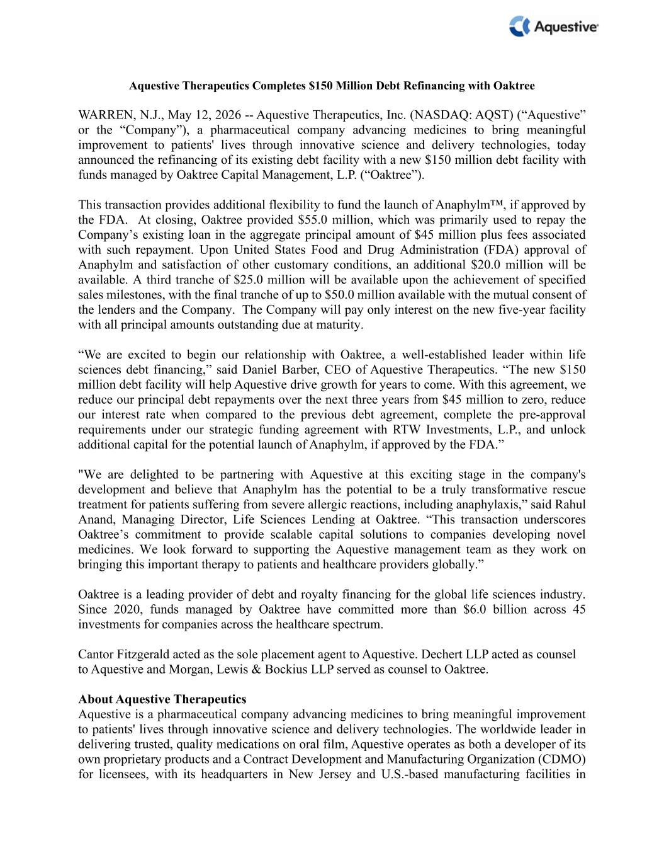

Aquestive Therapeutics Completes $150 Million Debt Refinancing with Oaktree WARREN, N.J., May 12, 2026 -- Aquestive Therapeutics, Inc. (NASDAQ: AQST) (“Aquestive” or the “Company”), a pharmaceutical company advancing medicines to bring meaningful improvement to patients' lives through innovative science and delivery technologies, today announced the refinancing of its existing debt facility with a new $150 million debt facility with funds managed by Oaktree Capital Management, L.P. (“Oaktree”). This transaction provides additional flexibility to fund the launch of Anaphylm™, if approved by the FDA. At closing, Oaktree provided $55.0 million, which was primarily used to repay the Company’s existing loan in the aggregate principal amount of $45 million plus fees associated with such repayment. Upon United States Food and Drug Administration (FDA) approval of Anaphylm and satisfaction of other customary conditions, an additional $20.0 million will be available. A third tranche of $25.0 million will be available upon the achievement of specified sales milestones, with the final tranche of up to $50.0 million available with the mutual consent of the lenders and the Company. The Company will pay only interest on the new five-year facility with all principal amounts outstanding due at maturity. “We are excited to begin our relationship with Oaktree, a well-established leader within life sciences debt financing,” said Daniel Barber, CEO of Aquestive Therapeutics. “The new $150 million debt facility will help Aquestive drive growth for years to come. With this agreement, we reduce our principal debt repayments over the next three years from $45 million to zero, reduce our interest rate when compared to the previous debt agreement, complete the pre-approval requirements under our strategic funding agreement with RTW Investments, L.P., and unlock additional capital for the potential launch of Anaphylm, if approved by the FDA.” "We are delighted to be partnering with Aquestive at this exciting stage in the company's development and believe that Anaphylm has the potential to be a truly transformative rescue treatment for patients suffering from severe allergic reactions, including anaphylaxis,” said Rahul Anand, Managing Director, Life Sciences Lending at Oaktree. “This transaction underscores Oaktree’s commitment to provide scalable capital solutions to companies developing novel medicines. We look forward to supporting the Aquestive management team as they work on bringing this important therapy to patients and healthcare providers globally.” Oaktree is a leading provider of debt and royalty financing for the global life sciences industry. Since 2020, funds managed by Oaktree have committed more than $6.0 billion across 45 investments for companies across the healthcare spectrum. Cantor Fitzgerald acted as the sole placement agent to Aquestive. Dechert LLP acted as counsel to Aquestive and Morgan, Lewis & Bockius LLP served as counsel to Oaktree. About Aquestive Therapeutics Aquestive is a pharmaceutical company advancing medicines to bring meaningful improvement to patients' lives through innovative science and delivery technologies. The worldwide leader in delivering trusted, quality medications on oral film, Aquestive operates as both a developer of its own proprietary products and a Contract Development and Manufacturing Organization (CDMO) for licensees, with its headquarters in New Jersey and U.S.-based manufacturing facilities in

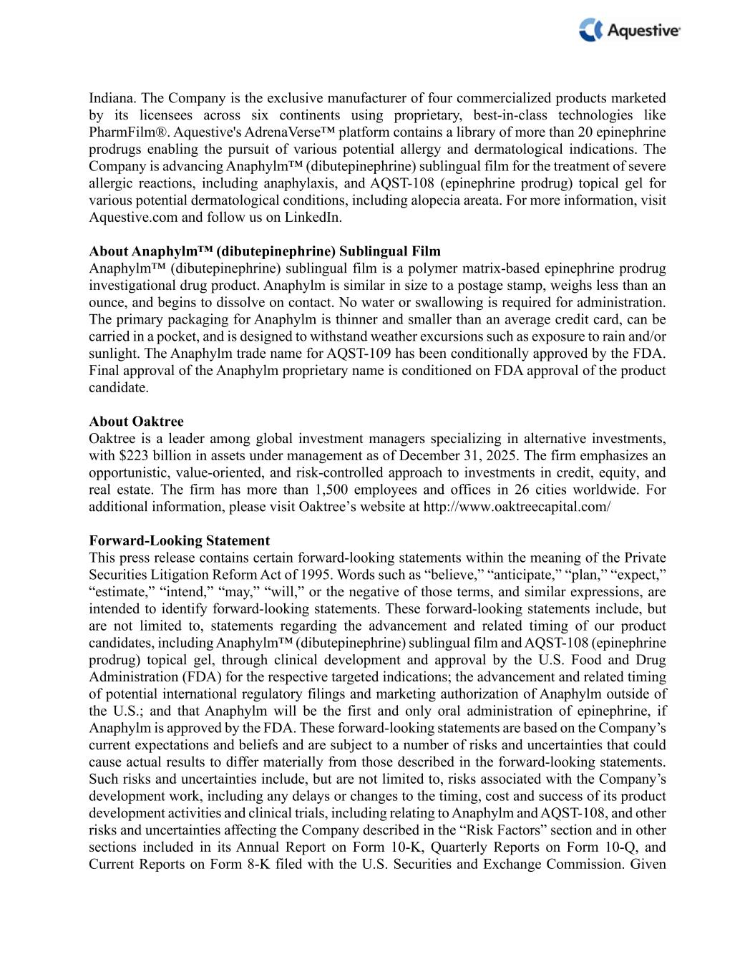
Indiana. The Company is the exclusive manufacturer of four commercialized products marketed by its licensees across six continents using proprietary, best-in-class technologies like PharmFilm®. Aquestive's AdrenaVerse™ platform contains a library of more than 20 epinephrine prodrugs enabling the pursuit of various potential allergy and dermatological indications. The Company is advancing Anaphylm™ (dibutepinephrine) sublingual film for the treatment of severe allergic reactions, including anaphylaxis, and AQST-108 (epinephrine prodrug) topical gel for various potential dermatological conditions, including alopecia areata. For more information, visit Aquestive.com and follow us on LinkedIn. About Anaphylm™ (dibutepinephrine) Sublingual Film Anaphylm™ (dibutepinephrine) sublingual film is a polymer matrix-based epinephrine prodrug investigational drug product. Anaphylm is similar in size to a postage stamp, weighs less than an ounce, and begins to dissolve on contact. No water or swallowing is required for administration. The primary packaging for Anaphylm is thinner and smaller than an average credit card, can be carried in a pocket, and is designed to withstand weather excursions such as exposure to rain and/or sunlight. The Anaphylm trade name for AQST-109 has been conditionally approved by the FDA. Final approval of the Anaphylm proprietary name is conditioned on FDA approval of the product candidate. About Oaktree Oaktree is a leader among global investment managers specializing in alternative investments, with $223 billion in assets under management as of December 31, 2025. The firm emphasizes an opportunistic, value-oriented, and risk-controlled approach to investments in credit, equity, and real estate. The firm has more than 1,500 employees and offices in 26 cities worldwide. For additional information, please visit Oaktree’s website at http://www.oaktreecapital.com/ Forward-Looking Statement This press release contains certain forward-looking statements within the meaning of the Private Securities Litigation Reform Act of 1995. Words such as “believe,” “anticipate,” “plan,” “expect,” “estimate,” “intend,” “may,” “will,” or the negative of those terms, and similar expressions, are intended to identify forward-looking statements. These forward-looking statements include, but are not limited to, statements regarding the advancement and related timing of our product candidates, including Anaphylm™ (dibutepinephrine) sublingual film and AQST-108 (epinephrine prodrug) topical gel, through clinical development and approval by the U.S. Food and Drug Administration (FDA) for the respective targeted indications; the advancement and related timing of potential international regulatory filings and marketing authorization of Anaphylm outside of the U.S.; and that Anaphylm will be the first and only oral administration of epinephrine, if Anaphylm is approved by the FDA. These forward-looking statements are based on the Company’s current expectations and beliefs and are subject to a number of risks and uncertainties that could cause actual results to differ materially from those described in the forward-looking statements. Such risks and uncertainties include, but are not limited to, risks associated with the Company’s development work, including any delays or changes to the timing, cost and success of its product development activities and clinical trials, including relating to Anaphylm and AQST-108, and other risks and uncertainties affecting the Company described in the “Risk Factors” section and in other sections included in its Annual Report on Form 10-K, Quarterly Reports on Form 10-Q, and Current Reports on Form 8-K filed with the U.S. Securities and Exchange Commission. Given

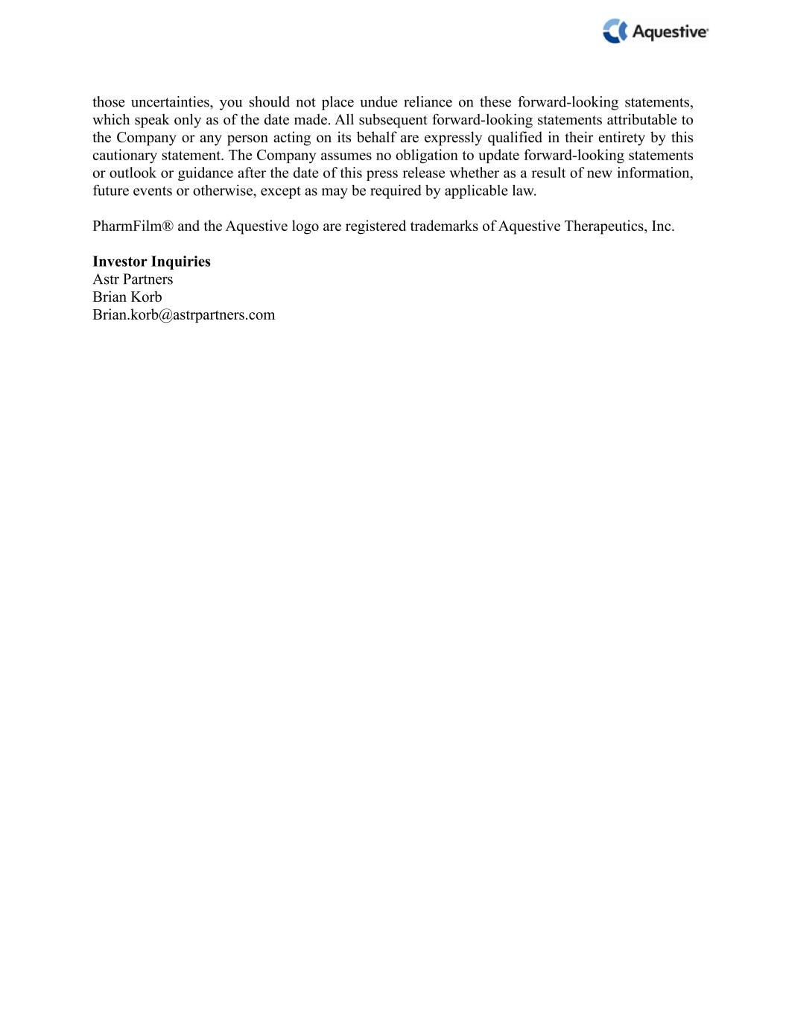
those uncertainties, you should not place undue reliance on these forward-looking statements, which speak only as of the date made. All subsequent forward-looking statements attributable to the Company or any person acting on its behalf are expressly qualified in their entirety by this cautionary statement. The Company assumes no obligation to update forward-looking statements or outlook or guidance after the date of this press release whether as a result of new information, future events or otherwise, except as may be required by applicable law. PharmFilm® and the Aquestive logo are registered trademarks of Aquestive Therapeutics, Inc. Investor Inquiries Astr Partners Brian Korb Brian.korb@astrpartners.com

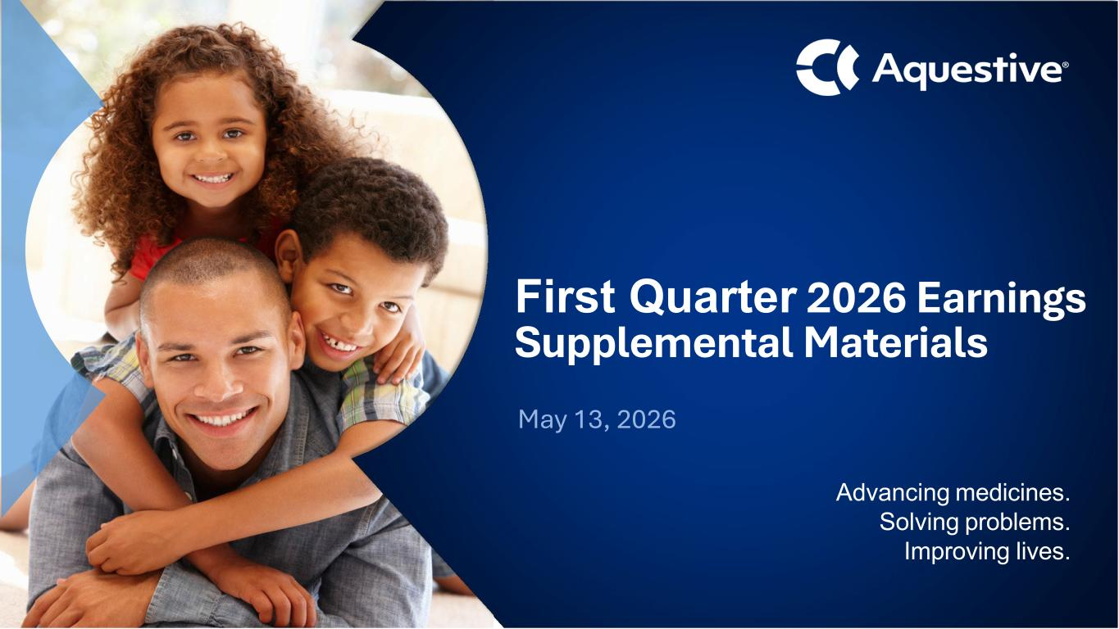
Advancing medicines. Solving problems. Improving lives. First Quarter 2026 Earnings Supplemental Materials May 13, 2026

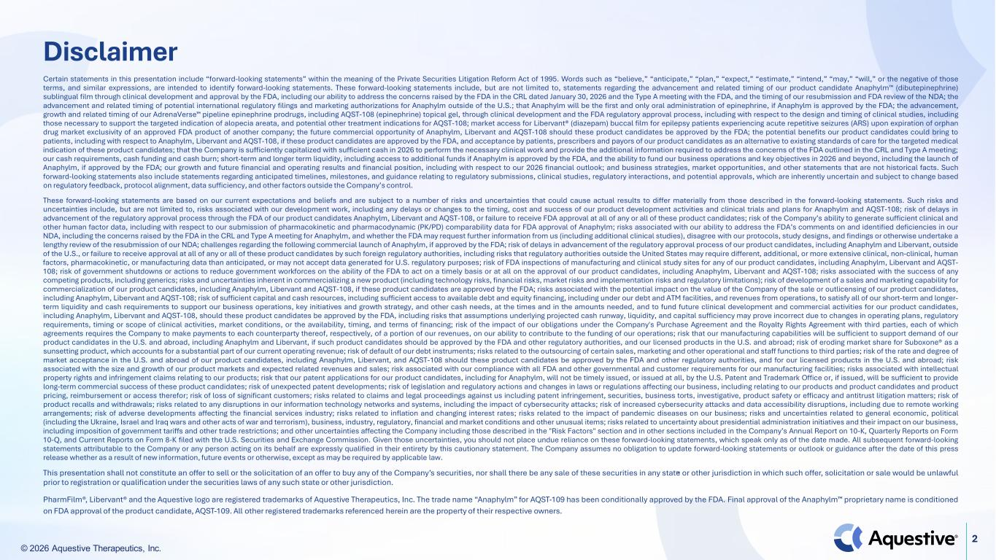
© 2026 Aquestive Therapeutics, Inc. 2 Disclaimer Certain statements in this presentation include “forward-looking statements” within the meaning of the Private Securities Litigation Reform Act of 1995. Words such as “believe,” “anticipate,” “plan,” “expect,” “estimate,” “intend,” “may,” “will,” or the negative of those terms, and similar expressions, are intended to identify forward-looking statements. These forward-looking statements include, but are not limited to, statements regarding the advancement and related timing of our product candidate Anaphylm (dibutepinephrine) sublingual film through clinical development and approval by the FDA, including our ability to address the concerns raised by the FDA in the CRL dated January 30, 2026 and the Type A meeting with the FDA, and the timing of our resubmission and FDA review of the NDA; the advancement and related timing of potential international regulatory filings and marketing authorizations for Anaphylm outside of the U.S.; that Anaphylm will be the first and only oral administration of epinephrine, if Anaphylm is approved by the FDA; the advancement, growth and related timing of our AdrenaVerse pipeline epinephrine prodrugs, including AQST-108 (epinephrine) topical gel, through clinical development and the FDA regulatory approval process, including with respect to the design and timing of clinical studies, including those necessary to support the targeted indication of alopecia areata, and potential other treatment indications for AQST-108; market access for Libervant® (diazepam) buccal film for epilepsy patients experiencing acute repetitive seizures (ARS) upon expiration of orphan drug market exclusivity of an approved FDA product of another company; the future commercial opportunity of Anaphylm, Libervant and AQST-108 should these product candidates be approved by the FDA; the potential benefits our product candidates could bring to patients, including with respect to Anaphylm, Libervant and AQST-108, if these product candidates are approved by the FDA, and acceptance by patients, prescribers and payors of our product candidates as an alternative to existing standards of care for the targeted medical indication of these product candidates; that the Company is sufficiently capitalized with sufficient cash in 2026 to perform the necessary clinical work and provide the additional information required to address the concerns of the FDA outlined in the CRL and Type A meeting; our cash requirements, cash funding and cash burn; short-term and longer term liquidity, including access to additional funds if Anaphylm is approved by the FDA, and the ability to fund our business operations and key objectives in 2026 and beyond, including the launch of Anaphylm, if approved by the FDA; our growth and future financial and operating results and financial position, including with respect to our 2026 financial outlook; and business strategies, market opportunities, and other statements that are not historical facts. Such forward-looking statements also include statements regarding anticipated timelines, milestones, and guidance relating to regulatory submissions, clinical studies, regulatory interactions, and potential approvals, which are inherently uncertain and subject to change based on regulatory feedback, protocol alignment, data sufficiency, and other factors outside the Company’s control. These forward-looking statements are based on our current expectations and beliefs and are subject to a number of risks and uncertainties that could cause actual results to differ materially from those described in the forward-looking statements. Such risks and uncertainties include, but are not limited to, risks associated with our development work, including any delays or changes to the timing, cost and success of our product development activities and clinical trials and plans for Anaphylm and AQST-108; risk of delays in advancement of the regulatory approval process through the FDA of our product candidates Anaphylm, Libervant and AQST-108, or failure to receive FDA approval at all of any or all of these product candidates; risk of the Company’s ability to generate sufficient clinical and other human factor data, including with respect to our submission of pharmacokinetic and pharmacodynamic (PK/PD) comparability data for FDA approval of Anaphylm; risks associated with our ability to address the FDA’s comments on and identified deficiencies in our NDA, including the concerns raised by the FDA in the CRL and Type A meeting for Anaphylm, and whether the FDA may request further information from us (including additional clinical studies), disagree with our protocols, study designs, and findings or otherwise undertake a lengthy review of the resubmission of our NDA; challenges regarding the following commercial launch of Anaphylm, if approved by the FDA; risk of delays in advancement of the regulatory approval process of our product candidates, including Anaphylm and Libervant, outside of the U.S., or failure to receive approval at all of any or all of these product candidates by such foreign regulatory authorities, including risks that regulatory authorities outside the United States may require different, additional, or more extensive clinical, non-clinical, human factors, pharmacokinetic, or manufacturing data than anticipated, or may not accept data generated for U.S. regulatory purposes; risk of FDA inspections of manufacturing and clinical study sites for any of our product candidates, including Anaphylm, Libervant and AQST- 108; risk of government shutdowns or actions to reduce government workforces on the ability of the FDA to act on a timely basis or at all on the approval of our product candidates, including Anaphylm, Libervant and AQST-108; risks associated with the success of any competing products, including generics; risks and uncertainties inherent in commercializing a new product (including technology risks, financial risks, market risks and implementation risks and regulatory limitations); risk of development of a sales and marketing capability for commercialization of our product candidates, including Anaphylm, Libervant and AQST-108, if these product candidates are approved by the FDA; risks associated with the potential impact on the value of the Company of the sale or outlicensing of our product candidates, including Anaphylm, Libervant and AQST-108; risk of sufficient capital and cash resources, including sufficient access to available debt and equity financing, including under our debt and ATM facilities, and revenues from operations, to satisfy all of our short-term and longer- term liquidity and cash requirements to support our business operations, key initiatives and growth strategy, and other cash needs, at the times and in the amounts needed, and to fund future clinical development and commercial activities for our product candidates, including Anaphylm, Libervant and AQST-108, should these product candidates be approved by the FDA, including risks that assumptions underlying projected cash runway, liquidity, and capital sufficiency may prove incorrect due to changes in operating plans, regulatory requirements, timing or scope of clinical activities, market conditions, or the availability, timing, and terms of financing; risk of the impact of our obligations under the Company's Purchase Agreement and the Royalty Rights Agreement with third parties, each of which agreements requires the Company to make payments to each counterparty thereof, respectively, of a portion of our revenues, on our ability to contribute to the funding of our operations; risk that our manufacturing capabilities will be sufficient to support demand of our product candidates in the U.S. and abroad, including Anaphylm and Libervant, if such product candidates should be approved by the FDA and other regulatory authorities, and our licensed products in the U.S. and abroad; risk of eroding market share for Suboxone® as a sunsetting product, which accounts for a substantial part of our current operating revenue; risk of default of our debt instruments; risks related to the outsourcing of certain sales, marketing and other operational and staff functions to third parties; risk of the rate and degree of market acceptance in the U.S. and abroad of our product candidates, including Anaphylm, Libervant, and AQST-108 should these product candidates be approved by the FDA and other regulatory authorities, and for our licensed products in the U.S. and abroad; risk associated with the size and growth of our product markets and expected related revenues and sales; risk associated with our compliance with all FDA and other governmental and customer requirements for our manufacturing facilities; risks associated with intellectual property rights and infringement claims relating to our products; risk that our patent applications for our product candidates, including for Anaphylm, will not be timely issued, or issued at all, by the U.S. Patent and Trademark Office or, if issued, will be sufficient to provide long-term commercial success of these product candidates; risk of unexpected patent developments; risk of legislation and regulatory actions and changes in laws or regulations affecting our business, including relating to our products and product candidates and product pricing, reimbursement or access therefor; risk of loss of significant customers; risks related to claims and legal proceedings against us including patent infringement, securities, business torts, investigative, product safety or efficacy and antitrust litigation matters; risk of product recalls and withdrawals; risks related to any disruptions in our information technology networks and systems, including the impact of cybersecurity attacks; risk of increased cybersecurity attacks and data accessibility disruptions, including due to remote working arrangements; risk of adverse developments affecting the financial services industry; risks related to inflation and changing interest rates; risks related to the impact of pandemic diseases on our business; risks and uncertainties related to general economic, political (including the Ukraine, Israel and Iraq wars and other acts of war and terrorism), business, industry, regulatory, financial and market conditions and other unusual items; risks related to uncertainty about presidential administration initiatives and their impact on our business, including imposition of government tariffs and other trade restrictions; and other uncertainties affecting the Company including those described in the "Risk Factors" section and in other sections included in the Company’s Annual Report on 10-K, Quarterly Reports on Form 10-Q, and Current Reports on Form 8-K filed with the U.S. Securities and Exchange Commission. Given those uncertainties, you should not place undue reliance on these forward-looking statements, which speak only as of the date made. All subsequent forward-looking statements attributable to the Company or any person acting on its behalf are expressly qualified in their entirety by this cautionary statement. The Company assumes no obligation to update forward-looking statements or outlook or guidance after the date of this press release whether as a result of new information, future events or otherwise, except as may be required by applicable law. This presentation shall not constitute an offer to sell or the solicitation of an offer to buy any of the Company’s securities, nor shall there be any sale of these securities in any state or other jurisdiction in which such offer, solicitation or sale would be unlawful prior to registration or qualification under the securities laws of any such state or other jurisdiction. PharmFilm®, Libervant® and the Aquestive logo are registered trademarks of Aquestive Therapeutics, Inc. The trade name “Anaphylm” for AQST-109 has been conditionally approved by the FDA. Final approval of the Anaphylm proprietary name is conditioned on FDA approval of the product candidate, AQST-109. All other registered trademarks referenced herein are the property of their respective owners.

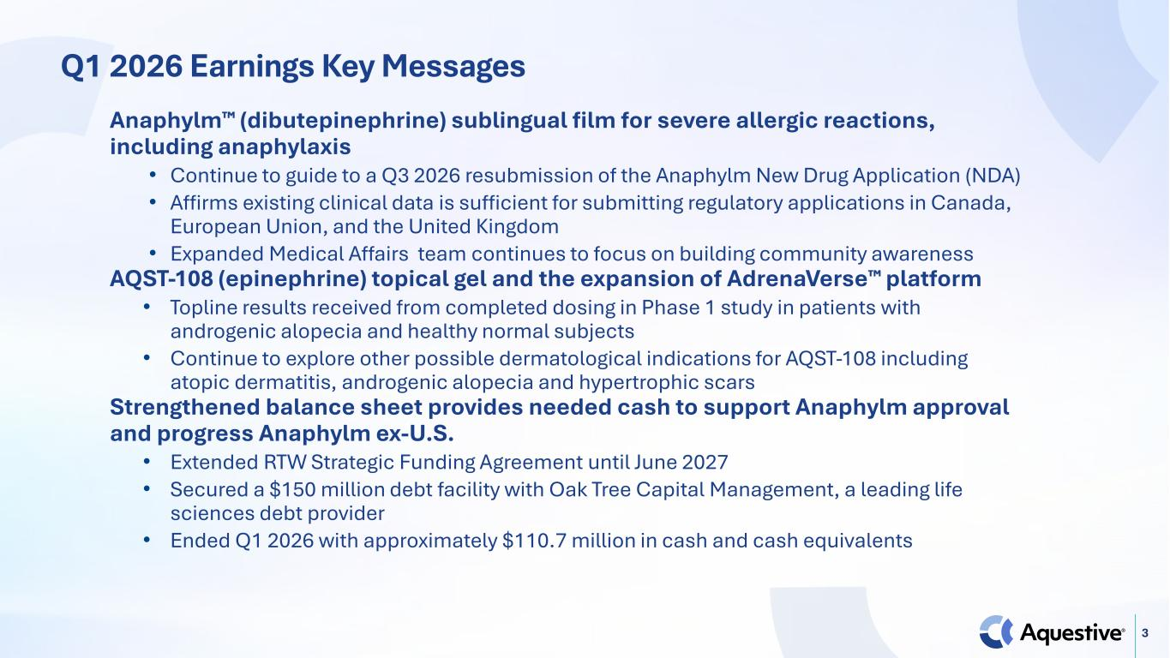
3 Q1 2026 Earnings Key Messages Anaphylm (dibutepinephrine) sublingual film for severe allergic reactions, including anaphylaxis • Continue to guide to a Q3 2026 resubmission of the Anaphylm New Drug Application (NDA) • Affirms existing clinical data is sufficient for submitting regulatory applications in Canada, European Union, and the United Kingdom • Expanded Medical Affairs team continues to focus on building community awareness AQST-108 (epinephrine) topical gel and the expansion of AdrenaVerse platform • Topline results received from completed dosing in Phase 1 study in patients with androgenic alopecia and healthy normal subjects • Continue to explore other possible dermatological indications for AQST-108 including atopic dermatitis, androgenic alopecia and hypertrophic scars Strengthened balance sheet provides needed cash to support Anaphylm approval and progress Anaphylm ex-U.S. • Extended RTW Strategic Funding Agreement until June 2027 • Secured a $150 million debt facility with Oak Tree Capital Management, a leading life sciences debt provider • Ended Q1 2026 with approximately $110.7 million in cash and cash equivalents

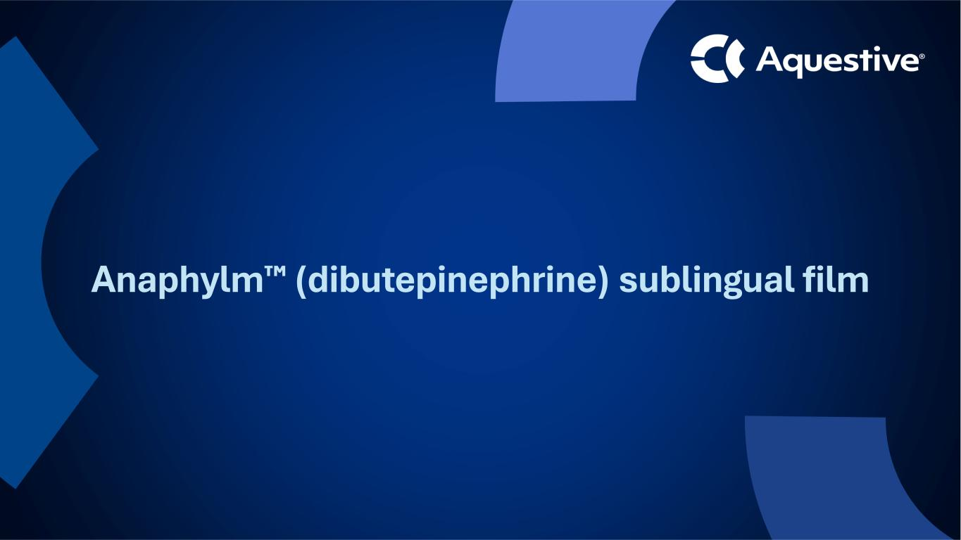
Anaphylm (dibutepinephrine) sublingual film

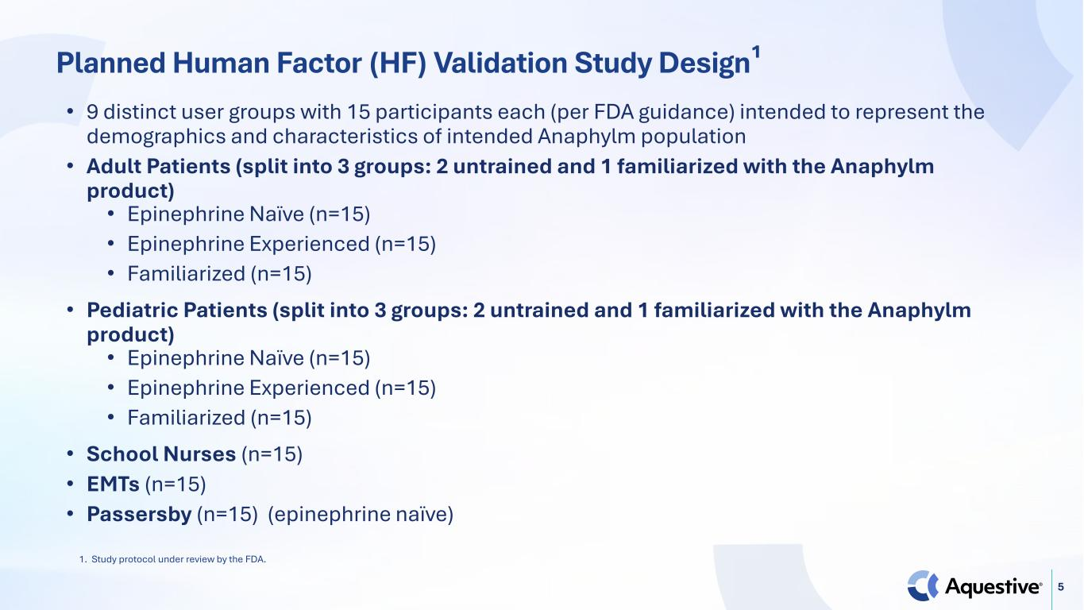
5 Planned Human Factor (HF) Validation Study Design¹ • 9 distinct user groups with 15 participants each (per FDA guidance) intended to represent the demographics and characteristics of intended Anaphylm population • Adult Patients (split into 3 groups: 2 untrained and 1 familiarized with the Anaphylm product) • Epinephrine Naïve (n=15) • Epinephrine Experienced (n=15) • Familiarized (n=15) • Pediatric Patients (split into 3 groups: 2 untrained and 1 familiarized with the Anaphylm product) • Epinephrine Naïve (n=15) • Epinephrine Experienced (n=15) • Familiarized (n=15) • School Nurses (n=15) • EMTs (n=15) • Passersby (n=15) (epinephrine naïve) 1. Study protocol under review by the FDA.

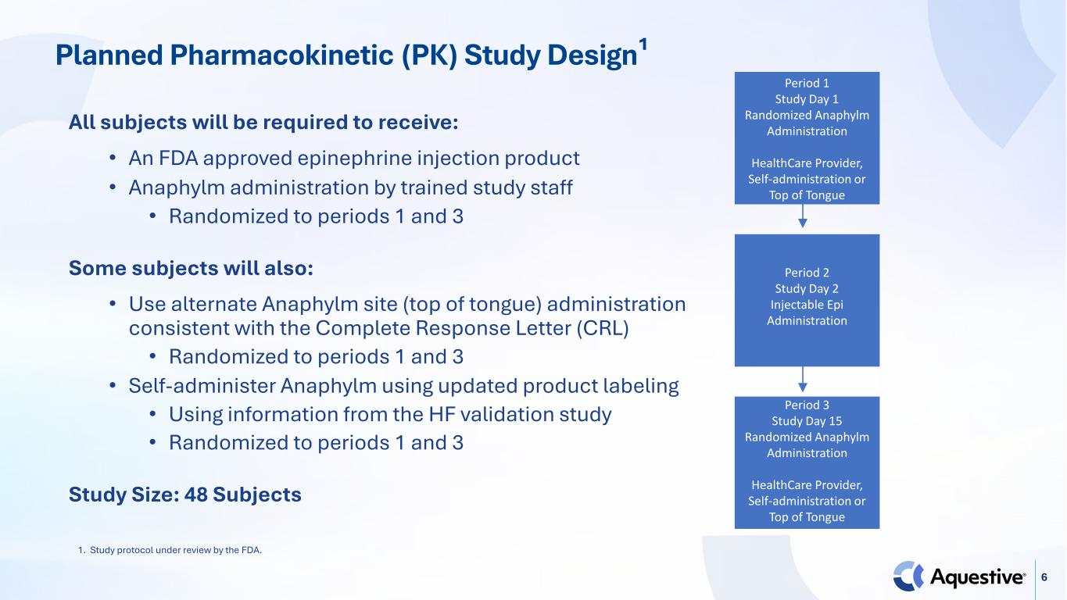
6 All subjects will be required to receive: • An FDA approved epinephrine injection product • Anaphylm administration by trained study staff • Randomized to periods 1 and 3 Some subjects will also: • Use alternate Anaphylm site (top of tongue) administration consistent with the Complete Response Letter (CRL) • Randomized to periods 1 and 3 • Self-administer Anaphylm using updated product labeling • Using information from the HF validation study • Randomized to periods 1 and 3 Study Size: 48 Subjects Planned Pharmacokinetic (PK) Study Design¹ Period 1 Study Day 1 Randomized Anaphylm Administration HealthCare Provider, Self-administration or Top of Tongue Period 2 Study Day 2 Injectable Epi Administration Period 3 Study Day 15 Randomized Anaphylm Administration HealthCare Provider, Self-administration or Top of Tongue 1. Study protocol under review by the FDA.

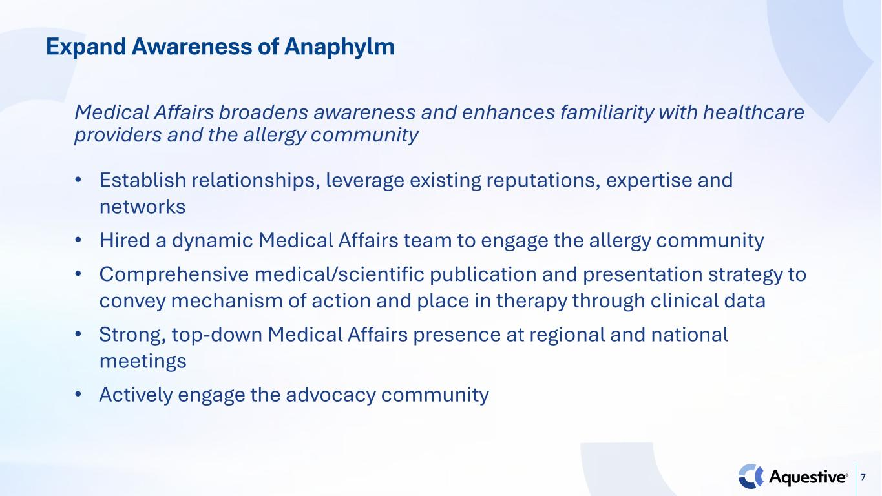
7 Expand Awareness of Anaphylm Medical Affairs broadens awareness and enhances familiarity with healthcare providers and the allergy community • Establish relationships, leverage existing reputations, expertise and networks • Hired a dynamic Medical Affairs team to engage the allergy community • Comprehensive medical/scientific publication and presentation strategy to convey mechanism of action and place in therapy through clinical data • Strong, top-down Medical Affairs presence at regional and national meetings • Actively engage the advocacy community

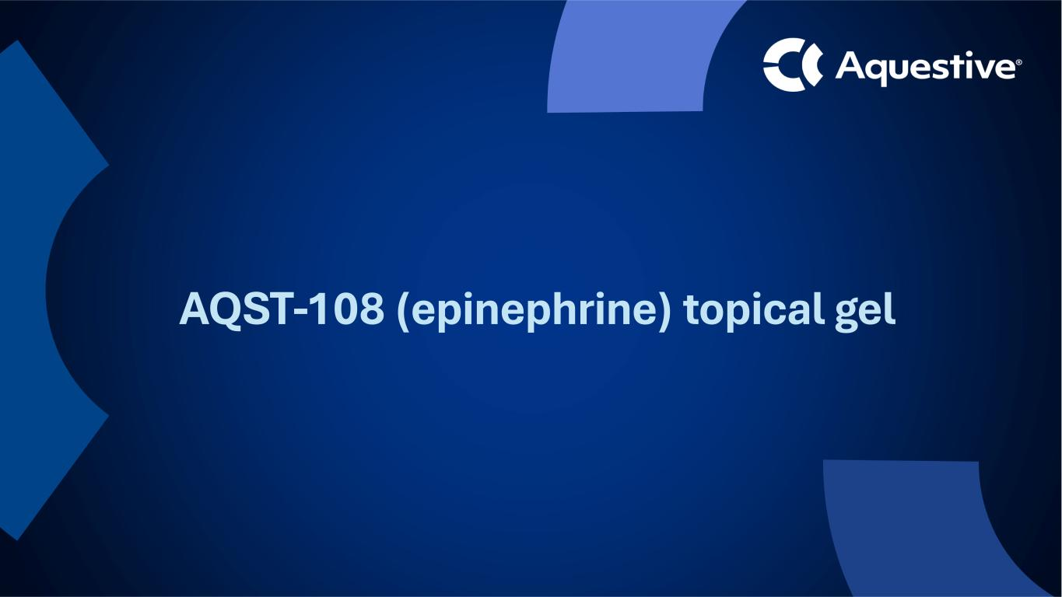
AQST-108 (epinephrine) topical gel

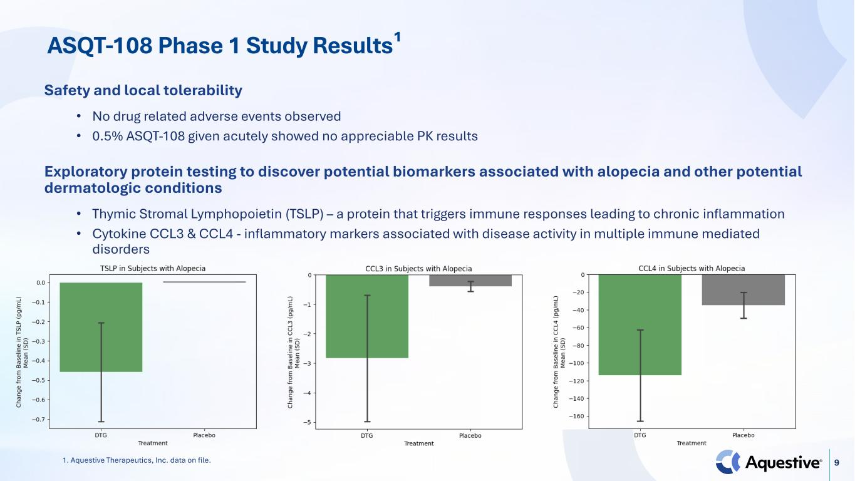
9 Safety and local tolerability • No drug related adverse events observed • 0.5% ASQT-108 given acutely showed no appreciable PK results Exploratory protein testing to discover potential biomarkers associated with alopecia and other potential dermatologic conditions • Thymic Stromal Lymphopoietin (TSLP) – a protein that triggers immune responses leading to chronic inflammation • Cytokine CCL3 & CCL4 - inflammatory markers associated with disease activity in multiple immune mediated disorders ASQT-108 Phase 1 Study Results¹ 1. Aquestive Therapeutics, Inc. data on file.


Key Upcoming Milestones

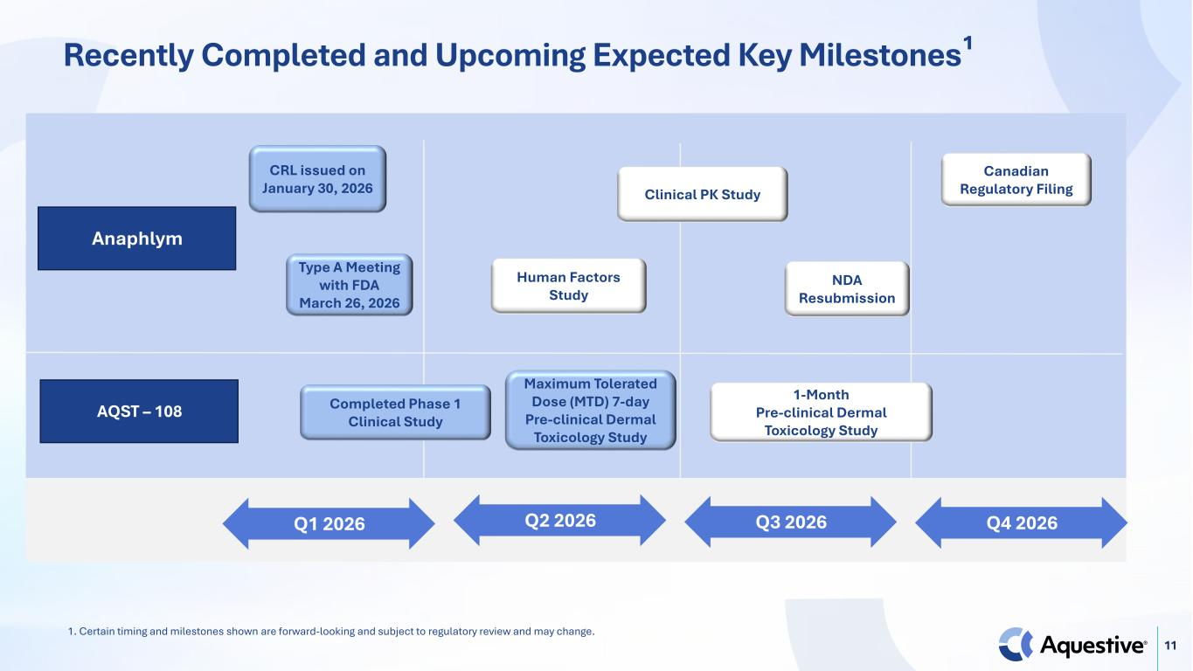
11 Recently Completed and Upcoming Expected Key Milestones¹ AQST – 108 Q4 2026Q1 2026 Q2 2026 Q3 2026 Anaphlym CRL issued on January 30, 2026 Canadian Regulatory Filing Completed Phase 1 Clinical Study Type A Meeting with FDA March 26, 2026 NDA Resubmission Human Factors Study Clinical PK Study Maximum Tolerated Dose (MTD) 7-day Pre-clinical Dermal Toxicology Study 1-Month Pre-clinical Dermal Toxicology Study 1. Certain timing and milestones shown are forward-looking and subject to regulatory review and may change.

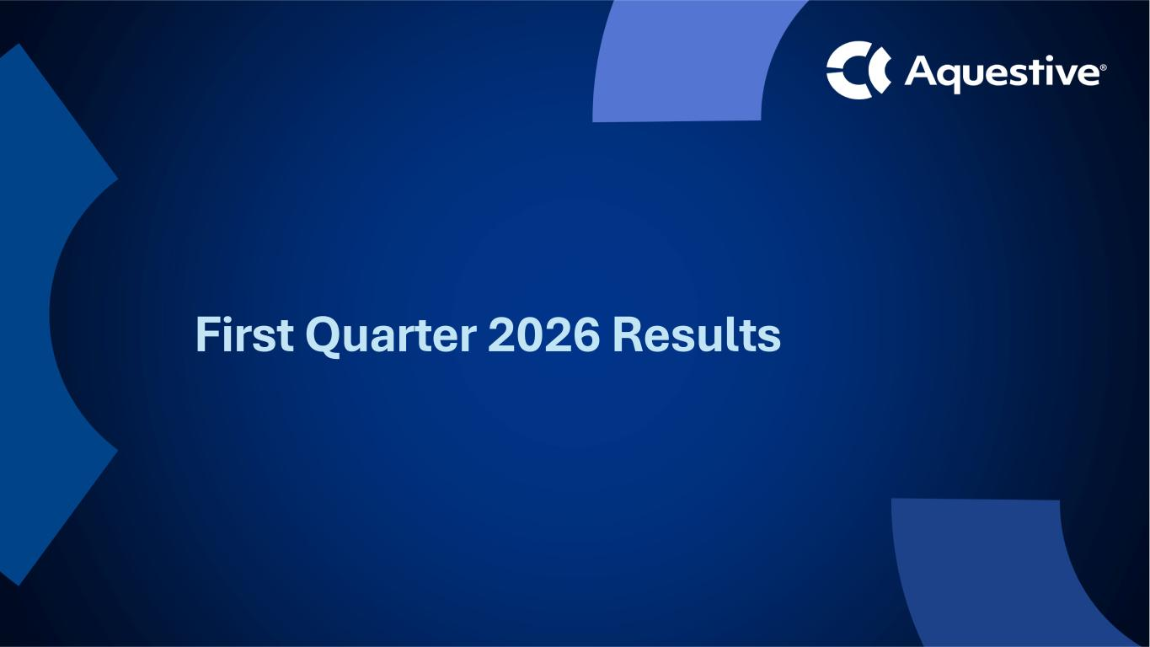
First Quarter 2026 Results

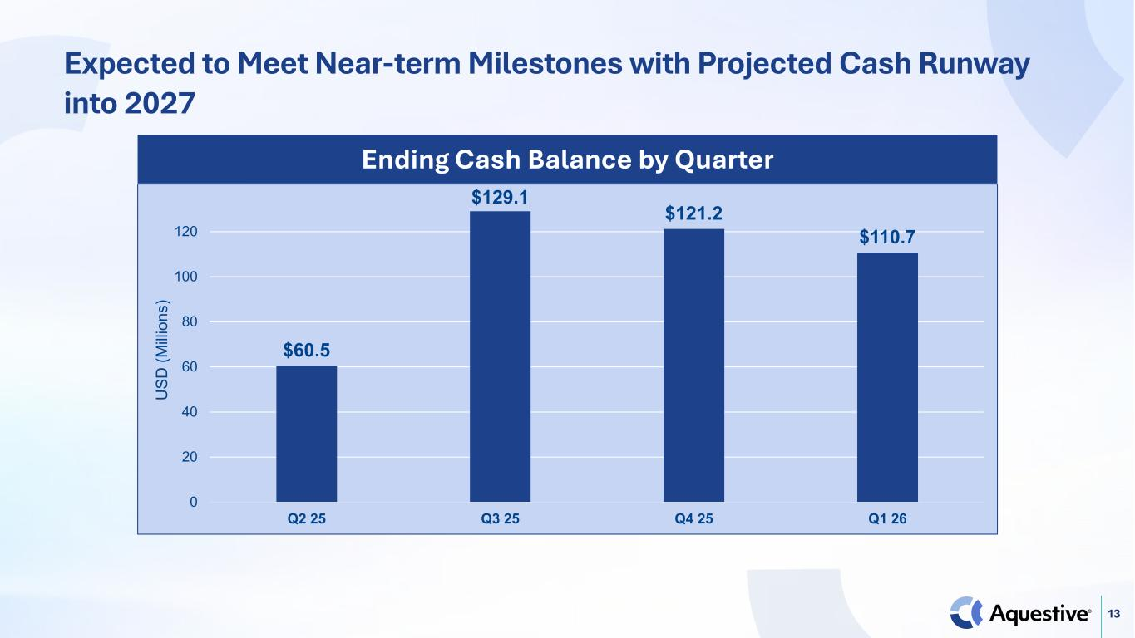
13 Expected to Meet Near-term Milestones with Projected Cash Runway into 2027 $60.5 $129.1 $121.2 $110.7 0 20 40 60 80 100 120 Q2 25 Q3 25 Q4 25 Q1 26 U SD (M illi on s) Ending Cash Balance by Quarter

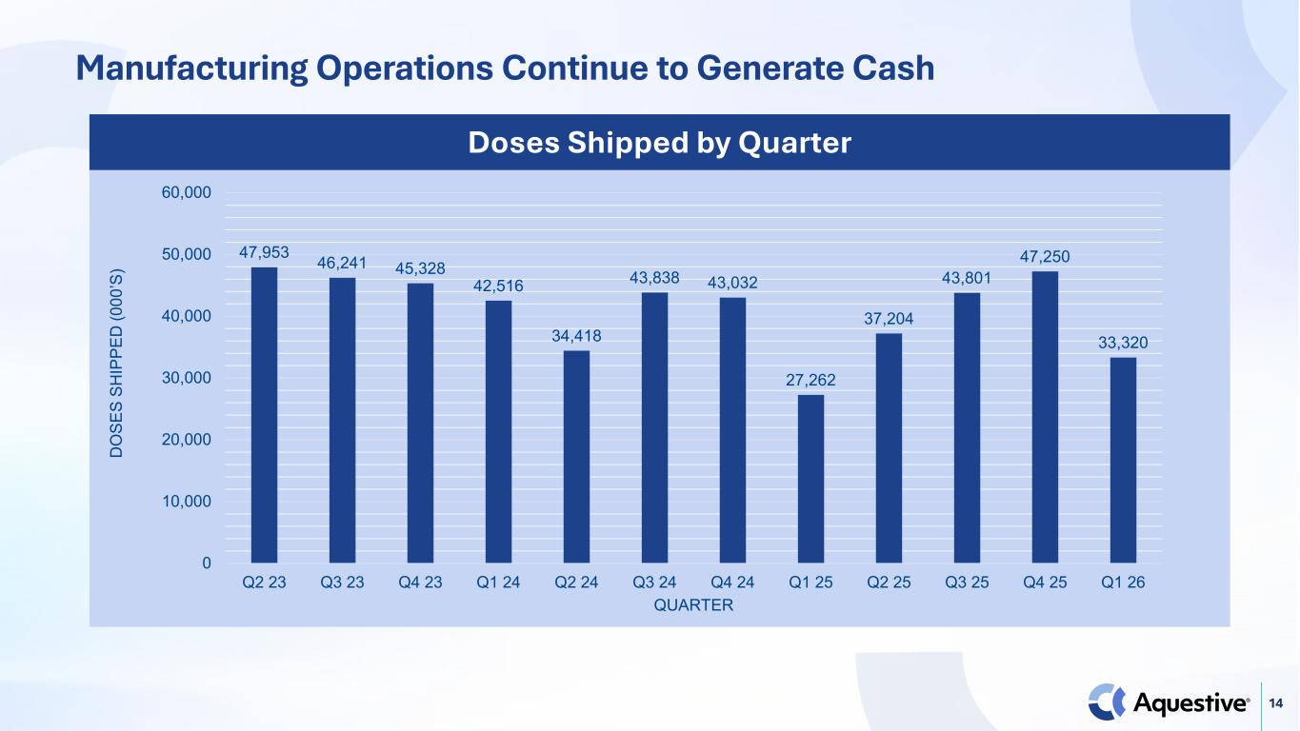
14 47,953 46,241 45,328 42,516 34,418 43,838 43,032 27,262 37,204 43,801 47,250 33,320 0 10,000 20,000 30,000 40,000 50,000 60,000 Q2 23 Q3 23 Q4 23 Q1 24 Q2 24 Q3 24 Q4 24 Q1 25 Q2 25 Q3 25 Q4 25 Q1 26 D O SE S SH IP PE D (0 00 ’S ) QUARTER Doses Shipped by Quarter Manufacturing Operations Continue to Generate Cash

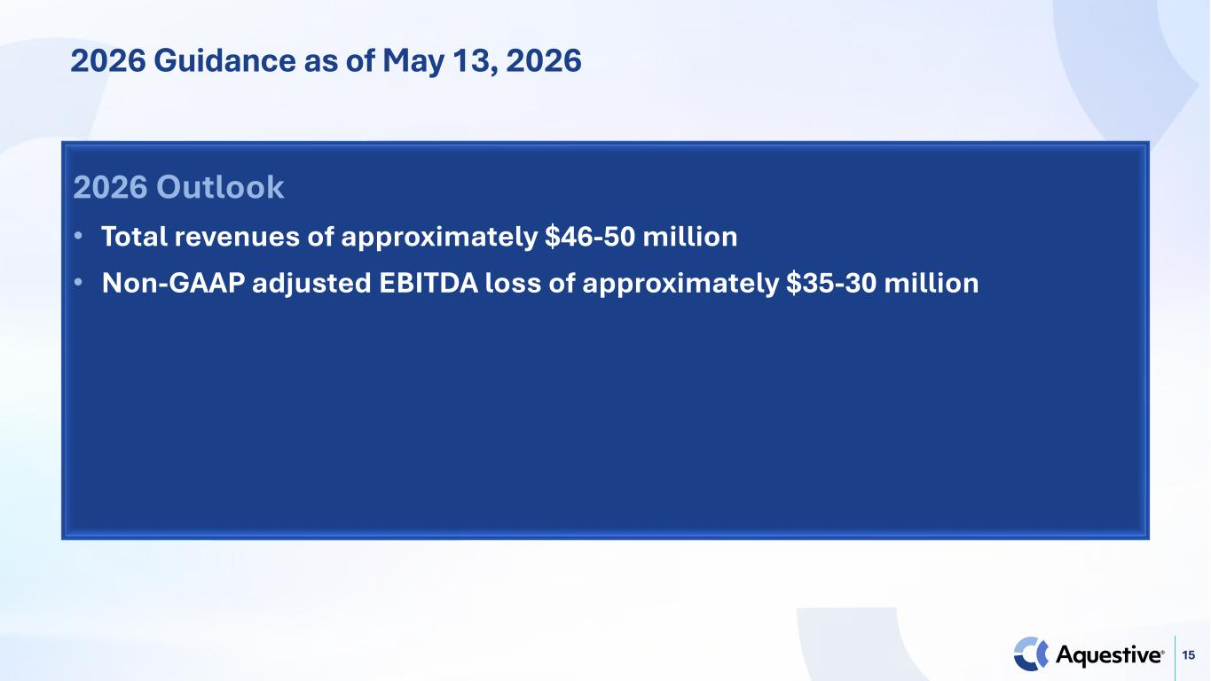
15 2026 Guidance as of May 13, 2026 2026 Outlook • Total revenues of approximately $46-50 million • Non-GAAP adjusted EBITDA loss of approximately $35-30 million


Thank You

